Maintenance Change Request
for the update of ISO 20022 financial repository items
- Name of the request:
CCP Supervisory Maintenance for the year 2025/26
- Submitting organization(s):
Bank of England
- Related messages:
auth.069.001.02 (Cleared Product)
- Commitments of the submitting organization:
The submitting organization must confirm that it can and will:
- undertake the development of the new version of the candidate ISO 20022 message models that it will submit to the RA for compliance review and evaluation. For the ISO 20022 yearly maintenance cycle, new valid Message Definition models must be available to the RA by December 1.
- provide a new version of part 1 of the Message Definition Report (MDR) by December 1, and, optionally, new examples of valid and invalid message instances of each candidate message by May 1 at the latest.
- address any queries related to the description of the new models and messages as published by the RA on the ISO 20022 website.
If the submitting organization cannot develop all or part of the changes included in this Maintenance Change Request in the timeframe agreed by the SEG, it must propose an alternative solution for the change requests it cannot develop in time (eg postpone to a later date or to the next yearly maintenance cycle).
The submitting organization must confirm whether it intends or not to organize any testing or the actual implementation of the new version of the messages once the related documentation has been published by the RA. The purpose is to ensure that the documentation of the new version of the messages is accurate and consistent and to verify that these approved messages can be implemented with no adverse effects on communication infrastructures and/or applications.
The submitting organization must confirm its knowledge and acceptance of the ISO 20022 Intellectual Property Rights policy for contributing organizations, as follows.
“Organizations that contribute information to be incorporated into the ISO 20022 Repository shall keep any Intellectual Property Rights (IPR) they have on this information. A contributing organization warrants that it has sufficient rights on the contributed information to have it published in the ISO 20022 Repository through the ISO 20022 Registration Authority in accordance with the rules set in ISO 20022. To ascertain a widespread, public and uniform use of the ISO 20022 Repository information, the contributing organization grants third parties a non-exclusive, royalty-free license to use the published information”.
The Bank of England understands the commitment to ISO 20022 and confirms it will meet the timescales defined by the ISO20022 governance process and undertake appropriate testing.
- Contact persons:
John Aveson john.aveson@bankofengland.co.uk
Richard Wickens richard.wickens@bankofengland.co.uk

Change request number 1503
This chapter must be completed for every change request that the submitting organization has been requested to implement.
Copy of the approved change request:
This is a copy of sections A to G of the change request approved by the SEG for further consideration, as communicated to the submitting organization by the RA.
A. Origin of the request:
A.1 Submitter:
Bank of England
A.2 Contact person:
John Aveson john.aveson@bankofengland.co.uk
A.3 Sponsors: /
B. Related messages:
auth.069.001.02 CCPClearedProductReportV02
C. Description of the change request:
The proposed change adds a new ‘MarginRate’ field to the ClearedProduct2 complex type. This field decomposes volume and risk contributions to initial margin by defining a fixed hypothetical portfolio on which the margin is calculated.

<xs:complexType name="ClearedProduct2">
<xs:sequence>
<xs:element maxOccurs="unbounded" minOccurs="1" name="TradgVn" type="MICIdentifier"/>
<xs:element name="CCPPdctId" type="GenericIdentification168"/>
<xs:element maxOccurs="1" minOccurs="0" name="UvrslPdctId" type="GenericIdentification168"/>
<xs:element name="Pdct" type="Product1Choice"/>
<xs:element name="OpnIntrst" type="OpenInterest1"/>
<xs:element maxOccurs="1" minOccurs="0" name="TrdsClrd" type="NonNegativeNumber"/>
<xs:element name="ClrdGrssNtnlAmt" type="ActiveCurrencyAnd24Amount"/>
<xs:element maxOccurs="1" minOccurs="0" name="MarginRate" type="MarginRate"/>
</xs:sequence>
</xs:complexType>

<xs:complexType name="MarginRate">
<xs:sequence>
<xs:element name="LongMarginRate" type="ActiveCurrencyAnd24Amount"/>
<xs:element name="ShortMarginRate" type="ActiveCurrencyAnd24Amount"/>
<xs:element name="MarginRatePortfolioDescription" type="Max2000Text"/>
</xs:sequence>
</xs:complexType>

Changes are shown in bold italic.

- Purpose of the change:
The information proposed to be included in this message is presently reported by CCPs to supervisory bodies through ad-hoc spreadsheet collections at time of market stress. The purpose of the change is to reduce the required overhead at busy times by putting the reporting on an automated footing.

- Urgency of the request:
Regular

- Business examples:
Examples illustrating the change request.

 |  | MarginRate
 |  | LongMarginRate |  | ShortMarginRate |  | PortfolioDescription
Trading_Venue | CCPProductId | Amt | Ccy | Amt | Ccy | PortfolioDescription
XONE | Gilt1 | 1000 | GBP | 1100 | GBP | 1 lot Gilt 5Y Future
XTWO | Equity2 | 500 | GBP | 500 | GBP | 1 lot Equity 1 3M Future
XXXX | Brent3 | 250 | EUR | 275 | EUR | 1 lot brent crude 3 month future
Illustrating example showing a subset of the existing fields (TradingVenue and CCPProductId) and how the new margin rate fields are populated.
- SEG/TSG recommendation:
This section is not to be taken care of by the submitter of the change request. It will be completed in due time by the SEG(s) in charge of the related ISO 20022 messages or the TSG for changes related to the BAH.

Consider |  | X | Timing
 |  |  | - Next yearly cycle: 2025/2026  (the change will be considered for implementation in the yearly maintenance cycle which starts in 2025 and completes with the publication of new message versions in the spring of 2026) |  | X
- At the occasion of the next maintenance of the messages
(the change will be considered for implementation, but does not justify maintenance of the messages in its own right – will be pending until more critical change requests are received for the messages)
- Urgent unscheduled
(the change justifies an urgent implementation outside of the normal yearly cycle)
 |  |  | - Other timing:
Comments:

Reject
Reason for rejection:

- Impact analysis and type of impact:
This section should describe whether the impact of the change requested will actually be as described in the approved change request. Any additional findings from the submitting organization when analysing the change request should be mentioned here. For example, additional impacted messages, not mentioned in the original change request, or additional required amendments that would have to be made to implement the requested change correctly, or complementary changes proposed by the submitting organisation at the occasion of this maintenance.
The impact of the proposed change only impacts the auth.069.001.02 report. There are no knock-on impacts to other reports
- Proposed implementation:
Detailed description – and illustration - of the required modification(s) to implement the requested change. This section should contain an illustration of the portions of the message definition that are impacted by the change, using for example, the Editor or an XML parser.

The proposed implementation follows closely that of the change request. The output from the standards editor tool has been shown below: the only distinction is that the names of the elements are slightly different, showing the shortening of the characters strings.

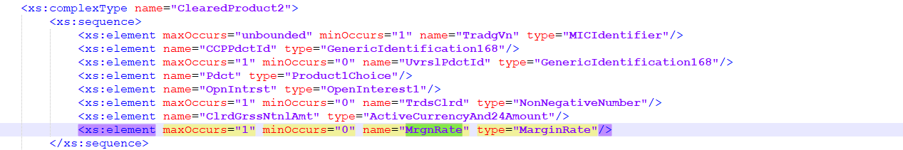
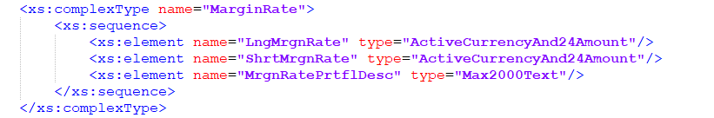

- Proposed timing:
The submitting organization confirms that it can implement the requested changes in the requested timing, or, if not, proposes another timing.

Timing | - As requested
 | - Other:

- Final decision of the SEG(s):
This section is not to be taken care of by the submitting organization. It will be completed in due time by the SEG(s) in charge of the related ISO 20022 messages.
Approve | X
Comments: The SEG approved the MCR with the condition that the MarginRate complex type was renamed MarginRatePortfolio, and the enclosed MarginRatePortfolioDescription was named Description

<xs:complexType name="MarginRatePortfolio">
<xs:sequence>
<xs:element name="LongMarginRate" type="ActiveCurrencyAnd24Amount"/>
<xs:element name="ShortMarginRate" type="ActiveCurrencyAnd24Amount"/>
<xs:element name="Description" type="Max2000Text"/>
</xs:sequence>
</xs:complexType>

Reject
Reason for rejection:

