Maintenance Change Request
for the update of ISO 20022 financial repository items

Name of the request:
“ISO 20022 Securities Clearing Maintenance 2025/2026”

Submitting organisation(s):
ASX – CHESS (Clearing House Electronic Subregister System)
Australian Securities Exchange (ASX)
20 Bridge Street
Sydney NSW 2000

Related messages:

Under this maintenance, below existing ISO 20022 message definitions will be maintained (resulting from the impact analysis performed on each CR).

Collateral Management message set:

- secl.001.001.04 – TradeLegNotificationV04
- secl.002.001.04 – Trade LegNotificationCancellationV04
- secl.003.001.04 – TradeLegStatementV04

Message sets impacted are under responsibility of SWIFT:
Please note that the Collateral Management message set is under the responsibility of SWIFT.

Commitments of the submitting organisation:

The submitting organisations confirm that they can and will:
- Undertake the development of the new version of the candidate ISO 20022 message models that it will submit to the RA for compliance review and evaluation. New valid Message Definition models will be made available to the RA by December 1.
- provide a new version of part 1 of the related Message Definition Reports (MDR) by December 1, and new examples of valid message instances of each candidate message (only when valid samples were published for current version) by May 1 at the latest.
- Address any queries related to the description of the new models and messages as published by the RA on the ISO 20022 website.

SWIFT intends to implement most of the above new versions on its SWIFTNet network once the related documentation has been published by the RA.

The submitting organisations confirm their knowledge and acceptance of the ISO 20022 Intellectual Property Rights policy for contributing organisations, as follows.
“Organisations that contribute information to be incorporated into the ISO 20022 Repository shall keep any Intellectual Property Rights (IPR) they have on this information. A contributing organisation warrants that it has sufficient rights on the contributed information to have it published in the ISO 20022 Repository through the ISO 20022 Registration Authority in accordance with the rules set in ISO 20022. To ascertain a widespread, public and uniform use of the ISO 20022 Repository information, the contributing organisation grants third parties a non-exclusive, royalty-free license to use the published information”.

Contact persons:

Priscilla Ferri de Barros – ASX, priscilla.ferridebarros@asx.com.au
Sigrid Wiley – ASX, sigrid.wiley@asx.com.au
Karine Taquet – SWIFT Standards, karine.taquet@swift.com

Change request CR01476:
Alignement among the collateral management messages

Origin of the request:
A.1 Submitter: ASX – CHESS (Clearing House Electronic Subregister System)
A.2 Contact person: Priscilla Ferri de Barros; priscilla.ferridebarros@asx.com.au;
+ 61 (02) 9227 0543
A.3 Sponsors: it is highly recommended that a submitter of a Change Request gain the agreement and support from as many additional organisations, groups, initiatives or communities of users as possible, thus demonstrating as wide as possible a consultation of the relevant stakeholders. All organisations, groups, initiatives or communities supporting the change request should be identified as sponsors along with a contact person, if possible. This community involvement is intended to help avoid delays and/or subsequent amendments to the change request.

Related messages:
The list of ISO 20022 messages which would be impacted by the change, including the Message IDs as shown in the Catalogue of ISO 20022 messages. Only the latest version of a message definition can be maintained.
The submitter is invited to carefully examine whether the change may have an impact on other messages that come into play earlier or later in the transaction chain or on other messages that also use message components that this change request may impact.
Related messages:

- secl.001.001.04 – TradeLegNotificationV04
- secl.002.001.04 – Trade LegNotificationCancellationV04
- secl.003.001.04 – TradeLegStatementV04

Description of the change request:

This Change Request includes 5 specific actions:

Change 1: currently, element Trading Capacity(/Document /TradLegNtfctn /TradLegDtls /TradgCpcty) contains a code list with 3 possible values: Agent, Principal and Riskless Principal. The addition of Code “Mixed” (Principal + agent) would comply with the ASX requirement as in Australia a single trade can mix client money and firm money (the execution firm can be either agent or/and principal). This is not allowed is most markets but is allowed in Australia per the ASIC regulation. Moreover, this would also align with FIX orders where order capacity does allow mix capacity.

Proposed New tag definition: mixed
“Executing firm is acting in a capacity that is not purely agency (AGEN) or purely principal (PRIN), but rather a combination of both.”

ISO 20022 proposed implementation:

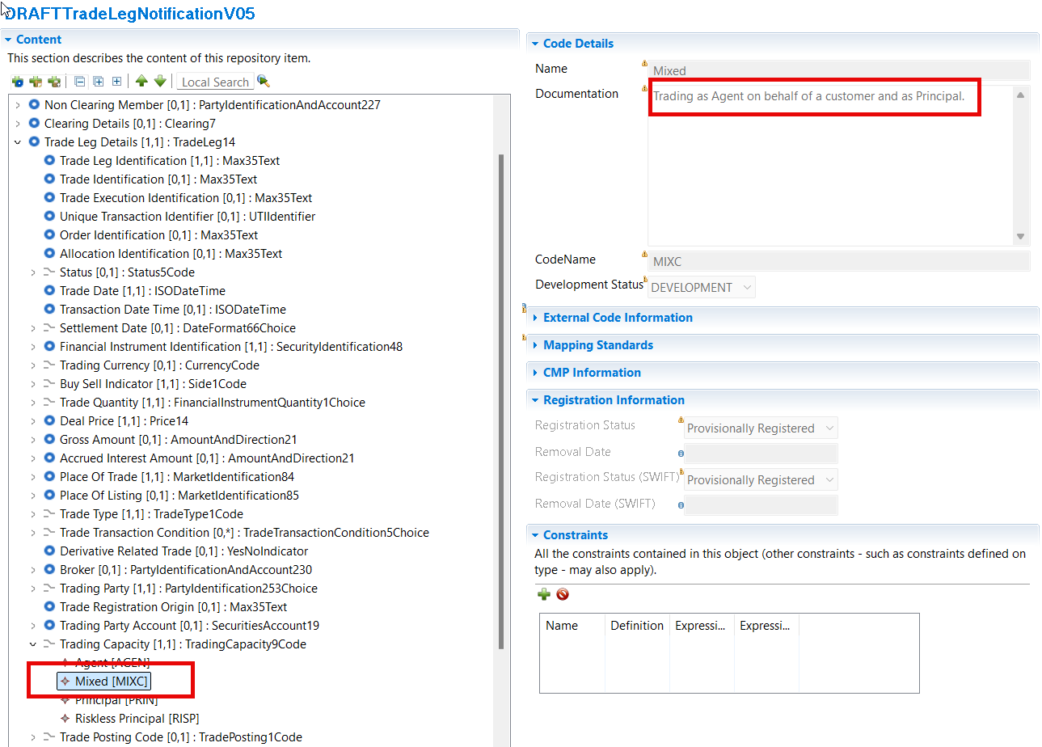

Change 2: Guaranteed Trade versus non-guaranteed Trade
In the latest version of the secl.001, a Guaranteed Trade Indicator is used to signal whether the trade is novated (and guaranteed) or not. The input of ‘false’ mandates the use of the “non-guaranteed trade” block. In Non-Guaranteed trade, you have the ability to disclose the Counterparty. In a Guaranteed trade, you don’t have the option.
In Australia, there are securities that do not allow the masking of the participant (meaning hide their identity), even for Guaranteed trades. Those securities are:
- Exchange traded Fund Units.
- Trading Long Exposure
- Trading Managed Fund
- QDB Managed Fund
- Managed Funds
- …
Therefore, the request is to have the same optional structure as “non-Guaranteed trade” repeated for “Guaranteed Trade”.
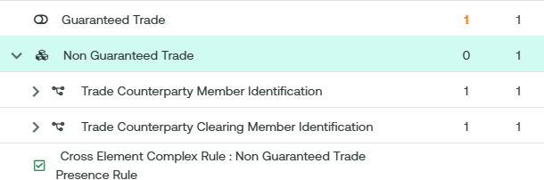

Please note that the workaround used by ASX today is to replicate the information in the Supplementary Data. We have attached a full sample at the end of the document.

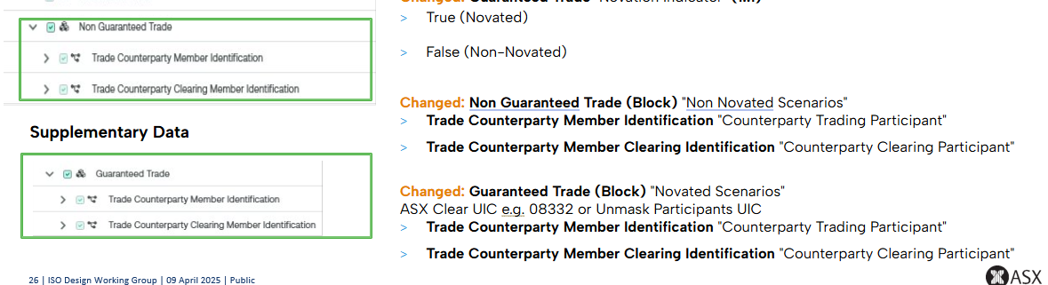

ISO 20022 proposed implementation:

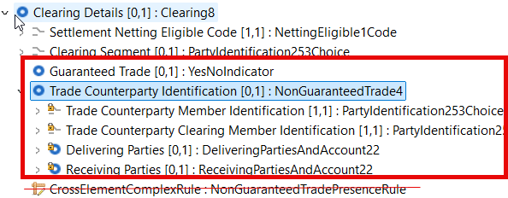

Note that this is one sided, the message is sent to delivering or receiving party. No need to have both in the message. So, either delivering parties or receiving parties should be filled. Trade counterparty is always present.

Additional change required:
Change the name of the message component from NonGauranteedTrade4 to TradeCouterpartyIdentification1 and define the traces to the business model.

Change 3: Additional elements in block “notified Trade Leg Details”.
To be better aligned with the FIX protocol, we request the addition of 3 more elements:

- Original Trade Date besides existing Trade Date. In FIX, Trade date indicates the date the trade is being reported, while the Original Trade Date specifies the date the trade occurred.

Pre meetings discussion and decision:
The group clarified the usage of Trade date vs Transaction date and time. No need for an additional date. The request for the Original Trade Date request is withdrawn.
However, the Trade Date definition to be changed from Provides the date and time of trade transaction to Provides the date or date and time of trade transaction. Also change data type date and time as structured in other messages.

CHANGE 3.1 use case was understood. But an extra date (Original Trade Date) is not required. Change of definition for Trade Date is required though.

ISO 20022 proposed implementation:

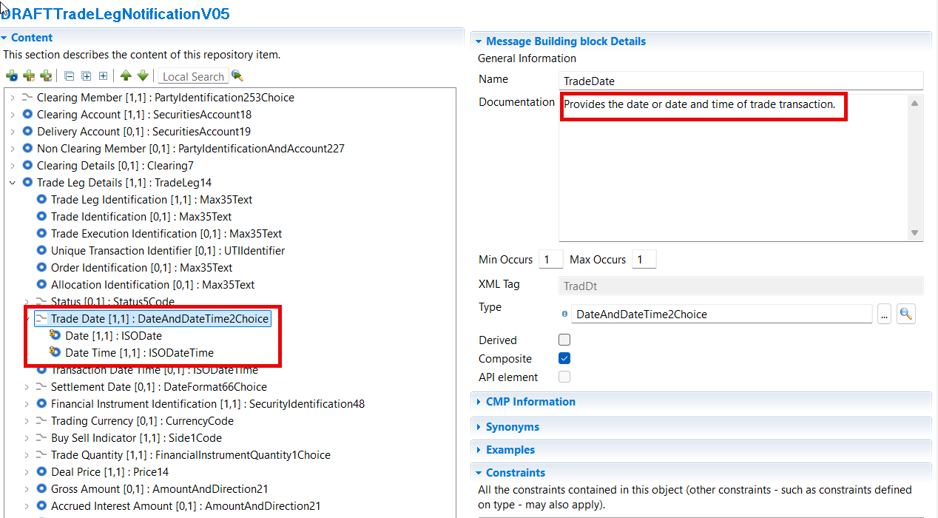

- Buyer Order Reference Number: The Buy Side Trading Participant's own reference for in-house processing of the Market Trade

Seller Order Reference Number: The Sell Side Trading Participant's own reference for in-house processing of the Market Trade

Pre meetings discussion and decision:

This info is not validated by ASX and is very generic could be an account or a reference. Therefore Seller/Buyer Reference Number will be included in the Supplementary Data.

CHANGE 3.2 use case was understood but the information is to market/ASX specific. So CR was rejected and supplementary data option is proposed.

Change 4: Addition of element “Trade Condition Code” for alignment with FIX Trade Capture. In FIX protocol, tag 20003 typically represents the condition code for trades, specifically indicating special conditions or circumstances related to a trade. Some codes do relate whether the trade is novated or not.
We are well aware that the element “Trade Transaction Condition Code” already exists in both MT and ISO 20022 messages. The ISO definition is very close to the FIX definition:
“Indicates the conditions under which the order/trade is to be/was executed”.
We could imagine adding the same element in the secl.001, and if we do not introduce new codes under “codes”, let ASX use the Proprietary tag to map the FIX codes.

For reference, here is an extract of the ASX proprietary codes (not FIX):

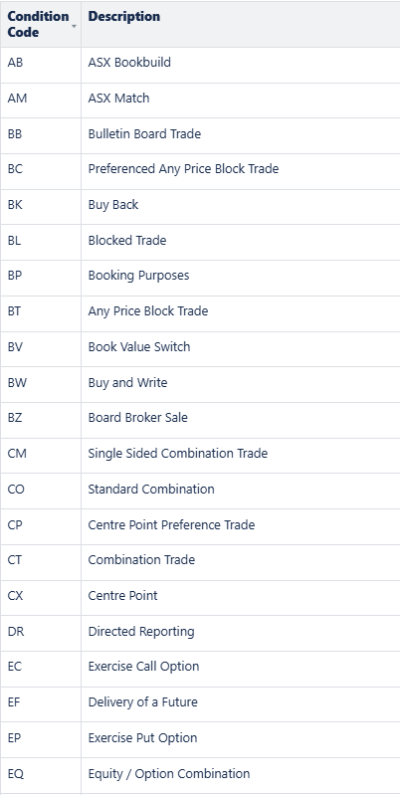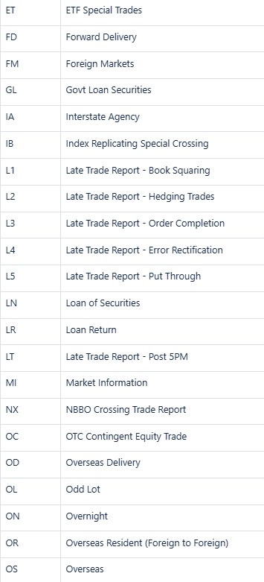

The Trade Transaction Condition (with datatype TradeTransactionCondition5Choice) should be added to the Trade Leg Details under Trade Type message element in secl.001 Trade Leg Notification.

Note that ASX proprietary codes are not aligned with FIX but are very similar to ISO 20022. The message component TradeTransactionCondition5Choice from sese.023 should be included in Trade Transaction Details.

ISO 20022 proposed implementation:

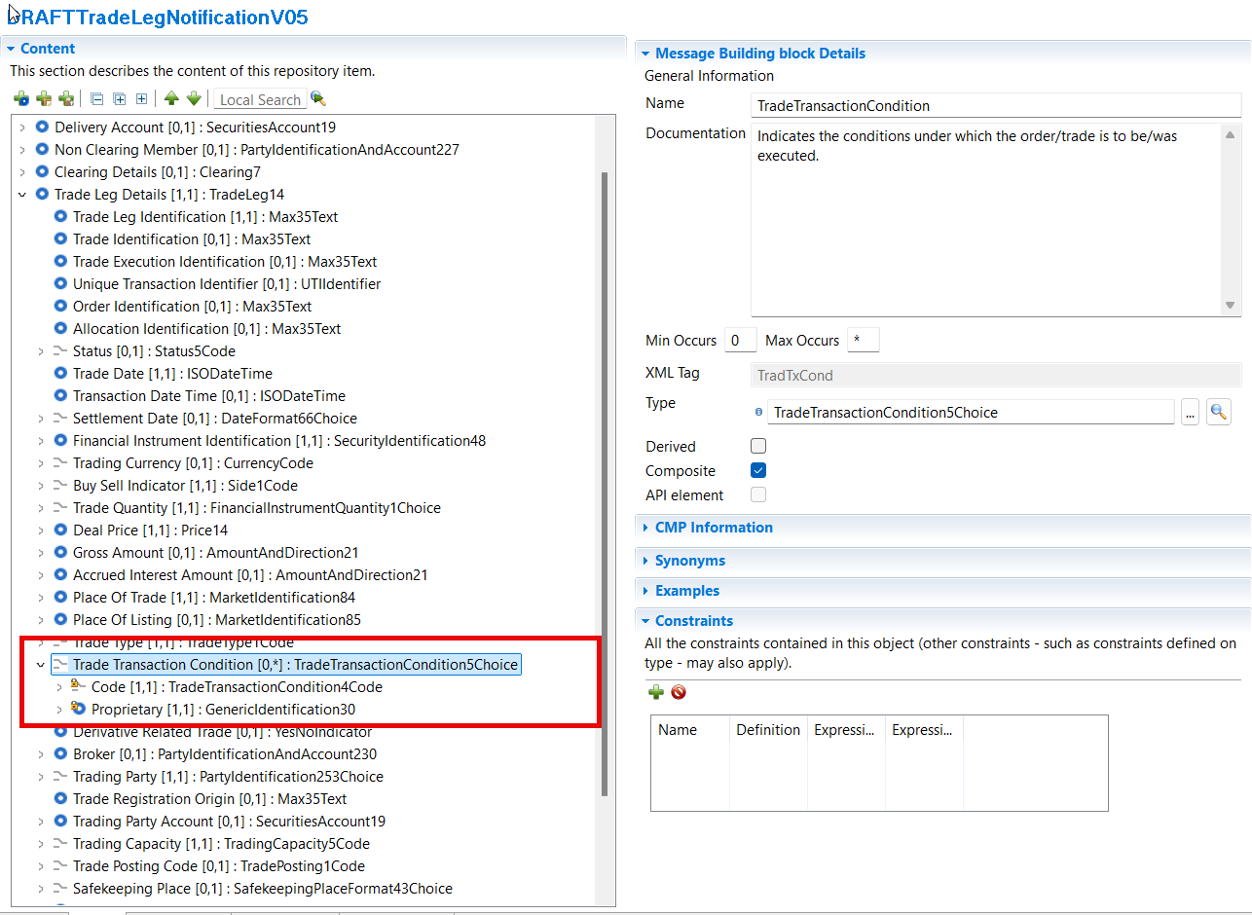
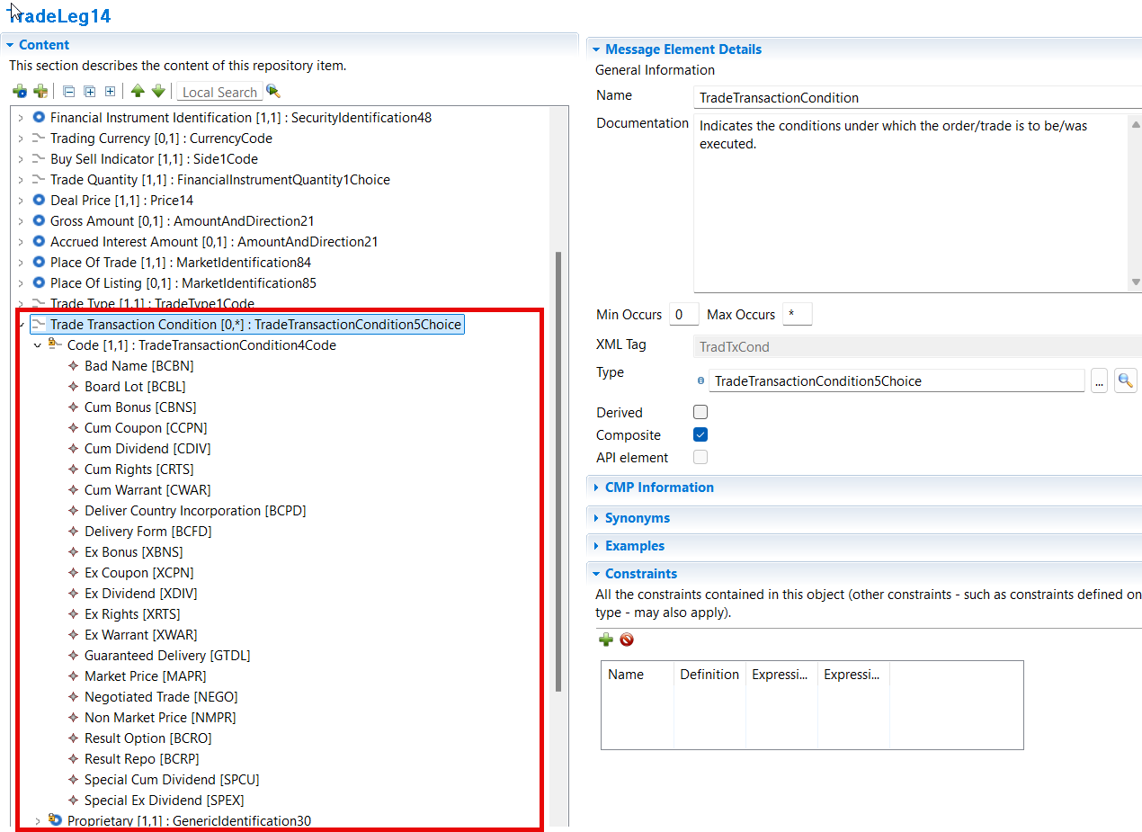

Pre meeting discussions and decision:
The ASX proprietary codes are not aligned with FIX but are very similar to ISO 20022. The message component TradeTransactionCondition5Choice from sese.023 will be included in Trade Transaction Details.

Change 5 (secl.002 Trade Leg Notification Cancellation):
In secl.002 add a cancellation reason as it is the case in other business areas such as Settlement and Reconciliation sese.020.

ISO 20022 proposed implementation:

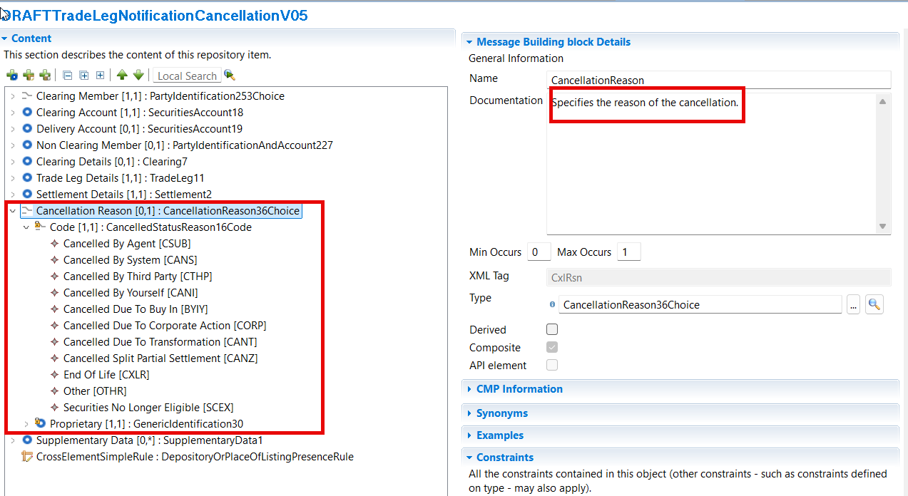

Purpose of the change:
The Australian Securities Exchange (ASX) has initiated a project to replace the current Australian equities clearing and settlement market infrastructure system (CHESS).
CHESS (Clearing House Electronic Subregister System) is the system operated by ASX to manage the clearing and settlement of equity market transactions, and to record current security holdings (and the holders) on a name on register basis. The implementation of the replacement system will provide the existing core functionality and services as well as service enhancements. The current proprietary CHESS messaging standards will be replaced with ISO 20022 standards.
The purpose of this Change Request is to fully align the ISO messages used in CHESS with the FIX messages used in the ASX Clearing Trade Acceptance Service, and to avoid using supplementary data for required elements.

Urgency of the request:
To be included as part of the annual maintenance cycle.

Business examples:

SEG/TSG recommendation:

Consider |  |  | Timing
 |  |  | - Next yearly cycle: 2025/2026  (the change will be considered for implementation in the yearly maintenance cycle which starts in 2021 and completes with the publication of new message versions in the spring of 2022) |  | X
- At the occasion of the next maintenance of the messages
(the change will be considered for implementation, but does not justify maintenance of the messages in its own right – will be pending until more critical change requests are received for the messages)
- Urgent unscheduled
(the change justifies an urgent implementation outside of the normal yearly cycle)
 |  |  | - Other timing:

Comments:

Proposed timing:
The submitting organisation confirms that it can implement the requested changes in the requested timing.

Timing

Proposed implementation:

Change 1: currently, element Trading Capacity(/Document /TradLegNtfctn /TradLegDtls /TradgCpcty) contains a code list with 3 possible values: Agent, Principal and Riskless Principal. The addition of Code “Mixed” (Principal + agent) would comply with the ASX requirement as in Australia a single trade can mix client money and firm money.

ISO 20022 proposed implementation:

Change 2: Guaranteed Trade and non-guaranteed Trade
In the latest version of the secl.001, a Guaranteed Trade Indicator is used to signal whether the trade is novated (and guaranteed) or not. The input of ‘false’ mandates the use of the “non-guaranteed trade” block. In Non-Guaranteed trade, you have the ability to disclose the Counterparty. The same should be possible for Guaranteed trade

ISO 20022 proposed implementation:

Additional change required:
Change the name of the message component from NonGauranteedTrade4 to TradeCouterpartyIdentification1 and define the traces to the business model.

Change 3: Trade Date definition to be changed from Provides the date and time of trade transaction to Provides the date or date and time of trade transaction. Also change data type date and time as structured in other messages.

ISO 20022 proposed implementation:

Change 4: Addition of element “Trade Condition Code” for alignment with FIX Trade Capture and ISO 20022.

ISO 20022 proposed implementation:

Change 5 (secl.002 Trade Leg Notification Cancellation):
In secl.002 add a cancellation reason as it is the case in other business areas such as Settlement and Reconciliation sese.020.

ISO 20022 proposed implementation:

Final decision of the SEG(s):

Accepted | X (partially)

Comments:

