Maintenance Change Request
for the update of ISO 20022 financial repository items

Table of Contents
Change request CR1483: nexo ACQ PaymentFacilitator and MarketPlace Identification 6
Change request CR1484: nexo ACQ Message from Merchant 14
Change request CR1485: nexo TMS Certification Request Type 30
Change request CR1486 nexo: TMS CryptogtaphicKey for DUKPT Solutions 35
Change request CR1487: nexo TMS Definition of ProtocolVersion Configuration 45

- Name of the request:
CAPE Messages Maintenance for year 2025-2026

- Submitting organisation(s):
nexo A.I.S.B.L. formerly (EPASOrg).
- Related messages:
The precise identification of the ISO 20022 messages that will be impacted by the changes included in this Maintenance Change Request, including the Message Ids as shown in the Catalogue of ISO 20022 messages.

Under this maintenance, below existing ISO 20022 message definitions will be maintained (resulting from the impact analysis performed on each CR).

C.1 Messages as listed in the CRs submitted originally

Card Payments Exchange - Acceptor to Acquirer message set:
- AcceptorAuthorisationRequest V14 (caaa.001.001.14)
- AcceptorCompletionAdvice V14 (caaa.003.001.14)
- AcceptorBatchTransfer V14 (caaa.011.001.14)
- AcceptorCurrencyConversionRequest V12 (caaa.016.001.12)
- TransactionAdvice V06 (caaa.020.001.06)
- AcceptorNonFinancialRequest V05 (caaa.022.001.05)
- AcceptorTransactionLogReportResponse V05 (caaa.025.001.05)
- AcceptorToAcquirerBatchFileExchange V02 (caaa.026.001.02)

Retailer Protocol message set:
- SaleToPOIServiceRequest V07 (casp.001.001.07)
- SaleToPOIServiceResponse V07 (casp.002.001.07)
- SaleToPOIReportResponse V07 (casp.010.001.07)
- SaleToPOIMessageStatusResponse V07 (casp.015.001.07)

Card Payments Exchange - Terminal Management message set:
- StatusReport V14 (catm.001.001.14)
- ManagementPlanReplacement V13 (catm.002.001.13)
- AcceptorConfigurationUpdate V14 (catm.003.001.14)
- MaintenanceDelegationRequest V11 (catm.005.001.11)
- CertificateManagementRequest V07 (catm.007.001.07)

C.2. Additional messages impacted on top of those listed in the CRs submitted originally

Card Payments Exchange - Acceptor to Acquirer message set:
- AcceptorAuthorisationResponse V14 (caaa.002.001.14)
- AcceptorCompletionAdviceResponse V13 (caaa.004.001.13)
- AcceptorCancellationRequest V14 (caaa.005.001.14)
- AcceptorCancellationResponse V13 (caaa.006.001.13)
- AcceptorCancellationAdvice V14 (caaa.007.001.14)
- AcceptorCancellationAdviceResponse V13 (caaa.008.001.13)
- AcceptorReconciliationRequest V13 (caaa.009.001.13)
- AcceptorReconciliationResponse V12 ( caaa.010.001.12)
- AcceptorBatchTransferResponse V13 (caaa.012.001.13)
- AcceptorDiagnosticRequest V13 (caaa.013.001.13)
- AcceptorDiagnosticResponse V12 (caaa.014.001.12)
- AcceptorRejection V06 (caaa.015.001.06)
- AcceptorCurrencyConversionResponse V12 (caaa.017.001.12)
- AcceptorCurrencyConversionAdvice V09 (caaa.018.001.09)
- AcceptorCurrencyConversionAdviceResponse V08 (caaa.019.001.08)
- TransactionAdviceResponse V06 (caaa.021.001.06)
- AcceptorNonFinancialResponse V05 (caaa.023.001.05)
- AcceptorTransactionLogReportRequest V05 (caaa.024.001.05)
- AcquirerToAcceptorBatchFileExchange V02 (caaa.027.001.02)

Retailer Protocol message set:
- SaleToPOIReconciliationRequest V07 (casp.003.001.07)
- SaleToPOIReconciliationResponse V07 (casp.004.001.07)
- SaleToPOISessionManagementRequest V07 (casp.005.001.07)
- SaleToPOISessionManagementResponse V07 (casp.006.001.07)
- SaleToPOIAdministrativeRequest V07 (casp.007.001.07)
- SaleToPOIAdministrativeResponse V07 (casp.008.001.07)
- SaleToPOIReportRequest V07 (casp.009.001.07)
- SaleToPOIAbort V07 (casp.011.001.07)
- SaleToPOIEventNotification V07 (casp.012.001.07)
- SaleToPOIMessageStatusRequest V07 (casp.014.001.07)
- SaleToPOIDeviceRequest V07 (casp.016.001.07)
- SaleToPOIDeviceResponse V07 (casp.017.001.07)

ATM Interface for Transaction Processing and ATM Management message set:
- ATMDeviceReport V04 (caam.001.001.04)
- ATMKeyDownloadRequest V04 (caam.003.001.04)
- ATMKeyDownloadResponse V04 (caam.004.001.04)

Note from the ISO 20022 Registration Authority: As part of the impact analysis, it has been identified that below messages are also impacted by the proposed changes. Since nexo is not the submitting organisation for these messages, it will not be responsible for implementing the changes. The ISO 20022 Registration Authority will notify the relevant submitting organisations of the impact, and it will be their responsibility to assess and decide on the implementation of the changes.

Acquirer to Issuer Card Messages (ATICA) message set (ISO TC68/SC9/TG1):
- AdministrativeInitiation V02 (caad.008.001.02)
- AdministrativeResponse V02 (caad.009.001.02)
- FileActionInitiation V03 (cafm.001.001.03)
- FileActionResponse V03 (cafm.002.001.03)
- AuthorisationInitiation V04 (cain.001.001.04)
- FinancialInitiation V04 (cain.003.001.04)
- RetrievalFulfilmentInitiation V03 (cain.014.001.03)
- InquiryInitiation V03 (cain.016.001.03)
- VerificationInitiation V03 (cain.018.001.03)
- RetrievalInitiation V03 (cain.021.001.03)
- CardManagementInitiation V03 (cain.023.001.03)
- ChargeBackInitiation V03 (cain.027.001.03)

Bank-to-Customer Cash Management message set (Swift):
- BankToCustomerAccountReport V13 (camt.052.001.13)
- BankToCustomerStatement V13 (camt.053.001.13)
- BankToCustomerDebitCreditNotification V13 (camt.054.001.13)

No new messages introduced with this Maintenance Change Request.

- Commitments of the submitting organization:
nexo confirms that it can and will:
- undertake the development of the new version of the candidate ISO 20022 message models that it will submit to the RA for compliance revie w and evaluation.
- provide a new version of part 1 of the Message Definition Report (MDR) by December 1, and, optionally, new examples of valid and invalid message instances of each candidate message by May 1 at the latest.
- address any queries related to the description of the new models and messages as published by the RA on the ISO 20022 website.
nexo intends to support any testing or the actual implementation of the new version of the messages once the related documentation has been published by the RA. The purpose is to ensure that the documentation of the new version of the messages is accurate and consistent and to verify that these approved messages can be implemented with no adverse effects on communication infrastructures and/or applications.
nexo confirms its knowledge and acceptance of the ISO 20022 Intellectual Property Rights policy for contributing organizations, as follows.
“Organizations that contribute information to be incorporated into the ISO 20022 Repository shall keep any Intellectual Property Rights (IPR) they have on this information. A contributing organization warrants that it has sufficient rights on the contributed information to have it published in the ISO 20022 Repository through the ISO 20022 Registration Authority in accordance with the rules set in ISO 20022. To ascertain a widespread, public and uniform use of the ISO 20022 Repository information, the contributing organization grants third parties a non-exclusive, royalty-free license to use the published information”.
In the analysis made on the following pages, nexo highlights ripple effect through a graphic and component changed by a previous Change Request or by a previous analysis is highlighted in green in every impact analysis.

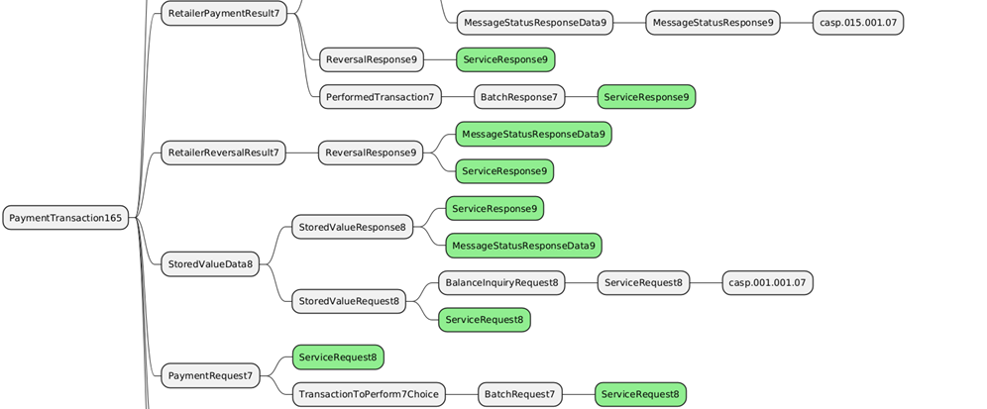
If a ripple effect must not be taken into account, the component will be highlighted in pink as in the following example.

In each chapter devoted to the implementation study, nexo presents the resulting implementation of all Change Request with respect to the legend presented below.
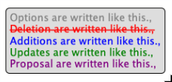
- Contact persons:
To get additional information on this Maintenance Change Request you can contact.
- Catherine BOUNDJIA (catherine.boundjia@nexo-standards.org)
- Evelyne de JONGHE (evelyne.de-jonghe@frenchsys.com)
- Philippe CECE (philippe.cece@frenchsys.com)

Change request CR1483: nexo ACQ PaymentFacilitator and MarketPlace Identification

- Origin of the request:
A.1 Submitter:
nexo A.I.S.B.L.
A.2 Contact person:
- Philippe CECE (philippe.cece@nexo-standards.org)
- Evelyne de JONGHE (evelyne.de-jonghe@frenchsys.com)
A.3 Sponsors:
nexo A.I.S.B.L.

- Related messages:
Card Payments Exchange - Acceptor to Acquirer message set:
- AcceptorAuthorisationRequest V14 (caaa.001.001.14)
- AcceptorCompletionAdvice V14 (caaa.003.001.14)
- AcceptorBatchTransfer V14 (caaa.011.001.14)
- AcceptorCurrencyConversionRequest V12 (caaa.016.001.12)
- TransactionAdvice V06 (caaa.020.001.06)
- AcceptorNonFinancialRequest V05 (caaa.022.001.05)
- AcceptorTransactionLogReportResponse V05 (caaa.025.001.05)
- AcceptorToAcquirerBatchFileExchange V02 (caaa.026.001.02)

Retailer Protocol message set:
- SaleToPOIServiceRequest V07 (casp.001.001.07)
- SaleToPOIServiceResponse V07 (casp.002.001.07)
- SaleToPOIReportResponse V07 (casp.010.001.07)
- SaleToPOIMessageStatusResponse V07 (casp.015.001.07)

- Description of the change request:
We want to update PartyType3Code to identify PaymentFacilitator or MarketPlace from Merchant. This distinction is important sometimes for clearing, but this information comes from the accepting device.

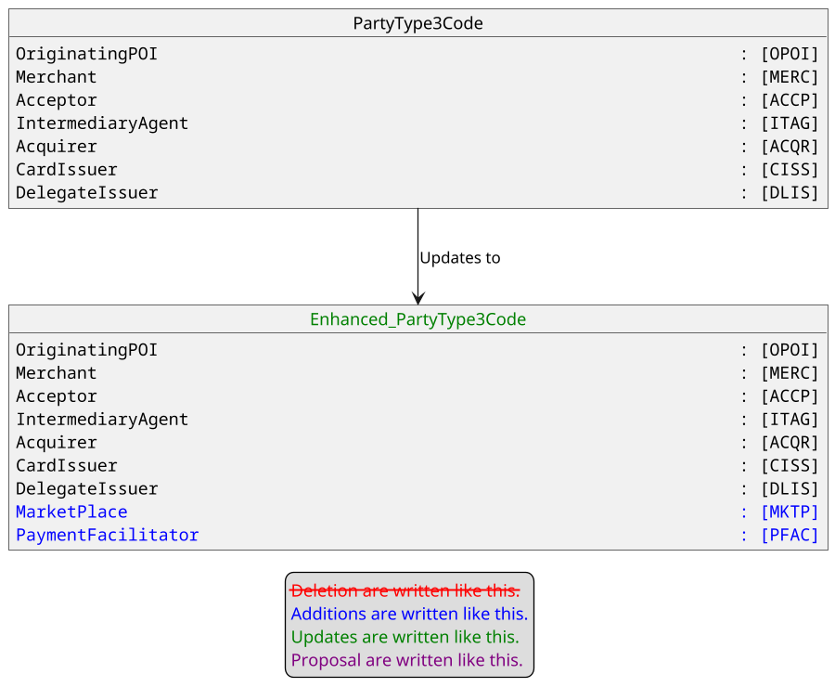
- Purpose of the change:
An Acquirer processing a transaction triggered by a MarketPlace on behalf of a merchant must indicate, in clearing messages, when merchant country is not the same as MarketPlace country. As a consequence, this information must come from the Acceptor messages sent to the Acquirer.
The current model provides information of SponsoredMerchant and specifically its CountryCode. Consequently, it is important to distinguish traditional Merchant from MarketPlace and PaymentFacilitator.
The aim of this Change Request is to do this by enhancing the PartyType codeset.

- Urgency of the request:
Urgent.

- Business examples:
Examples illustrating the change request.
- SEG/TSG recommendation:
This section is not to be taken care of by the submitter of the change request. It will be completed in due time by the SEG(s) in charge of the related ISO 20022 messages or the TSG for changes related to the BAH.

Consider |  | X | Timing
 |  |  | - Next yearly cycle: 2025/2026  (the change will be considered for implementation in the yearly maintenance cycle which starts in 2025 and completes with the publication of new message versions in the spring of 2026) |  | X
- At the occasion of the next maintenance of the messages
(the change will be considered for implementation, but does not justify maintenance of the messages in its own right – will be pending until more critical change requests are received for the messages)
- Urgent unscheduled
(the change justifies an urgent implementation outside of the normal yearly cycle)
 |  |  | - Other timing:
Comments:

Reject
Reason for rejection:

- Impact analysis and type of impact:
The proposal from the Change Request is accepted and the modification will be done on PartyType3Code. The analysis of the ripple effect identifies an important list of elements to update. This result is logic, since PartyType3Code is a key element in a transaction. Additionnal messages that are impacted on top of those already listed in the CR submitted originally are:
Card Payments Exchange - Acceptor to Acquirer message set:
- AcceptorAuthorisationResponse V14 (caaa.002.001.14)
- AcceptorCompletionAdviceResponse V13 (caaa.004.001.13)
- AcceptorCancellationRequest V14 (caaa.005.001.14)
- AcceptorCancellationResponse V13 (caaa.006.001.13)
- AcceptorCancellationAdvice V14 (caaa.007.001.14)
- AcceptorCancellationAdviceResponse V13 (caaa.008.001.13)
- AcceptorReconciliationRequest V13 (caaa.009.001.13)
- AcceptorReconciliationResponse V12 (caaa.010.001.12)
- AcceptorBatchTransferResponse V13 (caaa.012.001.13)
- AcceptorDiagnosticRequest V13 (caaa.013.001.13)
- AcceptorDiagnosticResponse V12 (caaa.014.001.12)
- AcceptorCurrencyConversionResponse V12 (caaa.017.001.12)
- AcceptorCurrencyConversionAdvice V09 (caaa.018.001.09)
- AcceptorCurrencyConversionAdviceResponse V08 (caaa.019.001.08)
- TransactionAdviceResponse V06 (caaa.021.001.06)
- AcceptorNonFinancialResponse V05 (caaa.023.001.05)
- AcceptorTransactionLogReportRequest V05 (caaa.024.001.05)
- AcquirerToAcceptorBatchFileExchange V02 (caaa.027.001.02)

Retailer Protocol message set:
- SaleToPOIReconciliationRequest V07 (casp.003.001.07)
- SaleToPOIReconciliationResponse V07 (casp.004.001.07)
- SaleToPOISessionManagementRequest V07 (casp.005.001.07)
- SaleToPOISessionManagementResponse V07 (casp.006.001.07)
- SaleToPOIAdministrativeRequest V07 (casp.007.001.07)
- SaleToPOIAdministrativeResponse V07 (casp.008.001.07)
- SaleToPOIAbort V07 (casp.011.001.07)
- SaleToPOIEventNotificationV07 (casp.012.001.07)
- SaleToPOIMessageStatusRequest V07 (casp.014.001.07)
- SaleToPOIDeviceRequest V07 (casp.016.001.07)
- SaleToPOIDeviceResponse V07 (casp.017.001.07)

Card Payments Exchange - Terminal Management message set:
- StatusReport V14 (catm.001.001.14)
- ManagementPlanReplacement V13 (catm.002.001.13)
- MaintenanceDelegationRequest V11 (catm.005.001.11)

The following messages are impacted on top of those already listed in the CR submitted originally but must be taken into account:
Bank-to-Customer Cash Management message set:
- BankToCustomerAccountReport V13 (camt.052.001.13)
- BankToCustomerStatement V13 (camt.053.001.13)
- BankToCustomerDebitCreditNotification V13 (camt.054.001.13)

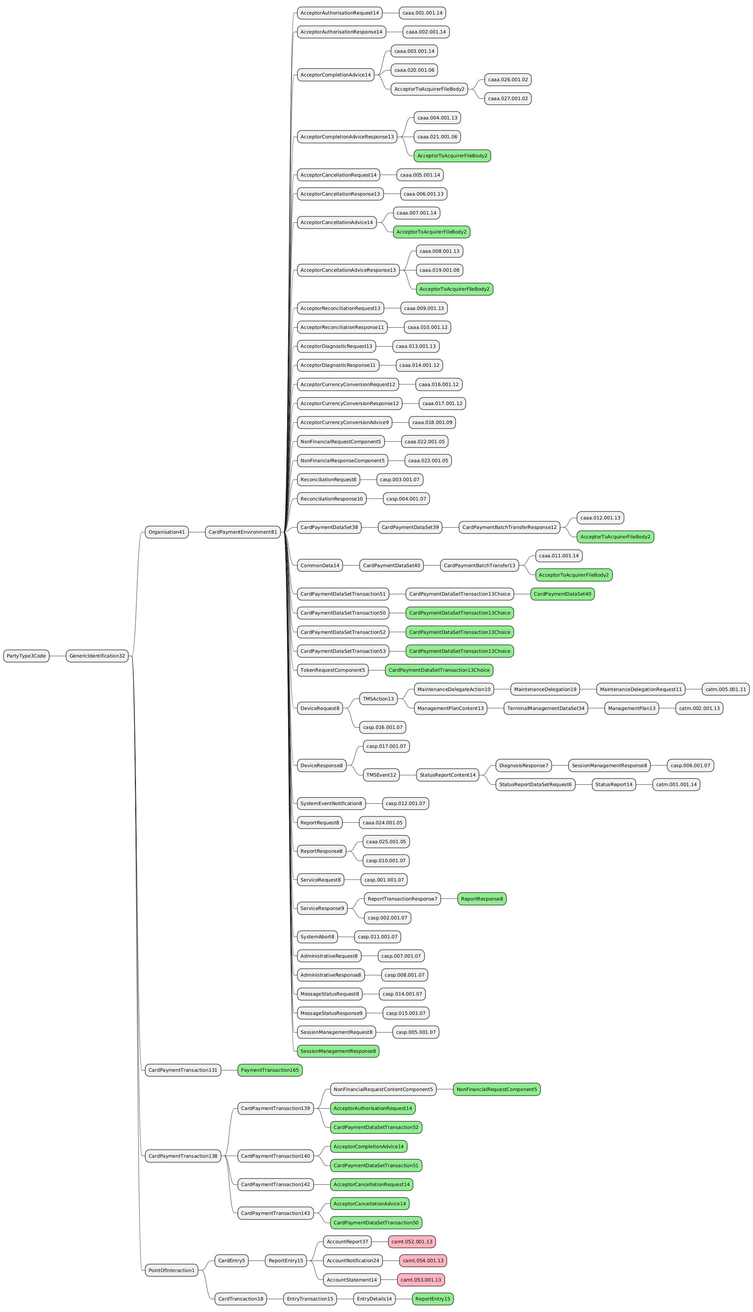
The severity of the impact of the proposed change for the message users should be indicated in the table below (either “no impact”, “conditional’ or “mandatory”).
Type of impact
 | No impact | The change(s) will not impact the schema (the version number will not change) and will not impact the business applications of any users, e.g. the clarification of a definition
X | Conditional | The change(s) will impact the schema (at least the version number) and the business applications of certain users but not all, e.g. the addition of an optional component
 | Mandatory | The change(s) will impact the schema and the business applications of all users, e.g. addition of a mandatory component.

- Proposed implementation:
The modification implies the update of PartyTypeCode codeset.

The following new values :
- MarketPlace – MKTP
- PaymentFacilitator – PFAC

will be added to the following list of PartyType codeset:
- OriginatingPOI – OPOI
- Merchant – MERC
- Acceptor – ACCP
- IntermediaryAgent – ITAG
- Acquirer – ACQR
- CardIssuer – CISS
- DelegateIssuer - DLIS

- Proposed timing:
The submitting organization confirms that it can implement the requested changes in the requested timing, or, if not, proposes another timing.

Timing | - As requested
 | - Other:

- Final decision of the SEG(s):
This section is not to be taken care of by the submitting organization. It will be completed in due time by the SEG(s) in charge of the related ISO 20022 messages.
Approve | X
Comments: Approved by the Cards SEG on 15 September 2025 with no comments

Reject
Reason for rejection:

Change request CR1484: nexo ACQ Message from Merchant

- Origin of the request:
A.1 Submitter:
nexo A.I.S.B.L.
A.2 Contact person:
- Philippe CECE (philippe.cece@nexo-standards.org)
- Evelyne de JONGHE (evelyne.de-jonghe@frenchsys.com)
A.3 Sponsors:
nexo A.I.S.B.L.
- Related messages:
Card Payments Exchange - Acceptor to Acquirer message set:
- AcceptorAuthorisationRequest V14 (caaa.001.001.14)
- AcceptorCompletionAdvice V14 (caaa.003.001.14)
- AcceptorBatchTransfer V14 (caaa.011.001.14)
- AcceptorCurrencyConversionRequest V12 (caaa.016.001.12)
- TransactionAdvice V06 (caaa.020.001.06)
- AcceptorNonFinancialRequest V05 (caaa.022.001.05)
- AcceptorTransactionLogReportResponse V05 (caaa.025.001.05)
- AcceptorToAcquirerBatchFileExchange V02 (caaa.026.001.02)

Retailer Protocol message set:
- SaleToPOIServiceRequest V07 (casp.001.001.07)
- SaleToPOIServiceResponse V07 (casp.002.001.07)
- SaleToPOIReportResponse V07 (casp.010.001.07)
- SaleToPOIMessageStatusResponse V07 (casp.015.001.07)
- Description of the change request:
We want to update CardPaymentTransaction139, CardPaymentTransaction140 and PaymentTransaction161 in order to convey message that a merchant may want to display on the cardholder bank statement.
This new message will be name MessageFromMerchant with a multiplicity [0..*] and typed as an enhancement of Action15. This component will allow to directly, for instance, print or display this message too.

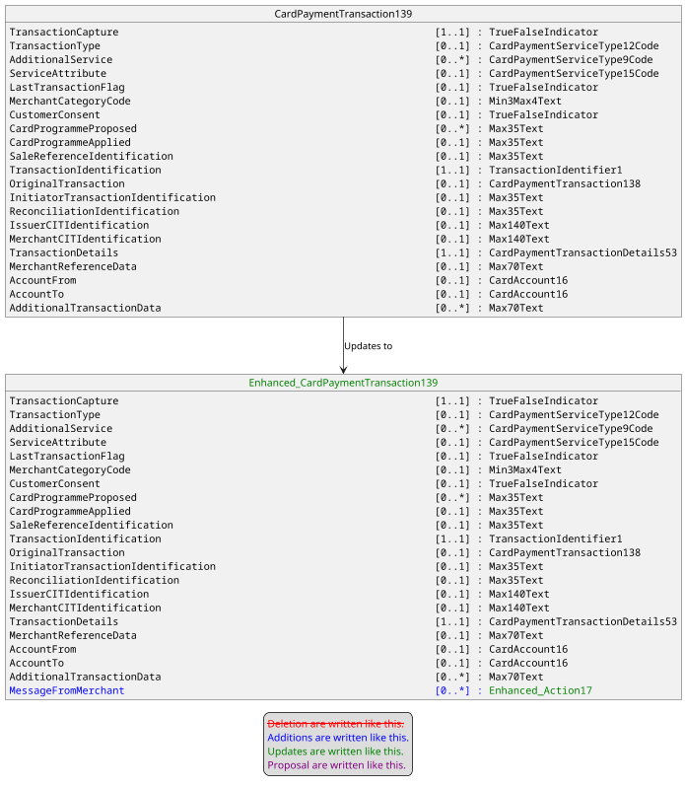

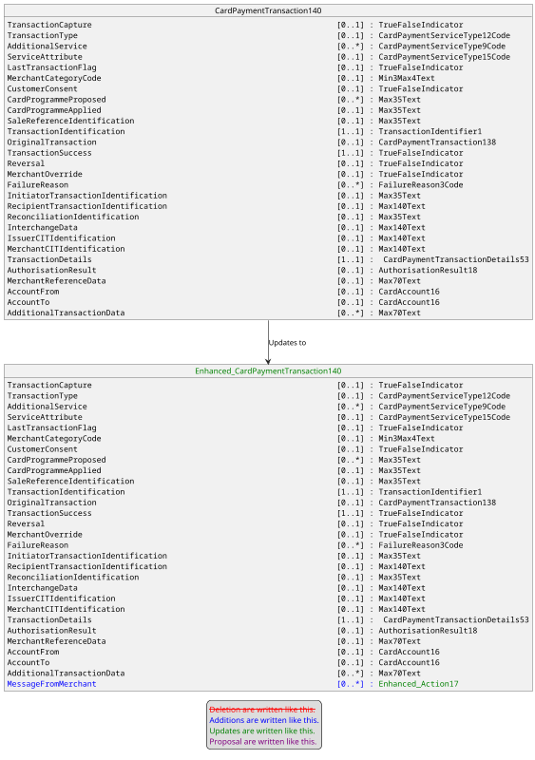
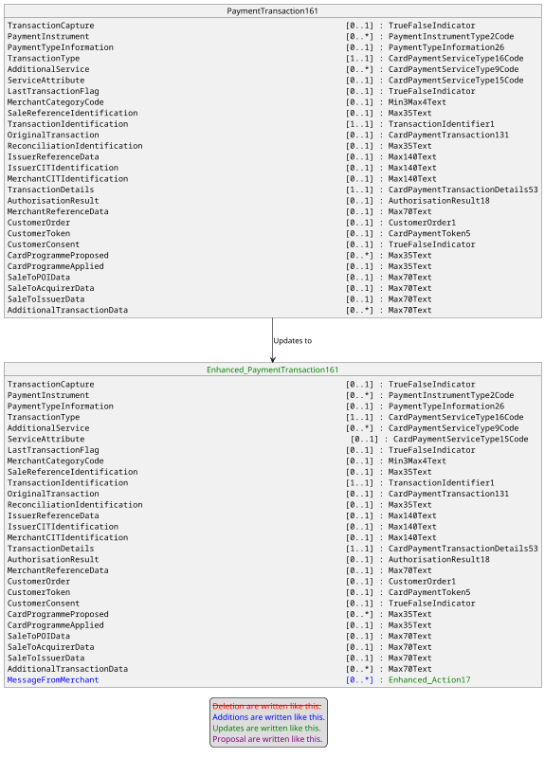

The message component Action17 will be updated to allow to identify the bank statement through the value CustomerStatement coded as CSTM of an enhanced UserInterface4Code in ActionMessage message component.

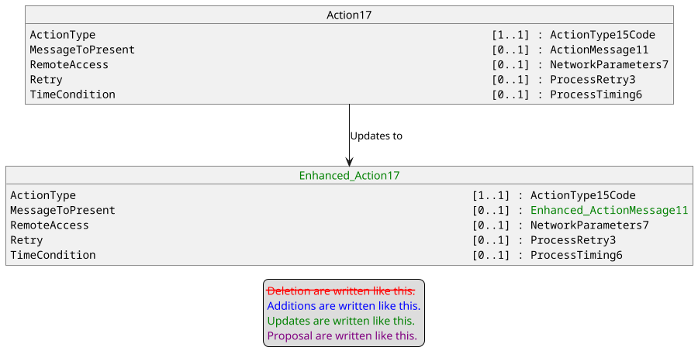

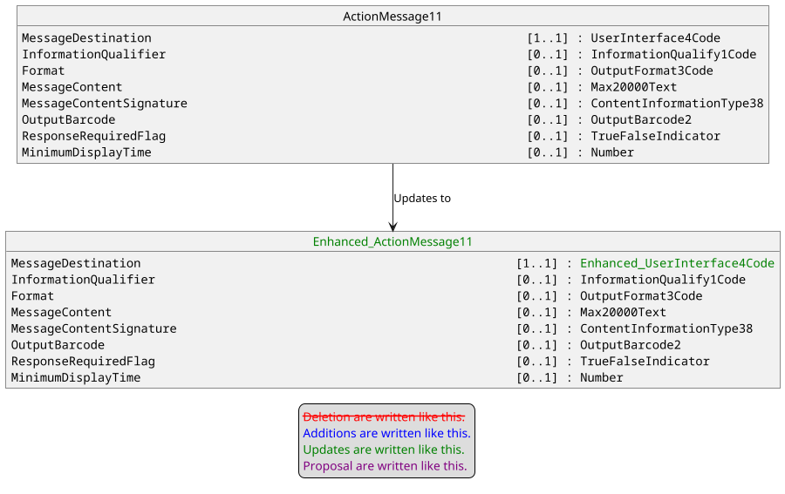

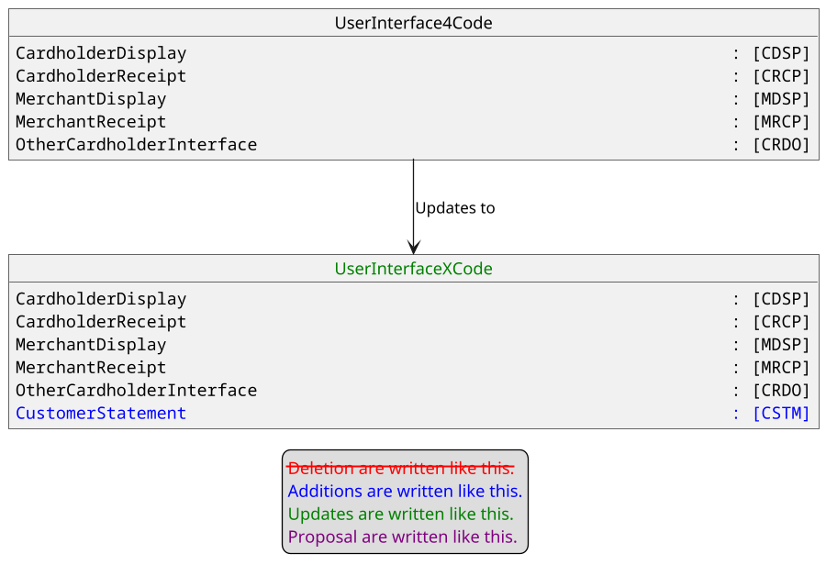

- Purpose of the change:

In some cases, it could be necessary to transfer information from Merchant to the bank statement of the Cardholder. For instance, it could be the case for aggregated transactions, to inform the cardholder on where to find additional data to identify aggregated transactions. Could be also used for an Original Credit according to some scheme rules.

- Urgency of the request:

Urgent.

- Business examples:
Examples illustrating the change request.
- SEG/TSG recommendation:
This section is not to be taken care of by the submitter of the change request. It will be completed in due time by the SEG(s) in charge of the related ISO 20022 messages or the TSG for changes related to the BAH.

Consider |  | X | Timing
 |  |  | - Next yearly cycle: 2025/2026  (the change will be considered for implementation in the yearly maintenance cycle which starts in 2025 and completes with the publication of new message versions in the spring of 2026) |  | X
- At the occasion of the next maintenance of the messages
(the change will be considered for implementation, but does not justify maintenance of the messages in its own right – will be pending until more critical change requests are received for the messages)
- Urgent unscheduled
(the change justifies an urgent implementation outside of the normal yearly cycle)
 |  |  | - Other timing:
Comments:

Reject
Reason for rejection:

- Impact analysis and type of impact:

Additionnal messages that are impacted on top of those already listed in the CR submitted originally are :

Card Payments Exchange - Acceptor to Acquirer message set:
- AcceptorAuthorisationResponse V14 (caaa.002.001.14)
- AcceptorCancellationResponse V13 (caaa.006.001.13)
- AcceptorCurrencyConversionResponse V12 (caaa.017.001.12)
- AcceptorCurrencyConversionAdvice V09 (caaa.018.001.09)
- AcceptorNonFinancialResponse V05 (caaa.023.001.05)

Retailer Protocol message set:
- SaleToPOISessionManagementRequest V07 (casp.005.001.07)
- SaleToPOISessionManagementResponse V07 (casp.006.001.07)
- SaleToPOIAbort V07 (casp.011.001.07)
- SaleToPOIEventNotification V07 (casp.012.001.07)
- SaleToPOIDeviceRequest V07 (casp.016.001.07)

Card Payments Exchange - Terminal Management message set:
- ManagementPlanReplacement V13 (catm.002.001.13)
- MaintenanceDelegationRequest V11 (catm.005.001.11)

The proposal from the Change Request is accepted and the modification will be done accordingly except for a minor change of scope.
Indeed, the impact analysis was done on PaymentTransaction165 instead of PaymentTransaction161 as:
- PaymentTransaction161 has no impact on Message Definitions.
- The new version of PaymentTransaction161 is PaymentTransaction164.
- PaymentTransaction164 has no impact on Message Definitions.
- PaymentTransaction165 exists but with association to a previous version.

The final modification will therefore be done on CardPaymentTransaction139, CardPaymentTransaction140, PaymentTransaction165, Action17, ActionMessage11, and UserInterface4Code.

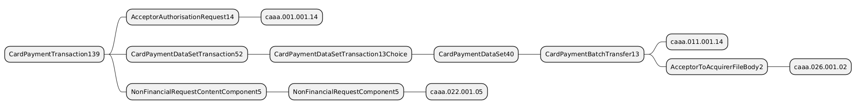

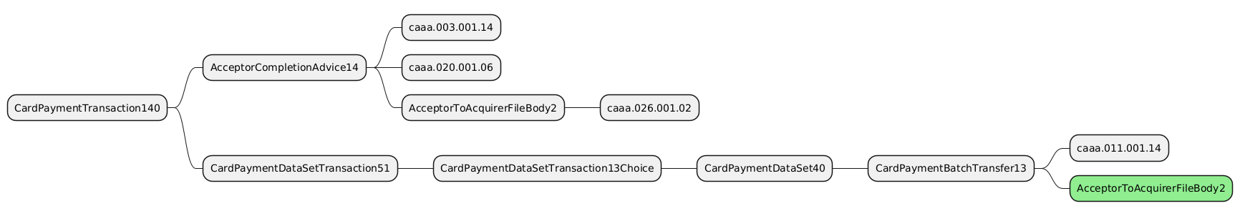

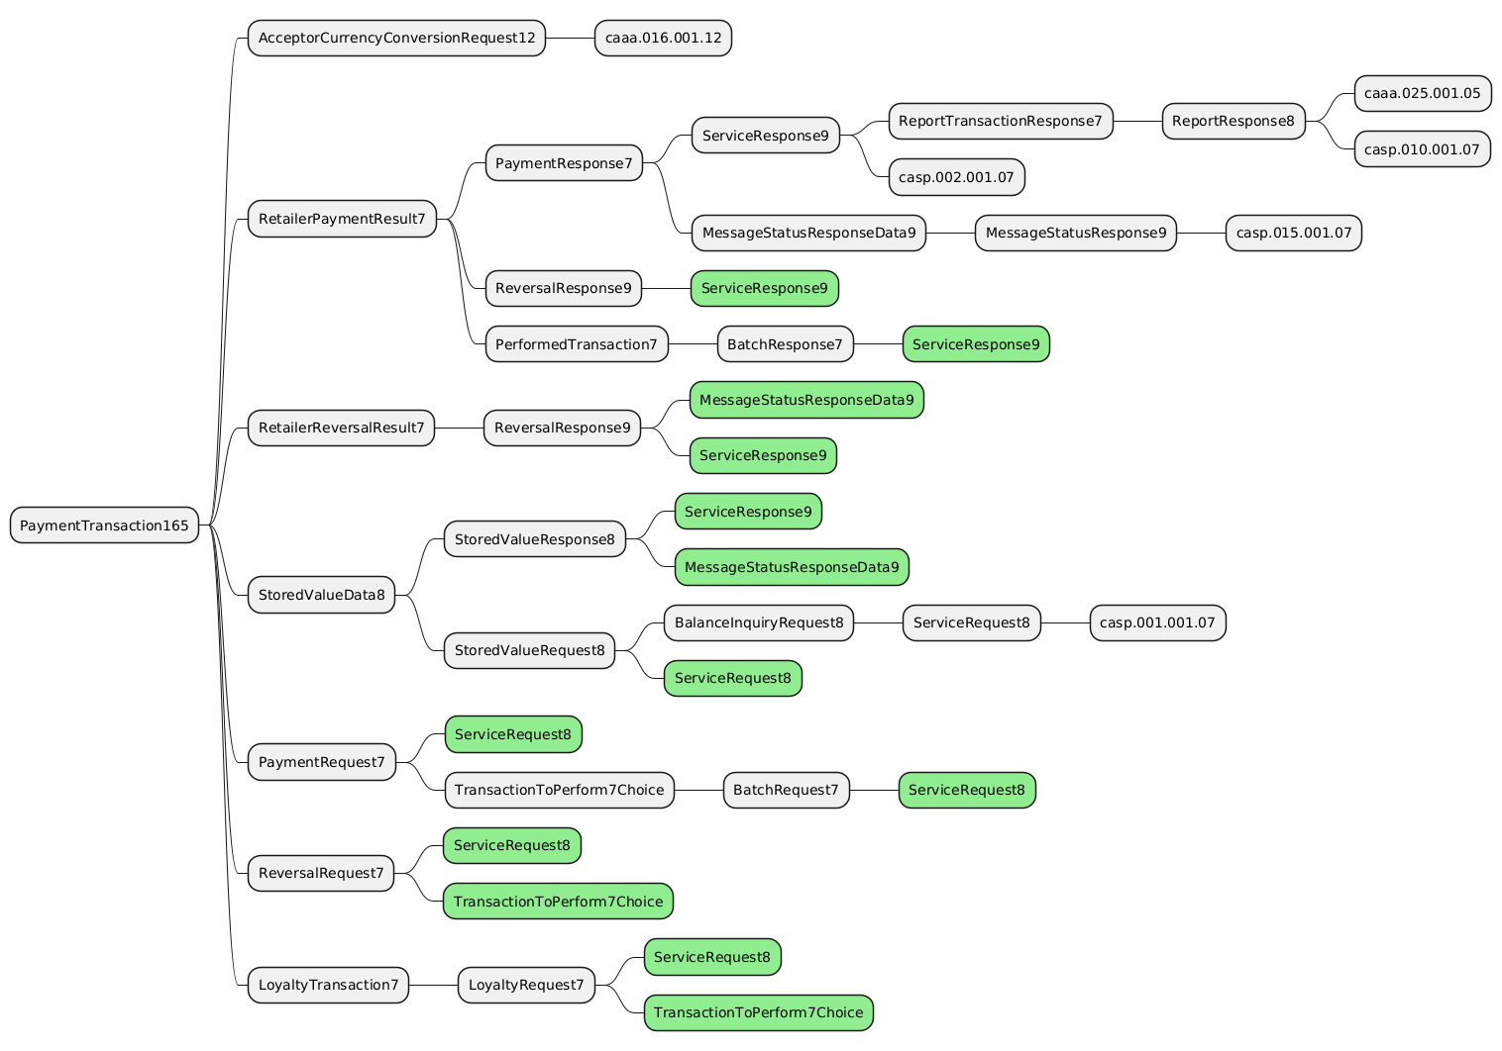

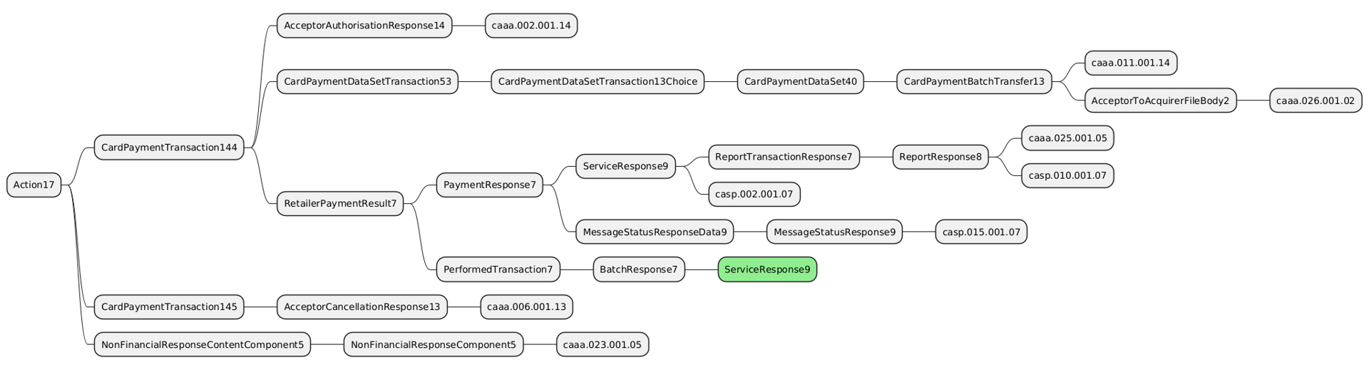

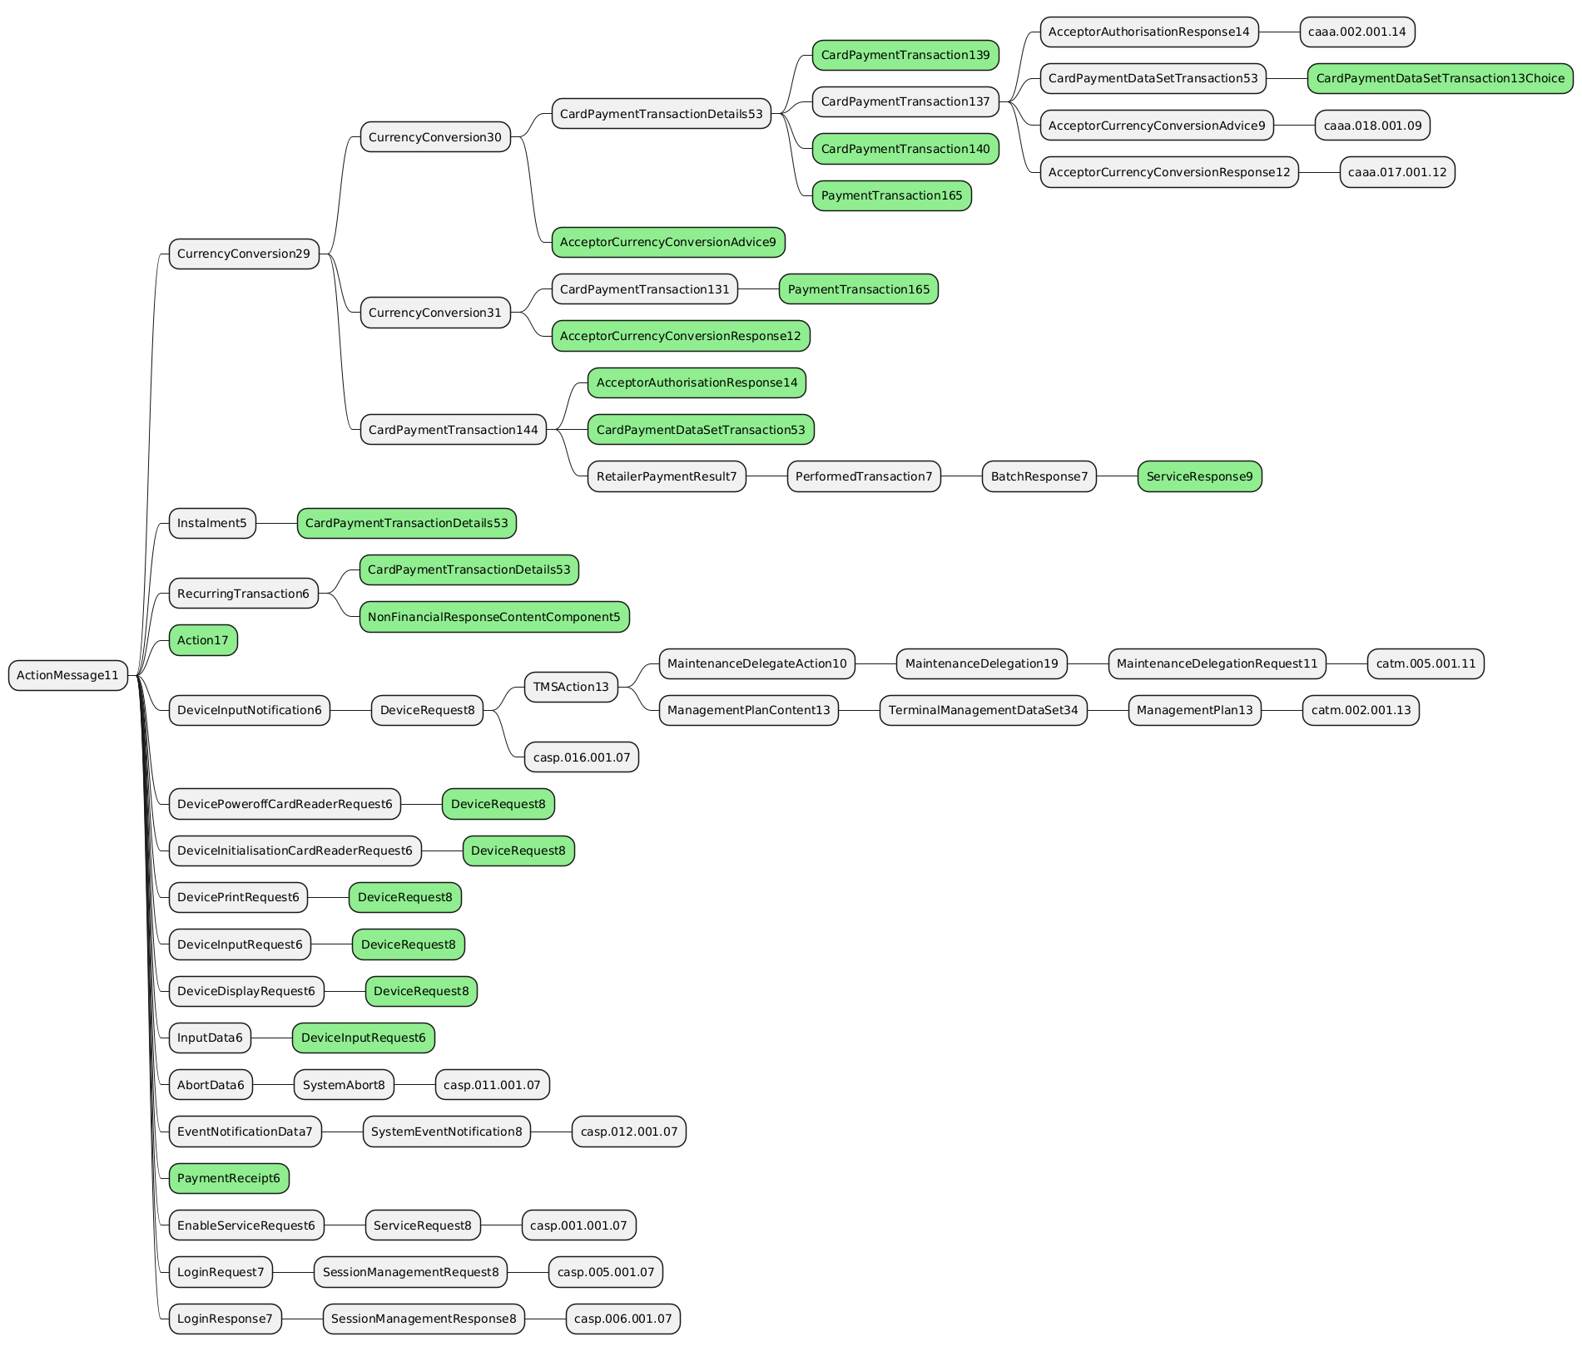
UserInterface4Code is in ActionMessage message component: the ripple effect analysis shall lead to the same result.

The severity of the impact of the proposed change for the message users should be indicated in the table below (either “no impact”, “conditional’ or “mandatory”).
Type of impact
 | No impact | The change(s) will not impact the schema (the version number will not change) and will not impact the business applications of any users, e.g. the clarification of a definition
X | Conditional | The change(s) will impact the schema (at least the version number) and the business applications of certain users but not all, e.g. the addition of an optional component
 | Mandatory | The change(s) will impact the schema and the business applications of all users, e.g. addition of a mandatory component.

- Proposed implementation:
The modification will be done accordingly to the description provided by the Change Request except for minor change of scope described in the previous section (PaymentTransaction165 instead of PaymentTransaction161).

The modification implies the creation of a new message in CardPaymentTransaction139.
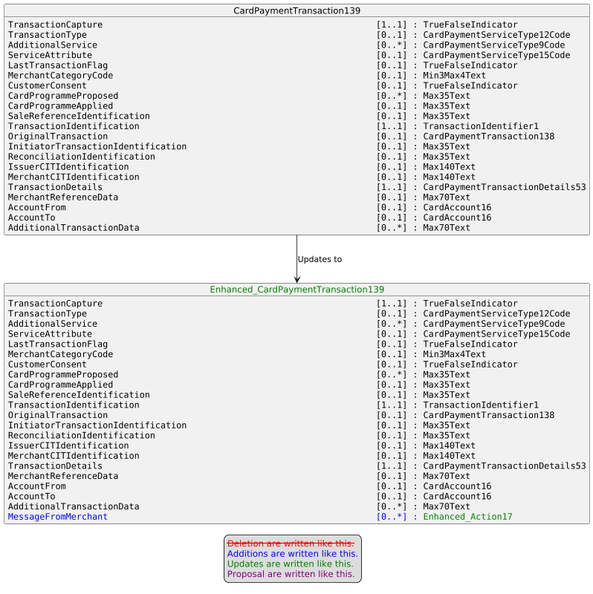

The modification implies the creation of a new message in CardPaymentTransaction140.
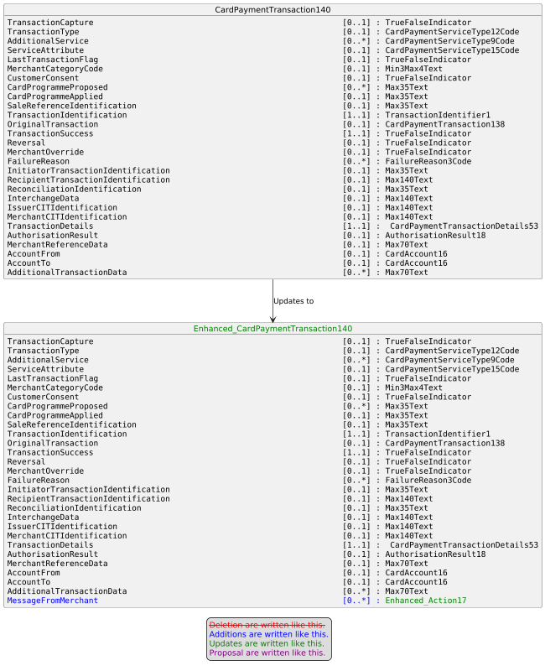

The modification implies the creation of a new message in PaymentTransaction165.
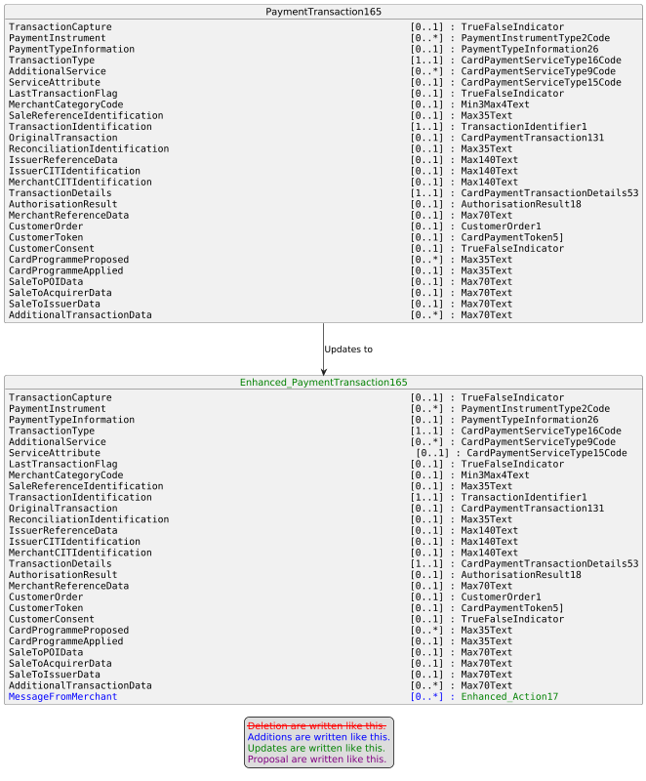

The modification implies the update of message component Action17.
The modification implies the update of message component ActionMessage11.

The modification implies the update of UserInterfaceCode codeset.

The following new value :
- CustomerStatement – CSTM

will be added to the following list:
- CardholderDisplay – CDSP
- CardholderReceipt – CRCP
- MerchantDisplay – MDSP
- MerchantReceipt – MRCP
- OtherCardholderInterface – CRDO

- Proposed timing:
The submitting organization confirms that it can implement the requested changes in the requested timing, or, if not, proposes another timing.

Timing | - As requested
 | - Other:

- Final decision of the SEG(s):
This section is not to be taken care of by the submitting organization. It will be completed in due time by the SEG(s) in charge of the related ISO 20022 messages.
Approve | X
Comments: Approved by the Cards SEG on 15 September 2025 with no comments

Reject
Reason for rejection:

Change request CR1485: nexo TMS Certification Request Type

- Origin of the request:
A.1 Submitter:
nexo A.I.S.B.L.
A.2 Contact person:
- Philippe CECE (philippe.cece@nexo-standards.org)
- Evelyne de JONGHE (evelyne.de-jonghe@frenchsys.com)
A.3 Sponsors:
nexo A.I.S.B.L.

- Related messages:
Card Payments Exchange - Terminal Management message set
- CertificateManagementRequest V07 (catm.007.001.07)
- Description of the change request:
We would like to change the type of the message element CertificationRequest in message component CertificateManagementRequest3 from CertificationRequest1 to SignedData9.

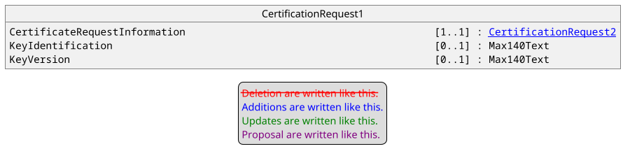

Where CertificationRequest2 is defined as.
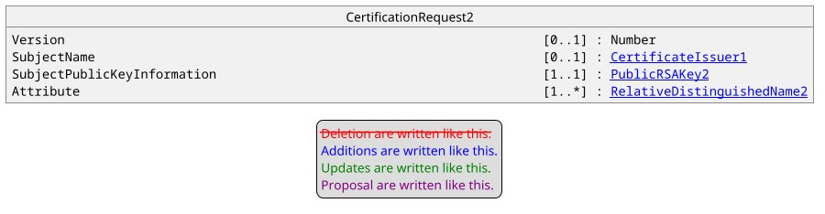

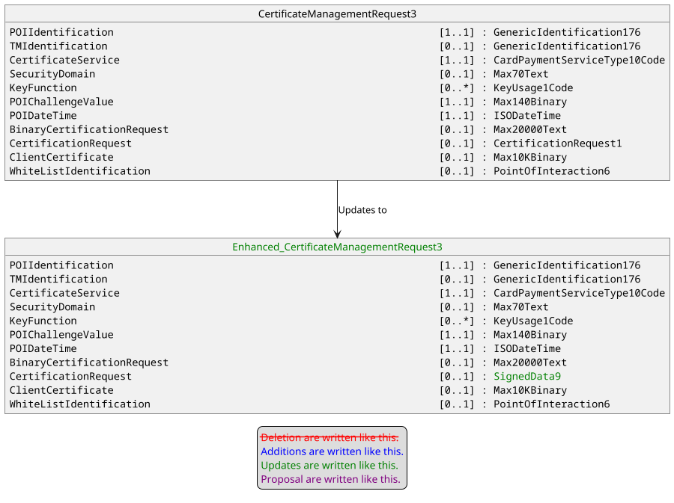

- Purpose of the change:
By analysing the definition of CertificationRequest1 and CertificationRequest2 we realized that the message component is not able to support other algorithms than RSA, and most important point, the request itself is not signed by the holder of the private key, leaving a risk of man in the middle attack. Consequently, we would like to change this definition to a SignedData9 which is the message component used by a SignedData in a CMS structure.
The aim of this Change Request is to correct these errors by reusing a standard way of managing this through a CMS sub-structure.

- Urgency of the request:
Urgent.

- Business examples:
Examples illustrating the change request.
- SEG/TSG recommendation:
This section is not to be taken care of by the submitter of the change request. It will be completed in due time by the SEG(s) in charge of the related ISO 20022 messages or the TSG for changes related to the BAH.

Consider |  | X | Timing
 |  |  | - Next yearly cycle: 2025/2026  (the change will be considered for implementation in the yearly maintenance cycle which starts in 2025 and completes with the publication of new message versions in the spring of 2026) |  | X
- At the occasion of the next maintenance of the messages
(the change will be considered for implementation, but does not justify maintenance of the messages in its own right – will be pending until more critical change requests are received for the messages)
- Urgent unscheduled
(the change justifies an urgent implementation outside of the normal yearly cycle)
 |  |  | - Other timing:
Comments:

Reject
Reason for rejection:

- Impact analysis and type of impact:
No additional messages are impacted beyond the one already listed in the originally submitted CR.
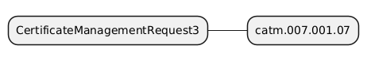

- Proposed implementation:
The modification will be done accordingly to the description provided by the Change Request.

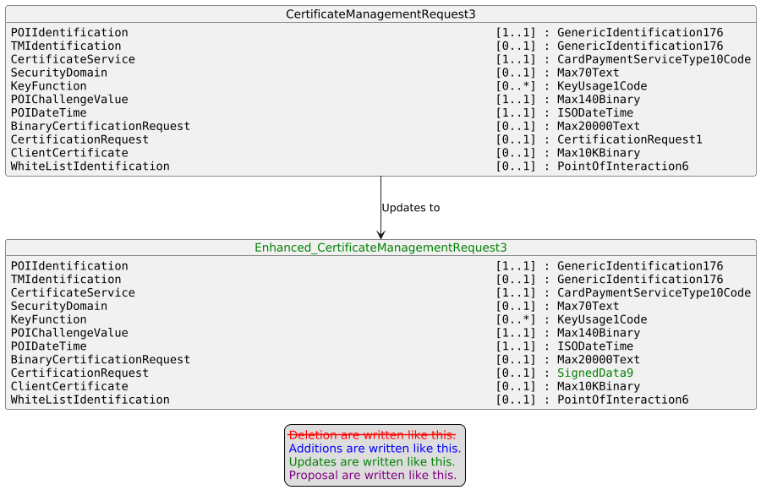
Where SignedData9 is defined as :
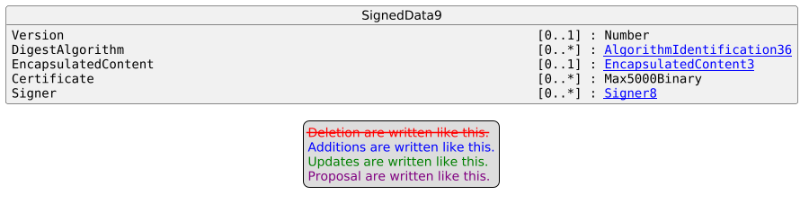

- Proposed timing:
The submitting organization confirms that it can implement the requested changes in the requested timing, or, if not, proposes another timing.

Timing | - As requested
 | - Other:

- Final decision of the SEG(s):
This section is not to be taken care of by the submitting organization. It will be completed in due time by the SEG(s) in charge of the related ISO 20022 messages.
Approve | X
Comments: Approved by the Cards SEG on 15 September 2025 with no comments

Reject
Reason for rejection:

Change request CR1486 nexo: TMS CryptogtaphicKey for DUKPT Solutions
- Origin of the request:
A.1 Submitter:
nexo A.I.S.B.L.
A.2 Contact person:
- Philippe CECE (philippe.cece@nexo-standards.org)
- Evelyne de JONGHE (evelyne.de-jonghe@frenchsys.com)
A.3 Sponsors:
nexo A.I.S.B.L.
- Related messages:
Card Payments Exchange - Terminal Management message set
- StatusReport V14 (catm.001.001.14)
- ManagementPlanReplacement V13 (catm.002.001.13)
- AcceptorConfigurationUpdate V14 (catm.003.001.14)
- MaintenanceDelegationRequest V11 (catm.005.001.11)
- Description of the change request:
We would like to update the CryptographicKey18 to add 2 new message elements. The first one is DerivationAlgorithmIdentifier with multiplicity [0..1] and type Max140Text to identify which derivation algorithm must be used, through the OID identification, to derived the key. The second one, AlgorithmIdentifier with multiplicity [0..1] and type Max140Text to identify which algorithm and mode must be used, through the OID identification, with the derived key. If DerivationAlgorithmIdentifier is missing, the AlgorithmIdentifier applies directly to the key.
In order to reuse CryptographicKey18 in place of KEKIdentifier5 and keep backward compatibility, we want to support also message elements of KEKIdentifier5.
Finally, we need also to update CryptographicKeyType3Code in order to support AES DUKPT derivation.

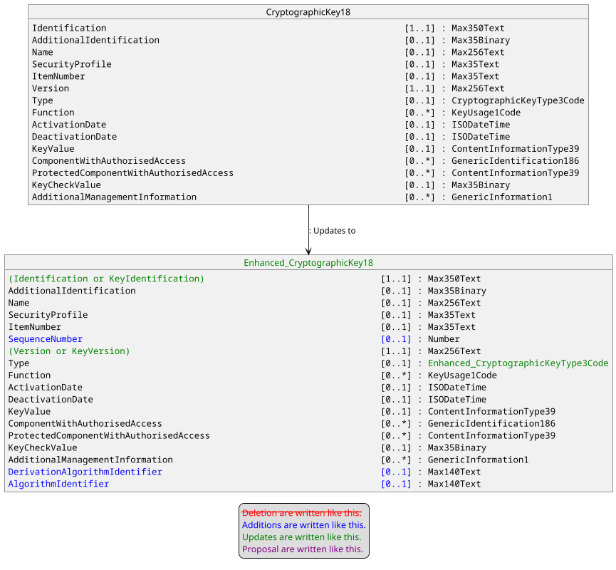

With the following update for CryptographicKeyType3Code.

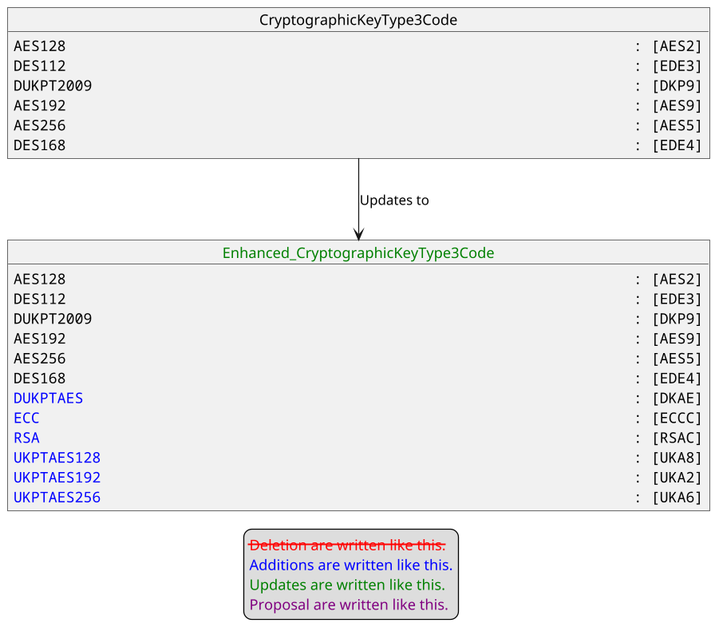
- Purpose of the change:
Currently, there is 2 message components that can identify a cryptographic key KEKIdentifier5 and CryptographicKey18. These 2 elements are not used in the same messages. CryptographicKey18 is mainly used in StatusReport and AcceptorConfigurationUpdate messages for key downloading and KEKIdentifier5 is used in other messages to identify which key to use to communicate with a specific host.
Unfortunately, KEKIdentifier5 only support DUKPT2009 and should be upgraded to support AES DUKPT. The addition of AES DUKPT also implies that we need also to identify the length of the derived key since we can derive shorter keys. Additionally, we need also to identify how to use the derived key, e.g the mode (CBC or GCM) in case of encryption.
We realized that the same needs apply if we download a BaseDerivationKey inside a POI.
Consequently, the same modifications apply on KEKIdentifier5 and CryptographicKey18, and since CryptographicKey18 supports more functionalities than KEKIdentifier5, the former one could easily replace the later one, hence reducing the complexity of the repository.
The aim of this Change Request is to bring correctness and harmonization in the protocol.
- Urgency of the request:
Urgent.
- Business examples:
Examples illustrating the change request.
- SEG/TSG recommendation:
This section is not to be taken care of by the submitter of the change request. It will be completed in due time by the SEG(s) in charge of the related ISO 20022 messages or the TSG for changes related to the BAH.

Consider |  | X | Timing
 |  |  | - Next yearly cycle: 2025/2026  (the change will be considered for implementation in the yearly maintenance cycle which starts in 2025 and completes with the publication of new message versions in the spring of 2026) |  | X
- At the occasion of the next maintenance of the messages
(the change will be considered for implementation, but does not justify maintenance of the messages in its own right – will be pending until more critical change requests are received for the messages)
- Urgent unscheduled
(the change justifies an urgent implementation outside of the normal yearly cycle)
 |  |  | - Other timing:
Comments:

Reject
Reason for rejection:

- Impact analysis and type of impact:

On top of those already listed in the CR submitted originally, all messages in following message sets are impacted:
- Card Payments Exchange - Acceptor to Acquirer (caaa)

The additionnal messages below are also impacted on top of those already listed in the CR submitted originally:

Retailer Protocol message set:
- SaleToPOIServiceRequest V07 (casp.001.001.07)
- SaleToPOIServiceResponse V07 (casp.002.001.07)
- SaleToPOIReconciliationRequest V07 (casp.003.001.07)
- SaleToPOIReconciliationResponse V07 (casp.004.001.07)
- SaleToPOISessionManagementRequest V07 (casp.005.001.07)
- SaleToPOISessionManagementResponse V07 (casp.006.001.07)
- SaleToPOIAdministrativeRequest V07 (casp.007.001.07)
- SaleToPOIAdministrativeResponse V07 (casp.008.001.07)
- SaleToPOIReportRequest V07 (casp.009.001.07)
- SaleToPOIReportResponse V07 (casp.010.001.07)
- SaleToPOIAbort V07 (casp.011.001.07)
- SaleToPOIEventNotification V07 (casp.012.001.07)
- SaleToPOIMessageStatusRequest V07 (casp.014.001.07)
- SaleToPOIMessageStatusResponse V07 (casp.015.001.07)
- SaleToPOIDeviceRequest V07 (casp.016.001.07)
- SaleToPOIDeviceResponse V07 (casp.017.001.07)

ATM Interface for Transaction Processing and ATM Management message set:
- ATMDeviceReport V04 (caam.001.001.04)
- ATMKeyDownloadRequest V04 (caam.003.001.04)
- ATMKeyDownloadResponse V04 (caam.004.001.04)

Acquirer to Issuer Card Messages (ATICA) message set (not under the responsibility of nexo):
- AdministrativeInitiation V02 (caad.008.001.02)
- AdministrativeResponse V02 (caad.009.001.02)
- FileActionInitiation V03 (cafm.001.001.03)
- FileActionResponse V03 (cafm.002.001.03)
- AuthorisationInitiation V04 (cain.001.001.04)
- FinancialInitiation V04 (cain.003.001.04)
- RetrievalFulfilmentInitiation V03 (cain.014.001.03)
- InquiryInitiation V03 (cain.016.001.03)
- VerificationInitiation V03 (cain.018.001.03)
- RetrievalInitiation V03 (cain.021.001.03)
- CardManagementInitiation V03 (cain.023.001.03)
- ChargeBackInitiation V03 (cain.027.001.03)

The proposal from the Change Request is accepted and the modification will be done accordingly on CryptographicKey18 and CryptographicKeyType3Code.
The analysis of the ripple effect identifies an important list of elements to update.
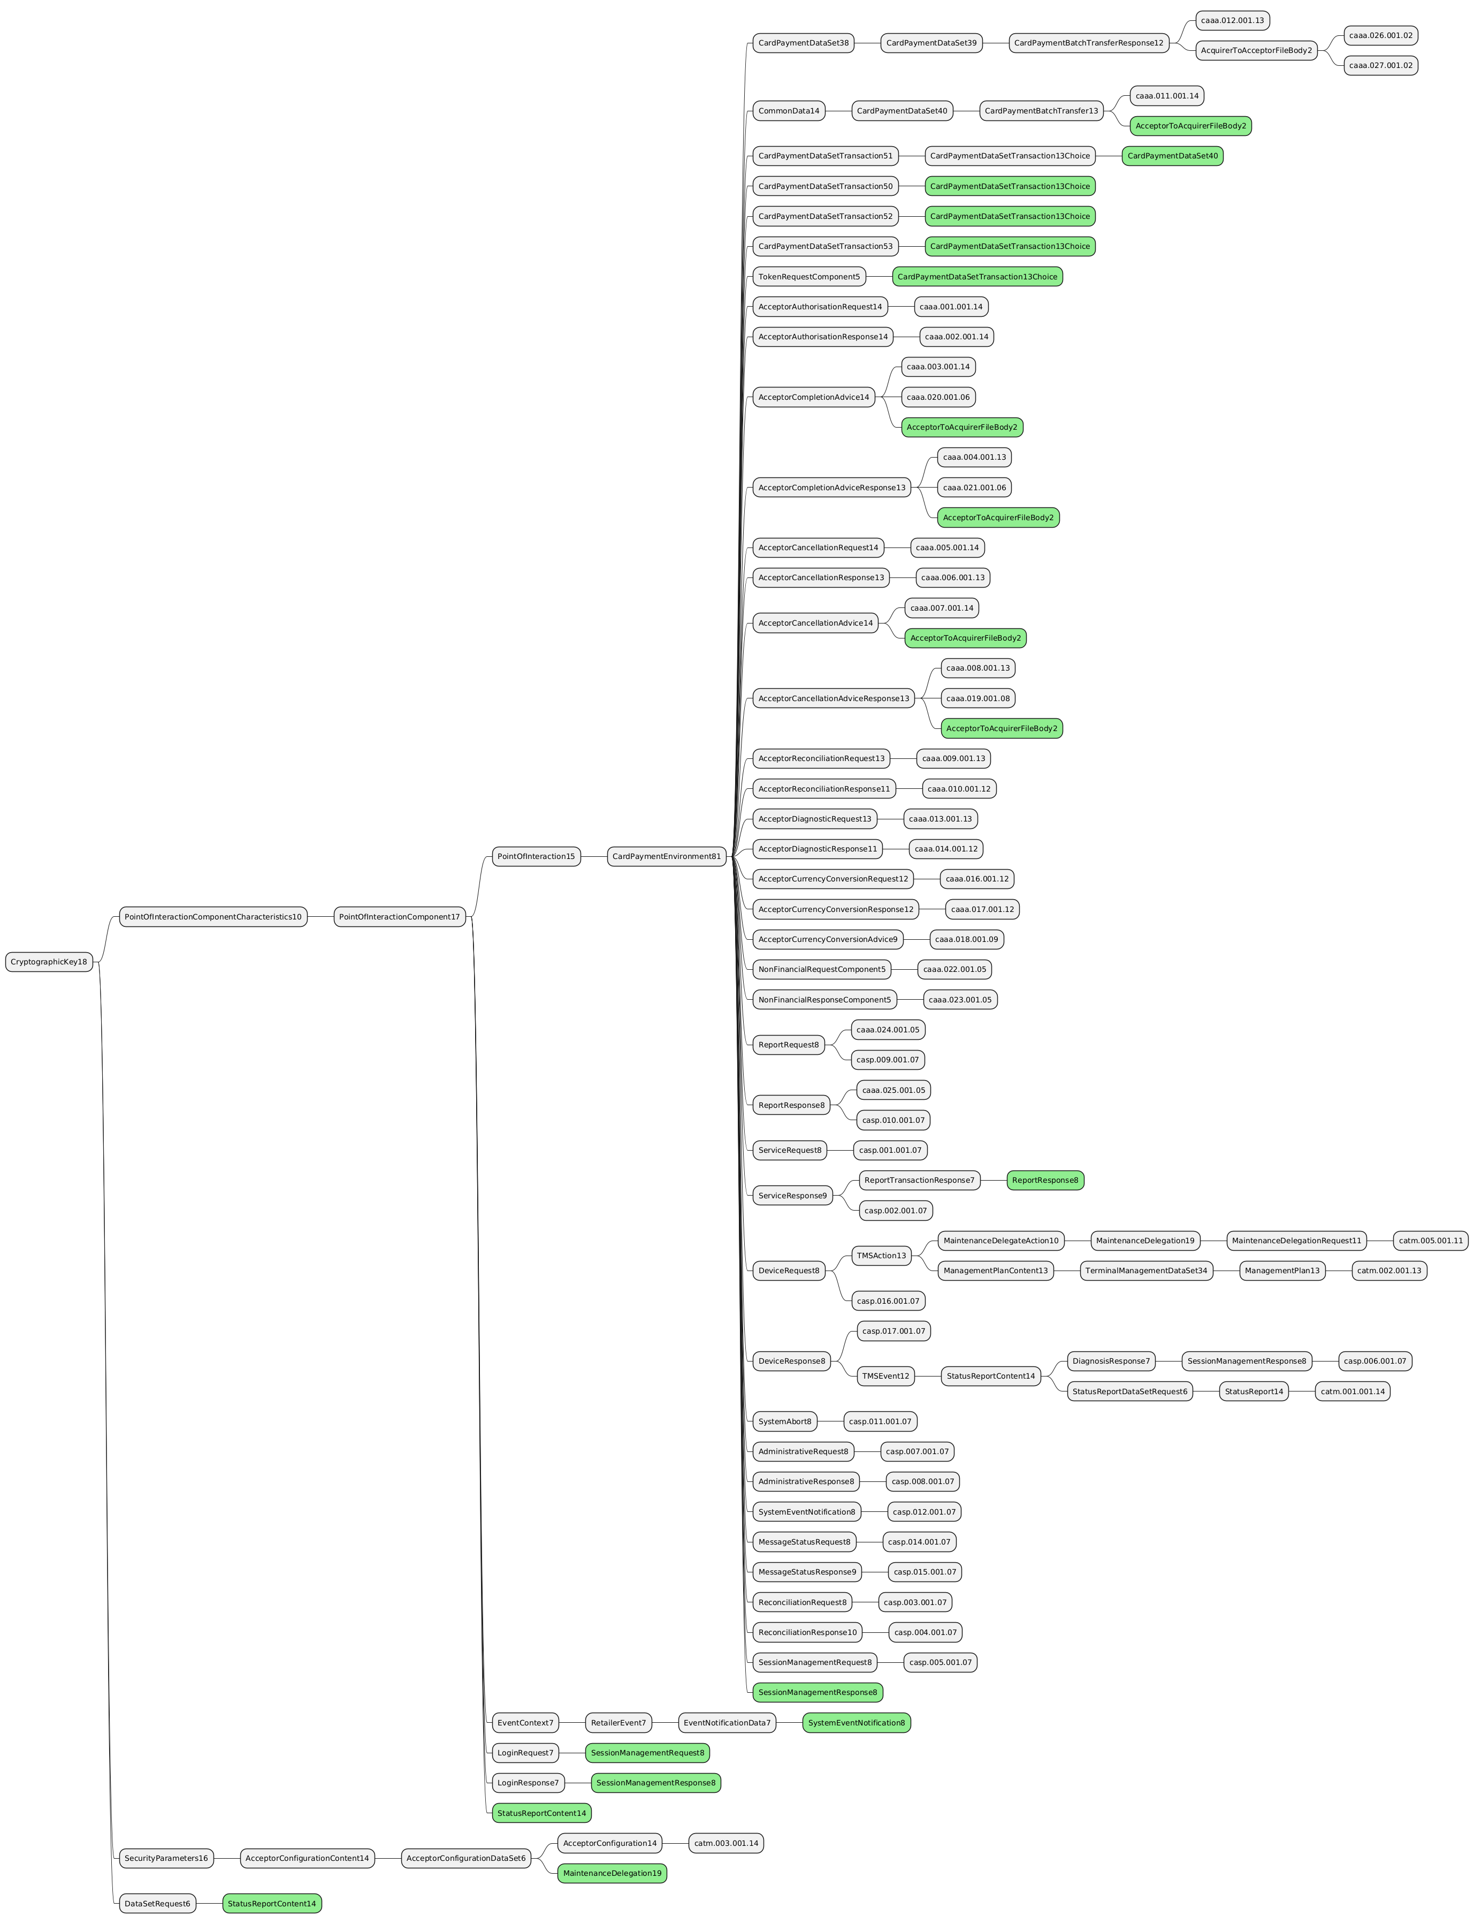
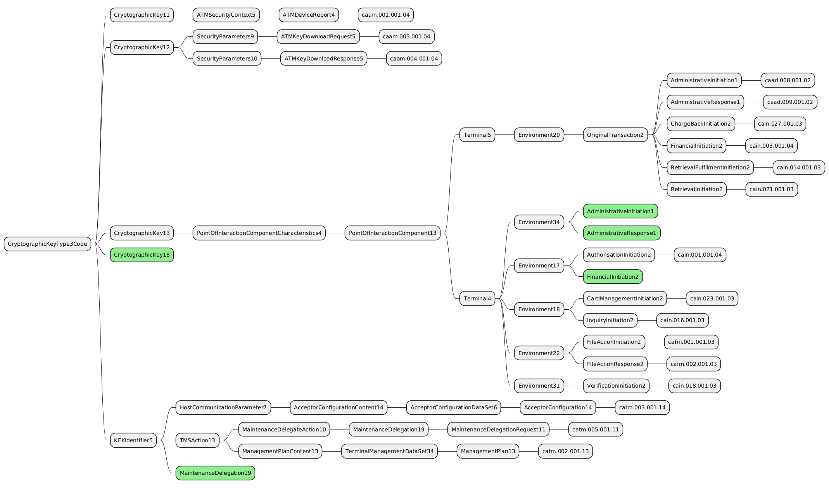

The severity of the impact of the proposed change for the message users should be indicated in the table below (either “no impact”, “conditional’ or “mandatory”).
Type of impact
 | No impact | The change(s) will not impact the schema (the version number will not change) and will not impact the business applications of any users, e.g. the clarification of a definition
X | Conditional | The change(s) will impact the schema (at least the version number) and the business applications of certain users but not all, e.g. the addition of an optional component
 | Mandatory | The change(s) will impact the schema and the business applications of all users, e.g. addition of a mandatory component.

- Proposed implementation:
The modification will be done accordingly to the description provided by the Change Request.

The modification implies the update of CryptographicKey18.

The modification implies the update of CryptographicKeyTypeCode codeset.

The following new values :
- DUKPTAES – DKAE
- ECC – ECCC
- RSA – RSAC
- UKPTAES128 – UKA8
- UKPTAES192 – UKA2
- UKPTAES256 – UKA6

will be added to the following list :
- AES128 – AES2
- DES112 – EDE3
- DUKPT2009 – DKP9
- AES192 – AES9
- AES256 – AES5
- DES168 – EDE4

- Proposed timing:
The submitting organization confirms that it can implement the requested changes in the requested timing, or, if not, proposes another timing.

Timing | - As requested
 | - Other:

- Final decision of the SEG(s):
This section is not to be taken care of by the submitting organization. It will be completed in due time by the SEG(s) in charge of the related ISO 20022 messages.
Approve | X
Comments: Approved by the Cards SEG on 15 September 2025 with no comments

Reject
Reason for rejection:

Change request CR1487: nexo TMS Definition of ProtocolVersion Configuration

- Origin of the request:
A.1 Submitter:
nexo A.I.S.B.L.
A.2 Contact person:
- Philippe CECE (philippe.cece@nexo-standards.org)
- Evelyne de JONGHE (evelyne.de-jonghe@frenchsys.com)
A.3 Sponsors:
nexo A.I.S.B.L.
- Related messages:
Card Payments Exchange - Terminal Management message set
- AcceptorConfigurationUpdate V14 (catm.003.001.14)

- Description of the change request:
We would like to update the definition of the message element ProtocolVersion in message component TMSProtocolParameters7, AcquirerHostConfiguration10, from “Protocol version to use when using these parameters.” to “Uniquely identifies the protocol name and version to use when using these parameters.”.
Additionally, we would like to correct the message component SaleToPOIProtocolParameter3 by adding a message element ProtocolVersion with a multiplicity [0..1] and typed as a Max8Text as other ProtocolVersion and with the previous revised definition.

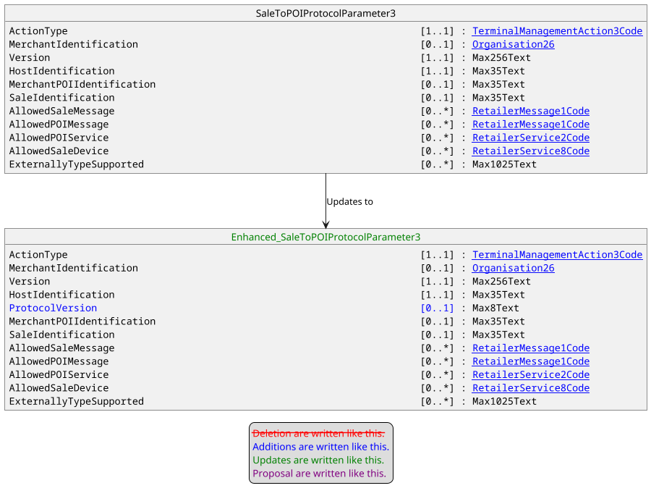

- Purpose of the change:
With a multi-application and multi-acquirer POI solutions, the communication going out from this POI might be done according to different versions of protocols or with different protocols. So it should be important to provide this support, and provide a solution that could be compatible and used by previous release of the catm protocol.
The aim of this Change Request is to provide such a solution.
- Urgency of the request:
Urgent.
- Business examples:
Examples illustrating the change request.
- SEG/TSG recommendation:
This section is not to be taken care of by the submitter of the change request. It will be completed in due time by the SEG(s) in charge of the related ISO 20022 messages or the TSG for changes related to the BAH.

Consider |  | X | Timing
 |  |  | - Next yearly cycle: 2025/2026  (the change will be considered for implementation in the yearly maintenance cycle which starts in 2025 and completes with the publication of new message versions in the spring of 2026) |  | X
- At the occasion of the next maintenance of the messages
(the change will be considered for implementation, but does not justify maintenance of the messages in its own right – will be pending until more critical change requests are received for the messages)
- Urgent unscheduled
(the change justifies an urgent implementation outside of the normal yearly cycle)
 |  |  | - Other timing:
Comments:

Reject
Reason for rejection:

- Impact analysis and type of impact:

On top of the message already listed in the CR submitted originally, the following message is impacted:
Card Payments Exchange - Terminal Management message set:
- MaintenanceDelegationRequest V11 (catm.005.001.11)

The proposal from the Change Request is accepted and the modification will be done accordingly on the definition of message element ProtocolVersion and on message component SaleToPOIProtocolParameter3.
The analysis of the ripple effect identifies two elements to update.
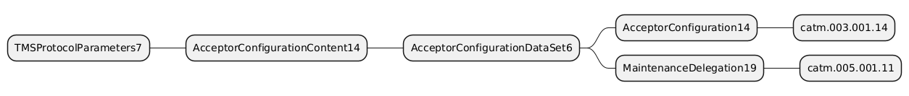
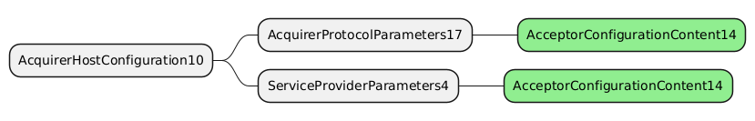

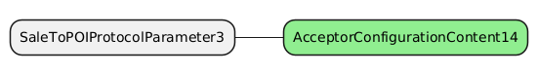

The severity of the impact of the proposed change for the message users should be indicated in the table below (either “no impact”, “conditional’ or “mandatory”).

Type of impact
 | No impact | The change(s) will not impact the schema (the version number will not change) and will not impact the business applications of any users, e.g. the clarification of a definition
X | Conditional | The change(s) will impact the schema (at least the version number) and the business applications of certain users but not all, e.g. the addition of an optional component
 | Mandatory | The change(s) will impact the schema and the business applications of all users, e.g. addition of a mandatory component.

- Proposed implementation:
The modification will be done accordingly to the description provided by the Change Request.
The modification implies the update of SaleToPOIProtocolParameter3.
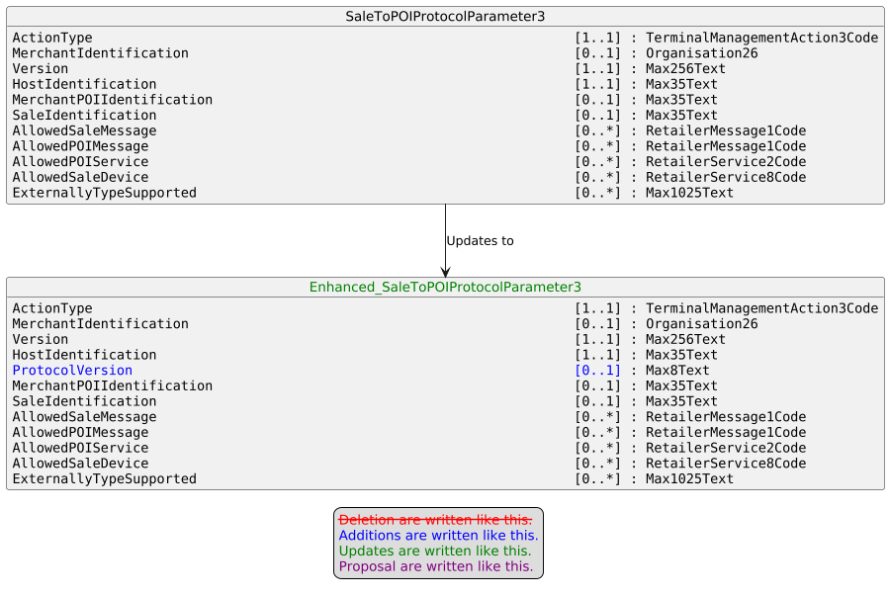
The modification implies the update message element ProtocolVersion definition in message components TMSProtocolParameters7 and AcquirerHostConfiguration10.
- Name : ProtocolVersion
Documentation : Uniquely identifies the protocol version to use when using these parameters.
- Proposed timing:
The submitting organization confirms that it can implement the requested changes in the requested timing, or, if not, proposes another timing.

Timing | - As requested
 | - Other:
- Final decision of the SEG(s):
This section is not to be taken care of by the submitting organization. It will be completed in due time by the SEG(s) in charge of the related ISO 20022 messages.
Approve | X
Comments: Approved by the Cards SEG on 15 September 2025 with no comments

Reject
Reason for rejection:

