Maintenance Change Request
for the update of ISO 20022 financial repository items

Name of the request:
ISO 20022 FX Maintenance 2025/2026

Submitting organization(s):
SWIFT, on behalf of CLS

Standards Department,
Avenue Adele, 1
1310 La Hulpe - Belgium

Related messages:
Under this maintenance, below existing ISO 20022 message definitions will be maintained (resulting from the impact analysis performed on each CR).

Post-Trade Foreign Exchange message set (under the responsibility of CLS):
camt.088.001.03 | NetReportV03

Note: SWIFT will implement the changes on behalf of CLS for this message set, this has been agreed with CLS.

Commitments of the submitting organization:
The submitting organization must confirm that it can and will:
- undertake the development of the new version of the candidate ISO 20022 message models that it will submit to the RA for compliance review and evaluation. For the ISO 20022 yearly maintenance cycle, new valid Message Definition models must be available to the RA by December 1.
- provide a new version of part 1 of the Message Definition Report (MDR) by December 1, and, optionally, new examples of valid and invalid message instances of each candidate message by May 1 at the latest.
- address any queries related to the description of the new models and messages as published by the RA on the ISO 20022 website.
If the submitting organization cannot develop all or part of the changes included in this Maintenance Change Request in the timeframe agreed by the SEG, it must propose an alternative solution for the change requests it cannot develop in time (e.g. postpone to a later date or to the next yearly maintenance cycle).

The submitting organization must confirm whether it intends or not to organize any testing or the actual implementation of the new version of the messages once the related documentation has been published by the RA. The purpose is to ensure that the documentation of the new version of the messages is accurate and consistent and to verify that these approved messages can be implemented with no adverse effects on communication infrastructures and/or applications.
The submitting organization must confirm its knowledge and acceptance of the ISO 20022 Intellectual Property Rights policy for contributing organizations, as follows.
“Organizations that contribute information to be incorporated into the ISO 20022 Repository shall keep any Intellectual Property Rights (IPR) they have on this information. A contributing organization warrants that it has sufficient rights on the contributed information to have it published in the ISO 20022 Repository through the ISO 20022 Registration Authority in accordance with the rules set in ISO 20022. To ascertain a widespread, public and uniform use of the ISO 20022 Repository information, the contributing organization grants third parties a non-exclusive, royalty-free license to use the published information”.

Contact persons:
The contact to get additional information on this Maintenance Change Request.

Rochell Ntow - SWIFT Standards, rochell.ntow@swift.com
Gregory Mestdag – SWIFT Standards, gregory.mestdag@swift.com

Change Request 1495: Add Split Obligation Data

Origin of the request:
A.1 Submitter: CLS Bank International
A.2 Contact person: Stuart Buckley. sbuckley@cls-services.com
A.3 Sponsors: This change will be socialised with all CLS Member/Participant banks via an official Participant notice. We adopt a policy at CLS of aligning our messages to the latest standards where there is a valid business case to do so. No objections to this strategy have been received.

Related messages:
Message | Message Name
camt.088.001.03.xsd | NetReportV03

Description of the change request:
This change is to extend the Net Report camt.088 message to support the splitting of a Net Obligation (NetOblgtn) into multiple smaller obligations that can be independently processed and settled.
This proposed extension incorporates two changes:
- Adding a repeatable element within `<NetOblgtn>` containing the split amount and a reference to the parent obligation within the existing NetOblgtn element to define splits at creation time
- Adding new elements to indicate if the obligation is a split or not, and a reference link to the original obligation. Enabling subsequent updates and independent processing of the split obligations.

Purpose of the change:
In order to comply with local market practices and reduce liquidity risks, CLSNet participants have requested CLS to split their large net obligations into multiple smaller obligations that can be processed individually. To support this functionality CLSNet needs to split large Net Obligations into smaller obligations, and indicate which obligations are split, number of splits and the amount of splits per obligation.

Urgency of the request:
This change is a prerequisite for introducing net payment splitting functionality and should be available by Nov 2026 (Standards 2026).

Business examples:
Example 1: When the net obligations are calculated and split for the first time.

<NetOblgtn>
<OblgtnId>B201603180000001</OblgtnId>
<Amt Ccy="GBP">10000.00</Amt>
<PtcptNetgId>
<NetgGrpId>Group AGB 1</NetgGrpId>
</PtcptNetgId>
<OblgtnDrctn>RECE</OblgtnDrctn>
<CtrPtyNetgId>
<NetgGrpId>Group BGB 1</NetgGrpId>
</CtrPtyNetgId>
<NetSvcCtrPtyId>
<PtyId>
<PtyNm>BANK BGB</PtyNm>
</PtyId>
</NetSvcCtrPtyId>
<TxsNb>5</TxsNb>
<!- New elements to indicate that this obligation is split into 2 obligations ->
<SplitInd>true</SplitInd>
<SpltOblgtnInd>false</SpltOblgtnInd>
<TtlNbOfSplts>2</TtlNbOfSplts>
<!- Details of 2 splits ->
<SpltOblgtnInf>
<OblgtnId>B201603180000001/01</OblgtnId>
<SpltSeqNb>1</SpltSeqNb>
<Amt Ccy="GBP">5000.00</Amt>
</SpltOblgtnInf>
<SpltOblgtnInf>
<OblgtnId>B201603180000001/02</OblgtnId>
<SpltSeqNb>2</SpltSeqNb>
<Amt Ccy="GBP">5000.00</Amt>
</SpltOblgtnInf>
</NetOblgtn>

SEG/TSG recommendation:
This section is not to be taken care of by the submitter of the change request. It will be completed in due time by the SEG(s) in charge of the related ISO 20022 messages or the TSG for changes related to the BAH.

Consider |  | X | Timing
 |  |  | - Next yearly cycle: 2025/2026  (the change will be considered for implementation in the yearly maintenance cycle which starts in 2025 and completes with the publication of new message versions in the spring of 2026) |  | X
- At the occasion of the next maintenance of the messages
(the change will be considered for implementation, but does not justify maintenance of the messages in its own right – will be pending until more critical change requests are received for the messages)
- Urgent unscheduled
(the change justifies an urgent implementation outside of the normal yearly cycle)
 |  |  | - Other timing:
Comments:

Reject
Reason for rejection:

Impact analysis and type of impact:
camt.088.001.03 | NetReportV03

Proposed implementation:
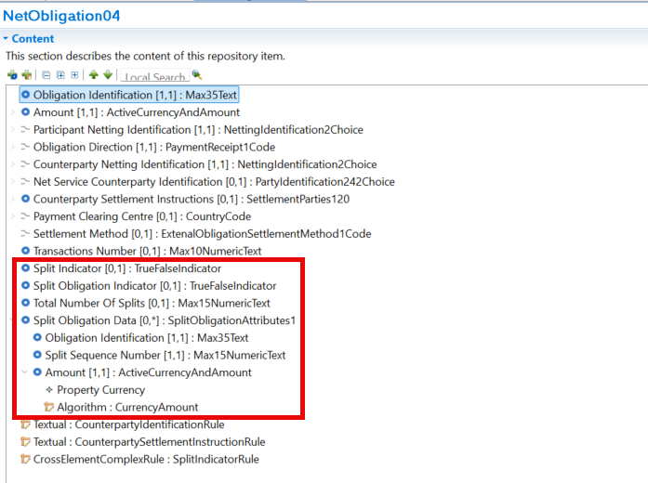

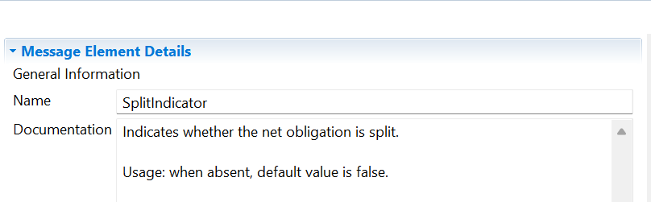

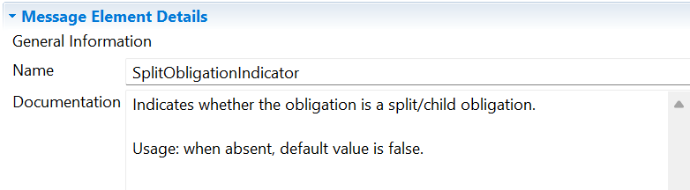
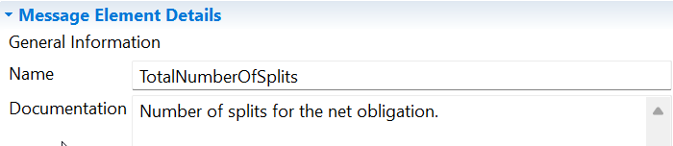

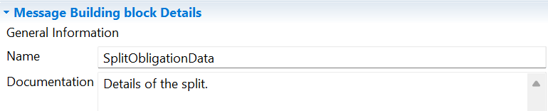
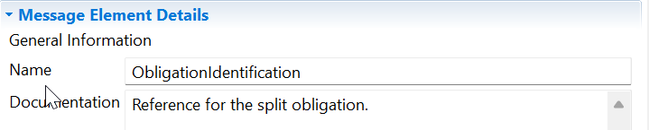
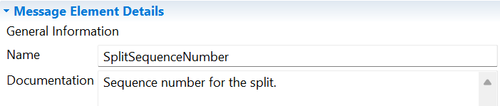
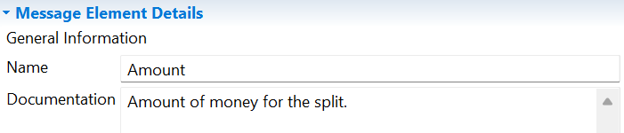

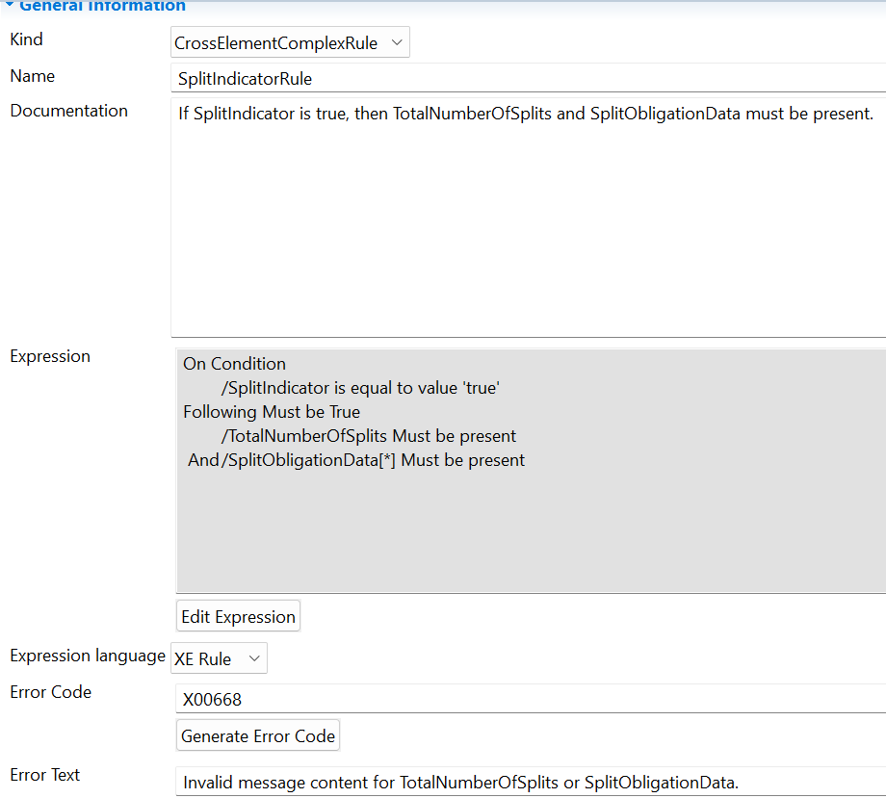

Proposed timing:
The submitting organization confirms that it can implement the requested changes in the requested timing, or, if not, proposes another timing.

Timing | - As requested

Final decision of the SEG(s):
This section is not to be taken care of by the submitting organization. It will be completed in due time by the SEG(s) in charge of the related ISO 20022 messages.
Approve | X
Comments:

Reject
Reason for rejection:

Change Request 1496: Add SettlementMethod

Origin of the request:
A.1 Submitter: CLS Bank International
A.2 Contact person: Stuart Buckley. sbuckley@cls-services.com
A.3 Sponsors: This change will be socialised with all CLS Member/Participant banks via an official Participant notice. We adopt a policy at CLS of aligning our messages to the latest standards where there is a valid business case to do so. No objections to this strategy have been received.

Related messages:
Message | Message Name
camt.088.001.03.xsd | NetReportV03

Description of the change request:
This change is to extend the Net Report camt.088 message to include the settlement method of the obligation in Net Obligation (NetOblgtn) element.
It should be possible to mark an obligation as bilateral or multilateral:
- Bilateral: Obligations that will be settled directly between the counterparties.
- Multilateral: Obligations that will be processed and settled via a central processing mechanism.

Purpose of the change:
CLSNet communicates net obligations to both counterparties using camt.088 net report. Currently, all net obligations are assumed to be processed and settled bilaterally. Currently, there is no specific indicator to qualify the obligations as bilateral or multilateral.
Future enhancements to CLSNet would require obligations to be designated as bilateral or multilateral so recipients can process the obligations differently.

Urgency of the request:
This change is required for planned CLSNet enhancements and should be available by Nov 2026 (Standards 2026)

Business examples:
To be added later.

SEG/TSG recommendation:
This section is not to be taken care of by the submitter of the change request. It will be completed in due time by the SEG(s) in charge of the related ISO 20022 messages or the TSG for changes related to the BAH.

Consider |  | X | Timing
 |  |  | - Next yearly cycle: 2025/2026  (the change will be considered for implementation in the yearly maintenance cycle which starts in 2025 and completes with the publication of new message versions in the spring of 2026) |  | X
- At the occasion of the next maintenance of the messages
(the change will be considered for implementation, but does not justify maintenance of the messages in its own right – will be pending until more critical change requests are received for the messages)
- Urgent unscheduled
(the change justifies an urgent implementation outside of the normal yearly cycle)
 |  |  | - Other timing:
Comments:

Reject
Reason for rejection:

Impact analysis and type of impact:
camt.088.001.03 | NetReportV03

Proposed implementation:

The settlement method element was added with the ExternalObligationSettlementMethod code set.
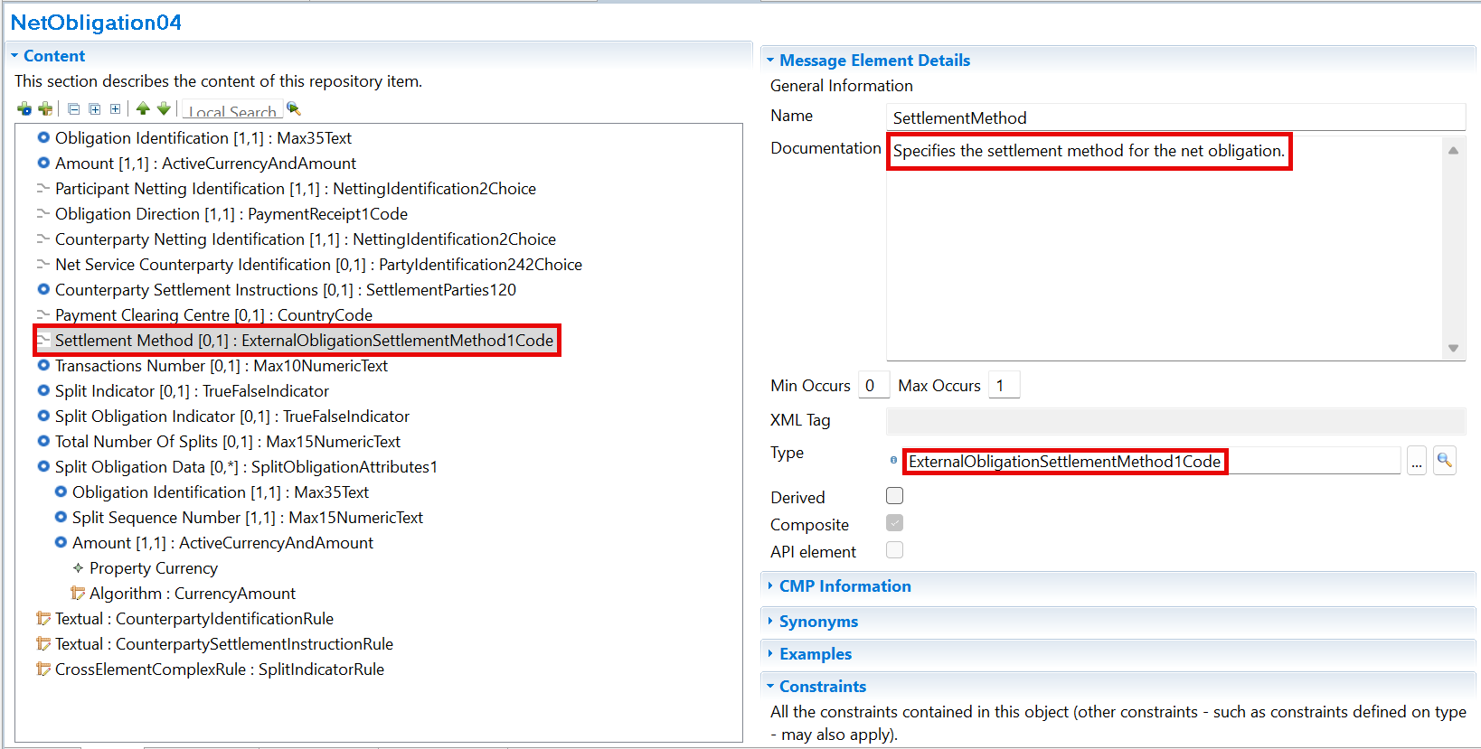

Codes listed in the ExternalObligationSettlementMethod code set
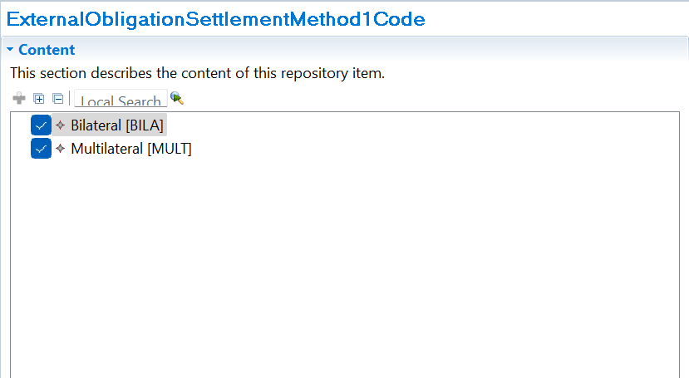
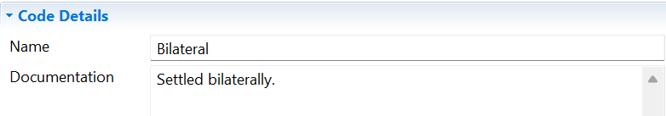
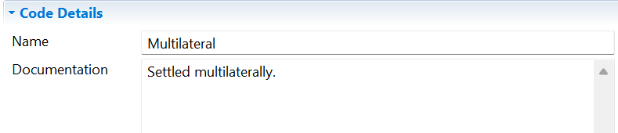

Proposed timing:

Timing | - As requested

Final decision of the SEG(s):
This section is not to be taken care of by the submitting organization. It will be completed in due time by the SEG(s) in charge of the related ISO 20022 messages.
Approve | X
Comments:

Reject
Reason for rejection:

