Maintenance Change Requests
for the update of ISO 20022 financial repository items

Name of the request:
Payments Maintenance 2025/2026

Submitting organization(s):
Swift

Standards Department,
Avenue Adele, 1
1310 La Hulpe – Belgium

Related messages:
Under this maintenance, below existing ISO 20022 message definitions will be maintained (resulting from the impact analysis performed on each CR).

Bank Account Management:
acmt.015.001.04 | AccountExcludedMandateMaintenanceRequestV04
acmt.016.001.04 | AccountExcludedMandateMaintenanceAmendmentRequestV04
acmt.017.001.04 | AccountMandateMaintenanceRequestV04
acmt.018.001.04 | AccountMandateMaintenanceAmendmentRequestV04

Exceptions and Investigation:
camt.029.001.13 | ResolutionOfInvestigationV13
camt.055.001.12 | CustomerPaymentCancellationRequestV12
camt.056.001.11 | FIToFIPaymentCancellationRequestV11

Payments, Clearing and Settlement:
pacs.002.001.15 | FIToFIPaymentStatusReportV15
pacs.003.001.11 | FIToFICustomerDirectDebitV11
pacs.004.001.14 | PaymentReturnV14
pacs.007.001.13 | FIToFIPaymentReversalV13
pacs.008.001.13 | FIToFICustomerCreditTransferV13
pacs.009.001.12 | FinancialInstitutionCreditTransferV12
pacs.028.001.06 | FIToFIPaymentStatusRequestV06

Bank-to-Customer Cash Management (previously under the responsibility of ISTH):
camt.052.001.13 | BankToCustomerAccountReportV13
camt.053.001.13 | BankToCustomerStatementV13
camt.054.001.13 | BankToCustomerDebitCreditNotificationV13

Payment Initiation
pain.001.001.12 | CustomerCreditTransferInitiationV12
pain.002.001.14 | CustomerPaymentStatusReportV14
pain.007.001.12 | CustomerPaymentReversalV12
pain.008.001.11 | CustomerDirectDebitInitiationV11

Notification To Receive
camt.057.001.08 | NotificationToReceiveV08
camt.058.001.09 | NotificationToReceiveCancellationAdviceV09
camt.059.001.08 | NotificationToReceiveStatusReportV08

Payment Tracking
trck.001.001.04 | PaymentStatusTrackerUpdateV04
trck.002.001.03 | PaymentStatusTrackerReportV03
trck.004.001.03 | PaymentStatusCustomerTrackerReportV03

Message sets impacted not under responsibility of Swift:
Swift in agreement with the submitting organisation and the RA, will implement the changes in those message sets, although Swift is not responsible, Swift will implement the changes on behalf of the submitting organisation.

Account Switching message set (under the responsibility of Payments UK):
acmt.027.001.05 | AccountSwitchInformationRequestV05
acmt.028.001.05 | AccountSwitchInformationResponseV05
acmt.029.001.05 | AccountSwitchCancelExistingPaymentV05
acmt.031.001.05 | AccountSwitchRequestBalanceTransferV05
acmt.032.001.05 | AccountSwitchBalanceTransferAcknowledgementV05
acmt.034.001.05 | AccountSwitchRequestPaymentV05

Note: SWIFT will implement the changes on behalf of Payments UK for this message set, if accepted.

Creditor Payment Activation Request message set (under the responsibility of CBI):
pain.013.001.11 | CreditorPaymentActivationRequestV11
pain.014.001.11 | CreditorPaymentActivationRequestStatusReportV11

Note: SWIFT will implement the changes on behalf of CBI for this message set, if accepted.

Exceptions and Investigation – Modernisation (under the responsibility of
PaySEG E&I work group):
camt.110.001.01 | InvestigationRequestV01
camt.111.001.02 | InvestigationResponseV02

Stand-Alone Remittance Advice (under the responsibility of IFX/OAGi):
remt.001.001.06 | RemittanceAdviceV06

Commitments of the submitting organization:
The submitting organization must confirm that it can and will:
- undertake the development of the new version of the candidate ISO 20022 message models that it will submit to the RA for compliance review and evaluation. For the ISO 20022 yearly maintenance cycle, new valid Message Definition models must be available to the RA by December 1.
- provide a new version of part 1 of the Message Definition Report (MDR) by December 1, and, optionally, new examples of valid and invalid message instances of each candidate message by May 1 at the latest.
- address any queries related to the description of the new models and messages as published by the RA on the ISO 20022 website.
If the submitting organization cannot develop all or part of the changes included in this Maintenance Change Request in the timeframe agreed by the SEG, it must propose an alternative solution for the change requests it cannot develop in time (e.g. postpone to a later date or to the next yearly maintenance cycle).
The submitting organization must confirm whether it intends or not to organize any testing or the actual implementation of the new version of the messages once the related documentation has been published by the RA. The purpose is to ensure that the documentation of the new version of the messages is accurate and consistent and to verify that these approved messages can be implemented with no adverse effects on communication infrastructures and/or applications.
The submitting organization must confirm its knowledge and acceptance of the ISO 20022 Intellectual Property Rights policy for contributing organizations, as follows.
“Organizations that contribute information to be incorporated into the ISO 20022 Repository shall keep any Intellectual Property Rights (IPR) they have on this information. A contributing organization warrants that it has sufficient rights on the contributed information to have it published in the ISO 20022 Repository through the ISO 20022 Registration Authority in accordance with the rules set in ISO 20022. To ascertain a widespread, public and uniform use of the ISO 20022 Repository information, the contributing organization grants third parties a non-exclusive, royalty-free license to use the published information”.

Contact persons:
The contacted to get additional information on this Maintenance Change Request.

Rochell Ntow - SWIFT Standards, rochell.ntow@swift.com
Gregory Mestdag – SWIFT Standards, gregory.mestdag@swift.com

Change request number 1365
Remove references to decommissioned Exceptions and Investigations messages

Origin of the request
A.1 Submitter: Swift

A.2 Contact person: Dean Chard dean.chard@swift.com

A.3 Sponsors:

Related messages
Exceptions and Investigations:

camt.029.001.13 | ResolutionOfInvestigationV13
camt.055.001.12 | CustomerPaymentCancellationRequestV12
camt.056.001.11 | FIToFIPaymentCancellationRequestV11

Description of the change request
The PAYSEG agreed that the existing exception and investigation messages would be maintained for a final time across the 2023/2024 cycle, in 2024/2025 they could become obsolete.
A few other registered message definitions and documents make mention to the exception and investigation messages that will become obsolete.
These references should be removed and/or updated.
The Registration Authority should carry out a full review to ascertain where these messages are mentioned, immediately apparent changes are as follows –
- Charges Management – MDR Part 1 Related Messages – remove mention of obsolete messages

- Exceptions and Investigations MDR Part 1 – camt.055, camt.056 and camt.029 should be the only remaining messages or they should be moved to the Exceptions and Investigations Modernization MDR Part 1

- The four highlighted camt.029 data blocks used to support the obsolete messages can be removed
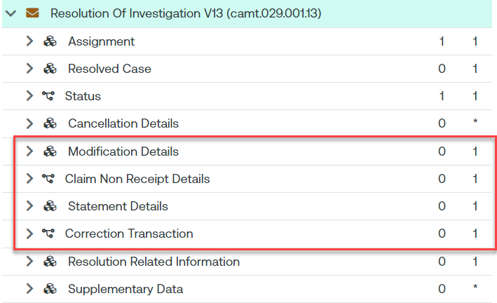

- The camt.029 Scope should be updated to remove mention of obsolete messages
Scope
The ResolutionOfInvestigation message is sent by a case assignee to a case creator/case assigner.
This message is used to inform of the resolution of a case, and optionally provides details about.
- the corrective action undertaken by the case assignee;
- information on the return where applicable.
Usage
The ResolutionOfInvestigation message is used by the case assignee to inform a case creator or case assigner about the resolution of a:
- request to cancel payment case;
- request to modify payment case;
- unable to apply case;
- claim non receipt case.
The ResolutionOfInvestigation message covers one and only one case at a time. If the case assignee needs to communicate about several cases, then several Resolution Of Investigation messages must be sent.
The ResolutionOfInvestigation message provides:
- the final outcome of the case, whether positive or negative;
- optionally, the details of the corrective action undertaken by the case assignee and the information of the return.
Whenever a payment instruction has been generated to solve the case under investigation following a claim non receipt or an unable to apply, the optional CorrectionTransaction component present in the message must be completed.
Whenever the action of modifying or cancelling a payment results in funds being returned or reversed, an investigating agent may provide the details in the resolution related investigation component, to identify the return or reversal transaction. These details will facilitate the account reconciliations at the initiating bank and the intermediaries. It must be stressed that the return or reversal of funds is outside the scope of this Exceptions and Investigation service. The features given here is only meant to transmit the information of return or reversal when it is available through the resolution of the case.
The ResolutionOfInvestigation message must:
- be forwarded by all subsequent case assignee(s) until it reaches the case creator;
- not be used in place of a RejectCaseAssignment or CaseStatusReport or NotificationOfCaseAssignment message.
Take note of an exceptional rule that allows the use of ResolutionOfInvestigation in lieu of a CaseStatusReport. CaseStatusReport is a response-message to a CaseStatusReportRequest. The latter which is sent when the assigner has reached its own time-out threshold to receive a response. However it may happen that when the request arrives, the investigating agent has just obtained a resolution. In such a situation, it would be redundant to send a CaseStatusReport when then followed immediately by a ResolutionOfInvestigation. It is therefore quite acceptable for the investigating agent, the assignee, to skip the Case Status Report and send the ResolutionOfInvestigation message directly.
The ResolutionOfInvestigation message should be the sole message to respond to a cancellation request. Details of the underlying transactions and the related statuses for which the cancellation request has been issued may be provided in the CancellationDetails component.

- The camt.055 Scope should be updated to remove mention of obsolete messages
Scope
The CustomerPaymentCancellationRequest message is sent by a case creator/case assigner to a case assignee.
The CustomerPaymentCancellationRequest message is issued by the initiating party to request the cancellation of an initiation payment message previously sent (such as CustomerCreditTransferInitiation, CreditorPaymentActivationRequest or CustomerDirectDebitInitiation).
Usage
The CustomerPaymentCancellationRequest message must be answered with a:
- ResolutionOfInvestigation message with a positive final outcome when the case assignee can perform the requested cancellation;
- ResolutionOfInvestigation message with a negative final outcome when the case assignee may perform the requested cancellation but fails to do so (too late, irrevocable instruction);
- RejectInvestigation message when the case assignee is unable or not authorised to perform the requested cancellation;
- NotificationOfCaseAssignment message to indicate whether the case assignee will take on the case himself or reassign the case to a subsequent party in the payment processing chain.
A CustomerPaymentCancellationRequest message concerns one and only one original payment instruction at a time.
When a case assignee successfully performs a cancellation, it must return the corresponding funds to the case assigner. It may provide some details about the return in the ResolutionOfInvestigation message.
The processing of a CustomerPaymentCancellationRequest message case may lead to a InvestigationRequest message sent to the creditor by its account servicing institution.
The CustomerPaymentCancellationRequest message may be used to escalate a case after an unsuccessful request to modify the payment. In this scenario, the case identification remains the same as in the original CustomerPaymentCancellationRequest message and the element ReopenCaseIndication is set to 'Yes' or 'true'.
The CustomerPaymentCancellationRequest message has the following main characteristics: the case creator assigns a unique case identification and the reason code for the cancellation request. This information will be passed unchanged to all subsequent case assignee(s).
For the CustomerPaymentCancellationRequest message the case has been made optional, as the message might be used outside of a case management environment where the case identification is not relevant.
Moreover, the case identification may be present at different levels:
- One unique case is defined per cancellation request message: If multiple underlying groups, payment information blocks or transactions are present in the message and the case assignee has already forwarded the transaction for which the cancellation is requested, the case cannot be forwarded to the next party in the chain (see rule on uniqueness of the case) and the case creator will have to issue individual cancellation requests for each underlying individual transaction. In response to this cancellation request, the case must also be present at the message level in the Resolution of Investigation message;
- One case per original group, payment information or transaction present in the cancellation request: For each group, payment information block or transaction within the payment information, a unique case has been assigned. This means, when a payment instruction has already been forwarded by the case assignee, the cancellation request may be forwarded to next party in the payment chain, with the unique case assigned to the transaction. When the group can only be cancelled partially, new cancellation requests need however to be issued for the individual transactions within the group for which the cancellation request has not been successful. In response to this cancellation request, the case must be present in the cancellation details identifying the original group or transaction in the Resolution of Investigation message;
- No case used in cancellation request message: The cancellation of a payment instruction can be initiated by either the debtor/creditor or any subsequent agent in the payment instruction processing chain.

- The camt.056 Scope should be updated to remove mention of obsolete messages
Scope
The FIToFIPaymentCancellationRequest message is sent by a case creator/case assigner to a case assignee.
This message is used to request the cancellation of an original payment instruction. The FIToFIPaymentCancellationRequest message is exchanged between the instructing agent and the instructed agent to request the cancellation of a interbank payment message previously sent (such as FIToFICustomerCreditTransfer, FIToFICustomerDirectDebit or FinancialInstitutionCreditTransfer).
The FIToFIPaymentCancellationRequest message supports both the request for cancellation (the instructed agent - or assignee - has not yet processed and forwarded the payment instruction) as well as the request for refund (payment has been fully processed already by the instructed agent - or assignee).
Usage
The FIToFIPaymentCancellationRequest message must be answered with a:
- ResolutionOfInvestigation message with a positive final outcome when the case assignee can perform the requested cancellation;
- ResolutionOfInvestigation message with a negative final outcome when the case assignee may perform the requested cancellation but fails to do so (too late, irrevocable instruction);
- RejectInvestigation message when the case assignee is unable or not authorised to perform the requested cancellation;
- NotificationOfCaseAssignment message to indicate whether the case assignee will take on the case himself or reassign the case to a subsequent party in the payment processing chain.
A FIToFIPaymentCancellationRequest message concerns one and only one original payment instruction at a time.
When a case assignee successfully performs a cancellation, it must return the corresponding funds to the case assigner. It may provide some details about the return in the ResolutionOfInvestigation message.
The processing of a FIToFIPaymentCancellationRequest message case may lead to a InvestigationRequest message sent to the creditor by its account servicing institution.
The FIToFIPaymentCancellationRequest message may be used to escalate a case after an unsuccessful request to modify the payment. In this scenario, the case identification remains the same as in the original FIToFIPaymentCancellationRequest message and the element ReopenCaseIndication is set to 'Yes' or 'true'.
The FIToFIPaymentCancellationRequest message has the following main characteristics: the case creator assigns a unique case identification and the reason code for the cancellation request. This information will be passed unchanged to all subsequent case assignee(s).
For the FIToFIPaymentCancellationRequest message the case has been made optional, as the message might be used outside of a case management environment where the case identification is not relevant.
Moreover, the case identification may be present at different levels:
- One unique case is defined per cancellation request message: If multiple underlying groups or transactions are present in the message and the case assignee has already forwarded the transaction for which the cancellation is requested, the case cannot be forwarded to the next party in the chain (see rule on uniqueness of the case) and the case creator will have to issue individual cancellation requests for each underlying individual transaction. In response to this cancellation request, the case must also be present at the message level in the Resolution of Investigation message;
- One case per original group or transaction present in the cancellation request: For each group or transaction, a unique case has been assigned. This means, when a payment instruction has already been forwarded by the case assignee, the cancellation request may be forwarded to next party in the payment chain, with the unique case assigned to the transaction. When the group can only be cancelled partially, new cancellation requests need however to be issued for the individual transactions within the group for which the cancellation request has not been successful. In response to this cancellation request, the case must be present in the cancellation details identifying the original group or transaction in the Resolution of Investigation message;
- No case used in cancellation request message.
Cancellation of a cover payment:
The cancellation of a payment instruction for which cover is provided by a separate instruction always results in the cancellation of the whole transaction, including the cover. The case assignee performing the cancellation must initiate the return of funds to the case creator. The case assigner must not request the cancellation of the cover separately.
Cancellation request initiators:
The cancellation of a payment instruction can be initiated by either the debtor/creditor or any subsequent agent in the payment instruction processing chain.

Purpose of the change:
Background, business context, community of users interested by the change and expected benefits/savings.
This section must explain why the existing ISO 20022 messages need to be changed. The reason for the update may be a business reason (e.g., evolution of market practice, or creation of new financial instruments), a technical reason (e.g., automation of the business process, or switch from a batch to a real time process), a regulatory reason (introduction, generally mandatory, of new rule/law) or the extension of the user community (newly identified business requirements).

- This will make the documentation and registered message definitions clearer, it will avoid the confusion of obsolete message definitions being mentioned.

Urgency of the request:
2024/2025 maintenance cycle

Business Examples:
N/A

SEG/TSG recommendation:
This section is not to be taken care of by the submitter of the change request. It will be completed in due time by the SEG(s) in charge of the related ISO 20022 messages or the TSG for changes related to the BAH.

Consider |  | X | Timing
 |  |  | - Next yearly cycle: 2025/2026  (the change will be considered for implementation in the yearly maintenance cycle which starts in 2025 and completes with the publication of new message versions in the spring of 2026) |  | X
- At the occasion of the next maintenance of the messages
(the change will be considered for implementation, but does not justify maintenance of the messages in its own right – will be pending until more critical change requests are received for the messages)
- Urgent unscheduled
(the change justifies an urgent implementation outside of the normal yearly cycle)
 |  |  | - Other timing:
Comments:

Reject
Reason for rejection:

Impact analysis and type of impact:
The following Message Identifiers will be impacted –

camt.029.001.13 | ResolutionOfInvestigationV13
camt.055.001.12 | CustomerPaymentCancellationRequestV12
camt.056.001.11 | FIToFIPaymentCancellationRequestV11

Proposed implementation:

New proposed scope for ResolutionOfInvestigation (camt.029)

Scope
The ResolutionOfInvestigation message is sent by a case assignee to a case creator/case assigner. This message is used to inform of the resolution of a case, and optionally provides details about. - the corrective action undertaken by the case assignee; - information on the return where applicable. Usage The ResolutionOfInvestigation message is used by the case assignee to inform a case creator or case assigner about the resolution of a: - request to cancel payment case; The ResolutionOfInvestigation message covers one and only one case at a time. If the case assignee needs to communicate about several cases, then several Resolution Of Investigation messages must be sent. The ResolutionOfInvestigation message provides: - the final outcome of the case, whether positive or negative; - optionally, the details of the corrective action undertaken by the case assignee and the information of the return. Whenever the action of modifying or cancelling a payment results in funds being returned or reversed, an investigating agent may provide the details in the resolution related investigation component, to identify the return or reversal transaction. These details will facilitate the account reconciliations at the initiating bank and the intermediaries. It must be stressed that the return or reversal of funds is outside the scope of this Exceptions and Investigation service. The features given here is only meant to transmit the information of return or reversal when it is available through the resolution of the case. The ResolutionOfInvestigation message must: - be forwarded by all subsequent case assignee(s) until it reaches the case creator; The ResolutionOfInvestigation message should be the sole message to respond to a cancellation request. Details of the underlying transactions and the related statuses for which the cancellation request has been issued may be provided in the CancellationDetails component.

The image below shows the removal of the mention of obsolete messages from the camt.029.

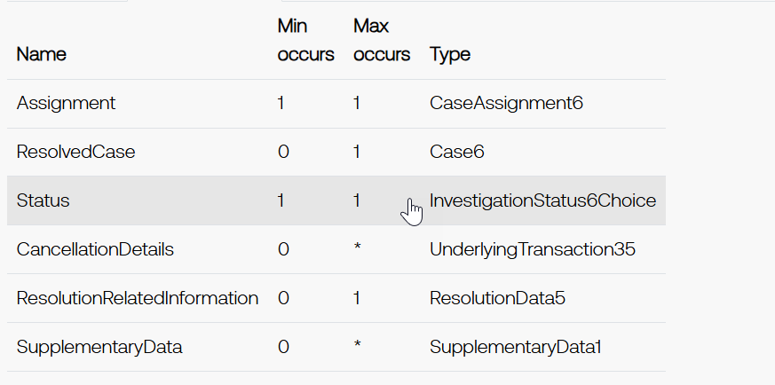

New proposed scope for CustomerPaymentCancellationRequest (camt.055)

Scope
The CustomerPaymentCancellationRequest message is sent by a case creator/case assigner to a case assignee. The CustomerPaymentCancellationRequest message is issued by the initiating party to request the cancellation of an initiation payment message previously sent (such as CustomerCreditTransferInitiation, CreditorPaymentActivationRequest or CustomerDirectDebitInitiation). Usage The CustomerPaymentCancellationRequest message must be answered with a: - ResolutionOfInvestigation message with a positive final outcome when the case assignee can perform the requested cancellation; - ResolutionOfInvestigation message with a negative final outcome when the case assignee may perform the requested cancellation but fails to do so (too late, irrevocable instruction); A CustomerPaymentCancellationRequest message concerns one and only one original payment instruction at a time. When a case assignee successfully performs a cancellation, it must return the corresponding funds to the case assigner. It may provide some details about the return in the ResolutionOfInvestigation message. The processing of a CustomerPaymentCancellationRequest message case may lead to a InvestigationRequest message sent to the creditor by its account servicing institution. The CustomerPaymentCancellationRequest message has the following main characteristics: the case creator assigns a unique case identification and the reason code for the cancellation request. This information will be passed unchanged to all subsequent case assignee(s). For the CustomerPaymentCancellationRequest message the case has been made optional, as the message might be used outside of a case management environment where the case identification is not relevant. Moreover, the case identification may be present at different levels: - One unique case is defined per cancellation request message: If multiple underlying groups, payment information blocks or transactions are present in the message and the case assignee has already forwarded the transaction for which the cancellation is requested, the case cannot be forwarded to the next party in the chain (see rule on uniqueness of the case) and the case creator will have to issue individual cancellation requests for each underlying individual transaction. In response to this cancellation request, the case must also be present at the message level in the Resolution of Investigation message; - One case per original group, payment information or transaction present in the cancellation request: For each group, payment information block or transaction within the payment information, a unique case has been assigned. This means, when a payment instruction has already been forwarded by the case assignee, the cancellation request may be forwarded to next party in the payment chain, with the unique case assigned to the transaction. When the group can only be cancelled partially, new cancellation requests need however to be issued for the individual transactions within the group for which the cancellation request has not been successful. In response to this cancellation request, the case must be present in the cancellation details identifying the original group or transaction in the Resolution of Investigation message; - No case used in cancellation request message: The cancellation of a payment instruction can be initiated by either the debtor/creditor or any subsequent agent in the payment instruction processing chain.

camt.056

New proposed scope for FIToFIPaymentCancellationRequest (camt.056)

Scope
The FIToFIPaymentCancellationRequest message is sent by a case creator/case assigner to a case assignee. This message is used to request the cancellation of an original payment instruction. The FIToFIPaymentCancellationRequest message is exchanged between the instructing agent and the instructed agent to request the cancellation of a interbank payment message previously sent (such as FIToFICustomerCreditTransfer, FIToFICustomerDirectDebit or FinancialInstitutionCreditTransfer). The FIToFIPaymentCancellationRequest message supports both the request for cancellation (the instructed agent - or assignee - has not yet processed and forwarded the payment instruction) as well as the request for refund (payment has been fully processed already by the instructed agent - or assignee). Usage The FIToFIPaymentCancellationRequest message must be answered with a: - ResolutionOfInvestigation message with a positive final outcome when the case assignee can perform the requested cancellation; - ResolutionOfInvestigation message with a negative final outcome when the case assignee may perform the requested cancellation but fails to do so (too late, irrevocable instruction); A FIToFIPaymentCancellationRequest message concerns one and only one original payment instruction at a time. When a case assignee successfully performs a cancellation, it must return the corresponding funds to the case assigner. It may provide some details about the return in the ResolutionOfInvestigation message. The processing of a FIToFIPaymentCancellationRequest message case may lead to a InvestigationRequest message sent to the creditor by its account servicing institution. The FIToFIPaymentCancellationRequest message has the following main characteristics: the case creator assigns a unique case identification and the reason code for the cancellation request. This information will be passed unchanged to all subsequent case assignee(s). For the FIToFIPaymentCancellationRequest message the case has been made optional, as the message might be used outside of a case management environment where the case identification is not relevant. Moreover, the case identification may be present at different levels: - One unique case is defined per cancellation request message: If multiple underlying groups or transactions are present in the message and the case assignee has already forwarded the transaction for which the cancellation is requested, the case cannot be forwarded to the next party in the chain (see rule on uniqueness of the case) and the case creator will have to issue individual cancellation requests for each underlying individual transaction. In response to this cancellation request, the case must also be present at the message level in the Resolution of Investigation message; - One case per original group or transaction present in the cancellation request: For each group or transaction, a unique case has been assigned. This means, when a payment instruction has already been forwarded by the case assignee, the cancellation request may be forwarded to next party in the payment chain, with the unique case assigned to the transaction. When the group can only be cancelled partially, new cancellation requests need however to be issued for the individual transactions within the group for which the cancellation request has not been successful. In response to this cancellation request, the case must be present in the cancellation details identifying the original group or transaction in the Resolution of Investigation message; - No case used in cancellation request message. Cancellation of a cover payment: The cancellation of a payment instruction for which cover is provided by a separate instruction always results in the cancellation of the whole transaction, including the cover. The case assignee performing the cancellation must initiate the return of funds to the case creator. The case assigner must not request the cancellation of the cover separately. Cancellation request initiators: The cancellation of a payment instruction can be initiated by either the debtor/creditor or any subsequent agent in the payment instruction processing chain.

Proposed timing:
The submitting organization confirms that it can implement the requested changes in the requested timing, or, if not, proposes another timing.

Timing | - As requested

Final decision of the SEG(s):
This section is not to be taken care of by the submitting organization. It will be completed in due time by the SEG(s) in charge of the related ISO 20022 messages.
Approve | X
Comments:

Reject
Reason for rejection:

Change request number 1405
Add the Unique Transaction Identifier to the cash management messages

Origin of the request
A.1 Submitter: SMPG payment task force represented by Charles Boniver – Swift Standards, Karine Taquet – Swift Standards, Dean Shard – Swift Standards.

A.2 Contact person:
- Karine Taquet – Swift Standards - karine.taquet@swift.com (+32 2 655 3784)
- Dean Chard – Swift Standards - dean.chard@swift.com (+44 20 7762 2334)

A.3 Sponsors:
SMPG payment task force

Related messages
camt.052.001.12 | BankToCustomerAccountReportV13
camt.053.001.12 | BankToCustomerStatementV13
camt.054.001.12 | BankToCustomerDebitCreditNotificationV13

Description of the change request
- Need to add the UTI reference in the camt.052, camt.053 and camt.054. It should be added in the entry details / Transaction details / References (/Document/BkToCstmrStmt/Stmt/Ntry/NtryDtls/TxDtls/Refs)
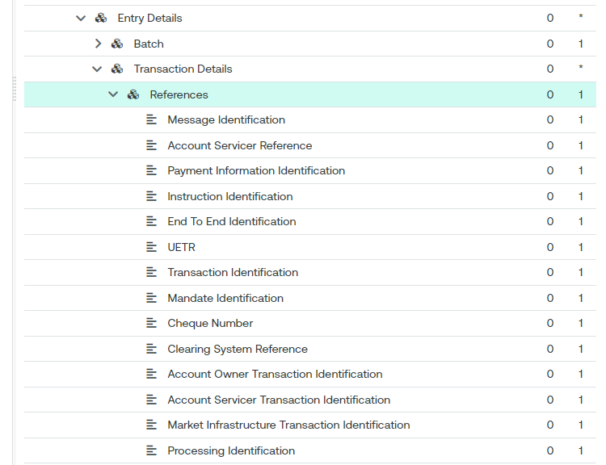

Purpose of the change:
The UTI (Universal Transaction Identifier) is more and more used within the securities transactions. By having this reference in the camt messages, it will ease the resolution of potential reconciliation breaks.

Urgency of the request:
Cycle 2024-2025

Business Examples:
N/A

SEG/TSG recommendation:
This section is not to be taken care of by the submitter of the change request. It will be completed in due time by the SEG(s) in charge of the related ISO 20022 messages or the TSG for changes related to the BAH.

Consider |  | X | Timing
 |  |  | - Next yearly cycle: 2025/2026  (the change will be considered for implementation in the yearly maintenance cycle which starts in 2025 and completes with the publication of new message versions in the spring of 2026) |  | X
- At the occasion of the next maintenance of the messages
(the change will be considered for implementation, but does not justify maintenance of the messages in its own right – will be pending until more critical change requests are received for the messages)
- Urgent unscheduled
(the change justifies an urgent implementation outside of the normal yearly cycle)
 |  |  | - Other timing:
Comments:

Reject
Reason for rejection:

Impact analysis and type of impact:
The following Message Identifiers will be impacted –

acmt.027.001.05 | AccountSwitchInformationRequestV05
acmt.028.001.05 | AccountSwitchInformationResponseV05
acmt.029.001.05 | AccountSwitchCancelExistingPaymentV05
acmt.031.001.05 | AccountSwitchRequestBalanceTransferV05
acmt.032.001.05 | AccountSwitchBalanceTransferAcknowledgementV05
acmt.034.001.05 | AccountSwitchRequestPaymentV05
camt.029.001.13 | ResolutionOfInvestigationV13
camt.052.001.13 | BankToCustomerAccountReportV13
camt.053.001.13 | BankToCustomerStatementV13
camt.054.001.13 | BankToCustomerDebitCreditNotificationV13
camt.055.001.12 | CustomerPaymentCancellationRequestV12
camt.056.001.11 | FIToFIPaymentCancellationRequestV11
camt.057.001.08 | NotificationToReceiveV08
camt.058.001.09 | NotificationToReceiveCancellationAdviceV09
camt.059.001.08 | NotificationToReceiveStatusReportV08
pacs.002.001.15 | FIToFIPaymentStatusReportV15
pacs.003.001.11 | FIToFICustomerDirectDebitV11
pacs.004.001.14 | PaymentReturnV14
pacs.007.001.13 | FIToFIPaymentReversalV13
pacs.008.001.13 | FIToFICustomerCreditTransferV13
pacs.009.001.12 | FinancialInstitutionCreditTransferV12
pacs.028.001.06 | FIToFIPaymentStatusRequestV06
pain.001.001.12 | CustomerCreditTransferInitiationV12
pain.002.001.14 | CustomerPaymentStatusReportV14
pain.007.001.12 | CustomerPaymentReversalV12
pain.008.001.11 | CustomerDirectDebitInitiationV11
pain.013.001.11 | CreditorPaymentActivationRequestV11
pain.014.001.11 | CreditorPaymentActivationRequestStatusReportV11
remt.001.001.06 | RemittanceAdviceV06

Proposed implementation:

Question to the SEG: Should the UTI be included in the Remittance information, as expressed bilaterally by a number of PaySEG members. Swift supports this implementation, as illustrated in below proposal.
The PAYSEG supported this implementation.

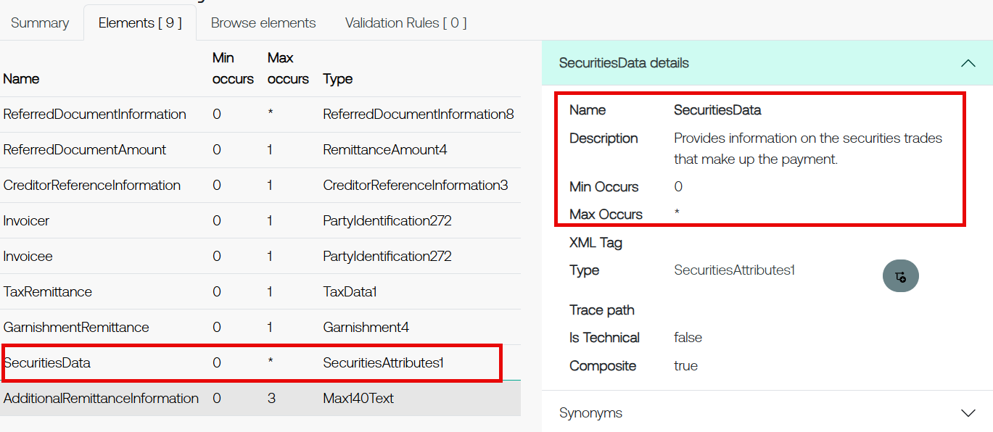

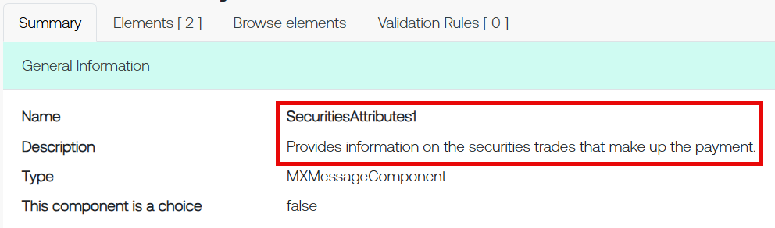

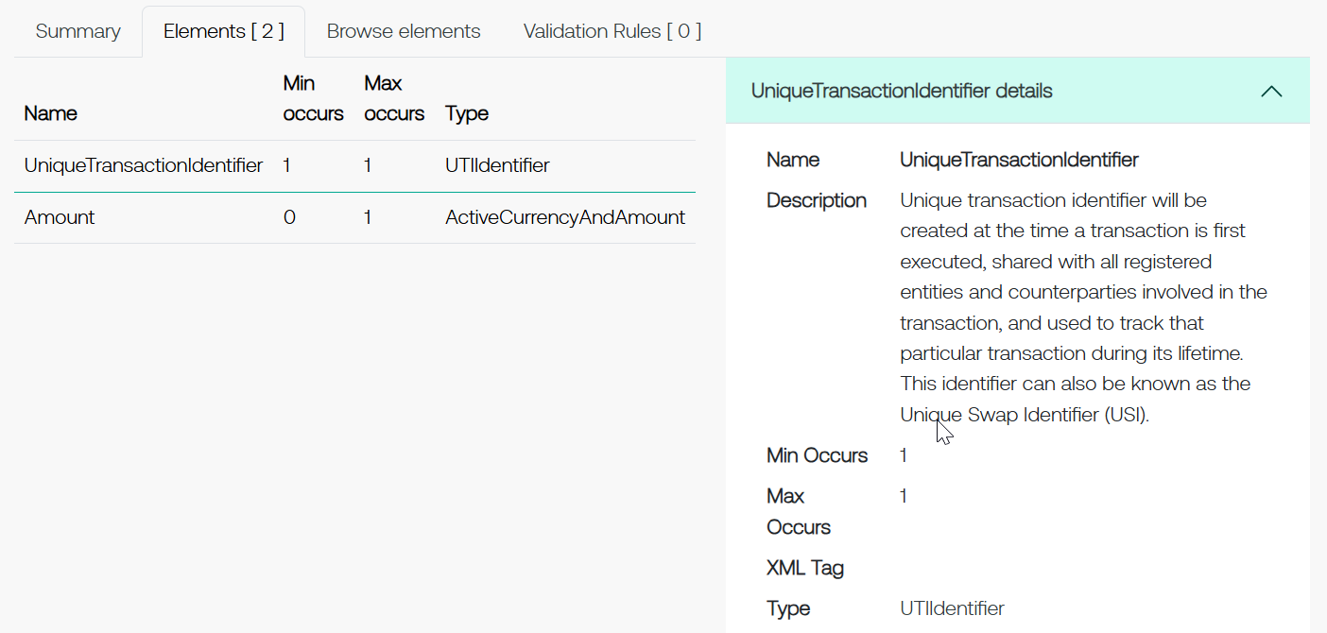

Proposed timing:
The submitting organization confirms that it can implement the requested changes in the requested timing, or, if not, proposes another timing.

Timing | - As requested

Final decision of the SEG(s):
This section is not to be taken care of by the submitting organization. It will be completed in due time by the SEG(s) in charge of the related ISO 20022 messages.
Approve | X
Comments:

Reject
Reason for rejection:

Change request number 1408
Change of the UTI implementation in ISO 20022 messages and additions

Origin of the request
A.1 Submitter: SMPG Settlements & Reconciliation Working Group represented by Robin Leary (UK&IE Representative) and Karine Taquet (Swift Standards)

A.2 Contact person: Robin Leary (robin.leary@citi.com)

A.3 Sponsors: SMPG Settlements & Reconciliation Working Group

Related messages
Securities Management
semt.017, semt.018, semt.019, semt.022 (T2S UTI not included at all), sese.021, sese.023, sese.024, sese.025, sese.026, sese.028, sese.030, sese.031, sese.032, sese.033, sese.034, sese.035, sese.036, sese.038, sese.022, sese.041, sese.042

Securities Trade (UTI not included must be)
setr.027, setr.030, setr.044, setr.029

Collateral Management
colr.005, colr.019, colr.020, colr.021, colr.022, colr.23, colr.024

Reference Data
reda.074

Cash Management
camt.057, camt.111

Payments Clearing and Settlement
pacs.009

Authorities
auth.016, auth.029, auth.030, auth.052, auth.070, auth.078, auth.079, auth.080, auth.083, auth.084, auth.085, auth.090, auth.091, auth.092, auth.105, auth.106, auth.107, auth.108, auth.109, auth.113

Foreign Exchange Trade
fxtr.008, fxtr.015, fxtr.016, fxtr.017, fxtr.014

Description of the change request
As part of SR2019 (CR 001448), the UTI was added to numerous MT messages and, as part of co-existence, all equivalent ISO 20022 messages. In ISO 15022, this was done by adding a new 20U format option in qualifier TRRF (Deal Reference) and in ISO 20022, the Trade Identification element was made repetitive, and the length increased from 35 characters to 52 characters.
Whilst the ISO 15022 addition is easily distinguished between a traditional Deal Reference (:20C::TRRF) and UTI (:20U::TRRF), the ISO 20022 element does not easily distinguish between the two and can lead to confusion.
The proposal is to create a new element in ISO 20022 for the UTI in the Trade Details sequence and revert the Trade Identification element to its original form (non-repetitive and 35 characters). The ISO 15022 use will remain as is.
In the ISO 20022 messages where the UTI is not present, I must be added.
Given there's not a huge usage of the UTI in ISO 20022 messages at present, the change should be low impact.

Purpose of the change:
Create a new "Unique Transaction Identifier" element in the Trade Details sequence (or other relevant sequences) in all impacted ISO 20022 messages (where the change was made in SR2019). The new element should be optional, non-repetitive and up to 52 characters in length.
The "Trade Identification" element should be changed to revert to being non-repetitive and up to 35 characters in length.
From a translation perspective, :20C::TRRF would align to the Trade Identification element and :20U::TRRF would align to the new Unique Transaction Identifier element.
No changes are expected to the ISO 15022 MT messages.
In the ISO 20022 messages where the UTI is missing, it must be added.

Urgency of the request:
2025/2026 maintenance cycle

Business Examples:
N/A

SEG/TSG recommendation:
This section is not to be taken care of by the submitter of the change request. It will be completed in due time by the SEG(s) in charge of the related ISO 20022 messages or the TSG for changes related to the BAH.

Consider |  | X | Timing
 |  |  | - Next yearly cycle: 2025/2026  (the change will be considered for implementation in the yearly maintenance cycle which starts in 2025 and completes with the publication of new message versions in the spring of 2026) |  | X
- At the occasion of the next maintenance of the messages
(the change will be considered for implementation, but does not justify maintenance of the messages in its own right – will be pending until more critical change requests are received for the messages)
- Urgent unscheduled
(the change justifies an urgent implementation outside of the normal yearly cycle)
 |  |  | - Other timing:
Comments:

Reject
Reason for rejection:

Impact analysis and type of impact:
The following Message Identifiers will be impacted –

acmt.027.001.05 | AccountSwitchInformationRequestV05
acmt.028.001.05 | AccountSwitchInformationResponseV05
acmt.029.001.05 | AccountSwitchCancelExistingPaymentV05
acmt.031.001.05 | AccountSwitchRequestBalanceTransferV05
acmt.032.001.05 | AccountSwitchBalanceTransferAcknowledgementV05
acmt.034.001.05 | AccountSwitchRequestPaymentV05
camt.029.001.13 | ResolutionOfInvestigationV13
camt.052.001.13 | BankToCustomerAccountReportV13
camt.053.001.13 | BankToCustomerStatementV13
camt.054.001.13 | BankToCustomerDebitCreditNotificationV13
camt.055.001.12 | CustomerPaymentCancellationRequestV12
camt.056.001.11 | FIToFIPaymentCancellationRequestV11
camt.057.001.08 | NotificationToReceiveV08
camt.058.001.09 | NotificationToReceiveCancellationAdviceV09
camt.059.001.08 | NotificationToReceiveStatusReportV08
pacs.002.001.15 | FIToFIPaymentStatusReportV15
pacs.003.001.11 | FIToFICustomerDirectDebitV11
pacs.004.001.14 | PaymentReturnV14
pacs.007.001.13 | FIToFIPaymentReversalV13
pacs.008.001.13 | FIToFICustomerCreditTransferV13
pacs.009.001.12 | FinancialInstitutionCreditTransferV12
pacs.028.001.06 | FIToFIPaymentStatusRequestV06
pain.001.001.12 | CustomerCreditTransferInitiationV12
pain.002.001.14 | CustomerPaymentStatusReportV14
pain.007.001.12 | CustomerPaymentReversalV12
pain.008.001.11 | CustomerDirectDebitInitiationV11
pain.013.001.11 | CreditorPaymentActivationRequestV11
pain.014.001.11 | CreditorPaymentActivationRequestStatusReportV11
remt.001.001.06 | RemittanceAdviceV06

Proposed implementation:

The proposed implementation is the same as CR1405.

Proposed timing:
The submitting organization confirms that it can implement the requested changes in the requested timing, or, if not, proposes another timing.

Timing | - As requested

Final decision of the SEG(s):
This section is not to be taken care of by the submitting organization. It will be completed in due time by the SEG(s) in charge of the related ISO 20022 messages.
Approve | X
Comments:

Reject
Reason for rejection:

Change request number 1465
Add ‘Regulatory Reporting element to the pacs.009

Origin of the request
A.1 Submitter: China National Member Group

A.2 Contact person: person(s) who can be contacted to get additional information on the request (name, e-mail, telephone)
Ms Zhang Yan swift@bankofchina.com 86 10 66591827

A.3 Sponsors:

Related messages
pacs.009.001.012

Description of the change request
To add the element "Regulatory Reporting" to pacs.009 messages. This element’s path and usage rules should mirror those of the element "Regulatory Reporting" in pacs.008 messages.

Purpose of the change:
Global users conduct cross-border RMB remittance transactions utilizing CBPR+ message formats such as pacs.008, pacs.009, and pacs.009cov. These messages require the inclusion of the China Cross-Border Interbank Payment System (CIPS) business category codes, which classify the transaction's purpose and ensure compliance with Chinese regulatory requirements. Examples of these codes include:
- GODX: Cross-border Goods Trade
- STRX: Cross-border Services Trade
- CTFX: Cross-border Capital Transfer
- RMTX: Cross-border Individual Remittance
- FTFX: Financial Institution Transfer
- OTFX: Other Transfer

From a standards perspective, these codes should be input in the "Regulatory Reporting" element. However, the current format of pacs.009 does not include the "Regulatory Reporting" element. To address this gap, it is essential to incorporate the "Regulatory Reporting" element into pacs.009 base message.

Urgency of the request:

Business Examples:

<RgltryRptg>
<DbtCdtRptgInd>CRED</DbtCdtRptgInd>
<Dtls>
<Tp>PURP</Tp>
<Cd>STRX</Cd>
</Dtls>
</RgltryRptg>

SEG/TSG recommendation:
This section is not to be taken care of by the submitter of the change request. It will be completed in due time by the SEG(s) in charge of the related ISO 20022 messages or the TSG for changes related to the BAH.

Consider |  | X | Timing
 |  |  | - Next yearly cycle: 2025/2026  (the change will be considered for implementation in the yearly maintenance cycle which starts in 2025 and completes with the publication of new message versions in the spring of 2026) |  | X
- At the occasion of the next maintenance of the messages
(the change will be considered for implementation, but does not justify maintenance of the messages in its own right – will be pending until more critical change requests are received for the messages)
- Urgent unscheduled
(the change justifies an urgent implementation outside of the normal yearly cycle)
 |  |  | - Other timing:
Comments:

Reject
Reason for rejection:

Impact analysis and type of impact:
The following Message Identifiers will be impacted –

pacs.009.001.12 FinancialInstitutionCreditTransferV12

Proposed implementation:

It is proposed that Regulatory Reporting is also added to Underlying Financial Institution Credit Transfer.
The PAYSEG supported this.

Current:

There is no regulatory reporting element present in the pacs.009 currently.

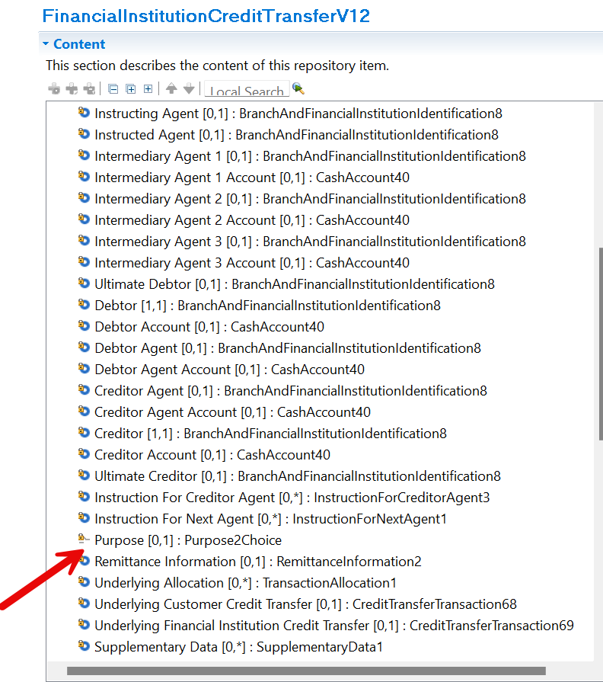

Proposed implementation

The regulatory reporting element is proposed to be added to the pacs.009.

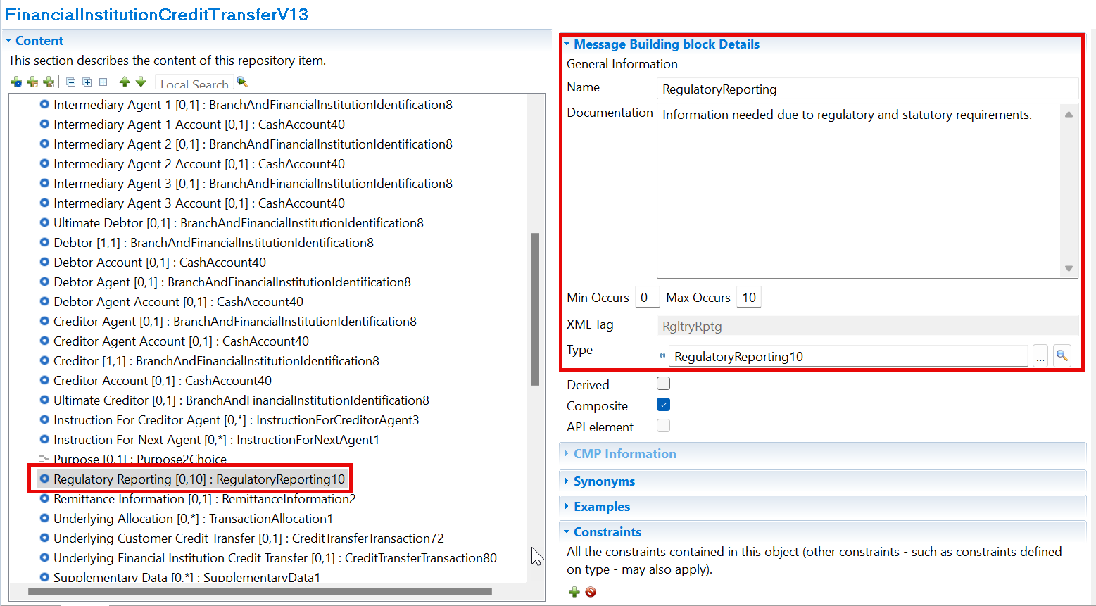

Proposed timing:
The submitting organization confirms that it can implement the requested changes in the requested timing, or, if not, proposes another timing.

Timing | - As requested

Final decision of the SEG(s):
This section is not to be taken care of by the submitting organization. It will be completed in due time by the SEG(s) in charge of the related ISO 20022 messages.
Approve | X
Comments:

Reject
Reason for rejection:

Change request number 1481
‘Standardise’ the usage of Regulatory Reporting elements

Origin of the request:
A.1 Submitter: PMPG (Payments Market Practice Group)

A.2 Contact person: Sean Mouton Sean.Mouton@absa.africa

A.3 Sponsors: PMPG (Payments Market Practice Group)

Related messages:
Account Switching message set (under the responsibility of Payments UK):
acmt.027.001.05 | AccountSwitchInformationRequestV05
acmt.028.001.05 | AccountSwitchInformationResponseV05
acmt.029.001.05 | AccountSwitchCancelExistingPaymentV05
acmt.031.001.05 | AccountSwitchRequestBalanceTransferV05
acmt.032.001.05 | AccountSwitchBalanceTransferAcknowledgementV05
acmt.034.001.05 | AccountSwitchRequestPaymentV05
Payments Initiation message set (under the responsibility of ISTH/SWIFT):
pain.001.001.12  pain.008.001.11 | CustomerCreditTransferInitiationV12  CustomerDirectDebitInitiationV11
Creditor Payment Activation Request message set (under the responsibility of CBI):
pain.013.001.11 | CreditorPaymentActivationRequestV11
Payments, Clearing and Settlement:
pacs.003.001.11 | FIToFICustomerDirectDebitV11
pacs.008.001.12 | FIToFICustomerCreditTransferV12

Description of the change request:
Reporting of Regulatory Reporting information to a Reporting Authority requires a minimum set of data, which may be complimented with additional data depending upon the requirements of particular Reporting Authorities. This Change Request proposes to ensure that the minimum set of data is identified within the base message and that the reporting type is standarised.
Within Regulatory Reporting:
  - the Debit Credit Reporting Indicator should be required when Regulatory Reporting is used.
  - Type, as a description of the type of Regulatory Reporting information included, is currently Max35Text; it is proposed to codify this Type with an external code (4 character), or proprietary code being selected.
Initial values for the new external code set would be as follows-

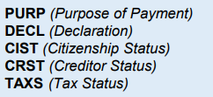

  - A new rule should also be implemented to require either Details>Code or Details>Information - both may be present; both cannot be absent.
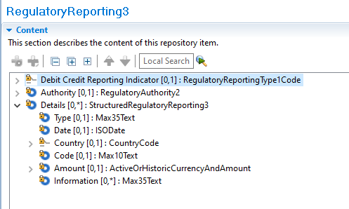

Purpose of the change:
With the introduction of ISO 20022, the submitter sees an opportunity to standardise usage of the Regulatory Reporting elements in ISO 20022 payment messages and ensure that, whenever Regulatory Reporting is used, it is used in a consistent way, with a minimum set of essential data. Maintaining the “Details>Type” element as a free format element makes standardization more difficult. Using an external code list will support validation by the network implementing the standard.
The Change Request proposes the following to the optional Regulatory Reporting element:
- Externalise Details>Type to a choice of Code or Proprietary, as a required element.
- Change the Debit Credit Reporting Indicator to a required element.
- Add a rule to ensure, at minimum, either Details>Code or Details>Information is provided.
This change request does not seek to standardise the codes used by Reporting Authorities.

Urgency of the request:
2025/2026 maintenance cycle

Business examples:
n/a

SEG/TSG Recommendation:
This section is not to be taken care of by the submitter of the change request. It will be completed in due time by the SEG(s) in charge of the related ISO 20022 messages or the TSG for changes related to the BAH.

Consider |  | X | Timing
 |  |  | - Next yearly cycle: 2025/2026  (the change will be considered for implementation in the yearly maintenance cycle which starts in 2025 and completes with the publication of new message versions in the spring of 2026) |  | X
- At the occasion of the next maintenance of the messages
(the change will be considered for implementation, but does not justify maintenance of the messages in its own right – will be pending until more critical change requests are received for the messages)
- Urgent unscheduled
(the change justifies an urgent implementation outside of the normal yearly cycle)
 |  |  | - Other timing:
Comments:

Reject
Reason for rejection:

Impact analysis and type of impact:
The following Message Identifiers will be impacted –

acmt.027.001.05 | AccountSwitchInformationRequestV05
acmt.028.001.05 | AccountSwitchInformationResponseV05
acmt.029.001.05 | AccountSwitchCancelExistingPaymentV05
acmt.031.001.05 | AccountSwitchRequestBalanceTransferV05
acmt.032.001.05 | AccountSwitchBalanceTransferAcknowledgementV05
acmt.034.001.05 | AccountSwitchRequestPaymentV05
pacs.003.001.11 | FIToFICustomerDirectDebitV11
pacs.008.001.13 | FIToFICustomerCreditTransferV13
pain.001.001.12 | CustomerCreditTransferInitiationV12
pain.008.001.11 | CustomerDirectDebitInitiationV11
pain.013.001.11 | CreditorPaymentActivationRequestV11
trck.001.001.04 | PaymentStatusTrackerUpdateV04
trck.002.001.03 | PaymentStatusTrackerReportV03
trck.004.001.03 | PaymentStatusCustomerTrackerReportV03

Proposed implementation:

Question to the PAYSEG: We would propose that Debit Credit Reporting Indicator remains optional. We can provide a default value that can be assumed, where the element is not present. We would suggest Both
22nd September – The CR submitter explained that mandating at an implementation level brought challenges in an end-to-end payment flow and therefore it was agreed that the indicator would in fact become mandatory.

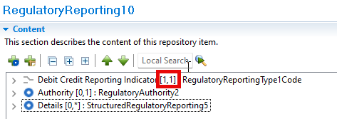

This is the proposed implementation -
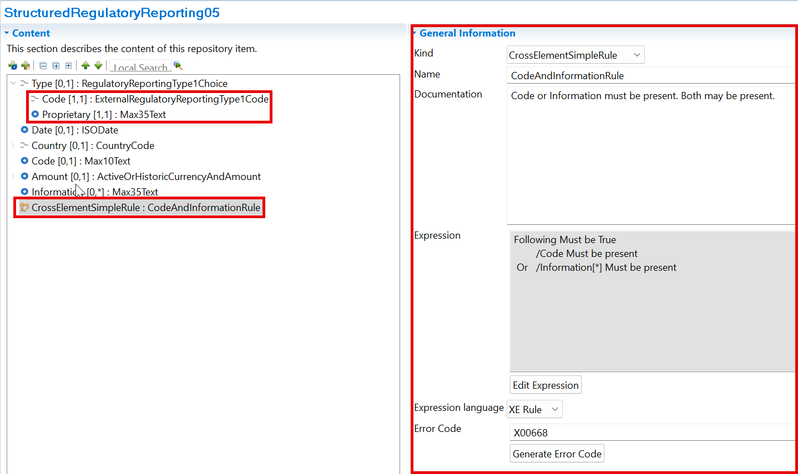

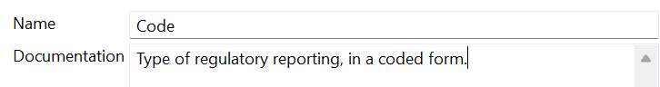

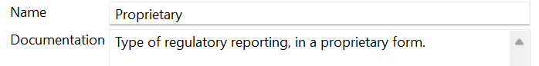

Proposed timing:
The submitting organization confirms that it can implement the requested changes in the requested timing, or, if not, proposes another timing.

Timing | - As requested

Final decision of the SEG(s):
This section is not to be taken care of by the submitting organization. It will be completed in due time by the SEG(s) in charge of the related ISO 20022 messages.
Approve | X
Comments:

Reject
Reason for rejection:

Change request number 1493
Correct the ‘OriginalMessageNameIdentification’ element description

Origin of the request:
A.1 Submitter: CBPRplus Working Group

A.2 Contact person: person(s) who can be contacted to get additional information on the request (name, e-mail, telephone)

A.2.1. First name, Last name | Mabel Lu
A.2.2. Email address | Mabel.Lu@swift.com
A.2.3. Telephone

A.3 Sponsors:

Related messages:
camt.055

Description of the change request:
Request type: Correct the description in the OriginalMessageNameIdentification (/Document/CstmrPmtCxlReq/Undrlyg/OrgnlPmtInfAndCxl/OrgnlGrpInf/OrgnlMsgNmId) element in camt.055 to exclude payment clearing and settlement (pacs.003 or MT103) messages.

Purpose of the change:
According to the definition, the camt.055 CustomerPaymentCancellationRequest message is issued by the initiating party to request the cancellation of a previously sent payment initiation message, such as a CustomerCreditTransferInitiation, CreditorPaymentActivationRequest, or CustomerDirectDebitInitiation. However, the description of the OriginalMessageNameIdentification element (/Document/CstmrPmtCxlReq/Undrlyg/OrgnlPmtInfAndCxl/OrgnlGrpInf/OrgnlMsgNmId) incorrectly refers to payment clearing and settlement messages, specifically 'pacs.003 or MT103.' This should be corrected to reference payment initiation messages, such as 'pain.001 or MT101.'

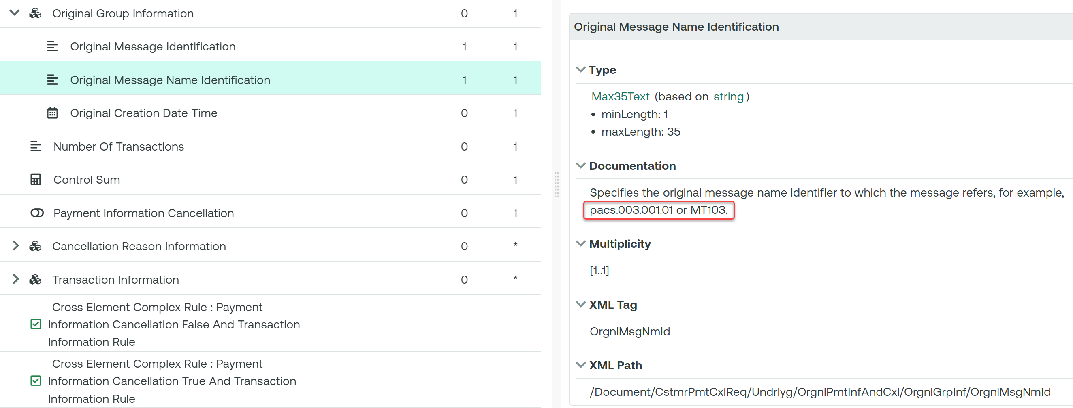

Urgency of the request:
Normal urgency

Business examples:
Change
“Specifies the original message name identifier to which the message refers, for example, pacs.003.001.01 or MT103.”
…to
“Specifies the original message name identifier to which the message refers, for example, pain.001.001.08 or MT101.”

SEG/TSG recommendation:
This section is not to be taken care of by the submitter of the change request. It will be completed in due time by the SEG(s) in charge of the related ISO 20022 messages or the TSG for changes related to the BAH.

Consider |  | X | Timing
 |  |  | - Next yearly cycle: 2025/2026  (the change will be considered for implementation in the yearly maintenance cycle which starts in 2025 and completes with the publication of new message versions in the spring of 2026) |  | X
- At the occasion of the next maintenance of the messages
(the change will be considered for implementation, but does not justify maintenance of the messages in its own right – will be pending until more critical change requests are received for the messages)
- Urgent unscheduled
(the change justifies an urgent implementation outside of the normal yearly cycle)
 |  |  | - Other timing:
Comments:

Reject
Reason for rejection:

Impact analysis and type of impact:
The following Message Identifiers will be impacted –

camt.029.001.13 | ResolutionOfInvestigationV13
camt.055.001.12 | CustomerPaymentCancellationRequestV12
camt.056.001.11 | FIToFIPaymentCancellationRequestV11
camt.110.001.01 | InvestigationRequestV01
camt.111.001.02 | InvestigationResponseV02
pacs.002.001.15 | FIToFIPaymentStatusReportV15
pacs.004.001.14 | PaymentReturnV14
pacs.007.001.13 | FIToFIPaymentReversalV13
pacs.028.001.06 | FIToFIPaymentStatusRequestV06

Proposed implementation:

Swift does not support the requested implementation of updating the example in the message, as the component is used across multiple messages. An example that applies to all messages is impossible. Therefore to avoid confusion, Swift proposes to remove the example.
The PAYSEG supported this.

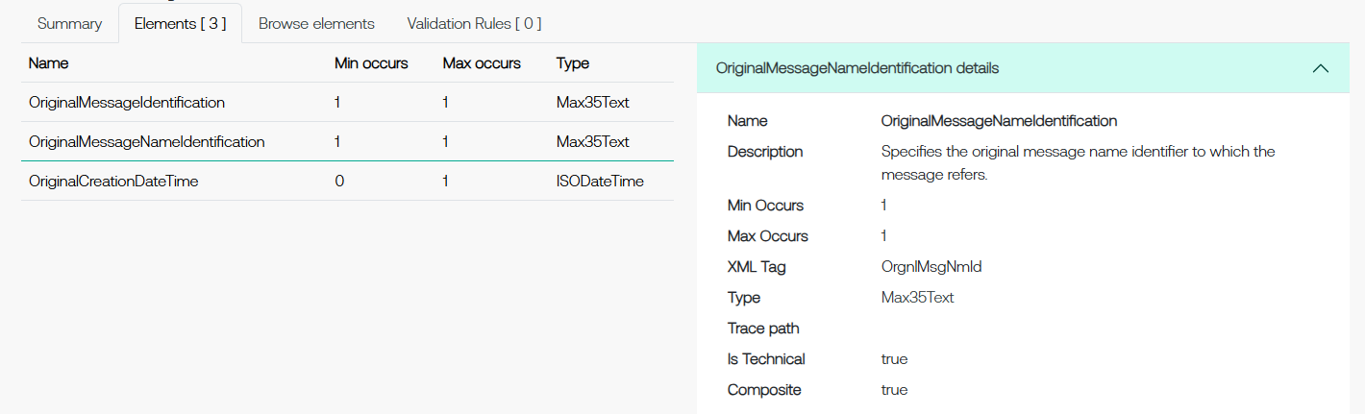

Proposed timing:
The submitting organization confirms that it can implement the requested changes in the requested timing, or, if not, proposes another timing.

Timing | - As requested

Final decision of the SEG(s):
This section is not to be taken care of by the submitting organization. It will be completed in due time by the SEG(s) in charge of the related ISO 20022 messages.
Approve | X
Comments:

Reject
Reason for rejection:

Change request number 1494
Change the ‘Organisation’ element from mandatory to optional.

Origin of the request:
A.1 Submitter:
SIX Interbank Clearing Ltd
A.2 Contact person:
Roman Locher, Senior Standards Manager
roman.locher@six-group.com
T +41 58 399 4125
A.3 Sponsors:
SIX Interbank Clearing participates in several committees focused on standardization in payments, acting as representative of the Swiss financial industry. SIX Interbank Clearing also operates the SIC system mandated by Swiss National Bank, which consists of the two CHF services SIC-RTGS and SIC IP (Instant Payments).

Related messages:
acmt.015 (AccountExcludedMandateMaintenanceRequest, latest version: acmt.015.001.04)

Description of the change request:
SIX requests the “Organisation” element (Document/AcctExcldMndtMntncReq/Org) to be changed from mandatory to optional. | 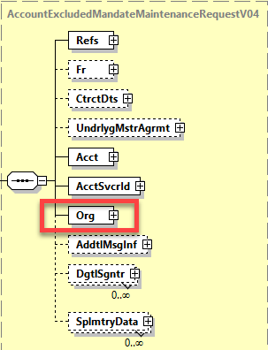

Purpose of the change:
SIX uses acmt.015 message for triggering different use cases by participants on their settlement accounts in the SIC system. Only the elements <Acct> and <AcctSvcrId> are required in the SIC system to identify parties and accounts involved in the corresponding use cases, whereas element <Org> is irrelevant and therefore ignored.
Due to the fact that the <Org> element is mandatory, system participants are actually forced to use this component with pseudo or default values to comply with ISO 20022 schema specifications. To avoid unnecessary pseudo data, SIX therefore requests the <Org> element to be defined as optional.

Urgency of the request:
Next yearly maintenance cycle (publication in April/May 2026).

Business examples:
n/a

SEG/TSG recommendation:
This section is not to be taken care of by the submitter of the change request. It will be completed in due time by the SEG(s) in charge of the related ISO 20022 messages or the TSG for changes related to the BAH.

Consider |  | X | Timing
 |  |  | - Next yearly cycle: 2025/2026  (the change will be considered for implementation in the yearly maintenance cycle which starts in 2025 and completes with the publication of new message versions in the spring of 2026) |  | X
- At the occasion of the next maintenance of the messages
(the change will be considered for implementation, but does not justify maintenance of the messages in its own right – will be pending until more critical change requests are received for the messages)
- Urgent unscheduled
(the change justifies an urgent implementation outside of the normal yearly cycle)
 |  |  | - Other timing:
Comments:

Reject
Reason for rejection:

Impact analysis and type of impact:

Bank Account Management:
acmt.015.001.04 | AccountExcludedMandateMaintenanceRequestV04
acmt.016.001.04 | AccountExcludedMandateMaintenanceAmendmentRequestV04
acmt.017.001.04 | AccountMandateMaintenanceRequestV04
acmt.018.001.04 | AccountMandateMaintenanceAmendmentRequestV04

Proposed implementation:

We recommend Organisation becomes optional across the four messages in the message set that relate to account mandates.
The PAYSEG supported this.
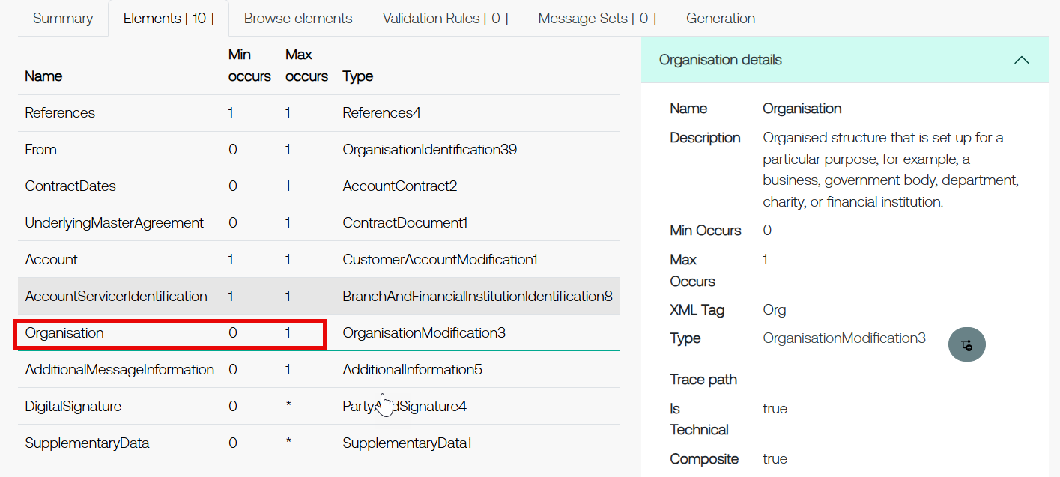

Proposed timing:
The submitting organization confirms that it can implement the requested changes in the requested timing, or, if not, proposes another timing.

Timing | - As requested

Final decision of the SEG(s):
This section is not to be taken care of by the submitting organization. It will be completed in due time by the SEG(s) in charge of the related ISO 20022 messages.
Approve | X
Comments:

Reject
Reason for rejection:

Change request number 1509
Add the ‘Return Identification’ element to cash management messages

Origin of the request
A.1 Submitter: UK BPC

A.2 Contact person:

Chloe Jenkins chloe.jenkins@barclays.com
Dean C Dean.CHARD@swift.com

A.3 Sponsors: CBPR+

Related messages
camt.052.001.13
camt.053.001.13
camt.054.001.13

Description of the change request
The pacs.004 payment return includes an optional element known as Return Identification. In some markets and implementations of this message this element is mandatory.
However this element is not included in the Bank to Customer Cash Management messages. This element should be added to these as an optional element.
We would suggest the element is added to the Return Information block that already exists.

Purpose of the change:
Improve reconciliation and reduce queries from customers.

Urgency of the request:
2025/2026 maintenance cycle

Business Examples:
N/A

SEG/TSG recommendation:
This section is not to be taken care of by the submitter of the change request. It will be completed in due time by the SEG(s) in charge of the related ISO 20022 messages or the TSG for changes related to the BAH.

Consider |  | X | Timing
 |  |  | - Next yearly cycle: 2025/2026  (the change will be considered for implementation in the yearly maintenance cycle which starts in 2025 and completes with the publication of new message versions in the spring of 2026) |  | X
- At the occasion of the next maintenance of the messages
(the change will be considered for implementation, but does not justify maintenance of the messages in its own right – will be pending until more critical change requests are received for the messages)
- Urgent unscheduled
(the change justifies an urgent implementation outside of the normal yearly cycle)
 |  |  | - Other timing:
Comments:

Reject
Reason for rejection:

Impact analysis and type of impact:
The following Message Identifiers will be impacted –

camt.052.001.13 | BankToCustomerAccountReportV13
camt.053.001.13 | BankToCustomerStatementV13
camt.054.001.13 | BankToCustomerDebitCreditNotificationV13
camt.111.001.02 | InvestigationResponseV02

Proposed implementation:

We propose to add this Return Identification element to the References block, as opposed to what was recommended in the CR.

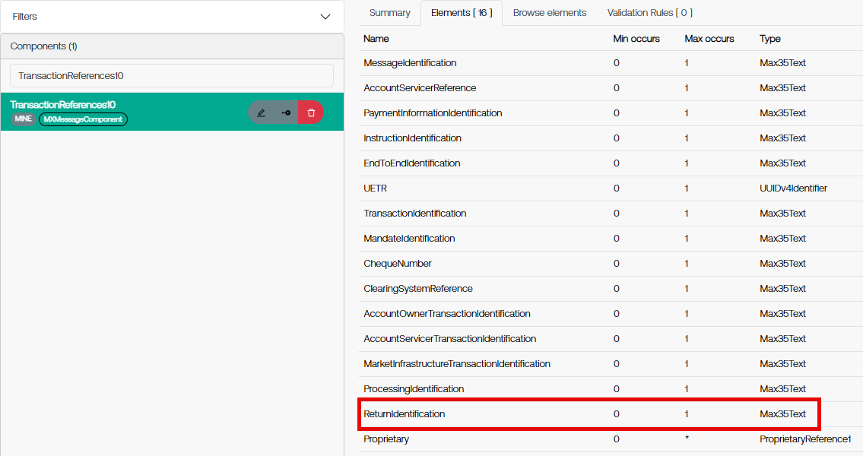

Proposed timing:
The submitting organization confirms that it can implement the requested changes in the requested timing, or, if not, proposes another timing.

Timing | - As requested

Final decision of the SEG(s):
This section is not to be taken care of by the submitting organization. It will be completed in due time by the SEG(s) in charge of the related ISO 20022 messages.
Approve | X
Comments:

Reject
Reason for rejection:

Change request number 1510
Change the scope description to the payment status report messages

Origin of the request
A.1 Submitter: UK BPC

A.2 Contact person:
Chloe Jenkins chloe.jenkins@barclays.com
Dean C Dean.CHARD@swift.com

A.3 Sponsors: CBPR+

Related messages
pacs.002.001.15
pain.002.001.14

Description of the change request
The pacs.002 scope currently states -
The FIToFIPaymentStatusReport message is exchanged between agents to provide status information about instructions previously sent. Its usage will always be governed by a bilateral agreement between the agents.
The pain.002 scope currently states –
The CustomerPaymentStatusReport message is exchanged between an agent and a non-financial institution customer to provide status information on instructions previously sent. Its usage will always be governed by a bilateral agreement between the agent and the non-financial institution customer.
The pacs.002 scope should be updated as follows –
The FIToFIPaymentStatusReport message is exchanged between agents to provide status information about instructions previously sent. Its usage will always be governed by a bilateral agreement between the agents, except where the status is rejected. Where a payment is rejected the FIToFIPaymentStatusReport message can be sent without a bilateral agreement being established.
The pain.002 scope should be updated as follows –
The CustomerPaymentStatusReport message is exchanged between an agent and a non-financial institution customer to provide status information on instructions previously sent. Its usage will always be governed by a bilateral agreement,between the agent and the non-financial institution customer, except where the status is rejected. Where a payment is rejected the CustomerPaymentStatusReport message can be sent without a bilateral agreement being established.

Purpose of the change:
As part of Swift’s cross border payment and reporting product some agents are refusing to accept a pacs.002 with a reject status as they claim the pacs.002 base message scope mandates a bilateral agreement be established first despite the status. This is somewhat illogical as Swift’s cross border payment and reporting implementation has mandated use of the pacs.002 in any reject scenario and it is within the interest of the agent to accept and process the pacs.002 reject as it directly impacts customers as a payment has been rejected. By amending the pacs.002 base message scope in this manner it will clarify to any implementors of this new message version that no bilateral agreement is required to inform of a reject status.
For alignment and consistency we also recommend updating the pain.002 base message scope however would accept only the pacs.002 base message scope being updated.

Urgency of the request:
2025/2026 maintenance cycle

Business Examples:
N/A

SEG/TSG recommendation:
This section is not to be taken care of by the submitter of the change request. It will be completed in due time by the SEG(s) in charge of the related ISO 20022 messages or the TSG for changes related to the BAH.

Consider |  | X | Timing
 |  |  | - Next yearly cycle: 2025/2026  (the change will be considered for implementation in the yearly maintenance cycle which starts in 2025 and completes with the publication of new message versions in the spring of 2026) |  | X
- At the occasion of the next maintenance of the messages
(the change will be considered for implementation, but does not justify maintenance of the messages in its own right – will be pending until more critical change requests are received for the messages)
- Urgent unscheduled
(the change justifies an urgent implementation outside of the normal yearly cycle)
 |  |  | - Other timing:
Comments:

Reject
Reason for rejection:

Impact analysis and type of impact:
The following Message Identifiers will be impacted –

pacs.002.001.15 FIToFIPaymentStatusReportV15
pain.002.001.14 CustomerPaymentStatusReportV14

Proposed implementation:

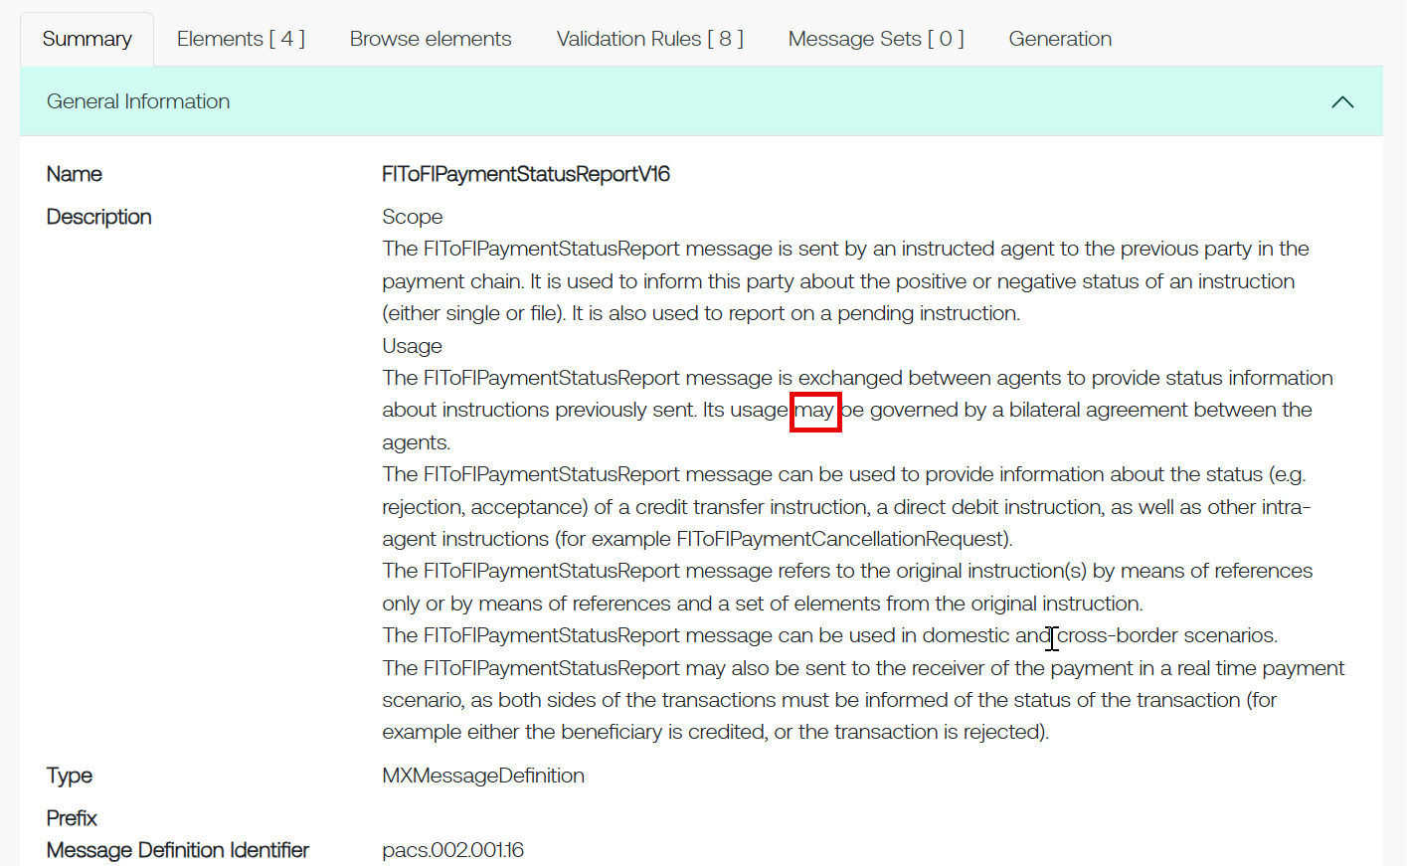

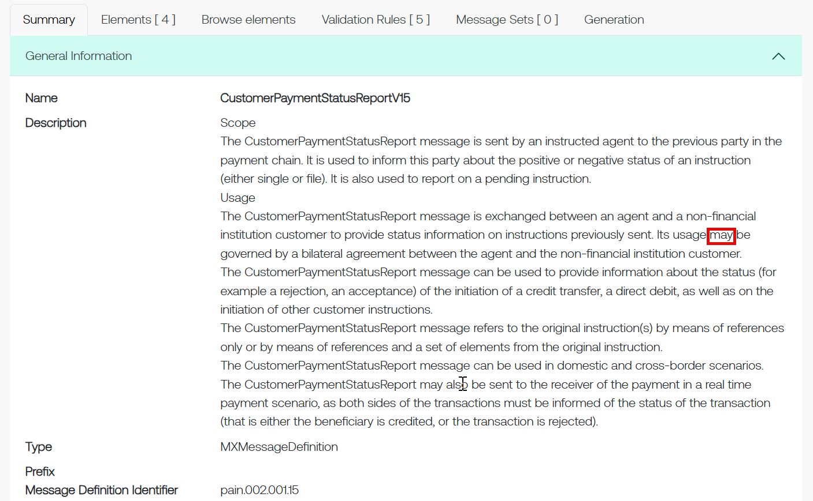

Proposed timing:
The submitting organization confirms that it can implement the requested changes in the requested timing, or, if not, proposes another timing.

Timing | - As requested

Final decision of the SEG(s):
This section is not to be taken care of by the submitting organization. It will be completed in due time by the SEG(s) in charge of the related ISO 20022 messages.
Approve | X
Comments:

Reject
Reason for rejection:

Additional technical adjustments in the ISO 20022 rules identified during the maintenance (standing change request)
As part of the implementation, we have identified a number of technical errors in the description of the rules defined in the messages. Below is the exhaustive list of corrections as applied to the messages:

 | Issue in rule or data type | Description of the change required
1 | Widely used component incorrectly states ‘person’. ISO Registration Authority propose a patch to correct this error. Patch will be applied to the latest version of the component on all impacted messages. | 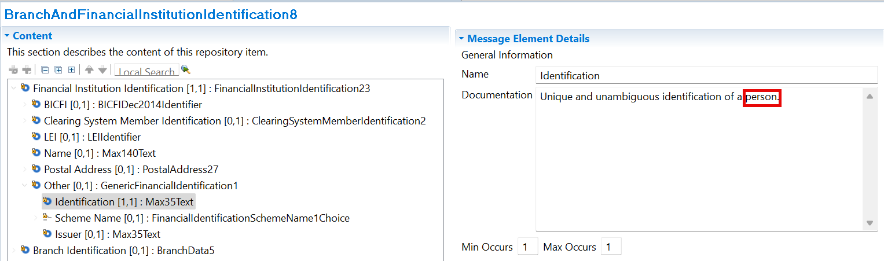
2 | InstructionForCreditorAgentRule The formal rule has been/will be updated to correctly implement the rule. | 