Change Request
for the update of an External Code Set
Note: this document is to be completed by parties that request to either add new codes or clarify the definition of existing codes or replace existing codes by new one(s) or expire existing codes in one of the External Code Sets used in ISO 20022 messages. All change requests conforming to this template that are received prior to the end of a quarter (31 March, 30 June, 30 September, 31 December) will be evaluated by the SEG and, if approved, incorporated in the following quarterly publication cycle of the External Code Sets (respectively, by end of May, August, November and February), unless otherwise specified by the SEG.

Origin of the request:

A.1 Submitter:

Name of the company, organization, group, initiative or community that submits the change request. | Swift

A.2 Contact person:
Person that can be contacted for additional information on the request

A.2.1. First name, Last name | David Wang
A.2.2. Email address | David.wang@swift.com
A.2.3. Telephone | +32484125885

A.3 Sponsors:
If the submitter acts on behalf of or has gained support from other organisations, groups, initiatives or communities, these should be listed as sponsors.

This request is submitted as part of the Swift Ledger initiative.

Description of the change request:
Specify the request type: creation of new code set, update of existing code set, deletion of existing code set.
For the creation of a new code set or for updating an existing code set, also complete the table in section H below. For the addition of new codes, all the details must be specified, including a proposed code, a proposed code name, a clear definition, and any other indications, such as an example or format to be published with the code set.

Request type: creation, update, deletion | Update of existing codeset

Related External Code Set:
For updating or deleting an existing code set, indicate the exact name of the code set as indicated in the External Code Sets documents on iso20022.org. For creating a new code set, indicate a proposed name for the new code set.
A specific change request form must be completed for each code set to be updated.

ExternalServiceLevel1Code

Purpose of the change:
Background, business context, community of users interested by the change and expected benefits/savings.
This section must explain why the existing code set needs to be changed. The reason for the update may be a business reason (e.g., evolution of market practice, or creation of new financial instruments), a technical reason (e.g., automation of the business process, or switch from a batch to a real time process), a regulatory reason (introduction, generally mandatory, of new rule/law) or the extension of the user community (newly identified business requirements).

Business background and context:
The financial industry is undergoing a profound transformation driven by tokenization and distributed ledger technology (DLT). These innovations are redefining how value and assets move globally, creating demand for real-time, always-on, programmable, and interoperable settlement solutions.
However, the industry faces a critical challenge: fragmentation. Independent initiatives risk creating isolated platforms with proprietary tokens and limited interoperability. This patchwork approach could undermine efficiency gains and increase operational complexity, rather than delivering the benefits tokenization promises.
Against this backdrop, there is a clear need for a neutral, shared infrastructure that bridges traditional financial systems and emerging digital ecosystems. The Swift Ledger introduces a new settlement paradigm in which transactions are recorded, validated, and settled on a permissioned distributed ledger, while remaining fully aligned with existing financial market infrastructures and messaging standards.
Reasons for the update of the service level codeset:
Swift Ledger requires the new service level code (proposed code is “SD01” for “Swift Digital Service - Swift Ledger”) to unambiguously identify that the transaction should be processed via the Swift Ledger.
Without a dedicated service level code, participants would lack a standardized and semantically accurate way to reference Swift Ledger–based activities, which could lead to ambiguity, operational risk, and inconsistent interpretation across the ecosystem.

Urgency of the request:
By default, valid change requests, subsequently approved by the SEG will be included in the following quarterly publication of External Code Sets, unless decided otherwise by the SEG.
If there is a need to have the new version of the related code set published earlier, the reason for the urgency and the expected consequences of a delay should be described here. Acceptance of such an unscheduled publication is subject to approval by the SEG.

Approval in March 2026
Publication in May/June 2026
Use in production June 2026

Business examples:
Provide examples illustrating usage of the code set and indicate messages where the code set may be used.

Scope:
The SD01 service level code is intended to be used in ISO 20022 pacs.008 messages to identify Swift Ledger as the orchestrator for clearing and settlement mechanism for eligible FI‑to‑FI credit transfers.
Visual representation of the usage of the Swift Ledger service level:
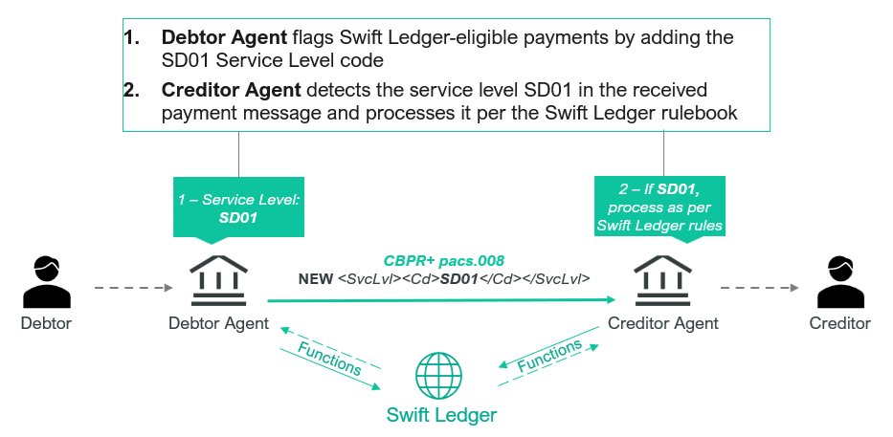
Sample xml message for illustration purposes:
<FIToFICstmrCdtTrf>
<GrpHdr>
<MsgId>123</MsgId>
<CreDtTm>2026-06-16T10:02:10+02:00</CreDtTm>
NbOfTxs>1</NbOfTxs>
<SttlmInf>
<SttlmMtd>INDA</SttlmMtd>
</SttlmInf>
</GrpHdr>
<CdtTrfTxInf>
</PmtId>
<InstrId>123</InstrId>
<EndToEndId>456</EndToEndId>
<UETR>fff0e2e0-de67-402e-bb4b-eca40713a479</UETR>
</PmtId>
<PmtTpInf>
<SvcLvl>
<Cd>SD01</Cd>
</SvcLvl>
</PmtTpInf>
<IntrBkSttlmAmt Ccy="USD">1000</IntrBkSttlmAmt>
<IntrBkSttlmDt>2026-06-16</IntrBkSttlmDt>
<InstdAmt Ccy="USD">1000</InstdAmt>
<ChrgBr>CRED</ChrgBr>
<InstgAgt>
</InstgAgt>
<InstdAgt>
</InstdAgt>
<IntrmyAgt1>
</IntrmyAgt1>
<Dbtr>
</Dbtr>
<DbtrAgt>
</DbtrAgt>
<CdtrAgt>
</CdtrAgt>
<Cdtr>
</Cdtr>
<CdtrAcct>
</CdtrAcct>
</CdtTrfTxInf>
</FIToFICstmrCdtTrf>

Visual Representation of the usage of the Swift Ledger service level in combination with another service level:
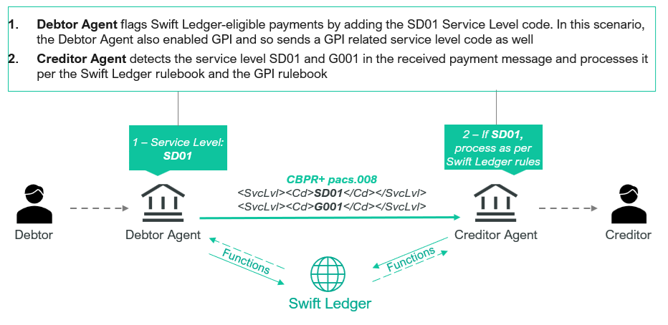
Sample xml message for illustration purposes:
<FIToFICstmrCdtTrf>
<GrpHdr>
<MsgId>123</MsgId>
<CreDtTm>2026-08-19T09:08:17+02:00</CreDtTm>
NbOfTxs>1</NbOfTxs>
<SttlmInf>
<SttlmMtd>INDA</SttlmMtd>
</SttlmInf>
</GrpHdr>
<CdtTrfTxInf>
</PmtId>
<InstrId>123</InstrId>
<EndToEndId>456</EndToEndId>
<UETR>fff0e2e0-de67-402e-bb4b-eca40713a479</UETR>
</PmtId>
<PmtTpInf>
<SvcLvl>
<Cd>SD01</Cd>
</SvcLvl>
<SvcLvl>
<Cd>G001</Cd>
</SvcLvl>
</PmtTpInf>
<IntrBkSttlmAmt Ccy="USD">1000</IntrBkSttlmAmt>
<IntrBkSttlmDt>2026-08-19</IntrBkSttlmDt>
<InstdAmt Ccy="USD">1000</InstdAmt>
<ChrgBr>CRED</ChrgBr>
<InstgAgt>
</InstgAgt>
<InstdAgt>
</InstdAgt>
<IntrmyAgt1>
</IntrmyAgt1>
<Dbtr>
</Dbtr>
<DbtrAgt>
</DbtrAgt>
<CdtrAgt>
</CdtrAgt>
<Cdtr>
</Cdtr>
<CdtrAcct>
</CdtrAcct>
</CdtTrfTxInf>
</FIToFICstmrCdtTrf>
</Document>

SEG recommendation:
This section will be completed by the SEG in charge of the related External Code Set.

Accept |  |  | Timing
 |  |  | Next possible quarterly release
 |  |  | Urgent request

Comments:

Reject

Reason for rejection:

DESCRIPTION OF THE CHANGE REQUEST

Type | Code Value | Code Name | Code Definition | Replaced By | Additional Information
Update | SD01 | Swift Digital Service: Swift Ledger | Transaction must be processed according to the Swift Ledger rules | N/A | To be used in pacs.008 between Debtor Agent and Creditor Agent for Swift Ledger-eligible payments

