Maintenance Change Request
for fast track maintenance of existing message definitions

- Submitting organization(s):
European Securities and Markets Authority (ESMA)
201-203 rue de Bercy
75012 Paris
France

- Related messages:
auth.076.001.01 FinancialSupervisedPartyIdentityReportV01
auth.077.001.01 FinancialBenchmarkReportV01

- Purpose of the change:
The Regulation (EU) 2016/1011 also called Benchmarks Regulation (BMR) introduces a set of requirements where ESMA shall collect and administer several sets of data about benchmarks’ administrators. Following the review of the BMR in 2025, ESMA is required to establish and maintain additional data on the public register starting 1 January 2026.
In addition, to those changes, the ESAP Regulation (EU) 2023/2859 and ESAP Omnibus Regulation (EU) 2023/2869, new metadata fields are added based on new Article 28a of BMR inserted under Article 12 of the ESAP omnibus Regulation.
Based on those changes, ESMA needs to perform small changes in benchmarks related messages (auth.076 and auth.077).
For the FinancialBenchmarkReport, fields Benchmark significance, Benchmark type and Hyperlink are added. And for message FinancialSupervisedPartyIdentityReport ESG Disclosure flag is added.
In addition, a Personal data flag and a Submission type have been added in both messages.
Furthermore, additional updates have been done to update the messages to latest recommendations and standards (ie formats, use of external code sets), since the messages were approved some years ago and practices have evolved since the approval.

- Urgency of the request:
Those message are only used internally by ESMA, and the new system to collect and publish the benchmarks metadata, included the new ones has to be in place in October 2026, considering that currently a transition period until 30 September 2026 is in place for Competent authorities or ESMA to designate as significant a benchmark provided by an administrator that was included in the register on 31 December 2025.

- Commitments of the submitting organization:
The ESMA BENCH project team confirms that it plans to develop a new version of the impacted messages and system in accordance with the changes proposed in this document.

- Contact persons:

Christophe Hasle – christophe.hasle@esma.europa.eu
Stephanie Gosso – stephanie.gosso@esma.europa.eu

Change number #1

- Related messages:
auth.076.001.01 FinancialSupervisedPartyIdentityReportV01
auth.077.001.01 FinancialBenchmarkReportV01

- Description of the change and type of impact:
Following the BMR review, ESMA shall collect and publish the following details:
- for administrators (message: auth.076):
  - ESG Disclosure, to indicate whether the administrator provides ESG benchmarks,
- for benchmarks (message: auth.077):
  - Benchmark significance,
  - Benchmark type,
  - Hyperlink to the statement, designation, or the public notice.

- Proposed implementation:
ESMA proposes the following solution:
- auth.076: creation of a new Element (ESGDisclosure) with datatype SpecialPurpose5Code, restricting datatype SpecialPurposeCode to Applicable / Not Applicable

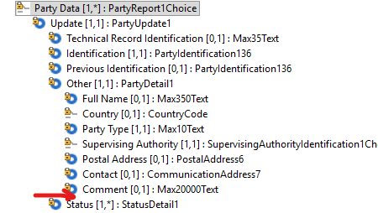
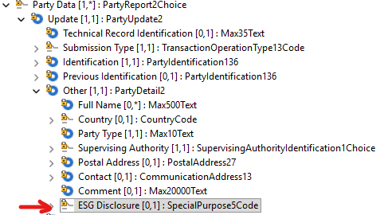
Current message Proposed change
- auth.077: creation of a new Element (BenchmarkSignificance) with datatype ExternalBenchmarkSignificance1Code, external code set
- auth.077: creation of a new Element (BenchmarkType) with datatype ExternalBenchmarkType1Code, external code set

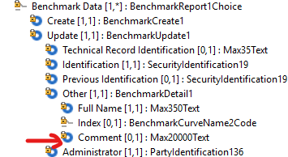
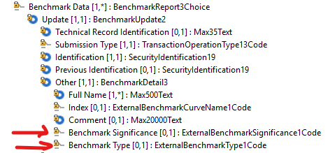
Current message Proposed change

- auth.077: creation of a new Element (Hyperlink) with datatype Max2048Text and renaming of the parent Element from “Status” to “Decision” (to avoid confusion with the sub-Element named “Status” as well)
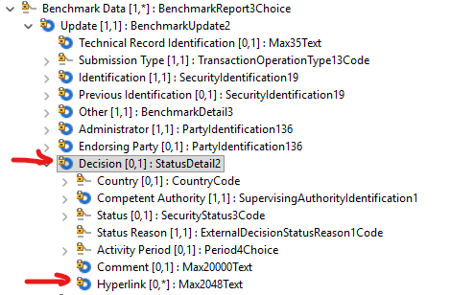
Current message Proposed change
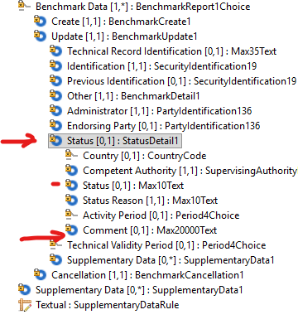

- Decision of the SEG(s):
This section is not to be taken care of by the submitting organization. It will be completed in due time by the SEG(s) in charge of the related ISO 20022 message definitions.

Change
approved
rejected
Comments:

Timing
- Fast track maintenance
(the change justifies an urgent implementation using the fast-track maintenance process)
- At the occasion of the next maintenance of the messages
(the change will be considered for implementation, but does not justify an urgent implementation – will be pending until the next [yearly] maintenance of the messages)

Change number #2

- Related messages:
auth.076.001.01 FinancialSupervisedPartyIdentityReportV01
auth.077.001.01 FinancialBenchmarkReportV01

- Description of the change and type of impact:
Following the introduction of ESAP Regulation, ESMA shall collect and publish the following details:
- Personal data flag to indicate whether the information includes personal data,
- Submission type, to indicate the type of submission (new, modification, correction or error), and consequently branch Create is removed from message auth.077
- Fullname in both messages updated from Max350Text to Max500Text to be consistent with ESAP messages

- Proposed implementation:
ESMA proposes the following solution:
- auth.076: creation of a new Element (PersonalData) with datatype TrueFalseIndicator
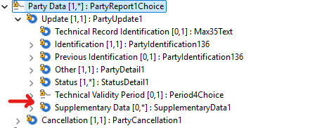
Current message Proposed change
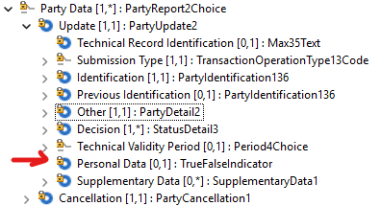

- auth.076: creation of a new Element (SubmissionType) with datatype TransactionOperationType13Code (based on TransactionOperationType13Code)
Current message Proposed change
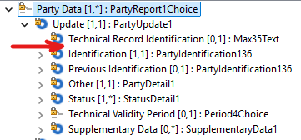
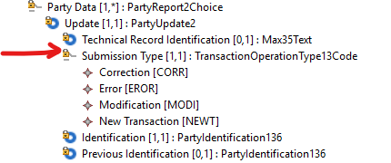

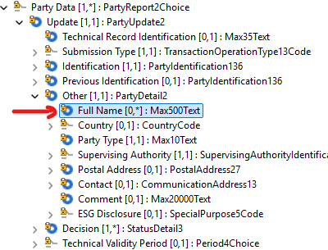
- auth.076: Element FullName type changed from Max350Text to Max500Text (to be consistent with ESAP messages)
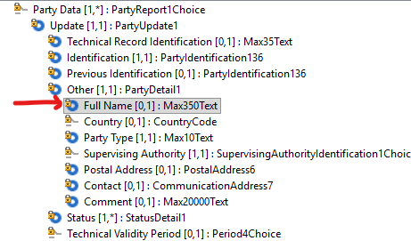

- auth.077: creation of a new Element (PersonalData) with datatype TrueFalseIndicator
Current message Proposed change
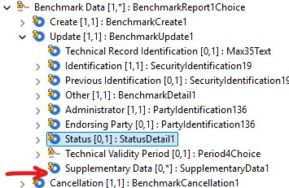
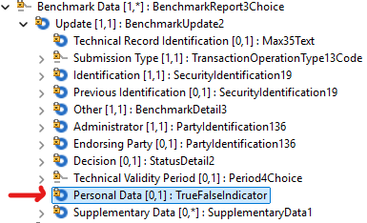

- auth.077: creation of a new Element (SubmissionType) with datatype TransactionOperationType13Code (based on TransactionOperationType13Code), and removal of Create branch which is not needed anymore
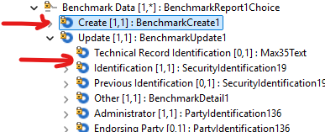
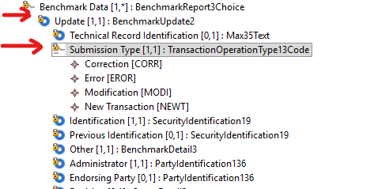
Current message Proposed change

- auth.077: Element FullName type changed from Max350Text to Max500Text (to be consistent with ESAP messages)
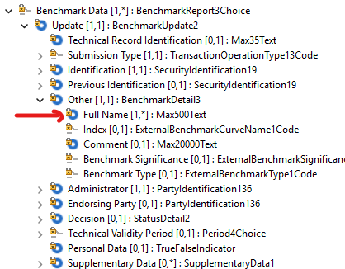
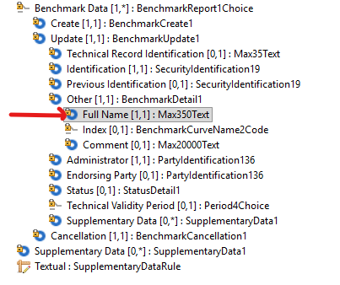
- Decision of the SEG(s):
This section is not to be taken care of by the submitting organization. It will be completed in due time by the SEG(s) in charge of the related ISO 20022 message definitions.

Change
approved
rejected
Comments:

Timing
- Fast track maintenance
(the change justifies an urgent implementation using the fast-track maintenance process)
- At the occasion of the next maintenance of the messages
(the change will be considered for implementation, but does not justify an urgent implementation – will be pending until the next [yearly] maintenance of the messages)

Change number #3

- Related messages:
auth.076.001.01 FinancialSupervisedPartyIdentityReportV01
auth.077.001.01 FinancialBenchmarkReportV01

- Description of the change and type of impact:
Furthermore, additional updates have been done to update the messages to latest recommendations and standards (ie formats, use of external code sets), since the messages were approved some years ago and practices have evolved since the approval.

- Proposed implementation:
ESMA proposes the following solution:
- auth.076: Element Status type changed from Max10Text to SecurityStatus3Code restricting datatype SecurityStatusCode to values Active / Inactive
- auth.076: Element StatusReason type changed from Max10Text to external code set
ExternalDecisionStatusReason1Code
- auth.076: Element PostalAddress type has been updated from PostalAddress6 to PostalAddress27
- auth.076: Element Contact type has been updated from CommunicationAddress7 to CommunicationAddress13
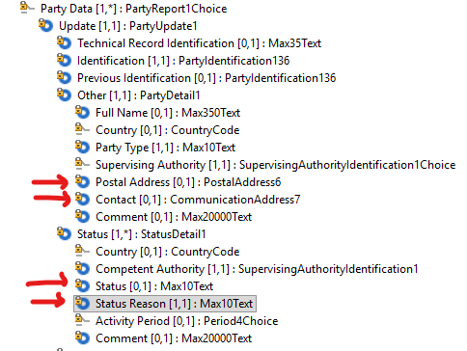
Current message Proposed change
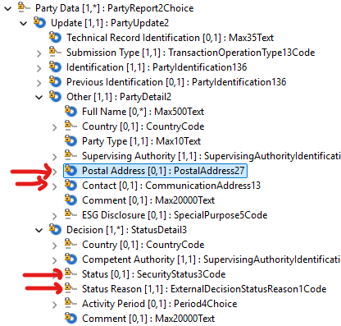

- auth.077: Element Status type changed from Max10Text to SecurityStatus3Code restricting datatype SecurityStatusCode to values Active / Inactive
- auth.077: Element StatusReason type changed from Max10Text to external code set
ExternalDecisionStatusReason1Code
- auth.077: Element Index type changed from BenchmarkCurveName2Code to external code set ExternalBenchmarkCurveName1Code based on BenchmarkCurveNameCode

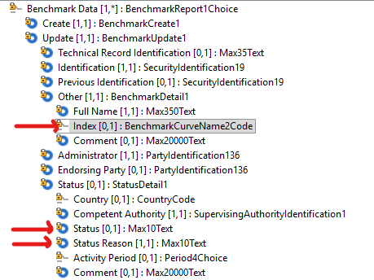
Current message Proposed change
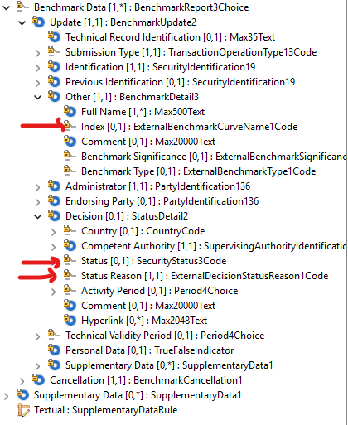

- Decision of the SEG(s):
This section is not to be taken care of by the submitting organization. It will be completed in due time by the SEG(s) in charge of the related ISO 20022 message definitions.

Change
approved
rejected
Comments:

Timing
- Fast track maintenance
(the change justifies an urgent implementation using the fast-track maintenance process)
- At the occasion of the next maintenance of the messages
(the change will be considered for implementation, but does not justify an urgent implementation – will be pending until the next [yearly] maintenance of the messages)

