Change Request
for the update of an External Code Set
Note: this document is to be completed by parties that request to either add new codes or clarify the definition of existing codes or replace existing codes by new one(s) or expire existing codes in one of the External Code Sets used in ISO 20022 messages. All change requests conforming to this template that are received prior to the end of a quarter (31 March, 30 June, 30 September, 31 December) will be evaluated by the SEG and, if approved, incorporated in the following quarterly publication cycle of the External Code Sets (respectively, by end of May, August, November and February), unless otherwise specified by the SEG.

Origin of the request:

A.1 Submitter:

Name of the company, organization, group, initiative or community that submits the change request. | Swift

A.2 Contact person:
Person that can be contacted for additional information on the request

A.2.1. First name, Last name | Dominique Forceville  Emma Saxton
A.2.2. Email address | dominique.forceville@swift.com  emma.saxton@swift.com
A.2.3. Telephone | +32 2 655 4948  +44 207 7622077

A.3 Sponsors:
If the submitter acts on behalf of or has gained support from other organisations, groups, initiatives or communities, these should be listed as sponsors.

Swift Scheme Initiative Design Group

Description of the change request:
Specify the request type: creation of new code set, update of existing code set, deletion of existing code set.
For the creation of a new code set or for updating an existing code set, also complete the table in section H below. For the addition of new codes, all the details must be specified, including a proposed code, a proposed code name, a clear definition, and any other indications, such as an example or format to be published with the code set.

Request type: creation, update, deletion | Update of existing codeset

Related External Code Set:
For updating or deleting an existing code set, indicate the exact name of the code set as indicated in the External Code Sets documents on iso20022.org. For creating a new code set, indicate a proposed name for the new code set.
A specific change request form must be completed for each code set to be updated.

ExternalServiceLevel1Code

Purpose of the change:
Background, business context, community of users interested by the change and expected benefits/savings.
This section must explain why the existing code set needs to be changed. The reason for the update may be a business reason (e.g., evolution of market practice, or creation of new financial instruments), a technical reason (e.g., automation of the business process, or switch from a batch to a real time process), a regulatory reason (introduction, generally mandatory, of new rule/law) or the extension of the user community (newly identified business requirements).

Business background and context:

Swift and its community have substantially improved cross-border transactions in recent years through innovations that have brought end-to-end visibility and accelerated flows around the world. As a result, payments across Swift today are fast – up to 90% reach beneficiary banks within one hour. And they are transparent too, with more than 90% having end to end visibility across their journey.
These major improvements, however, have not translated into a material uplift in the end-to-end user experience, particularly for retail payments.
Swift Scheme is an endeavor driven by Swift and multiple FI’s across the global payment ecosystem to further enhance the payment landscape with a clear goal to ensure upfront predictability on price, speed and delivery with no hidden fees, full value transfers and next to 24x7 instant settlement made visible via a consistent front-end experience.

Reasons for the update of the service level codeset:

Scheme payments require the new Scheme service level code (proposed code is SPSC for “Swift Payment Scheme”) because of various reasons (non-exhaustive):
- Enable recognition and processing of Scheme-eligible transactions
Gateway Intermediaries that receive payments from the Debtor Agents can identify transactions that qualify under the Scheme and process them according to Scheme rules (Scheme payments will be subject to an SLA and Rulebook).

- Establish a foundation for future developments supporting the Scheme, e.g.:

  - Performance monitoring: provide reporting tools, deliver insights and trend analyses
  - Enforcement framework: Ensure adherence to Scheme rules to maintain trust and franchise value.

Urgency of the request:
By default, valid change requests, subsequently approved by the SEG will be included in the following quarterly publication of External Code Sets, unless decided otherwise by the SEG.
If there is a need to have the new version of the related code set published earlier, the reason for the urgency and the expected consequences of a delay should be described here. Acceptance of such an unscheduled publication is subject to approval by the SEG.

Approval in January 2026
Publication in February/March 2026
Use in production June 2026

Business examples:
Provide examples illustrating usage of the code set and indicate messages where the code set may be used.

Scope:
Messages where the new Swift Scheme service level code SPSC is used to indicate the conditions Scheme participants should apply when processing Scheme eligible payment transactions e.g., the CBPR+ pacs.008 (or later in Scheme specific pacs.008 usage guidelines).

Visual representation of the usage of the Swift Scheme service level:

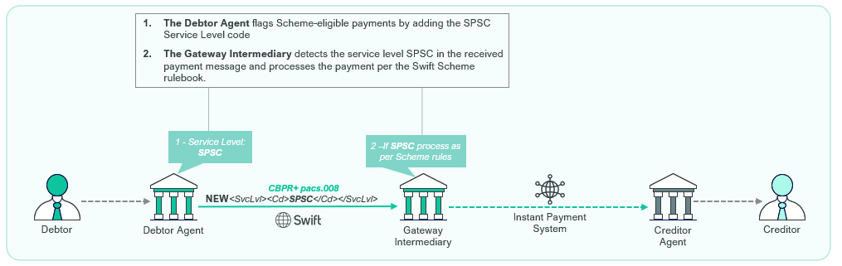

Sample xml message for illustration purposes:
<FIToFICstmrCdtTrf>
<GrpHdr>
<MsgId>123</MsgId>
<CreDtTm>2026-08-19T09:08:17+02:00</CreDtTm>
<NbOfTxs>1</NbOfTxs>
<SttlmInf>
<SttlmMtd>INDA</SttlmMtd>
</SttlmInf>
</GrpHdr>
<CdtTrfTxInf>
</PmtId>
<InstrId>123</InstrId>
<EndToEndId>456</EndToEndId>
<UETR>fff0e2e0-de67-402e-bb4b-eca40713a479</UETR>
</PmtId>
<PmtTpInf>
<SvcLvl>
<Cd>SPSC</Cd>
</SvcLvl>
</PmtTpInf>
<IntrBkSttlmAmt Ccy="USD">1000</IntrBkSttlmAmt>
<IntrBkSttlmDt>2026-08-19</IntrBkSttlmDt>
<InstdAmt Ccy="USD">1000</InstdAmt>
<ChrgBr>CRED</ChrgBr>
<InstgAgt>
</InstgAgt>
<InstdAgt>
</InstdAgt>
<IntrmyAgt1>
</IntrmyAgt1>
<Dbtr>
</Dbtr>
<DbtrAgt>
</DbtrAgt>
<CdtrAgt>
</CdtrAgt>
<Cdtr>
</Cdtr>
<CdtrAcct>
</CdtrAcct>
</CdtTrfTxInf>
</FIToFICstmrCdtTrf>
</Document>

Visual representation of the usage of the Swift Scheme service level in combination with another service level:
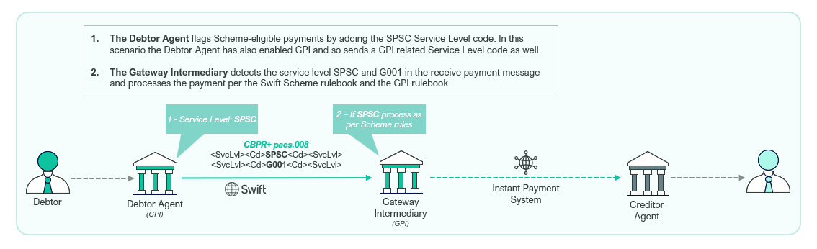

Sample xml message for illustration purposes:
<FIToFICstmrCdtTrf>
<GrpHdr>
<MsgId>123</MsgId>
<CreDtTm>2026-08-19T09:08:17+02:00</CreDtTm>
<NbOfTxs>1</NbOfTxs>
<SttlmInf>
<SttlmMtd>INDA</SttlmMtd>
</SttlmInf>
</GrpHdr>
<CdtTrfTxInf>
<PmtId>
<InstrId>123</InstrId>
<EndToEndId>456</EndToEndId>
< UETR>fff0e2e0-de67-402e-bb4b-eca40713a479</UETR>
</PmtId>
<PmtTpInf>
<SvcLvl>
<Cd>SPSC</Cd>
</SvcLvl>
<SvcLvl>
<Cd>G001</Cd>
</SvcLvl>
</PmtTpInf>
<IntrBkSttlmAmt Ccy="USD">1000</IntrBkSttlmAmt>
<IntrBkSttlmDt>2026-08-19</IntrBkSttlmDt>
<InstdAmt Ccy="USD">1000</InstdAmt>
<ChrgBr>CRED</ChrgBr>
<InstgAgt>
</InstgAgt>
<InstdAgt>
</InstdAgt>
<IntrmyAgt1>
</IntrmyAgt1>
<Dbtr>
</Dbtr>
<DbtrAgt>
</DbtrAgt>
<CdtrAgt>
</CdtrAgt>
<Cdtr>
</Cdtr>
<CdtrAcct>
</CdtrAcct>
</CdtTrfTxInf>
</FIToFICstmrCdtTrf>
</Document>

SEG recommendation:
This section will be completed by the SEG in charge of the related External Code Set.

Accept |  |  | Timing
 |  |  | Next possible quarterly release
 |  |  | Urgent request

Comments:

Reject

Reason for rejection:

DESCRIPTION OF THE CHANGE REQUEST

Type | Code Value | Code Name | Code Definition | Replaced By | Additional Information
Update (add) | SPSC | Swift Scheme | Transaction must be processed according to the Swift Scheme rulebook. | N/A | To be used between agents which are participating in the Swift Scheme, to identify the rules under which the payment transaction should be processed. This Service Level may be used throughout the end-to-end transaction lifecycle (where the Scheme applies).

