Maintenance Change Request
for fast track maintenance of existing message definitions
Note: the purpose of this document is to give guidelines to submitting organizations that intend to use the Fast Track maintenance process to develop a new version of existing ISO 20022 messages. Such development is subject to the approval, by the related Standards Evaluation Group (SEG), of a Maintenance Change Request which must include a detailed description of the impact of each change on the related messages. The Maintenance Change Request must start with a general chapter covering topics related to the whole maintenance effort and a specific chapter for each change request, as described below. Please consult the iso20022.org website for additional details on the Fast Track maintenance process.
Maintenance Changes requests are to be submitted through the ISO 20022 website through this e-request, in which this template must be attached.

- Submitting organization(s):
Identity of the organization, group, initiative or community that is undertaking the development of the new version of the message(s). This organisation must be either the submitting organisation in charge of the message definitions or another organisation that has been authorized by the original submitting organisation to develop a new version.
Swift

- Related messages:
The precise identification of the current ISO 20022 message definitions that will be impacted by the changes included in this Maintenance Change Request, including the Message Ids. Only the latest version of a message definition can be updated.
Note: Maintenance Change Requests may not lead to creation of new messages or variants of existing messages. In such cases, the submitting organization should introduce a 'Business Justification' for development of new candidate ISO 20022 message definitions or variants.
Trck.001.001.04
Trck.002.001.03
Trck.004.001.03

- Purpose of the change:
Background, business context, community of users interested by the new version and expected benefits/savings.
This section must explain why the current ISO 20022 message versions need to be changed. The reason for the update may be a business reason (e.g., evolution of market practice, or creation of new services), a technical reason (e.g., automation of the business process, or switch from a batch to a real time process), a regulatory reason (introduction, generally mandatory, of new rule/law) or the extension of the user community (newly identified business requirements).

Purpose:
Request to add the FX Agent into the user-to-tracker and tracker-to-user messages to clearly identify which agent has carried out the currency conversation.

- Urgency of the request:
The reason for the urgency of the maintenance and the expected consequences of a delay should be described here. Acceptance of a Fast Track maintenance is subject to the approval of the SEG.
Submitter is late for this CR and still wants to have the new element included in the maintenance 2025/2026 as the intention is to use it in the implementation already in November 2026.

Commitments of the submitting organization:
The submitting organization must confirm that it can and will:
- undertake the development of the new version of the candidate ISO 20022 message model that it will submit to the RA for compliance review. The submitting organisation is invited to mention here the expected date of submission to the RA for compliance review.
- address any queries related to the description of the message versions as published by the RA on the ISO 20022 website.
The submitting organization must confirm its knowledge and acceptance of the ISO 20022 Intellectual Property Rights policy for contributing organizations, as follows.
“Organizations that contribute information to be incorporated into the ISO 20022 Repository shall keep any Intellectual Property Rights (IPR) they have on this information. A contributing organization warrants that it has sufficient rights on the contributed information to have it published in the ISO 20022 Repository through the ISO 20022 Registration Authority in accordance with the rules set in ISO 20022. To ascertain a widespread, public and uniform use of the ISO 20022 Repository information, the contributing organization grants third parties a non-exclusive, royalty-free license to use the published information”.

- Contact persons:
The submitting organization will identify the person(s) at the submitting organization that can be contacted to get additional information on this Maintenance Change Request. This person will be invited to participate in the SEG review of the MCR.

Dominique Forceville (Swift) – dominique.forceville@swift.com
John Yates (Swift) – john.yates@swift.com

Change number #
This section must be completed for each particular change.
- Related messages:
The list of current ISO 20022 message definitions which would be impacted by the particular change, including the Message IDs. Only the latest version of a message definition can be updated.
The submitter is invited to carefully examine whether the change may have an impact on other messages that come into play earlier or later in the transaction chain or on other messages that also use message components that this change request may impact.

Trck.001.001.04
Trck.002.001.03
Trck.004.001.03

- Description of the change and type of impact:
For example, adding, deleting, modifying, renaming, changing the cardinality, moving an element/component, changing the type of an element or changing a code set.
The identification of Agent who has performed the FX is requested to be added.
Purpose:
Request to add the FX Agent into the user-to-tracker and tracker-to-user messages to clearly identify which agent has carried out the currency conversation.

- Proposed implementation:
Detailed description – and illustration - of the required modification(s) to implement the requested change. This section should contain an illustration of the portions of the message definition that are impacted by the change, using for example, the Editor or an XML parser. Optionally, the XML schema of the proposed new version can be appended to the MCR.

Detailed change: addition of a new FXAgent element typed by the BranchAndFinancialInstitutionIdentification6 component.

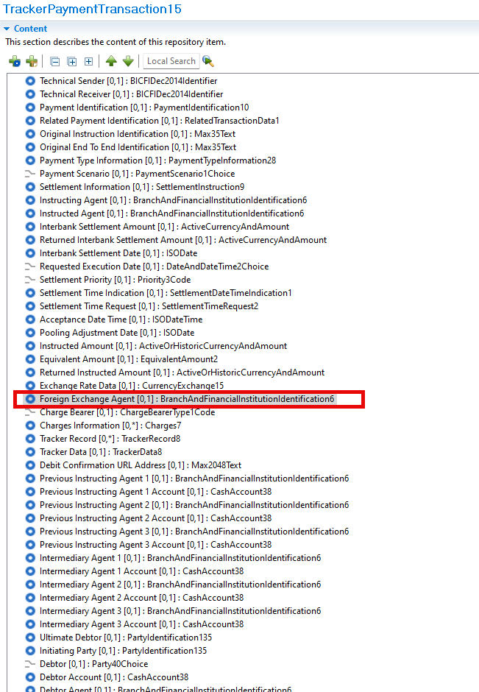
- Decision of the SEG(s):
This section is not to be taken care of by the submitting organization. It will be completed in due time by the SEG(s) in charge of the related ISO 20022 message definitions.

Change
approved
rejected
Comments:

Timing
- Fast track maintenance
(the change justifies an urgent implementation using the fast track maintenance process)
- At the occasion of the next maintenance of the messages
(the change will be considered for implementation, but does not justify an urgent implementation – will be pending until the next [yearly] maintenance of the messages)

