Change Request
for the update of an External Code Set
Note: this document is to be completed by parties that request to either add new codes or clarify the definition of existing codes or replace existing codes by new one(s) or expire existing codes in one of the External Code Sets used in ISO 20022 messages. All change requests conforming to this template that are received prior to the end of a quarter (31 March, 30 June, 30 September, 31 December) will be evaluated by the SEG and, if approved, incorporated in the following quarterly publication cycle of the External Code Sets (respectively, by end of May, August, November and February), unless otherwise specified by the SEG.

Origin of the request:

A.1 Submitter:

Name of the company, organization, group, initiative or community that submits the change request. | Case Management Plenary Group

A.2 Contact person:
Person that can be contacted for additional information on the request

A.2.1. First name, Last name | Dominique Forceville
A.2.2. Email address | dominique.forceville@swift.com
A.2.3. Telephone | 0032 2 655 4948

A.3 Sponsors:
If the submitter acts on behalf of or has gained support from other organisations, groups, initiatives or communities, these should be listed as sponsors.

Case Management Plenary Group

Description of the change request:
Specify the request type: creation of new code set, update of existing code set, deletion of existing code set.
For the creation of a new code set or for updating an existing code set, also complete the table in section H below. For the addition of new codes, all the details must be specified, including a proposed code, a proposed code name, a clear definition, and any other indications, such as an example or format to be published with the code set.

Request type: creation, update, deletion | Creation

Related External Code Set:
For updating or deleting an existing code set, indicate the exact name of the code set as indicated in the External Code Sets documents on iso20022.org. For creating a new code set, indicate a proposed name for the new code set.
A specific change request form must be completed for each code set to be updated.

ExternalInvestigationReasonSubType1Code

Purpose of the change:
Background, business context, community of users interested by the change and expected benefits/savings.
This section must explain why the existing code set needs to be changed. The reason for the update may be a business reason (e.g., evolution of market practice, or creation of new financial instruments), a technical reason (e.g., automation of the business process, or switch from a batch to a real time process), a regulatory reason (introduction, generally mandatory, of new rule/law) or the extension of the user community (newly identified business requirements).

In the context of the Case Management project and its multi-year transformation plan intended to the move the community from the MT E&I messages to the use of the ISO camt.110/111 messages, a number of codeset CRs have been identified.

(1) Addition of 4 new codes to the ExternalInvestigationReasonSubType1Code in relation to the sanction and compliance area:

(2) Addition of 3 new codes to the ExternalInvestigationReasonSubType1Code in relation to the Unable To Execute usages.
The codes to be added are:

As described below, for Unable To Execute (UTEX), in the camt.110, a restricted set of reason codes (7) will be allowed. To further clarify the request, these reason codes can be accompanied with a reason subtype code MISS (missing), INVA (invalid) or ICOM (incomplete).
These 3 reason subtype codes are currently missing in the ExternalInvestigationReasonSubType1Code list and are requested to be added.

This table clarifies how in the context of the Case Manager the reason codes will be used in association with the new reason subtype codes (and also with the narrative).
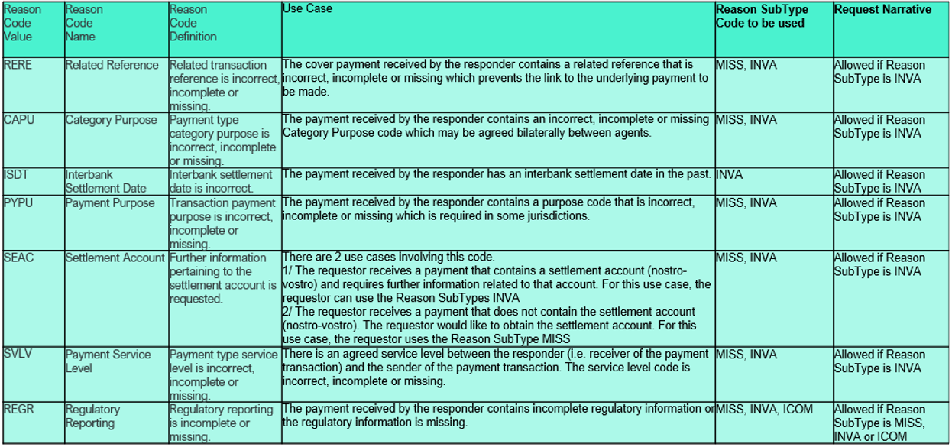

Urgency of the request:
By default, valid change requests, subsequently approved by the SEG will be included in the following quarterly publication of External Code Sets, unless decided otherwise by the SEG.
If there is a need to have the new version of the related code set published earlier, the reason for the urgency and the expected consequences of a delay should be described here. Acceptance of such an unscheduled publication is subject to approval by the SEG.

As soon as possible, next cycle

Business examples:
Provide examples illustrating usage of the code set and indicate messages where the code set may be used.

SEG recommendation:
This section will be completed by the SEG in charge of the related External Code Set.

Accept |  |  | Timing
 |  |  | Next possible quarterly release
 |  |  | Urgent request

Comments:

Reject

Reason for rejection:

DESCRIPTION OF THE CHANGE REQUEST

Type | Code Value | Code Name | Code Definition | Replaced By | Additional Information
Addition | RQDP | RequestDetailedPurposeOfPayment | Detailed purpose of payment requested. | N/A | ExternalInvestigationReasonSubType1Code
Addition | RQBW | RequestBusinessWebsite | Business website requested. | N/A | ExternalInvestigationReasonSubType1Code
Addition | RQOG | RequestOriginOfGoods | Origin of goods requested. | N/A | ExternalInvestigationReasonSubType1Code
Addition | RQUU | RequestFinalUserAndUsageOfGoodsOrServices | Final user and usage of goods or services requested. | N/A | ExternalInvestigationReasonSubType1Code
Addition | MISS | Missing | Information is missing. | N/A | ExternalInvestigationReasonSubType1Code
Addition | INVA | Invalid | Information is invalid. | N/A | ExternalInvestigationReasonSubType1Code
Addition | ICOM | Incomplete | Information is incomplete. | N/A | ExternalInvestigationReasonSubType1Code

