Change Request
for the update of ISO 20022 financial repository items
- Origin of the request:
A.1 Submitter:
- Swiss Commission for Financial Standardisation (SCFS) – Sub-Commission Funds.
A.2 Contact person:
- Matthias Schindler, Matthias.schindler@avaloq.com, +41 58 316 2287
A.3 Sponsors:
- This CR is sponsored by the sub commission for funds (FK FUNDS) of the Swiss Commission of Financial Standardisation (SCFS).
- Related messages:
- SETR.016.001.04
- Description of the change request:
With this request the rejection reason code NRGM (NoCancellationMatch) should be removed from the SETR.016 message.
Three applicable element paths:
- Document/OrdrInstrStsRpt/StsRpt/OrdrDtlsRpt/OrdrSts/Rjctd/Rsn/Cd
- Document/OrdrInstrStsRpt/StsRpt/IndvOrdrDtlsRpt/OrdrSts/Rjctd/Rsn/Cd
- Document/OrdrInstrStsRpt/StsRpt/SwtchOrdrDtlsRpt/OrdrSts/Rjctd/Rsn/Cd
- Purpose of the change:
Currently the rejection reason code NRGM (NoCancellationMatch) exists in the SETR.016 messages (OrderInstructionStatusReport) which does not make sense for this message as it is only needed in the according reply message for cancellation requests which would be the SETR.017 message (OrderCancellationStatusReport).
- Urgency of the request:
Subject to normal maintenance cycle.
- Business examples:
Existing rejection reason codes on SETR.016 message (NRGM included):
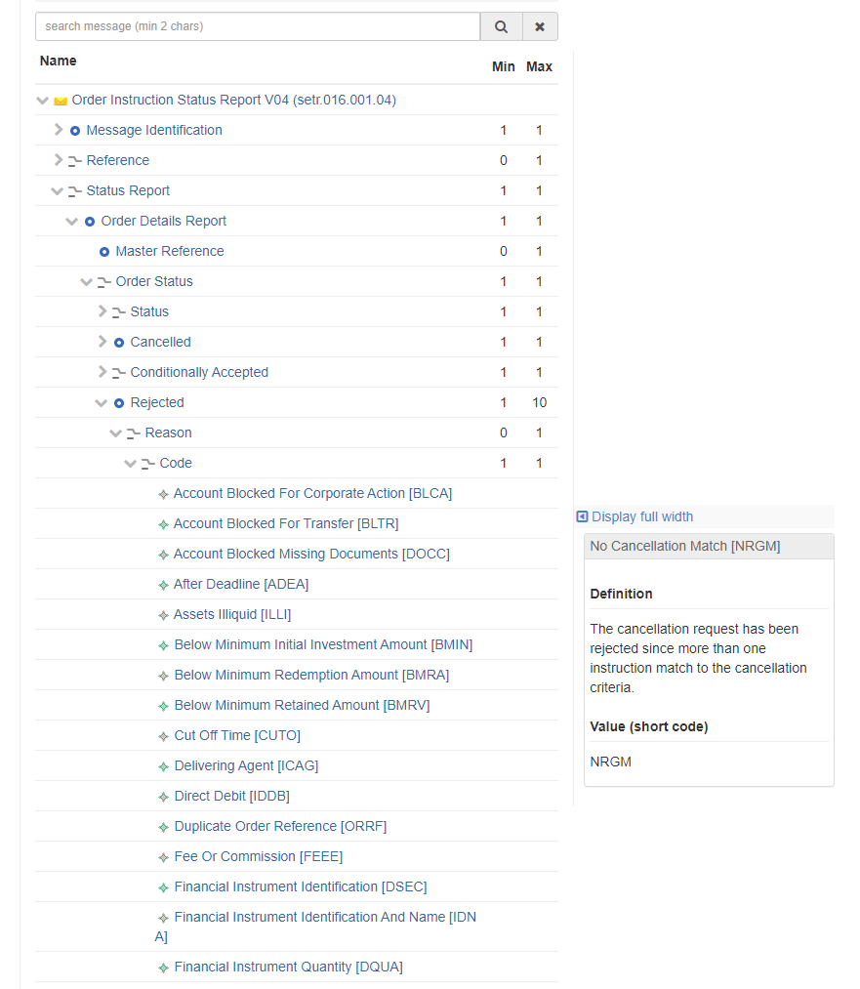
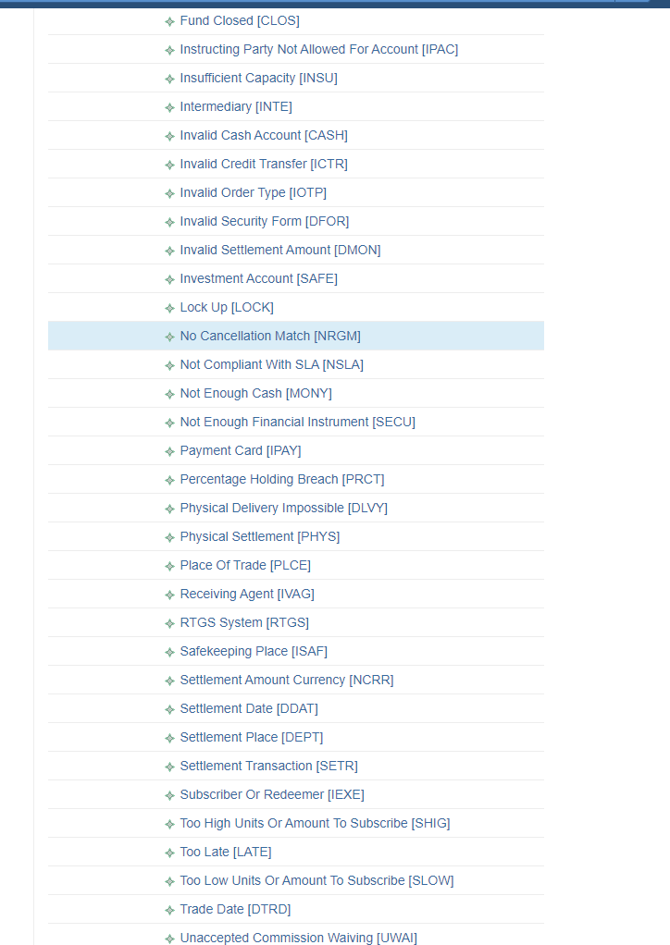

- SEG/TSG recommendation:
This section is not to be taken care of by the submitter of the change request. It will be completed in due time by the SEG(s) in charge of the related ISO 20022 messages or the TSG for changes related to the BAH.

Consider |  | X | Timing
- Next yearly cycle: 2020/2021
(the change will be considered for implementation in the yearly maintenance cycle which starts in 2018 and completes with the publication of new message versions in the spring of 2019)
 |  |  | - At the occasion of the next maintenance of the messages  (the change will be considered for implementation, but does not justify maintenance of the messages in its own right – will be pending until more critical change requests are received for the messages) |  | X
- Urgent unscheduled
(the change justifies an urgent implementation outside of the normal yearly cycle)
 |  |  | - Other timing:
Comments:
Maintenance 2025/2026: consider.

Reject
Reason for rejection:

