Maintenance Change Request

Note: the purpose of this document is to give guidelines to submitting organisations that will develop a new version of existing ISO 20022 messages based on change requests screened by the Standards Evaluation Group(s). Such development is subject to the approval of a Maintenance Change Request which must include a detailed description of the impact of each change on the related messages. The Maintenance Change Request must start with a general chapter covering topics related to the whole maintenance effort and a specific chapter for each change request, as described below. Please consult the iso20022.org website for additional details on the maintenance process.

- Name of the request:
General Meeting Messages Maintenance for year 2025/2026

- Submitting organization(s):
Swift

- Related messages:
Under this project, the following ISO 20022 General Meeting messages highlighted in blue below would be maintained in the context of the General Meeting messages maintenance for year 2025/2026 – pending approval of the proposed implementation solutions (which will be reviewed on the 20^{th of} August 2025):

 | Message Name | Abbreviated Name | Identifier
1 | MeetingNotificationV12 | MENO | seev.001.001.12
2 | MeetingCancellationV10 | MECN | seev.002.001.10
3 | MeetingEntitlementNotificationV10 | MENT | seev.003.001.10
4 | MeetingInstructionV10 | MEIN | seev.004.001.10
5 | MeetingInstructionCancellationRequestV10 | MEIC | seev.005.001.10
6 | MeetingInstructionStatusV11 | MEIS | seev.006.001.11
7 | MeetingVoteExecutionConfirmationV11 | MECO | seev.007.001.11
8 | MeetingResultDisseminationV10 | MERD | seev.008.001.10
9 | Securities Message Rejection |  | semt.001.001.04

- Commitments of the submitting organization:
Swift confirms that it can and will:
- undertake the development of the new version of the candidate ISO 20022 message models that it will submit to the RA for compliance review and evaluation by December 1st, 2025.
- provide a new version of part 1 of the Message Definition Report (MDR) and new examples of valid message instances of each message by May 1st, 2026, at the latest.
- address any queries related to the description of the new models and messages as published by the RA on the ISO 20022 website.
Swift confirms that it intends to organize the actual implementation of the new version of the messages on its SwiftNet network once the related documentation has been published by the RA.

Swift confirms their knowledge and acceptance of the ISO 20022 Intellectual Property Rights policy for contributing organisations, as follows.
“Organisations that contribute information to be incorporated into the ISO 20022 Repository shall keep any Intellectual Property Rights (IPR) they have on this information. A contributing organisation warrants that it has sufficient rights on the contributed information to have it published in the ISO 20022 Repository through the ISO 20022 Registration Authority in accordance with the rules set in ISO 20022. To ascertain a widespread, public and uniform use of the ISO 20022 Repository information, the contributing organisation grants third parties a non-exclusive, royalty-free license to use the published information”.

- Contact persons:
Christine Strandberg – christine.strandberg@seb.se – phone: +46 8 763 6074
Mari Fumagalli – mariangela.fumagalli@bnpparibas.com – phone: +44 207 595 4988
Miriam Ortseifen – miriam.ortseifen@swift.com – phone: +34 91 4251317

Table of Contents

CR1479: Amend Definitions in General Meeting Voting Instructions 4
CR1489: Add Beneficial Owner Email for Virtual Meeting Participation 8
CR1490: Add Rights Holder Account ID and Entitlement Fixing Date to Instructions 12
CR1491: Introduce Meeting Format Type in General Meeting Notification 16
CR1506: Add Cumulative Voting Multiplier to Meeting Notification 21
CR1511: Add Participant Disclosure data in Meeting Instructions 25
CR1512: Add Investor Classification data in Meeting Instructions 30

CR1479: Amend Definitions in General Meeting Voting Instructions
A. Origin of the request:
A.1 Submitter: SMPG CA-WG
A.2 Contact persons:
Christine Strandberg
Mariangela Fumagalli
Miriam Ortseifen
A.3 Sponsors:
SMPG CA WG members
B. Related messages:
seev.004.001.10
seev.007.001.11
C. Description of the change request:
In the seev.004, in accordance with recently updated global market practice, amend the definition of Instruction / VoteDetails / VoteInstructionForAgendaResolution / VotePerAgendaResolution / VoteInstruction as follows:
Instruction specifying the instructed quantity of voting rights per resolution.Split votes can be indicated. If only one type of decision is indicated, the number of votes cast must not be adjusted if the position of the voting party increases.
Also amend the definition of the below elements in the seev.004, in sequence Instruction / VoteDetails / VoteInstructionForAgendaResolution / VotePerAgendaResolution / VoteInstruction
And in the seev.007, in sequence VoteInstructions / VotePerResolution as follows:
VotePerAgendaResolution - VoteInstruction - For <For>
Current definition: Number of votes in favour of one resolution.
Amended definition: Number of securities for which vote in favour is instructed.
VotePerAgendaResolution - VoteInstruction - Against <Agnst>
Current definition: Number of votes against one resolution.
Amended definition: Number of securities for which vote against is instructed.
VotePerAgendaResolution - VoteInstruction - Abstain <Abstn>
Current definition: Number of abstention votes for one resolution.
Amended definition: Number of securities for which vote to abstain is instructed
VotePerAgendaResolution - VoteInstruction - Withhold <Wthhld>
Current definition: Number of votes withheld for one resolution.
Amended definition: Number of securities for which vote to withhold is instructed.
VotePerAgendaResolution - VoteInstruction - WithManagement <WthMgmt>
Current definition: Number of votes in line with the votes of the management.
Amended definition: Number of securities for which vote in line with the votes of the management is instructed.
VotePerAgendaResolution - VoteInstruction - AgainstManagement <AgnstMgmt>
Current definition: Number of votes against the voting recommendation of the management.
Amended definition: Number of securities for which vote against the voting recommendation of the management is instructed.
VotePerAgendaResolution - VoteInstruction – Discretionary <Dscrtnry>
Current definition: Number of votes for which decision is left to the party that will exercise the voting right.
Amended definition: Number of securities for which decision is left to the party that will exercise the voting right.
VotePerAgendaResolution - VoteInstruction - OneYear <OneYr>
Current definition: Number of votes in favour for one year for "say on pay" type of resolution.
Amended definition: Number of securities for which vote in favour for one year for "say on pay" type of resolution is instructed.
VotePerAgendaResolution - VoteInstruction - TwoYears <TwoYrs>
Current definition: Number of votes in favour of two years for "say on pay" type of resolution.
Amended definition: Number of securities for which vote in favour of two years for "say on pay" type of resolution is instructed.
VotePerAgendaResolution - VoteInstruction - ThreeYears <ThreeYrs>
Current definition: Number of votes in favour of three years for "say on pay" type of resolution.
Amended definition: Number of securities for which vote in favour of three years for "say on pay" type of resolution is instructed.
D. Purpose of the change:
There are securities with voting rights not equal to one voting right per security. The number of voting rights can be more or less than one. The messages were originally created under the assumption that the instructing party, i.e. the party that is entitled to vote or its agent, would amend the Quantity in such cases to correctly reflect the number of voting rights resulting from the entitled quantity. This has not been the case. The SMPG has together with proxy providers amended global market practice to specify that it is the quantity of securities that are to be specified in all cases. This CR is to amend affected elements in the Meeting Instruction message and the Vote Execution Confirmation message to reflect global market practice and usage.
E. Urgency of the request:
For next release.
Note: the ISO 20022 maintenance results in the publication of a new version of an ISO 20022 message. The actual implementation of such new version on networks and in user installations is not within the purview of ISO.
F. Business examples:
N/A
G. SEG/TSG recommendation:
This section is not to be taken care of by the submitter of the change request. It will be completed in due time by the SEG(s) in charge of the related ISO 20022 messages or the TSG for changes related to the BAH.
Consider: X
Timing:
- Next yearly cycle: 2025/2026: X
(the change will be considered for implementation in the yearly maintenance cycle which starts in 2025 and completes with the publication of new message versions in the spring of 2026)
- At the occasion of the next maintenance of the messages:
(the change will be considered for implementation, but does not justify maintenance of the messages in its own right – will be pending until more critical change requests are received for the messages)
- Urgent unscheduled:
(the change justifies an urgent implementation outside of the normal yearly cycle)
- Other timing:

Comments: N/A
H. Impact analysis:
This change request impacts the following General meeting messages: seev.004 and seev.007.
I. Proposed implementation solution:
see above under C.
J. Proposed timing:
The submitting organization confirms that it can implement the requested changes in the requested timing.
Timing | As requested

K. Final decision of the SEG(s):
This section is not to be taken care of by the submitting organization. It will be completed in due time by the SEG(s) in charge of the related ISO 20022 messages.
Approve
Comments:

Reject
Reason for rejection:

CR1489: Add Beneficial Owner Email for Virtual Meeting Participation

A. Origin of the request:
A.1 Submitter:
SMPG CA-WG
A.2 Contact person:
Christine Strandberg
Mariangela Fumagalli
Miriam Ortseifen
A.3 Sponsors:
SMPG CA WG members

B. Related messages:
seev.001. Meeting Notification (MENO)
seev.006 Meeting Instruction Status (MEIS)

C. Description of the change request:
Add additional beneficial owner details for the general meeting processing to facilitate virtual attendance to a general meeting. Post covid a number of countries have changed national legislation and opened for general meetings to be conducted either only virtually or with the possibility to attend virtually. The General meeting messages has the possibility to inform of virtual attendance via the participation method VIRT. However, the messages do not support a communication form where the meeting operator/registrar can establish contact with the rightsholder (for log on and identification purpose).
To facilitate the contact between the operator of the meeting and the beneficial owner, there must be possibility to establish a connection via the general meeting message sent to the rightsholder via the intermediaries. By informing that the meeting opens for virtual participation, via the participation method code VIRT, intermediaries should understand that an e-mail address must be added in the vote instruction messages for the rightsholder choosing participation VIRT. This may not always be clear to rightsholders, and an element to state this may thus be useful.
When the meeting instruction includes the participation method VIRT, the rightsholder’s email address must be included in the MEIN. The meeting operator can then establish contact with the rightsholder to provide the necessary logon/password to attend the meeting.
If the meeting instruction does not contain an email address (or includes an invalid e-mail address), the instruction will need to be rejected. Accordingly, there must be a specific rejection reason in the instruction status message, for the intermediary/ rightsholder to resend the instruction with a valid email address.
D. Purpose of the change:
To add new attributes to the message flow to facilitate virtual attendance via the ISO messages.
In the seev.001, addition of an element to state that email address must be included in an seev.004 for meeting participation method VIRT.
In the seev.006, there is a need for a new rejection code to be added: rejection code NACD "Not ACcepteD, E-mail address missing". Instruction to virtually attend meeting is rejected due to missing rightsholder email address. Not possible to create logon for rightsholder as contact cannot be established.
E. Urgency of the request:
For next release.
Note: the ISO 20022 maintenance results in the publication of a new version of an ISO 20022 message. The actual implementation of such new version on networks and in user installations is not within the purview of ISO.
F. Business examples:
Examples illustrating the change request.
N/A
G. SEG/TSG recommendation:
This section is not to be taken care of by the submitter of the change request. It will be completed in due time by the SEG(s) in charge of the related ISO 20022 messages or the TSG for changes related to the BAH.
Consider: X
Timing:
- Next yearly cycle: 2025/2026: X
(the change will be considered for implementation in the yearly maintenance cycle which starts in 2025 and completes with the publication of new message versions in the spring of 2026)
- At the occasion of the next maintenance of the messages:
(the change will be considered for implementation, but does not justify maintenance of the messages in its own right – will be pending until more critical change requests are received for the messages)
- Urgent unscheduled:
(the change justifies an urgent implementation outside of the normal yearly cycle)
- Other timing:
Comments:
H/I. Analysis/implementation solution proposal
a. In the seev.001 (MeetingNotification), in message building block Meeting, in sequence Participation, add new optional and non-repeatable element “AttendeeEmailRequiredIndicator”, typed as Yes/No Indicator, which is to be used in combination with participation method “VIRT”.
Add cross-element rule “If participation method is VIRT, then AttendeeEmailRequiredIndicator must be set to Y.
Add textual rule: “If participation method is VIRT, then the email address of the party who will attend the virtual meeting must be provided in the Meeting Instruction.”
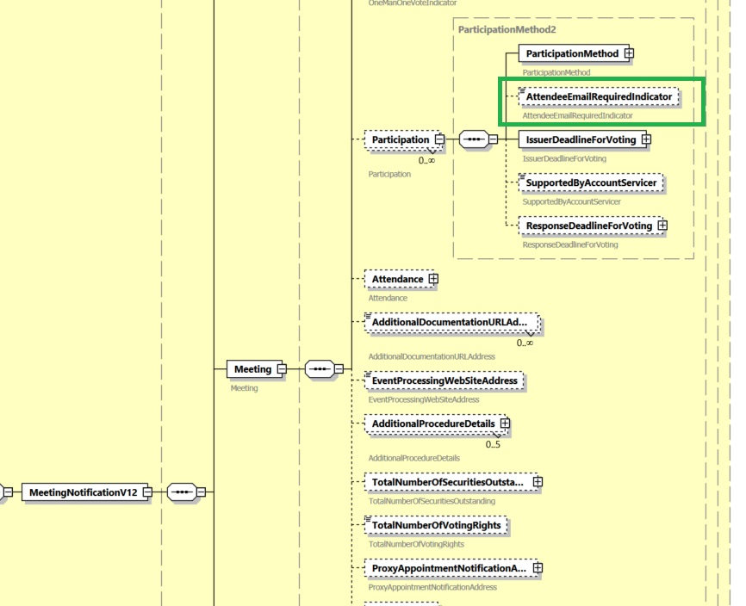
b) in the seev.006 (MeetingInstructionStatus), in message building block “InstructionTypeStatus”, add rejection reason code “NACD (Not ACcepteD, E-mail address missing)" in sequence Rejected/Reason/ReasonCode/Code, with the following definition “Instruction to virtually attend meeting is rejected due to missing rightsholder email address. Not possible to create logon for rightsholder as contact cannot be established.”
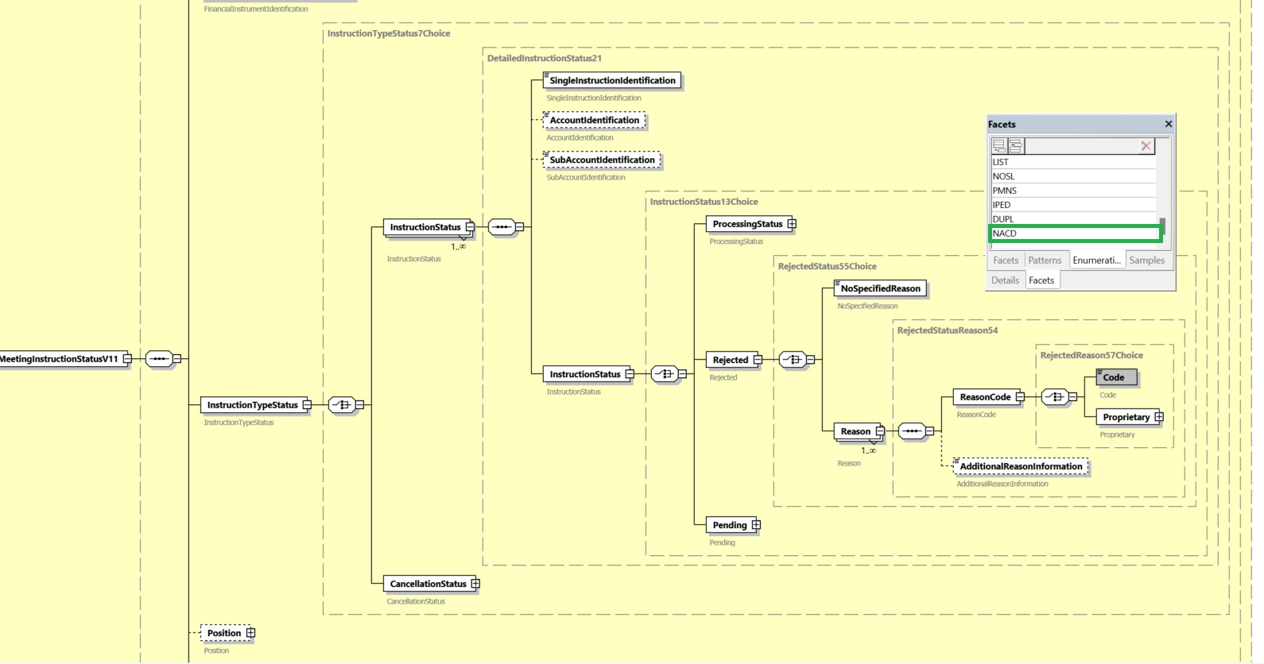
J. Proposed timing:
The submitting organization confirms that it can implement the requested changes in the requested timing.
Timing | As requested

K. Final decision of the SEG(s):
This section is not to be taken care of by the submitting organization. It will be completed in due time by the SEG(s) in charge of the related ISO 20022 messages.
Approve
Comments:

Reject
Reason for rejection:

CR1490: Add Rights Holder Account ID and Entitlement Fixing Date to Instructions

A. Origin of the request:
A.1 Submitter: DESSUG CA – PSG (Deutsche SWIFT Securities Market User Group - Corporate Actions - Proxy Subgroup Germany). This group represents more than 20 different institutions including domestic and global proxy providers and registrars with a key role in the German General Meeting process.
A.2 Contact person: Hendrik Melchior, Hendrik.Melchior@Clearstream.com, Phone +49 69 211-13263 --- Daniel Schäfer, Daniel.Schaefer@hsbc.de, Phone +49 211 910-2362 --- Nils Stock, Nils.Stock@db.com, Phone +49 69 910-43199 --- Rainer Prior, Rainer.Prior@linkmarketservices.de, Phone +49 6196 8870 514
A.3 Sponsors: German Market
B. Related messages:
seev.004
C. Description of the change request:
Name: RightsHolderAccountIdentification <RghtsHldrAcctId> (® SRDII IR; T4-B03 Number of the securities account)
Presence: [0..1]
Datatype: Max35Text
Definition: Account Identification of the Rights Holder where financial instruments are maintained. Account serviced by the last intermediary for an account holder.
Location: /Document/Instr/AcctDtls/RghtsHldr/RghtsHldrAcctId

Name: EntitlementFixingDate <EntitlmntFxgDt> (® SRDII IR; T4-B01 Record Date)
Presence: [0..1]
Datatype: as in seev.001 or seev.003
Definition: as in seev.001 or seev.003
Location: /Document/MtgRef/EntitlmntFxgDt
D. Purpose of the change:
In some markets or for bonds and fund meeting events the account number of the rights holder is required as part of the meeting instructions.
It would be beneficial to report the Entitlement Fixing Date (when given in seev.001) in the meeting instruction. This could then also allow full compliance with Article 5 of Commission Implementing Regulation (EU) 2018/1212 references Table 4 “Confirmation of Entitlement” of the Implementing Regulation 2018-1212 as this is in some markets required as part of the meeting instruction.
E. Urgency of the request:
SR2026
Note: the ISO 20022 maintenance results in the publication of a new version of an ISO 20022 message. The actual implementation of such new version on networks and in user installations is not within the purview of ISO.
F. Business examples:
Examples illustrating the change request.
N/A
G. SEG/TSG recommendation:
This section is not to be taken care of by the submitter of the change request. It will be completed in due time by the SEG(s) in charge of the related ISO 20022 messages or the TSG for changes related to the BAH.
Consider: X
Timing:
- Next yearly cycle: 2025/2026: X
(the change will be considered for implementation in the yearly maintenance cycle which starts in 2025 and completes with the publication of new message versions in the spring of 2026)
- At the occasion of the next maintenance of the messages:
(the change will be considered for implementation, but does not justify maintenance of the messages in its own right – will be pending until more critical change requests are received for the messages)
- Urgent unscheduled:
(the change justifies an urgent implementation outside of the normal yearly cycle)
- Other timing:

Comments: N/A
H. Impact analysis:
This change request impacts the following General meeting messages: seev.004.
I. Proposed implementation solution:
a. In the seev.004 (MeetingInstruction), in message building block Instruction, in sequence AccountDetails/RightsHolder, add optional and non-repetitive element “Account Identification” to both LegalPerson and NaturalPerson, typed by Max35Text and described as “Account Identification of the Rights Holder where financial instruments are maintained. Account serviced by the last intermediary for an account holder.”
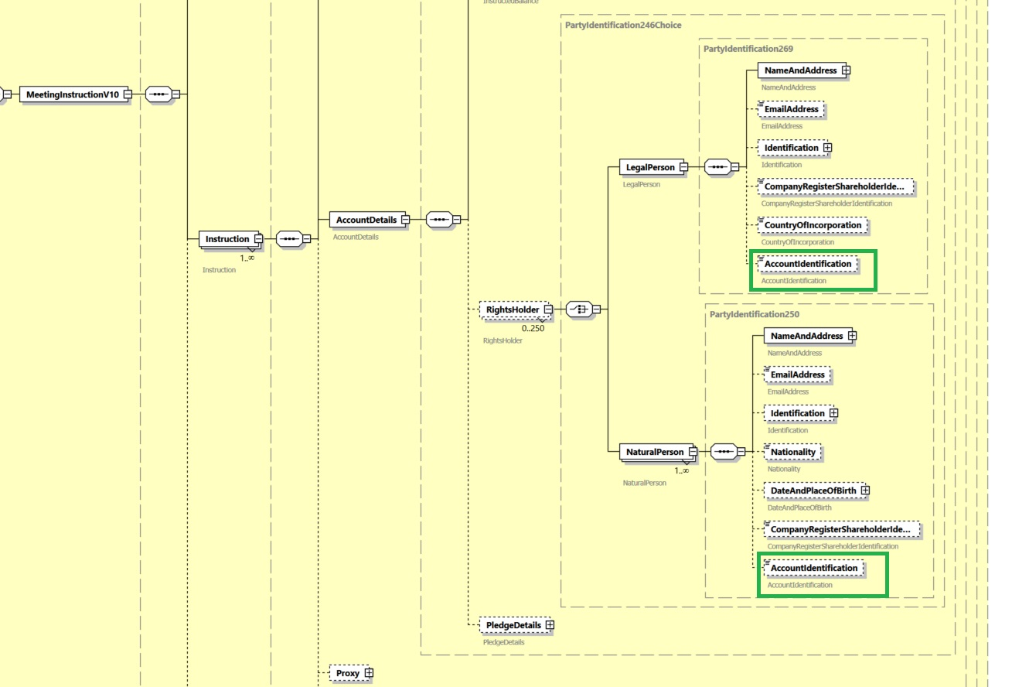
b. In the seev.004 (MeetingInstruction), in message building block Meeting Reference, add optional and non-repetitive message component “Entitlement Fixing Date”, typed by DateFormat1, as illustrated below:
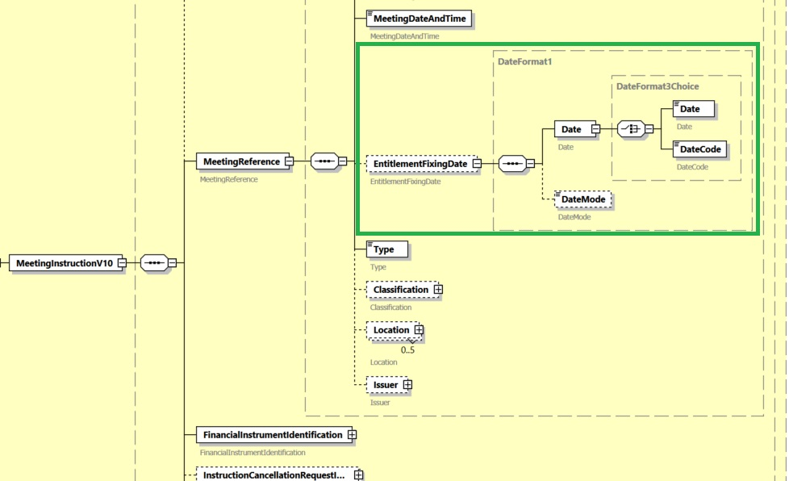
J. Proposed timing:
The submitting organization confirms that it can implement the requested changes in the requested timing.
Timing | As requested

K. Final decision of the SEG(s):
This section is not to be taken care of by the submitting organization. It will be completed in due time by the SEG(s) in charge of the related ISO 20022 messages.
Approve
Comments:

Reject
Reason for rejection:

CR1491: Introduce Meeting Format Type in General Meeting Notification
A. Origin of the request:
A.1 Submitter: DESSUG CA – PSG (Deutsche SWIFT Securities Market User Group - Corporate Actions - Proxy Subgroup Germany). This group represents more than 20 different institutions including domestic and global proxy providers and registrars with a key role in the German General Meeting process.
A.2 Contact person: Hendrik Melchior, Hendrik.Melchior@Clearstream.com, Phone +49 69 211-13263 --- Daniel Schäfer, Daniel.Schaefer@hsbc.de, Phone +49 211 910-2362 --- Nils Stock, Nils.Stock@db.com, Phone +49 69 910-43199 --- Rainer Prior, Rainer.Prior@linkmarketservices.de, Phone +49 6196 8870 514
A.3 Sponsors: German Market
B. Related messages:
seev.004
C. Description of the change request:
Name: MeetingFormatType <MtgFmtTp>
Presence: [0..1]
Definition: Meeting format set by the issuer.
Datatype: CodeSet with multiple Codes
- PHYS: Physical meeting format
- HYBR: Hybrid meeting format
- VIRT: Virtual meeting format
- OTHR: Other format
Location: New field in “Meeting Details” before “Location”:
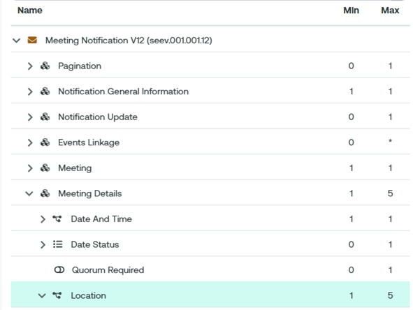

D. Purpose of the change:
General meetings can be held and conducted in several ways.
- Physical general meetings are held by physical presence of the stockholders and their authorised representatives at the place at which the general meeting is being held.
- Virtual general meetings are held without the stockholders or their authorised representatives being physically present at the place at which it is being held
- Hybrid general meetings combine both physical and virtual elements. It allows some attendees to physically attend the general meeting at the meeting location, while others can participate remotely through online platforms.
Adding the implementation type of the general meeting allows to depict the way the general meeting is conducted.
It is important to note that still the place of the general meeting at which it is being held needs to be announced in the meeting notification. This is where the members of the management or supervisory board are to attend. Therefore, the code of implementation shall not be merged into the existing location code or a participation code like VIRT is sufficient.
E. Urgency of the request:
SR2026
Note: the ISO 20022 maintenance results in the publication of a new version of an ISO 20022 message. The actual implementation of such new version on networks and in user installations is not within the purview of ISO.
F. Business examples:
Example like the following have been noticed in production, which shows that the participation method VIRT is not self-explanatory and issuer and market members want to better report the format of the meeting.
<MtgDtls>
…
<Lctn>
<Adr>
<AdrTp>ADDR</AdrTp>
<AdrLine>Street, zip code City, Country</AdrLine>
<Ctry>FR</Ctry>
</Adr>
</Lctn>
<Lctn>
<Adr>
<AdrTp>ADDR</AdrTp>
<AdrLine>The meeting is being held in a hybrid format.</AdrLine>
<Ctry>DE</Ctry>
</Adr>
</Lctn>
</MtgDtls>
….

With this CR the report would be as follows:
<MtgDtls>
…
<MtgFmtTp>HYBR</MtgFmtTp>
<Lctn>
<Adr>
<AdrTp>ADDR</AdrTp>
<AdrLine>Street, zip code City, Country</AdrLine>
<Ctry>FR</Ctry>
</Adr>
</Lctn>
<MtgDtls>
…
G. SEG/TSG recommendation:
This section is not to be taken care of by the submitter of the change request. It will be completed in due time by the SEG(s) in charge of the related ISO 20022 messages or the TSG for changes related to the BAH.
Consider: X
Timing:
- Next yearly cycle: 2025/2026: X
(the change will be considered for implementation in the yearly maintenance cycle which starts in 2025 and completes with the publication of new message versions in the spring of 2026)
- At the occasion of the next maintenance of the messages:
(the change will be considered for implementation, but does not justify maintenance of the messages in its own right – will be pending until more critical change requests are received for the messages)
- Urgent unscheduled:
(the change justifies an urgent implementation outside of the normal yearly cycle)
- Other timing:

Comments: N/A
H. Impact analysis:
This change request impacts the following General meeting messages: seev.001.
I. Proposed implementation solution:
In the seev.001 (MeetingNotification), in message building block MeetingDetails, add new optional and non-repetitive element “Meeting Format Type”, typed by datatype MeetingFormatType1Code, defined as “Meeting format set by the issuer”, and including the following code values:
- PHYS: Physical meeting format
- HYBR: Hybrid meeting format
- VIRT: Virtual meeting format
- OTHR: Other format

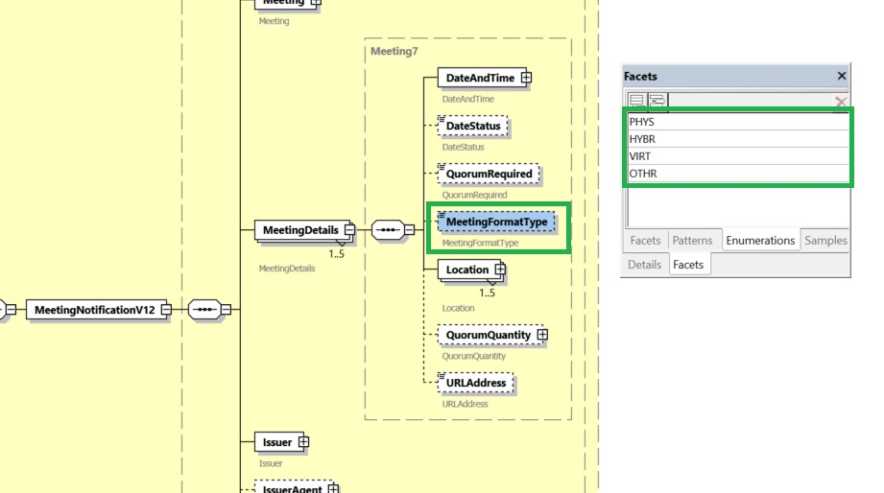
J. Proposed timing:
The submitting organization confirms that it can implement the requested changes in the requested timing.
Timing | As requested

K. Final decision of the SEG(s):
This section is not to be taken care of by the submitting organization. It will be completed in due time by the SEG(s) in charge of the related ISO 20022 messages.
Approve
Comments:

Reject
Reason for rejection:

CR1506: Add Cumulative Voting Multiplier to Meeting Notification

A. Origin of the request:
A.1 Submitter: Eurobonds market / XS NMPG
A.2 Contact person: Jean- Paul Lambotte (jean-paul.lambotte@euroclear.com, +32 2 326 29 59) and Hatem Soliman (hatem.soliman@euroclear.com, +32 2 326 5107)
A.3 Sponsors: ICSDs
B. Related messages:
seev.001.001.12
C. Description of the change request:
In the seev.001 meeting notification message, add an optional field/tag at resolution level (XML path <MtgNtfctn/Rsltn>) to indicate the cumulative voting multiplier when cumulative voting is applicable to specific resolution(s).
D. Purpose of the change:
There are meeting events for which cumulative voting applies for specific resolution(s).
It means that for a number of resolutions for a meeting event, clients can vote for an amount of the eligible balance multiplied by the number of resolutions for which cumulative voting applies.
The sum of the votes by the client for the applicable resolutions should not exceed the eligible balance multiplied by the number of resolutions with cumulative voting.
It must be possible to announce the multiplier when cumulative voting applies to specific resolution(s) as decided by the issuer.
The account servicer receiving a meeting instruction will compare the instruction quantity with the position multiplied by the “cumulative voting multiplier” to either accept (“PACK”), reject (“rejected/LACK”) or keep instruction recycling (“pending/LACK”). (Rejecting or keeping instruction pending to be decided based on account servicer SLA, as for other meeting instructions.). There is no need to define a new reason for this specific case.
E. Urgency of the request:
SR2026
Note: the ISO 20022 maintenance results in the publication of a new version of an ISO 20022 message. The actual implementation of such new version on networks and in user installations is not within the purview of ISO.

F. Business examples:
Around 40 meeting events with cumulative voting announced over the last 6 months, mainly on EURO instruments, Finnish, HK and US markets (mainly for depository receipts).
Example 1:
CUMULATIVE VOTING APPLIES TO RESOLUTION 4
.
2 DIRECTORS ARE TO BE ELECTED TO THE BOARD.
.
TO INSTRUCT, MULTIPLY YOUR ELIGIBLE POSITION BY THE NUMBER OF
DIRECTORS TO BE ELECTED. IF YOU WANT TO SPLIT YOUR VOTE, ASSIGN
AN AMOUNT TO EACH DIRECTOR UNTIL YOUR TOTAL CUMULATED POSITION IS ACCOUNTED FOR.
.
FOR EXAMPLE, IF YOU HAVE 10 ADRS ON RECORD DATE, YOU ARE ENTITLED
TO VOTE ON 2 (NUMBER OF NOMINATED DIRECTORS) X 10, EQUALLING 20
VOTES TO DISTRIBUTE AMONG THE NUMBER OF PROPOSED DIRECTORS.
.
Example 2:
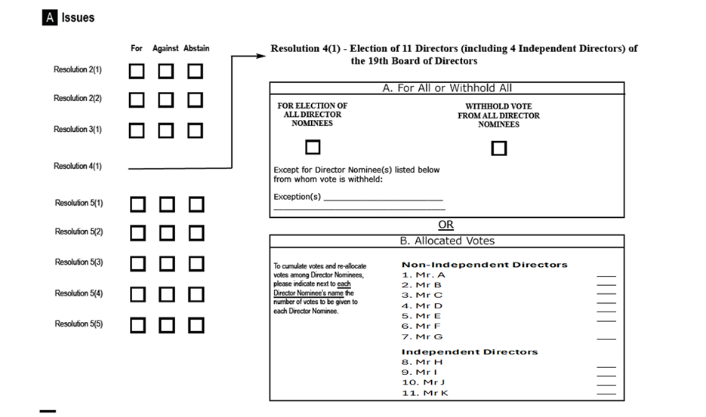

G. SEG/TSG recommendation:
This section is not to be taken care of by the submitter of the change request. It will be completed in due time by the SEG(s) in charge of the related ISO 20022 messages or the TSG for changes related to the BAH.
Consider: X
Timing:
- Next yearly cycle: 2025/2026: X
(the change will be considered for implementation in the yearly maintenance cycle which starts in 2025 and completes with the publication of new message versions in the spring of 2026)
- At the occasion of the next maintenance of the messages:
(the change will be considered for implementation, but does not justify maintenance of the messages in its own right – will be pending until more critical change requests are received for the messages)
- Urgent unscheduled:
(the change justifies an urgent implementation outside of the normal yearly cycle)
- Other timing:

Comments: N/A
H. Impact analysis:
This change request impacts the following General meeting message: seev.001.
I. Proposed implementation solution:
In the seev.001 (MeetingNotification), in message building block Resolution, add new optional and non-repetitive element “Cumulative Voting Multiplier”, typed by a YesNoIndicator, as illustrated below:
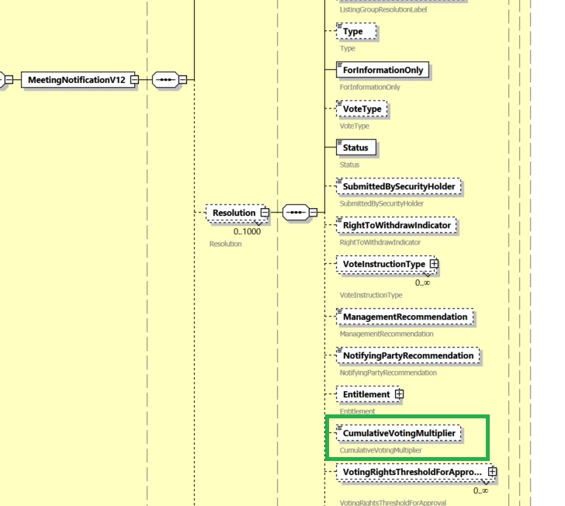
J. Proposed timing:
The submitting organization confirms that it can implement the requested changes in the requested timing.
Timing | As requested

K. Final decision of the SEG(s):
This section is not to be taken care of by the submitting organization. It will be completed in due time by the SEG(s) in charge of the related ISO 20022 messages.
Approve
Comments:

Reject
Reason for rejection:

CR1511: Add Participant Disclosure data in Meeting Instructions

A. Origin of the request:
A.1 Submitter: Eurobonds market / XS NMPG
A.2 Contact person: Jean- Paul Lambotte (jean-paul.lambotte@euroclear.com, +32 2 326 29 59) and Hatem Soliman (hatem.soliman@euroclear.com, +32 2 326 5107)
A.3 Sponsors: ICSDs
B. Related messages:
seev.001 Meeting Notification
seev.004 Meeting Instruction
seev.006 Meeting Instruction Status
C. Description of the change request:
Participant Instruction Details
Where applicable and required by the issuer, participants’ instruction message should allow the disclosure of the participant account number/name and instruction reference of the participant, that may be different from the instruction party.
The ICSDs are required to provide this information to the issuer/issuer agent, representing blocking ID or an instruction reference that might also be required in supporting documentation handled in parallel outside the custody chain.
- Participation disclosure requirement indicator (seev.001)
A flag Y/N (similar to beneficial owner disclosure) must be present in the notification that is acted if the participants’ details are required by the issuer
(NOTE: participation details may be required in addition to beneficial holders, they are not mutually exclusive, and both can be enabled)
- seev.004 - The ICSDs therefore request the introduction of an additional optional repeatable section in seev.004 providing:
/Document/MtgInstr/Instr/AcctDtls/Prtpnt/LglPrsn/Nm
/Document/MtgInstr/Instr/AcctDtls/Prtpnt/LglPrsn/AccNm
/Document/MtgInstr/Instr/AcctDtls/Prtpnt/LglPrsn/AccId/
/Document/MtgInstr/Instr/AcctDtls/Prtpnt/LglPrsn/Id/LEI
/Document/MtgInstr/Instr/AcctDtls/Prtpnt/LglPrsn/Id/AnyBIC
3. Instruction rejection advice – seev.006
If the ICSDs failed to provide the participant details, albeit being a requirement expressly indicated in the seev.001, the issuer agent should indicate that in the rejection advice as “Participant Details Missing” (XXXX).
D. Purpose of the change:
Improve automation.
E. Urgency of the request:
SR2026
Note: the ISO 20022 maintenance results in the publication of a new version of an ISO 20022 message. The actual implementation of such new version on networks and in user installations is not within the purview of ISO.
F. Business examples:
Participant Instruction Details
Participant-level disclosure allows the agent to handle queries from holders and custodians more efficiently, reducing the need to contact the ICSD.
Also, participant disclosure details are crucial for the issuer and working group to understand where instructions and holdings are coming from. If not addressed, this could lead to more corporate actions requiring beneficial-level disclosure or allocation codes, increasing the operational burden on custodians and forcing holders to face shorter instruction windows due to larger buffers set by custodians. The reference could be the ICSD blocking confirmation as part of the instruction to the agent.
G. SEG/TSG recommendation:
This section is not to be taken care of by the submitter of the change request. It will be completed in due time by the SEG(s) in charge of the related ISO 20022 messages or the TSG for changes related to the BAH.
Consider: X
Timing:
- Next yearly cycle: 2025/2026: X
(the change will be considered for implementation in the yearly maintenance cycle which starts in 2025 and completes with the publication of new message versions in the spring of 2026)
- At the occasion of the next maintenance of the messages:
(the change will be considered for implementation, but does not justify maintenance of the messages in its own right – will be pending until more critical change requests are received for the messages)
- Urgent unscheduled:
(the change justifies an urgent implementation outside of the normal yearly cycle)
- Other timing:

Comments: N/A
H. Impact analysis:
This change request impacts the following General meeting messages: seev.001, seev.004, seev.006.
I. Proposed implementation solution:
a. In the seev.001 (MeetingNotification), in message building block Vote, add new optional and non-repetitive element “Participant Details Disclosure”, typed by a YesNoIndicator, as illustrated below:
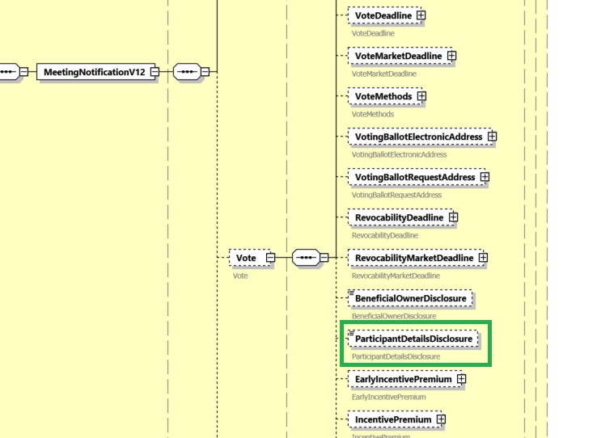
b. In the seev.004 (MeetingIntsruction), in message building block Instruction, in sequence AccountDetails, add new optional and repeatable element “Participant”, typed by datatype PartyIdentificationXX and including the participant's (legal person’s) Name, Account Name, Account Identification, LEI and AnyBIC.

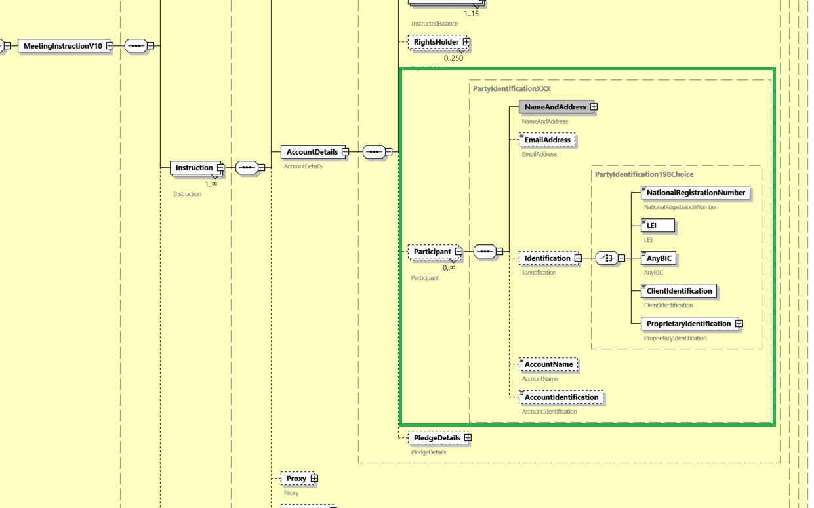
c. In the seev.006 (Meeting Instruction Status), in the message building block Instruction Type Status, in sequence Instruction Status, add rejection code “Participant Details Missing (PRTM)” to element Reason/ReasonCode/Code, as illustrated below:
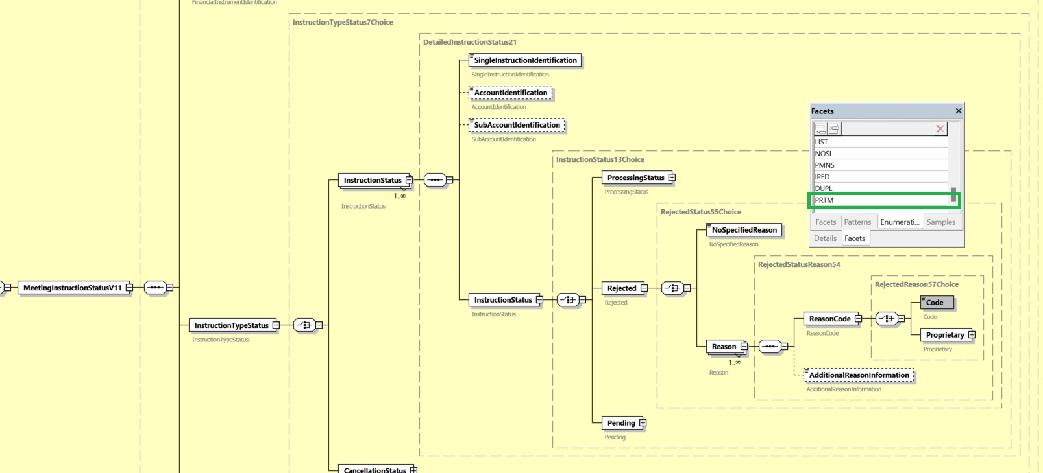
J. Proposed timing:
The submitting organization confirms that it can implement the requested changes in the requested timing.
Timing | As requested

K. Final decision of the SEG(s):
This section is not to be taken care of by the submitting organization. It will be completed in due time by the SEG(s) in charge of the related ISO 20022 messages.
Approve
Comments:

Reject
Reason for rejection:

CR1512: Add Investor Classification data in Meeting Instructions

A. Origin of the request:
A.1 Submitter: Eurobonds Market
A.2 Contact persons: Catarina Marques (catarina.marques@clearstream.com) / Jean-Paul Lambotte/ Hatem Soliman (hatem.soliman@euroclear.com)
A.3 Sponsors: ICSDs and Eurobonds community

B. Related messages:
seev.001 MeetingNotification
seev.004 MeetingInstruction
seev.006 MeetingInstructionStatus

C. Description of the change request:
- Investor Classification Requirement
Introduce an optional sequence in seev.001 to allow the provision of investor categories / shareholder eligibility declaration and corresponding descriptions, as defined by the issuer, allowing voters which are subject to conditions, to indicate the category they pertain to in their voting instructions.
As multiple categories may apply, various classifications should be offered with the possibility to provide a description for each of the listed classifications. Given the Eurobonds market caters for a multiplicity of markets, an additional unspecified category is suggested, to cover for less frequent classification, in addition to the known categories listed below.
Field Definition: Investor Classification: Information identifying at event level the investor types that may apply, and that are subject to conditional vote defined by the issuer in their terms.
· Eligible: The investor meets the requirements of the Eligible terms.
· Non-Eligible: The investor does not meet the requirements of the Eligible terms.
· QIB: Qualified Institutional Buyer
· Non-QIB: The investor does not meet the Qualified Institutional Buyer requirements
· Generic: investor classification to be defined by the issuer
Investor Classification / Categories and Description Field Structure in seev.001
/Document/MtgNtfctn/InvstrClssfctn (0 : 5)
Type: PartyIdentification
· Eligible /Document/MtgNtfctn/InvstrClssfctn/Elig 0 : 1)
· Non-Eligible /Document/MtgNtfctn/InvstrClssfctn/NonElig (maxLength: 1025) (0 : 1)
· QIB /Document/MtgNtfctn/InvstrClssfctn/QIB (maxLength: 1025) (0 : 1)
· Non-QIB /Document/MtgNtfctn/InvstrClssfctn/NonQIB (maxLength: 1025) (0 : 1)
· “Generic” classification /Document/MtgNtfctn/InvstrClssfctn/Other (maxLength: 1025) (0 : 1)

- Investor Classification Disclosure in seev.004
Offer the possibility to indicate the classification applicable to the rightsholder in their vote instruction.
Investors may submit their instructions selecting/indicating their classification in the instruction as follows:
/Document/MtgInstr/Instr/AcctDtls/RghtsHldr/LglPrsn/InvstrClssfctn (0 : 1)
Or
/Document/MtgInstr/Instr/AcctDtls/RghtsHldr/NtrlPrsn/InvstrClssfctn (0 : 1)
· Eligible
· Non-Eligible
· QIB
· Non-QIB
· Generic
Additionally, the rightsholder section must be enabled, so that, where required by the issuer, the investor (rightsholder) is informed of additional requirements and/or information to be provided, in correlation to the investor’s classification, such as geographical restriction or obligation.
The instruction must allow multiple fields pertaining to the RightsHolder section to order to indicate various combinations.
(legal or natural person) namely:
/Document/MtgNtfctn/Scty/Pos/RghtsHldr/LglPrsn/NmAndAdr or
/Document/MtgNtfctn/Scty/Pos/RghtsHldr/NtrlPrs/NmAndAdr
Example: Eligible + geographical location US

- Rights Holder Account and Reference
In several instances, it is necessary to report the investor's account number or a reference field.
· /Document/MtgInstr/Instr/AcctDtls/RghtsHldr/LglPrsn/AccId
· /Document/MtgInstr/Instr/AcctDtls/RghtsHldr/LglPrsn/Rfrnc (maxLength: 35)
· /Document/MtgInstr/Instr/AcctDtls/RghtsHldr/NtrlPrsn/AccId
· /Document/MtgInstr/Instr/AcctDtls/RghtsHldr/NtrlPrsn/Rfrnc (maxLength: 35)

- Make the Rights Holder Identification repeatable
The identification should be repeatable 2 or 3 times.
/Document/MtgInstr/Instr/AcctDtls/RghtsHldr/LglPrsn/Id
/Document/MtgInstr/Instr/AcctDtls/RghtsHldr/NtrlPrsn/Id
In some instances, it is required for the issuer/agent to receive more than one identification of an investor, e.g. LEI plus tax id. This could also solve a problem for other markets where multiple identifications are required (tax id in addition to the LEI is required)

- Rights Holder Identification
Currently the name (or first and surname) fields are defined as mandatory, when the rights holder is reported. In some instances only the nationality, a classification or a reference is required. The fields should be changed to conditional, whereby if the notification requested the identification of the holders, at least one of the elements will be expected in the instruction.
One/more of the following elements may be provided:
/Document/MtgInstr/Instr/AcctDtls/RghtsHldr/LglPrsn/NmAndAdr/Nm
and
/Document/MtgInstr/Instr/AcctDtls/RghtsHldr/NtrlPrsn/NmAndAdr/FrstNm
/Document/MtgInstr/Instr/AcctDtls/RghtsHldr/NtrlPrsn/NmAndAdr/Srnm

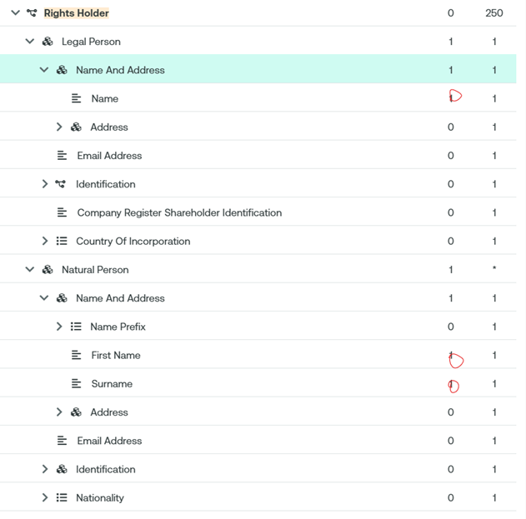
- Investor Classification Validation in SEEV.006
It is foreseen to use new rejection reason “Missing Investor Classification Details” [XXXX] if the classification submitted in the instruction does not match the investor classification in the notification.
D. Purpose of the change:
Improve automation.
E. Urgency of the request:
SR2026
Note: the ISO 20022 maintenance results in the publication of a new version of an ISO 20022 message. The actual implementation of such new version on networks and in user installations is not within the purview of ISO.
F. Business examples:
In the bonds business the investor classification is often required for corporate actions and general meetings. In MT564 different options are used for the different investor classifications.
G. SEG/TSG recommendation:
This section is not to be taken care of by the submitter of the change request. It will be completed in due time by the SEG(s) in charge of the related ISO 20022 messages or the TSG for changes related to the BAH.

Consider: X
Timing:
- Next yearly cycle: 2025/2026: X
(the change will be considered for implementation in the yearly maintenance cycle which starts in 2025 and completes with the publication of new message versions in the spring of 2026)
- At the occasion of the next maintenance of the messages:
(the change will be considered for implementation, but does not justify maintenance of the messages in its own right – will be pending until more critical change requests are received for the messages)
- Urgent unscheduled:
(the change justifies an urgent implementation outside of the normal yearly cycle)
- Other timing:

Comments: N/A
H. Impact analysis:
This change request impacts the following General meeting messages: seev.001, seev.004, seev.006.
I. Proposed implementation solution:
a. In the seev.001 (MeetingNotification), in message building block “Vote”, add new optional and repetitive (up to 5 times) sequence component InvestorClassification, typed by datatype InvestorClassificationInformation1, including the following two elements:
- Mandatory and non-repetitive element InvestorTypeIdentification, typed by InvestorClassificationType1Code, with the following code values and corresponding descriptions:
· Eligible (ELIG): The investor meets the requirements of the Eligible terms.
· Non-Eligible (NLIG): The investor does not meet the requirements of the Eligible terms.
· QIB (QUIB): Qualified Institutional Buyer
· Non-QIB (NQIB): The investor does not meet the Qualified Institutional Buyer requirements.
· Generic (NSPC): Investor classification to be defined by the issuer.
- Optional and non-repetitive element “Description”, typed by Max1025Text datatype.

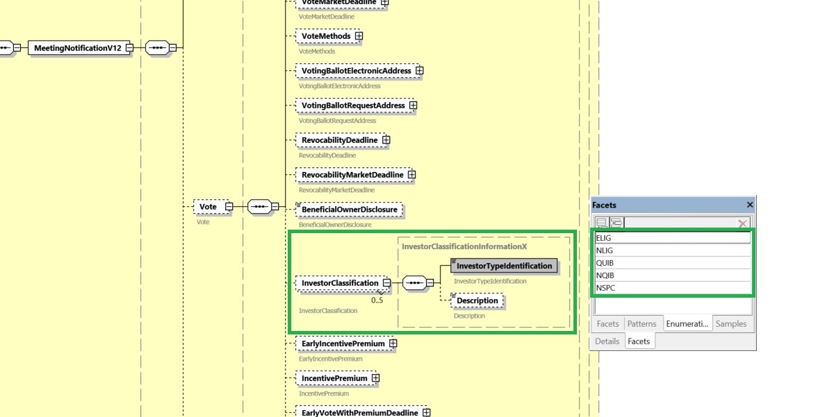
b. In the seev.004 (MeetingInstruction), in message building block Instruction, in sequence AccountDetails, add new element “InvestorTypeIdentification”, typed by InvestorClassificationTypeXCode (code list might be reduced to the categories applicable to legal vs. natural person), as optional and non-repetitive element for component RightsHolder/LegalPerson and RightsHolder/NaturalPerson, as illustrated below:
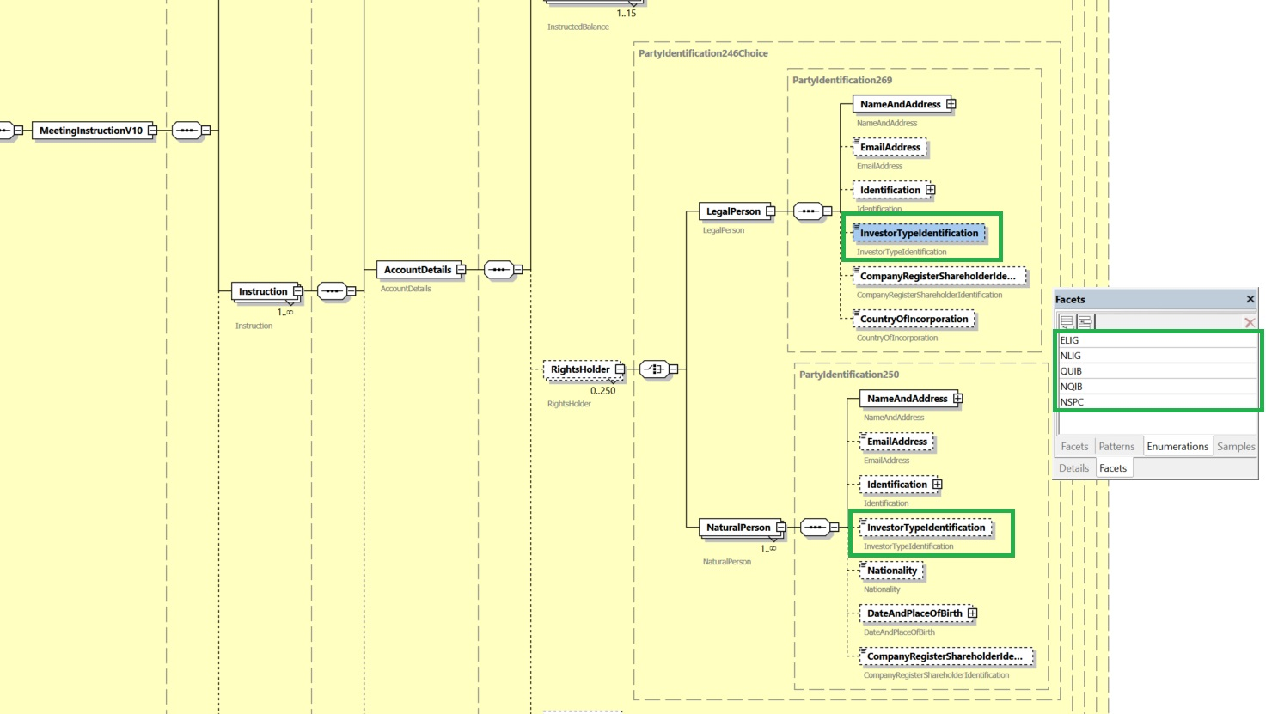
c. In the seev.004 (MeetingInstruction), in message building block Instruction, in sequence AccountDetails, make element “Rights Holder” mandatory;

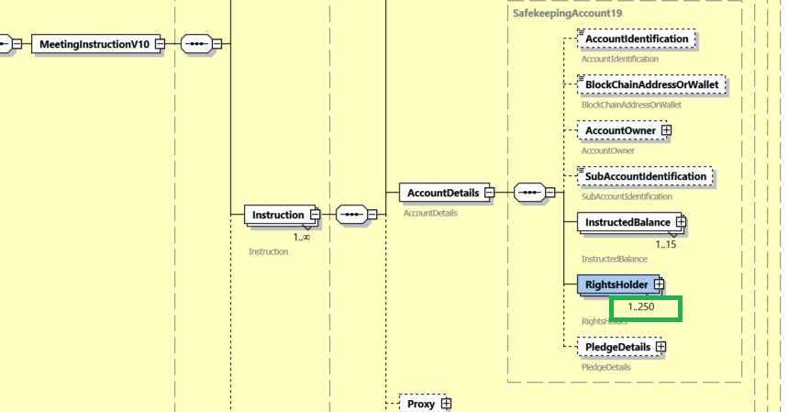
d. In the seev.004 (MeetingInstruction), in the message building block Instruction, in sequence AccountDetails, add two new optional and non-repetitive elements: “Account Identification”, typed by Max35Text, and “Reference”, typed by Max35Text, to component RightsHolder/LegalPerson and Rights/NaturalPerson, as illustrated below:
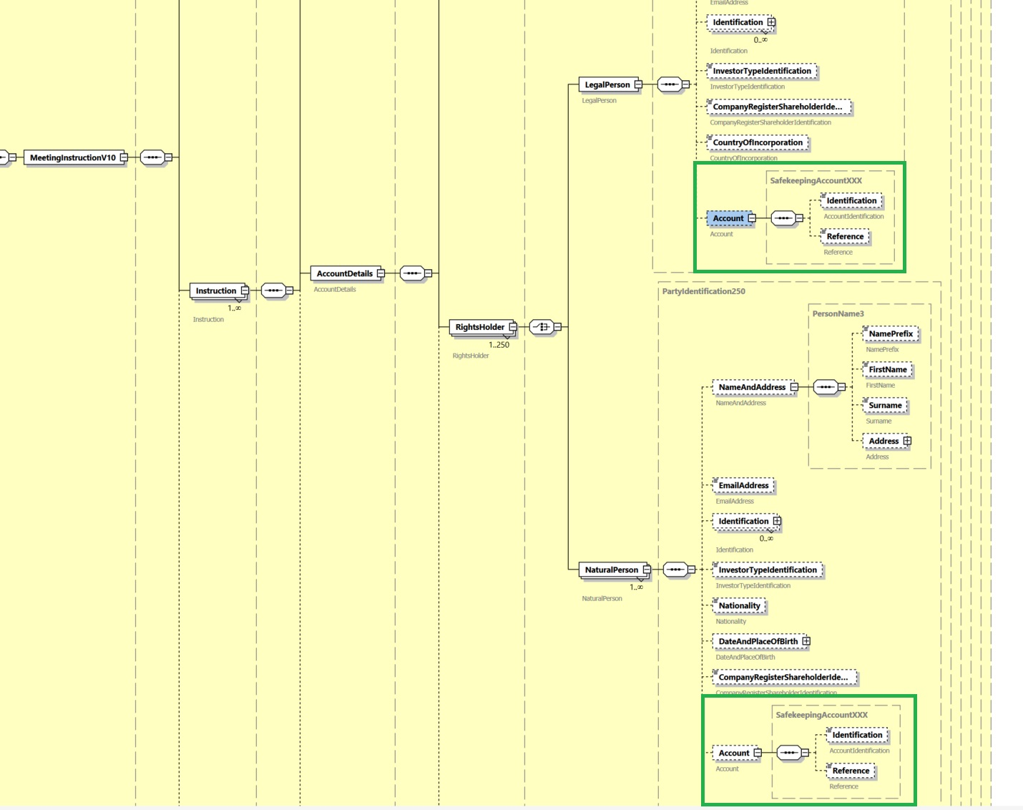

e. In the seev.004 (MeetingInstruction), in the message building block Instruction, in sequence AccountDetails, make element Identification repeatable for both RightsHolder/LegalPerson and RightsHolder/NaturalPerson, as illustrated below:
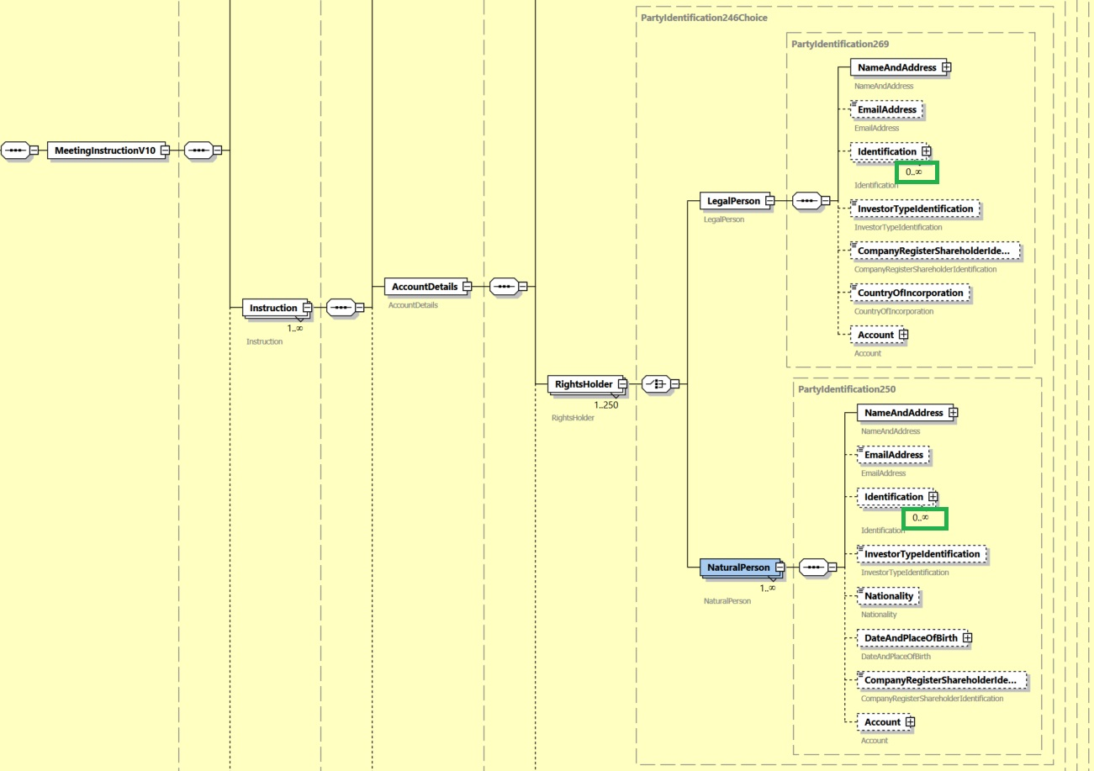

f. In the seev.004 (MeetingInstruction), in the message building block Instruction, in sequence AccountDetails, make elements Name and Address and Name optional for component RightsHolder/LegalPerson and make elements Name and Address, First Name and Surname optional for component RightsHolder/NaturalPerson;
Add cross-element rule “If Legal or Natural Person is present, then at least one sub-element (e.g. Name or Nationality) must be present.”

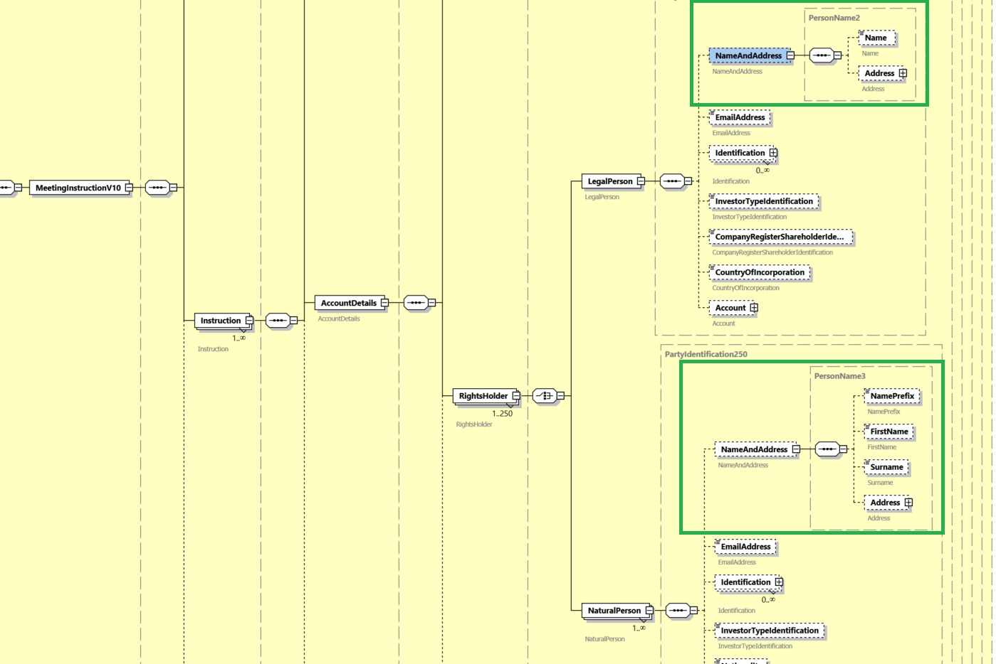
g. In the seev.006 (Meeting Instruction Status), in the message building block Instruction Type Status, in sequence Instruction Status, add rejection reason code “MINC” (Missing Investor Classification Details) to element Rejected/Reason/ReasonCode/Code, as illustrated below:
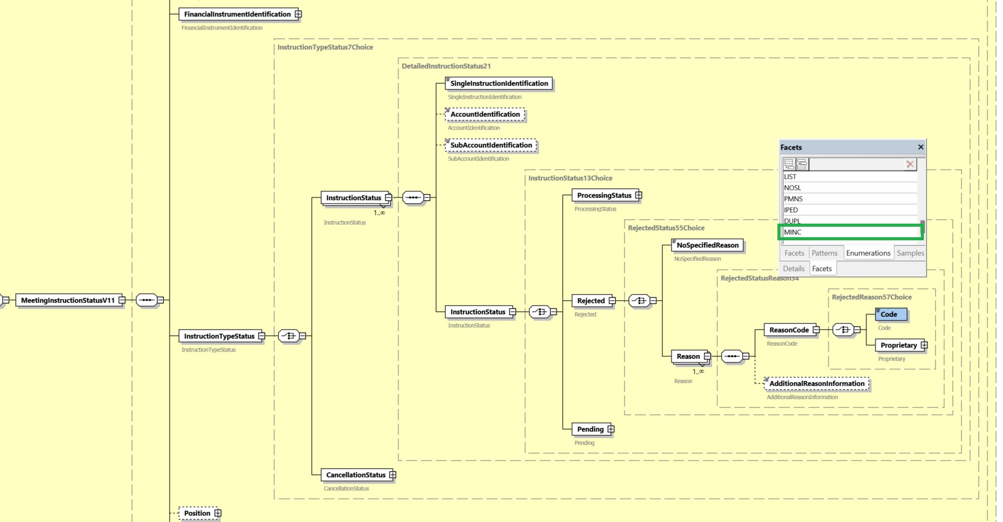

J. Proposed timing:
The submitting organization confirms that it can implement the requested changes in the requested timing.
Timing | As requested

K. Final decision of the SEG(s):
This section is not to be taken care of by the submitting organization. It will be completed in due time by the SEG(s) in charge of the related ISO 20022 messages.
Approve
Comments:

Reject
Reason for rejection:

