Change Request
for the update of ISO 20022 financial repository items
- Origin of the request:
A.1 Submitter:
The Mojaloop Foundation
A.2 Contact person:
Michael Richards. MRichards@Mojaloop.io +44 7785 360009
A.3 Sponsors:
- Related messages:
Pacs.009.001 – FinancialInstitutionCreditTransfer
Pacs.091.001 – FICreditTransferProposal
Pacs.092.001 - FICreditTransferConfirmation

- Description of the change request:
The Mojaloop Foundation uses pacs.009 and its cognates, pacs.091 and pacs.092, to manage currency conversion requests and their execution. In Instant Payment Systems based on the Mojaloop model, these requests are not based on a pre-existing correspondent relationship and its underlying pre-defined terms, but may be made by any type of regulated institution to any financial institution which is registered in the IPS for the provision of currency conversion services.
Since this is the case, participants will need to specify the currency from which conversion is requested, and currency converters will need to specify the exchange rate offered. In addition, the costs associated with the conversion will need to be specified in the messages, since they will not reliably be defined by pre-existing agreements between the parties.
We wish to extend the existing Credit Transfer Definition data element (CreditTransferTransaction67) used in the pacs.009 message and its cognates to include the following additional items of information, all of which currently form part of the CreditTransferTransaction structure used in the current FIToFICustomerCreditTransfer message (CreditTransferTransaction70):
- The instructed amount and currency for the credit transfer. This will be used to specify the amount of the conversion in the source currency. It appears in the CreditTransferTransaction70 structure as the Instructed Amount (InstdAmt).
- The exchange rate to be applied for the conversion. It appears in the CreditTransferTransaction70 structure as the Exchange Rate (XchgRate).
- A description of the pre-agreed exchange rate for the currency conversion (AgrdRate).
- How the charges associated with the currency conversion are to be borne. It appears in the CreditTransferTransaction70 structure as the Charge Bearer (ChrgBr).
- The charges associated with the currency conversion. It appears in the CreditTransferTransaction70 structure as Charges Information (ChrgsInf).
Our proposal is to include the equivalent items in a new version of the CreditTransferTransaction structure used in the current version of the FinancialInstitutionCreditTransfer message (pacs.009) and its proposed cognates. To maintain backwards compatibility, we further propose that the Charge Bearer element, which is a mandatory element in the CreditTransferTransaction70 structure, should be an optional element in the proposed new structure.

Credit Transfer Transaction
The current structure of the credit transfer transaction component used in the pacs.009 message is as shown below:

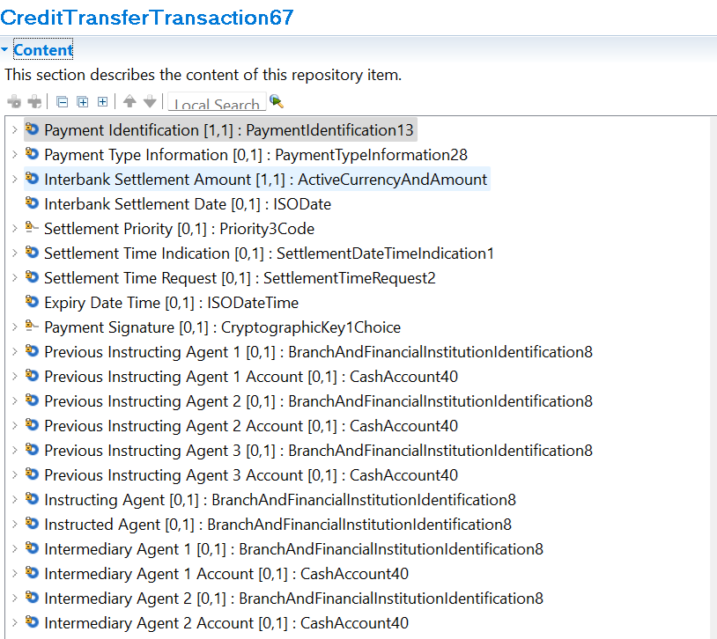
We propose that the structure should be extended as shown below:
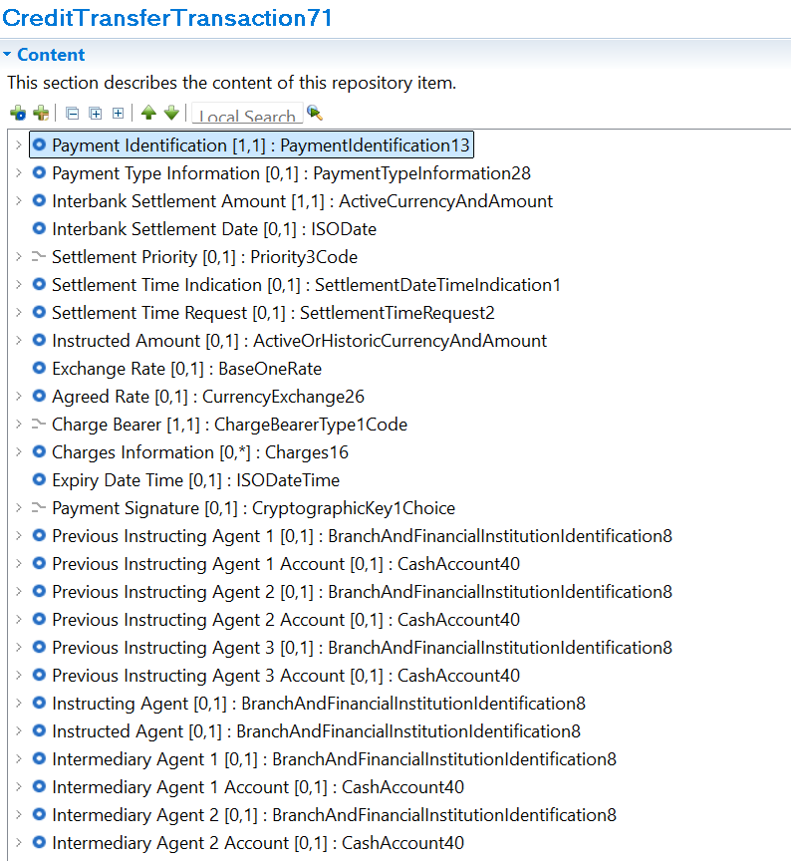
- Purpose of the change:
The purpose of the change is to allow information about currency conversion and the charges associated with processing a payment to be included in FI-to-FI credit transfers (pacs.009) as well as account-to-account transfers.
The existing credit transfer definition for FI-to-FI works well in situations where there is a pre-existing agreement between the FIs which allows correspondents to manage the fees associated with credit transfers independently of the definition of the credit transfers themselves. An IPS, however, will normally require providers of currency conversion services to offer them to any member of the IPS, without needing to reach separate agreements with each user of their services. In addition, participants in an IPS may very well not be traditional banks, and as such will not normally be in a position to enter into correspondent agreements with traditional banks.
Since this is the case, we need to manage charges for inter-DFSP transfers in the same way as we manage charges for account-to-account transfers: by allowing the participants to declare both who is to bear any charges and the amount of the charges. Where FI-to-FI services are required as part of the definition and execution of a payment, as is the case, for instance, with currency conversion, it is essential for conversion charges and exchange rates to be included in the terms agreed. The proposed mechanism allows this information to be exchanged between Financial Institutions and the FIs providing currency conversion services before the terms of the overall payment are agreed, and hence to ensure that senders receive comprehensive and reliable information about the terms of the payment before giving their consent to the payment.
- Urgency of the request:
It is proposed to include this change request in the next regular maintenance cycle.
- Business examples:
Business examples of the change are given in the Business Justification for the agreement of terms (BJ201).

- SEG/TSG recommendation:
This section is not to be taken care of by the submitter of the change request. It will be completed in due time by the SEG(s) in charge of the related ISO 20022 messages or the TSG for changes related to the BAH.

Consider |  |  | Timing
- Next yearly cycle: 2025/2026
(the change will be considered for implementation in the yearly maintenance cycle which starts in 2025 and completes with the publication of new message versions in the spring of 2026)
- At the occasion of the next maintenance of the messages
(the change will be considered for implementation, but does not justify maintenance of the messages in its own right – will be pending until more critical change requests are received for the messages)
- Urgent unscheduled
(the change justifies an urgent implementation outside of the normal yearly cycle)
 |  |  | - Other timing:
Comments:

Reject
Reason for rejection:

