Change Request
for the update of ISO 20022 financial repository items
Note: the purpose of this document is to give guidelines to parties who want to introduce a request to change an existing ISO 20022 message(s), or update other items of the ISO 20022 financial repository. Such change requests are subject to the approval of the ISO 20022 Standards Evaluation Group(s) in charge of the related message/item or to the approval of the Technical Support Group (TSG), if the requested change relates to the Business Application Header (BAH). Please consult the iso20022.org website for additional details on the maintenance process. Change requests are to be sent to iso20022ra@iso20022.org. All change requests conforming to this template received by June 1st will be considered for development in the following yearly ISO 20022 maintenance cycle which completes with publication of new message versions in April/May of the following year.
- Origin of the request:
A.1 Submitter: Eurobonds market / XS NMPG
A.2 Contact person: Jean- Paul Lambotte (jean-paul.lambotte@euroclear.com, +32 2 326 29 59) and Hatem Soliman (hatem.soliman@euroclear.com, +32 2 326 5107)
A.3 Sponsors: ICSDs

- Related messages:
seev.001.001.12

- Description of the change request:
In the seev.001 meeting notification message, add an optional field/tag at resolution level (XML path <MtgNtfctn/Rsltn>) to indicate the cumulative voting multiplier when cumulative voting is applicable to specific resolution(s).

- Purpose of the change:
There are meeting events for which cumulative voting applies for specific resolution(s).
It means that for a number of resolutions for a meeting event, clients can vote for an amount of the eligible balance multiplied by the number of resolutions for which cumulative voting applies.
The sum of the votes by the client for the applicable resolutions should not exceed the eligible balance multiplied by the number of resolutions with cumulative voting.
It must be possible to announce the multiplier when cumulative voting applies to specific resolution(s) as decided by the issuer.

- Urgency of the request:
For SR2026.

- Business examples:
Around 40 meeting events with cumulative voting announced over the last 6 months, mainly on EURO instruments, Finnish, HK and US markets (mainly for depository receipts).
Example 1:
CUMULATIVE VOTING APPLIES TO RESOLUTION 4
.
2 DIRECTORS ARE TO BE ELECTED TO THE BOARD.
.
TO INSTRUCT, MULTIPLY YOUR ELIGIBLE POSITION BY THE NUMBER OF
DIRECTORS TO BE ELECTED. IF YOU WANT TO SPLIT YOUR VOTE, ASSIGN
AN AMOUNT TO EACH DIRECTOR UNTIL YOUR TOTAL CUMULATED POSITION IS ACCOUNTED FOR.
.
FOR EXAMPLE, IF YOU HAVE 10 ADRS ON RECORD DATE, YOU ARE ENTITLED
TO VOTE ON 2 (NUMBER OF NOMINATED DIRECTORS) X 10, EQUALLING 20
VOTES TO DISTRIBUTE AMONG THE NUMBER OF PROPOSED DIRECTORS.
.

Example 2:
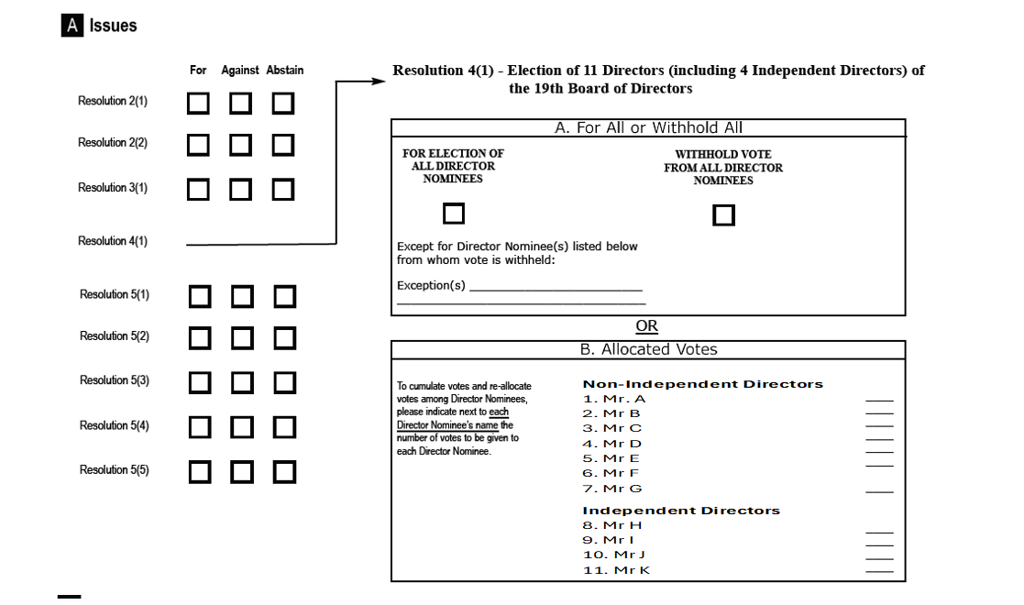
SEG/TSG recommendation:
This section is not to be taken care of by the submitter of the change request. It will be completed in due time by the SEG(s) in charge of the related ISO 20022 messages or the TSG for changes related to the BAH.

Consider |  | X | Timing
 |  |  | - Next yearly cycle: 2025/2026  (the change will be considered for implementation in the yearly maintenance cycle which starts in 2025 and completes with the publication of new message versions in the spring of 2026) |  | X
- At the occasion of the next maintenance of the messages
(the change will be considered for implementation, but does not justify maintenance of the messages in its own right – will be pending until more critical change requests are received for the messages)
- Urgent unscheduled
(the change justifies an urgent implementation outside of the normal yearly cycle)
 |  |  | - Other timing:
Comments:

Reject
Reason for rejection:

