Change Request
for the update of ISO 20022 financial repository items
Note: the purpose of this document is to give guidelines to parties who want to introduce a request to change an existing ISO 20022 message(s), or update other items of the ISO 20022 financial repository. Such change requests are subject to the approval of the ISO 20022 Standards Evaluation Group(s) in charge of the related message/item or to the approval of the Technical Support Group (TSG), if the requested change relates to the Business Application Header (BAH). Please consult the iso20022.org website for additional details on the maintenance process. Change requests are to be sent to iso20022ra@iso20022.org. All change requests conforming to this template received by June 1st will be considered for development in the following yearly ISO 20022 maintenance cycle which completes with publication of new message versions in April/May of the following year.

- Origin of the request:
A.1 Submitter: Eurobonds Market
A.2 Contact persons: Catarina Marques (catarina.marques@clearstream.com) / Jean-Paul Lambotte/ Hatem Soliman (hatem.soliman@euroclear.com)
A.3 Sponsors: ICSDs and Eurobonds community

- Related messages:
seev.001 MeetingNotification
seev.004 MeetingInstruction
seev.006 MeetingInstructionStatus

- Description of the change request:

- Investor Classification Requirement
Introduce an optional sequence in seev.001 to allow the provision of investor categories / shareholder eligibility declaration and corresponding descriptions, as defined by the issuer, allowing voters which are subject to conditions, to indicate the category they pertain to in their voting instructions.
As multiple categories may apply, various classifications should be offered with the possibility to provide a description for each of the listed classifications. Given the Eurobonds market caters for a multiplicity of markets, an additional unspecified category is suggested, to cover for less frequent classification, in addition to the known categories listed below.
Field Definition: Investor Classification: Information identifying investor types subject to conditions’ classification as defined by the issuer in their terms.
- Eligible: The investor meets the requirements of the Eligible terms.
- Non-Eligible: The investor does not meet the requirements of the Eligible terms.
- QIB: Qualified Institutional Buyer
- Non-QIB: The investor does not meet the Qualified Institutional Buyer requirements
- Generic: investor classification to be defined by the issuer
Investor Classification / Categories and Description Field Structure in seev.001
/Document/MtgNtfctn/RghtsHldr/InvstrClssfctn (0 : 5)
Type: PartyIdentification
- Eligible /Document/MtgNtfctn/RghtsHldr/InvstrClssfctn/Elig 0 : 1)
- Non-Eligible /Document/MtgNtfctn/RghtsHldr/InvstrClssfctn/NonElig (maxLength: 1025) (0 : 1)
- QIB /Document/MtgNtfctn/RghtsHldr/InvstrClssfctn/QIB (maxLength: 1025) (0 : 1)
- Non-QIB /Document/MtgNtfctn/RghtsHldr/InvstrClssfctn/NonQIB (maxLength: 1025) (0 : 1)
- “Generic” classification /Document/MtgNtfctn/InvstrClssfctn/Other (maxLength: 1025) (0 : 1)

- Investor Classification Disclosure in seev.004
Offer the possibility to indicate the classification applicable to the rightsholder in their vote instruction.
Investors may submit their instructions selecting/indicating their classification in the instruction as follows:
/Document/MtgInstr/Instr/AcctDtls/RghtsHldr/LglPrsn/InvstrClssfctn (0 : 1)
Or
/Document/MtgInstr/Instr/AcctDtls/RghtsHldr/NtrlPrsn/InvstrClssfctn (0 : 1)
- Eligible
- Non-Eligible
- QIB
- Non-QIB
- Generic
Additionally, the rightsholder section must be enabled, so that, where required by the issuer, the investor (rightsholder) is informed of additional requirements and/or information to be provided, in correlation to the investor’s classification, such as geographical restriction or obligation.
The instruction must allow multiple fields pertaining to the RightsHolder section to order to indicate various combinations.
(legal or natural person) namely:
/Document/MtgNtfctn/Scty/Pos/RghtsHldr/LglPrsn/NmAndAdr or
/Document/MtgNtfctn/Scty/Pos/RghtsHldr/NtrlPrs/NmAndAdr
Example: Eligible + geographical location US

- Rights Holder Account and Reference
In several instances, it is necessary to report the investor's account number or a reference field.
- /Document/MtgInstr/Instr/AcctDtls/RghtsHldr/LglPrsn/AccId
- /Document/MtgInstr/Instr/AcctDtls/RghtsHldr/LglPrsn/Rfrnc (maxLength: 35)
- /Document/MtgInstr/Instr/AcctDtls/RghtsHldr/NtrlPrsn/AccId
- /Document/MtgInstr/Instr/AcctDtls/RghtsHldr/NtrlPrsn/Rfrnc (maxLength: 35)

- Make the Rights Holder Identification repeatable
The identification should be repeatable 2 or 3 times.
/Document/MtgInstr/Instr/AcctDtls/RghtsHldr/LglPrsn/Id
/Document/MtgInstr/Instr/AcctDtls/RghtsHldr/NtrlPrsn/Id

In some instances, it is required for the issuer/agent to receive more than one identification of an investor, e.g. LEI plus tax id. This could also solve a problem for other markets where multiple identifications are required (tax id in addition to the LEI is required)

- Rights Holder Identification
Currently the name (or first and surname) fields are defined as mandatory, when the rights holder is reported. In some instances only the nationality, a classification or a reference is required. The fields should be changed to optional.
/Document/MtgInstr/Instr/AcctDtls/RghtsHldr/LglPrsn/NmAndAdr/Nm
and
/Document/MtgInstr/Instr/AcctDtls/RghtsHldr/NtrlPrsn/NmAndAdr/FrstNm
/Document/MtgInstr/Instr/AcctDtls/RghtsHldr/NtrlPrsn/NmAndAdr/Srnm

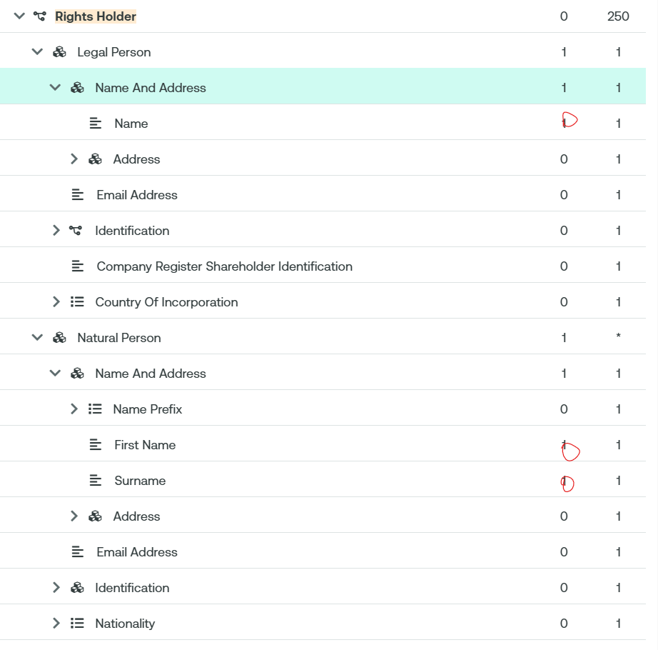

- Investor Classification Validation in SEEV.006
It is foreseen to use new rejection reason “Missing Investor Classification Details” [XXXX] if the classification submitted in the instruction does not match the investor classification in the notification

- Purpose of the change:
Improve automation.

- Urgency of the request:
SR2026

- Business examples:
In the bonds business the investor classification is often required for corporate actions and general meetings. In MT564 different options are used for the different investor classifications.

- SEG/TSG recommendation:
This section is not to be taken care of by the submitter of the change request. It will be completed in due time by the SEG(s) in charge of the related ISO 20022 messages or the TSG for changes related to the BAH.

Consider |  | X | Timing
 |  |  | - Next yearly cycle: 2025/2026  (the change will be considered for implementation in the yearly maintenance cycle which starts in 2025 and completes with the publication of new message versions in the spring of 2026) |  | X
- At the occasion of the next maintenance of the messages
(the change will be considered for implementation, but does not justify maintenance of the messages in its own right – will be pending until more critical change requests are received for the messages)
- Urgent unscheduled
(the change justifies an urgent implementation outside of the normal yearly cycle)
 |  |  | - Other timing:
Comments:

Reject
Reason for rejection:

