Change Request
for the update of ISO 20022 financial repository items
Note: the purpose of this document is to give guidelines to parties who want to introduce a request to change an existing ISO 20022 message(s), or update other items of the ISO 20022 financial repository. Such change requests are subject to the approval of the ISO 20022 Standards Evaluation Group(s) in charge of the related message/item or to the approval of the Technical Support Group (TSG), if the requested change relates to the Business Application Header (BAH). Please consult the iso20022.org website for additional details on the maintenance process. All change requests conforming to this template received by June 1st will be considered for development in the following yearly ISO 20022 maintenance cycle which completes with publication of new message versions in April/May of the following year.
Changes requests are to be submitted through the ISO 20022 website through this e-request, in which this template must be attached.

- Origin of the request:
A.1 Submitter: DESSUG CA – PSG (Deutsche SWIFT Securities Market User Group - Corporate Actions - Proxy Subgroup Germany). This group represents more than 20 different institutions including domestic and global proxy providers and registrars with a key role in the German General Meeting process.
A.2 Contact person: Hendrik Melchior, Hendrik.Melchior@Clearstream.com, Phone +49 69 211-13263 --- Daniel Schäfer, Daniel.Schaefer@hsbc.de, Phone +49 211 910-2362 --- Nils Stock, Nils.Stock@db.com, Phone +49 69 910-43199 --- Rainer Prior, Rainer.Prior@linkmarketservices.de, Phone +49 6196 8870 514
A.3 Sponsors: German Market

- Related messages:
seev.001

- Description of the change request:

Name: MeetingFormatType <MtgFmtTp>
Presence: [0..1]
Definition: Meeting format set by the issuer.
Datatype: CodeSet with multiple Codes
- PHYS: Physical meeting format
- HYBR: Hybrid meeting format
- VIRT: Virtual meeting format
- OTHR: Other format
Location: New field in “Meeting Details” before “Location”.
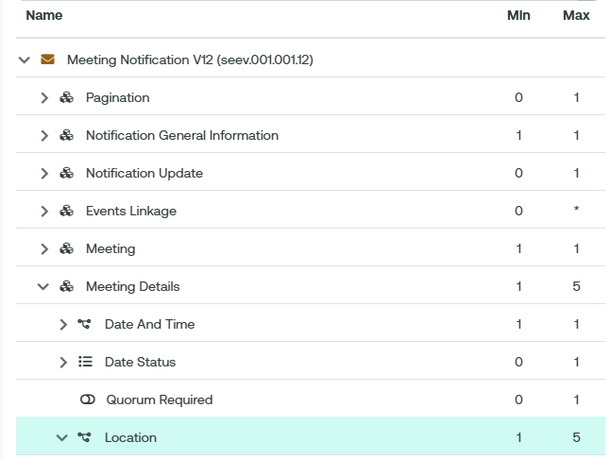

- Purpose of the change:
General meetings can be held and conducted in several ways.
- Physical general meetings are held by physical presence of the stockholders and their authorised representatives at the place at which the general meeting is being held.
- Virtual general meetings are held without the stockholders or their authorised representatives being physically present at the place at which it is being held
- Hybrid general meetings combine both physical and virtual elements. It allows some attendees to physically attend the general meeting at the meeting location, while others can participate remotely through online platforms.
Adding the implementation type of the general meeting allows to depict the way the general meeting is conducted.
It is important to note that still the place of the general meeting at which it is being held needs to be announced in the meeting notification. This is where the members of the management or supervisory board are to attend. Therefore, the code of implementation shall not be merged into the existing location code or a participation code like VIRT is sufficient.

- Urgency of the request:
SR2026

Business examples:
Example like the following have been noticed in production, which shows that the participation method VIRT is not self-explanatory and issuer and market members want to better report the format of the meeting.
<MtgDtls>
…
<Lctn>
<Adr>
<AdrTp>ADDR</AdrTp>
<AdrLine>Street, zip code City, Country</AdrLine>
<Ctry>FR</Ctry>
</Adr>
</Lctn>
<Lctn>
<Adr>
<AdrTp>ADDR</AdrTp>
<AdrLine>The meeting is being held in a hybrid format.</AdrLine>
<Ctry>DE</Ctry>
</Adr>
</Lctn>
</MtgDtls>
….

With this CR the report would be as follows:
<MtgDtls>
…
<MtgFmtTp>HYBR</MtgFmtTp>
<Lctn>
<Adr>
<AdrTp>ADDR</AdrTp>
<AdrLine>Street, zip code City, Country</AdrLine>
<Ctry>FR</Ctry>
</Adr>
</Lctn>
<MtgDtls>
…

SEG/TSG recommendation:
This section is not to be taken care of by the submitter of the change request. It will be completed in due time by the SEG(s) in charge of the related ISO 20022 messages or the TSG for changes related to the BAH.

Consider |  |  | Timing
- Next yearly cycle: 2025/2026
(the change will be considered for implementation in the yearly maintenance cycle which starts in 2022 and completes with the publication of new message versions in the spring of 2025)
- At the occasion of the next maintenance of the messages
(the change will be considered for implementation, but does not justify maintenance of the messages in its own right – will be pending until more critical change requests are received for the messages)
- Urgent unscheduled
(the change justifies an urgent implementation outside of the normal yearly cycle)
 |  |  | - Other timing:
Comments:

Reject
Reason for rejection:

