Maintenance Change Request
for fast track maintenance of existing message definitions

- Submitting organization(s):
European Securities and Markets Authority (ESMA)
201-203 rue de Bercy
75012 Paris
France

- Related messages:
auth.044.001.02 (FinancialInstrumentReportingEquityTradingActivityResultV02)

- Purpose of the change:
The European Commission Delegated Regulation (EU) 2017/587 (RTS 1) and Commission Delegated Regulation (EU) 2017/583 (RTS 2) further specify the MiFIR pre-trade and post-trade transparency requirements for equity, equity-like and non-equity instruments, respectively.
The revised MiFIR regulation was published in the Official Journal of the EU on 8 March 2024. In this context, ESMA has been empowered to review various technical standards further specifying certain provisions.
The final report on the revised RTS 1 regarding the transparency calculation results of the equity and equity-like instruments was published on ESMA website on 16 December 2024.
Based on the new business requirements of the revised RTS 1 ESMA needs to perform minor changes in the equity trading activity result message (auth.044). The changes are related to the inclusion of the ‘Application Period’ in the calculation results that are produced and will be published by ESMA’s transparency system. As the message mainly used by ESMA, we propose to update the message description accordingly. (No change in the non-equity trading activity result message envisaged as according to changes in the revised RTS 2, the non-equity calculation and result publication will be discontinued in the 2026).

To align with the changes in the regulation the proposed solution for the update in the Financial Instrument Reporting Equity Trading Activity Result report is:
- Addition of the element: ‘Application Period’ (/Document/FinInstrmRptgEqtyTradgActvtyRslt/EqtyTrnsprncyData/ApplPrd) with datatype: Period4Choice.
- Update the description of the message in the General Information section to describe properly the reporting scope:
‘The FinancialInstrumentReportingEquityTradingActivityResult message is used by a reporting entity or authority to provide information on computed results data of equity specific trading activity.‘

- Urgency of the request:
There is no other structural modification in the proposed solution, the change in the message is limited to this addition. Based on the feedback from ESMA policy teams no other changes in the RTS1 envisaged from the European Commission (EC). The updated regulatory standard is expected to be published in the Official Journal of the EU in the summer 2025. According to the Final Report on the RTS1 review, the new requirements will enter into force from 1 January 2026.
As the proposed change is minor and to keep the regulatory deadline ESMA would like to launch the ISO evaluation via the fast-track maintenance procedure.
This would allow ESMA to develop the changes and include it in the next major maintenance release cycle of its transparency calculation system and also provide enough implementation lead-time to the market participants to prepare their processing for downloading the updated transparency result files from ESMA website.

- Commitments of the submitting organization:
The ESMA FITRS project team confirms that it plans to develop a new version of the impacted message and system in accordance with the changes proposed in this document.

- Contact persons:

Krisztina Miklossy – krisztina.miklossy@esma.europa.eu
Aggelos Tavladorakis - aggelos.tavladorakis-ext@esma.europa.eu

Change number #1

- Related messages:
auth.044.001.03 FinancialInstrumentReportingEquityTradingActivityResult report

- Description of the change and type of impact:
For the publication of the Financial Instrument Reporting Equity Trading Activity Result report, ESMA’s transparency system will have to be able to include the ‘Application Period’ (XML path: (/Document/FinInstrmRptgEqtyTradgActvtyRslt/EqtyTrnsprncyData/ApplPrd) of each produced result in the relevant publication files.
This field clarifies the time-period that a result record is considered applicable, depending on the methodology/type of the calculation that was performed.

- Proposed implementation:
ESMA proposes the following solution:
- Creation of a new Element (ApplicationPeriod) with datatype Period4Choice. It will be proposed to restrict the other options of this message component in Usage Guideline, except the element FromDateToDate: Period2.

Current message Proposed change
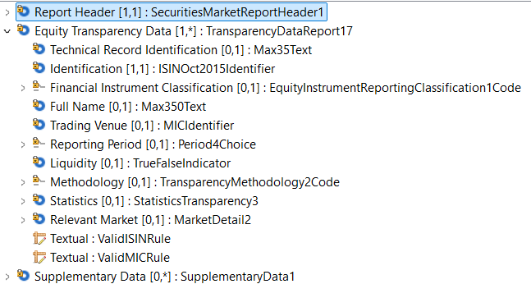
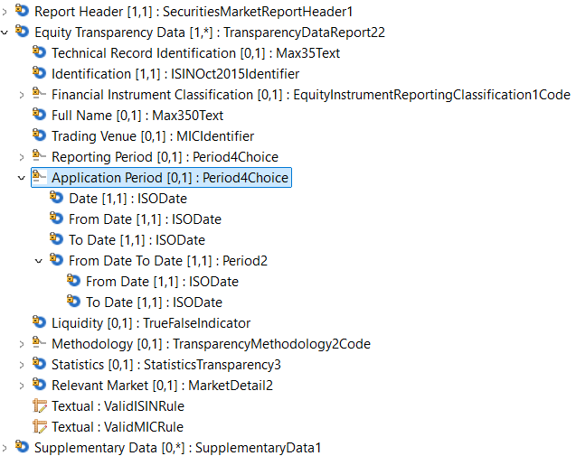

- Decision of the SEG(s):
This section is not to be taken care of by the submitting organization. It will be completed in due time by the SEG(s) in charge of the related ISO 20022 message definitions.

Change
approved
rejected
Comments:

Timing
- Fast track maintenance
(the change justifies an urgent implementation using the fast-track maintenance process)
- At the occasion of the next maintenance of the messages
(the change will be considered for implementation, but does not justify an urgent implementation – will be pending until the next [yearly] maintenance of the messages)

Change number #2

- Related messages:
auth.044.001.03 FinancialInstrumentReportingEquityTradingActivityResult report

- Description of the change and type of impact:
The purpose of this report was to support the reporting of the trading activity result performed by the national competent authorities of the European member states who had not delegated the transparency calculation tasks to ESMA. However, the same reporting message is used to provide information on the transparency calculation results that is performed by ESMA on behalf of the delegating NCAs. (Since 2022 all NCAs delegated these calculations to ESMA.) Therefore in addition to the modification described in Change #1, we propose to update the description of the message in the General Information section too in order to better align with the scope and the providers of the report.

- Proposed implementation:
ESMA proposes to update the message description as follows:
‘The FinancialInstrumentReportingEquityTradingActivityResult message is used by a reporting entity or authority to provide information on computed results data of equity specific trading activity .‘

Current message Proposed change
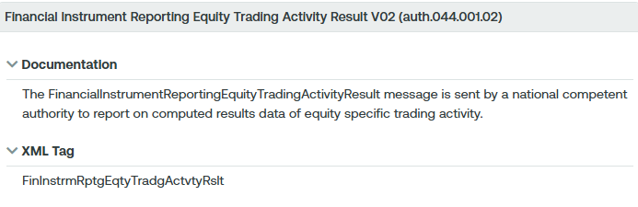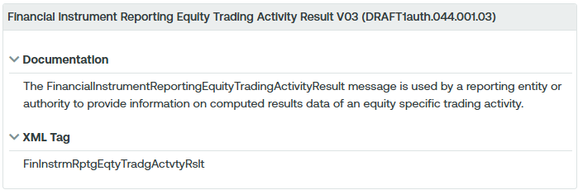

- Decision of the SEG(s):
This section is not to be taken care of by the submitting organization. It will be completed in due time by the SEG(s) in charge of the related ISO 20022 message definitions.

Change
approved
rejected
Comments:

Timing
- Fast track maintenance
(the change justifies an urgent implementation using the fast-track maintenance process)
- At the occasion of the next maintenance of the messages
(the change will be considered for implementation, but does not justify an urgent implementation – will be pending until the next [yearly] maintenance of the messages)

Regulation (EU) 2024/791 of the European Parliament and of the Council of 28 February 2024 amending Regulation (EU) No 600/2014 as regards enhancing data transparency, removing obstacles to the emergence of consolidated tapes, optimising the trading obligations and prohibiting receiving payment for order flow. (https://eur-lex.europa.eu/eli/reg/2024/791/oj/eng )
ESMA74-2134169708-7636 Final Report on equity transparency (https://www.esma.europa.eu/sites/default/files/2024-12/ESMA74-2134169708-7636_MiFIR_Review_Final_Report_on_Equity_transparency.pdf )
ESMA74-2134169708-7775 Final Report on the Review of RTS 2 on transparency for bonds, structured finance products and emission allowances and RTS on reasonable commercial basis (https://www.esma.europa.eu/sites/default/files/2024-12/ESMA74-2134169708-7775_MiFIR_Review_Final_Report_on_amendment_of_RTS_2_and_RTS_on_RCB.pdf )

