Maintenance Change Request
for the update of ISO 20022 financial repository items

Table of contents
Overview 8
A. Name of the request: 8
B. Submitting organization(s): 8
C. Related messages: 8
D. Commitments of the submitting organization: 10
E. Contact persons: 12
Additional Updates performed/requested by nexo 13
Change request number #1381 nexo ACQ Deferred Clearing 16
A. Origin of the request: 16
B. Related messages: 16
C. Description of the change request: 16
D. Purpose of the change: 17
E. Urgency of the request: 17
F. Business examples: 18
G. SEG recommendation: 18
H. Impact analysis and type of impact: 18
I. Proposed implementation: 20
J. Proposed timing: 20
K. Final decision of the SEG(s): 21
Change request number #1382 nexo ACQ Card On File Not Supported 22
A. Origin of the request: 22
B. Related messages: 22
C. Description of the change request: 22
D. Purpose of the change: 23
E. Urgency of the request: 23
F. Business examples: 24
G. SEG recommendation: 24
H. Impact analysis and type of impact: 24
I. Proposed implementation: 25
J. Proposed timing: 27
K. Final decision of the SEG(s): 27
Change request number #1383 nexo ATM Config 28
A. Origin of the request: 28
B. Related messages: 28
C. Description of the change request: 28
D. Purpose of the change: 31
E. Urgency of the request: 33
F. Business examples: 33
G. SEG recommendation: 33
H. Impact analysis and type of impact: 34
I. Proposed implementation: 35
J. Proposed timing: 38
K. Final decision of the SEG(s): 38
Change request number #1384 nexo ATM Misc. 39
A. Origin of the request: 39
B. Related messages: 39
C. Description of the change request: 39
D. Purpose of the change: 77
E. Urgency of the request: 77
F. Business examples: 78
G. SEG recommendation: 78
H. Impact analysis and type of impact: 78
ExpiryDate. 78
Multiple Balance. 79
Update of type AuthorisationCode. 79
Reject, Format and ValidationError Incident Code, . 80
Support for HostTransactionDateTime. 80
Support for Cheques, Envelope & Multiple Deposits. 83
Support for Cash Dispenser. 83
Support for Replenishment Swap Operation. 84
Support new type of FlowTotals. 85
Addition of a Reason to ATMGlobalStatus. 85
Redesign of FallbackIndicator. 85
Corrections to Deposit Messages. 86
Add AccountMatchesMultipleAccounts. 86
Support Multi currency Deposit. 87
Add account information to ATMWithdrawalResponse, ATMDepositResponse and ATMTransferResponse. 87
Add Fee information to ATMWithdrawalResponse, ATMDepositResponse, ATMInquiryResponse and ATMTransferResponse. 88
Extend the AccountIdentifier to include email and mobile phone number. 88
AccountDownloadCode 88
Support Interactive Transactions. 89
Add Individual Check Authorisation Information to the ATMDepositResponse message. 89
Extend DCC for EU regulations. 90
Further Individual Check Authorisation Information to the ATMDepositResponse message 90
Add Source and Destination Account Information to the ATMTransferResponse message 91
Mini Statement Code. 91
Extending ATM Capabilities. 91
Add FlowTotals <FlowTtls> Elements for Initial amount/count 92
Add new Incident codeset values 92
I. Proposed implementation: 93
Update of the AmountAndDirection43. 93
Creation of ATMAccountUsage1Code. 93
Update of CardAccount12. 94
Creation of ATMFeeComponent1 94
Update of AuthorisationResult13. 95
Update of FailureReason7Code 96
Update of TransactionIdentifier1. 98
Update of ATMMediaType2Code. 98
Update of ATMTotals1 99
Creation of ATMCassetteStatus1Code 99
Update of ATMCassette2 100
Creation of ATMReconciliationOperation1. 101
Update of ATMTransaction25 101
Update of ATMCounterType1Code 102
Update of ATMStatus1 102
Update of PaymentCard22. 103
Update of PaymentCard23 103
Creation of ATMDepositComponent1. 104
Update of ATMTransaction15 104
Update of ATMTransaction16 105
Update of ATMTransaction19. 106
Update of ResultDetail4Code. 106
Update of ATMTransaction14 110
Update of ATMTransaction24 111
Update of ATMTransaction21 112
Update of AccountIdentification31Choice. 112
Update of ATMServiceType3Code. 113
Update of Response4Code. 113
Creation of ATMMediaStatus1Code 114
Creation of ATMDepositedMediaItems1 114
Update of ATMDepositedMedia3. 115
Merge of ATMDepositedMedia1 with ATMDepositedMedia3 115
Creation of ATMExchangeRateComponent1 115
Update of CurrencyConversion9 116
Update of ATMServiceType10Code. 117
Update of PointOfInteractionCapabilities7 118
Update of ATMCassetteCounters4 118
J. Proposed timing: 119
K. Final decision of the SEG(s): 119
Change request number #1385 nexo ATM Reconciliation 120
A. Origin of the request: 120
B. Related messages: 120
C. Description of the change request: 120
1. Add a new Command code value 120
2. Add a new TypeOfOperation code value 121
3. Create a new ATMReconciliationRequest Message 121
4. Create a new ATMReconciliationResponse Message 122
D. Purpose of the change: 123
Example Use Case 123
E. Urgency of the request: 124
F. Business examples: 124
G. SEG recommendation: 124
H. Impact analysis and type of impact: 125
Add a new Command code value. 125
Add a new TypeOfOperation code value. 126
Creation a new ATMReconciliationRequest Message. 126
Create a new ATMReconciliationResponse Message. 126
I. Proposed implementation: 128
Update of ATMCommand6Code. 128
Update of ATMOperation1Code 129
Creation of new ATMTransaction30. 129
Creation of ATMReconciliationRequestComponent1 130
Creation of new message ATMReconciliationRequest. 130
Update of ATMCassetteCounter3 130
Creation of new message ATMReconciliationResponse 131
J. Proposed timing: 131
K. Final decision of the SEG(s): 131
Change request number #1387 nexo TMS Batch Of Messages 132
A. Origin of the request: 132
B. Related messages: 132
C. Description of the change request: 132
D. Purpose of the change: 134
E. Urgency of the request: 134
F. Business examples: 134
G. SEG recommendation: 134
H. Impact analysis and type of impact: 135
I. Proposed implementation: 135
J. Proposed timing: 137
K. Final decision of the SEG(s): 137
Change request number #1388 nexo TMS Monitoring 138
A. Origin of the request: 138
B. Related messages: 138
C. Description of the change request: 138
D. Purpose of the change: 140
E. Urgency of the request: 141
F. Business examples: 141
G. SEG recommendation: 141
H. Impact analysis and type of impact: 142
I. Proposed implementation: 145
Update of POIComponentType6Code 145
Update of DataSetCategory18Code. 146
Update of PointOfInteractionComponent15 147
J. Proposed timing: 147
K. Final decision of the SEG(s): 147
Change request number #1389 nexo TMS Support API and JSON 148
A. Origin of the request: 148
B. Related messages: 148
C. Description of the change request: 148
D. Purpose of the change: 149
E. Urgency of the request: 149
F. Business examples: 149
G. SEG recommendation: 149
H. Impact analysis and type of impact: 150
I. Proposed implementation: 150
Creation of CAPEEncodingMode1Code. 150
Creation of CAPEExchangeMode1Code. 151
Update of HostCommunicationParameters6 151
J. Proposed timing: 151
K. Final decision of the SEG(s): 152
Change request number #1386 nexo RET Multi Payment Instrument 153
A. Origin of the request: 153
B. Related messages: 153
C. Description of the change request: 153
D. Purpose of the change: 154
E. Urgency of the request: 154
F. Business examples of changes: 154
G. SEG recommendation: 155
H. Impact analysis and type of impact: 156
Credit transfer use case (push and differed payment) 156
Instant Credit Transfer use case (push and fast payment): standard process 158
Instant Credit Transfer use case (push and fast payment): process using PIPS for payment initiation. 159
Deferred Direct debit use case (pull and deferred payment) 160
Changes on Context 161
Changes on Transaction for a Request 162
Changes on Transaction for a Response 163
I. Proposed implementation: 164
Creation of CreditTransferContext1 164
Update of MandateRelatedInformation13 164
Creation of DirectDebitContext1 from CardDirectDebit2 165
Update of CardPaymentContext30 165
Update of CardPaymentServiceType5Code. 166
Creation of PaymentInstrumentType1Code. 167
Creation of PaymentTransactionXX from CardPaymentTransaction136 168
Update of RetailerPaymentResult6 169
J. Proposed timing: 172
K. Final decision of the SEG(s): 172

Overview

Name of the request:
“CAPE Messages Maintenance for year 2024-2025”

Submitting organization(s):
nexo A.I.S.B.L. formerly (EPASOrg).

Related messages:
The precise identification of the ISO 20022 messages that will be impacted by the changes included in this Maintenance Change Request, including the Message Ids as shown in the Catalogue of ISO 20022 messages.

Acceptor to Acquirer Card Transactions message set (27 messages):
- AcceptorAuthorisationRequest V13 (caaa.001.001.13)
- AcceptorAuthorisationResponse V13 (caaa.002.001.13)
- AcceptorCompletionAdvice V13 (caaa.003.001.13)
- AcceptorCompletionAdviceResponse V12 (caaa.004.001.12)
- AcceptorCancellationRequest V13 (caaa.005.001.13)
- AcceptorCancellationResponse V12 (caaa.006.001.12)
- AcceptorCancellationAdvice V13 (caaa.007.001.13)
- AcceptorCancellationAdviceResponse V12 (caaa.008.001.12)
- AcceptorReconciliationRequest V12 (caaa.009.001.12)
- AcceptorReconciliationResponse V11 (caaa.010.001.11)
- AcceptorBatchTransfer V13 (caaa.011.001.13)
- AcceptorBatchTransferResponse V12 (caaa.012.001.12)
- AcceptorDiagnosticRequest V12 (caaa.013.001.12)
- AcceptorDiagnosticResponse V11 (caaa.014.001.11)
- AcceptorCurrencyConversionRequest V11 (caaa.016.001.11)
- AcceptorCurrencyConversionResponse V17 (caaa.017.001.11)
- AcceptorCurrencyConversionAdvice V08 (caaa.018.001.08)
- AcceptorCurrencyConversionAdviceResponse V07 (caaa.019.001.07)
- TransactionAdvice V05 (caaa.020.001.05)
- TransactionAdviceResponse V05 (caaa.021.001.05)
- AcceptorNonFinancialRequest V04 (caaa.022.001.04)
- AcceptorNonFinancialResponse V04 (caaa.023.001.04)
- AcceptorTransactionLogReportRequest V04 (caaa.024.001.04)
- AcceptorTransactionLogReportResponse V04 (caaa.025.001.04)
- AcceptorToAcquirerBatchFileExchange V01 (caaa.026.001.01)
- AcquirerToAcceptorBatchFileExchange V01 (caaa.027.001.01)

ATM Management message set (12 messages)
- ATMDeviceReport V03 (caam.001.001.03)
- ATMDeviceControl V03 (caam.002.001.03)
- ATMKeyDownloadRequest V03 (caam.003.001.03)
- ATMKeyDownloadResponse V03 (caam.004.001.03)
- ATMDiagnosticRequest V02 (caam.005.001.02)
- ATMReconciliationAdvice V02 (caam.009.001.02)
- ATMReconciliationAcknowledgement V02 (caam.010.001.02)
- ATMExceptionAdvice V01 (caam.011.001.01)
- ATMExceptionAcknowledgement V01 (caam.012.001.01)

Retail Protocol - Sale to POI Card Transactions message set (16 messages)
- SaleToPOIServiceRequest V06 (casp.001.001.06)
- SaleToPOIServiceResponse V06 (casp.002.001.06)
- SaleToPOIReconciliationRequest V06 (casp.003.001.06)
- SaleToPOIReconciliationResponse V06 (casp.004.001.06)
- SaleToPOISessionManagementRequest V06 (casp.005.001.06)
- SaleToPOISessionManagementResponse V06 (casp.006.001.06)
- SaleToPOIAdministrativeRequest V06 (casp.007.001.06)
- SaleToPOIAdministrativeResponse V06 (casp.008.001.06)
- SaleToPOIReportRequest V06 (casp.009.001.06)
- SaleToPOIReportResponse V06 (casp.010.001.06)
- SaleToPOIAbort V06 (casp.011.001.06)
- SaleToPOIEventNotification V06 (casp.012.001.06)
- SaleToPOIMessageStatusRequest V06 (casp.014.001.06)
- SaleToPOIMessageStatusResponse V06 (casp.015.001.06)
- SaleToPOIDeviceRequest V06 (casp.016.001.06)
- SaleToPOIDeviceResponse V06 (casp.017.001.06)

Card Payments Exchange - Terminal Management (4 messages)
- StatusReport V13 (catm.001.001.13)
- ManagementPlanReplacement V12 (catm.002.001.12)
- AcceptorConfigurationUpdate V13 (catm.003.001.13)
- MaintenanceDelegationRequest V10 (catm.005.001.10)

ATM Card Transactions message set (17 messages)
- ATMWithdrawalRequest V02 (catp.001.001.02)
- ATMWithdrawalResponse V02 (catp.002.001.02)
- ATMWithdrawalCompletionAdvice V02 (catp.003.001.02)
- ATMWithdrawalCompletionAcknowledgement V02 (catp.004.001.02)
- ATMInquiryRequest V02 (catp.006.001.02)
- ATMInquiryResponse V02 (catp.007.001.02)
- ATMCompletionAdvice V02 (catp.008.001.02)
- ATMCompletionAcknowledgement V02 (catp.009.001.02)
- ATMPINManagementRequest V02 (catp.010.001.02)
- ATMPINManagementResponse V02 (catp.011.001.02)
- ATMDepositRequest V01 (catp.012.001.01)
- ATMDepositResponse V01 (catp.013.001.01)
- ATMDepositCompletionAdvice V01 (catp.014.001.01)
- ATMDepositCompletionAcknowledgement V01 (catp.015.001.01)
- ATMTransferRequest V01 (catp.016.001.01)
- ATMTransferResponse V01 (catp.017.001.01)

New messages introduced with this Maintenance Change Request.
- ATMConfigurationReport V01 (caam.013.001.01)
- ATMConfigurationControl V01 (caam.014.001.01)
- ATMReconciliationRequest V01 (caam.015.001.01)
- ATMReconciliationResponse V01 (caam.016.001.01)

Commitments of the submitting organization:
nexo confirms that it can and will:
- undertake the development of the new version of the candidate ISO 20022 message models
- that it will submit to the RA for compliance review and evaluation.
- submit new valid Message Definition models to the RA by December 1.
- provide a new version of part 1 of the Message Definition Report (MDR) by December 1, and, new examples of valid message instances of each candidate message by May 1 at the latest.
- address any queries related to the description of the new models and messages as published by the RA on the ISO 20022 website.

nexo intends to support any testing or the actual implementation of the new version of the messages once the related documentation has been published by the RA. The purpose is to ensure that the documentation of the new version of the messages is accurate and consistent and to verify that these approved messages can be implemented with no adverse effects on communication infrastructures and/or applications.
nexo confirms its knowledge and acceptance of the ISO 20022 Intellectual Property Rights policy for contributing organizations, as follows.
“Organizations that contribute information to be incorporated into the ISO 20022 Repository shall keep any Intellectual Property Rights (IPR) they have on this information. A contributing organization warrants that it has sufficient rights on the contributed information to have it published in the ISO 20022 Repository through the ISO 20022 Registration Authority in accordance with the rules set in ISO 20022. To ascertain a widespread, public and uniform use of the ISO 20022 Repository information, the contributing organization grants third parties a non-exclusive, royalty-free license to use the published information”.

In the analysis made on the following pages, nexo highlights ripple effect through a graphic and component changed by a previous Change Request or by a previous analysis is highlighted in green in every impact analysis.

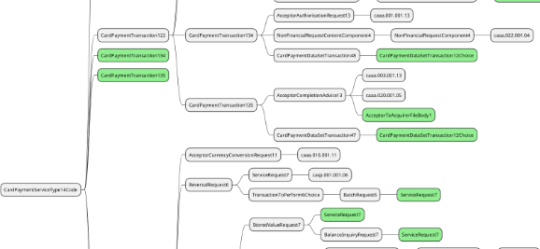
So, in the previous figure, we can see that the update of CardPaymentServiceType14Code will update CardPaymentTransaction122, CardPaymentTransaction134 andCardPaymentTransaction135. We can see also that the update of CardPaymentTransaction134 and CardPaymentTransaction135 is already covered by the analysis of CardPaymentTransaction122.
If a ripple effect must not be taken into account, the component will be highlighted in pink as in the following example.
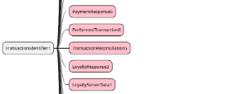

In each chapter devoted to the implementation study, nexo presents the resulting implementation of all Change Request with respect to the legend presented below.

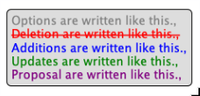

Contact persons:
To get additional information on this Maintenance Change Request you can contact.

- Philippe CECE (philippe.cece@ingenico.com), +33 6 84 42 93 14
- Evelyne de JONGHE (evelyne.de-jonghe@frenchsys.com), +33 6 49 31 04 75
- Laure BELTRI (laure.beltri@frenchsys.com ), +33 6 72 57 79 75
- Alain GUITARD (aguitard@sdpinc.ca),
- Jean KANY (jean.kany@jpmchase.com),

Additional Updates performed/requested by nexo

During the implementation with the update of the repository, specifically the ATMOperation2Code, we realized that we forgot to add in the Change Request an additional code:
- Swap (SWAP) with the definition: Unload all cassettes, and load a new set of cassettes to replace these. The Cassette structures determine what was removed and what was added.
In the same manner, since the ATMCounterType2Code is created, we would like take the opportunity to improve the definition of 2 existing code from
- OperatorAdjust (OPER): Counters since the last update by an operator on the ATMAccountUsage1Code
- Operation (PRTN): Counters for an operation performed by an operator on the ATM.
To
- OperatorAdjust (OPER): Counters since the last update by an operator on the ATM.
- Operation (PRTN): Counters as a result of some replenishment operation carried out by an operator (for example adding cash to a cash unit).
Since we are not able to do it by our own, we would be grateful if the RA is able to do it.

During the update of the ResultDetail5Code, we realized that a code was missing, and we correct this error:
ATMDeposited
- FeeMissing (FEEM): Transaction fee is missing from the request.
During the update of the FailureReason9Code, we realized that a code was missing, and we correct this error:
- Restart (RSTR): The ATM has restarted.
During the update of the Message ATMInquiryRequest, we realized that we forgot to add in the MaintenanceChangeRequest that a PreferredLanguage should be added in the Customer message element. We change it in order to provide a useful message.
During the update of ATMServiceType12Code, we realized that it could beneficial to change the definition of AccountStatements from:
- Ask for account statement information to a related customer account.
To :
- Request a full statement (i.e. legal statement) related to a customer account.
Since we are not able to change the definition, we would be grateful if the RA could change it.

During the update of the repository, we realized that we forgot to include a change in ATMEnvironment10 since we need to provide Card related information. We change it in order to provide a useful message.

Change request number #1381 nexo ACQ Deferred Clearing

Origin of the request:
A.1 Submitter:
nexo A.I.S.B.L.
A.2 Contact person:
- Philippe CECE (philippe.cece@nexo-standards.org)
- Evelyne de JONGHE (evelyne.de-jonghe@frenchsys.com)
A.3 Sponsors:
nexo A.I.S.B.L.

Related messages:

- AcceptorAuthorisationRequest V13 (caaa.001.001.13)
- AcceptorCompletionAdvice V13 (caaa.003.001.13)
- AcceptorCancellationRequest V13 (caaa.005.001.13)
- AcceptorCancellationAdvice V13 (caaa.007.001.13)
- AcceptorBatchTransfer V13 (caaa.011.001.13)
- AcceptorCurrencyConversionRequest V11 (caaa.016.001.11)
- TransactionAdvice V05 (caaa.020.001.05)
- AcceptorNonFinancialRequest V04 (caaa.022.001.04)
- AcceptorTransactionLogReportResponse V04 (caaa.025.001.04)
- AcceptorToAcquirerBatchFileExchange V01 (caaa.026.001.01)
- SaleToPOIServiceRequest V06 (casp.001.001.06)
- SaleToPOIServiceResponse V06 (casp.002.001.06)
- SaleToPOIReportResponse V06 (casp.010.001.06)
- SaleToPOIMessageStatusResponse V06 (casp.015.001.06)

Description of the change request:
We want to update CardPaymentServiceType9Code to identify transactions that are eligible to deferred clearing like transactions related to health system.
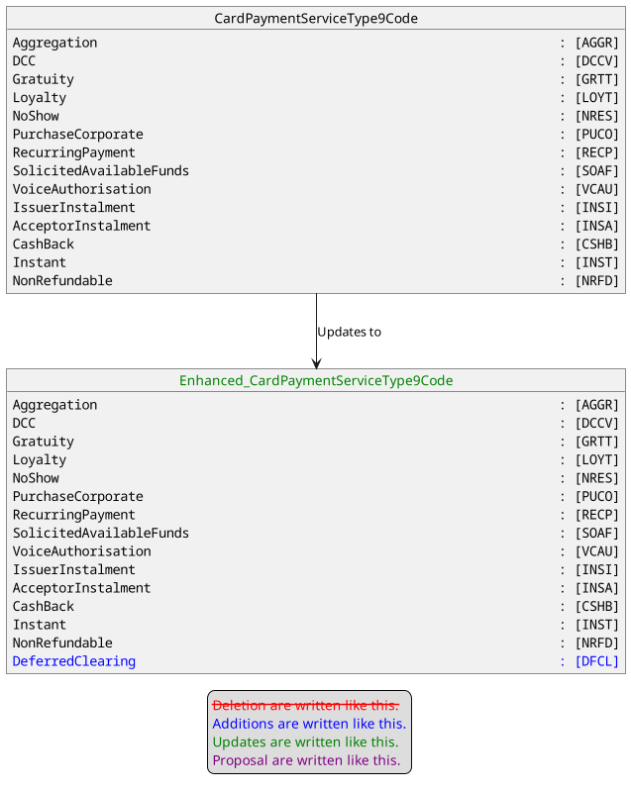

Purpose of the change:
This change request aims to inform acquiring and clearing system that the transaction is eligible to deferred clearing. This feature is common for transaction related to healthcare.

Urgency of the request:
Urgent

Business examples:
Examples illustrating the change request.

SEG recommendation:
This section is not to be taken care of by the submitter of the change request. It will be completed in due time by the SEG(s) in charge of the related ISO 20022 messages.

Consider |  | X | Timing
 |  |  | - Next yearly cycle: 2024/2025  (the change will be considered for implementation in the yearly maintenance cycle which starts in 2024 and completes with the publication of new message versions in the spring of 2025) |  | X
- At the occasion of the next maintenance of the messages
(the change will be considered for implementation, but does not justify maintenance of the messages in its own right – will be pending until more critical change requests are received for the messages)
- Urgent unscheduled
(the change justifies an urgent implementation outside of the normal yearly cycle)
 |  |  | - Other timing:
Comments:
The position of the new code is not the right one in AdditionalService with the TypeCardPaymentServiceType9Code. Since it is more a service attribute the submitter is asked to consider whether the code list ServiceAttribute with multiplicity [0..1] can be used for this new code. If there is no objection from the nexo Acquirer Protocol WG members this solution will be implemented otherwise the code list AdditionalService will be enhanced.

Reject
Reason for rejection:

Impact analysis and type of impact:
The proposal of the CardSEG is accepted and the modification will be done on CardPaymentServiceType14Code.

The analysis of the ripple effect identifies an important list of elements to update. This result is logic, since the ServiceAttribute is a key element in a transaction.

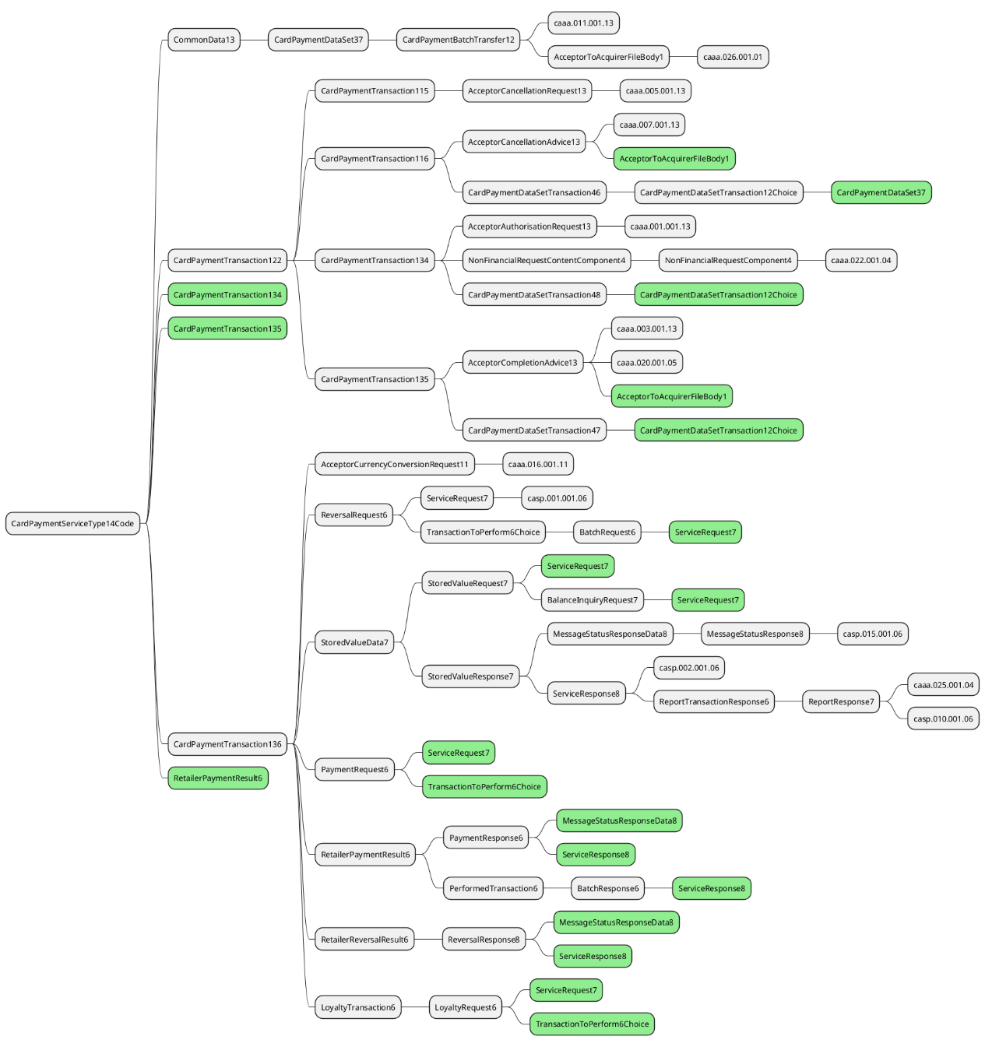

The severity of the impact of the proposed change for the message users should be indicated in the table below (either “no impact”, “conditional’ or “mandatory”).
Type of impact
 | No impact | The change(s) will not impact the schema (the version number will not change) and will not impact the business applications of any users, e.g. the clarification of a definition
X | Conditional | The change(s) will impact the schema (at least the version number) and the business applications of certain users but not all, e.g. the addition of an optional component
 | Mandatory | The change(s) will impact the schema and the business applications of all users, e.g. addition of a mandatory component.

Proposed implementation:

The implementation will be done accordingly to the proposal of the CardSEG aiming ServiceAttribute (CardPaymentServiceType14Code) rather than AdditionalService (CardPaymentServiceType9Code).

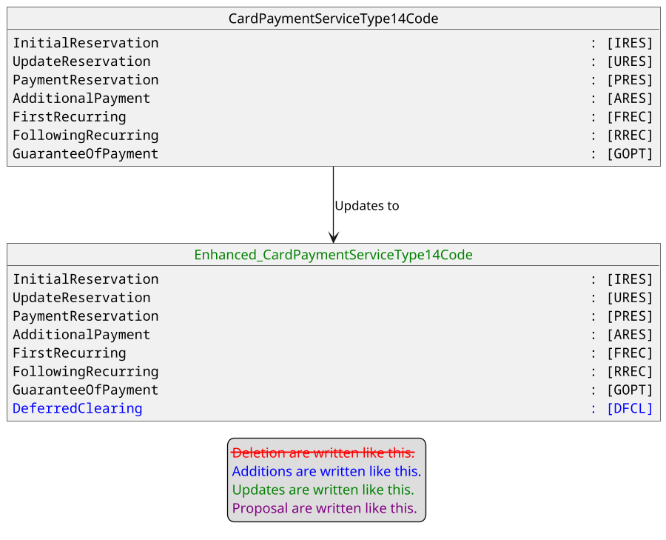

The documentation for this new codeset is :
- DECL : DeferredClearing identifies transactions, like ones related to health care system, that allows a delay in clearing which ensure the payer to be refunded by a system, e.g an insurance, before its bank account is debited.

Proposed timing:
The submitting organization confirms that it can implement the requested changes in the requested timing, or, if not, proposes another timing.

Timing | - As requested
 | - Other:

Final decision of the SEG(s):
This section is not to be taken care of by the submitting organization. It will be completed in due time by the SEG(s) in charge of the related ISO 20022 messages.
Approve | X
Comments:

Reject
Reason for rejection:

Change request number #1382 nexo ACQ Card On File Not Supported

Origin of the request:
A.1 Submitter: nexo A.I.S.B.L.
A.2 Contact person:
- Philippe CECE (philippe.cece@nexo-standards.org)
- Evelyne de JONGHE (evelyne.de-jonghe@frenchsys.com)
A.3 Sponsors:
nexo A.I.S.B.L.

Related messages:
- AcceptorAuthorisationResponse V13 (caaa.002.001.13)
- AcceptorCancellationResponse V13 (caaa.006.001.13)
- AcceptorBatchTransfer V13 (caaa.011.001.13)
- AcceptorNonFinancialResponse V04 (caaa.023.001.04)
- AcceptorTransactionLogReportResponse V04 (caaa.025.001.04)
- AcceptorToAcquirerBatchFileExchange V01 (caaa.026.001.01)
- SaleToPOIServiceResponse V06 (casp.002.001.06)
- SaleToPOIReportResponse V06 (casp.010.001.06)
- SaleToPOIMessageStatusResponse V06 (casp.015.001.06)

Description of the change request:
We want to update ActionType13Code to identify that the card must not be stored on a CardOnFile because it can’t be used for credential on file and recurring setup.
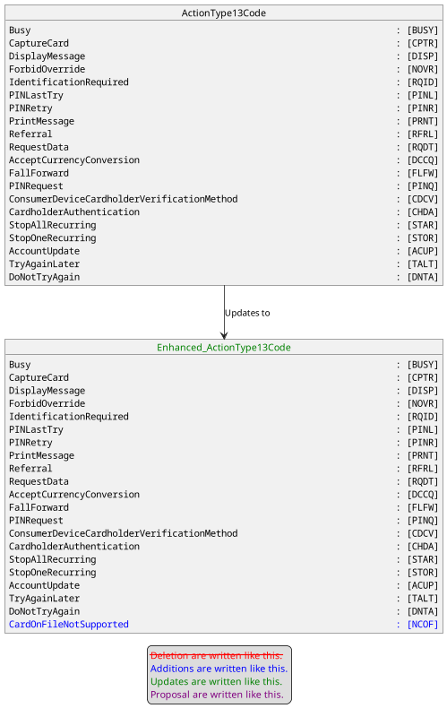

Purpose of the change:
This change request aims to inform the accepting solution that it can’t process a subsequent transaction with credentials for this account. Then it could help the accepting solution to run specific tasks related to this action. This action code could be received with an Approved transaction.

Urgency of the request:
Urgent

Business examples:
Examples illustrating the change request.

SEG recommendation:
This section is not to be taken care of by the submitter of the change request. It will be completed in due time by the SEG(s) in charge of the related ISO 20022 messages or the TSG for changes related to the BAH.

Consider |  | X | Timing
 |  |  | - Next yearly cycle: 2024/2025  (the change will be considered for implementation in the yearly maintenance cycle which starts in 2024 and completes with the publication of new message versions in the spring of 2025) |  | X
- At the occasion of the next maintenance of the messages
(the change will be considered for implementation, but does not justify maintenance of the messages in its own right – will be pending until more critical change requests are received for the messages)
- Urgent unscheduled
(the change justifies an urgent implementation outside of the normal yearly cycle)
 |  |  | - Other timing:
Comments:
There are comments from representatives of some Card Schemes that the new Action Type CARD ON FILE NOT SUPPORTED is not existing in Issuer Responses. This is a Merchant Advice Code so far. Nevertheless the other participants recommend to tolerate this minor inconsistency since the terminal to Acquirer Host may interpret the response of the issuer in another way.

Reject
Reason for rejection:

Impact analysis and type of impact:
The modification will be done accordingly to the description provided by the Change Request.

The modification will be aiming mainly transaction response messages as highlighted by the following diagram.

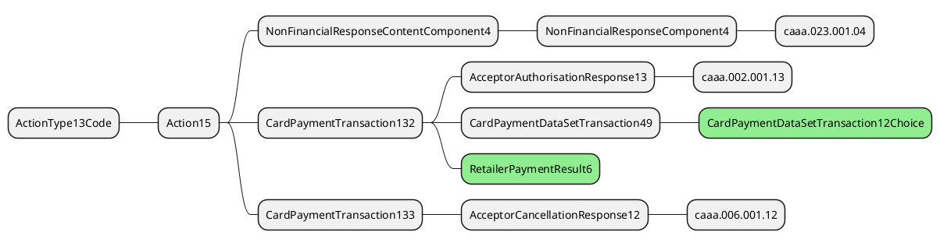
The severity of the impact of the proposed change for the message users should be indicated in the table below (either “no impact”, “conditional’ or “mandatory”).
Type of impact
 | No impact | The change(s) will not impact the schema (the version number will not change) and will not impact the business applications of any users, e.g. the clarification of a definition
X | Conditional | The change(s) will impact the schema (at least the version number) and the business applications of certain users but not all, e.g. the addition of an optional component
 | Mandatory | The change(s) will impact the schema and the business applications of all users, e.g. addition of a mandatory component.

Proposed implementation:

The modification implies the creation of a new code in the codeset.

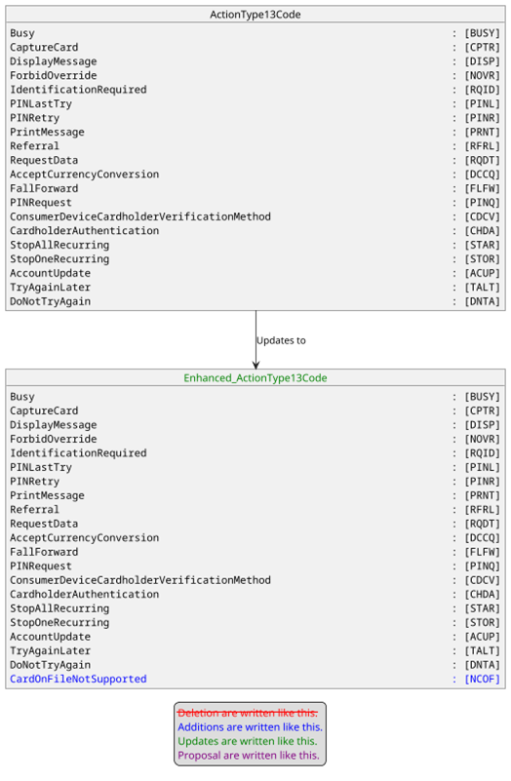

The documentation for CardOnFileNotSupported may be :
- NCOF : The reference used to process the transaction has been created for this transaction and shouldn’t be used for additional transactions.

Proposed timing:
The submitting organization confirms that it can implement the requested changes in the requested timing, or, if not, proposes another timing.

Timing | - As requested
 | - Other:

Final decision of the SEG(s):
This section is not to be taken care of by the submitting organization. It will be completed in due time by the SEG(s) in charge of the related ISO 20022 messages.
Approve | X
Comments:

Reject
Reason for rejection:

Change request number #1383 nexo ATM Config

Origin of the request:
A.1 Submitter:
nexo A.I.S.B.L.
A.2 Contact person:
- Andrew Hamilton (andrewr.hamilton@ncratleos.com)
- Philippe Cece (philippe.cece@nexo-standards.org)
A.3 Sponsors:
nexo A.I.S.B.L.

Related messages:
New messages introduced.

Description of the change request:
Two new messages are proposed to support Configuration Downloads. The proposed message structure would be as shown below.
The ATMConfigurationReport is defined:

Or | Message Element | Mult. | Type
 | Header <Hdr> | [1..1] | Header31
 | ProtectedATMConfigurationReport <PrtctdAtmCfgRp> | [0..1] | ±
 | ATMConfigurationReport <AtmCfgRp> | [0..1]
 | Environment <Env> | [1..1] | ATMEnvironment7
 | ActiveVersion <ActvVrsn> | [0..1] | Max35Text
 | NonActiveVersion <NActvVrsn> | [0..*]
 | ConfigurationVersion <ConfgrtnVrsn> | [1..1] | Max35Text
 | ConfigurationStatus <ConfigSts> | [1..1] | Codeset: values: Fail, AwaitingActivation
 | FailReason <FailRsn> | [0..1] | Max70Text
 | SecurityTrailer <ScrtyTrlr> | [0..1] | ContentInformationType15

Where:
ActiveVersion <ActvVrsn>
Presence: [0..1]
Definition: The configuration version which is active on the terminal.
Datatype: Max35Text
ConfigurationVersion <ConfgrtnVrsn>
Presence: [1..1]
Definition: The non-active configuration version which is being reported.
Datatype: Max35Text
ConfigurationStatus <ConfgrtnSts>
Presence: [1..1]
Definition: The status of the non-active configuration. This can be either: ‘Fail’ (i.e. the configuration update has failed), or ‘AwaitingActivation’ (i.e. the configuration download was successful and is now awaiting a future activation date).
Datatype: ActivationStatus
FailReason <FailRsn>
Presence: [0..1]
Definition: The reason a configuration update has failed on the terminal.
Datatype: Max70Text

The ATMConfigurationControl is defined:

Or | Message Element | Mult. | Type
 | Header <Hdr> | [1..1] | Header31
 | ProtectedATMConfigurationControl <PrtctdAtmCfgCtrl> | [0..1] | ±
 | ATMConfigurationControl <AtmCfgCtrl> | [0..1]
 | Environment <Env> | [1..1] | ATMEnvironment7
 | ConfigurationVersion <ConfgrntVrsn> | [0..1] | Max35Text
 | ActionRequired <ActnReq> | [1..1] | Codeset. Values: APLY, NONE
 | Property <Prop> | [0..*]
 | PropertyName <PropName> | [1..1] | Max70Text
 | PropertyType <PropTp> | [0..1] | Codeset. Values: String, Number, Boolean, JSON, CSV
 | PropertyValue <PropVal> | [1..1] | Max2000Text
 | ActivationDate <ActvtnDt> | [0..1] | DateTime
 | SecurityTrailer <ScrtyTrlr> | [0..1] | ContentInformationType15

Where:
ConfigurationVersion <ConfgrtnVrsn>
Presence: [0..1]
Definition: The configuration version which is being sent to the terminal.
Datatype: Max35Text
ActionRequired <ActnReq>
Presence: [1..1]
Definition: The action which is required by the terminal on receipt of this configuration update. This will be one of: APLY (Apply) apply the configuration update, or NONE no configuration to be applied.
Datatype: Codeset
PropertyName <PropName>
Presence: [1..1]
Definition: The name of the property to be update on the terminal.
Datatype: text
PropertyType <PropTp>
Presence: [1..1]
Definition: The type of the property. It will be one of: String, Number, Boolean, JSON, CSV (i.e. a CSV string representing a table of data).
Datatype: codeset
PropertyValue <PropVal>
Presence: [1..1]
Definition: The value to be assigned to the property.
Datatype: Max2000Text
ActivationDate <ActvntDt>
Presence: [0..1]
Definition: Date when the whole configuration is to be activated. If no activation date is provided, the activation must occur immediately.
Datatype: “ISODate”

Purpose of the change:
Business justification:
It is very common to have configuration options on ATM client applications. For example, updating a Financial Institution Table (FIT) to enable new cards to be supported, or enabling a transaction which previously had been disabled.
Ideally, we want such configuration changes to be made dynamically without requiring an application restart. They are different to application configuration changes which can be done using software download and then require the terminal to be restarted to take effect.
The proposal is to add a very lightweight set of messages which enable properties of the client to be updated. The property is defined by a name (text), a type (codeset) and a value (text). The value types would be: a number, a string, a boolean, a complex structure in a JSON formatted string, or a Table which is made up of a CSV string representing a table of data). A configuration will have a version. When requested by a server the terminal will be able to report the version of the configuration properties it has active, so the server can decide whether to update the client with a new version or not. A date and time optional element would denote when the configuration should be activated on the terminal.

Example use cases
- Dynamic Configuration Update
The following shows a sequence diagram of the use case where the configuration update is requested by the server on the back of a Response message. The Terminal sends an ATMConfigurationReport message to the server with the version of the configuration which is active. The server determines a new version of the configuration properties needs to be sent to the terminal and responds with an ATMConfigurationControl message containing the updated properties. Once the client has made the updates on the terminal, it sends an ATMConfigurationReport message to inform the server the updates have been activated on the terminal and informs it of its new configuration version. The server responds with an ATMConfigurationControl (informing the client no further updates are required).
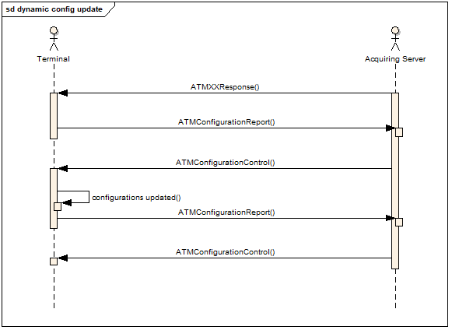
Diagram: Dynamic Configuration Update

- Timed Configuration Update
The following diagram shows a timed configuration update. The configuration change is sent back to the terminal in the ATMConfigurationControl. The terminal parses the updates to be made, and if these are changes it can make, it schedules a task to activate the updates at the time requested and sends back an ATMConfigurationReport message with a Status value for the configuration version of AwaitingActivation. When the time comes to make the update, the terminal activates the configuration updates. If the update was successfully made, it will update the version of the configuration on the terminal to the one associated with the new configuration. Optionally the terminal may send another ATMConfigurationReport message to the server informing it of the change in status of the configuration version.
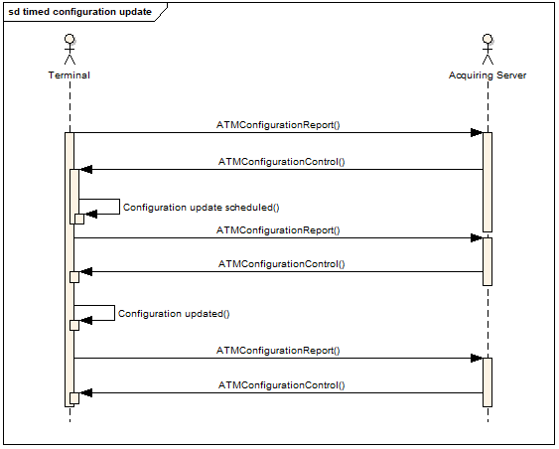
Diagram: Timed configuration update
- Configuration Update Failure
The sequence diagram for a failed configuration update will be the same as the previous diagram. When a configuration download or its activation fails, a ConfigurationReport should be sent to the server to inform it of the failure. An optional FailReason element describing in text the reason for the failure. The proposed semantics would be if any one parameter update fails, all updates are backed out, so the configuration version clearly identifies the values of all configuration parameters.

Urgency of the request:
Urgent.

Business examples:

SEG recommendation:
This section is not to be taken care of by the submitter of the change request. It will be completed in due time by the SEG(s) in charge of the related ISO 20022 messages.

Consider |  | X | Timing
 |  |  | - Next yearly cycle: 2024/2025  (the change will be considered for implementation in the yearly maintenance cycle which starts in 2024 and completes with the publication of new message versions in the spring of 2025) |  | X
- At the occasion of the next maintenance of the messages
(the change will be considered for implementation, but does not justify maintenance of the messages in its own right – will be pending until more critical change requests are received for the messages)
- Urgent unscheduled
(the change justifies an urgent implementation outside of the normal yearly cycle)
 |  |  | - Other timing:

Comments:

Reject
Reason for rejection:

Impact analysis and type of impact:

The 2 new messages will be created as presented in the Change Request. This update won’t generate any impact on other elements since these 2 new messages are using either existing message components or new components.
The severity of the impact of the proposed change for the message users should be indicated in the table below (either “no impact”, “conditional’ or “mandatory”).
Type of impact
 | No impact | The change(s) will not impact the schema (the version number will not change) and will not impact the business applications of any users, e.g. the clarification of a definition
X | Conditional | The change(s) will impact the schema (at least the version number) and the business applications of certain users but not all, e.g. the addition of an optional component
 | Mandatory | The change(s) will impact the schema and the business applications of all users, e.g. addition of a mandatory component.

Proposed implementation:

Before creating, these 2 new messages, we need to create components that will be reused by elements in the message.

For ATMConfigurationReportV01

First of all, we need to create the ActivationStatusCodeSet.
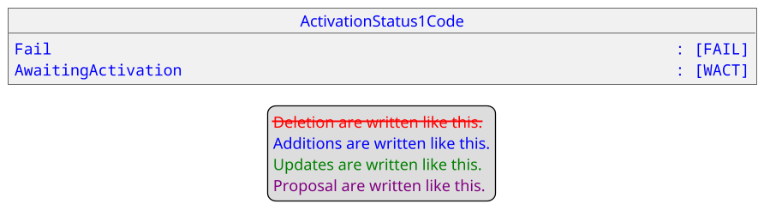
The documentation for these new codeset values are:
- FAIL : The configuration update has failed.
- WACT : The configuration download was successful and is now awaiting a future activation date.

Then, we can create the message component ATMVersionReport1.

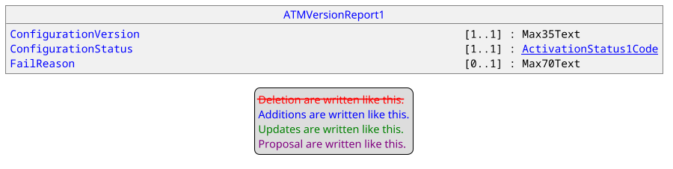

Consequently, we can create the ATMConfigurationReportComponent1

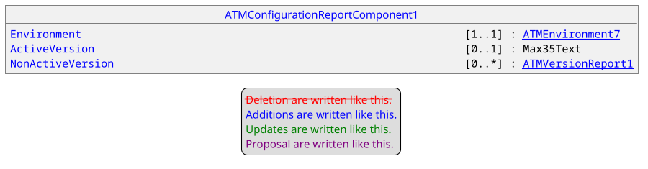

Once these previous components created, we can create the message ATMConfigurationReportV01 as caam.013.001.01.

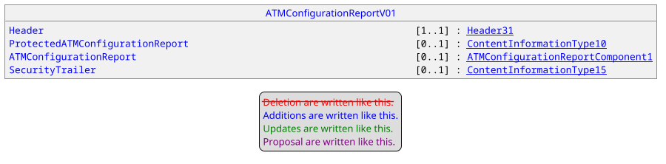

For ATMConfigurationControlV01

First of all, we need to create a new codeset. ATMPropertyType1Code.

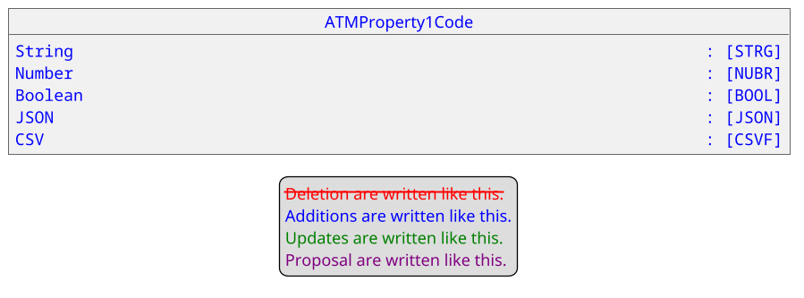
The documentation for these new codeset values are:
- STRG : The property is encoded as a String.
- NUBR : The property is encoded as a Number.
- BOOL : The property is encoded as a Boolean.
- JSON : The property is encoded in JSON.
- CSVF : The property is a CSV string representing a table of data.

Then we can create the message component ATMPropertyComponent1.

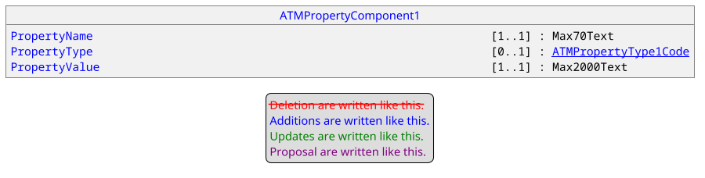

Additionally, we have to create the codeset ATMActionType1Code

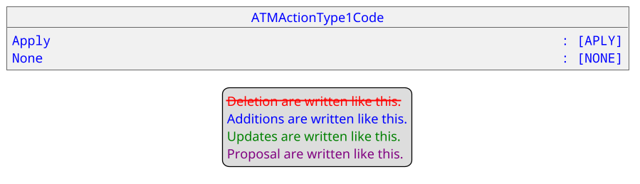

The documentation for these new codeset values are:
- APLY : The received configuration must be applied.
- NONE : There is no specific action required with the received configuration.

Consequently we can create the message component ATMConfigurationControlComponent1.

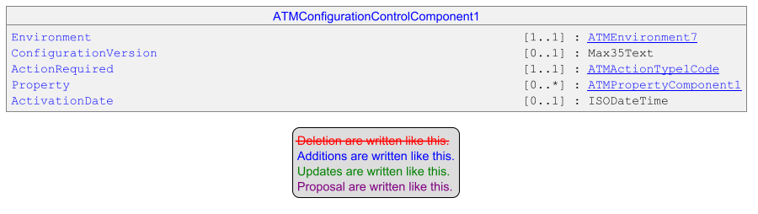

Finally, the message ATMConfigurationControl could be created as caam.014.001.01

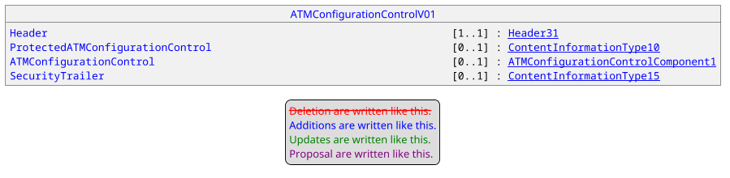

Proposed timing:
The submitting organization confirms that it can implement the requested changes in the requested timing, or, if not, proposes another timing.

Timing | - As requested
 | - Other:

Final decision of the SEG(s):
This section is not to be taken care of by the submitting organization. It will be completed in due time by the SEG(s) in charge of the related ISO 20022 messages.
Approve | X
Comments:

RA confirms the message identifiers for the new messages:
- ATMConfigurationReportV01 (caam.013.001.01)
- ATMConfigurationControlV01 (caam.014.001.01)

Reject
Reason for rejection:

Change request number #1384 nexo ATM Misc.

Origin of the request:
A.1 Submitter:
nexo A.I.S.B.L
A.2 Contact person:
- Andrew Hamilton (andrewr.hamilton@ncratleos.com)
- Philippe Cece (philippe.cece@nexo-standards.org)
A.3 Sponsors:
nexo A.I.S.B.L.

Related messages:
- ATMExceptionAdviceV01 (Caam.011.001.01),
- ATMWithdrawalRequestV02 (catp.001.001.02),
- ATMWithdrawalResponseV02 (catp.002.001.02),
- ATMWithdrawalCompletionV02 (catp.003.001.02),
- ATMInquiryRequestV02 (catp.006.001.02),
- ATMInquiryResponseV02 (catp.007.001.02),
- ATMCompletionAdviceV02 (catp.008.001.02),
- ATMPinManagementRequestV02 (catp.010.001.02),
- ATMPinManagementResponseV02 (catp.011.001.02),
- ATMDepositRequestV01 (catp.012.001.01),
- ATMDepositResponseV01 (catp.013.001.01),
- ATMDepositCompletionAdviceV01 (catp.014.001.01),
- ATMTransferRequestV01 (catp.016.001.01),
- ATMTransferResponseV01 (catp.017.001.01).

Description of the change request:
The following lists the changes requested. Changes are highlighted with a yellow highlighter.
- ExpiryDate <XpryDt> within PlainCardData <PlainCardData>
Enhance the description of the ExpirytDate <XpryDt> element. The description at present states: “Expiry date of the card expressed either in the YYYY-MM format, or in the YYYY-MM-DD format”. The proposal is to add the format “YY-MM” to the description. The standard ISO card (ISO/IEC 7813) uses the format YYMM. The client should not be guessing what the century is; it is up to the card issuer to determine this. The definition would then become:
Definition: Expiry date of the card expressed either in the YY-MM format, YYYY-MM format, or in the YYYY-MM-DD format.

- Support Multiple Balances within AccountInformation <AcctInf> within ATMInquiryResponse <ATMNqryRspn>
The Account Balance returned in an ATMInquiryResponse is defined as:
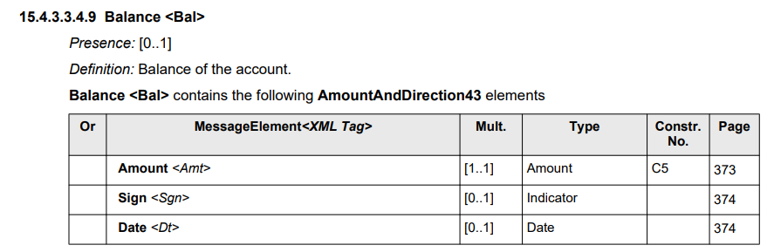
This limits this response to return a single Balance per account. There is a requirement to return multiple balances. An example is where we wish to return a ‘ledger’ and an ‘available’ balance. To enable this we would propose making the cardinality of Balance <Bal> [0..*], and adding an additional sub-element Label which defines the type of balance being returned.
The new structure would then be:
Balance <Bal>
Presence: [0..*]
Definition: Balance of the account.
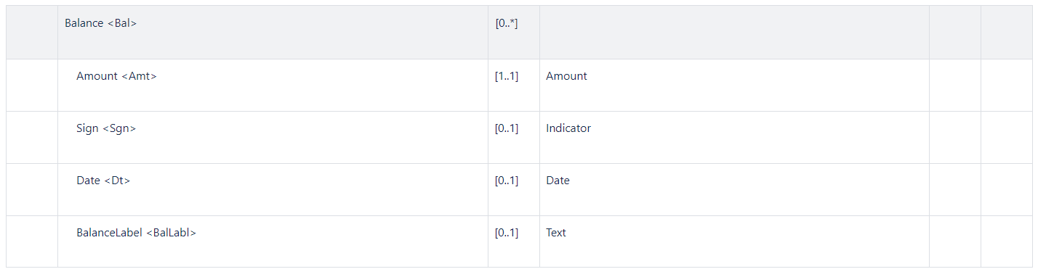
where BalanceLabel is defined:
Label <BalLabl>
Presence: [0..1]
Definition: Description of the balance amount that may be provided to the customer (for example ‘Available’, ‘Ledger’). If this element is not included in a Balance <Bal> it is assumed the balance is a ‘ledger’ balance.

- Authorisation Code <AuthstnCd>
The AuthorisationCode <AuthstnCd> within the AuthorisationResult <AuthstnRslt> a ATMWithdrawalCompletionAdvice <ATMWdrwlCmpltnAdvc> is defined as:
Presence: [0..1]
Definition: Value assigned by the authorising party.
Datatype: "Min6Max8Text" on page 1299
This type seems to be restricted to the value element 38 in an ISO 8583 response. The requirements for this data type should be extended to include a string whose minimal length is 1 and maximal length is 8 and hence not be restricted to the ISO 8583 value (i.e. Min1Max8Text). Hence the change would be:
Datatype: " Min1Max8Text "

- Reject Incident Code
When we get an ATMReject message in a response to an authorisation request, there is value in sending a Completion Advice message to indicate this has occurred even if no other incidents have occurred. In this case bank staff would be able to answer any customer queries regarding this failed transaction.
The proposal is to add to <Incdnt> the following value (i.e. a change to FailureReason7Code):
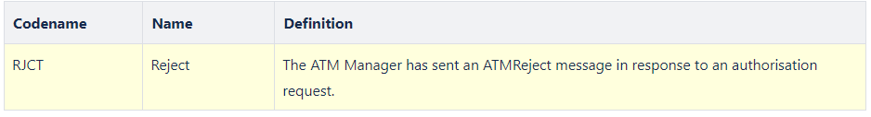

- FormatError & ValidationError Incident Code
When we get an authorisation response which fails some validation error (for example the ExchangeIdentifier does not match the Request’s one) or format (for example sending an integer where a dateTime was expected), instead of sending an ATMReject message to the server some will prefer to send a Completion Advice message. In this case it would be necessary to send an Incident with information of the reason for a transaction failure. The following suggests we send an incident to inform the server a validation or format error which occurred with the authorisation response.
The proposal is to add to <Incdnt> the following values (i.e. a change to FailureReason7Code):
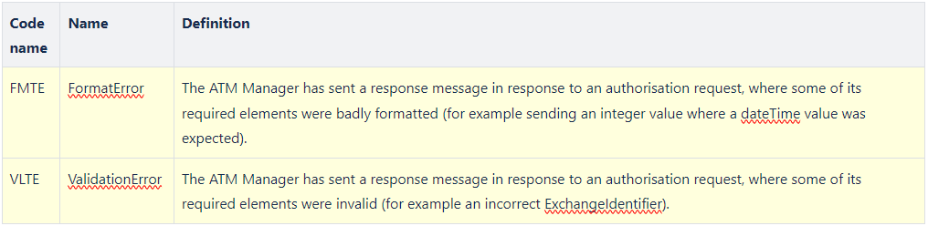

- Add Support for HostTransactionDateTime
The Transaction Identification <TxId> contains a TransactionDateTime <TxDtTm> element which identifies the local time for the transaction assigned by the ATM. The terminal clock may not be reliable in some circumstances, and some prefer to use a date time assigned by the server, which is more reliable. The proposal is to add a HostTransactionrDateTime <TxSrvDtTm> element to the TransactionIdentifier <TxId> element as an optional element. This element would optionally be populated in a Response message, and subsequently could be populated within all CompletionAdvice message components and CompletionAcknowledgement message components.
The proposal then is to add a new element to <TxId> (i.e. change the TransactionIdentifier1):
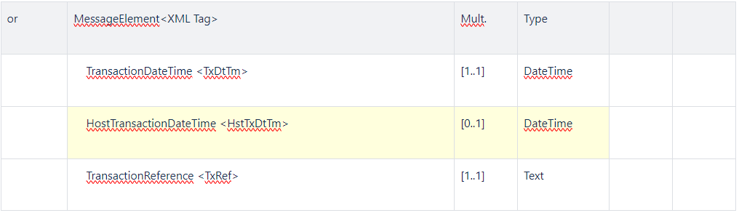
- Add Support for Cheques, Envelope & Multiple Deposits in Deposit and Reconciliation Messages
The ATMDepositRequest has a MediaType which includes a code list value for cheques. However, the MediaType does not support envelope deposit or multiple deposit (i.e. multiple items outside an envelope or in multiple envelopes). Additionally, the ATMReconciliationAdvice message does not support cheques, envelopes or multiple deposits. The following details suggestions how to support these.
  - Add Support for Envelope & Multiple Deposits in the ATMDepositRequest Message
In the ATMDepositRequest, ATMDepositResponse & ATMDepositCompletionAdvice (both within DepositedMedia <DpstdMdia> and ToBeReconciledMediaCounters <ToBeRcncldMdiaCntrs>) the MediaType <MdiaTp> can be extended to include the missing code set values.
ATMMediaType2Code should become ATMMediaType3Code:
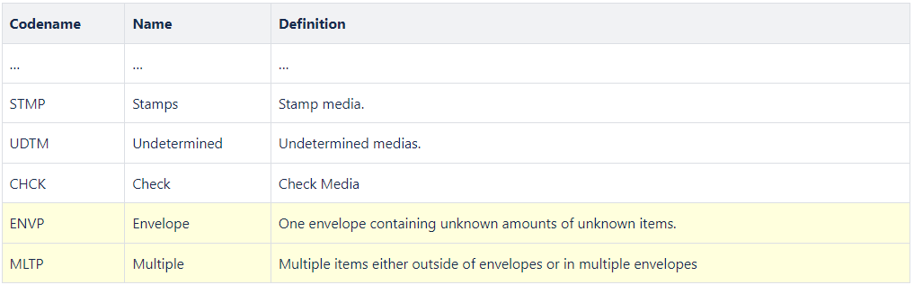
  - Add Support for Cheque, Envelope & Multiple Deposits in the ATMReconciliationAdvice Message
In the ATMReconciliationAdvice message the MediaType within the Cassette element should be changed to use the new MediaType defined (i.e ATMMediaType1Code should become ATMMediaType3Code).
- Add Support for Cash Dispenser/Deposit Cassette Status
There are three places where cassette information is provided to a host system in the existing messages. These are in the: Cash Withdrawal Completion Advice/Acknowledgement, the Deposit Completion Advice/Acknowledgement and the Reconciliation Advice/Acknowledgement. The proposal is to add a new simple element <CssttStts> to the Cassette <Csstt> element contained within each of these messages.
Cassette <Csstt> to contain the following ATMCassette3:
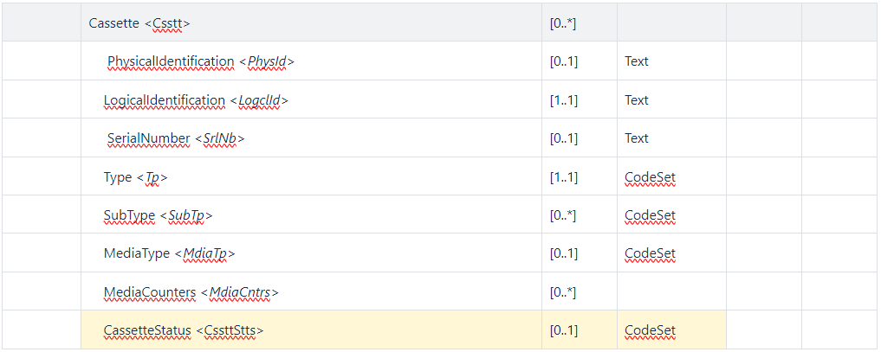
Where Status is defined:
CassetteStatus < CssttStts >
Presence: [0..1]
Definition: The status of the cassette is as reported by CEN XFS, which can be one of: OK, Full, High, Low, Empty, Inoperative, Missing, NotAvailable, NoReference or Manipulated. This element may not be provided if the status has not changed from the previous time the cassette information has been provided.
Datatype: CassetteStatus1Code
CodeName | Name | Definition
CUOK | OK | The cash unit is in a good state.
CUFL | Full | The cash unit is full.
CUHG | High | The cash unit is high, that is it has reached or exceeded the threshold defined for this cassette.
CULW | Low | The cash unit is low, that is it has reached or is below the threshold defined for this cassette.
CUMT | Empty | The cash unit is empty.
CUNP | Inoperative | The cash unit is inoperative.
CUMS | Missing | The cash unit is missing.
CUNA | NotAvailable | The values of this cash unit are not available.
CUNR | NoReference | There are no reference values available for this cash unit.
CUMP | Manipulated | The device has been inserted when the device was not in an exchange state.

- Add Support for Replenishment Swap Operation
Probably the most common replenishment operation at an ATM is the cash swap. This will involve removing existing cassettes, and replacing these with a new set of cassettes. The existing ATMReconciliationAdvice message does not allow us to create a single message for this operation; it would allow us to create a message to Unload a cassette, and another to Load a cassette (see the TypeOfOperation <TpOfOpr> element within Transaction <Tx>). It would be preferable to have a single message, and to enable this the proposal is to add an Operation <Opr> element which allows one to have multiple operations under this.
Transaction <Tx> to contain the following ATMTransactionXX:
Or | MessageElement<XML Tag> | Mult. | Type | Constr.  No. | Page
 | Transaction <Tx> | [1..1]
 | ReconciliationOperation <ReconOpr> | [0..*]
where ReconciliationOperation<ReconOpr> contains the following ReconOpr1:
Or | MessageElement<XML Tag> | Mult. | Type | Constr. No. | Page
 | ReconciliationOperation <ReconOpr> | [0..*]
 | TypeOfOperation <TpOfOpr> | [0..1] | CodeSet
 | TransactionIdentification <TxId> | [1..1]
 | ReconciliationIdentification <RcncltnId> | [1..1] | Text
 | ATMTotals <ATMTtls> | [0..*]
 | Cassette <Csstt> | [0..*]
The following shows an example message where a single logical type of cassette with 12 notes is replaced with a new logical cassette with 1000 notes.
Example ATMRcncltnAdv
- <?xml version="1.0" encoding="UTF-8"?>

- <n1:Document xmlns:xsi="http://www.w3.org/2001/XMLSchema-instance" xmlns:n1="urn:iso:std:iso:20022:tech:xsd:caam.009.001.02" xsi:schemaLocation="urn:iso:std:iso:20022:tech:xsd:caam.009.001.02 caam.009.001.02.xsd">
- <n1:ATMRcncltnAdvc>
- <n1:Hdr>
- <n1:MsgFctn>
- <n1:Fctn>TMOP</n1:Fctn>
- </n1:MsgFctn>
- <n1:PrtcolVrsn>1</n1:PrtcolVrsn>
- <n1:XchgId>1</n1:XchgId>
- <n1:CreDtTm>2001-12-17T09:30:47Z</n1:CreDtTm>
- <n1:InitgPty>a</n1:InitgPty>
- </n1:Hdr>
- <n1:ATMRcncltnAdvc>
- <n1:Envt>
- <n1:ATM>
- <n1:Id>123</n1:Id>
- <n1:BaseCcy>USD</n1:BaseCcy>
- </n1:ATM>
- </n1:Envt>
- <n1:Tx>
- <n1:ReconOpr>
- <n1:TpOfOpr>UNLD</n1:TpOfOpr>
- <n1:TxId>
- <n1:TxDtTm>2001-12-17T09:30:47Z</n1:TxDtTm>
- <n1:TxRef>1</n1:TxRef>
- </n1:TxId>
- <n1:RcncltnId>1</n1:RcncltnId>
- <n1:ATMTtls>
- <n1:MdiaTp>NOTE</n1:MdiaTp>
- <n1:ATMBal>0</n1:ATMBal>
- <n1:ATMCur>0</n1:ATMCur>
- </n1:ATMTtls>
- <n1:Csstt>
- <n1:LogclId>A</n1:LogclId>
- <n1:Tp>DISP</n1:Tp>
- <n1:MdiaTp>NOTE</n1:MdiaTp>
- <n1:MdiaCntrs>
- <n1:UnitVal>20</n1:UnitVal>
- <n1:MdiaCtgy>FITN</n1:MdiaCtgy>
- <n1:CurNb>0</n1:CurNb>
- <n1:CurAmt>0</n1:CurAmt>
- <n1:FlowTtls>
- <n1:Tp>PRTN</n1:Tp>
- <n1:RmvdNb>12</n1:RmvdNb>
- </n1:FlowTtls>
- </n1:MdiaCntrs>
- </n1:Csstt>
- </n1:ReconOpr>
- <n1:ReconOpr>
- <n1:TpOfOpr>LOAD</n1:TpOfOpr>
- <n1:TxId>
- <n1:TxDtTm>2001-12-17T09:30:47Z</n1:TxDtTm>
- <n1:TxRef>1</n1:TxRef>
- </n1:TxId>
- <n1:RcncltnId>1</n1:RcncltnId>
- <n1:ATMTtls>
- <n1:MdiaTp>NOTE</n1:MdiaTp>
- <n1:ATMBal>20000</n1:ATMBal>
- <n1:ATMCur>20000</n1:ATMCur>
- </n1:ATMTtls>
- <n1:Csstt>
- <n1:LogclId>A</n1:LogclId>
- <n1:Tp>DISP</n1:Tp>
- <n1:MdiaTp>NOTE</n1:MdiaTp>
- <n1:MdiaCntrs>
- <n1:UnitVal>20</n1:UnitVal>
- <n1:CurNb>1000</n1:CurNb>
- <n1:CurAmt>20000</n1:CurAmt>
- <n1:FlowTtls>
- <n1:Tp>OPER</n1:Tp>
- <n1:AddedNb>1000</n1:AddedNb>
- </n1:FlowTtls>
- </n1:MdiaCntrs>
- </n1:Csstt>
- </n1:ReconOpr>
- </n1:Tx>
- </n1:ATMRcncltnAdvc>
- </n1:ATMRcncltnAdvc>
- </n1:Document>

- Add a new Type of FlowTotals Operation & Improve Descriptions
The types <Tp> of FlowTotals <FlowTtls> has the values defined below:
CodeName | Name | Definition
INQU | CountersInquiry | Counters since the last counters inquiry.
CTXN | CustomerTransaction | Counters for a customer transaction.
CTOF | CutOff | Counters since the last cut-off.
BDAY | BusinessDay | Counters since the beginning of the business day.
PRTN | Operation | Counters for an operation performed by  an operator on the ATM.
OPER | OperatorAdjust | Counters since the last update by an operator on the ATM.
However, none of these would be used if one wanted to send the counters since the last replenishment within either a CompletionAdvice or a ReconciliationAdvice message. This proposes we add a new Type codeset value as shown below:
CodeName | Name | Definition
SLRP | SinceLastReplenishmentPoint | Counters since last replenishment point.
The following shows an example message element from a CompletionAdvice showing the consumer transaction had caused 4 notes to be presented, and the total number of presented notes since the last replenishment point to be 800:
Example Cassette structure
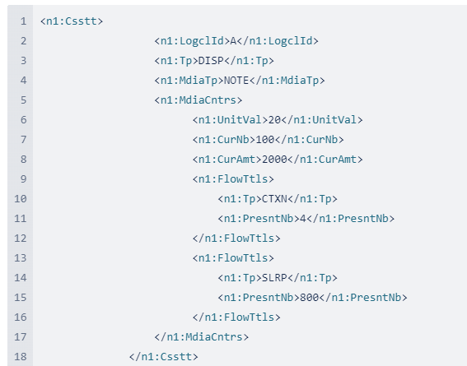
Additionally, the existing types PRTN and OPER are very confusing. The descriptions are:
CodeName | Name | Definition
PRTN | Operation | Counters for an operation performed by an operator on the ATM.
OPER | OperatorAdjust | Counters since the last update by an operator on the ATM.

The two use cases covered by these are:
- where a replenishment occurs where media is moved in or out of a cash unit (e.g. an operator adds cash),
- where an operator counts the cash in a cassette and adjusts the count for this cassette. No media is moved in or out of the cash unit.
The proposal is to change the codesets to better reflect these semantics to the following:
CodeName | Name | Definition
OPER | Operation | Counters as a result of some replenishment operation carried out by an operator (e.g. adding cash to a cash unit).
OPAD | OperatorAdjust | Counters as a result of an operator adjusting the counts without removing or adding media (also known as a ‘balance set’).

Based on this the updated codeset would become:
CodeName | Name | Definition
INQU | CountersInquiry | Counters since the last counters inquiry.
CTXN | CustomerTransaction | Counters for a customer transaction.
CTOF | CutOff | Counters since the last cut-off.
BDAY | BusinessDay | Counters since the beginning of the business day.
OPER | Operation | Counters as a result of some replenishment operation carried out by an operator (e.g. adding cash to a cash unit).
OPAD | OperatorAdjust | Counters as a result of an operator adjusting the counts without removing or adding media (also known as a ‘balance set’).
SLRP | SinceLastReplenishmentPoint | Counters since last replenishment point.

- Add a Reason to ATMGlobalStatus
When an ATM reports itself to be out of service, it would be very useful for the ATM Manager to know the reason the ATM is out of service. This can be achieved by adding an optional CurrentStatusReason <CurStsRsn> element to ATMGlobalStatus <ATMGblSts>, as shown below:
Presence: [1..1]
Definition: Global status of the ATM.
ATMGlobalStatus <ATMGblSts> contains the following ATMStatus1 elements
or | MessageElement<XML Tag> | Mult. | Type | Constr. No. | Page
 | CurrentStatus <CurSts> | [1..1] | CodeSet
 | CurrentStatusReason <CurStsRsn> | [0..*] | Text
 | DemandedStatus <DmnddSts> | [0..1] | CodeSet
Where CurrentStatusReason <CurStsRsn> is defined as:
Presence: [0..1]
Definition: A description of why the ATM is in this status. This would typically be populated with a value when CurrentStatus is OutOfService (OUTS).
Datatype: "Max70Text"
- Redesign FallbackIndicator
An EMV Fallback transaction is indicated by the usage of the following FallbackIndicator <FllbckInd> element:
Presence: [0..1]
Definition: Indicate the occurrence of a fall-back on the card entry mode.
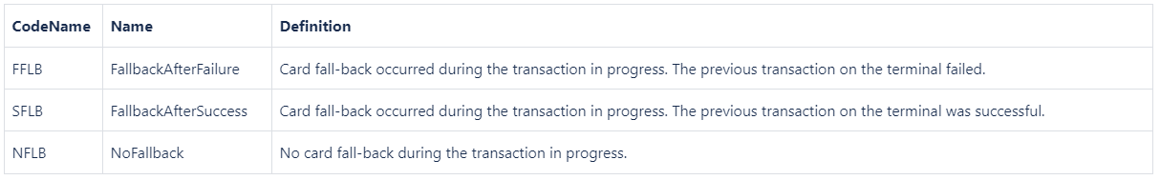
It would appear the definition of this has been copied from the ATICA definition, which in turn has been copied from existing ISO 8583 acquirer to issuer message implementations which conform to VISA and Mastercard message requirements.
However, from the ATM client point of view this level of information is not commonly provided by an ATM. It is more common for ATM’s to simply indicate if fallback has occurred (i.e. a Boolean). The proposal therefor is to simplify this element to be:
Presence: [0..1]
Definition: Indicate the occurrence of a fall-back on the card entry mode.
Datatype: TrueFalseIndicator:
- Meaning When True: Fallback is used.
- Meaning When False: No fallback is used.

- Corrections to Deposit messages
The Deposit messages were intended to allow one to deposit into one or more accounts. We can see this in the fact an ATMDepositRequest message contains an AccountSequenceNumber [0..1] within a DetailedRequestedAmount [0..*] element. However, the AccountData element has a cardinality of [0..1]. This should be [0..*] to enable multiple accounts to be defined, so that later within the message where the DetailedRequestedAmount and the DepositedMedia is defined, these can reference accounts defined within AccountData.
The message structure where AccountData is defined within the Transaction element, and then referenced within the DetailedRequestedAmount and DepositedMedia by using a sequence number. This is not an ideal structure. A better structure is to have a sub-element of the Transaction which contains the AccountData, the DetailedRequestedAmount and DepositedMedia all within the one element, and if there are multiple accounts to deposit into, then we can have multiple such sub-elements. The following describes the changes which will be required to enable this structure within the ATMDepositRequest, the the ATMDepositResponse and the ATMDepositCompletionAdvice.
The following details the changes required:
Transaction<Tx> of type ATMTransaction15 (used within the ATMDepositRequest):
MessageElement<XML Tag> | Mult. | Type
Transaction <Tx> | [1..1]
TransactionIdentification <TxId> | [1..1]
ReconciliationIdentification <RcncltnId> | [0..1] | Text
TotalRequestedAmount <TtlReqAmt> | [0..1] | Amount
SubDeposit <SubDpst> | [0..*] | +
SubDepositIdentification <SubDpstId> | [0..1] | Text
AccountData <AcctData> | [0..*] | +
DetailedRequestedAmount <DtldReqdAmt> | [0..*] | +
DepositedMedia <DpstdMdia> | [0..*] | +
RequestedReceipt <ReqdRct> | [0..1] | Indicator
ICCRelatedData <ICCRltdData> | [0..1] | Binary

Transaction<Tx> of type ATMTransaction16 (used within the ATMDepositResponse):
MessageElement<XML Tag> | Mult. | Type
Transaction <Tx> | [1..1]
TransactionIdentification <TxId> | [1..1]
ReconciliationIdentification <RcncltnId | [0..1] | Text
CompletionRequired<CmpltnReqrd> | [0..1] | Amount
TotalAuthoriseddAmount <TtlAuthrsdAmt> | [1..1] | +
TotalRequestedAmount <TtlReqAmt> | [0..1] | Amount
SubDeposit <SubDpst> | [0..*] | +
SubDepositIdentification <SubDpstId> | [0..1] | Text
AccountData <AcctData> | [0..*] | +
DetailedRequestedAmount <DtldReqdAmt> | [0..*] | +
AdditionalCharge <AddtlChrg> | [0..*] | +
Transaction<Tx> of type ATMTransaction19 (used within the ATMDepositCompletionAdvice):
MessageElement<XML Tag> | Mult. | Type
Transaction <Tx> | [1..1]
TransactionIdentification <TxId> | [1..1]
TransactionStatus<TxSts> | [1..1] | CodeSet
ReconciliationIdentification <RcncltnId> | [0..1] | Text
Incident <Incdnt> | [0..*] | Codeset
IncidentDetail <IncdntDtl> | [0..*] | Text
TotalDepositedAmount <TtlDpstdAmt> | [1..1] | +
TotalAuthoriseddAmount <TtlAuthrsdAmt> | [1..1] | +
TotalRequestedAmount <TtlReqAmt> | [0..1] | Amount
SubDeposit <SubDpst> | [0..*] | +
SubDepositIdentification <SubDpstId> | [0..1] | Text
AccountData <AcctData> | [0..*] | +
DetailedRequestedAmount <DtldReqdAmt> | [0..*] | +
DepositedMedia <DpstdMdia> | [0..*] | +
AdditionalCharge <AddtlChrg> | [0..*] | +

- Add AccountMatchesMultipleAccounts ResponseReason
In an authorisation request it is possible to send a SelectedAccountType (e.g. Savings) with no AccountIdentifier, and for there to be multiple accounts which match this account type. In this case the response message needs to indicate the authorisation has been declined due to multiple accounts having matched the account type selected. I don’t believe there is a ResponseReason which would fit this, and hence I propose to add a new value to ResultDetail4Code codeset as suggested:
Codename | Name | Definition
AMMA | AccountMatchesMultipleAccounts | The account details provided in the request message matches multiple accounts.
…

- Support Multi-Currency Deposit
The existing Deposit messages only support a single currency (i.e. the TotalAmount element is defined with multiplicity [0..1]). To enable multiple-currency support the following changes are required:
15.1 ATMDepositRequest changes
The ATMDepositRequest TotalAmount needs to change its multiplicity to be 0..*:
Or | MessageElement<XML Tag> | Mult. | Type | Constr. No. | Page
 | Transaction <Tx> | [1..1]
 | TotalAmount <TtlAmt> | [0..*]

15.2 ATMDepositResponse changes
The ATMDepositResponse needs to change the TotalAuthorisedAmount to be 1..*, and on TotalRequestedAmount to be 0..*:
Or | MessageElement<XML Tag> | Mult. | Type | Constr. No. | Page
 | Transaction <Tx> | [1..1]
 | TotalAuthorisedAmount <TtlAuthrsdAmt> | [1..*]
 | TotalRequestedAmount <TtlReqAmt> | [0..*]

15.3 ATMDepositCompletionAdvice changes
The ATMDepositCompletionAdvice needs to change the multiplicity of TotalDepositedAmount and TotalAuthorisedAmount to be 1..* and TotalRequestedAmount to be 0..*:
Or | MessageElement<XML Tag> | Mult. | Type | Constr. No. | Page
 | Transaction <Tx> | [1..1]
 | TotalDepositedAmount <TtlDepstdAmt> | [1..*]
 | TotalAuthorisedAmount <TtlAuthrsdAmt> | [1..*]
 | TotalRequestedAmount <TtlReqAmt> | [0..*]

- Add Account Information to ATMWithdrawalResponse, ATMDepositResponse, and ATMTransferResponse messages
For the use case where a consumer selects an account type (say ‘savings’), the issuer may decline the authorisation if there are more than one account associated with the card used. In this case, instead of requiring a separate ATMInquiryRequest to get all the accounts associated with the card, it would be preferable if the authorisation response returned the accounts which the consumer must select from. This will make the message exchange more efficient.
The proposal is to add the <AcctInf> element within the <Tx> element which would contain the account information that matches the account type selected by the consumer. The following highlighted in yellow would be the change to the ATMWithdrawalResponse:
Or | MessageElement<XML Tag> | Mult. | Type | Constr. No. | Page
 | ATMWithdrawalResponse <ATMWdrwRspn> | [0..1]
 | Environment <Envt> | [1..1]
 | Context <Cntxt> | [1..1]
 | Transaction <Tx> | [1..1]
 | TransactionIdentification <TxId> | [1..1]
 | ReconciliationIdentification <RcncltnId> | [0..1]
 | ...
 | AuthorisationResult <AuthstnRslt> | [1..1]
 | AccountInformation <AcctInf> | [0..*]
 | …

The intent would be if the consumer has selected an account type (e.g. savings) and there is more than one account of this type associated with the card, the response would return in the <AcctInf> element all the accounts which were of this type (that is it will not return all accounts associated with the card, only the ones which match the selection by the consumer).
The same new element would be added to the ATMDepositResponse:
Or | MessageElement<XML Tag> | Mult. | Type | Constr. No. | Page
 | ATMDepositResponse <ATMDpstRspn> | [0..1]
 | Environment <Envt> | [1..1]
 | Context <Cntxt> | [1..1]
 | Transaction <Tx> | [1..1]
 | TransactionIdentification <TxId> | [1..1]
 | ReconciliationIdentification <RcncltnId> | [0..1]
 | ...
 | AuthorisationResult <AuthstnRslt> | [1..1]
 | AccountInformation <AcctInf> | [0..*]
 | ...

For the ATMTransferResponse:
Or | MessageElement<XML Tag> | Mult. | Type | Constr. No. | Page
 | ATMTransferResponse <ATMTrfRspn> | [0..1]
 | Environment <Envt> | [1..1]
 | Context <Cntxt> | [1..1]
 | Transaction <Tx> | [1..1]
 | TransactionIdentification <TxId> | [1..1]
 | ReconciliationIdentification <RcncltnId> | [0..1]
 | ...
 | AuthorisationResult <AuthstnRslt> | [1..1]
 | AccountInformation <AcctInf> | [0..*]
 | …
Note in the transfer, the AccountFrom and/or the AccountTo account type may be associated with more than one account. The expectation is the response message will only return the list of accounts of whichever has multiple accounts of that type (it could be for both types).
ATMInquiryResponse does not need to be updated as it supports the AccountInformation element already.
- Add Fee Information to ATMWithdrawalResponse, ATMDepositResponse, ATMInquiryResponse and ATMTransferResponse messages
This addresses the use case where a consumer selects a cash withdrawal and the acquirer or issuer declines the authorisation due to fees which the consumer must agree to. In this case, instead of requiring a separate ATMInquiryRequest to get fees which the consumer must agree to, it would be preferable if the authorisation response returned the corresponding fees. This will make the message exchange more efficient.
The proposal for the ATMWithdrawalResponse is to include a FeeToAdd as described below (change highlighted in yellow):
Or | MessageElement<XML Tag> | Mult. | Type | Constr. No. | Page
 | ATMWithdrawalResponse <ATMWdlRspn> | [0..1]
 | Environment <Envt> | [1..1]
 | Context <Cntxt> | [1..1]
 | Transaction <Tx> | [1..1]
 | TransactionIdentification <TxId> | [1..1]
 | ReconciliationIdentification <RcncltnId> | [0..1]
 | ...
 | AuthorisationResult <AuthstnRslt> | [1..1]
 | AuthorisationEntity <AuthstnNtty> | [0..1]
 | AuthorisationResponse <AuthstnRspn> | [1..1]
 | ...
 | Action <Actn> | [0..*]
 | FeeToAdd <FeeToAdd> | [0..*] | ±
 | Amount <Amt> | [1..1] | Amount
 | Currency <Ccy> | [0..1] | Codeset
 | FeeLabel <FeeLabl> | [0..1] | Text
The equivalent proposal for the ATMDepositResponse is to include a FeeToAdd as described below:
Or | MessageElement<XML Tag> | Mult. | Type | Constr. No. | Page
 | ATMDepositResponse <ATMDpstRspn> | [0..1] | ±
 | Environment <Envt> | [1..1] | ±
 | Context <Cntxt> | [1..1] | ±
 | Transaction <Tx> | [1..1] | ±
 | TransactionIdentification <TxId> | [1..1] | Text
 | ReconciliationIdentification <RcncltnId> | [0..1] | Text
 | ...
 | AuthorisationResult <AuthstnRslt> | [1..1] | ±
 | AuthorisationEntity <AuthstnNtty> | [0..1]
 | AuthorisationResponse <AuthstnRspn> | [1..1]
 | ...
 | Action <Actn> | [0..*]
 | FeeToAdd <FeeToAdd> | [0..*] | ±
 | Amount <Amt> | [1..1] | Amount
 | Currency <Ccy> | [0..1] | CodeSet
 | FeeLabel <FeeLabl> | [0..1] | Text

The equivalent proposal for the ATMDepositResponse is to include a FeeToAdd as described below:
Or | MessageElement<XML Tag> | Mult. | Type | Constr. No. | Page
 | ATMDepositResponse <ATMDpstRspn> | [0..1] | ±
 | Environment <Envt> | [1..1] | ±
 | Context <Cntxt> | [1..1] | ±
 | Transaction <Tx> | [1..1] | ±
 | TransactionIdentification <TxId> | [1..1] | Text
 | ReconciliationIdentification <RcncltnId> | [0..1] | Text
 | ...
 | AuthorisationResult <AuthstnRslt> | [1..1] | ±
 | AuthorisationEntity <AuthstnNtty> | [0..1]
 | AuthorisationResponse <AuthstnRspn> | [1..1]
 | ...
 | Action <Actn> | [0..*]
 | FeeToAdd <FeeToAdd> | [0..*] | ±
 | Amount <Amt> | [1..1] | Amount
 | Currency <Ccy> | [0..1] | CodeSet
 | FeeLabel <FeeLabl> | [0..1] | Text
The equivalent proposal for the ATMTransferResponse is to include a FeeToAdd as described below:
Or | MessageElement<XML Tag> | Mult. | Type | Constr. No. | Page
 | ATMTransferResponse <ATMTrfRspn> | [0..1] | ±
 | Environment <Envt> | [1..1] | ±
 | Context <Cntxt> | [1..1] | ±
 | Transaction <Tx> | [1..1] | ±
 | TransactionIdentification <TxId> | [1..1] | Text
 | ReconciliationIdentification <RcncltnId> | [0..1] | Text
 | ...
 | AuthorisationResult <AuthstnRslt> | [1..1] | ±
 | AuthorisationEntity <AuthstnNtty> | [0..1]
 | AuthorisationResponse <AuthstnRspn> | [1..1]
 | ...
 | Action <Actn> | [0..*]
 | FeeToAdd <FeeToAdd> | [0..*] | ±
 | Amount <Amt> | [1..1] | Amount
 | Currency <Ccy> | [0..1] | CodeSet
 | FeeLabel <FeeLabl> | [0..1] | Text
The equivalent proposal for the ATMInquiryResponse is to include a FeeToAdd as described below:
Or | MessageElement<XML Tag> | Mult. | Type | Constr. No. | Page
 | ATMInquiryResponse <ATMNqryRspn> | [0..1] | ±
 | Environment <Envt> | [1..1] | ±
 | Context <Cntxt> | [1..1] | ±
 | Transaction <Tx> | [1..1] | ±
 | TransactionIdentification <TxId> | [1..1] | Text
 | ReconciliationIdentification <RcncltnId> | [0..1] | Text
 | ...
 | AuthorisationResult <AuthstnRslt> | [1..1] | ±
 | AuthorisationEntity <AuthstnNtty> | [0..1]
 | AuthorisationResponse <AuthstnRspn> | [1..1]
 | ...
 | Action <Actn> | [0..*]
 | FeeToAdd <FeeToAdd> | [0..*] | ±
 | Amount <Amt> | [1..1] | Amount
 | Currency <Ccy> | [0..1] | CodeSet
 | FeeLabel <FeeLabl> | [0..1] | Text
Note this change assumes the AuthorisationResult element has been added to the ATMInquiryResponse message (i.e. a separate change request).
- Extend the AccountIdentifier to include email and mobile phone number
It is now possible to transfer funds into an account identified by an email address or a mobile phone number (MSISDN). Examples of usage are PayPal and Zelle. The proposal is to reuse the same definitions as the CAPE specification -which already has these defined. This requires the AccountIdentifier <AcctIdr> element to be extended as following:

Or | MessageElement<XML Tag> | Mult. | Type | Constr. No. | Page
{Or | IBAN <IBAN> | [1..1] | IdentifierSet
Or | BBAN <BBAN> | [1..1] | IdentifierSet
Or | UPIC <UPIC> | [1..1] | IdentifierSet
Or | Domestic <Dmst> | [1..1] | ±
Or | MSISDN <MSISDN> | [1..1] | Text
Or} | EMail <EMail> | [1..1] | Text
Where MSISDN is defined:
MSISDN <MSISDN>
Presence: [1..1]
Definition: Mobile Subscriber Integrated Service Digital Network (i.e. mobile phone number of the SIM card).
DataType: Max16Text
and EMail is defined as:
EMail <Email>
Presence: [1..1]
Definition: E-mail identifying the account.
DataType: Max256Text.

- Account Download Code
The existing ATMInquiryRequest defines within its ServiceType a list of possible data to request from an acquiring server. However this codeset does not define a value for downloading the set of accounts associated with the consumer card. This proposal adds a new codeset value which defines such an option.
ServiceType <SvcTp> is defined as:
Presence: [1..1]
Definition: Describes the type of inquiry selected by the customer or the ATM.
DataType: CodeSet ATMServiceType11Code

CodeName | Name | Definition
ASTS | AccountStatements | Ask for account statement information to a related customer account.
...
CMPF | CustomerProfile | Ask for customer profile with eventually  related account information.
ACCD | AccountDownload | Download accounts associated to the customer card.

- Support Interactive Transactions
There are transactions which require some interactions between the consumer and the acquiring server. Examples are transactions in which DCC, fees, multiple account selection is involved, etc.

The proposed way to achieve this is where a transaction returns with a Response which states this transaction requires some additional information from the consumer, and if provided the transaction can be continued. In this example if the consumer agrees to the fees, another transaction request can be sent which has the same transaction ID as the previous one (i.e. as far as the acquiring server is concerned a single transaction has been executed).
At present the MUG does not describe how such a scenario could be handled. No status code exists that allows the acquiring server to inform the terminal that the transaction authorisation can be continued if the further consumer input is provided.
The proposal is to add a new Response code of ‘ApprovalSuspended’ meaning that the consumer must provide further information to continue with the approval process.
The following change needs to be made:
Response <Rspn>
Presence: [1..1]
Definition: Result of the requested transaction.
Datatype: Response5Code
CodeName | Name | Definition
APPR | Approved | Service has been successfully provided.
DECL | Declined | Service is declined.
PART | PartialApproved | Service has been partially provided
SUSP | ApprovalSuspended | To provide this service additional information needs to be provided by the customer.
The MUG should be updated to document the advocated way to handle this functionality.
The proposal is to extend the ResponseReason <RspnRsn> element codeset ResultDetail4Code to include the additional code values:

CodeName | Name | Definition
AGFE | AgreeFee | Consumer must agree fee from those provided to authorise the transaction. See <Tx><AuthstnRslt><FeeToAdd>.
SACT | SelectAccount | Consumer must select an account from those provided to authorise the transaction. See <Tx><AcctInf>.
ADCC | AgreeDCC | Consumer must choose whether to accept DCC offer provided to authorise the transaction. See <Tx><CcyConvsElgblty>.
OTHR | Other | For reason see the AdditionalResponseInformation element. This is used in cases where the reason is not one of those defined by this codeset.

- Add Individual Check Authorisation Information to the ATMDepositResponse message
The existing ATMDepositResponse message returns a Response of ‘Approved’, ‘Declined’ or ‘PartialApproved’. However, it does not cater for a use case where some checks may be accepted and some rejected (that is the information of which checks are accepted/rejected cannot be included in the response message). In this situation a consumer will be informed of the checks which have been approved, return those that have not, and request the consumer agrees to making the deposit of the accepted checks .
The following sequence diagram shows a check deposit transaction where some checks are rejected and returned to the consumer, and the consumer decides to continue with the deposit transaction. The following proposal assumes another proposal to support an ‘ApprovalSuspended’ Response is supported.
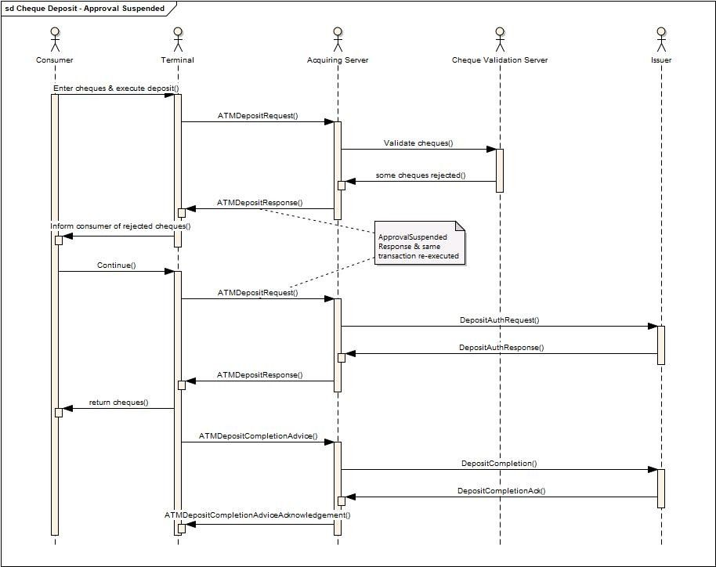
The sequence of events for the transaction are as follows:
- The consumer enters multiple cheques and executes the deposit transaction.
- On receiving the ATMDepositRequest message the acquiring server checks with a cheque validation server if the cheques are to be accepted.
- The cheque validation server responds with a subset of the cheques being rejected.
- The acquiring server sends an ATMDepositResponse message to the Terminal with a Response of ApprovalSuspended and listing those cheques which have been accepted and those which have been rejected.
- The consumer agrees to continue with the transaction.
- To continue the same transaction an ATMDepositRequest is sent from the Terminal to the Acquiring Server.
- The acquiring server then sends a message to the host to authorise the subset of cheques which have been accepted.
- The host responds with an authorised response.
- The acquiring server sends an ATMDepositResponse message to the Terminal with a Response of Approved.
- The rejected cheques are returned to the consumer.
- The Terminal sends an ATMDepositCompletionAdvice message to the acquiring server.
- The acquiring server informs the host of the transaction outcome and responds to the Terminal with an ATMDepositCompletionAcknowledgement message.
There are possible alternatives on this message exchange. Two of them could be:
- Instead of returning an ‘ApprovalSuspended’ Response, return a ‘PartialApproved’ with the information of what cheques have been rejected and those accepted. In this case the Terminal has the option to request if the consumer agrees. This is followed by an ATMDepositCompletionAdvice message to inform the acquiring server of the outcome (i.e. continue or cancel).
- When the cheque validation server returns denoting only a subset of cheques are accepted, the acquiring server then returns a response of Decline to the Terminal. If the consumer decides to continue with the transaction, then a new ATMDepositRequest message is sent to the acquiring server. In this case a new transaction is initiated. The rest is as expected in a deposit transaction.
In any of these scenarios if the consumer decides not to continue with the transaction, then an ATMDepositCompletionAdvice message would be sent to the acquiring server with the TransactionStatus set to Failure and an Incident of CustomerCancel.
The following changes addresses these requirements. Note to correlate the cheques in the Request with those in the response we will add an ID for each cheque in the Request and the Response.
The proposed change to the ATMDepositResponse is:

Or | Message Element | Mult. | Type
 | ATMDepositResponse <ATMDepstRspn> | [0..1] | ±
 | …
 | Transaction <Tx> | [1.1] | ±
 | …
 | DepositedMedia <DpstdMdia> | [0..*] | ±
 | …
 | MediaItems <MdiaItms> | [1..*] | ±
 | MediaID <MdiaID> | [0..1] | Text
 | Count <Cnt> | [0..1] | Quantity
 | …
 | MediaStatus <MdiaSts> | [0..1] | Codeset
Where DepositedMedia is of a new type ATMDepositedMedia4 which includes a MediaItem of new type ATMDepositedMediaItems1. The ATMDepositedMediaItems1 type extends the existing ATMDepositedMedia2 with a MediaId, and MediaStatus elements as shown above.
Where:
MediaID <MdiaID> is defined as:
Presence: [0..1]
Definition: Within a list of MediaItems uniquely identifies a specific item. Typically will be an integer index 0..n, where there are n Items in the list of MediaItems.
DataType: Text

MediaStatus <MdiaSts> is defined as:
Presence: [0..1]
Definition: Status of the media item.
DataType: CodeSet

CodeName | Name | Definition
ACPT | Accepted | Item (such as a check) has been accepted.
REJT | Rejected | Item (such as a check) has been rejected.
The proposed change to the ATMDepositRequest is:

Or | Message Element | Mult. | Type
 | ATMDepositRequest <ATMDepstReq> | [0..1] | ±
 | …
 | Transaction <Tx> | [1.1] | ±
 | …
 | DepositedMedia <DpstdMdia> | [0..*] | ±
 | …
 | MediaItems <MdiaItms> | [1..*] | ±
 | MediaID <MdiaID> | [0..1] | Text
 | Count <Cnt> | [0..1] | Quantity
 | …
 | MediaStatus <MdiaSts> | [0..1] | Codeset
Where DepositedMedia <DpstdMdia> is of type ATMDepositedMedia3 defined previously. The MediaID, within MediaItems, may be populated in the request, but the MediaStatus will not be populated within the request. These latter element is intended to be populated optionally on the Response message if available.
No changes are required to the ATMDepositCompletionAdvice and the ATMDepositAcknowledgement messages.

- Extend DCC for EU regulations
Based on “REGULATION (EC) No 924/2009 OF THE EUROPEAN PARLIAMENT”, “P8_TA(2019)0124” and “2018/0076 (Article 3a)” payment service providers are required to increase transparency of DCC transactions to cardholders/consumers prior to the initiation of a payment transaction. This transparency has to be achieved by showing a “reference exchange rate” published by ECB. To allow this information to be shown on ATM the proposal is to extend existing type CurrencyConversionResult with a new element ReferenceRate.

or | MessageElement<XML Tag> | Mult. | Type
 | CurrencyConversionResult
 | CurrencyConversionIdentification | [0..1] | Text
 | …
 | ReferenceRate <RefRate> | [0..1]
 | ExchangeRate <XchgRate> | [1..1] | Rate
 | PublishDate <PubDt> | [1..1] | DateTime
 | AddInfo <AddInfo> | [0..1] | Text
Where:
ReferenceRate <RefRate> is defined as:
Presence: [0..1]
Definition: Reference exchange rate to be shown to the consumer. Requirement within the EC, see “REGULATION (EC) No 924/2009 OF THE EUROPEAN PARLIAMENT”, “P8_TA(2019)0124” and “2018/0076 (Article 3a)”.
The ReferenceRate <RefRate> contains the following:

or | MessageElement<XML Tag> | Mult. | Type
 | ReferenceRate <RefRate> | [0..1]
 | ExchangeRate <XchgRate> | [1..1] | Rate
 | PublishDate <PubDt> | [1..1] | DateTime
 | AddInfo <AddInfo> | [0..1] | Text
Where:
ExchangeRate <XchgRate> is defined as:
Presence: [1..1]
Definition: Exchange rate, expressed as a percentage, applied to convert the original amount into the resulting amount.
DataType: Rate
PublishDate <PubDt> is defined as:
Presence: [1..1]
Definition: Date when exchange rate published.
DataType: DateTime
AddInfo <AddInfo> is defined as:
Presence: [0..1]
Definition: Additional information to be provided to the consumer related to the reference rate.
DataType: Text

- Add Further Individual Check Authorisation Information to the ATMDepositResponse message
The following extends the proposal in section 21.
In a check deposit transaction, when an individual check is rejected, some Financial Institutions may want to provide an explanation of the reason why the item has been rejected to give that feedback to the cardholder.
When a check is accepted by the issuer, a FI may want to provide a check reference number for each check accepted for traceability reasons.
Potentially, some FI's may want to return other ad hoc data related to a check item, but which we cannot predict.
To cater for these three further data the following data elements will be added:
- RejectReason: a FI specific field with a textual description of the reason why the item was rejected.
- MediaItemReference: a string that uniquely identifies the media item in the FI's bank system.
- MediaItemAdditionalData: used to pass other information related to the media item but not modelled by the other properties. This is a key value pair that gives flexibility to model some ad hoc data a FI wishes to pass through to the ATM.
The proposed change to the ATMDepositResponse is:

or | MessageElement<XML Tag> | Mult. | Type
 | ATMDepositResponse <ATMDepstRspn> | [0..1] | ±
 | …
 | Transaction <Tx> | [1..1]
 | …
 | DepositedMedia <DpstdMdia> | [0..*] | ±
 | …
 | MediaItems <MdiaItms> | [1..*] | ±
 | MediaID <MdiaID> | [0..1] | Text
 | Count <Cnt> | [0..1] | Quantity
 | …
 | MediaStatus <MdiaSts> | [0..1] | CodeSet
 | RejectedReason <RjctdRsn> | [0..1] | Text
 | MediaItemReference <MdiaItmRef> | [0..1] | Text
 | MediaItemAdditionalData <MdiaItemAddtlData> | [0..*] | ±
 | Identification <Id> | [1..1] | Text
 | Value <Val> | [1..1] | Text
where:
RejectedReason <RjctdRsn> is defined as:
Presence: [0..1]
Definition: The reason a media item (such as a check) has been rejected. This may be used to inform the cardholder.
DataType: Text

MediaItemReference <MdiaItmRef> is defined as:
Presence: [0..1]
Definition: a string that uniquely identifies the media item in the FI's bank system. This may be used for traceability reasons.
DataType: Text

MediaItemAdditionalData <MdiaItemAddtlData> is defined as:
Presence: [0..*]
Definition: a key value pair which is associated with the media item. This provides flexibility to model some ad hoc data a FI wishes to pass through to the ATM.
DataType: Text

Identification <Id> is defined as:
Presence: [1..1]
Definition: an identifier of the data item being passed to the ATM.
DataType: Text
Value<Val> is defined as:
Presence: [1..1]
Definition: the value of the data item being passed to the ATM.
DataType: Text

- Add Source and Destination Account Information to the ATMTransferResponse message
In 16, above, it was agreed we would add AccountInformation to various Response messages to enable account information to be returned to the terminal where a consumer is required to select a specific account to debit/credit. However, the AccountInformation element does not include information of whether the accounts returned are to be source or destination accounts. Some host system are able to provide this information, so we should change the ATMTransferResponse message to include this additional data.
The proposal is to add one new element to the AccountInformation (AcctInf) element which is in ATMTransferResponse:

Or | Message Element |  |  |  |  |  | Mult. | Type
 | AccountInformation<AcctInf> |  |  |  |  |  | [0..*] | ±
 | AccountType <AcctTp> |  |  |  |  |  | [0..1] | codeset
 | AccountName<AcctNm> |  |  |  |  |  | [0..1] | text
 | AccountUsageCode<AcctUsgCd> |  |  |  |  |  | [0..1] | codeset
 | ...
where:
AccountUsageCode<AcctUsgCd>
Presence: [0..1]
Definition: Determines whether the account is a destination or a source (or both) account.

CodeName | Name | Definition
SRCE | Source | Source account
DSTN | Destination | Destination account
BOTH | Both | Can be both the source and the destination account.

- Mini Statement Code
A statement that contains complete information for a statement period is often referred as a legal or full statement. A statement that contains limited information or a set number of transactions is often referred to as a partial or mini statement. The former may be printed on more than one page on a full size printer, whereas the latter will typically print a single small receipt on the receipt printer.
The existing ATMInquiryRequest defines within its ServiceType a list of possible data to request from an acquiring server. This codeset defines a value for Account Statements, however it does not clarify if this is for a Full Statement or a Mini Statement. This proposal adds a new codeset value which defines an option for mini statement, and clarifies the meaning of the AccountStatements (ASTS) refers to a full (or legal) statement.
ServiceType <SvcTp> is defined as:
Presence: [1..1]
Definition: Describes the type of inquiry selected by the customer or the ATM.
DataType: CodeSet ATMServiceType11Code

CodeName | Name | Definition
ASTS | AccountStatements | Request a full statement (i.e. legal statement) related to a customer account.
...
ACCD | AccountDownload | Download accounts associated to the customer card.
MINI | MiniStatement | Request a mini-statement (i.e. partial statement) related to a customer account.

- Extending ATM Capabilities
ATM’s have the capability to offer various options to a consumer, such as DCC, fees, etc. These options are closely linked to the interactive Transactions feature which has been agreed previously. It would be useful to a Terminal Handler/acquiring server to inform it of the features which an ATM can handle. If an ATM was unable to handle say DCC, there would be no point in the terminal handler/acquiring server to offer such a feature in an authorization response. Also whether receipt printing is available would be useful information to provide, as in some cases there is a requirement to provide a receipt if DCC or fees is to be offered to a consumer.
The proposal is to add another two elements under the Capabilities <Cpblties> element which would provide this information (see yellow shaded elements).
Capabilities <Cpblties>
Or | Message Element | Mult. | Type
 | CardReadData <CardRdData> | [0..*] | CodeSet
 | CardWriteData <CardWrtData> | [0..*] | CodeSet
 | …
 | InteractiveTransactions <IntrctvTxs> | [0..*] | String
 | ReceiptPrinting <RcptPrting> | [0..1] | boolean
Where InteractiveTransactions <IntrctvTxs>:
Presence: [0..*]
Definition: Interactive Transaction Capabilities such as DCC, Fees, Accounts, etc. which the terminal can support.
Datatype: string (although we can enumerate three possible values, there are likely to be many more, and we do not want to limit what these values may be).
And ReceiptPrinting <RcptPrting>:
Presence: [0..1]
Definition: whether the terminal can print a receipt (i.e. the device is functional, and it has paper).
Datatype: Boolean.
- Add FlowTotals <FlowTtls> Elements for Initial amount/count
The FlowTotals <FlowTtls> element within a ReconciliationAdvice, WithdrawalCompletionAdvice and DepositCompletionAdvice, include the number of items removed, deposited, retracted, etc. but not the initial amount/count. These counters are required by current bank cash management systems when a cutover occurs. Banking systems expect to receive:
- Items at the beginning of the accounting period.
- Items added/removed during the accounting period.
- Items dispensed during the accounting period.
- Items deposited during the accounting period.
- Remaining at the end of the accounting period.
The proposed changes to FlowTotals <FlowTtls> is highlighted in yellow:
Presence: [0..*]
Definition: Counters of media inside the cassette
Or | Message Element | Mult. | Type
 | Type <Tp> | [1..1] | CodeSet
 | AddedNumber <AddedNb> | [0..1] | Quantity
 | RemovedNumber <RmvdNb> | [0..1] | Quantity
 | RemovedAmt <RmvdAmt> | [0..1] | Amount
 | DispensedNumber <DspnsdNb> | [0..1] | Quantity
 | DepositedNumber <DpstdNb> | [0..1] | Quantity
 | DepositedAmt <DpstdAmt> | [0..1] | Amount
 | ReclycledNumber <RcycldNb> | [0..1] | Quantity
 | RetractedNumber <RtrctdNb> | [0..1] | Quantity
 | RetractedAmt <RtrctdAmt> | [0..1] | Amount
 | RejectedNumber <RjctdNb> | [0..1] | Quantity
 | PresentedNumber <PresntdNb> | [0..1] | Quantity
 | InitialNumber <InitNb> | [0..1] | Quantity
 | InitialAmount <InitAmt> | [0..1] | Amount
where
InitialNumber <InitNb>
Presence: [0..1]
Definition: Initial number added during a servicing operation.
Datatype: number.

InitialAmount <InitAmt>
Presence: [0..1]
Definition: Initial amount added during a servicing operation.
Datatype: ImpliedCurrencyAndAmount.

- Add new Incident codeset values
The FailureReason7Code defines a set of incidents which can occur during the processing of an ATM transaction. The following suggests adding these additional incidents:

CodeName | Name | Definition
CHFG | CashDispenserRetract | Following a cash dispense operation the consumer forgot to take the notes, which have subsequently been retracted following a Present time-out. The number of notes retracted is unknown.
DCFG | CashDepositRetract | Following a cash return, on a deposit operation, the consumer forgot to take the returned notes, causing them to be retracted. The number of notes retracted is unknown.
CQFG | ChequeDepositRetract | Following cheques being returned, on a cheque deposit operation, the consumer forgot to take the returned cheques, causing them to be retracted. The number of cheques retracted is unknown.
CFGC | CashDispenserRetractCounted | Following a cash dispense operation the consumer forgot to take the returned notes, which have subsequently been retracted following a Present time-out. The number of notes retracted is known as the device was able to count the notes retracted.
DFGC | CashDepositRetractCounted | Following a cash return, on a deposit operation, the consumer forgot to take the returned notes, causing them to be retracted. The number of notes retracted is known as the device was able to count the notes retracted.
QFGC | ChequeDepositRetractCounted | Following cheques being returned, on a cheque deposit operation, the consumer forgot to take the returned cheques, causing them to be retracted. The number of cheques retracted is known as the device was able to count the cheques retracted
DCRT | DepositsRetained | Cash has been retained by the terminal since it has been unable to return it.
CQRT | ChequesRetained | Cheques have been retained by the terminal since it has been unable to return them.

Purpose of the change:
Business justification:
All these change requests are due to gaps in our initial specifications and were discovered while implementing applications. One change request introduces the concept of interactive transactions, whereby a more efficient method of providing fee, DCC, account, etc. information can be provided to a terminal by an acquiring server.

Urgency of the request:
Urgent.

Business examples:

SEG recommendation:
This section is not to be taken care of by the submitter of the change request. It will be completed in due time by the SEG(s) in charge of the related ISO 20022 messages.

Consider |  | X | Timing
 |  |  | - Next yearly cycle: 2024/2025  (the change will be considered for implementation in the yearly maintenance cycle which starts in 2024 and completes with the publication of new message versions in the spring of 2025) |  | X
- At the occasion of the next maintenance of the messages
(the change will be considered for implementation, but does not justify maintenance of the messages in its own right – will be pending until more critical change requests are received for the messages)
- Urgent unscheduled
(the change justifies an urgent implementation outside of the normal yearly cycle)
 |  |  | - Other timing:

Comments:

Reject
Reason for rejection:

Impact analysis and type of impact:

ExpiryDate.

The modification focuses on definition and the type Max10Text will be kept. So there is no direct impact on data model.

Multiple Balance.

The modification will be done accordingly to the Change Request.
The modification will be spread to other elements since the label is optional and could be discarded if necessary.

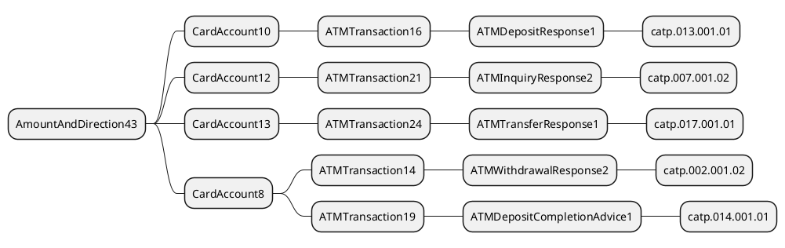

The modification of CardAccount12 will be done as expressed in the Change Request.
There is no specific impact for this change request since it is already managed through the previous one.

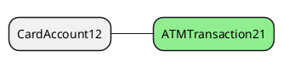

Update of type AuthorisationCode.

The update of AuthorisationResult13 will be done accordingly to the Change Request, but it will require the creation of a new type Min1Max8Text.

The modification will be spread over all relevant elements.

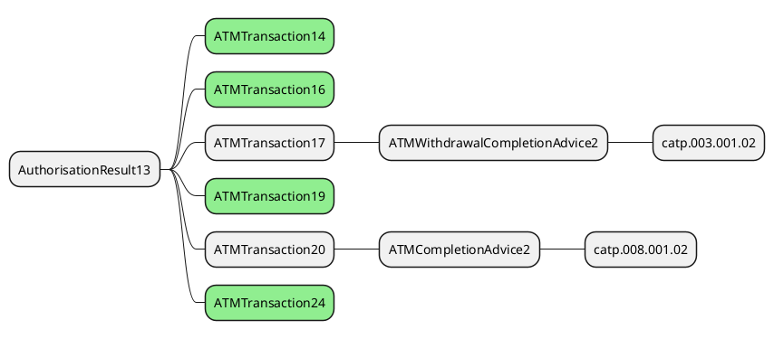

Reject, Format and ValidationError Incident Code, .

The update consists of adding a new value to FailureReason7Code and will be done accordingly to the Change Request.

All modifications related to this improvement have been managed through previous updates.
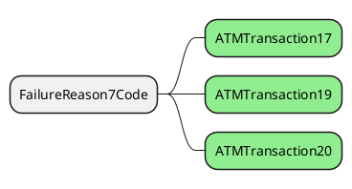

Support for HostTransactionDateTime.

The modification will be done accordingly to the Change Request and will focus on TransactionIdentifier1.

This update is only expected by ATM protocol users, since other protocols generally rely on identifier from both parts, then the ripple effect will be limited to ATM protocol.
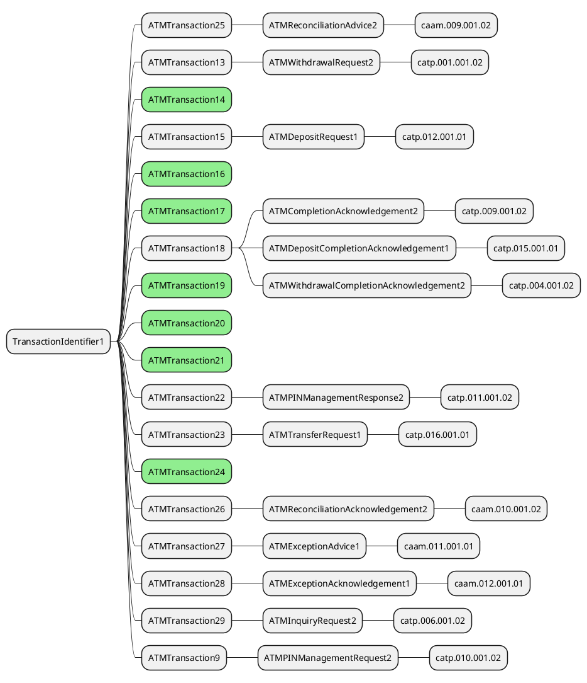

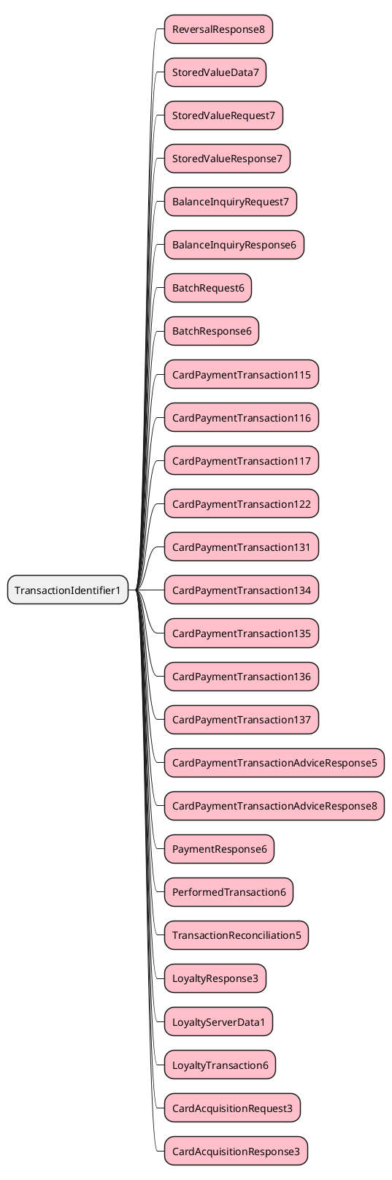

Support for Cheques, Envelope & Multiple Deposits.

This Change Request implies the update of ATMMediaType2Code with new values and leads to the following updates. But the new value of ATMMediaType2Code won’t be updated to ATMMediaType3Code since this code already exists.

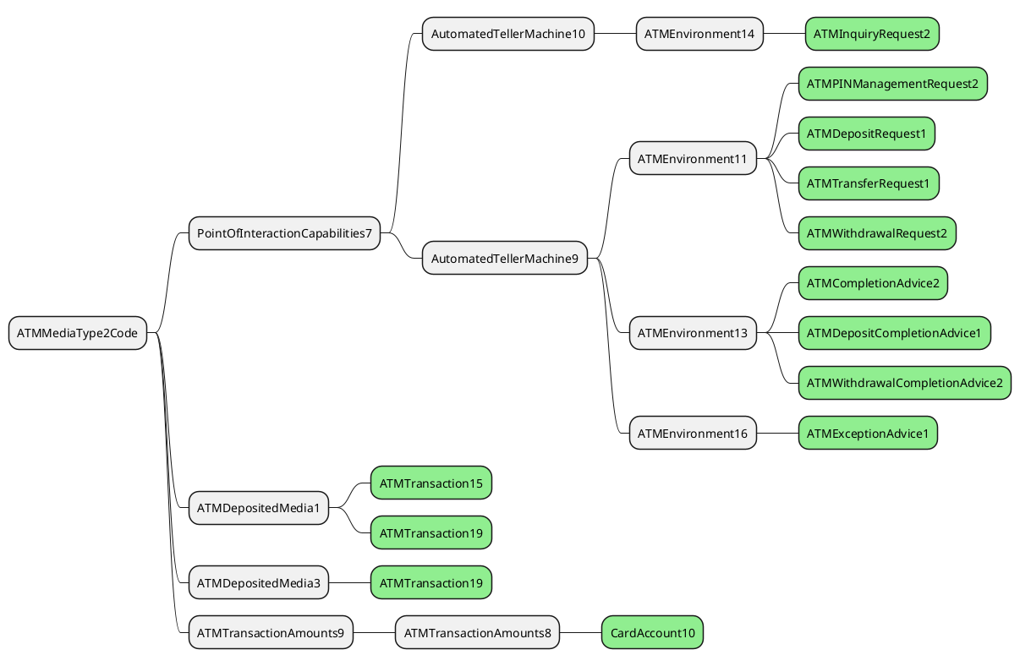

Support for Cash Dispenser.

The ATMTotals1 will be updated with the new ATMMediaType2Code to support the new codeset values in ATMReconciliationAdvice, which implies the following update.

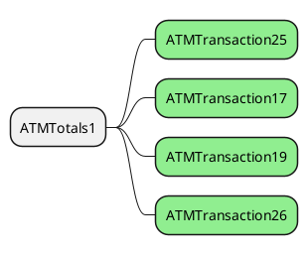

We will create ATMCassetteStatus1Code rather than CassetteStatus1Code in order to be closer to ATMCassetteType1Code.
Consequently, we can update the Cassette component on ATMCassette2 since ATMCassette3 doesn’t exist in the repository. This modification will affect the following message components.

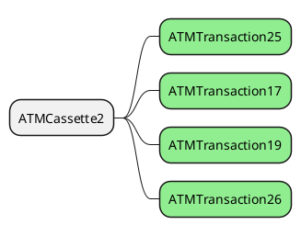

Support for Replenishment Swap Operation.

This update will generate the creation of message component ATMReconciliationOperation1 and the update of ATMTransaction25, that will impact only the ATMReconciliationAdvice2 message component.

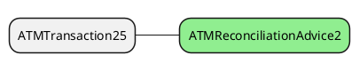

Support new type of FlowTotals.

This modification will update ATMCounterType1Code with a new code as defined in the Change Request. The update of this codeset will have a limited scope of impact since it will rejoin the one of the ATMCassette2.

The other modifications aimed documentation part of the repository.

Addition of a Reason to ATMGlobalStatus.

This Change Request aims ATMStatus1 and will be done accordingly to its description. The impact of this update is highlighted by the following diagram.

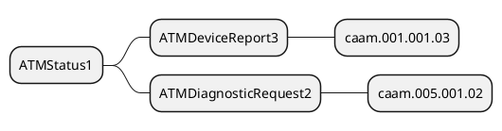

Redesign of FallbackIndicator.

This ChangeRequest will impact PaymentCard22, PaymentCard23 and will change the type of FallbackIndicator. The ripple effect of these changes is depicted by the 2 following diagrams.

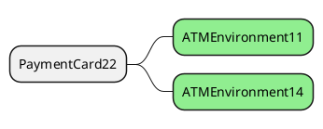

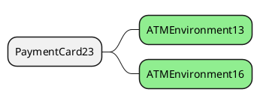

Corrections to Deposit Messages.

This Change Request creates a new component ATMDepositComponent1 that will be reused in ATMTransaction15, ATMTransaction16 and ATMTransaction19. This unique and new component is possible since the DepositedMedia is an optional element. This feature allows us to stick with our aim to restrict the number of elements in the repository. Another modification from the Change Request will be the addition of the ProtectedAccountData.

Since the ATMDepositedMedia1 has been enhanced by a previous update, the ripple effect of these ATMTransaction15, ATMTransaction16 and ATMTransaction19 have been already managed.

Add AccountMatchesMultipleAccounts.

The update on ResultDetail4Code will be done accordingly to the Change Request and will lead to the following ripple effect.

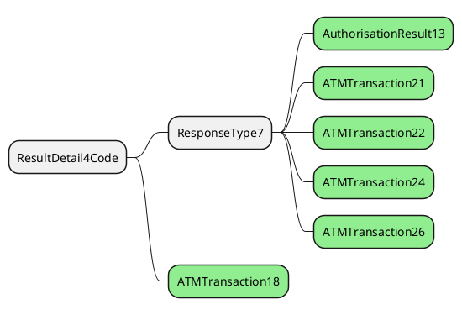

Support Multi currency Deposit.

This Change Request aims ATMTransaction15, ATMTransaction16 and ATMTransaction19. The analysis of impact has already been done.

Add account information to ATMWithdrawalResponse, ATMDepositResponse and ATMTransferResponse.

The proposal consists of adding a CardAccount12 message elements in ATMTransaction14, ATMTransaction16 and ATMTransaction24. Since these message components are already updated by previous enhancement (like the TranactionIdentifier), the impact of this change is already managed.

Add Fee information to ATMWithdrawalResponse, ATMDepositResponse, ATMInquiryResponse and ATMTransferResponse.

This proposal will lead to the creation of the message component ATMFeesComponent1 and to include a message element in AuthorisationResult13, and to add an AuthorisationResult13 in a ATMTransaction21. The impact of this update has been already studied with the enhancement of AuthorisationResult13.
.

Extend the AccountIdentifier to include email and mobile phone number.

This Change Request requires the update of AccountIdentification31Choice, which will lead to the following impacted elements.

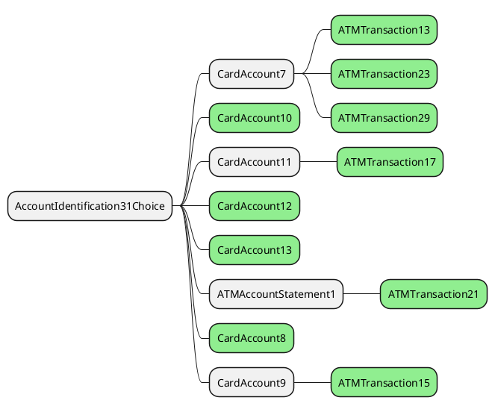

AccountDownloadCode

This proposal aims the update of ATMServiceType3Code, which will lead to following impact elements.

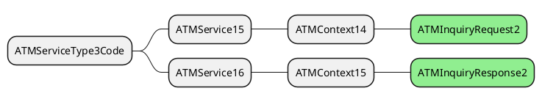

Support Interactive Transactions.

This enhancement is based on Response4Code and not Response5Code as identified in the Change Request, since this latest element is not used in ATM messages. The proposed code value SUSP is changed into ASUP since the proposed value is already used for another purpose.
The modification regarding ResponseReason will be done as requested except for the addition of OTHR since the code OTHR is already available to indicate Other Error.

The impact of these updates is highlighted by the following diagram regarding Response4Code since the impact of ResultDetail4Code’s modification is already managed by a previous update.

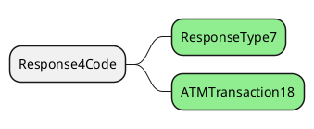

Add Individual Check Authorisation Information to the ATMDepositResponse message.

This Change Request will be done as described except that it will aim ATMDepositedMedia3 rather than ATMDepositedMedia4
These modifications will affect ATMTransaction19 which is already updated by previous update.

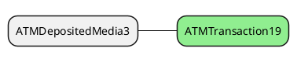

So, in order to meet the expectation and provide the support within ATMTransaction16 the element DepositedMedia must be updated in the new ATMDepositComponent1 previously created. This will need to add the element AccountSequenceNumber, which is optional, to the updated ATMDepositedMedia3 in order to replace ATMDepositedMedia1.
This modification will provide consequently the support of this new feature in ATMDepositRequest and ATMDepositResponse.

Extend DCC for EU regulations.

This proposal will lead to the creation of a new message component ATMExchangeRateComponent1 defined accordingly to the description of the Change Request and to the update of CurrencyConversion9 to include an element of this new type.
The impact of this modification is depicted by the following diagram.

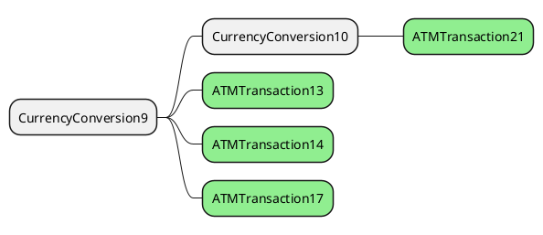

Further Individual Check Authorisation Information to the ATMDepositResponse message

This proposal consists of extending the newly ATMDepositedMediaItems1 with 2 elements as indicated by the Change Request. Nonetheless, rather than to create a new specific component for MediaItemAdditionalData it is suggested reusing GenericInformation1 since the value is optional.
There is no need to specifically study the ripple effect, since this has been done previously.

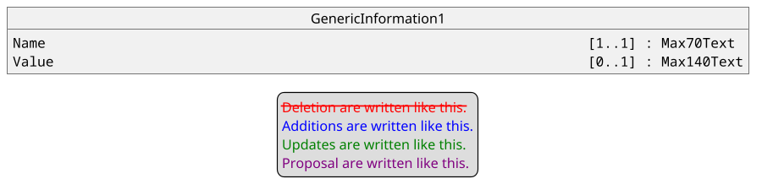

Add Source and Destination Account Information to the ATMTransferResponse message

This proposal aims the creation of a new component ATMAccountUsage1Code which will be used in the updated CardAccount12. Consequently, the impact’s analysis has been previously done.

Mini Statement Code.

The proposal consists of updating ATMServiceType10Code rather than ATMServiceType11Code as expressed in the Change Request. The new values will be created as defined in the Change Request and taking into account the following impacts.

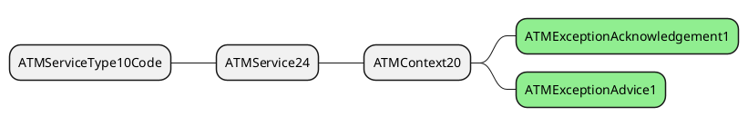

Extending ATM Capabilities.

The proposal consists of updating PointOfInteractionCapabilities7 with the proposed modifications identified in the Change Request.
The impact of this modification is highlighted in the following diagram.

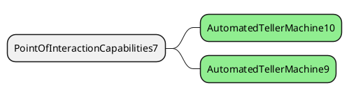

Add FlowTotals <FlowTtls> Elements for Initial amount/count

The proposal consists of updating the ATMCassetteCounters4 which is already updated by a previous request. The new values will be added as requested in the Change Request.

Add new Incident codeset values

This proposal consists of enhancing a previous modification of FailureReason7Code. So, the new values will be added as defined in the Change Request. There is no need to run an additional analysis of impact since it has been done before.

The severity of the impact of the proposed change for the message users should be indicated in the table below (either “no impact”, “conditional’ or “mandatory”).
Type of impact
 | No impact | The change(s) will not impact the schema (the version number will not change) and will not impact the business applications of any users, e.g. the clarification of a definition
X | Conditional | The change(s) will impact the schema (at least the version number) and the business applications of certain users but not all, e.g. the addition of an optional component
 | Mandatory | The change(s) will impact the schema and the business applications of all users, e.g. addition of a mandatory component.

Proposed implementation:

Update of the AmountAndDirection43.
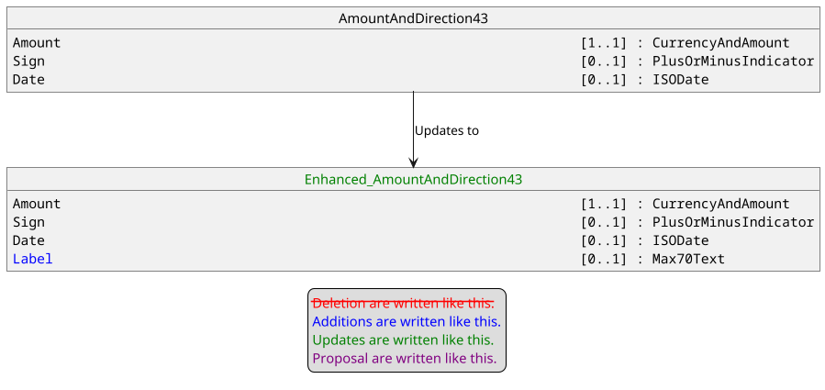

Creation of ATMAccountUsage1Code.
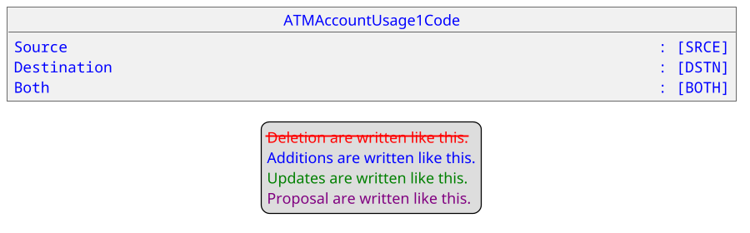

The documentation for these new codeset values are:
- SRCE : Source account.
- DSTN : Destination account.
- BOTH : Can be both the source and the destination account.

Update of CardAccount12.
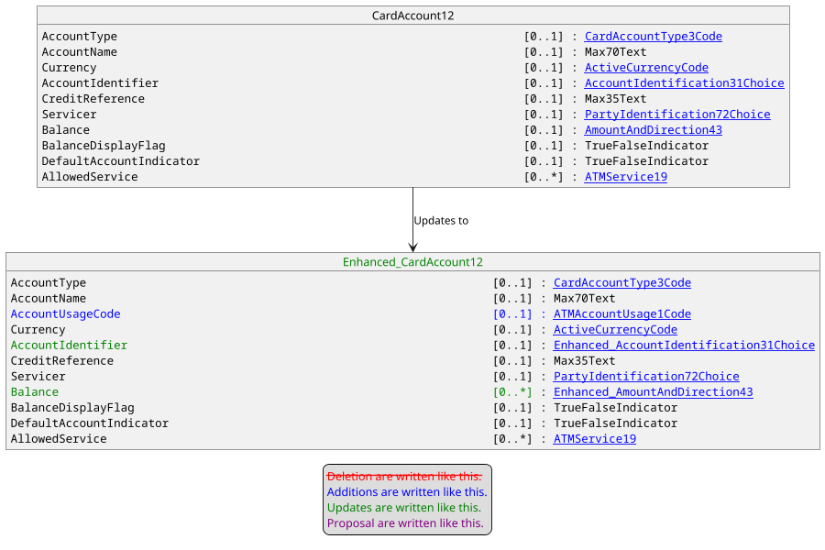

Creation of ATMFeeComponent1
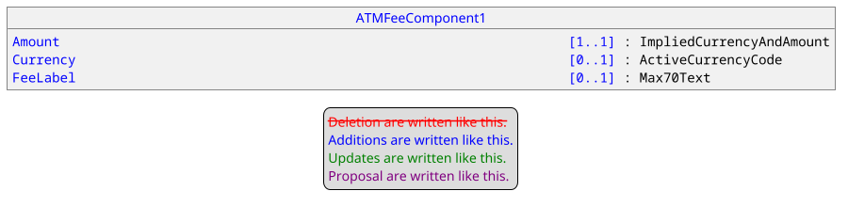

Update of AuthorisationResult13.
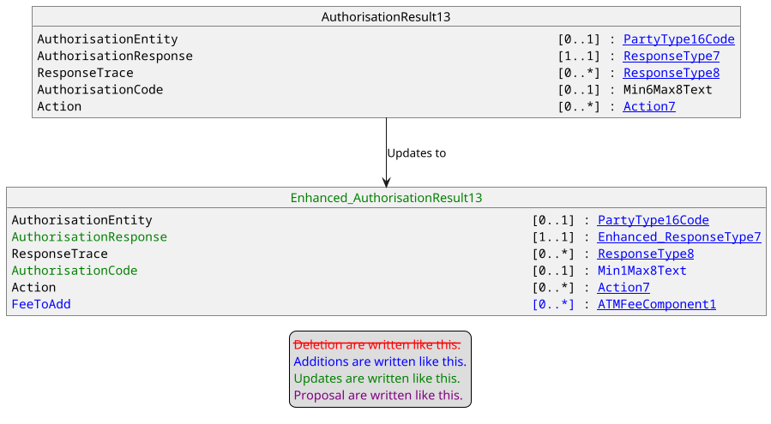

Update of FailureReason7Code
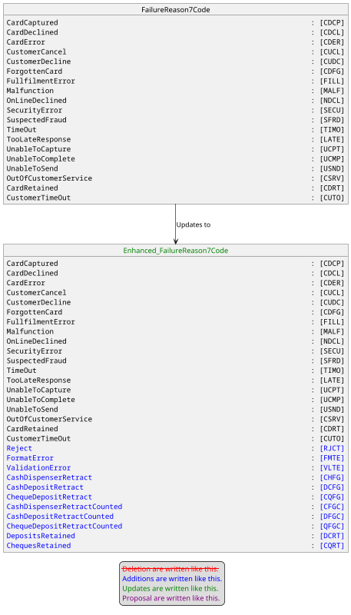

The documentation for these new codeset values are:
- RJCT : The ATM Manager has sent an ATMReject message in response to an authorisation request.
- FMTE : The ATM Manager has sent a response message in response to an authorisation request where some of its required elements were badly formatted (for example an integer value where a dateTime value was expected).
- VLTE : The ATM Manager has sent a response message in response to an authorisation request where some of its required elements were invalid (for example an incorrect ExchangeIdentifier).
- CHFG : Following a cash dispense operation the consumer forgot to take the notes, which have subsequently been retracted following a Present time-out. The number of notes retracted is unknown.
- DCFG : Following a cash return, on a deposit operation, the consumer forgot to take the returned notes, causing them to be retracted. The number of notes retracted is unknown.
- CQFG : Following cheques being returned, on a cheque deposit operation, the consumer forgot to take the returned cheques, causing them to be retracted. The number of cheques retracted is unknown.
- CFGC : Following a cash dispense operation the consumer forgot to take the returned notes, which have subsequently been retracted following a Present time-out. The number of notes retracted is known as the device was able to count the notes retracted.
- DFGC : Following a cash return, on a deposit operation, the consumer forgot to take the returned notes, causing them to be retracted. The number of notes retracted is known as the device was able to count the notes retracted.
- QFGC : Following cheques being returned, on a cheque deposit operation, the consumer forgot to take the returned cheques, causing them to be retracted. The number of cheques retracted is known as the device was able to count the cheques retracted.
- DCRT : Cash has been retained by the terminal since it has been unable to return it.
- CQRT : Cheques have been retained by the terminal since it has been unable to return them.

Update of TransactionIdentifier1.
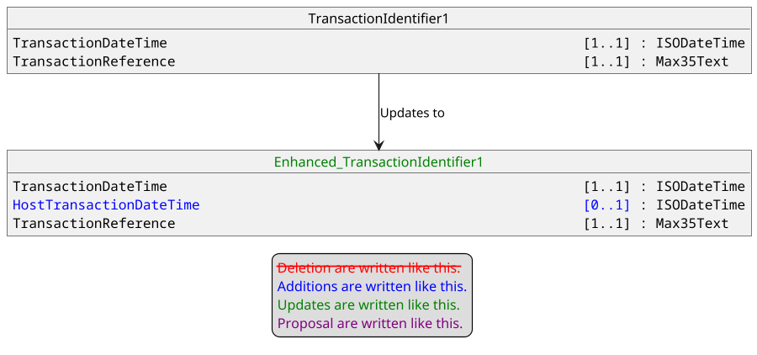

Update of ATMMediaType2Code.
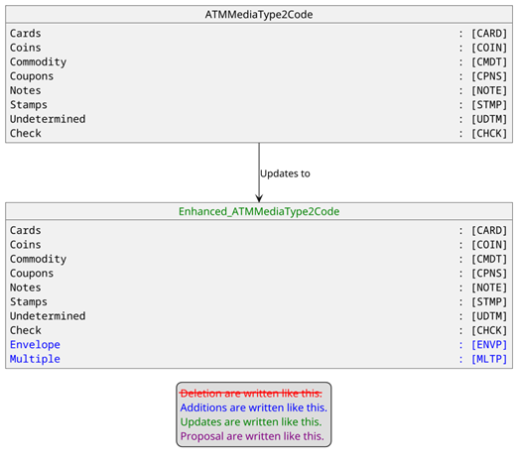

The documentation for these 2 new codeset values are :
- ENVP : One envelope containing unknown amounts of unknown items.
- MLTP: Multiple items either outside of envelope or in multiple envelopes.

Update of ATMTotals1
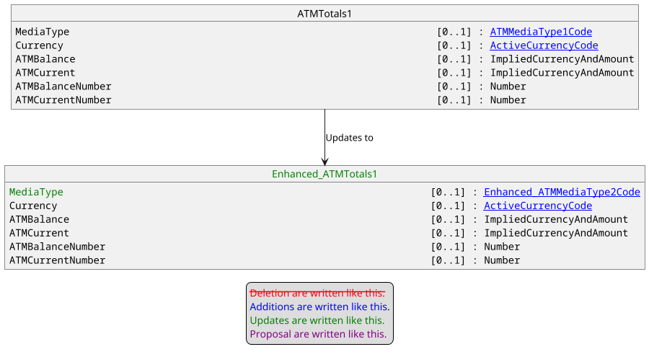

Creation of ATMCassetteStatus1Code
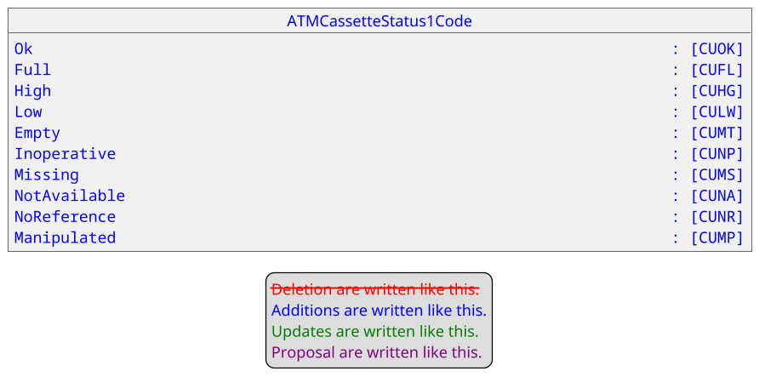
The documentation for these new codeset values are:
- CUOK : The cash unit is in a good state.
- CUFL : The cash unit is full.
- CUHG : The cash unit is high, that is it has reached or exceeded the threshold defined for this cassette.
- CULW : The cash unit is low, that is it has reached or is below the threshold defined for this cassette.
- CUMT : The cash unit is empty.
- CUNP : The cash unit is inoperative.
- CUMS : The cash unit is missing.
- CUNA: The values of this cash unit are not available.
- CUNR : There are no reference values available for this cash unit.
- CUMP : The device has been inserted when the device was not in an exchange state.

Update of ATMCassette2
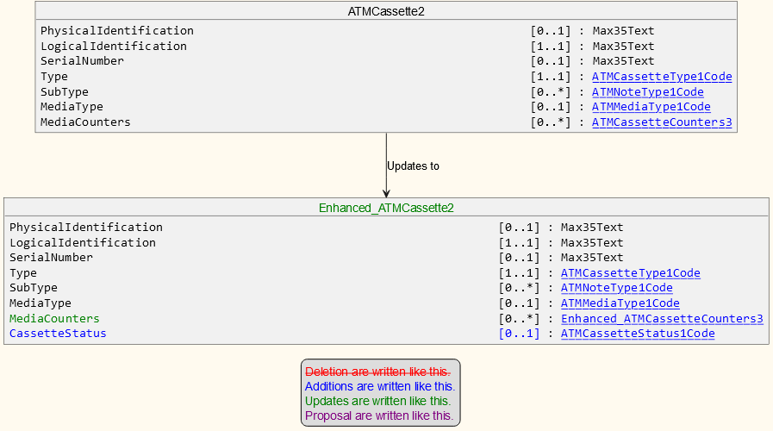

Creation of ATMReconciliationOperation1.
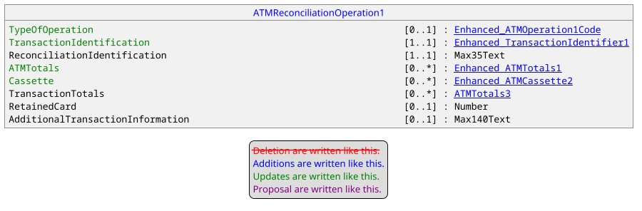

Update of ATMTransaction25
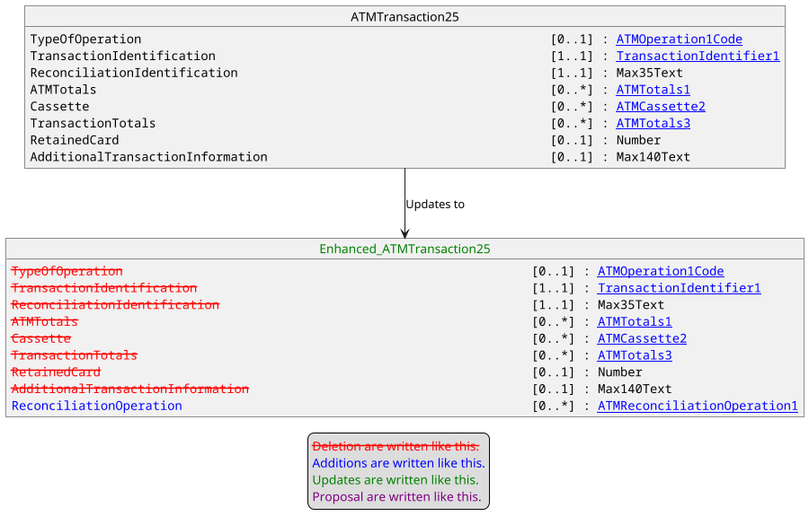

Update of ATMCounterType1Code
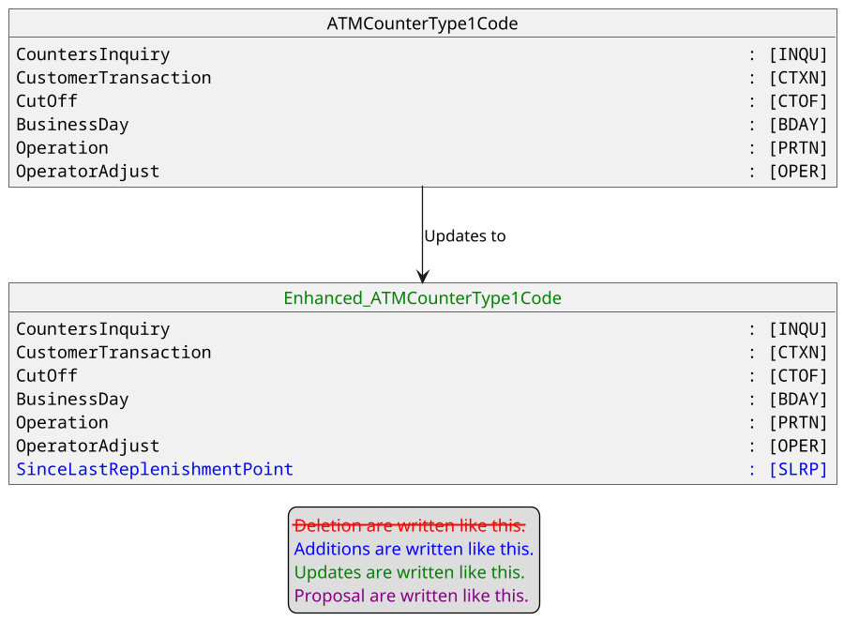

Update of ATMStatus1
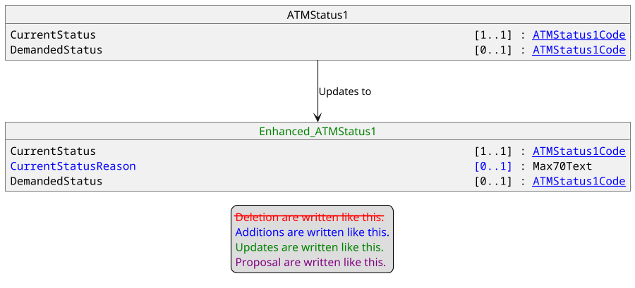

Update of PaymentCard22.
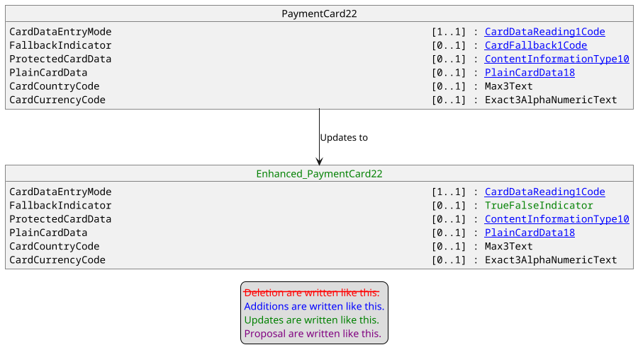

Update of PaymentCard23
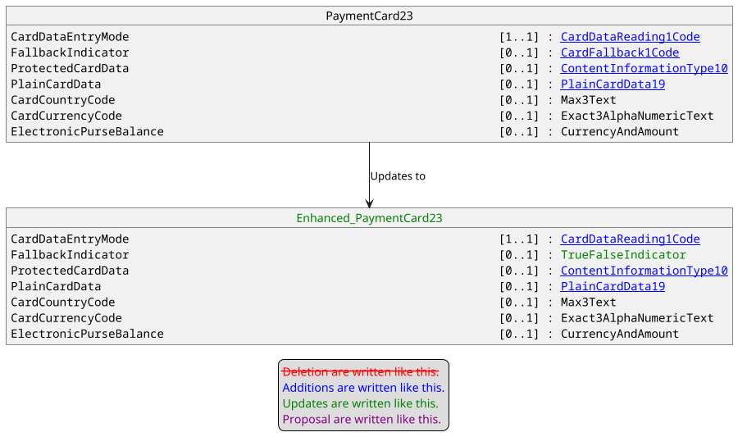

Creation of ATMDepositComponent1.
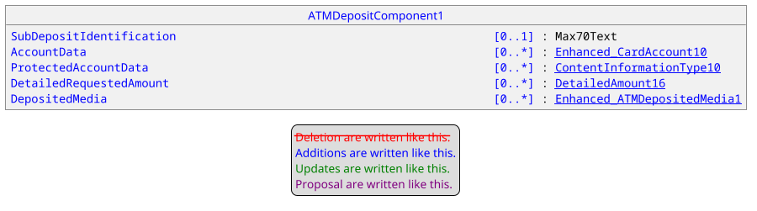

Update of ATMTransaction15
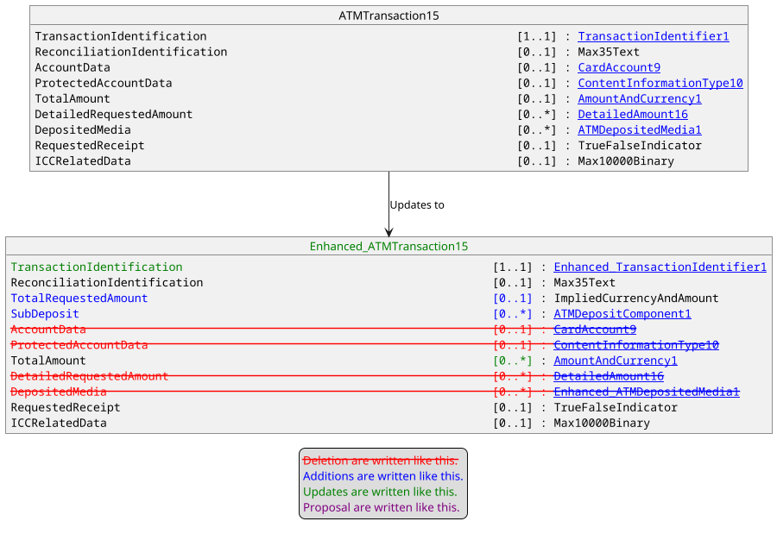

Update of ATMTransaction16
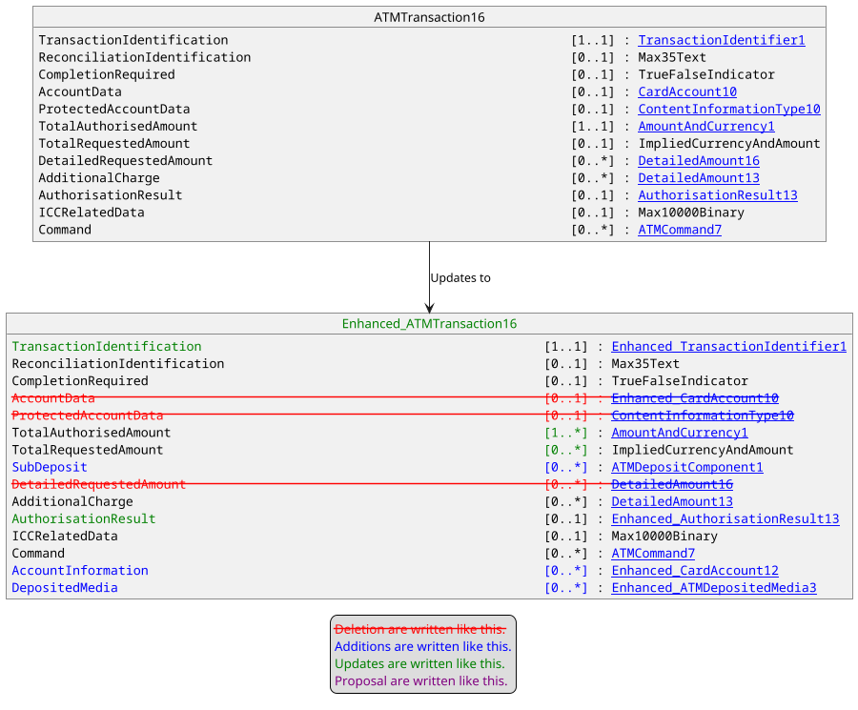

Update of ATMTransaction19.
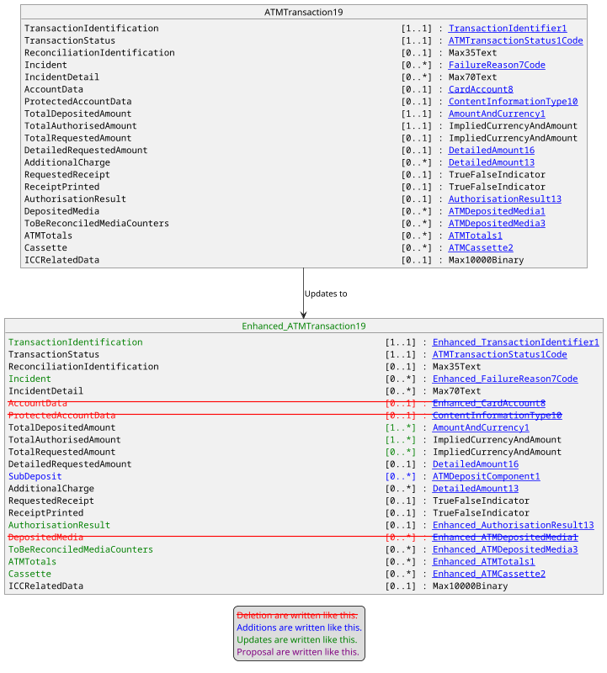

Update of ResultDetail4Code.
The following new values:
- AccountMatchesMultipleAccounts related to AMMA,
- AgreeFee related to AGFE,
- SelectAccount related to SACT
- AgreeDCC related to ADCC

will be added to the following existing list:

- AccountNotFound – ACTF
- AcquirerNotSupported – ACQS
- AMLValidation – AMLV
- AmountNotFound – AMTA
- AuthenticationFailed – AUTH
- BankNotFound – BANK
- CardError – CRDR
- CardVerificationFailed – CRDF
- ClosedAccount – ACTC
- CutoverInProcess – CTVG
- DatabaseError – DBER
- DisputedFees – FEES
- ExceededTransactionLifeCycle – TXNL
- DepositAmountLimit – AMTD
- DepositNumberLimit – NMBD
- ExpiredCard – CRDX
- FallbackDeclined – FDCL
- FormatError – FMTR
- InProgress – TXNG
- InsufficientFunds – FNDI
- InvalidAcceptor – ACPI]
- InvalidAmount – AMTI
- InvalidAddress – ADDI
- InvalidBranch – BRHI
- InvalidCardholderIdentification – CHDI
- InvalidCardNumber – CRDI
- InvalidCertificate – CTFV
- InvalidOriginalAmount – AMTO
- InvalidPIN – PINV
- InvalidToken – TKKO
- InvalidSignature – SGNI
- InvalidTokenIdentification – TKID
- InvalidTransaction – TXNV
- InvalidTransactionDateTime – DATI
- IssuerInoperative – ISSP
- IssuerNotFound – ISSF
- IssuerSignedOff – ISSO
- IssuerTimeOut – ISST
- IssuerUnavailable – ISSU
- KeyStorageSaturation – KEYS
- LiabilityAccepted – LBLA
- LostCard – CRDL
- MACError – MACR
- MACKeyError – MACK
- MissingICCData – ICCM
- NewPINInvalid – PINN
- NoCardRecord – CRDA
- NoLiabilityAccepted – LBLU
- NotAbleToValidatePIN – PINA
- NotPermittedToAcceptor – NPRA
- OffLineProcess – OFFL
- OffLineProcessAfterReferral – ONLP
- NotPermittedToCardholder – NPRC
- OriginalDoesNotMatch – TXNM
- OtherError – OTHR
- OutOfBalance – BALO
- OutOfSequence – SEQO]
- PINChangeRequired – PINC
- PINDataRequired – PIND
- PINSecurityError – PINS
- PINTriesExceeded – PINX
- PINEncryptionError – PINE
- QueueMaximumExceeded – QMAX
- RecurringDataError – RECD
- RestrictedCard – CRDT
- SecurityViolation – SECV
- ServiceNotEnabled – SRVU
- SoftwareOrHardwareError – SFWE
- SpecialConditions – SPCC
- StolenCard – CRDS
- SurchargeNotPermitted – SRCH
- SuspectedCounterfeitCard – CNTC
- SuspectedFraud – FRDS
- SystemInoperative – SYSP]
- SystemMalfunction – SYSM
- TerminalNotConfigured – TRMI
- ToAccountError – ACTT
- TotalsNotAvailable – TTLV
- TransactionDidNotComplete – TXNU
- TransactionDuplicate – TXND
- UnableToFindOriginal – ORGF
- UnableToGoOnLine – UNBO
- UnableToProcessOffLine – UNBP
- UnacceptableCurrency – UNBC
- UnavailablecommunicationKey – CMKY
- UneffectiveCard – CRDU
- UnsupportedService – SVSU
- VendorFormatError – VNDR
- VendorNotFound – VNDF
- WithdrawalAmountLimit – AMTW
- WithdrawalNumberLimit – NMBW
- WrongCard – CRDW
- InvalidMediaType – MEDI
- InvalidService – SRVI

The documentation for these new codeset values are :
- AMMA : The account details provided in the request message matches multiple accounts.
- AGFE : Consumer must agree fee from those provided to authorise the transaction. See <Tx><AuthstnRslt><FeeToAdd>.
- SACT : Consumer must select an account from those provided to authorise the transaction. See <Tx><AcctInf>.
- ADCC : Consumer must choose whether to accept DCC offer provided to authorise the transaction. See <Tx><CcyConvsElgblty>.

Update of ATMTransaction14
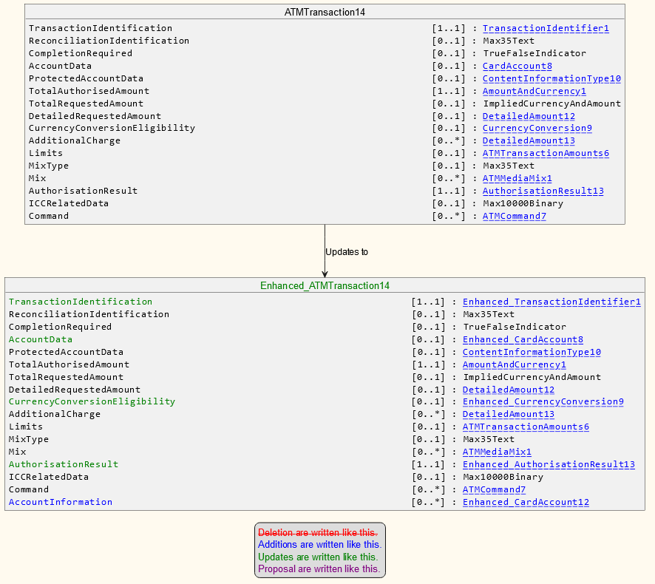

Update of ATMTransaction24
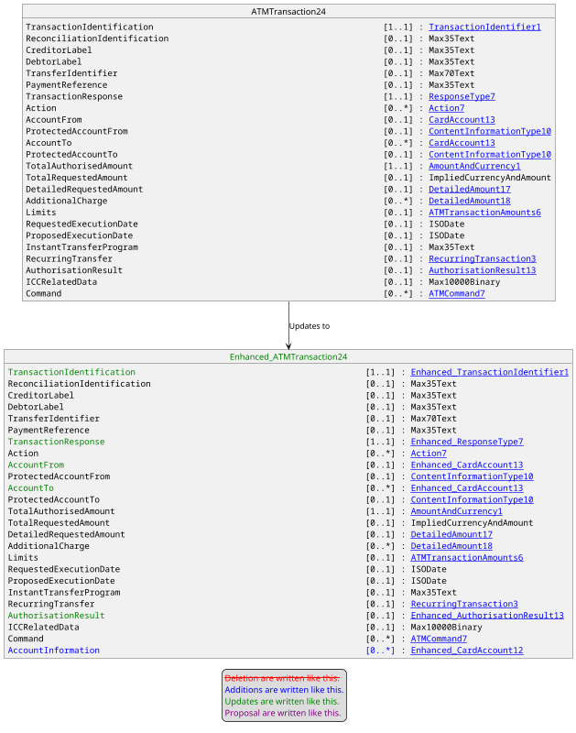

Update of ATMTransaction21
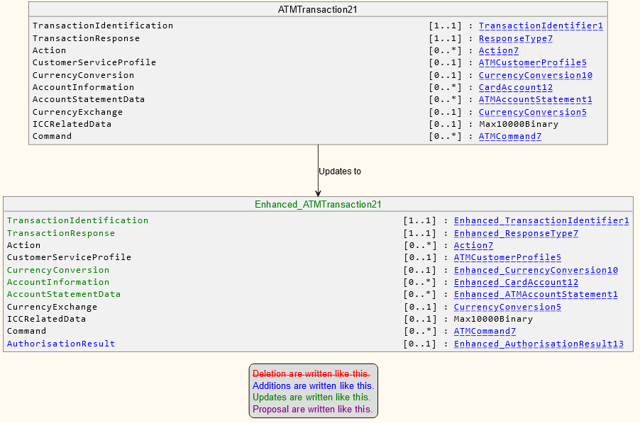

Update of AccountIdentification31Choice.
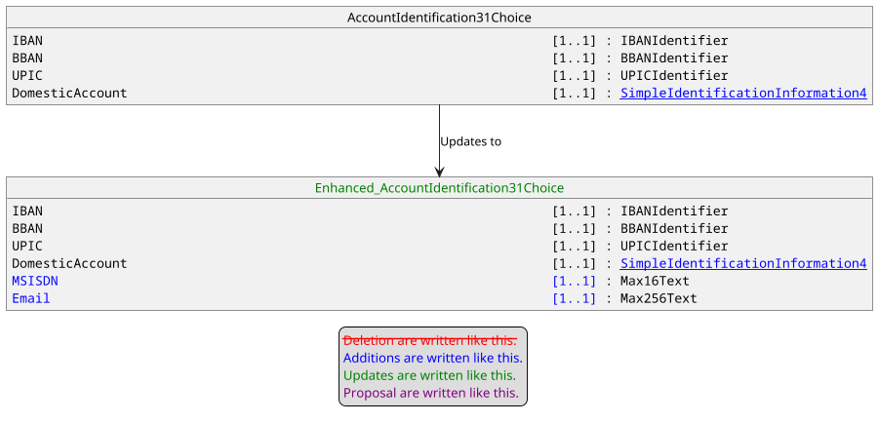

Update of ATMServiceType3Code.
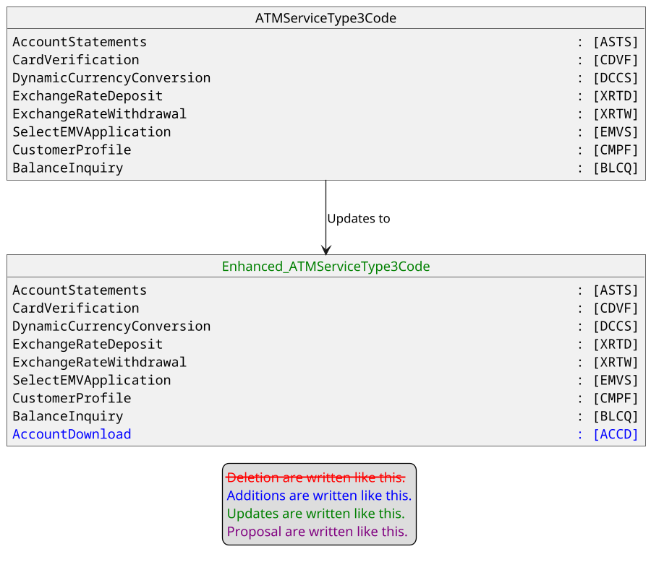
The documentation for this new codeset value will be : Download accounts associated to the customer card.

Update of Response4Code.
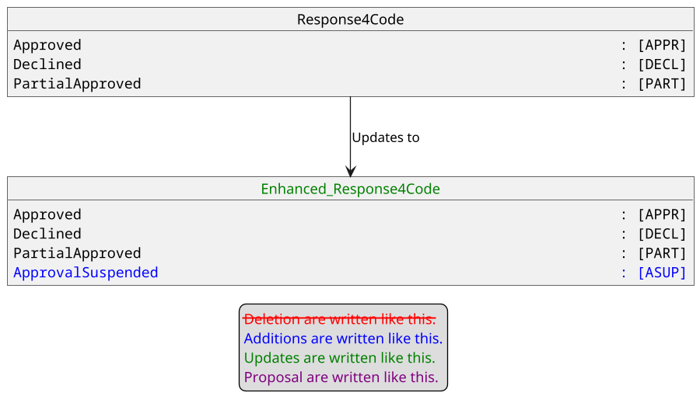

The documentation for this new codeset value will be : To provide this service additional information needs to be provided by the customer.

Creation of ATMMediaStatus1Code
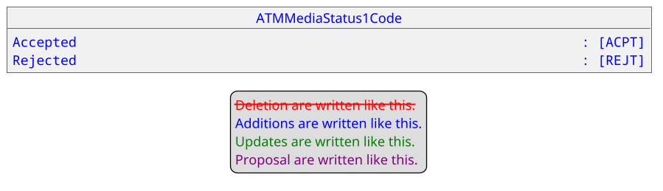
The documentation for these new codeset values are:
- ACPT : Item (such as a check) has been accepted.
- REJT : Item (such as a check) has been rejected.

Creation of ATMDepositedMediaItems1
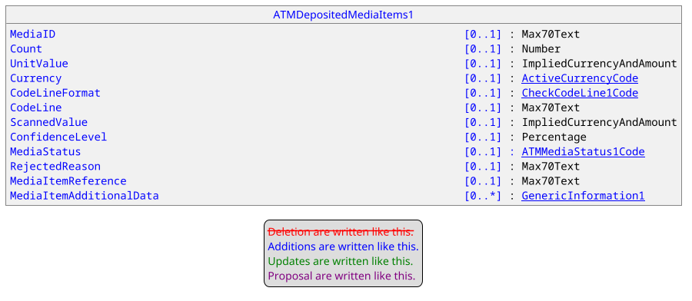

Update of ATMDepositedMedia3.
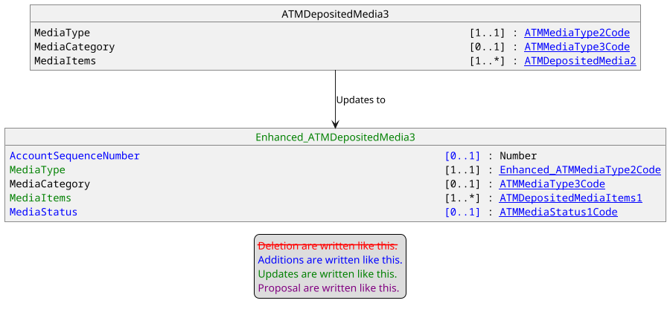

Merge of ATMDepositedMedia1 with ATMDepositedMedia3
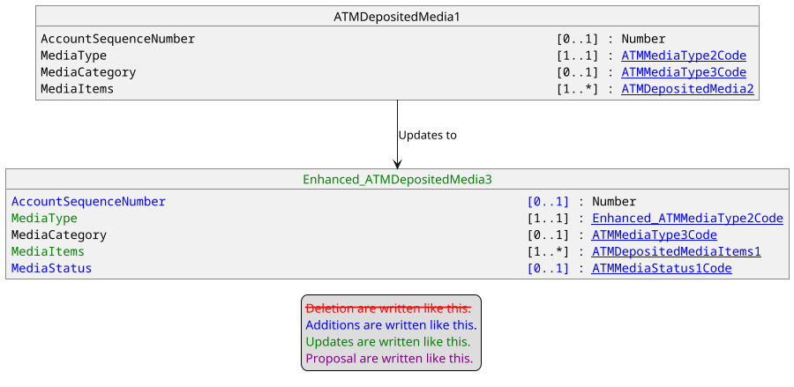

Creation of ATMExchangeRateComponent1
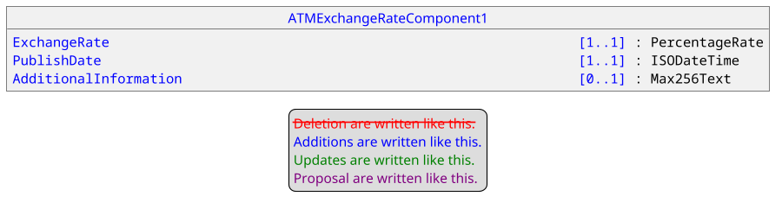

Update of CurrencyConversion9
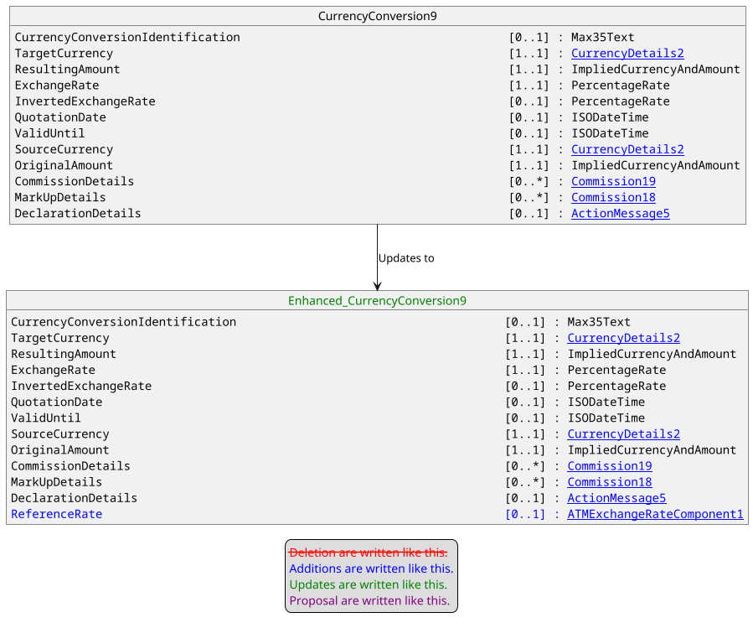

Update of ATMServiceType10Code.
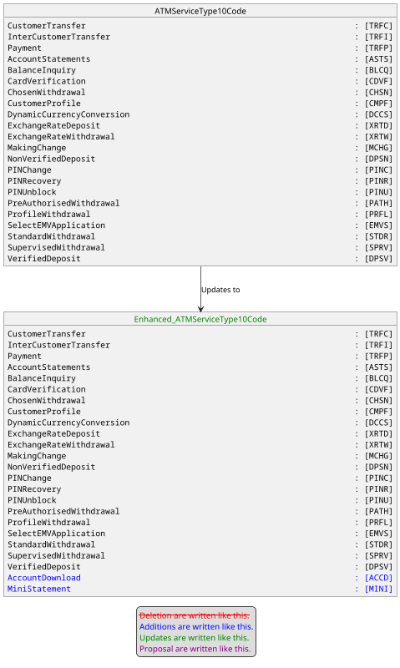
The documentation for the new codeset value ACCD has been provided earlier. The documentation for MINI will be : Request a mini-statement (i.e. partial statement) related to a customer account.

Update of PointOfInteractionCapabilities7
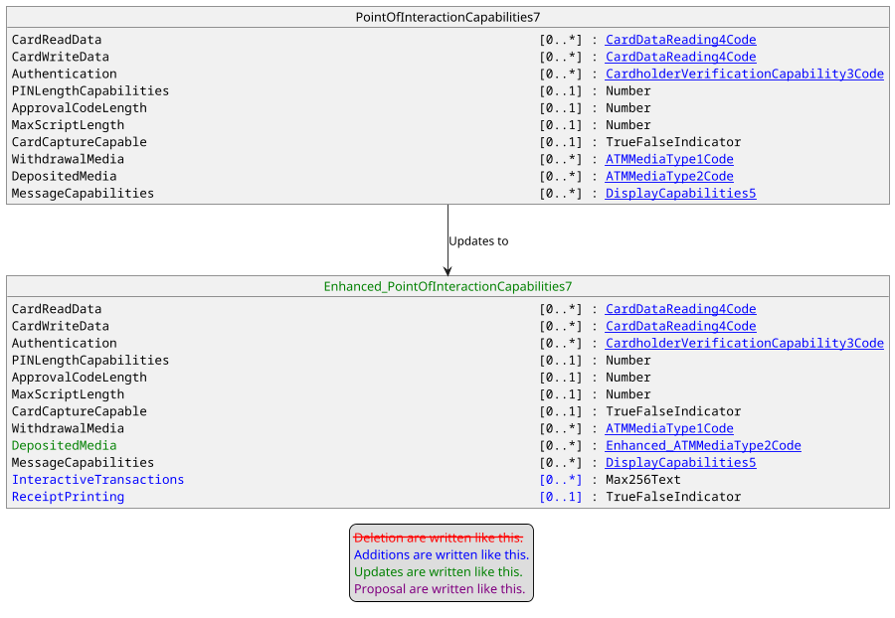

Update of ATMCassetteCounters4
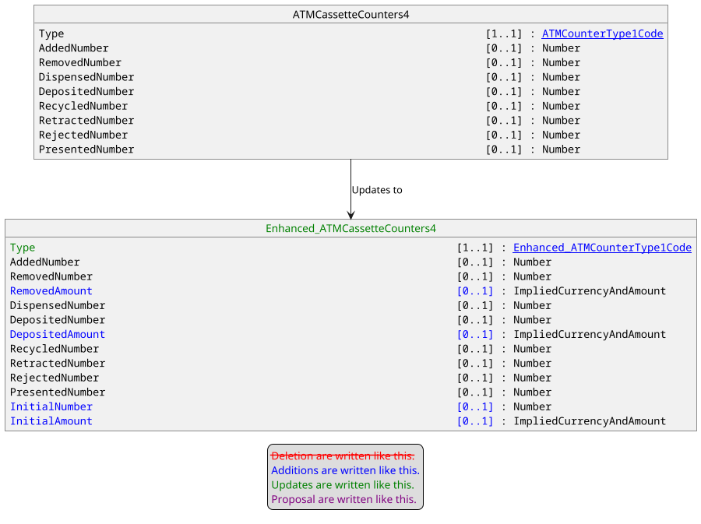

Proposed timing:
The submitting organization confirms that it can implement the requested changes in the requested timing, or, if not, proposes another timing.

Timing | - As requested
 | - Other:

Final decision of the SEG(s):
This section is not to be taken care of by the submitting organization. It will be completed in due time by the SEG(s) in charge of the related ISO 20022 messages.
Approve | X
Comments:

Reject
Reason for rejection:

Change request number #1385 nexo ATM Reconciliation

Origin of the request:
A.1 Submitter:
nexo A.I.S.B.L.
A.2 Contact person:
- Andrew Hamilton (andrewr.hamilton@ncratleos.com)
- Philippe Cece (philippe.cece@nexo-standards.org)
A.3 Sponsors:
nexo A.I.S.B.L.

Related messages:
- ATMDeviceReport (caam.001.001.03),
- ATMDeviceControlV03 (caam.002.001.03),
- ATMKeyDownloadRequestV03 (caam.003.001.03),
- ATMKeyDownloadResponseV03 (caam.004.001.03),
- ATMReconciliationAdviceV02 (caam.009.001.02),
- ATMReconciliationAcknowledgementV02 (caam.010.001.02).
2 new messages introduced.

Description of the change request:

1. Add a new Command code value
The Command Type ATMCommand6Code will be extended to include: ReconciliationRequest
Datatype: ATMCommand6Code
CodeName | Name | Definition
…
KCHG | KeyReplace | Replaces an existing cryptographic key. In a TR34 scheme this would be used to implement a Rebind operation.
RREQ | ReconciliationRequest | Send a ReconciliationRequest message

2. Add a new TypeOfOperation code value
The codeset ATMOperation1Code will be extended to include: RemoteCounterUpdate
Datatype: ATMOperation1Code
CodeName | Name | Definition
…
UNLD | Unloading | Unloading cassette.
RCUP | RemoteCounterUpdate | Remotely updating an ATM counter.

3. Create a new ATMReconciliationRequest Message
The ATMReconciliationRequest message is sent by a terminal to an acquiring server when it needs it to inform the terminal of updates to the reconciliation counts. The terminal will send the existing counts in the Cassette structure.
The ATMReconciliationRequest <ATMRcncltnReq> message is defined as:
Or | Message Element | Mult. | Type
 | Header <Hdr> | [1..1] | Header31
 | ProtectedATMRcncltnReqRequest <Prtctd ATMRcncltnReq> | [0..1] | ±
 | ATMReconciliationRequest < ATMRcncltnReq > | [0..1]
 | Environment <Env> | [1..1] | ATMEnvironment7
 | Transaction <Tx> | [0..1]
 | TypeOfOperation <TpOfOpr> | [1..1] | Codeset. Note the new value RCUP (Remote Counter Update)
 | TransactionId <TxId> | [0..1] | Text
 | ReconciliationId <RcncltnId> | [0..1] | Text
 | Cassette <Csstt> | [0..*] | ±
 | SecurityTrailer <SctyTrlr> | [0..1] | ±

4. Create a new ATMReconciliationResponse Message
The ATMReconciliationResponse message is sent by an acquiring server to a terminal in response to an ATMReconciliationRequest message. The response will contain the counts which need to be updated.
The ATMReconciliationResponse <ATMRcncltnRspn> message is defined as:
Or | Message Element | Mult. | Type
 | Header <Hdr> | [1..1] | Header31
 | ProtectedATMRcncltnReqResponse <Prtctd ATMRcncltnRspn> | [0..1] | ±
 | ATMReconciliationResponse < ATMRcncltnRspn > | [0..1]
 | Environment <Env> | [1..1] | ATMEnvironment7
 | Transaction <Tx> | [0..1]
 | TypeOfOperation <TpOfOpr> | [1..1] | Codeset. New value RCUP (Remote Counter Update)
 | TransactionId <TxId> | [0..1] | Text
 | ReconciliationId <RcncltnId> | [0..1] | Text
 | Cassette <Csstt> | [0..*]
 | PhysicalIdentifier <PhysId> | [1..1] | Text
 | LogicalIdentifier <LogicId> | [0..1] | Text
 | SerialNumber <SrlNb> | [0..1] | Text
 | Type <Tp> | [0..1] | Codeset
 | SubType <SubTp> | [0..1] | Codeset
 | MediaType <MdiaTp> | [0..1] | Codeset
 | MediaCounters <MdiaCntrs> | [0..*]
 | UnitValue <UnitVal> | [0..1] | Amount
 | Currency <Ccy> | [0..1] | Codeset
 | MediaCategory <MdiaCtgy> | [0..1] | Codeset
 | InitialCount <InitCnt> | [0..1] | Number
 | CurrentNumber <CurNb> | [0..1] | Number
 | CurrentAmount <CurAmt> | [0..1] | Amount
 | FlowTotals <FlowTtls> | [0..*]
 | Type <Tp> | [1..1] | Codeset
 | AddedNumber <AddedNb> | [0..1] | Quantity
 | RemovedNumber <RmvdNb> | [0..1] | Quantity
 | DispensedNumber <DspnsdNb> | [0..1] | Quantity
 | DepositedNumber <DpstdNb> | [0..1] | Quantity
 | RecycledNumber <RcycldNb> | [0..1] | Quantity
 | RetractedNumber <RtrctdNb> | [0..1] | Quantity
 | RejectedNumber <RjctdNb> | [0..1] | Quantity
 | PresentedNumber <PresntdNb> | [0..1] | Quantity
 | SecurityTrailer <SctyTrlr> | [0..1] | ±

Where InitialCount <InitCnt> is a new element in MediaCounters <MdiaCntrs> and is defined:
Presence: [0..1]
Definition: Number of media items in cassette after last replenishment
Datatype: Positive Number
All elements, apart from InitialCount, in the above two messages are as presently defined in the nexo ISO20022 standard.

Purpose of the change:
Business justification:
During replenishment of valuables the Cash-in-Transit (CIT) personnel may cause an error in counts by entering an incorrect value for valuables in a cassette swap, media added or media removed. This proposal allows an operator at a remote location to correct mistakes entered at the ATM during replenishment; for example, the CIT person informs the acquiring server (through a supervisor application) that 1000 notes have been entered, when actually 2000 notes were entered. An acquiring server operator can remotely set the initial value to 2000 by adding 1000 notes, hence correcting the mistake.
The proposal adds a new command which will command the ATM to send a new Reconciliation Request to its acquiring server. When this message is sent, the acquiring server will respond with a new Reconciliation Response message which contains the corrected counts.

Example Use Case
The following diagram shows an example sequence, where in a DeviceControl message from the server a ReconciliationRequest command is sent to the terminal. The terminal will send the ReconciliationRequest message to the Server, followed by the ReconciliationResponse message from the server with the corrected counts for the cassettes. On receipt of this message the terminal will update the XFS counts for the relevant cassettes and inform the server of the update by sending a ReconciliationAdvice message, which would be followed by the ReconciliationAcknowledgement message by the server to acknowledge receipt of the Advice.
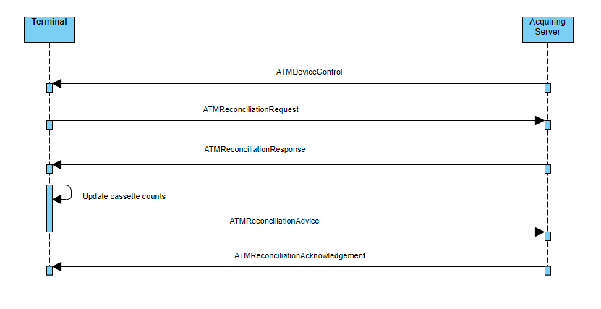

Urgency of the request:
Urgent.

Business examples:

SEG recommendation:
This section is not to be taken care of by the submitter of the change request. It will be completed in due time by the SEG(s) in charge of the related ISO 20022 messages.

Consider |  |  |  | X | Timing
 |  |  |  |  | - Next yearly cycle: 2024/2025  (the change will be considered for implementation in the yearly maintenance cycle which starts in 2024 and completes with the publication of new message versions in the spring of 2025) |  | X
- At the occasion of the next maintenance of the messages
(the change will be considered for implementation, but does not justify maintenance of the messages in its own right – will be pending until more critical change requests are received for the messages)
- Urgent unscheduled
(the change justifies an urgent implementation outside of the normal yearly cycle)
 |  |  |  |  | - Other timing:

Comments:

Reject
Reason for rejection:

Impact analysis and type of impact:

Add a new Command code value.
The new value will be added as defined in the Change Request and will imply the following modification listed in the following diagram.
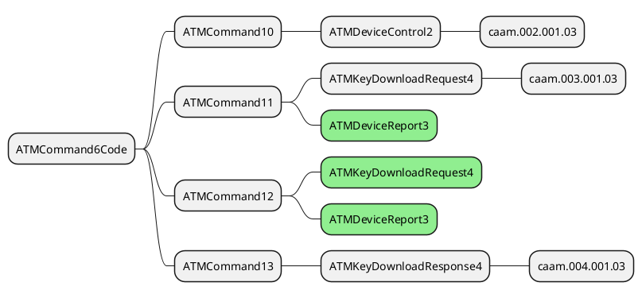

Add a new TypeOfOperation code value.
The new value will be added as expressed in the Change Request, that will impact components already enhanced by previous changes.

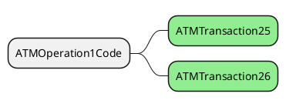

Creation a new ATMReconciliationRequest Message.
This new message implies the creation of a new ATMTransaction message component with new updated elements and a new message component ATMReconciliationRequestComponent1. There is no impact since we are creating new components.

Create a new ATMReconciliationResponse Message.
This new message will be created with updated elements existing in the repository or already enhanced by a previous Change Request. For instance, in the Cassette message element, the message element LogicalIdentifier is the mandatory element rather than PhysicalIdentifier.

The enhanced ATMCassetteCounter3 message component will be updated to include the element InitialCount as identified in the Change Request.

The impact of this update is limited to the update of ATMCassetteCounter3 which has already been taken into account with a previous update.

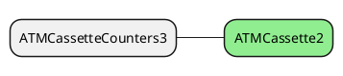

The severity of the impact of the proposed change for the message users should be indicated in the table below (either “no impact”, “conditional’ or “mandatory”).
Type of impact
 | No impact | The change(s) will not impact the schema (the version number will not change) and will not impact the business applications of any users, e.g. the clarification of a definition
X | Conditional | The change(s) will impact the schema (at least the version number) and the business applications of certain users but not all, e.g. the addition of an optional component
 | Mandatory | The change(s) will impact the schema and the business applications of all users, e.g. addition of a mandatory component.

Proposed implementation:

Update of ATMCommand6Code.
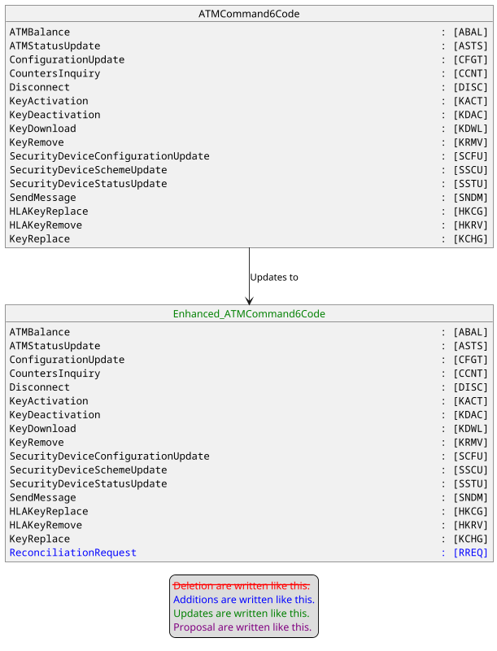
The documentation for this new codeset value will be : Send a ReconciliationRequest message.

Update of ATMOperation1Code
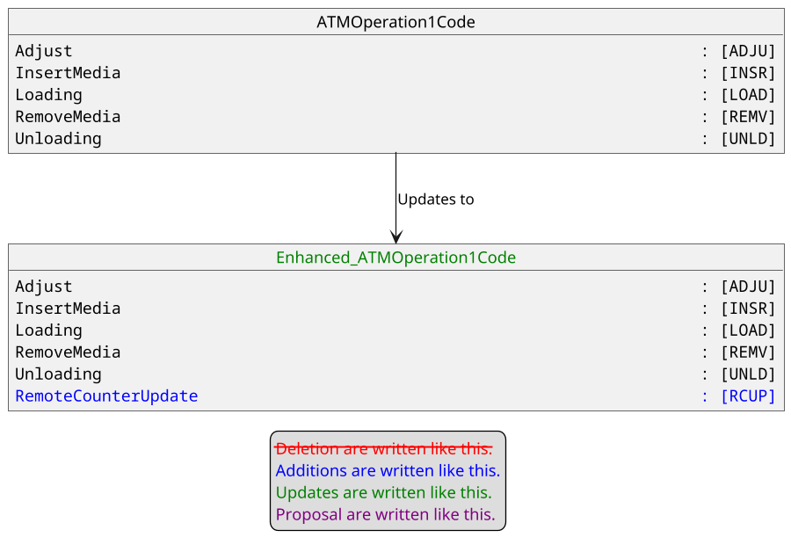
The documentation for this new codeset value will be : Remotely updating an ATM counter.

Creation of new ATMTransaction30.
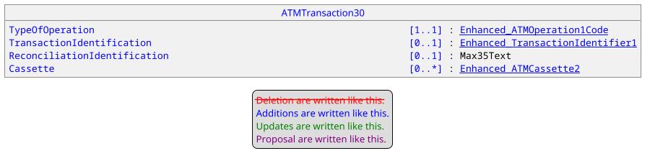

Creation of ATMReconciliationRequestComponent1
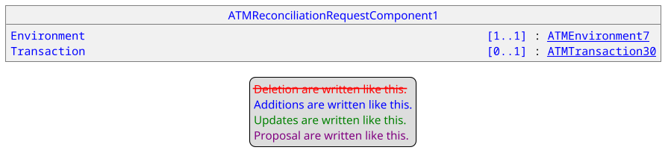

Creation of new message ATMReconciliationRequest.
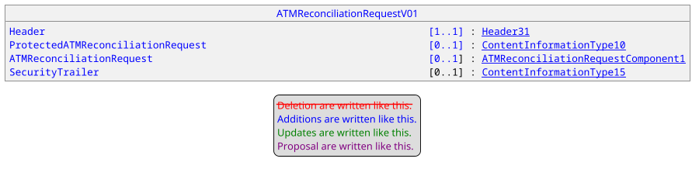

Update of ATMCassetteCounter3
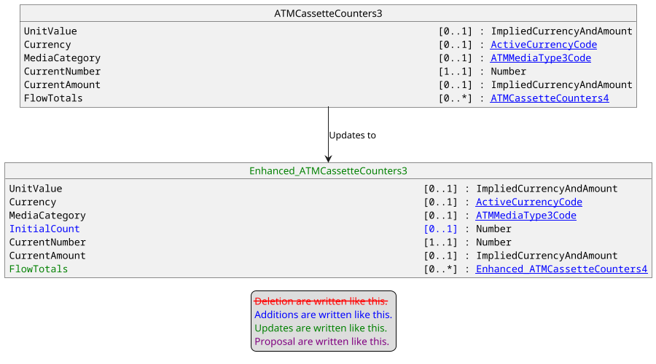

Creation of new message ATMReconciliationResponse
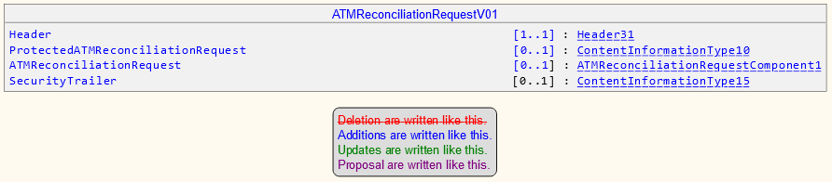

Proposed timing:
The submitting organization confirms that it can implement the requested changes in the requested timing, or, if not, proposes another timing.

Timing | - As requested
 | - Other:

Final decision of the SEG(s):
This section is not to be taken care of by the submitting organization. It will be completed in due time by the SEG(s) in charge of the related ISO 20022 messages.
Approve | X
Comments:
RA confirms the message identifiers for the new messages:
- ATMReconciliationRequestV01 (caam.015.001.01)
- ATMReconciliationResponseV01 (caam.016.001.01)

Reject
Reason for rejection:

Change request number #1387 nexo TMS Batch Of Messages

Origin of the request:
A.1 Submitter:
nexo A.I.S.B.L.
A.2 Contact person:
- Philippe CECE (philippe.cece@nexo-standards.org)
- Laure BELTRI (laure.beltri@frenchsys.com)
A.3 Sponsors:
nexo A.I.S.B.L.

Related messages:
- AcceptorConfigurationUpdate V13 (catm.003.001.13)

Description of the change request:
We want to update MessageFunction43Code to identify the support of the AcceptorToAcquirerBatchFileExchange by an Acquirer server.

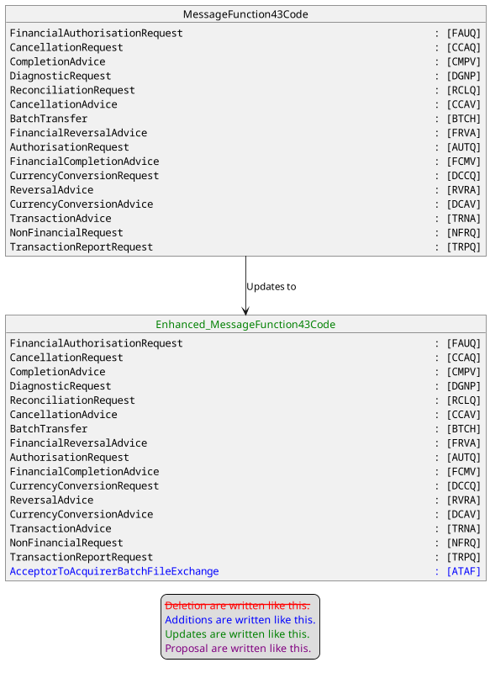

Purpose of the change:
This change request aims to keep consistency in protocol usage and allow configuration of any exchanges that a server supports and to correct a forgiveness.

Urgency of the request:
Urgent

Business examples:
Examples illustrating the change request.

SEG recommendation:
This section is not to be taken care of by the submitter of the change request. It will be completed in due time by the SEG(s) in charge of the related ISO 20022 messages.

Consider |  | X | Timing
 |  |  | - Next yearly cycle: 2024/2025  (the change will be considered for implementation in the yearly maintenance cycle which starts in 2024 and completes with the publication of new message versions in the spring of 2025) |  | X
- At the occasion of the next maintenance of the messages
(the change will be considered for implementation, but does not justify maintenance of the messages in its own right – will be pending until more critical change requests are received for the messages)
- Urgent unscheduled
(the change justifies an urgent implementation outside of the normal yearly cycle)
 |  |  | - Other timing:
Comments:

Reject
Reason for rejection:

Impact analysis and type of impact:
The modification will be done accordingly to the description in the Change Request and will create the following modifications.

The severity of the impact of the proposed change for the message users should be indicated in the table below (either “no impact”, “conditional’ or “mandatory”).
Type of impact
 | No impact | The change(s) will not impact the schema (the version number will not change) and will not impact the business applications of any users, e.g. the clarification of a definition
X | Conditional | The change(s) will impact the schema (at least the version number) and the business applications of certain users but not all, e.g. the addition of an optional component
 | Mandatory | The change(s) will impact the schema and the business applications of all users, e.g. addition of a mandatory component.

Proposed implementation:
The MessageFunction43Code will be updated as explained below.
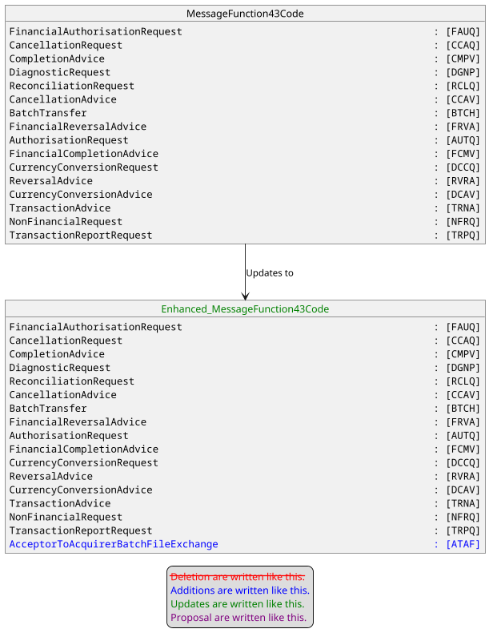
The documentation for the new codeset value ATAF will be : Concatenation of multiple exchanges in one file.

Proposed timing:
The submitting organization confirms that it can implement the requested changes in the requested timing, or, if not, proposes another timing.

Timing | - As requested
 | - Other:

Final decision of the SEG(s):
This section is not to be taken care of by the submitting organization. It will be completed in due time by the SEG(s) in charge of the related ISO 20022 messages.
Approve | X
Comments:

Reject
Reason for rejection:

Change request number #1388 nexo TMS Monitoring

Origin of the request:
A.1 Submitter:
nexo A.I.S.B.L.
A.2 Contact person:
- Philippe CECE (philippe.cece@nexo-standards.org)
- Laure BELTRI (laure.beltri@frenchsys.com)
A.3 Sponsors:
nexo A.I.S.B.L.

Related messages:
- StatusReport V13 (catm.001.001.13)
- ManagementPlanReplacement V13 (catm.002.001.13)

Description of the change request:
We want to update PointOfInteractionComponent15 in order to add a new message element to include a ProbeValue and extend PointOfInteractionCapabilities9 code that specifies the message element Type. These elements will identify a probe and provide it’s value as a POIComponent.
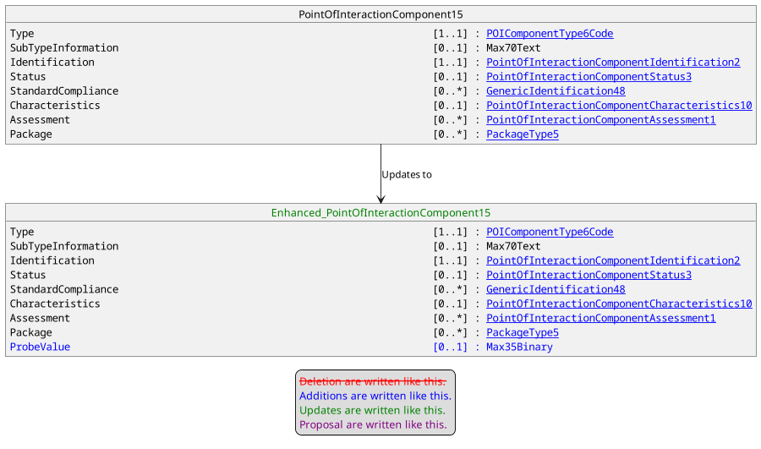
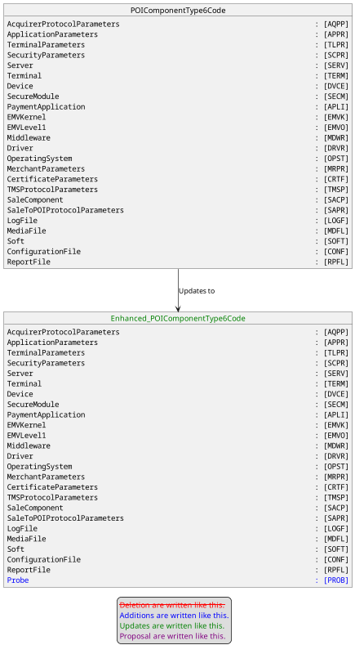

We want also to update DataSetCategory18Code in order to identify a PROBE as a DataSet.

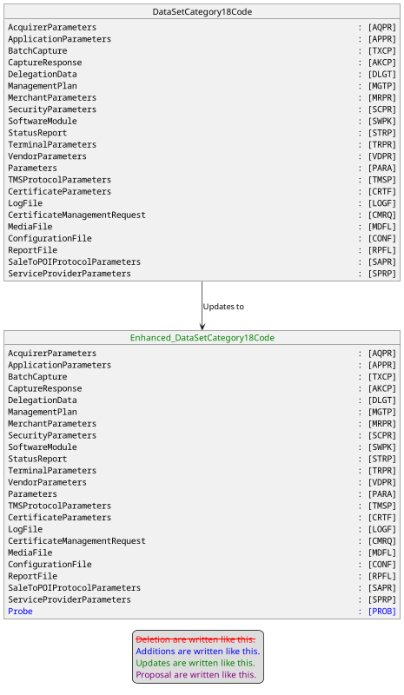

Purpose of the change:
Some nexo members want to use ManagementPlanReplacement to specify, through DataSet/Identification, probes’ identification that should be send back in StatusReport messages, or that should be Restart to clear probes history of min, max or mean values. This function will help TM Server to monitor POIs deployed on the field.

Urgency of the request:
Urgent

Business examples:
Examples illustrating the change request.

SEG recommendation:
This section is not to be taken care of by the submitter of the change request. It will be completed in due time by the SEG(s) in charge of the related ISO 20022 messages.

Consider |  | X | Timing
 |  |  | - Next yearly cycle: 2024/2025  (the change will be considered for implementation in the yearly maintenance cycle which starts in 2024 and completes with the publication of new message versions in the spring of 2025) |  | X
- At the occasion of the next maintenance of the messages
(the change will be considered for implementation, but does not justify maintenance of the messages in its own right – will be pending until more critical change requests are received for the messages)
- Urgent unscheduled
(the change justifies an urgent implementation outside of the normal yearly cycle)
 |  |  | - Other timing:
Comments:

Reject
Reason for rejection:

Impact analysis and type of impact:
The modification will be done accordingly to the explanation of the Change Request. The impact analysis could be restricted to POIComponentType6Code and DataSetCategory18Code, and is highlighted below. Since these updates aim the POI which is part of environment, all messages are impacted.

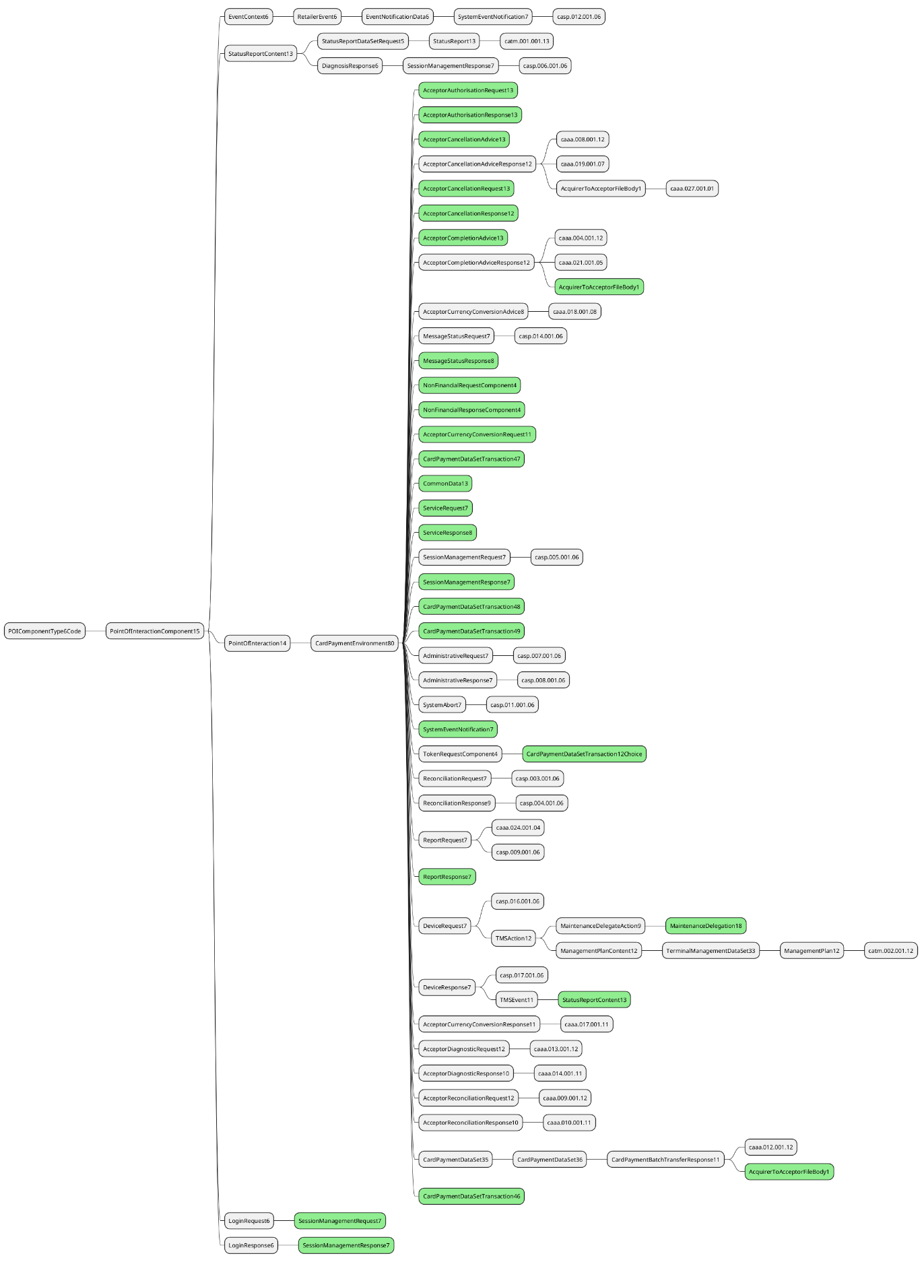

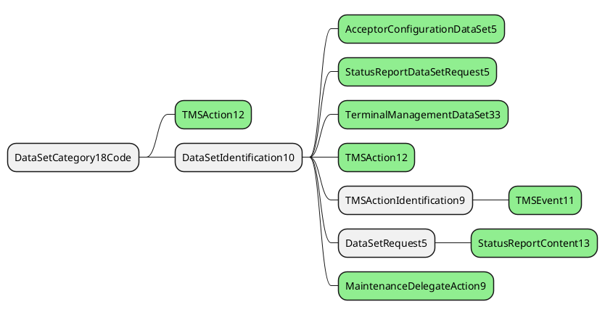
The severity of the impact of the proposed change for the message users should be indicated in the table below (either “no impact”, “conditional’ or “mandatory”).
Type of impact
 | No impact | The change(s) will not impact the schema (the version number will not change) and will not impact the business applications of any users, e.g. the clarification of a definition
X | Conditional | The change(s) will impact the schema (at least the version number) and the business applications of certain users but not all, e.g. the addition of an optional component
 | Mandatory | The change(s) will impact the schema and the business applications of all users, e.g. addition of a mandatory component.

Proposed implementation:

Update of POIComponentType6Code
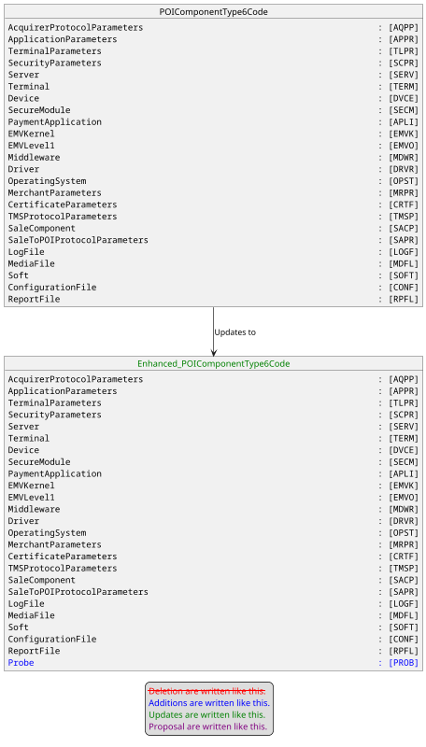
The documentation for the new codeset value will be : Probe used to monitor a feature on the POI.

Update of DataSetCategory18Code.
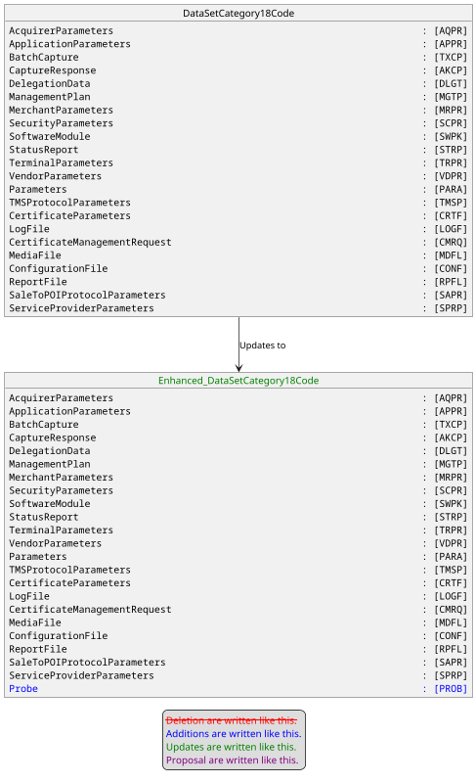

Update of PointOfInteractionComponent15
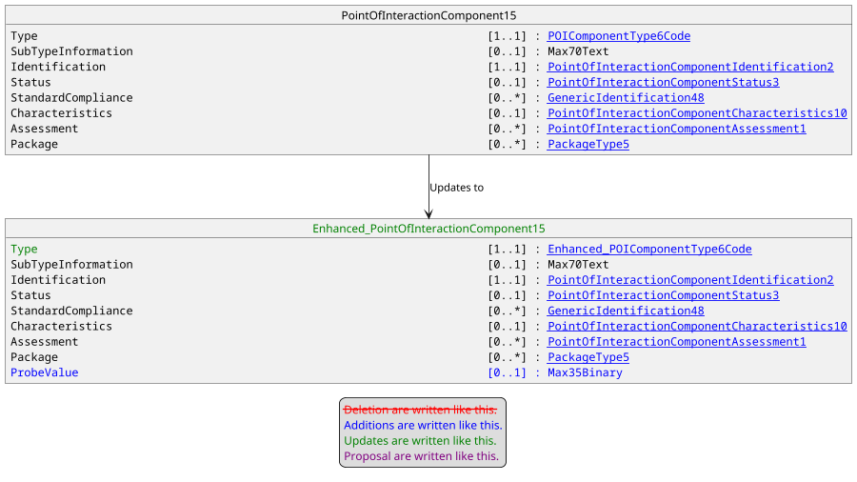

Proposed timing:
The submitting organization confirms that it can implement the requested changes in the requested timing, or, if not, proposes another timing.

Timing | - As requested
 | - Other:

Final decision of the SEG(s):
This section is not to be taken care of by the submitting organization. It will be completed in due time by the SEG(s) in charge of the related ISO 20022 messages.
Approve | X
Comments:

Reject
Reason for rejection:

Change request number #1389 nexo TMS Support API and JSON

Origin of the request:
A.1 Submitter:
nexo A.I.S.B.L.
A.2 Contact person:
- Philippe CECE (philippe.cece@nexo-standards.org)
- Laure BELTRI (laure.beltri@frenchsys.com)
A.3 Sponsors:
nexo A.I.S.B.L.

Related messages:
- AcceptorConfigurationUpdate V13 (catm 003.001.13)

Description of the change request:
We want to update the message component HostCommunicationParameters6 in order to add 2 new message elements. These new elements will identify if a receiver is able to support XML messages or API, in XML or in JSON.

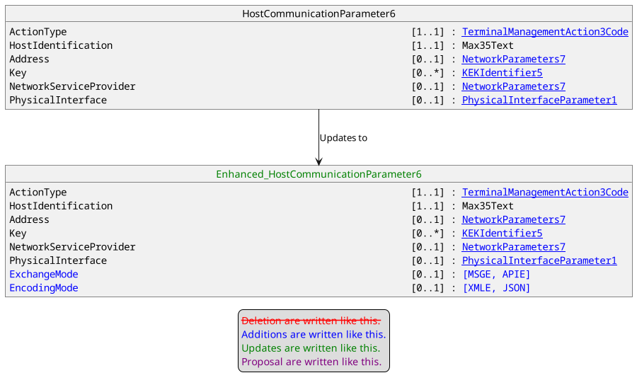

Purpose of the change:
nexo standards plans to provide specifications with support of API and JSON encoding. Then a live solution on the field might be composed of POIs and servers communicating through classical ISO20022 XML messages or through JSON API. In order to ensure interoperability, it is important to identify how communication could be initiated between these actors. Since the POI is initiating this communication, it must know how to communicate and should be able to find this configuration in the HostCommunicationParameters received through an AcceptorConfigurationUpdate.

Urgency of the request:
Urgent

Business examples:
Examples illustrating the change request.

SEG recommendation:
This section is not to be taken care of by the submitter of the change request. It will be completed in due time by the SEG(s) in charge of the related ISO 20022 messages.

Consider |  | X | Timing
 |  |  | - Next yearly cycle: 2024/2025  (the change will be considered for implementation in the yearly maintenance cycle which starts in 2024 and completes with the publication of new message versions in the spring of 2025) |  | X
- At the occasion of the next maintenance of the messages
(the change will be considered for implementation, but does not justify maintenance of the messages in its own right – will be pending until more critical change requests are received for the messages)
- Urgent unscheduled
(the change justifies an urgent implementation outside of the normal yearly cycle)
 |  |  | - Other timing:
Comments:

Reject
Reason for rejection:

Impact analysis and type of impact:
The modifications will be done accordingly to the definition in the Change Request. Consequently, CAPEExchangeMode1Code and CAPEEncodingMode1Code will be created.

The impact analysis gives a limited result due to previous updates.

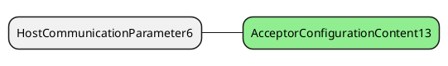

The severity of the impact of the proposed change for the message users should be indicated in the table below (either “no impact”, “conditional’ or “mandatory”).
Type of impact
 | No impact | The change(s) will not impact the schema (the version number will not change) and will not impact the business applications of any users, e.g. the clarification of a definition
X | Conditional | The change(s) will impact the schema (at least the version number) and the business applications of certain users but not all, e.g. the addition of an optional component
 | Mandatory | The change(s) will impact the schema and the business applications of all users, e.g. addition of a mandatory component.

Proposed implementation:

Creation of CAPEEncodingMode1Code.
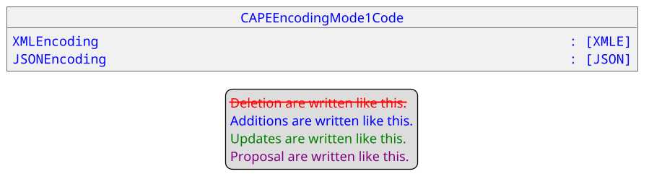
The documentation for these 2 new codeset values are:
- XMLE : Data exchanged with the protocol between both parties are encoded in XML.
- JSON : Data exchanged with the protocol between both parties are encoded in JSON.

Creation of CAPEExchangeMode1Code.
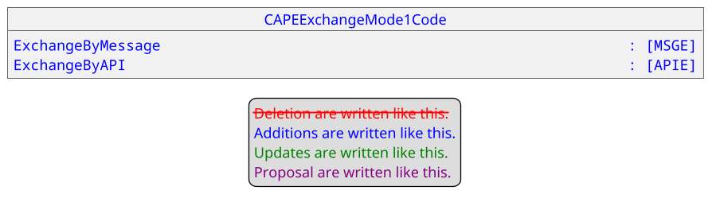
The documentation for these 2 new codeset values are:
- MSGE : With this protocol, the communication is done through message exchanges.
- APIE : With this protocol, the communication is done through calls to API.

Update of HostCommunicationParameters6
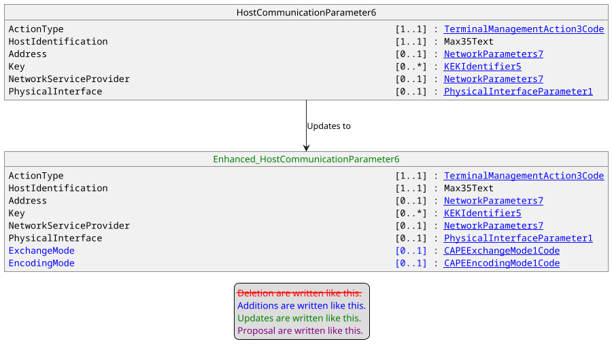

Proposed timing:
The submitting organization confirms that it can implement the requested changes in the requested timing, or, if not, proposes another timing.

Timing | - As requested
 | - Other:

Final decision of the SEG(s):
This section is not to be taken care of by the submitting organization. It will be completed in due time by the SEG(s) in charge of the related ISO 20022 messages.
Approve | X
Comments:

Reject
Reason for rejection:

Change request number #1386 nexo RET Multi Payment Instrument

Origin of the request:
A.1 Submitter: nexo A.I.S.B.L.
A.2 Contact person:
- Philippe CECE (philippe.cece@ingenico.com) /
- Alain GUITARD (aguitard@sdpinc.ca)
- Jean KANY (jean.kany@jpmchase.com)
A.3 Sponsors: nexo A.I.S.B.L.

Related messages:
- All messages using message component “Context” in CAPE messages.
- Retailer messages
  - SaleToPOIServiceRequestV06 – casp.001.001.06)
  - SaleToPOIServiceResponseV06 – casp.002.001.06)
  - SaleToPOIReconciliationRequestV06 – casp.003.001.06)
  - SaleToPOIReconciliationResponseV06 – casp.004.001.06)
  - SaleToPOISessionManagementRequestV06 – casp.005.001.06)
  - SaleToPOISessionManagementResponseV06 – casp.006.001.06)
  - SaleToPOIAdministrativeRequestV06 – casp.007.001.06)
  - SaleToPOIAdministrativeResponseV06 – casp.008.001.06)
  - SaleToPOIReportRequestV06 – casp.009.001.06)
  - SaleToPOIReportResponseV06 – casp.010.001.06)

Description of the change request:
New payment instruments in casp protocol (document V06)

Since 2022, nexo standards is standardizing acceptance not only for cards but for all payment instruments (payment methods)
nexo standards would like to extend the support of retailer messages to all payment instruments: cards, credit transfer, instant credit transfer, direct debit, instant direct debit, plus cheques, cash, vouchers, etc.
The Retailer protocol should be used for both face-to-face payments as well as for remote payment (e-Commerce), MOTO context and unattended terminal context.
For that, we would like to update the retailer financial messages as following:
- We update and complete the “Context” data element to describe the debtor and creditor involved in credit transfer and direct debit transactions, plus add some additional information on context (like if the transaction is instant payment or not).
- We add two new transactions in the ServiceRequest/PaymentRequest (and in the response) to bring all data related to credit transfer and direct debit transaction, including the PaymentTypeInformation giving data about the context of the transaction initiation for mitigate risk and the involved players (payer/payee or customer/acceptor). This will ensure compatibility with pain messages.

Purpose of the change:
In regards of this request, we would like:
- To improve the Context component:
  - To give details about Credit transfer context, instant transaction or not.
  - To give details about Direct debit context, instant transaction or not.
- To add two new transaction details in the payment request and responses having the same data element as for the pain corresponding message, and especially to manage the end-to-end transaction risk, indicating the type of payment initiation in PaymentTypeInformation.

As the “Context” date element is common component for several messages of several CAPE protocols (Retailer, Acquirer, etc.), these modifications would impact several messages.

In addition, message “ServiceRequest / PaymentRequest” is updated to support CreditTransferTransaction and DirectDebitTransaction in addition to CardPaymentTransaction.
Same update will occur with the response “ServiceResponse / PaymentResponse”.

Urgency of the request:
Not urgent.

Business examples of changes:
Payment instrument updates
The “Context” message component will be upgraded.

IN the messages using Transaction like ServiceRequest/PaymentRequest casp.001 and response casp.002, Transaction will be updated to reflect several payment instrument and at least Card, CreditTransfer and DirectDebit.
The specific data indicating service level and other risk data component will be inserted.

We will not reuse pain message components.

The other messages: SaleToPOIReconciliationRequest/Response, SaleToPOIreportRequest/Response, etc. are automatically updated according those modifications in PaymentRequest.

SEG recommendation:
This section is not to be taken care of by the submitter of the change request. It will be completed in due time by the SEG(s) in charge of the related ISO 20022 messages.

Consider |  | X | Timing
 |  |  | - Next yearly cycle: 2024/2025  (the change will be considered for implementation in the yearly maintenance cycle which starts in 2024 and completes with the publication of new message versions in the spring of 2025) |  | X
- At the occasion of the next maintenance of the messages
(the change will be considered for implementation, but does not justify maintenance of the messages in its own right – will be pending until more critical change requests are received for the messages)
- Urgent unscheduled
(the change justifies an urgent implementation outside of the normal yearly cycle)
 |  |  | - Other timing:
Comments:

Reject
Reason for rejection:

Impact analysis and type of impact:
Generally speaking, CAPE messages are designed around 3 main elements: Environment, Context and Transaction. The environment mainly identifies actors, the context collects how actors are in relation to create specific processing information that are stored in the Transaction element.
Consequently, the introduction of new payment instruments will have an impact on the Context and Transaction elements. The Transaction element has a specific layout for request or response, which implies the update of the two message components.

Several use cases for new payment instruments (Credit transfer, Instant credit transfer, Direct debit, Instant direct debit) have been considered by nexo to submit this proposal. Only one of them is transposed in sequence diagram with nexo messages.

Credit transfer use case (push and differed payment)
It applies mainly for e-Commerce context: the consumer/payer can send money directly to the merchant and waits for delivery. This is different from in-store shops that usually require the payer to pay immediately before the merchant delivers the goods or services.
Alternative can be the use of an Intermediary Agent able to initiate a credit transfer on behalf the payer after the payer has given its consent to the payee.
Credit transfer is done with a reference of the payee account transmitted by the merchant/payee.
Once the payee receives the funds, a notification could be sent to the payee and if implemented, to the payer.

Process diagram
Variant 1: standard use case, the consumer initiates the credit transfer
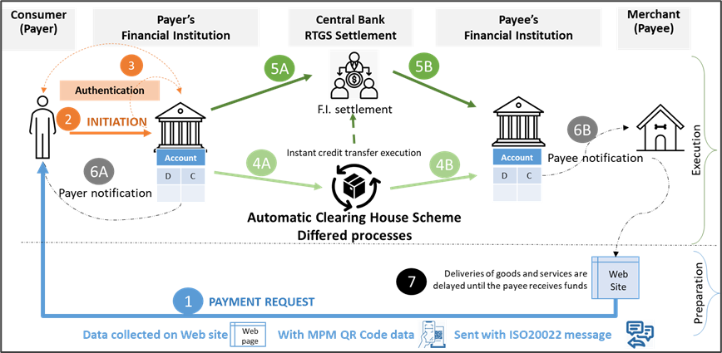

- 0- The acceptor prepares the basket and proposes a page to pay
- 1- The consumer/internet user selects the payment instrument: standard credit transfer. By doing so, the payee account references are attached to the initiated credit transfer so as to allow reconciliation
- 2- The payer is redirected its home banking application, enter the payee account references and initiates a deferred credit transfer to the merchant/payee
- 3- The Payer Institution authenticates the payer to validate the order
- 4- The transaction is processed by the scheme(s) and institutions to update the account balances during a clearing cycle (between 0 to 5 days delay).
- 5- The F.I. to F.I. settlement is executed after clearing vacation.
- 6- Payee institution notifies the acceptor.
- 7- After that, the payee/merchant initiates the delivery of goods and services included in the basket (totally or partially)

Variant 2: Third party use case, an intermediary agent (a PISP) initiates the credit transfer on behalf the payer/consumer.
Context
It applies mainly for e-Commerce context: the consumer/payer can send money directly to the merchant and waits for delivery. In this variant, the use case inserts a PISP that initiates the transaction on behalf the payer.

Process Diagram
Variant 2: The consumer initiates the credit transfer via a PISP.

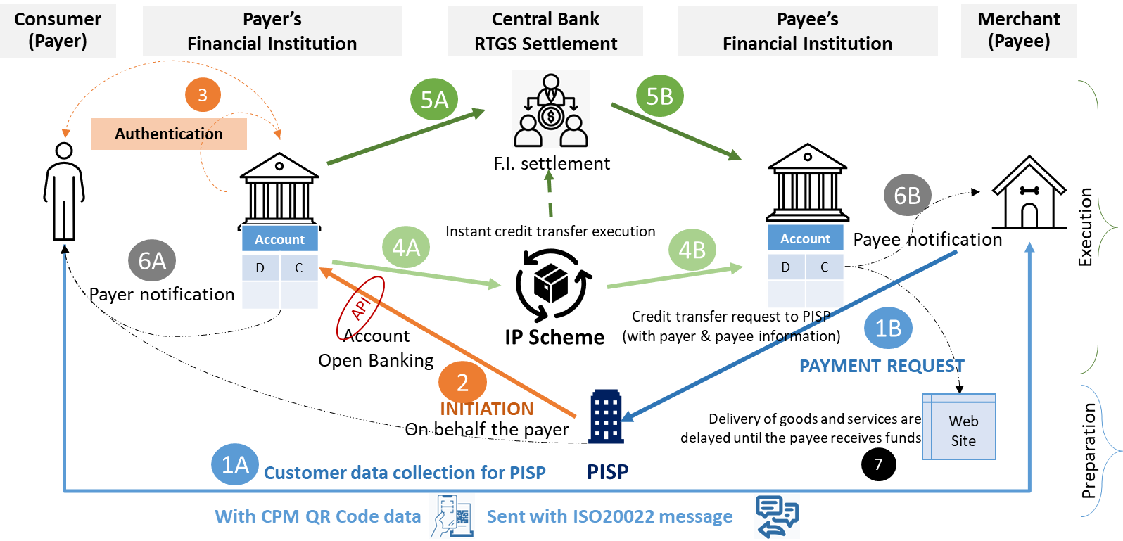
This diagram will be internally analysed later.

- 0- The acceptor prepares the basket and proposes a page to pay
- 1- The consumer/internet user selects the payment instrument: standard credit transfer. By doing so the payee account references are attached to the initiated credit transfer to allow reconciliation
- 2- The request is sent to an agent PISP that will initiates the credit transfer on behalf the payer
- 3- The Payer Institution authenticates the payer to validate the order
- - The transaction is processed by the scheme(s) and institutions to update the account balances during a clearing cycle (between 0 to 5 days delay).
- 5- The F.I. to F.I. settlement is executed after clearing vacation.
- 6- Payee institution notifies the acceptor. The payer can be notified as well.
- 7- After that, the payee/merchant initiates the delivery of goods and services included in the basket (totally or partially)

Instant Credit Transfer use case (push and fast payment): standard process
Context
This kind of payment applies to all contexts, in-store shops, e-Commerce context, customer attended terminal, MOTO transactions.
This use case is not widely implemented today, several variants may exist in many countries, especially to prepare the payment with several way to request payment.
The Instant credit transfer requires a preparation phase in which the acceptor requests the payment to the customer: via QR Codes, or via Request-To-Pay messages, or other contactless messages via NFC or BLE.
Process diagram
Overview of standard instant credit transfer payment (preparation and execution)
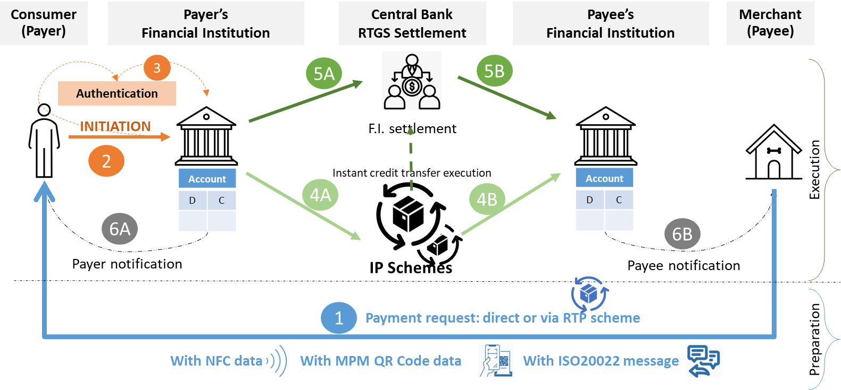

- 1- The acceptor requests a payment, according to several methods: MPM QR Code, NFC exchange, RTP via ISO20022 message).
  - Note that each region country specifies the content of data in NFC message, QR Code messages or ISO20022 messages.
  - Nexo will be agnostic of the data transferred during preparation. However, the retailer protocol will support all specific data necessary to finalise the complete payment process, including risk data.
- 2- The payer initiates the credit transfer transaction directly to its financial institution
- 3- The Payer Institution authenticates the payer to validate the order
- 4- The transaction is processed by the scheme(s) and institutions to update the account balances in less than 30 s. Some region uses several interconnected schemes.
- 5- Either the payer financial institution or the scheme requests a financial real time settlement F.I. to F.I. via RTGS
- 6- Payee institution notifies the acceptor. Payer institution notifies the consumer

Note
This use case assumes the POI system starts the request to the payer and to receive the final notification.

Instant Credit Transfer use case (push and fast payment): process using PIPS for payment initiation.
Notes:
- PISP: Payment initiation Service provider (not a financial institution)

Context
This is an alternative to previous use case, using PISP to initiate the ICT transaction on behalf the payer. This kind of payment applies mainly to in-store shops and can also apply to some e-Commerce context.
This use case is not implemented today, and several variants may exist in many countries, according to the services supplied by the PISP.
The main key point is that the Acceptor collects all detailed information from the consumer and prepares a payment request with information from the payer, from the payee and from the transaction. Then an intermediate agent initiates the transaction on behalf the payer.
Process diagram
Overview of instant credit transfer payment (preparation and execution) with PISP
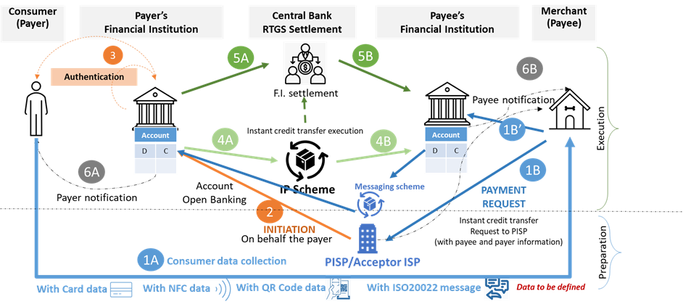

- 1A- The acceptor requests consumer’s data, to prepare a payment request to a PISP used in multi-lateral interoperability via QR Code CPM, NFC, RTP via ISO20022 message or even card data.
- 1B- The payee sends the Payment Request with all data including the consumer one to the PISP (intermediate agent)
- 2 The PISP initiates the credit transfer on behalf the payer
- 3- The Payer Institution authenticate the payer to validate the order using consumer data
- 4- The transaction is processed by the scheme and institutions to updates the account balances.
- 5 Either the payer financial institution or the scheme requests a financial real time settlement F.I. to F.I. via RTGS
- 6- Either institutions or PISP notifies the acceptor/payee and the payer

Deferred Direct debit use case (pull and deferred payment)
Context
This use cases also applies mainly for e-Commerce context. It also can apply when some agreement between payer and payee occurs to make the merchant to manage a lodged merchant account.
Usually, for e-Commerce situation, the payer creates a commercial account on the web site of the merchant, indicating its own payer account reference and giving a mandate to the merchant to allow him to debit its bank account.
Diagram
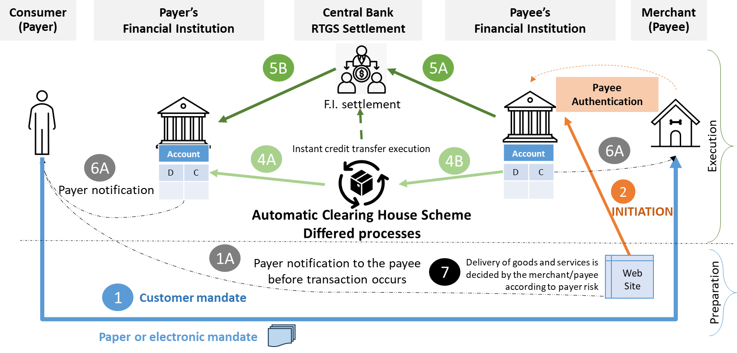

- 0- The acceptor prepares the basket and proposes a page to pay.
- 1- The consumer/internet user selects the payment instrument: standard direct debit.
  - Most of the time the payer has registered its bank account reference in the merchant payment system (or in Sale System).
  - He also sent a mandate (digital or physical). Sometimes, the mandate can be created especially for one transaction.
- 2- The acceptor validates the payee choice and initiates a transaction to its payee institution, with all the details of transaction including mandate.
  - Alternatively, he can delegate this task to an agent (acceptor PSP)
- 3- The Payee Institution authenticates the payee to validate the order
- 4- The transaction is processed by the scheme(s) and institutions to update the account balances during a clearing cycle (between 0 to 5 days delay).
- 5- The F.I. to F.I. settlement is executed after clearing vacation.
- 6- Payee institution notifies the acceptor. Option: the payer institution could notify the payer.
- 7- The payee/merchant initiates the delivery of goods and services before or after direct debit confirmation.

Changes on Context
The modification of the Context will lead to the update of the DirectDebitContext and the creation of CreditTransferContext. The update of DirectDebitContext will be the opportunity to rename the message components and move from CardDirectDebit2 to DirectDebitContext1 and to update the MandateRelatedInformation13, with the protection of signature, which is only used in this component.

Consequently, the analysis of impacts could be restricted to CardDirectDebit2.

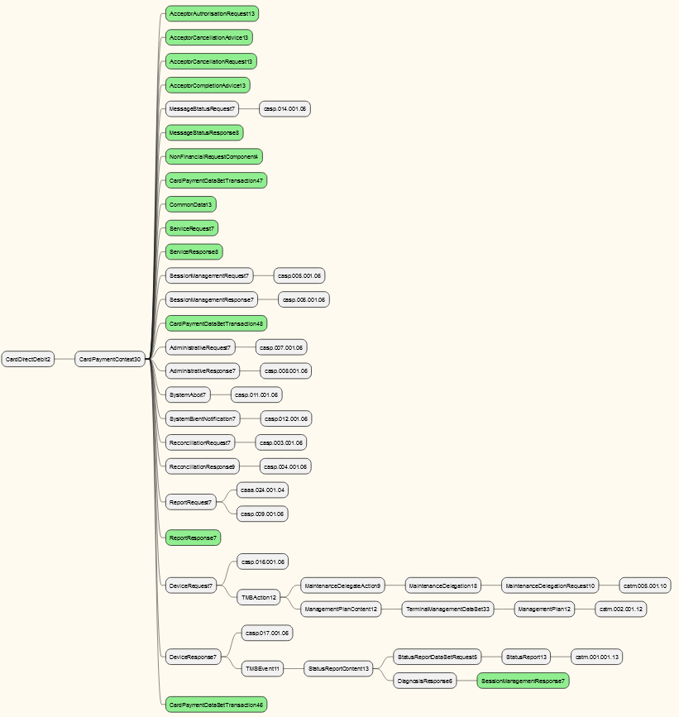

Changes on Transaction for a Request
The update consists of providing information related to risk management for CreditTransfer or DirectDebit through the addition of message element PaymentTypeInformation defined with the existing PaymentTypeInformation26 which is already used in pain messages.
This update will be also the opportunity to rename message component CardPaymentTransaction136 to a new PaymentTransaction component.
Additionally, TransactionType must be enhanced to identify a Payment request made as CreditTransfer or DirectDebit, and PaymentInstrument must be added to select from SaleSystem the list of Payment Instrument allowed to fulfil the payment. This modification will be also an opportunity to support an additional value for payment made with Voucher.

These updates will have the following impact.

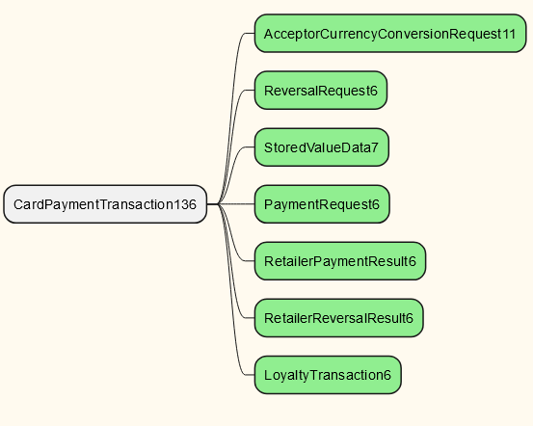

Changes on Transaction for a Response
As a result of the transaction processing, the Sale system should be aware of TransactionType and which payment instrument has been used to process the transaction.

The update of RetailerPaymentResult6 will have the following impact.

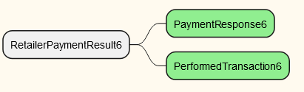

The severity of the impact of the proposed change for the message users should be indicated in the table below (either “no impact”, “conditional’ or “mandatory”).
Type of impact
 | No impact | The change(s) will not impact the schema (the version number will not change) and will not impact the business applications of any users, e.g. the clarification of a definition
X | Conditional | The change(s) will impact the schema (at least the version number) and the business applications of certain users but not all, e.g. the addition of an optional component
 | Mandatory | The change(s) will impact the schema and the business applications of all users, e.g. addition of a mandatory component.

Proposed implementation:

Creation of CreditTransferContext1
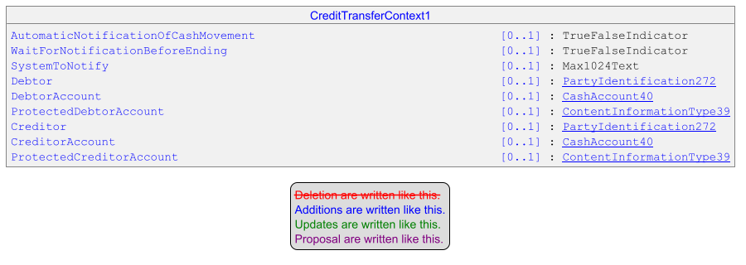

Update of MandateRelatedInformation13
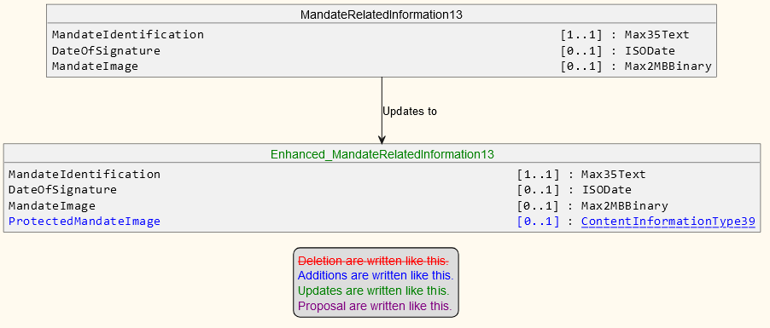

Creation of DirectDebitContext1 from CardDirectDebit2
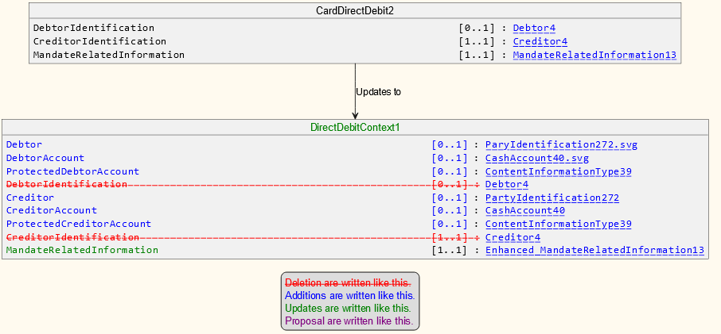

Update of CardPaymentContext30
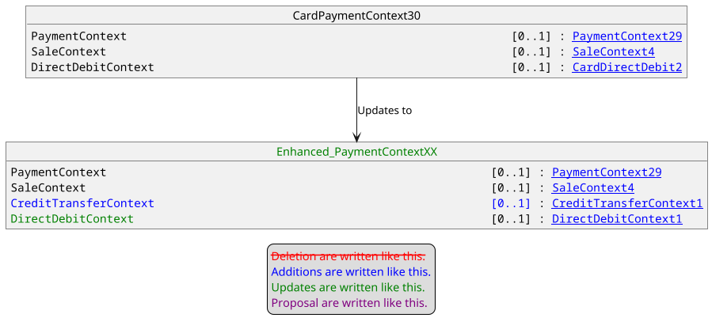

Update of CardPaymentServiceType5Code.
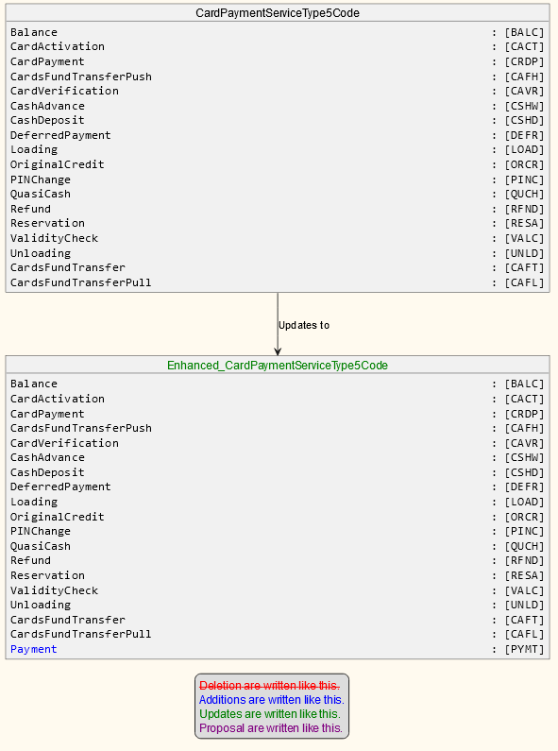
The documentation for this new codeset will be: Payment without specific constraints on the Payment Instrument Type to use.

Creation of PaymentInstrumentType1Code.
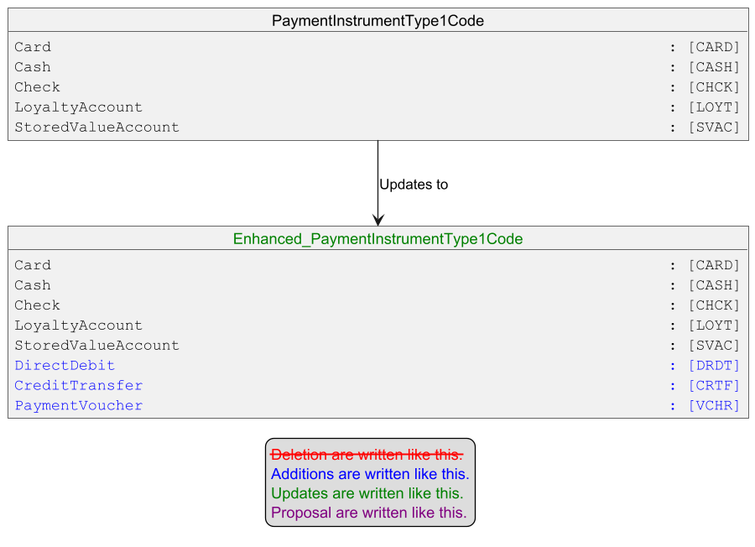
The documentation for these new codeset will be inspired by wikipedia to ensure a broader usage :
- DRDT : Is a financial transaction in which one organisation withdraws funds from a payer's bank account.
- CRTF : Is a financial transaction where funds are transfer by the payer from his bank account to the organisation’s account.
- VCHR : Is a bond of the redeemable transaction type which is worth a certain monetary value and which may be spent only for specific reasons or on specific goods.

Creation of PaymentTransactionXX from CardPaymentTransaction136
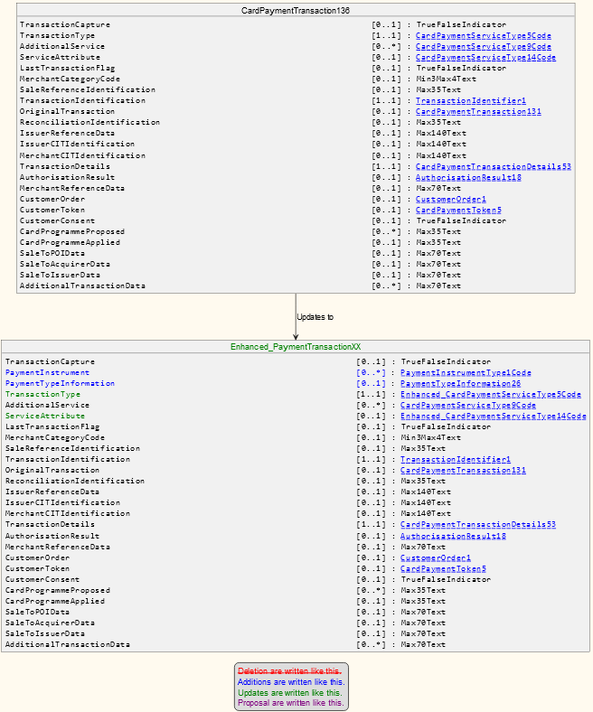

Update of RetailerPaymentResult6
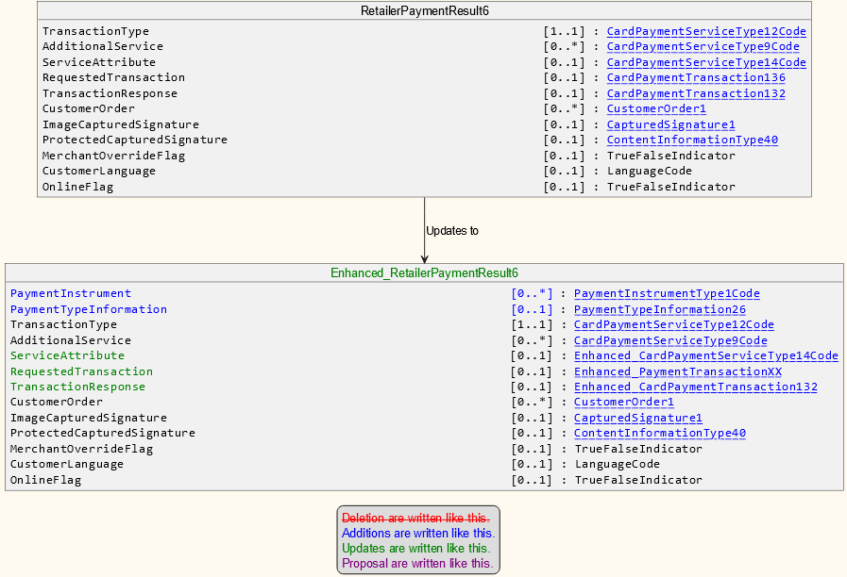

Example of Sequence Diagram:
The following diagram highlight how the previous modifications are used in case of Instant Credit transfer use case.

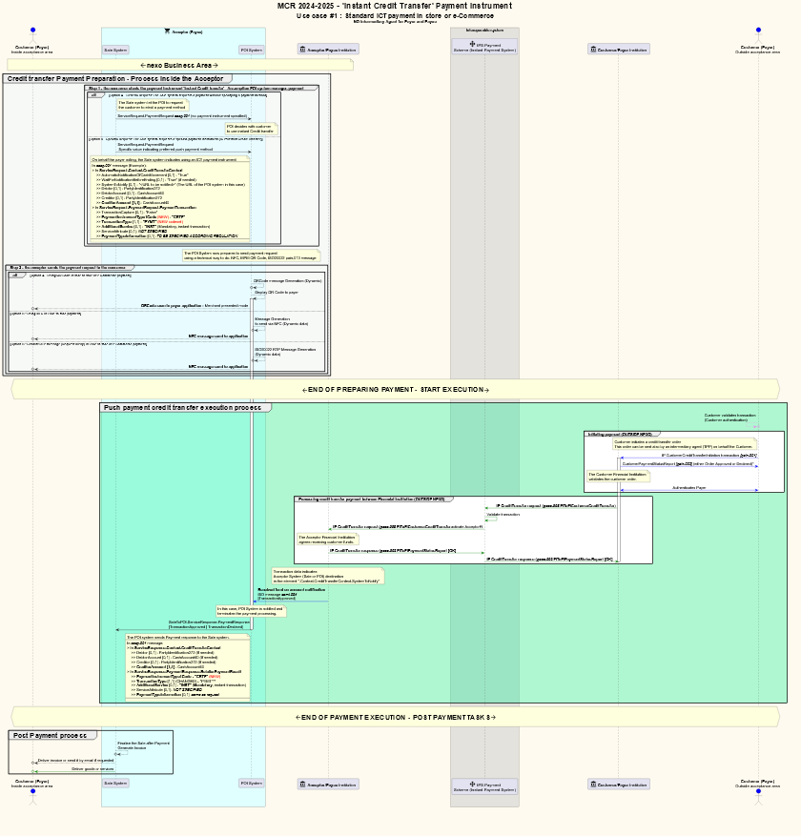

With detailed parts of the previous diagram.

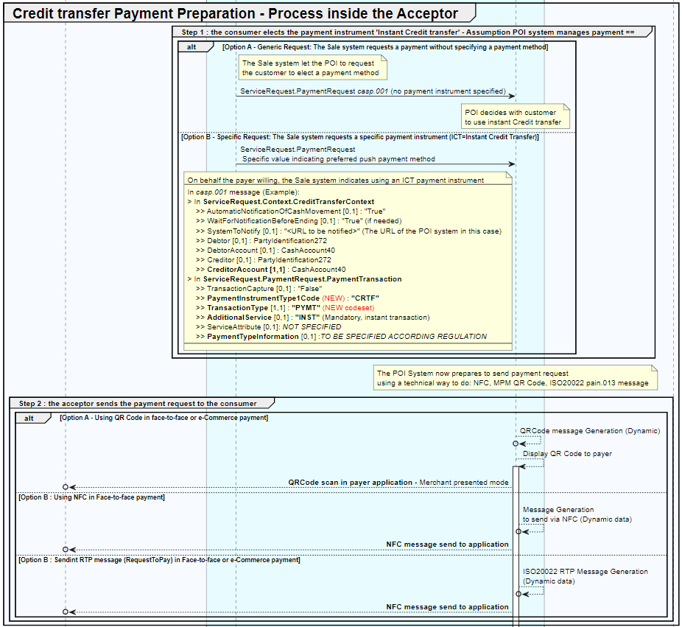

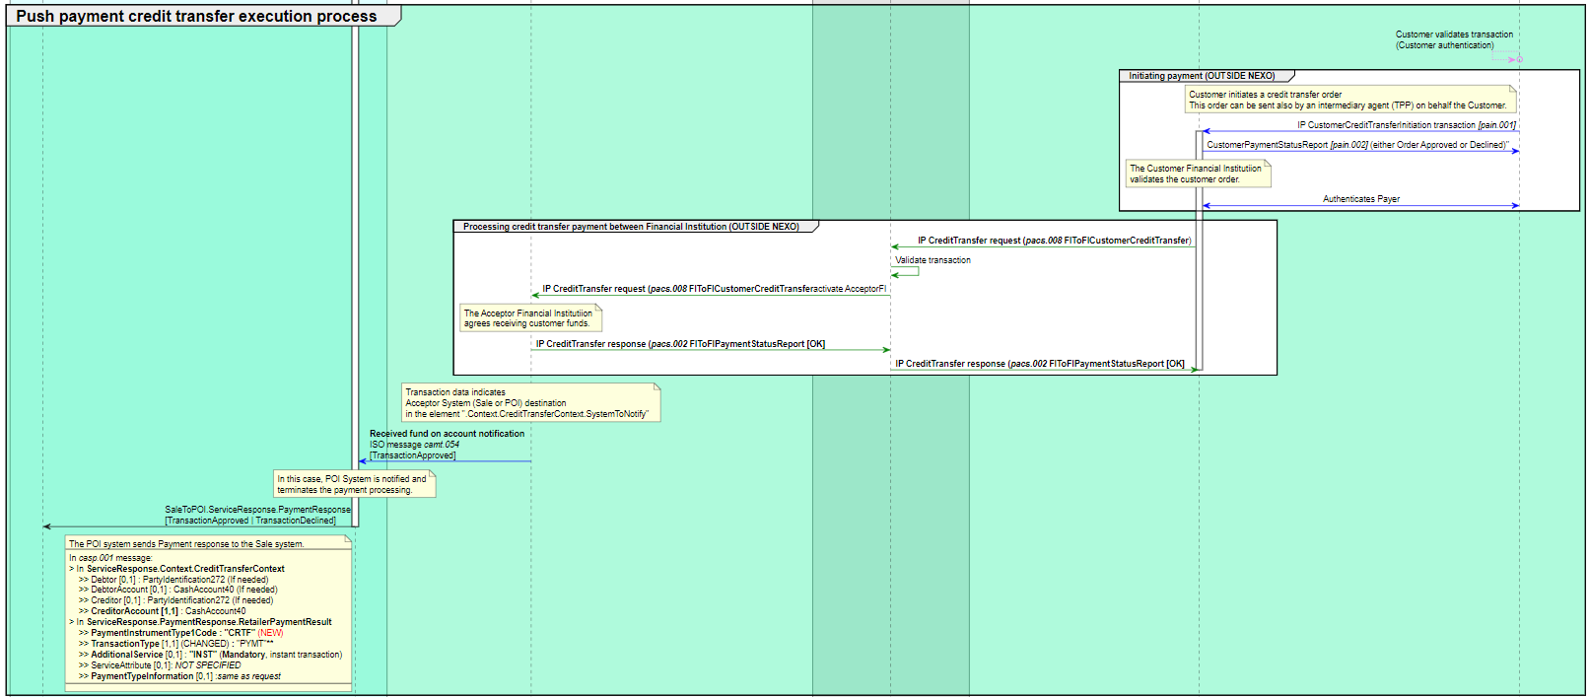

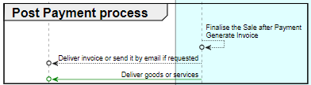

Proposed timing:
The submitting organization confirms that it can implement the requested changes in the requested timing, or, if not, proposes another timing.

Timing | - As requested
 | - Other:

Final decision of the SEG(s):
This section is not to be taken care of by the submitting organization. It will be completed in due time by the SEG(s) in charge of the related ISO 20022 messages.
Approve | X
Comments:
Meeting on 30/09/2024:
Michelle Zhang: The placement of DirectDebit and CreditTransfer in
PaymentInstrumentType might be not the correct place. ServiceType should be the better
level.
nexo: Since it is more the underlying instrument of transferring funds,
PaymentInstrumentType is the acceptable place.
nexo and Sean Mouton: MobileTransfer might be added in PaymentInstrumentType, too. (to
be considered as ChangeRequest in 2025-2026)
William Vanobberghen: Maybe an ExternalCode list should be used to address the payment
mean in this specific market/location in addition.
At the end of this meeting the remaining participants approved this MCR for the nexo
Retailer Protocol.

Reject
Reason for rejection:

Conforms to https://tools.ietf.org/html/rfc4180, where commas are used as separators, double quotes are used where a cell value has a comma, and headers are provided.

