Change Request
for the update of ISO 20022 financial repository items
Note: the purpose of this document is to give guidelines to parties who want to introduce a request to change an existing ISO 20022 message(s), or update other items of the ISO 20022 financial repository. Such change requests are subject to the approval of the ISO 20022 Standards Evaluation Group(s) in charge of the related message/item or to the approval of the Technical Support Group (TSG), if the requested change relates to the Business Application Header (BAH). Please consult the iso20022.org website for additional details on the maintenance process. Change requests are to be sent to iso20022ra@iso20022.org. All change requests conforming to this template received by June 1st will be considered for development in the following yearly ISO 20022 maintenance cycle which completes with publication of new message versions in April/May of the following year.
- Origin of the request:
A.1 Submitter:
SIX Interbank Clearing Ltd
A.2 Contact person:
Roman Locher, Senior Standards Manager
roman.locher@six-group.com
T +41 58 399 4125
A.3 Sponsors:
SIX Interbank Clearing participates in several committees focused on standardization in payments, acting as representative of the Swiss financial industry. SIX Interbank Clearing also operates the SIC system mandated by Swiss National Bank, which consists of the two CHF services SIC-RTGS and SIC IP (Instant Payments).
- Related messages:
acmt.015 (AccountExcludedMandateMaintenanceRequest, latest version: acmt.015.001.04)
- Description of the change request:
SIX requests the “Organisation” element (Document/AcctExcldMndtMntncReq/Org) to be changed from mandatory to optional. | 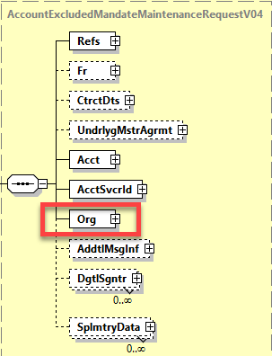
- Purpose of the change:
SIX uses acmt.015 message for triggering different use cases by participants on their settlement accounts in the SIC system. Only the elements <Acct> and <AcctSvcrId> are required in the SIC system to identify parties and accounts involved in the corresponding use cases, whereas element <Org> is irrelevant and therefore ignored.
Due to the fact that the <Org> element is mandatory, system participants are actually forced to use this component with pseudo or default values to comply with ISO 20022 schema specifications. To avoid unnecessary pseudo data, SIX therefore requests the <Org> element to be defined as optional.
- Urgency of the request:
Next yearly maintenance cycle (publication in April/May 2026).
- Business examples:
n/a
- SEG/TSG recommendation:
This section is not to be taken care of by the submitter of the change request. It will be completed in due time by the SEG(s) in charge of the related ISO 20022 messages or the TSG for changes related to the BAH.

Consider |  |  | Timing
- Next yearly cycle: 2025/2026
(the change will be considered for implementation in the yearly maintenance cycle which starts in 2025 and completes with the publication of new message versions in the spring of 2026)
- At the occasion of the next maintenance of the messages
(the change will be considered for implementation, but does not justify maintenance of the messages in its own right – will be pending until more critical change requests are received for the messages)
- Urgent unscheduled
(the change justifies an urgent implementation outside of the normal yearly cycle)
 |  |  | - Other timing:
Comments:

Reject
Reason for rejection:

