Change Request
for the update of ISO 20022 financial repository items
Note: the purpose of this document is to give guidelines to parties who want to introduce a request to change an existing ISO 20022 message(s), or update other items of the ISO 20022 financial repository. Such change requests are subject to the approval of the ISO 20022 Standards Evaluation Group(s) in charge of the related message/item or to the approval of the Technical Support Group (TSG), if the requested change relates to the Business Application Header (BAH). Please consult the iso20022.org website for additional details on the maintenance process. All change requests conforming to this template received by June 1st will be considered for development in the following yearly ISO 20022 maintenance cycle which completes with publication of new message versions in April/May of the following year.
Changes requests are to be submitted through the ISO 20022 website through this e-request, in which this template must be attached.
- Origin of the request:
A.1 Submitter:
Identity of the company, organization, group, initiative or community that submits the change request. | CBPRplus work group

A.2 Contact person: person(s) who can be contacted to get additional information on the request (name, e-mail, telephone)
A.2.1. First name, Last name | Mabel Lu
A.2.2. Email address | Mabel.Lu@swift.com
A.2.3. Telephone

A.3 Sponsors: it is highly recommended that a submitter of a Change Request gain the agreement and support from as many additional organisations, groups, initiatives or communities of users as possible, thus demonstrating as wide as possible a consultation of the relevant stakeholders. All organisations, groups, initiatives or communities supporting the change request should be identified as sponsors along with a contact person, if possible. This community involvement is intended to help avoid delays and/or subsequent amendments to the change request.

- Related messages:
The list of ISO 20022 messages which would be impacted by the change, including the Message IDs as shown in the Catalogue of ISO 20022 messages. Only the latest version of a message definition can be maintained.
The submitter is invited to carefully examine whether the change may have an impact on other messages that come into play earlier or later in the transaction chain or on other messages that also use message components that this change request may impact.
camt.055

- Description of the change request:
A specific change request form must be completed for each particular change requested (for example, adding, deleting, modifying, renaming, changing the cardinality, moving an element/component, or changing the type of an element, changing a code set).
If the change request consists, for example, of adding new functionality which requires several changes which would not make sense if not performed all together, then all these related changes should be described on the same form.
Change requests may not lead to creation of new messages. In such cases, a 'business justification' for development of new candidate ISO 20022 messages must be introduced by a submitting organization that is ready to develop the new messages.
Request type: Correct the description in the OriginalMessageNameIdentification (/Document/CstmrPmtCxlReq/Undrlyg/OrgnlPmtInfAndCxl/OrgnlGrpInf/OrgnlMsgNmId) element in camt.055 to exclude payment clearing and settlement (pacs.003 or MT103) messages.

- Purpose of the change:
Background, business context, community of users interested by the change and expected benefits/savings.
This section must explain why the existing ISO 20022 messages need to be changed. The reason for the update may be a business reason (e.g., evolution of market practice, or creation of new financial instruments), a technical reason (e.g., automation of the business process, or switch from a batch to a real time process), a regulatory reason (introduction, generally mandatory, of new rule/law) or the extension of the user community (newly identified business requirements).
According to the definition, the camt.055 CustomerPaymentCancellationRequest message is issued by the initiating party to request the cancellation of a previously sent payment initiation message, such as a CustomerCreditTransferInitiation, CreditorPaymentActivationRequest, or CustomerDirectDebitInitiation.
However, the description of the OriginalMessageNameIdentification element (/Document/CstmrPmtCxlReq/Undrlyg/OrgnlPmtInfAndCxl/OrgnlGrpInf/OrgnlMsgNmId) incorrectly refers to payment clearing and settlement messages, specifically 'pacs.003 or MT103.' This should be corrected to reference payment initiation messages, such as 'pain.001 or MT101.'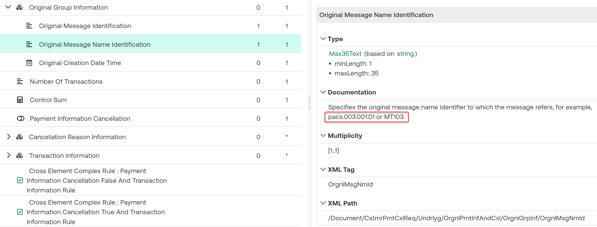

- Urgency of the request:
By default, valid change requests introduced by June 1 and subsequently approved by the SEG/TSG will be included in the following yearly maintenance cycle which completes with the publication of new message versions by April/May of the following year, unless decided otherwise by the SEG/TSG.
If there is a need to have the new version of the related messages published earlier, the reason for the urgency of the maintenance and the expected consequences of a delay should be described here. Acceptance of such an unscheduled maintenance for the BAH is subject to approval by TSG. Acceptance of an unscheduled maintenance for messages other than the BAH is subject to the approval of the SEG and availability of a submitting organization to develop the new version of the messages.
Note: the ISO 20022 maintenance results in the publication of a new version of an ISO 20022 message. The actual implementation of such new version on networks and in user installations is not within the purview of ISO.
Normal urgency

- Business examples:
Examples illustrating the change request.
Change
“Specifies the original message name identifier to which the message refers, for example, pacs.003.001.01 or MT103.”
…to
“Specifies the original message name identifier to which the message refers, for example, pain.001.001.08 or MT101.”

- SEG/TSG recommendation:
This section is not to be taken care of by the submitter of the change request. It will be completed in due time by the SEG(s) in charge of the related ISO 20022 messages or the TSG for changes related to the BAH.

Consider |  |  | Timing
- Next yearly cycle: 2025/2026
(the change will be considered for implementation in the yearly maintenance cycle which starts in 2025 and completes with the publication of new message versions in the spring of 2026)
- At the occasion of the next maintenance of the messages
(the change will be considered for implementation, but does not justify maintenance of the messages in its own right – will be pending until more critical change requests are received for the messages)
- Urgent unscheduled
(the change justifies an urgent implementation outside of the normal yearly cycle)
 |  |  | - Other timing:
Comments:

Reject
Reason for rejection:

