Change Request
for the update of ISO 20022 financial repository items

- Origin of the request:
A.1 Submitter: nexo A.I.S.B.L.
A.2 Contact person:
- Philippe CECE (philippe.cece@nexo-standards.org)
- Evelyne de JONGHE (evelyne.de-jonghe@frenchsys.com)

A.3 Sponsors: nexo A.I.S.B.L.

- Related messages:

- All messages in
  - caaa
  - casp
  - catm

- Description of the change request:

Even if this description aims one message component, we would like to update message components ContentInformationType38, ContentInformationType39, the one used to explain modifications and ContentInformationType40. The support of post quantum cryptography implies modifications of EnvelopedData and SignedData but also the addition of AuthenticatedEnvelopedData as highlighted in this diagram.

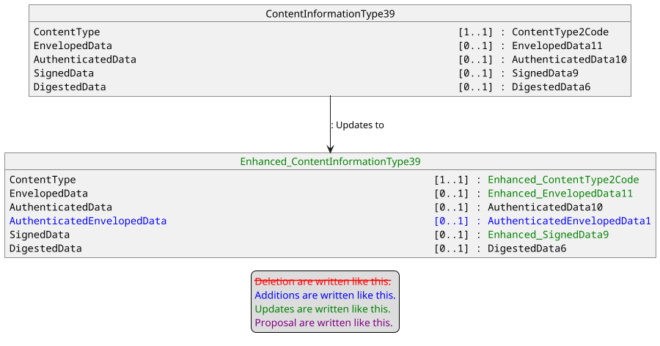

The codeset ContentType2Code must be updated in order to include the new message elements.

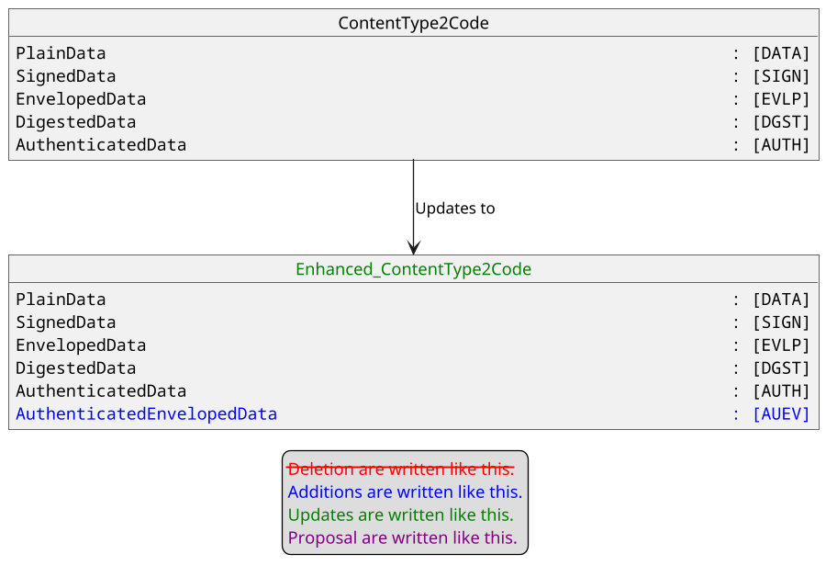

The EnvelopedData must be updated in order to support an updated message element Recipient from updated message component Recipient15Choice, mainly initiated by the introduction of the AuthenticatedEnvelopedData.

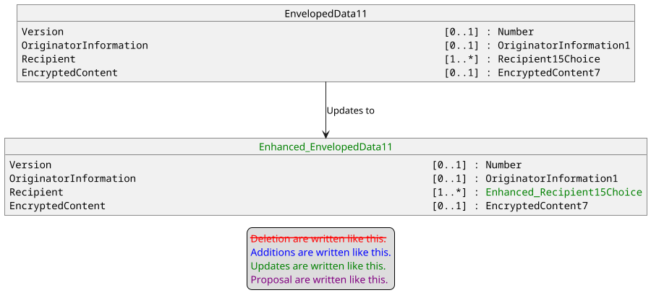

Message element SignedData must be updated due to the update of the message component Signer8.

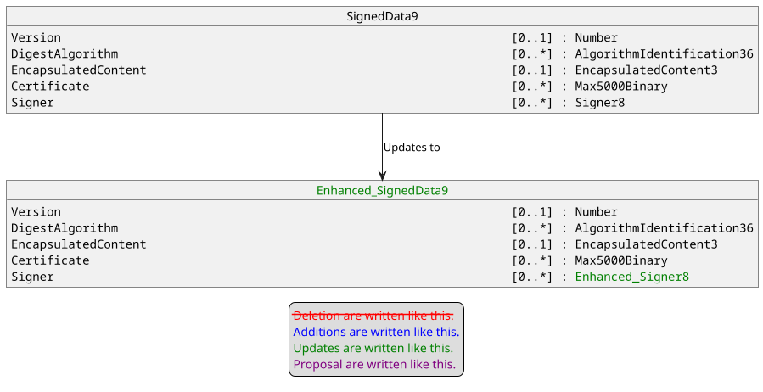

Message component Signer8 is updated due to the update of message component AlgorithmIdentification33.

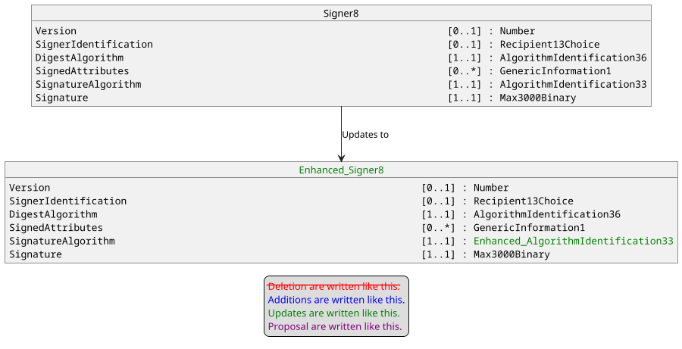

The aim of the update of AlgorithmIdentification33 is at least to support new post quantic signature algorithm like ML_DSA, but in order to be crypto agile, we prefer to add a message element AlgorithmIdentifier with multiplicity [0..1] as a Max140Text to provide the official OID value of the algorithm when the codeset Algorithm is set to AccordingToOID.

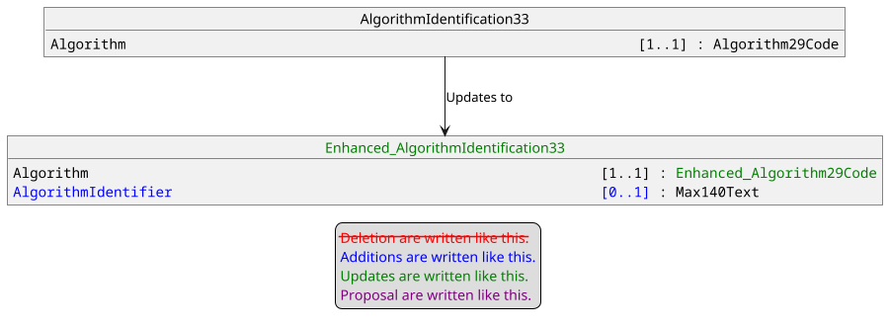

Consequently Algorithm29Code is also updated to add the AccordingToOID value.

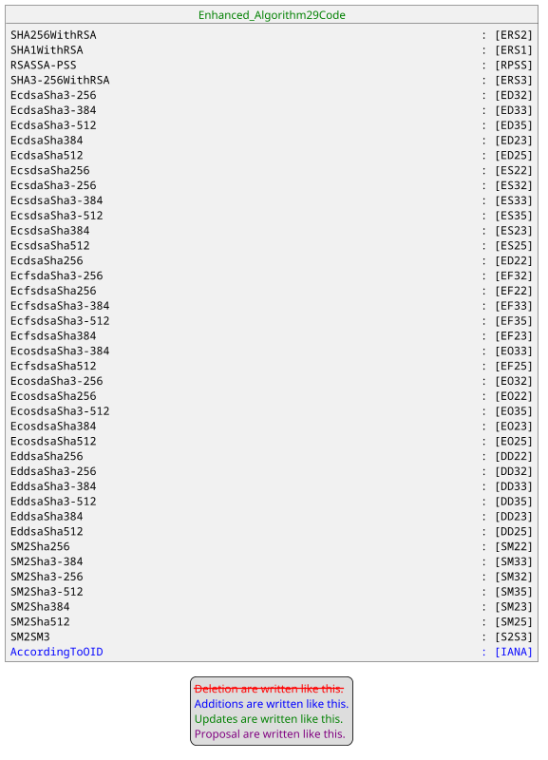

The main modification will be the creation of message component AuthenticatedEnvelopedData1 to conform to ASN.1 structure.

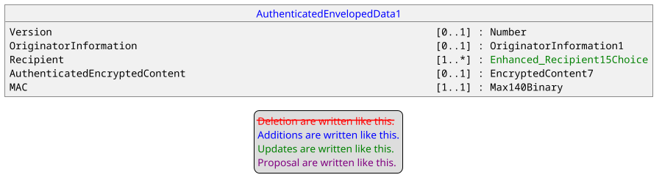

The message component Recipient15Choice is updated to add the support of message element OtherRecipientInfo with multiplicity [1..1] as OtherRecipientCmsComponent1.

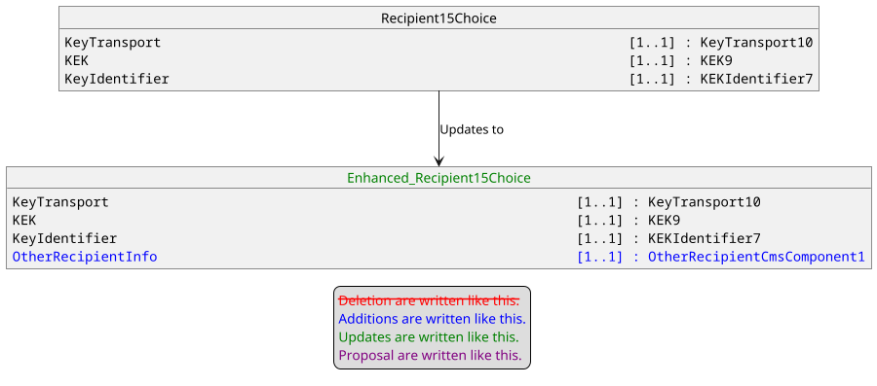

The message component OtherRecipientCmsComponent1 will be defined with only the KeyEncapsulationMechanism since other elements of ASN.1 structure won’t be used for post quantum cryptographic algorithms.

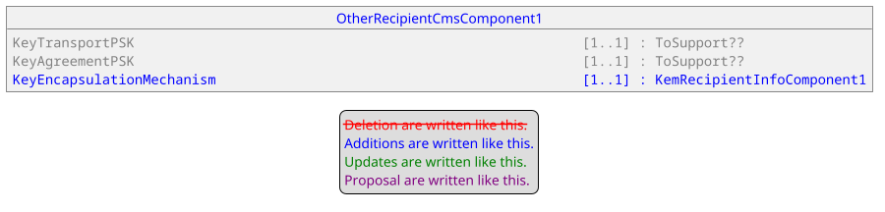

The message component KemRecipientInfoComponent1 will be inspired by the ASN.1 structure with a focus on elements used by post quantum cryptographic algorithms.

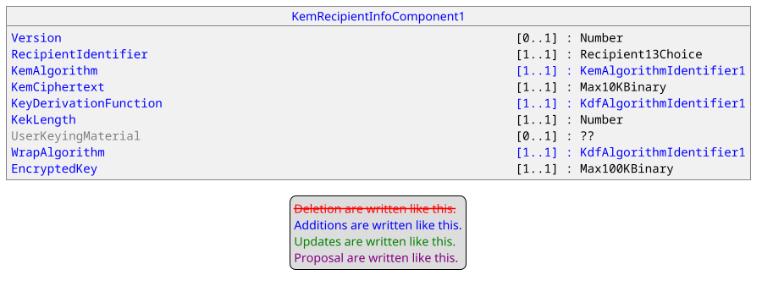

The KemAlgorithmIdentifier1 will be defined from the ASN.1 structure restricted to AlgorithmIdentifier, Value and Params.

Params will be defined as Parameter12 in order to reuse a existing message component. AlgorithmIdentifier will be defined as Max140Text in order to provide OID value corresponding to the IANA definition of the algorithm.

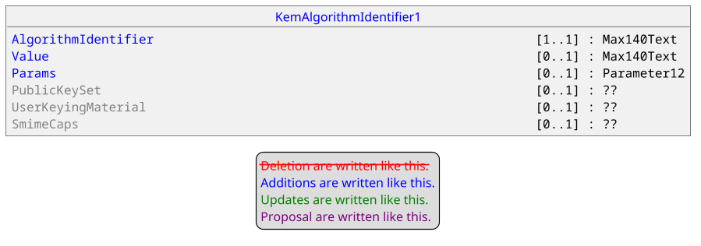

With Parameter12 defined as.

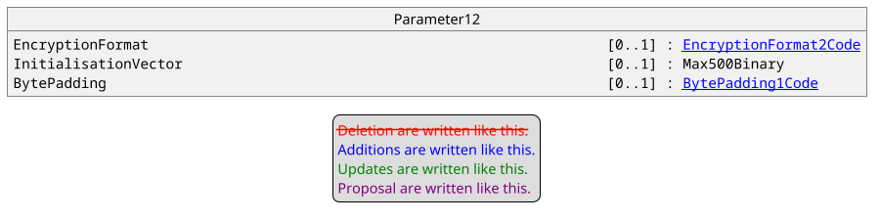

The KdfAlgorithmIdentifier1 will be defined as highlighted below.

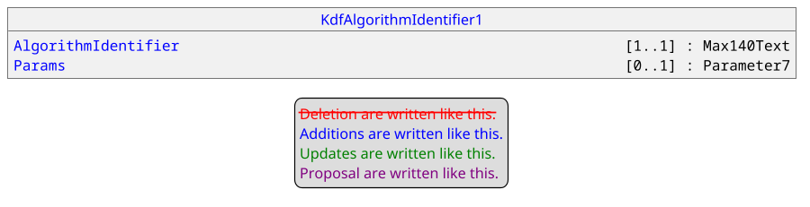

With Parameter7 defined as.

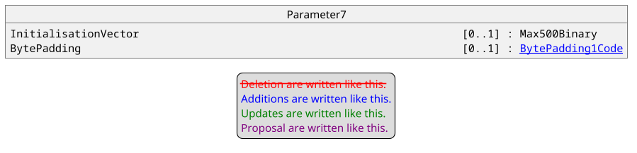

- Purpose of the change:

The advent of quantum computing implies the support of post quantum cryptographic algorithms in environment where for instance confidentiality and authentication are necessary and managed by asymmetric algorithms. Additionally certain jurisdictions recommends in this case to support hybrid solutions, combination of post quantum and traditional algorithms, in order to mitigate risks. Consequently, it appears that CAAA, CASP and CATM messages must be updated in order to comply to these recommendations. One should note that current works regarding CMS hybrid solutions are done in accordance to CMS post quantum solutions and are mainly aiming Key Encryption Mechanisms. Then the aim of this Change Request is to harmonize ISO20022 CMS structure to the ASN.1 structure.

- Urgency of the request:

Urgent.

- Business examples:
Examples illustrating the change request.
- SEG/TSG recommendation:
This section is not to be taken care of by the submitter of the change request. It will be completed in due time by the SEG(s) in charge of the related ISO 20022 messages or the TSG for changes related to the BAH.

Consider |  |  | Timing
- Next yearly cycle: 2025/2026
(the change will be considered for implementation in the yearly maintenance cycle which starts in 2025 and completes with the publication of new message versions in the spring of 2026)
- At the occasion of the next maintenance of the messages
(the change will be considered for implementation, but does not justify maintenance of the messages in its own right – will be pending until more critical change requests are received for the messages)
- Urgent unscheduled
(the change justifies an urgent implementation outside of the normal yearly cycle)
 |  |  | - Other timing:
Comments:

Reject
Reason for rejection:

