Change Request
for the update of ISO 20022 financial repository items

- Origin of the request:
A.1 Submitter: nexo A.I.S.B.L.
A.2 Contact person:
- Philippe CECE (philippe.cece@nexo-standards.org)
- Evelyne de JONGHE (evelyne.de-jonghe@frenchsys.com)

A.3 Sponsors: nexo A.I.S.B.L.

- Related messages:

- AcceptorConfigurationUpdate V14 (catm.003.001.14)

- Description of the change request:

We would like to update the definition of the message element ProtocolVersion in message component TMSProtocolParameters7, AcquirerHostConfiguration10, from “Protocol version to use when using these parameters.” to “Uniquely identifies the protocol name and version to use when using these parameters.”.
Additionally, we would like to correct the message component SaleToPOIProtocolParameter3 by adding a message element ProtocolVersion with a multiplicity [0..1] and typed as a Max8Text as other ProtocolVersion and with the previous revised definition.

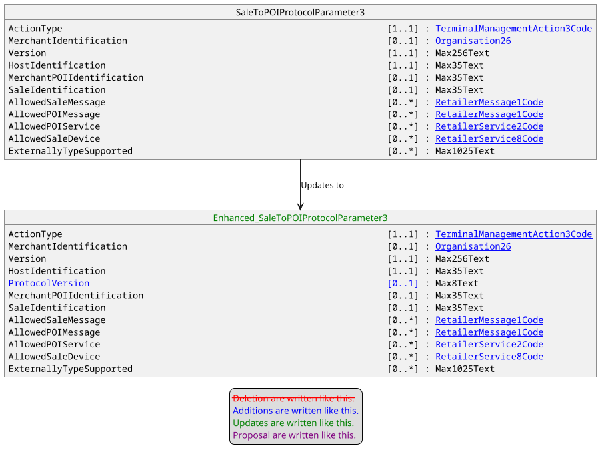

- Purpose of the change:

With a multi-application and multi-acquirer POI solutions, the communication going out from this POI might be done according to different versions of protocols or with different protocols. So it should be important to provide this support, and provide a solution that could be compatible and used by previous release of the catm protocol.
The aim of this Change Request is to provide such a solution.

- Urgency of the request:

Urgent.

- Business examples:
Examples illustrating the change request.
- SEG/TSG recommendation:
This section is not to be taken care of by the submitter of the change request. It will be completed in due time by the SEG(s) in charge of the related ISO 20022 messages or the TSG for changes related to the BAH.

Consider |  |  | Timing
- Next yearly cycle: 2025/2026
(the change will be considered for implementation in the yearly maintenance cycle which starts in 2025 and completes with the publication of new message versions in the spring of 2026)
- At the occasion of the next maintenance of the messages
(the change will be considered for implementation, but does not justify maintenance of the messages in its own right – will be pending until more critical change requests are received for the messages)
- Urgent unscheduled
(the change justifies an urgent implementation outside of the normal yearly cycle)
 |  |  | - Other timing:
Comments:

Reject
Reason for rejection:

