Change Request
for the update of ISO 20022 financial repository items

- Origin of the request:
A.1 Submitter: nexo A.I.S.B.L.
A.2 Contact person:
- Philippe CECE (philippe.cece@nexo-standards.org)
- Evelyne de JONGHE (evelyne.de-jonghe@frenchsys.com)

A.3 Sponsors: nexo A.I.S.B.L.

- Related messages:

- StatusReport V14 (catm.001.001.14)
- ManagementPlanReplacement V13 (catm.002.001.13)
- AcceptorConfigurationUpdate V14 (catm.003.001.14)
- MaintenanceDelegationRequest V11 (catm.005.001.11)

- Description of the change request:

We would like to update the CryptographicKey18 to add 2 new message elements. The first one is DerivationAlgorithmIdentifier with multiplicity [0..1] and type Max140Text to identify which derivation algorithm must be used, through the OID identification, to derived the key. The second one, AlgorithmIdentifier with multiplicity [0..1] and type Max140Text to identify which algorithm and mode must be used, through the OID identification, with the derived key. If DerivationAlgorithmIdentifier is missing, the AlgorithmIdentifier applies directly to the key.
In order to reuse CryptographicKey18 in place of KEKIdentifier5 and keep backward compatibility, we want to support also message elements of KEKIdentifier5.
Finally, we need also to update CryptographicKeyType3Code in order to support AES DUKPT derivation.

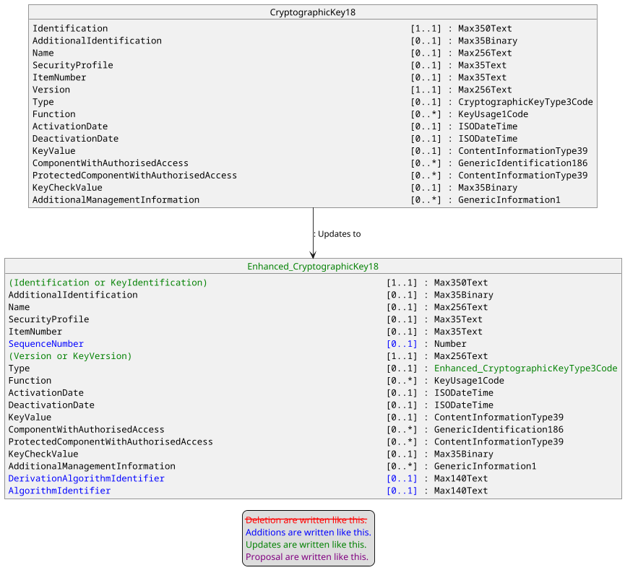

With the following update for CryptographicKeyType3Code.

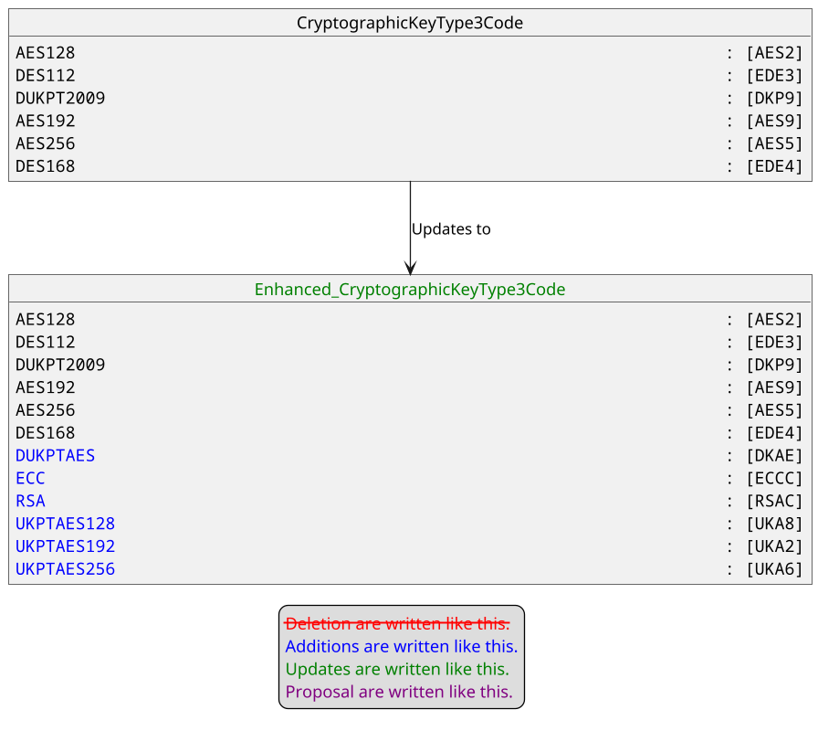

- Purpose of the change:

Currently, there is 2 message components that can identify a cryptographic key KEKIdentifier5 and CryptographicKey18. These 2 elements are not used in the same messages. CryptographicKey18 is mainly used in StatusReport and AcceptorConfigurationUpdate messages for key downloading and KEKIdentifier5 is used in other messages to identify which key to use to communicate with a specific host.
Unfortunately, KEKIdentifier5 only support DUKPT2009 and should be upgraded to support AES DUKPT. The addition of AES DUKPT also implies that we need also to identify the length of the derived key since we can derive shorter keys. Additionally, we need also to identify how to use the derived key, e.g the mode (CBC or GCM) in case of encryption.
We realized that the same needs apply if we download a BaseDerivationKey inside a POI.
Consequently, the same modifications apply on KEKIdentifier5 and CryptographicKey18, and since CryptographicKey18 supports more functionalities than KEKIdentifier5, the former one could easily replace the later one, hence reducing the complexity of the repository.
The aim of this Change Request is to bring correctness and harmonization in the protocol.

- Urgency of the request:

Urgent.

- Business examples:
Examples illustrating the change request.
- SEG/TSG recommendation:
This section is not to be taken care of by the submitter of the change request. It will be completed in due time by the SEG(s) in charge of the related ISO 20022 messages or the TSG for changes related to the BAH.

Consider |  |  | Timing
- Next yearly cycle: 2025/2026
(the change will be considered for implementation in the yearly maintenance cycle which starts in 2025 and completes with the publication of new message versions in the spring of 2026)
- At the occasion of the next maintenance of the messages
(the change will be considered for implementation, but does not justify maintenance of the messages in its own right – will be pending until more critical change requests are received for the messages)
- Urgent unscheduled
(the change justifies an urgent implementation outside of the normal yearly cycle)
 |  |  | - Other timing:
Comments:

Reject
Reason for rejection:

