Change Request
for the update of ISO 20022 financial repository items

- Origin of the request:
A.1 Submitter: nexo A.I.S.B.L.
A.2 Contact person:
- Philippe CECE (philippe.cece@nexo-standards.org)
- Evelyne de JONGHE (evelyne.de-jonghe@frenchsys.com)

A.3 Sponsors: nexo A.I.S.B.L.

- Related messages:

- CertificateManagementRequest V07 (catm.007.001.07)

- Description of the change request:

We would like to change the type of the message element CertificationRequest in message component CertificateManagementRequest3 from CertificationRequestRequest1 to SignedData9.

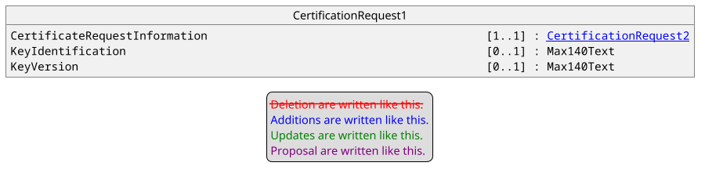

Where CertificationRequest2 is defined as.
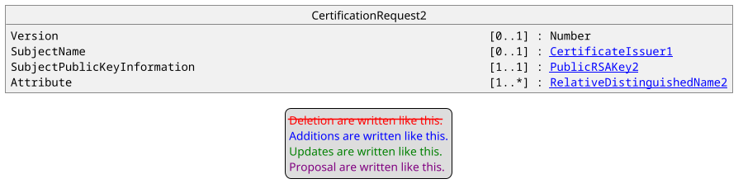

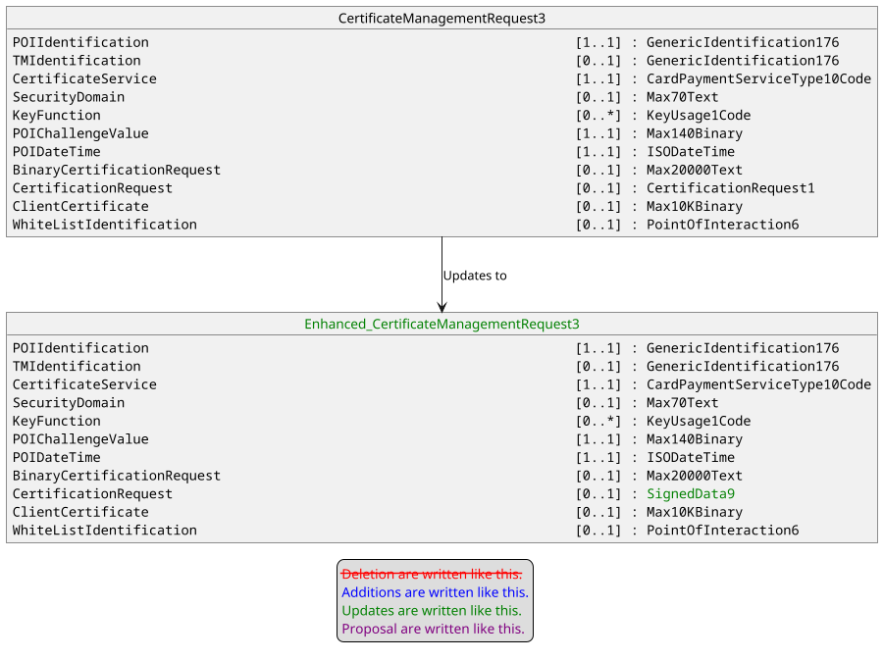

- Purpose of the change:

By analyzing the definition of CertificationRequest1 and CertificationRequest2 we realized that the message component is not able to support other algorithms than RSA, and most important point, the request itself is not signed by the holder of the private key, leaving a risk of man in the middle attack. Consequently, we would like to change this definition to a SignedData9 which is the message component used by a SignedData in a CMS structure.
The aim of this Change Request is to correct these errors by reusing a standard way of managing this through a CMS sub-structure.

- Urgency of the request:

Urgent.

- Business examples:
Examples illustrating the change request.
- SEG/TSG recommendation:
This section is not to be taken care of by the submitter of the change request. It will be completed in due time by the SEG(s) in charge of the related ISO 20022 messages or the TSG for changes related to the BAH.

Consider |  |  | Timing
- Next yearly cycle: 2025/2026
(the change will be considered for implementation in the yearly maintenance cycle which starts in 2025 and completes with the publication of new message versions in the spring of 2026)
- At the occasion of the next maintenance of the messages
(the change will be considered for implementation, but does not justify maintenance of the messages in its own right – will be pending until more critical change requests are received for the messages)
- Urgent unscheduled
(the change justifies an urgent implementation outside of the normal yearly cycle)
 |  |  | - Other timing:
Comments:

Reject
Reason for rejection:

