Change Request
for the update of ISO 20022 financial repository items

- Origin of the request:
A.1 Submitter: nexo A.I.S.B.L.
A.2 Contact person:
- Philippe CECE (philippe.cece@nexo-standards.org)
- Evelyne de JONGHE (evelyne.de-jonghe@frenchsys.com)

A.3 Sponsors: nexo A.I.S.B.L.

- Related messages:

- AcceptorAuthorisationRequest V14 (caaa.001.001.14)
- AcceptorCompletionAdvice V14 (caaa.003.001.14)
- AcceptorBatchTransfer V14 (caaa.011.001.14)
- AcceptorCurrencyConversionRequest V12 (caaa.016.001.12)
- TransactionAdvice V06 (caaa.020.001.06)
- AcceptorNonFinancialRequest V05 (caaa.022.001.05)
- AcceptorTransactionLogReportResponse V05 (caaa.025.001.05)
- AcceptorToAcquirerBatchFileExchange V02 (caaa.026.001.02)

- SaleToPOIServiceRequest V07 (casp.001.001.07)
- SaleToPOIServiceResponse V07 (casp.002.001.07)
- SaleToPOIReportResponse V07 (casp.010.001.07)
- SaleToPOIMessageStatusResponse V07 (casp.015.001.07)

- Description of the change request:

We want to update CardPaymentTransaction139, CardPaymentTransaction140 and PaymentTransaction161 in order to convey message that a merchant may want to display on the cardholder bank statement.
This new message will be name MessageFromMerchant with a multiplicity [0..*] and typed as an enhancement of Action15. This component will allow to directly, for instance, print or display this message too.

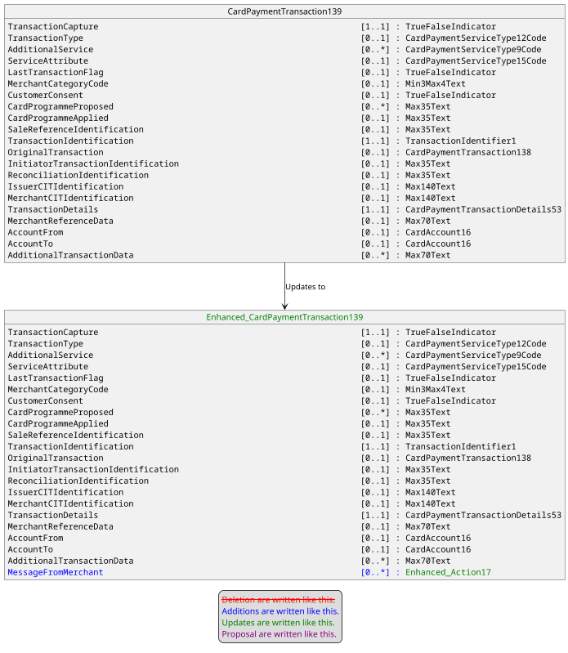

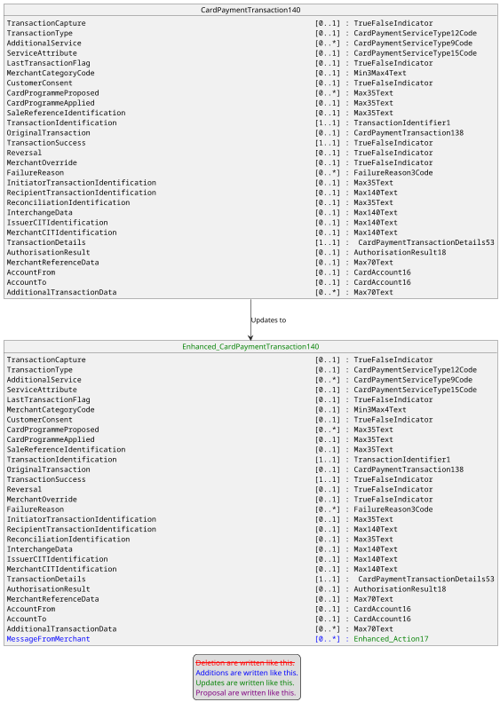
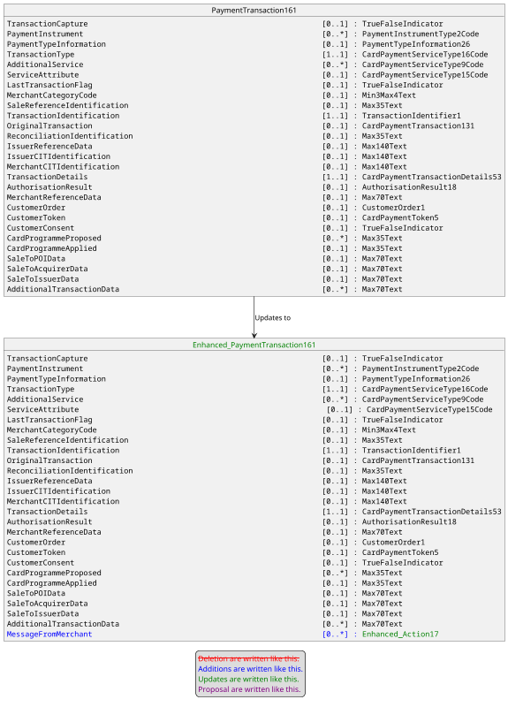

The message component Action17 will be updated to allow to identify the bank statement through the value CustomerStatement coded as CSTM of an enhanced UserInterface4Code in ActionMessage message component.

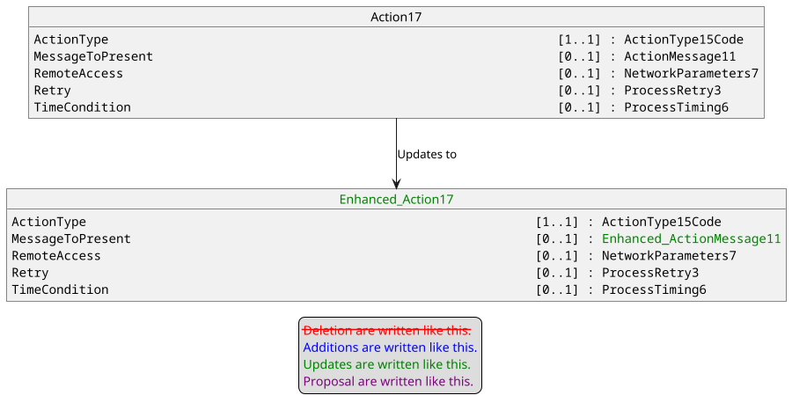

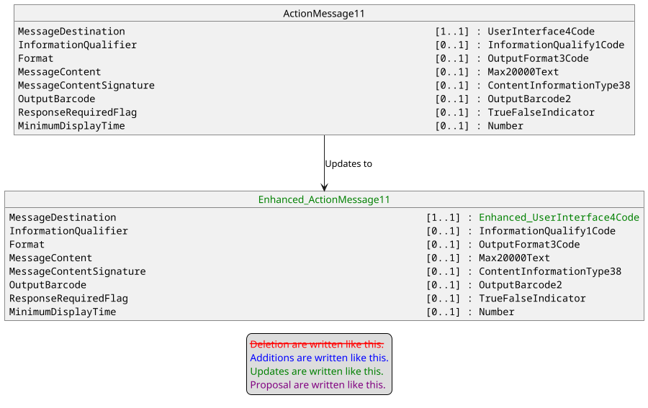

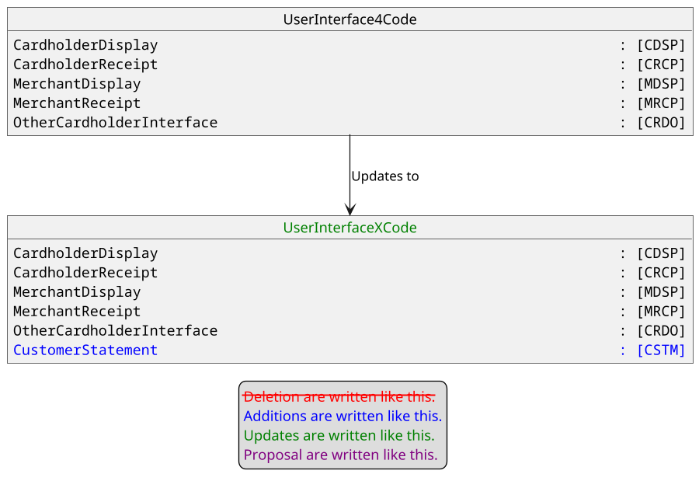

- Purpose of the change:

In some cases, it could be necessary to transfer information from Merchant to the bank statement of the Cardholder. For instance, it could be the case for aggregated transactions, to inform the cardholder on where to find additional data to identify aggregated transactions. Could be also used for an Original Credit according to some scheme rules.

- Urgency of the request:

Urgent.

- Business examples:
Examples illustrating the change request.
- SEG/TSG recommendation:
This section is not to be taken care of by the submitter of the change request. It will be completed in due time by the SEG(s) in charge of the related ISO 20022 messages or the TSG for changes related to the BAH.

Consider |  |  | Timing
- Next yearly cycle: 2025/2026
(the change will be considered for implementation in the yearly maintenance cycle which starts in 2025 and completes with the publication of new message versions in the spring of 2026)
- At the occasion of the next maintenance of the messages
(the change will be considered for implementation, but does not justify maintenance of the messages in its own right – will be pending until more critical change requests are received for the messages)
- Urgent unscheduled
(the change justifies an urgent implementation outside of the normal yearly cycle)
 |  |  | - Other timing:
Comments:

Reject
Reason for rejection:

