Change Request
for the update of ISO 20022 financial repository items

- Origin of the request:
A.1 Submitter: nexo A.I.S.B.L.
A.2 Contact person:
- Philippe CECE (philippe.cece@nexo-standards.org)
- Evelyne de JONGHE (evelyne.de-jonghe@frenchsys.com)
A.3 Sponsors: nexo A.I.S.B.L.

- Related messages:

- AcceptorAuthorisationRequest V14 (caaa.001.001.14)
- AcceptorCompletionAdvice V14 (caaa.003.001.14)
- AcceptorBatchTransfer V14 (caaa.011.001.14)
- AcceptorCurrencyConversionRequest V12 (caaa.016.001.12)
- TransactionAdvice V06 (caaa.020.001.06)
- AcceptorNonFinancialRequest V05 (caaa.022.001.05)
- AcceptorTransactionLogReportResponse V05 (caaa.025.001.05)
- AcceptorToAcquirerBatchFileExchange V02 (caaa.026.001.02)

- SaleToPOIServiceRequest V07 (casp.001.001.07)
- SaleToPOIServiceResponse V07 (casp.002.001.07)
- SaleToPOIReportResponse V07 (casp.010.001.07)
- SaleToPOIMessageStatusResponse V07 (casp.015.001.07)

- Description of the change request:

We want to update PartyType3Code to identify PaymentFacilitator or MarketPlace from Merchant. This distinction is important sometimes for clearing, but this information comes from the accepting device.

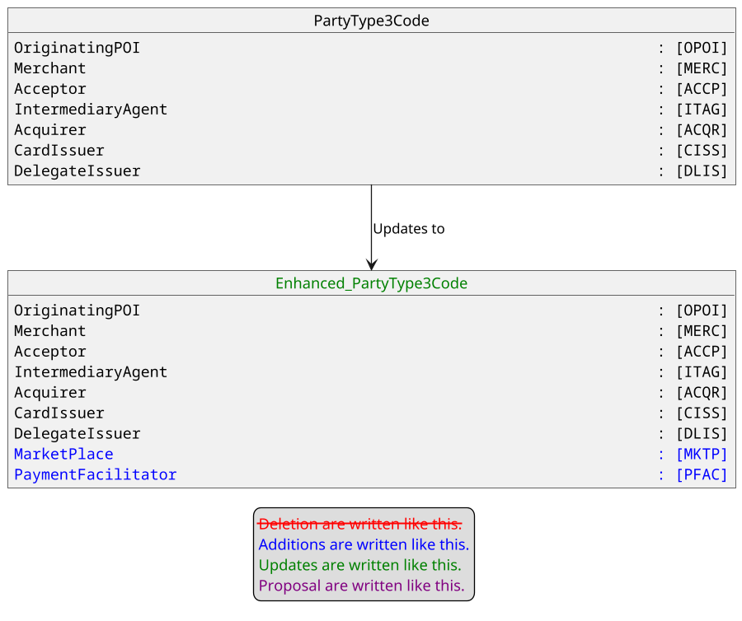

- Purpose of the change:

An Acquirer processing a transaction triggered by a MarketPlace on behalf of a merchant must indicate, in clearing messages, when merchant country is not the same as MarketPlace country. As a consequence, this information must come from the Acceptor messages sent to the Acquirer.
The current model provides information of SponsoredMerchant and specifically its CountryCode. Consequently, it is important to distinguish traditional Merchant from MarketPlace and PaymentFacilitator.
The aim of this Change Request is to do this by enhancing the PartyType codeset.

- Urgency of the request:

Urgent.

- Business examples:
Examples illustrating the change request.
- SEG/TSG recommendation:
This section is not to be taken care of by the submitter of the change request. It will be completed in due time by the SEG(s) in charge of the related ISO 20022 messages or the TSG for changes related to the BAH.

Consider |  |  | Timing
- Next yearly cycle: 2025/2026
(the change will be considered for implementation in the yearly maintenance cycle which starts in 2025 and completes with the publication of new message versions in the spring of 2026)
- At the occasion of the next maintenance of the messages
(the change will be considered for implementation, but does not justify maintenance of the messages in its own right – will be pending until more critical change requests are received for the messages)
- Urgent unscheduled
(the change justifies an urgent implementation outside of the normal yearly cycle)
 |  |  | - Other timing:
Comments:

Reject
Reason for rejection:

