Change Request
for the update of ISO 20022 financial repository items
Note: the purpose of this document is to give guidelines to parties who want to introduce a request to change an existing ISO 20022 message(s), or update other items of the ISO 20022 financial repository. Such change requests are subject to the approval of the ISO 20022 Standards Evaluation Group(s) in charge of the related message/item or to the approval of the Technical Support Group (TSG), if the requested change relates to the Business Application Header (BAH). Please consult the iso20022.org website for additional details on the maintenance process. Change requests are to be sent to iso20022ra@iso20022.org. All change requests conforming to this template received by June 1st will be considered for development in the following yearly ISO 20022 maintenance cycle which completes with publication of new message versions in April/May of the following year.
- Origin of the request:
A.1 Submitter: PMPG (Payments Market Practice Group)

A.2 Contact person: Sean Mouton Sean.Mouton@absa.africa

A.3 Sponsors: PMPG (Payments Market Practice Group)

- Related messages:
Account Switching message set (under the responsibility of Payments UK):

acmt.027.001.05 | AccountSwitchInformationRequestV05
acmt.028.001.05 | AccountSwitchInformationResponseV05
acmt.029.001.05 | AccountSwitchCancelExistingPaymentV05
acmt.031.001.05 | AccountSwitchRequestBalanceTransferV05
acmt.032.001.05 | AccountSwitchBalanceTransferAcknowledgementV05
acmt.034.001.05 | AccountSwitchRequestPaymentV05
Payments Initiation message set (under the responsibility of ISTH/SWIFT):

pain.001.001.12  pain.008.001.11 | CustomerCreditTransferInitiationV12  CustomerDirectDebitInitiationV11
Creditor Payment Activation Request message set (under the responsibility of CBI):

pain.013.001.11 | CreditorPaymentActivationRequestV11
Payments, Clearing and Settlement:

pacs.003.001.11 | FIToFICustomerDirectDebitV11
pacs.008.001.12 | FIToFICustomerCreditTransferV12

- Description of the change request:
Reporting of Regulatory Reporting information to a Reporting Authority requires a minimum set of data, which may be complimented with additional data depending upon the requirements of particular Reporting Authoirities. This Change Request proposes to ensure that the minimum set of data is identified within the base message and that the reporting type is standarised.
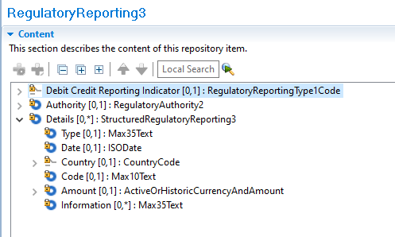
- Within Regulatory Reporting:
  - the Debit Credit Reporting Indicator should be required when Regulatory Reporting is used.
  - Type, as a description of the type of Regulatory Reporting information included, is currently Max35Text; it is proposed to codify this Type with an external code (4 character), or proprietary code being selected.
Initial values for the new external code set would be as follows-
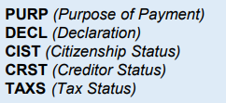

  - A new rule should also be implemented to require either Details>Code or Details>Information - both may be present; both cannot be absent.
- Purpose of the change:
With the introduction of ISO 20022, the submitter sees an opportunity to standardise usage of the Regulatory Reporting elements in ISO 20022 payment messages and ensure that, whenever Regulatory Reporting is used, it is used in a consistent way, with a minimum set of essential data. Maintaining the “Details>Type” element as a free format element makes standardization more difficult. Using an external code list will support validation by the network implementing the standard.
The Change Request proposes the following to the optional Regulatory Reporting element:
- Externalise Details>Type to a choice of Code or Proprietary, as a required element.
- Change the Debit Credit Reporting Indicator to a required element.
- Add a rule to ensure, at minimum, either Details>Code or Details>Information is provided.
This change request does not seek to standardise the codes used by Reporting Authorities.

- Urgency of the request:
2025/2026 maintenance cycle
- Business examples:
n/a
- SEG/TSG Recommendation:
This section is not to be taken care of by the submitter of the change request. It will be completed in due time by the SEG(s) in charge of the related ISO 20022 messages or the TSG for changes related to the BAH.

Consider |  |  | Timing
- Next yearly cycle: 2025/2026
(the change will be considered for implementation in the yearly maintenance cycle which starts in 2025 and completes with the publication of new message versions in the spring of 2026)
- At the occasion of the next maintenance of the messages
(the change will be considered for implementation, but does not justify maintenance of the messages in its own right – will be pending until more critical change requests are received for the messages)
- Urgent unscheduled
(the change justifies an urgent implementation outside of the normal yearly cycle)
 |  |  | - Other timing:
Comments:

Reject
Reason for rejection:

