Change Request
for the update of ISO 20022 financial repository items
Note: the purpose of this document is to give guidelines to parties who want to introduce a request to change an existing ISO 20022 message(s), or update other items of the ISO 20022 financial repository. Such change requests are subject to the approval of the ISO 20022 Standards Evaluation Group(s) in charge of the related message/item or to the approval of the Technical Support Group (TSG), if the requested change relates to the Business Application Header (BAH). Please consult the iso20022.org website for additional details on the maintenance process. All change requests conforming to this template received by June 1st will be considered for development in the following yearly ISO 20022 maintenance cycle which completes with publication of new message versions in April/May of the following year.
Changes requests are to be submitted through the ISO 20022 website through this e-request, in which this template must be attached.

- Origin of the request:
A.1 Submitter: identity of the company, organization, group, initiative or community that submits the change request.
Bank of England
Threadneedle Street, London, EC2R 8AH

A.2 Contact person: person(s) who can be contacted to get additional information on the request (name, e-mail, telephone)

Helen Bygrave helen.bygrave@bankofengland.co.uk | Imran Khan  imran.khan@bankofengland.co.uk

A.3 Sponsors: it is highly recommended that a submitter of a Change Request gain the agreement and support from as many additional organisations, groups, initiatives or communities of users as possible, thus demonstrating as wide as possible a consultation of the relevant stakeholders. All organisations, groups, initiatives or communities supporting the change request should be identified as sponsors along with a contact person, if possible. This community involvement is intended to help avoid delays and/or subsequent amendments to the change request.

- Related messages:
The list of ISO 20022 messages which would be impacted by the change, including the Message IDs as shown in the Catalogue of ISO 20022 messages. Only the latest version of a message definition can be maintained.
The submitter is invited to carefully examine whether the change may have an impact on other messages that come into play earlier or later in the transaction chain or on other messages that also use message components that this change request may impact.
pacs.029.001.02 MultilateralSettlementV02

- Description of the change request:
A specific change request form must be completed for each particular change requested (for example, adding, deleting, modifying, renaming, changing the cardinality, moving an element/component, or changing the type of an element, changing a code set).
If the change request consists, for example, of adding new functionality which requires several changes which would not make sense if not performed all together, then all these related changes should be described on the same form.
Change requests may not lead to creation of new messages. In such cases, a 'business justification' for development of new candidate ISO 20022 messages must be introduced by a submitting organization that is ready to develop the new messages.

The submitter asks for a change to the Reference field (currently [0..1]) within each movement record in a pacs.029 multilateral settlement message such that multiple references [0..*] of a type specified in an external code list can be associated with each movement record.
The Reference field [/Document/MulSttlmReq/SttlmReq/MvmntRcrd/Ref] is defined as “information to complement a movement record”.
Currently the pacs.029 allows [0..1] occurrences of a free text Reference field (Max35Text) per movement record as shown in Figure 1.
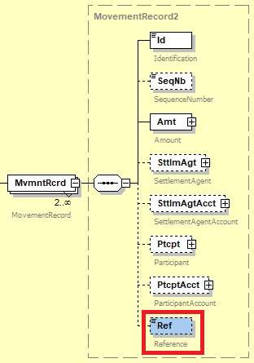
Figure 1 Current Reference field within a pacs.029 movement record
The requested change would replace the free text Reference field with an optional References block containing two fields; Reference [1..*] and Type [1..1]. This structure would allow one or more occurrences of Reference identified by a reference Type as shown in Figure 2. Type would be populated from a new external code list “ExternalReferenceType1Code” (see table 1).
The length of the Reference field within the new References block should be increased to 36 to accommodate a Universally Unique Identifier (UUID).

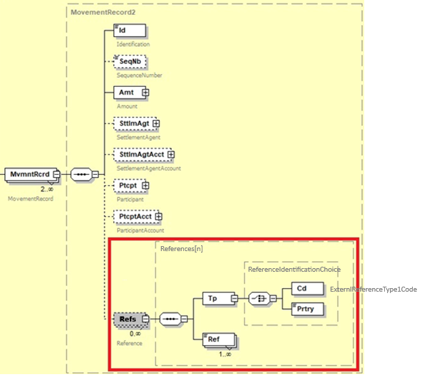
Figure 2 Proposed References message component within pacs.029 movement record

Table 1 suggested codes for new external code set ExternalReferenceType1Code

Code Set | Code Value | Code Name
ExternalReferenceType1Code | RVID | Reservation Identification
ExternalReferenceType1Code | UUID | Universally unique identifier

Purpose of the change:
Background, business context, community of users interested by the change and expected benefits/savings.
This section must explain why the existing ISO 20022 messages need to be changed. The reason for the update may be a business reason (e.g., evolution of market practice, or creation of new financial instruments), a technical reason (e.g., automation of the business process, or switch from a batch to a real time process), a regulatory reason (introduction, generally mandatory, of new rule/law) or the extension of the user community (newly identified business requirements).

The specific use case that has led to this maintenance request is the submitters need to link balance reservations made on accounts in an RTGS system via one or more camt.103 Create Reservation messages to the associated debit movement(s) in a pacs.029 Multilateral Settlement.
The submitter will receive multiple camt.103 Create Reservation messages throughout a set period. Funds will move, in the accounts specified, from an available balance to an earmarked (reserved) balance. These funds are being reserved to settle a future Multilateral Settlement.
At specified intervals the submitter will receive a pacs.029 multilateral settlement message and needs to know which if any reservations are linked to each movement in the settlement so that:
- the reservations can be released when the settlement completes
- the RTGS system knows unequivocally for the purpose of audit, which reservation the submitter is using to settle the funds.
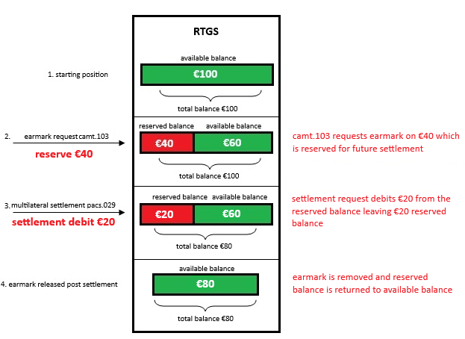
Figure 3 earmark reservation, settlement and earmark release

Continued…

Multiple references are required in a pacs.029 Multilateral Settlement message because a single movement can be linked to one or more reservations as shown below.

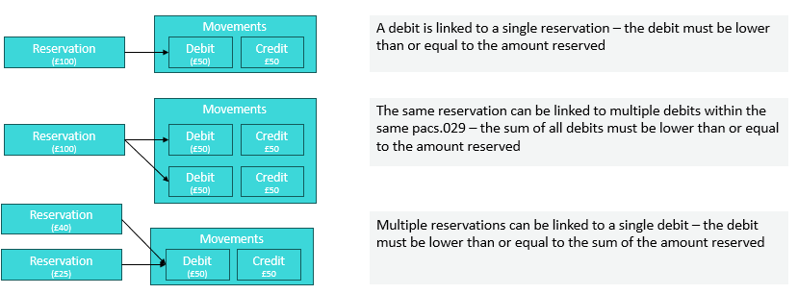
Figure 4 relationship of reservation ids to movement debits in the pacs.029

- Urgency of the request:
By default, valid change requests introduced by June 1 and subsequently approved by the SEG/TSG will be included in the following yearly maintenance cycle which completes with the publication of new message versions by April/May of the following year, unless decided otherwise by the SEG/TSG.
If there is a need to have the new version of the related messages published earlier, the reason for the urgency of the maintenance and the expected consequences of a delay should be described here. Acceptance of such an unscheduled maintenance for the BAH is subject to approval by TSG. Acceptance of an unscheduled maintenance for messages other than the BAH is subject to the approval of the SEG and availability of a submitting organization to develop the new version of the messages.
Note: the ISO 20022 maintenance results in the publication of a new version of an ISO 20022 message. The actual implementation of such new version on networks and in user installations is not within the purview of ISO.
Next yearly cycle: 2025/2026

Continued…
Business examples:
Examples illustrating the change request.
A camt.103 Create Reservation creates a single reservation by the member and managed by the transaction administrator.
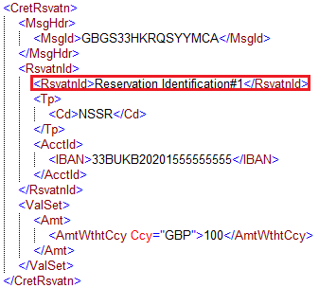
Figure 5 camt.103 Create Reservation

The latest version of the pacs.029.001.02 MultilateralSettlementV02 allows a single 35-character reference to be associated with each movement record. This does not allow multiple reservations against an account to be associated with a movement record on that account.
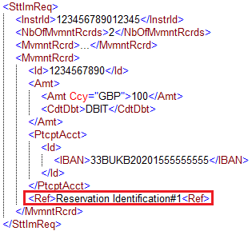
Figure 6 Current pacs.029 Reference implementation can contain only one instance of 35 characters
The proposed change to the pacs.029.001.02 MultilateralSettlementV02 would optionally allow for multiple references to be associated with each movement record.
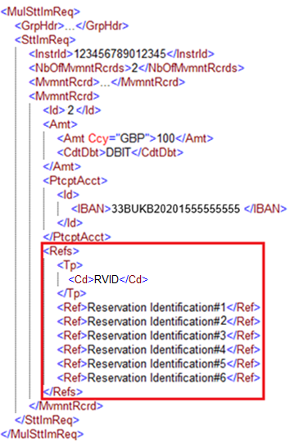
Figure 7 Proposed pacs.029 Reference implementation containing multiple reservation identification references of the same type

The proposed change allows some flexibility in how references are transported for implementations that may require fewer references of different types.

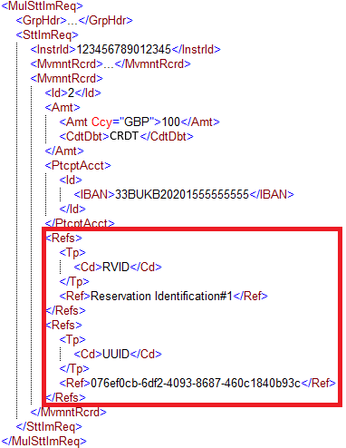
Figure 8 Proposed pacs.029 Reference implementation containing multiple reservation identification references of different types

SEG/TSG recommendation:
This section is not to be taken care of by the submitter of the change request. It will be completed in due time by the SEG(s) in charge of the related ISO 20022 messages or the TSG for changes related to the BAH.

Consider |  |  | Timing
- Next yearly cycle: 2023/2024
(the change will be considered for implementation in the yearly maintenance cycle which starts in 2022 and completes with the publication of new message versions in the spring of 2023)
- At the occasion of the next maintenance of the messages
(the change will be considered for implementation, but does not justify maintenance of the messages in its own right – will be pending until more critical change requests are received for the messages)
- Urgent unscheduled
(the change justifies an urgent implementation outside of the normal yearly cycle)
 |  |  | - Other timing:
Comments:

Reject
Reason for rejection:

