Change Request
for the update of ISO 20022 financial repository items
Note: the purpose of this document is to give guidelines to parties who want to introduce a request to change an existing ISO 20022 message(s), or update other items of the ISO 20022 financial repository. Such change requests are subject to the approval of the ISO 20022 Standards Evaluation Group(s) in charge of the related message/item or to the approval of the Technical Support Group (TSG), if the requested change relates to the Business Application Header (BAH). Please consult the iso20022.org website for additional details on the maintenance process. Change requests are to be sent to iso20022ra@iso20022.org. All change requests conforming to this template received by June 1st will be considered for development in the following yearly ISO 20022 maintenance cycle which completes with publication of new message versions in April/May of the following year.
- Origin of the request:
A.1 Submitter: ASX – CHESS (Clearing House Electronic Subregister System)
Australian Securities Exchange (ASX)
20 Bridge Street
Sydney NSW 2000

A.2 Contact person:
Priscilla Ferri de Barros
priscilla.ferridebarros@asx.com.au
+ 61 (02) 9227 0543
A.3 Sponsors: it is highly recommended that a submitter of a Change Request gain the agreement and support from as many additional organisations, groups, initiatives or communities of users as possible, thus demonstrating as wide as possible a consultation of the relevant stakeholders. All organisations, groups, initiatives or communities supporting the change request should be identified as sponsors along with a contact person, if possible. This community involvement is intended to help avoid delays and/or subsequent amendments to the change request.

- Related messages:
secl.001.001.04 - Trade Leg Identification

- Description of the change request:
A specific change request form must be completed for each particular change requested (for example, adding, deleting, modifying, renaming, changing the cardinality, moving an element/component, or changing the type of an element, changing a code set).
If the change request consists, for example, of adding new functionality which requires several changes which would not make sense if not performed all together, then all these related changes should be described on the same form.
Change requests may not lead to creation of new messages. In such cases, a 'business justification' for development of new candidate ISO 20022 messages must be introduced by a submitting organization that is ready to develop the new messages.

This Change Request includes 4 specific actions:

Change 1: currently, element Trading Capacity(/Document /TradLegNtfctn /TradLegDtls /TradgCpcty) contains a code list with 3 possible values: Agent, Principal and Riskless Principal. The addition of Code “Mixed” (Principal + agent) would align with FIX messages. FIX allows for the combination of tag 452 Party Role with tag 2376 PartyRoleQualifier, where value 100 represents ‘mixed’.
Proposed New tag definition: mixed
“Executing firm is acting in a capacity that is not purely agency (AGEN) or purely principal (PRIN), but rather a combination of both.”

Change 2: Guaranteed Trade versus non-guaranteed Trade
In the latest version of the secl.001, a Guaranteed Trade Indicator is used to signal whether the trade is novated (and guaranteed) or not. The input of ‘false’ mandates the use of the “non-guaranteed trade” block. In Non-Guaranteed trade, you have the ability to disclose the Counterparty. In a Guaranteed trade, you don’t have the option.
In Australia, there are securities that do not allow the masking of the participant (meaning hide their identity), even for Guaranteed trades. Those securities are:
- Exchange traded Fund Units.
- Trading Long Exposure
- Trading Managed Fund
- QDB Managed Fund
- Managed Funds
- …
Therefore, the request is to have the same optional structure as “non-Guaranteed trade” repeated for “Guaranteed Trade”.
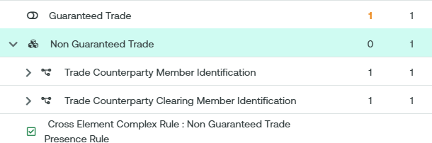

Please note that the workaround used by ASX today is to replicate the information in the Supplementary Data. We have attached a full sample at the end of the document.

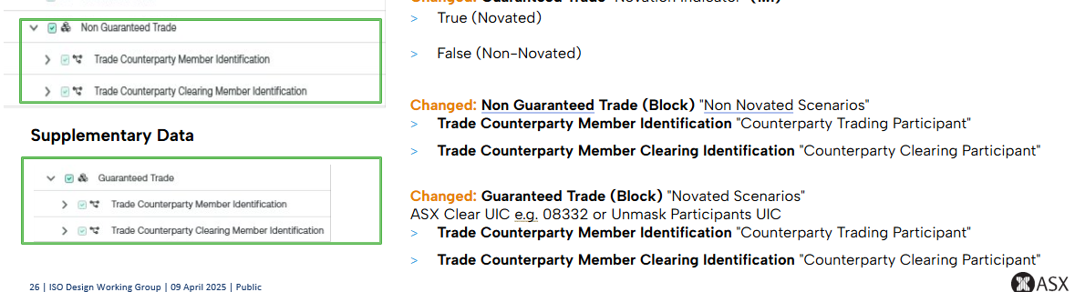

Change 3: Additional elements in block “notified Trade Leg Details”.
To be better aligned with the FIX protocol, we request the addition of 3 more elements:

- Original Trade Date besides existing Trade Date. In FIX, Trade date indicates the date the trade is being reported, while the Original Trade Date specifies the date the trade occurred.
- Buyer Order Reference Number: The Buy Side Trading Participant's own reference for in-house processing of the Market Trade
- Seller Order Reference Number: The Sell Side Trading Participant's own reference for in-house processing of the Market Trade

Change 4: Addition of element “Trade Condition Code” for alignment with FIX Trade Capture. In FIX protocol, tag 20003 typically represents the condition code for trades, specifically indicating special conditions or circumstances related to a trade. Some codes do relate whether the trade is novated or not.
We are well aware that the element “Trade Transaction Condition Code” already exists in both MT and ISO 20022 messages. The ISO definition is very close to the FIX definition:
“Indicates the conditions under which the order/trade is to be/was executed”.
We could imagine adding the same element in the secl.001, and if we do not introduce new codes under “codes”, let ASX use the Proprietary tag to map the FIX codes.

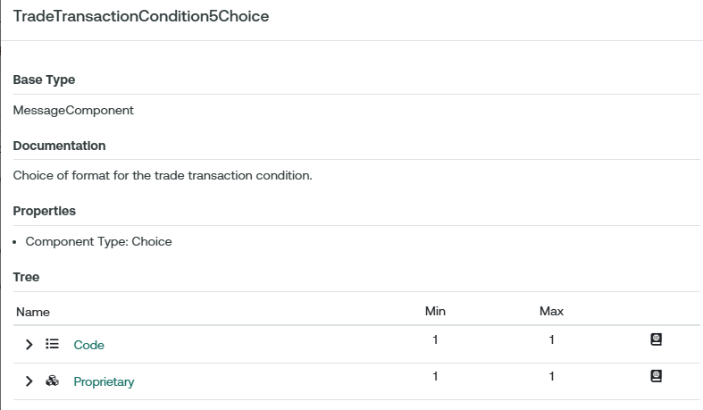

For reference, here is an extract of the FIX codes that are accepted by ASX:
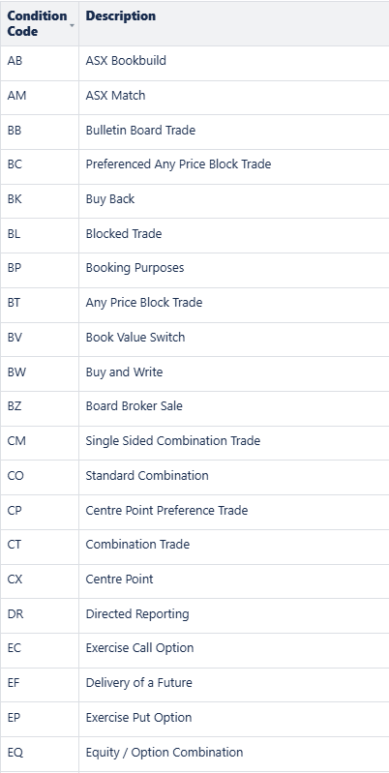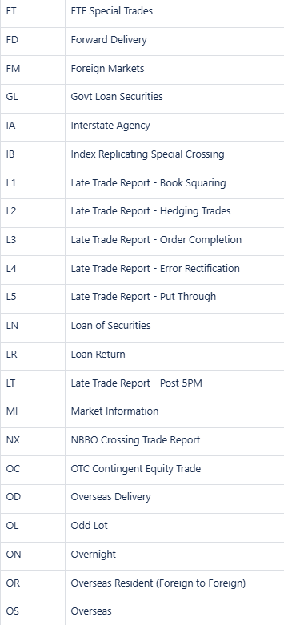

- Purpose of the change:
The Australian Securities Exchange (ASX) has initiated a project to replace the current Australian equities clearing and settlement market infrastructure system (CHESS).
CHESS (Clearing House Electronic Subregister System) is the system operated by ASX to manage the clearing and settlement of equity market transactions, and to record current security holdings (and the holders) on a name on register basis. The implementation of the replacement system will provide the existing core functionality and services as well as service enhancements. The current proprietary CHESS messaging standards will be replaced with ISO 20022 standards.
The purpose of this Change Request is to fully align the ISO messages used in CHESS with the FIX messages used in the ASX Clearing Trade Acceptance Service, and to avoid using supplementary data for required elements.

- Urgency of the request:
By default, valid change requests introduced by June 1 and subsequently approved by the SEG/TSG will be included in the following yearly maintenance cycle which completes with the publication of new message versions by April/May of the following year, unless decided otherwise by the SEG/TSG.
If there is a need to have the new version of the related messages published earlier, the reason for the urgency of the maintenance and the expected consequences of a delay should be described here. Acceptance of such an unscheduled maintenance for the BAH is subject to approval by TSG. Acceptance of an unscheduled maintenance for messages other than the BAH is subject to the approval of the SEG and availability of a submitting organization to develop the new version of the messages.
Note: the ISO 20022 maintenance results in the publication of a new version of an ISO 20022 message. The actual implementation of such new version on networks and in user installations is not within the purview of ISO.

- Business examples:
Examples illustrating the change request.

Sample of a novated Trade with Unmasked Clearing Participant, with supplementary data:
<Document xmlns:xsi="http://www.w3.org/2001/XMLSchema-instance" xmlns="urn:iso:std:iso:20022:tech:xsd:secl.001.001.04" xsi:schemaLocation="urn:iso:std:iso:20022:tech:xsd:secl.001.001.04 ASX_AU_CHS_clrg_501_001_02_secl_001_001_04.xsd">
<TradLegNtfctn>
<ClrMmb>
<PrtryId>
<Id>01402</Id>
<Issr>XASX</Issr>
</PrtryId>
</ClrMmb>

<ClrAcct>
<Id>01402GA200</Id>
<Tp>HOUS</Tp>
</ClrAcct>
<ClrDtls>
<SttlmNetgElgblCd>NETT</SttlmNetgElgblCd>
<ClrSgmt>
<BIC>XASXAU2S</BIC>
</ClrSgmt>
<GrntedTrad>true</GrntedTrad>
</ClrDtls>
<TradLegDtls>
<TradLegId>918100067403W555</TradLegId>
<TradExctnId>1000555599</TradExctnId>
<TradDt>2024-08-13T00:00:00+10:00</TradDt>
<TxDtTm>2024-08-13T09:30:47+10:00</TxDtTm>
<SttlmDt>
<Dt>2024-08-15</Dt>
</SttlmDt>
<FinInstrmId>
<ISIN>AU000000IVV3</ISIN>
<OthrId>
<Id>IVV</Id>
<Tp>
<Prtry>INFO</Prtry>
</Tp>
</OthrId>
</FinInstrmId>
<BuySellInd>SELL</BuySellInd>
<TradQty>
<Unit>100</Unit>
</TradQty>
<DealPric>
<Val>
<Amt Ccy="AUD">2.50</Amt>
</Val>
</DealPric>
<PlcOfTrad>
<Id>
<MktIdrCd>XASX</MktIdrCd>
</Id>
<Tp>
<Cd>EXCH</Cd>
</Tp>
</PlcOfTrad>
<TradTp>OOBK</TradTp>
<TradgPty>
<PrtryId>
<Id>1444</Id>
<Issr>XASX</Issr>
</PrtryId>
</TradgPty>
<TradgCpcty>AGEN</TradgCpcty>
</TradLegDtls>
<SttlmDtls>
<SttlmAmt>
<Amt Ccy="AUD">250</Amt>
<CdtDbtInd>CRDT</CdtDbtInd>
</SttlmAmt>
<Dpstry>
<BIC>XASXAU2S</BIC>
</Dpstry>
</SttlmDtls>
<SplmtryData>
<Envlp>
<Document xmlns="urn:asx:xsd:xasx.501.001.02" xmlns:xsi="http://www.w3.org/2001/XMLSchema-instance" xsi:schemaLocation="urn:asx:xsd:xasx.501.001.02 ASX_AU_CHS_clrg_501_001_02_secl_001_001_04_sup.xsd">
<Clrg501SuplDataV01>
<NotfdTradLegDtls>
<BuyrOrdrRefNb>1234567890</BuyrOrdrRefNb>
<SellrOrdrRefNb>222222222</SellrOrdrRefNb>
<GrntedTrad>
<TradCtrPtyMmbId>
<PrtryId>
<Id>1777</Id>
<Issr>XASX</Issr>
</PrtryId>
</TradCtrPtyMmbId>
<TradCtrPtyClrMmbId>
<PrtryId>
<Id>01117</Id>
<Issr>XASX</Issr>
</PrtryId>
</TradCtrPtyClrMmbId>
</GrntedTrad>
</NotfdTradLegDtls>
</Clrg501SuplDataV01>
</Document>
</Envlp>
</SplmtryData>
</TradLegNtfctn>
</Document>
- SEG/TSG recommendation:
This section is not to be taken care of by the submitter of the change request. It will be completed in due time by the SEG(s) in charge of the related ISO 20022 messages or the TSG for changes related to the BAH.

Consider |  |  | Timing
- Next yearly cycle: 2025/2026
(the change will be considered for implementation in the yearly maintenance cycle which starts in 2025 and completes with the publication of new message versions in the spring of 2026)
- At the occasion of the next maintenance of the messages
(the change will be considered for implementation, but does not justify maintenance of the messages in its own right – will be pending until more critical change requests are received for the messages)
- Urgent unscheduled
(the change justifies an urgent implementation outside of the normal yearly cycle)
 |  |  | - Other timing:
Comments:

Reject
Reason for rejection:

