Change Request
for the update of ISO 20022 financial repository items
Note: the purpose of this document is to give guidelines to parties who want to introduce a request to change an existing ISO 20022 message(s), or update other items of the ISO 20022 financial repository. Such change requests are subject to the approval of the ISO 20022 Standards Evaluation Group(s) in charge of the related message/item or to the approval of the Technical Support Group (TSG), if the requested change relates to the Business Application Header (BAH). Please consult the iso20022.org website for additional details on the maintenance process. Change requests are to be sent to iso20022ra@iso20022.org. All change requests conforming to this template received by June 1st will be considered for development in the following yearly ISO 20022 maintenance cycle which completes with publication of new message versions in April/May of the following year.
- Origin of the request:
A.1 Submitter: EPC – European Payments Council.
A.2 Contact person: Christophe Godefroi, Christophe.godefroi@epc-cep.eu, + 32 2 739 16 93
A.3 Sponsors: The payment service providers (PSPs) community of SEPA (Single Euro Payments Area)
- Related messages:
This change request impacts the following ISO 20022 message definitions that are currently used by the SEPA PSP community:
- pain.001.001.12 CustomerCreditTransferInitiationV12
- pain.002.001.14 CustomerPaymentStatusReportV14
- pain.007.001.12 CustomerPaymentReversalV12
- pain.008.001.11 CustomerDirectDebitInitiationV11
- pain.009.001.08 MandateInitiationRequestV08
- pain.010.001.08 MandateAmendmentRequestV08
- pain.011.001.08 MandateCancellationRequestV08
- pain.012.001.08 MandateAcceptanceReportV08
- pain.013.001.11 CreditorPaymentActivationRequestV11
- pain.014.001.11 CreditorPaymentActivationRequestStatusReportV11

- pacs.002.001.14 FIToFIPaymentStatusReportV14
- pacs.003.001.11 FIToFICustomerDirectDebitV11
- pacs.004.011.13 PaymentReturnV13
- pacs.007.001.13 FIToFIPaymentReversalV13
- pacs.008.001.12 FIToFICustomerCreditTransferV12
- pacs.028.001.06 FIToFIPaymentStatusRequestV06

- camt.029.001.13 ResolutionOfInvestigationV13
- camt.052.001.12 BankToCustomerAccountReportV12
- camt.053.001.12 BankToCustomerStatementV12
- camt.054.001.12 BankToCustomerDebitCreditNotificationV12
- camt.055.001.12 CustomerPaymentCancellationRequestV12
- camt.056.001.11 FIToFIPaymentCancellationRequestV11
The following messages are also used by the SEPA PSP community but they are no longer maintained by ISO 20022:
- camt.027.001.10 ClaimNonReceiptV10
- camt.087.001.09 RequestToModifyPaymentV09
It is to be noted that additional ISO 20022 messages may be impacted by this Change Request.
- Description of the change request:
The ISO 20022 Payments SEG is presented with a choice between the two options outlined below. The main difference between Option 1 and Option 2 is that in Option 1, ‘Name’ is to be used for the ‘Full Legal Name’, whereas in Option 2 there is a dedicated sub-element.
The proposal applicable to the elements ‘Creditor’ and ‘Ultimate Creditor’ is a follows:

OPTION 1: Introduce optional sub-element [0..1] ‘TradingName’

OPTION 2: Introduce optional sub-element [0..1] ‘Additional Names’, containing two sub-elements i.e. ‘FullLegalName’ and ‘TradingName’ .

.

Note: the proposed modifications are marked in green below:
OPTION 1
UltimateCreditor <UltmtCdtr> / Creditor <Cdtr> contain the following elements:

Or | MessageElement<XML Tag> | Mult. | Type | Constr. No. | Page
 | Name <Nm> | [0..1] | Text |  | 691
 | TradingName <TrdngNm> | [0..1] | Text
 | PostalAddress <PstlAdr> | [0..1] | ± |  | 692
 | Identification <Id> | [0..1] |  |  | 692
{Or | OrganisationIdentification <OrgId> | [1..1] |  |  | 693
 | AnyBIC <AnyBIC> | [0..1] | IdentifierSet | C3 | 694
 | LEI <LEI> | [0..1] | IdentifierSet |  | 694
 | Other <Othr> | [0..*] |  |  | 694
 | Identification <Id> | [1..1] | Text |  | 695
 | SchemeName <SchmeNm> | [0..1] |  |  | 695
{Or | Code <Cd> | [1..1] | CodeSet |  | 695
Or} | Proprietary <Prtry> | [1..1] | Text |  | 695
 | Issuer <Issr> | [0..1] | Text |  | 695
Or} | PrivateIdentification <PrvtId> | [1..1] |  |  | 695
 | DateAndPlaceOfBirth <DtAndPlcOfBirth> | [0..1] |  |  | 696
 | BirthDate <BirthDt> | [1..1] | Date |  | 696
 | ProvinceOfBirth <PrvcOfBirth> | [0..1] | Text |  | 696
 | CityOfBirth <CityOfBirth> | [1..1] | Text |  | 697
 | CountryOfBirth <CtryOfBirth> | [1..1] | CodeSet | C9 | 697
 | Other <Othr> | [0..*] |  |  | 697
 | Identification <Id> | [1..1] | Text |  | 697
 | SchemeName <SchmeNm> | [0..1] |  |  | 697
{Or | Code <Cd> | [1..1] | CodeSet |  | 698
Or} | Proprietary <Prtry> | [1..1] | Text |  | 698
 | Issuer <Issr> | [0..1] | Text |  | 698
 | CountryOfResidence <CtryOfRes> | [0..1] | CodeSet | C9 | 698
 | ContactDetails <CtctDtls> | [0..1] | ± |  | 698

Suggested definitions related to additional element:
TradingName <TrdngNm>
Presence: [0..1]
Definition: Name used by a business for commercial purposes, although its registered legal name, used for contracts and other formal situations, may be another
Datatype: "Max350Text"
Please note that this element is already used in for example the acmt.016 (Account Excluded Mandate Maintenance Amendment Request) message.

OPTION 2
UltimateCreditor <UltmtCdtr> / Creditor <Cdtr> contain the following elements:

Or | MessageElement<XML Tag> |  | Mult. | Type | Constr. No. | Page
 | Name <Nm> |  | [0..1] | Text |  | 691
 | AdditionalNames <AddtnlNms> |  | [0..1]
 | FullLegalName <FullLglNm> |  | [0..1] | Text
 | TradingName <TrdngNm> |  | [0..1] | Text
 | PostalAddress <PstlAdr> |  | [0..1] | ± |  | 692
 | Identification <Id> |  | [0..1] |  |  | 692
{Or | OrganisationIdentification <OrgId> |  | [1..1] |  |  | 693
 | AnyBIC <AnyBIC> |  | [0..1] | IdentifierSet | C3 | 694
 | LEI <LEI> |  | [0..1] | IdentifierSet |  | 694
 | Other <Othr> |  | [0..*] |  |  | 694
 | Identification <Id> |  | [1..1] | Text |  | 695
 | SchemeName <SchmeNm> |  | [0..1] |  |  | 695
{Or | Code <Cd> |  | [1..1] | CodeSet |  | 695
Or} | Proprietary <Prtry> |  | [1..1] | Text |  | 695
 | Issuer <Issr> |  | [0..1] | Text |  | 695
Or} | PrivateIdentification <PrvtId> |  | [1..1] |  |  | 695
 | DateAndPlaceOfBirth <DtAndPlcOfBirth> |  | [0..1] |  |  | 696
 | BirthDate <BirthDt> |  | [1..1] | Date |  | 696
 | ProvinceOfBirth <PrvcOfBirth> |  | [0..1] | Text |  | 696
 | CityOfBirth <CityOfBirth> |  | [1..1] | Text |  | 697
 | CountryOfBirth <CtryOfBirth> |  | [1..1] | CodeSet | C9 | 697
 | Other <Othr> |  | [0..*] |  |  | 697
 | Identification <Id> |  | [1..1] | Text |  | 697
 | SchemeName <SchmeNm> |  | [0..1] |  |  | 697
{Or | Code <Cd> |  | [1..1] | CodeSet |  | 698
Or} | Proprietary <Prtry> |  | [1..1] | Text |  | 698
 | Issuer <Issr> |  | [0..1] | Text |  | 698
 | CountryOfResidence <CtryOfRes> |  | [0..1] | CodeSet | C9 | 698
 | ContactDetails <CtctDtls> |  | [0..1] | ± |  | 698

Suggested definitions related to additional elements:
Creation of a new complex type AdditionalNames <AddtnlNms>, consisting of two simple types.
AdditionalNames <AddtnlNms> contains the following NameIdentificationxx elements:

Or | MessageElement<XML Tag> |  | Mult. | Type | Constr. No. | Page
 | FullLegalName <FullLglNm> |  | [0..1] | Text
 | TradingName <TrdngNm> |  | [0..1] | Text

FullLegalName <FullLglNm>
Presence: [0..1]
Definition: Name by which a party is known and which is usually used to identify that party.
Datatype: "Max350Text"

TradingName <TrdngNm>
Presence: [0..1]
Definition: Name used by a business for commercial purposes, although its registered legal name, used for contracts and other formal situations, may be another
Datatype: "Max350Text"

Please note that the above elements are already used in for example the acmt.016 (Account Excluded Mandate Maintenance Amendment Request) message.

- Purpose of the change:
In July 2020, the Euro Retail Payments Board (ERPB) established a working group on transparency for retail payments end users to make it easy to identify, from a consumer’s payment account statement or online application, to whom, where and when a payment was made. A list of recommendations was developed (ERPB/2021/006), which was endorsed in June 2021 by the ERPB. One of the key recommendations is related to the fact that the commercial trade name of the payee should be used all along the chain, as this is the name most easily recognized by the consumer. In certain cases, i.e. when intermediaries are involved in order to facilitate the transaction or process the payment, it is advisable to use the commercial trade names of both the payee and the intermediary/ies. In this context, the following guidance is provided in the ERPB report:
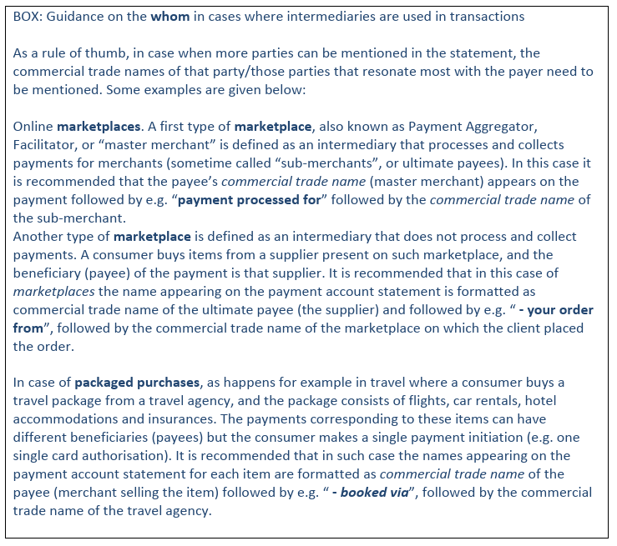
This change request is applicable to the payment service providers (PSPs) community of SEPA (Single Euro Payments Area).
- Urgency of the request:
The change request is to be included in the 2025-2026 maintenance cycle.
- Business examples:
As Payees/Creditors know best under what name they are known by their customers – most likely the name they use for marketing efforts - Payees should also include their commercial trade name (e.g. “Premium Belgian chocolates”) - when different from their legal name (e.g. “Brussels XYZ SRPL”) - in any SEPA payment transaction they present to the Payer-Consumer. Acting in this way, the Payee’s commercial trade name can then also appear in the payment account statements of the Payer/Debtor (consumer) besides its legal name. This enables the Payer/Debtor (consumer) to easily identify to whom a payment was made.

OPTION 1 Example (organisation)

<Cdtr>
<Nm> Brussels XYZ SRPL</Nm>
<TrdngNm> Premium Belgian chocolates</TrdngNm>
</Cdtr>
…

<UltmtCdtr>
<Nm> Ixelles ABC SRPL</Nm>
<TrdngNm> Premium Belgian gifts</TrdngNm>
</UltmtCdtr>

OPTION 2: Example (organisation)

<Cdtr>
<Nm> Brussels XYZ</Nm>
<AddtnlNms>
<FullLglNm> Brussels XYZ SRPL</FullLglNm>
<TrdngNm> Premium Belgian chocolates </TrdngNm>
</AddtnlNms>
</Cdtr>

OPTION 2: Example (natural person – e.g. painter)

<Cdtr>
<Nm> P. Brush</Nm>
<AddtnlNms>
<TrdngNm>Perfect Colours</TrdngNm>
</AddtnlNms>
</Cdtr>

Other examples:
Payments via Open Banking:
- Customer visits the website of ‘Sports unlimited’ to buy a pair of shoes.
- Customer clicks ‘pay by bank’, and selects their bank.
- Customer is redirected to its bank and logs in.
- The customer only sees the 'Creditor Name' and 'Amount,' which are pre-populated by the creditor and cannot be edited. The creditor name is typically the legal name of the creditor (e.g. ABC Unlimited ).
- Once the customer initiates the payment, the customer is redirected back to the website of ‘Sports unlimited’. Although a pop-up might appear on the website stating that “the transaction will appear as ABC unlimited on the bank statement”, the customer might not remember this after a couple of weeks and might hence question what this payment is related to.
Paying for subscriptions of magazines (via QR code for example):
- The customer visits the ‘Payments Magazine’ website to subscribe.
- The creditor provides the customer with a QR code.
- The customer scans the QR code using their online banking app.
- All details are pre-populated by the creditor and cannot be modified.
- The creditor’s name is listed as ‘Press Holding’.
- The customer may forget the purpose of the payment to ‘Press Holding’ after a few weeks.

Examples of transparency issues identified in the aforementioned ERPB report:
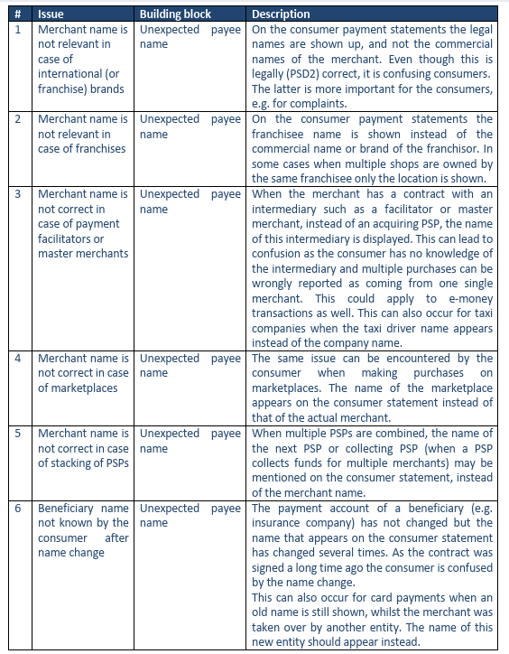

- SEG/TSG recommendation:
This section is not to be taken care of by the submitter of the change request. It will be completed in due time by the SEG(s) in charge of the related ISO 20022 messages or the TSG for changes related to the BAH.

Consider |  |  | Timing
- Next yearly cycle: 2025/2026
(the change will be considered for implementation in the yearly maintenance cycle which starts in 2025 and completes with the publication of new message versions in the spring of 2026)
- At the occasion of the next maintenance of the messages
(the change will be considered for implementation, but does not justify maintenance of the messages in its own right – will be pending until more critical change requests are received for the messages)
- Urgent unscheduled
(the change justifies an urgent implementation outside of the normal yearly cycle)
 |  |  | - Other timing:
Comments:

Reject
Reason for rejection:

The Euro Retail Payments Board (ERPB) is a high-level strategic body tasked with fostering the integration, innovation and competitiveness of euro retail payments in the European Union. https://www.ecb.europa.eu/paym/groups/erpb/html/index.en.html

