Maintenance Change Request
for the update of ISO 20022 financial repository items

Name of the request:
ISO 20022 FX Maintenance 2024/2025

Submitting organisation(s):
SWIFT, on behalf of CLS

Standards Department,
Avenue Adele, 1
1310 La Hulpe - Belgium

Related messages:

Under this maintenance, below existing ISO 20022 message definitions will be maintained (resulting from the impact analysis performed on each CR).

Message sets impacted not under responsibility of SWIFT:
Please note that not all message sets are under the responsibility of SWIFT, and the RA contact the original submitting organisation of those messages set to confirm they intend to implement the changes in their respective message sets.
For those message sets, SWIFT cannot guarantee the submitting organisations will agree to implement the changes.

Post-Trade Foreign Exchange message set (under the responsibility of CLS):

fxtr.014.001.05 | ForeignExchangeTradeInstructionV05
fxtr.015.001.05 | ForeignExchangeTradeInstructionAmendmentV05
fxtr.016.001.05 | ForeignExchangeTradeInstructionCancellationV05
fxtr.017.001.05  fxtr.008.001.07  fxtr.030.001.05  camt.088.001.02 | ForeignExchangeTradeStatusAndDetailsNotificationV05  ForeignExchangeTradeStatusNotificationV07  ForeignExchangeTradeBulkStatusNotificationV05  NetReportV02

Note: SWIFT will implement the changes on behalf of CLS for this message set, if accepted.

Commitments of the submitting organisation:

The submitting organisations confirm that they can and will:
- undertake the development of the new version of the candidate ISO 20022 message models that it will submit to the RA for compliance review and evaluation. New valid Message Definition models will be made available to the RA by December 1.
- provide a new version of part 1 of the related Message Definition Reports (MDR) by December 1, and new examples of valid message instances of each candidate message (only when valid samples were published for current version) by May 1 at the latest.
- address any queries related to the description of the new models and messages as published by the RA on the ISO 20022 website.

SWIFT intends to implement most of the above new versions on its SWIFTNet network once the related documentation has been published by the RA.

The submitting organisations confirm their knowledge and acceptance of the ISO 20022 Intellectual Property Rights policy for contributing organisations, as follows.
“Organisations that contribute information to be incorporated into the ISO 20022 Repository shall keep any Intellectual Property Rights (IPR) they have on this information. A contributing organisation warrants that it has sufficient rights on the contributed information to have it published in the ISO 20022 Repository through the ISO 20022 Registration Authority in accordance with the rules set in ISO 20022. To ascertain a widespread, public and uniform use of the ISO 20022 Repository information, the contributing organisation grants third parties a non-exclusive, royalty-free license to use the published information”.

Contact persons:
Dean Chard – SWIFT Standards, dean.chard@swift.com
Karin Deridder – SWIFT Standads, karin.deridder@swift.com

Change Requests Withdrawn:
CR1281 was withdrawn by the submitter as this has been superseded by CR1393.

Change request CR1393: Update Post Trade FX messages to align with MT3xx

Origin of the request:
A.1 Submitter: CLS Bank International
A.2 Contact person: Stuart Buckley. sbuckley@cls-services.com

A.3 Sponsors: This change will be socialised with all CLS Member/Participant banks via an official Participant notice. We adopt a policy at CLS of aligning our messages to the latest standards where there is a valid business case to do so. No objections to this strategy have been received.

Related messages:
The list of ISO 20022 messages which would be impacted by the change, including the Message IDs as shown in the Catalogue of ISO 20022 messages. Only the latest version of a message definition can be maintained.

Message | Message Name
fxtr.014.001.05.xsd | ForeignExchangeTradeInstructionV05
fxtr.015.001.05.xsd | ForeignExchangeTradeInstructionAmendmentV05
fxtr.016.001.05.xsd | ForeignExchangeTradeInstructionCancellationV05
fxtr.017.001.05.xsd | ForeignExchangeTradeStatusAndDetailsNotificationV05

Description of the change request:
Updating the message schemas listed above from the suite of CLS related FX messages with the following:

- Underlying Product Identifier (update from 6-12 chr to align to 22U in the MT 300/304)
- Calculation Agent field (to align to 26K)
- Payment Clearing Centre field (to align to 39M)
- Post Trade Events sequence (to align to Optional sequence F)
  - Event Type and Reference (to align to 21H)
  - Underlying liability Reference (to align to 21F)
  - Profit and Loss Settlement Date (to align to 30F)
  - Profit and Loss Settlement Amount (to align to 32H)
  - Outstanding Settlement Amount (to align to 33E)

These additions to the fxtr messages will ensure that they are fully aligned to the MT 300 and MT 304 and meet future market expectations regarding standards compatibility between the XML message suite and the MT 3XX messages.

Purpose of the change:
CLS also has a policy of aligning messages to the latest versions and standards. Adding the above fields to the fxtr messages continues this practice. These fields have been omitted from previous updates but may be required by the market in the future, so we feel the updates are essential to ensure the fxtr messages are up to date when required by the business. This will meet our Participants expectations regarding standards alignment across our message suite.

Urgency of the request:
Default timeline of June 1st for submission and availability of the new versions in SR2025.

Business examples:
These are new MX elements required in the fxtr messages to align with the below MT 300 and MT 304 change requests from previous Standards releases.

Field 22U
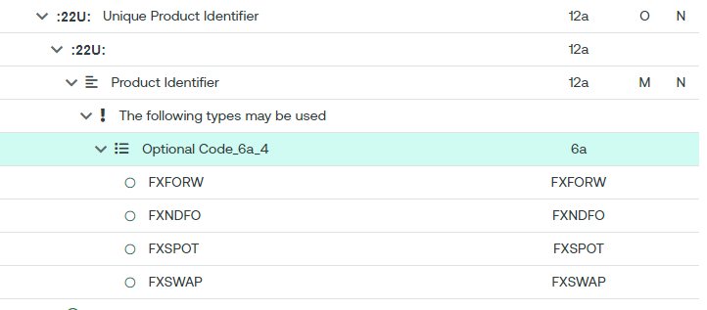
Field 39M
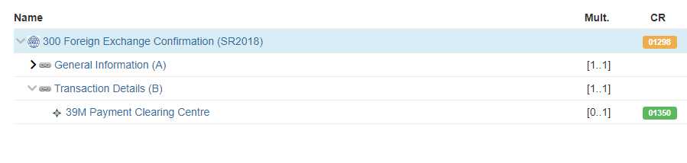

Field 26K
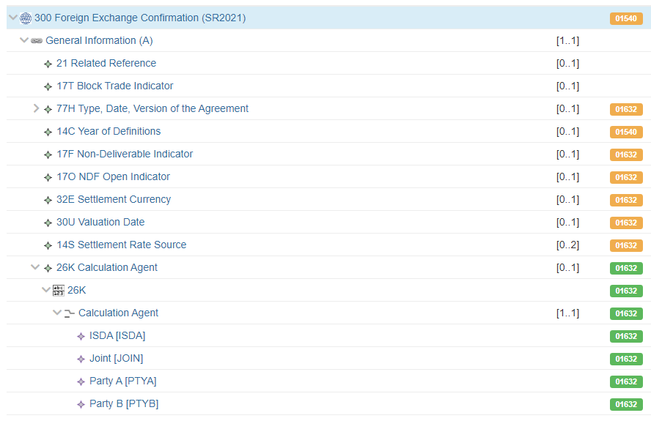

Post Trade events sequence (Fields 21H, 21F, 30F, 32H and 33E)
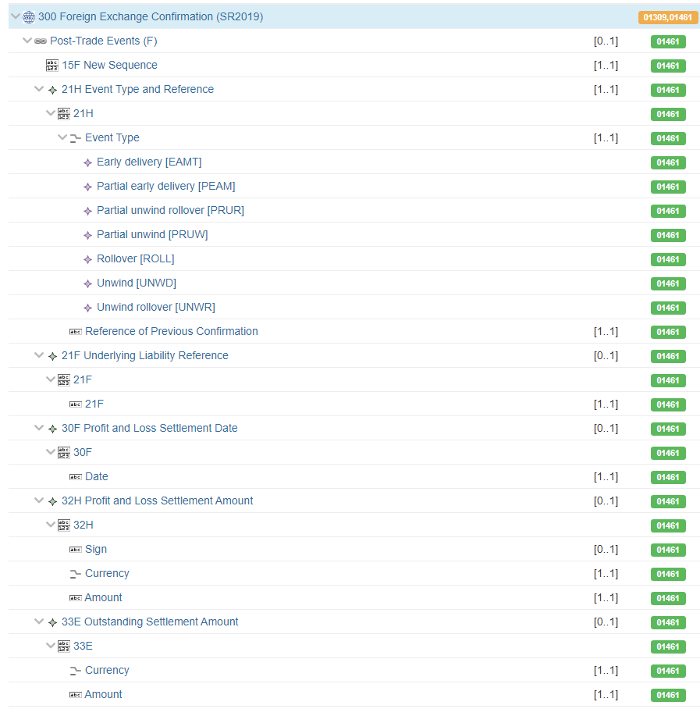

SEG/TSG recommendation:
This section is not to be taken care of by the submitter of the change request. It will be completed in due time by the SEG(s) in charge of the related ISO 20022 messages or the TSG for changes related to the BAH.

Consider |  | X | Timing
 |  |  | - Next yearly cycle: 2024/2025  (the change will be considered for implementation in the yearly maintenance cycle which starts in 2024 and completes with the publication of new message versions in the spring of 2025) |  | X
- At the occasion of the next maintenance of the messages
(the change will be considered for implementation, but does not justify maintenance of the messages in its own right – will be pending until more critical change requests are received for the messages)
- Urgent unscheduled
(the change justifies an urgent implementation outside of the normal yearly cycle)
 |  |  | - Other timing:
Comments:
CLS stated that they plan to use the Payment Clearing Centre as soon as it is available, as part of their netting service. They would therefore like the CR to be implemented as part of the maintenance cycle 2024/2025.
It was noted that Underlying Product Identifier should be correctly referred to as Unique Product Identifier.

Reject
Reason for rejection:

Impact analysis and type of impact:
The following Message Identifiers will be impacted –

fxtr.014.001.05 | ForeignExchangeTradeInstructionV05
fxtr.015.001.05 | ForeignExchangeTradeInstructionAmendmentV05
fxtr.016.001.05 | ForeignExchangeTradeInstructionCancellationV05
fxtr.017.001.05  fxtr.008.001.07  fxtr.030.001.05 | ForeignExchangeTradeStatusAndDetailsNotificationV05  ForeignExchangeTradeStatusNotificationV07  ForeignExchangeTradeBulkStatusNotificationV05

Proposed implementation:
For discussion -
An incorrect and obsolete data type of DTI2021Identifier was being used across the messages in the Identifier element. This has been replaced with the DTI2024Identifier data type. The obsolete data type only supported 8 characters when up 9 characters is correct. Does the FXSEG support this?
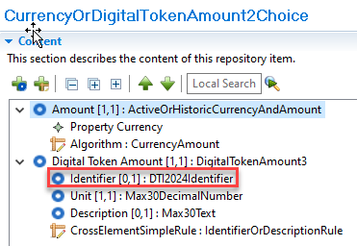
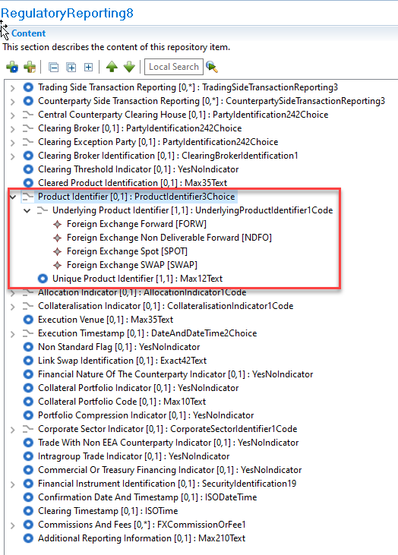
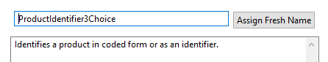
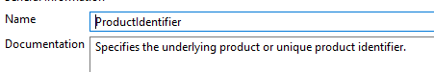
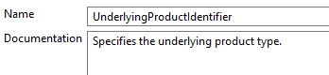
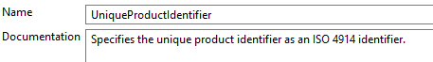
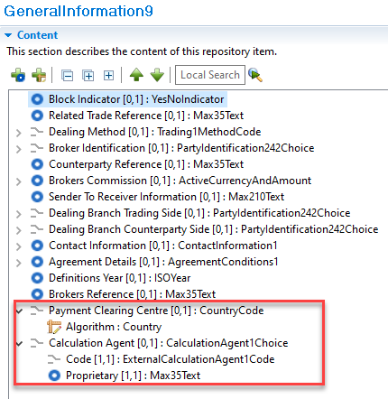
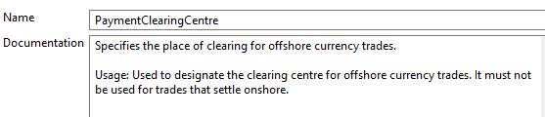
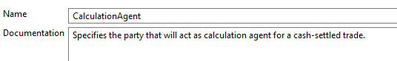
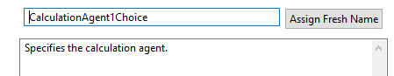
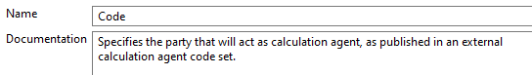
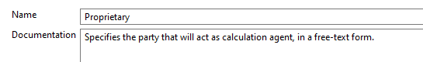
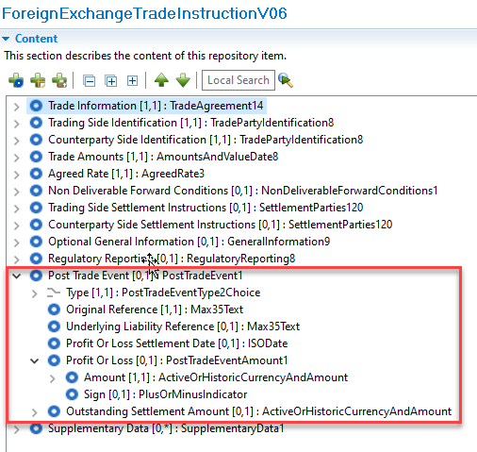
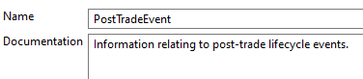
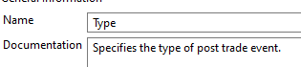
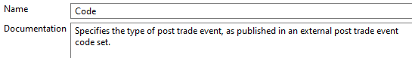
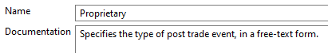
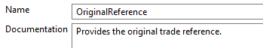
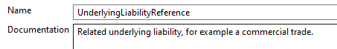
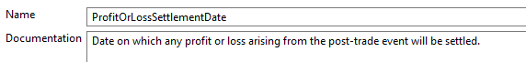
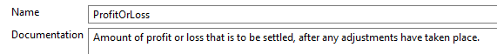
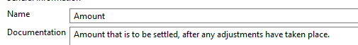
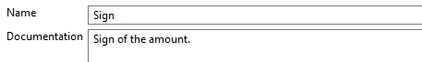
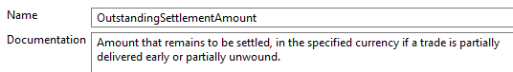

Proposed timing:
The submitting organisation confirms that it can implement the requested changes in the requested timing.

Timing | X

Final decision of the SEG(s):

Approve

Reject
Reason for rejection:

Change request CR1395: Post Trade FX - camt.088 alignment to MT3xx

Origin of the request:
A.1 Submitter: CLS Bank International
A.2 Contact person: Stuart Buckley. sbuckley@cls-services.com

A.3 Sponsors: This change will be socialised with all CLS Member/Participant banks via an official Participant notice. We adopt a policy at CLS of aligning our messages to the latest standards where there is a valid business case to do so. No objections to this strategy have been received.

Related messages:
The list of ISO 20022 messages which would be impacted by the change, including the Message IDs as shown in the Catalogue of ISO 20022 messages. Only the latest version of a message definition can be maintained.

Message | Message Name
camt.088.001.02.xsd | NetReportV02

Description of the change request:
Updating the camt.088 with the capability of handling CNH/CNY to align with the fxtr messages that are also being updated to align with field 39M Payment Clearing Centre in the MT 300 and MT 304.
This addition to the camt.088 will ensure that we are fully aligned to the MT 300 and MT 304 and meet future market expectations regarding standards compatibility between the XML message suite and the MT 3XX messages.

Purpose of the change:
CLS also has a policy of aligning messages to the latest versions and standards. Adding the above change to the camt.088 continues this practice. This Payment Clearing Centre option has been omitted from previous updates but may be required by the market in the future, so we feel the updates are essential to ensure the camt.088 is up to date when required by the business. This will meet our Participants expectations regarding standards alignment across our message suite.

Urgency of the request:
Default timeline of June 1st for submission and availability of the new versions in SR2025

Business examples:
The new MX element/s required in the camt.088 message to align with the below MT 300 and MT 304 change requests from previous Standards releases.

Field 39M

SEG/TSG recommendation:
This section is not to be taken care of by the submitter of the change request. It will be completed in due time by the SEG(s) in charge of the related ISO 20022 messages or the TSG for changes related to the BAH.

Consider |  | X | Timing
 |  |  | - Next yearly cycle: 2024/2025  (the change will be considered for implementation in the yearly maintenance cycle which starts in 2024 and completes with the publication of new message versions in the spring of 2025) |  | X
- At the occasion of the next maintenance of the messages
(the change will be considered for implementation, but does not justify maintenance of the messages in its own right – will be pending until more critical change requests are received for the messages)
- Urgent unscheduled
(the change justifies an urgent implementation outside of the normal yearly cycle)
 |  |  | - Other timing:
Comments:
CLS stated that they wish to use this feature as soon as possible and would therefore like it included to the maintenance cycle 2024/2025. This CR is directly linked to CR1394.

Reject
Reason for rejection:

Impact analysis and type of impact:
The following Message Identifiers will be impacted –

camt.088.001.02 | NetReportV02

Proposed implementation:
For discussion -
Added to the NetObligation block. Does the FXSEG support this?

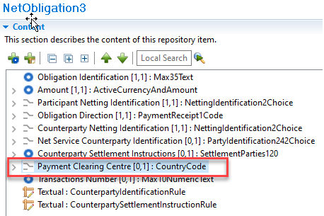
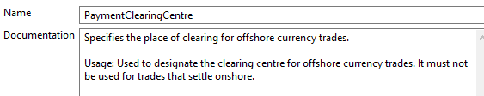

Proposed timing:
The submitting organisation confirms that it can implement the requested changes in the requested timing.

Timing | X

Final decision of the SEG(s):

Approve

Reject
Reason for rejection:

Change request CR1394: Post Trade FX - fxtr.030 optimization for CLSNet

Origin of the request:
A.1 Submitter: CLS Bank International
A.2 Contact person: Stuart Buckley. sbuckley@cls-services.com

A.3 Sponsors: This change will be socialised with all CLS Member/Participant banks via an official Participant notice. We adopt a policy at CLS of aligning our messages to the latest standards where there is a valid business case to do so. No objections to this strategy have been received.

Related messages:
The list of ISO 20022 messages which would be impacted by the change, including the Message IDs as shown in the Catalogue of ISO 20022 messages. Only the latest version of a message definition can be maintained.

Message | Message Name
fxtr.030.001.05.xsd | ForeignExchangeTradeBulkStatusNotificationV05

Description of the change request:
Updating the message schema for the fxtr.030.001.05 message to optimize the bulk trade status notifications for bilateral netting in CLSNet and reducing the number of notifications generated.
Bulk trade status notifications generated for bilateral netting in CLSNet currently require individual notifications to link each net position (<LkdRptId>) with the corresponding trades. This message schema creates inefficiencies when handling a large number of bilateral net positions, requiring generation of numerous notifications. To optimize this process, we propose a schema update that allows the inclusion of multiple bilateral positions within a single bulk notification. This improvement will significantly reduce the number of notifications generated.

Currently in CLSNet the fxtr.030 is used to link the Obligation Id (Bilateral Reference) for each net position to the underlying trades.

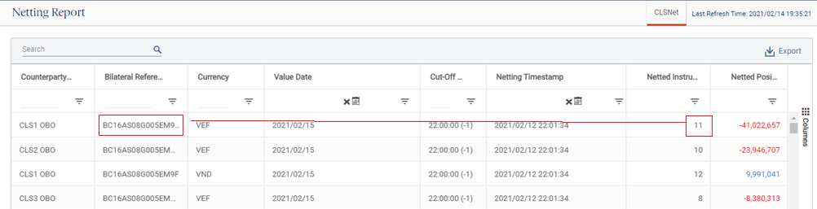

Purpose of the change:
To optimize the fxtr.030 message for bilateral netting to reduce the number of notifications generated for CLSNet without negatively impacting the schema for general use in the primary CLSSettlement service.

Urgency of the request:
Default timeline of June 1st for submission and availability of the new versions in SR2025

Business examples:
Sample fxtr.030:
Unlike the primary CLSSettlement service, we need to establish the link between the bilateral net position and the underlying trades; So the <LkdRptId> (Obligation Id in camt.088) is populated.

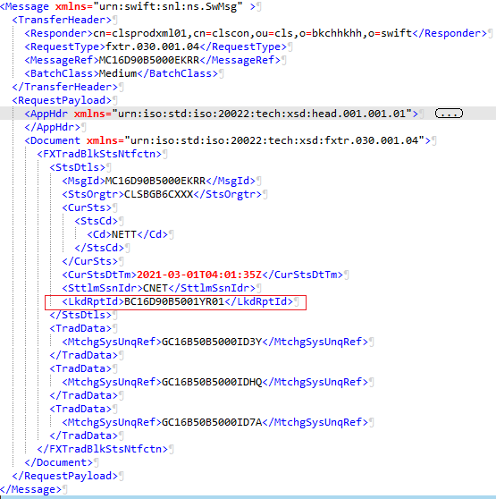

Sample camt.088 showing a single obligation:

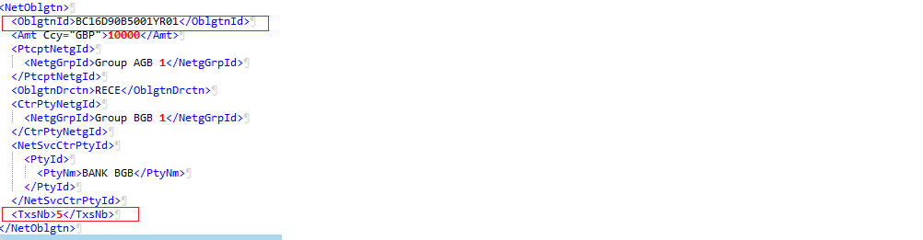

SEG/TSG recommendation:
This section is not to be taken care of by the submitter of the change request. It will be completed in due time by the SEG(s) in charge of the related ISO 20022 messages or the TSG for changes related to the BAH.

Consider |  | X | Timing
 |  |  | - Next yearly cycle: 2024/2025  (the change will be considered for implementation in the yearly maintenance cycle which starts in 2024 and completes with the publication of new message versions in the spring of 2025) |  | X
- At the occasion of the next maintenance of the messages
(the change will be considered for implementation, but does not justify maintenance of the messages in its own right – will be pending until more critical change requests are received for the messages)
- Urgent unscheduled
(the change justifies an urgent implementation outside of the normal yearly cycle)
 |  |  | - Other timing:
Comments:
CLS stated that they wish to use this feature as soon as possible and would therefore like it included to the maintenance cycle 2024/2025. This CR is directly linked to CR1395.

Reject
Reason for rejection:

Impact analysis and type of impact:
The following Message Identifiers will be impacted –

fxtr.030.001.05 | ForeignExchangeTradeBulkStatusNotificationV05

Proposed implementation:
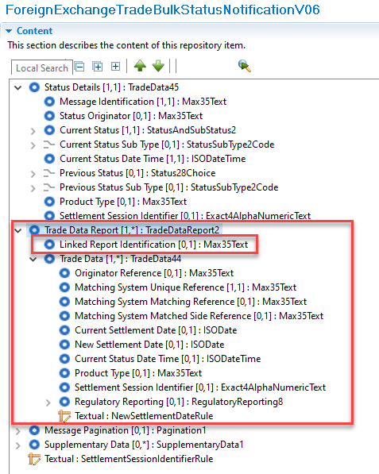

Proposed timing:
The submitting organisation confirms that it can implement the requested changes in the requested timing.

Timing | X

Final decision of the SEG(s):

Approve

Reject
Reason for rejection:

Change request CR1408: Change of the UTI implementation and additions

Origin of the request:
A.1 Submitter: SMPG Settlements & Reconciliation Working Group represented by Robin Leary (UK&IE Representative) and Karine Taquet (Swift Standards)
A.2 Contact person: Robin Leary (robin.leary@citi.com)
A.3 Sponsors: SMPG Settlements & Reconciliation Working Group

Related messages:

Securities Management
semt.017, semt.018, semt.019, semt.022 (T2S UTI not included at all), sese.021, sese.023, sese.024, sese.025, sese.026, sese.028, sese.030, sese.031, sese.032, sese.033, sese.034, sese.035, sese.036, sese.038, sese.022, sese.041, sese.042

Securities Trade (UTI not included must be)
setr.027, setr.030, setr.044, setr.029

Collateral Management
colr.005, colr.019, colr.020, colr.021, colr.022, colr.23, colr.024

Reference Data
reda.074

Cash Management
camt.057, camt.111

Payments Clearing and Settlement
pacs.009

Authorities
auth.016, auth.029, auth.030, auth.052, auth.070, auth.078, auth.079, auth.080, auth.083, auth.084, auth.085, auth.090, auth.091, auth.092, auth.105, auth.106, auth.107, auth.108, auth.109, auth.113

Foreign Exchange Trade
fxtr.008, fxtr.015, fxtr.016, fxtr.017, fxtr.014

Description of the change request:
As part of SR2019 (CR 001448), the UTI was added to numerous MT messages and, as part of co-existence, all equivalent ISO 20022 messages. In ISO 15022, this was done by adding a new 20U format option in qualifier TRRF (Deal Reference) and in ISO 20022, the Trade Identification element was made repetitive, and the length increased from 35 characters to 52 characters.
Whilst the ISO 15022 addition is easily distinguished between a traditional Deal Reference (:20C::TRRF) and UTI (:20U::TRRF), the ISO 20022 element does not easily distinguish between the two and can lead to confusion.
The proposal is to create a new element in ISO 20022 for the UTI in the Trade Details sequence and revert the Trade Identification element to its original form (non-repetitive and 35 characters). The ISO 15022 use will remain as is.
In the ISO 20022 messages where the UTI is not present, I must be added.
Given there's not a huge usage of the UTI in ISO 20022 messages at present, the change should be low impact.

Purpose of the change:
Create a new "Unique Transaction Identifier" element in the Trade Details sequence (or other relevant sequences) in all impacted ISO 20022 messages (where the change was made in SR2019). The new element should be optional, non-repetitve and up to 52 characters in length.
The "Trade Identification" element should be changed to revert to being non-repetitve and up to 35 characters in length.
From a translation perspective, :20C::TRRF would align to the Trade Identification element and :20U::TRRF would align to the new Unique Transaction Identifier element.
No changes are expected to the ISO 15022 MT messages.
In the ISO 20022 messages where the UTI is missing, it must be added.

Urgency of the request:
Cycle 2024-2025

Business examples:
Examples illustrating the change request.

SEG/TSG recommendation:
This section is not to be taken care of by the submitter of the change request. It will be completed in due time by the SEG(s) in charge of the related ISO 20022 messages or the TSG for changes related to the BAH.

Consider |  | X | Timing
- Next yearly cycle: 2024/2025
(the change will be considered for implementation in the yearly maintenance cycle which starts in 2024 and completes with the publication of new message versions in the spring of 2025)
 |  |  | - At the occasion of the next maintenance of the messages  (the change will be considered for implementation, but does not justify maintenance of the messages in its own right – will be pending until more critical change requests are received for the messages) |  | X
- Urgent unscheduled
(the change justifies an urgent implementation outside of the normal yearly cycle)
 |  |  | - Other timing:
Comments:
There is no urgency for the FX changes. However, most of the messages will anyway be maintained as part of the maintenance cycle 2024/2025, as part of CR 1393, so this UTI change will be implemented alongside that.
It was noted that the UTI message component traces to type Max35Text in the business model, and that this will have to be changed.

Reject
Reason for rejection:

Impact analysis and type of impact:
The following Message Identifiers will be impacted –

fxtr.014.001.05 | ForeignExchangeTradeInstructionV05
fxtr.015.001.05 | ForeignExchangeTradeInstructionAmendmentV05
fxtr.016.001.05 | ForeignExchangeTradeInstructionCancellationV05
fxtr.017.001.05  fxtr.008.001.07  fxtr.030.001.05 | ForeignExchangeTradeStatusAndDetailsNotificationV05  ForeignExchangeTradeStatusNotificationV07  ForeignExchangeTradeBulkStatusNotificationV05

Proposed implementation:
For discussion -
The relevant messages being maintained as part of this cycle already contained elements to support Unique Transaction Identifiers using data type Max52Text. The data type has been changed to data type UTIIdentifier as discussed at the screening meeting. Does the FXSEG support this?
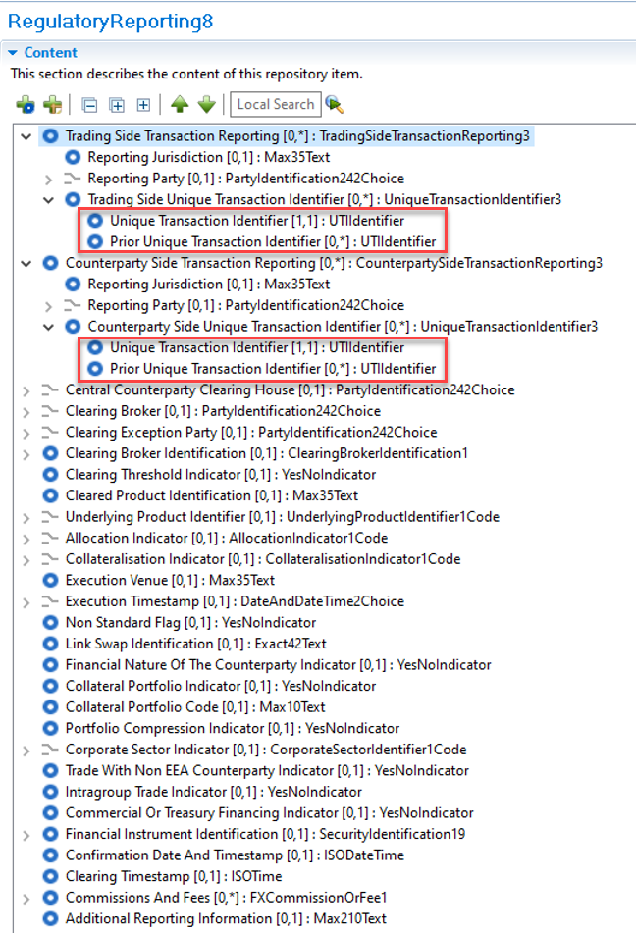

Proposed timing:
The submitting organisation confirms that it can implement the requested changes in the requested timing.

Timing | X

Final decision of the SEG(s):

Approve

Reject
Reason for rejection:

Additional technical adjustments in the ISO 20022 rules identified during the maintenance (standing change request)
As part of the implementation, we have identified a number of technical errors in the description of the rules defined in the messages. Below is the exhaustive list of corrections as applied to the messages:

 | Issue in rule or data type | Description of the change required

List of Change Requests for consideration after first screening
Change request CR1393: Update Post Trade FX messages to align with MT3xx 3
Change request CR1395: Post Trade FX - camt.088 alignment to MT3xx 13
Change request CR1394: Post Trade FX - fxtr.030 optimization for CLSNet 17
Change request CR1408: Change of the UTI implementation and additions 22
Additional technical adjustments in the ISO 20022 rules identified during the maintenance (standing change request) 28

