Change Request
for the update of ISO 20022 financial repository items

- Origin of the request:
A.1 Submitter:
Deutsche Bundesbank, on behalf of the Eurosystem
A.2 Contact person:
Steffen Fährmann, steffen.faehrmann@bundesbank.de, +49 171 9244421
Stéphanie Radet, stephanie.radet@bundesbank.de, +49 69 9566-33528
evolution.emip@bundesbank.de
A.3 Sponsors:
The banking community of T2 (Eurosystems’ Market Infrastructures Platform)

- Related messages:
Bank To Customer Account Report V12 (camt.052.001.12)
Bank To Customer Statement V12 (camt.053.001.12)
Bank To Customer Debit Credit Notification V12 (camt.054.001.12)

- Description of the change request:
Similar to the camt.006 Return Transaction, we would like to see Instruction Copy added to the reporting messages.
- Element Name: <Instruction Copy>
- Multiplicity: [0..1]
- Datatype: Max20000Text (based on string), minLength: 1, maxLength: 20000.
- Proposed definition: “Copy of the original instruction, in free form text.

Illustration with an extract from the camt.006.001.11, in which Instruction Copy is nested in Transaction (see : /Document/RtrTx/RptOrErr/BizRpt/TxRpt/TxOrErr/Tx/Pmt/InstrCpy)
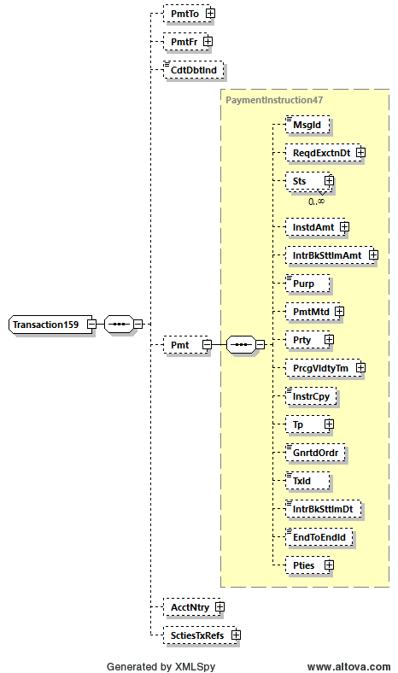

In all three messages, Instruction Copy could be included in “Entry Transaction” (see illustration below).
The camt.052/053/054 are not only used by Corporates and banks, but also by Global Custodians and investment managers, who could also benefit from the addition of the Instruction Copy element towards the end of the message, close to “Additional transaction Information”.

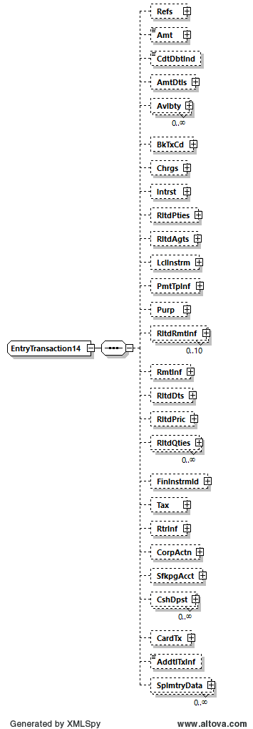
- Purpose of the change:
The camt.052, camt.053 and camt.054 aim to provide information for cash management and/or reconciliation. They can include details of underlying transactions that have been included in the entry.
Similarly, the camt.006 ReturnTransaction provides details of underlying transactions with the transaction administrator. But in addition to elements such as transaction references and agents/parties present in the camt.052/053 and 054, the camt.006 also enables the inclusion of the underlying transaction in element <InstructionCopy> and some of those transactions may not have been initiated by an ISO 20022 XML messages, as for instance today in T2:
- system generated transactions (e.g., standing order or automated liquidity transfers),
- User-to-Application entries (via GUI),
- proprietary XML messages where information cannot be fully mapped into camt.052, camt.053 and camt.054 structure,
Further benefits of the element <InstructionCopy> would be provision of
- full business message, i.e. including also the head.001 in addition to document into camt.052, camt.053, camt.054 reporting.
- transaction details of messages originally initiated in other data format, e.g., JSON
In the case of recovery scenario T2 will need <InstrCpy> in camt.054 to rebuild information on settled/executed instructions which cannot be retrieved from NSP. In particular a full copy of U2A and TARGET Services internal A2A messages is needed.

- Urgency of the request:
Next maintenance cycle.

- Business examples:
<InstrCpy>
<![CDATA[ <AppHdr xmlns="urn:iso:std:iso:20022:tech:xsd:head.001.001.01" xmlns:n1="http://www.w3.org/2000/09/xmldsig#" xmlns:xsi="http://www.w3.org/2001/XMLSchema-instance" xsi:schemaLocation="urn:iso:std:iso:20022:tech:xsd:head.001.001.01 CLM_head_001_001_01_20200504.xsd"><Fr><FIId><FinInstnId><BICFI>PBABVED0XXX</BICFI><ClrSysMmbId><ClrSysId><Prtry>CLM</Prtry></ClrSysId><MmbId>SUR1-pbabved0xxx</MmbId></ClrSysMmbId></FinInstnId></FIId></Fr><To><FIId><FinInstnId><BICFI>TRGTXETTCLM</BICFI></FinInstnId></FIId></To><BizMsgIdr>B111712080576001</BizMsgIdr><MsgDefIdr>camt.050.001.05</MsgDefIdr><CreDt>2023-11-17T12:08:15Z</CreDt></AppHdr><Document xmlns="urn:iso:std:iso:20022:tech:xsd:camt.050.001.05" xmlns:xsi="http://www.w3.org/2001/XMLSchema-instance" xsi:schemaLocation="urn:iso:std:iso:20022:tech:xsd:camt.050.001.05 CLM_camt_050_001_05_20210624.xsd"><LqdtyCdtTrf><MsgHdr><MsgId>NONREF</MsgId></MsgHdr><LqdtyCdtTrf><LqdtyTrfId><InstrId>E111712080576001</InstrId><EndToEndId>E111712080576001</EndToEndId></LqdtyTrfId><CdtrAcct><Id><Othr><Id>AcctID</Id></Othr></Id></CdtrAcct><TrfdAmt><AmtWthCcy Ccy="EUR">01.00</AmtWthCcy></TrfdAmt><DbtrAcct><Id><Othr><Id>AcctID</Id></Othr></Id></DbtrAcct><SttlmDt>2023-11-17</SttlmDt></LqdtyCdtTrf></LqdtyCdtTrf></Document> ]]>
</InstrCpy>
- SEG/TSG recommendation:
This section is not to be taken care of by the submitter of the change request. It will be completed in due time by the SEG(s) in charge of the related ISO 20022 messages or the TSG for changes related to the BAH.

Consider |  |  | Timing
- Next yearly cycle: 2024/2025
(the change will be considered for implementation in the yearly maintenance cycle which starts in 2024 and completes with the publication of new message versions in the spring of 2025)
- At the occasion of the next maintenance of the messages
(the change will be considered for implementation, but does not justify maintenance of the messages in its own right – will be pending until more critical change requests are received for the messages)
- Urgent unscheduled
(the change justifies an urgent implementation outside of the normal yearly cycle)
 |  |  | - Other timing:
Comments:

Reject
Reason for rejection:

