Maintenance Change Request
for fast track maintenance of existing message definitions

- Submitting organizations:
- European Securities and Markets Authority (ESMA)
201-203 rue de Bercy
75012 Paris
France

- Commodity Futures Trading Commission (CFTC)
Three Lafayette Centre
1155 21st Street, NW
Washington, DC 20581
United States

- Australian Securities and Investments Commission (ASIC)
Level 5, 100 Market St
Sydney NSW 2000
Australia

- Financial Services Agency Government of Japan (JFSA)
3-2-1 Kasumigaseki, Chiyoda-ku
Tokyo 100-8967
Japan

- Hong Kong Monetary Authority (HKMA)
55th Floor, Two International Finance Centre
8 Finance Street, Central
Hong Kong

- Securities and Futures Commission (SFC)
54th Floor, One Island East
18 Westlands Road, Quarry Bay
Hong Kong

- Monetary Authority of Singapore (MAS)
10 Shenton Way, MAS Building
Singapore 079117

- Related messages:
auth.030.001.03 (DerivativesTradeReportV03)
auth.091.001.02 (DerivativesTradeReconciliationStatisticalReportV02)
auth.107.001.01 (DerivativesTradeStateReportV01)
auth.029.001.04 (DerivativesTradeReportQueryV04)
auth.108.001.01 (DerivativesTradeMarginDataReportV01)
auth.109.001.01 (DerivativesTradeMarginDataTransactionStateReportV01)

- Purpose of the change:
In the context of the preparations for the implementations of the revised OTC derivative reporting rules, the regulators have identified certain instances where the auth.030 message (developed based on the internationally agreed CDE Technical Guidance) would need to be further expanded to cover jurisdiction-specific requirements. Incorporation of such changes, such as additional elements for barrier options or secondary transaction identifier, will enable the regulators to use the globally recognised ISO message while accommodating for their specific needs. Furthermore, additional elements were added to reflect the new CDEs included in the updated CDE Technical Guidance, notably: Underlying asset trading platform identifier and Underlying asset price source. Finally, additional changes were proposed to align the existing definitions used in the auth.030 message and to modify the cardinality where required and to better align with reporting use-cases.
In addition to the updates requested by other regulators that plan to utilize the auth.030 and related messages in their respective implementations, ESMA decided to incorporate further changes, following the additional feedback received from its stakeholders (such as trade repositories and national competent authorities) as part of their preparation towards 29 April 2024 go-live of the EMIR REFIT reporting. In particular, one minor code correction is required to report the received paper collateral sub-product type in the auth.030/auth.107 messages (currently it is using the OTHR code instead of RCVP); update of the documentation of further modifications flag under reconciliation categories is required in the auth.091 reconciliation message to align with the guidelines on reporting under EMIR. Moreover, ESMA would like to remove one duplicated structure in the reconciliation report (auth.091) and provide for more flexibility in terms of frequencies of queries that could be submitted by the competent authorities through auth.029 message. These updates will provide relevant improvements to the current messaging without major impact on the stakeholders.
Details of all changes in scope of this maintenance change request, as well as their proposed implementation are provided as an annex to this document.

- Urgency of the request:
Several jurisdictions are preparing for the go-live of the reporting under the revised rules using ISO 20022 messages, starting with JFSA reporting on 1 April 2024, EMIR reporting in the EU on 29 April 2024 and ASIC and MAS reporting on 21 October 2024.
Amending the base message without undue delay is necessary to ensure that the interested jurisdictions can start using the updated ISO 20022 messages on their go-live date or otherwise as soon as the proposed changes can be reflected in the jurisdictional rules. This will support adoption of the standardised reporting in ISO 20022 within the relevant jurisdictions.

- Commitments of the submitting organization:
The ESMA TRACE project team confirms that it plans to develop a new version of the impacted message and system in accordance with the changes proposed in this document.
The participating regulators confirm their knowledge and acceptance of the ISO 20022 Intellectual Property Rights policy for contributing organizations, as follows.
“Organizations that contribute information to be incorporated into the ISO 20022 Repository shall keep any Intellectual Property Rights (IPR) they have on this information. A contributing organization warrants that it has sufficient rights on the contributed information to have it published in the ISO 20022 Repository through the ISO 20022 Registration Authority in accordance with the rules set in ISO 20022. To ascertain a widespread, public and uniform use of the ISO 20022 Repository information, the contributing organization grants third parties a non-exclusive, royalty-free license to use the published information”.

- Contact persons:
ESMA:
Joanna Lednicka – Joanna.Lednicka@esma.europa.eu
Krisztina Miklossy – krisztina.miklossy@esma.europa.eu
Michal Zubrycki – michal.Zubrycki-ext@esma.europa.eu
CFTC:
Robert Stowsky - RStowsky@CFTC.gov
Laboni Ashrafi – LAshrafi@CFTC.gov
ASIC:
Craig McBurnie – craig.mcburnie@asic.gov.au
FSA:
Megumi Ota – megumi.ota@fsa.go.jp
Kiyoshi Tsuchiya – kiyoshi.tsuchiya@fsa.go.jp
HKMA:
Polly Lee - pyklee@hkma.gov.hk
Cherry Wong - cpkwong@hkma.gov.hk
SFC:
Eunice Cheng – ekwcheng1@sfc.hk
Kennancy Leung – kksleung@sfc.hk
MAS:
Edward OEI – Edward_Oei@mas.gov.sg
Priscilla KHONG – Priscilla_Khong@mas.gov.sg
YEO Jia Li – Yeo_Jia_Li@mas.gov.sg

- List of changes (detailed in the following section):

Change number #1
- Related messages:
auth.030.001.03 (DerivativesTradeReportV03)
auth.107.001.01 (DerivativesTradeStateReportV01)
- Description of the change:
Following request from the JFSA (Japan), Confirmation Timestamp element has been updated to an optional field in the auth.030 (.../CmonTradData/TxData/TradConf/Confd/TmStmp) for all action types; and in the auth.107 (…/CmonTradData/TxData/TradConf/Confd/TmStmp). Rationale behind this request is the fact that under the Japanese derivatives reporting regime, time stamp is not required to be reported by the counterparties. Making the element optional will allow the regulator to disable this field at the usage guideline level.
- Proposed implementation:
Approved message | Proposed change
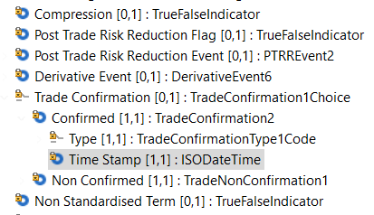 | 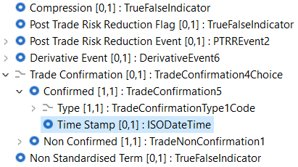
- Decision of the SEG(s):
This section is not to be taken care of by the submitting organization. It will be completed in due time by the SEG(s) in charge of the related ISO 20022 message definitions.

Change
approved
rejected

Change number #2
- Related messages:
auth.030.001.03 (DerivativesTradeReportV03)
auth.107.001.01 (DerivativesTradeStateReportV01)

- Description of the change:
Following request from ASIC (Australia), as proposed by Australian industry participants, a new element Secondary Transaction Identifier (/Document/DerivsTradRpt/TradData/Rpt/New/CmonTradData/TxData/ScndTxId) has been added under the Transaction Data block (placed directly under the Transaction Identification component). The element is set as optional with Max72Text as underlying data type. The rationale behind this addition is that the secondary transaction identifier would provide industry participants with an additional manner to tie trade repository records to their internal books and records. Definition of the element is as follows: “An optional, additional trade identifier as determined by the Reporting Counterparty. Usage: this element is not intended to be used in any data handling to link a report to any previous report.” Applicable to both auth.030 and auth.107.
ASIC advises that the Australian offices of the following financial institutions have consented to ASIC to be named as supporting this change request :
Australia and New Zealand Banking Group Limited | Citibank, National Association
Commonwealth Bank of Australia | JPMorgan Chase Bank, National Association
Macquarie Bank Limited | National Australia Bank Limited
State Street Bank and Trust Company | Westpac Banking Corporation

- Proposed implementation:
Approved message | Proposed change
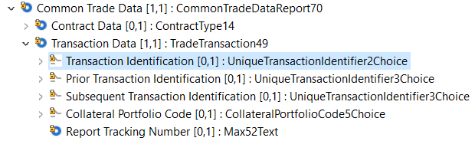 |  | 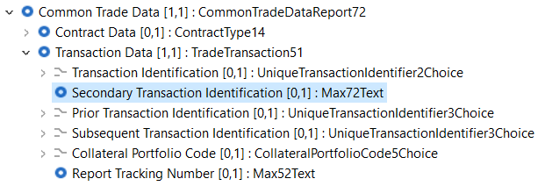

- Decision of the SEG(s):
This section is not to be taken care of by the submitting organization. It will be completed in due time by the SEG(s) in charge of the related ISO 20022 message definitions.

Change
approved
rejected

Change number #3
- Related messages:
auth.030.001.03 (DerivativesTradeReportV03)
auth.107.001.01 (DerivativesTradeStateReportV01)
- Description of the change:
Following request from ASIC (Australia), two new additional optional components have been added under Option – Lower Or Only Barrier and Upper Barrier. Definition of the former: “For a barrier option, specifies the predetermined price of an underlier at which the occurrence of a barrier event (e.g. knock-out) is determined. Usage: In the case of a barrier option involving only one barrier price, the only barrier price. In the case of a barrier option involving two barrier prices, the lower of the two barrier prices.” Definition of the latter: “For a barrier option involving two barrier prices, specifies the predetermined price of an underlier at which the occurrence of a barrier event (e.g. knock-out) is determined. Usage: In the case of a barrier option involving only one barrier price, this element is not reported. In the case of a barrier option involving two barrier prices, the higher of the two barrier prices.” Both components are defined with underlying type SecuritiesTransactionPrice17Choice. Change is applicable in both auth.030 and auth.107.
- Proposed implementation:
Approved message | Proposed change
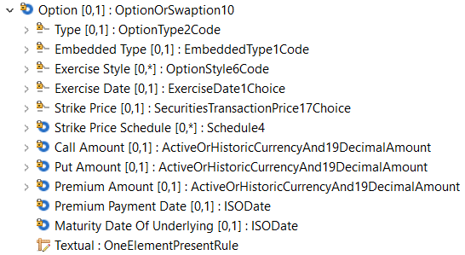 |  | 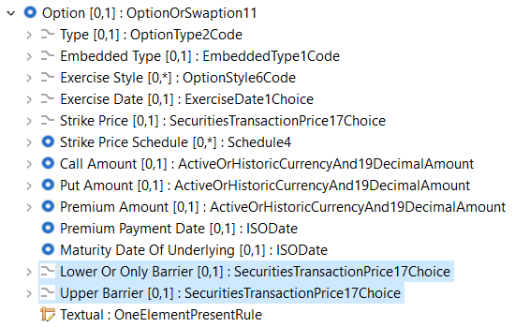

- Decision of the SEG(s):
This section is not to be taken care of by the submitting organization. It will be completed in due time by the SEG(s) in charge of the related ISO 20022 message definitions.
Change
approved
rejected

Change number #4
- Related messages:
auth.030.001.03 (DerivativesTradeReportV03)
auth.107.001.01 (DerivativesTradeStateReportV01)
auth.108.001.01 (DerivativesTradeMarginDataReportV01)
auth.109.001.01 (DerivativesTradeMarginDataTransactionStateReportV01)
- Description of the change:
Following request from ASIC (Australia), definitions for InitialMarginPortfolioCode and VariationMarginPortfolioCode have been corrected as were improperly pointing to elements not par. The outdated usage part of the documentation “NoCode” has been changed to “NoPortfolio” to avoid confusion for the users of the message.
In addition, the cardinalities of InitialMarginPortfolioCode and VariationMarginPortfolioCode would be switched with each other – that is:
- InitialMarginPortfolioCode would change from [1,1] to [0,1]
- VariationMarginPortfolioCode would change from [0,1] to [1,1]
The rationale is to enable more efficient use of the message – noting that, in practice, there are more reporting instances of only a VariationMarginPortfolioCode (and no InitialMarginPortfolioCode) than reporting instances of the opposite (only an InitialMarginPortfolioCode and no VariationMarginPortfolioCode)
- Proposed implementation:
Approved message | Proposed change
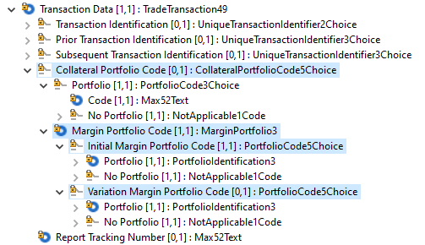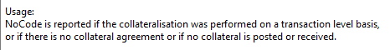 |  | 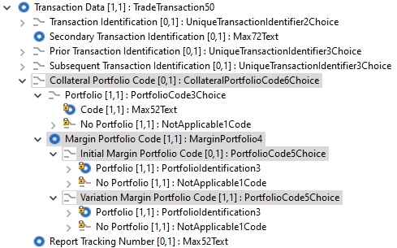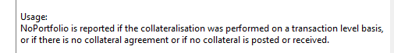
- Decision of the SEG(s):
This section is not to be taken care of by the submitting organization. It will be completed in due time by the SEG(s) in charge of the related ISO 20022 message definitions.

Change
approved
rejected

Change number #5
- Related messages:
auth.030.001.03 (DerivativesTradeReportV03)
auth.107.001.01 (DerivativesTradeStateReportV01)
- Description of the change:
Following request from ESMA based on the stakeholders feedback, the Sub-product code list for Recovered Paper Commodity (.../CmonTradData/TxData/Cmmdty/Ppr/RcvrdPpr/SubPdc) has been updated. In particular, code [OTHR] has been replaced with [RCVP].
- Proposed implementation:
Approved message | Proposed change
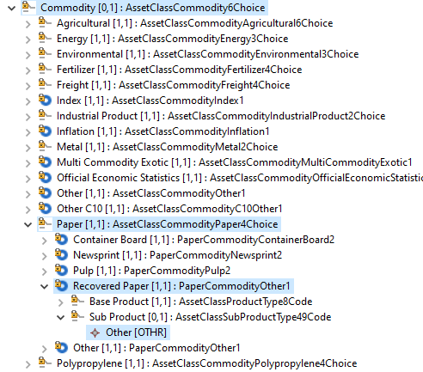 |  | 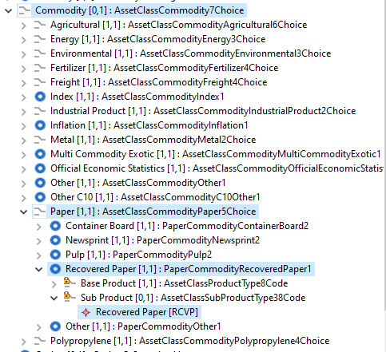

- Decision of the SEG(s):
This section is not to be taken care of by the submitting organization. It will be completed in due time by the SEG(s) in charge of the related ISO 20022 message definitions.

Change
approved
rejected

Change number #6
- Related messages:
auth.030.001.03 (DerivativesTradeReportV03)
auth.107.001.01 (DerivativesTradeStateReportV01)
- Description of the change:
Addition of 2 new optional elements from IOSCO CDE v3 (Sep 2023) around the underlying assets in the contract data block - Underlying Asset Trading Platform Identifier and Underlying Asset Price Source. Documentation for these elements corresponds to the definitions listed in the technical guidance.
- Proposed implementation:
Approved message | Proposed change
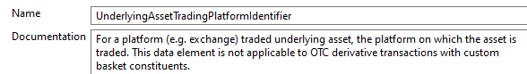  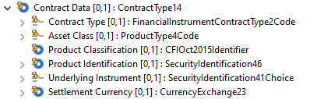 | 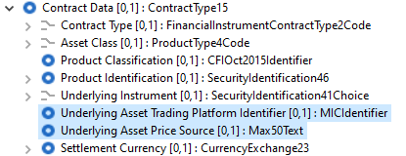

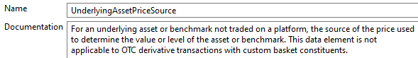

- Decision of the SEG(s):
This section is not to be taken care of by the submitting organization. It will be completed in due time by the SEG(s) in charge of the related ISO 20022 message definitions.
Change
approved
rejected

Change number #7
- Related messages:
auth.091.001.02 (DerivativesTradeReconciliationStatisticalReportV02)
- Description of the change:
Following request from ESMA based on the stakeholders feedback, message component assigned to (../MtchgCrit/TxMtchgCrit/NtnlAmtScndLeg/Val1, was updated to remove content related to the Leg 2 Schedule Amount Reference Amount because it duplicated the following block: (../MtchgCrit/TxMtchgCrit/NtnlAmtScndLegSchdlAmt). The new assigned component will be AmountAndDirection106, just like in the first leg.
- Proposed implementation:
Approved message | Proposed change
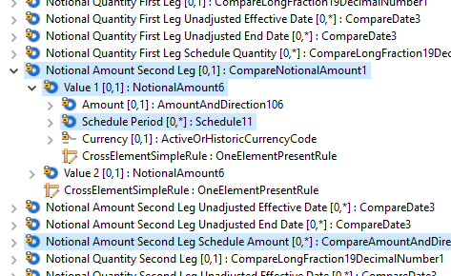 |  | 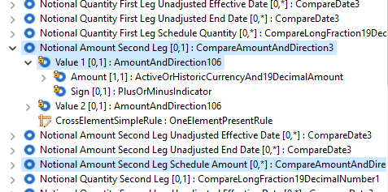
- Decision of the SEG(s):
This section is not to be taken care of by the submitting organization. It will be completed in due time by the SEG(s) in charge of the related ISO 20022 message definitions.
Change
approved
rejected

Change number #8
- Related messages:
auth.091.001.02 (DerivativesTradeReconciliationStatisticalReportV02)
- Description of the change:
Following request from ESMA based on the stakeholders feedback, definition of Further Modification (...RcncltnCtgrs/RptgRqrmnt/FrthrMod) (indicator as part of the Reconciliation Categories block (defined in ReconciliationCategory2 and ReconciliationCategory3) part: ", but not a correction of a report." has been removed.
- Proposed implementation
Approved message | Proposed change
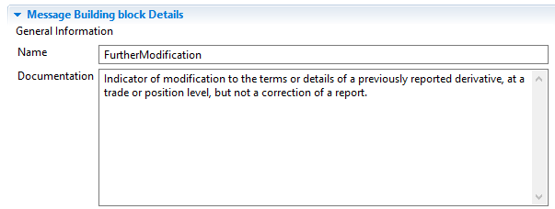  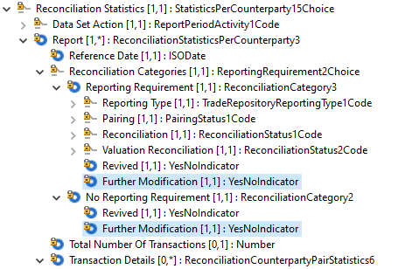 |  | 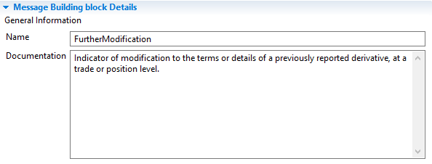  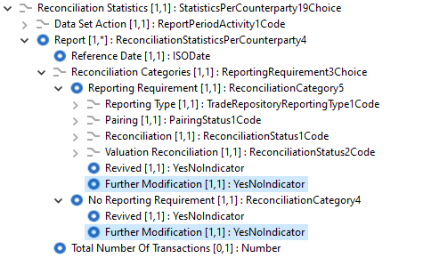
- Decision of the SEG(s):
This section is not to be taken care of by the submitting organization. It will be completed in due time by the SEG(s) in charge of the related ISO 20022 message definitions.

Change
approved
rejected

Change number #9
- Related messages:
auth.029.001.04 (DerivativesTradeReportQueryV04)
- Description of the change:
Following request from ESMA based on the stakeholders feedback, Recurrent Query branch of Trade Query Data was updated to include Frequency (..TradQryData/RcrntQry/Frqcy) component as multiple occurrences. This would allow for more flexible querying by competent authorities.
- Proposed implementation:
Approved message | Proposed change
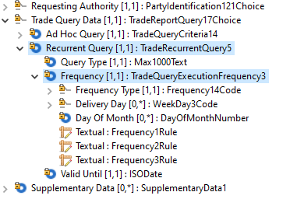 |  | 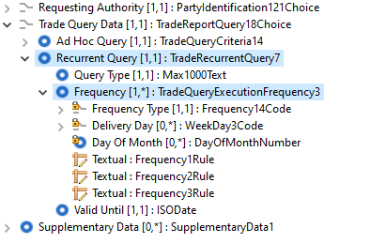

- Decision of the SEG(s):
This section is not to be taken care of by the submitting organization. It will be completed in due time by the SEG(s) in charge of the related ISO 20022 message definitions.
Change
approved
rejected

Timing
- Fast track maintenance
(the change justifies an urgent implementation using the fast track maintenance process)
- At the occasion of the next maintenance of the messages
(the change will be considered for implementation, but does not justify an urgent implementation – will be pending until the next [yearly] maintenance of the messages)

See: https://www.leiroc.org/publications/gls/roc_20210922.pdf

