Standards
Standards MT Release 2024
Discussion paper and Minutes
Corporate Actions
Distribution: Corporate Action Maintenance Working Group
Author: Jacques Littré
Date Issued: 28 September 2023
Version: Final 1.1
Meeting Date: August 29, 2023

Table of Contents
1 Introduction 3
ISO 15022 – 20022 Maintenance Process 3
Standards Illustrations in this document 3
SR 2024 change requests 3
CR Title Colour notation (for minutes only) 3
Contact persons regarding this document 3
CA MWG Members for SR2024 3
2 Overview of User Change requests 5
2.1 CR 002028: Add new Balance Types Codes for Triparty Securities Lending Services 5
2.2 CR 002018: Amend Currency Option Definition 13
2.3 CR 001999: New Indicators and Amounts to Improve STP of French DVOP events 16
2.4 CR 002015: Add Reversal Reason Codes for Payment Reversals 23
2.5 CR 002002: Remove Useless Market Claim Indicator Codes in Confirmations 29
2.6 CR 002026: Add new Pending and Rejection Status Reason Code for Instructions Received Prior to Entitlement Date 33
2.7 CR 002007: Amend MT565 and 567 to Allow Usage for Market Claims 40
2.8 CR 002033: Add Missing Non Eligible Proceed Indicator Code NELS (ISO 20022 CR 1303) 59
2.9 CR 002034: New Indicator for Presence of Eligible Balance in Notification (ISO 20022 CR 1320) 61
2.10 CR 002035: Remove Update Description and Update Date in Narratives (ISO 20022 CR 1295) 64
2.11 CR 002036: Amend Scope of Movement Preliminary Advice (ISO 20022 CR 1298) 69
2.12 CR 002037: Add DateTime format to Posting Date / Original Posting Date (ISO 20022 CR 1321) 72
2.13 CR 002038: Align Pending StatusReason Codes in Instruction Statement Report (ISO 20022 CR 1297) 77
2.14 CR 002039: Set Elements as Mandatory in Market Claim messages (ISO 20022 CR 1301) 79
2.15 CR 002040: Issuer Agent - Agent Notification Status - Reason Code Updates and Alignment with CA messages (ISO 20022 CR 1315) 82
2.16 CR 002066: Align Pagination Mechanism with GM and SID messages (ISO 20022 CR 1331) 91

Introduction

ISO 15022 – 20022 Maintenance Process
As from the year 2012, a joint maintenance process has been put in place for ISO 20022 and 15022 and Corporate Action messages with the support of the ISO 20022 RMG and of the SWIFT Board.
This joint maintenance will ensure interoperability between the two standards and a more efficient maintenance process.

Standards Illustrations in this document
Standards illustrations are provided by SWIFT Standards. They are not part of the original request.
Any standard illustrations (rules, codes, qualifiers, wordings) are only for illustration purposes. It does not mean SWIFT Standards is in agreement with the maintenance request or that the final standards solutions (for accepted maintenance requests) will be as shown in this document.
The MT Standards Release Guide (+ potential erratum) and the ISO 20022 message definition reports are the ONLY source of reliable information based on which implementation of changes should be made. Any other documentation (including this one) is subject to change.

SR 2024 change requests
This document contains all CA MT/MX CRs for MT category 5 and equivalent MX messages investigated this year for implementation in SR 2024.
The requests originator is indicated as follows:
  - Requesting Country; Country code of requesting NMPG or UG; eg. BE
  - Requesting Group: a SWIFT User Group or a National (Securities) Market Practice Group with the acknowledgement of the UGC or Recognized industry group eg. SMPG (the global Securities Market Practice Group)

CR Title Colour notation (for minutes only)
In GREEN are items that are approved or approved with comments or approved with alternative solution.
In RED are items that are rejected, postponed, withdrawn or linked to agreed items

Contact persons regarding this document
Jacques Littré – SWIFT Standards; jacques.littre@swift.com

CA MWG Members for SR2024
The following people are part of the CA MWG for SR2024.

Maintenance working group members | Representing
Priscilla Ferri de Barros (ASX) – Absent at the meeting | AU
Hakim Akka (BNY) | BE
David Petitville (RBC) | CA
Michael Blumer (CS) | CH
Daniel Schäfer (HSBC) | DE
Tanja Ronne Kofod (Nykredit) | DK
Diego Garcia (DB) - Absent at the meeting – Feedback provided | ES
Mihaela Fallourd (BNP) / Stephane Peard (SG) | FR
James Mullens (Nomura) | HK
Yoshihito Suzuki (Mizuho) | JP
Catarina Marques (Clearstream) | LU
Paola De Antoni (SG) | IT
Huseyin Boler (ABN Amro) | NL
Mariangela Fumagalli (BNP) | UK
Paul Fullam (FIS) | US / ISITC
Jean-Paul Lambotte (Euroclear) | XS
Sanjeev Jayram (RMB) | ZA
Christine Strandberg (SEB) | ISO 20022 Securities SEG (SE)
Steve Sloan (DTCC) | ISO 20022 Securities SEG (US)
Jacques Littré (Swift) | CA MWG Chair

Overview of User Change requests

CR 002028: Add new Balance Types Codes for Triparty Securities Lending Services
Origin of request
Requesting Country:
Requesting Group: | XS NMPG
Sponsors
Message type(s) impacted
MT 564, MT 566, seev.031, seev.035, seev.036
Complies with regulation
None
Business impact of this request
LOW - The new balances will be optional and used only by institutions offering triparty securities lending.
Commitment to implement the change
Number of messages sent and received: 9999999
Percentage of messages impacted: 1
Commits to implement and when: XS (and can also be used by any triparty agent offering triparty securities lending services) - 2024
Business context
Two types of securities lending services exist :
- Bilateral Autoborrow (Lending and Borrowing)
- Triparty Securities Lending (TSL)
The lent/borrowed balances generated by these two services should be reported in distinct balances of the MT564. Indeed, a different level of service can be applied to balances generated by the bilateral autoborrow service compared to the balances generated by the Triparty Securities Lending service. By using different balances, the account owner will know that different actions are required depending on the balances on which the securities are held.
For instance, automated transfer of proceeds from borrower to lender are usually automated on the bilateral lending and borrowing but not on the triparty securities lending. This is the reason why it is important to differentiate the balances resulting from those two types of services.
Nature of change
Create 2 new balances in the section B2 of the MT564 to report the Triparty Lent Balance and Triparty Borrowed Balance (e.g. TPLN and TPBR).
A similar change request has been submitted for ISO 20022 General Meeting messages in order to keep consistency of balances reported in meetings & CA announcements.
Examples

SWIFT Comment

Standards Illustration
1. ISO 15022 Illustration
In the MT 564 in the subsequence B2 and in the MT566 in sequence B, add the 3 new Balance Type codes AUTO (Automatic Securities Lending), BILA (Bilateral Securities Lending) and TRIP (Triparty Securities Lending) in field 93a for qualifiers BORR, COLI, COLO and LOAN as defined and illustrated below and add also 2 new format option G and H allowing the usage of consecutive Balance Type Codes as follows:

MT 564 Field Specifications
29. Field 93a: Balance
FORMAT
Option B | :4!c/[8c]/4!c/[N]15d | (Qualifier)(Data Source Scheme)(Quantity Type Code)(Sign)(Balance)
Option C | :4!c//4!c/4!c/[N]15d | (Qualifier)(Quantity Type Code)(Balance Type Code)(Sign)(Balance)
Option E | :4!c//4!c/4!c/[N]30d | (Qualifier)(Quantity Type Code)(Balance Type Code)(Sign)(Balance of Digital Tokens)
Option F | :4!c/[8c]/4!c/[N]30d | (Qualifier)(Data Source Scheme)(Quantity Type Code)(Sign)(Balance of Digital Tokens)
Option G | :4!c//4!c/4!c/[4!c]/[N]15d | (Qualifier)(Quantity Type Code)(Balance Type Code1)(BalanceTypeCode2)(Sign)(Balance)
Option H | :4!c//4!c/4!c/[4!c]/[N]30d | (Qualifier)(Quantity Type Code)(Balance Type Code1)(BalanceTypeCode2)(Sign)(Balance of Digital Tokens)
PRESENCE
Conditional (see rule C2) in mandatory subsequence B2
QUALIFIER
(Error code(s): T89)
Order | M/O | Qualifier | R/N | CR | Options | Qualifier Description
1 | O | ELIG | R | C12 | B, C, E, or F | Total Eligible for Corporate Action Balance
2 | O | BLOK | N |  | B, C, or E | Blocked Balance
3 | O | BORR | N R |  | B, C, E, G or H | Borrowed Balance
4 | O | COLI | N R |  | B, C, E, G or H | Collateral In Balance
5 | O | COLO | N R |  | B, C, E, G or H | Collateral Out Balance
6 | O | LOAN | N R |  | B, C, E, G or H | On Loan Balance
7 | O | PEND | R |  | B, C, or E | Pending Delivery Balance
……
DEFINITION
This qualified generic field specifies:
AFFB | Affected Balance | Balance that has been affected by the process run through the event.
BLOK | Blocked Balance | Balance of financial instruments that are blocked.
BORR | Borrowed Balance | Balance of financial instruments that have been borrowed from another party.
COLI | Collateral In Balance | Balance of securities that belong to a third party and that are held for the purpose of collateralisation.
COLO | Collateral Out Balance | Balance of securities that belong to the safekeeping account indicated within this message, and are deposited with a third party for the purpose of collateralisation.
ELIG | Total Eligible for Corporate Action Balance | Total balance of securities eligible for this corporate action event. The entitlement calculation is based on this balance.
INBA | Instructed Balance | Balance of instructed position.
LOAN | On Loan Balance | Balance of financial instruments that have been loaned to a third party.
NOMI | Registered Balance | Balance of financial instruments that are registered (in the name of a nominee name or of the beneficial owner).
…….
UNBA | Uninstructed Balance | Balance of uninstructed position.
CODES
In option B, if Data Source Scheme is not present, Quantity Type Code must contain one of the following codes (Error code(s): K93):
AMOR | Amortised Value | Quantity expressed as an amount representing the current amortised face amount of a bond, for example, a periodic reduction/increase of a bond's principal amount.
FAMT | Face Amount | Quantity expressed as an amount representing the face amount, that is, the principal, of a debt instrument.
UNIT | Unit Number | Quantity expressed as a number, for example, a number of shares.
CODES
In option C, Quantity Type Code must contain one of the following codes (Error code(s): K93):
AMOR | Amortised Value | Quantity expressed as an amount representing the current amortised face amount of a bond, for example, a periodic reduction/increase of a bond's principal amount.
FAMT | Face Amount | Quantity expressed as an amount representing the face amount, that is, the principal, of a debt instrument.
UNIT | Unit Number | Quantity expressed as a number, for example, a number of shares.
CODES
In option C or E, if Qualifier is ELIG, Balance Type Code must contain one of the following codes (Error code(s): K93):
FUPU | Full Period Units | Number of units of a fund that were purchased in a previous distribution period and/or held at the beginning of a distribution period, for example Group I Units in the UK.
PAPU | Part Way Period Units | Number of units of a fund that were purchased part way throughout a distribution period, for example Group II Units in the UK.
CODES
In option E, Quantity Type Code must contain the following code (Error code(s): K93):
DITU | Digital Token Unit Number | Quantity of digital token expressed as a number, for example, a number of blockchain tokens.
CODES
In option F, if Qualifier is ELIG and Data Source Scheme is not present, Quantity Type Code must contain the following code (Error code(s): K93):
DITU | Digital Token Unit Number | Quantity of digital token expressed as a number, for example, a number of blockchain tokens.
CODES
In option C or E, if Qualifier is BLOK or Qualifier is BORR or Qualifier is COLI or Qualifier is COLO or Qualifier is LOAN or Qualifier is REGO or Qualifier is SPOS or Qualifier is TRAD or Qualifier is TRAN or Qualifier is NOMI or Qualifier is UNBA or Qualifier is INBA or Qualifier is OBAL or Qualifier is AFFB or Qualifier is UNAF, Balance Type Code must contain one of the following codes (Error code(s): K93):
ELIG | Eligible | Balance of securities eligible for this corporate action event.
NELG | Not Eligible | Balance of securities not eligible for this corporate action event.
CODES
In option C or E, if Qualifier is BORR or Qualifier is COLI or Qualifier is COLO or Qualifier is LOAN, Balance Type Code must contain one of the following codes (Error code(s): K93):
AUTO | Automatic Securities Lending | Position resulting from an automated lending/borrowing transaction.
BILA | Bilateral Securities Lending | Position resulting from a bilateral lending/borrowing transaction.
ELIG | Eligible | Balance of securities eligible for this corporate action event.
NELG | Not Eligible | Balance of securities not eligible for this corporate action event.
TRIP | Triparty Securities Lending | Position resulting from a triparty securities lending transaction.

CODES
In option G or H, Balance Type Code1 must contain one of the following codes (Error code(s): K93):
AUTO | Automatic Securities Lending | Position resulting from an automated lending/borrowing transaction.
BILA | Bilateral Securities Lending | Position resulting from a bilateral lending/borrowing transaction.
ELIG | Eligible | Balance of securities eligible for this corporate action event.
NELG | Not Eligible | Balance of securities not eligible for this corporate action event.
TRIP | Triparty Securities Lending | Position resulting from a triparty securities lending transaction.

CODES
In option G or H, Balance Type Code2, if present, must contain one of the following codes (Error code(s): K93):
ELIG | Eligible | Balance of securities eligible for this corporate action event.
NELG | Not Eligible | Balance of securities not eligible for this corporate action event.

CODES
In option C or E, if Qualifier is PEND or Qualifier is PENR or Qualifier is SETT, Balance Type Code must contain one of the following codes (Error code(s): K93):
ELIG | Eligible | Balance of securities eligible for this corporate action event.
FUPU | Full Period Units | Number of units of a fund that were purchased in a previous distribution period and/or held at the beginning of a distribution period, for example Group I Units in the UK.
NELG | Not Eligible | Balance of securities not eligible for this corporate action event.
PAPU | Part Way Period Units | Number of units of a fund that were purchased part way throughout a distribution period, for example Group II Units in the UK.
NETWORK VALIDATED RULES
The integer part of Balance and Balance of Digital Tokens must contain at least one digit. A decimal comma is mandatory and is included in the maximum length (Error code(s): T40,T43).
If Balance or Balance of Digital Tokens is zero, Sign must not be present (Error code(s): T14).
USAGE RULES
Sign must be present when Balance is negative.
Standing instructions are part of the instructed balance (INBA).
Unaffected balance and affected balances should only be mentioned as a result of the process that was run through the event, for instance lottery results, Dutch auction results or tender offer results.
Format option E or F may only be used for digital assets.

2. ISO 20022 Illustration
In the seev.031 (CANO - CorporateActionNotification) message, in the sequence AccountDetails/AccountsListAndBalanceDetails/Balance,

and in the seev.035 (CAPA – CorporateActionMovementPreliminaryAdvice) message, in the sequence AccountDetails/AccountsListAndBalanceDetails/Balance,

and in the seev.036 (CACO – CorporateActionMovementConfirmation) message, in the sequence AccountDetails/Balance,

for the 4 following balances: OnLoanBalance, BorrowedBalance, CollateralInBalance and CollateralOutBalance, make these balances repeatable and change the BalanceFormat11Choice data type by a Choice data type containing the 3 additional following elements:
AutomaticSecuritiesLending, BilateralSecuritiesLending and TripartySecuritiesLending typed by a sequence of the following element:
- A mandatory ShortLongPosition element
- A mandatory Quantity element typed by FinancialInstrumentQuantity33Choice
- An optional Eligibility element typed by a code list with “Eligible” or “NotEligible” codes
as illustrated below:

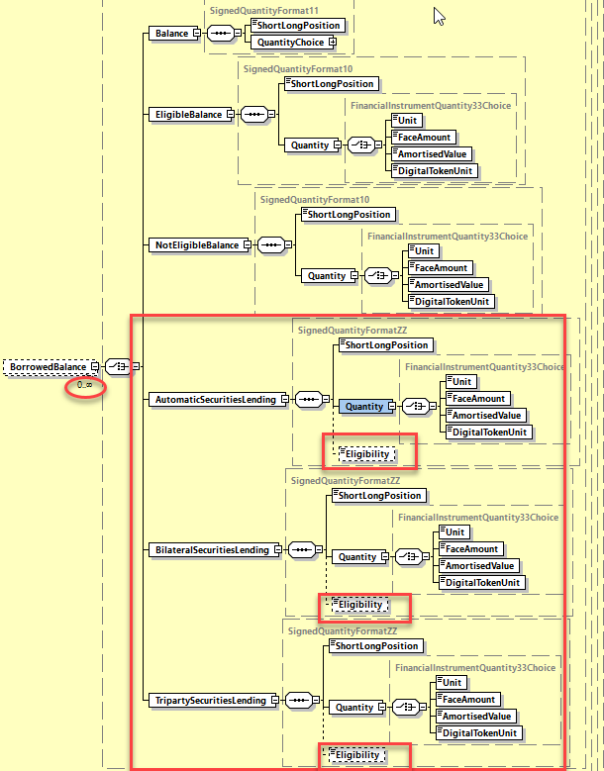
.

Working Group Meeting
To be completed by Standards after the meeting in August.

Discussion
The SWG agreed with the business case but the initial solution proposed - adding 2 new specific balances for the triparty lending service - is not deemed appropriate by a number of countries which would prefer to mark the difference between a triparty or an automated/bilateral lending service via sub-balances i.e. rather creating 3 new Balance Type codes in addition to ELIG and NELG).
DE and CH suggest that the change should also encompass the COLI & COLO balances in addition to the BORR / LOAN balances and that the solution should be more generic for securities that are out on loan but where the service differs (as not everyone offers triparty).
UK agreed with this above proposal as well.

Swift made the comment that balances would likely better be aligned across CA and S&R MTs as it seems that the MT 535 is impacted and therefore the CR should have been submitted as a common cat 5 CR and discussed with SnR
However, according to the submitter and a majority of countries in the MWG, the business case is CA processing specific and the solution based on adding new Balance Type codes should not impact SnR messages and anyway balances between SnR (MT535) and CA messages are actually not at all aligned.

The ISO SEG Evaluation Team recommendation is rather to postpone the CR until an adequate solution is found and the impact can be better assessed.

Finally, the SWG agreed to vote on the CR based on the new solution proposed introducing new balance type codes for COLI, COLO, LOAN and BORR.
The CR is approved by a majority of 13 votes in favor.
DE and JP do not have a mandate to vote on the new solution proposal.

The CA SWG requests Swift and Euroclear to work on the final details of the solution design in the next couple of days and to circulate the detailed design solution to the SWG for further validation and messages impact before the CR is fully approved.

Decision / Final Outcome
Withdrawn by submitter (XS NMPG) on September 6, 2023 with the following reasons:
- The complexity of the newly proposed solution could create issues in implementation for all involved actors (account servicers and account owners) and might have some side-effects not identified yet.
- There is no fully equivalent solutions for the same change request between CA and GM messages (see #ISO CR 1307 for GM) which increases also the complexity of the implementation.

XS NMPG prefers to take the time to analyse the solutions/impacts with the SMPG and (if needed) re-submit those change requests in SR2025

CR 002018: Amend Currency Option Definition
Origin of request
Requesting Country:
Requesting Group: | SMPG
Sponsors
Message type(s) impacted
MT 564, MT 565, MT 566, seev.031, seev.033, seev.035, seev.036
Complies with regulation
None
Business impact of this request
None
Commitment to implement the change
Number of messages sent and received: 20000000
Percentage of messages impacted: 20
Commits to implement and when: SMPG Members 2024
Business context
The :11A::OPTN Currency option qualifier definition restricts its usage to 2 CA event types i.e. Interest or Dividend payment whilst in reality it is used in more events than those defined. It is therefore proposed to amend the definition so that it is more in line with the actual usage of this qualifier.
Nature of change
Make the standards definition for OPTN more generic as follows: “Currency in which cash proceeds are to be credited/debited”; instead of the current one: “Currency in which the cash disbursed from an interest or dividend payment is offered.”
Examples

SWIFT Comment

Standards Illustration
1. ISO 15022 Illustration
In the MT 564 sequences E and E1 and in MT 565 in sequence D and in the MT566 in sequences D and D1, in field 11A, change the definition of the OPTN qualifier as illustrated below:
MT 564 Field Specifications
59. Field 11A: Currency: Currency Option
FORMAT
Option A | :4!c//3!a | (Qualifier)(Currency Code)
PRESENCE
Optional in optional sequence E
QUALIFIER
(Error code(s): T89)
Order | M/O | Qualifier | R/N | CR | Options | Qualifier Description
1 | O | OPTN | N |  | A | Currency Option
DEFINITION
This qualified generic field specifies:
OPTN | Currency Option | Currency in which the cash proceeds disbursed from an interest or dividend payment is offered are to be credited or debited.
NETWORK VALIDATED RULES
Currency Code must be a valid ISO 4217 currency code (Error code(s): T52).

2. ISO 20022 Illustration
In the seev.031 (CANO – CorporateActionNotification) message, in sequences CorporateActionOptionDetails and CorporateActionOptionDetails/SecuritiesMovementDetails,

And in the seev.033 (CAIN – CorporateActionInstruction) message, in the sequenceCorporateActionInstruction,

And In the seev.035 (CAPA – CorporateActionMovementPreliminaryAdvice) message, in the sequences CorporateActionMovementDetails and CorporateActionMovementDetails/SecuritiesMovementDetails,

And in the seev.036 (CACO – CorporateActionMovementConfirmation) message, in the sequences CorporateActionConfirmationDetails and CorporateActionConfirmationDetails/securitiesMovementDetails,

Amend the definition of the element CurrencyOption as proposed in ISO 15022 above.

Working Group Meeting
To be completed by Standards after the meeting in August.

Discussion
The whole CA SWG agreed with the business case and solution.
Decision
Approved as is.

CR 001999: New Indicators and Amounts to Improve STP of French DVOP events
Origin of request
Requesting Country: | FR France
Requesting Group: | FR NMPG
Sponsors
Message type(s) impacted
MT 564, MT 566, seev.031, seev.035, seev.036
Complies with regulation
None
Business impact of this request
MEDIUM
Commitment to implement the change
Number of messages sent and received: 1000000
Percentage of messages impacted: 100
Commits to implement and when: France 2024
Business context
In France, when instructing to re-invest a dividend into securities in a DVOP, such re-investment can be processed either NET of tax (i.e. the tax is withheld prior to reinvest the dividend) or GROSS (i.e. the cash dividend is reinvested fully and the tax is debited separately in cash). Currently, there is no indicator in the CA option to distinguish the two options. Instead, all parties rely on narratives. To improve STP, we would like to have an option feature to specify whether the re-investment will be processed net or gross.
Another specific process in France, for DVOPs, is the possibility to elect to round-up to the next securities entitlement. We have requested a few years ago a specific DISF code (BUYU) to identify this option. However, we noticed there is no way to inform account owners of the amount (19B in the M564/566) they need to be debited for the round up when they decide to reinvest in the round-up option. Some organisations use the CINL but it’s not 100% correct because it’s not a credit but a debit. We would like to have BUYU code made available in the amounts.
Nature of change
1. Create a new indicator (ideally a new code in OPTF) to identify the NET or GRSS reinvestment option in the MT564.
2. Create a new amount type (BUYU) in 19B of the M564/566
Examples

SWIFT Comment

Since the new OPTF codes are restricted to the usage of the DVOP event, shouldn’t we add a NVR to enforce the link with DVOP ?

Standards Illustration
1. ISO 15022 Illustration
1. In the MT 564 in sequence E and in the MT 566 in sequence D, in field 22F for Qualifier OPTF, create 2 new codes: RGRS (Gross Dividend Reinvestment) and RNET (Net Dividend Reinvestment) as defined and illustrated below:

MT 564 Field Specifications
57. Field 22F: Indicator
FORMAT
Option F | :4!c/[8c]/4!c | (Qualifier)(Data Source Scheme)(Indicator)
PRESENCE
Mandatory in optional sequence E
QUALIFIER
(Error code(s): T89)
Order | M/O | Qualifier | R/N | CR | Options | Qualifier Description
1 | M | CAOP | N | C5, C23 | F | Corporate Action Option Code Indicator
2 | O | DISF | N |  | F | Disposition of Fractions Indicator
3 | O | OFFE | R | C27, C28 | F | Offer Type Indicator
4 | O | OPTF | R | C20 | F | Option Features Indicator
5 | O | OSTA | N |  | F | Option Status
6 | O | CETI | R |  | F | Certification/Breakdown Type Indicator
7 | O | BIRI | N |  | F | Bid Range Type Indicator
DEFINITION
This qualified generic field specifies:
BIRI | Bid Range Type Indicator | Specifies the type of acceptable bid range values.
CAOP | Corporate Action Option Code Indicator | Specifies the corporate action options available to the account owner.
CETI | Certification/Breakdown Type Indicator | Specifies the type of certification/breakdown.
DISF | Disposition of Fractions Indicator | Specifies how fractions resulting from derived securities will be processed or how prorated decisions will be rounding, if provided with a pro ration rate.
OFFE | Offer Type Indicator | Specifies the conditions that apply to the offer.
OPTF | Option Features Indicator | Specifies the features that may apply to a corporate action option.
OSTA | Option Status | Specifies the status of the option.
CODES
If Qualifier is OPTF and Data Source Scheme is not present, Indicator must contain one of the following codes (Error code(s): K22):
ASVO | Account Servicer Option | Option is offered by the account servicer only.
BOIS | Beneficiary Owner Instruction | Indicates that the holder needs to instruct at beneficiary owner level only.
CAOS | Corporate Action Option Applicability | The option applicability is not subject to the account owner decision but depends on the terms defined by the issuer, for example in the case of Equity Linked Notes or warrants.
COND | Conditional | Feature whereby the holder can elect to place a condition on the acceptance of the option.
MAXC | Maximum Cash | Maximum cash option, may be subject to scaling, as such you may receive a combination of cash and securities outturn.
MAXS | Maximum Securities | Maximum stock option, may be subject to scaling, as such you may receive a combination of securities and cash outturn.
NOSE | No Service Offered Indicator | Feature whereby the holder must elect directly to the issuer's agent (issuer only supported option).
OPLF | Odd Lot Preference | Tender or Exchange with the Odd Lot Preference.
PINS | Previous Instruction Invalidity | Indicates that the previously sent instructions become invalid. It is only applicable after a market deadline extension.
PROR | Pro Ration | Feature whereby the option can be subject to pro ration in case, for example, of over-subscription.
QCAS | Instruct Cash Amount | Feature whereby the holder should only instruct a cash amount.
RGRS | Gross Dividend Reinvestment | The gross dividend is reinvested.
RNET | Net Dividend Reinvestment | The dividend reinvestment is processed net of withholding tax.
SHAR | Shareholder Number | Indicates usage of a reference number to identify an investor or a shareholder with the issuer or the registration provider (for instance allocation code).
VVPR | Reduced Withholding Tax | Reduced withholding tax rate applies to the option.

2. In the MT 564 in sequence E2 and in the MT 566 in sequence D2, in field 19B, create a new optional qualifier BUYU as defined and illustrated below:

MT 564 Field Specifications
94. Field 19B: Amount
FORMAT
Option B | :4!c//3!a15d | (Qualifier)(Currency Code)(Amount)
PRESENCE
Conditional (see rule C2) in optional subsequence E2
QUALIFIER
(Error code(s): T89)
Order | M/O | Qualifier | R/N | CR | Options | Qualifier Description
1 | O | ENTL | N |  | B | Entitled Amount
2 | O | RESU | N | C1 | B | Resulting Amount
……
49 | O | DEIT | N |  | B | Deemed Interest Amount
50 | O | DERY | N |  | B | Deemed Royalties Amount
51 | O | BUYU | N |  | B | Buy Up Amount

DEFINITION
This qualified generic field specifies:
ACRU | Accrued Interest Amount | Amount of interest that has been accrued in between coupon payment periods.
ATAX | Additional Tax Amount | Amount of additional taxes that cannot be categorised.
BUYU | Buy Up Amount | Amount of cash debited in the context of a buy up option.
BWIT | Back Up Withholding Tax Amount | Amount of tax related to back up withholding.
CAPG | Capital Gains Amount | Amount of money distributed as the result of a capital gain.
CDFI | Foreign Income Amount | Amount relating to a foreign income such as a conduit foreign income.
……..
WITL | Second Level Tax Amount | Amount of money withheld by the jurisdiction other than the jurisdiction of the issuer's country of tax incorporation, for which a relief at source and/or reclaim may be possible. It is levied in complement or offset of the withholding tax rate (TAXR) levied by the jurisdiction of the issuer's tax domicile.

2. ISO 20022 Illustration
1. In the seev.031 (CANO – CorporateActionNotification) message, in sequence CorporateActionOptionDetails/OptionFeatures,

And in the seev.035 (CAPA – CorporateActionMovementPreliminaryAdvice) message, in sequence CorporateActionMovementDetails/OptionFeatures,

And in the seev.036 (CACO – CorporateActionMovementConfirmation) message, in sequence CorporateActionConfirmationDetails/OptionFeatures, change the data type of the element Code so as to add 2 new code values RGRS (Gross Dividend Reinvestment) and RNET (Net Dividend Reinvestment) as defined in ISO 15022 above and as illustrated below:

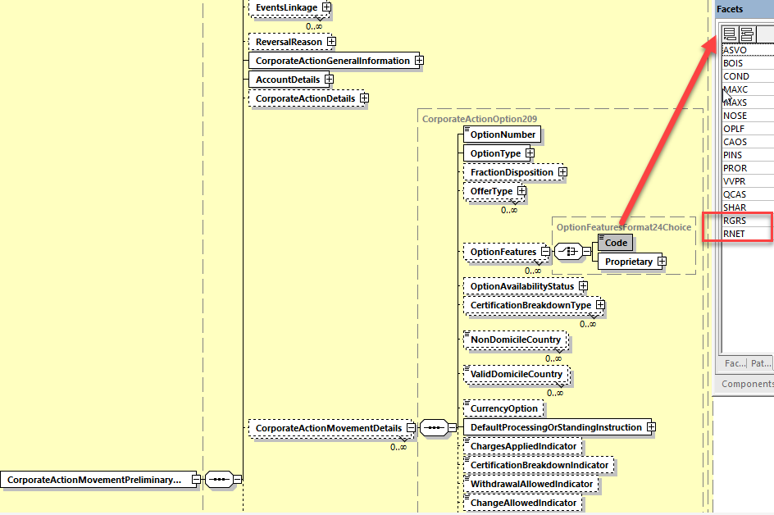

2. In the seev.031 (CANO – CorporateActionNotification) message, in sequence CorporateActionOptionDetails/CashMovementDetails/AmountDetails,

And in the seev.035 (CAPA – CorporateActionMovementPreliminaryAdvice) message, in sequence CorporateActionMovementDetails/ CashMovementDetails/AmountDetails,

And in the seev.036 (CACO – CorporateActionMovementConfirmation) message, in sequence CorporateActionConfirmationDetails/ CashMovementDetails/AmountDetails, add the optional and non-repeatable amount element BuyUpAmount typed by the data type ActiveCurrencyAndAmount and as defined in ISO 15022 above and as illustrated below:

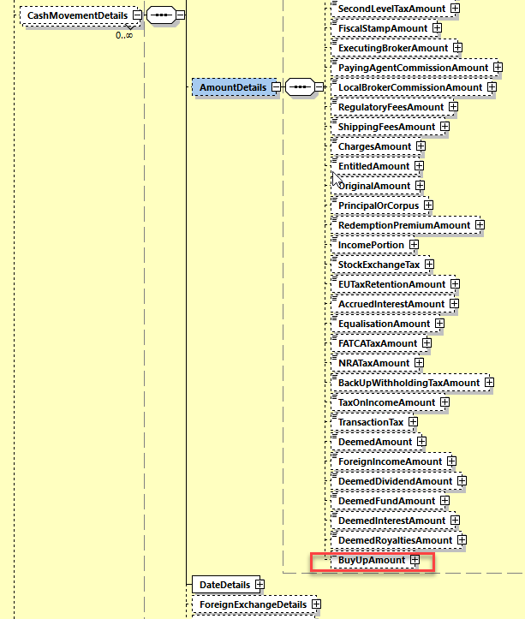

Working Group Meeting
To be completed by Standards after the meeting in August.

Discussion
The SWG agreed with the specific business case which exists in France but for XS, LU and BE the low volume of such DVOP cases does not justify the change and in addition not all issuers propose a DVOP with a buy up option either.

XS and LU are of the opinion that the gross or net reinvestment is also implied by the presence or not of the tax element. However, FR thinks it must be made more explicit in the message and it does not work for tax exempt clients. Today that information is mentioned only in the narrative.
The UK and ISO SEG CA ET support fully the request as it may be useful also in UK and IE or NO.

DE and CH support the creation of the gross/net indicators, however, they would prefer to reuse the cash in lieu (CINL) amount instead of adding a new buy up amount.
However, CINL implies a credit of cash and not a debit which is implied by buying up securities.
This would mean that the definition of cash in lieu should be slightly changed and used in combination with the debit/credit indicator which is not very clear.

Finally, the SWG resolved to vote on the CR.
The CR was approved by 10 votes in favour and 5 against.
Decision
Approved as is.

CR 002015: Add Reversal Reason Codes for Payment Reversals
Origin of request
Requesting Country:
Requesting Group: | SMPG
Sponsors
Message type(s) impacted
MT 564, MT 566
Complies with regulation
None
Business impact of this request
MEDIUM
This change requires to add a new optional field in the MT 564 and 566 structure.
Commitment to implement the change
Number of messages sent and received: 20000000
Percentage of messages impacted: 2
Commits to implement and when: SMPG members
2024
Business context
When reviewing the reverse engineering of CA MX messages seev.035 and seev.037, we noticed that the ReversalReason (RvslRsn) data elements and its reason codes are not available in the MT564 and MT566.
Nature of change
Add a new 24B field and a qualifier to the MT564 and MT566 to record the following Reversal Reason codes:
DCBD - DayCountBasisDifference - Difference in day count basis.
FNRC - FundsNotReceived - Funds have not been received.
IRED - IncorrectEntitlementDate - Entitlement date is incorrect.
IETR - IncorrectEventLevelTaxRate - Event level tax rate is incorrect.
IPCU - IncorrectPaymentCurrency - Payment currency is incorrect.
IPRI - IncorrectPrice - Price is incorrect.
IVAD - IncorrectValueDate - Value date is incorrect.
POCS - PaymentOutsideClearingSystem - Payment will occur outside of clearing system.
UPAY - UnduePayment - Payment is not due.
Examples

SWIFT Comment

Should we create a new NVR in the MT564 and 566 to enforce the usage of the message as a preadvice of reversal or as a reversal ?

Standards Illustration
1. ISO 15022 Illustration
1. In sequence A of the MT 564 and MT 566, add a new optional subsequence A2 Reversal Reason with one mandatory non-repeatable :24B: field with the qualifier REVR (Reversal Reason Code) and one optional non-repeatable :70D: field with the qualifier REVR (Reversal Reason Narrative) as defined and illustrated below (for the MT564 – the design is the same for the MT566):
MT 564 Format Specifications
MT 564 Corporate Action Notification
Status | Tag | Qualifier | Generic Field Name | Detailed Field Name | Content/Options | No.
Mandatory Sequence A General Information
M | 16R |  |  | Start of Block | GENL | 1
O | 28E |  |  | Page Number/Continuation Indicator | 5n/4!c | 2
----->
M | 20C | 4!c | Reference | (see qualifier description) | :4!c//16x | 3
-----|
M | 23G |  |  | Function of the Message | 4!c[/4!c] | 4
----->
M | 22F | 4!c | Indicator | (see qualifier description) | :4!c/[8c]/4!c | 5
-----|
O | 98a | PREP | Date/Time | Preparation Date/Time | A, C, or E | 6
M | 25D | PROC | Status Code | Processing Status | :4!c/[8c]/4!c | 7
-----> Optional Repetitive Subsequence A1 Linkages
M | 16R |  |  | Start of Block | LINK | 8
O | 22F | LINK | Indicator | Linkage Type Indicator | :4!c/[8c]/4!c | 9
O | 13a | LINK | Number Identification | Linked Message | A or B | 10
M | 20C | 4!c | Reference | (see qualifier description) | :4!c//16x | 11
M | 16S |  |  | End of Block | LINK | 12
-----| End of Subsequence A1 Linkages
-----> Optional Subsequence A2 Reversal Reason
M | 16R |  |  | Start of Block | REVR | 13
M | 24B | REVR | Reversal Reason Code | (see qualifier description) | :4!c/[8c]/4!c | 14
O | 70D | REVR | Reversal Reason Narrative | (see qualifier description) | :4!c//7*35x | 15
M | 16S |  |  | End of Block | REVR | 16
-----| End of Subsequence A2 Reversal Reason
M | 16S |  |  | End of Block | GENL | 17
End of Sequence A General Information

MT 564 Field Specifications
14. Field 24B: Reversal Reason Code
FORMAT
Option B | :4!c/[8c]/4!c | (Qualifier)(Data Source Scheme)(Reason Code)
PRESENCE
Mandatory in optional subsequence A2
QUALIFIER
(Error code(s): T89)
Order | M/O | Qualifier | R/N | CR | Options | Qualifier Description
1 | M | REVR | N | C32 | B | Reversal Reason
DEFINITION
This qualified generic field specifies:
REVR | Reversal Reason | Specifies the reason for the payment reversal.
CODES
If Qualifier is REVR and Data Source Scheme is not present, Reason Code must contain one of the following codes (Error code(s): K24):
DCBD | Day Count Basis Difference | Difference in day count basis.
FNRC | Funds Not Received | Funds have not been received.
IRED | Incorrect Entitlement Date | Entitlement date is incorrect.
IETR | Incorrect Event Level Tax Rate | Event level tax rate is incorrect.
IPCU | Incorrect Payment Currency | Payment currency is incorrect.
IPRI | Incorrect Price | Price is incorrect.
IVAD | Incorrect Value Date | Value date is incorrect.
POCS | Payment Outside Clearing System | Payment will occur outside of clearing system.
UPAY | Undue Payment | Payment is not due.
NARR | Narrative Reason | See narrative field for reason.

MT 564 Field Specifications
15. Field 70D: Narrative: Reversal Reason Narrative
FORMAT
Option D | :4!c//7*35x | (Qualifier)(Narrative)
PRESENCE
Optional in optional subsequence A2
QUALIFIER
(Error code(s): T89)
Order | M/O | Qualifier | R/N | CR | Options | Qualifier Description
1 | O | REVR | N |  | D | Reversal Reason Narrative
DEFINITION
This qualified generic field specifies:
REAS | Reason Narrative | Provides additional reason information.
USAGE RULES
Unless bilaterally agreed, narrative field 70a must not contain information that can be provided in a structured field.

2. Optional Change: In the MT 564, add a new NVR C32 to enforce the usage of the MT 564 as a preadvice of movement for a payment reversal as illustrated below:

C32
In subsequence A2, if field :24B::REVR is present, then in sequence D, field :22F::ADDB//REVR must be present (Error code(s): XY0X).

In sequence A2  if field 24B::REVR is ... ⁽¹⁾ | Then in sequence D field :22F::ADDB//REVR is …
Present | Mandatory
Not Present | Optional
(1) if the Data Source Scheme is present in field :24B::REVR, then the conditional rule does not apply

3. Optional Change: In the MT 566, add a new NVR C11 to enforce the usage of the MT 566 as a payment reversal as illustrated below:

C11
In subsequence A2, if field :24B::REVR is present, then in sequence A, field :23G:REVR must be present (Error code(s): XY0X).

In sequence A2  if field 24B::REVR is ... ⁽¹⁾ | Then in sequence A field :23G:REVR is ...
Present | Mandatory
Not Present | Optional
(1) if the Data Source Scheme is present in field :24B::REVR, then the conditional rule does not apply

Working Group Meeting
To be completed by Standards after the meeting in August.

Discussion
The CA SWG acknowledges the business case i.e. the misalignment of ISO 15022 with ISO 20022 for the reversal reasons, however, CH and LU believe the misalignment is not critical enough to justify a reverse engineering in 15022 especially when the change in 15022 is quite heavy i.e. adding a brand new subsequence in the message with a complex NVR.

FR supports the change but would like to have the NVR removed or at least simplified.

XS supports the change but it would need to be complemented with an SMPG Market practice to ensure the information comes from a single source and communicated accordingly, else it could lead to issues.

Finally, the SWG resolved to vote on the CR.
The CR was approved by 11 votes in favour and 3 against.
The SWG also agreed to have the MT 564 NVR C32 simplified by imposing a condition only on :22F::ADDB//REVR code.
Decision
Approved with comments

CR 002002: Remove Useless Market Claim Indicator Codes in Confirmations
Origin of request
Requesting Country:
Requesting Group: | SMPG
Sponsors
Message type(s) impacted
MT 566
Complies with regulation
None
Business impact of this request
LOW
Commitment to implement the change
Number of messages sent and received: 10000000
Percentage of messages impacted: 3
Commits to implement and when: SMPG Members 2024
Business context
Clean up the inadequate market claims indicator codes in the confirmation message and align ISO 20022 and ISO 15022 ADDB market claims codes.
Nature of change
Remove the following market claims related ADDB indicator codes from the confirmation message: ACLA (automatic Market Claims), ATXF (Subject to Transformation), CNTR (Cancel Underlying Trades), NAMC (No Automatic Market Claims and Transformations).
Examples

SWIFT Comment

Standards Illustration
1. ISO 15022 Illustration
In the MT 566, in sequence C, in field 22F for qualifier ADDB, remove the code values ACLA (automatic Market Claims), ATXF (Subject to Transformation), CNTR (Cancel Underlying Trades), NAMC (No Automatic Market Claims and Transformations) as illustrated below:
MT 566 Field Specifications
37. Field 22F: Indicator
FORMAT
Option F | :4!c/[8c]/4!c | (Qualifier)(Data Source Scheme)(Indicator)
PRESENCE
Optional in optional sequence C
QUALIFIER
(Error code(s): T89)
Order | M/O | Qualifier | R/N | CR | Options | Qualifier Description
1 | O | DIVI | N |  | F | Dividend Type Indicator
2 | O | CONV | N |  | F | Event Sequence Type Indicator
3 | O | DITY | N |  | F | Occurrence Type Indicator
4 | O | OFFE | R |  | F | Offer Type Indicator
5 | O | ADDB | R | C9 | F | Additional Business Process Indicator
6 | O | CHAN | R |  | F | Change Type Indicator
7 | O | RHDI | N | C5 | F | Intermediate Securities Distribution Type Indicator
8 | O | ECIO | N |  | F | Capital Gain In/Out Indicator
9 | O | TDTA | N |  | F | TID/TIS Calculated Indicator
10 | O | LOTO | N |  | F | Lottery Type
11 | O | TNDP | R |  | F | Tax On Non-Distributed Proceeds Indicator

CODES
If Qualifier is ADDB and Data Source Scheme is not present, Indicator must contain one of the following codes (Error code(s): K22):
ACLA | Automatic Market Claims | Will automatically give rise to market claims by the account servicer (typically, a CSD).
ATXF | Subject to Transformation | As a result of the Corporate Action, all transactions in the underlying security will be cancelled by the system and replaced with transactions in the outturn resource(s).
CLAI | Claim or Compensation | Relates to a claim on the associated corporate action event.
CNTR | Cancel Underlying Trades | As a result of the Corporate Action, all transactions in the underlying security will be cancelled by the system.
CONS | Consent | Relates to a consent within a corporate action event other than a Consent event (:22F::CAEV//CONS).
FPRE | Full Pre-Funding | Full pre-funding of a debt instrument by the issuer prior to original maturity when the issuer deposits assets in trust. Applicable only in the frame of a partial defeasance corporate action event.
INCP | Incentive Premium Payment | The event is a payment of an incentive premium related to the voting conditions prescribed at a general meeting.
NAMC | No Automatic Market Claims and Transformations | The event will not automatically give rise to market claims and transformations by the account servicer (typically, a CSD).
NPLE | No Split Election | The issuer only allows a single option to be selected per designated holding.
PPRE | Partial Pre-Funding | Partial pre-funding of a debt instrument prior to maturity drawn through a lottery process. One new security is issued with an earlier maturity date for the refunded (called portion) and the other new security is issued with the original maturity date for the non refunded (remaining) portion. Applicable only in the frame of a partial defeasance corporate action event .
PPUT | Partial Mandatory Put Redemption | Partial mandatory exchange of a portion of bonds where the exchanged securities are usually remarketed. The issuer may offer holders the right to retain instead of exchanging their securities. A lottery will be used to determine eligibility for the event.
SCHM | Scheme/Plan of Arrangement | Component event of a scheme/plan of arrangement: a reorganisation of a company or a group of companies, and their capital.
TAXR | Tax Refund | Relates to a tax refund from the authorities on the associated corporate action event.

Working Group Meeting
To be completed by Standards after the meeting in August.

Discussion
NL does not fully agree with the business case as they find it handy to have a status update for the claims even if it is actually not something for the MT566. NL thinks that there should be an option to inform account owners for the next action.
NL is however not against the solution.

Nevertheless, all the other SWG members agree with the business case and proposed solution.
Decision
Approved as is.

CR 002026: Add new Pending and Rejection Status Reason Code for Instructions Received Prior to Entitlement Date
Origin of request
Requesting Country:
Requesting Group: | SMPG
Sponsors
Message type(s) impacted
MT 567, seev.034, seev.042
Complies with regulation
None
Business impact of this request
MEDIUM
Commitment to implement the change
Number of messages sent and received: 5000000
Percentage of messages impacted: 5
Commits to implement and when: SMPG Members
2024
Business context
If instructions are received before record date, entitlements are not final and are thus very likely to change. In that case, account servicers may either reject or set the instructions status as pending until entitlement date is reached, however, the status message does not provide currently adequate status reason codes to cover these uses cases.
Nature of change
Add a new status reason code to PEND and REJT statuses in the MT567 for -Instruction received prior to entitlement date- to inform account owners of the fact the instruction has been received prior to the entitlement date.
Examples

SWIFT Comment

Standards Illustration
1. ISO 15022 Illustration
In the MT 567, in sequence A2a, in field 24B, add a new reason code EARL (Too Early Instruction) for qualifier PEND (Pending) and REJT (Reject) as defined and illustrated below:

MT 567 Field Specifications
13. Field 24B: Reason Code
FORMAT
Option B | :4!c/[8c]/4!c | (Qualifier)(Data Source Scheme)(Reason Code)
PRESENCE
Mandatory in optional subsequence A2a
QUALIFIER
(Error code(s): T89)
Order | M/O | Qualifier | R/N | CR | Options | Qualifier Description
1 | M | PEND | N | C1 | B | Pending Reason
 | or | REJT | N | C1 | B | Rejection Reason
 | or | CAND | N | C1 | B | Cancellation Reason
 | or | CANP | N | C1 | B | Cancellation Pending Reason
 | or | PACK | N | C1 | B | Accepted Reason
DEFINITION
This qualified generic field specifies:
CAND | Cancellation Reason | Specifies the reason why the instruction is cancelled.
CANP | Cancellation Pending Reason | Specifies the reason why a cancellation request sent for the related instruction is pending.
PACK | Accepted Reason | Specifies additional information about the processed instruction.
PEND | Pending Reason | Specifies the reason why the instruction/event has a pending status.
REJT | Rejection Reason | Specifies the reason why the instruction/cancellation request has a rejected status.
CODES
If Qualifier is PEND and Data Source Scheme is not present, Reason Code must contain one of the following codes (Error code(s): K24):
ADEA | Account Servicer Deadline Missed | Received after the account servicer's deadline. Processed on best effort basis.
AUTH | Sent to Tax Authorities | For tax reclaim, the event is pending because the reclaim is sent to the tax authorities.
BSTR | Before Instruction Period | Instruction is submitted before instruction start date.
CERT | Incorrect Certification | The provided certification is incorrect or incomplete.
DQCS | Disagreement on Cash Amount | Unrecognised or invalid instructed cash amount.
DQUA | Disagreement on Quantity | Unrecognised or invalid instructed quantity.
IPED | Instruction Prior to Entitlement Date | Instruction was received prior to entitlement date.
FULL | Pending Beneficiary Owner Details | Pending receipt of beneficiary owner details.
IPAW | Invalid Paperwork | Required paperwork is invalid, incomplete, or missing.
ITAX | Incorrect Tax Rate | Tax rate provided is incorrect. It falls outside the acceptable values for that investment country.
LACK | Lack of Securities | Insufficient financial instruments in your account.
LATE | Market Deadline Missed | Instruction was received after market deadline.
…….
SNAV | System Not Available | System is not available. Instruction is sent outside of business hours.
VLDA | Valid for Tax Authorities | For tax reclaim, the event is pending, the tax reclaim is valid for the tax authorities.
CODES
If Qualifier is REJT and Data Source Scheme is not present, Reason Code must contain one of the following codes (Error code(s): K24):
ADEA | Account Servicer Deadline Missed | Received after the account servicer's deadline.
BSTR | Before Instruction Period | Instruction is submitted before instruction start date.
CANC | Cancelled | Option is not valid; it has been cancelled by the market or service provider, and cannot be responded to. Any responses already processed against this option are considered void and new responses will be required.
CERT | Incorrect Certification | Instruction is rejected since the provided certification is incorrect or incomplete.
CTCT | Missing Contact | Contact information is missing.
DCAN | Rejected Since Already Cancelled | Cancellation request was rejected since the instruction has already been cancelled.
DPRG | Rejected Since In Progress | Cancellation request has been rejected because the instruction process is in progress or has been processed.
DQAM | Instruction Type Rejection | Invalid use of instructed amount (QCAS) or of instructed quantity (QINS) qualifiers .
DQBI | Invalid Bid Increment | Bid price/basis points/percentage increments rejected due to invalid bid increment for the event (generally used in Dutch Auctions or Bid Tenders).
DQBV | Invalid Bid Value | Bid price/basis points/percentage falls outside of bid range for the event (generally used in Dutch Auctions or Bid Tenders).
DQCC | Currency Rejection | Invalid instructed currency.
DQCS | Amount Rejection | Unrecognised or invalid instructed cash amount.
DQUA | Quantity Rejection | Unrecognised or invalid instructed quantity.
DSEC | Security Rejection | Unrecognised or invalid financial instrument identification.
DUPL | Duplicate Instruction | Instruction is rejected due to duplicate business message identifier.
IPED | Instruction Prior To Enritlement Date | Instruction was received prior to entitlement date.
EVNM | Unrecognised Corporate Action Event Number Rejection | Unrecognised corporate action event number.
FULL | Missing Beneficiary Owner Details | Rejected due to missing beneficiary owner details.
……….
ULNK | Unknown | Linked reference is unknown.

2. ISO 20022 Illustration
In the seev.034 (CAIS – CorporateActionInstructionStatusAdvice) message, in sequence InstructionProcessingStatus/Rejected/Reason/ReasonCode add in the data type code RejectionReason66Code of the Code element the new status code IPED (Instruction Prior To Entitlement Date) as defined in ISO15022 above and as illustrated below:

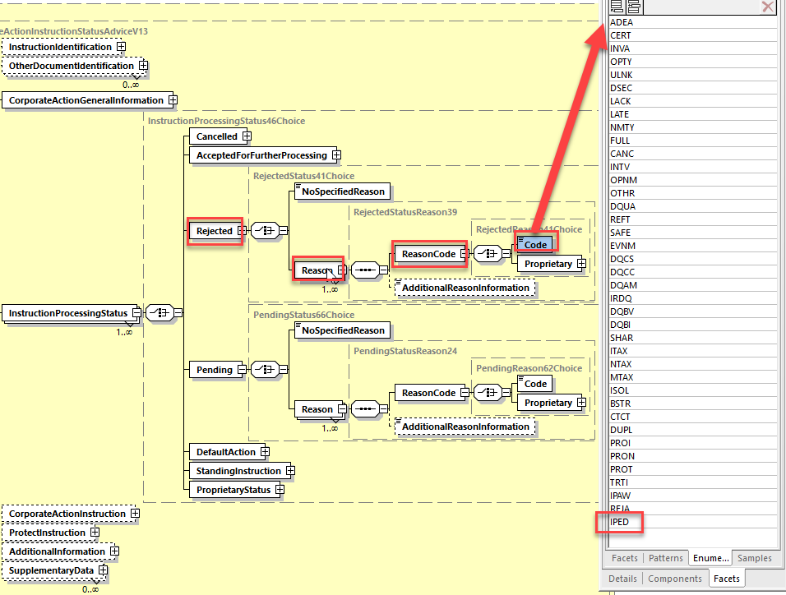

In the seev.034 (CAIS – CorporateActionInstructionStatusAdvice) message, in sequence InstructionProcessingStatus/Pending/Reason/ReasonCode, add in the data type code PendingReason23Code of the Code element the new status code IPED (Prior To Entitlement Date) as defined in ISO15022 above and as illustrated below:

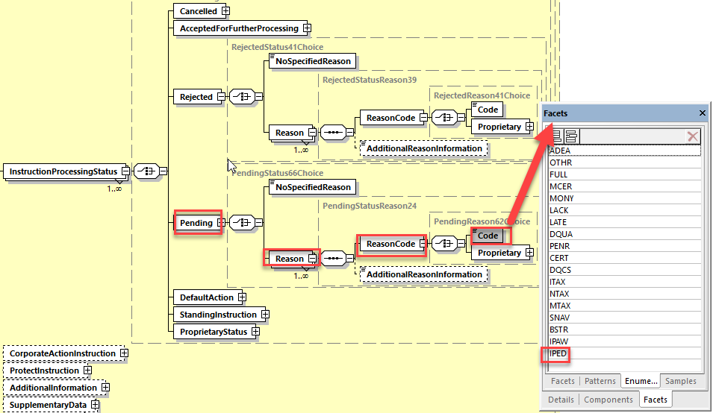

In the seev.042 (CAPC – CorporateActionInstructionStatementReport) message, in the sequence AccountAndStatementDetails/ CorporateActionEventAndBalance/Balance/ TotalInstructedBalanceDetails/OptionDetails/OptionInstructionDetails/InstructionStatus/Rejected/Reason/ReasonCode, add a new code value IPED (Prior To Entitlement Date) as defined in ISO15022 above in the data type RejectionReason64Code of the Code element.

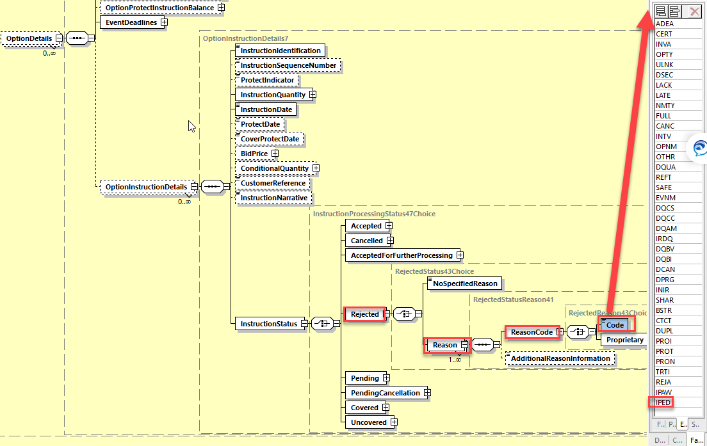

And if CR2038 is approved), in the sequence AccountAndStatementDetails/ CorporateActionEventAndBalance/Balance/ TotalInstructedBalanceDetails/OptionDetails/OptionInstructionDetails/InstructionStatus/Pending/Reason/ReasonCode/Code add a new code value IPED (Prior To Entitlement Date) as defined in ISO15022 above in the data type structure to be added as requested in the CR2038 (Align Pending StatusReason Codes in Instruction Statement Report) further down in this document.

Working Group Meeting
To be completed by Standards after the meeting in August.

Discussion
All CA SWG members agree with the business case and proposed solution.
Decision
Approved as is.

CR 002007: Amend MT565 and 567 to Allow Usage for Market Claims
Origin of request
Requesting Country:
Requesting Group: | UK&IE NMPG
Sponsors
Message type(s) impacted
MT 565, MT 567
Complies with regulation
None
Business impact of this request
MEDIUM
null
Commitment to implement the change
Number of messages sent and received: 1000000
Percentage of messages impacted: 100
Commits to implement and when: UK NMPG
2024
Business context
Since we created dedicated ISO20022 messages to inform account owners of market claims and their status (seev.050 to 053), we would like to request changes to the MT567 message to create a new function of the message (CLAI) and other changes to report the creation and status of market claims so to reverse engineer the ISO20022 claim messages.
Small changes are also required to the MT565 to allow instructions to amend market claims.
Nature of change
We would like to implement a new optional function of the message and make changes to the structure of the MT567 as per the enclosed excel file. The changes to the MT565 are also detailed in the excel file.
Changes to MT 565
MT565 - Revamped | to instruct cancellation or update of market claim |  | yellow means new in the message
Sequence A | 20C | CORP
 | 20C | COAF
 | 22F | CAEV
 | 23G | CLAC | Request of cancellation of the market claim
 | 23G | CLAU | Request to update market claim
Subsequence A1 | 20C | RELA | Reference of the market claim transaction (either MITI or ASRF)
Sequence B | 35B | ISIN | ISIN for the market claim transaction
Subsequence B2 | 97 | SAFE | Account of the instructing party
Sequence D | 22F | CLAI//CANC | CANC
 | 22F | CLAI//SPLT | SPLT
 | 36B | QCLA | Quantity of the market claim in securities
 | 19B | CCY + amount | currency and amount of the cash claim
Changes to MT 567
MT567 - Revamped
Sequence A | 20C | CORP
 | 20C | COAF
 | 22F | CAEV
 |  | ISIN | ISIN of the underlying security on which the event was announced
Sequence A1 | 23G | CLAI | new function code
 | 20C | RELA
 | 20C | SPLT | Reference of the original market claim (to inform the creation of the new claims following a split)
 | 20C | MITI | Reference of the market claim assigned by the market infrastructure (e.g. T2S)
 | 20C | ASRF | Reference of the market claim assigned by the Account Servicer
 | 20C | PRCD | Reference of the market claim assigned by the CSD (processor transaction ID)
Sequence A2 | 25D | CLAM//NEWC | New market claim transaction has been created - new status code
 |  | CLAM//CANC
 |  | CLAM//UPDT | Market claims transaction has been updated
 | 24B | UPDT/PRIO | change of priority - new reason code
 |  | UPDT/HOLD | when status of market claim updated to hold (associated with UPDATE)
 |  | UPDT/RELE | when status of market claim updated to release (associated with UPDATE)
 |  | CANC/SPLT | market claims transaction cancelled due to split
 |  | CANC/REJT | cancellation rejected
 |  | CANC/CANP | cancellation pending cpty matching
 |  | CANC/CANO | cancelled by the counterparty
 |  | CANC/CANS | cancelled by the CSD
 |  | CANC/CAND | cancellation completed (associated with CANC)
Sequence B | 97A | SAFE | Account of the instructing party
 | 35B | ISIN | ISIN of the claim transaction
 | 36B | QCLA | Quantity of the market claim in securities
 | 19B | CCY + amount | currency and amount of the cash claim
 | 98A | TRAD | Trade date of the market claim in securities
 | 98A | SETT | Intended Settlement Date of the market claim in securities
Sequence B1 |  | Counterparty | Counterparty
 | 95P | DEAG | Delivering party
 | 95P | REAG | Receiving party
 | 95P | BUYR | Buyer
 | 95P | SELL | Seller
 | 95P | PSET | Place of Settlement

Examples

SWIFT Comment

Standards Illustration
1. ISO 15022 Illustration
A. Changes in the MT 565

1. In the MT 565, in sequence A, in field 23G, add 2 new functions as follows
a) CLAC: Message requesting to cancel a market claim
b) CLAU: Message requesting to update a market claim
as illustrated below:
MT 565 Field Specifications
3. Field 23G: Function of the Message
FORMAT
Option G | 4!c[/4!c] | (Function)(Subfunction)
PRESENCE
Mandatory (referenced in rule C1) in mandatory sequence A
DEFINITION
This field identifies the function of the message.
CODES
Function must contain one of the following codes (Error code(s): T86):
CANC | Cancellation Request | Message requesting the cancellation of a previously sent message.
CLAC | Claim Cancellation Request | Message requesting to cancel a market claim.
CLAU | Claim Update Request | Message requesting to update a market claim.
NEWM | New | New message.
CODES
Subfunction, when present, must contain one of the following codes (Error code(s): T85):
CODU | Copy Duplicate | Message is a copy to a party other than the account owner/account servicer, for information purposes and the message is a duplicate of a message previously sent.
COPY | Copy | Message is a copy to a party other than the account owner/account servicer, for information purposes.
DUPL | Duplicate | Message is for information/confirmation purposes. It is a duplicate of a message previously sent.
USAGE RULES
To cancel a previously sent message, Function is CANC. The reference in the linkages sequence must contain the Sender's reference of the message to be cancelled. A copy of at least the mandatory fields of the message to be cancelled must be present; optional fields need not be present for SWIFT validation.

2. In the MT 565, in sequence D, in field 22F, add a new optional qualifier CLAI (Claim Features Indicator) as defined and illustrated below:
MT 565 Field Specifications
40. Field 22a: Indicator
FORMAT
Option F | :4!c/[8c]/4!c | (Qualifier)(Data Source Scheme)(Indicator)
Option H | :4!c//4!c | (Qualifier)(Indicator)
PRESENCE
Mandatory in mandatory sequence D
QUALIFIER
(Error code(s): T89)
Order | M/O | Qualifier | R/N | CR | Options | Qualifier Description
1 | M | CAOP | N | C2, C8 | F or H | Corporate Action Option Code Indicator
2 | O | DISF | N |  | F | Disposition of Fractions Indicator
3 | O | CHAN | R |  | F | Change Type Indicator
4 | O | COLE | N |  | F | Collateral Pool Indicator
5 | O | OPTF | N |  | F | Option Features Indicator
6 | O | CLAI | N |  | F | Claim Features Indicator
DEFINITION
This qualified generic field specifies:
CAOP | Corporate Action Option Code Indicator | Specifies the corporate action options available to the account owner.
CHAN | Change Type Indicator | Specifies the type of change announced.
CLAI | Claim Features Indicator | Specifies the features that may apply to a corporate action claims.
COLE | Collateral Pool Indicator | Specifies whether the corporate action instruction should be processed using the pool of securities eligible for collateral purposes.
DISF | Disposition of Fractions Indicator | Specifies how fractional amount/quantities are treated.
OPTF | Option Features Indicator | Specifies the features that may apply to a corporate action option.

CODES
In option F, if Qualifier is CLAI and Data Source Scheme is not present, Indicator must contain one of the following codes (Error code(s): K22):
CANC | Cancel Market Claim | Request to cancel the market claim.
SPLT | Split Market Claim | Request to split the market claim.

3. In the MT565, in the sequence D, in field 36B, add the new qualifier QCLA (Market Claim Quantity) as defined and illustrated below:
MT 565 Field Specifications
43. Field 36a: Quantity of Financial Instrument
FORMAT
Option B | :4!c//4!c/15d | (Qualifier)(Quantity Type Code)(Quantity)
Option C | :4!c//4!c | (Qualifier)(Quantity Code)
Option D | :4!c//4!c/30d | (Qualifier)(Quantity Type Code)(Quantity of Digital Tokens)
PRESENCE
Conditional (see rule C5) in mandatory sequence D
QUALIFIER
(Error code(s): T89)
Order | M/O | Qualifier | R/N | CR | Options | Qualifier Description
1 | O | QINS | R | C4, C7 | B, C, or D | Quantity of Securities Instructed
2 | O | COND | N |  | B or D | Conditional Quantity
3 | O | RDUQ | N |  | B or D | Additional Round Up Quantity
4 | O | QCLA | N |  | B or D | Market Claim Quantity
DEFINITION
This qualified generic field specifies:
COND | Conditional Quantity | Minimum quantity of securities to be accepted (used in the framework of conditional privilege on election). In case of proration, if this minimum quantity is not reached then the instruction is void.
QINS | Quantity of Securities Instructed | Quantity of securities to which this instruction applies.
RDUQ | Additional Round Up Quantity | Quantity of additional shares requested due to the difference of "round-up against payment" practice between the account servicer and the account holder (for instance for French dividend option).
QCLA | Market Claim Quantity | Quantity of the market claim in securities.

4. In the MT 565, in sequence D, in field 19B, add a new optional qualifier CCLA (Cash Claim) as defined and illustrated below:

MT 565 Field Specifications
44. Field 19B: Amount: Instructed Amount
FORMAT
Option B | :4!c//3!a15d | (Qualifier)(Currency Code)(Amount)
PRESENCE
Optional in mandatory sequence D
QUALIFIER
(Error code(s): T89)
Order | M/O | Qualifier | R/N | CR | Options | Qualifier Description
1 | O | QCAS | N | C5 | B | Instructed Amount
2 | O | CCLAI | N |  | B | Cash Claim
DEFINITION
This qualified generic field specifies:
QCAS | Instructed Amount | Cash amount to be instructed.
CCLA | Cash Claim | Cash Amount claimed.
NETWORK VALIDATED RULES
The integer part of Amount must contain at least one digit. A decimal comma is mandatory and is included in the maximum length. The number of digits following the comma must not exceed the maximum allowed for the specified currency (Error code(s): C03,T40,T43).
Currency Code must be a valid ISO 4217 currency code (Error code(s): T52).

B. Changes in the MT 567

5. In the MT 567, in sequence A, add a new optional field 35B Identification of the Financial Instrument and in sequence A1 as illustrated below:

MT 567 Format Specifications
MT 567 Corporate Action Status and Processing Advice
Status | Tag | Qualifier | Generic Field Name | Detailed Field Name | Content/Options | No.
Mandatory Sequence A General Information
M | 16R |  |  | Start of Block | GENL | 1
----->
M | 20C | 4!c | Reference | (see qualifier description) | :4!c//16x | 2
-----|
M | 23G |  |  | Function of the Message | 4!c[/4!c] | 3
M | 22F | CAEV | Indicator | Corporate Action Event Indicator | :4!c/[8c]/4!c | 4
O | 98a | PREP | Date/Time | Preparation Date/Time | A, C, or E | 5
O | 35B |  |  | Identification of the Financial Instrument | [ISIN1!e12!c]  [4*35x] | 6
-----> Mandatory Repetitive Subsequence A1 Linkages
M | 16R |  |  | Start of Block | LINK | 6
O | 13a | LINK | Number Identification | Linked Message | A or B | 7
M | 20C | 4!c | Reference | (see qualifier description) | :4!c//16x | 8
M | 16S |  |  | End of Block | LINK | 9
-----| End of Subsequence A1 Linkages

6. In the MT 567, in sequence A, in field 23G Function of the Message, add a new code CLAI for Market Claim Status as defined and illustrated below:
MT 567 Field Specifications
3. Field 23G: Function of the Message
FORMAT
Option G | 4!c[/4!c] | (Function)(Sufunction)
PRESENCE
Mandatory (referenced in rules C2 and C4) in mandatory sequence A
DEFINITION
This field identifies the function of the message.
CODES
Function must contain one of the following codes (Error code(s): T86):
CAST | Cancellation Request Status | Message reporting on a cancellation request status.
EVST | Event Status | Message reporting on a corporate action event status.
INST | Instruction Status | Message reporting on an instruction status.
CLAI | Market Claim Status | Message reporting a market claim creation or status.
CODES
Subfunction, when present, must contain one of the following codes (Error code(s): T85):
CODU | Copy Duplicate | Message is a copy to a party other than the account owner/account servicer, for information purposes and the message is a duplicate of a message previously sent.
COPY | Copy | Message is a copy to a party other than the account owner/account servicer, for information purposes.
DUPL | Duplicate | Message is for information/confirmation purposes. It is a duplicate of a message previously sent.

7. In the MT567, in sequence A1 Linkages, in field 20C Reference, add four new qualifiers SPLT, MITI, ASRF and PRCD as defined and illustrated below:

MT 564 Field Specifications
11. Field 20C: Reference
FORMAT
Option C | :4!c//16x | (Qualifier)(Reference)
PRESENCE
Mandatory in optional subsequence A1
QUALIFIER
(Error code(s): T89)
Order | M/O | Qualifier | R/N | CR | Options | Qualifier Description
1 | M | CORP | N |  | C | Corporate Action Reference
 | or | PREV | N | C9 | C | Previous Message Reference
 | or | RELA | N |  | C | Related Message Reference
 | or | CACN | N |  | C | Case Number
 | or | COAF | N |  | C | Official Corporate Action Event Reference
 | or | SPLT | N |  | C | Original Market Claim Reference
 | or | MITI | N |  | C | Market Infrastructure Transaction Identification
 | or | ASRF | N |  | C | Account Servicer Reference
 | or | PRTD | N |  | C | Processor Transaction Identification
DEFINITION
This qualified generic field specifies:
ASRF | Account Servicer Reference | Reference of the market claim assigned by the Account Servicer.
CACN | Case Number | Reference assigned by a court to a class action.
COAF | Official Corporate Action Event Reference | Official and unique reference assigned by the official central body/entity within each market at the beginning of a corporate action event.
CORP | Corporate Action Reference | Reference assigned by the account servicer to unambiguously identify a related corporate action event.
MITI | Market Infrastructure Transaction Identification | Reference of the market claim assigned by the market infrastructure.
PREV | Previous Message Reference | Message reference of the linked message which was previously sent.
PRTD | Processor Transaction Identification | Reference of the market claim assigned by the CSD.
RELA | Related Message Reference | Message reference of the linked message which was previously received.
SPLT | Original Market Claim Reference | Reference of the original market claim used to inform the creation of the new claims following a split.
NETWORK VALIDATED RULES
Reference must not start or end with a slash '/' and must not contain two consecutive slashes '//' (Error code(s): T26).

8. In the MT 567, in sequence A2, in field 25D Status Code, add the new qualifier CLAM (Market Claim Processing Status) with three new status codes NEWC (New Market Claim), CANC (Market Claim Cancelled) and UPDT (Market Claim Updated) as defined and illustrated below:
MT 567 Field Specifications
11. Field 25D: Status Code
FORMAT
Option D | :4!c/[8c]/4!c | (Qualifier)(Data Source Scheme)(Status Code)
PRESENCE
Mandatory in mandatory subsequence A2
QUALIFIER
(Error code(s): T89)
Order | M/O | Qualifier | R/N | CR | Options | Qualifier Description
1 | M | CPRC | N | C4 | D | Cancellation Processing Status
 | or | EPRC | N | C4 | D | Corporate Action Event Processing Status
 | or | IPRC | N | C4 | D | Instruction Processing Status
 | or | CLAM | N | C4 | D | Market Claim Processing Status
DEFINITION
This qualified generic field specifies:
CPRC | Cancellation Processing Status | Provides the status of a cancellation request.
EPRC | Corporate Action Event Processing Status | Provides the status of a corporate action or the status of a payment.
IPRC | Instruction Processing Status | Provides the status of an instruction.
CLAM | Market Claim Processing Status | Provides the status of a market claim transaction.
CODES
If Qualifier is CLAM and Data Source Scheme is not present, Status Code must contain one of the following codes (Error code(s): K25):
NEWC | Claim Created | New market claim transaction has been created.
CANC | Claim Cancelled | Market claim transaction has been cancelled.
UPDT | Claim Updated | Market claim transaction has been updated.

9. In the MT 567, update NVR C4 as follows:

C4
If the message is a cancellation request status (:23G:CAST), then, in every occurrence of sequence A2 Status, a cancellation processing status must be reported (:25D::CPRC...).
If the message is an instruction status (:23G:INST) then, in every occurrence of sequence A2 Status, an instruction processing status (:25D::IPRC...) must be reported.
If the message is corporate action event processing status (:23G:EVST), then, in every occurrence of sequence A2 Status, an event status (:25D::EPRC...) must be reported.
If the message is a market claim status (:23G:CLAI), then, in every occurrence of sequence A2 Status, a market claim processing status (:25D::CLAM...) must be reported (Error code(s): C65).
In sequence A  if field :23G: is ... | Then, in every occurrence of sequence A2 Status, field :25D must be...
CAST | :25D::CPRC...
INST | :25D::IPRC...
EVST | :25D::EPRC...
CLAI | :25D::CLAM

10. In the MT 567, in sequence A2a, in field 24B Reason Code, add the new qualifiers CANC (Claim Cancelled) and UPDT (Claim Updated) with the following reason codes as defined and illustrated below:
MT 567 Field Specifications
13. Field 24B: Reason Code
FORMAT
Option B | :4!c/[8c]/4!c | (Qualifier)(Data Source Scheme)(Reason Code)
PRESENCE
Mandatory in optional subsequence A2a
QUALIFIER
(Error code(s): T89)
Order | M/O | Qualifier | R/N | CR | Options | Qualifier Description
1 | M | PEND | N | C1 | B | Pending Reason
 | or | REJT | N | C1 | B | Rejection Reason
 | or | CAND | N | C1 | B | Cancellation Reason
 | or | CANP | N | C1 | B | Cancellation Pending Reason
 | or | PACK | N | C1 | B | Accepted Reason
 | or | UPDT | N | C1 | B | Claim Update Reason
 | or | CANC | N | C1 | B | Claim Cancellation Reason
DEFINITION
This qualified generic field specifies:
CANC | Claim Cancellation Reason | Specifies the reason why the market claim is cancelled.
CAND | Cancellation Reason | Specifies the reason why the instruction is cancelled.
CANP | Cancellation Pending Reason | Specifies the reason why a cancellation request sent for the related instruction is pending.
PACK | Accepted Reason | Specifies additional information about the processed instruction.
PEND | Pending Reason | Specifies the reason why the instruction/event has a pending status.
REJT | Rejection Reason | Specifies the reason why the instruction/cancellation request has a rejected status.
UPDT | Claim Update Reason | Specifies the reason why the market claim is cancelled.
CODES
If Qualifier is CANC and Data Source Scheme is not present, Reason Code must contain one of the following codes (Error code(s): K24):
CAND | Claim Cancellation Complete | Market claim cancellation completed.
CANO | Claim Cancelled by Counterparty | Market claim cancelled by the counterparty.
CANP | Claim cancellation pending | Market claim cancellation pending counterparty matching.
CANS | Claim Cancelled by CSD | Market claim cancelled by the CSD.
REJT | Claim cancellation rejected | Market claim cancellation rejected.
SPLT | Claim split | Market claim transaction cancelled due to split.

CODES
If Qualifier is UPDT and Data Source Scheme is not present, Reason Code must contain one of the following codes (Error code(s): K24):
HOLD | Updated to Hold | Status of market claim updated to hold.
PRIO | Priority Change | Market claim had its priority changed.
RELE | Updated to Release | Status of market claim updated to release.

11. In the MT 567, update NVR C1 as follows:

C1
Within each occurrence of subsequence A2a, the qualifier in field 24B must be the same as the code (Status Code) used with the appropriate qualifier in field 25D of its surrounding subsequence A2 (Error code(s): E37).
In each occurrence of sequence A2 Status
In each occurrence of subsequence A2a Reason (if present) if field :24B:: is ... | Then in sequence A2 Status, field :25D:: must be ... ⁽¹⁾
:24B::CAND | :25D::IPRC//CAND or  :25D::CPRC//CAND
:24B::CANP | :25D::CPRC//CANP
:24B::PACK | :25D::IPRC//PACK or  :25D::CPRC//PACK
:24B::PEND | :25D::IPRC//PEND or  :25D::EPRC//PEND
:24B::REJT | :25D::IPRC//REJT or  :25D::CPRC//REJT
:24B::UPDT | :25D::CLAM
:24B::CANC | :25D::CLAM
(1) if the Data Source Scheme is present in field :25D:: then the conditional rule does not apply.

12. Optional - In the MT 567, in sequence B, in field 36a Quantity of Financial Instrument, add a new optional qualifier QCLA Claimed Quantity as defined and illustrated below:

MT 567 Field Specifications
25. Field 36a: Quantity of Financial Instrument: Status Quantity
FORMAT
Option B | :4!c//4!c/15d | (Qualifier)(Quantity Type Code)(Quantity)
Option D | :4!c//4!c/30d | (Qualifier)(Quantity Type Code)(Quantity of Digital Tokens)
PRESENCE
Optional in optional sequence B
QUALIFIER
(Error code(s): T89)
Order | M/O | Qualifier | R/N | CR | Options | Qualifier Description
1 | O | STAQ | R | C3 | B or D | Status Quantity
2 | O | QCLA | R | C3 | B or D | Claimed Quantity
DEFINITION
This qualified generic field specifies:
STAQ | Status Quantity | Quantity of securities that has been assigned the status indicated.
QCLA | Claimed Quantity | Quantity of securities in the market claim.
CODES
In option B, Quantity Type Code must contain one of the following codes (Error code(s): K36):
AMOR | Amortised Value | Quantity expressed as an amount representing the current amortised face amount of a bond, for example, a periodic reduction/increase of a bond's principal amount.
FAMT | Face Amount | Quantity expressed as an amount representing the face amount, that is, the principal, of a debt instrument.
UNIT | Unit Number | Quantity expressed as a number, for example, a number of shares.
CODES
In option D, Quantity Type Code must contain the following code (Error code(s): K36):
DITU | Digital Token Unit Number | Quantity of digital token expressed as a number, for example, a number of blockchain tokens.
NETWORK VALIDATED RULES
The integer part of Quantity must contain at least one digit. A decimal comma is mandatory and is included in the maximum length (Error code(s): T40,T43).
USAGE RULES
Format option D may only be used for digital assets.

13. In the MT 567, in sequence B, add a new optional field 98a with the new optional qualifiers TRAD (Claim Trade Date) and SETT (Claim Settlement Date) as defined and illustrated below:

Optional Sequence B Corporate Action Details
M | 16R |  |  | Start of Block | CADETL | 18
O | 13A | CAON | Number Identification | CA Option Number | :4!c//3!c | 19
----->
O | 22a | 4!c | Indicator | (see qualifier description) | F or H | 20
-----|
O | 95a | ACOW | Party | Account Owner | P or R | 21
----->
O | 97a | 4!c | Account | (see qualifier description) | A, D, or E | 22
-----|
O | 94a | SAFE | Place | Place of Safekeeping | B, C, or F | 23
O | 35B |  |  | Identification of the Financial Instrument | [ISIN1!e12!c]  [4*35x] | 24
----->
O | 36a | STAQ | Quantity of Financial Instrument | Status Quantity | B or D | 25
-----|
----->
O | 19B | 4!c | Amount | (see qualifier description) | :4!c//3!a15d | 26
-----|
----->
O | 93a | 4!c | Balance | (see qualifier description) | B or F | 27
-----|
----->
O | 98a | 4!c | Date/Time | (see qualifier description) | A, B, C or E | 28
-----|
O | 17B | SODF | Flag | Solicitation Dealer Fee Indicator | :4!c//1!a | 28
M | 16S |  |  | End of Block | CADETL | 29
End of Sequence B Corporate Action Details

28. Field 98a: Date/Time
FORMAT
Option A | :4!c//8!n | (Qualifier)(Date)
Option B | :4!c/[8c]/4!c | (Qualifier)(Data Source Scheme)(Date Code)
Option C | :4!c//8!n6!n | (Qualifier)(Date)(Time)
Option E | :4!c//8!n6!n[,3n][/[N]2!n[2!n]] | (Qualifier)(Date)(Time)(Decimals)(UTC Indicator)
PRESENCE
Optional in mandatory sequence D
QUALIFIER
(Error code(s): T89)
Order | M/O | Qualifier | R/N | CR | Options | Qualifier Description
1 | O | SETT | N |  | A, B, C, or E | Claim Settlement Date/Time
2 | O | TRAD | N |  | A, B, C, or E | Claim Trade Date/Time
DEFINITION
This qualified generic field specifies:
SETT | Claim Settlement Date/Time | Date/time at which the settlement of the market claim in securities was intended.
TRAD | Claim Trade Date/Time | Date/time at which the market claim in securities was traded.
CODES
In option B, if Data Source Scheme is not present, Date Code must contain one of the following codes (Error code(s): K98):
ONGO | Ongoing Basis | Date is determined by "on going basis" process, for example "au fil de l'eau".
UKWN | Unknown Date | Date is unknown by the sender or has not been established.
NETWORK VALIDATED RULES
Date must be a valid date expressed as YYYYMMDD (Error code(s): T50).
Time must be a valid time expressed as HHMMSS (Error code(s): T38).
UTC Indicator must be a valid time expressed as HH[MM] (Error code(s): T39).
Sign ([N]) must not be used when UTC Indicator is equal to all zeroes (Error code(s): T14).

14. In the MT 567, add a new optional subsequence B1 with a mandatory field 95a Counterparty with the qualifiers DEAG, REAG, BUYR, SELL and PSET as defined as illustrated below:

Optional Sequence B Corporate Action Details
M | 16R |  |  |  |  |  | Start of Block |  | CADETL |  | 18
O | 13A |  | CAON |  | Number Identification |  | CA Option Number |  | :4!c//3!c |  | 19
----->
O | 22a |  | 4!c |  | Indicator |  | (see qualifier description) |  | F or H |  | 20
-----|
O | 95a |  | ACOW |  | Party |  | Account Owner |  | P or R |  | 21
----->
O | 97a |  | 4!c |  | Account |  | (see qualifier description) |  | A, D, or E |  | 22
-----|
O | 94a |  | SAFE |  | Place |  | Place of Safekeeping |  | B, C, or F |  | 23
O | 35B |  |  |  |  |  | Identification of the Financial Instrument |  | [ISIN1!e12!c]  [4*35x] |  | 24
----->
O | 36a |  | STAQ |  | Quantity of Financial Instrument |  | Status Quantity |  | B or D |  | 25
-----|
----->
O | 19B |  | 4!c |  | Amount |  | (see qualifier description) |  | :4!c//3!a15d |  | 26
-----|
----->
O | 93a |  | 4!c |  | Balance |  | (see qualifier description) |  | B or F |  | 27
-----|
----->
O | 98a |  | 4!c |  | Date/Time |  | (see qualifier description) |  | A, B, C or E |  | 28
-----|
O | 17B |  | SODF |  | Flag |  | Solicitation Dealer Fee Indicator |  | :4!c//1!a |  | 28
-----> Optional Repetitive Subsequence B1 Counterparty
M |  | 16R |  |  |  |  |  | Start of Block |  | CNTPTY |  | 29
----->
M |  | 95a |  | 4!c |  | Party |  | (see qualifier description) |  | C, P, Q, R, or S |  | 30
-----|
M |  | 16S |  |  |  |  |  | End of Block |  | CNTPTY |  | 31
-----| End of Subsequence B1 Counterparty
M | 16S |  |  |  |  |  | End of Block |  | CADETL |  | 32
End of Sequence B Corporate Action Details

30. Field 95a: Party
FORMAT
Option C | :4!c//2!a | (Qualifier)(Country Code)
Option P | :4!c//4!a2!a2!c[3!c] | (Qualifier)(Identifier Code)
Option Q | :4!c//4*35x | (Qualifier)(Name and Address)
Option R | :4!c/8c/34x | (Qualifier)(Data Source Scheme)(Proprietary Code)
PRESENCE
Mandatory in optional subsequence D1b
QUALIFIER
(Error code(s): T89)
Order | M/O | Qualifier | R/N | CR | Options | Qualifier Description
1 | M | BUYR | N |  | P, Q, or R | Buyer
 | or | DEAG | N |  | P, Q, or R | Delivering Agent
 | or | REAG | N |  | P, Q, or R | Receiving Agent
 | or | SELL | N |  | P, Q, or R | Seller
 | or | PSET | N |  | C, P, or Q | Place of Settlement
DEFINITION
This qualified generic field specifies:
ALTE | Alternate Identification | Alternate identification for a party.
BUYR | Buyer | Party that receives the financial instrument.
DEAG | Delivering Agent | Delivering party that interacts with the place of settlement.
PSET | Place of Settlement | Place of Settlement.
REAG | Receiving Agent | Receiving party that interacts with the place of settlement.
SELL | Seller | Party that delivers the financial instrument.
NETWORK VALIDATED RULES
Country Code must be a valid ISO country code (Error code(s): T73).
Identifier Code must be a registered BIC (Error code(s): T27,T28,T29,T45).
Proprietary code (Format Option R), Alternate ID (Format Option S) and Name and Address (Format Option Q) must not start or end with a slash '/' and must not contain two consecutive slashes '//'. For field formats with more than 1 line, the rule applies for each line (Error code(s): T26).
USAGE RULES
In option R, Proprietary Code specifies a local national code or market segment code identifying the party.

Working Group Meeting
To be completed by Standards after the meeting in August.

Discussion
- CH does not support the changes requested in the MT567.
- ISITC/US is concerned about the possible misrouting of the MT 567 used for CA if we do the changes. From a software perspective this will be a massive change and US does not support it. ISITC/US also stated that a fully fledge ISO20022 Market Claim solution already exist and that this will not encourage the industry to move out from ISO 15022 messaging.
- Euroclear agreed with ISITC/US. There will never be some appetite to pick up ISO 20022 market claim messages if we retrofit it into ISO 15022.
- DE claimed that it needs more thorough discussion at the SMPG. This was not really presented at the SMPG before.
- IT asked whether market claims would still be an issue even if UK moves to T+1. UK confirmed they will be. IT also raised the concern that the impact on other markets has not been assessed. Also there are so many other regulation proposals that are being discussed at the moment that It would be better to delay the decision.
- CA would support a proposal to delay the implementation, however, even though Canada is also going to move to T+1 there will still be market claims. A deeper assessment would be needed.
- Swift raised the issue that normally ISO 20022 is not retrofitted into ISO 15022. Also the requested changes to the MT 567 are quite heavy and will impact everyone.

The SWG resolved to vote.
The results shows that 13 countries are not in favour of the CR (but 4 agree to rediscuss it next year) and 1 country only is in favour.
In conclusion the CR was rejected for SR2024 but should be discussed at SMPG for a clearer proposal to be resubmitted for SR 2025.
Decision
Rejected

CR 002033: Add Missing Non Eligible Proceed Indicator Code NELS (ISO 20022 CR 1303)
Origin of request
Requesting Country:
Requesting Group: | Euroclear
Sponsors
Message type(s) impacted
seev.031, seev.035
Complies with regulation
None
Business impact of this request
Low
Commitment to implement the change
Business context
Allow reporting of non-eligible securities proceeds and improve consistency between seev.031 and MT564.
Nature of change
In the MT564 (Sequence E1), it is possible to report the indicator :22F::NELP//NELS to indicate that a proceed security is not eligible in the CSD.
This code does not exists in ISO20022. The value NELS “Security not eligible in the CSD” should be added in the message seev.031, in the element /Corporate Action Notification/ Corporate Action Options/Securities Movement/Non-Eligible Proceed Indicator [NELP].
Examples

SWIFT Comment

Standards Illustration

1. ISO 20022 Illustration
In the seev.031 (CANO – CorporateActionNotification) message, in sequence CorporateActionOptionDetails/SecuritiesMovementDetails, and

In the seev.035 (CAPA – CorporateActionMovementPreliminaryAdvice) message, in sequence CorporateActionMovementDetails/SecuritiesMovementDetails, for the element NonEligibleProceedIndicator, add the new code value NELS (Non Eligible Security) defined as “Security not eligible in the CSD.” in the data type code NonEligibleProceedsIndicator1Code as illustrated below.

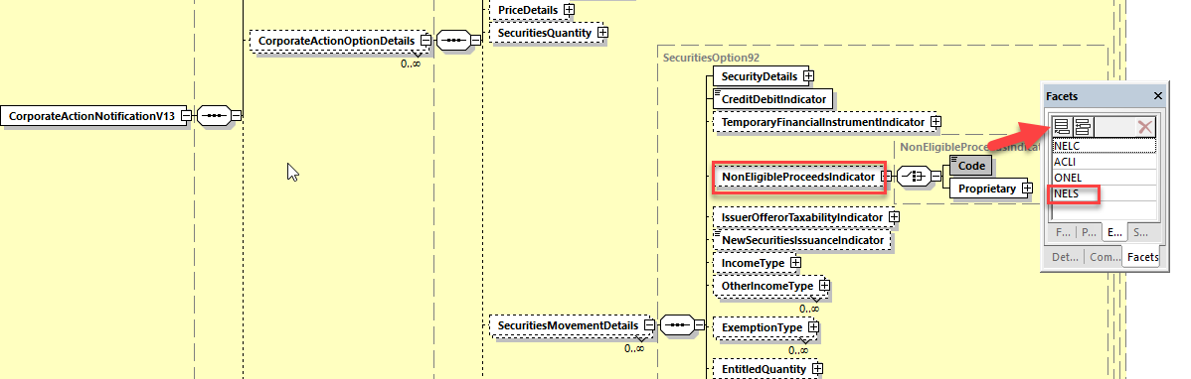

Working Group Meeting
To be completed by Standards after the meeting in August.

Discussion
The CA SWG concur with the ISO 20022 Securities SEG recommendation to approve the CR.
Decision
Not applicable as the CR was presented to the SWG for information.

CR 002034: New Indicator for Presence of Eligible Balance in Notification (ISO 20022 CR 1320)
Origin of request
Requesting Country:
Requesting Group: | ISITC
Sponsors
Message type(s) impacted
seev.031
Complies with regulation
None
Business impact of this request
Low
Commitment to implement the change
2024
Business context
In SR2023, the Eligible Balance Indicator was removed from the CANO message and the ENTL function was added to the CAPA Corporate Action Preliminary Advice (seev.035) to indicate eligibility of entitlements. DTCC is requesting the creation of a new Balance Notification Indicator in the CANO as a means of communicating when the CANO message is being sent to provide Balance (holdings) information without entitlements.
Previously, the Eligible Balance Indicator within the CANO was used as a means for recipients of DTCC Announcements to distinguish between the two variations of the seev.031. First as a generic message to all clients advising of the complete event announcement details (without balances) which did not display the Eligible Balance Indicator.
Second, as a balance notification (displaying the Eligible Balance Indicator) at the account level for Reorganization, Distribution and Redemption Events throughout the lifecycle of the event with only basic event information. The timing of the CANO balance notification (referred to at DTCC as the CANO-E) is triggered based on the type of event. Please note the basic timings of how DTCC generates the CANO message with balances:
Redemption Events (DRAW) – based on Record / Publication Date
Reorganization Events – Mandatory Events (Payment Date -7)
Voluntary Events – Instruction Expiration Date – 7
Distribution Events – Record Date
Please note that the two variations of the message can be independent of each other. Event detail changes without impact to a client holding position will produce the generic Event announcement without a balance notification. While Balance changes that occur without any event detail changes will produce a CANO balance notification only.
Ultimately, this request will provide DTCC recipients to provide the distinction between these two variations of the CANO message.
Nature of change
Add new Balance Notification indicator for CANO message Balance Notification Indicator within Corporate Action Notification General Information as Yes / No Indicator (Boolean) in
/Document/CorpActnNtfctn/NtfctnGnlInf/Balance_Notification.
Examples

SWIFT Comment

Standards Illustration

1. ISO 20022 Illustration
In the seev.031 (CANO – CorporateActionNotification) message, in the building block NotificationGeneralInformation, add a new optional and non-repeatable element BalanceNotificationIndicator typed by a YesNoIndicator data type as illustrated below and defined as “Indicates the notification includes eligible balance information.”.

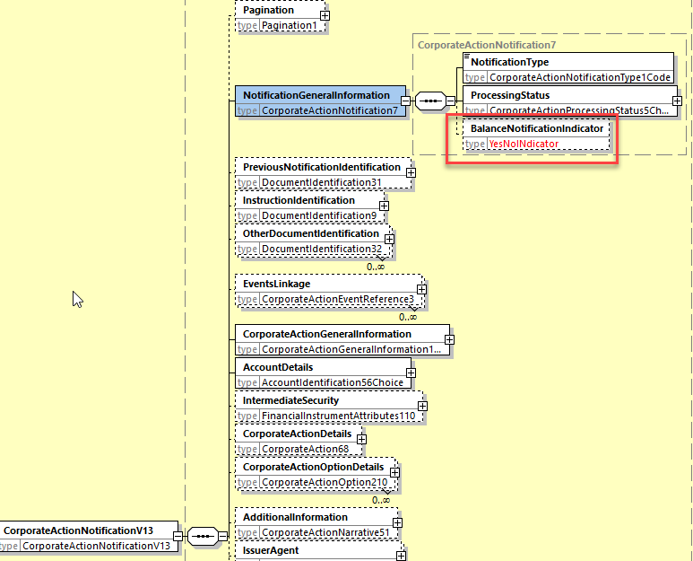

Working Group Meeting
To be completed by Standards after the meeting in August.

Discussion
At the August 3 ET meeting, the ISO 20022 securities SEG CA Evaluation Team recommended to reject the change request since it is also possible to simply use the presence of the ELIG balance in the message as an indicator.
This change might also be very confusing after the SR2023 CA CR to move the entitlement function from the seev.031 to the seev.035 as the indicator removed last year would be put back in the seev.031.
The CA SWG concur with the ISO 20022 Securities SEG recommendation to reject the CR.
Decision
Not applicable as the CR was presented to the SWG for information

CR 002035: Remove Update Description and Update Date in Narratives (ISO 20022 CR 1295)
Origin of request
Requesting Country:
Requesting Group: | SMPG
Sponsors
Message type(s) impacted
seev.031, seev.035, seev.038
Complies with regulation
None
Business impact of this request
Commitment to implement the change
Business context
Remove these elements which are deemed more confusing than useful for users.
Nature of change
We would like to remove UpdateDescription < UpdDesc> and UpdateDate <UpdDt> data elements from seev.031, seev.035 and seev.038.
Examples

SWIFT Comment

Standards Illustration
1. ISO 20022 Illustration

In the seev.031 (CANO – CorporateActionNotification) message, in sequence CorporateActionDetails, remove the optional elements UpdateDate and UpdateDescription from the sequences:
- AdditionalInformation/Offerror
- AdditionalInformation/NewCompanyName
- AdditionalInformation/URLAddress

For Offerror and NewCompanyName, replace the current data type UpdatedAdditionalInformation3 by the data type: Max350Text

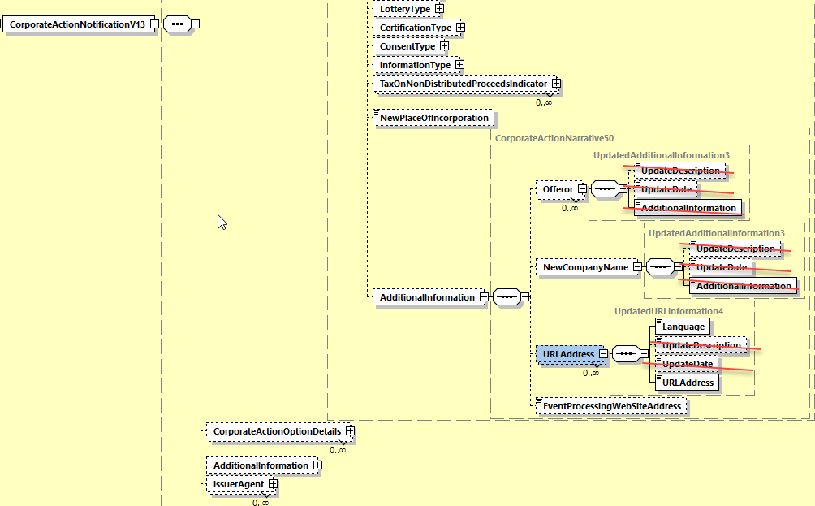

in sequence CorporateActionOptionDetails, remove the optional elements UpdateDate and UpdateDescription from the sequences:
- AdditionalInformation/AdditionalText
- AdditionalInformation/NarrativeVersion
- AdditionalInformation/InformationConditions
- AdditionalInformation/InformationToComplyWith
- AdditionalInformation/SecurityRestriction
- AdditionalInformation/TaxationConditions
- AdditionalInformation/Disclaimer
- AdditionalInformation/CertificationBreakdown
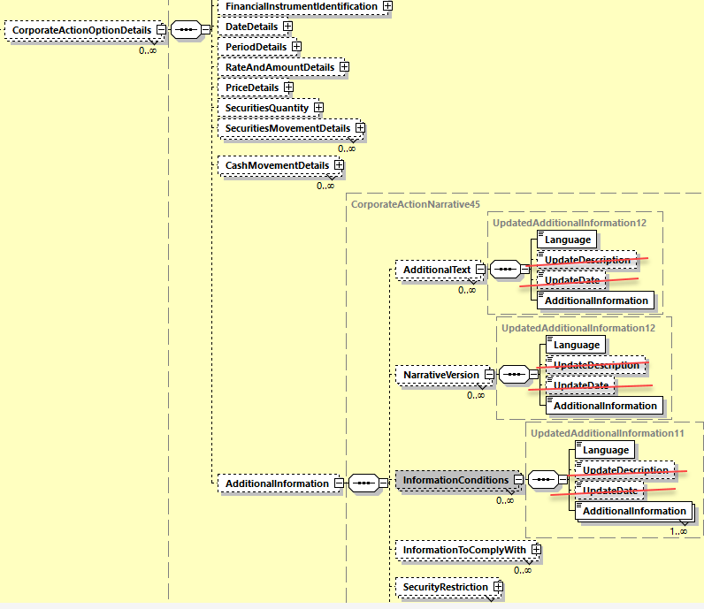

In the AdditionalInformation building block, remove the optional elements UpdateDate and UpdateDescription from the sequences:
- AdditionalText
- NarrativeVersion
- InformationConditions
- InformationToComplyWith
- TaxationConditions
- Disclaimer
- PartyContactNarrative
- RegistrationDetails
- BasketOrIndexInformation
- CertificationBreakdown
- URLAddress
- ProcessingTextForNextIntermediary

as illustrated above.

In the seev.035 (CAPA – CorporateActionMovementPreliminaryAdvice) message, in sequence CorporateActionMovementDetails, remove the optional elements UpdateDate and UpdateDescription from the sequences:
- AdditionalInformation/AdditionalText
- AdditionalInformation/NarrativeVersion
- AdditionalInformation/InformationConditions
- AdditionalInformation/InformationToComplyWith
- AdditionalInformation/SecurityRestriction
- AdditionalInformation/TaxationConditions
- AdditionalInformation/Disclaimer
- AdditionalInformation/CertificationBreakdown

as illustrated above.

In the AdditionalInformation building block, remove the optional elements UpdateDate and UpdateDescription from the sequences:
- AdditionalText
- NarrativeVersion
- InformationConditions
- InformationToComplyWith
- TaxationConditions
- Disclaimer
- PartyContactNarrative
- RegistrationDetails
- BasketOrIndexInformation
- CertificationBreakdown
- ProcessingTextForNextIntermediary

as illustrated above.

In the seev.038 (CANA – Corporate Action Narrative) message, in the building block AdditionalInformation, change the data type by Max8000Text and make the building block repetitive (this removes automatically the optional elements UpdateDate and UpdateDescription and get rid of the useless nesting level) as illustrated below.

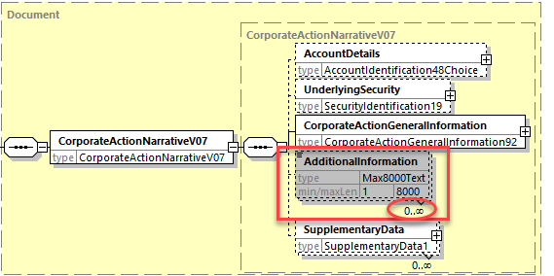

Working Group Meeting
To be completed by Standards after the meeting in August.

Discussion
Apart from the US who fears the structure of the narratives is modified in lots of places and apart from DE who believes that these fields can be useful in some cases, the CA SWG reached consensus to concur with the ISO 20022 Securities SEG recommendation to approve the CR.
Decision
Not applicable as the CR was presented to the SWG for information.

CR 002036: Amend Scope of Movement Preliminary Advice (ISO 20022 CR 1298)
Origin of request
Requesting Country:
Requesting Group: | SMPG
Sponsors
Message type(s) impacted
seev.035
Complies with regulation
Business impact of this request
Commitment to implement the change
Business context
To align the description of the message scope to the future usage of the message.
Nature of change
We would like to amend the scope of the seev.035 message to reflect the change introduced in SR2023 with the new “Function” element with a “CAPA” or “ENTL” codes.
Examples

SWIFT Comment

Standards Illustration
1. ISO 20022 Illustration
The introduction of a new element “Function” of the message in the seev.035 in order to make the distinction between the seev.035 message being used as an entitlement message (in replacement of the seev.031) and the message being used as a pure movement preadvice message, requires that the scope description of the seev.035 be updated in order to reflect correctly the enhancement in the message functionalities.

The current scope and usage has been defined as follows:
It is proposed to remove the term “Final” in the text of the scope.

Scope
The CorporateActionMovementPreliminaryAdvice message is sent by an account servicer to an account owner or its designated agent:
- to advise about the final eligible balance and entitlements and,
- to pre-advise an upcoming posting or reversal of securities and/or cash postings.
Usage
The message may also be used to:
- re-send a message previously sent (the sub-function of the message is Duplicate),
- provide a third party with a copy of a message for information (the sub-function of the message is Copy),
- re-send to a third party a copy of a message for information (the sub-function of the message is Copy Duplicate), using the relevant elements in the business application header (BAH).

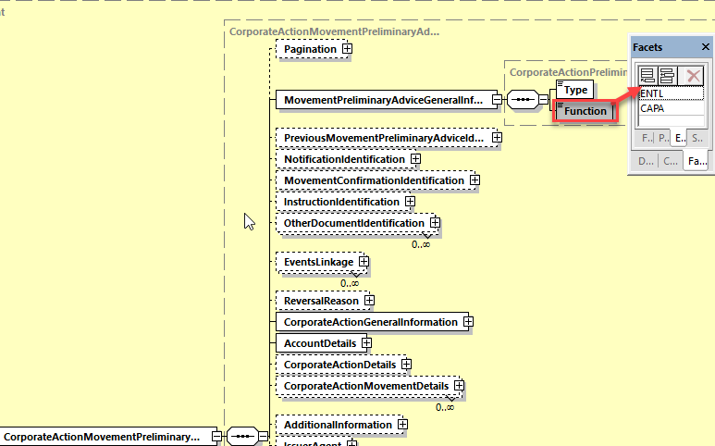

Working Group Meeting
To be completed by Standards after the meeting in August.

Discussion
The CA SWG concurred with the ISO 20022 Securities SEG recommendation to approve the CR.
Decision
Not applicable as the CR was presented to the SWG for information.

CR 002037: Add DateTime format to Posting Date / Original Posting Date (ISO 20022 CR 1321)
Origin of request
Requesting Country:
Requesting Group: | ISITC
Sponsors
Message type(s) impacted
MT 566, seev.036, seev.037
Complies with regulation
Business impact of this request
Commitment to implement the change
Business context
Volumes:
In 2022, there were over 61 million CACO allocation messages sent by DTCC.
DTCC uses this time feature on all Corporate Action Payment messages for Distribution, Redemption and Reorganization events, details below.
20022 CACO MX Messages (DTCC)
- Redemptions - 3,338,785
- Distributions - 57,207,781
- Reorganizations - 673,273
20022 CARE MX Messages – 7,136

Importance of the Change:
The Posting Date / Time feature is utilized by DTCC’s clients as an independent data field separate from the timestamp of the message. Given that DTC does not “autopay” and does not allocate funds to clients until it receives funding from the agent / issuer, the posting date and time is critical for clients as they allocate funds downstream. In addition to payments that are funded timely / accurately on the prescribed pay date, DTCC receives late payments, post allocation adjustments and rate changes at various dates and times that are not always aligned with Pay Date. It is critical that the CACO message reflects an accurate date / time so clients allocate accurately in the downstream payment process. In addition, downstream clients use this date as a critical audit trail as to when they were funded by DTCC. Therefore, it is not just DTC Participants that use this field, but also Asset Managers and others downstream as the funds flow to the beneficial owner.
(As additional background related to the aforementioned process of DTCC not “autopaying” on pay date, this link provides additional detail on the US Market’s Payment Refinement Initiative (https://www.dtcc.com/-/media/Files/Downloads/Settlement-Asset-Services/cash-processing/Payment_Refinement.pdf) in which DTCC will only allocate P&I payments in which it has received funding from the Paying Agents)

Background:
In the SR2023 release, CR1780 was implemented to harmonize the use of Date Time qualifiers within Corporate Action messages. The change request rationalized that certain Date elements did not need to have a Time component and, as such, removed the Date Time component. Most of these changes were logical and were never used by DTCC, but the use of the time feature for Posting Date is critical for the US Market. The impact of the removal of the posting date and original posting date was not uncovered during the original (2022) review period by DTCC. While originally this should have been noted and removed from the request, we are asking that this time feature be re-inserted to the CACO and CARE message.

Ramifications of not Approving the Change:
A lack of approval of this CR will result in the inability for DTCC’s clients to receive the allocation date and time in an automated manner, thus removing a critical audit trail of when funding occurred.
In addition, a lack of approval of this CR will result in the inability for DTCC’s clients to provide Asset Managers and Beneficial Holders these details in the MT566 message downstream, thus removing a critical audit trail of when funding occurred.
Nature of change
Add DateTime (ISODateTime) format for Posting Date within CACO seev.036 message within both Cash Movement and Securities Movement Details
/Document/CorpActnMvmntConf/CorpActnConfDtls/SctiesMvmntDtls/DtDtls/PstngDt
/Document/CorpActnMvmntConf/CorpActnConfDtls/CshMvmntDtls/DtDtls/PstngDt

Add DateTime (ISODateTime) format for Posting Date and Original Posting Date within CARE seev.037 Message within Cash Movement and Securities Movement Details
/Document/CorpActnMvmntRvslAdvc/CorpActnConfDtls/SctiesMvmntDtls/PstngDt
/Document/CorpActnMvmntRvslAdvc/CorpActnConfDtls/SctiesMvmntDtls/OrgnlPstngDt
/Document/CorpActnMvmntRvslAdvc/CorpActnConfDtls/CshMvmntDtls/PstngDt
/Document/CorpActnMvmntRvslAdvc/CorpActnConfDtls/CshMvmntDtls/OrgnlPstngD
Examples

SWIFT Comment

This Change request impacts only the MT566 message in ISO 15022 for Posting Date as the Original Posting Date does not exist in MT.

Standards Illustration
1. ISO 15022 Illustration
In the MT 566 message, in subsequence D1 and D2, in field 98a for qualifier POST, add format option C to the 98a field and to the POST qualifier and rename the qualifier “PostingDateTime” and amend the definition as illustrated below:
MT 566 Field Specifications
67. Field 98a: Date/Time
FORMAT
Option A | :4!c//8!n | (Qualifier)(Date)
Option B | :4!c/[8c]/4!c | (Qualifier)(Data Source Scheme)(Date Code)
Option C | :4!c//8!n6!n | (Qualifier)(Date)(Time)
PRESENCE
Mandatory in optional subsequence D1
QUALIFIER
(Error code(s): T89)
Order | M/O | Qualifier | R/N | CR | Options | Qualifier Description
1 | M | POST | N |  | A, C | Posting Date/Time
2 | O | AVAL | N |  | A or B | Available Date For Trading
3 | O | DIVR | N |  | A or B | Dividend Ranking Date
4 | O | EARL | N |  | A or B | Earliest Payment Date
5 | O | PAYD | N |  | A or B | Payment Date
6 | O | PPDT | N |  | A or B | Pari Passu Date
DEFINITION
This qualified generic field specifies:
AVAL | Available Date For Trading | Date at which securities become available for trading, for example first dealing date.
DIVR | Dividend Ranking Date | Date at which a security will be entitled to a dividend.
EARL | Earliest Payment Date | Date at which a payment can be made, for example, if payment date is a non-business day or to indicate the first payment date of an offer.
PAYD | Payment Date | Date at which the movement is due to take place (cash and/or securities).
POST | Posting Date/Time | Date/Time of the posting (credit or debit) to the account.
PPDT | Pari Passu Date | Date on which security will assimilate, become fungible, or have the same rights to dividends as the parent issue.

2. ISO 20022 Illustration
In the seev.036 (CACO – CorporateActionMovementConfirmation) message, in sequences CorporateActionConfirmationDetails/SecuritiesMovementDetails/DateDetails and in the sequence CorporateActionConfirmationDetails/CashMovementDetails/DateDetails, change the data type ISODate of the PostingDate element by “DateAndDateTime2Choice” as illustrated below:

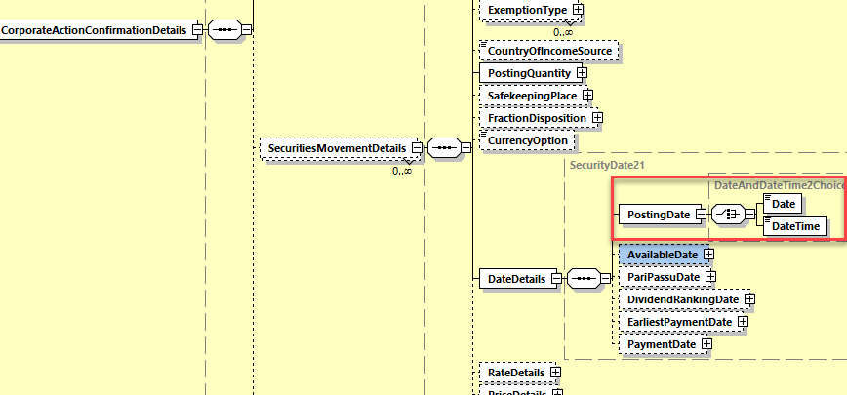

In the seev.037 (CARE – CorporateActionMovementReversalAdvice) message, , in sequences CorporateActionConfirmationDetails/SecuritiesMovementDetails and in the sequence CorporateActionConfirmationDetails/CashMovementDetails, change the data type ISODate of the PostingDate and OriginalPostingDate elements by “DateAndDateTime2Choice” as illustrated below:

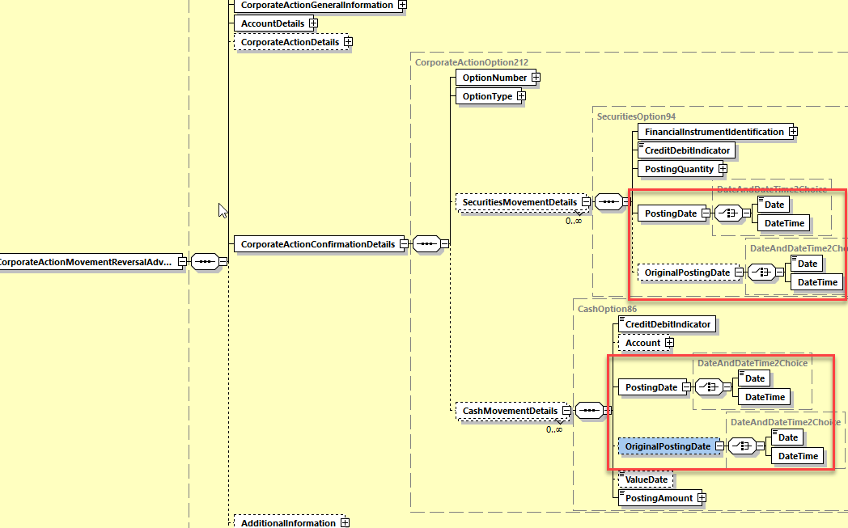

Working Group Meeting
To be completed by Standards after the meeting in August.

Discussion
The CA SWG agreed with the business case but UK suggests to implement the CR in ISO 20022 only and not in ISO 15022.
Swift indicated that is important to keep the coexistence between MT and MX.

The CA SWG resolved to vote.
The result is 12 countries in favour of the change in MT & MX and 1 country in favour of MX only. No countries are against the implementation.

Decision
Approved as is (with change in MT & MX)

CR 002038: Align Pending Status Reason Codes in Instruction Statement Report (ISO 20022 CR 1297)
Origin of request
Requesting Country:
Requesting Group: | SMPG
Sponsors
Message type(s) impacted
seev.042
Complies with regulation
None
Business impact of this request
Commitment to implement the change
Business context
The pending reason codes defined in the InstructionStatementReport message must be fully aligned with the same pending status reason codes defined in the CorporateActionInstructionStatus message and in the MT567.
Nature of change
In the seev.042 (CorporateActionInstructionStatementReport) message, change the data type “NoSpecifiedReason1” of the “Pending” status element in path “AccountAndStatementDetails / CorporateActionEventAndBalance / Balance / TotalInstructedBalanceDetails / OptionDetails / OptionInstructionDetails / InstructionStatus” by the data type “PendingStatus66Choice” used to type the “Pending” element in the seev.034 (CorporateActionInstructionStatusAdvice) message.
Examples

SWIFT Comment

Standards Illustration
1. ISO 20022 Illustration
In the seev.042 (CAPC – CorporateActionInstructionStatementReport) message, in the sequence AccountAndStatementDetails/CorporateActionEventAndBalance/Balance/ TotalInstructedBalanceDetails/OptionDetails/OptionInstructionDetails/InstructionStatus/Pending, change the data type “NoSpecifiedReason1” by the data type “PendingStatus66Choice” used in the seev.034 (CorporateActionInstructionStatusAdvice) message for the Pending status as illustrated below:

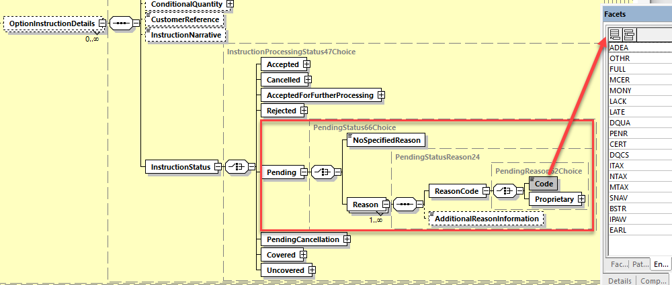

Working Group Meeting
To be completed by Standards after the meeting in August.

Discussion
The CA SWG concurred with the decision of the ISO 20022 Securities SEG ET to approve the CR.
Decision
Not applicable as the CR was presented to the SWG for information.

CR 002039: Set Elements as Mandatory in Market Claim messages (ISO 20022 CR 1301)
Origin of request
Requesting Country:
Requesting Group: | SMPG
Sponsors
Message type(s) impacted
seev.050, seev.052, seev.053
Complies with regulation
None
Business impact of this request
Commitment to implement the change
Business context
To add mandatory elements to the messages.
Nature of change
In the seev.050 and seev.052:
1. the Cash Movement block does not have a mandatory amount element. We believe Entitled Amount must be mandatory if the block is included, just as Entitled Quantity is mandatory in the Securities Movement block.
2. the Receiving/Delivering Settlement Parties blocks do not seem to have any mandatory elements. Based on settlement messages, at least Depository and Party 1 should be mandatory if the blocks are included.
Examples

SWIFT Comment

Standards Illustration
1. ISO 20022 Illustration
A. In the seev.050 (MarketClaimCreation) message, and
in the seev.052 (MarketClaimStatusAdvice) message, and
in the seev.053 (MarketClaimCancelletionRequestStatusAdvice) message,

in sequence MarketClaimDetails/CashMovementDetails, set the element “EntitledAmount” as mandatory as illustrated below for the seev.050.

B. In the seev.050 (MarketClaimCreation) message, in building blocks DeliveringSettlementParties and ReceivingSettlementParties, set the elements “Depository” and “Party1” as mandatory as illustrated below:

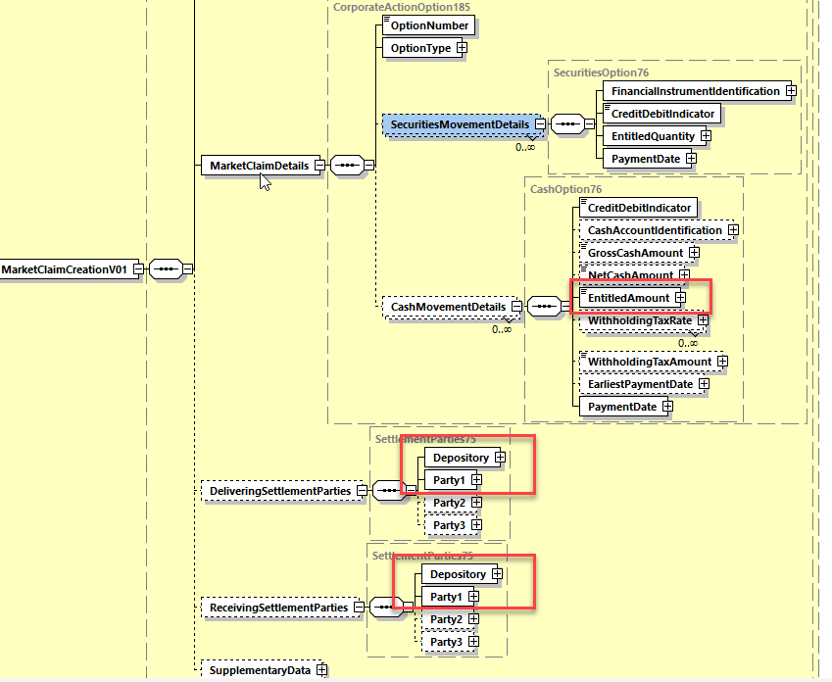

Working Group Meeting
To be completed by Standards after the meeting in August.

Discussion
The CA SWG concurred with the decision of the ISO 20022 Securities SEG ET to approve the CR.
Decision
Not applicable as the CR was presented to the SWG for information.

CR 002040: Issuer Agent - Agent Notification Status - Reason Code Updates and Alignment with CA messages (ISO 20022 CR 1315)
Origin of request
Requesting Country:
Requesting Group: | ISITC
Sponsors
Message type(s) impacted
seev.011
Complies with regulation
None
Business impact of this request
Commitment to implement the change
Business context
DTCC as part of its Agent Announcement program is proposing the modification of the seev.011.001.01 Agent Notification Status Advice Message (ANSA). DTC is currently working with the US agent community on defining requirements to automate the Voluntary Reorganization announcement process. Today, DTCC staff monitor a mailbox and EDGAR Pro for offering documentation which is a manual process.

The new initiative with US Agents will focus on two strategies: Use of the CANO (seev.031) message with a potential Agent Extension and (2) an Agent Portal which will allow for manual entry.
The working group formed will be creating templates for all US based Voluntary Reorg scenarios. These templates will focus on data requirements from a new message (NEWM) and the golden copy (COMP).
The ANSA message will play a key role to validate the CANO messages received. The goal is to use status messaging to control the workflow. The RECE status will be used for initial confirmation that the message has passed schema validation (well formed) and account validation. Certain events which require no review will go to an accepted (PACK) status with no operational review. Some events even if properly formatted will go to a Pending Confirmation status (PENC) for operational before either being accepted or rejected. Once DTCC announces the event to the market with a COAF, a confirmation (SENT) will be provided with the COAF reference. Agents will be expected to cross reference any Replacement messages with the COAF and the Agent Corporate Action Event ID.
As well, Event Cancellation requests would be received from an agent using a CACN message seev.039.002.12. Confirmation of the Agent Cancellation would occur using the ANSA message with the Cancellation Request Status either being Received (RECE), Completed (COMP) or Rejected with the reject code.
The change request does NOT eliminate any fields from the initial version of the ANSA. Instead, we have proposed the addition of certain fields / codes. Second, , bringing the message in line with the CANO structure such as data types or elimination of the certain fields up to the current “type” maintained on the CANO message such as “Event Type” and the elimination of the XOR structure. Lastly, we have asked for certain elements to be repositioned such as Underlying Security and Other Underlying Security to conform to the CANO structure.
Nature of change
This change request seeks to update the seev.011.001.01 Agent Notification Status Advice. This message was originally created but has not been maintained since its adoption.
Several changes are being requested so that the message is in line with the current CANO seev.031 message. As well, some structural changes are being requested to add code values to existing fields or add new data elements in line with the CANO. Below are the changes:

- Structurally the message should remove the usage of the {XOR} choice structures and align it with the current format used in ISO 20022 for choices (i.e. use of a “Choice” message component.
- Identification building block – Must be removed as this information is now provided in the BAH V2 that should be used with this message.
- Agent Identification: Data type to be aligned with the data type used for the party identifications in the seev.031 i.e. PartyIdentification129Choice
- Issuer Corporate Action Identification: Replace with OfficialCorporateActionEventIdentification as in seev.031
- Corporate Action Processing Identification: Replace with CorporateActionEventIdentification as in seev.031
- Event Type: Utilize the Event Type structure “CorporateActionEventType84Choice”
- Event Processing Type: Data type to be aligned with the data type used in the seev.031 i.e. CorporateActionEventProcessingType2Choice
- Mandatory Voluntary Event Type: Data type to be aligned with the data type used in the seev.031 i.e CorporateActionMandatoryVoluntary3Choice
- Underlying Security: To use the same structure as the Financial Instrument Identification within the seev.031 message

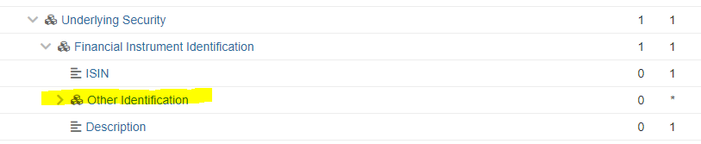

- Other Underlying Security Should be Other Identification within the Financial Instrument Identification as shown above. This should be mapped to the OtherIdentification2 datatype in line with the seev.031 CANO message.

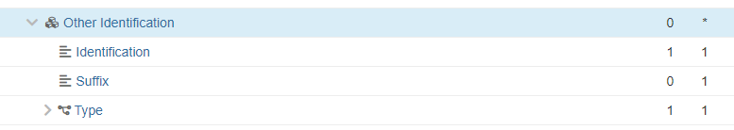

Processed Status - new Pending Code (PEND) should be added to Status with values
- Pending Confirmation (PENC)
- System Not Available (SNAV)

Rejected Status – Add the following new codes:
Missing Proration Rate | PROR
Missing Bid Interval | INTV
Missing Minimum Price | MINP
Missing Maximum Price | MAXP
Missing First Bid Increment | FIRS
Missing Last Bid Increment | LAST
Missing Oversubscription Price | OVPR
Missing Oversubscription Charge Flag | OVCH
Missing Oversubscription Flag | OVFL
Missing Rights Transferrable Flag | RITR
Missing Solicitation Dealer Fee Flag | SFEE
Missing Back End Odd Lot Quantity | BACK
Missing Conditional Tenders Accepted Flag | COND
Missing Full Conditional Flag | FULL
Missing Odd Lot Priority Flag | ODLT
Missing Proration Rounding Indicator | PROR
Missing Protect Charge Indicator | PRCH
Missing Subscription Price | SUPR
Missing Subscription Charge Flag | SUCH
Missing Unspecified Price Allowed | UNSP
Missing Cash Rate | CSRT
Missing Securities Rate | SERT
Missing Payout Type | PTYP
Missing Cash in Lieu Price | CINL
Missing Disbursed Security ID | MDIS
Invalid Disbursed Security ID | IDIS
Missing Fractional Disposition | FRAC
Missing Price Basis | PBAS
Missing Rounding Factor | ROUN
Missing Issuer Agent | ISSR
Invalid or Missing Issuer Agent Contact Information | ISSC

Examples

SWIFT Comment

- “Safekeeping Place” Data Type

In the version 001 of the message, the “SafekeepingPlace” element is typed by a PartyIdentification2Choice data type which is the same as data type used for the various parties in the corporate action messages whilst the SafekeepingPlace element in the corporate action messages is typed by SafekeepingPlaceFormat28Choice which is quite different from the PartyIdentificationChoice data type which does not seem really appropriate.

We would recommend to reuse the same data type as in the corporate action messages unless this was done on purpose in the issuer agent messages.
To be discussed at the SWG meeting.

- “Other Underlying Security” sequence

It is not clear whether this is for the identification of additional securities or for an alternate identification of the same security as the one in the sequence UnderlyingSecurity.
To be discussed at the SWG meeting

Standards Illustration
1. ISO 20022 Illustration
A. Current message design:

The following picture shows globally the high-level changes impacting the version 001 of the seev.011 messages i.e.:
- Removal of the Identification building block as this information is now included into the Business Application Header.
- Merge of the linkage information i.e. merge between the information about the identifications of the related messages and the information about the statuses associated to these related messages. This will avoid to create cross element rules to link the message identification to the statuses provided.
- The building block “CorporateActionGeneralInformation” will keep all its current elements but the data types and some names used will be harmonised with the data types used for the same elements in the latest version of the corporate action messages. See details in next section.

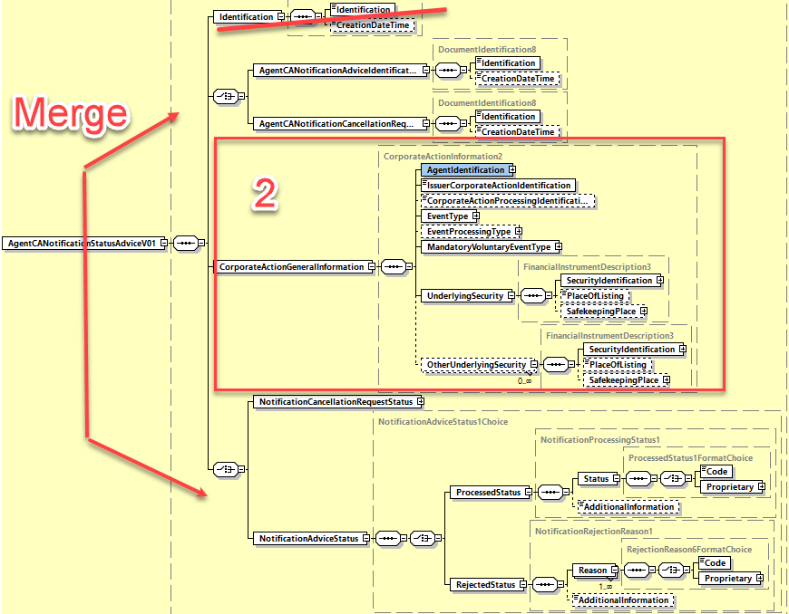

B. New message design:

The new version of the seev.011 message includes only 2 building blocks, one aggregating the identification of the related messages for which the status is provided together with the statuses renamed “LinkedDocumentIdentificationAndStatus” and the other CorporateActionGeneralInformation building block as illustrated below.
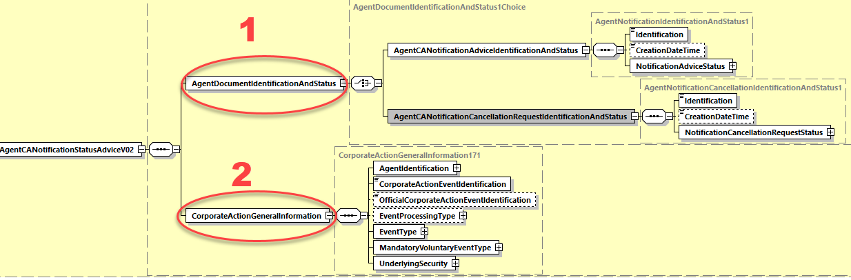

B1. Detailed design of the “LinkedDocumentIdentificationAndStatus” building block

This building block is a choice between the identification and status of the CorporateActionNotification (seev.031 - CANO) message sent by the agent or the identification and status of the CorporateActionCAncellationAdvice (seev.039 – CACN) message sent by the agent.

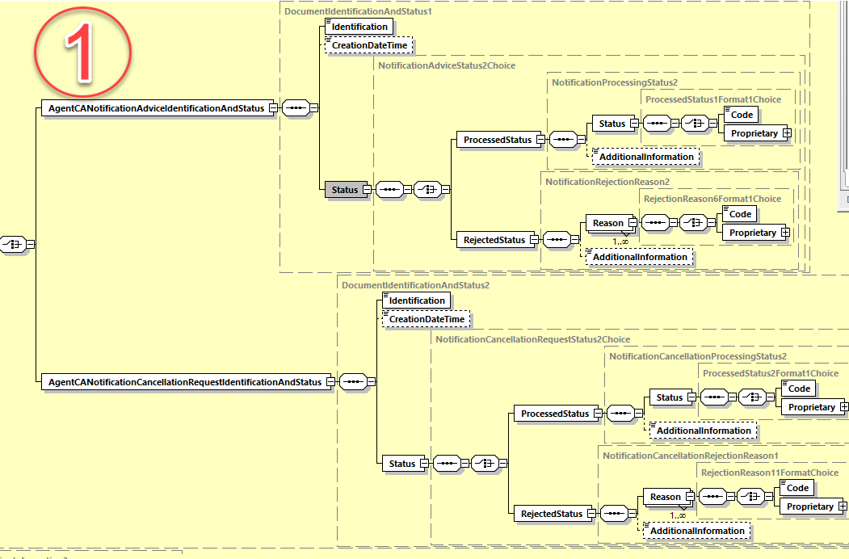

The ProcessedStatus of the NotificationAdvice messages are updated with the following additional code values:
- Pending (PEND)
- System Not Available (SNAV)
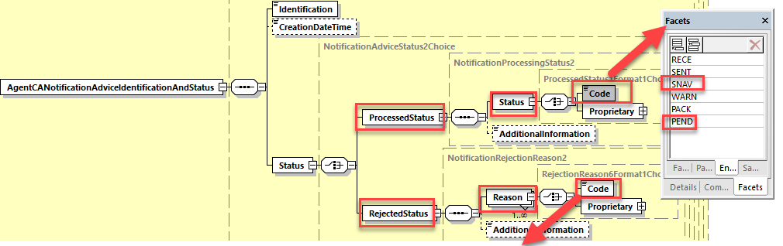
The RejectedStatus of the NotificationAdvice messages are updated with the following additional code values:

(*Since INTV already exist as a rejection reason code as “Option Inactive”, it is suggested to use “BIDI” code instead)
Missing Proration Rate | PROR
Missing Bid Interval | (INTV*) BIDI
Missing Minimum Price | MINP
Missing Maximum Price | MAXP
Missing First Bid Increment | FIRS
Missing Last Bid Increment | LAST
Missing Oversubscription Price | OVPR
Missing Oversubscription Charge Flag | OVCH
Missing Oversubscription Flag | OVFL
Missing Rights Transferrable Flag | RITR
Missing Solicitation Dealer Fee Flag | SFEE
Missing Back End Odd Lot Quantity | BACK
Missing Conditional Tenders Accepted Flag | COND
Missing Full Conditional Flag | (FULL*)  MFCF
Missing Odd Lot Priority Flag | ODLT
Missing Proration Rounding Indicator | (PROR*) MPRI
Missing Protect Charge Indicator | PRCH
Missing Subscription Price | SUPR
Missing Subscription Charge Flag | SUCH
Missing Unspecified Price Allowed | UNSP
Missing Cash Rate | CSRT
Missing Securities Rate | SERT
Missing Payout Type | PTYP
Missing Cash in Lieu Price | CINL
Missing Disbursed Security ID | MDIS
Invalid Disbursed Security ID | IDIS
Missing Fractional Disposition | FRAC
Missing Price Basis | PBAS
Missing Rounding Factor | ROUN
Missing Issuer Agent | ISSR
Invalid or Missing Issuer Agent Contact Information | ISSC

B2. Detailed design of the “CorporateActionGeneralInformation” building block
Summary of changes:
- AgentIdentification: Data type replaced by PartyIdentification129Choice
- Corporate Action Processing Identification: Renamed as CorporateActionEventIdentification
- Issuer Corporate Action Identification: Rename as OfficialCorporateActionEventIdentification
- EventType: replace data type by CorporateActionEventType84Choice
- Event Processing Type: replace data type by CorporateActionEventProcessingType2Choice
- Mandatory Voluntary Event Type: Data type to be replaced by CorporateActionMandatoryVoluntary3Choice
- Underlying Security: data type replaced by FinancialInstrumentDescription4
- Other Underlying Security: data type replaced by FinancialInstrumentDescription4

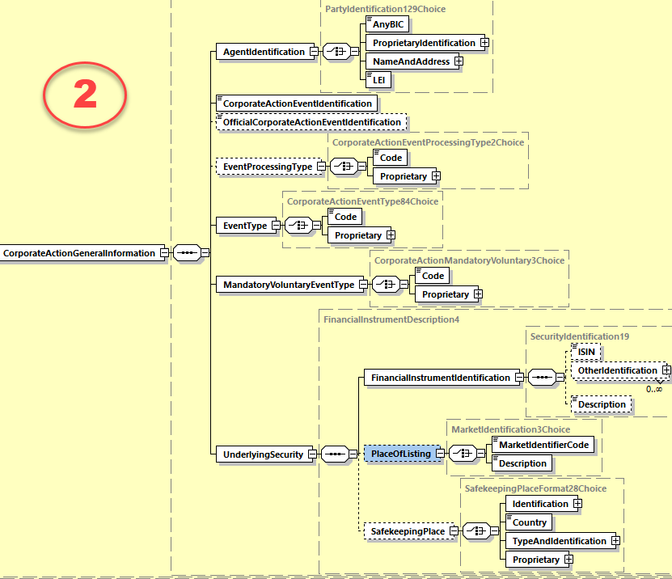

Working Group Meeting
To be completed by Standards after the meeting in August.

Discussion
The CA SWG concurred with the decision of the ISO 20022 Securities SEG ET to approve the CR.
Decision
Not applicable as the CR was presented to the SWG for information.

CR 002066: Align Pagination Mechanism with GM and SID messages (ISO 20022 CR 1331)
Origin of request
Requesting Country:
Requesting Group: | SMPG, Swift
Sponsors
Message type(s) impacted
seev.031, seev.035, seev.036
Complies with regulation
None
Business impact of this request
Medium
Commitment to implement the change
Business context
Align the pagination mechanism in corporate action messages with the new mechanism used already in SR2023 for the General Meeting messages (in seev.001, 004, 007, 008) and Shareholder Identification Disclosure (seev.047) messages by identifying the group of paginated messages with a single identification.
Nature of change
In the seev.031 (CorporateActionNotification) message, add in the building block “NotificationGeneralInformation” a new optional element “NotificationIdentification” typed by Max35Text.
In the seev.035 (CorporateActionMovementPreliminaryAdvice) message, add in the building block “MovementPreliminaryAdviceGeneralInformation” a new optional element “MovementPreliminaryAdviceIdentification” typed by Max35Text.
In the seev.036 (CorporateActionConfirmation) message, add a new optional element “ConfirmationIdentification” typed by Max35Text.
Examples

SWIFT Comment

This change was already proposed for SR2023 in the solution of the ISO 20022 CR1112 (Swift CR001900) but this change was rejected for SR2023 as it was not directly related to the initial scope and changes proposed in that last year CR (which was to move the entitlement function from the CANO (seev.031) to the CAPA (seev.035) message).
However the evaluation team accepted to have the change request submitted for SR2024 but the CR was forgotten at the submission time in May 2023. Hence the fast track procedure requested to ISO 20022 RA.

It is important that this change be implemented as soon as possible within the SR2024 before the Corporate action messages be more heavily used in the context of ECMS/SCoRE in 2025.

Standards Illustration
1. ISO 20022 Illustration
C1. In the seev.031 (CANO – CorporateActionNotification) message, in the NotificationGeneralInformation building block, add the optional non repeatable element NotificationIdentification typed by Max35Text as illustrated below:
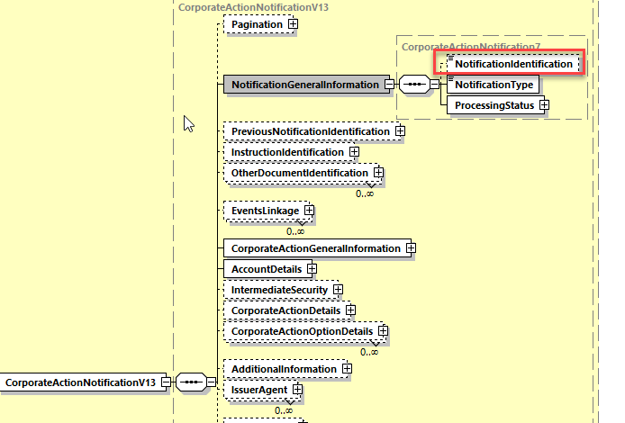

The “NotificationIdentification” will be the single identification of the group of notifications messages when the notification needs to be split into several pages.
The “NotificationIdentification” is defined as “Unique identification of the group of corporate action notification messages when the notification is split in multiple (paginated) messages.”.

C2. In the seev.035 (CAPA – CorporateActionMovementPreliminaryAdvice) message, in the MovementPreliminaryAdviceGeneralInformation building block, add the optional non repeatable element “MovementPreliminaryAdviceIdentification” typed by Max35Text as illustrated below:
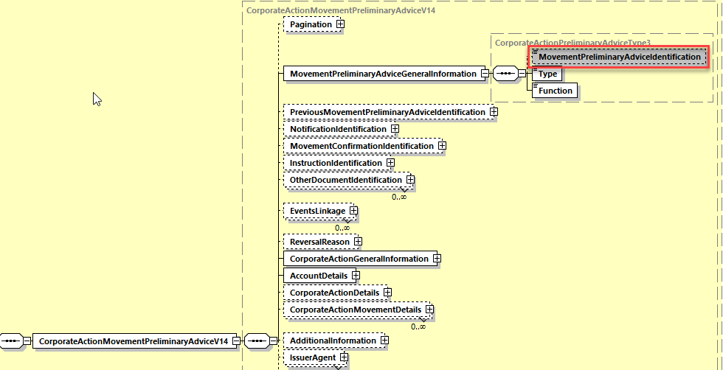

The MovementPreliminaryAdviceIdentification will be the single identification of the group of preliminary advice messages when the preliminary advice message needs to be split into several pages.
The MovementPreliminaryAdviceIdentification element is defined as “Unique identification of the group of corporate action movement preliminary advice messages when the preliminary advice is split in multiple (paginated) messages.”.

C3. In the seev.036 (CACO – CorporateActionMovementConfirmation) message, add at the top of the message after the pagination element, the optional non repeatable element “MovementConfirmationIdentification” typed by Max35Text as illustrated below:

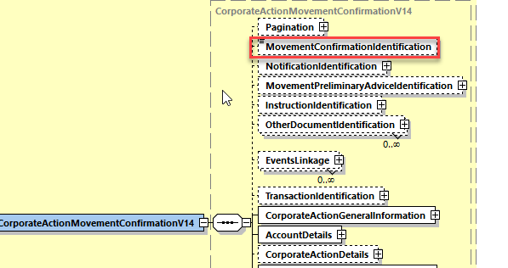

The MovementConfirmationIdentification will be the single identification of the group of movement confirmation messages when the movement confirmation message needs to be split into several pages.
The MovementConfirmationIdentification element is defined as “Unique identification of the group of corporate action movement confirmation messages when the movement confirmation is split in multiple (paginated) messages.”.

Working Group Meeting
To be completed by Standards after the meeting in August.

Discussion
The CA SWG concurred with the decision of the ISO 20022 Securities SEG ET to approve the CR.
Decision
Not applicable as the CR was presented to the SWG for information.

End of document

MWG maintenance meeting minutes are distributed around first week of September.

