Maintenance Change Request
for the update of ISO 20022 financial repository items

Name of the request:
ISO 20022 Payments Maintenance 2023/2024

Submitting organisation(s):
SWIFT, on behalf of SWIFT, Bank of England, CBI, EPC, FFI, GUF, IFX/OAGi, ISTH, Payments UK, RU-CMPG, SABS, Securities SEG, T2S, Trade Finance SEG, SETTTSG and TWIST

Standards Department,
Avenue Adele, 1
1310 La Hulpe - Belgium

Related messages:

Under this maintenance, below existing ISO 20022 message definitions will be maintained (resulting from the impact analysis performed on each CR).

Account Management:

acmt.007.001.04 | AccountOpeningRequestV04
acmt.008.001.04 | AccountOpeningAmendmentRequestV04
acmt.009.001.03 | AccountOpeningAdditionalInformationRequestV03
acmt.010.001.03 | AccountRequestAcknowledgementV03
acmt.011.001.03 | AccountRequestRejectionV03
acmt.012.001.03 | AccountAdditionalInformationRequestV03
acmt.013.001.03 | AccountReportRequestV03
acmt.014.001.04 | AccountReportV04
acmt.015.001.03 | AccountExcludedMandateMaintenanceRequestV03
acmt.016.001.03 | AccountExcludedMandateMaintenanceAmendmentRequestV03
acmt.017.001.03 | AccountMandateMaintenanceRequestV03
acmt.018.001.03 | AccountMandateMaintenanceAmendmentRequestV03
acmt.019.001.03 | AccountClosingRequestV03
acmt.020.001.03 | AccountClosingAmendmentRequestV03
acmt.021.001.03 | AccountClosingAdditionalInformationRequestV03
Cash Management:

camt.003.001.07 | GetAccountV07
camt.004.001.09 | ReturnAccountV09
camt.005.001.10 | GetTransactionV10
camt.006.001.10 | ReturnTransactionV10
camt.007.001.09 | ModifyTransactionV09
camt.007.002.03 | RequestToModifyPaymentV03
camt.008.001.10 | CancelTransactionV10
camt.009.001.07 | GetLimitV07
camt.010.001.08 | ReturnLimitV08
camt.011.001.07 | ModifyLimitV07
camt.012.001.07 | DeleteLimitV07
camt.024.001.07 | ModifyStandingOrderV07
camt.025.001.06 | ReceiptV06
camt.026.001.09 | UnableToApplyV09
camt.027.001.09 | ClaimNonReceiptV09
camt.028.001.11 | AdditionalPaymentInformationV11
camt.029.001.12 | ResolutionOfInvestigationV12
camt.030.001.05 | NotificationOfCaseAssignmentV05
camt.031.001.06 | RejectInvestigationV06
camt.032.001.04 | CancelCaseAssignmentV04
camt.033.001.06 | RequestForDuplicateV06
camt.034.001.06 | DuplicateV06
camt.035.001.05 | ProprietaryFormatInvestigationV05
camt.036.001.05 | DebitAuthorisationResponseV05
camt.037.001.09 | DebitAuthorisationRequestV09
camt.038.001.04 | CaseStatusReportRequestV04
camt.039.001.05 | CaseStatusReportV05
camt.046.001.07 | GetReservationV07
camt.047.001.07 | ReturnReservationV07
camt.048.001.06 | ModifyReservationV06
camt.049.001.06 | DeleteReservationV06
camt.050.001.06 | LiquidityCreditTransferV06
camt.051.001.06 | LiquidityDebitTransferV06
camt.055.001.11 | CustomerPaymentCancellationRequestV11
camt.056.001.10 | FIToFIPaymentCancellationRequestV10
camt.057.001.07 | NotificationToReceiveV07
camt.058.001.08 | NotificationToReceiveCancellationAdviceV08
camt.059.001.07 | NotificationToReceiveStatusReportV07
camt.060.001.06 | AccountReportingRequestV06
camt.069.001.04 | GetStandingOrderV04
camt.070.001.05 | ReturnStandingOrderV05
camt.071.001.04 | DeleteStandingOrderV04
camt.087.001.08 | RequestToModifyPaymentV08
camt.101.001.01 | CreateLimitV01
camt.102.001.02 | CreateStandingOrderV02
camt.103.001.02 | CreateReservationV02
camt.105.001.01 | ChargesPaymentNotificationV01
camt.106.001.01 | ChargesPaymentRequestV01
camt.107.001.01 | ChequePresentmentNotificationV01
camt.108.001.01 | ChequeCancellationOrStopRequestV01
camt.109.001.01 | ChequeCancellationOrStopReportV01
Payments, Clearing and Settlement:

pacs.002.001.13 | FIToFIPaymentStatusReportV13
pacs.003.001.10 | FIToFICustomerDirectDebitV10
pacs.004.001.12 | PaymentReturnV12
pacs.007.001.12 | FIToFIPaymentReversalV12
pacs.008.001.11 | FIToFICustomerCreditTransferV11
pacs.009.001.10 | FinancialInstitutionCreditTransferV10
pacs.010.001.05 | FinancialInstitutionDirectDebitV05
Payments Initiation:

pain.009.001.07 | MandateInitiationRequestV07
pain.010.001.07 | MandateAmendmentRequestV07
pain.011.001.07 | MandateCancellationRequestV07
pain.012.001.07 | MandateAcceptanceReportV07

Message sets impacted not under responsibility of SWIFT:
Please note that not all message sets are under the responsibility of SWIFT, and the RA contact the original submitting organisation of those messages set to confirm they intend to implement the changes in their respective message sets.
For those message sets, SWIFT cannot guarantee the submitting organisations will agree to implement the changes.

ISO 20022 Business Message Envelope and Business Application Header (under the responsibility of Technical Support Group (TSG):

nvlp.001.001.01  head.001.001.03 | BusinessMessageEnvelopeV01  BusinessApplicationHeaderV03

Note: SWIFT will implement the changes on behalf of TSG for this message set, if accepted.

Change or Verify Account Identification message set (under the responsibility of GUF):

acmt.022.001.03 | IdentificationModificationAdviceV03
acmt.023.001.03 | IdentificationVerificationRequestV03
acmt.024.001.03 | IdentificationVerificationReportV03

Note: SWIFT will implement the changes on behalf of GUF for this message set, if accepted.

Account Switching message set (under the responsibility of Payments UK):

acmt.027.001.04 | AccountSwitchInformationRequestV04
acmt.028.001.04 | AccountSwitchInformationResponseV04
acmt.029.001.04 | AccountSwitchCancelExistingPaymentV04
acmt.030.001.03 | AccountSwitchRequestRedirectionV03
acmt.031.001.04 | AccountSwitchRequestBalanceTransferV04
acmt.032.001.04 | AccountSwitchBalanceTransferAcknowledgementV04
acmt.034.001.04 | AccountSwitchRequestPaymentV04

Note: SWIFT will implement the changes on behalf of Payments UK for this message set, if accepted.

Target2-Securities message set (under the responsibility of T2S):

admi.005.001.01 | ReportQueryRequestV01
camt.066.001.01 | IntraBalanceMovementInstructionV01
camt.067.001.01 | IntraBalanceMovementStatusAdviceV01
camt.068.001.01 | IntraBalanceMovementConfirmationV01
camt.072.001.01 | IntraBalanceMovementModificationRequestV01
camt.073.001.01 | IntraBalanceMovementModificationRequestStatusAdviceV01
camt.074.001.01 | IntraBalanceMovementCancellationRequestV01
camt.075.001.01 | IntraBalanceMovementCancellationRequestStatusAdviceV01
camt.078.001.01 | IntraBalanceMovementQueryV01
camt.079.001.01 | IntraBalanceMovementQueryResponseV01
camt.080.001.01 | IntraBalanceMovementModificationQueryV01
camt.081.001.01 | IntraBalanceMovementModificationReportV01
camt.082.001.01 | IntraBalanceMovementCancellationQueryV01
camt.083.001.01 | IntraBalanceMovementCancellationReportV01
camt.084.001.01 | IntraBalanceMovementPostingReportV01
camt.085.001.01 | IntraBalanceMovementPendingReportV01
colr.001.001.01 | CollateralValueQueryV01
colr.002.001.01 | CollateralValueReportV01
reda.014.001.01 | PartyCreationRequestV01
reda.017.001.01 | PartyReportV01
reda.022.001.01 | PartyModificationRequestV01
reda.041.001.01 | PartyActivityAdviceV01
reda.043.001.01 | PartyAuditTrailReportV01

Note: SWIFT will implement the changes on behalf of T2S for this message set, if accepted.

Authorities Financial Investigations message set (under the responsibility of FFI):

auth.001.001.01  auth.002.001.01 | InformationRequestOpeningV01  InformationRequestResponseV01

Note: SWIFT will implement the changes on behalf of FFI for this message set, if accepted.

Cross-Border Transactions Currency Control Reporting message set (under the responsibility of RU-CMPG):

auth.018.001.03 | ContractRegistrationRequestV03
auth.019.001.03 | ContractRegistrationConfirmationV03
auth.020.001.03 | ContractRegistrationClosureRequestV03
auth.021.001.03 | ContractRegistrationAmendmentRequestV03
auth.022.001.03 | ContractRegistrationStatementV03
auth.023.001.03 | ContractRegistrationStatementRequestV03
auth.024.001.03 | PaymentRegulatoryInformationNotificationV03
auth.025.001.03 | CurrencyControlSupportingDocumentDeliveryV03
auth.026.001.03 | CurrencyControlRequestOrLetterV03
auth.027.001.03 | CurrencyControlStatusAdviceV03

Bank-to-Customer Cash Management message set (under the responsibility of ISTH):

camt.052.001.11 | BankToCustomerAccountReportV11
camt.053.001.11 | BankToCustomerStatementV11
camt.054.001.11 | BankToCustomerDebitCreditNotificationV11

Note: SWIFT will implement the changes in the name of ISTH as they no longer exist.

Bank Services Billing message set (under the responsibility of TWIST & SWIFT):

camt.086.001.04 | BankServicesBillingStatementV04

Note: SWIFT will implement the changes on behalf of TWIST for this message set, if accepted.

Payments Clearing and Settlement message set (under the responsibility of SWIFT & EPC):

pacs.028.001.05 | FIToFIPaymentStatusRequestV05

Note: SWIFT will implement the changes in the name of EPC.

Multilateral Settlement message set (under the responsibility of Bank of England):

pacs.029.001.01 | MultilateralSettlementRequestV01

Note: SWIFT will implement the changes on behalf of Bank of England for this message set, if accepted.

Payments Initiation message set (under the responsibility of ISTH/SWIFT):

pain.001.001.11 | CustomerCreditTransferInitiationV11
pain.002.001.13 | CustomerPaymentStatusReportV13
pain.007.001.11 | CustomerPaymentReversalV11
pain.008.001.10 | CustomerDirectDebitInitiationV10

Note: SWIFT will implement the changes in the name of ISTH as they no longer exist.

Creditor Payment Activation Request message set (under the responsibility of CBI):

pain.013.001.10 | CreditorPaymentActivationRequestV10
pain.014.001.10 | CreditorPaymentActivationRequestStatusReportV10

Note: SWIFT will implement the changes on behalf of CBI for this message set, if accepted.

Payments Mandates message set (under the responsibility of SWIFT & SABS):

pain.017.001.03 | MandateCopyRequestV03
pain.018.001.03 | MandateSuspensionRequestV03

Note: SWIFT will implement the changes in the name of SABS.

Request To Pay -RTP- Service message set (under the responsibility of EPC):

reda.066.001.01 | RequestToPayCreditorEnrolmentRequestV01
reda.067.001.01 | RequestToPayCreditorEnrolmentAmendmentRequestV01
reda.068.001.01 | RequestToPayCreditorEnrolmentCancellationRequestV01
reda.069.001.01 | RequestToPayCreditorEnrolmentStatusReportV01
reda.070.001.01 | RequestToPayDebtorActivationRequestV01
reda.071.001.01 | RequestToPayDebtorActivationAmendmentRequestV01
reda.072.001.01 | RequestToPayDebtorActivationCancellationRequestV01
reda.073.001.01 | RequestToPayDebtorActivationStatusReportV01

Note: SWIFT will implement the changes on behalf of EPC for this message set, if accepted.

Stand-Alone Remittance Advice message set (under the responsibility of IFX/OAGi):

remt.001.001.05 | RemittanceAdviceV05
remt.002.001.02 | RemittanceLocationAdviceV02

Note: SWIFT will implement the changes on behalf of IFX/OAGi for this message set, if accepted.

Various Securities message sets (under the responsibility of Securities SEG):
Settlement And Reconciliation -

semt.022.001.05 | SecuritiesSettlementTransactionAuditTrailReportV05

Note: SWIFT will implement the changes on behalf of Securities SEG for this message set, if accepted.

Various Trade Services message sets (under the responsibility of Trade Finance SEG):
Factoring Services -

tsin.006.001.01 | InvoiceAssignmentRequestV01
tsin.007.001.01 | InvoiceAssignmentStatusV01
tsin.008.001.01 | InvoiceAssignmentNotificationV01
tsin.009.001.01 | PartyRegistrationAndGuaranteeRequestV01
tsin.010.001.01 | PartyRegistrationAndGuaranteeStatusV01
tsin.011.001.01 | PartyRegistrationAndGuaranteeNotificationV01
tsin.012.001.01 | PartyRegistrationAndGuaranteeAcknowledgementV01
tsin.013.001.01 | InvoiceAssignmentAcknowledgementV01
tsmt.053.001.01 | InvoicePaymentReconciliationAdviceV01
tsmt.054.001.01 | InvoicePaymentReconciliationStatusV01
tsmt.055.001.01 | PartyEventAdviceV01
Demand Guarantees and Standby Letters of Credit –

tsin.005.001.01 | UndertakingApplicationV01
tsrv.001.001.01 | UndertakingIssuanceV01
tsrv.002.001.01 | UndertakingIssuanceAdviceV01
tsrv.003.001.01 | UndertakingIssuanceNotificationV01
tsrv.004.001.01 | UndertakingAmendmentRequestV01
tsrv.005.001.01 | UndertakingAmendmentV01
tsrv.006.001.01 | UndertakingAmendmentAdviceV01
tsrv.007.001.01 | UndertakingAmendmentNotificationV01
tsrv.008.001.01 | UndertakingAmendmentResponseV01
tsrv.009.001.01 | UndertakingAmendmentResponseNotificationV01
tsrv.010.001.01 | UndertakingNonExtensionRequestV01
tsrv.011.001.01 | UndertakingNonExtensionNotificationV01
tsrv.012.001.01 | UndertakingTerminationNotificationV01
tsrv.013.001.01 | UndertakingDemandV01
tsrv.014.001.01 | ExtendOrPayRequestV01
tsrv.015.001.01 | ExtendOrPayResponseV01
tsrv.016.001.01 | DemandRefusalNotificationV01
tsrv.017.001.01 | DemandWithdrawalNotificationV01
tsrv.018.001.01 | TradeStatusReportV01
tsrv.019.001.01 | UndertakingStatusReportV01

Invoice Tax Report –

auth.034.001.01 | InvoiceTaxReportV01

Note: SWIFT will implement the changes on behalf of Trade Finance SEG for these message sets, if accepted.

Commitments of the submitting organisation:

The submitting organisations confirm that they can and will:
- undertake the development of the new version of the candidate ISO 20022 message models that it will submit to the RA for compliance review and evaluation. New valid Message Definition models will be made available to the RA by December 1.
- provide a new version of part 1 of the related Message Definition Reports (MDR) by December 1, and new examples of valid message instances of each candidate message (only when valid samples were published for current version) by May 1 at the latest.
- address any queries related to the description of the new models and messages as published by the RA on the ISO 20022 website.

SWIFT intends to implement most of the above new versions on its SWIFTNet network once the related documentation has been published by the RA.

The submitting organisations confirm their knowledge and acceptance of the ISO 20022 Intellectual Property Rights policy for contributing organisations, as follows.
“Organisations that contribute information to be incorporated into the ISO 20022 Repository shall keep any Intellectual Property Rights (IPR) they have on this information. A contributing organisation warrants that it has sufficient rights on the contributed information to have it published in the ISO 20022 Repository through the ISO 20022 Registration Authority in accordance with the rules set in ISO 20022. To ascertain a widespread, public and uniform use of the ISO 20022 Repository information, the contributing organisation grants third parties a non-exclusive, royalty-free license to use the published information”.

Contact persons:
Dean Chard – SWIFT Standards, dean.chard@swift.com
Karin Deridder – SWIFT Standads, karin.deridder@swift.com

Change Requests Withdrawn:
The ISO Registration Authority notes that CR1305 and CR1323 were withdrawn by the submitter during the initial PAYSEG CR screening.

Change request CR0942: Enhance Postal Address

Origin of the request:
A.1 Submitter:

- CFONB, Comité Français d’Organisation et de Normalisation Bancaires (French Committee for Banking Organisation and Normalisation),
- GUF, Groupement des Utilisateurs de SWIFT en France (French SWIFT Members and Users Group).

A.2 Contact person: person(s) who can be contacted to get additional information on the request (name, e-mail, telephone)
Laurent LAFEUILLADE laurent.lafeuillade@socgen.com +33 1 42 14 66 70
Sylvain DAUGE Sylvain.Dauge@socgen.com +33 1 58 98 94 16
Rocco ZIRPOLI Rocco.Zirpoli@caissedesdepots.fr +33 1 58 50 19 50
A.3 Sponsors:
French mail institution, “La Poste”, which has written the postal address standard NF Z 10-011, used in France and in French Territories, made available to all users around the world through the UPU.

Related messages:
All ISO20022 messages using the Postal Address <PstlAdr> element.

Description of the change request:
We are requesting the extension of the length of the BuildingName element to more than 35c.
We ask you for advice on alignment with the length of the Floor element, i.e. 70c.

Purpose of the change:
We request to bring closer the lengths of the elements BuildingName (at 35c) and Floor (at 70c). We are looking for consistency between these elements.
The objective of this Change Request is to allow the BuildingName element to be filled by a French postal address, without truncation and thus ensuring its conformity with the French postal standard, while avoiding an induced loss of data.
Failing that, additional information could be filled in the Floor element only, by keeping the BuildingName element unused, but this is not desirable, in order to keep and store this data in its appropriate information category.

Urgency of the request:
End November 2022 for a usage in 2023.

Business examples:
You will find, herebelow, the summary of Universal Post Union element description of French addresses and some examples of French addresses, for both physical persons and companies, impacted by this issue.
The Examples illustrate the difficulty to fill, with the Line 2 from the French Postal Standard, the ISO20022 BuildingName element, for both physical persons and companies:

“Line 2” from French Postal Standard (38c) | “Building Name” Tag (35c)
“Zone industrielle de la Ballastrierre” | “Zone industrielle de la Ballastrier”
“Résidence des Capucins Bâtiment Quater” | “Résidence des Capucins Bâtiment Qua”
“Chez Mme COPPÉ Porte A Bâtiment Cerise” | “Chez Mme COPPÉ Porte A Bâtiment Cer”

FR | France
Summary Corporate Address
Level | ISO20022 tag | Element description | DataType | Universal Post Union (UPU) element description of French addresses |  | DataType
2 | <Dbtr> | Debtor
3 | <Nm> | Name |  |  | corporate name
3 | <PstlAdr> | Postal Address
4 | <Dept> | Department | Max70Text | Line 2 | Unit, addressee | Max 38
4 | <SubDept> | Sub Department | Max70Text | Line 2 | Unit, addressee | Max 38
4 | <StrtNm> | Street Name | Max70Text | Line 4 | house number and street name (= max 38 characters for the line) | 32
4 | <BldgNb> | Building Number | Max16Text |  |  | 5+1
4 | <BldgNm> | Building Name | Max35Text | Line 3 | additional geographical information (this line contains also the "Room" information) | Max 38
4 | <Flr> | Floor | Max70Text | Line 3 |  | Max 38
4 | <PstBx> | Post Box | Max16Text | Line 5 | PO box number (this line contains also the "Town Location Name" information) | Max 38
4 | <Room> | Room | Max70Text | Line 3 | additional geographical information  ==> Refers also to ISO 20022 elements "Building Name" and "Floor"
4 | <PstCd> | Post Code | Max16Text | Line 6 | postcode and CEDEX delivery office (= max 38 characters for the line) | 5+1
4 | <TwnNm> | Town Name | Max35Text |  |  | 32
4 | <TwnLctnNm> | Town Location Name | Max35Text | Line 5 | locality (only if geographical locality differs from CEDEX delivery office)  ==> Refers also to ISO 20022 element "Post Box"
4 | <DstrctNm> | District Name | Max35Text |  | Not used in French addresses
4 | <CtrySubDvsn> | Country Sub Division | Max35Text |  | Not used in French addresses
4 | <Ctry> | Country | Code2Text | Line 7 | COUNTRY | Max 38
Summary Private individual
Level | ISO20022 tag | Element description | DataType | Universal Post Union (UPU) element description of French addresses |  | DataType
2 | <Dbtr> | Debtor
3 | <Nm> | Name |  |  | Name
3 | <PstlAdr> | Postal Address
4 | <Dept> | Department | Max70Text |  | Not used in French addresses of private individuals | Max 38
4 | <SubDept> | Sub Department | Max70Text |  | Not used in French addresses of private individuals | Max 38
4 | <StrtNm> | Street Name | Max70Text | Line 4 | house number and street name (= max 38 characters for the line) | 32
4 | <BldgNb> | Building Number | Max16Text |  |  | 5+1
4 | <BldgNm> | Building Name | Max35Text | Line 3 | additional geographical information | Max 38
4 | <Flr> | Floor | Max70Text | Line 2 | additional delivery point information (This line contains also the "Room" information) | Max 38
4 | <PstBx> | Post Box | Max16Text | Line 5 | If PO BOX available
4 | <Room> | Room | Max70Text | Line 2 | additional delivery point information  ==> Refers also to ISO 20022 element "Floor" | Max 38
4 | <PstCd> | Post Code | Max16Text | Line 6 | postcode and locality (= max 38 characters for the line) | 5+1
4 | <TwnNm> | Town Name | Max35Text |  | postcode and locality (= max 38 characters for the line) | 32
4 | <TwnLctnNm> | Town Location Name | Max35Text | Line 5 | lieu-dit or hamlet name | Max 38
4 | <DstrctNm> | District Name | Max35Text |  | Not used in French addresses
4 | <CtrySubDvsn> | Country Sub Division | Max35Text |  | Not used in French addresses
4 | <Ctry> | Country | Code2Text | Line 7 | PAYS | Max 38

ISO code | Country name
FR | France
Example #1: Company 1
Level | ISO20022 tag | Element description | Universal Post Union (UPU) example | French postal elements | Recommended  ISO20022 mapping exemple | Possible  ISO20022 mapping example
2 | <Dbtr> | Debtor
3 | <Nm> | Name | DURAND SA  Service achat  Zone industrielle de la Ballastrierre  22BIS RUE DES FLEURS  BP 40122  33506 LIBOURNE CEDEX  France | DURAND SA | DURAND SA | DURAND SA
3 | <PstlAdr> | Postal Address
4 | <Dept> | Department |  | Service achat |  | Service achat
4 | <SubDept> | Sub Department |  | Service achat
4 | <StrtNm> | Street Name |  | 22BIS RUE DES FLEURS | 22BIS RUE DES FLEURS | RUE DES FLEURS
4 | <BldgNb> | Building Number |  | 22BIS RUE DES FLEURS |  | 22BIS
4 | <BldgNm> | Building Name |  | Zone industrielle de la Ballastrierre | Zone industrielle de la Ballastrierre
4 | <Flr> | Floor |  | Zone industrielle de la Ballastrierre |  | Zone industrielle de la Ballastrierre
4 | <PstBx> | Post Box |  | BP 40122 | BP 40122 | BP 40122
4 | <Room> | Room
4 | <PstCd> | Post Code |  | 33506 LIBOURNE CEDEX | 33506 | 33506
4 | <TwnNm> | Town Name |  | 33506 LIBOURNE CEDEX | LIBOURNE CEDEX | LIBOURNE CEDEX
4 | <TwnLctnNm> | Town Location Name
4 | <DstrctNm> | District Name
4 | <CtrySubDvsn> | Country Sub Division
4 | <Ctry> | Country |  | France | France | France
Example #2: Company 2
Level | ISO20022 tag | Element description | Universal Post Union element (UPU) | French postal elements | Recommended  ISO20022 mapping exemple | Possible  ISO20022 mapping example
2 | <Dbtr> | Debtor
3 | <Nm> | Name | Société DUPONT  Mademoiselle Lucie MARTIN  Résidence des Capucins Batiment Quater  56 RUE EMILE ZOLA  BP 90432 MONTFERRIER SUR LEZ  34092 MONTPELLIER CEDEX 5  France | Société DUPONT | Société DUPONT | Société DUPONT
3 | <PstlAdr> | Postal Address
4 | <Dept> | Department |  | Mademoiselle Lucie MARTIN | Mademoiselle Lucie MARTIN | Mademoiselle Lucie MARTIN
4 | <SubDept> | Sub Department |  | Mademoiselle Lucie MARTIN
4 | <StrtNm> | Street Name |  | 56 RUE EMILE ZOLA | 56 RUE EMILE ZOLA | RUE EMILE ZOLA
4 | <BldgNb> | Building Number |  | 56 RUE EMILE ZOLA |  | 56
4 | <BldgNm> | Building Name |  | Résidence des Capucins Batiment Quater | Résidence des Capucins Batiment Quater
4 | <Flr> | Floor |  | Résidence des Capucins Batiment Quater |  | Résidence des Capucins Batiment Quater
4 | <PstBx> | Post Box |  | BP 90432 | BP 90432 | BP 90432
4 | <Room> | Room
4 | <PstCd> | Post Code |  | 34092 MONTPELLIER CEDEX 5 | 34092 | 34092
4 | <TwnNm> | Town Name |  | 34092 MONTPELLIER CEDEX 5 | MONTPELLIER CEDEX 5 | MONTPELLIER CEDEX 5
4 | <TwnLctnNm> | Town Location Name |  | MONTFERRIER SUR LEZ | MONTFERRIER SUR LEZ | MONTFERRIER SUR LEZ
4 | <DstrctNm> | District Name
4 | <CtrySubDvsn> | Country Sub Division
4 | <Ctry> | Country |  | France | France | France
Example #3: Private Individual in residence
Level | ISO20022 tag | Element description | Universal Post Union element (UPU) | French postal elements | Recommended  ISO20022 mapping exemple | Possible  ISO20022 mapping example
2 | <Dbtr> | Debtor
3 | <Nm> | Name | Monsieur Jean DELHOURME  Chez Mme COPPÉ  Porte A Bâtiment Cerise  25 RUE DE L EGLISE  CAUDOS  33380 MIOS  FRANCE | Monsieur Jean DELHOURME | Monsieur Jean DELHOURME | Monsieur Jean DELHOURME
3 | <PstlAdr> | Postal Address
4 | <Dept> | Department
4 | <SubDept> | Sub Department
4 | <StrtNm> | Street Name |  | 25 RUE DE L EGLISE | 25 RUE DE L EGLISE | RUE DE L EGLISE
4 | <BldgNb> | Building Number |  | 25 RUE DE L EGLISE |  | 25
4 | <BldgNm> | Building Name |  | Porte A Bâtiment Cerise
4 | <Flr> | Floor |  |  | Porte A Bâtiment Cerise | Chez Mme COPPÉ Porte A Bâtiment Cerise
4 | <PstBx> | Post Box
4 | <Room> | Room |  | Chez Mme COPPÉ | Chez Mme COPPÉ
4 | <PstCd> | Post Code |  | 33380 MIOS | 33380 | 33380
4 | <TwnNm> | Town Name |  | 33380 MIOS | MIOS | MIOS
4 | <TwnLctnNm> | Town Location Name |  | CAUDOS | CAUDOS | CAUDOS
4 | <DstrctNm> | District Name
4 | <CtrySubDvsn> | Country Sub Division
4 | <Ctry> | Country |  | France | France | France

SEG/TSG recommendation:
This section is not to be taken care of by the submitter of the change request. It will be completed in due time by the SEG(s) in charge of the related ISO 20022 messages or the TSG for changes related to the BAH.

Consider |  | X | Timing
- Next yearly cycle: 2020/2021
(the change will be considered for implementation in the yearly maintenance cycle which starts in 2020 and completes with the publication of new message versions in the spring of 2021)
- At the occasion of the next maintenance of the messages
(the change will be considered for implementation, but does not justify maintenance of the messages in its own right – will be pending until more critical change requests are received for the messages)
- Urgent unscheduled
(the change justifies an urgent implementation outside of the normal yearly cycle)
 | X |  | - Other timing: Agreement by the Payments SEG WG to implement the CR during the 2023/2024 Maintenance cycle
Comments:
June 2022: Given that the CR impacts almost all the messages, the implementation timing will be defined by the Registration Authority.

As part of the evaluation of this CR the Payments SEG decided in July 2022 to set up a dedicated working group under the Payments SEG to perform an exhaustive review of the requirements for this CR
After extensive analysis and after discussion of other standards bodies, the group agreed that the current structure of ISO 20022 postal address was too narrow, and that these changes were needed. An alignment in the data type for all elements that intend to provide a name was proposed, and there were two data elements that were identified as gaps to be added.

The group also agreed that all ISO20022 Payments message definitions using the Postal Address <PstlAdr> element should be considered (typed by PostalAddress24). Impact in other business domains will be considered by the respective SEGs to assess whether the updated postal address will be implemented or not.

From an implementation point of view, the group agreed to following changes:

Extension of the length of the following elements to 140 characters:
· StreetName
· BuildingName
· TownName
· TownLocationName
· DistrictName
This should be done by implementing a Max140Text to replace the current defined length.

Addition of the two following new elements:
· Care of (C/O) optional, defined with a Max140Text datatype. Proposed Definition: “Address where you can be contacted when you are staying away from your regular address Used to provide the name of the person at this address.”
· Unit number optional, defined with a Max16Text datatype. Definition: “Unit number (formerly also called dwelling number) is part of your official address, and indicates which flat in the building you live in.”

Reject
Reason for rejection:

Impact analysis and type of impact:
The following Message Identifiers will be impacted –

acmt.007.001.04 | AccountOpeningRequestV04
acmt.008.001.04 | AccountOpeningAmendmentRequestV04
acmt.009.001.03 | AccountOpeningAdditionalInformationRequestV03
acmt.010.001.03 | AccountRequestAcknowledgementV03
acmt.011.001.03 | AccountRequestRejectionV03
acmt.012.001.03 | AccountAdditionalInformationRequestV03
acmt.013.001.03 | AccountReportRequestV03
acmt.014.001.04 | AccountReportV04
acmt.015.001.03 | AccountExcludedMandateMaintenanceRequestV03
acmt.016.001.03 | AccountExcludedMandateMaintenanceAmendmentRequestV03
acmt.017.001.03 | AccountMandateMaintenanceRequestV03
acmt.018.001.03 | AccountMandateMaintenanceAmendmentRequestV03
acmt.019.001.03 | AccountClosingRequestV03
acmt.020.001.03 | AccountClosingAmendmentRequestV03
acmt.021.001.03 | AccountClosingAdditionalInformationRequestV03
acmt.022.001.03 | IdentificationModificationAdviceV03
acmt.023.001.03 | IdentificationVerificationRequestV03
acmt.024.001.03 | IdentificationVerificationReportV03
acmt.027.001.04 | AccountSwitchInformationRequestV04
acmt.028.001.04 | AccountSwitchInformationResponseV04
acmt.029.001.04 | AccountSwitchCancelExistingPaymentV04
acmt.030.001.03 | AccountSwitchRequestRedirectionV03
acmt.031.001.04 | AccountSwitchRequestBalanceTransferV04
acmt.032.001.04 | AccountSwitchBalanceTransferAcknowledgementV04
acmt.034.001.04 | AccountSwitchRequestPaymentV04
admi.005.001.01 | ReportQueryRequestV01
auth.018.001.03 | ContractRegistrationRequestV03
auth.019.001.03 | ContractRegistrationConfirmationV03
auth.020.001.03 | ContractRegistrationClosureRequestV03
auth.021.001.03 | ContractRegistrationAmendmentRequestV03
auth.022.001.03 | ContractRegistrationStatementV03
auth.023.001.03 | ContractRegistrationStatementRequestV03
auth.024.001.03 | PaymentRegulatoryInformationNotificationV03
auth.025.001.03 | CurrencyControlSupportingDocumentDeliveryV03
auth.026.001.03 | CurrencyControlRequestOrLetterV03
auth.027.001.03 | CurrencyControlStatusAdviceV03
camt.003.001.07 | GetAccountV07
camt.004.001.09 | ReturnAccountV09
camt.005.001.10 | GetTransactionV10
camt.006.001.10 | ReturnTransactionV10
camt.007.001.09 | ModifyTransactionV09
camt.008.001.10 | CancelTransactionV10
camt.009.001.07 | GetLimitV07
camt.010.001.08 | ReturnLimitV08
camt.011.001.07 | ModifyLimitV07
camt.012.001.07 | DeleteLimitV07
camt.024.001.07 | ModifyStandingOrderV07
camt.025.001.06 | ReceiptV06
camt.026.001.09 | UnableToApplyV09
camt.027.001.09 | ClaimNonReceiptV09
camt.028.001.11 | AdditionalPaymentInformationV11
camt.029.001.12 | ResolutionOfInvestigationV12
camt.030.001.05 | NotificationOfCaseAssignmentV05
camt.031.001.06 | RejectInvestigationV06
camt.032.001.04 | CancelCaseAssignmentV04
camt.033.001.06 | RequestForDuplicateV06
camt.034.001.06 | DuplicateV06
camt.035.001.05 | ProprietaryFormatInvestigationV05
camt.036.001.05 | DebitAuthorisationResponseV05
camt.037.001.09 | DebitAuthorisationRequestV09
camt.038.001.04 | CaseStatusReportRequestV04
camt.039.001.05 | CaseStatusReportV05
camt.046.001.07 | GetReservationV07
camt.047.001.07 | ReturnReservationV07
camt.048.001.06 | ModifyReservationV06
camt.049.001.06 | DeleteReservationV06
camt.050.001.06 | LiquidityCreditTransferV06
camt.051.001.06 | LiquidityDebitTransferV06
camt.052.001.11 | BankToCustomerAccountReportV11
camt.053.001.11 | BankToCustomerStatementV11
camt.054.001.11 | BankToCustomerDebitCreditNotificationV11
camt.055.001.11 | CustomerPaymentCancellationRequestV11
camt.056.001.10 | FIToFIPaymentCancellationRequestV10
camt.057.001.07 | NotificationToReceiveV07
camt.058.001.08 | NotificationToReceiveCancellationAdviceV08
camt.059.001.07 | NotificationToReceiveStatusReportV07
camt.060.001.06 | AccountReportingRequestV06
camt.066.001.01 | IntraBalanceMovementInstructionV01
camt.067.001.01 | IntraBalanceMovementStatusAdviceV01
camt.068.001.01 | IntraBalanceMovementConfirmationV01
camt.069.001.04 | GetStandingOrderV04
camt.070.001.05 | ReturnStandingOrderV05
camt.071.001.04 | DeleteStandingOrderV04
camt.072.001.01 | IntraBalanceMovementModificationRequestV01
camt.073.001.01 | IntraBalanceMovementModificationRequestStatusAdviceV01
camt.074.001.01 | IntraBalanceMovementCancellationRequestV01
camt.075.001.01 | IntraBalanceMovementCancellationRequestStatusAdviceV01
camt.078.001.01 | IntraBalanceMovementQueryV01
camt.079.001.01 | IntraBalanceMovementQueryResponseV01
camt.080.001.01 | IntraBalanceMovementModificationQueryV01
camt.081.001.01 | IntraBalanceMovementModificationReportV01
camt.082.001.01 | IntraBalanceMovementCancellationQueryV01
camt.083.001.01 | IntraBalanceMovementCancellationReportV01
camt.084.001.01 | IntraBalanceMovementPostingReportV01
camt.085.001.01 | IntraBalanceMovementPendingReportV01
camt.086.001.04 | BankServicesBillingStatementV04
camt.087.001.08 | RequestToModifyPaymentV08
camt.101.001.01 | CreateLimitV01
camt.102.001.02 | CreateStandingOrderV02
camt.103.001.02 | CreateReservationV02
camt.105.001.01 | ChargesPaymentNotificationV01
camt.106.001.01 | ChargesPaymentRequestV01
camt.107.001.01 | ChequePresentmentNotificationV01
camt.108.001.01 | ChequeCancellationOrStopRequestV01
camt.109.001.01 | ChequeCancellationOrStopReportV01
colr.001.001.01 | CollateralValueQueryV01
colr.002.001.01 | CollateralValueReportV01
head.001.001.03 | BusinessApplicationHeaderV03
nvlp.001.001.01 | BusinessMessageEnvelopeV01
pacs.002.001.13 | FIToFIPaymentStatusReportV13
pacs.003.001.10 | FIToFICustomerDirectDebitV10
pacs.004.001.12 | PaymentReturnV12
pacs.007.001.12 | FIToFIPaymentReversalV12
pacs.008.001.11 | FIToFICustomerCreditTransferV11
pacs.009.001.10 | FinancialInstitutionCreditTransferV10
pacs.010.001.05 | FinancialInstitutionDirectDebitV05
pacs.028.001.05 | FIToFIPaymentStatusRequestV05
pacs.029.001.01 | MultilateralSettlementRequestV01
pain.001.001.11 | CustomerCreditTransferInitiationV11
pain.002.001.13 | CustomerPaymentStatusReportV13
pain.007.001.11 | CustomerPaymentReversalV11
pain.008.001.10 | CustomerDirectDebitInitiationV10
pain.009.001.07 | MandateInitiationRequestV07
pain.010.001.07 | MandateAmendmentRequestV07
pain.011.001.07 | MandateCancellationRequestV07
pain.012.001.07 | MandateAcceptanceReportV07
pain.013.001.10 | CreditorPaymentActivationRequestV10
pain.014.001.10 | CreditorPaymentActivationRequestStatusReportV10
pain.017.001.03 | MandateCopyRequestV03
pain.018.001.03 | MandateSuspensionRequestV03
reda.066.001.01 | RequestToPayCreditorEnrolmentRequestV01
reda.067.001.01 | RequestToPayCreditorEnrolmentAmendmentRequestV01
reda.068.001.01 | RequestToPayCreditorEnrolmentCancellationRequestV01
reda.069.001.01 | RequestToPayCreditorEnrolmentStatusReportV01
reda.070.001.01 | RequestToPayDebtorActivationRequestV01
reda.071.001.01 | RequestToPayDebtorActivationAmendmentRequestV01
reda.072.001.01 | RequestToPayDebtorActivationCancellationRequestV01
reda.073.001.01 | RequestToPayDebtorActivationStatusReportV01
remt.001.001.05 | RemittanceAdviceV05
remt.002.001.02 | RemittanceLocationAdviceV02
reda.014.001.01 | PartyCreationRequestV01
reda.017.001.01 | PartyReportV01
reda.022.001.01 | PartyModificationRequestV01
reda.041.001.01 | PartyActivityAdviceV01
reda.043.001.01 | PartyAuditTrailReportV01

Proposed implementation:
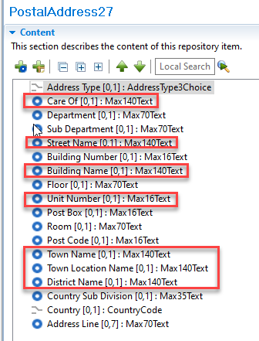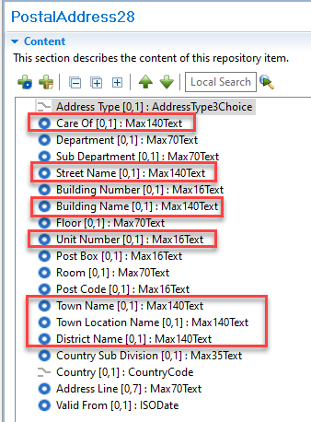
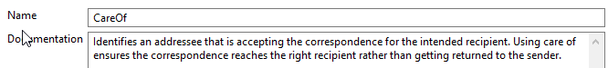

For discussion -
1. The ISO Registration Authority understand the Payment Market Practice Group (PMPG) intend to submit a CR to amend the definition of Town Name. If approved the ISO Registration Authority propose to update the definition as part of the Payments Maintenance 2023/2024.
2. The ISO Registration Authority note that approved business justification 204 will see the creation of new exception and investigation messages to supersede the existing messages (camt.029, camt.055 and camt.056). Various CRs throughout this MCR impact the legacy messages, is the preference of the PAYSEG to mark the existing messages as obsolete (new versions are not created) or maintain the existing messages (new versions created with CRs implemented)?

Proposed timing:
The submitting organisation confirms that it can implement the requested changes in the requested timing.

Timing

Final decision of the SEG(s):

Approve

Reject
Reason for rejection:

Change request CR1124: Extend Identification length within Organisation Identification / Other

Origin of the request:
A.1 Submitter:
360kompany AG
A.2 Contact person:
Dusan Stanojevic
dusan.stanojevic@kompany.com
+4368110466320
A.3 Sponsors:
360kompany AG as the registered partner of the SWIFT, is building an interface to the SWIFT network for entity verification, for which we had asked the sponsorship of this change request.

Related messages:
The ISO 20022 message which would be impacted by the change: pain.001.001.11CustomerCreditTransferInitiationV11
Component affected: OrganisationIdentification29 / GenericOrganisationIdentification1
Scheme name: COID

Description of the change request:
The current definition for the field RegistrationAuthorityIdentification in the Organisation & Party Identification Schema (https://www.iso20022.org/standardsrepository/type/OrganisationIdentification) has an 35 character limitation. However, most of the issuing bodies for company registration numbers have defined registration numbers with a longer length. Therefore, this change request addresses the need to extend the field length to max of 50 characters.

Purpose of the change:
Users of the schema which want to perform entity verification versus official register number will not be able to perform this action because of the current max 35 character limitation while official register number usually exceed this limitation.

Urgency of the request:
By default, valid change requests introduced by June 1 and subsequently approved by the SEG/TSG will be included in the following yearly maintenance cycle which completes with the publication of new message versions by April/May of the following year, unless decided otherwise by the SEG/TSG.
If there is a need to have the new version of the related messages published earlier, the reason for the urgency of the maintenance and the expected consequences of a delay should be described here. Acceptance of such an unscheduled maintenance for the BAH is subject to approval by TSG. Acceptance of an unscheduled maintenance for messages other than the BAH is subject to the approval of the SEG and availability of a submitting organization to develop the new version of the messages.
Note: the ISO 20022 maintenance results in the publication of a new version of an ISO 20022 message. The actual implementation of such new version on networks and in user installations is not within the purview of ISO.

Business examples:

India official register number: U63040DL2008PTC173850

German official numbers contain as part of registration number, also the federal court, therefore it is possible that for specific German cases the length of registration number might even exceed 50 characters.
Germany official register number: VR 120720Arnstadt Zweigstelle Ilmenau

SEG/TSG recommendation:
This section is not to be taken care of by the submitter of the change request. It will be completed in due time by the SEG(s) in charge of the related ISO 20022 messages or the TSG for changes related to the BAH.

Consider |  | X | Timing
 |  |  | - Next yearly cycle: 2023/2024  (the change will be considered for implementation in the yearly maintenance cycle which starts in 2023 and completes with the publication of new message versions in the spring of 2024) |  | X
- At the occasion of the next maintenance of the messages
(the change will be considered for implementation, but does not justify maintenance of the messages in its own right – will be pending until more critical change requests are received for the messages)
- Urgent unscheduled
(the change justifies an urgent implementation outside of the normal yearly cycle)
 |  |  | - Other timing:
Comments:

Reject
Reason for rejection:

Impact analysis and type of impact:
The following Message Identifiers will be impacted –

acmt.007.001.04 | AccountOpeningRequestV04
acmt.008.001.04 | AccountOpeningAmendmentRequestV04
acmt.009.001.03 | AccountOpeningAdditionalInformationRequestV03
acmt.010.001.03 | AccountRequestAcknowledgementV03
acmt.011.001.03 | AccountRequestRejectionV03
acmt.012.001.03 | AccountAdditionalInformationRequestV03
acmt.013.001.03 | AccountReportRequestV03
acmt.014.001.04 | AccountReportV04
acmt.015.001.03 | AccountExcludedMandateMaintenanceRequestV03
acmt.016.001.03 | AccountExcludedMandateMaintenanceAmendmentRequestV03
acmt.017.001.03 | AccountMandateMaintenanceRequestV03
acmt.018.001.03 | AccountMandateMaintenanceAmendmentRequestV03
acmt.019.001.03 | AccountClosingRequestV03
acmt.020.001.03 | AccountClosingAmendmentRequestV03
acmt.021.001.03 | AccountClosingAdditionalInformationRequestV03
acmt.022.001.03 | IdentificationModificationAdviceV03
acmt.023.001.03 | IdentificationVerificationRequestV03
acmt.024.001.03 | IdentificationVerificationReportV03
acmt.025.001.01 | AccountQueryListV01
acmt.026.001.01 | AccountListReportV01
acmt.027.001.04 | AccountSwitchInformationRequestV04
acmt.028.001.04 | AccountSwitchInformationResponseV04
acmt.029.001.04 | AccountSwitchCancelExistingPaymentV04
acmt.030.001.03 | AccountSwitchRequestRedirectionV03
acmt.031.001.04 | AccountSwitchRequestBalanceTransferV04
acmt.032.001.04 | AccountSwitchBalanceTransferAcknowledgementV04
acmt.034.001.04 | AccountSwitchRequestPaymentV04
auth.001.001.01 | InformationRequestOpeningV01
auth.002.001.01 | InformationRequestResponseV01
auth.018.001.03 | ContractRegistrationRequestV03
auth.019.001.03 | ContractRegistrationConfirmationV03
auth.020.001.03 | ContractRegistrationClosureRequestV03
auth.021.001.03 | ContractRegistrationAmendmentRequestV03
auth.022.001.03 | ContractRegistrationStatementV03
auth.023.001.03 | ContractRegistrationStatementRequestV03
auth.024.001.03 | PaymentRegulatoryInformationNotificationV03
auth.025.001.03 | CurrencyControlSupportingDocumentDeliveryV03
auth.026.001.03 | CurrencyControlRequestOrLetterV03
auth.027.001.03 | CurrencyControlStatusAdviceV03
auth.034.001.01 | InvoiceTaxReportV01
camt.003.001.07 | GetAccountV07
camt.004.001.09 | ReturnAccountV09
camt.005.001.10 | GetTransactionV10
camt.006.001.10 | ReturnTransactionV10
camt.007.002.03 | RequestToModifyPaymentV03
camt.008.001.10 | CancelTransactionV10
camt.026.001.09 | UnableToApplyV09
camt.027.001.09 | ClaimNonReceiptV09
camt.028.001.11 | AdditionalPaymentInformationV11
camt.029.001.12 | ResolutionOfInvestigationV12
camt.030.001.05 | NotificationOfCaseAssignmentV05
camt.031.001.06 | RejectInvestigationV06
camt.032.001.04 | CancelCaseAssignmentV04
camt.033.001.06 | RequestForDuplicateV06
camt.034.001.06 | DuplicateV06
camt.035.001.05 | ProprietaryFormatInvestigationV05
camt.036.001.05 | DebitAuthorisationResponseV05
camt.037.001.09 | DebitAuthorisationRequestV09
camt.038.001.04 | CaseStatusReportRequestV04
camt.039.001.05 | CaseStatusReportV05
camt.052.001.11 | BankToCustomerAccountReportV11
camt.053.001.11 | BankToCustomerStatementV11
camt.054.001.11 | BankToCustomerDebitCreditNotificationV11
camt.055.001.11 | CustomerPaymentCancellationRequestV11
camt.056.001.10 | FIToFIPaymentCancellationRequestV10
camt.057.001.07 | NotificationToReceiveV07
camt.058.001.08 | NotificationToReceiveCancellationAdviceV08
camt.059.001.07 | NotificationToReceiveStatusReportV07
camt.060.001.06 | AccountReportingRequestV06
camt.086.001.04 | BankServicesBillingStatementV04
camt.087.001.08 | RequestToModifyPaymentV08
camt.107.001.01 | ChequePresentmentNotificationV01
camt.108.001.01 | ChequeCancellationOrStopRequestV01
camt.109.001.01 | ChequeCancellationOrStopReportV01
cbrf.001.001.01 | ClearingPositionsSettlementInstructionV01
cbrf.004.001.01 | LiquidityReportV01
cbrf.005.001.01 | ParticipantProfileReportV01
cbrf.006.001.01 | PacketHeaderV01
cbrf.008.001.01 | QueueReorderingNotificationV01
cbrf.009.001.01 | ConditionalInstructionConfirmationV01
cbrf.010.001.01 | UnfundedShortPositionsNotificationV01
head.001.001.03 | BusinessApplicationHeaderV03
nvlp.001.001.01 | BusinessMessageEnvelopeV01
pacs.002.001.13 | FIToFIPaymentStatusReportV13
pacs.003.001.10 | FIToFICustomerDirectDebitV10
pacs.004.001.12 | PaymentReturnV12
pacs.007.001.12 | FIToFIPaymentReversalV12
pacs.008.001.11 | FIToFICustomerCreditTransferV11
pacs.009.001.10 | FinancialInstitutionCreditTransferV10
pacs.028.001.05 | FIToFIPaymentStatusRequestV05
pacs.029.001.01 | MultilateralSettlementRequestV01
pain.001.001.11 | CustomerCreditTransferInitiationV11
pain.002.001.13 | CustomerPaymentStatusReportV13
pain.007.001.11 | CustomerPaymentReversalV11
pain.008.001.10 | CustomerDirectDebitInitiationV10
pain.009.001.07 | MandateInitiationRequestV07
pain.010.001.07 | MandateAmendmentRequestV07
pain.011.001.07 | MandateCancellationRequestV07
pain.012.001.07 | MandateAcceptanceReportV07
pain.013.001.10 | CreditorPaymentActivationRequestV10
pain.014.001.10 | CreditorPaymentActivationRequestStatusReportV10
pain.017.001.03 | MandateCopyRequestV03
pain.018.001.03 | MandateSuspensionRequestV03
reda.066.001.01 | RequestToPayCreditorEnrolmentRequestV01
reda.067.001.01 | RequestToPayCreditorEnrolmentAmendmentRequestV01
reda.068.001.01 | RequestToPayCreditorEnrolmentCancellationRequestV01
reda.069.001.01 | RequestToPayCreditorEnrolmentStatusReportV01
reda.070.001.01 | RequestToPayDebtorActivationRequestV01
reda.071.001.01 | RequestToPayDebtorActivationAmendmentRequestV01
reda.072.001.01 | RequestToPayDebtorActivationCancellationRequestV01
reda.073.001.01 | RequestToPayDebtorActivationStatusReportV01
remt.001.001.05 | RemittanceAdviceV05
remt.002.001.02 | RemittanceLocationAdviceV02
semt.022.001.05 | SecuritiesSettlementTransactionAuditTrailReportV05
tsin.005.001.01 | UndertakingApplicationV01
tsin.006.001.01 | InvoiceAssignmentRequestV01
tsin.007.001.01 | InvoiceAssignmentStatusV01
tsin.008.001.01 | InvoiceAssignmentNotificationV01
tsin.009.001.01 | PartyRegistrationAndGuaranteeRequestV01
tsin.010.001.01 | PartyRegistrationAndGuaranteeStatusV01
tsin.011.001.01 | PartyRegistrationAndGuaranteeNotificationV01
tsin.012.001.01 | PartyRegistrationAndGuaranteeAcknowledgementV01
tsin.013.001.01 | InvoiceAssignmentAcknowledgementV01
tsmt.053.001.01 | InvoicePaymentReconciliationAdviceV01
tsmt.054.001.01 | InvoicePaymentReconciliationStatusV01
tsmt.055.001.01 | PartyEventAdviceV01
tsrv.001.001.01 | UndertakingIssuanceV01
tsrv.002.001.01 | UndertakingIssuanceAdviceV01
tsrv.003.001.01 | UndertakingIssuanceNotificationV01
tsrv.004.001.01 | UndertakingAmendmentRequestV01
tsrv.005.001.01 | UndertakingAmendmentV01
tsrv.006.001.01 | UndertakingAmendmentAdviceV01
tsrv.007.001.01 | UndertakingAmendmentNotificationV01
tsrv.008.001.01 | UndertakingAmendmentResponseV01
tsrv.009.001.01 | UndertakingAmendmentResponseNotificationV01
tsrv.010.001.01 | UndertakingNonExtensionRequestV01
tsrv.011.001.01 | UndertakingNonExtensionNotificationV01
tsrv.012.001.01 | UndertakingTerminationNotificationV01
tsrv.013.001.01 | UndertakingDemandV01
tsrv.014.001.01 | ExtendOrPayRequestV01
tsrv.015.001.01 | ExtendOrPayResponseV01
tsrv.016.001.01 | DemandRefusalNotificationV01
tsrv.017.001.01 | DemandWithdrawalNotificationV01
tsrv.018.001.01 | TradeStatusReportV01
tsrv.019.001.01 | UndertakingStatusReportV01

Proposed implementation:
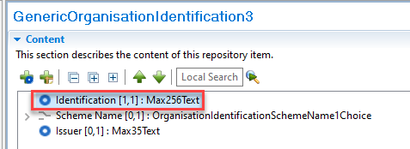
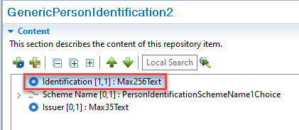

For discussion -
1. The ISO Registration Authority propose a data type of Max256Text, this allows a longer identification than 50 characters to be populated (as per the German example given in the CR) and would also allow an email address to be quoted. Is this supported by the PAYSEG?
2. The ISO Registration Authority propose making the same change to GenericPersonIdentification. This aligns both components now as opposed to a future high impact change request being required. Is this supported by the PAYSEG?

Proposed timing:
The submitting organisation confirms that it can implement the requested changes in the requested timing.

Timing

Final decision of the SEG(s):

Approve

Reject
Reason for rejection:

Change request CR1310: Enhance Contact Details

Origin of the request:
A.1 Submitter:
Federal Reserve Bank of New York (on behalf of the US Federal Reserve Banks)
33 Liberty Street
New York, NY 10045
U.S.A.
A.2 Contact person:
Federal Reserve Bank of New York
Mr. Frank Van Driessche (frank.vandriessche@ny.frb.org)
A.3 Sponsors:

Related messages:
pain.013.001.10 – Creditor Payment Activation Request (‘Request for Payment’)
Potential impact on all other messages where Party Identification / Contact Details component is used.

Description of the change request:
Request to add a URL option to the Contact Details component (in this case to the Creditor element) to inform how to contact a creditor/biller customer department online, e.g., through chat function.
As shown in the graphic below this could be achieved by either explicitly adding a URL option to the currently present methods like email, mobile, fax, or by enhancing the Identification element under the Other channel method (currently restricted to Max128Text).
If added as a result also the Preferred Method would need to have the online option.

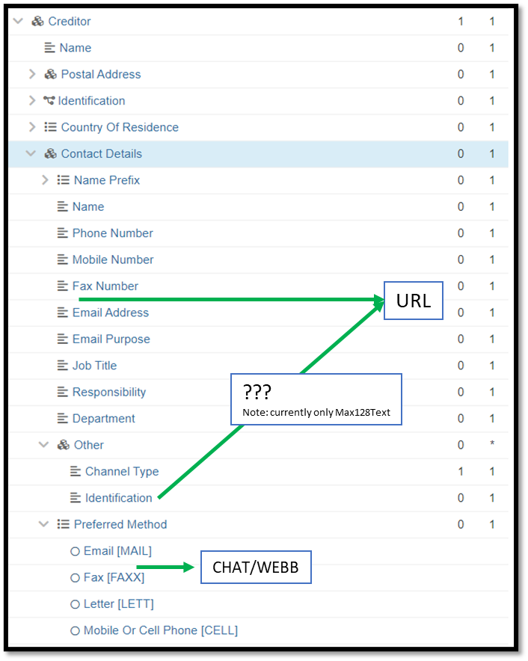

Purpose of the change:
Enable customers to reach biller customer support through chat.

Urgency of the request:
Request to include the change in the current maintenance cycle.

Business examples:
See above.

SEG/TSG recommendation:
This section is not to be taken care of by the submitter of the change request. It will be completed in due time by the SEG(s) in charge of the related ISO 20022 messages or the TSG for changes related to the BAH.

Consider |  | X | Timing
 |  |  | - Next yearly cycle: 2023/2024  (the change will be considered for implementation in the yearly maintenance cycle which starts in 2023 and completes with the publication of new message versions in the spring of 2024) |  | X
- At the occasion of the next maintenance of the messages
(the change will be considered for implementation, but does not justify maintenance of the messages in its own right – will be pending until more critical change requests are received for the messages)
- Urgent unscheduled
(the change justifies an urgent implementation outside of the normal yearly cycle)
 |  |  | - Other timing:
Comments:

Reject
Reason for rejection:

Impact analysis and type of impact:
The following Message Identifiers will be impacted –

acmt.007.001.04 | AccountOpeningRequestV04
acmt.008.001.04 | AccountOpeningAmendmentRequestV04
acmt.009.001.03 | AccountOpeningAdditionalInformationRequestV03
acmt.010.001.03 | AccountRequestAcknowledgementV03
acmt.011.001.03 | AccountRequestRejectionV03
acmt.012.001.03 | AccountAdditionalInformationRequestV03
acmt.013.001.03 | AccountReportRequestV03
acmt.014.001.04 | AccountReportV04
acmt.015.001.03 | AccountExcludedMandateMaintenanceRequestV03
acmt.016.001.03 | AccountExcludedMandateMaintenanceAmendmentRequestV03
acmt.017.001.03 | AccountMandateMaintenanceRequestV03
acmt.018.001.03 | AccountMandateMaintenanceAmendmentRequestV03
acmt.019.001.03 | AccountClosingRequestV03
acmt.020.001.03 | AccountClosingAmendmentRequestV03
acmt.021.001.03 | AccountClosingAdditionalInformationRequestV03
acmt.022.001.03 | IdentificationModificationAdviceV03
acmt.023.001.03 | IdentificationVerificationRequestV03
acmt.024.001.03 | IdentificationVerificationReportV03
acmt.027.001.04 | AccountSwitchInformationRequestV04
acmt.028.001.04 | AccountSwitchInformationResponseV04
acmt.029.001.04 | AccountSwitchCancelExistingPaymentV04
acmt.030.001.03 | AccountSwitchRequestRedirectionV03
acmt.031.001.04 | AccountSwitchRequestBalanceTransferV04
acmt.032.001.04 | AccountSwitchBalanceTransferAcknowledgementV04
acmt.034.001.04 | AccountSwitchRequestPaymentV04
auth.018.001.03 | ContractRegistrationRequestV03
auth.019.001.03 | ContractRegistrationConfirmationV03
auth.020.001.03 | ContractRegistrationClosureRequestV03
auth.021.001.03 | ContractRegistrationAmendmentRequestV03
auth.022.001.03 | ContractRegistrationStatementV03
auth.023.001.03 | ContractRegistrationStatementRequestV03
auth.024.001.03 | PaymentRegulatoryInformationNotificationV03
auth.025.001.03 | CurrencyControlSupportingDocumentDeliveryV03
auth.026.001.03 | CurrencyControlRequestOrLetterV03
auth.027.001.03 | CurrencyControlStatusAdviceV03
camt.003.001.07 | GetAccountV07
camt.004.001.09 | ReturnAccountV09
camt.005.001.10 | GetTransactionV10
camt.006.001.10 | ReturnTransactionV10
camt.008.001.10 | CancelTransactionV10
camt.026.001.09 | UnableToApplyV09
camt.027.001.09 | ClaimNonReceiptV09
camt.028.001.11 | AdditionalPaymentInformationV11
camt.029.001.12 | ResolutionOfInvestigationV12
camt.030.001.05 | NotificationOfCaseAssignmentV05
camt.031.001.06 | RejectInvestigationV06
camt.032.001.04 | CancelCaseAssignmentV04
camt.033.001.06 | RequestForDuplicateV06
camt.034.001.06 | DuplicateV06
camt.035.001.05 | ProprietaryFormatInvestigationV05
camt.036.001.05 | DebitAuthorisationResponseV05
camt.037.001.09 | DebitAuthorisationRequestV09
camt.038.001.04 | CaseStatusReportRequestV04
camt.039.001.05 | CaseStatusReportV05
camt.052.001.11 | BankToCustomerAccountReportV11
camt.053.001.11 | BankToCustomerStatementV11
camt.054.001.11 | BankToCustomerDebitCreditNotificationV11
camt.055.001.11 | CustomerPaymentCancellationRequestV11
camt.056.001.10 | FIToFIPaymentCancellationRequestV10
camt.057.001.07 | NotificationToReceiveV07
camt.058.001.08 | NotificationToReceiveCancellationAdviceV08
camt.059.001.07 | NotificationToReceiveStatusReportV07
camt.060.001.06 | AccountReportingRequestV06
camt.086.001.04 | BankServicesBillingStatementV04
camt.087.001.08 | RequestToModifyPaymentV08
camt.107.001.01 | ChequePresentmentNotificationV01
camt.108.001.01 | ChequeCancellationOrStopRequestV01
camt.109.001.01 | ChequeCancellationOrStopReportV01
head.001.001.03 | BusinessApplicationHeaderV03
nvlp.001.001.01 | BusinessMessageEnvelopeV01
pacs.002.001.13 | FIToFIPaymentStatusReportV13
pacs.003.001.10 | FIToFICustomerDirectDebitV10
pacs.004.001.12 | PaymentReturnV12
pacs.007.001.12 | FIToFIPaymentReversalV12
pacs.008.001.11 | FIToFICustomerCreditTransferV11
pacs.009.001.10 | FinancialInstitutionCreditTransferV10
pacs.028.001.05 | FIToFIPaymentStatusRequestV05
pacs.029.001.01 | MultilateralSettlementRequestV01
pain.001.001.11 | CustomerCreditTransferInitiationV11
pain.002.001.13 | CustomerPaymentStatusReportV13
pain.007.001.11 | CustomerPaymentReversalV11
pain.008.001.10 | CustomerDirectDebitInitiationV10
pain.009.001.07 | MandateInitiationRequestV07
pain.010.001.07 | MandateAmendmentRequestV07
pain.011.001.07 | MandateCancellationRequestV07
pain.012.001.07 | MandateAcceptanceReportV07
pain.013.001.10 | CreditorPaymentActivationRequestV10
pain.014.001.10 | CreditorPaymentActivationRequestStatusReportV10
pain.017.001.03 | MandateCopyRequestV03
pain.018.001.03 | MandateSuspensionRequestV03
reda.066.001.01 | RequestToPayCreditorEnrolmentRequestV01
reda.067.001.01 | RequestToPayCreditorEnrolmentAmendmentRequestV01
reda.068.001.01 | RequestToPayCreditorEnrolmentCancellationRequestV01
reda.069.001.01 | RequestToPayCreditorEnrolmentStatusReportV01
reda.070.001.01 | RequestToPayDebtorActivationRequestV01
reda.071.001.01 | RequestToPayDebtorActivationAmendmentRequestV01
reda.072.001.01 | RequestToPayDebtorActivationCancellationRequestV01
reda.073.001.01 | RequestToPayDebtorActivationStatusReportV01
remt.001.001.05 | RemittanceAdviceV05
remt.002.001.02 | RemittanceLocationAdviceV02
reda.014.001.01 | PartyCreationRequestV01
reda.017.001.01 | PartyReportV01
reda.022.001.01 | PartyModificationRequestV01
reda.041.001.01 | PartyActivityAdviceV01
reda.043.001.01 | PartyAuditTrailReportV01

Proposed implementation:
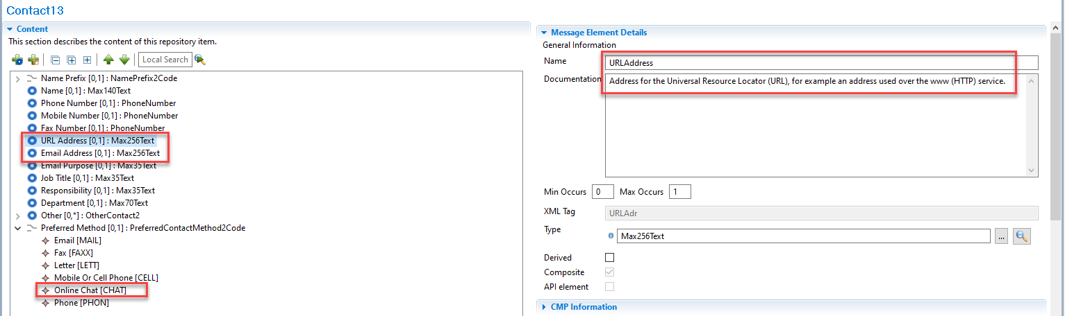
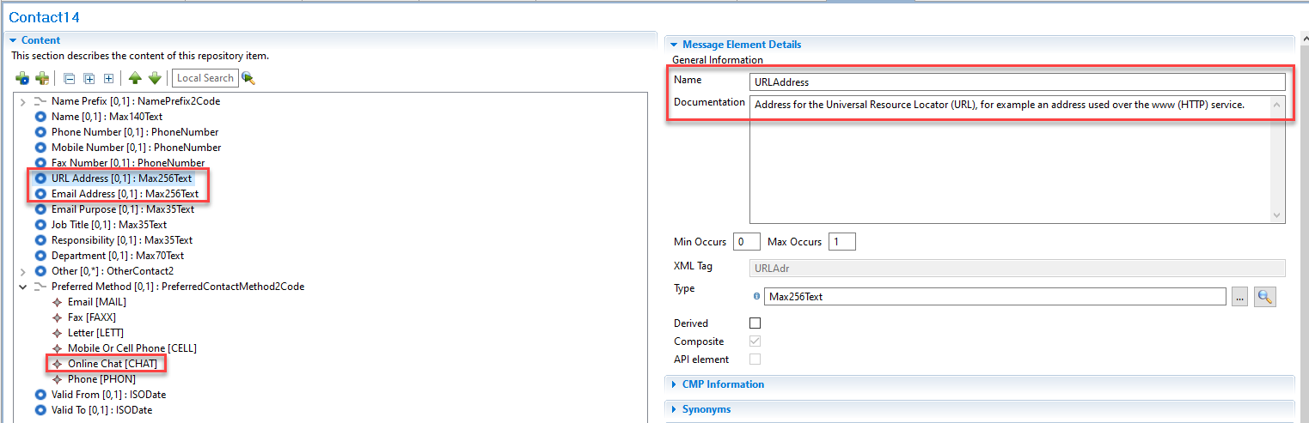
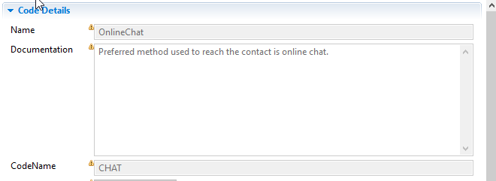
Please note data type for Email Address in previous versions of components was incorrect, this has been corrected to Max256Text.

Proposed timing:
The submitting organisation confirms that it can implement the requested changes in the requested timing.

Timing

Final decision of the SEG(s):

Approve

Reject
Reason for rejection:

Change request CR1322: Enhance Referred Document Information structure within Structured Remittance Information

Origin of the request:
A.1 Submitter:
Federal Reserve Bank of New York (on behalf of the US Federal Reserve Banks)
33 Liberty Street
New York, NY 10045
U.S.A.
A.2 Contact person:
Federal Reserve Bank of New York
Mr. Frank Van Driessche (frank.vandriessche@ny.frb.org)
A.3 Sponsors:
-

Related messages:
pain.013 – Creditor Payment Activation Request (aka Request for Payment)
Other impacted messages: all messages with the StructuredRemittanceInformation17 component, e.g., pain.001, pacs.008, pacs.009.

Description of the change requests:
Add the following dates in the Referred Document Information component, next to the existing Related Date:
- Invoice Date
- Payment Due Date
- Next Billing Date
To future-proof the remittance information component we suggest considering a structural change to the component enabling a repetitive component with each occurrence having a date in combination with a qualifying Type indicator (and an externalized code list as shown in the graphic below).
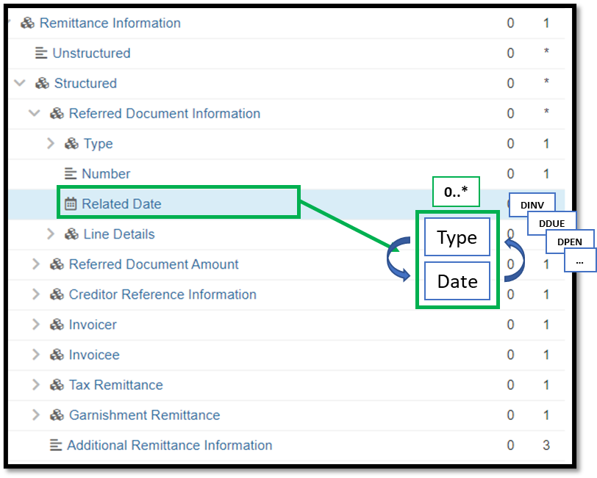

Purpose of the change:
The change will enable a more flexible inclusion of different dates needed to communicate for bill payment and allow the component to easily reflect evolving payment use cases that require more dates beyond a traditional (single) invoice date.

Urgency of the request:
Request to include the change in the current maintenance cycle.

Business examples:
See above.

SEG/TSG recommendation:
This section is not to be taken care of by the submitter of the change request. It will be completed in due time by the SEG(s) in charge of the related ISO 20022 messages or the TSG for changes related to the BAH.

Consider |  | X | Timing
 |  |  | - Next yearly cycle: 2023/2024  (the change will be considered for implementation in the yearly maintenance cycle which starts in 2023 and completes with the publication of new message versions in the spring of 2024) |  | X
- At the occasion of the next maintenance of the messages
(the change will be considered for implementation, but does not justify maintenance of the messages in its own right – will be pending until more critical change requests are received for the messages)
- Urgent unscheduled
(the change justifies an urgent implementation outside of the normal yearly cycle)
 |  |  | - Other timing:
Comments:

Reject
Reason for rejection:

Impact analysis and type of impact:
The following Message Identifiers will be impacted –

acmt.027.001.04 | AccountSwitchInformationRequestV04
acmt.028.001.04 | AccountSwitchInformationResponseV04
acmt.029.001.04 | AccountSwitchCancelExistingPaymentV04
acmt.031.001.04 | AccountSwitchRequestBalanceTransferV04
acmt.032.001.04 | AccountSwitchBalanceTransferAcknowledgementV04
acmt.034.001.04 | AccountSwitchRequestPaymentV04
camt.026.001.09 | UnableToApplyV09
camt.027.001.09 | ClaimNonReceiptV09
camt.028.001.11 | AdditionalPaymentInformationV11
camt.029.001.12 | ResolutionOfInvestigationV12
camt.037.001.09 | DebitAuthorisationRequestV09
camt.052.001.11 | BankToCustomerAccountReportV11
camt.053.001.11 | BankToCustomerStatementV11
camt.054.001.11 | BankToCustomerDebitCreditNotificationV11
camt.055.001.11 | CustomerPaymentCancellationRequestV11
camt.056.001.10 | FIToFIPaymentCancellationRequestV10
camt.057.001.07 | NotificationToReceiveV07
camt.058.001.08 | NotificationToReceiveCancellationAdviceV08
camt.059.001.07 | NotificationToReceiveStatusReportV07
camt.087.001.08 | RequestToModifyPaymentV08
cbrf.001.001.01 | ClearingPositionsSettlementInstructionV01
cbrf.006.001.01 | PacketHeaderV01
pacs.002.001.13 | FIToFIPaymentStatusReportV13
pacs.003.001.10 | FIToFICustomerDirectDebitV10
pacs.004.001.12 | PaymentReturnV12
pacs.007.001.12 | FIToFIPaymentReversalV12
pacs.008.001.11 | FIToFICustomerCreditTransferV11
pacs.009.001.10 | FinancialInstitutionCreditTransferV10
pacs.028.001.05 | FIToFIPaymentStatusRequestV05
pain.001.001.11 | CustomerCreditTransferInitiationV11
pain.002.001.13 | CustomerPaymentStatusReportV13
pain.007.001.11 | CustomerPaymentReversalV11
pain.008.001.10 | CustomerDirectDebitInitiationV10
pain.009.001.07 | MandateInitiationRequestV07
pain.010.001.07 | MandateAmendmentRequestV07
pain.011.001.07 | MandateCancellationRequestV07
pain.012.001.07 | MandateAcceptanceReportV07
pain.013.001.10 | CreditorPaymentActivationRequestV10
pain.014.001.10 | CreditorPaymentActivationRequestStatusReportV10
pain.017.001.03 | MandateCopyRequestV03
pain.018.001.03 | MandateSuspensionRequestV03
remt.001.001.05 | RemittanceAdviceV05

Proposed implementation:
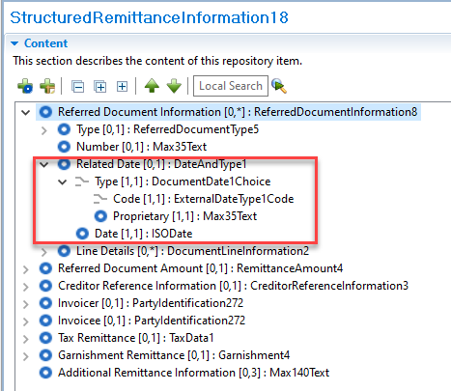
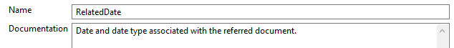

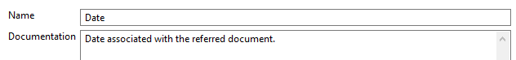

Proposed timing:
The submitting organisation confirms that it can implement the requested changes in the requested timing.

Timing

Final decision of the SEG(s):

Approve

Reject
Reason for rejection:

Change request CR1319: Enhance Referred Document Amount structure within Structured Remittance Information

Origin of the request:
A.1 Submitter:
Federal Reserve Bank of New York (on behalf of the US Federal Reserve Banks)
33 Liberty Street
New York, NY 10045
U.S.A.
A.2 Contact person:
Federal Reserve Bank of New York
Mr. Frank Van Driessche (frank.vandriessche@ny.frb.org)
A.3 Sponsors:
-

Related messages:
pain.013 – Creditor Payment Activation Request (aka Request for Payment)
Other impacted messages: all messages with the StructuredRemittanceInformation17 component, e.g., pain.001, pacs.008, pacs.009.

Description of the change requests:
- Add the following elements to the Referred Document Amount component to better cater for evolving (request for) payment use cases, e.g., mortgage, bank loan, and credit card payments.
Below a non-exhaustive list of some of the amounts needed:
- For Mortgage and other Bank Loan payments
  - Outstanding Principal Amount
  - Total Payment
  - Principal Payment
  - Interest Payment
  - Escrow Amount
  - Tax Amount
  - Insurance Amount
  - …
- For Credit Card payments
  - Outstanding Balance
  - Statement Balance
  - Minimum Amount Due
  - Past Due Amount
  - Available Credit
  - Previous Balance
  - Payments and Credits
  - New Charges
  - Fees
  - Interest Charges
  - …

To future-proof the remittance information component we suggest considering a structural change to the component enabling a repetitive component with each occurrence having an amount in combination with a qualifying Type indicator (and an externalized code list as shown in the graphic below).
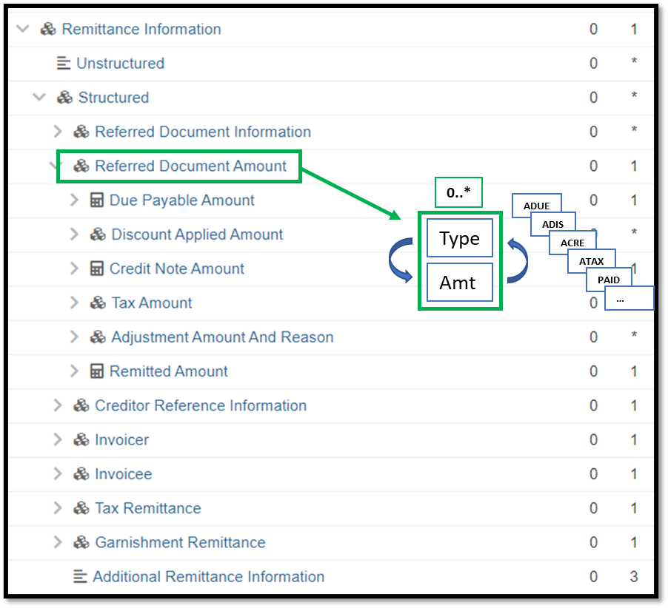

Purpose of the change:
The change will enable a more flexible inclusion of the different amounts needed to communicate for use cases beyond the more traditional invoice bill payment use case.

Urgency of the request:
Request to include the change in the current maintenance cycle.

Business examples:
See above.

SEG/TSG recommendation:
This section is not to be taken care of by the submitter of the change request. It will be completed in due time by the SEG(s) in charge of the related ISO 20022 messages or the TSG for changes related to the BAH.

Consider |  | X | Timing
 |  |  | - Next yearly cycle: 2023/2024  (the change will be considered for implementation in the yearly maintenance cycle which starts in 2023 and completes with the publication of new message versions in the spring of 2024) |  | X
- At the occasion of the next maintenance of the messages
(the change will be considered for implementation, but does not justify maintenance of the messages in its own right – will be pending until more critical change requests are received for the messages)
- Urgent unscheduled
(the change justifies an urgent implementation outside of the normal yearly cycle)
 |  |  | - Other timing:
Comments:

Reject
Reason for rejection:

Impact analysis and type of impact:
The following Message Identifiers will be impacted –

acmt.027.001.04 | AccountSwitchInformationRequestV04
acmt.028.001.04 | AccountSwitchInformationResponseV04
acmt.029.001.04 | AccountSwitchCancelExistingPaymentV04
acmt.031.001.04 | AccountSwitchRequestBalanceTransferV04
acmt.032.001.04 | AccountSwitchBalanceTransferAcknowledgementV04
acmt.034.001.04 | AccountSwitchRequestPaymentV04
camt.026.001.09 | UnableToApplyV09
camt.027.001.09 | ClaimNonReceiptV09
camt.028.001.11 | AdditionalPaymentInformationV11
camt.029.001.12 | ResolutionOfInvestigationV12
camt.037.001.09 | DebitAuthorisationRequestV09
camt.052.001.11 | BankToCustomerAccountReportV11
camt.053.001.11 | BankToCustomerStatementV11
camt.054.001.11 | BankToCustomerDebitCreditNotificationV11
camt.055.001.11 | CustomerPaymentCancellationRequestV11
camt.056.001.10 | FIToFIPaymentCancellationRequestV10
camt.057.001.07 | NotificationToReceiveV07
camt.058.001.08 | NotificationToReceiveCancellationAdviceV08
camt.059.001.07 | NotificationToReceiveStatusReportV07
camt.087.001.08 | RequestToModifyPaymentV08
cbrf.001.001.01 | ClearingPositionsSettlementInstructionV01
cbrf.006.001.01 | PacketHeaderV01
pacs.002.001.13 | FIToFIPaymentStatusReportV13
pacs.003.001.10 | FIToFICustomerDirectDebitV10
pacs.004.001.12 | PaymentReturnV12
pacs.007.001.12 | FIToFIPaymentReversalV12
pacs.008.001.11 | FIToFICustomerCreditTransferV11
pacs.009.001.10 | FinancialInstitutionCreditTransferV10
pacs.028.001.05 | FIToFIPaymentStatusRequestV05
pain.001.001.11 | CustomerCreditTransferInitiationV11
pain.002.001.13 | CustomerPaymentStatusReportV13
pain.007.001.11 | CustomerPaymentReversalV11
pain.008.001.10 | CustomerDirectDebitInitiationV10
pain.013.001.10 | CreditorPaymentActivationRequestV10
pain.014.001.10 | CreditorPaymentActivationRequestStatusReportV10
remt.001.001.05 | RemittanceAdviceV05

Proposed implementation:
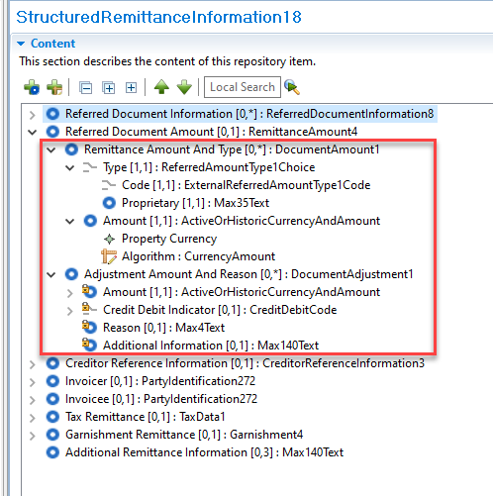


For discussion -
1. The ISO Registration Authority noted a near identical component was used in Referred Document Information / Line Details. For alignment we propose to implement the same new component in both Referred Document Information / Line Details and Referred Document Amount. Is this supported by the PAYSEG?
2. The ISO Registration Authority notes the current Discount Amount Applied component uses the ExternalDiscountAmountType1Code set and the current Tax Amount component uses ExternalTaxAmountType1Code set. These two code sets will be marked as obsolete with the codes moving to the newly created ExternalReferredAmountType1Code set. Is this supported by the PAYSEG?
3. The ISO Registration Authority has made the new Remittance Amount And Type element repeatable, previously only certain amount types were repeatable. Is this supported by the PAYSEG?
4. The ISO Registration Authority note a new code for “Payments and Credits” has been requested. What does this mean?
5. The ISO Registration Authority note a new code for “Outstanding Principal” and “Principal” has been requested. Are both required?

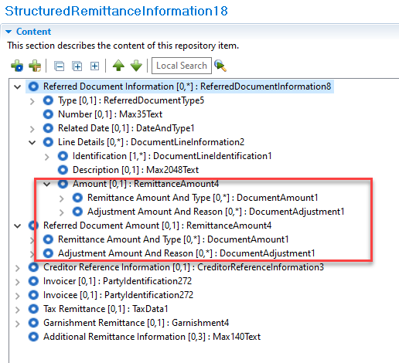

Proposed timing:
The submitting organisation confirms that it can implement the requested changes in the requested timing.

Timing

Final decision of the SEG(s):

Approve

Reject
Reason for rejection:

Change request CR1318: Externalize certain code sets within Structured Remittance Information

Origin of the request:
A.1 Submitter:
Federal Reserve Bank of New York (on behalf of the US Federal Reserve Banks)
33 Liberty Street
New York, NY 10045
U.S.A.
A.2 Contact person:
Federal Reserve Bank of New York
Mr. Frank Van Driessche (frank.vandriessche@ny.frb.org)
A.3 Sponsors:
-

Related messages:
pain.013 – Creditor Payment Activation Request (aka Request for Payment)
Further impact: all messages with StructuredRemittanceInformation17 component, e.g., pain.001, pacs.008, pacs.009, etc.

Description of the change requests:
- Externalize the codes of the Type/Code element in Referred Document Information component (Referred Document Information/Type/CodeOrProprietary/Code).
- Externalize the codes of the Type/Code element in Creditor Reference Information component (CreditorReferenceInformation/Type/CodeOrProprietary/Code)
Graphic for information purposes.
- 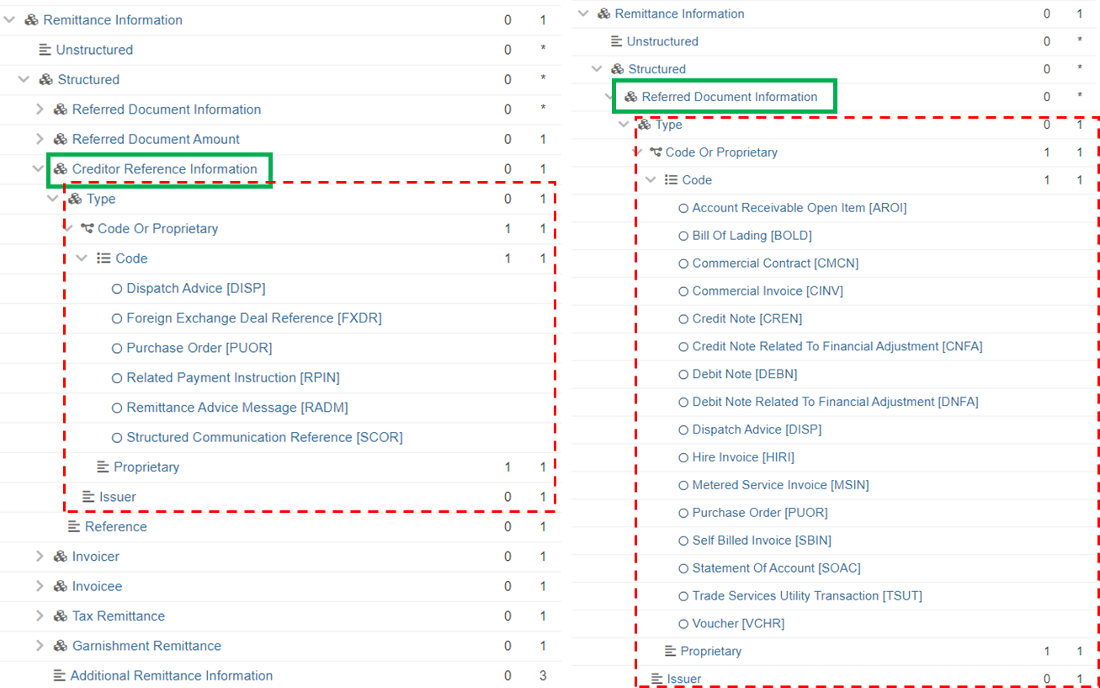

Purpose of the change:
By now most of the codes across ISO 20022 (payment) message have been externalized for increased flexibility in updating/adding codes to lists without impact on the message xsds.
The code lists mentioned under Section C are still embedded in the schema, and externalizing will offer that same flexibility of adding codes and cater for additional (request for) payment use cases through quarterly updates of externalized lists versus yearly maintenance of the message component.
Examples of use cases to be catered for: remittance information related to mortgage, bank loan, credit card payments, etc. for which no (embedded) codes are available today.

Urgency of the request:
Request to include the change in the current maintenance cycle.

Business examples:
See above.

SEG/TSG recommendation:
This section is not to be taken care of by the submitter of the change request. It will be completed in due time by the SEG(s) in charge of the related ISO 20022 messages or the TSG for changes related to the BAH.

Consider |  | X | Timing
 |  |  | - Next yearly cycle: 2023/2024  (the change will be considered for implementation in the yearly maintenance cycle which starts in 2023 and completes with the publication of new message versions in the spring of 2024) |  | X
- At the occasion of the next maintenance of the messages
(the change will be considered for implementation, but does not justify maintenance of the messages in its own right – will be pending until more critical change requests are received for the messages)
- Urgent unscheduled
(the change justifies an urgent implementation outside of the normal yearly cycle)
 |  |  | - Other timing:
Comments:

Reject
Reason for rejection:

Impact analysis and type of impact:
The following Message Identifiers will be impacted –

acmt.027.001.04 | AccountSwitchInformationRequestV04
acmt.028.001.04 | AccountSwitchInformationResponseV04
acmt.029.001.04 | AccountSwitchCancelExistingPaymentV04
acmt.031.001.04 | AccountSwitchRequestBalanceTransferV04
acmt.032.001.04 | AccountSwitchBalanceTransferAcknowledgementV04
acmt.034.001.04 | AccountSwitchRequestPaymentV04
auth.034.001.01 | InvoiceTaxReportV01
camt.007.002.03 | RequestToModifyPaymentV03
camt.026.001.09 | UnableToApplyV09
camt.027.001.09 | ClaimNonReceiptV09
camt.028.001.11 | AdditionalPaymentInformationV11
camt.029.001.12 | ResolutionOfInvestigationV12
camt.037.001.09 | DebitAuthorisationRequestV09
camt.052.001.11 | BankToCustomerAccountReportV11
camt.053.001.11 | BankToCustomerStatementV11
camt.054.001.11 | BankToCustomerDebitCreditNotificationV11
camt.055.001.11 | CustomerPaymentCancellationRequestV11
camt.056.001.10 | FIToFIPaymentCancellationRequestV10
camt.057.001.07 | NotificationToReceiveV07
camt.058.001.08 | NotificationToReceiveCancellationAdviceV08
camt.059.001.07 | NotificationToReceiveStatusReportV07
camt.087.001.08 | RequestToModifyPaymentV08
cbrf.001.001.01 | ClearingPositionsSettlementInstructionV01
cbrf.006.001.01 | PacketHeaderV01
pacs.002.001.13 | FIToFIPaymentStatusReportV13
pacs.003.001.10 | FIToFICustomerDirectDebitV10
pacs.004.001.12 | PaymentReturnV12
pacs.007.001.12 | FIToFIPaymentReversalV12
pacs.008.001.11 | FIToFICustomerCreditTransferV11
pacs.009.001.10 | FinancialInstitutionCreditTransferV10
pacs.028.001.05 | FIToFIPaymentStatusRequestV05
pain.001.001.11 | CustomerCreditTransferInitiationV11
pain.002.001.13 | CustomerPaymentStatusReportV13
pain.007.001.11 | CustomerPaymentReversalV11
pain.008.001.10 | CustomerDirectDebitInitiationV10
pain.009.001.07 | MandateInitiationRequestV07
pain.010.001.07 | MandateAmendmentRequestV07
pain.011.001.07 | MandateCancellationRequestV07
pain.012.001.07 | MandateAcceptanceReportV07
pain.013.001.10 | CreditorPaymentActivationRequestV10
pain.014.001.10 | CreditorPaymentActivationRequestStatusReportV10
pain.017.001.03 | MandateCopyRequestV03
pain.018.001.03 | MandateSuspensionRequestV03
remt.001.001.05 | RemittanceAdviceV05
tsin.004.001.01 | FinancialInvoiceV01

Proposed implementation:
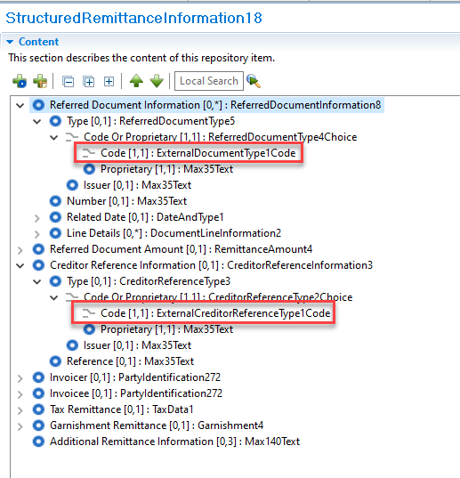

For discussion -
1. The ISO Registration Authority has used the existing Document Type external code set within Referred Document Information. The existing code set will be updated to include a small number of codes from the current embedded code list. Is this supported by the PAYSEG?

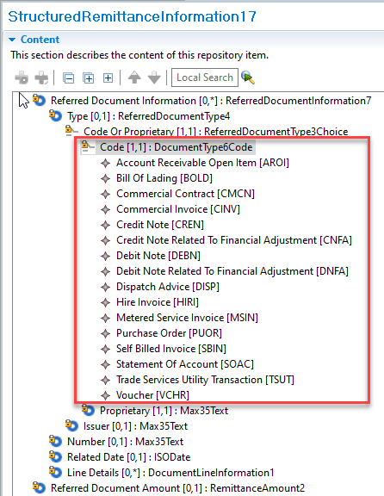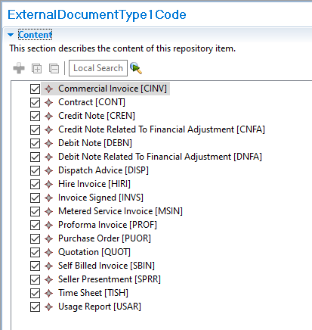

Proposed timing:
The submitting organisation confirms that it can implement the requested changes in the requested timing.

Timing

Final decision of the SEG(s):

Approve

Reject
Reason for rejection:

Change request CR1317: Amend Payment Condition sub elements

Origin of the request:
A.1 Submitter:
Federal Reserve Bank of New York (on behalf of the US Federal Reserve Banks)
33 Liberty Street
New York, NY 10045
U.S.A.
A.2 Contact person:
Federal Reserve Bank of New York
Mr. Frank Van Driessche (frank.vandriessche@ny.frb.org)
A.3 Sponsors:

Related messages:
pain.013.001.10 – Creditor Payment Activation Request (‘Request for Payment’)
pain.014.001.10 – Creditor Payment Activation Request Status Report (‘Request for Payment Response’)

Description of the change request:
Ease the schema restrictions in the Payment Condition (pain.013) and Payment Condition Status (pain.014) components to make conditions within the component individually independent and optional vs. jointly required (i.e., make Amount Modification Allowed, Early Payment Allowed and Guaranteed Payment Requested optional 0..1 vs. 1..1 as shown in graphic).
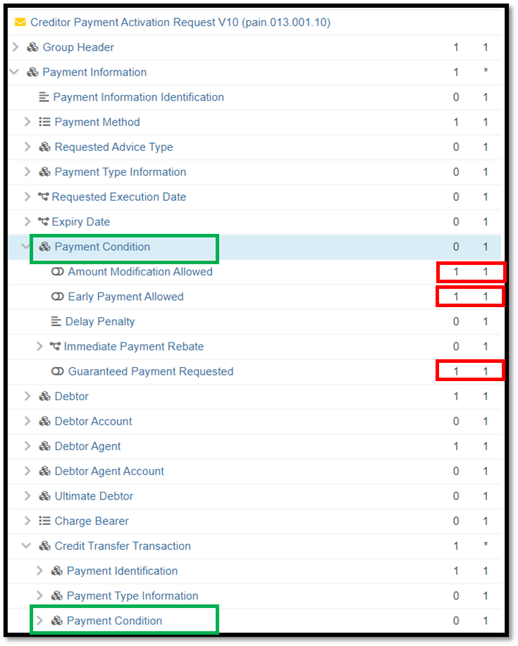

Purpose of the change:
Offer flexibility with possible use of these conditions when specifically needed for a payment use case vs. forcing all indicators upon all users even if only one indicator is relevant for the payment use case. For example, if a biller is willing to allow payments of a different amount, then there is no reason to force that biller to indicate whether a bank guarantee is requested.

Urgency of the request:
Request to include the change in the current maintenance cycle.

Business examples:
See above.

SEG/TSG recommendation:
This section is not to be taken care of by the submitter of the change request. It will be completed in due time by the SEG(s) in charge of the related ISO 20022 messages or the TSG for changes related to the BAH.

Consider |  | X | Timing
 |  |  | - Next yearly cycle: 2023/2024  (the change will be considered for implementation in the yearly maintenance cycle which starts in 2023 and completes with the publication of new message versions in the spring of 2024) |  | X
- At the occasion of the next maintenance of the messages
(the change will be considered for implementation, but does not justify maintenance of the messages in its own right – will be pending until more critical change requests are received for the messages)
- Urgent unscheduled
(the change justifies an urgent implementation outside of the normal yearly cycle)
 |  |  | - Other timing:
Comments:

Reject
Reason for rejection:

Impact analysis and type of impact:
The following Message Identifiers will be impacted –

pain.013.001.10 | CreditorPaymentActivationRequestV10
pain.014.001.10 | CreditorPaymentActivationRequestStatusReportV10

Proposed implementation:
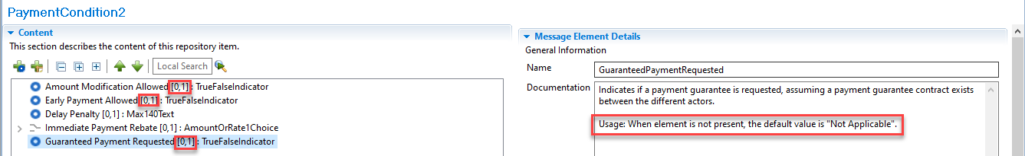

For discussion -
1. The ISO Registration Authority have added the above usage rule for when Guaranteed Payment Requested is not present. Is this supported by the PAYSEG?

Proposed timing:
The submitting organisation confirms that it can implement the requested changes in the requested timing.

Timing

Final decision of the SEG(s):

Approve

Reject
Reason for rejection:

Change request CR1316: Add a Sequence Type to the Payment Type Information component

Origin of the request:
A.1 Submitter:
Federal Reserve Bank of New York (on behalf of the US Federal Reserve Banks)
33 Liberty Street
New York, NY 10045
U.S.A.
A.2 Contact person:
Federal Reserve Bank of New York
Mr. Frank Van Driessche (frank.vandriessche@ny.frb.org)
A.3 Sponsors:

Related messages:
pain.013.001.10 – Creditor Payment Activation Request (‘Request for Payment’)

Description of the change request:
Request to add a Sequence Type to the Payment Type Information component (at both levels in the pain.013 message where the component occurs) to indicate the frequency / recurrence of a request for payment (RFP) as shown in the below graphic.
Possible values to be aligned with SequenceType3Code values (recurring, first, final, one-off, re-presented).

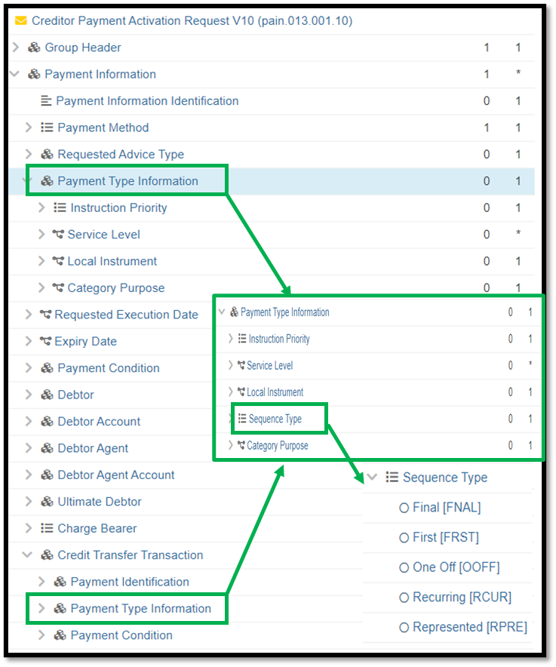

Purpose of the change:
Very similar to direct debits, (agreement around) billing via RFP may be a one-off occasion or an invoice/service may be billed via a series of recurring RFPs. Having the frequency indicator will enable the receiving FIs to optimize/automate processing and response mechanisms.

Urgency of the request:
Request to include the change in the current maintenance cycle.

Business examples:
See above.

SEG/TSG recommendation:
This section is not to be taken care of by the submitter of the change request. It will be completed in due time by the SEG(s) in charge of the related ISO 20022 messages or the TSG for changes related to the BAH.

Consider |  | X | Timing
 |  |  | - Next yearly cycle: 2023/2024  (the change will be considered for implementation in the yearly maintenance cycle which starts in 2023 and completes with the publication of new message versions in the spring of 2024) |  | X
- At the occasion of the next maintenance of the messages
(the change will be considered for implementation, but does not justify maintenance of the messages in its own right – will be pending until more critical change requests are received for the messages)
- Urgent unscheduled
(the change justifies an urgent implementation outside of the normal yearly cycle)
 |  |  | - Other timing:
Comments:

Reject
Reason for rejection:

Impact analysis and type of impact:
The following Message Identifiers will be impacted –

acmt.027.001.04 | AccountSwitchInformationRequestV04
acmt.028.001.04 | AccountSwitchInformationResponseV04
acmt.029.001.04 | AccountSwitchCancelExistingPaymentV04
acmt.031.001.04 | AccountSwitchRequestBalanceTransferV04
acmt.032.001.04 | AccountSwitchBalanceTransferAcknowledgementV04
acmt.034.001.04 | AccountSwitchRequestPaymentV04
pain.001.001.11 | CustomerCreditTransferInitiationV11
pain.013.001.10 | CreditorPaymentActivationRequestV10
pain.014.001.10 | CreditorPaymentActivationRequestStatusReportV10
remt.001.001.05 | RemittanceAdviceV05

Proposed implementation:
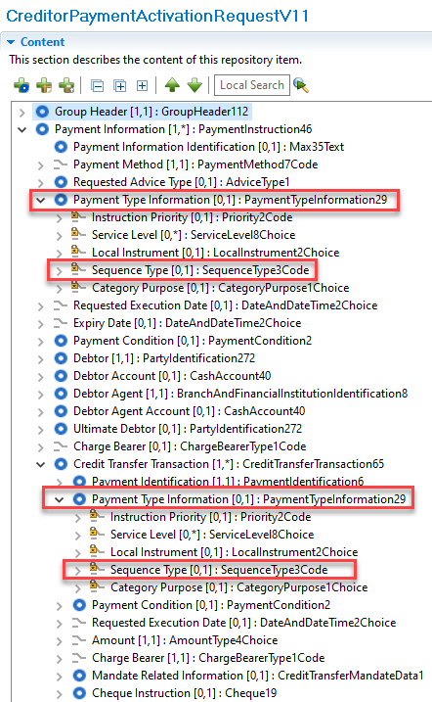

For discussion -
1. The ISO Registration Authority have only implemented the above in the pain.013 and pain.014 as these relate to direct debits, the remaining impacted messages do not. Is this supported by the PAYSEG?

Proposed timing:
The submitting organisation confirms that it can implement the requested changes in the requested timing.

Timing

Final decision of the SEG(s):

Approve

Reject
Reason for rejection:

Change request CR1282: Update Movement Record Usage Definition

Origin of the request:
A.1 Submitter: identity of the company, organization, group, initiative or community that submits the change request.

Bank of England,
Threadneedle St, London, EC2R 8AH
United Kingdom

A.2 Contact person: person(s) who can be contacted to get additional information on the request (name, e-mail, telephone)

Helen Bygrave helen.bygrave@bankofengland.co.uk

A.3 Sponsors: it is highly recommended that a submitter of a Change Request gain the agreement and support from as many additional organisations, groups, initiatives or communities of users as possible, thus demonstrating as wide as possible a consultation of the relevant stakeholders. All organisations, groups, initiatives or communities supporting the change request should be identified as sponsors along with a contact person, if possible. This community involvement is intended to help avoid delays and/or subsequent amendments to the change request.

Related messages:
The list of ISO 20022 messages which would be impacted by the change, including the Message IDs as shown in the Catalogue of ISO 20022 messages. Only the latest version of a message definition can be maintained.
The submitter is invited to carefully examine whether the change may have an impact on other messages that come into play earlier or later in the transaction chain or on other messages that also use message components that this change request may impact.

pacs.029.001.01 MultilateralSettlementRequestV01
No other messages should be impacted by this change.

Description of the change request:
A specific change request form must be completed for each particular change requested (for example, adding, deleting, modifying, renaming, changing the cardinality, moving an element/component, or changing the type of an element, changing a code set).
If the change request consists, for example, of adding new functionality which requires several changes which would not make sense if not performed all together, then all these related changes should be described on the same form.
Change requests may not lead to creation of new messages. In such cases, a 'business justification' for development of new candidate ISO 20022 messages must be introduced by a submitting organization that is ready to develop the new messages.

The pacs.029 /Document/MulSttlmReq/SttlmReq/MvmntRcrd has an incorrect entry under Documentation Usage – “Usage: Number of occurrences of MovementRecord shall always be even.”
It is not the case that there must be an even number of Movement Records. The only requirement is that the sum of all debits and credits should net to zero. We would like to request that the documentation be updated accordingly as shown below.

From
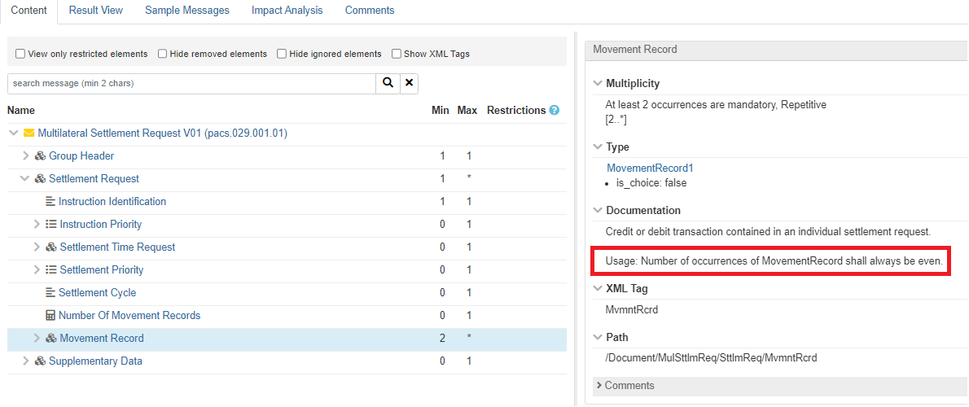
To
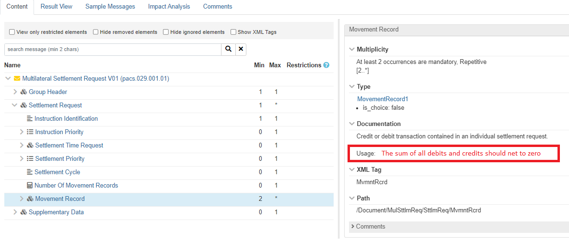

Purpose of the change:
Background, business context, community of users interested by the change and expected benefits/savings.
This section must explain why the existing ISO 20022 messages need to be changed. The reason for the update may be a business reason (e.g., evolution of market practice, or creation of new financial instruments), a technical reason (e.g., automation of the business process, or switch from a batch to a real time process), a regulatory reason (introduction, generally mandatory, of new rule/law) or the extension of the user community (newly identified business requirements).

The purpose of this change is to correct an error made in the original pacs.029 submission and in doing so remove the possibility that a user of the message may align to this incorrect usage direction.

Urgency of the request:
By default, valid change requests introduced by June 1 and subsequently approved by the SEG/TSG will be included in the following yearly maintenance cycle which completes with the publication of new message versions by April/May of the following year, unless decided otherwise by the SEG/TSG.
If there is a need to have the new version of the related messages published earlier, the reason for the urgency of the maintenance and the expected consequences of a delay should be described here. Acceptance of such an unscheduled maintenance for the BAH is subject to approval by TSG. Acceptance of an unscheduled maintenance for messages other than the BAH is subject to the approval of the SEG and availability of a submitting organization to develop the new version of the messages.
Note: the ISO 20022 maintenance results in the publication of a new version of an ISO 20022 message. The actual implementation of such new version on networks and in user installations is not within the purview of ISO.

Business examples:
Examples illustrating the change request.

SEG/TSG recommendation:
This section is not to be taken care of by the submitter of the change request. It will be completed in due time by the SEG(s) in charge of the related ISO 20022 messages or the TSG for changes related to the BAH.

Consider |  | X | Timing
 |  |  | - Next yearly cycle: 2023/2024  (the change will be considered for implementation in the yearly maintenance cycle which starts in 2023 and completes with the publication of new message versions in the spring of 2024) |  | X
- At the occasion of the next maintenance of the messages
(the change will be considered for implementation, but does not justify maintenance of the messages in its own right – will be pending until more critical change requests are received for the messages)
- Urgent unscheduled
(the change justifies an urgent implementation outside of the normal yearly cycle)
 |  |  | - Other timing:
Comments:

Reject
Reason for rejection:

Impact analysis and type of impact:
The following Message Identifiers will be impacted –

pacs.029.001.01 | MultilateralSettlementRequestV01

Proposed implementation:
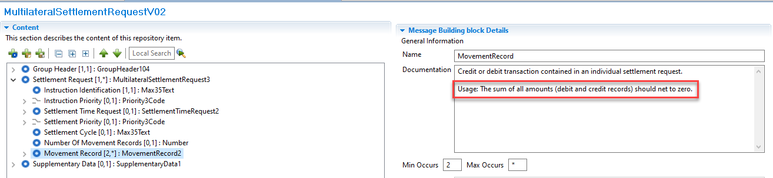
For discussion -
1. The ISO Registration Authority have noted the message will allow movements of different currencies. Is this a realistic use of the message? If not, and all the movement currencies should be the same do we need extra validation? If the currencies can be different the concept of netting to zero becomes more difficult.

Proposed timing:
The submitting organisation confirms that it can implement the requested changes in the requested timing.

Timing

Final decision of the SEG(s):

Approve

Reject
Reason for rejection:

Change request CR1157: Add Old Limit Amount and Increase Decrease Amount to Limit Details

Origin of the request:
A.1 Submitter: identity of the company, organization, group, initiative or community that submits the change request.

Bank of England,
Threadneedle St, London, EC2R 8AH
United Kingdom

A.2 Contact person: person(s) who can be contacted to get additional information on the request (name, e-mail, telephone)

Helen Bygrave helen.bygrave@bankofengland.co.uk

A.3 Sponsors: it is highly recommended that a submitter of a Change Request gain the agreement and support from as many additional organisations, groups, initiatives or communities of users as possible, thus demonstrating as wide as possible a consultation of the relevant stakeholders. All organisations, groups, initiatives or communities supporting the change request should be identified as sponsors along with a contact person, if possible. This community involvement is intended to help avoid delays and/or subsequent amendments to the change request.

Related messages:
The list of ISO 20022 messages which would be impacted by the change, including the Message IDs as shown in the Catalogue of ISO 20022 messages. Only the latest version of a message definition can be maintained.
The submitter is invited to carefully examine whether the change may have an impact on other messages that come into play earlier or later in the transaction chain or on other messages that also use message components that this change request may impact.
camt.011.001.07 ModifyLimitV07
We do not believe that any other related camt messages should be impacted by this change.

Description of the change request:
A specific change request form must be completed for each particular change requested (for example, adding, deleting, modifying, renaming, changing the cardinality, moving an element/component, or changing the type of an element, changing a code set).
If the change request consists, for example, of adding new functionality which requires several changes which would not make sense if not performed all together, then all these related changes should be described on the same form.
Change requests may not lead to creation of new messages. In such cases, a 'business justification' for development of new candidate ISO 20022 messages must be introduced by a submitting organization that is ready to develop the new messages.

Following the recommendation of the Pay SEG on September 12th 2022 the submitter would like to request the following change to the camt.011 Modify Limit message.
Optionally include at the same level as message component <New Limit Value Set>, the difference between the previous amount of money of the limit and the new amount of money of the limit. The new message component should be named <Increase Decrease Amount>.
In addition to the above, the Pay SEG requested a new optional message component <Old Limit Value> to carry the previous amount of money of the limit. <Old Limit Value> should also be at the same level as <New Limit Value Set>.
A rule should also be implemented to ensure that <Old Limit Value> and <Increase Decrease Amount> are mutually exclusive.

Purpose of the change:
Background, business context, community of users interested by the change and expected benefits/savings.
This section must explain why the existing ISO 20022 messages need to be changed. The reason for the update may be a business reason (e.g., evolution of market practice, or creation of new financial instruments), a technical reason (e.g., automation of the business process, or switch from a batch to a real time process), a regulatory reason (introduction, generally mandatory, of new rule/law) or the extension of the user community (newly identified business requirements).

The Bank of England (BoE) provides a deferred net settlement (DNS) service which is moving to ISO 20022 from a proprietary MT format.
This DNS service simultaneously settles net obligations arising from customer transactions built up over time between participants. Transactions are recorded by a Scheme Operator on an ongoing basis and then at regular intervals netted off and sent to the BoE for simultaneous settlement.
Each Scheme participant has an account at the BoE used to settle these obligations. The Scheme participant can increase or decrease the limit on this account. To do this, the participant will send a camt.011 modify limit message to the BoE settlement service. The BoE will then forward this to the Scheme Operator to notify them of the amount of the new limit requested. The Scheme Operator will then accept or reject the limit modification using a camt.025 Receipt. If accepted the BoE will change the limit. If rejected, the limit remains the same as it was prior to the modify limit request.

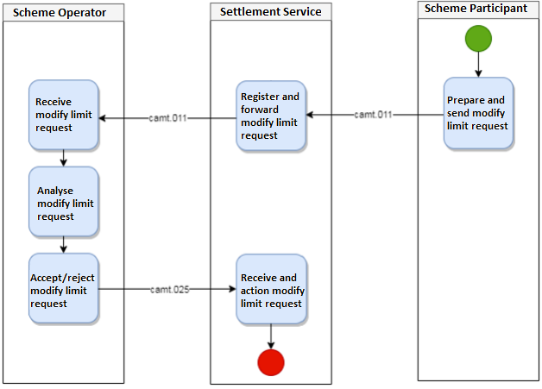

The camt.011 allows the BoE to send the amount of the new limit, but for the Scheme Operator to reconcile in all scenarios, they also need to know the difference between that new limit and the old limit. The Scheme Operator cannot in all scenarios reliably calculate this difference based on their record of the previous limit in their system and the new limit in the camt.011. It is critical for financial stability that the BoE and the Scheme Operator agree at all times on both what the change in limit is and what the new limit is.
ISO 20022 provides five camt messages to create, request, return, modify and delete the limit set on an account. These messages are the camt.101, camt.009, 010,011 and 012 respectively.
On reviewing the camt messages, the BoE has not identified a suitable message that could carry this change in limit and believes it is best placed in the camt.011 with the limit itself. Therefore, when a modify limit message is sent, it will include the new limit and optionally either the difference between that new limit and the old limit OR the old limit.

Additional Information
Why does the DNS Scheme Operator need the BoE to send the difference between the old limit and the new limit as well as the balance?
In the situation where the Scheme Operator sends the BoE a net settlement request at nearly the same time as the BoE sends the Operator a modify limit request, the DNS Scheme operator can't tell if the balance in the modify limit request is the balance before or after the settlement without the change also being provided. They need to know whether the balance was the result of an increase and by how much, or a decrease and by how much.

Urgency of the request:
Next yearly cycle: 2023/2024.

Business examples:
Examples illustrating the change request.
The ISO 20022 repository contains the message component Amount1Choice (used in tsrv.004.001.01 UndertakingAmendmentRequestV01) which provides all the elements required to convey an increase or decrease in limit.

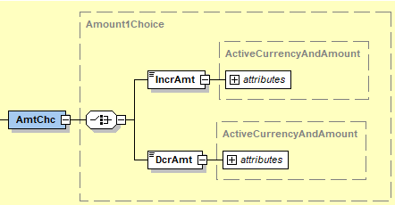

However, the IncrAmt and DcrAmt sub components of Amount1Choice only allow amount with currency. The PaySEG recommended that this be extended to include both amount with currency and amount without currency. Therefore, a new message component Amount4Choice (see diagram below – IncrDcrAmt) has been created to meet this requirement.
Old Limit Value (see diagram below – OdLmtVal) reuses the existing New Limit Value Set datatype, Limit8.

Diagram shows proposed structure for the new message component.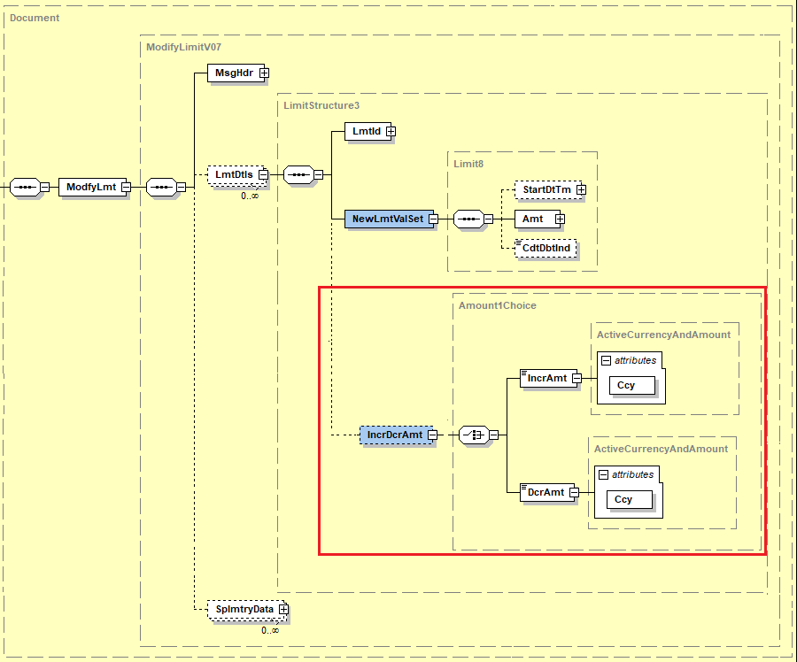
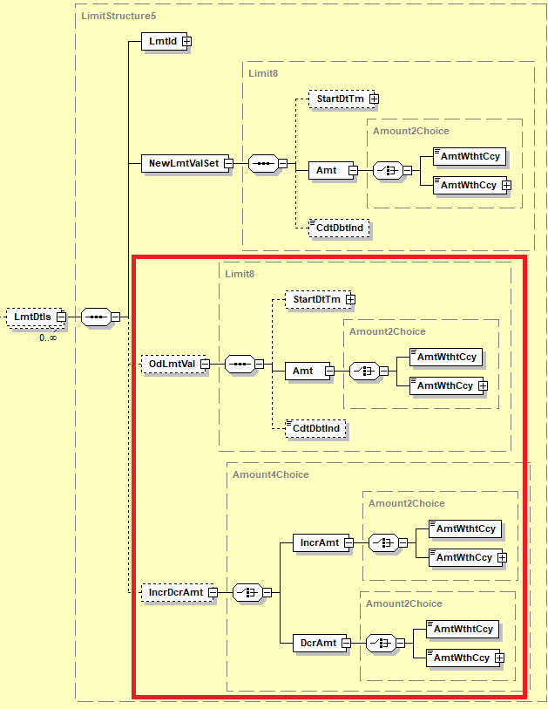
Diagram shows the proposed ModifyLimitV08 message structure within the Standards Editor
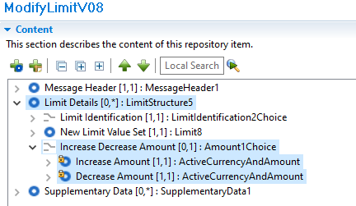

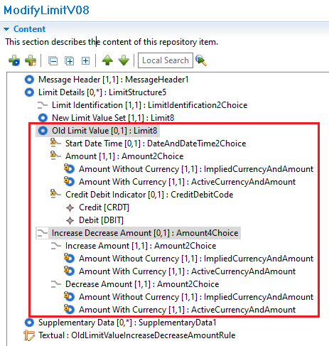

Diagram shows the mutually exclusive constraint applied to OldLimitValue and IncreaseDecreaseAmount
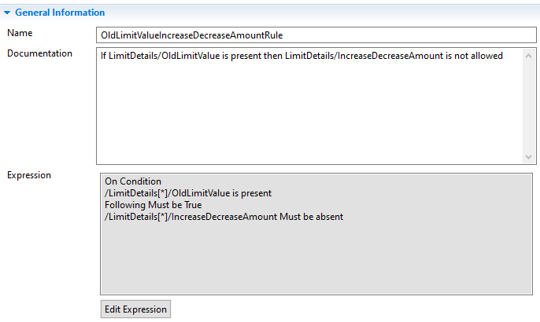
Example XML
Example 1 requesting the value of limit for account 72604168 to be set at 100 and indicating that the difference between the old limit and this new limit is an increase of 25
<Document>
<ModfyLmt>
<MsgHdr>
<MsgId>GBGS33HKRQSYYMCA</MsgId>
<CreDtTm>2021-11-05T15:08:59.026+00:00</CreDtTm>
</MsgHdr>
<LmtDtls>
<LmtId>
<Cur>
<Tp>
<Cd>MULT</Cd>
</Tp>
<AcctId>
<Othr>
<Id>72604168</Id>
</Othr>
</AcctId>
</Cur>
</LmtId>
<NewLmtValSet>
<Amt>
<AmtWthtCcy>100</AmtWthtCcy>
</Amt>
</NewLmtValSet>
<IncrDcrAmt>
<IncrAmt>
<AmtWthtCcy>25</AmtWthtCcy>
</IncrAmt>
</IncrDcrAmt>
</LmtDtls>
</ModfyLmt>
</Document>

Example 2 requesting the value of limit for account 72604168 to be set at 70 and indicating that the difference between the old limit and this new limit is a decrease of 30.<Document>
<ModfyLmt>
<MsgHdr>
<MsgId>GBGS33HKRQSYYMCA</MsgId>
<CreDtTm>2021-11-05T15:08:59.026+00:00</CreDtTm>
</MsgHdr>
<LmtDtls>
<LmtId>
<Cur>
<Tp>
<Cd>MULT</Cd>
</Tp>
<AcctId>
<Othr>
<Id>72604168</Id>
</Othr>
</AcctId>
</Cur>
</LmtId>
<NewLmtValSet>
<Amt>
<AmtWthtCcy>70</AmtWthtCcy>
</Amt>
</NewLmtValSet>
<IncrDcrAmt>
<DcrAmt>
<AmtWthtCcy>30</AmtWthtCcy>
</DcrAmt>
</IncrDcrAmt>
</LmtDtls>
</ModfyLmt>
</Document>
Example 3 requesting the value of limit for account 72604168 to be set at 100 and indicating that the old limit of the account is 40.

<Document>
<ModfyLmt>
<MsgHdr>
<MsgId>GBGS33HKRQSYYMCA</MsgId>
<CreDtTm>2021-11-05T15:08:59.026+00:00</CreDtTm>
</MsgHdr>
<LmtDtls>
<LmtId>
<Cur>
<Tp>
<Cd>MULT</Cd>
</Tp>
<AcctId>
<Othr>
<Id>72604168</Id>
</Othr>
</AcctId>
</Cur>
</LmtId>
<NewLmtValSet>
<Amt>
<AmtWthtCcy>100</AmtWthtCcy>
</Amt>
</NewLmtValSet>
<OdLmtVal>
<Amt>
<AmtWthtCcy>40</AmtWthtCcy>
</Amt>
</OdLmtVal>
</LmtDtls>
</ModfyLmt>
</Document>

SEG/TSG recommendation:
This section is not to be taken care of by the submitter of the change request. It will be completed in due time by the SEG(s) in charge of the related ISO 20022 messages or the TSG for changes related to the BAH.

Consider |  | X | Timing
 |  |  | - Next yearly cycle: 2023/2024  (the change will be considered for implementation in the yearly maintenance cycle which starts in 2023 and completes with the publication of new message versions in the spring of 2024) |  | X
- At the occasion of the next maintenance of the messages
(the change will be considered for implementation, but does not justify maintenance of the messages in its own right – will be pending until more critical change requests are received for the messages)
- Urgent unscheduled
(the change justifies an urgent implementation outside of the normal yearly cycle)
 |  |  | - Other timing:
Comments:
CR is for the request of a new field in Modify Limit message, camt.011 update:
- Request is to add the Old Amount, using Amount1Choice reused.
- Maybe needs more flexibility, with an option to increase/ decrease and an option to provide the old amount.
- Need to implement a choice of the Amount: With Currency and Implied Currency to align with the amount fields defined in all Cash Management messages
- Proposal to also add an exclusive choice between the Delta (Increase / Decrease) and the Old Amounts.
Submitting organization to provide a reviewed implementation proposal in the MCR.

Reject
Reason for rejection:

Impact analysis and type of impact:
The following Message Identifiers will be impacted –

camt.011.001.07 | ModifyLimitV07

Proposed implementation:
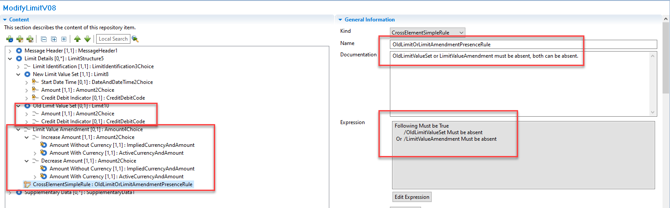

Proposed timing:
The submitting organisation confirms that it can implement the requested changes in the requested timing.

Timing

Final decision of the SEG(s):

Approve

Reject
Reason for rejection:

Change request CR1311: Enhance Structured Remittance Information with new Allocation block

Origin of the request:
A.1 Submitter: ISITC

A.2 Contact person: Jason Brasile jbrasile@statestreet.com

A.3 Sponsors: ISITC
ISITC represents just under 100 organisations from the buy-side, sell-side, global custodian, vendor and utility communities. This change request has broad support from the Investment Management and Global Custodian community.

Related messages:
Notification to Receive message set:
- camt.057.001.07 - NotificationToReceiveV07
Payments Clearing and Settlement message set:
- pacs.009.001.10 - FinancialInstitutionCreditTransferV10

Description of the change requests:
StructuredRemittanceInformation data type should be updated to include optional Allocation element.
Usage of Allocation element must always be bilaterally agreed between sender and receiver.
The element must be repeatable.
The element must contain sub-elements Account, Amount, Purpose and Reference, these should not be repeatable and are mandatory.
An additional sub-element Related Reference should also be present, this is optional and repeatable. It should use data type References1Choice to align with the sese.023 message definition.

Once updated the StructuredRemittanceInformation data type should be added to the pacs.009 within the Remittance Information element.

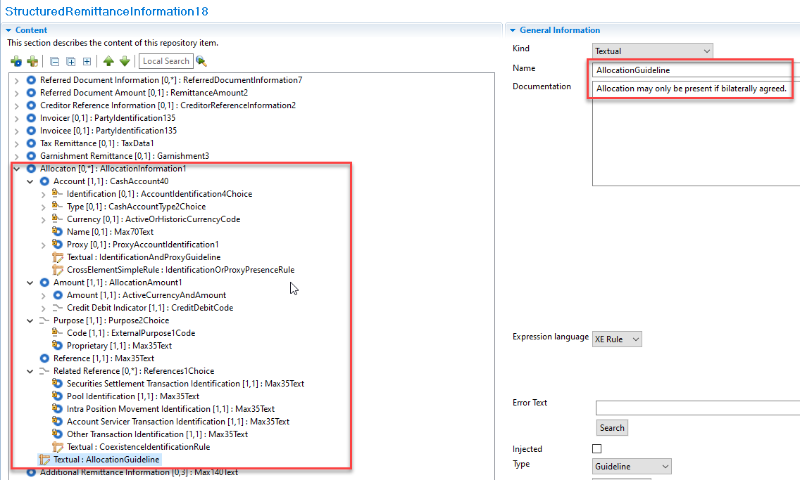

Purpose of the change:
Investment Managers instruct their account servicers to make a net payment (pacs.009) / expect a net receipt (camt.057) from/to a single custody account. However, Investment Managers also send the related fund accounting/breakdown information in a separate instruction, typically a proprietary format such as fax or email.
The CR aims to introduce a standard format and syntax for providing breakdown information and/or additional accounting detail related to a net payment or net receipt of funds, allowing both the Investment Manager and Account Servicer to automate the processing of the breakdown.
The preference of the Securities Industry is to include this information within the pacs.009/camt.057 as opposed to developing a separate message.
There is no requirement to update the pacs.002, camt.056 or camt.058 in relation to this change. We expect that when a pacs.009 or a camt.057 is cancelled the account servicer automatically cancels all accounting associated with it. Furthermore for reviewing the breakdowns, we expect that impacted Securities account owners will leverage cash statement messages on a next day basis.
We believe this will lead to significant savings for the Securities Industry in terms of the reduction/elimination of manual processing, as well as the reduction/elimination of fails and interest claims. A precise estimate of said savings is not feasible. However, we believe that closing this gap in the coverage of message standards significantly enhances the value proposition for migration to ISO 20022 for the Securities Industry.

Urgency of the request:
2024 publication

Business examples:
Breakdown information currently transported via manually over spreadsheet/email –
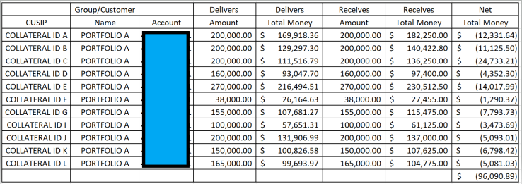

SEG/TSG recommendation:
This section is not to be taken care of by the submitter of the change request. It will be completed in due time by the SEG(s) in charge of the related ISO 20022 messages or the TSG for changes related to the BAH.

Consider |  | X | Timing
 |  |  | - Next yearly cycle: 2023/2024  (the change will be considered for implementation in the yearly maintenance cycle which starts in 2023 and completes with the publication of new message versions in the spring of 2024) |  | X
- At the occasion of the next maintenance of the messages
(the change will be considered for implementation, but does not justify maintenance of the messages in its own right – will be pending until more critical change requests are received for the messages)
- Urgent unscheduled
(the change justifies an urgent implementation outside of the normal yearly cycle)
 |  |  | - Other timing:
Comments:

Reject
Reason for rejection:

Impact analysis and type of impact:
The following Message Identifiers will be impacted –

acmt.027.001.04 | AccountSwitchInformationRequestV04
acmt.028.001.04 | AccountSwitchInformationResponseV04
acmt.029.001.04 | AccountSwitchCancelExistingPaymentV04
acmt.031.001.04 | AccountSwitchRequestBalanceTransferV04
acmt.032.001.04 | AccountSwitchBalanceTransferAcknowledgementV04
acmt.034.001.04 | AccountSwitchRequestPaymentV04
camt.026.001.09 | UnableToApplyV09
camt.027.001.09 | ClaimNonReceiptV09
camt.028.001.11 | AdditionalPaymentInformationV11
camt.029.001.12 | ResolutionOfInvestigationV12
camt.037.001.09 | DebitAuthorisationRequestV09
camt.052.001.11 | BankToCustomerAccountReportV11
camt.053.001.11 | BankToCustomerStatementV11
camt.054.001.11 | BankToCustomerDebitCreditNotificationV11
camt.055.001.11 | CustomerPaymentCancellationRequestV11
camt.056.001.10 | FIToFIPaymentCancellationRequestV10
camt.057.001.07 | NotificationToReceiveV07
camt.058.001.08 | NotificationToReceiveCancellationAdviceV08
camt.059.001.07 | NotificationToReceiveStatusReportV07
camt.087.001.08 | RequestToModifyPaymentV08
pacs.002.001.13 | FIToFIPaymentStatusReportV13
pacs.003.001.10 | FIToFICustomerDirectDebitV10
pacs.004.001.12 | PaymentReturnV12
pacs.007.001.12 | FIToFIPaymentReversalV12
pacs.008.001.11 | FIToFICustomerCreditTransferV11
pacs.009.001.10 | FinancialInstitutionCreditTransferV10
pacs.028.001.05 | FIToFIPaymentStatusRequestV05
pain.001.001.11 | CustomerCreditTransferInitiationV11
pain.002.001.13 | CustomerPaymentStatusReportV13
pain.007.001.11 | CustomerPaymentReversalV11
pain.008.001.10 | CustomerDirectDebitInitiationV10
pain.013.001.10 | CreditorPaymentActivationRequestV10
pain.014.001.10 | CreditorPaymentActivationRequestStatusReportV10
remt.001.001.05 | RemittanceAdviceV05

Proposed implementation:
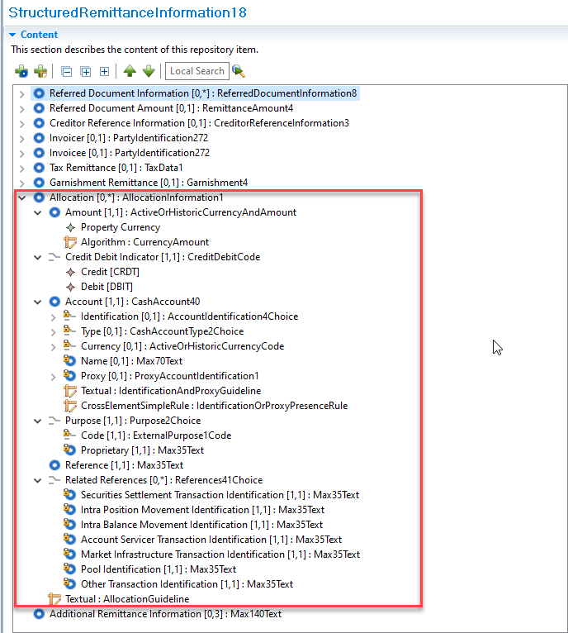


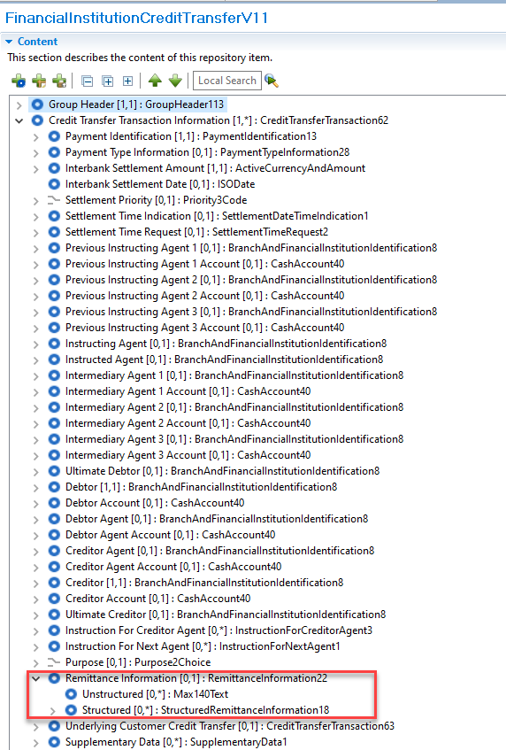
For discussion -
1. The ISO Registration Authority note several approved change requests to the structured remittance information block will be implemented as part of the Payments Maintenance 2023/2024. The ISO Registration Authority would support making this change now as opposed to a later year when new versions of multiple messages would again be needed.

Proposed timing:
The submitting organisation confirms that it can implement the requested changes in the requested timing.

Timing

Final decision of the SEG(s):

Approve

Reject
Reason for rejection:

Additional technical adjustments in the ISO 20022 rules identified during the maintenance (standing change request)
As part of the implementation, we have identified a number of technical errors in the description of the rules defined in the messages. Below is the exhaustive list of corrections as applied to the messages:

 | Issue in rule or data type | Description of the change required
1. | The validation (expression) within the ChequeMaturityDateRule is incorrect and does not match the documentation.  The documentation states -  If ChequeMaturityDate is present, then ChequeType must be present and equal to DRFT or ELDR. | Validation (expression) needs to be updated from…  On Condition  /ChequeType is present  And /ChequeType is within DataType <<Code>> ChequeType3Code  Following Must be True  /ChequeMaturityDate Must be absent  To…  On Condition  /ChequeMaturityDate is present  Following Must be True  /ChequeType Must be present  And /ChequeType Must be within DataType <<Code>> ChequeType3Code
2. | A different data type is used in Structured / Tax Remittance (TaxData1) and Credit Transfer Transaction Information / Tax (TaxInformation10).  The only difference in data types is that TaxData1 contains Ultimate Debtor.  The two components can be aligned to use TaxData1, this change should have previously been made as part of CR0938 in the 2020 / 2021 maintenance. | Credit Transfer Transaction Information / Tax component migrates to data type TaxData1 to align with Structured / Tax Remittance.
3. | The documentation within the PaymentTypeOrLocalInstrumentRule is incorrect and does not match the validation (expression).  The documentation states -  PaymentTypeInformation or LocalInstrument must be present.  The validation states –  Following Must be True  /PaymentTypeInformation Must be absent  Or /LocalInstrument Must be absent | Documentation needs to be updated to…  PaymentTypeInformation or LocalInstrument must be absent, both can be absent.
4. | Component has not been modelled correctly within various Target 2 Securities messages. | Modelling needs to be updated from…    To…
5. | Various outdated data types have been updated to align with the correct version.  These changes should have previously been made as part of earlier maintenance cycles. | CashAccount24 > CashAccount40  CashAccount38 > CashAccount40  BranchAndFinancialInstitutionIdentification5 > BranchAndFinancialInstitutionIdentification8
6. | The XML tag for FinancialInstitutionIdentification will update to FIId from FinInstnId within the BranchAndFinancialInstitutionIdentification8 data type.  XML tag will now be aligned across the BAH and message body. | FinInstnId > FIId

List of message definitions impacted by Item 1 which have been updated:

Message | Rule Name | Location of the rule in the message
AccountSwitchInformationRequestV05 | ChequeMaturityDateRule | Cheque19
AccountSwitchInformationResponseV05 | ChequeMaturityDateRule | Cheque19
AccountSwitchCancelExistingPaymentV05 | ChequeMaturityDateRule | Cheque19
AccountSwitchRequestBalanceTransferV05 | ChequeMaturityDateRule | Cheque19
AccountSwitchBalanceTransferAcknowledgementV05 | ChequeMaturityDateRule | Cheque19
AccountSwitchRequestPaymentV05 | ChequeMaturityDateRule | Cheque19
CustomerCreditTransferInitiationV12 | ChequeMaturityDateRule | Cheque19

List of message definitions impacted by Item 2 which have been updated:

Message | Data Type | Location of the component in the message
AccountSwitchBalanceTransferAcknowledgementV05 | TaxInformation10 > TaxData1 | CreditTransferTransaction59
AccountSwitchCancelExistingPaymentV05 | TaxInformation10 > TaxData1 | CreditTransferTransaction59
AccountSwitchInformationRequestV05 | TaxInformation10 > TaxData1 | CreditTransferTransaction59
AccountSwitchInformationResponseV05 | TaxInformation10 > TaxData1 | CreditTransferTransaction59
AccountSwitchRequestBalanceTransferV05 | TaxInformation10 > TaxData1 | CreditTransferTransaction59
AccountSwitchRequestPaymentV05 | TaxInformation10 > TaxData1 | CreditTransferTransaction59
BankToCustomerAccountReportV12 | TaxInformation10 > TaxData1 | EntryTransaction14
BankToCustomerDebitCreditNotificationV12 | TaxInformation10 > TaxData1 | EntryTransaction14
BankToCustomerStatementV12 | TaxInformation10 > TaxData1 | EntryTransaction14
CreditorPaymentActivationRequestV11 | TaxInformation10 > TaxData1 | CreditTransferTransaction65
CustomerCreditTransferInitiationV12 | TaxInformation10 > TaxData1 | CreditTransferTransaction61
CustomerDirectDebitInitiationV11 | TaxInformation10 > TaxData1 | DirectDebitTransactionInformation32
FIToFICustomerCreditTransferV12 | TaxInformation10 > TaxData1 | CreditTransferTransaction64
FinancialInstitutionCreditTransferV11 | TaxInformation10 > TaxData1 | CreditTransferTransaction63
PaymentReturnV13 | TaxInformation10 > TaxData1 | CreditTransferTransaction63

List of message definitions impacted by Item 3 which have been updated:

Message | Rule Name | Location of the rule in the message
BankToCustomerAccountReportV12 | PaymentTypeOrLocalInstrumentRule | EntryTransaction14
BankToCustomerDebitCreditNotificationV12 | PaymentTypeOrLocalInstrumentRule | EntryTransaction14
BankToCustomerStatementV12 | PaymentTypeOrLocalInstrumentRule | EntryTransaction14

List of message definitions impacted by Item 4 which have been updated:

Message | Data Type | Location of the component in the message
IntraBalanceMovementCancellationRequestStatusAdviceV02 | Identification14 > Max35Text | Request Reference
IntraBalanceMovementInstructionV02 | Identification14 > Max35Text | Corporate Action Event Identification
IntraBalanceMovementModificationRequestStatusAdviceV02 | Identification14 > Max35Text | Request Reference

