Maintenance Change Request
for fast track maintenance of existing message definitions

- Submitting organization(s):
European Securities and Markets Authority (ESMA)
201-203 rue de Bercy
75012 Paris
France

- Related messages:
auth.016.001.02 FinancialInstrumentReportingTransactionReportV02

- Purpose of the change:
In the context of the DLT Pilot regime, ESMA conducted a call for evidence in 2022 to seek feedback on the need to amend data reporting requirements. Based on the feedback received, ESMA published a report recommending to have the possibility, in the context of DLT transactions, to receive information on:
- the Digital Token Identifier (DTI) of the DLT financial instrument;
- the Digital Token Identifier (DTI) of the e-money tokens used in the transaction.
ESMA proposes to update the Financial Instrument Reporting Transaction Report message in order to allow the message to convey that information.

- Urgency of the request:
This update is expected to be used by National Competent Authorities and DLT-MTFs/TSSs to implement the DLT Pilot regime, and ESMA aims to make available the updated XML Schema in June 2023.

- Commitments of the submitting organization:
ESMA will make available the updated XML Schema to National Competent Authorities and DLT-MTFs/TSSs following its approval, so that they can use it in the context of the DLT Pilot regime.

- Contact persons:
Cyril Minoux – cyril.minoux@esma.europa.eu
Christophe Hasle – christophe.hasle@esma.europa.eu
Stephanie Gosso – stephanie.gosso@esma.europa.eu
Giulia Ferraris – giulia.ferraris@esma.europa.eu
Salvatore Pantaleo – salvatore.pantaleo@esma.europa.eu

Change number #1
- Related messages:
auth.016.001.02 FinancialInstrumentReportingTransactionReportV02

- Description of the change and type of impact:
Support the possibility to report both the ISIN and the Digital Token Identifier (DTI) of the concerned financial instrument.

- Proposed implementation:
In order to retain backwards compatibility, the existing Identification branch continues to refer to the instrument’s ISIN only.
A new branch of the choice element has been added to give the possibility to report the ISIN and the DTI of the instrument. For this the existing SecurityIdentification19 message component can be used – it will be further restricted in Usage Guidelines to focus on ISIN+DTI.

Approved message | Proposed change
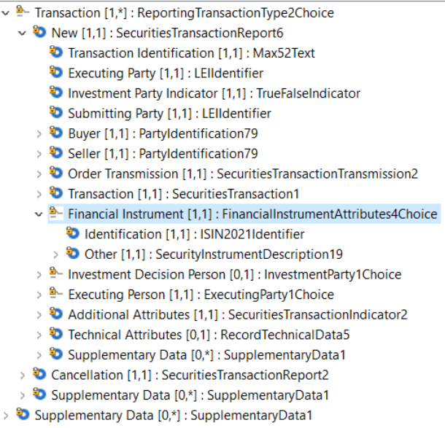 | 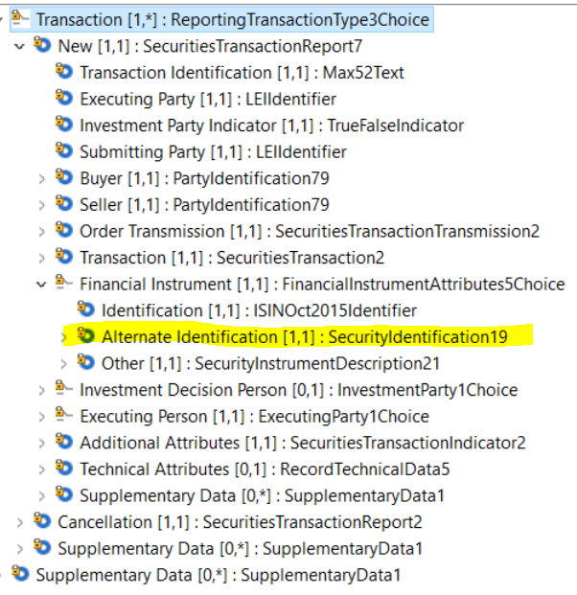
For OTC transactions, the Other branch is used. In this branch, an optional element is added using the existing OtherIdentification1 message component to convey the DTI – it will be further restricted in Usage Guidelines to focus on DTI.

Approved message | Proposed change
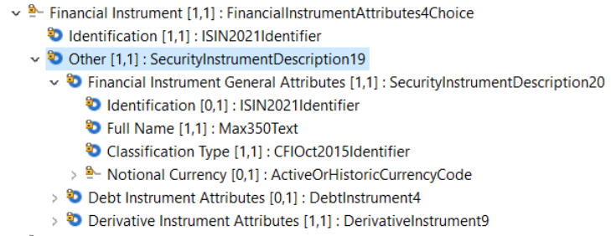 | 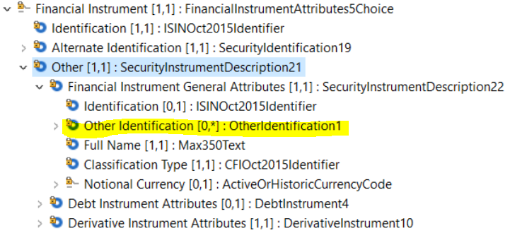
- Decision of the SEG(s):
This section is not to be taken care of by the submitting organization. It will be completed in due time by the SEG(s) in charge of the related ISO 20022 message definitions.

Change
approved
rejected
Comments:

Timing
- Fast track maintenance
(the change justifies an urgent implementation using the fast track maintenance process)
- At the occasion of the next maintenance of the messages
(the change will be considered for implementation, but does not justify an urgent implementation – will be pending until the next [yearly] maintenance of the messages)

Change number #2
- Related messages:
auth.016.001.02 FinancialInstrumentReportingTransactionReportV02

- Description of the change and type of impact:
Support the possibility to report both the Digital Token Identifier (DTI) of the e-money involved in the transaction, which may be needed at the level of Quantity and Price.

- Proposed implementation:
In order to retain backwards compatibility, the existing Quantity element remains unchanged. An optional element is added to convey the Digital Token Quantity, using the existing DigitalTokenAmount1 message components which allows to convey the DTI and the number of units.
Approved message | Proposed change
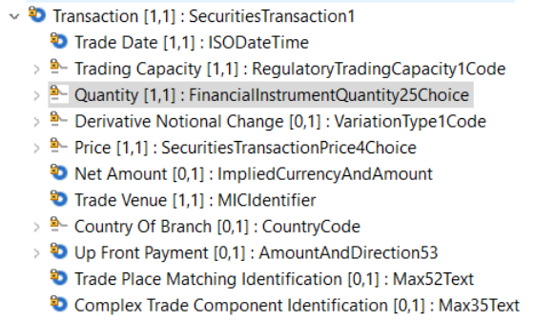 | 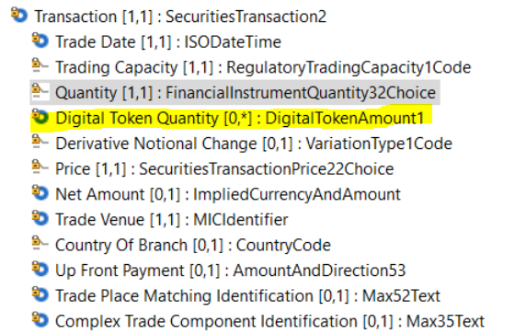

For the Price, a new branch of the choice element has been added to give the possibility to report both the number of e-money tokens, and the monetary value.
Approved message | Proposed change
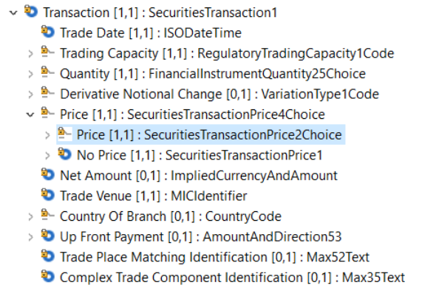 | 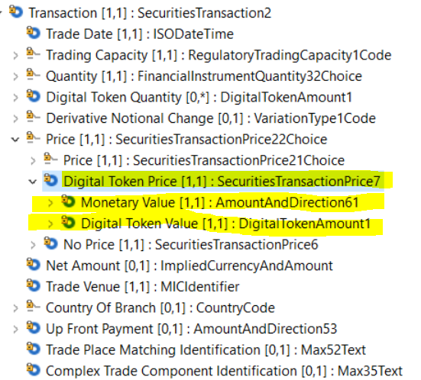
Finally in case the price is “Pending”, an optional element to convey the DTI has been added. In such case, the number of units may not be known, so the DigitalTokenAmount2 message component has been created where the number of units is optional. The DTI Identifier element would be turned mandatory in Usage Guidelines.
Approved message | Proposed change
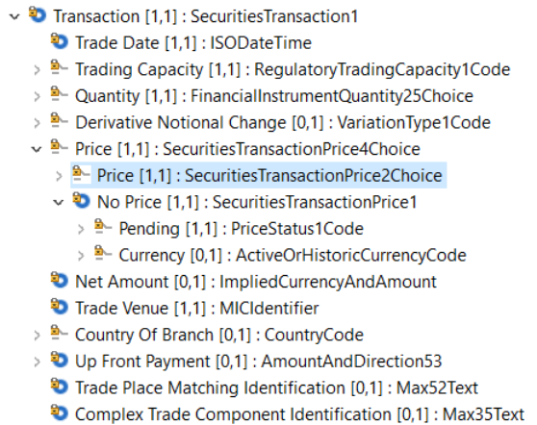 | 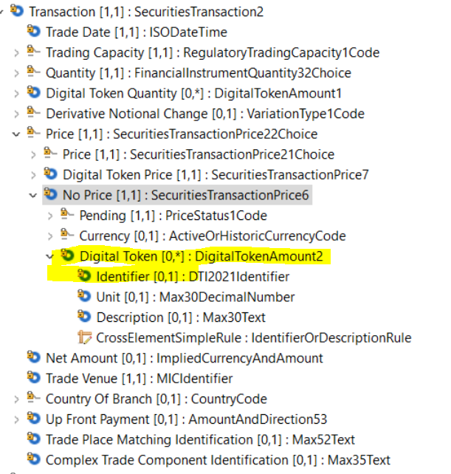

- Decision of the SEG(s):
This section is not to be taken care of by the submitting organization. It will be completed in due time by the SEG(s) in charge of the related ISO 20022 message definitions.

Change
approved
rejected
Comments:

Timing
- Fast track maintenance
(the change justifies an urgent implementation using the fast track maintenance process)
- At the occasion of the next maintenance of the messages
(the change will be considered for implementation, but does not justify an urgent implementation – will be pending until the next [yearly] maintenance of the messages)

esma70-460-111_report_on_the_dlt_pilot_regime.pdf (europa.eu)

