Standards
Standards MT Release 2023
Discussion paper and Minutes
Corporate Actions
Distribution: Corporate Action Maintenance Working Group
Author: Jacques Littré
Date Issued: 6 September 2022
Version: FINAL 1.0
Meeting Date: August 23, 2022

Table of Contents
1 Introduction 3
ISO 15022 – 20022 Maintenance Process 3
Standards Illustrations in this document 3
SR 2023 change requests 3
CR Title Colour notation (for minutes only) 3
Contact persons regarding this document 3
CA MWG Members for SR2023 3
2 Overview of User Change requests 5
2.1 CR 001847: New CA Event for the Payment of Meeting Events' Incentive Fees 5
2.2 CR 001780: DateTime Qualifiers Harmonisation across CA Messages 9
2.3 CR 001845: Add new Conditional Tag and NVR for Full Call Events 23
2.4 CR 001846: Add Tax Information to Securities Proceeds 29
2.5 CR 001900: Change Function of the Message between CANO & CAPA (ISO 20022 CR 1112) 46
2.6 CR 001901: Update Reversal Reason Code IRED (ISO 20022 CR 1113) 51
2.7 CR 001902: Add new Textual Information in Instruction Cancellation (ISO 20022 CR 1114) 53
2.8 CR 001903: Add Reject Reason Codes to Instruction Cancellation Request Status Advice (ISO 20022 CR 1115) 56

Introduction

ISO 15022 – 20022 Maintenance Process
As from the year 2012, a joint maintenance process has been put in place for ISO 20022 and 15022 and Corporate Action messages with the support of the ISO 20022 RMG and of the SWIFT Board.
This joint maintenance will ensure interoperability between the two standards and a more efficient maintenance process.

Standards Illustrations in this document
Standards illustrations are provided by SWIFT Standards. They are not part of the original request.
Any standard illustrations (rules, codes, qualifiers, wordings) are only for illustration purposes. It does not mean SWIFT Standards is in agreement with the maintenance request or that the final standards solutions (for accepted maintenance requests) will be as shown in this document.
The MT Standards Release Guide (+ potential erratum) and the ISO 20022 message definition reports are the ONLY source of reliable information based on which implementation of changes should be made. Any other documentation (including this one) is subject to change.

SR 2023 change requests
This document contains all CA MT/MX CRs for MT category 5 and equivalent MX messages investigated this year for implementation in SR 2023.
The requests originator is indicated as follows:
  - Requesting Country; Country code of requesting NMPG or UG; eg. BE
  - Requesting Group: a SWIFT User Group or a National (Securities) Market Practice Group with the acknowledgement of the UGC or Recognized industry group eg. SMPG (the global Securities Market Practice Group)

CR Title Colour notation (for minutes only)
In GREEN are items that are approved or approved with comments or approved with alternative solution.
In RED are items that are rejected, postponed, withdrawn or linked to agreed items

Contact persons regarding this document
Jacques Littré – SWIFT Standards; jacques.littre@swift.com

CA MWG Members for SR2023
The following people are part of the CA MWG for SR2023.

Maintenance working group members | Representing | Attendance
Priscilla Ferri de Barros | AU | Yes
No representative | BE | x
Michael Blumer | CH | Yes
Daniel Schäfer | DE | Yes
Tanja Ronne Kofod | DK | Yes
Stephanie Clark Fischer / Mihaela Fallourd | FR | Yes
James Mullens | HK | Excused
Yoshihito Suzuki | JP | Yes
Catarina Marques | LU | Yes
Paola De Antoni | IT | Yes
Huseyin Boler | NL | Yes
Jyi-Chen Chueh | SG | Yes
Mariangela Fumagalli | UK | Yes
Paul Fullam | US / ISITC | Yes
Jean-Paul Lambotte | XS | Yes
Sanjeev Jayram | ZA | Yes
Christine Strandberg | ISO 20022 Securities SEG (SE) | Yes
Steve Sloan | ISO 20022 Securities SEG (US) | Yes
Jacques Littré | SWIFT - CA MWG Chair | Yes

Overview of User Change requests

CR 001847: New CA Event for the Payment of Meeting Events' Incentive Fees
Origin of request
Requesting Group: | SMPG
Sponsors
Message type(s) impacted
(CA) MT 564, MT 566, MT 568
(SnR): MT 508, MT 536, MT 537, MT538, MT548, MT575
(CA): seev.031 (CANO), 035 (CAPA), 036 (CACO), 037 (CARE), 039 (CACN), 044 (CAPC)
(SnR): semt.015, 016, 017, 018
Complies with regulation
None
Business impact of this request
MEDIUM
Commitment to implement the change
Number of messages sent and received: 150
Percentage of messages impacted: 100
Commits to implement and when: (i)CSDs and major global custodians in SR 2023
Business context
Some general meetings (e.g in Spain and at ICSD) are announced with an incentive premium. Rightholders may benefit of a payment in case they vote or vote in certain direction, according depending on the terms of the event.
The payment of such incentives is announced and processed via a mandatory CONS event to be used together with the ADDB//INCP indicator. To correctly identify such events as related to votes lodged for a meeting with incentive premium, we would like to request the creation of a dedicated CAEV code.
Nature of change
To correctly identify such events as related to votes lodged for a meeting with incentive premium, we would like to request the creation of a dedicated CAEV code.
Workaround
Currently, the payment of the incentive premium is announced with CAEV CONS with the linkage to the meeting ID of the general meeting and the inclusion of the ADDB//INCP indicator. Further explanations are provided in narratives.
Examples
Iberdrola - ES0144580Y14
Ercros ES0125140A14
Iberpapel - ES0147561015
Vidrala - ES0183746314
Viscofan - ES0184262212

SWIFT Comment

Should we remove ADDB//INCP for SR2023 if the new event is approved ?

Standards Illustration
1. ISO 15022 Illustration
1. In the MT564, MT 566, and MT 568 messages, in sequence A, create a new event type PMET (Payment of Meeting Incentive Fees) in field :22F: in qualifier CAEV as defined and illustrated below:

MT 564 Field Specifications

5. Field 22F: Indicator

FORMAT
Option F | :4!c/[8c]/4!c | (Qualifier)(Data Source Scheme)(Indicator)

PRESENCE
Mandatory in mandatory sequence A

QUALIFIER
(Error code(s): T89)
Order | M/O | Qualifier | R/N | CR | Options | Qualifier Description
1 | O | CAEP | N |  | F | Corporate Action Event Processing
2 | M | CAEV | N | C4, C6, C10, C11, C23, C26, C30 | F | Corporate Action Event Indicator
3 | M | CAMV | N |  | F | Mandatory/Voluntary Indicator

DEFINITION
This qualified generic field specifies:
CAEP | Corporate Action Event Processing | Type of processing involved by a Corporate Action.
CAEV | Corporate Action Event Indicator | Specifies the type of corporate event.
CAMV | Mandatory/Voluntary Indicator | Specifies whether the event is mandatory, mandatory with options or voluntary.

CODES
If Qualifier is CAEV and Data Source Scheme is not present, Indicator must contain one of the following codes (Error code(s): K22):
ACCU | Accumulation | Funds related event in which the income (for example accumulation units) that accrues during an accounting period is retained within the fund instead of being paid away to investors. The retained income is nonetheless deemed to have been distributed to investors for tax purposes.
ACTV | Trading Status: Active | Trading in the security has commenced or security has been re-activated after a suspension in trading.
ATTI | Attachment | Combination of different security types to create a unit. Units are usually comprised of warrants and bonds or warrants and equities. Securities may be combined at the request of the security holder or based on market convention.
… | …. | ….
PLAC | Place of Incorporation | Changes in the state of incorporation for US companies and changes in the place of incorporation for foreign companies. Where shares need to be registered following the incorporation change, the holder(s) may have to elect the registrar.
PMET | Payment of Meeting Incentive Fees | Payment of incentive fees related to votes lodged for a meeting with incentive premium in the context of a general meeting event.
PPMT | Instalment Call | An instalment towards the purchase of equity capital, subject to an agreement between an issuer and a purchaser.
PRED | Partial Redemption With Pool Factor Reduction | Securities are redeemed in part before their scheduled final maturity date. The redemption is reflected in a pool factor reduction. No movement of securities occurs.
…. | …. | …..
WRTH | Worthless | Booking out of valueless securities.
WTRC | Withholding Tax Relief Certification | Certification process for withholding tax reduction or exemption based on the tax status of the holder.
XMET | Extraordinary or Special General Meeting | Extraordinary or special general meeting.

Apply the same change in the qualifier :22F::CAEV in the following messages:
- MT508 sequence B,
- MT536 subsequence B1a2
- MT537 subsequence B2b, C2
- MT538 subsequence B2a
- MT548 subsequence C1a1B1
- MT575 subsequence B1a2, B1a3, C2,

2. ISO 20022 Illustration
New Event Type
In the latest version of the parent Data Type Code CorporateActionEventTypeV6Code, add a new event type code PaymentOfMeetingIncentiveFees (PMET) as defined and illustrated above in ISO 15022.
Create new versions of the CorporateActionEventType30Code, CorporateActionEventType31Code, CorporateActionEventType32Code, CorporateActionEventType33Code and add the new Event type PMET and tracing to the new version of the parent Data Type code CorporateActionEventTypeV6Code for Corporate Action event types.
This will trigger the addition of the PMET event in messages seev.031, seev.035, seev.036, seev.37, seev.039 and seev.044, in the data type of the CorporateActionGeneralInformation/EventType/Code elements as well as in the MX messages semt.015, semt.016, semt.017, semt.018.

Working Group Meeting

Discussion
The MWG globally understands the business case and acknowledges the business issue raised.
However, a majority of the MWG members estimates that due to the low volume of messages concerned, the investment required in this solution (creation of a new CA event) is too big (this solution does not simply impact CA but also SnR messages) for the expected benefit taking also into account that another solution (new ADDB//INCP code) for this issue was already approved for implementation last year for SR2022.
It is not clear either for most of the MWG members what would happen to this solution implemented for SR2022 if a new CA event is created. Do we need for SR2023 to remove the code added last year or leave it ? A majority of the MWG members are of the opinion that the coexistence of 2 solutions for the same business case will be highly confusing and risky.
In conclusion, the MWG members agree by consensus that there is no valid business case, the volumes are too low to create a new event, especially since a solution with ADDB was already implemented in SR 2022. The CR is rejected.
Decision
Rejected

CR 001780: DateTime Qualifiers Harmonisation across CA Messages
Origin of request
Requesting Group: | SMPG
Sponsors
NMPG members of the SMPG
Message type(s) impacted
MT 564, MT 565, MT 566, MT 567, MT568
seev.031 (CANO), seev.035 (CAPA), seev.036 (CACO), seev.039 (CACS), seev.044 (CAPC)
Complies with regulation
None
Business impact of this request
MEDIUM
Commitment to implement the change
Number of messages sent and received: 40.000.000
Percentage of messages impacted: 25
Commits to implement and when: NMPG Members of the SMPG in SR 2023
Business context
A full review of all :98a: Date/Time qualifiers across all CA MT messages done by the SMPG in 2021 has shown that there were a lack of consistency in the usage of some of the format options across the messages regarding particularly the usage of the UTC time that was missing in many qualifiers. Furthermore, it appeared that some Date/Time qualifiers did not need to have a "time" component and some others for which their presence in the MT 566 does not make any sense at all.
The SMPG decided that it was time to make the necessary changes in the messages.
The CR was already approved in SR2022 but postponed to SR2023 to fine tune the requirements.
Nature of change
In the MT564:
> Add UTC Time (Format Option E) to:
PREP, EXPI, ANOU, CERT, IFIX, REGI, RESU, SPLT, ETPD, FDAT, OAPD, TPDT, TSDT, SUBS, DVCP, FXDT
> Remove Time (Format Option C) and rename:
EFFD, EQUL, LOTO, MATU, PROD, RDTE, UNCO, WUCO, XDTE, COAP, GUPA, LAPD, MCDT, MFIX, SXDT, PAYD, AVAL, DIVR, PPDT, LTRD, EARL, VALU,

In the MT565, Add UTC Time (Format Option E) to PREP, EXRQ.

In the MT566:
> Add UTC Time (Format Option E) to: PREP, IFIX, FXDT
> Remove Time (Format Option C) and rename: POST, EQUL, LOTO, MATU, PROD, RDTE, XDTE, PAYD, AVAL, DIVR,PPDT, EARL, VALU
>Remove qualifier: EXPI (in Seq. D), ANOU, CERT, EFFD, REGI, RESU, SPLT, TAXB, UNCO, WUCO, PODT, RDDT, SUBS, MKDT,

In the MT567, add UTC Time (Format Option E) to PREP

In the MT568, add UTC Time (Format Option E) to PREP

Summary of changes in table
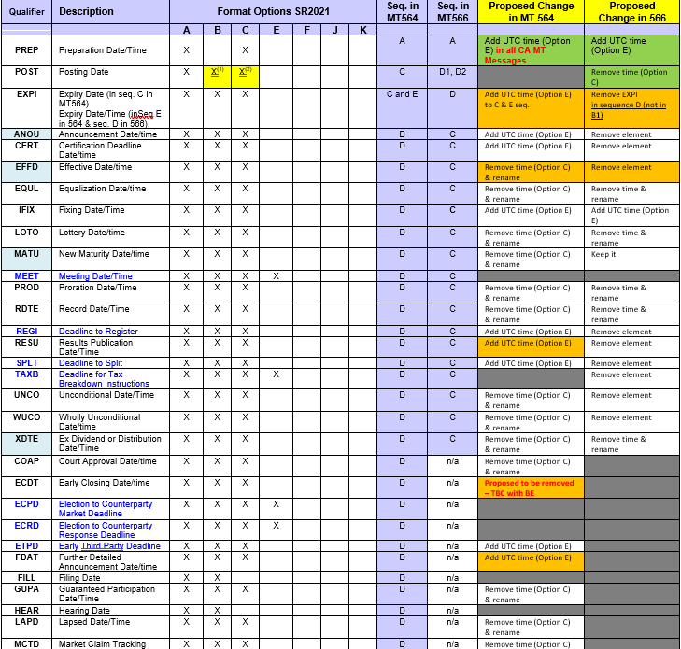
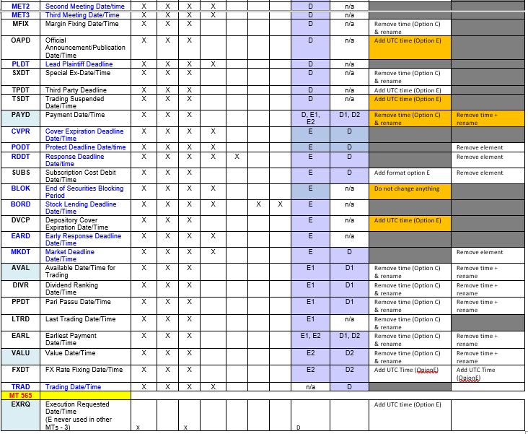
Workaround
None
Examples
None

SWIFT Comment

Standards Illustration
1. ISO 15022 Illustration
1. In all MT 56X messages in sequence A in field 98a, add format option E to qualifier PREP as illustrated for the MT564 below:

MT 564 Field Specifications

6. Field 98a: Date/Time: Preparation Date/Time

FORMAT
Option A | :4!c//8!n | (Qualifier)(Date)
Option C | :4!c//8!n6!n | (Qualifier)(Date)(Time)
Option E | :4!c//8!n6!n[,3n][/[N]2!n[2!n]] | (Qualifier)(Date)(Time)(Decimals)(UTC Indicator)

PRESENCE
Optional in mandatory sequence A

QUALIFIER
(Error code(s): T89)
Order | M/O | Qualifier | R/N | CR | Options | Qualifier Description
1 | O | PREP | N |  | A, or C or E | Preparation Date/Time

DEFINITION
This qualified generic field specifies:
PREP | Preparation Date/Time | Date/time at which the message was prepared.

NETWORK VALIDATED RULES
Date must be a valid date expressed as YYYYMMDD (Error code(s): T50).
Time must be a valid time expressed as HHMMSS (Error code(s): T38).
UTC Indicator must be a valid time expressed as HH[MM] (Error code(s): T39).
Sign ([N]) must not be used when UTC Indicator is equal to all zeroes (Error code(s): T14).

2. In the MT 564, add UTC Time (Format Option E) to the following :98a: Date/Time qualifiers:
In sequence C: EXPI
In Sequence D: ANOU, CERT, IFIX, REGI, RESU, SPLT, ETPD, FDAT, OAPD, TPDT, TSDT
In sequence E: EXPI, SUBS, DVCP
In sequence E1: -
In sequence E2: FXDT
Example: see example below for MT 564 sequence D

3. In the MT 564, remove Time (Format Option C) and rename the qualifier by removing “Time” word in the name and in the definition for the following :98a: Date/Time qualifiers:
In sequence C: -
In Sequence D: EFFD, EQUL, LOTO, MATU, PROD, RDTE, UNCO, WUCO, XDTE, COAP, GUPA, LAPD, MCDT, MFIX, SXDT, PAYD
In sequence E:
In sequence E1: PAYD, AVAL, DIVR, PPDT, LTRD, EARL
In sequence E2: PAYD, EARL, VALU
Example in MT 564 sequence D

MT 564 Field Specifications

43. Field 98a: Date/Time

FORMAT
Option A | :4!c//8!n | (Qualifier)(Date)
Option B | :4!c/[8c]/4!c | (Qualifier)(Data Source Scheme)(Date Code)
Option C | :4!c//8!n6!n | (Qualifier)(Date)(Time)
Option E | :4!c//8!n6!n[,3n][/[N]2!n[2!n]] | (Qualifier)(Date)(Time)(Decimals)(UTC Indicator)

PRESENCE
Optional in optional sequence D

QUALIFIER
(Error code(s): T89)
Order | M/O | Qualifier | R/N | CR | Options | Qualifier Description
1 | O | ANOU | N |  | A, B, C or E | Announcement Date/Time
2 | O | CERT | N |  | A, B, C or E | Certification Deadline Date/Time
3 | O | XDTE | N |  | A, B, or C | Ex-Dividend or Distribution Date/Time
4 | O | EFFD | N |  | A, B, or C | Effective Date/Time
5 | O | FDAT | N |  | A, B, C or E | Further Detailed Announcement Date/Time
6 | O | PROD | N |  | A, B, or C | Proration Date/Time
7 | O | REGI | N |  | A, B, C or E | Deadline to Register
8 | O | RESU | N |  | A, B, C or E | Results Publication Date/Time
9 | O | SPLT | N |  | A, B, C or E | Deadline to Split
10 | O | MEET | N |  | A, B, C, or E | Meeting Date/Time
11 | O | RDTE | N |  | A, B, or C | Record Date/Time
12 | O | TAXB | N |  | A, B, C, or E | Deadline for Tax Breakdown Instructions
13 | O | TSDT | N |  | A, B, C or E | Trading Suspended Date/Time
14 | O | LOTO | N |  | A, B, or C | Lottery Date/Time
15 | O | UNCO | N |  | A, B, or C | Unconditional Date/Time
16 | O | WUCO | N |  | A, B, or C | Wholly Unconditional Date/Time
17 | O | MET2 | N |  | A, B, C, or E | Second Meeting Date/Time
18 | O | MET3 | N |  | A, B, C, or E | Third Meeting Date/Time
19 | O | EQUL | N |  | A, B, or C | Equalization Date/Time
20 | O | ECDT | N |  | A, B, or C | Early Closing Date/Time
21 | O | IFIX | N |  | A, B, C or E | Fixing Date/Time
22 | O | MFIX | N |  | A, B, or C | Margin Fixing Date/Time
23 | O | COAP | N |  | A, B, or C | Court Approval Date/Time
24 | O | MATU | N |  | A, B, or C | New Maturity Date/Time
25 | O | OAPD | N |  | A, B, C or E | Official Announcement/Publication Date/Time
26 | O | SXDT | N |  | A, B, or C | Special Ex-Date/Time
27 | O | GUPA | N |  | A, B, or C | Guaranteed Participation Date/Time
28 | O | ECPD | N |  | A, B, C, or E | Election to Counterparty Market Deadline
29 | O | LAPD | N |  | A, B, or C | Lapsed Date/Time
30 | O | MCTD | N |  | A, B, or C | Market Claim Tracking End Date
31 | O | PAYD | N | C16 | A, B, or C | Payment Date/Time
32 | O | TPDT | N |  | A, B, C or E | Third Party Deadline
33 | O | ETPD | N |  | A, B, C or E | Early Third Party Deadline
34 | O | PLDT | N |  | A, B, C, or E | Lead Plaintiff Deadline
35 | O | FILL | N |  | A or B | Filing Date
36 | O | HEAR | N |  | A or B | Hearing Date
37 | O | ECRD | N |  | A, B, C, or E | Election to Counterparty Response Deadline

DEFINITION
This qualified generic field specifies:
ANOU | Announcement Date/Time | Date/time at which the issuer announced that a corporate action event will occur.
CERT | Certification Deadline Date/Time | Deadline by which the certification must be sent.
COAP | Court Approval Date/Time | Date/Time upon which the Court provided approval.
ECDT | Early Closing Date/Time | First possible early closing date of an offer if different from the expiry date.
ECPD | Election to Counterparty Market Deadline | Deadline by which an entitled holder needs to advise their counterparty to a transaction of their election for a corporate action event, also known as Buyer Protection Deadline.
ECRD | Election to Counterparty Response Deadline | Date/time the account servicer has set as the deadline to respond, with instructions, prior to the election to counterparty market deadline.
EFFD | Effective Date/Time | Date/Time at which an event is officially effective from the issuer's perspective.
EQUL | Equalization Date/Time | Date/Time at which all or part of any holding bought in a unit trust is subject to being treated as capital rather than income. This is normally one day after the previous distribution's ex date.
ETPD | Early Third Party Deadline | Date/Time set by the issuer agent as a first early deadline by which the account owner must instruct directly another party, possibly giving the holder eligibility to incentives. For example, to provide documentation to an issuer agent.
FDAT | Further Detailed Announcement Date/Time | Date/time at which additional information on the event will be announced, for example, exchange ratio announcement date.
FILL | Filing Date | Date on which the action was filed at the applicable court.
GUPA | Guaranteed Participation Date/Time | Last date/Time by which a buying counterparty to a trade can be sure that it will have the right to participate in an event.
HEAR | Hearing Date | Date for the hearing between the plaintiff and defendant, as set by the court.
IFIX | Fixing Date/Time | Date/time at which an index/rate/price/value will be determined.
LAPD | Lapsed Date/Time | Date/Time at which an event/offer is terminated or lapsed.
LOTO | Lottery Date/Time | Date/Time at which the lottery is run and applied to the holder's positions. This is also applicable to partial calls.
MATU | New Maturity Date/Time | Date/Time to which the maturity date of an interest bearing security is extended.
MCTD | Market Claim Tracking End Date | Date by which the depository stops monitoring activities of the event, for instance, accounting and tracking activities for due bills end.
MEET | Meeting Date/Time | Date/time at which the bondholders' or shareholders' meeting will take place.
MET2 | Second Meeting Date/Time | Date/time at which the company's general meeting is scheduled, 2nd session if applicable (for example, Italy).
MET3 | Third Meeting Date/Time | Date/time at which the company's general meeting is scheduled, 3rd session if applicable (for example, Italy).
MFIX | Margin Fixing Date/Time | Date/Time at which the margin rate will be determined.
OAPD | Official Announcement/Publication Date/Time | Date/time at which the corporate action is legally announced by an official body, for example, publication by a governmental administration.
PAYD | Payment Date/Time | Date/Time at which the movement is due to take place (cash and/or securities).
PLDT | Lead Plaintiff Deadline | Last day an investor can become a lead plaintiff.
PROD | Proration Date/Time | Date/Time at which the issuer will determine a proration amount/quantity of an offer.
RDTE | Record Date/Time | Date/Time at which positions are struck at the end of the day to note which parties will receive the relevant amount of entitlement, due to be distributed on payment date.
REGI | Deadline to Register | Date/time at which instructions to register or registration details will be accepted.
RESU | Results Publication Date/Time | Date/time at which results are published, for example, results of an offer.
SPLT | Deadline to Split | Deadline by which instructions must be received to split securities, for example, of physical certificates.
SXDT | Special Ex-Date/Time | Date/Time as from which 'special processing' can start to be used by participants for that event. Special processing is a means of marking a transaction, that would normally be traded ex or cum, as being traded cum or ex respectively, for example, a transaction dealt 'special' after the ex date would result in the buyer being eligible for the entitlement. This is typically used in the UK and Irish markets.
TAXB | Deadline for Tax Breakdown Instructions | Date/time until which tax breakdown instructions will be accepted.
TPDT | Third Party Deadline | Date/Time by which the account owner must instruct directly another party, for example to provide documentation to an issuer agent.
TSDT | Trading Suspended Date/Time | Date/time at which trading of a security is suspended as the result of an event.
UNCO | Unconditional Date/Time | Date/Time upon which the terms of the take-over become unconditional as to acceptances.
WUCO | Wholly Unconditional Date/Time | Date/Time at which all conditions, including regulatory, legal etc. pertaining to the take-over, have been met.
XDTE | Ex-Dividend or Distribution Date/Time | Date/Time as from which trading (including exchange and OTC trading) occurs on the underlying security without the benefit.

4. In the MT 565, add UTC Time (Format Option E) to the following :98a: Date/Time qualifiers in sequence D: EXRQ.

5. In the MT 566, add UTC Time (Format Option E) to the following :98a: Date/Time qualifiers in sequence C: IFIX. and in sequence D2, FXDT

6. In the MT 566, remove Time (Format Option C) and rename the qualifier by removing “Time” word in the name and in the definitions for the following :98a: Date/Time qualifiers:
In sequence C: EQUL, LOTO, MATU, PROD, RDTE, XDTE
In sequence D: -
In sequence D1: PAYD, AVAL, DIVR, PPDT, EARL, POST
In sequence D2: PAYD, EARL, VALU, POST
Example: see example below for MT 566 sequence C

7. In the MT 566, remove the following :98a: DateTime qualifiers:
In sequence C: ANOU, CERT, EFFD, REGI, RESU, SPLT, TAXB, UNCO, WUCO
In sequence D: EXPI, PODT, RDDT, SUBS, MKDT
Example: MT 566 sequence C

MT 566 Field Specifications

29. Field 98a: Date/Time

FORMAT
Option A | :4!c//8!n | (Qualifier)(Date)
Option B | :4!c/[8c]/4!c | (Qualifier)(Data Source Scheme)(Date Code)
Option C | :4!c//8!n6!n | (Qualifier)(Date)(Time)
Option E | :4!c//8!n6!n[,3n][/[N]2!n[2!n]] | (Qualifier)(Date)(Time)(Decimals)(UTC Indicator)

PRESENCE
Optional in optional sequence C

QUALIFIER
(Error code(s): T89)
Order | M/O | Qualifier | R/N | CR | Options | Qualifier Description
1 | O | ANOU | N |  | A, B, or C | Announcement Date/Time
2 | O | CERT | N |  | A, B, or C | Certification Deadline Date/Time
3 | O | XDTE | N |  | A, B, or C | Ex-Dividend or Distribution Date/Time
4 | O | EFFD | N |  | A, B, or C | Effective Date/Time
5 | O | PROD | N |  | A, B, or C | Proration Date/Time
6 | O | REGI | N |  | A, B, or C | Deadline to Register
7 | O | RESU | N |  | A, B, or C | Results Publication Date/Time
8 | O | SPLT | N |  | A, B, or C | Deadline to Split
9 | O | MEET | N |  | A, B, C, or E | Meeting Date/Time
10 | O | RDTE | N |  | A, B, or C | Record Date/Time
11 | O | TAXB | N |  | A, B, C, or E | Deadline for Tax Breakdown Instructions
12 | O | LOTO | N |  | A, B, or C | Lottery Date/Time
13 | O | UNCO | N |  | A, B, or C | Unconditional Date/Time
14 | O | WUCO | N |  | A, B, or C | Wholly Unconditional Date/Time
15 | O | EQUL | N |  | A, B, or C | Equalization Date/Time
16 | O | MATU | N |  | A, B, | New Maturity Date
17 | O | IFIX | N |  | A, B, C or E | Fixing Date/Time

DEFINITION
This qualified generic field specifies:
ANOU | Announcement Date/Time | Date/time at which the issuer announced that a corporate action event will occur.
CERT | Certification Deadline Date/Time | Deadline by which the certification must be sent.
EFFD | Effective Date/Time | Date/time at which an event is officially effective from the issuer's perspective.
EQUL | Equalization Date/Time | Date/Time at which all or part of any holding bought in a unit trust is subject to being treated as capital rather than income. This is normally one day after the previous distribution's ex date.
IFIX | Fixing Date/Time | Date/time at which an index/rate/price/value will be determined.
LOTO | Lottery Date/Time | Date/Time at which the lottery is run and applied to the holder's positions. This is also applicable to partial calls.
MATU | New Maturity Date/Time | Date/time to which the maturity date of an interest bearing security is extended.
MEET | Meeting Date/Time | Date/time at which the bondholders' or shareholders' meeting will take place.
PROD | Proration Date/Time | Date/Time at which the issuer will determine a proration amount/quantity of an offer.
RDTE | Record Date/Time | Date/Time at which positions are struck at the end of the day to note which parties will receive the relevant amount of entitlement, due to be distributed on payment date.
REGI | Deadline to Register | Date/time at which instructions to register or registration details will be accepted.
RESU | Results Publication Date/Time | Date/time at which results are published, for example, results of an offer.
SPLT | Deadline to Split | Deadline by which instructions must be received to split securities, for example, of physical certificates.
TAXB | Deadline for Tax Breakdown Instructions | Date/time until which tax breakdown instructions will be accepted.
UNCO | Unconditional Date/Time | Date/time upon which the terms of the take-over become unconditional as to acceptances.
WUCO | Wholly Unconditional Date/Time | Date/time at which all conditions, including regulatory, legal etc. pertaining to the take-over, have been met.
XDTE | Ex-Dividend or Distribution Date/Time | Date/Time as from which trading (including exchange and OTC trading) occurs on the underlying security without the benefit.

2. ISO 20022 Illustration
In ISO 20022, the UTC Time is already part of the ISODateTime data type itself. There is therefore nothing to change to support UTC time.

1. In the seev.031 (CANO – CorporateActionNotification) message, replace the data type DateAndDateTime2Choice of the Date element by the data type ISODate for the following elements:
In CorporateActionDetails/DateDetails:
- EffectiveDate
- EqualisationDate
- LotteryDate
- NewMaturityDate
- ProrationDate
- RecordDate
- UnconditionalDate
- WhollyUnconditionalDate
- ExDividendDate
- CourtApprovalDate
- GuaranteedParticipationDate
- LapsedDate
- MarketClaimTrackingEndDate
- MarginFixingDate
- SpecialExDate
- PaymentDate

This comes down to replace the Datatype DateFormat43Choice of the date element by DateFormat30Choice data type as illustrated below for EffectiveDate:

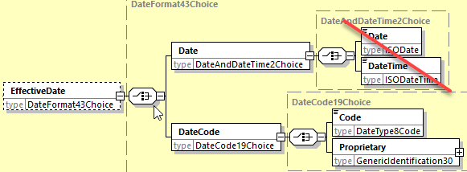

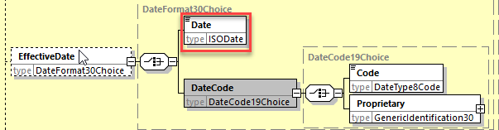

In CorporateActionOptionDetails/SecuritiesMovementDetails/DateDetails:
- PaymentDate
- AvailableDate
- DividendRankingDate
- PariPassuDate
- LastTradingDate
- EarliestPaymentDate

In CorporateActionOptionDetails/CashMovementDetails/DateDetails:
- PaymentDate
- EarliestPaymentDate
- ValueDate

2. In the seev.035 (CAPA – CorporateActionMovementPreliminaryAdvice), replace the data type DateAndDateTime2Choice of the Date element by the data type ISODate for the following elements:

This comes down to replace the Datatype DateFormat43Choice of the date element by DateFormat30Choice data type as illustrated below for EffectiveDate:

In CorporateActionDetails/DateDetails:
- RecordDate
- ExDividendDate
- LotteryDate

In CorporateActionMovementDetails/SecuritiesMovementDetails/DateDetails:
- PaymentDate
- AvailableDate
- DividendRankingDate
- PariPassuDate
- LastTradingDate
- EarliestPaymentDate

In CorporateActionMovementDetails/CashMovementDetails/DateDetails:
- PaymentDate
- EarliestPaymentDate
- ValueDate

3. In the seev.036 (CACO – CorporateActionMovementConfirmation), replace the data type DateAndDateTime2Choice of the Date element by the data type ISODate for the following elements:
This comes down to replace the Datatype DateFormat43Choice of the date element by DateFormat30Choice data type as illustrated below for EffectiveDate:

In CorporateActionDetails/DateDetails:
- RecordDate
- ExDividendDate
- MaturityDate

In CorporateActionConfirmationDetails/SecuritiesMovementDetails/DateDetails:
- PostingDate
- PaymentDate
- AvailableDate
- DividendRankingDate
- PariPassuDate
- EarliestPaymentDate

In CorporateActionConfirmationDetails/CashMovementDetails/DateDetails:
- PostingDate
- PaymentDate
- EarliestPaymentDate
- ValueDate

4. In the seev.036 (CACO – CorporateActionMovementConfirmation), remove the following Date elements:

In CorporateActionConfirmationDetails/DateDetails:
- ExpiryDate
- ProtectDeadline
- ResponseDeadline
- SubscriptionCostDebitDate
- MarketDeadline

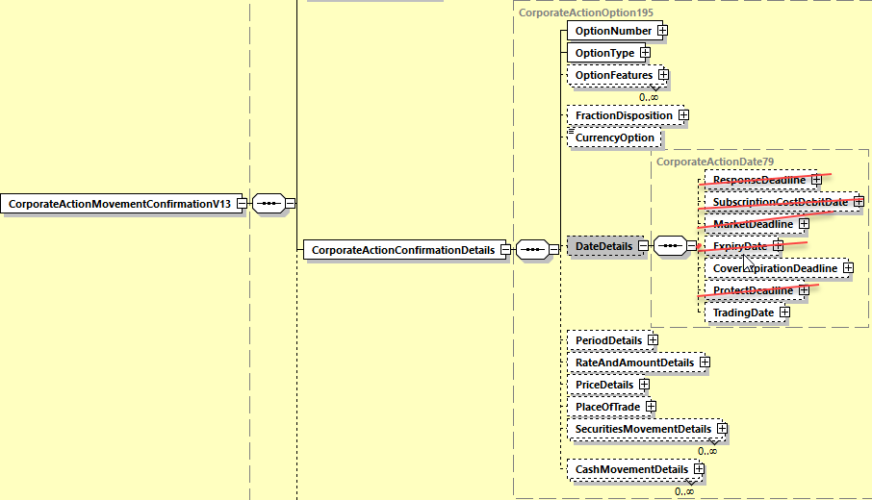

5. In the seev.039 (CACN – CorporateActionCancellationAdvice) message, replace the data type DateAndDateTime2Choice of the Date element by the data type ISODate for the following elements:

In CorporateActionDetails/DateDetails:
- RecordDate
- ExDividendDate

6. In the seev.044 (CAPC – CorporateActionMovementPreliminaryAdviceCancellationAdvice) message, replace the data type DateAndDateTime2Choice of the Date element by the data type ISODate for the following elements:

In CorporateActionDetails/DateDetails:
- RecordDate
- ExDividendDate

Working Group Meeting

Discussion
This change request was already submitted in SR2022 but the MWG resolved to postpone the implementation to SR2023 so as to have more time for an additional in-depth review of the proposed changes by the SMPG members and to ensure all remaining question marks were solved.
The US asked whether the changes between last year CR and this year have been tracked. The answer is no but there were no changes other than solving the remaining question marks and the purpose was mainly to increase the country feedback on the proposed changes agreed within the SMPG.
XS mentioned the situation (in EU) with the CA messages release that the Eurosystem would implement for ECMS. Originally the Eurosystem planned to implement the SR2019 version of the ISO 20022 CA messages.
Thanks to the SMPG letter sent to AMI-SeCo to raise the concern of the market players with the SR2019 version, the Eurosystem agreed to review the approach and to align ECMS at the minimum with the SR2022. The Eurosystem reported that the level of confidence to implement the SR2023 would be high if the CR1780 is postponed. If not, there is a high risk that implementing SR2023 won’t be feasible for ECMS. The fallback solution would be to implement the SR 2022 version of the CA messages.
Therefore, the IT representative suggested to split the implementation on 2 years, adding UTC time in MT messages for SR2023 (with no MX impact) and postpone the rest of the CR to SR2024.
The LU representative supported the suggestion, but expressed the need to revalidate with the communities.
Nevertheless, this proposal was not accepted by most MWG representatives as they could not get the feedback of their community on this proposal at such short notice and they did not have the mandate to vote on this partial implementation alternative.
Some of the MWG members were of the opinion that the decision to implement a CR should not necessarily take into account specific infrastructure project in a region/country otherwise a CR might be postponed several years in a row.
JP agreed with most of the proposed changes except the removal of qualifiers in MT566 (i.e. EXPI, ANOU, CERT, EFFD, REGI, RESU, SPLT, TAXB, UNCO, WUCO, PODT, RDDT, SUBS, MKDT). However, a majority of the MWG members did not support this proposal.
Finally, the MWG resolved to vote on the following proposal:
- accept the CR for implementation in SR2023 as is (with MATU in 566 having same changes as in the 564).
- Or postpone the whole CR to next year
10 countries voted in favor of the CR for SR2023 and 4 countries in favour of postponing to next year. The CR is therefore approved by a majority of 71%.
Decision
Approved as is.

CR 001845: Add new Conditional Tag and NVR for Full Call Events
Origin of request
Requesting Group: | ISITC
Sponsors
Message type(s) impacted
MT 564 / seev.031 (CANO)
Complies with regulation
None
Business impact of this request
MEDIUM
Commitment to implement the change
Number of messages sent and received: Not provided
Percentage of messages impacted: Not provided
Commits to implement and when: US in SR 2023
Business context
We would like to see a Y/N tag indicating if a full call is conditional or not. GSAM along with a number of other Asset Managers have seen issues where a Full Call is processed on the redemption date only for us to learn after the fact that it did not pay because it was conditional. If we had a specific tag in the announcement message highlighting the conditional status we could then build an effective process to validate conditional calls before seeing them get processed.
Nature of change
Add a new event level indicator called Conditional Payment Indicator with the option to select Y or N to indicate whether the payment made by the Issuer for a Full Call event is based on a stated condition. This change is applicable for the announcement messages. A new Network Validation rule may be needed to permit the usage for MCAL events only.
Workaround
The only workaround today is to try and capture in the narrative (if the custodian even includes that) that the call is conditional. Having a specific field for full call events will help MT564 recipients to build automation on their side to track conditional calls and hold off processing a call until confirmed.
Examples
MT564
:16R:GENL
:20C::CORP// 127178526
:20C::SEME// 2021062384690948
20C::COAF// US127178526
:23G:REPL
:22F::CAEV//MCAL
:22F::CAMV//MAND
:98C::PREP//20220430221911
:25D::PROC//COMP
:16S:GENL
:16R:USECU
:35B:/US/66585VAW5
NORTHERN TOB SEC RV AK D08/17/06
:97A::SAFE//NONREF
:16S:ACCTINFO
:16S:USECU
:16R:CAOPTN
:13A::CAON//001
:22F::CAOP//CASH
:11A::OPTN//USD
:17B::DFLT//Y
:16R:CASHMOVE
:22H::CRDB//CRED
:98A::PAYD//20210709
:90B::OFFR//ACTU/USD1000,0
:16S:CASHMOVE
:16S:CAOPTN
:16R:ADDINFO
:70E::INCO//Conditional Payment
:16S:ADDINFO
----------------------------------------------------------
CANO
<NtfctnGnlInf>
<NtfctnTp>REPL</NtfctnTp>
<PrcgSts>
<Cd>
<EvtCmpltnsSts>COMP</EvtCmpltnsSts>
<EvtConfSts>CONF</EvtConfSts>
</Cd>
</PrcgSts>
</NtfctnGnlInf>
<CorpActnGnlInf>
<CorpActnEvtId>127178526</CorpActnEvtId>
<OffclCorpActnEvtId>US127178526</OffclCorpActnEvtId>
<EvtTp>
<Cd>MCAL</Cd>
</EvtTp>
<MndtryVlntryEvtTp>
<Cd>MAND</Cd>
</MndtryVlntryEvtTp>
<UndrlygScty>
<FinInstrmId>
<OthrId>
<Id>66585VAW5</Id>
<Tp>
<Cd>CUSP</Cd>
</Tp>
</OthrId>
<Desc>NORTHERN TOB SEC RV AK D08/17/06 5.000PCT JD46 BE</Desc>
</FinInstrmId>
</UndrlygScty>
</CorpActnGnlInf>
<AcctDtls>
<ForAllAccts>
<IdCd>GENR</IdCd>
</ForAllAccts>
</AcctDtls>
<CorpActnOptnDtls>
<OptnNb>001</OptnNb>
<OptnTp>
<Cd>CASH</Cd>
</OptnTp>
<DfltPrcgOrStgInstr>
<DfltOptnInd>true</DfltOptnInd>
</DfltPrcgOrStgInstr>
<CshMvmntDtls>
<CdtDbtInd>CRDT</CdtDbtInd>
<DtDtls>
<PmtDt>
<Dt>
<Dt>2021-07-09</Dt>
</Dt>
</PmtDt>
</DtDtls>
<PricDtls>
<GncCshPricRcvdPerPdct>
<AmtPricPerFinInstrmQty>
<AmtPricTp>ACTU</AmtPricTp>
<PricVal Ccy="USD">1000</PricVal>
<FinInstrmQty>
<FaceAmt>1000</FaceAmt>
</FinInstrmQty>
</AmtPricPerFinInstrmQty>
</GncCshPricRcvdPerPdct>
</PricDtls>
</CshMvmntDtls>
</CorpActnOptnDtls>
<AddtlInf>
<InfConds>
<UpdDt>2021-06-23</UpdDt>
<AddtlInf>Conditional Payment</AddtlInf>
</InfConds>
<SplmtryData>
<Envlp>
<Document xmlns="urn:iso:std:iso:20022:tech:xsd:supl.001.001.12">
<DTCCCANOCSDDataSD1>
<NtfctnGnlInf>
<PlcAndNm>/Document/CorpActnNtfctn/NtfctnGnlInf</PlcAndNm>
<CretDtAndTm>2021-06-23T17:29:52</CretDtAndTm>
<UpdDtAndTm>2021-06-23T17:30:26</UpdDtAndTm>
</NtfctnGnlInf>
<CorpActnGnlInf>
<PlcAndNm>/Document/CorpActnNtfctn/CorpActnGnlInf</PlcAndNm>
<EvtGrp>REDM</EvtGrp>
<EvtTp>FPAY</EvtTp>
<RedId>113122231</RedId>
<AsstSvcrPrcgFlg>true</AsstSvcrPrcgFlg>
</CorpActnGnlInf>
<UndrlygScty>
<PlcAndNm>/Document/CorpActnNtfctn/CorpActnGnlInf/UndrlygScty</PlcAndNm>
<DTCAsstClss>MUNB</DTCAsstClss>
<DTCAsstTp>S708</DTCAsstTp>
<DIVANNSctyDesc>NORTHERN TOB SEC RV AK D08/17/06 5.000Q JD46 BE</DIVANNSctyDesc>
</UndrlygScty>
<CorpActnDtls>
<PlcAndNm>/Document/CorpActnNtfctn/CorpActnDtls</PlcAndNm>
<CondlPmtAplblFlg>true</CondlPmtAplblFlg>
<RDPRefNb>R77F0066585VAW500000002107090000</RDPRefNb>
</CorpActnDtls>

SWIFT Comment

Standards Illustration
1. ISO 15022 Illustration
1. In the MT 564 in sequence D in field 17B, add a new optional flag qualifier FCCP as illustrated below:

MT 564 Field Specifications

50. Field 17B: Flag

FORMAT
Option B | :4!c//1!a | (Qualifier)(Flag)

PRESENCE
Optional in optional sequence D

QUALIFIER
(Error code(s): T89)
Order | M/O | Qualifier | R/N | CR | Options | Qualifier Description
1 | O | CERT | N |  | B | Certification/Breakdown Flag
2 | O | RCHG | N |  | B | Charges Flag
3 | O | COMP | N |  | B | Information to be Complied With
4 | O | ACIN | N |  | B | Accrued Interest Indicator
5 | O | LEOG | N |  | B | Letter of Guaranteed Delivery Flag
6 | O | SRDC | N |  | B | Shareholder Rights Directive Indicator
7 | O | FCCP | N | C31 | B | Conditional Payment Indicator

DEFINITION
This qualified generic field specifies:
ACIN | Accrued Interest Indicator | Indicates whether the holder is entitled to accrued interest.
CERT | Certification/Breakdown Flag | Indicates whether certification/breakdown is required.
COMP | Information to be Complied With | Indicates whether restrictions apply to the event.
FCCP | Conditional Payment Indicator | Indicates whether the payment made by the Issuer for a full call redemption event is based on a stated condition.
LEOG | Letter of Guaranteed Delivery Flag | Indicates whether a letter of guaranteed delivery can be submitted in order to participate in the offer on full eligible position. It is not intended for use in situations arising from failed or late trades.
RCHG | Charges Flag | Indicates whether charges apply to the holder, for instance redemption charges.
SRDC | Shareholder Rights Directive Indicator | Indicates whether the announcement was initiated by the first intermediary in the custody chain in accordance with SRD II.

2. In the MT 564, add a new NVR rule C31 to restrict the presence of the Conditional Payment Indicator flag (:17B::FCCP) for the MCAL CA event.

C31
In sequence D, if field :17B::FCCP is present, then in sequence A, field :22F::CAEV//MCAL must be present.
In sequence D if field :17B::FCCP is ... | then in sequence A, field :22F::CAEV//MCAL...
Present | Is mandatory
Not present | Not applicable

2. ISO 20022 Illustration
1. In the seev.031 (CANO – CorporateActionNotification) message, in the CorporateActionDetails building block, add the new optional ConditionalPaymentIndicator element typed by a YesNoIndicator type as defined in ISO 15022 above and as illustrated below:

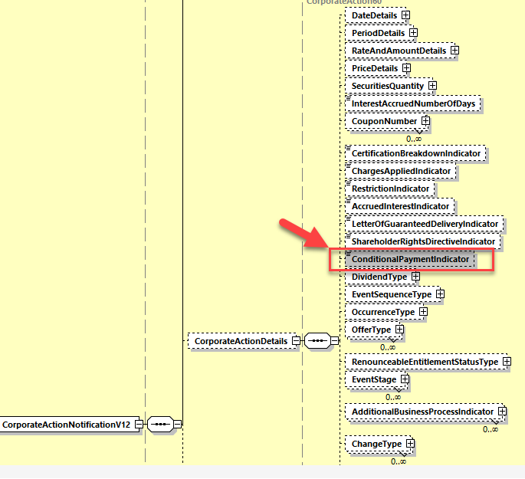
2. In the seev.031 (CANO – CorporateActionNotification) message, add one new cross element rule in the root of the message to restrict the usage of the element ConditionalPaymentIndicator in the CorporateActionDetails to the MCAL corporate event and defined as follows:
If ConditionalPaymentIndicator is present in CorporateActionDetails, then CorporateActionGeneralInformation/EventType/Code value must be equal to MCAL (Full Call). (MT 564 NVR C31)

Working Group Meeting

Discussion
The US mentions that this indicator is already available in the ISO 20022 extension (supplementary data) used by DTCC and they would like to move it to the core notification message.
For the US, the volume of conditional calls is significant as there are thousands of full calls per year and the percentage of the conditional calls is a bit less than 10 pct.
The UK and SG representatives suggest instead to reuse the :22F::OPTF//CAOS indicator in the option sequence. The definition of the CAOS indicator seems to fit the business need even if technically it is an event condition rather than an option.
The US agree with the alternative solution suggested and agree a change is not necessary.
The CAOS market practice could optionally be modified to reflect the US conditional case highlighted by the CR.
Finally the whole MWG agree with that existing alternative proposal and agree to reject the CR.
Decision
Rejected

CR 001846: Add Tax Information to Securities Proceeds
Origin of request
Requesting Group: | SMPG
Sponsors
Message type(s) impacted
MT 564, MT 566 / seev.031 (CANO), seev.035 (CAPA), seev.036 (CACO)
Complies with regulation
None
Business impact of this request
MEDIUM
Commitment to implement the change
Number of messages sent and received: 50.000.000
Percentage of messages impacted: 100
Commits to implement and when: Major custodians
Business context
When securities proceeds are paid, the SECMOVE doesn't allow to record the tax rate (TAXR) that has been applied to the securities distribution/re-investment, neither the cash equivalent of the tax that has been deducted and could be reclaimed.
Nature of change
We would like to enhance the MT564 and MT566 reporting adding the following elements in the SECMOVE in sequence E1/D1:
1) tax rate applicable to the securities proceeds (TAXR)
2) the taxable amount (TAXR amount)
and to add price element CINL in E2 to correctly report the price at which fractions are indemnified.
Workaround
Currently, the information is provided in narratives or, separately, via dedicated tax reports.
Examples
MT566 sent by the account servicer to confirm payment of the income proceeds using the tax rates provided by the account owner in the tax breakdown:
Based on the instructions received, the account owner elected to:
- receive CASH for 2,000 securities to be taxed at 26%
  - gross dividend: €2,000.00 (2000 * €1 per share)
  - taxation: €520.00 (2000*€0.26 per share)

- re-invest in new securities for 2,600 interim securities, to be taxed at 15%
  - new securities: (2,600*€1*0.85)/4.44€ = 497.747748
  - tax applied: €390.00 (2,600*€1*0.15)
  - fractions: (497.747748-497)*€4.44 = €3.32
Payment of cash proceeds
:16R: GENL
:20C:: CORP//DIV3437599
:20C:: SEME//253147820
:23G: NEWM
:22F:: CAEV//DVOP
:16S: GENL
:16R: USECU
:97A:: SAFE//98-0112441-05
:35B: ISIN IT0005440877
:93B:: ELIG//UNIT/4600,
:93B:: CONB//UNIT/2000,
:16S: USECU
:16R: CACONF
:13A:: CAON//001
:22F:: CAOP//CASH
:11A:: OPTN//EUR
:16R: SECMOVE
:22H:: CRDB//DEBT
:35B: ISIN IT0005440877
:36B:: PSTA// UNIT/2000,
:98A:: POST//20YY0325
:16S: SECMOVE
:16R: CASHMOVE
:22H:: CRDB//CRED
:19B:: GRSS//EUR2000,
:19B:: TAXR//EUR520,
:19B:: NETT//EUR1480,
:98A:: POST//20YY0325
:92F:: GRSS//EUR1,
:92A:: TAXR//26,
:16S: CASHMOVE
:16S: CACONF

Payment of securities proceeds
:16R: GENL
:20C:: CORP//DIV3437599
:20C:: SEME//253147820
:23G: NEWM
:22F:: CAEV//DVOP
:16S: GENL
:16R: USECU
:97A:: SAFE//98-0112441-05
:35B: ISIN IT0005440877
:93B:: ELIG//UNIT/4600,
:93B:: CONB//UNIT/2600,
:16S: USECU
:16R: CACONF
:13A:: CAON//002
:22F:: CAOP//SECU
:16R: SECMOVE
:22H:: CRDB//DEBT
:35B: ISIN IT0005440877
:36B:: PSTA// UNIT/2600,
:98A:: POST//20YY0325
:16S: SECMOVE
:16R: SECMOVE
:22H:: CRDB//CRED
:35B: ISIN IT0000218401
:36B: PSTA//UNIT/497,
:22F:: DISF/CINL
:90B:: PRPP//EUR4,44
:90B:: CINL//EUR4,44
:92K:: NEWO//1/5,22
:92A:: TAXR//15,
:19B:: TAXR//EUR390,
:98A:: POST//20YY0325
:16S: SECMOVE
:16R: CASHMOVE
:22H:: CRDB//CRED
:19B:: CINL//EUR3,32
:98A:: POST//20YY0325
:90B:: CINL//ACTU/EUR4,44
:16S: CASHMOVE
:16S: CACONF

SWIFT Comment

Can the definition of :19B::TAXR in E1/D1 be the same as the TAXR amount in E2/D2 ?
Format Options for TAXR and CINL to be checked.

Standards Illustration
1. ISO 15022 Illustration
1. In the MT 564 in sequence E1 and in the MT 566 in sequence D1 in field :92a: Rate, add a new optional and repeatable Wihthholding Tax Rate (TAXR) and Second Level Tax (WITL) qualifiers identically to the :92a::TAXR and :92a::WITL qualifiers defined in the sequence E2/D2 as illustrated below:

MT 564 Field Specifications

86. Field 92a: Rate

FORMAT
Option A | :4!c//[N]15d | (Qualifier)(Sign)(Rate)
Option D | :4!c//15d/15d | (Qualifier)(Quantity1)(Quantity2)
Option F | :4!c//3!a15d | (Qualifier)(Currency Code)(Amount)
Option K | :4!c//4!c | (Qualifier)(Rate Type Code)
Option L | :4!c//3!a15d/3!a15d | (Qualifier)(First Currency Code)(Amount1)(Second Currency Code)(Amount2)
Option M | :4!c//3!a15d/15d | (Qualifier)(Currency Code)(Amount)(Quantity)
Option N | :4!c//15d/3!a15d | (Qualifier)(Quantity)(Currency Code)(Amount)
Option R | :4!c/[8c]/4!c/15d | (Qualifier)(DataSourceScheme)(RateTypeCode)(Rate)

PRESENCE
Optional in optional subsequence E1

QUALIFIER
(Error code(s): T89)
Order | M/O | Qualifier | R/N | CR | Options | Qualifier Description
1 | O | ADEX | N |  | D, K, or L | Additional for Existing Securities
2 | O | NEWO | N |  | D, K, L, M, or N | New to Old
3 | O | ADSR | N |  | D, K, or L | Additional for Subscribed Resultant Securities
4 | O | TRAT | N |  | A | Transformation Rate
5 | O | CHAR | N |  | A, F, or K | Charges/Fees
6 | O | FISC | N |  | A or K | Fiscal Stamp
7 | O | RATE | N |  | A or K | Applicable Rate
8 | O | TAXC | N |  | A, F, or K | Tax Credit Rate
9 | O | TRAX | N |  | A or K | Financial Transaction Tax Rate
10 | O | TAXR | R | C7, C8, C19 | A, F or K, R | Withholding Tax Rate
11 | O | WITL | R | C7, C8, C19 | A, F, K or R | Second Level Tax

DEFINITION
This qualified generic field specifies:
ADEX | Additional for Existing Securities | Quantity of additional securities for a given quantity of underlying securities where underlying securities are not exchanged or debited, for example, 1 for 1: 1 new equity credited for every 1 underlying equity = 2 resulting equities.
ADSR | Additional for Subscribed Resultant Securities | Quantity of additional intermediate securities/new equities awarded for a given quantity of securities derived from subscription.
CHAR | Charges/Fees | Rate used to calculate the amount of the charges/fees that cannot be categorised.
FISC | Fiscal Stamp | Percentage of fiscal tax to apply.
NEWO | New to Old | Quantity of new securities for a given quantity of underlying securities, where the underlying securities will be exchanged or debited, for example, 2 for 1: 2 new equities credited for every 1 underlying equity debited = 2 resulting equities.
RATE | Applicable Rate | Rate applicable to the event announced, for example, redemption rate for a redemption event.
TAXC | Tax Credit Rate | Amount of money per equity allocated as the result of a tax credit.
TAXR | Withholding Tax Rate | Percentage of a cash distribution that will be withheld by the tax authorities of the jurisdiction of the issuer, for which a relief at source and/or reclaim may be possible.
TRAT | Transformation Rate | Rate used to determine the cash consideration split across outturn settlement transactions that are the result of a transformation of the parent transaction.
TRAX | Financial Transaction Tax Rate | Rate of financial transaction tax.
WITL | Second Level Tax | Rate at which the income will be withheld by a jurisdiction other than the jurisdiction of the issuer’s country of tax incorporation, for which a relief at source and/or reclaim may be possible. It is levied in complement or offset of the withholding tax rate (TAXR) levied by the jurisdiction of the issuer’s tax domicile.

CODES
In option K, Rate Type Code must contain the following code (Error code(s): K92):
UKWN | Unknown Rate | Rate is unknown by the sender or has not been established.

CODES
In option R, if Qualifier is TAXR or Qualifier is WITL and Data Source Scheme is not present, Rate Type Code must contain one of the following codes (Error code(s): K92):
BWIT | Back Up Withholding | Withholding tax related to payments subject to Back up Withholding.
FTCA | FATCA Tax | Withholding Tax related to income subject to FATCA (Foreign Account Tax Compliance Act).
NRAT | NRA Tax | Withholding tax related to income subject NRA (Non Resident Alien).

MT 566 Field Specifications

66. Field 92a: Rate

FORMAT
Option A | :4!c//[N]15d | (Qualifier)(Sign)(Rate)
Option D | :4!c//15d/15d | (Qualifier)(Quantity)(Quantity)
Option F | :4!c//3!a15d | (Qualifier)(Currency Code)(Amount)
Option L | :4!c//3!a15d/3!a15d | (Qualifier)(First Currency Code)(Amount)(Second Currency Code)(Amount)
Option M | :4!c//3!a15d/15d | (Qualifier)(Currency Code)(Amount)(Quantity)
Option N | :4!c//15d/3!a15d | (Qualifier)(Quantity)(Currency Code)(Amount)
Option R | :4!c/[8c]/4!c/15d | (Qualifier)(DataSourceScheme)(RateTypeCode)(Rate)

PRESENCE
Optional in optional subsequence D1

QUALIFIER
(Error code(s): T89)
Order | M/O | Qualifier | R/N | CR | Options | Qualifier Description
1 | O | ADEX | N |  | D or L | Additional for Existing Securities
2 | O | NEWO | N |  | D, L, M, or N | New to Old
3 | O | ADSR | N |  | D or L | Additional for Subscribed Resultant Securities
4 | O | CHAR | N |  | A or F | Charges/Fees
5 | O | FISC | N |  | A | Fiscal Stamp
6 | O | RATE | N |  | A | Applicable Rate
7 | O | TAXC | N | C3, C4 | A or F | Tax Credit Rate
8 | O | TRAX | N |  | A | Financial Transaction Tax Rate
9 | O | TAXR | R | C3, C4, C8 | A,F or R | Withholding Tax Rate
10 | O | WITL | R | C3, C4, C8 | A, F or R | Second Level Tax

DEFINITION
This qualified generic field specifies:
ADEX | Additional for Existing Securities | Quantity of additional securities for a given quantity of underlying securities where underlying securities are not exchanged or debited, for example, 1 for 1: 1 new equity credited for every 1 underlying equity = 2 resulting equities.
ADSR | Additional for Subscribed Resultant Securities | Quantity of additional intermediate securities/new equities awarded for a given quantity of securities derived from subscription.
CHAR | Charges/Fees | Rate used to calculate the amount of the charges/fees that cannot be categorised.
FISC | Fiscal Stamp | Percentage of fiscal tax to apply.
NEWO | New to Old | Quantity of new securities for a given quantity of underlying securities, where the underlying securities will be exchanged or debited, for example, 2 for 1: 2 new equities credited for every 1 underlying equity debited = 2 resulting equities.
RATE | Applicable Rate | Rate applicable to the event announced, for example, redemption rate for a redemption event.
TAXC | Tax Credit Rate | Amount of money per equity allocated as the result of a tax credit.
TAXR | Withholding Tax Rate | Percentage of a cash distribution that will be withheld by the tax authorities of the jurisdiction of the issuer, for which a relief at source and/or reclaim may be possible.
TRAX | Financial Transaction Tax Rate | Rate of financial transaction tax.
WITL | Second Level Tax | Rate at which the income will be withheld by a jurisdiction other than the jurisdiction of the issuer’s country of tax incorporation, for which a relief at source and/or reclaim may be possible. It is levied in complement or offset of the withholding tax rate (TAXR) levied by the jurisdiction of the issuer’s tax domicile.

CODES
In option R, if Qualifier is TAXR or Qualifier is WITL and Data Source Scheme is not present, Rate Type Code must contain one of the following codes (Error code(s): K92):
BWIT | Back Up Withholding | Withholding tax related to payments subject to Back up Withholding.
FTCA | FATCA Tax | Withholding Tax related to income subject to FATCA (Foreign Account Tax Compliance Act).
NRAT | NRA Tax | Withholding tax related to income subject NRA (Non Resident Alien).

2. In the MT 564 in sequence E1 and in the MT 566 in sequence D1, add a new optional :19B: Amount field and an optional and non-repeatable Wihthholding Tax Rate (TAXR) amount qualifier and Second level Tax Amount qualifier similar to the :19B::TAXR qualifier and :19B::WITL qualifier defined in the sequence E2/D2 as illustrated below (for the MT564 – same implementation for the MT 566):

MT 564 Field Specifications
End of Subsequence E1a Financial Instrument Attributes
----->
O | 36a | ENTL | Quantity of Financial Instrument | Entitled Quantity | B or D | 80
-----|
----->
O | 94a | 4!c | Place | (see qualifier description) | B, C, or F | 81
-----|
O | 22F | DISF | Indicator | Disposition of Fractions | :4!c/[8c]/4!c | 82
O | 11A | OPTN | Currency | Currency Option | :4!c//3!a | 83
O | 69a | TRDP | Period | Trading Period | A, B, C, D, E, F, or J | 84
----->
O | 90a | 4!c | Price | (see qualifier description) | A, B, E, F, J, K, or L | 85
-----|
----->
O | 92a | 4!c | Rate | (see qualifier description) | A, D, F, K, L, M, or N | 86
-----|
----->
M | 98a | 4!c | Date/Time | (see qualifier description) | A, B, or C | 87
-----|
O | 19B | 4!c | Amount | (see qualifier description) | B | 88
M | 16S |  |  | End of Block | SECMOVE | 89
-----| End of Subsequence E1 Securities Movement

MT 564 Field Specifications

93. Field 19B: Amount

FORMAT
Option B | :4!c//3!a15d | (Qualifier)(Currency Code)(Amount)

PRESENCE
Conditional (see rule C2) in optional subsequence E2

QUALIFIER
(Error code(s): T89)
Order | M/O | Qualifier | R/N | CR | Options | Qualifier Description
1 | O | TAXR | N |  | B | Withholding Tax Amount
2 | O | WITL | N |  | B | Second Level Tax Amount

DEFINITION
This qualified generic field specifies:
TAXR | Withholding Tax Amount | Amount of a cash distribution that will be withheld by the tax authorities of the jurisdiction of the issuer, for which a relief at source and/or reclaim may be possible.
WITL | Second Level Tax Amount | Amount of money withheld by the jurisdiction other than the jurisdiction of the issuer's country of tax incorporation, for which a relief at source and/or reclaim may be possible. It is levied in complement or offset of the withholding tax rate (TAXR) levied by the jurisdiction of the issuer's tax domicile.

NETWORK VALIDATED RULES
The integer part of Amount must contain at least one digit. A decimal comma is mandatory and is included in the maximum length. The number of digits following the comma must not exceed the maximum allowed for the specified currency (Error code(s): C03,T40,T43).
Currency Code must be a valid ISO 4217 currency code (Error code(s): T52).

3. In the MT 564 in sequence E2 and in the MT 566 in sequence D2, add a new optional and non-repeatable Cash In Lieu of Share Price (CINL) qualifier similar to the :92a::CINL qualifier defined in the sequence E1/D1 as illustrated below:

MT 564 Field Specifications

96. Field 90a: Price

FORMAT
Option A | :4!c//4!c/[N]15d | (Qualifier)(Percentage Type Code)(Sign)(Price)
Option B | :4!c//4!c/3!a15d | (Qualifier)(Amount Type Code)(Currency Code)(Price)
Option E | :4!c//4!c | (Qualifier)(Price Code)
Option F | :4!c//4!c/3!a15d/4!c/15d | (Qualifier)(Amount Type Code)(Currency Code)(Amount)(Quantity Type Code)(Quantity)
Option J | :4!c//4!c/3!a15d/3!a15d | (Qualifier)(Amount Type Code)(Currency Code)(Amount)(Currency Code)(Amount)
Option K | :4!c//15d | (Qualifier)(Index Points)
Option L | :4!c//[N]15d | (Qualifier)(Sign)(Index Points)

PRESENCE
Optional in optional subsequence E2

QUALIFIER
(Error code(s): T89)
Order | M/O | Qualifier | R/N | CR | Options | Qualifier Description
1 | O | OFFR | N |  | A, B, E, F, J, or L | Generic Cash Price Received per Product
2 | O | PRPP | N |  | A, B, E, or K | Generic Cash Price Paid per Product
3 | O | CINL | N |  | A, B or E | Cash in Lieu of Shares Price

DEFINITION
This qualified generic field specifies:
CINL | Cash in Lieu of Shares Price | Cash disbursement in lieu of equities; usually in lieu of fractional quantity.
OFFR | Generic Cash Price Received per Product | Generic cash price received per product by the underlying security holder either as a percentage or an amount, for example, redemption price.
PRPP | Generic Cash Price Paid per Product | Generic cash price paid per product by the underlying security holder either as a percentage or an amount or a number of points above an index, for example, reinvestment price, strike price and exercise price.

CODES
In option A, Percentage Type Code must contain one of the following codes (Error code(s): K90):
DISC | Discount | Price expressed as the number of percentage points below par, for example, a discount price of 2.0% equals a price of 98 when par is 100.
PRCT | Percentage | Price expressed as a percentage of par.
PREM | Premium | Price expressed as the number of percentage points above par, for example, a premium price of 2.0% equals a price of 102 when par is 100.
YIEL | Yield | Price expressed as a yield.

CODES
In option B or F or J, Amount Type Code must contain one of the following codes (Error code(s): K90):
ACTU | Actual Amount | Price expressed as an amount of currency per unit or per share.
DISC | Discount | Price expressed as a discount amount.
PLOT | Lot | Price expressed as an amount of money per lot.
PREM | Premium | Price expressed as a premium.

CODES
In option E, if Qualifier is OFFR, Price Code must contain one of the following codes (Error code(s): K90):
NILP | Nil Payment | Price will not be paid.
TBSP | To be Specified | Price to be specified by account owner.
UKWN | Unknown Price | Price is unknown by the sender or has not been established.
UNSP | Unspecified | Price is not required to be specified by account owner.

CODES
In option E, if Qualifier is PRPP or CINL, Price Code must contain the following code (Error code(s): K90):
UKWN | Unknown Price | Price is unknown by the sender or has not been established.

MT 566 Field Specifications

86. Field 90a: Price

FORMAT
Option A | :4!c//4!c/[N]15d | (Qualifier)(Percentage Type Code)(Sign)(Price)
Option B | :4!c//4!c/3!a15d | (Qualifier)(Amount Type Code)(Currency Code)(Price)
Option F | :4!c//4!c/3!a15d/4!c/15d | (Qualifier)(Amount Type Code)(Currency Code)(Amount)(Quantity Type Code)(Quantity)
Option J | :4!c//4!c/3!a15d/3!a15d | (Qualifier)(Amount Type Code)(Currency Code)(Amount)(Currency Code)(Amount)
Option K | :4!c//15d | (Qualifier)(Index Points)
Option L | :4!c//[N]15d | (Qualifier)(Sign)(Index Points)

PRESENCE
Optional in optional subsequence D2

QUALIFIER
(Error code(s): T89)
Order | M/O | Qualifier | R/N | CR | Options | Qualifier Description
1 | O | OFFR | N |  | A, B, F, J, or L | Generic Cash Price Received per Product
2 | O | PRPP | N |  | A, B, or K | Generic Cash Price Paid per Product
3 | O | CINL | N |  | A or B | Cash in Lieu of Shares Price

DEFINITION
This qualified generic field specifies:
CINL | Cash in Lieu of Shares Price | Cash disbursement in lieu of equities; usually in lieu of fractional quantity.
OFFR | Generic Cash Price Received per Product | Generic cash price received per product by the underlying security holder either as a percentage or an amount for example, redemption price.
PRPP | Generic Cash Price Paid per Product | Generic cash price paid per product by the underlying security holder either as a percentage or an amount or a number of points above an index, for example, reinvestment price, strike price and exercise price.

CODES
In option A, Percentage Type Code must contain one of the following codes (Error code(s): K90):
DISC | Discount | Price expressed as the number of percentage points below par, for example, a discount price of 2.0% equals a price of 98 when par is 100.
PRCT | Percentage | Price expressed as a percentage of par.
PREM | Premium | Price expressed as the number of percentage points above par, for example, a premium price of 2.0% equals a price of 102 when par is 100.
YIEL | Yield | Price expressed as a yield.

CODES
In option B or F or J, Amount Type Code must contain one of the following codes (Error code(s): K90):
ACTU | Actual Amount | Price expressed as an amount of currency per unit or per share.
DISC | Discount | Price expressed as a discount amount.
PLOT | Lot | Price expressed as an amount of money per lot.
PREM | Premium | Price expressed as a premium.

2. ISO 20022 Illustration
A1. In the seev.031 (CANO – CorporateActionNotification) message, in the sequence CorporateActionOptionDetails/SecuritiesMovementDetails/RateDetails,

And in the seev.035 (CAPA – CorporateActionMovementPreliminaryAdvice) message, in sequence CorporateActionMovementDetails/SecuritiesMovementDetails/RateDetails,

add the new optional and repeatable element WithholdingTaxRate and SecondLevelTax as defined in ISO 15022 above and typed by the data type RateAndAmountFormat41Choice as illustrated below:

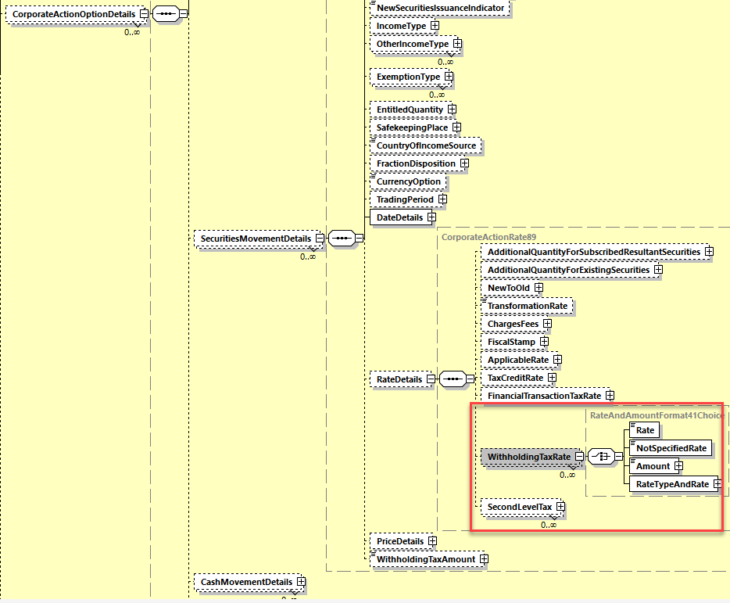

A2. In the seev.036 (CACO – CorporateActionConfirmation) message, in the sequence CorporateActionConfirmationDetails/SecuritiesMovementDetails/RateDetails, add the new optional andrepeatable element withholdingTaxRate and SecondLevelTax as defined in ISO 15022 above and typed by the data type RateAndAmountFormat40Choice as illustrated below:

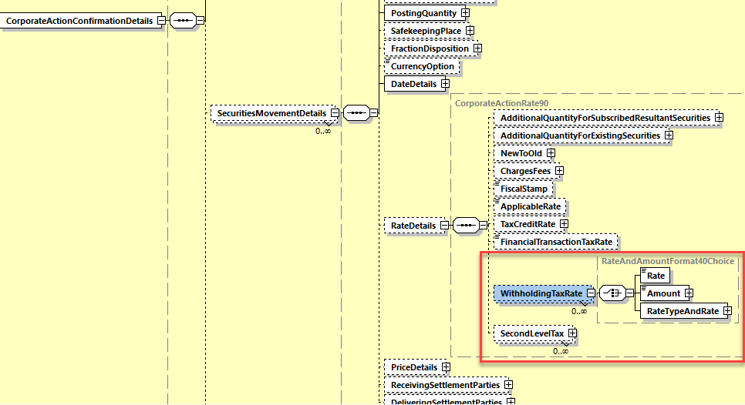

B1. In the seev.031 (CANO – CorporateActionNotification) message, in the sequence CorporateActionOptionDetails/SecuritiesMovementDetails/AmountDetails,

And in the seev.035 (CAPA – CorporateActionMovementPreliminaryAdvice) message, in sequence CorporateActionMovementDetails/SecuritiesMovementDetails/AmountDetails,

And in the seev.036 (CACO – CorporateActionConfirmation) message, in the sequence CorporateActionConfirmationDetails/SecuritiesMovementDetails/AmountDetails,

add a new optional and non-repeatable element WhithholdingTaxAmount and SecondLevelTaxAmount as defined in ISO 15022 above and typed by ActiveCurrencyAndAmount data type as illustrated below:

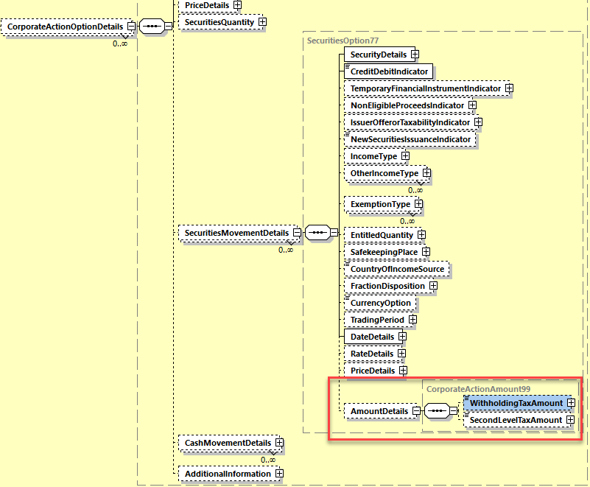

C1. In the seev.031 (CANO – CorporateActionNotification) message, in the sequence CorporateActionOptionDetails/CashMovementDetails/PriceDetails,

And in the seev.035 (CAPA – CorporateActionMovementPreliminaryAdvice) message, in sequence CorporateActionMovementDetails/CashMovementDetails/PriceDetails,

add the new optional and non-repeatable element CashInLieuOfSharePrice as defined in ISO 15022 above and typed by the data type PriceFormat45Choice as illustrated below:
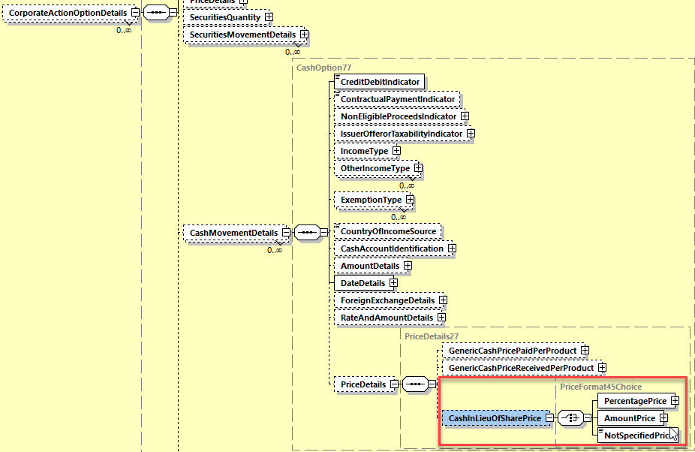

C2. In the seev.036 (CACO – CorporateActionConfirmation) message, in the sequence CorporateActionConfirmationDetails/CashMovementDetails/PriceDetails, add the new optional and non-repeatable element CashInLieuOfSharePrice as defined in ISO 15022 above and typed by the data type PriceFormat50Choice as illustrated below:

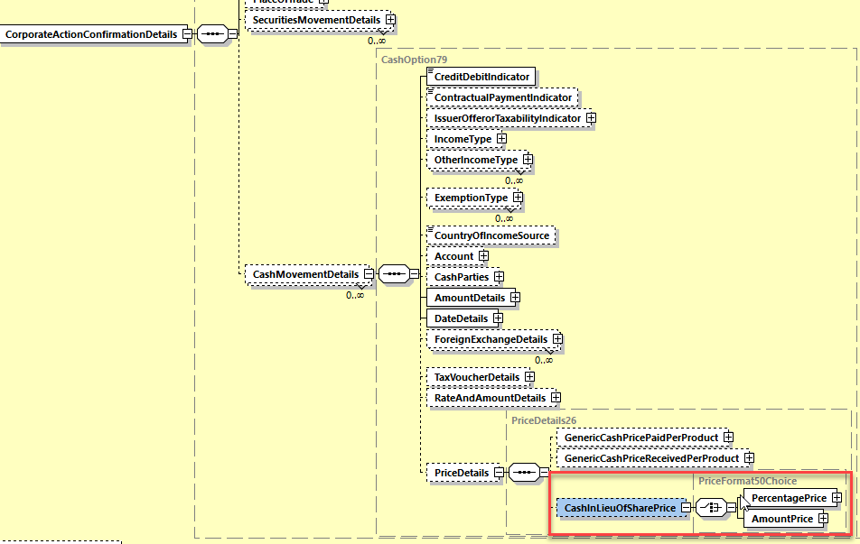

Working Group Meeting

Discussion
The MWG globally agreed with the business case and the proposed solution with the following implementation remarks:
- :92a::TAXR in E1/D1 must have the same characteristics than in E2/D2 i.e. TAXR must be repeatable with format options A,F,K, or R in E1 (& A, F, R in D1) and with same NVRs i.e. C7, C8, C19 (& C3,C4, C8 in D1);
- Add in E1/D1 the tax rate qualifier :92a::WITL with same characteristics as in E2/D2;
- Add in E1/D1 the :19B::WITL amount qualifier as well.
The MWG agreed with proposed remarks on the solution and approved the CR.
Decision
Approved

CR 001900: Change Function of the Message between CANO & CAPA (ISO 20022 CR 1112)
Origin of request
Requesting Group: | SMPG
Sponsors
Message type(s) impacted
seev.031 (CANO), seev.035 (CAPA)
Complies with regulation
None
Business impact of this request
MEDIUM
Commitment to implement the change
Number of messages sent and received: NA
Percentage of messages impacted: NA
Commits to implement and when: NMPGs members of SMPG in SR2023
Business context
We would like to change the CAPA message to assimilate it to the meeting entitlement message (MENT) and remove this function from the CANO message (similarly to the GM messages).
Nature of change
- change the CANO by removing the “eligibility indicator” (thus, assimilating the usage of the CANO to the MENO);
- change the CANO definition to remove the entitlement function.
- amend the CAPA by introducing a mandatory “eligibility indicator” to confirm entitlements (thus, assimilating the usage of the CAPA to the MENT) – if the indicator is set to YES, then the message confirms entitlements, if set to NO, it pre-advises proceeds.
- amend the definition of the CAPA accordingly.
Workaround
None
Examples
An example of the new message flows would be as follows:

A.First announcement (INCO / CONF) | CANO NEWM
B.Announcement with changes of terms and/or COMP/CONF | CANO REPL
C.Entitlement confirmed | CAPA NEWM + Entitlement flag is true (or Function code ENTL)
D.First Change in the terms of the events (without entitlement impact) | CANO REPL
E.Second change in the terms of the event (with entitlement impact e.g. dividend rate change) | CANO REPL
F.Entitlement updated confirmed | CAPA REPL + Entitlement flag is true
G.Preadvice of movements | CAPA REPL + entitlement flag is false (or Function code CAPA)
H.Payment | CACO

SWIFT Comment

Since there is already in the seev.035 CAPA message an optional EligibilityIndicator element present, there are 2 possible alternative design/solutions to modify the seev.035 CAPA message.
- Either we keep the “EligibilityIndicator” (Yes/no) element “as is” in the message and we make it mandatory and modify its purpose by changing the definition of the element so as to indicate that the CAPA message can be either a final entitlement message or a true preadvice of movement.
This solution has less impact on the message structure itself, but the change in the role of the CAPA message is not really very clear and the name of the element is not directly related to its new usage.

- Alternatively, we could also remove the EligibilityIndicator and replace it with a new more explicit mandatory element called “Function” and typed with a code with values “Final Entitlement” (ENTF) or “Preadvice O fMovement” (CAPA). In this case, the purpose of the new element is clearer and the role that the message has in the lifecycle is more explicit.
In order to fully align the CA notification design with the GM notification changes for SR2023 in terms of the pagination mechanism, there is an opportunity to add a new notification identification element in the seev.031 and a new preadvice identification in the seev.035 messages so as to have a unique identification for all pages of a same notification/preadvice.
Since this change is of a technical nature and is also impacting globally both the CANO and CAPA messages, SWIFT recommends to approve this change as well in the context of this CR.
The CA Maintenance WG should also decide whether this technical change should also be applied to the MT 564 and MT 568 messages to keep the messages aligned with ISO 20022.

Standards Illustration
2. ISO 20022 Illustration
1. In the seev.031 (CANO – CorporateActionNotification) message, amend the message definition as follows:

Scope
The CorporateActionNotification message is sent by an account servicer to an account owner or its designated agent to notify details of a corporate action event and optionally account information, and preliminary information about eligible balance and entitlements.

It may also include possible elections or choices available to the account owner. The account servicer can initially send the CorporateActionNotification message as a preliminary advice, subsequently replaced by another CorporateActionNotification message with complete or confirmed information.

It may also be sent to an account owner or its designated agent, to remind of event details and/or of missing or incomplete instructions for a corporate action event.

Usage
The message may also be used to:
- re-send a message previously sent (the sub-function of the message is Duplicate),
- provide a third party with a copy of a message for information (the sub-function of the message is Copy),
- re-send to a third party a copy of a message for information (the sub-function of the message is Copy Duplicate), using the relevant elements in the business application header (BAH).

2. In the seev.031 (CANO – CorporateActionNotification) message, in the NotificationGeneralInformation building block, remove the optional EligibleBalanceIndicator as illustrated below:

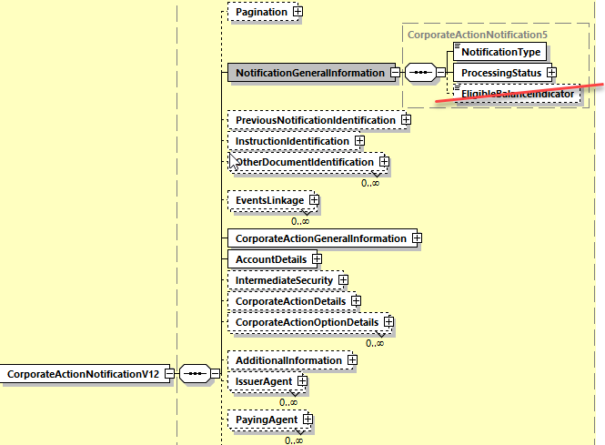

3. In the seev.035 (CAPA – CorporateActionMovementPreliminaryAdvice) message, amend the message definition as follows:

Scope
The CorporateActionMovementPreliminaryAdvice message is sent by an account servicer to an account owner or its designated agent:
- to advise about the final eligible balance and entitlements and;
- to pre-advise an upcoming posting or reversal of securities and/or cash postings.

Usage
The message may also be used to:
- re-send a message previously sent (the sub-function of the message is Duplicate),
- provide a third party with a copy of a message for information (the sub-function of the message is Copy),
- re-send to a third party a copy of a message for information (the sub-function of the message is Copy Duplicate), using the relevant elements in the business application header (BAH).

4. In the seev.035 (CAPA – CorporateActionMovementPreliminaryAdvice) message, in the MovementPreliminaryAdviceGeneralInformation building block,

Alternative 1:
Make the EligibilityIndicator element mandatory and amend its definition as follows:

EligibilityIndicator: Indicates whether the movement preliminary advice is sent after as a entitlement date message or as a movement preliminary advice message to pre-advise an upcoming posting or reversal of securities and/or cash postings.
Value is Yes (true) if the message is sent as movement preliminary advice sent after entitlement date and No (false) if sent before entitlement date as a entitlement message.

Alternative 2:
Remove the optional EligibilityIndicator element and add a new mandatory non-repeatable Function element typed by a data type code with code values Entitlement (ENTL) and code value PreadviceOfMovement (CAPA).

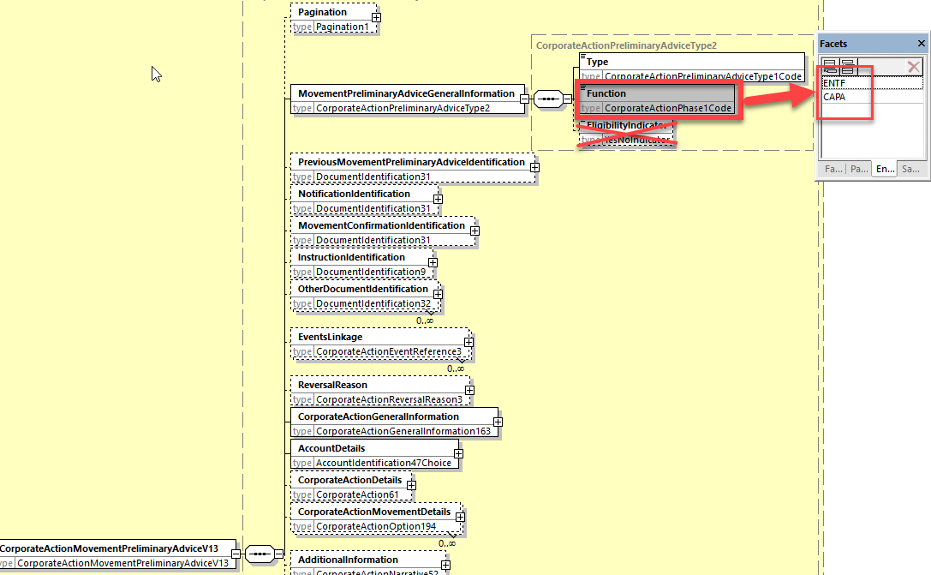

Working Group Meeting

Discussion
The UK representative clarified the business context of the CR from the SMPG. The change request aims at streamlining the process to make sure we follow the same logic as in the General Meeting messages (in MENO & MENT messages) and avoid to replicate the REPE and REPL confusion existing in the MT 564 in the CANO message.
There was a clear majority of the MWG countries and the ISO SEG CA ET which are in favour of the alternative 2 solution (new “Function” element).
However, the idea of the ISO 20022 CR is not about mentioning a “final” entitlement; the term “final” must be removed from the seev.035 message definition and the ENTF code renamed ENTL in the new “Function” element.
The MWG finally agreed with the business case and the proposed alternative 2 with the remarks made above.
The MWG, however, rejected unanimously the part of the solution concerning the pagination element for ISO15022 and ISO 20022 as it does not relate directly to the CR business case.
Another CR will need to be submitted next year for the pagination change.
Decision
Approved with comments

CR 001901: Update Reversal Reason Code IRED (ISO 20022 CR 1113)
Origin of request
Requesting Group: | SMPG
Sponsors
Message type(s) impacted
seev.035 (CANO), see.037 (CARA)
Complies with regulation
None
Business impact of this request
MEDIUM
Commitment to implement the change
Number of messages sent and received: Not provided
Percentage of messages impacted: Not provided
Commits to implement and when: NMPGs members of SMPG in SR2023
Business context
In case of a change of entitlement date (ex-date or record date), any payment previously processed should be reversed and the reason code for such reversal should be reported as IRED.
The name of IRED should be changed from “IncorrectRecordDate” to “IncorrectEntitlementDate” so that it can be applied both in a scenario of incorrect record date or incorrect ex-date.
The definition of IRED should be changed from “Record date is incorrect” to Entitlement date is incorrect”.
Nature of change
Change of name and definition of reason code IRED.
Workaround
None
Examples
None

SWIFT Comment

Standards Illustration
1. ISO 20022 Illustration
1. Create a new version V2 of the CorporateActionReversalReasonCode parent code as CorporateActionReversalReasonV2Code and Change the name of the IRED code from “Incorrect Record Date” to “Incorrect Entitlement Date” and change the definition of the IRED code as follows: “Entitlement date is incorrect.”

Create a new CorporateActionReversalReason2Code derived from the new CorporateActionReversalReasonV2Code parent code.

In the seev.035 (CAPA – CorporateActionMovementPreliminaryAdvice) message, and in the seev.037 (CARE – CorporateActionMovementReversalAdvice) in the ReversalReason building block, in the Reason sequence, change the data type of the element Code from CorporateActionReversalReason1Code to CorporateActionReversalReason2Code.

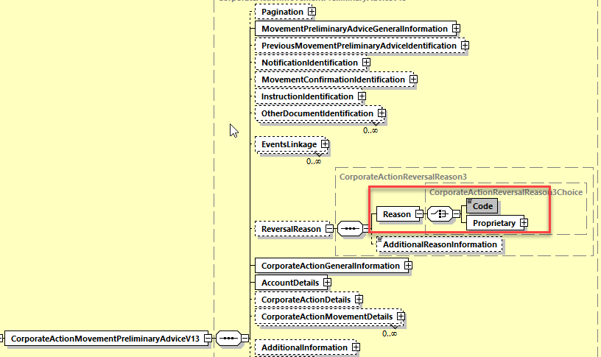

Working Group Meeting

Discussion
The CA MWG agreed with the business case and proposed solution.
The CR is approved.
Decision
Approved

CR 001902: Add new Textual Information in Instruction Cancellation (ISO 20022 CR 1114)
Origin of request
Requesting Group: | ISITC
Sponsors
US
Message type(s) impacted
seev.040 (CAIC)
Complies with regulation
None
Business impact of this request
MEDIUM
Commitment to implement the change
Number of messages sent and received: Not provided
Percentage of messages impacted: Not provided
Commits to implement and when: US in SR 2023
Business context
Currently, there is no ability to put narrative on the Corporate Action Instruction Cancellation message seev.040.00X.10. There are occasions when a client may wish to supply narrative when cancelling a corporate action instruction to justify their cancellation to the Issuer / Agent. The CACS Corporate Action Instruction Cancellation Request Status Advice does have Additional Information to which comments can be supplied by the Agent / Issuer if they wish to provide narrative. Both messages should have such capability. DTCC does provide clients capability to use narrative while cancelling an instruction within its proprietary system and would want to have such capability extended to the CAIC message for automation purposes. This capability exists in the MT565 message because both the instruction and withdrawal are used on the same message.
Nature of change
Add Additional Information – Additional Text element to Corporate Action Instruction Cancellation
Proposed Placement: CorpActnInstrCxlReq/AddtlInf/AddtlTxt
Workaround
None
Examples

SWIFT Comment

To maintain the alignment with the narrative in the seev.041 (CACS) message, the whole “AdditionalIInformation” building block from that message could be reused in the seev.040 (CAIC) message as well if the PartyContactNarrative element can be useful in the cancellation request ?

Standards Illustration

ISO 20022 Illustration
In the seev.040 (CAIC – CorporateActionInstructionCancellationRequest) message, add the new optional and non-repeatable “AdditionalInformation” building block similar to the one used in the seev.041 message as illustrated below:

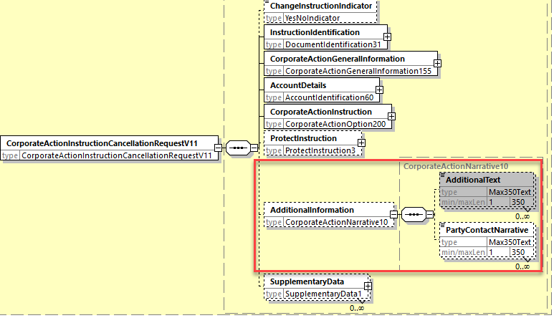

Working Group Meeting

Discussion
UK, DE, FR and IT had strong concerns to introduce a narrative in the instruction cancellation request as it breaks STP.
The US stated this can be anyway done via other channels so this is clearly seen as a business need. The business need was also acknowledged by AU and JP.
In addition, the US pointed out that the CR is rather an alignment with what exists already in ISO 15022 since the MT565 accommodates a narrative which is also valid for the instruction cancellation.
As there was mixed feeling in the MWG about the support for this CR, the MWG decides to vote.
The result showed 10 countries in favour of the CR and 4 countries against it.
The CR was therefore approved as is by a majority of 71%.
Decision
Approved as is.

CR 001903: Add Reject Reason Codes to Instruction Cancellation Request Status Advice (ISO 20022 CR 1115)
Origin of request
Requesting Group: | ISITC
Sponsors
US
Message type(s) impacted
seev.041 (CACS)
Complies with regulation
None
Business impact of this request
MEDIUM
Commitment to implement the change
Number of messages sent and received: Not provided
Percentage of messages impacted: Not provided
Commits to implement and when: US in SR 2023
Business context
The change is required as there are gaps in the Cancellation Status Advice message in terms of Reject Reason Codes which are available on the Instruction Status advice which apply in the Instruction Cancellation Advice. Currently because of this we have to use OTHR. Also, within 15022 all of these codes would be for use within the MT567 as the there is only one message for the advice of instructions and cancellations.
Nature of change
To align several reject reason codes in the seev.041.00x.12 Instruction Cancellation Status Advice to codes currently used within the Instruction Status Advice seev.034.00x.13. The list of codes requested to be added is as follows:
Missing Contact (CTCT)
Invalid Security (DSEC)
Quantity Rejection (DQUA)
Missing Protect Date (PROT)
Invalid Reference (ULNK)
Safekeeping Account Rejection (SAFE)
Missing Protect Identification (PROI)
Missing Transaction Type (TRTI)
Duplicate Instruction (DUPL)
/Document/CorpActnInstrCxlReqStsAdvc/InstrCxlReqSts/Rjctd/Rsn/RsnCd/Cd
Workaround
None
Examples
None

SWIFT Comment

Standards Illustration

ISO 20022 Illustration
In the seev.041 (CACS – CorporateActionInstructionCancellationRequestStatusAdvice) message, in the InstructionCancellationRequestStatus building block, in the sequence Rejected/Reason/ReasonCode, update the data type RejectionReason67Code of the Code element with the following reason code list as defined in the MT 567 reason code list and as illustrated below:

- Missing Contact (CTCT)
- Invalid Security (DSEC)
- Quantity Rejection (DQUA)
- Missing Protect Date (PROT)
- Invalid Reference (ULNK)
- Safekeeping Account Rejection (SAFE)
- Missing Protect Identification (PROI)
- Missing Transaction Type (TRTI)
- Duplicate Instruction (DUPL)

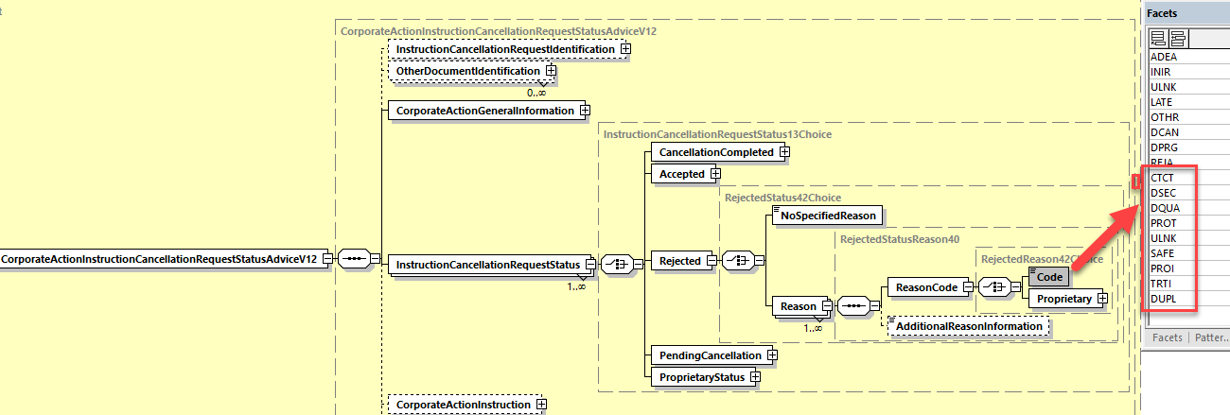

Working Group Meeting

Discussion
FR agreed only to add DSEC, DQUA, SAFE and DUPL.
SWIFT stated that it was agreed when we started to design the ISO 20022 CA messages to implement in the ISO 20022 CA status messages only the reason codes recommended in the SMPG market practice(SMPG MP Part 3) and not all reason codes listed in the ISO 15022 messages. Therefore, the seev.041 message is today compliant with the SMPG MP.
The MWG finally reached consensus on the business need which requires to extend the list of available rejected reason codes in the instruction cancellation request status message as the need for these additional rejected reason codes is not limited to the US.
Decision
Approved as is

Legal Notices
Copyright
SWIFT © 2022. All rights reserved.
Disclaimer
This publication constitutes advance information only and is not to be considered the final and complete standards documentation for the subject matter published herein. The information in this publication may change from time to time. You must always refer to the latest available version.
SWIFT Standards Intellectual Property Rights (IPR) Policy - End-User License Agreement
SWIFT Standards are licensed subject to the terms and conditions of the SWIFT Standards IPR Policy - End-User License Agreement, available at www.swift.com > About Us > Legal > IPR Policies > SWIFT Standards IPR Policy.
Translations
The English version of SWIFT documentation is the only official and binding version.
Trademarks
SWIFT is the trade name of S.W.I.F.T. SC. The following are registered trademarks of SWIFT: 3SKey, Innotribe, MyStandards, Sibos, SWIFT, SWIFTNet, SWIFT Institute, the Standards Forum logo, the SWIFT logo and UETR. Other product, service, or company names in this publication are trade names, trademarks, or registered trademarks of their respective owners.

End of document

MWG maintenance meeting minutes are distributed around first week of September.

