**Maintenance Change Request**

*Note: the purpose of this document is to give guidelines to submitting organisations that will develop a new version of existing ISO 20022 messages based on change requests screened by the Standards Evaluation Group(s). Such development is subject to the approval of a Maintenance Change Request which must include a detailed description of the impact of each change on the related messages. The Maintenance Change Request must start with a general chapter covering topics related to the whole maintenance effort and a specific chapter for each change request, as described below. Please consult the iso20022.org website for additional details on the* [*maintenance process*](http://www.iso20022.org/maintenance.page)*.*

*The Maintenance Change Requests for this ISO 20022 maintenance will follow the fast track process and will be sent to* [*iso20022ra@iso20022.org*](mailto:iso20022ra@iso20022.org) *by end of August 2019.*

## Name of the request:

General Meeting Messages Maintenance for year 2020/2021

1. **Submitting organization(s):**

SWIFT, SMPG

1. **Related messages:**

Under this project, all the following ISO 20022 Proxy Voting messages would be maintained:

|  |  |  |
| --- | --- | --- |
|  | **Message Name** | **Identifier** |
| 1 | MeetingNotificationV07 | seev.001.001.07 |
| 2 | MeetingCancellationV06 | seev.002.001.06 |
| 3 | MeetingEntitlementNotificationV06 | seev.003.001.06 |
| 4 | MeetingInstructionV06 | seev.004.001.06 |
| 5 | MeetingInstructionCancellationRequestV06 | seev.005.001.06 |
| 6 | MeetingInstructionStatusV06 | seev.006.001.06 |
| 7 | MeetingVoteExecutionConfirmationV06 | seev.007.001.06 |
| 8 | MeetingResultDisseminationV06 | seev.008.001.06 |

1. **Commitments of the submitting organization:**

SWIFT and SMPG confirm that it can and will:

* undertake the development of the new version of the candidate ISO 20022 message models that it will submit to the RA for compliance review and evaluation by September 2020.
* provide a new version of part 1 of the Message Definition Report (MDR) and new examples of valid message instances of each message by October 2020 at the latest.
* address any queries related to the description of the new models and messages as published by the RA on the ISO 20022 website.

SWIFT confirms that it intends to organize the actual implementation of the new version of the messages on its SWIFTNet network once the related documentation has been published by the RA.

The submitting organisations confirm their knowledge and acceptance of the ISO 20022 Intellectual Property Rights policy for contributing organisations, as follows.

*“Organisations that contribute information to be incorporated into the ISO 20022 Repository shall keep any Intellectual Property Rights (IPR) they have on this information. A contributing organisation warrants that it has sufficient rights on the contributed information to have it published in the ISO 20022 Repository through the ISO 20022 Registration Authority in accordance with the rules set in ISO 20022. To ascertain a widespread, public and uniform use of the ISO 20022 Repository information, the contributing organisation grants third parties a non-exclusive, royalty-free license to use the published information”.*

1. **Contact persons:**

Christine Strandberg – [christine.strandberg@seb.se](mailto:christine.strandberg@seb.se) – phone: +46 8 763 6074

Mari Fumagalli – [mariangela.fumagalli@bnpparibas.com](mailto:mariangela.fumagalli@bnpparibas.com) – phone: +44 207 595 4988

Jacques Littré – [jacques.littre@swift.com](mailto:jacques.littre@swift.com) – phone: +32 2 655 43 35

**ISO 20022 Proxy Voting Messages Maintenance 2020/2021**

**Table of Contents**

1 CR0860: Remove BAH Version in Message Definition 3

2 CR0862: Set MeetingIdentification Mandatory in all Messages 7

3 CR0890: Set ReconfirmInstruction to optional In Notification 11

4 CR0891: Set QuorumRequired to Optional in Notification 14

5 CR0894: Set BeneficialOwnerDisclosure as Optional in Notification 17

6 CR0888: Remove RegistrationParticipationMarketDeadline and RegistrationParticipationDeadline in Notification 20

7 CR0889: Remove ProxyAppointment1Rule in Notification 23

8 CR0892: Amend Textual Description in Rule EntitlementDate1Guideline in Notification 26

9 CR0893: Amend textual description in Rule DateStatus1Rule in Notification 29

10 CR0895: Set Datatype of AnnouncementDate as a Date or DateTime Choice in Notification 32

11 CR0897: Add Support for Multi Languages Announcements and Resolutions 35

12 CR0910: Add a Vote Type List for Incentive Premium 42

13 CR0911: Add Listing Vote Indicator and Rejection Reason Code in Status 46

14 CR0912: Add Voting Method sequence and Admission Conditions Codes in Notification And Status 51

15 CR0915: Add Withdrawal Indicator in Resolutions in Notification 55

16 CR0885: Amend PreassignedProxy Name as Identification 58

17 CR0879: Set RightsHolder Repeatable in All Messages 61

18 CR0914: Add Natural Person and Pledge Details For RightsHolder in Instruction 65

19 CR0859: Remove VoteInstructionForAgendaResolution for Proxy in Instructions 74

20 CR0878: Remove CHRM and DISC Option Types in GlobalVote in Instruction 77

21 CR0883: Remove ProxyRule in Instruction 80

22 CR0884: Set ParticipationMethod to optional in Instruction 83

23 CR0887: Amend Textual Description in rule BalanceQall1Rule 86

24 CR0905: Enable non-Voting MeetingAttendee in Instruction and Add Related Status 89

25 CR0882: Add New Shareholder Registration Completed Processing Status Code in Instruction Status 93

26 CR0886: Remove multiplicity on InstructedPosition in Instruction Cancelation 96

27 CR0880: Remove GlobalInstructionStatus in Instruction Status 99

28 CR0881: Amend Definition of RCIS Code In Instruction Status 102

29 CR0861: Make Proprietary in VoteResult Repeatable In Vote Results Dissemination Message 105

# CR0860: Remove BAH Version in Message Definition

1. **Origin of the request:**

*A.1 Submitter*: SMPG (Securities Market Practice Group)

*A.2 Contact person:*

Christine Strandberg: [christine.strandberg@seb.se](mailto:christine.strandberg@seb.se) - +46 (8) 763 60 74

Mariangela Fumagalli: [mariangela.fumagalli@bnpparibas.com](mailto:mariangela.fumagalli@bnpparibas.com) - +442075954988

Jacques Littré: [jacques.littre@swift.com](mailto:jacques.littre@swift.com) - +3226554335

*A.3 Sponsors*:

Securities Market Practice Group

1. **Related messages:**

seev.002.001.06

seev.003.001.06

seev.004.001.06

seev.005.001.06

seev.006.001.06

seev.007.001.06

seev.008.001.06

1. **Description of the change request:**

Remove the explicit reference to a specific version (i.e. head.001.001.01) of the BAH in the scope and usage paragraph of the messages so as to only leave the following sentence: “*This message definition is intended for use with the Business Application Header (BAH)*.”.

1. **Purpose of the change:**

Avoid linking the message to a specific version of the BAH in the description of the message scope and usage as the version may evolve independently.

1. **Urgency of the request:**

For SR2021*.*

1. **Business examples:**

N/A

1. **SEG/TSG recommendation:**

*This section is not to be taken care of by the submitter of the change request. It will be completed in due time by the SEG(s) in charge of the related ISO 20022 messages or the TSG for changes related to the BAH.*

|  |  |  |  |
| --- | --- | --- | --- |
| **Consider** | |  | **Timing** |
|  | | - **Next yearly cycle: 2020/2021**  (the change will be considered for implementation in the yearly maintenance cycle which starts in 2020 and completes with the publication of new message versions in the spring of 2021) | | X |
|  | | - **At the occasion of the next maintenance of the messages**  (the change will be considered for implementation, but does not justify maintenance of the messages in its own right – will be pending until more critical change requests are received for the messages) | |  |
|  | | - **Urgent unscheduled**  (the change justifies an urgent implementation outside of the normal yearly cycle) | |  |  |
|  | | - **Other timing:** | | |  |

Comments:

|  |  |
| --- | --- |
| **Reject** |  |

Reason for rejection:

1. **Impact analysis:**

This change request impacts only the documentation of the following messages:

seev.002.001.06 MeetingCancellationV06

seev.003.001.06 MeetingEntitlementNotificationV06

seev.004.001.06 MeetingInstructionV06

seev.005.001.06 MeetingInstructionCancellationRequestV06

seev.006.001.06 MeetingInstructionStatusV06

seev.007.001.06 MeetingVoteExecutionConfirmationV06

seev.008.001.06 MeetingResultDisseminationV06

There is no impact or changes on the structure / schema of these messages.

1. **Proposed implementation:**

For all 7 listed messages above, in the documentation of the message in section “Usage”, change the last sentence

*“This message definition is intended for use with the Business Application Header (head.001.001.01).”*

By the following one:

***“This message definition is intended for use with the Business Application Header (BAH)”***

## Proposed timing:

The submitting organization confirms that it can implement the requested changes in the requested timing

|  |  |
| --- | --- |
| Timing | * As requested |

## Final decision of the SEG(s):

|  |  |
| --- | --- |
| Approve | X |

Comments:

|  |  |
| --- | --- |
| Reject |  |

Reason for rejection:

# CR0862: Set MeetingIdentification Mandatory in all Messages

1. **Origin of the request:**

*A.1 Submitter*: SMPG (Securities Market Practice Group)

*A.2 Contact person:*

Christine Strandberg: [christine.strandberg@seb.se](mailto:christine.strandberg@seb.se) - +46 (8) 763 60 74

Mariangela Fumagalli: [mariangela.fumagalli@bnpparibas.com](mailto:mariangela.fumagalli@bnpparibas.com) - +442075954988

Jacques Littré: [jacques.littre@swift.com](mailto:jacques.littre@swift.com) - +3226554335

*A.3 Sponsors*:

Securities Market Practice Group

1. **Related messages:**

seev.001.001.07

seev.003.001.06

seev.004.001.06

seev.005.001.06

seev.006.001.06

seev.007.001.06

seev.008.001.06

1. **Description of the change request:**

Set the element “MeetingIdentification” as mandatory in all general meeting messages where currently optional. The element is located in the “Meeting” sequence of the notification message and in the “MeetingReference” sequence for all other messages.

1. **Purpose of the change:**

The “MeetingIdentification” element in the general meeting messages is similar to the corporate action reference (CORP) element in the CA messages and is a key element for the identification of a corporate event in general. Similarly to the CA messages, this identification should be mandatory overall.

1. **Urgency of the request:**

For SR2021*.*

1. **Business examples:**

N/A

1. **SEG/TSG recommendation:**

*This section is not to be taken care of by the submitter of the change request. It will be completed in due time by the SEG(s) in charge of the related ISO 20022 messages or the TSG for changes related to the BAH.*

|  |  |  |  |
| --- | --- | --- | --- |
| **Consider** | |  | **Timing** |
|  | | - **Next yearly cycle: 2020/2021**  (the change will be considered for implementation in the yearly maintenance cycle which starts in 2020 and completes with the publication of new message versions in the spring of 2021) | |  |
|  | | - **At the occasion of the next maintenance of the messages**  (the change will be considered for implementation, but does not justify maintenance of the messages in its own right – will be pending until more critical change requests are received for the messages) | |  |
|  | | - **Urgent unscheduled**  (the change justifies an urgent implementation outside of the normal yearly cycle) | |  |  |
|  | | - **Other timing:** | | |  |

Comments:

|  |  |
| --- | --- |
| **Reject** |  |

Reason for rejection:

1. **Impact analysis:**

This change request impacts the following messages:

seev.001.001.07 MeetingCancellationV06

seev.003.001.06 MeetingEntitlementNotificationV06

seev.004.001.06 MeetingInstructionV06

seev.005.001.06 MeetingInstructionCancellationRequestV06

seev.006.001.06 MeetingInstructionStatusV06

seev.007.001.06 MeetingVoteExecutionConfirmationV06

seev.008.001.06 MeetingResultDisseminationV06

1. **Proposed implementation:**
2. **In the seev.001** (MENO – MeetingNotification) message, in the ***Meeting*** message building block, set the ***MeetingIdentification*** element as mandatory.

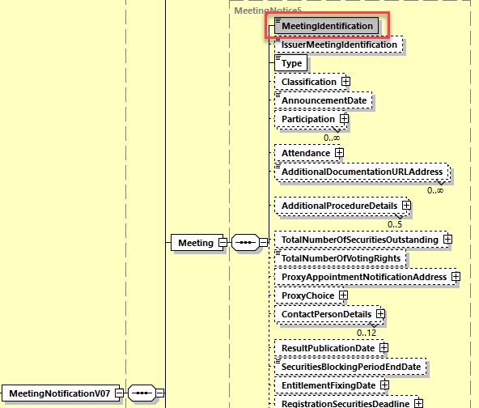

1. **In all other seev.003 to seev.008 message**, set the ***MeetingIdentification*** element in the ***MeetingReference*** message building block (***MeetingReference8*** MC) as mandatory.

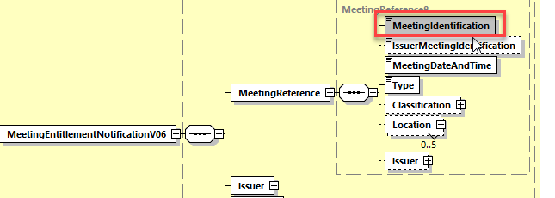

1. since the element “MeetingDateAndTime” element is mandatory in all seev.001 to seev.008 messages but except in the seev.002, it is also highly recommended to set element as mandatory in the ***MeetingReference*** message building block of the **seev.002 (MECA – Meeting Cancellation)** message as illustrated below:

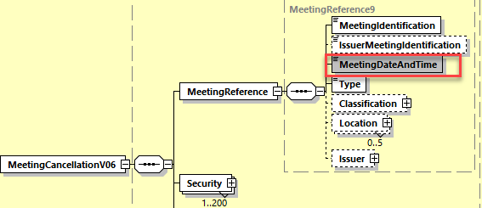

1. The SMPG and SWIFT propose also to add in the Instruction message a new sequence to enable to refer to another instruction or instruction cancellation message sent previously like what exist in the corporate action instruction message seev.033 with the “OtherDocumentationIdentification” message building block.

In the **seev.004** (MEIN – MeetingInstruction) message add a new optional and repeatable “***OtherDocumentationIdentification***” message building block typed by the data type ***DocumentIdentification32*** as illustrated below:

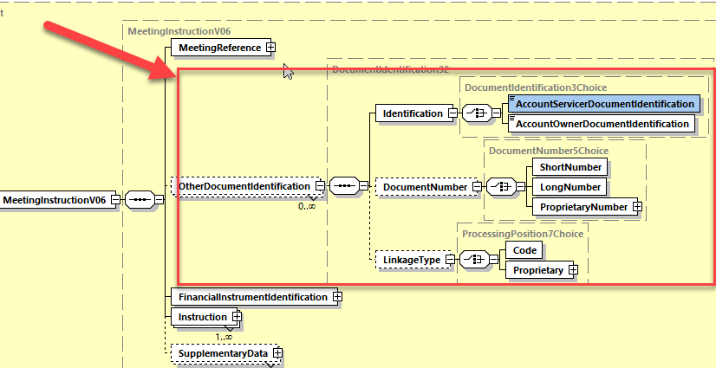

## Proposed timing:

The submitting organization confirms that it can implement the requested changes in the requested timing

|  |  |
| --- | --- |
| Timing | * As requested |

## Final decision of the SEG(s):

|  |  |
| --- | --- |
| Approve | X |

Comments:

|  |  |
| --- | --- |
| Reject |  |

Reason for rejection:

# CR0890: Set ReconfirmInstruction to optional In Notification

1. **Origin of the request:**

*A.1 Submitter*: SMPG (Securities Market Practice Group)

*A.2 Contact person:*

Christine Strandberg: [christine.strandberg@seb.se](mailto:christine.strandberg@seb.se) - +46 (8) 763 60 74

Mariangela Fumagalli: [mariangela.fumagalli@bnpparibas.com](mailto:mariangela.fumagalli@bnpparibas.com) - +442075954988

Jacques Littré: [jacques.littre@swift.com](mailto:jacques.littre@swift.com) - +3226554335

*A.3 Sponsors*:

Securities Market Practice Group

1. **Related messages:**

seev.001.001.07

1. **Description of the change request:**

In the sequence “NotificationUpdate”, set the element “ReconfirmInstruction” as optional.

1. **Purpose of the change:**

The process of reconfirming instruction after a GM notification update is not supported in all jurisdictions, therefore it is better to make this element optional.

1. **Urgency of the request:**

For SR2021*.*

1. **Business examples:**

N/A

1. **SEG/TSG recommendation:**

*This section is not to be taken care of by the submitter of the change request. It will be completed in due time by the SEG(s) in charge of the related ISO 20022 messages or the TSG for changes related to the BAH.*

|  |  |  |  |
| --- | --- | --- | --- |
| **Consider** | |  | **Timing** |
|  | | - **Next yearly cycle: 2020/2021**  (the change will be considered for implementation in the yearly maintenance cycle which starts in 2020 and completes with the publication of new message versions in the spring of 2021) | | X |
|  | | - **At the occasion of the next maintenance of the messages**  (the change will be considered for implementation, but does not justify maintenance of the messages in its own right – will be pending until more critical change requests are received for the messages) | |  |
|  | | - **Urgent unscheduled**  (the change justifies an urgent implementation outside of the normal yearly cycle) | |  |  |
|  | | - **Other timing:** | | |  |

Comments:

|  |  |
| --- | --- |
| **Reject** |  |

Reason for rejection:

1. **Impact analysis:**

This change request impacts the following messages:

seev.001.001.07 MeetingNotificationV07

1. **Proposed implementation:**

In the seev.001 (MENO – MeetingNotification) message, in the ***NotificationUpdate*** message building block, set the ***ReconfirmInstruction*** element as optional.

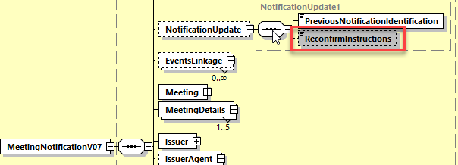

## Proposed timing:

The submitting organization confirms that it can implement the requested changes in the requested timing

|  |  |
| --- | --- |
| Timing | * As requested |

## Final decision of the SEG(s):

|  |  |
| --- | --- |
| Approve | X |

Comments:

|  |  |
| --- | --- |
| Reject |  |

Reason for rejection:

# CR0891: Set QuorumRequired to Optional in Notification

1. **Origin of the request:**

*A.1 Submitter*: SMPG (Securities Market Practice Group)

*A.2 Contact person:*

Christine Strandberg: [christine.strandberg@seb.se](mailto:christine.strandberg@seb.se) - +46 (8) 763 60 74

Mariangela Fumagalli: [mariangela.fumagalli@bnpparibas.com](mailto:mariangela.fumagalli@bnpparibas.com) - +442075954988

Jacques Littré: [jacques.littre@swift.com](mailto:jacques.littre@swift.com) - +3226554335

*A.3 Sponsors*:

Securities Market Practice Group

1. **Related messages:**

seev.001.001.07

1. **Description of the change request:**

In the sequence “Meeting”, set the element “QuorumRequired” as optional.

1. **Purpose of the change:**

Setting or having a quorum for a GM is not mandatory in all jurisdictions, therefore it is better to not make this element mandatory.

1. **Urgency of the request:**

For SR2021*.*

1. **Business examples:**

N/A

1. **SEG/TSG recommendation:**

*This section is not to be taken care of by the submitter of the change request. It will be completed in due time by the SEG(s) in charge of the related ISO 20022 messages or the TSG for changes related to the BAH.*

|  |  |  |  |
| --- | --- | --- | --- |
| **Consider** | |  | **Timing** |
|  | | - **Next yearly cycle: 2020/2021**  (the change will be considered for implementation in the yearly maintenance cycle which starts in 2020 and completes with the publication of new message versions in the spring of 2021) | | X |
|  | | - **At the occasion of the next maintenance of the messages**  (the change will be considered for implementation, but does not justify maintenance of the messages in its own right – will be pending until more critical change requests are received for the messages) | |  |
|  | | - **Urgent unscheduled**  (the change justifies an urgent implementation outside of the normal yearly cycle) | |  |  |
|  | | - **Other timing:** | | |  |

Comments:

|  |  |
| --- | --- |
| **Reject** |  |

Reason for rejection:

1. **Impact analysis:**

This change request impacts the following messages:

seev.001.001.07 MeetingNotificationV07

1. **Proposed implementation:**

In the seev.001 (MENO – MeetingNotification) message, in the MeetingDetails message building block,set the element ***QuorumRequired*** as optional.

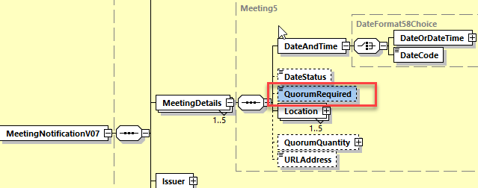

## Proposed timing:

The submitting organization confirms that it can implement the requested changes in the requested timing

|  |  |
| --- | --- |
| Timing | * As requested |

## Final decision of the SEG(s):

|  |  |
| --- | --- |
| Approve | X |

Comments:

|  |  |
| --- | --- |
| Reject |  |

Reason for rejection:

# CR0894: Set BeneficialOwnerDisclosure as Optional in Notification

1. **Origin of the request:**

*A.1 Submitter*: SMPG (Securities Market Practice Group)

*A.2 Contact person:*

Christine Strandberg: [christine.strandberg@seb.se](mailto:christine.strandberg@seb.se) - +46 (8) 763 60 74

Mariangela Fumagalli: [mariangela.fumagalli@bnpparibas.com](mailto:mariangela.fumagalli@bnpparibas.com) - +442075954988

Jacques Littré: [jacques.littre@swift.com](mailto:jacques.littre@swift.com) - +3226554335

*A.3 Sponsors*:

Securities Market Practice Group

1. **Related messages:**

seev.001.001.07

1. **Description of the change request:**

In the sequence “Vote”, set the element “BeneficialOwnerDisclosure” as optional.

1. **Purpose of the change:**

The process of disclosing beneficial owners in the context of general meetings is not mandated in all jurisdictions, therefore it is better to make this element optional.

1. **Urgency of the request:**

For SR2021*.*

1. **Business examples:**

N/A

1. **SEG/TSG recommendation:**

*This section is not to be taken care of by the submitter of the change request. It will be completed in due time by the SEG(s) in charge of the related ISO 20022 messages or the TSG for changes related to the BAH.*

|  |  |  |  |
| --- | --- | --- | --- |
| **Consider** | |  | **Timing** |
|  | | - **Next yearly cycle: 2020/2021**  (the change will be considered for implementation in the yearly maintenance cycle which starts in 2020 and completes with the publication of new message versions in the spring of 2021) | | X |
|  | | - **At the occasion of the next maintenance of the messages**  (the change will be considered for implementation, but does not justify maintenance of the messages in its own right – will be pending until more critical change requests are received for the messages) | |  |
|  | | - **Urgent unscheduled**  (the change justifies an urgent implementation outside of the normal yearly cycle) | |  |  |
|  | | - **Other timing:** | | |  |

Comments:

|  |  |
| --- | --- |
| **Reject** |  |

Reason for rejection:

1. **Impact analysis:**

This change request impacts the following message:

seev.001.001.07 MeetingNotificationV07

1. **Proposed implementation:**

**In the seev.001** (MENO – MeetingNotification) message, in the ***Vote*** message building block, set the ***BeneficialOwnerDisclosure*** element as optional.

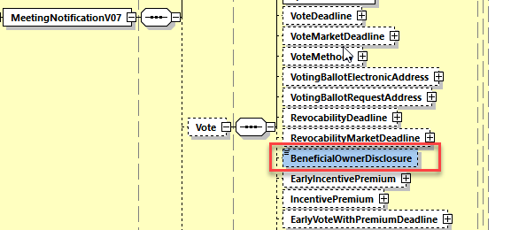

## Proposed timing:

The submitting organization confirms that it can implement the requested changes in the requested timing

|  |  |
| --- | --- |
| Timing | * As requested |

## Final decision of the SEG(s):

|  |  |
| --- | --- |
| Approve | X |

Comments:

|  |  |
| --- | --- |
| Reject |  |

Reason for rejection:

# CR0888: Remove RegistrationParticipationMarketDeadline and RegistrationParticipationDeadline in Notification

1. **Origin of the request:**

*A.1 Submitter*: SMPG (Securities Market Practice Group)

*A.2 Contact person:*

Christine Strandberg: [christine.strandberg@seb.se](mailto:christine.strandberg@seb.se) - +46 (8) 763 60 74

Mariangela Fumagalli: [mariangela.fumagalli@bnpparibas.com](mailto:mariangela.fumagalli@bnpparibas.com) - +442075954988

Jacques Littré: [jacques.littre@swift.com](mailto:jacques.littre@swift.com) - +3226554335

*A.3 Sponsors*:

Securities Market Practice Group

1. **Related messages:**

seev.001.001.07

1. **Description of the change request:**

In the sequence “Meeting”, remove the deadlines “RegistrationParticipationMarketDeadline and “RegistrationParticipationDeadline”.

1. **Purpose of the change:**

Redundant with “ConfirmationDeadline” and “ConfirmationMarketDeadline” in “Meeting/Attendance” sequence and redundant with “VoteDeadline” and “VoteMarketDeadline” in “Vote” sequence.

1. **Urgency of the request:**

For SR2021*.*

1. **Business examples:**

N/A

1. **SEG/TSG recommendation:**

*This section is not to be taken care of by the submitter of the change request. It will be completed in due time by the SEG(s) in charge of the related ISO 20022 messages or the TSG for changes related to the BAH.*

|  |  |  |  |
| --- | --- | --- | --- |
| **Consider** | |  | **Timing** |
|  | | - **Next yearly cycle: 2020/2021**  (the change will be considered for implementation in the yearly maintenance cycle which starts in 2020 and completes with the publication of new message versions in the spring of 2021) | | X |
|  | | - **At the occasion of the next maintenance of the messages**  (the change will be considered for implementation, but does not justify maintenance of the messages in its own right – will be pending until more critical change requests are received for the messages) | |  |
|  | | - **Urgent unscheduled**  (the change justifies an urgent implementation outside of the normal yearly cycle) | |  |  |
|  | | - **Other timing:** | | |  |

Comments:

|  |  |
| --- | --- |
| **Reject** |  |

Reason for rejection:

1. **Impact analysis:**

This change request impacts the following message:

seev.001.001.07 MeetingNotificationV07

1. **Proposed implementation:**

**In the seev.001** (MENO – MeetingNotification) message, in the ***Meeting*** message building block, delete the optional elements ***RegistrationParticipationMarketDeadline*** and ***RegistrationParticipationDeadline***.

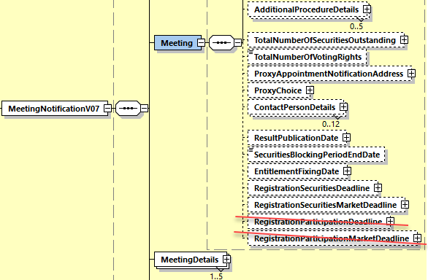

## Proposed timing:

The submitting organization confirms that it can implement the requested changes in the requested timing

|  |  |
| --- | --- |
| Timing | * As requested |

## Final decision of the SEG(s):

|  |  |
| --- | --- |
| Approve | X |

Comments:

|  |  |
| --- | --- |
| Reject |  |

Reason for rejection:

# CR0889: Remove ProxyAppointment1Rule in Notification

1. **Origin of the request:**

*A.1 Submitter*: SMPG (Securities Market Practice Group)

*A.2 Contact person:*

Christine Strandberg: [christine.strandberg@seb.se](mailto:christine.strandberg@seb.se) - +46 (8) 763 60 74

Mariangela Fumagalli: [mariangela.fumagalli@bnpparibas.com](mailto:mariangela.fumagalli@bnpparibas.com) - +442075954988

Jacques Littré: [jacques.littre@swift.com](mailto:jacques.littre@swift.com) - +3226554335

*A.3 Sponsors*:

Securities Market Practice Group

1. **Related messages:**

seev.001.001.07

1. **Description of the change request:**

In the sequence “Meeting/ProxyChoice/ProxyAuthorisedProxy”, remove the CrossElementComplexRule ProxyAppointment1Rule (Rule C16 in documentation).

1. **Purpose of the change:**

The contact details within the PersonDetails sequence cannot be known by the Issuer when the Proxy Type is the “security holder” or “Discretionary”.

1. **Urgency of the request:**

For SR2021*.*

1. **Business examples:**

N/A

1. **SEG/TSG recommendation:**

*This section is not to be taken care of by the submitter of the change request. It will be completed in due time by the SEG(s) in charge of the related ISO 20022 messages or the TSG for changes related to the BAH.*

|  |  |  |  |
| --- | --- | --- | --- |
| **Consider** | |  | **Timing** |
|  | | - **Next yearly cycle: 2020/2021**  (the change will be considered for implementation in the yearly maintenance cycle which starts in 2020 and completes with the publication of new message versions in the spring of 2021) | | X |
|  | | - **At the occasion of the next maintenance of the messages**  (the change will be considered for implementation, but does not justify maintenance of the messages in its own right – will be pending until more critical change requests are received for the messages) | |  |
|  | | - **Urgent unscheduled**  (the change justifies an urgent implementation outside of the normal yearly cycle) | |  |  |
|  | | - **Other timing:** | | |  |

Comments:

|  |  |
| --- | --- |
| **Reject** |  |

Reason for rejection:

1. **Impact analysis:**

This change request impacts the following message:

seev.001.001.07 MeetingNotificationV07

1. **Proposed implementation:**

In the **seev.001** (MENO – MeetingNotification) message, in the ***Meeting*** message building block, in the sequence ***ProxyChoice/Proxy/AuthorisedProxy***, remove the cross element complex rule ***ProxyAppointment1Rule*** (Rule C16 in documentation).

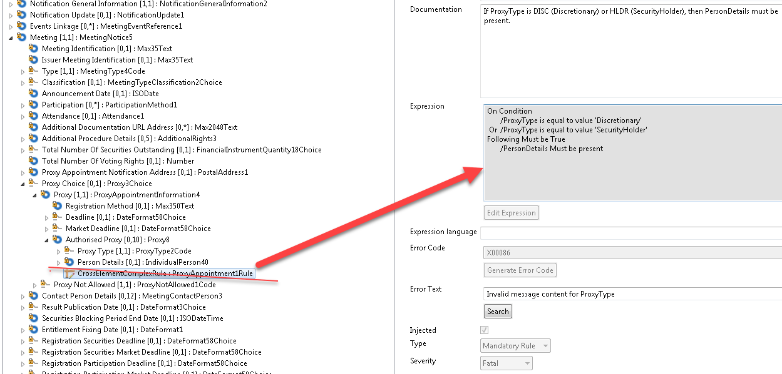

## Proposed timing:

The submitting organization confirms that it can implement the requested changes in the requested timing

|  |  |
| --- | --- |
| Timing | * As requested |

## Final decision of the SEG(s):

|  |  |
| --- | --- |
| Approve | X |

Comments:

|  |  |
| --- | --- |
| Reject |  |

Reason for rejection:

# CR0892: Amend Textual Description in Rule EntitlementDate1Guideline in Notification

1. **Origin of the request:**

*A.1 Submitter*: SMPG (Securities Market Practice Group)

*A.2 Contact person:*

Christine Strandberg: [christine.strandberg@seb.se](mailto:christine.strandberg@seb.se) - +46 (8) 763 60 74

Mariangela Fumagalli: [mariangela.fumagalli@bnpparibas.com](mailto:mariangela.fumagalli@bnpparibas.com) - +442075954988

Jacques Littré: [jacques.littre@swift.com](mailto:jacques.littre@swift.com) - +3226554335

*A.3 Sponsors*:

Securities Market Practice Group

1. **Related messages:**

seev.001.001.07

1. **Description of the change request:**

The element path of “EntitlementFixingDate” in the textual description of the “EntitlementDate1Guideline” rule in the root of the message is incorrect. The textual description must be modified as follows:

“*If both Meeting/EntitlementFixingDate and Security/Position/HoldingBalance/Date are present, it is recommended that both date values be identical*.”.

1. **Purpose of the change:**

Incorrect element path of the “*EntitlementFixingDate”* element in the textual rule due to changes in the structure of the message in SR2020 for SRDII.

1. **Urgency of the request:**

For SR2021*.*

1. **Business examples:**

N/A

1. **SEG/TSG recommendation:**

*This section is not to be taken care of by the submitter of the change request. It will be completed in due time by the SEG(s) in charge of the related ISO 20022 messages or the TSG for changes related to the BAH.*

|  |  |  |  |
| --- | --- | --- | --- |
| **Consider** | |  | **Timing** |
|  | | - **Next yearly cycle: 2020/2021**  (the change will be considered for implementation in the yearly maintenance cycle which starts in 2020 and completes with the publication of new message versions in the spring of 2021) | | X |
|  | | - **At the occasion of the next maintenance of the messages**  (the change will be considered for implementation, but does not justify maintenance of the messages in its own right – will be pending until more critical change requests are received for the messages) | |  |
|  | | - **Urgent unscheduled**  (the change justifies an urgent implementation outside of the normal yearly cycle) | |  |  |
|  | | - **Other timing:** | | |  |

Comments:

|  |  |
| --- | --- |
| **Reject** |  |

Reason for rejection:

1. **Impact analysis:**

This change request impacts the following message:

seev.001.001.07 MeetingNotificationV07

1. **Proposed implementation:**

In the **seev.001** (MENO – MeetingNotification) message, in the root of the message, amend the textual description of the ***EntitlementDate1Guideline*** rule (Rule C9 in documentation) as follows:

“*If both* ***Meeting*** *~~EntitlementSpecification~~ /EntitlementFixingDate and Security/Position/HoldingBalance/Date are present, it is recommended that both date values be identical*.”

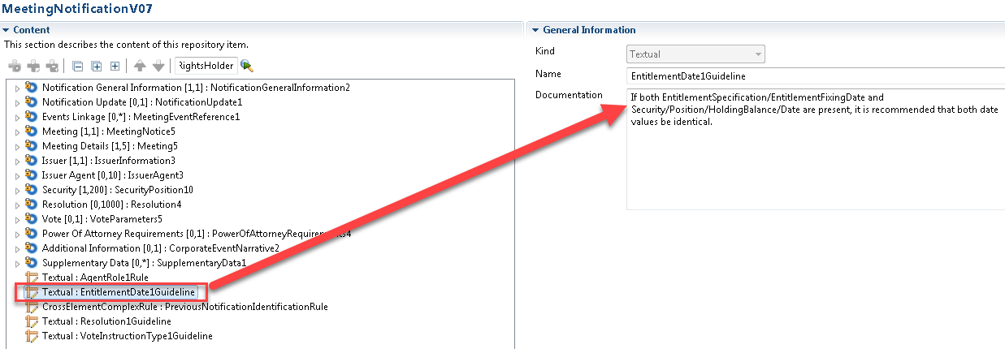

## Proposed timing:

The submitting organization confirms that it can implement the requested changes in the requested timing

|  |  |
| --- | --- |
| Timing | * As requested |

## Final decision of the SEG(s):

|  |  |
| --- | --- |
| Approve | X |

Comments:

|  |  |
| --- | --- |
| Reject |  |

Reason for rejection:

# CR0893: Amend textual description in Rule DateStatus1Rule in Notification

1. **Origin of the request:**

*A.1 Submitter*: SMPG (Securities Market Practice Group)

*A.2 Contact person:*

Christine Strandberg: [christine.strandberg@seb.se](mailto:christine.strandberg@seb.se) - +46 (8) 763 60 74

Mariangela Fumagalli: [mariangela.fumagalli@bnpparibas.com](mailto:mariangela.fumagalli@bnpparibas.com) - +442075954988

Jacques Littré: [jacques.littre@swift.com](mailto:jacques.littre@swift.com) - +3226554335

*A.3 Sponsors*:

Securities Market Practice Group

1. **Related messages:**

seev.001.001.07

1. **Description of the change request:**

Correct typo in the spelling of the word “Unknown” in the textual description of the “DateStatus1Rule” in the sequence MeetingDetails:

“*If DateAndTime/DateCode is "UKWN" (Unknwon), then DateStatus must not be present*.”

1. **Purpose of the change:**

Incorrect spelling in the textual description of the rule.

1. **Urgency of the request:**

For SR2021*.*

1. **Business examples:**

N/A

1. **SEG/TSG recommendation:**

*This section is not to be taken care of by the submitter of the change request. It will be completed in due time by the SEG(s) in charge of the related ISO 20022 messages or the TSG for changes related to the BAH.*

|  |  |  |  |
| --- | --- | --- | --- |
| **Consider** | |  | **Timing** |
|  | | - **Next yearly cycle: 2020/2021**  (the change will be considered for implementation in the yearly maintenance cycle which starts in 2020 and completes with the publication of new message versions in the spring of 2021) | | X |
|  | | - **At the occasion of the next maintenance of the messages**  (the change will be considered for implementation, but does not justify maintenance of the messages in its own right – will be pending until more critical change requests are received for the messages) | |  |
|  | | - **Urgent unscheduled**  (the change justifies an urgent implementation outside of the normal yearly cycle) | |  |  |
|  | | - **Other timing:** | | |  |

Comments:

|  |  |
| --- | --- |
| **Reject** |  |

Reason for rejection:

1. **Impact analysis:**

This change request impacts the following message:

seev.001.001.07 MeetingNotificationV07

1. **Proposed implementation:**

In the **seev.001** (MENO – MeetingNotification) message, in the ***MeetingDetails*** message building block, amend the textual description of the ***DateStatus1Rule*** rule to correct the typo in the spelling of the word “Unknown” as follows:

“*If DateAndTime/DateCode is "UKWN" (Unknwon), then DateStatus must not be present*.”

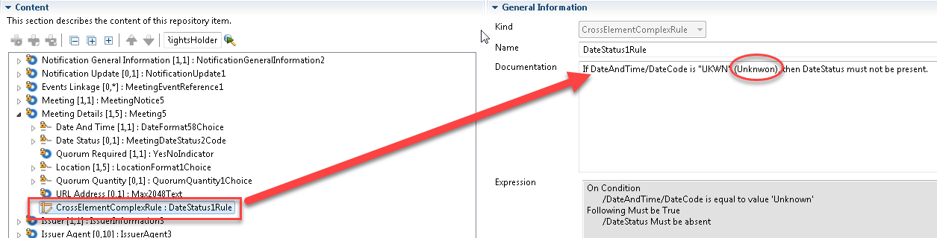

## Proposed timing:

The submitting organization confirms that it can implement the requested changes in the requested timing

|  |  |
| --- | --- |
| Timing | * As requested |

## Final decision of the SEG(s):

|  |  |
| --- | --- |
| Approve | X |

Comments:

|  |  |
| --- | --- |
| Reject |  |

Reason for rejection:

# CR0895: Set Datatype of AnnouncementDate as a Date or DateTime Choice in Notification

1. **Origin of the request:**

*A.1 Submitter*: SMPG (Securities Market Practice Group)

*A.2 Contact person:*

Christine Strandberg: [christine.strandberg@seb.se](mailto:christine.strandberg@seb.se) - +46 (8) 763 60 74

Mariangela Fumagalli: [mariangela.fumagalli@bnpparibas.com](mailto:mariangela.fumagalli@bnpparibas.com) - +442075954988

Jacques Littré: [jacques.littre@swift.com](mailto:jacques.littre@swift.com) - +3226554335

*A.3 Sponsors*:

Securities Market Practice Group

1. **Related messages:**

seev.001.001.07

1. **Description of the change request:**

Change the data type “ISODate” of the element “AnnouncementDate” in the Meeting sequence by a data type offering a choice between a date or a date and Time (DateAndDateTime2Choice).

1. **Purpose of the change:**

Alignment with the “AnnouncementDate” element in the similar corresponding corporate action notification message that offers a choice between a date or a date and time.

1. **Urgency of the request:**

For SR2021*.*

1. **Business examples:**

N/A

1. **SEG/TSG recommendation:**

*This section is not to be taken care of by the submitter of the change request. It will be completed in due time by the SEG(s) in charge of the related ISO 20022 messages or the TSG for changes related to the BAH.*

|  |  |  |  |
| --- | --- | --- | --- |
| **Consider** | |  | **Timing** |
|  | | - **Next yearly cycle: 2020/2021**  (the change will be considered for implementation in the yearly maintenance cycle which starts in 2020 and completes with the publication of new message versions in the spring of 2021) | | X |
|  | | - **At the occasion of the next maintenance of the messages**  (the change will be considered for implementation, but does not justify maintenance of the messages in its own right – will be pending until more critical change requests are received for the messages) | |  |
|  | | - **Urgent unscheduled**  (the change justifies an urgent implementation outside of the normal yearly cycle) | |  |  |
|  | | - **Other timing:** | | |  |

Comments:

|  |  |
| --- | --- |
| **Reject** |  |

Reason for rejection:

1. **Impact analysis:**

This change request impacts the following message:

seev.001.001.07 MeetingNotificationV07

1. **Proposed implementation:**

In the **seev.001** (MENO – MeetingNotification) message, in the ***Meeting*** message building block, change the data type of the element ***AnnouncementDate*** from ***ISODate*** to ***DateAndDateTime2Choice***, a choice between a date or a date and time as illustrated below:

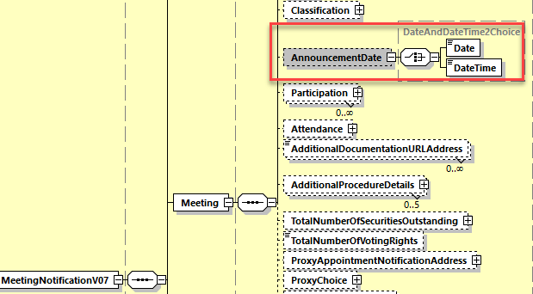

## Proposed timing:

The submitting organization confirms that it can implement the requested changes in the requested timing

|  |  |
| --- | --- |
| Timing | * As requested |

## Final decision of the SEG(s):

|  |  |
| --- | --- |
| Approve | X |

Comments:

|  |  |
| --- | --- |
| Reject |  |

Reason for rejection:

# CR0897: Add Support for Multi Languages Announcements and Resolutions

1. **Origin of the request:**

*A.1 Submitter*: SMPG (Securities Market Practice Group)

*A.2 Contact person:*

Christine Strandberg: [christine.strandberg@seb.se](mailto:christine.strandberg@seb.se) - +46 (8) 763 60 74

Mariangela Fumagalli: [mariangela.fumagalli@bnpparibas.com](mailto:mariangela.fumagalli@bnpparibas.com) - +442075954988

Jacques Littré: [jacques.littre@swift.com](mailto:jacques.littre@swift.com) - +3226554335

*A.3 Sponsors*:

Securities Market Practice Group

1. **Related messages:**

seev.031.00x.10 and seev.001.001.07

1. **Description of the change request:**

**In the seev.031 message,**

1. in the sequence *CorporateActionDetails/AdditionalInformation*, make the element *URLAddress* repeatable and change the data type *UpdatedURLInformation2* by adding a mandatory element named *Language* typed with the data type *ISO2ALanguageCode as illustrated below:*

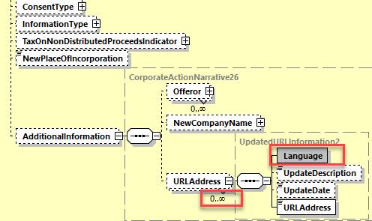

1. In the sequence CorporateActionOptionDetails/AdditionalInformation, make all narrative type elements repetitive and change the data type *UpdatedURLInformation3* by adding a mandatory element named *Language* typed with the data type *ISO2ALanguageCode as illustrated below:*

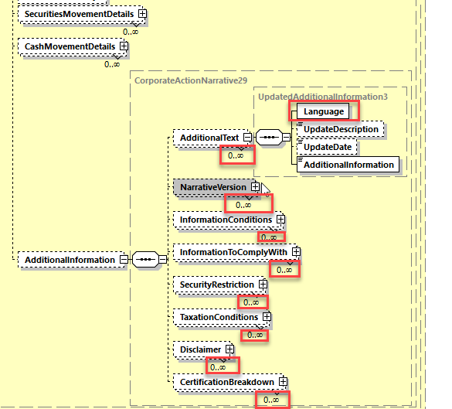

1. In the sequence AdditionalInformation, make all narrative type elements repetitive and change the data type *UpdatedURLInformation8* by adding a mandatory element named *Language* typed with the data type *ISO2ALanguageCode* and for the URLAddress element, change the data type Max2048 Text by the new data type used to type the URLAddress in the CorporateActionDetails sequence as illustrated below*:*

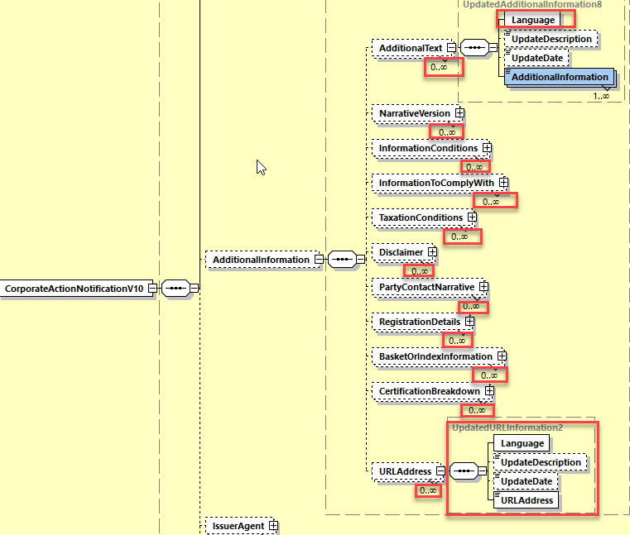

**In the seev.001 message,**

1. In the Resolution sequence, Create a new subsequence containing the elements Description, Title and a new element *Language* typed by the data type *ISO2ALanguageCode* as illustrated below:

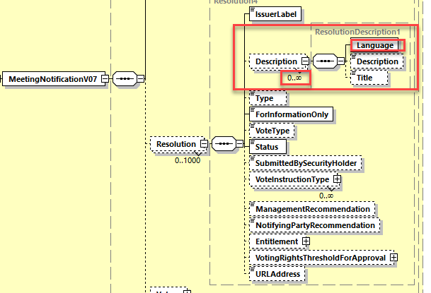

1. In the AdditionalInformation sequence, replace the data type of the ***Disclaimer*** element by a new data type containing the mandatory element Language typed by *ISO2ALanguageCode* and the element AdditionalInformation typed by Max8000Text (similarly to the seev.031 Corporate Action Notification message).

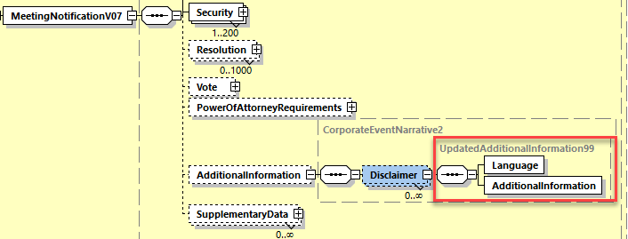

1. **Purpose of the change:**

The Shareholder Rights Directive (SRD) Implementation Regulation EU 2018/1212 specifies in article 2 paragraph 2 for corporate action events and general meetings that “The information shall be provided by the issuer in the language in which it publishes its financial information pursuant to Directive 2004/109/EC of the European Parliament and of the Council (1) and, unless not justified taking into account the issuer's shareholder base, also in a language customary in the sphere of international finance.”

This means that the announcement messages for corporate actions and general meetings in the scope of SRDII must be able to accommodate in addition to English the same narrative information in one or more other languages used in the EU/EEA countries and be able identify the language itself.

It should also be possible to provide references to a web site via URL addresses with information in different languages. Therefore it is also necessary to enable the repetition of the URL address element in the announcement and be able to identify the language of the provided information to which the URL is pointing.

1. **Urgency of the request:**

For SR2021*.*

1. **Business examples:**

N/A

1. **SEG/TSG recommendation:**

*This section is not to be taken care of by the submitter of the change request. It will be completed in due time by the SEG(s) in charge of the related ISO 20022 messages or the TSG for changes related to the BAH.*

|  |  |  |  |
| --- | --- | --- | --- |
| **Consider** | |  | **Timing** |
|  | | - **Next yearly cycle: 2020/2021**  (the change will be considered for implementation in the yearly maintenance cycle which starts in 2020 and completes with the publication of new message versions in the spring of 2021) | | X |
|  | | - **At the occasion of the next maintenance of the messages**  (the change will be considered for implementation, but does not justify maintenance of the messages in its own right – will be pending until more critical change requests are received for the messages) | |  |
|  | | - **Urgent unscheduled**  (the change justifies an urgent implementation outside of the normal yearly cycle) | |  |  |
|  | | - **Other timing:** | | |  |

Comments:

|  |  |
| --- | --- |
| **Reject** |  |

Reason for rejection:

1. **Impact analysis:**

This change request impacts the following messages:

seev.001.001.07 MeetingNotificationV07

1. **Proposed implementation on seev.001 (for seev.031 see the CA MCR):**
2. In the **seev.001** (MENO – MeetingNotification) message, in the Resolution message building block, create a new optional and repeatable ***Description*** subsequence including the existing optional elements ***Title*** and ***Description*** and the new mandatory element ***Language*** typed by the data type ***ISO2ALanguageCode***as illustrated below:



1. In the **seev.001** (MENO – MeetingNotification) message, in the ***AdditionalInformation*** message building block, replace the data type of the ***Disclaimer*** element by a new data type containing the mandatory element Language typed by ***ISO2ALanguageCode***and the element ***AdditionalInformation*** typed by Max8000Text (similarly to the seev.031 Corporate Action Notification message for the same narrative).



## Proposed timing:

The submitting organization confirms that it can implement the requested changes in the requested timing

|  |  |
| --- | --- |
| Timing | * As requested |

## Final decision of the SEG(s):

|  |  |
| --- | --- |
| Approve | X |

Comments:

|  |  |
| --- | --- |
| Reject |  |

Reason for rejection:

# CR0910: Add a Vote Type List for Incentive Premium

1. **Origin of the request:**

*A.1 Submitter*: ITALY

*A.2 Contact person:*

Mattia Zangrossi, BP2S

[mattia.zangrossi@bnpparibas.com](mailto:mattia.zangrossi@bnpparibas.com),

phone +39 02 7247 4299

*A.3 Sponsors*: …..

1. **Related messages:**

Change request is impacting Seev.001.001.07 Meeting notificationV07

1. **Description of the change request:**

**C.1 Seev.001: add a new subsequence for Per Vote Type of incentive premium**

Within the existing Type of incentive premium:

* Per Security
* Per Vote
* Per attendee

If the Per vote option is chosen a new conditional repetitive subsequence named *Vote option expressed* must be opened specifying which Vote instruction codes give the entitlement to an incentive premium among the current existing ones:

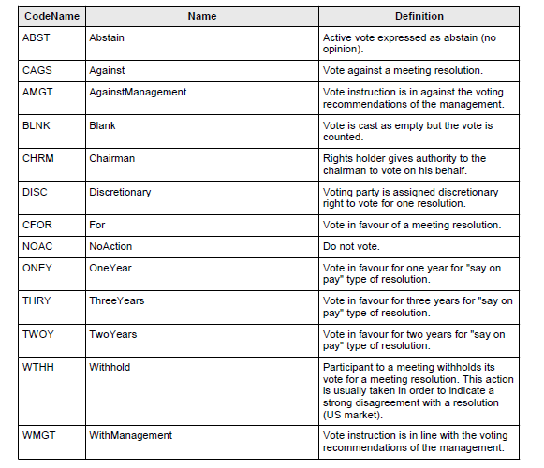

1. **Purpose of the change:**

**Background**

Currently in the Italian market a specific category of meeting events exist where shareholders voting in favour of resolutions of the meeting become entitled to receive an incentive cash premium.

**Business context and expected benefits**

The requested CR will allow to inform clients transparently on specific meeting conditions currently not foreseen by the existing standard messages.

1. **Urgency of the request:**

Urgency of the request: default with regular maintenance cycle.

Expected to be live by standard release of November 2021

1. **Business examples:**

N/A

1. **SEG/TSG recommendation:**

*This section is not to be taken care of by the submitter of the change request. It will be completed in due time by the SEG(s) in charge of the related ISO 20022 messages or the TSG for changes related to the BAH.*

|  |  |  |  |
| --- | --- | --- | --- |
| **Consider** | |  | **Timing** |
|  | | - **Next yearly cycle: 2021**  (the change will be considered for implementation in the yearly maintenance cycle which starts in 2020 and completes with the publication of new message versions in the spring of 2021) | | X |

Comments:

|  |  |
| --- | --- |
| **Reject** |  |

Reason for rejection:

1. **Impact analysis:**

This change request impacts the following messages:

seev.001.001.07 MeetingNotificationV07

1. **Proposed implementation:**

In the **seev.001** (MENO – MeetingNotification) message, in the ***Vote*** message building block, replace the data type “Number” of the element EarlyIncentivePremium/Type/PerVote and IncentivePremium/Type/PerVote by a new MC ***VoteTypeAndQuantiy1*** which is a sequence of 2 mandatory and non repeatable elements ***VoteInstructionType*** typed by ***VoteInstructionType1Choice*** and **VoteQuantity** typed by ***Number***.

Also set the element **PerVote** as repeatable in the 2 incentive premium elements.

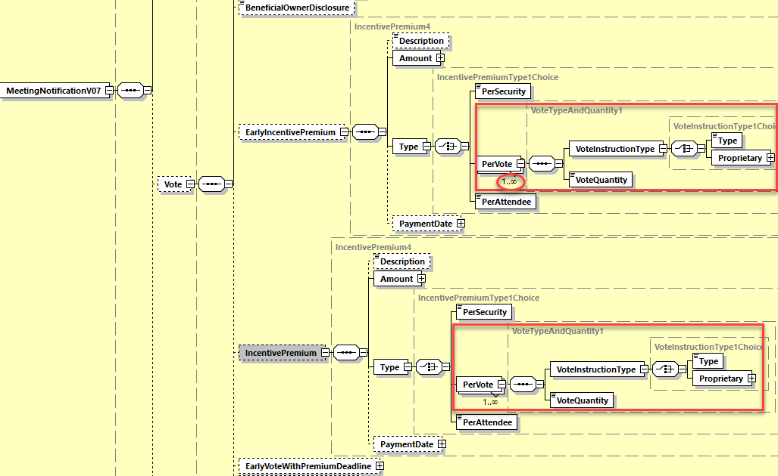

## Proposed timing:

The submitting organization confirms that it can implement the requested changes in the requested timing

|  |  |
| --- | --- |
| Timing | * As requested |

## Final decision of the SEG(s):

|  |  |
| --- | --- |
| Approve | X |

Comments:

|  |  |
| --- | --- |
| Reject |  |

Reason for rejection:

# CR0911: Add Listing Vote Indicator and Rejection Reason Code in Status

1. **Origin of the request:**

*A.1 Submitter*: ITALY

*A.2 Contact person:*

Mattia Zangrossi, BP2S

[mattia.zangrossi@bnpparibas.com](mailto:mattia.zangrossi@bnpparibas.com),

phone +39 02 7247 4299

*A.3 Sponsors*: …..

1. **Related messages:**

Change request is impacting

* Seev.001.001.07 Meeting notificationV07
* Seev.004.001.06 MeetingInstructionV06
* Seev.006.001.06 Meeting instruction StatusV06

1. **Description of the change request:**

**C.1 Seev.001: add a new optional Listing vote indicator under Resolution sequence**

The Listing vote indicator must be optional in the sequence and its aim is to mark if a specific resolution must be considered under the specific rules of the listing vote.

Only if the Listing vote indicator is set to YES an additional mandatory subsequence named *Listing* *Group resolution label number* must be filled for all the resolutions with listing indicator flagged.

All the different resolutions of the same listing vote set of agenda items have to report the same Group resolution label number

As a nice to have we kindly request additional fields described at point C.2 and C.3

**C.2 Seev.004: add a new optional Listing vote indicator under Resolution sequence**

Add a new subsequence in Instruction sequence of the seev.004 under **VoteInstructionForAgendaResolution subsequence** named*Listing* *Group resolution label number.*

If a resolution has been notified in the MENO as subject to Listing vote provisions, it’s strongly recommended that Listing Group resolution label number is reported by client’s MEIN.

*New constraints in seev.004*

*If Listing* *Group resolution label number is quoted in the seev.004, only one resolution among the ones belonging to the same Listing Group resolution label (i.e. having the same Group number) can have a “vote in favour” option.*

**C.3 Seev.006: add a new rejection reason code**

Add a new rejection reason code named LIST to be used in case an instruction is invalid due to multiple resolutions instructed as “vote for” and belonging to the same Listing Group label number. Typically it could happen if client is instructing inhomogeneously across different messages.

1. **Purpose of the change:**

**Background**

The specificity of listing vote exists for some resolutions that are parts of a meeting.

That’s to say that - within a subgroup of resolutions foreseen in the same meeting - shareholder can vote in favor of only one resolution of the same group, while the vote of other lists within the same group of resolutions can be inhomogeneous (abstain, against and so on).

See below a use case:

|  |  |  |  |  |  |
| --- | --- | --- | --- | --- | --- |
| **Resolution** | **Listing vote resolution** | **Resolution group** | **INX 1** | **INX 2** | **INX 3** |
| **1** | No | A | For | For | For |
| **2** | No | B | Against | Against | Against |
| **3** | **Yes** | **C** | Abstain | For | **For** |
| **4** | **Yes** | **C** | Abstain | Abstain | **For** |
| **5** | **Yes** | **C** | Abstain | Abstain | Abstain |
| **6** | **Yes** | **D** | Abstain | For | **For** |
| **7** | **Yes** | **D** | Abstain | Abstain | **For** |
| **8** | **Yes** | **D** | Abstain | Against | Against |
|  |  |  | **OK** | **OK** | **KO** |

Currently in the ISO20022 messages for meeting:

* There no place to inform in the seev.001 which resolutions are falling under the special consistency voting rules posed by listing votes
* There is no room in seev.004 to say that client is instructing a resolution under listing votes conditions and there’s no consistency checks foreseen in Swift to control that client will not vote in favor of two lists within the same message
* There is no specific reason code to inform clients that a vote in favor of more than one resolution of the same group is not allowed causing the rejection of the voting instruction.

**Business context and expected benefits** 4

Seev.004 messages needs to be modified in order to incorporate mandatory regulatory information foreseen by local Italian law, thus allowing a STP processing of the client’s instruction via seev.004

*\* law 29 december 1962 n° 1745 art. 5 in connection with Royal Decree 29 March 1942 n° 239 and law 31 October 1955 n° 1064*

1. **Urgency of the request:**

Urgency of the request: default with regular maintenance cycle.

Expected to be live by standard release of November 2021

1. **Business examples:**
2. **SEG/TSG recommendation:**

*This section is not to be taken care of by the submitter of the change request. It will be completed in due time by the SEG(s) in charge of the related ISO 20022 messages or the TSG for changes related to the BAH.*

|  |  |  |  |
| --- | --- | --- | --- |
| **Consider** | |  | **Timing** |
|  | | - **Next yearly cycle: 2021**  (the change will be considered for implementation in the yearly maintenance cycle which starts in 2020 and completes with the publication of new message versions in the spring of 2021) | | X |
|  | | - **Other timing:** | | |  |

Comments:

|  |  |
| --- | --- |
| **Reject** |  |

Reason for rejection:

1. **Impact analysis:**

This change request impacts the following messages:

seev.001.001.07 MeetingNotificationV07

seev.004.001.06 MeetingInstructionV06

seev.006.001.06 MeetingInstructionStatusV06

1. **Proposed implementation:**
2. In the **seev.001** (MENO – MeetingNotification) message, in the ***Resolution*** message building block, add a new optional and non repeatable element ***ListingGroupLabel*** typed by the data type Max35Text.

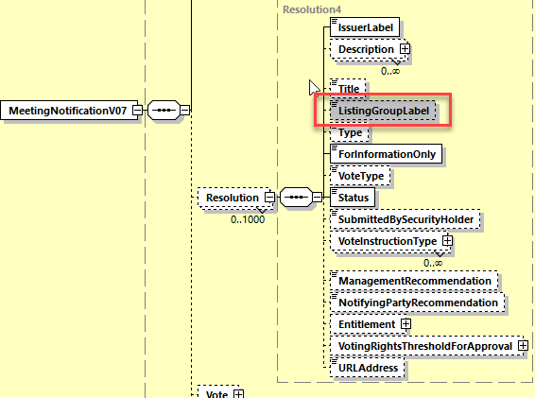

1. In the **seev.004** (MEIN – MeetingInstruction) message, in the ***Instruction*** message building block, in sequence ***VoteDetails/VoteInstructionForAgendaResolution/VotePerAgendaResolution/VoteInstruction***, add a new optional and non repeatable element ***ListingGroupLabel*** typed by ***Max35Text.***

In the same VotePerAgendaResolution Choice component, add a new rule ***InFavourListingGroup1Rule*** which reads:

*“If two or more occurrences of the element* ***VoteInstruction/ListingGroupLabel*** *have the exact same textual value, then only a single occurrence of the* ***VoteInstruction*** *sequence may have the element “****For****” (In favour) being present.”*

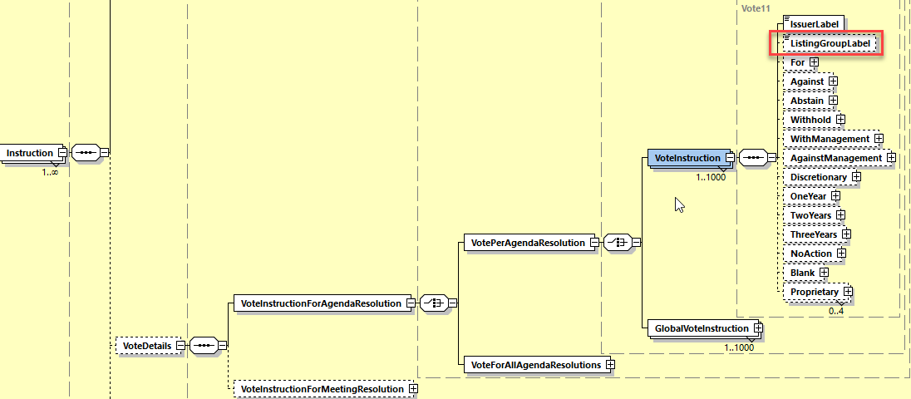

1. **In the seev.006** (MENO – MeetingInstructionStatus) message, in the ***InstructionTypeStatus*** message building block, add a new rejection reason Code **LIST** (***IncorrectVoteInFavourGroupListing***) with definition : *“Invalid instruction due to multiple resolutions instructed as vote in favour and belonging to the same listing group label number.”*

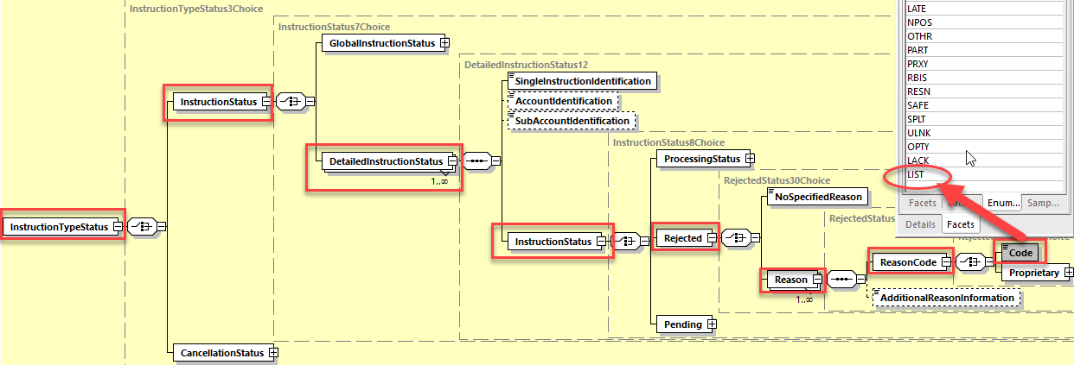

## Proposed timing:

The submitting organization confirms that it can implement the requested changes in the requested timing

|  |  |
| --- | --- |
| Timing | * As requested |

## Final decision of the SEG(s):

|  |  |
| --- | --- |
| Approve | X |

Comments:

|  |  |
| --- | --- |
| Reject |  |

Reason for rejection:

# CR0912: Add Voting Method sequence and Admission Conditions Codes in Notification And Status

1. **Origin of the request:**

*A.1 Submitter*: ITALY

*A.2 Contact person:*

Mattia Zangrossi, BP2S

[mattia.zangrossi@bnpparibas.com](mailto:mattia.zangrossi@bnpparibas.com),

phone +39 02 7247 4299

*A.3 Sponsors*: …..

1. **Related messages:**

Change request is impacting

* Seev.001.001.07 Meeting notificationV07
* Seev.006.001.06 Meeting instruction Status

1. **Description of the change request:**

**C.1 Seev.001: add a new optional Voting method sequence**

Add a new optional Voting method subsequence in the Meeting sequence of the seev.001 where possible value can be:

* OMOV: one-man-one-vote

**C.2 Seev.001: add two new Admission conditions in the seev.001 in Attendance subsequence**

Add two new codes in seev.001 Admissions Conditions codes:

* MASL: meeting participation allowed if shareholder is registered in company stock ledger book
* MADS: meeting participation if the delegate of the shareholder is registered in the company stock ledger book

**C.3 Seev.006: add a new rejection reason code**

Add a new rejection reason code named NOSL to be used in case an instruction is invalid cause the shareholder or its delegate are not registered in the company stock ledger book.

1. **Purpose of the change:**

**Background**

Currently in the Meeting Notification (MENO) there is no specific Voting method to inform the clients that special voting conditions exists such as the case of one-man-one-vote system (per capita vote) typically used for popular banks or cooperative companies’ meeting nor specific Admission Conditions are foreseen.

In principle:

* In case of one-man-one-vote meeting, shareholder attending in the meeting has one vote only, regardless the holding positions
* The shareholder or the delegate attending the meeting must be registered in company's stock ledger to be allowed to join the meeting

**Business context and expected benefits**

The requested CR will allow to inform clients transparently on possible special voting method and on specific admission conditions currently not foreseen by the existing standard messages.

1. **Urgency of the request:**

Urgency of the request: default with regular maintenance cycle.

Expected to be live by standard release of November 2021

1. **Business examples:**
2. **SEG/TSG recommendation:**

*This section is not to be taken care of by the submitter of the change request. It will be completed in due time by the SEG(s) in charge of the related ISO 20022 messages or the TSG for changes related to the BAH.*

|  |  |  |  |
| --- | --- | --- | --- |
| **Consider** | |  | **Timing** |
|  | | - **Next yearly cycle: 2021**  (the change will be considered for implementation in the yearly maintenance cycle which starts in 2020 and completes with the publication of new message versions in the spring of 2021) | | X |

Comments:

|  |  |
| --- | --- |
| **Reject** |  |

Reason for rejection:

1. **Impact analysis:**

This change request impacts the following messages:

seev.001.001.07 MeetingNotificationV07

seev.006.001.06 MeetingInstructionStatusV06

1. **Proposed implementation:**
2. In the **seev.001** (MENO – MeetingNotification) message, in the ***Meeting*** message building block, add a new optional non repeatable indicator element ***OneManOneVoteIndicator*** typed by ***YesNoIndicator*** data type.

In the ***Meeting*** message building block, in the data type AttendanceAdmissionConditions1Code of the element ***Attendance/AdmisssionConditions/Code***, add 2 new code values **MASL** and **MADS** defined as follows:

* MASL: AllowedIfRegisteredInStockLedger - meeting participation allowed if shareholder is registered in company stock ledger book.
* MADS: DelegateAllowedIfRegisteredInStockLedger - meeting participation if the delegate of the shareholder is registered in the company stock ledger book.

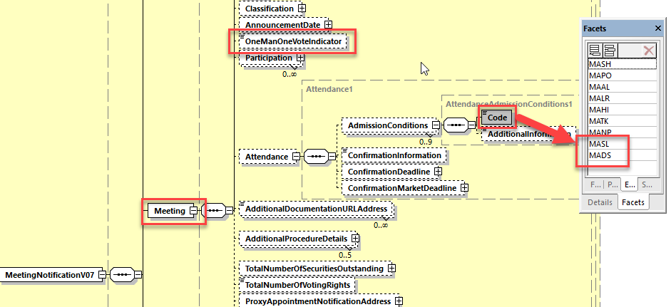

1. **In the seev.006** (MENO – MeetingInstructionStatus) message, in the ***InstructionTypeStatus*** message building block, add a new rejection reason Code **NOSL** (*NotRegisteredInInStockLedger*) with definition : *“Invalid instruction as the shareholder or its delegate is not registered in the company stock ledger book.”*

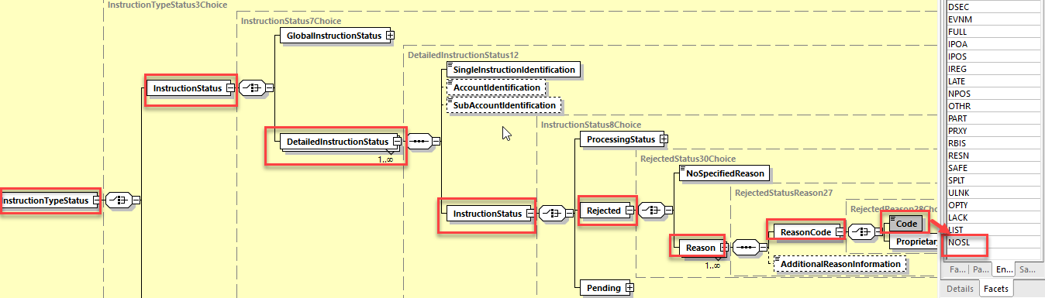

## Proposed timing:

The submitting organization confirms that it can implement the requested changes in the requested timing

|  |  |
| --- | --- |
| Timing | * As requested |

## Final decision of the SEG(s):

|  |  |
| --- | --- |
| Approve | X |

Comments:

|  |  |
| --- | --- |
| Reject |  |

Reason for rejection:

# CR0915: Add Withdrawal Indicator in Resolutions in Notification

1. **Origin of the request:**

*A.1 Submitter*: ITALY

*A.2 Contact person:*

Mattia Zangrossi, BP2S

[mattia.zangrossi@bnpparibas.com](mailto:mattia.zangrossi@bnpparibas.com),

phone +39 02 7247 4299

*A.3 Sponsors*: …..

1. **Related messages:**

Change request is impacting

* Seev.001.001.07 Meeting notificationV07

1. **Description of the change request:**

**C.1 Seev.001: add a new indicator at Resolution sequence**

Add a new indicator at resolution level called “Rights to withdraw resolution”

The definition is: indicator indicates whether a client is not voting in favour to the resolutions and resolution is approved, client has the right to withdraw.

• *Meaning When True:* Yes

• *Meaning When False:* No

1. **Purpose of the change:**

**Background**

Currently if some resolutions in the agenda are approved, shareholders that didn’t vote in favour to those resolutions have the right to withdraw in a separate corporate action events.

**Business context and expected benefits**

The requested CR will allow to inform clients about resolutions that can originate a withdrawal events.

1. **Urgency of the request:**

Urgency of the request: default with regular maintenance cycle.

Expected to be live by standard release of November 2021

1. **Business examples:**
2. **SEG/TSG recommendation:**

*This section is not to be taken care of by the submitter of the change request. It will be completed in due time by the SEG(s) in charge of the related ISO 20022 messages or the TSG for changes related to the BAH.*

|  |  |  |  |
| --- | --- | --- | --- |
| **Consider** | |  | **Timing** |
|  | | - **Next yearly cycle: 2021**  (the change will be considered for implementation in the yearly maintenance cycle which starts in 2020 and completes with the publication of new message versions in the spring of 2021) | | X |

Comments:

|  |  |
| --- | --- |
| **Reject** |  |

Reason for rejection:

1. **Impact analysis:**

This change request impacts the following messages:

seev.001.001.07 MeetingNotificationV07

1. **Proposed implementation:**

In the seev.001 (MENO – MeetingNotification) message, in the ***Resolution*** message building block, add a new optional and non repeatable indicator element ***RightToWithdrawIndicator*** typed by the data type ***YesNoIndicator*** and defined as follows: *“Indicates whether a client who has not voted in favour of the resolutions which is finally approved, has the right to withdraw from a related corporate action event.”*

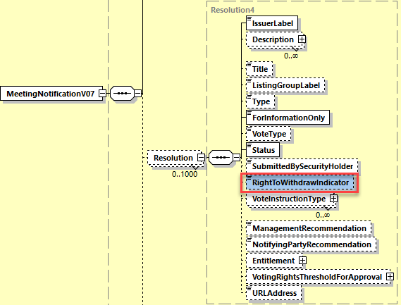

## Proposed timing:

The submitting organization confirms that it can implement the requested changes in the requested timing

|  |  |
| --- | --- |
| Timing | * As requested |

## Final decision of the SEG(s):

|  |  |
| --- | --- |
| Approve | X |

Comments:

|  |  |
| --- | --- |
| Reject |  |

Reason for rejection:

# CR0885: Amend PreassignedProxy Name as Identification

1. **Origin of the request:**

*A.1 Submitter*: SMPG (Securities Market Practice Group)

*A.2 Contact person:*

Christine Strandberg: [christine.strandberg@seb.se](mailto:christine.strandberg@seb.se) - +46 (8) 763 60 74

Mariangela Fumagalli: [mariangela.fumagalli@bnpparibas.com](mailto:mariangela.fumagalli@bnpparibas.com) - +442075954988

Jacques Littré: [jacques.littre@swift.com](mailto:jacques.littre@swift.com) - +3226554335

*A.3 Sponsors*:

Securities Market Practice Group

1. **Related messages:**

seev.004.001.06

1. **Description of the change request:**

In the “Instruction/MeetingAttendee” sequence, rename the “PreassignedProxy” element as “Identification”.

1. **Purpose of the change:**

The “Instruction/MeetingAttendee” sequence was modified in the SR2020 release with the Change request CR14. However, the change request was not implemented correctly as the element that should have been named “Identification” was named “Preassigned Proxy”.

1. **Urgency of the request:**

For SR2021*.*

1. **Business examples:**

N/A

1. **SEG/TSG recommendation:**

*This section is not to be taken care of by the submitter of the change request. It will be completed in due time by the SEG(s) in charge of the related ISO 20022 messages or the TSG for changes related to the BAH.*

|  |  |  |  |
| --- | --- | --- | --- |
| **Consider** | |  | **Timing** |
|  | | - **Next yearly cycle: 2020/2021**  (the change will be considered for implementation in the yearly maintenance cycle which starts in 2020 and completes with the publication of new message versions in the spring of 2021) | | X |
|  | | - **At the occasion of the next maintenance of the messages**  (the change will be considered for implementation, but does not justify maintenance of the messages in its own right – will be pending until more critical change requests are received for the messages) | |  |
|  | | - **Urgent unscheduled**  (the change justifies an urgent implementation outside of the normal yearly cycle) | |  |  |
|  | | - **Other timing:** | | |  |

Comments:

|  |  |
| --- | --- |
| **Reject** |  |

Reason for rejection:

1. **Impact analysis:**

This change request impacts the following messages:

seev.004.001.06 MeetingInstructionV06

1. **Proposed implementation:**
2. In the seev.004 (MEIN – MeetingInstruction) message, in the ***Instruction*** message building block, in the sequence ***MeetingAttendee***, rename the element ***PreassignedProxy*** as “Identification”.

However, keep the name “***Preassigned*** Proxy” in sequence ***Proxy/PersonDetails*** - although the MC ***IndividualPerson39*** is shared between MeetingAttendee and Proxy, this should be changed and the MeetingAttendee sequence should be typed by a new MC similar to ***IndividualPerson39*** but with the ***PreassignedProxy*** element renamed “***Identification***” as illustrated below.

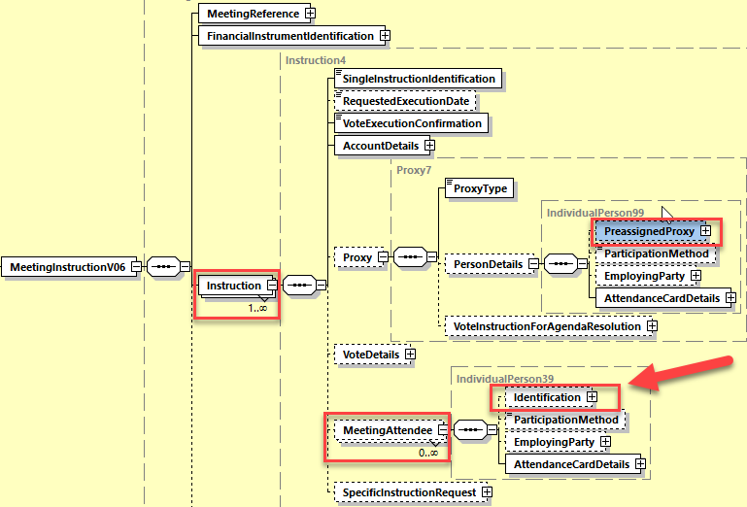

## Proposed timing:

The submitting organization confirms that it can implement the requested changes in the requested timing

|  |  |
| --- | --- |
| Timing | * As requested |

## Final decision of the SEG(s):

|  |  |
| --- | --- |
| Approve | X |

Comments:

|  |  |
| --- | --- |
| Reject |  |

Reason for rejection:

# CR0879: Set RightsHolder Repeatable in All Messages

1. **Origin of the request:**

*A.1 Submitter*: SMPG (Securities Market Practice Group)

*A.2 Contact person:*

Christine Strandberg: [christine.strandberg@seb.se](mailto:christine.strandberg@seb.se) - +46 (8) 763 60 74

Mariangela Fumagalli: [mariangela.fumagalli@bnpparibas.com](mailto:mariangela.fumagalli@bnpparibas.com) - +442075954988

Jacques Littré: [jacques.littre@swift.com](mailto:jacques.littre@swift.com) - +3226554335

*A.3 Sponsors*:

Securities Market Practice Group

1. **Related messages:**

seev.001.001.07

seev.002.001.06

seev.003.001.06

seev.004.001.06

seev.005.001.06

seev.006.001.06

seev.007.001.06

seev.008.001.06

1. **Description of the change request:**

Set the sequence “RightsHolder” as repetitive to a bigger number than 10 i.e. either unlimited or up to about 250 times in all GM messages.

1. **Purpose of the change:**

Align the repeatability of the “RightsHolder” elements with all other rights holder elements in the GM messages and increase the occurence to a bigger number than 10 to cover some specific cases of high number of joint rights owners.

1. **Urgency of the request:**

For SR2021*.*

1. **Business examples:**

N/A

1. **SEG/TSG recommendation:**

*This section is not to be taken care of by the submitter of the change request. It will be completed in due time by the SEG(s) in charge of the related ISO 20022 messages or the TSG for changes related to the BAH.*

|  |  |  |  |
| --- | --- | --- | --- |
| **Consider** | |  | **Timing** |
|  | | - **Next yearly cycle: 2020/2021**  (the change will be considered for implementation in the yearly maintenance cycle which starts in 2020 and completes with the publication of new message versions in the spring of 2021) | | X |
|  | | - **At the occasion of the next maintenance of the messages**  (the change will be considered for implementation, but does not justify maintenance of the messages in its own right – will be pending until more critical change requests are received for the messages) | |  |
|  | | - **Urgent unscheduled**  (the change justifies an urgent implementation outside of the normal yearly cycle) | |  |  |
|  | | - **Other timing:** | | |  |

Comments:

|  |  |
| --- | --- |
| **Reject** |  |

Reason for rejection:

1. **Impact analysis:**

This change request impacts the following messages:

seev.001.001.07 MeetingNotificationV07

seev.002.001.06 MeetingCancellationV06

seev.003.001.06 MeetingEntitlementNotificationV06

seev.004.001.06 MeetingInstructionV06

seev.005.001.06 MeetingInstructionCancellationRequestV06

seev.006.001.06 MeetingInstructionStatusV06

seev.007.001.06 MeetingVoteExecutionConfirmationV06

seev.008.001.06 MeetingResultDisseminationV06

1. **Proposed implementation:**

In the seev.001 (MENO – MeetingNotification) message, in the ***Security*** message building block, in sequence ***Position***,

In the seev.002 (MECN – MeetingCancellation) message, in the ***Security*** message building block, in sequence ***Position,***

In the seev.003 (MENT – MeetingEntitlementNotification) message, in the ***Security*** message building block, in sequence ***Position,***

In the seev.004 (MEIN – MeetingInstruction) message, in the ***Instruction*** message building block, in sequence ***AccountDetails,***

In the seev.005 (MEIC – MeetingInstructionCancellationRequest) message, in the ***ToBeCancelledInstruction*** message building block, in sequence ***InstructedPosition,***

In the seev.006 (MEIS – MeetingInstructionStatus) message,

In the seev.007 (MECO – MeetingVoteExecutionConfirmation) message, in the ***VoteInstructions*** message building block,

In the seev.008 (MERD – MeetingResultDissemination) message, in the ***Security*** message building block, in sequence ***Position,***

**set the multiplicity of the RightsHolder element to [0..250]** as illustrated below:

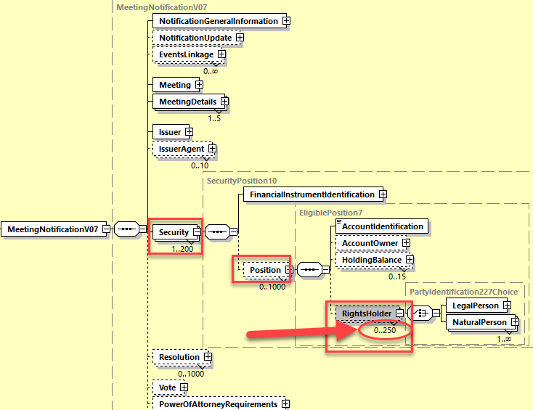

## Proposed timing:

The submitting organization confirms that it can implement the requested changes in the requested timing

|  |  |
| --- | --- |
| Timing | * As requested |

## Final decision of the SEG(s):

|  |  |
| --- | --- |
| Approve | X |

Comments:

|  |  |
| --- | --- |
| Reject |  |

Reason for rejection:

# CR0914: Add Natural Person and Pledge Details For RightsHolder in Instruction

1. **Origin of the request:**

*A.1 Submitter*: ITALY

*A.2 Contact person:*

Mattia Zangrossi, BP2S

[mattia.zangrossi@bnpparibas.com](mailto:mattia.zangrossi@bnpparibas.com),

phone +39 02 7247 4299

*A.3 Sponsors*: …..

1. **Related messages:**

Change request is impacting the seev.004.001.06 MeetingInstructionV06 message only

1. **Description of the change request:**

**C.1 Add a new optional subsequence under Right holder/Natural Person with string: <NaturalPersonComplementaryData>**

That includes:

**BirthDate** (format YYYY-MM-DD) – *Mandatory if sequence is filled*

**BirthPlace**: *(mandatory if sequence is filled)*

* Town (any value filled by the client)
* CountrySubDivision (2 chars long)
* Country, according to the abbreviation it will translated in the Iso country code correspondent (see other mail enclosed)

**Gender** (M/F/Neutral/not defined) - *optional*

The sub-sequence Natural Person complementary data will be optional (mandatory for Italian market only) and it will be located in

Instruction Building Block (level 1)

Account details <AcctDtls> (level 2)

Rights Holder <RghtsHldr> (level 3)

Natural Person <NtrlPrsn> (level 4)

Functionally it will be conditional to the filling of Natural Person subsequence

***Comments from the ISO Securities SEG ET in July 2020: Align NaturalPerson Details of Rightsholder and Proxy with the NaturalPerson details defined in SID messages by adding the optional elements DateAndPlaceOfBirth, Nationality and NamePrefix instead of Gender (in NameAndAddress sequence).***

**C.2 Add a new optional subsequence Pledge Details <PledgeInformation>**

That includes:

**Pledge Details <PledgeInformation>**

1. Pledger (Legal/Natural Person) – *(mandatory if sequence <PledgeInformation> is filled)*

* if the pledger is a Natural Person the standard Right Holder Person details Right holder + the new data aforementioned Natural Person Complementary Date (birth date, birth place and gender) have to be added for the right holder Natural person in the schema.
* if the pledger is a Legal Personal the Legal Person details must be populated similar to seev.047 – (4.4.5.2.6.3.3.4) with identification with LEI or BIC or proprietary code

1. Third Party: also known as the guarantor of the pledge. It’s assumed that will always be a legal person considering it must be a bank. Identification has to be done via the usual repetitive sequence identification for the legal person with in addition the specification of the ABI code (specific for the Italian market) – (conditional: mandatory if ID sequence </PldgTp> > assumes specific value: for example value “10”)
2. Pledge Type: mandatory if sequence <PledgeInformation> is filled
3. Pledge Return Securities Indicator: to be flagged if the pledger is entitled to vote, otherwise the right to vote is with the right holder (optional)

The subsequence Pledge Details will be optional and it will be located in:

Instruction Building Block (level 1)

Account details <AcctDtls> (level 2)

Rights Holder <RghtsHldr> (level 3)

Pledgle Details <PldgInfo> (level 3)

1. **Purpose of the change:**

**Background**

* Post trading regulations and Italian Law (Civil code*) foresees some mandatory information that the Rights Holder has to transmit before the meeting:
  + *Sex*
  + *Date of birth* (composed by City of Birth, Province and State)
  + *City of birth*
  + If *stocks are under pledge* or not (depending on the choice of the owner the voting rights can be exercised either by the original owner or by the pledger)
* Those fields aren’t foreseen by ISO20022 seev.004 and there is no place for them while they are foreseen in the communication protocol currently used on Italian market among intermediaries and issuers.

**Business context and expected benefits**

Seev.004 messages needs to be modified in order to incorporate mandatory regulatory information foreseen by local Italian law, thus allowing a STP processing of the client’s instruction via seev.004

*\* law 29 december 1962 n° 1745 art. 5 in connection with Royal Decree 29 March 1942 n° 239 and law 31 October 1955 n° 1064*

1. **Urgency of the request:**

Urgency of the request: default with regular maintenance cycle.

Expected to be live by standard release of November 2021

As an interim solution waiting for the target one expected in November 2021 release, we kindly request to use the following sequence in the Supplementary data field of the seev.004

1. **Business examples:**

Examples illustrating the change request.

1. **Example for new optional subsequence under Right holder/Natural Person with string: <NaturalPersonComplementaryData>**

<NtrlPrsnCmplData>

<DtAndPlcOfBirth>

<BirthDt>**2001-01-01**</BirthDt>

<PrvcOfBirth>**AG**</PrvcOfBirth>

<CityOfBirth>**TwnNm**</CityOfBirth>

<CtryOfBirth>**IT**</CtryOfBirth>

</DtAndPlcOfBirth>

<Gndr>**MALE**</Gndr>

</NtrlPrsnCmplData

**Example for new optional subsequence Pledge Details <PldgInfo> for Legal person with pledge type**

<PldgInf>

<Pldgr>

<LglPrsn>

<NmAndAdr>

<Nm>**test**</Nm>

<Adr>

<AdrLine>**L1**</AdrLine>

<BldgNb>**1**</BldgNb>

<PstBx>**POBOX**</PstBx>

<PstCd>**75000**</PstCd>

<TwnNm>**Town**</TwnNm>

<CtrySubDvsn>**MI**</CtrySubDvsn>

<Ctry>**IT**</Ctry>

</Adr>

</NmAndAdr>

<EmailAdr>**test@universe.com**</EmailAdr>

<Id>

**<!-- any legalperson ID type allowed here, not restricted to ABI -->**

<LEI>**12345678901234567890**</LEI>

</Id>

</LglPrsn>

</Pldgr>

<ThrdPty>

<Role>

<Cd>**GATR**</Cd>

</Role>

**<!-- only LegalPersons identified with an ABI code allowed here -->**

<LglPrsn>

<NmAndAdr>

<Nm>**test**</Nm>

<Adr>

<AdrLine>**L1**</AdrLine>

<BldgNb>**1**</BldgNb>

<PstBx>**POBOX**</PstBx>

<PstCd>**75000**</PstCd>

<TwnNm>**Town**</TwnNm>

<CtrySubDvsn>**AG**</CtrySubDvsn>

<Ctry>**IT**</Ctry>

</Adr>

</NmAndAdr>

<EmailAdr>**ops@BankWithABIcode.com**</EmailAdr>

<Id>

**<!-- only ABI codes with exactly MOTI/ABI allowed here -->**

<PrtryId>

<Id>**test**</Id>

<Issr>**MOTI**</Issr>

<SchmeNm>**ABI**</SchmeNm>

</PrtryId>

</Id>

</LglPrsn>

</ThrdPty>

<PldgTp>

<Id>10</Id>

<Issr>MOTI</Issr>

<SchmeNm>ABI</SchmeNm>

</PldgTp>

<PldgRtrnInd>**true**</PldgRtrnInd>

</PldgInf>

</Document>

1. **Example for new optional subsequence Pledge Details <PldgInfo> for Natural person**

<PldgInf>

<Pldgr>

<NtrlPrsn>

<NmAndAdr>

<FrstNm>**test**</FrstNm>

<Srnm>**test**</Srnm>

<Adr>

<AdrLine>**L1**</AdrLine>

<BldgNb>**1**</BldgNb>

<PstBx>**POBOX**</PstBx>

<PstCd>**75000**</PstCd>

<TwnNm>**Town**</TwnNm>

<CtrySubDvsn>**AG**</CtrySubDvsn>

<Ctry>**IT**</Ctry>

</Adr>

</NmAndAdr>

<EmailAdr>**test@cosmos.com**</EmailAdr>

<Id>

<Id>**123456**</Id>

<IdTp>

<Cd>**IDCD**</Cd>

</IdTp>

</Id>

<DtAndPlcOfBirth>

<BirthDt>**2001-01-01**</BirthDt>

<PrvcOfBirth>**AG**</PrvcOfBirth>

<CityOfBirth>**TwnNm**</CityOfBirth>

<CtryOfBirth>**IT**</CtryOfBirth>

</DtAndPlcOfBirth>

<Gndr>**MALE**</Gndr>

</NtrlPrsn>

</Pldgr>

<ThrdPty>

<Role>

<Cd>**GATR**</Cd>

</Role>

**<!-- only LegalPersons identified with an ABI code allowed here -->**

<LglPrsn>

<NmAndAdr>

<Nm>**test**</Nm>

<Adr>

<AdrLine>**L1**</AdrLine>

<BldgNb>**1**</BldgNb>

<PstBx>**POBOX**</PstBx>

<PstCd>**75000**</PstCd>

<TwnNm>**Town**</TwnNm>

<CtrySubDvsn>**AG**</CtrySubDvsn>

<Ctry>**IT**</Ctry>

</Adr>

</NmAndAdr>

<EmailAdr>**ops@BankWithABIcode.com**</EmailAdr>

<Id>

<**!-- only ABI codes with exactly MOTI/ABI allowed here --**>

<PrtryId>

<Id>**test**</Id>

<Issr>**MOTI**</Issr>

<SchmeNm>**ABI**</SchmeNm>

</PrtryId>

</Id>

</LglPrsn>

</ThrdPty>

<PldgRtrnInd>**true**</PldgRtrnInd>

</PldgInf>

1. **SEG/TSG recommendation:**

*This section is not to be taken care of by the submitter of the change request. It will be completed in due time by the SEG(s) in charge of the related ISO 20022 messages or the TSG for changes related to the BAH.*

|  |  |  |  |
| --- | --- | --- | --- |
| **Consider** | |  | **Timing** |
|  | | - **Next yearly cycle: 2021**  (the change will be considered for implementation in the yearly maintenance cycle which starts in 2020 and completes with the publication of new message versions in the spring of 2021) | | X |

Comments:

|  |  |
| --- | --- |
| **Reject** |  |

Reason for rejection:

1. **Impact analysis:**

This change request impacts the following messages:

seev.001.001.07 MeetingNotificationV07

seev.002.001.06 MeetingCancellationV06

seev.003.001.06 MeetingEntitlementNotificationV06

seev.004.001.06 MeetingInstructionV06

seev.005.001.06 MeetingInstructionCancellationRequestV06

seev.006.001.06 MeetingInstructionStatusV06

seev.007.001.06 MeetingVoteExecutionConfirmationV06

seev.008.001.06 MeetingResultDisseminationV06

1. **Proposed implementation:**
2. **Add additional detailed information for NaturalPerson sequence**

The SMPG and SWIFT propose that the change concerning the addition of the date and place of birth for the sequence “***NaturalPerson***” used for ***AccountOwner***, ***RightsHolder***, ***Proxy*** and ***MeetingAttendee*** identifications, be implemented in the same way in all occurrences of these sequences in all GM messages in order to be consistent.

As in the ShareholderIdentificationDisclosure (seev.047) message where the optional ***DateAndPlaceOfBirth*** element is present with an optional ***Nationality*** element, it is also propose to add the optional ***Nationality*** element together with the ***DateAndPlaceOfBirth*** in all “***NaturalPerson***” sequences in all messagesand to add the optional ***NamePrefix*** element in the ***NameAndAddress*** sequences to provide the gender***.***

Therefore all GM messages are therefore impacted by this change and is illustrated below for the seev.004 for instance.

**The same change on Natural Person must be applied identically on all other GM messages.**

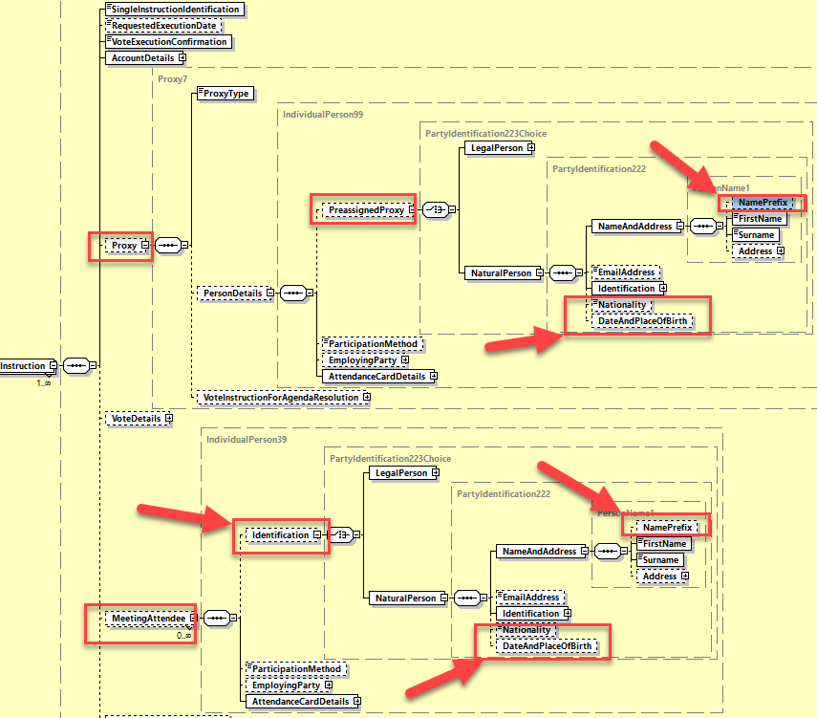

1. **Add a new sequence PledgeDetails in the seev.004**

In the seev.004 (MEIN – MeetingInstruction) message, in the ***Instruction*** message building block, add a new optional ***PledgeDetails*** sequence in the existing ***AccountDetails*** sequence.

The PledgeDetails sequence must include:

* A mandatory and non-repeatable ***Pledger*** sequence typed by the componant to identify a legal or a natural person (PartyIdentification223Choice);
* An optional and non-repeatable ***ThirdParty*** component typed by a MC composed of a ***Role*** element with code value “***Guarantor***” (***GATR***) and a legal person identification component (PartyIdentification221).
* A mandatory and non-repeatable ***PledgeType*** element typed by ***GenericIdentification36***
* An optional and non-repeatable ***ReturnSecuritiesIndicator*** element typed by a ***YesNoIndicator*** data type.

As illustrated here below:

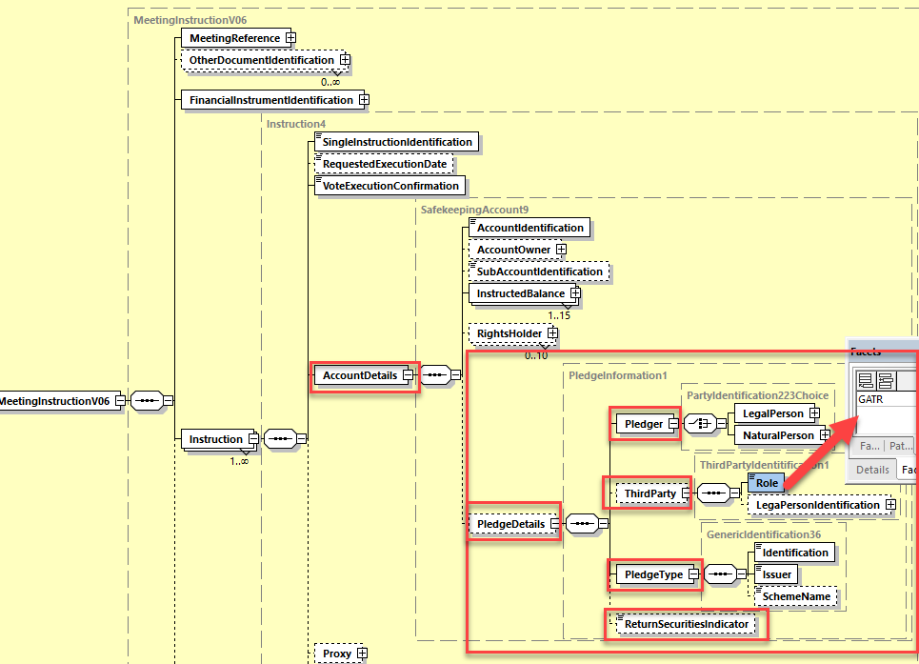

## Proposed timing:

The submitting organization confirms that it can implement the requested changes in the requested timing

|  |  |
| --- | --- |
| Timing | * As requested |

## Final decision of the SEG(s):

|  |  |
| --- | --- |
| Approve | X |

Comments:

|  |  |
| --- | --- |
| Reject |  |

Reason for rejection:

# CR0859: Remove VoteInstructionForAgendaResolution for Proxy in Instructions

1. **Origin of the request:**

*A.1 Submitter*: SMPG (Securities Market Practice Group)

*A.2 Contact person:*

Christine Strandberg: [christine.strandberg@seb.se](mailto:christine.strandberg@seb.se) - +46 (8) 763 60 74

Mariangela Fumagalli: [mariangela.fumagalli@bnpparibas.com](mailto:mariangela.fumagalli@bnpparibas.com) - +442075954988

Jacques Littré: [jacques.littre@swift.com](mailto:jacques.littre@swift.com) - +3226554335

*A.3 Sponsors*:

Securities Market Practice Group

1. **Related messages:**

seev.004.001.06

1. **Description of the change request:**

In the “Instruction/Proxy” sequence, remove the “VoteInstructionForAgendaResolution” element and the textual guideline “VoteInstruction1Guidelines” rule can then be removed as no longer consistent.

1. **Purpose of the change:**

The “VoteInstructionForAgendaResolution” element in the “Instruction/Proxy” sequence is redundant with the same element in “Instruction/VoteDetails”. It is better to avoid having 2 ways of inserting votes in the instruction messages depending on whether it is a vote by the proxy or not.

1. **Urgency of the request:**

For SR2021*.*

1. **Business examples:**

N/A

1. **SEG/TSG recommendation:**

*This section is not to be taken care of by the submitter of the change request. It will be completed in due time by the SEG(s) in charge of the related ISO 20022 messages or the TSG for changes related to the BAH.*

|  |  |  |  |
| --- | --- | --- | --- |
| **Consider** | |  | **Timing** |
|  | | - **Next yearly cycle: 2020/2021**  (the change will be considered for implementation in the yearly maintenance cycle which starts in 2020 and completes with the publication of new message versions in the spring of 2021) | | X |
|  | | - **At the occasion of the next maintenance of the messages**  (the change will be considered for implementation, but does not justify maintenance of the messages in its own right – will be pending until more critical change requests are received for the messages) | |  |
|  | | - **Urgent unscheduled**  (the change justifies an urgent implementation outside of the normal yearly cycle) | |  |  |
|  | | - **Other timing:** | | |  |

Comments:

|  |  |
| --- | --- |
| **Reject** |  |

Reason for rejection:

1. **Impact analysis:**

This change request impacts the following messages:

seev.004.001.06 MeetingInstructionV06

1. **Proposed implementation:**
2. In the seev.004 (MEIN – MeetingInstruction) message, in the ***Instruction*** message building block, in the sequence ***Proxy***, delete the ***VoteInstructionForAgendaResolution*** element.

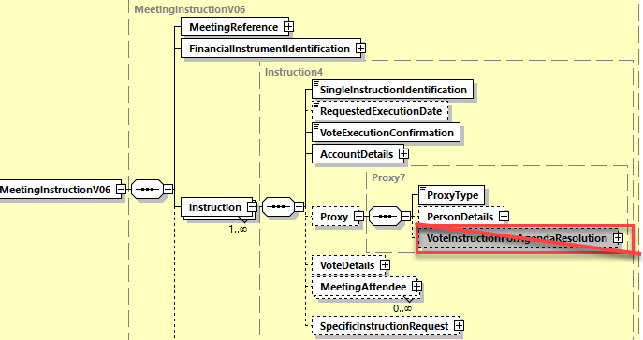

1. In the seev.004 (MEIN – MeetingInstruction) message, in the ***Instruction*** message building block, remove the textual guideline “***VoteInstruction1Guidelines***”.

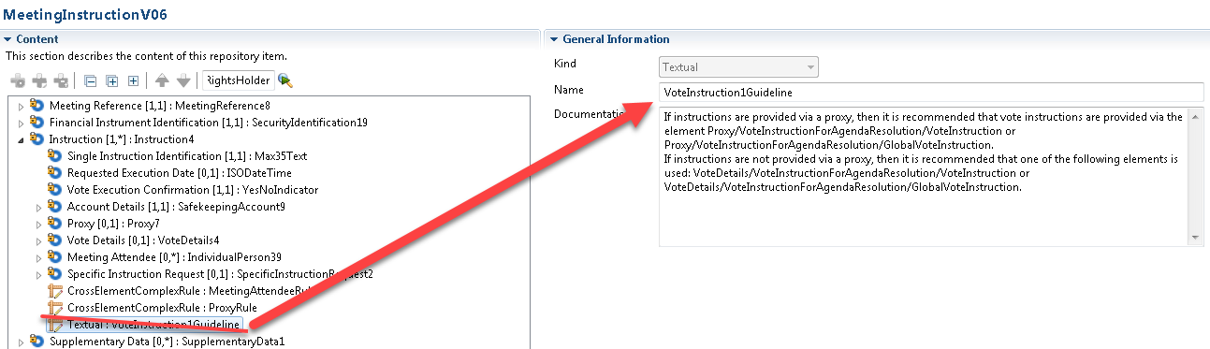

## Proposed timing:

The submitting organization confirms that it can implement the requested changes in the requested timing

|  |  |
| --- | --- |
| Timing | * As requested |

## Final decision of the SEG(s):

|  |  |
| --- | --- |
| Approve | X |

Comments:

|  |  |
| --- | --- |
| Reject |  |

Reason for rejection:

# CR0878: Remove CHRM and DISC Option Types in GlobalVote in Instruction

1. **Origin of the request:**

*A.1 Submitter*: SMPG (Securities Market Practice Group)

*A.2 Contact person:*

Christine Strandberg: [christine.strandberg@seb.se](mailto:christine.strandberg@seb.se) - +46 (8) 763 60 74

Mariangela Fumagalli: [mariangela.fumagalli@bnpparibas.com](mailto:mariangela.fumagalli@bnpparibas.com) - +442075954988

Jacques Littré: [jacques.littre@swift.com](mailto:jacques.littre@swift.com) - +3226554335

*A.3 Sponsors*:

Securities Market Practice Group

1. **Related messages:**

seev.004.001.06

1. **Description of the change request:**

In the “Instruction/VoteDetails/VoteInstructionForAgendaResolutions/VotePerAgendaResolution/ GlobalVoteInstruction/VoteOption/Type” element, remove the code values CHRM (Chairman) and DISC (Discretionary) in the data type VoteInstruction6Code.

1. **Purpose of the change:**

As we recommend to use the proxy sequence to appoint the chairman, these 2 code values do not make sense here.

1. **Urgency of the request:**

For SR2021*.*

1. **Business examples:**

N/A

1. **SEG/TSG recommendation:**

*This section is not to be taken care of by the submitter of the change request. It will be completed in due time by the SEG(s) in charge of the related ISO 20022 messages or the TSG for changes related to the BAH.*

|  |  |  |  |
| --- | --- | --- | --- |
| **Consider** | |  | **Timing** |
|  | | - **Next yearly cycle: 2020/2021**  (the change will be considered for implementation in the yearly maintenance cycle which starts in 2020 and completes with the publication of new message versions in the spring of 2021) | | X |
|  | | - **At the occasion of the next maintenance of the messages**  (the change will be considered for implementation, but does not justify maintenance of the messages in its own right – will be pending until more critical change requests are received for the messages) | |  |
|  | | - **Urgent unscheduled**  (the change justifies an urgent implementation outside of the normal yearly cycle) | |  |  |
|  | | - **Other timing:** | | |  |

Comments:

|  |  |
| --- | --- |
| **Reject** |  |

Reason for rejection:

1. **Impact analysis:**

This change request impacts the following messages:

seev.004.001.06 MeetingInstructionV06

1. **Proposed implementation:**

In the **seev.004** (MEIN – MeetingInstruction) message, in the ***VoteDetails*** message building block, remove the code values CHRM (Chaiman) and DISC (Discretionary) from the code list ***VoteInstrucction6Code*** data typing the element ***VoteInstructionForAgendaResolution/ VotePerAgendaResolution/GlobalVoteInstruction/VoteOption/Type***.

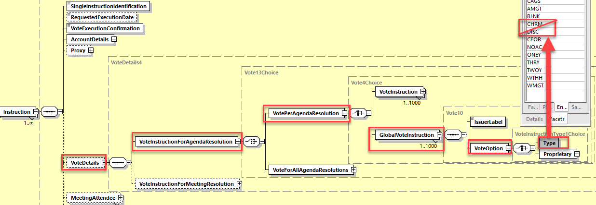

## Proposed timing:

The submitting organization confirms that it can implement the requested changes in the requested timing

|  |  |
| --- | --- |
| Timing | * As requested |

## Final decision of the SEG(s):

|  |  |
| --- | --- |
| Approve | X |

Comments:

|  |  |
| --- | --- |
| Reject |  |

Reason for rejection:

# CR0883: Remove ProxyRule in Instruction

1. **Origin of the request:**

*A.1 Submitter*: SMPG (Securities Market Practice Group)

*A.2 Contact person:*

Christine Strandberg: [christine.strandberg@seb.se](mailto:christine.strandberg@seb.se) - +46 (8) 763 60 74

Mariangela Fumagalli: [mariangela.fumagalli@bnpparibas.com](mailto:mariangela.fumagalli@bnpparibas.com) - +442075954988

Jacques Littré: [jacques.littre@swift.com](mailto:jacques.littre@swift.com) - +3226554335

*A.3 Sponsors*:

Securities Market Practice Group

1. **Related messages:**

seev.004.001.06

1. **Description of the change request:**

In the “Instruction” sequence, remove the cross element complex rule “ProxyRule” (rule C12).

1. **Purpose of the change:**

The presence of the participation method with values “Proxy” is not necessary and not consistent when the sequence “Proxy” is present.

1. **Urgency of the request:**

For SR2021*.*

1. **Business examples:**

N/A

1. **SEG/TSG recommendation:**

*This section is not to be taken care of by the submitter of the change request. It will be completed in due time by the SEG(s) in charge of the related ISO 20022 messages or the TSG for changes related to the BAH.*

|  |  |  |  |
| --- | --- | --- | --- |
| **Consider** | |  | **Timing** |
|  | | - **Next yearly cycle: 2020/2021**  (the change will be considered for implementation in the yearly maintenance cycle which starts in 2020 and completes with the publication of new message versions in the spring of 2021) | | X |
|  | | - **At the occasion of the next maintenance of the messages**  (the change will be considered for implementation, but does not justify maintenance of the messages in its own right – will be pending until more critical change requests are received for the messages) | |  |
|  | | - **Urgent unscheduled**  (the change justifies an urgent implementation outside of the normal yearly cycle) | |  |  |
|  | | - **Other timing:** | | |  |

Comments:

|  |  |
| --- | --- |
| **Reject** |  |

Reason for rejection:

1. **Impact analysis:**

This change request impacts the following messages:

seev.004.001.06 MeetingInstructionV06

1. **Proposed implementation:**

In the seev.004 (MEIN – MeetingInstruction) message, in the ***Instruction*** message building block, delete the cross element complex rule ***ProxyRule*** (Rule C12 in ISO documentation).

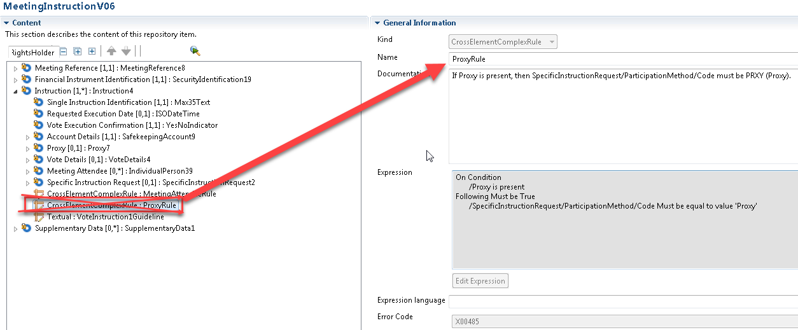

## Proposed timing:

The submitting organization confirms that it can implement the requested changes in the requested timing

|  |  |
| --- | --- |
| Timing | * As requested |

## Final decision of the SEG(s):

|  |  |
| --- | --- |
| Approve | X |

Comments:

|  |  |
| --- | --- |
| Reject |  |

Reason for rejection:

# CR0884: Set ParticipationMethod to optional in Instruction

1. **Origin of the request:**

*A.1 Submitter*: SMPG (Securities Market Practice Group)

*A.2 Contact person:*

Christine Strandberg: [christine.strandberg@seb.se](mailto:christine.strandberg@seb.se) - +46 (8) 763 60 74

Mariangela Fumagalli: [mariangela.fumagalli@bnpparibas.com](mailto:mariangela.fumagalli@bnpparibas.com) - +442075954988

Jacques Littré: [jacques.littre@swift.com](mailto:jacques.littre@swift.com) - +3226554335

*A.3 Sponsors*:

Securities Market Practice Group

1. **Related messages:**

seev.004.001.06

1. **Description of the change request:**

In the “Instruction/ SpecificInstructionRequest” sequence, the element “ParticipationMethod” must be set as optional.

1. **Purpose of the change:**

It should not be mandatory to include the participation method when a specific instruction request is provided in the case where only securities registration is required.

1. **Urgency of the request:**

For SR2021*.*

1. **Business examples:**

N/A

1. **SEG/TSG recommendation:**

*This section is not to be taken care of by the submitter of the change request. It will be completed in due time by the SEG(s) in charge of the related ISO 20022 messages or the TSG for changes related to the BAH.*

|  |  |  |  |
| --- | --- | --- | --- |
| **Consider** | |  | **Timing** |
|  | | - **Next yearly cycle: 2020/2021**  (the change will be considered for implementation in the yearly maintenance cycle which starts in 2020 and completes with the publication of new message versions in the spring of 2021) | | X |
|  | | - **At the occasion of the next maintenance of the messages**  (the change will be considered for implementation, but does not justify maintenance of the messages in its own right – will be pending until more critical change requests are received for the messages) | |  |
|  | | - **Urgent unscheduled**  (the change justifies an urgent implementation outside of the normal yearly cycle) | |  |  |
|  | | - **Other timing:** | | |  |

Comments:

|  |  |
| --- | --- |
| **Reject** |  |

Reason for rejection:

1. **Impact analysis:**

This change request impacts the following messages:

seev.004.001.06 MeetingInstructionV06

1. **Proposed implementation:**

In the seev.004 (MEIN – MeetingInstruction) message, in the ***Instruction*** message building block, set the ***SpecificInstructionRequest/ParticipationMethod*** sequence as optional.

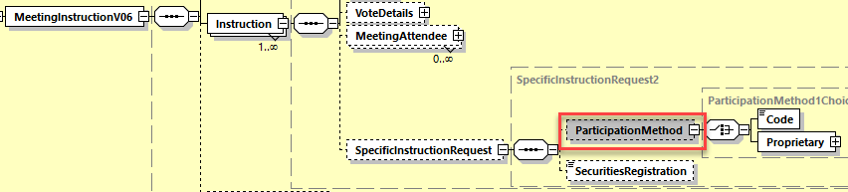

## Proposed timing:

The submitting organization confirms that it can implement the requested changes in the requested timing

|  |  |
| --- | --- |
| Timing | * As requested |

## Final decision of the SEG(s):

|  |  |
| --- | --- |
| Approve | X |

Comments:

|  |  |
| --- | --- |
| Reject |  |

Reason for rejection:

# CR0887: Amend Textual Description in rule BalanceQall1Rule

1. **Origin of the request:**

*A.1 Submitter*: SMPG (Securities Market Practice Group)

*A.2 Contact person:*

Christine Strandberg: [christine.strandberg@seb.se](mailto:christine.strandberg@seb.se) - +46 (8) 763 60 74

Mariangela Fumagalli: [mariangela.fumagalli@bnpparibas.com](mailto:mariangela.fumagalli@bnpparibas.com) - +442075954988

Jacques Littré: [jacques.littre@swift.com](mailto:jacques.littre@swift.com) - +3226554335

*A.3 Sponsors*:

Securities Market Practice Group

1. **Related messages:**

seev.004.001.06

seev.005.001.06

1. **Description of the change request:**

In the seev.004, in sequence “Instruction:AccountDetails” and in the seev.005 in sequence “ToBeCancelledInstructionI/InstructedPosition”, in the cross element complex rule “BalanceQall1Rule”the element path in the textual description of the rule is incorrect and must be fixed. It should read “If SubAccountIdentification is present, then InstructedBalance/Balance/Code "QALL" (AllSecurities) is not allowed in any occurrence of InstructedBalance.".

1. **Purpose of the change:**

Fix incorrect element path in the textual description of the rule.

1. **Urgency of the request:**

For SR2021*.*

1. **Business examples:**

N/A

1. **SEG/TSG recommendation:**

*This section is not to be taken care of by the submitter of the change request. It will be completed in due time by the SEG(s) in charge of the related ISO 20022 messages or the TSG for changes related to the BAH.*

|  |  |  |  |
| --- | --- | --- | --- |
| **Consider** | |  | **Timing** |
|  | | - **Next yearly cycle: 2020/2021**  (the change will be considered for implementation in the yearly maintenance cycle which starts in 2020 and completes with the publication of new message versions in the spring of 2021) | | X |
|  | | - **At the occasion of the next maintenance of the messages**  (the change will be considered for implementation, but does not justify maintenance of the messages in its own right – will be pending until more critical change requests are received for the messages) | |  |
|  | | - **Urgent unscheduled**  (the change justifies an urgent implementation outside of the normal yearly cycle) | |  |  |
|  | | - **Other timing:** | | |  |

Comments:

|  |  |
| --- | --- |
| **Reject** |  |

Reason for rejection:

1. **Impact analysis:**

This change request impacts the following messages:

seev.004.001.06 MeetingInstructionV06

seev.005.001.06 MeetingInstructionCancellationRequestV06

1. **Proposed implementation:**

In **the seev.004** (MEIN – MeetingInstruction) message, in the ***Instruction*** message building block, amend the textual description of the cross element complex rule ***BalanceQall1Rule*** (Rule C2 in ISO documentation) in sequence ***AccountDetails*** so as to read:

*“If SubAccountIdentification is present, then InstructedBalance/Balance/Code "QALL" (AllSecurities) is not allowed in any occurrence of InstructedBalance."*

In the **seev.005** (MEIC – MeetingInstructionCancellationRequest) message, in the ***ToBeCancelledInstruction*** message building block, amend the textual description of the cross element complex rule ***BalanceQall1Rule*** (Rule C2 in ISO documentation) in sequence ***InstructedPosition*** so as to read:

*“If SubAccountIdentification is present, then InstructedBalance/Balance/Code "QALL" (AllSecurities) is not allowed in any occurrence of InstructedBalance."*

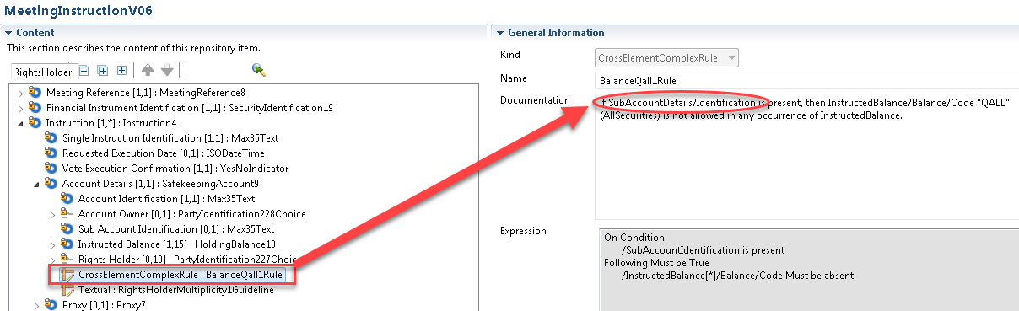

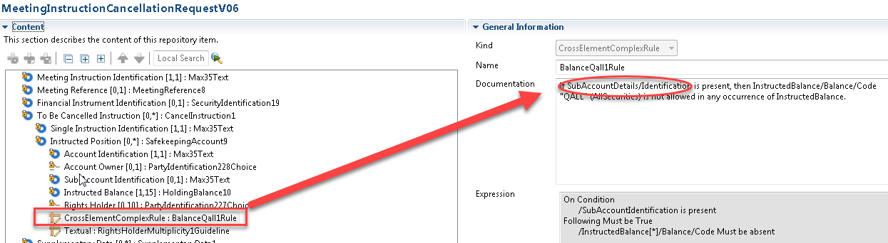

## Proposed timing:

The submitting organization confirms that it can implement the requested changes in the requested timing

|  |  |
| --- | --- |
| Timing | * As requested |

## Final decision of the SEG(s):

|  |  |
| --- | --- |
| Approve | X |

Comments:

|  |  |
| --- | --- |
| Reject |  |

Reason for rejection:

# CR0905: Enable non-Voting MeetingAttendee in Instruction and Add Related Status

1. **Origin of the request:**

*A.1 Submitter*: SMPG (Securities Market Practice Group)

*A.2 Contact person:*

Christine Strandberg: [christine.strandberg@seb.se](mailto:christine.strandberg@seb.se) - +46 (8) 763 60 74

Mariangela Fumagalli: [mariangela.fumagalli@bnpparibas.com](mailto:mariangela.fumagalli@bnpparibas.com) - +442075954988

Jacques Littré: [jacques.littre@swift.com](mailto:jacques.littre@swift.com) - +3226554335

*A.3 Sponsors*:

Securities Market Practice Group

1. **Related messages:**

seev.004.001.06 & seev.006.001.06

1. **Description of the change request:**
2. In the instruction message, a “version” of the Participation Method should be added to the Meeting Attendee block, to be used only for stating PHNV (non-voting) [eat the biscuits person] when applicable. This should be optional, and only with one code/value – and hence could be amended to be a flag/indicator with Y/N.
3. In the Instruction Message, in the DeliveryMethod element in both the sequences Proxy and MeetingAttendee, add the new code value for “Card needs to be sent via email”.
4. In the status message, add a new processing status to confirm attendance at the meeting and add an optional element in the Instruction status so as to be able to provide the attendee card number (AttendanceCardLabelling) when the attendance status is confirmed.
5. **Purpose of the change:**

To simplify the usage of the Proxy and Meeting Attendees blocks.

The existing Proxy and MeetingAttendee blocks in the seev.004 message need to be changed as they are very confusing and do not allow for all existing practices. As an example, the rightholder may appoint several people to attend the meeting and the message does not currently allow to specify who is entitled to vote and who will simply attend.

In the Instruction Status message (seev.006), when sending a confirmation for a meeting attendee instruction, we need to be able to indicate the details of “admission ticket” that has been granted by the custodian or the issuer.

1. **Urgency of the request:**

For SR2021*.*

1. **Business examples:**

N/A

1. **SEG/TSG recommendation:**

*This section is not to be taken care of by the submitter of the change request. It will be completed in due time by the SEG(s) in charge of the related ISO 20022 messages or the TSG for changes related to the BAH.*

|  |  |  |  |
| --- | --- | --- | --- |
| **Consider** | |  | **Timing** |
|  | | - **Next yearly cycle: 2020/2021**  (the change will be considered for implementation in the yearly maintenance cycle which starts in 2020 and completes with the publication of new message versions in the spring of 2021) | | X |
|  | | - **At the occasion of the next maintenance of the messages**  (the change will be considered for implementation, but does not justify maintenance of the messages in its own right – will be pending until more critical change requests are received for the messages) | |  |
|  | | - **Urgent unscheduled**  (the change justifies an urgent implementation outside of the normal yearly cycle) | |  |  |
|  | | - **Other timing:** | | |  |

Comments:

|  |  |
| --- | --- |
| **Reject** |  |

Reason for rejection:

1. **Impact analysis:**

This change request impacts the following messages:

seev.004.001.06 MeetingInstructionV06

seev.006.001.06 MeetingInstructionStatusV06

1. **Proposed implementation:**
2. In the seev.004 (MEIN – MeetingInstruction) message, in the *Instruction* message building block, add new optional and non repeatable element *ParticipationMethod* typed by the data type *VotingParticipationMethod2Code* with code value PHNV (Non Voting) to the MeetingAttendee sequence.

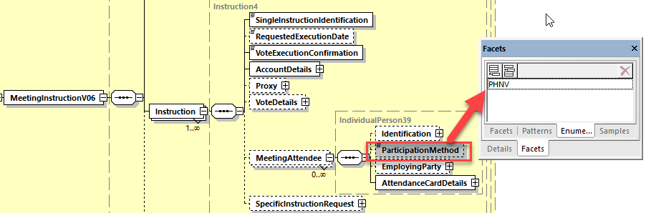

1. In the seev.004 (MEIN – MeetingInstruction) message, in the ***Instruction*** message building block, in the data type ***DeliveryPlace1Code*** of the message element ***DeliveryMethod*** in both sequences ***Proxy/PersonDetails/AttendanceCardDetails*** and ***MeetingAttendee/AttendanceCardDetails***, add the new code value EMAL (Email – “Card needs to be sent via email”).

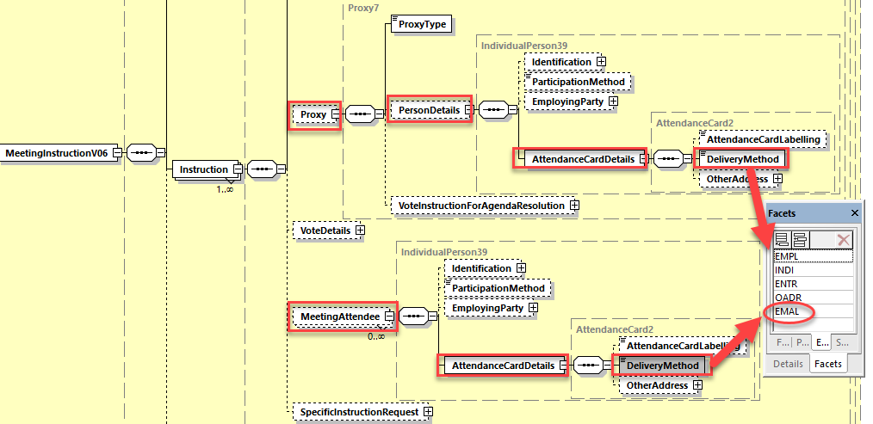

1. In the seev.006 (MEIS – MeetingInstructionStatus) message, in the ***InstructionTypeStatus*** message building block, add a new processing status code ***ATTC (Attendance Confirmed*** – “Attendance is confirmed at the meeting”.) to the data type ***Status8Code*** typing the message element ***Status*** in the sequence ***InstructionStatus/DetailedInstructionStatus/InstructionStatus/ProcessingStatus***.

Additionally, in the sequence I***nstructionStatus/DetailedInstructionStatus/InstructionStatus/ProcessingStatus***, add a new optional and non-repeatable element ***AttendanceCardNumber*** typed by ***Max35Text*** to provide the number of the admission ticket that has been granted by the custodian or the issuer.

Additionally, in the sequence I***nstructionStatus/DetailedInstructionStatus/InstructionStatus/ProcessingStatus***, add a new cross element rule (if possible) ***AttendanceCardNumber1Rule*** so that the element AttendanceCardNumber may only be present if the Status code value is “ATTC” (Attendance Confirmed).

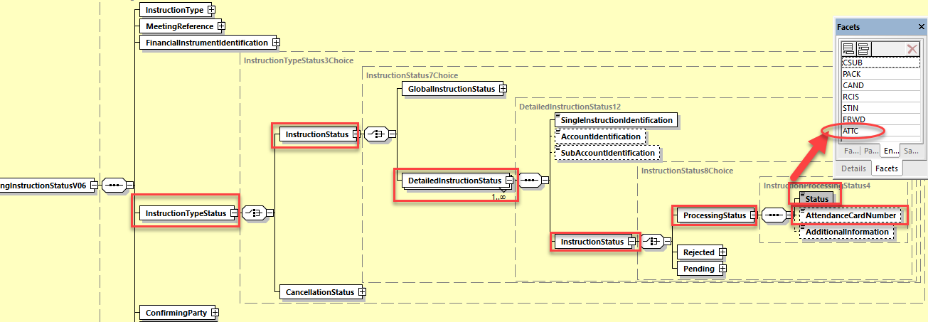

## Proposed timing:

The submitting organization confirms that it can implement the requested changes in the requested timing

|  |  |
| --- | --- |
| Timing | * As requested |

## Final decision of the SEG(s):

|  |  |
| --- | --- |
| Approve | X |

Comments:

|  |  |
| --- | --- |
| Reject |  |

Reason for rejection:

# CR0882: Add New Shareholder Registration Completed Processing Status Code in Instruction Status

1. **Origin of the request:**

*A.1 Submitter*: SMPG (Securities Market Practice Group)

*A.2 Contact person:*

Christine Strandberg: [christine.strandberg@seb.se](mailto:christine.strandberg@seb.se) - +46 (8) 763 60 74

Mariangela Fumagalli: [mariangela.fumagalli@bnpparibas.com](mailto:mariangela.fumagalli@bnpparibas.com) - +442075954988

Jacques Littré: [jacques.littre@swift.com](mailto:jacques.littre@swift.com) - +3226554335

*A.3 Sponsors*:

Securities Market Practice Group

1. **Related messages:**

seev.006.001.06

1. **Description of the change request:**

Add a new processing status code for “Shareholder Registration Completed” for the element “Status” in sequence “InstructionTypeStatus/InstructionStatus/DetailedIInstructionStatus/InstructionStatus/ProcessingStatus”.

1. **Purpose of the change:**

A status which allows to confirm that the rights holder has been registered to participate to the meeting is missing in the message.

1. **Urgency of the request:**

For SR2021*.*

1. **Business examples:**

N/A

1. **SEG/TSG recommendation:**

*This section is not to be taken care of by the submitter of the change request. It will be completed in due time by the SEG(s) in charge of the related ISO 20022 messages or the TSG for changes related to the BAH.*

|  |  |  |  |
| --- | --- | --- | --- |
| **Consider** | |  | **Timing** |
|  | | - **Next yearly cycle: 2020/2021**  (the change will be considered for implementation in the yearly maintenance cycle which starts in 2020 and completes with the publication of new message versions in the spring of 2021) | | X |
|  | | - **At the occasion of the next maintenance of the messages**  (the change will be considered for implementation, but does not justify maintenance of the messages in its own right – will be pending until more critical change requests are received for the messages) | |  |
|  | | - **Urgent unscheduled**  (the change justifies an urgent implementation outside of the normal yearly cycle) | |  |  |
|  | | - **Other timing:** | | |  |

Comments:

|  |  |
| --- | --- |
| **Reject** |  |

Reason for rejection:

1. **Impact analysis:**

This change request impacts the following messages:

seev.006.001.06 MeetingInstructionStatusV06

1. **Proposed implementation:**

In the seev.006 (MEIS – MeetingInstructionStatus) message, in the ***InstructionTypeStatus*** message building block, add a new processing status code ***REGM (Registered To Participate at Meeting*** – “Rights holder has been registered to participate to the meeting”.) to the data type ***Status8Code*** typing the message element ***Status*** in the sequence ***InstructionStatus/DetailedInstructionStatus/InstructionStatus/ProcessingStatus***.

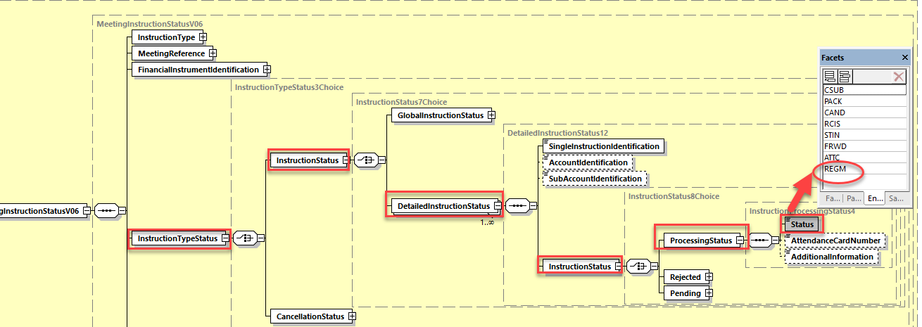

## Proposed timing:

The submitting organization confirms that it can implement the requested changes in the requested timing

|  |  |
| --- | --- |
| Timing | * As requested |

## Final decision of the SEG(s):

|  |  |
| --- | --- |
| Approve | X |

Comments:

|  |  |
| --- | --- |
| Reject |  |

Reason for rejection:

# CR0886: Remove multiplicity on InstructedPosition in Instruction Cancelation

1. **Origin of the request:**

*A.1 Submitter*: SMPG (Securities Market Practice Group)

*A.2 Contact person:*

Christine Strandberg: [christine.strandberg@seb.se](mailto:christine.strandberg@seb.se) - +46 (8) 763 60 74

Mariangela Fumagalli: [mariangela.fumagalli@bnpparibas.com](mailto:mariangela.fumagalli@bnpparibas.com) - +442075954988

Jacques Littré: [jacques.littre@swift.com](mailto:jacques.littre@swift.com) - +3226554335

*A.3 Sponsors*:

Securities Market Practice Group

1. **Related messages:**

seev.005.001.06

1. **Description of the change request:**

In the “ToBeCancelledInstruction” sequence, remove the multiplicity of the element “InstructedPosition”.

1. **Purpose of the change:**

The “ToBeCancelledInstruction” sequence was added in the SR2020 release with the Change request CR17. However, the change request was not implemented correctly as the element “InstructedPosition” was left repeatable whilst the change request specified that this element should be optional and non-repeatable.

1. **Urgency of the request:**

For SR2021*.*

1. **Business examples:**

N/A

**SEG/TSG recommendation:**

*This section is not to be taken care of by the submitter of the change request. It will be completed in due time by the SEG(s) in charge of the related ISO 20022 messages or the TSG for changes related to the BAH.*

|  |  |  |  |
| --- | --- | --- | --- |
| **Consider** | |  | **Timing** |
|  | | - **Next yearly cycle: 2020/2021**  (the change will be considered for implementation in the yearly maintenance cycle which starts in 2020 and completes with the publication of new message versions in the spring of 2021) | | X |
|  | | - **At the occasion of the next maintenance of the messages**  (the change will be considered for implementation, but does not justify maintenance of the messages in its own right – will be pending until more critical change requests are received for the messages) | |  |
|  | | - **Urgent unscheduled**  (the change justifies an urgent implementation outside of the normal yearly cycle) | |  |  |
|  | | - **Other timing:** | | |  |

Comments:

|  |  |
| --- | --- |
| **Reject** |  |

Reason for rejection:

1. **Impact analysis:**

This change request impacts the following messages:

seev.005.001.06 MeetingInstructionCancellationRequestV06

1. **Proposed implementation:**

In the **seev.005** (MEIC – MeetingInstructionCancellationRequest) message, in the ***ToBeCancelledInstruction*** message building block, change the multiplicity of the sequence ***InstructedPosition*** to [0..1].

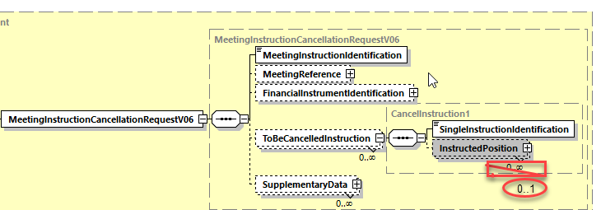

## Proposed timing:

The submitting organization confirms that it can implement the requested changes in the requested timing

|  |  |
| --- | --- |
| Timing | * As requested |

## Final decision of the SEG(s):

|  |  |
| --- | --- |
| Approve | X |

Comments:

|  |  |
| --- | --- |
| Reject |  |

Reason for rejection:

# CR0880: Remove GlobalInstructionStatus in Instruction Status

1. **Origin of the request:**

*A.1 Submitter*: SMPG (Securities Market Practice Group)

*A.2 Contact person:*

Christine Strandberg: [christine.strandberg@seb.se](mailto:christine.strandberg@seb.se) - +46 (8) 763 60 74

Mariangela Fumagalli: [mariangela.fumagalli@bnpparibas.com](mailto:mariangela.fumagalli@bnpparibas.com) - +442075954988

Jacques Littré: [jacques.littre@swift.com](mailto:jacques.littre@swift.com) - +3226554335

*A.3 Sponsors*:

Securities Market Practice Group

1. **Related messages:**

seev.006.001.06

1. **Description of the change request:**

Remove the Global Status sequence “InstructionTypeStatus/InstructionStatus/GlobalInstructionStatus”.

1. **Purpose of the change:**

Processing wise, it is not deemed safe to provide a global status on a multiplicity of individual instructions.

1. **Urgency of the request:**

For SR2021*.*

1. **Business examples:**

N/A

1. **SEG/TSG recommendation:**

*This section is not to be taken care of by the submitter of the change request. It will be completed in due time by the SEG(s) in charge of the related ISO 20022 messages or the TSG for changes related to the BAH.*

|  |  |  |  |
| --- | --- | --- | --- |
| **Consider** | |  | **Timing** |
|  | | - **Next yearly cycle: 2018/2019**  (the change will be considered for implementation in the yearly maintenance cycle which starts in 2018 and completes with the publication of new message versions in the spring of 2019) | | X |
|  | | - **At the occasion of the next maintenance of the messages**  (the change will be considered for implementation, but does not justify maintenance of the messages in its own right – will be pending until more critical change requests are received for the messages) | |  |
|  | | - **Urgent unscheduled**  (the change justifies an urgent implementation outside of the normal yearly cycle) | |  |  |
|  | | - **Other timing:** | | |  |

Comments:

|  |  |
| --- | --- |
| **Reject** |  |

Reason for rejection:

1. **Impact analysis:**

This change request impacts the following messages:

seev.006.001.06 MeetingInstructionStatusV06

1. **Proposed implementation:**

In the **seev.006** (MEIS – MeetingInstructionStatus) message, in the ***InstructionTypeStatus*** message building block, delete the ***GlobalInstructionStatus*** sequence in the ***InstructionStatus*** sequence and change the type of the ***InstructionStatus*** by the ***DetailedInstructionStatus12*** message component and set the ***InstructionStatus*** as repeatable from 1 to N.

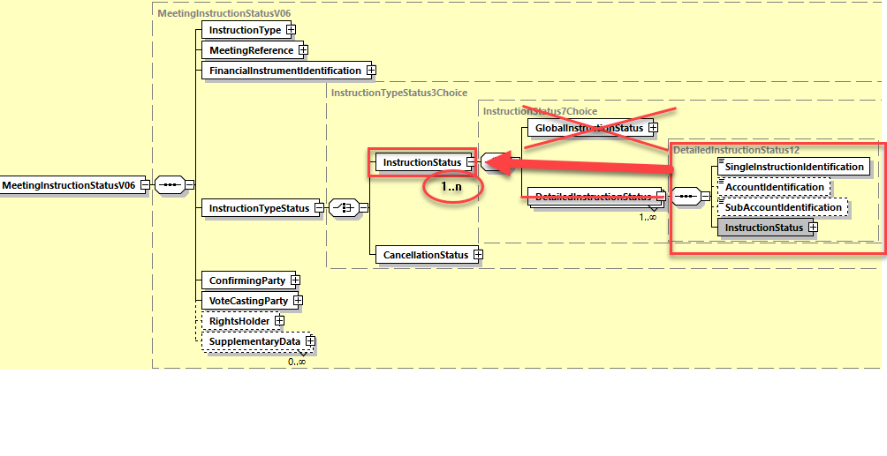

## Proposed timing:

The submitting organization confirms that it can implement the requested changes in the requested timing

|  |  |
| --- | --- |
| Timing | * As requested |

## Final decision of the SEG(s):

|  |  |
| --- | --- |
| Approve | X |

Comments:

|  |  |
| --- | --- |
| Reject |  |

Reason for rejection:

# CR0881: Amend Definition of RCIS Code In Instruction Status

1. **Origin of the request:**

*A.1 Submitter*: SMPG (Securities Market Practice Group)

*A.2 Contact person:*

Christine Strandberg: [christine.strandberg@seb.se](mailto:christine.strandberg@seb.se) - +46 (8) 763 60 74

Mariangela Fumagalli: [mariangela.fumagalli@bnpparibas.com](mailto:mariangela.fumagalli@bnpparibas.com) - +442075954988

Jacques Littré: [jacques.littre@swift.com](mailto:jacques.littre@swift.com) - +3226554335

*A.3 Sponsors*:

Securities Market Practice Group

1. **Related messages:**

seev.006.001.06

1. **Description of the change request:**

In the status code of the Status element in the sequence “InstructionTypeStatus/InstructionStatus/GlobalInstructionStatus/ProcessingStatus” and in sequence “InstructionTypeStatus/InstructionStatus/DetailedInstructionStatus/InstructionStatus/ProcessingStatus”, amend the definition of the RCIS (ReceivedByIssuerOrRegistrar) code so as to read: “Instruction has been received by the issuer, equivalent to the confirmation of receipt of votes cast electronically.”

1. **Purpose of the change:**

In the SR2020 release of GM in change request CR18, the definition of the RCIS code was supposed to be amended, however this change was not implemented correctly.

1. **Urgency of the request:**

For SR2021*.*

1. **Business examples:**

N/A

1. **SEG/TSG recommendation:**

*This section is not to be taken care of by the submitter of the change request. It will be completed in due time by the SEG(s) in charge of the related ISO 20022 messages or the TSG for changes related to the BAH.*

|  |  |  |  |
| --- | --- | --- | --- |
| **Consider** | |  | **Timing** |
|  | | - **Next yearly cycle: 2020/2021**  (the change will be considered for implementation in the yearly maintenance cycle which starts in 2020 and completes with the publication of new message versions in the spring of 2021) | | X |
|  | | - **At the occasion of the next maintenance of the messages**  (the change will be considered for implementation, but does not justify maintenance of the messages in its own right – will be pending until more critical change requests are received for the messages) | |  |
|  | | - **Urgent unscheduled**  (the change justifies an urgent implementation outside of the normal yearly cycle) | |  |  |
|  | | - **Other timing:** | | |  |

Comments:

|  |  |
| --- | --- |
| **Reject** |  |

Reason for rejection:

1. **Impact analysis:**

This change request impacts the following messages:

seev.006.001.06 MeetingInstructionStatusV06

1. **Proposed implementation:**

In the **seev.006** (MEIS – MeetingInstructionStatus) message, in the ***InstructionTypeStatus*** message building block, amend the textual description of the ***RCIS*** code (ReceivedByIssuerOrRegistrar) in the Status8Code typing the elements ***InstructionStatus/DetailedInstructionStatus/InstructionStatus/ProcessingStatus/Status*** and ***InstructionStatus/GlobalInstructionStatus/ProcessingStatus/Status*** so as to read: “*Instruction has been received by the issuer, equivalent to the confirmation of receipt of votes cast electronically.”*

## Proposed timing:

The submitting organization confirms that it can implement the requested changes in the requested timing

|  |  |
| --- | --- |
| Timing | * As requested |

## Final decision of the SEG(s):

|  |  |
| --- | --- |
| Approve | X |

Comments:

|  |  |
| --- | --- |
| Reject |  |

Reason for rejection:

# CR0861: Make Proprietary in VoteResult Repeatable In Vote Results Dissemination Message

1. **Origin of the request:**

*A.1 Submitter*: SMPG (Securities Market Practice Group)

*A.2 Contact person:*

Christine Strandberg: [christine.strandberg@seb.se](mailto:christine.strandberg@seb.se) - +46 (8) 763 60 74

Mariangela Fumagalli: [mariangela.fumagalli@bnpparibas.com](mailto:mariangela.fumagalli@bnpparibas.com) - +442075954988

Jacques Littré: [jacques.littre@swift.com](mailto:jacques.littre@swift.com) - +3226554335

*A.3 Sponsors*:

Securities Market Practice Group

1. **Related messages:**

seev.008.001.06

1. **Description of the change request:**

In the sequence “VoteResult”, set the element “Proprietary” as repeatable (up to 4 times at least).

1. **Purpose of the change:**

In the SR2020 release of GM in change request CR22, the multiplicity of that element was not implemented correctly.

1. **Urgency of the request:**

For SR2021*.*

1. **Business examples:**

N/A

1. **SEG/TSG recommendation:**

*This section is not to be taken care of by the submitter of the change request. It will be completed in due time by the SEG(s) in charge of the related ISO 20022 messages or the TSG for changes related to the BAH.*

|  |  |  |  |
| --- | --- | --- | --- |
| **Consider** | |  | **Timing** |
|  | | - **Next yearly cycle: 2020/2021**  (the change will be considered for implementation in the yearly maintenance cycle which starts in 2020 and completes with the publication of new message versions in the spring of 2021) | | X |
|  | | - **At the occasion of the next maintenance of the messages**  (the change will be considered for implementation, but does not justify maintenance of the messages in its own right – will be pending until more critical change requests are received for the messages) | |  |
|  | | - **Urgent unscheduled**  (the change justifies an urgent implementation outside of the normal yearly cycle) | |  |  |
|  | | - **Other timing:** | | |  |

Comments:

|  |  |
| --- | --- |
| **Reject** |  |

Reason for rejection:

1. **Impact analysis:**

This change request impacts the following messages:

seev.008.001.06 MeetingResultDisseminationV06

1. **Proposed implementation:**

In the seev.008 (MERD – MeetingResultDisemination) message, in the ***VoteResult*** message building block, set the multiplicity of the ***Proprietary*** element to (0..4).

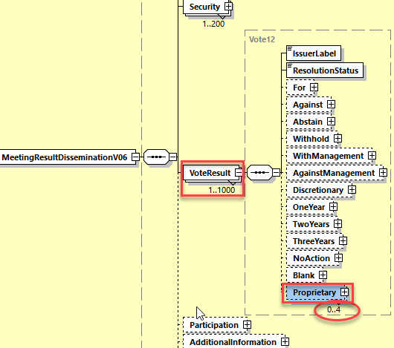

## Proposed timing:

The submitting organization confirms that it can implement the requested changes in the requested timing

|  |  |
| --- | --- |
| Timing | * As requested |

## Final decision of the SEG(s):

|  |  |
| --- | --- |
| Approve | X |

Comments:

|  |  |
| --- | --- |
| Reject |  |

Reason for rejection: