Maintenance Change Request
for the update of ISO 20022 financial repository items
Note: the purpose of this document is to give guidelines to submitting organizations that will develop a new version of existing ISO 20022 messages based on change requests screened by the Standards Evaluation Group(s). Such development is subject to the approval of a Maintenance Change Request which must include a detailed description of the impact of each change on the related messages. The Maintenance Change Request must start with a general chapter covering topics related to the whole maintenance effort and a specific chapter for each change request, as described below. Please consult the iso20022.org website for additional details on the maintenance process. Valid Maintenance Change Requests for the following ISO 20022 yearly maintenance cycle must be sent to iso20022ra@iso20022.org by August 21st.
- Name of the request:
CAPE Messages Maintenance for year 2020-2021

Change request number 0743 - Nexo catm BeforeAction 5
Change request number 0863 - Nexo caaa LocationCategoryCode 13
Change request number 0864 - Nexo caaa Reconciliation 20
Change request number 0866 - Nexo caaa Technical Error in Response Code 29
Change request number 0867 - Nexo caaa TokenHarmonization 35
Change request number 0868 - Nexo casp Device Play Sound Request 45
Change request number 0869 - Nexo casp Response Code 53
Change request number 0870 – Nexo casp Reversal Request 59
Change request number 0871 – Nexo catm Harmonization Of Names Length 64
Change request number 0872 – Nexo catm New Acquirer Messages 84
Change request number 0873 – Nexo catm POI Group 105
Change request number 0874 – Nexo catm Process Timing 110
Change request number 0875 – Nexo catm Reservation Settings 116
Change request number 0876 – Nexo catm Sale To POI Parameters 122
Change request number 0877 – Nexo catm Split Message 127
Modifications done during repository update. 141

- Submitting organization(s):
nexo A. I. S. B. L. (formerly EPASOrg).

- Related messages:

- AcceptorAuthorisationRequestV09 (caaa.001.001.09)
- AcceptorAuthorisationResponseV09 (caaa.002.001.09)
- AcceptorBatchTransferResponseV08 (caaa.012.001.08)
- AcceptorBatchTransferV09 (caaa.011.001.09)
- AcceptorCancellationAdviceResponseV08 (caaa.008.001.08)
- AcceptorCancellationAdviceV09 (caaa.007.001.09)
- AcceptorCancellationRequestV09 (caaa.005.001.09)
- AcceptorCancellationResponseV08 (caaa.006.001.08)
- AcceptorCompletionAdviceResponseV08 (caaa.004.001.08)
- AcceptorCompletionAdviceV09 (caaa.003.001.09)
- AcceptorCurrencyConversionAdviceResponseV03 (caaa.019.001.03)
- AcceptorCurrencyConversionAdviceV04 (caaa.018.001.04)
- AcceptorCurrencyConversionRequestV07 (caaa.016.001.07)
- AcceptorCurrencyConversionResponseV07 (caaa.017.001.07)
- AcceptorDiagnosticRequestV08 (caaa.013.001.08)
- AcceptorDiagnosticResponseV07 (caaa.014.001.07)
- AcceptorReconciliationRequestV08 (caaa.009.001.08)
- AcceptorReconciliationResponseV07 (caaa.010.001.07)

- TransactionAdviceV01 (caaa.020.001.01)
- TransactionAdviceResponseV01 (caaa.021.001.01)
- AcceptorNonFinancialRequestV01 (caaa,022.001.01) : New
- AcceptorNonFinancialResponseV01 (caaa.023.001.01) : New

- AcceptorConfigurationUpdateV09 (catm.003.001.09)
- CertificateManagementRequestV03 (catm.007.001.03)
- CertificateManagementResponseV03 (catm.008.001.03)
- MaintenanceDelegationRequestV06 (catm.005.001.06)
- MaintenanceDelegationResponseV04 (catm.006.001.04)
- ManagementPlanReplacementV08 (catm.002.001.08)
- StatusReportV09 (catm.001.001.09)

- SaleToPOIAbortV02 (casp.011.001.02)
- SaleToPOIAdministrativeRequestV02 (casp.007.001.02)
- SaleToPOIAdministrativeResponseV02 (casp.008.001.02)
- SaleToPOIDeviceRequestV02 (casp.016.001.02)
- SaleToPOIDeviceResponseV02 (casp.017.001.02)
- SaleToPOIEventNotificationV02 (casp.012.001.02)

- SaleToPOIMessageStatusRequestV02 (casp.014.001.02)
- SaleToPOIMessageStatusResponseV02 (casp.015.001.02)
- SaleToPOIReconciliationRequestV02 (casp.003.001.02)
- SaleToPOIReconciliationResponseV02 (casp.004.001.02)
- SaleToPOIReportRequestV02 (casp.009.001.02)
- SaleToPOIReportResponseV02 (casp.010.001.02)
- SaleToPOIServiceReuestV02 (casp.001.001.02)
- SaleToPOIServiceResponseV02 (casp.002.001.02)
- SaleToPOISessionManagementRequestV02 (casp.005.001.02)
- SaleToPOISessionManagementResponseV02 (casp.006.001.02)

- Commitments of the submitting organization:
nexo confirms that it can and will:
undertake the development of the new version of the candidate ISO 20022 message models that it will submit to the RA for compliance review and evaluation.
submit new valid Message Definition models to the RA by December 1.
provide a new version of part 1 of the Message Definition Report (MDR) by December 1, and, new examples of valid message instances of each candidate message by May 1 at the latest.
address any queries related to the description of the new models and messages as published by the RA on the ISO 20022 website.

nexo intends to support any testing or the actual implementation of the new version of the messages once the related documentation has been published by the RA. The purpose is to ensure that the documentation of the new version of the messages is accurate and consistent and to verify that these approved messages can be implemented with no adverse effects on communication infrastructures and/or applications.
nexo confirms its knowledge and acceptance of the ISO 20022 Intellectual Property Rights policy for contributing organizations, as follows.
“Organizations that contribute information to be incorporated into the ISO 20022 Repository shall keep any Intellectual Property Rights (IPR) they have on this information. A contributing organization warrants that it has sufficient rights on the contributed information to have it published in the ISO 20022 Repository through the ISO 20022 Registration Authority in accordance with the rules set in ISO 20022. To ascertain a widespread, public and uniform use of the ISO 20022 Repository information, the contributing organization grants third parties a non-exclusive, royalty-free license to use the published information”.

In the analysis made on the following pages, nexo highlights ripple effect in red and component changed by a previous Change Request in green in every impact analysis. In each chapter devoted to the implementation study, nexo presents the resulting implementation of all Change Request with respect to the legend presented below.

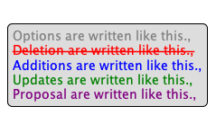

- Contact persons:
The submitting organization will identify the person(s) at the submitting organization that can be contacted to get additional information on this Maintenance Change Request.

- Philippe CECE (philippe.cece@ingenico.com), +33 6 84 42 93 14
- Pierre MOURA (pierre.moura@frenchsys.com), +33 1 40 15 58 92
- Philippe MERMOUD (philippe.mermoud@natixis.com), + 33 5 61 10 25 80
- Bruno AIELLO (brunoa9@verifone.com), +33 1 78 74 28 30

Change request number 0743 - Nexo catm BeforeAction
This chapter must be completed for every change request that the submitting organization has been requested to implement.
Copy of the approved change request:
This is a copy of sections A to G of the change request approved by the SEG for further consideration as communicated to the submitting organization by the RA.

Origin of the request:

A.1 Submitter: nexo A.I.S.B.L

A.2 Contact person:
Philippe CECE (Philippe.cece@ingenico.com) / Pierre PETITCUENOT (pierre.petitcuenot@e-i.com)

A.3 Sponsors: nexo A.I.S.B.L.

Related messages:
ManagementPlanReplacement V07 (catm.002.001.07)

Description of the change request:
Inside TMSAction7 data element add data elements:
- MessageToPresent as an ActionMessage2

In the TerminalManagementAction4Code add new value:
- Display (DISP)
- Input (INPT)
- Play (PLAY)
- Print (PRNT)
- Read (READ)
- Send (SEND)

Purpose of the change:

Currently there is no way through the catm protocol to print or display a message before or after an action.
The proposal here aims to fill this gap and providing additional actions.

Urgency of the request:
Not urgent.

Business examples:

SEG/TSG recommendation:
This section is not to be taken care of by the submitter of the change request. It will be completed in due time by the SEG(s) in charge of the related ISO 20022 messages or the TSG for changes related to the BAH.

Consider |  | X | Timing
 |  |  | - Next yearly cycle: 2020/2021  (the change will be considered for implementation in the yearly maintenance cycle which starts in 2020 and completes with the publication of new message versions in the spring of 2021) |  | X
- At the occasion of the next maintenance of the messages
(the change will be considered for implementation, but does not justify maintenance of the messages in its own right – will be pending until more critical change requests are received for the messages)
- Urgent unscheduled
(the change justifies an urgent implementation outside of the normal yearly cycle)
 |  |  | - Other timing:
Comments:

Reject
Reason for rejection:

Impact analysis and type of impact:

After a long study, we believe that it would be more efficient and evolution oriented to back the solution on a existing component of the Sale to POI protocol (casp).

Consequently the idea is to be able to trig a SaleToPOI message, in this case the DeviceRequest, which already supports all these options. Since this command provides more than needed, restrictions will be defined and setby the MUG.

This will create modifications in :
- TerminalManagementAction4Code
- TMSAction8
- TMSEvent7

The analysis of the ripple effect provide the following result:

On TerminalManagementAction4Code
- Used in
  - TMSAction7 : No more used in V9 replaced by TMSAction8
  - TMSAction8
  - TMSActionIdentification5 : No more used in V9 replaced by TMSActionIdentification6
  - TMSActionidentification6
- MaintenanceDelegationRequestV06
  - MaintenanceDelegationRequest6
    - MaintenanceDelegation10
      - MaintenanceDelegateAction5
        - TMSAction8
          - TerminalManagementAction4Code
- ManagementPlanReplacementV08
  - ManagementPlan8
    - TerminalManagementDataSet29
      - ManagementPlanContent8
        - TMSAction8
          - TerminalManagementAction4Code.
- SaleToPOISessionManagementResponseV02
  - SessionManagementResponse3
    - DiagnosisResponse2
      - StatusReportContent9
        - TMSEvent7
          - TMSActionIdentification6
            - TerminalManagementAction4Code
- StatusReportV09
  - StatusReport9
    - StatusReportDataSetRequest1
      - StatusReportContent9
        - TMSEvent7
          - TMSActionIdentification6
            - TerminalManagementAction4Code

On TMSAction8
Done with the previous data element, since TerminalAction4Code is a subElement.

On TMSEvent7
Done previously, since TerminalAction4Code is a subElement.

The severity of the impact of the proposed change for the message users should be indicated in the table below (either “no impact”, “conditional’ or “mandatory”).
Type of impact
 | No impact | The change(s) will not impact the schema (the version number will not change) and will not impact the business applications of any users, e.g. the clarification of a definition
X | Conditional | The change(s) will impact the schema (at least the version number) and the business applications of certain users but not all, e.g. the addition of an optional component
 | Mandatory | The change(s) will impact the schema and the business applications of all users, e.g. addition of a mandatory component.

Proposed implementation:

So the TerminalManagementAction4Code will be updated to add the option DeviceRequest identified with the codeset value DEVR and defined as Request to execute a device request. Then the TMSAction8 will be updated by upgrading the message component Type from TerminalManagementAction4Code to a new one, and adding the message component DeviceRequest defined as Information related to a device request of the POI with multiplicity [0,1] and type DeviceRequest2 or better.

Finally the TMSEvent7 message component is updated by adding a message element DeviceResponse defined as with multiplicity [0,1] and type DeviceResponse2 or better, and by upgrading the message element ActionIdentification to an enhanced TMSActionIdentification6 since the message element ActionType of this component must be upgraded to the enhanced TerminalManagementAction4Code.

These modifications are highlighted by the following diagrams.

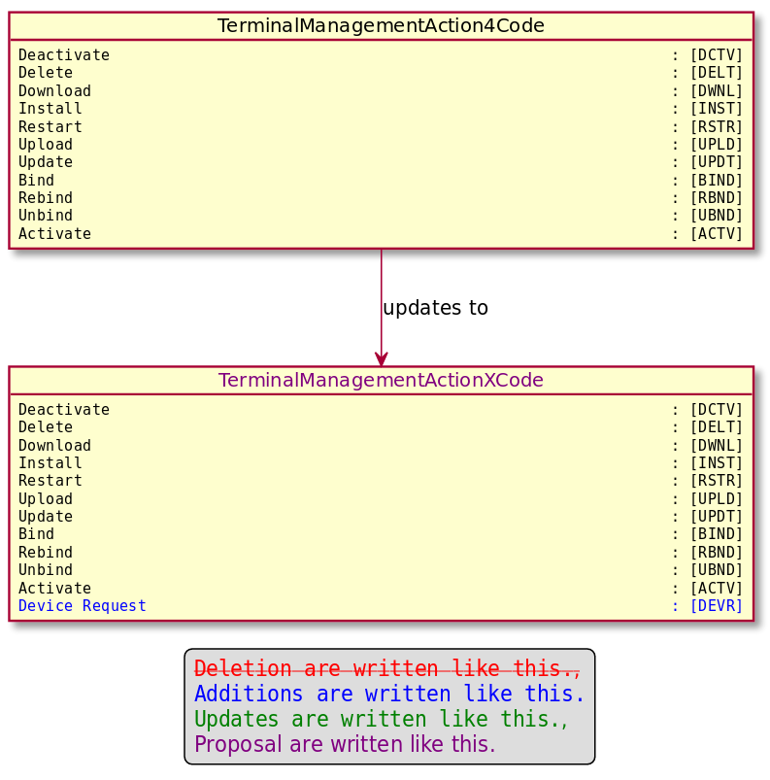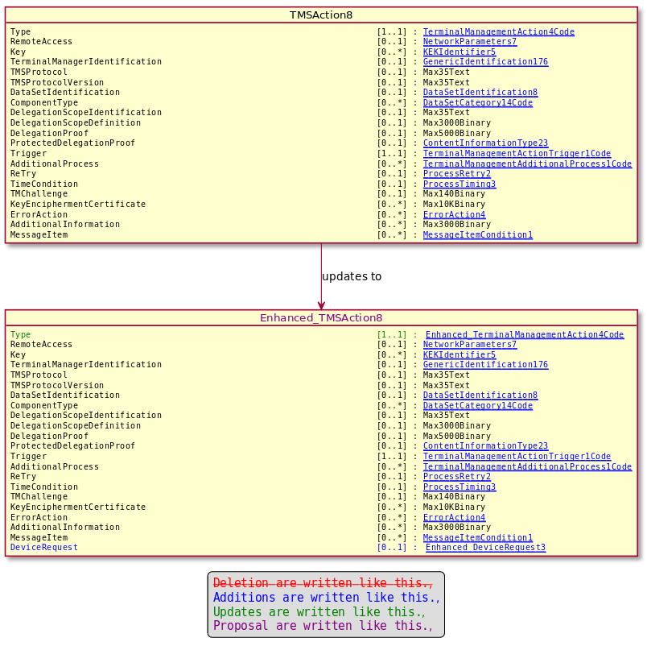

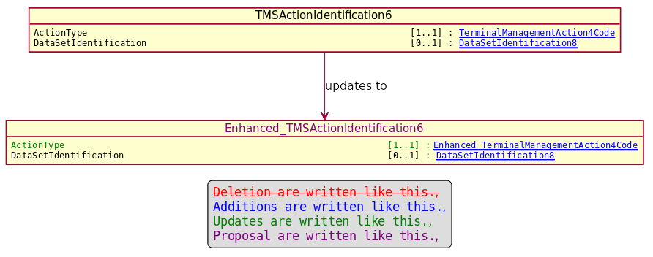

Proposed timing:
The submitting organization confirms that it can implement the requested changes in the requested timing, or, if not, proposes another timing.

Timing | - As requested
 | - Other:

Final decision of the SEG(s):
This section is not to be taken care of by the submitting organization. It will be completed in due time by the SEG(s) in charge of the related ISO 20022 messages.
Approve
Comments:

Reject
Reason for rejection:

Change request number 0863 - Nexo caaa LocationCategoryCode

Copy of the approved change request:

Origin of the request:
A.1 Submitter: nexo A.I.S.B.L.
A.2 Contact person: Philippe CECE (Philippe.cece@ingenico.com) / Pierre MOURA (pierre.moura@frenchsys.com) / Bruno AIELLO (Bruno.Aiello@VERIFONE.com) / Philippe MERMOUD (philippe.mermoud@natixis.com)
A.3 Sponsors: nexo A.I.S.B.L.

Related messages:

For the caaa related messages:
- AcceptorAuthorisationRequest V09 caaa.001.001.09
- AcceptorAuthorisationResponse V09 caaa.002.001.09
- AcceptorCompletionAdvice V09 caaa.003.001.09
- AcceptorCompletionAdviceResponse V08 caaa.004.001.08
- AcceptorCancellationRequest V09 caaa.005.001.09
- AcceptorCancellationResponse V08 caaa.006.001.08
- AcceptorCancellationAdvice V09 caaa.007.001.09
- AcceptorCancellationAdviceResponse V08 caaa.008.001.08
- AcceptorReconciliationRequest V08 caaa.009.001.08
- AcceptorReconciliationResponse V07 caaa.010.001.07
- AcceptorBatchTransfer V09 caaa.011.001.09
- AcceptorBatchTransferResponse V08 caaa.012.001.08
- AcceptorDiagnosticRequest V08 caaa.013.001.08
- AcceptorDiagnosticResponse V07 caaa.014.001.07
- AcceptorCurrencyConversionRequest V07 caaa.016.001.07
- AcceptorCurrencyConversionResponse V07 caaa.017.001.07
- AccpetorCurrencyConversionAdvice V04 caaa.018.001.04
- AcceptorCurrencyConversionAdviceResponse V03 caaa.019.001.03
- TransactionAdvice V01 caaa.020.001.01
- TransactionAdviceResponse V01 caaa.021.001.01

For the casp related messages:
- SaleToPOIServiceRequest V02 casp 001.001.02
- SaleToPOIServiceResponse V02 casp 002.001.02
- SaleToPOIReconciliationRequest V02 casp 003.001.02
- SaleToPOIReconciliationResponse V02 casp 004.001.02
- SaleToPOISessionManagementRequest V02 casp 005.001.02
- SaleToPOISessionManagementResponse V02 casp 006.001.02
- SaleToPOIAdministrativeRequest V02 casp 007.001.02
- SaleToPOIAdministrativeResponse V02 casp 008.001.02
- SaleToPOIReportRequest V02 casp 009.001.02
- SaleToPOIReportResponse V02 casp 010.001.02
- SaleToPOIAbort V02 casp 011.001.02
- SaleToPOIEventNotification V02 casp 012.001.02
- SaleToPOIMessageStatusRequest V02 casp 014.001.02
- SaleToPOIMessageStatusResponse V02 casp 015.001.02
- SaleToPOIDeviceRequest V02 casp 016.001.02
- SaleToPOIDeviceResponse V02 casp 017.001.02

Description of the change request:

We would like to change the coding of LocationCategory1Code to avoid any misunderstanding and covering new use cases.

Purpose of the change:

The code set value FIXED wasn't clearly understood and the codeset MOTO created misunderstanding with the TransactionChannel. So in order to remove any misunderstanding and also provide a codeset for e-commerce solution, we would like to change the values of LocationCategory1Code with the following proposal.

The updated messages are listed in a bold green font in the following diagram. Impacts on the RetailerProtocol have been also identified.

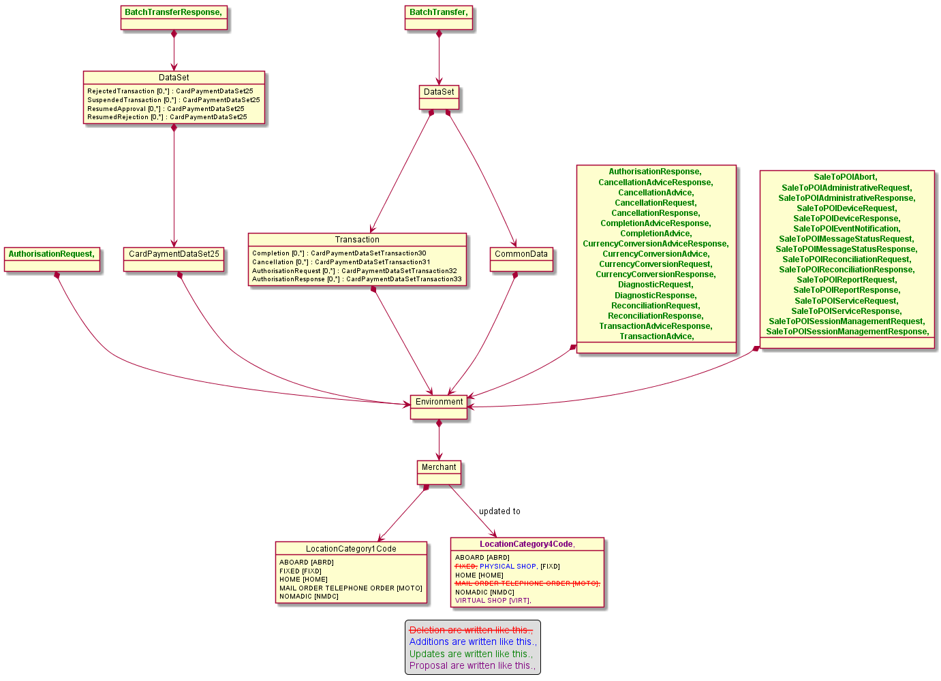

Urgency of the request:

Urgent.

Business examples:
Examples illustrating the change request.

SEG/TSG recommendation:
This section is not to be taken care of by the submitter of the change request. It will be completed in due time by the SEG(s) in charge of the related ISO 20022 messages or the TSG for changes related to the BAH.

Consider |  | X | Timing
 |  |  | - Next yearly cycle: 2020/2021  (the change will be considered for implementation in the yearly maintenance cycle which starts in 2020 and completes with the publication of new message versions in the spring of 2021) |  | X
- At the occasion of the next maintenance of the messages
(the change will be considered for implementation, but does not justify maintenance of the messages in its own right – will be pending until more critical change requests are received for the messages)
- Urgent unscheduled
(the change justifies an urgent implementation outside of the normal yearly cycle)
 |  |  | - Other timing:
Comments:
Card SEG Comment dated 25/06/2020: Codes to be reconsidered to avoid misunderstandings. Nexo Acquirer Protocol TWG should involve TG1 for a common solution.

Reject
Reason for rejection:

Impact analysis and type of impact:

After an internal review and exchanges with the CardSEG and the TG1 Group, we slighty change our mind.
First as agreed with TG1 group, since LocationCategoryCode is not used in the ATTICA protocol, there is no need for common definitions.
Second, we will also remove the codeset value HOME. We don’t need it in the repository since we could retrieve the information with VIRTUAL_SHOP and EntryMode set to CICC.

Some defintion of codesets will be changed to the following ones:
- Nomadic is used when the merchant is traveling to different locations (e.g fair or sport events, home delivery, food truck)
- Aboard is used when the sale is done in a vehicle (e.g a bus, train, ship, airplane, taxi, etc)

Regarding the Ripple Effect of this modification, we know that :
- LocationCategory1Code is used by
  - Organisation32 which is used by
    - CardPaymentEnvironment74
    - CardPaymentEnvironment75

These last 2 components are modified by CR_0867, so the ripple effect of these 2 elements will be review in CR_0867.

Since we are changing Codeset values, the impact is important.
The severity of the impact of the proposed change for the message users should be indicated in the table below (either “no impact”, “conditional’ or “mandatory”).
Type of impact
 | No impact | The change(s) will not impact the schema (the version number will not change) and will not impact the business applications of any users, e.g. the clarification of a definition
 | Conditional | The change(s) will impact the schema (at least the version number) and the business applications of certain users but not all, e.g. the addition of an optional component
X | Mandatory | The change(s) will impact the schema and the business applications of all users, e.g. addition of a mandatory component.

Proposed implementation:

Then the LocationCategory1Code will be changed to the following structure :
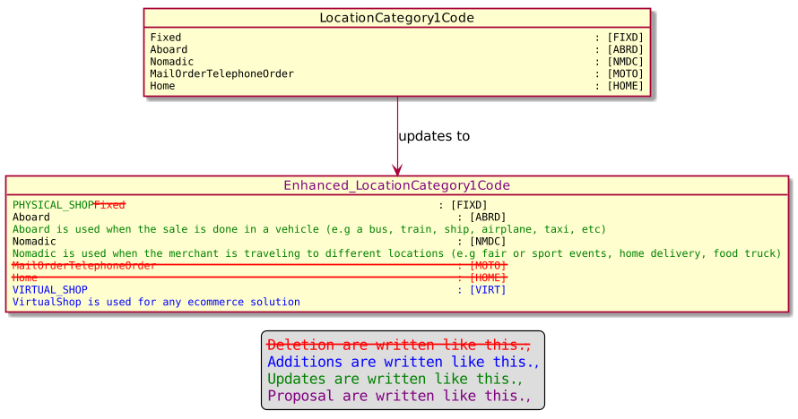

And the Organisation32 will be updated accrodingly.

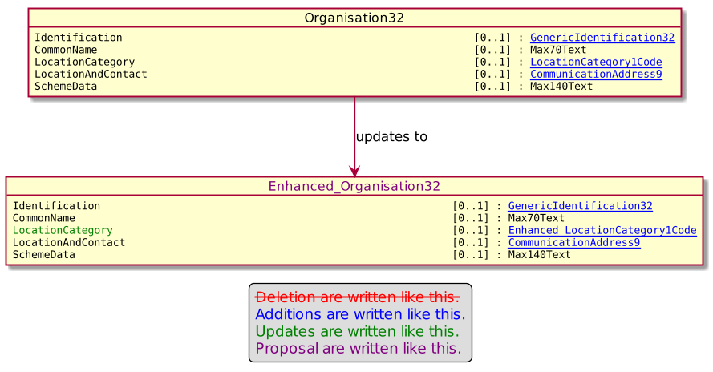

Detailed description of the required modification to implement the requested change.

Proposed timing:
The submitting organization confirms that it can implement the requested changes in the requested timing, or, if not, proposes another timing.

Timing | - As requested
 | - Other:

Final decision of the SEG(s):
This section is not to be taken care of by the submitting organization. It will be completed in due time by the SEG(s) in charge of the related ISO 20022 messages.
Approve
Comments:

Reject
Reason for rejection:

Change request number 0864 - Nexo caaa Reconciliation

Copy of the approved change request:

Origin of the request:
A.1 Submitter: nexo A.I.S.B.L.
A.2 Contact person: Philippe CECE (Philippe.cece@ingenico.com) / Pierre MOURA (pierre.moura@frenchsys.com) .
A.3 Sponsors: nexo A.I.S.B.L.

Related messages:

- AcceptorReconciliationRequest V08 caaa.009.001.08
- AcceptorReconciliationResponse V07 caaa.010.001.07

- AcceptorConfigurationUpdate V09 catm 003.001.09

Description of the change request:

Some members want to be able to check transactions totals and reconciliate according to the card brand and not only card product profile. For instance, this might be the case with contact or contactless card.
Obviously this choice of reconciliation should be enabled by the TMS protocol.

Purpose of the change:

The proposal consists to add this option among others in the TransactionTotals message element as highlighted in the following diagram.

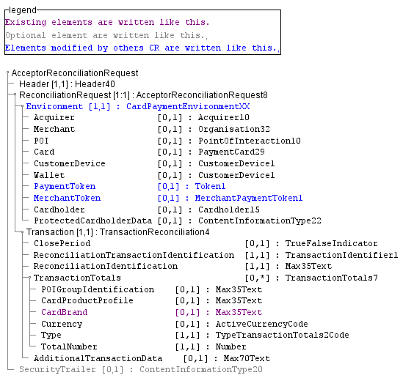

The second part of the modification is to add the settings in the AcquirerProtocolParameters, with the optional addition of up to 3 SplitTotalCriteria message element defined from a codeset.

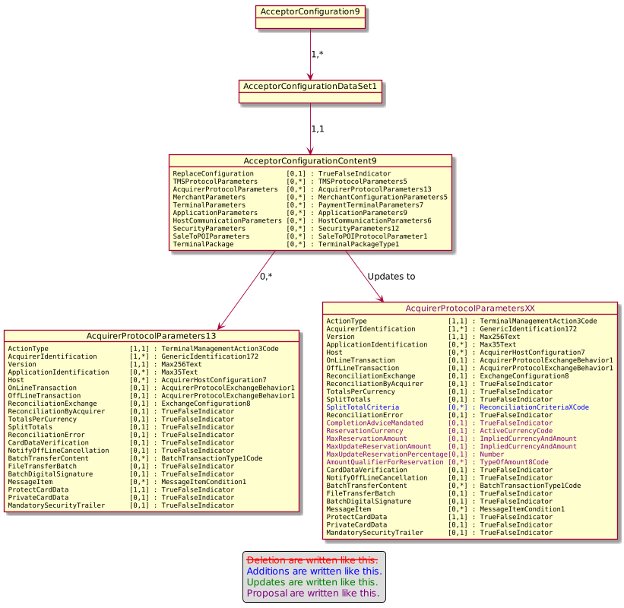
Finally, the codeset ReconciliationCriteriaXCode is defined with 3 different values.

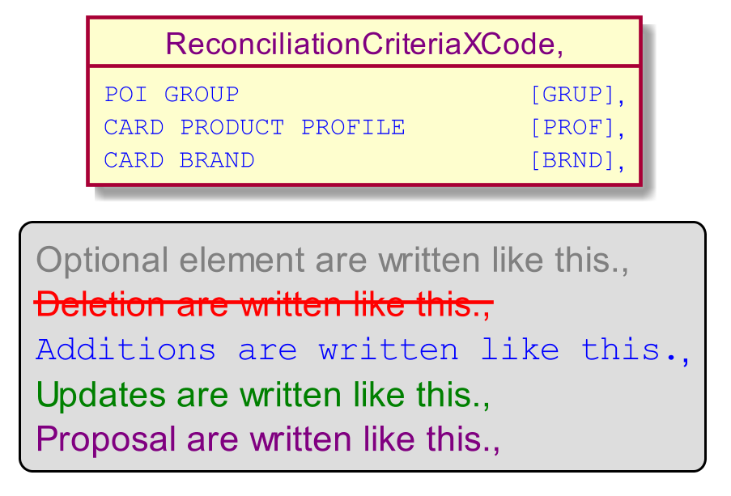

Urgency of the request:

Urgent.

Business examples:
Examples illustrating the change request.

SEG/TSG recommendation:
This section is not to be taken care of by the submitter of the change request. It will be completed in due time by the SEG(s) in charge of the related ISO 20022 messages or the TSG for changes related to the BAH.

Consider |  | X | Timing
 |  |  | - Next yearly cycle: 2020/2021  (the change will be considered for implementation in the yearly maintenance cycle which starts in 2018 and completes with the publication of new message versions in the spring of 2019) |  | X
- At the occasion of the next maintenance of the messages
(the change will be considered for implementation, but does not justify maintenance of the messages in its own right – will be pending until more critical change requests are received for the messages)
- Urgent unscheduled
(the change justifies an urgent implementation outside of the normal yearly cycle)
 |  |  | - Other timing:
Comments:
Remark of Cards SEG on 25/06/2020: Move Card Brand above Card Product Profile

Reject
Reason for rejection:

Impact analysis and type of impact:

The change request will be compliant with the approved change request.

But according to the analysis of impact, additional messsages will be changed.
- AcceptorBatchTransferV09
- AcceptorBatchTransferResponseV08

This result is highlighted by the following ripple effect analysis, drawn from the lowest component to the highest one.

TransactionTotals7
- CardPaymentBatchTransfer8
  - AcceptorBatchTransferV09
- CardPaymentBatchTransferResponse7
  - AcceptorBatchTransferResponseV08
- CardPaymentDataSet23
  - CardPaymentBatchTransfer8
    - AcceptorBatchTransferV09
- CardPaymentDataSet24
  - CardPaymentBatchTransferResponse7
    - AcceptorBatchTransferResponseV08
- TransactionReconciliation4
  - AcceptorReconciliationRequest8
    - AcceptorReconciliationRequestV08
  - AcceptorReconciliationResponse6
    - AcceptorReconciliationResponseV07

AcquirerProtocolParameters13
- AcceptorConfigurationContent9
  - AcceptorConfigurationDataSet1
    - AcceptorConfiguration9
      - AcceptorConfigurationUpdateV03
    - MaintenanceDelegation10
      - MaintenanceDelegationRequest6
        - MaintenanceDelegationRequestV06

The severity of the impact of the proposed change for the message users should be indicated in the table below (either “no impact”, “conditional’ or “mandatory”).
Type of impact
 | No impact | The change(s) will not impact the schema (the version number will not change) and will not impact the business applications of any users, e.g. the clarification of a definition
X | Conditional | The change(s) will impact the schema (at least the version number) and the business applications of certain users but not all, e.g. the addition of an optional component
 | Mandatory | The change(s) will impact the schema and the business applications of all users, e.g. addition of a mandatory component.

Proposed implementation:

The update of the message component TransactionTotals7 gives the following diagram.

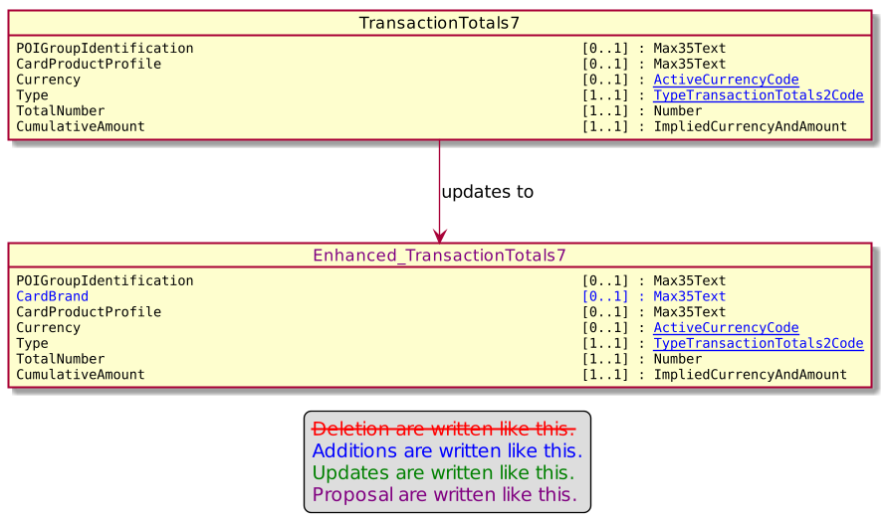

The update of the AcquirerProtocolParameters13, with modification of CR_0875, will give the following component.

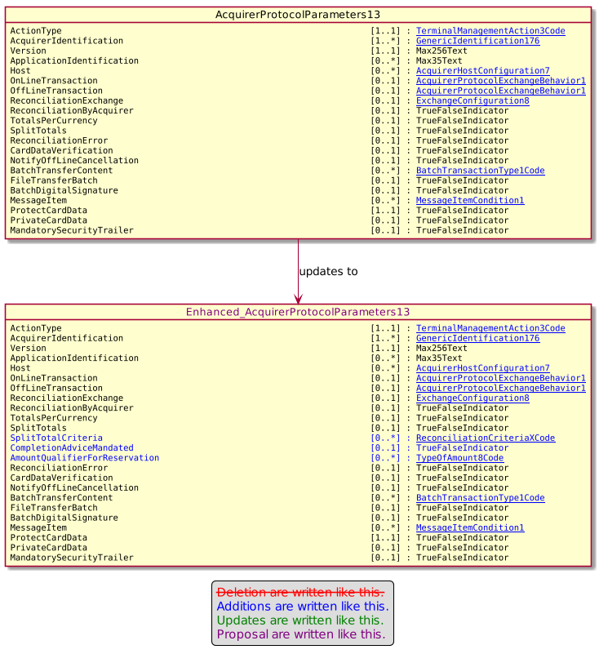

With the new ReconciliationCriteriaXCode defined as.

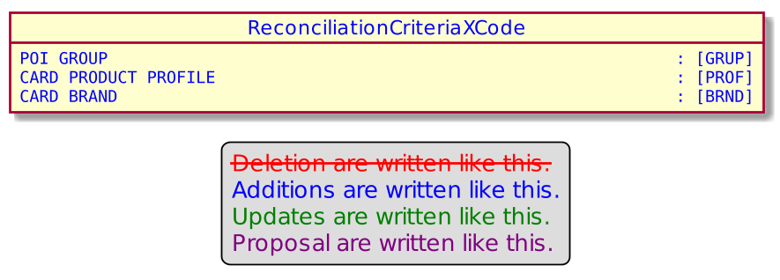

Proposed timing:
The submitting organization confirms that it can implement the requested changes in the requested timing, or, if not, proposes another timing.

Timing | - As requested
 | - Other:

Final decision of the SEG(s):
This section is not to be taken care of by the submitting organization. It will be completed in due time by the SEG(s) in charge of the related ISO 20022 messages.
Approve
Comments:

Reject
Reason for rejection:

Change request number 0866 - Nexo caaa Technical Error in Response Code

Copy of the approved change request:

Origin of the request:
A.1 Submitter: nexo A.I.S.B.L.
A.2 Contact person: Philippe CECE (Philippe.cece@ingenico.com) / Pierre MOURA (pierre.moura@frenchsys.com)
A.3 Sponsors: nexo A.I.S.B.L.

Related messages:

- AcceptorAuthorisationRequest V09 caaa.001.001.09
- AcceptorCompletionAdvice V09 caaa.003.001.09
- AcceptorCompletionAdviceResponse V08 caaa.004.001.08
- AcceptorCancellationRequest V09 caaa.005.001.09
- AcceptorCancellationResponse V08 caaa.006.001.08
- AcceptorCancellationAdvice V09 caaa.007.001.09
- AcceptorCancellationAdviceResponse V08 caaa.008.001.08
- AcceptorReconciliationResponse V07 caaa.010.001.07
- AcceptorBatchTransfer V09 caaa.011.001.09
- AcceptorCurrencyConversionAdviceResponse V03 caaa.019.001.03
- TransactionAdvice V01 caaa.020.001.01
- TransactionAdviceResponse V01 caaa.021.001.01

Description of the change request:

We would like to add TechnicalError to the Reponse4Code, and by extend to replace this codeset by the existing Response6Code.

Purpose of the change:

The authorisation response sent by an acquirer to an acceptor ise set by a Response6Code. But in a CompletionAdvice message, the authorization response sent back from the acceptor to the acquirer, is set amongst Response4Code. The subject of this update, is to reuse Response6Code in any messages.

The updated messages are listed in a bold green font in the following diagram.

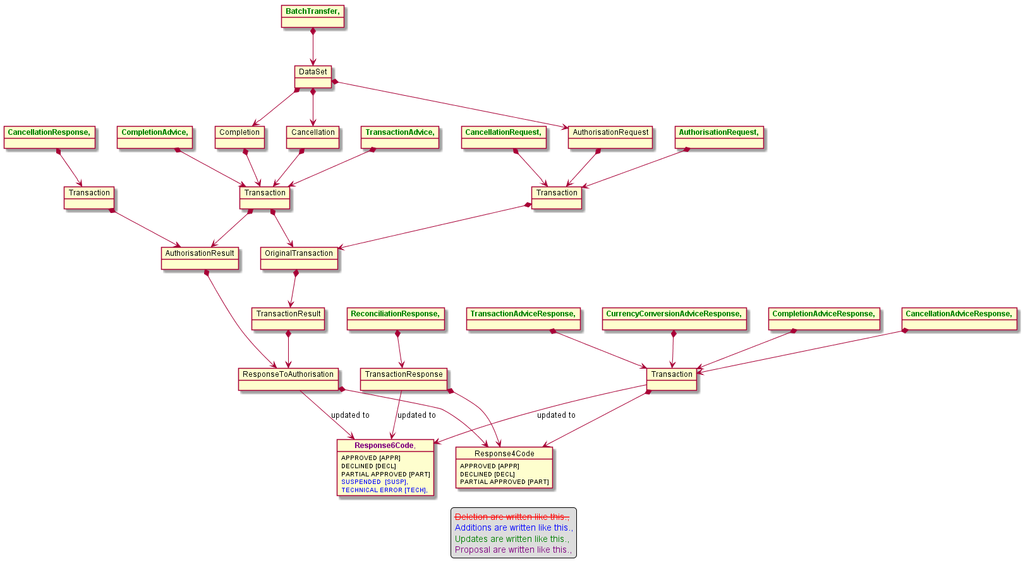

The addition, of the value TechnicalError will also impact the message component ActionType8Code with new values that are still under study. These new values will be provided later.

Urgency of the request:

Urgent.

Business examples:
Examples illustrating the change request.

SEG/TSG recommendation:
This section is not to be taken care of by the submitter of the change request. It will be completed in due time by the SEG(s) in charge of the related ISO 20022 messages or the TSG for changes related to the BAH.

Consider |  | X | Timing
 |  |  | - Next yearly cycle: 2020/2021  (the change will be considered for implementation in the yearly maintenance cycle which starts in 2020 and completes with the publication of new message versions in the spring of 2021) |  | X
- At the occasion of the next maintenance of the messages
(the change will be considered for implementation, but does not justify maintenance of the messages in its own right – will be pending until more critical change requests are received for the messages)
- Urgent unscheduled
(the change justifies an urgent implementation outside of the normal yearly cycle)
 |  |  | - Other timing:
Comments:

Reject
Reason for rejection:

Impact analysis and type of impact:

Except that the identified Response6Code in the Change Request corresponds to the Response9Code of the repository, and that there is no need for additional update of ActionTypeCode, modifications will be done as described in the approved Change Request.

The analysis of the ripple effect gives the following dependancies

Response4Code
- CardPaymentTransactionAdviceResponse7
  - AcceptorCancellationAdviceResponse8
    - AcceptorCancellationAdviceResponseV08
    - AcceptorCurrencyConversionAdviceResponseV03
  - AcceptorCompletionAdviceResponse8
    - AcceptorCompletionAdviceResponseV08
    - TransactionAdviceResponseV01
- ResponseType5
  - AcceptorReconciliationResponse6
  - AuthorisationResult11
    - CardPaymentTransaction99
      - AcceptorCompletionAdvice9
        - AcceptorCompletionAdviceV09
        - TransactionAdviceV01
      - CardPaymentDataSetTransaction30
        - CardPaymentDataSetTransaction8Choice
          - CardPaymentDataSet23
  - AuthorisationResult12
    - CardPaymentTransaction95
      - AcceptorCancellationAdvice9
        - AcceptorCancellationAdviceV09
      - CardPaymentDataSetTransaction31
        - CardPaymentDataSetTransaction8Choice
    - CardPaymentTransaction98
      - AcceptorCancellationResponse8
        - AcceptorCancellationResponseV08
  - CardPaymentTransactionResult3
    - CardPaymentTransaction101
      - CardPaymentTransaction92
        - AcceptorAuthorisationRequest9
          - AcceptorAuthorisationRequestV09
        - CardPaymentDataSetTransaction32
          - CardPaymentDataSetTransaction8Choice
      - CardPaymentTransaction95
      - CardPaymentTransaction96
        - AcceptorCancellationRequest9
          - AcceptorCancellationRequestV09
      - CardPaymentTransaction99

The severity of the impact of the proposed change for the message users should be indicated in the table below (either “no impact”, “conditional’ or “mandatory”).
Type of impact
 | No impact | The change(s) will not impact the schema (the version number will not change) and will not impact the business applications of any users, e.g. the clarification of a definition
X | Conditional | The change(s) will impact the schema (at least the version number) and the business applications of certain users but not all, e.g. the addition of an optional component
 | Mandatory | The change(s) will impact the schema and the business applications of all users, e.g. addition of a mandatory component.

Proposed implementation:

The Response9Code will be used.
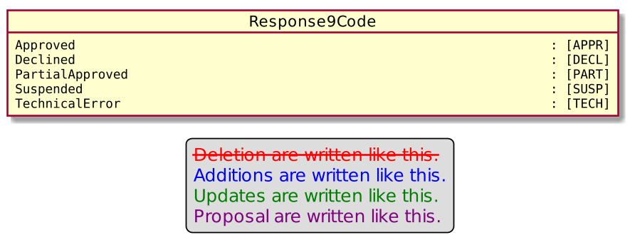

Proposed timing:
The submitting organization confirms that it can implement the requested changes in the requested timing, or, if not, proposes another timing.

Timing | - As requested
 | - Other:

Final decision of the SEG(s):
This section is not to be taken care of by the submitting organization. It will be completed in due time by the SEG(s) in charge of the related ISO 20022 messages.
Approve
Comments:

Reject

Change request number 0867 - Nexo caaa TokenHarmonization

Copy of the approved change request:

Origin of the request:
A.1 Submitter: nexo A.I.S.B.L.
A.2 Contact person: Philippe CECE (Philippe.cece@ingenico.com) / Pierre MOURA (pierre.moura@frenchsys.com) / Bruno AIELLO (Bruno.Aiello@VERIFONE.com) / Philippe MERMOUD (philippe.mermoud@natixis.com).
A.3 Sponsors: nexo A.I.S.B.L.

Related messages:

For the caaa related messages:
- AcceptorAuthorisationRequest V09 caaa.001.001.09
- AcceptorAuthorisationResponse V09 caaa.002.001.09
- AcceptorCompletionAdvice V09 caaa.003.001.09
- AcceptorCompletionAdviceResponse V08 caaa.004.001.08
- AcceptorCancellationRequest V09 caaa.005.001.09
- AcceptorCancellationResponse V08 caaa.006.001.08
- AcceptorCancellationAdvice V09 caaa.007.001.09
- AcceptorCancellationAdviceResponse V08 caaa.008.001.08
- AcceptorReconciliationRequest V08 caaa.009.001.08
- AcceptorReconciliationResponse V07 caaa.010.001.07
- AcceptorBatchTransfer V09 caaa.011.001.09
- AcceptorBatchTransferResponse V08 caaa.012.001.08
- AcceptorDiagnosticRequest V08 caaa.013.001.08
- AcceptorDiagnosticResponse V07 caaa.014.001.07
- AcceptorCurrencyConversionRequest V07 caaa.016.001.07
- AcceptorCurrencyConversionResponse V07 caaa.017.001.07
- AccpetorCurrencyConversionAdvice V04 caaa.018.001.04
- AcceptorCurrencyConversionAdviceResponse V03 caaa.019.001.03
- TransactionAdvice V01 caaa.020.001.01
- TransactionAdviceResponse V01 caaa.021.001.01

For the casp related messages:
- SaleToPOIServiceRequest V02 casp 001.001.02
- SaleToPOIServiceResponse V02 casp 002.001.02
- SaleToPOIReconciliationRequest V02 casp 003.001.02
- SaleToPOIReconciliationResponse V02 casp 004.001.02
- SaleToPOISessionManagementRequest V02 casp 005.001.02
- SaleToPOISessionManagementResponse V02 casp 006.001.02
- SaleToPOIAdministrativeRequest V02 casp 007.001.02
- SaleToPOIAdministrativeResponse V02 casp 008.001.02
- SaleToPOIReportRequest V02 casp 009.001.02
- SaleToPOIReportResponse V02 casp 010.001.02
- SaleToPOIAbort V02 casp 011.001.02
- SaleToPOIEventNotification V02 casp 012.001.02
- SaleToPOIMessageStatusRequest V02 casp 014.001.02
- SaleToPOIMessageStatusResponse V02 casp 015.001.02
- SaleToPOIDeviceRequest V02 casp 016.001.02
- SaleToPOIDeviceResponse V02 casp 017.001.02

Description of the change request:

In order to foster the adoption of iso20022 protocols, we would like to harmonize the token message component with the one defined by the ATICA protocol. This update will simplify the usage of tokens from the acceptor devices until the issuer domain.

Additionally to the introduction, last year, of new codeset related to 3DS v2.2, we realize that the authorization response, asking for ConsumerDeviceCardholderVerificationMethod, may require change the CustomerDevice1 message component.

Purpose of the change:

Regarding the update of the message component CustomerDevice1, we only have to extend the length of the message element CustomerDevice/Type from Max35Text to Max70Text.

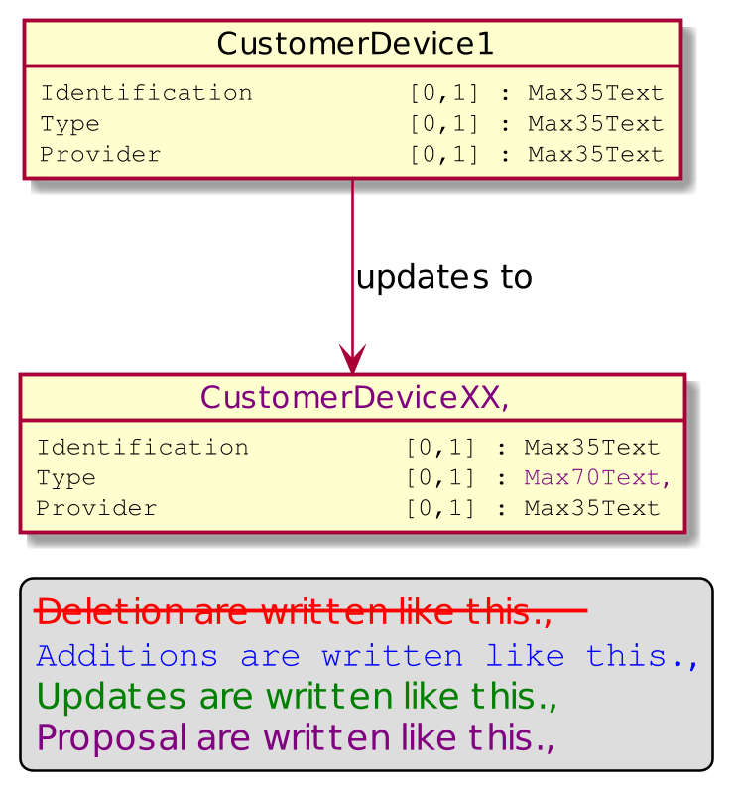

Currently, acceptor to acquirer message transports token through a message element named PaymentToken defined with the message component CardPaymentToken5. The aim of this proposal is to split the current usage of PaymentToken in two parts. The first part will focused on credit card token with the same use cases than the token defined by ATICA protocol. So the first part, still named PaymentToken will be defined with the ATICA message component, which might, as far as we know, be named Token1. The second part of the former PaymentToken message element, will cover use cases that are not managed by the ATICA protocol. This element will be named MerchantPaymentToken and will be defined by the message component MerchantPaymentToken1. This later message component will be a copy from CardPaymentToken5. The introduction of this new message component should underline that the scope of this token is not the same as the card payment token defined by ATICA.

The updated messages are listed in a bold green font in the following diagram. Impacts on the RetailerProtocol have been also identified.

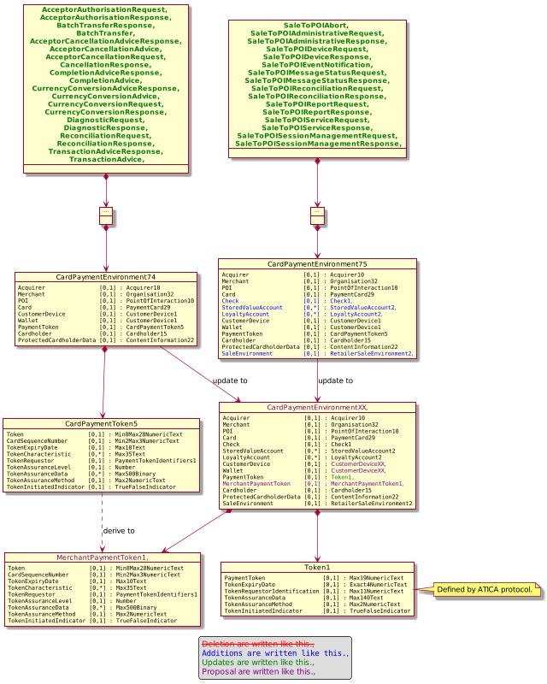

Urgency of the request:

Not urgent.

Business examples:
Examples illustrating the change request.

SEG/TSG recommendation:
This section is not to be taken care of by the submitter of the change request. It will be completed in due time by the SEG(s) in charge of the related ISO 20022 messages or the TSG for changes related to the BAH.

Consider |  | X | Timing
 |  |  | - Next yearly cycle: 2020/2021  (the change will be considered for implementation in the yearly maintenance cycle which starts in 2020 and completes with the publication of new message versions in the spring of 2021) |  | X
- At the occasion of the next maintenance of the messages
(the change will be considered for implementation, but does not justify maintenance of the messages in its own right – will be pending until more critical change requests are received for the messages)
- Urgent unscheduled
(the change justifies an urgent implementation outside of the normal yearly cycle)
 |  |  | - Other timing:
Comments:

Reject
Reason for rejection:

Impact analysis and type of impact:
After an additional study, we believe that the message element CardSequenceNumber is not necessary in the MerchantPaymentToken message component.
Except this the modifications will be compliant with the approved Change Request.
The analysis of impact, provides the following dependancies.
CustomerDevice1
- CardPaymentEnvironment74
  - AcceptorAuthorisationRequest9
  - AcceptorAuthorisationResponse9
    - AcceptorAuthorisationResponseV09
  - AcceptorCancellationAdvice9
  - AcceptorCancellationAdviceResponse8
  - AcceptorCancellationRequest9
  - AcceptorCancellationResponse8
  - AcceptorCompletionAdvice9
  - AcceptorCompletionAdviceResponse8
  - AcceptorCurrencyConversionAdvice4
    - AcceptorCurrencyConversionAdviceV04
  - AcceptorCurrencyConversionRequest7
    - AcceptorCurrencyConversionRequestV07
  - AcceptorCurrencyConversionResponse7
    - AcceptorCurrencyConversionResponseV07
  - AcceptorDiagnosticRequest8
    - AcceptorDiagnosticRequestV08
  - AcceptorDiagnosticResponse6
    - AcceptorDiagnosticResponseV07
  - AcceptorReconciliationRequest8
  - AcceptorReconciliationResponse6
  - CardPaymentDataSet25
    - CardPaymentDataSet24
  - CardPaymentDataSetTransaction30
  - CardPaymentDataSetTransaction31
  - CardPaymentDataSetTransaction32
  - CardPaymentDataSetTransaction33
    - CardPaymentDataSetTransaction8Choice
  - CommonData9
    - CardPaymentDataSet23
- CardPaymentEnvironment75
  - AdministrativeRequest3
    - SaleToPOIAdministrativeRequestV02
  - AdministrativeResponse3
    - SaleToPOIAdministrativeResponseV02
  - DeviceRequest3
    - SaleToPOIDeviceRequestV02
  - DeviceResponse3
    - SaleToPOIDeviceResponseV02
  - MessageStatusRequest3
    - SaleToPOIMessageStatusRequestV02
  - MessageStatusResponse3
    - SaleToPOIMessageStatusResponseV02
  - ReconciliationRequest3
    - SaleToPOIReconciliationRequestV02
  - ReconciliationResponse4
    - SaleToPOIReconciliationResponseV02
  - ReportRequest3
    - SaleToPOIReportRequestV02
  - ReportResponse3
    - SaleToPOIReportResponseV02
  - ServiceRequest3
    - SaleToPOIServiceRequestV02
  - ServiceResponse3
    - SaleToPOIServiceResponseV02
  - SessionManagementRequest3
    - SaleToPOISessionManagementRequestV02
  - SessionManagementResponse3
  - SystemAbort3
    - SaleToPOIAbortV02
  - SystemEventNotification3
    - SaleToPOIEventNotificationV02
The severity of the impact of the proposed change for the message users should be indicated in the table below (either “no impact”, “conditional’ or “mandatory”).
Type of impact
 | No impact | The change(s) will not impact the schema (the version number will not change) and will not impact the business applications of any users, e.g. the clarification of a definition
X | Conditional | The change(s) will impact the schema (at least the version number) and the business applications of certain users but not all, e.g. the addition of an optional component
 | Mandatory | The change(s) will impact the schema and the business applications of all users, e.g. addition of a mandatory component.

Proposed implementation:
The MerchantPaymentToken will be created as follow:
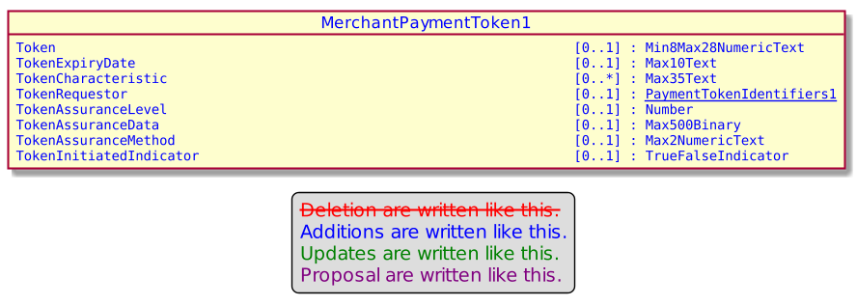

The CardPaymentEnvironment74 will be updated as follow :
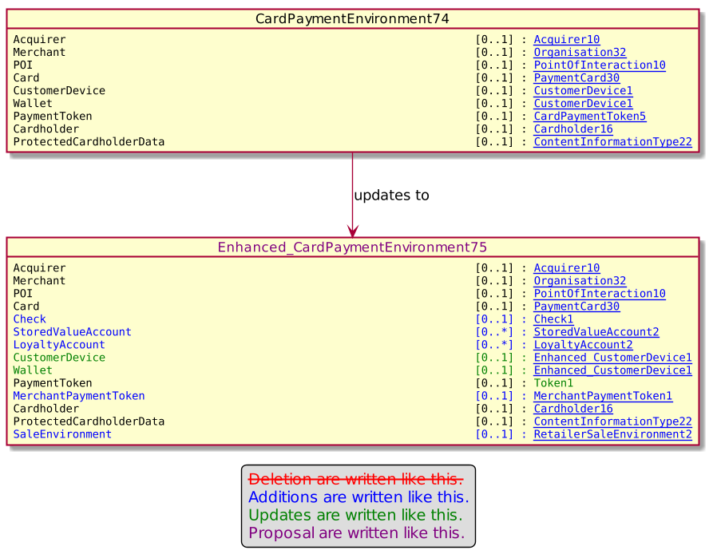

And the CardPaymentEnvironement75 will be updated to the same new component.

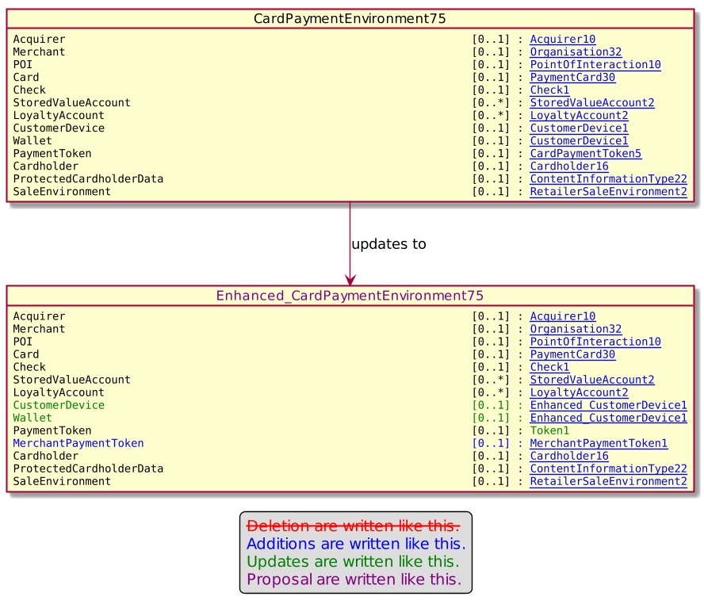

Proposed timing:
The submitting organization confirms that it can implement the requested changes in the requested timing, or, if not, proposes another timing.

Timing | - As requested
 | - Other:

Final decision of the SEG(s):
This section is not to be taken care of by the submitting organization. It will be completed in due time by the SEG(s) in charge of the related ISO 20022 messages.
Approve
Comments:

Reject
Reason for rejection:

Change request number 0868 - Nexo casp Device Play Sound Request

Copy of the approved change request:

Origin of the request:
A.1 Submitter: nexo A.I.S.B.L.
A.2 Contact person: Philippe CECE (Philippe.cece@ingenico.com) / Bruno AIELLO (Bruno.Aiello@VERIFONE.com) / Philippe MERMOUD (philippe.mermoud@natixis.com)
A.3 Sponsors: nexo A.I.S.B.L.

Related messages:

- SaleToPOIDeviceRequest V02 casp 016.001.02

Description of the change request:

When we defined the SaleToPOI messages, we defined a PlaySound command. But we realize that it would be more interesting to defined a more universal command like a PlayResource, with a sound, or movie resource.
The aim of this Change Request is to introduce this PlayResource command

Purpose of the change:

The proposal consists to revamp the existing PlaySoundRequest to a PlayResourceRequest. Consequently to this renaming, we need to change the codeset SoundEnd to EndOfPlay in the message component ResponseModeCode. The codesets StartSound and StopSound are also renamed Play and Stop in the message component SoundActionCode. Finally the SoundAction is renamed ResourceAction.
The generalization created by this new name also creates new actions identified by the codeset PlayInLoop, Pause, Resume in the SoundActionXCode.
Even if this current proposal is based on the reuse of the message component SoundActionCode, we might create a ResourceActionCode for repository consistency.

Since the resource could be a video, we need to provide additional information like the DisplayResolution or the TimeSlot when the resource needs to be played. This timeslot, that could be before, during or after the transaction or not in the transaction aiming the idle state is defined thanks to the ProcessingPosition2Code already defined in the repository.

Finally, the ResourceContent message component allows to define the resource to play. This could be a TextToSpeech with a relevant language or the identifier of this resource (UniformResourceIdentifier).

The following diagram depicts this proposal.

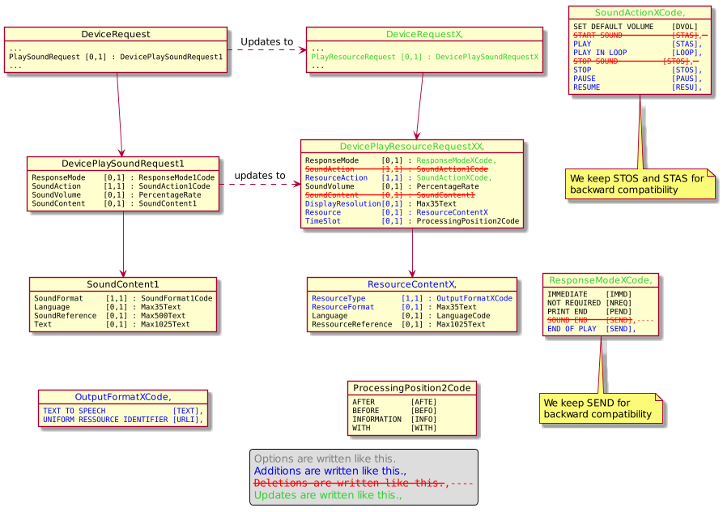

Urgency of the request:

Urgent.

Business examples:
Examples illustrating the change request.

SEG/TSG recommendation:
This section is not to be taken care of by the submitter of the change request. It will be completed in due time by the SEG(s) in charge of the related ISO 20022 messages or the TSG for changes related to the BAH.

Consider |  | X | Timing
 |  |  | - Next yearly cycle: 2020/2021  (the change will be considered for implementation in the yearly maintenance cycle which starts in 2020 and completes with the publication of new message versions in the spring of 2021) |  | X
- At the occasion of the next maintenance of the messages
(the change will be considered for implementation, but does not justify maintenance of the messages in its own right – will be pending until more critical change requests are received for the messages)
- Urgent unscheduled
(the change justifies an urgent implementation outside of the normal yearly cycle)
 |  |  | - Other timing:
Comments:

Reject
Reason for rejection:

Impact analysis and type of impact:

After review, we prefer to create a new codeset called ResourceActionXCode rather than to reuse the SoundActionXCode.
The other elements listed in the approved Change Request will be unchanged.

The analysis of the ripple effet provides the following list.

ResponseMode1Code
- DevicePlaySoundRequest1
  - DeviceRequest3
    - SaleToPOIDeviceRequestV02
- DevicePrintRequest2
  - DeviceRequest3
SoundAction1Code
- DevicePlaySoundRequest1
SoundContent1
- DevicePlaySoundRequest1

The severity of the impact of the proposed change for the message users should be indicated in the table below (either “no impact”, “conditional’ or “mandatory”).
Type of impact
 | No impact | The change(s) will not impact the schema (the version number will not change) and will not impact the business applications of any users, e.g. the clarification of a definition
X | Conditional | The change(s) will impact the schema (at least the version number) and the business applications of certain users but not all, e.g. the addition of an optional component
 | Mandatory | The change(s) will impact the schema and the business applications of all users, e.g. addition of a mandatory component.

Proposed implementation:

Creation of the message component ResourceAction1Code according to the following diagram

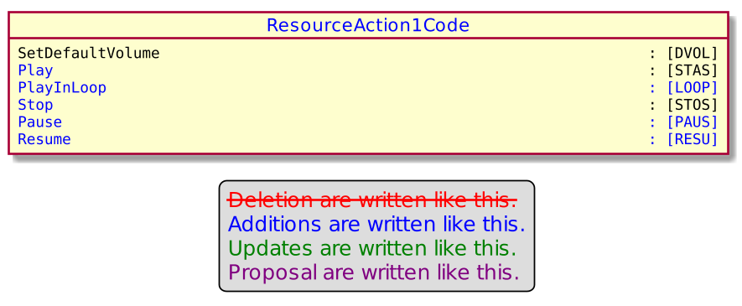

Update of the message component ResponseMode1Code in order to include broder usage.

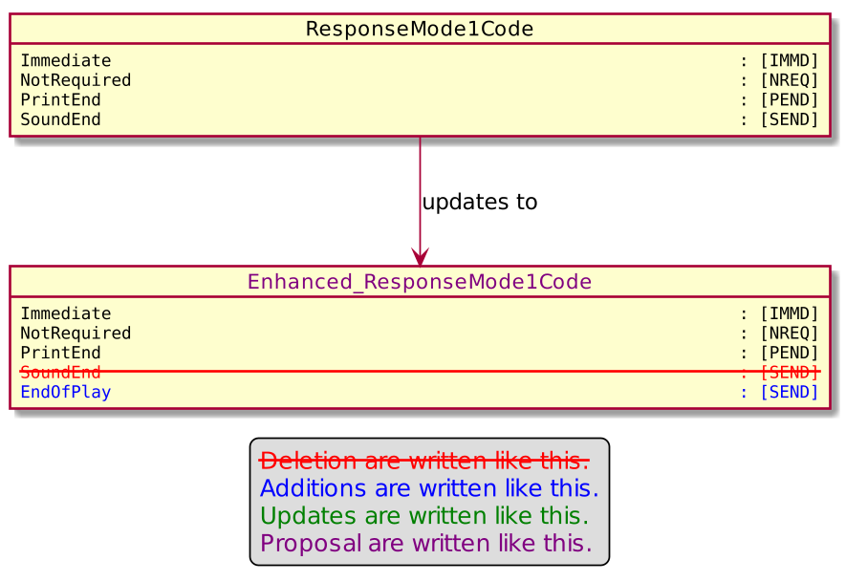

Creation of a new message component OutputFormat1Code.

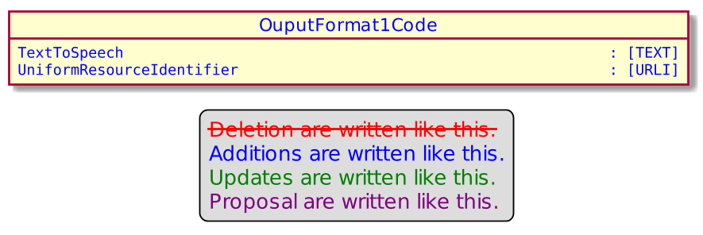

Then we can update the message component SoundContent1 to ResourceContent1.

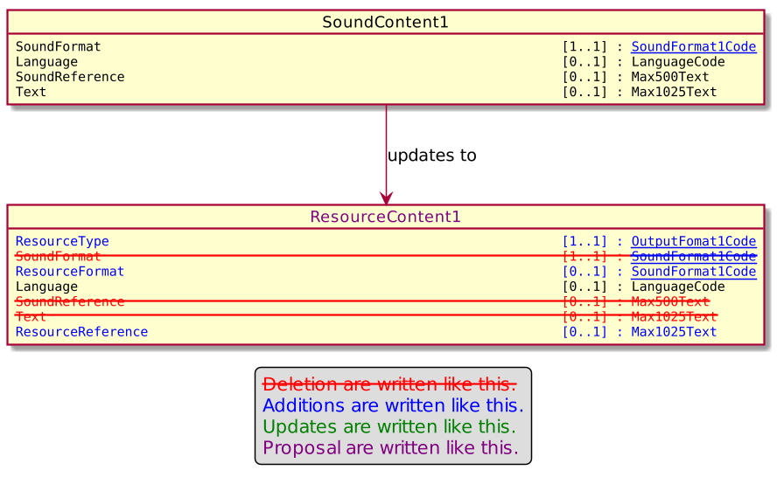

An the update of the message component DevicePlaySoundRequest1.

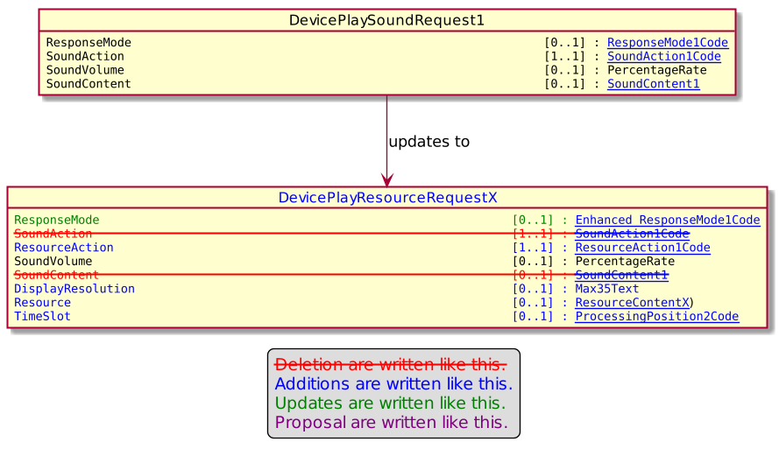

Finally we can update the DeviceRequest3
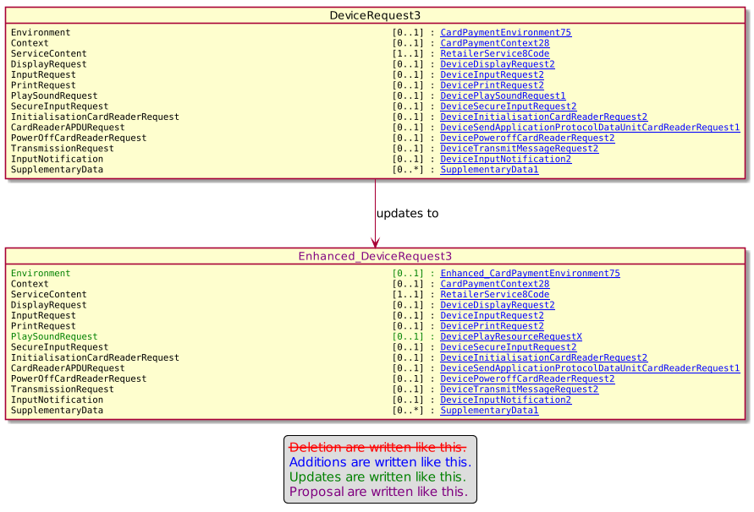

Proposed timing:
The submitting organization confirms that it can implement the requested changes in the requested timing, or, if not, proposes another timing.

Timing | - As requested
 | - Other:

Final decision of the SEG(s):
This section is not to be taken care of by the submitting organization. It will be completed in due time by the SEG(s) in charge of the related ISO 20022 messages.
Approve
Comments:

Reject
Reason for rejection:

Change request number 0869 - Nexo casp Response Code

Copy of the approved change request:

Origin of the request:
A.1 Submitter: nexo A.I.S.B.L.
A.2 Contact person: Philippe CECE (Philippe.cece@ingenico.com) / Bruno AIELLO (Bruno.Aiello@VERIFONE.com) / Philippe MERMOUD (philippe.mermoud@natixis.com)
A.3 Sponsors: nexo A.I.S.B.L.

Related messages:

- SaleToPOIServiceResponse V02 casp 002.001.02
- SaleToPOIReconciliationResponse V02 casp 004.001.02
- SaleToPOISessionManagementResponse V02 casp 006.001.02
- SaleToPOIAdministrativeResponse V02 casp 008.001.02
- SaleToPOIReportResponse V02 casp 010.001.02
- SaleToPOIMessageStatusResponse V02 casp 015.001.02
- SaleToPOIDeviceResponse V02 casp 017.001.02

Description of the change request:

When we defined the SaleToPOI messages, we tried to reuse as much as possible existing codeset or component. Unfortunately, we realize that this could sometimes create misundertanding, like the reuse of PARTIAL_APPROVAL to notify a successful processing of a request with some warnings. The aim of this Change Request is to correct this misunderstanding.

Purpose of the change:

A new codeset will be defined in the ResponseCode as SUCCESS WITH WARNING, and the Response5Code will be updated to replace the current PARTIAL APPROVED by this new codeset. This new resulting ResultXXCode will be used in every response message of the Retailer protocol.
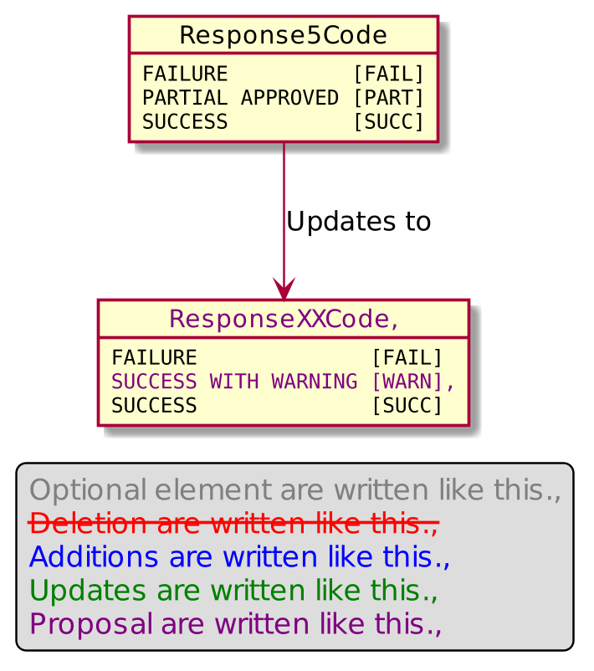

Urgency of the request:

Urgent.

Business examples:
Examples illustrating the change request.

SEG/TSG recommendation:
This section is not to be taken care of by the submitter of the change request. It will be completed in due time by the SEG(s) in charge of the related ISO 20022 messages or the TSG for changes related to the BAH.

Consider |  | X | Timing
 |  |  | - Next yearly cycle: 2020/2021  (the change will be considered for implementation in the yearly maintenance cycle which starts in 2020 and completes with the publication of new message versions in the spring of 2021) |  | X
- At the occasion of the next maintenance of the messages
(the change will be considered for implementation, but does not justify maintenance of the messages in its own right – will be pending until more critical change requests are received for the messages)
- Urgent unscheduled
(the change justifies an urgent implementation outside of the normal yearly cycle)
 |  |  | - Other timing:
Comments:
Remark of Cards SEG on 25/06/2020: Use only “Warning” instead “Success with Warning”

Reject
Reason for rejection:

Impact analysis and type of impact:

As suggested by the CardSEG, we will define the codeset as WARNING with the following definition : An additional Response Code, mainly a functional one, should be considered to identify the outcome of the request.

The analysi of the ripple effet provides the following list.

Response5Code.
- ResponseType9
  - AdministrativeResponse3
  - DeviceResponse3
  - MessageStatusResponse3
  - MessageStatusResponseData3
    - MessageStatusResponse3
  - OutputResult1
    - DeviceDisplayResponse1
      - DeviceResponse3
    - DeviceInputResponse2
      - DeviceResponse3
  - PerformedTransaction2
    - BatchResponse2
      - ServiceResponse3
  - PointOfInteractionTransactionReport2
    - ReportTransactionResponse2
      - ReportResponse3
  - ReconciliationResponse4
  - ReportResponse3
  - ServiceResponse3
  - SessionManagementResponse3

The severity of the impact of the proposed change for the message users should be indicated in the table below (either “no impact”, “conditional’ or “mandatory”).
Type of impact
 | No impact | The change(s) will not impact the schema (the version number will not change) and will not impact the business applications of any users, e.g. the clarification of a definition
 | Conditional | The change(s) will impact the schema (at least the version number) and the business applications of certain users but not all, e.g. the addition of an optional component
X | Mandatory | The change(s) will impact the schema and the business applications of all users, e.g. addition of a mandatory component.

Proposed implementation:

So Response5Code will be updated as highlighted by the following diagram.

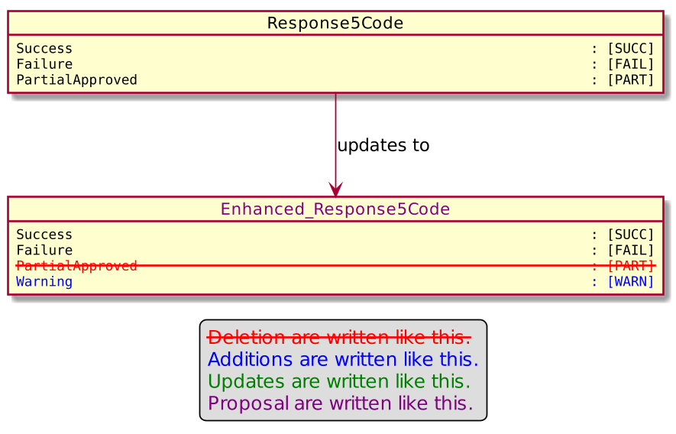

Detailed description of the required modification to implement the requested change.

Proposed timing:
The submitting organization confirms that it can implement the requested changes in the requested timing, or, if not, proposes another timing.

Timing | - As requested
 | - Other:

Final decision of the SEG(s):
This section is not to be taken care of by the submitting organization. It will be completed in due time by the SEG(s) in charge of the related ISO 20022 messages.
Approve
Comments:

Reject
Reason for rejection:

Change request number 0870 – Nexo casp Reversal Request

Copy of the approved change request:

Origin of the request:
A.1 Submitter: nexo A.I.S.B.L.
A.2 Contact person: Philippe CECE (Philippe.cece@ingenico.com) / Bruno AIELLO (Bruno.Aiello@VERIFONE.com) / Philippe MERMOUD (philippe.mermoud@natixis.com)
A.3 Sponsors: nexo A.I.S.B.L.

Related messages:

- SaleToPOIServiceRequest V02 casp 001.001.02

Description of the change request:

When we defined the ReversalRequest in the SaleToPOI messages, we made a mistake in the name of OriginalPaymentTransaction. Indeed, this transaction identification is the one coming from the sale for this reversal request and should have been named SaleTransaction. This SaleTransaction is mandatory to trace any service requests to manage disputes. Unfortunately, we realize that the current OriginalPaymentTransaction creates misundertanding since we tend to provide payment information rather than sale information. The aim of this Change Request is to correct this misunderstanding.

Purpose of the change:

The proposal consists to rename the message element OriginalPaymentTransaction into SaleTransaction inside the message component ReversalRequest2 as highlighted in the following diagram.

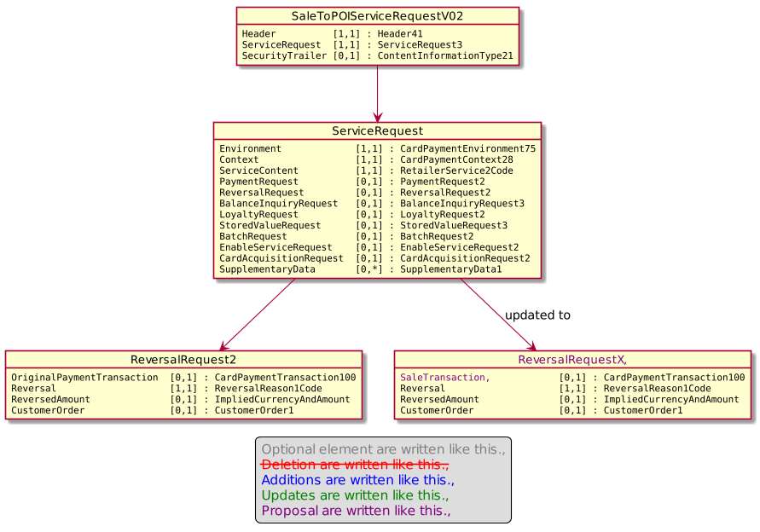

A review of the other message elements present in the message component ServiceRequest will be done to check if SaleTransactionIdentification will be mandated to log any request between between the sale system and the poi system.

Urgency of the request:

Urgent.

Business examples:
Examples illustrating the change request.

SEG/TSG recommendation:
This section is not to be taken care of by the submitter of the change request. It will be completed in due time by the SEG(s) in charge of the related ISO 20022 messages or the TSG for changes related to the BAH.

Consider |  | X | Timing
 |  |  | - Next yearly cycle: 2020/2021  (the change will be considered for implementation in the yearly maintenance cycle which starts in 2020 and completes with the publication of new message versions in the spring of 2021) |  | X
- At the occasion of the next maintenance of the messages
(the change will be considered for implementation, but does not justify maintenance of the messages in its own right – will be pending until more critical change requests are received for the messages)
- Urgent unscheduled
(the change justifies an urgent implementation outside of the normal yearly cycle)
 |  |  | - Other timing:
Comments:
Remark of Cards SG on 25/06/2020: All sub cases have to be checked!

Reject
Reason for rejection:

Impact analysis and type of impact:

After a review of some use cases, we opt for some changes in the implementation of the new ReversalRequestXX message component.

To avoid any misconception and keep uniformity in names, the OriginalPaymentTransaction is renammed ReversalTransaction. In order to correctly managed loyalty, message elements LoyaltyData with multiplicity [0..x] is also added like in a PaymentRequest.

The analysis of impact of modifications gives the following changes.

ReversalRequest2
- ServiceRequest3
- TransactionToPerform2Choice
  - BatchRequest2
    - ServiceRequest3

The severity of the impact of the proposed change for the message users should be indicated in the table below (either “no impact”, “conditional’ or “mandatory”).
Type of impact
 | No impact | The change(s) will not impact the schema (the version number will not change) and will not impact the business applications of any users, e.g. the clarification of a definition
X | Conditional | The change(s) will impact the schema (at least the version number) and the business applications of certain users but not all, e.g. the addition of an optional component
 | Mandatory | The change(s) will impact the schema and the business applications of all users, e.g. addition of a mandatory component.

Proposed implementation:

The ReversalRequest2 will be updated accordingly to the following diagram.

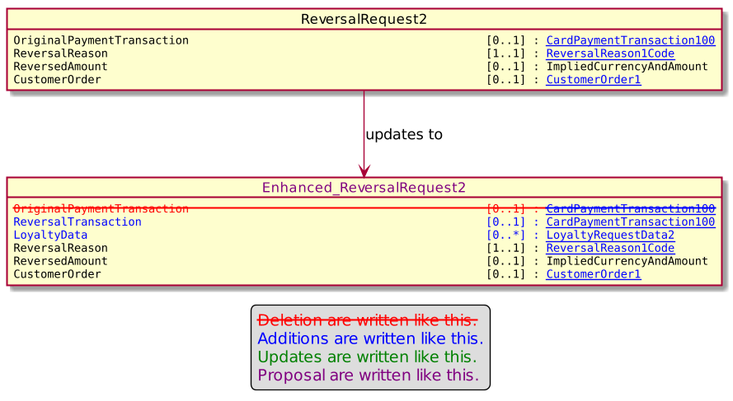

Proposed timing:
The submitting organization confirms that it can implement the requested changes in the requested timing, or, if not, proposes another timing.

Timing | - As requested
 | - Other:

Final decision of the SEG(s):
This section is not to be taken care of by the submitting organization. It will be completed in due time by the SEG(s) in charge of the related ISO 20022 messages.
Approve
Comments:

Reject
Reason for rejection:

Change request number 0871 – Nexo catm Harmonization Of Names Length

Copy of the approved change request:

Origin of the request:
A.1 Submitter: nexo A.I.S.B.L.
A.2 Contact person: Philippe CECE (Philippe.cece@ingenico.com) / Pierre MOURA (pierre.moura@frenchsys.com)
A.3 Sponsors: nexo A.I.S.B.L.

Related messages:

- AcceptorAuthorisationRequest V09 caaa.001.001.09
- AcceptorAuthorisationResponse V09 caaa.002.001.09
- AcceptorCompletionAdvice V09 caaa.003.001.09
- AcceptorCompletionAdviceResponse V08 caaa.004.001.08
- AcceptorCancellationRequest V09 caaa.005.001.09
- AcceptorCancellationResponse V08 caaa.006.001.08
- AcceptorCancellationAdvice V09 caaa.007.001.09
- AcceptorCancellationAdviceResponse V08 caaa.008.001.08
- AcceptorReconciliationRequest V08 caaa.009.001.08
- AcceptorReconciliationResponse V07 caaa.010.001.07
- AcceptorBatchTransfer V09 caaa.011.001.09
- AcceptorBatchTransferResponse V08 caaa.012.001.08
- AcceptorDiagnosticRequest V08 caaa.013.001.08
- AcceptorDiagnosticResponse V07 caaa.014.001.07
- AcceptorCurrencyConversionRequest V07 caaa.016.001.07
- AcceptorCurrencyConversionResponse V07 caaa.017.001.07
- AccpetorCurrencyConversionAdvice V04 caaa.018.001.04
- AcceptorCurrencyConversionAdviceResponse V03 caaa.019.001.03
- TransactionAdvice V01 caaa.020.001.01
- TransactionAdviceResponse V01 caaa.021.001.01

- StatusReport V09 catm 001.001.09
- ManagementPlanReplacement V08 catm 002.001.08
- AcceptorConfigurationUpdate V09 catm 003.001.09
- MaintenanceDelegationRequest V06 catm 005.001.06
- MaintenanceDelegationResponse V04 catm 006.001.04
- CertificateManagementRequest V03 catm 007.001.03
- CertificateManagementResponse V03 catm 008.001.03

- SaleToPOIServiceRequest V02 casp 001.001.02
- SaleToPOIServiceResponse V02 casp 002.001.02
- SaleToPOIReconciliationRequest V02 casp 003.001.02
- SaleToPOIReconciliationResponse V02 casp 004.001.02
- SaleToPOISessionManagementRequest V02 casp 005.001.02
- SaleToPOISessionManagementResponse V02 casp 006.001.02
- SaleToPOIAdministrativeRequest V02 casp 007.001.02
- SaleToPOIAdministrativeResponse V02 casp 008.001.02
- SaleToPOIReportRequest V02 casp 009.001.02
- SaleToPOIReportResponse V02 casp 010.001.02
- SaleToPOIAbort V02 casp 011.001.02
- SaleToPOIEventNotification V02 casp 012.001.02
- SaleToPOIMessageStatusRequest V02 casp 014.001.02
- SaleToPOIMessageStatusResponse V02 casp 015.001.02
- SaleToPOIDeviceRequest V02 casp 016.001.02
- SaleToPOIDeviceResponse V02 casp 017.001.02

Description of the change request:

We would like to extend the length of some message element Names since currently we are not able to transport their full value.

For instance, when a TMS sends parameters to a POI, Identification brings all the information through a DataSetIdentification8 message component. The Name included in Identification is a Max256Text. When the POI wants to report the presence of this parameters, it has to set the identification of a POIComponent defined with the PointOfInteractionComponentIdentification1. But currently the Identification (the name field) of this message component is currently defined as a Max35Text.

The same inconsistency applies on SerialNumber of the SignerIdentification of the CMS structure. Generally speaking this one is set with the ASCII representation of a result of SHA1 (160 bits) computation with ":" between each byte value (e.g : 41:9D:CF:A5:FD:30:24:C0:C9:80:85:9E:2D:2D:22:9D:1D:78:8F:4A) leading to 39 ASCII values that we have to fit into a Max35Binary.

Finally, we would like to correct our previous model for elliptic curve signature in order to match the corresponding model encoded in ASN.1

Since we will have to update the CMS structure, all messages, except rejection, will have to be updated.

Purpose of the change:

As previously explained, the first modification will target the PoinOfInteractionComponentIdenticiation1 as highlighted by the following diagram.

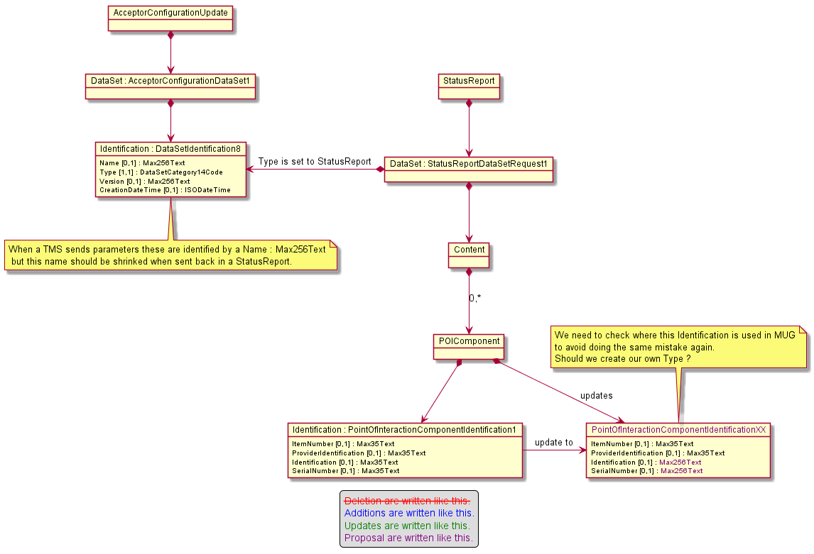

The second update targets CryptographicKey14 message component in order to extend size of message elements.

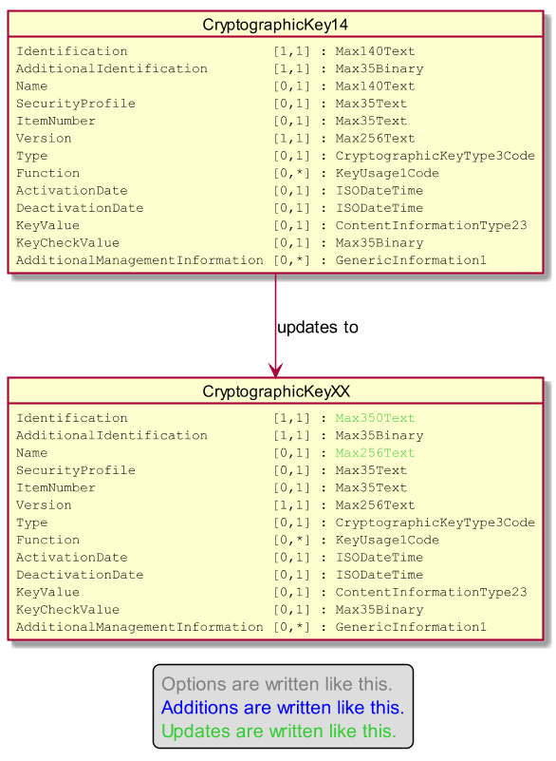

Then we want to change the type of the message element SerialNumber from Max35Binary to Max350Text. Then we will be able to set the value in any identification message element.
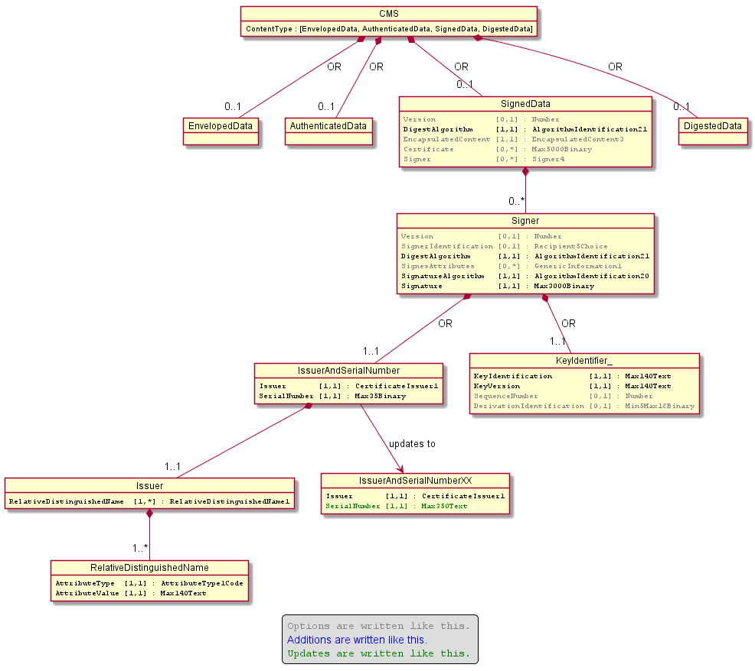

We won't change the size of the AttributeValue of the message component RelativeDistinguishedName since according to the RFC3280 the maximum length should be limited to 64.

Finally we want to change the way we identify signature computed through elliptic curve algortihm. Currently our design uses a codeset to identify the curve and the digest might be provided by a Parameter. Except the error, in the cardinality inside the message component Parameter, the classical and standardized ASN.1 way to define this kind of algorithm is to define a codeset identifying the digest algorithm and a parameter to identify the name of the curve. To avoid any misunderstanding regarding the name of the curve, the corresponding OID value will be provided in a text manner (e.g 1.2.840.10045.4.3.2).
The following diagram explains the modifications.

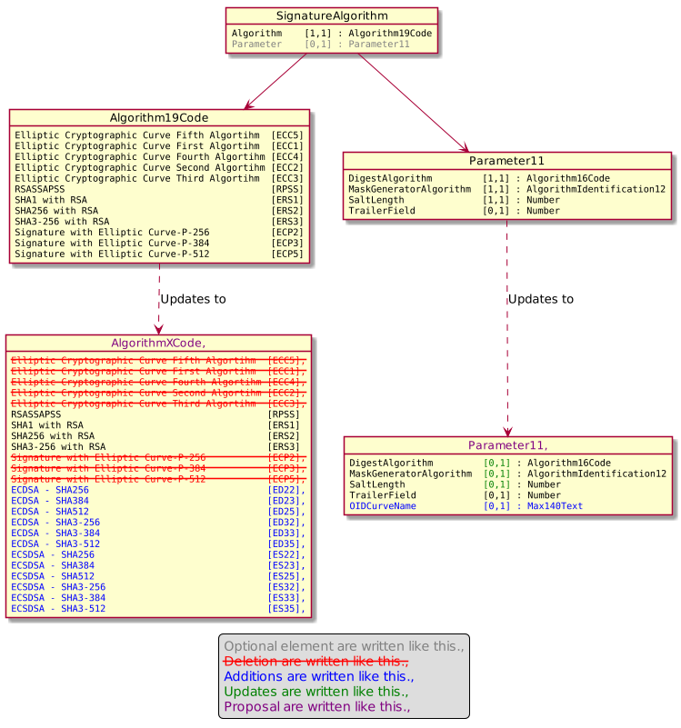

Urgency of the request:

Urgent.

Business examples:
Examples illustrating the change request.

SEG/TSG recommendation:
This section is not to be taken care of by the submitter of the change request. It will be completed in due time by the SEG(s) in charge of the related ISO 20022 messages or the TSG for changes related to the BAH.

Consider |  | X | Timing
 |  |  | - Next yearly cycle: 2020/2021  (the change will be considered for implementation in the yearly maintenance cycle which starts in 2020 and completes with the publication of new message versions in the spring of 2021) |  | X
- At the occasion of the next maintenance of the messages
(the change will be considered for implementation, but does not justify maintenance of the messages in its own right – will be pending until more critical change requests are received for the messages)
- Urgent unscheduled
(the change justifies an urgent implementation outside of the normal yearly cycle)
 |  |  | - Other timing:
Comments:

Reject
Reason for rejection:

Impact analysis and type of impact:

The modifications will be done accordingly to the approved Change Request.

Since we are modifying components that are reused in may other message components, the analysis of ripple effects gives a long list.

PointOfInteractionComponentIdentification1
- LoginRequest2
  - SessionManagementRequest3
- PointOfInteractionComponent10
  - EventContext2
    - RetailerEvent2
      - EventNotificationData2
        - SystemEventNofification3
  - LoginRequest2
  - LoginResponse2
    - SessionManagementResponse3
  - PointOfInteraction10
    - CardPaymentEnvironment74
    - CardPaymentEnvironment75
  - StatusReportContent9
- TerminalPackageType1
  - AcceptorConfigurationContent9
CryptographicKey14
- DataSetRequest1
  - StatusReportContent9
- PointOfInteractionComponentCharacteristics6
  - PointOfInteractionComponent10
- SecurityParameters12
  - AcceptorConfigurationContent9
IssuerAndSerialNumber1
- Recipient5Choice
  - KeyTransport5
    - Recipient8Choice
      - AuthenticatedData6
        - ContentInformationType21
          - ActionMessage7 (cf below)
          - StatusReportV09
          - ManagementPlanReplacementV08
          - AcceptorConfigurationUpdateV09
          - MaintenanceDelegationRequestV06
          - MaintenanceDelegationResponseV04
          - CertificateManagementRequestV03
          - CertificateManagementResponseV03
          - SaleToPOIServiceRequestV02
          - SaleToPOIServiceResponseV02
          - SaleToPOIReconciliationuestV02
          - SaleToPOIReconciliationResponseV02
          - SaleToPOISessionManagementRequestV02
          - SaleToPOISessionManagementResponseV02
          - SaleToPOIAdministrativeRequestV02
          - SaleToPOIAdministrativeResponseV02
          - SaleToPOIReportRequestV02
          - SaleToPOIReportResponseV02
          - SaleToPOIAbortV02
          - SaleToPOIEventNotificationV02
          - SaleToPOIMessageStatusRequestV02
          - SaleToPOIMessageStatusResponseV02
          - SaleToPOIDeviceRequestV02
          - SaleToPOIDeviceResponseV02
        - ContentInformationType23
          - CryptographicKey14
          - DataSetRequest1 (cf below)
          - ExternallyDefinedData1 (cf below)
          - InputResultData2 (cf below)
          - MaintenanceDelegation9 (cf below)
          - TMSAction8
        - ContentInformationType24
          - AcceptorAuthorisationRequestV09
          - AcceptorToAuthorisationResponseV09
          - AcceptorCompletionAdviceV09
          - AcceptorCompletionAdviceResponseV08
          - AcceptorCancellationRequestV09
          - AcceptorCancellationResponseV08
          - AcceptorCancellationAdviceV09
          - AcceptorCancellationAdviceResponseV08
          - AcceptorReconciliationRequestV08
          - AcceptorReconciliationResponseV07
          - AcceptorBatchTransferV09
          - AcceptorBatchTransferResponseV08
          - AcceptorDiagnosticRequestV08
          - AcceptorDiagnosticResponseV07
          - AcceptorCurrencyConversionRequestV07
          - AcceptorCurrencyConversionResponseV07
          - AcceptorCurrencyConversionAdviceV04
          - AcceptorCurrencyConversionAdviceResponseV03
          - TransactionAdviceV01
          - TransactionAdviceResponseV01
      - EnvelopedData7
        - ContentInformationType22
          - ApplicationParameters9 (cf below)
          - CardholderAuthentication13
          - CardPaymentEnvironment74
          - CardPaymentEnvinvironment75
          - CardPaymentTransaction94
          - MobileData2 (cf below)
          - OnLinePin7 (cf below)
          - PaymentCard30 (cf below)
          - RetailerPaymentResult2
        - ContentInformationType23
  - Signer4
    - SignedData5
      - ContentInformationType21
      - ContentInformationType23
ActionMessage7
- AbortData2
  - SystemAbort3
- Action10
  - CardPaymentTransaction94
    - AcceptorAuthorisationResponse9
    - CardPaymentDataSetTransaction33
    - RetailerPaymentResult2
      - PaymentResponse2
        - MessageStatusRespoonseData3
        - PointOfInteractionTransactionReport2
        - ServiceResponse3
      - PerformedTransaction2
  - CardPaymentTransaction98
- CurrencyConversion19
  - CardPaymentTransaction94
  - CurrencyConversion17
    - AcceptorCurrencyConversionAdvice4
    - CardPaymentTransactionDetails48
      - CardPaymentTransaction100
        - AcceptorCurrencyConversionRequest7
        - LoyaltyTransaction2
          - LoyaltyRequest2 (cf below)
        - PaymentRequest2
          - ServiceRequest3
          - TransactionToPerform2Choice
        - RetailerPaymentResult2
        - RetailerReversalResult2
          - ReversalResponse3 (cf below)
        - ReversalRequest2
        - StoredValueData3
          - StoredValueRequest3 (cf below)
          - StoredValueResponse3 (cf below)
      - CardPaymentTransaction92
      - CardPaymentTransaction93
        - AcceptorAuthorisationResponse9
        - AcceptorCurrencyConversionAdvice4
        - AcceptorCurrencyConversionResponse7
        - CardPaymentDataSetTransaction33
      - CardPaymentTransaction99
  - CurrencyConversion18
    - AcceptorCurrencyConversionResponse7
    - CardPaymentTransaction102
      - CardPaymentTransaction100
- DeviceDisplayRequest2
  - DeviceRequest3
- DeviceInitialisationCardReaderRequest2
  - DeviceRequest3
- DeviceInputNotification2
  - DeviceRequest3
- DeviceInputRequest2
  - DeviceRequest3
- DevicePoweroffCardReaderRequest2
  - DeviceRequest3
- DevicePrintRequest2
- EnableServiceRequest2
  - ServiceRequest3
- EventNotificationData2
  - SystemEventNotification3
- InputData2
  - DeviceInputRequest2
- LoginRequest2
  - SessionManagementRequest3
- LoginResponse2
  - SessionManagementResponse3
- PaymentReceipt2
  - BalanceInquiryResponse2
    - ServiceResponse3
  - PaymentResponse2
    - MessageStatusResponseData3
    - PointOfInteractionTransactionReport2
    - ServiceResponse3
  - ReversalResponse3
    - MessageStatusResponseData3
    - ServiceResponse3
  - StoredValueResponse3
    - MessageStatusResponseData3
    - ServiceResponse3
- LoyaltyRequest2
  - ServiceRequest3
  - TransactionToPerform2Choice
- StoredValueRequest3
  - BalanceInquiryRequest3
    - ServiceRequest3
  - ServiceRequest3
- DataSetRequest1
  - StatusReportContent9
- ExternallyDefinedData1
  - CardholderAuthentication13
    - Cardholder16
      - CardPaymentEnvironment74
      - CardPaymentEnvironment75
  - CardPaymentTransactionDetails48
  - PackageType1
    - PointOfInteractionComponent10
    - TerminalPackageType1
- InputResultData2
  - InputResult2
    - DeviceInputResponse2
- MaintenanceDelegation9
  - MaintenanceDelegationResponse4
    - MaintenanceDelegationResponseV04
- AppcationParameters9
  - AcceptorConfigurationContent9
- MobileData2
  - Cardholder16
- OnLinePin7
  - CardholderAuthentication13
  - DeviceSecureInputRequest2
    - DeviceRequest3
  - DeviceSecureInputResponse2
    - DeviceResponse3
- PaymentCard30
  - CardPaymentEnvironment74
  - CardPaymentEnvironment75
Algorithm19Code
- AlgorithmIdentification20 (cf below)
Parameter11
- AlgorithmIdentification20 (cf below)
AlgorithmIdentification20
- Signer4

The severity of the impact of the proposed change for the message users should be indicated in the table below (either “no impact”, “conditional’ or “mandatory”).
Type of impact
 | No impact | The change(s) will not impact the schema (the version number will not change) and will not impact the business applications of any users, e.g. the clarification of a definition
 | Conditional | The change(s) will impact the schema (at least the version number) and the business applications of certain users but not all, e.g. the addition of an optional component
X | Mandatory | The change(s) will impact the schema and the business applications of all users, e.g. addition of a mandatory component.

Proposed implementation:

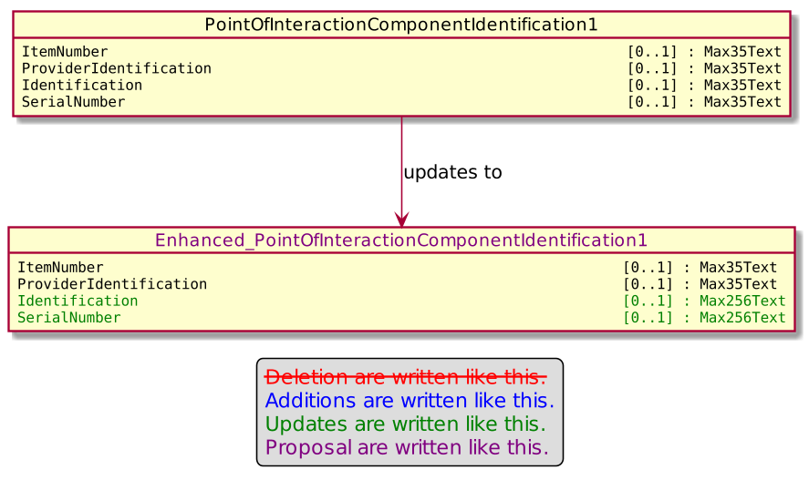

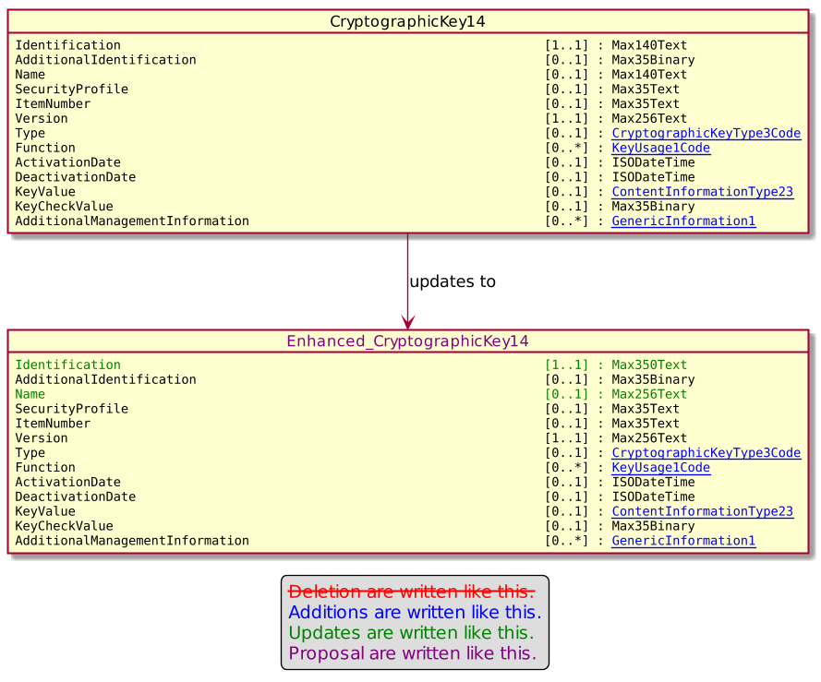

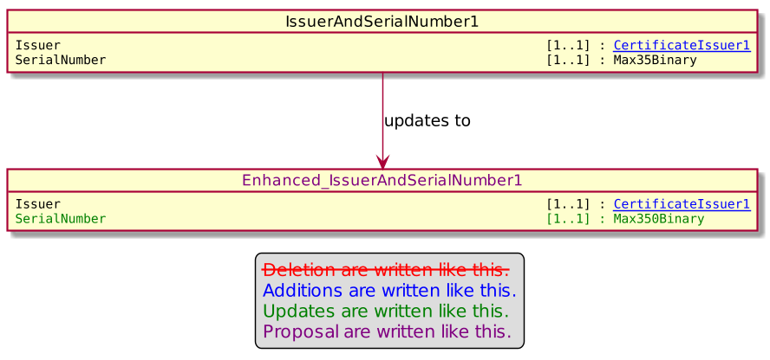

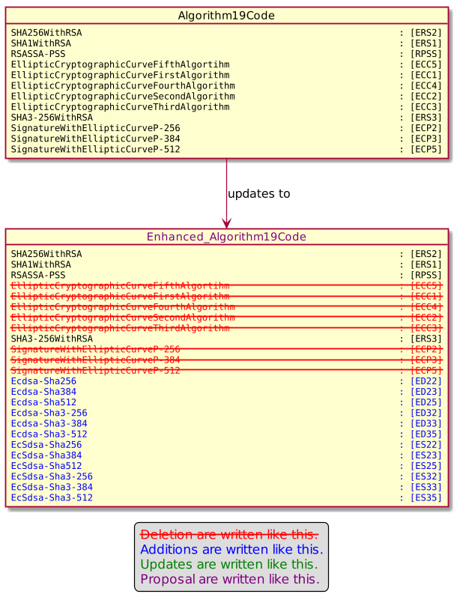

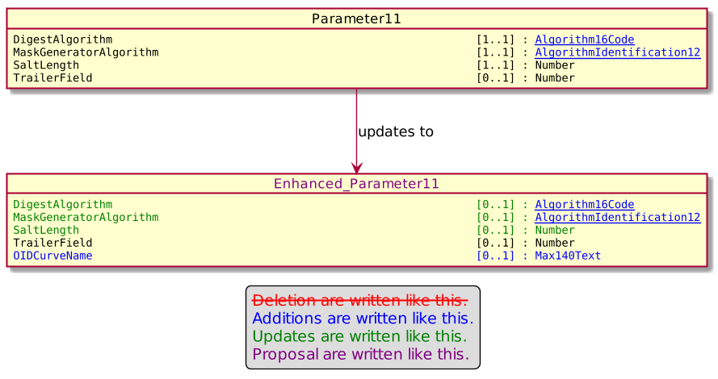

Proposed timing:
The submitting organization confirms that it can implement the requested changes in the requested timing, or, if not, proposes another timing.

Timing | - As requested
 | - Other:

Final decision of the SEG(s):
This section is not to be taken care of by the submitting organization. It will be completed in due time by the SEG(s) in charge of the related ISO 20022 messages.
Approve
Comments:

Reject
Reason for rejection:

Change request number 0872 – Nexo catm New Acquirer Messages

Copy of the approved change request:

Origin of the request:
A.1 Submitter: nexo A.I.S.B.L.
A.2 Contact person: Philippe CECE (Philippe.cece@ingenico.com) / Pierre MOURA (pierre.moura@frenchsys.com)
A.3 Sponsors: nexo A.I.S.B.L.

Related messages:

- AcceptorBatchTransfer V09 caaa.011.001.09

- AcceptorConfigurationUpdate V09 catm.003.001.09
- MaintenanceDelegationRequest V06 catm 005.001.06

Description of the change request:

In order to cover new use cases, it would be interesting to include 2 couples of new messages in the caaa protocols:
- AcceptorNonFinancialRequest / AcceptorNonFinancialResponse
- AcceptorTransactionLogReportRequest / AcceptorTransactionLogReportResponse

The goal of the AcceptorNonFinancialRequest/Response is to allow the development of pre-acquiring services, in addition to the acquiring services performed by the Acquirer. These pre-acquiring services may include (but are not limited to) Risk management, final Acquirer selection and Routing. These pre-acquiring services could be performed by the Acquirer or an Agent. In order to foster usage of tokens between acceptor and acquirer and limit the usage of sensitive information, we also propose to support token and PAR inquiries in the request, and received them back in the response, since the PAR is an element of a the Card message component.

The second couple of messages AcceptorTransactionLogReportRequest/Response allow detailed reconciliation through reports between an Acceptor and an Agent.

The creation of these new messages implies the update of the TMS protocol to still clearly identify which messages a POI might sent to an acquirer. An additional update of the BatchTransfer messages is also considered to be able to request a batch of Tokens.

Purpose of the change:

- AcceptorNonFinancialRequest

The proposal is based on the same message element used in an authorization request coupled with a clear indication of the requested services and flags to identify which token are expected in the response.
The diagram below highlights the proposed structure of the message schema.

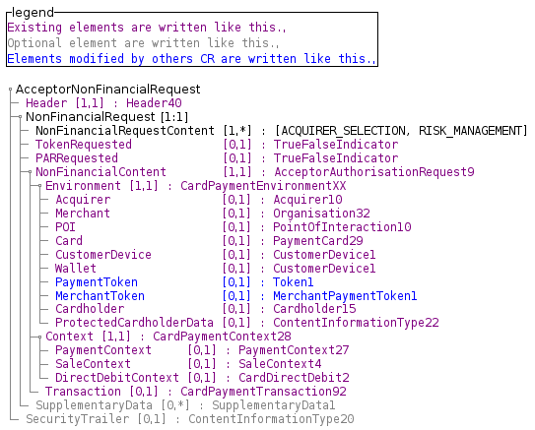

- AcceptorNonFinancialResponse

The response should provide the result of the requested services and the environment to provide tokens or PAR in the Card message element.
The diagram below highlights the proposed structure of the message schema.

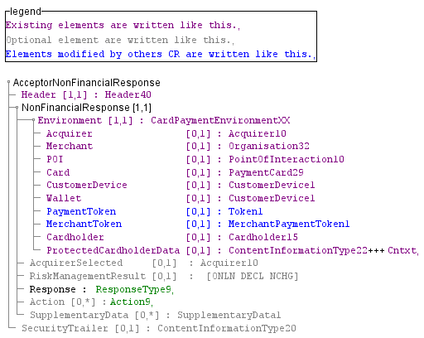

- TokenRequest through BatchTransfer

In order to manage a batch of token, we want to create a TokenRequestComponent message component which holds a TransactionSeuquenceCounter which might act as an identifier like in any other message component in a CardPaymentDataSetTransaction8Choice of a BatchTrasnfer.

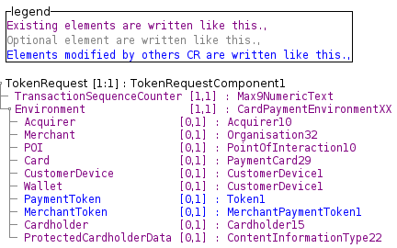

The message component, which brings the response, is made with the same component.

Then, in order to allow request/response through the BatchTransfer message, we will update the CardPaymentDataSetTransaction8Choice with the following proposal.

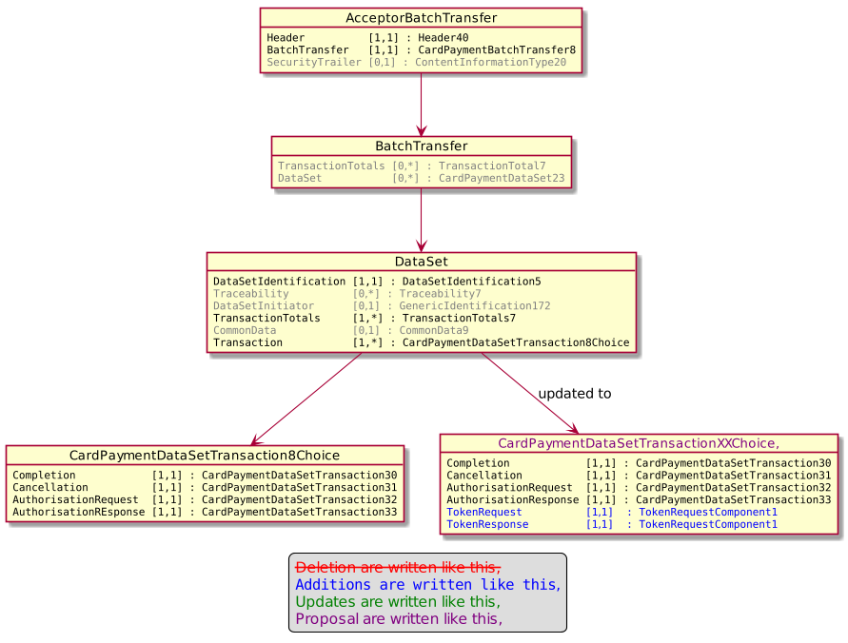
The BatchTransferResponse doesn't need to evolve since the SequenceCounter of the request could be set in the RejectedTransaction\TransactionCounter or SuspendedTransaction\TransactionCounter of the response.

- AcceptorTransactionLogReportRequest

The proposal aims to reuse a message defined in the casp domain.
The diagram below highlights the proposed structure of the message schema.

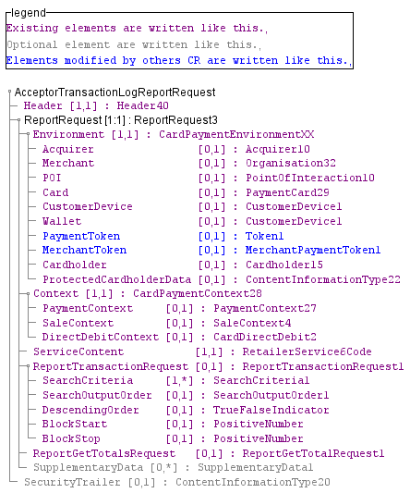

- AcceptorTransactionLogReportResponse

Obviously, we follow the same idea for the response and reuse the message from casp domain.
The diagram below highlights the proposed structure of the message schema.

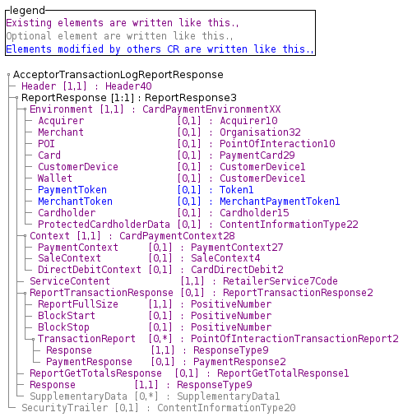

- Update on TMS message

Then the TMS messages have to be updated in order to clearly identify which acquirer messages a POI may send to an acquirer.
This update only aims the MessageToSend message element of type MessageFunction16Code as highlighted by the following diagram.
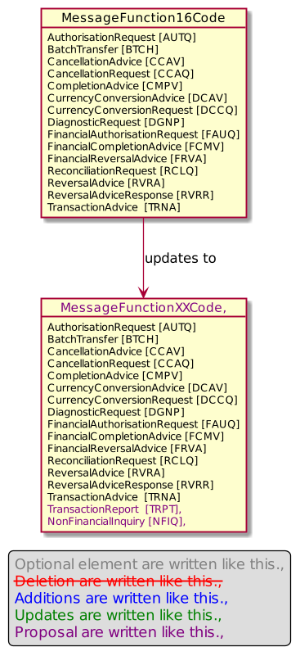

Urgency of the request:

Urgent.

Business examples:
Examples illustrating the change request.

SEG/TSG recommendation:
This section is not to be taken care of by the submitter of the change request. It will be completed in due time by the SEG(s) in charge of the related ISO 20022 messages or the TSG for changes related to the BAH.

Consider |  | X | Timing
 |  |  | - Next yearly cycle: 2020/2021  (the change will be considered for implementation in the yearly maintenance cycle which starts in 2018 and completes with the publication of new message versions in the spring of 2019) |  | X
- At the occasion of the next maintenance of the messages
(the change will be considered for implementation, but does not justify maintenance of the messages in its own right – will be pending until more critical change requests are received for the messages)
- Urgent unscheduled
(the change justifies an urgent implementation outside of the normal yearly cycle)
 |  |  | - Other timing:
Comments:
Cards SEG remark: The service description pre-acquiring is misleading.

Reject
Reason for rejection:

Impact analysis and type of impact:

After additional reviews, we changed a little bit the NonFinancialRequest layout, in order to keep a common layout with other acquirer messages. This layout should also allows us to ease future maintenance. We also introduce the notion of ServiceProvider, to identify agent which support messages like NonFinancialRequest, consequently this information is also used directly in the AcceptorConfigurationUpdate message.

Additionally the creation of new Acquirer messages implies an update of the MessageFunction41Code, which will create by ripple effect an update of message component Header58.

The configuration of message supported by acquirer sent througth the TMS message is done by the creation of a new type of parameters ServiceProviderParameters, which we believe improves readability and future evolution. Consequently to this creation, we need to update the DataSetCategory15Code and DataSetCategory11Code in order to support delegation for this kind of parameters.

The analysis of ripple effects of these changes provides the following list.

CardPaymentDataSetTransaction8Choice
- Already managed by previous Change Request.

MessageFunction40Code
- AcquirerHostConfiguration7
  - AcquirerProtocolParameters13
MessageFunction41Code
- Header58
  - AcceptorAuthorisationRequestV09
  - AcceptorAuthorisationResponseV09
  - AcceptorCompletionAdviceV09
  - AcceptorCompletionAdviceResponseV08
  - AcceptorCancellationRequestV09
  - AcceptorCancellationResponseV08
  - AcceptorCancellationAdviceV09
  - AcceptorCancellationAdviceResponseV08
  - AcceptroReconciliationRequestV08
  - AcceptorReconciliationResponseV07
  - AcceptorDiagnosticRequestV08
  - AcceptorDiagnosticResponseV07
  - AcceptorCurrencyConversionRequestV07
  - AcceptorCurrencyConversionResponseV07
  - AcceptorCurrencyConversionAdviceV04
  - AcceptorCurrencyConversionAdviceResponseV03
  - TransactionAdviceV01
  - TransactionAdviceResponseV01
DataSetCategory15Code
- MaintenanceDelegation10

The severity of the impact of the proposed change for the message users should be indicated in the table below (either “no impact”, “conditional’ or “mandatory”).
Type of impact
 | No impact | The change(s) will not impact the schema (the version number will not change) and will not impact the business applications of any users, e.g. the clarification of a definition
X | Conditional | The change(s) will impact the schema (at least the version number) and the business applications of certain users but not all, e.g. the addition of an optional component
 | Mandatory | The change(s) will impact the schema and the business applications of all users, e.g. addition of a mandatory component.

Proposed implementation:

Update of the MessageFunction41Code.

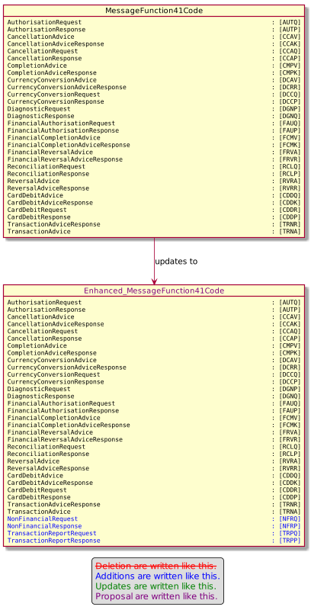

The new message NonFinancialRequest is described by the following diagrams.

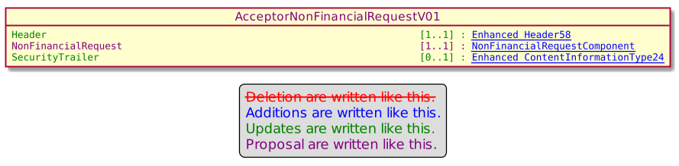

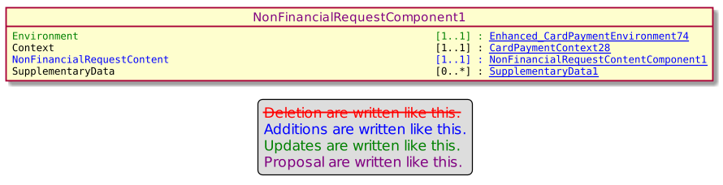

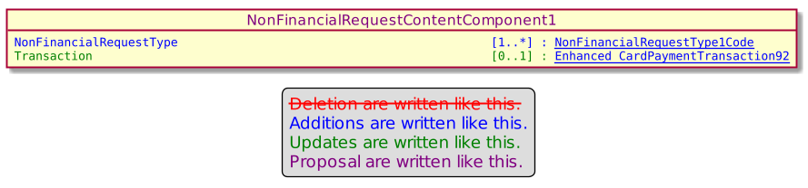

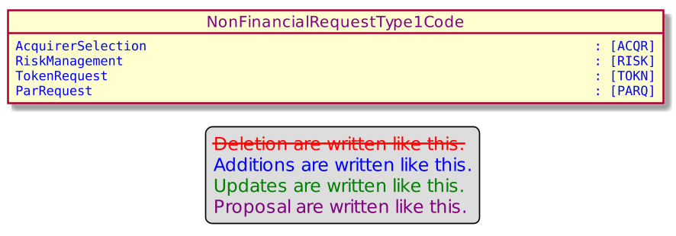

The new message NonFinancialResponse is described by the following diagrams.

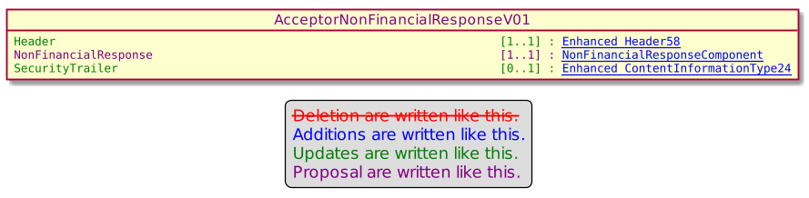

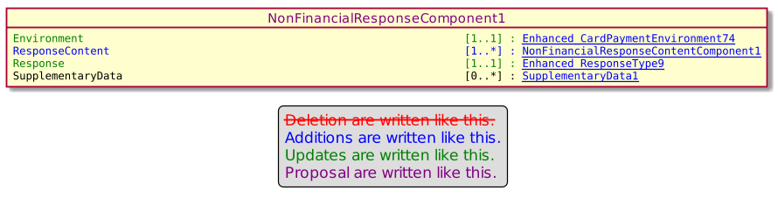

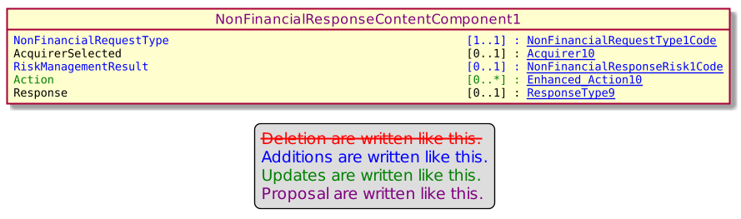

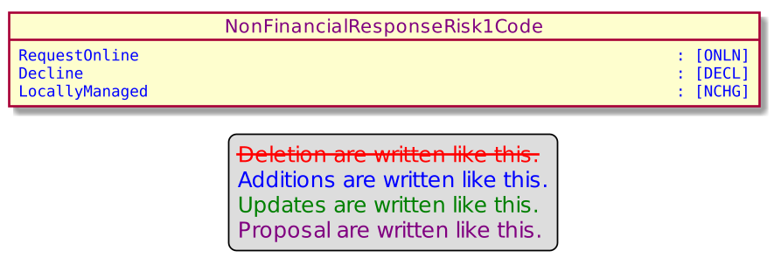

The message component TokenRequestComponent is created accordingly to the approved Change Request.

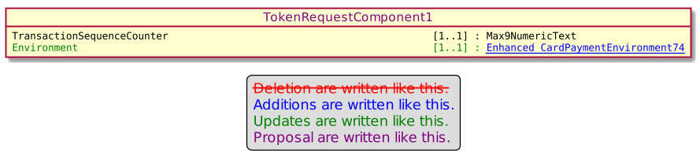

Then the CardPaymentDataSetTransaction8Choice is enhanced to add 2 new message elements as highlighted here.

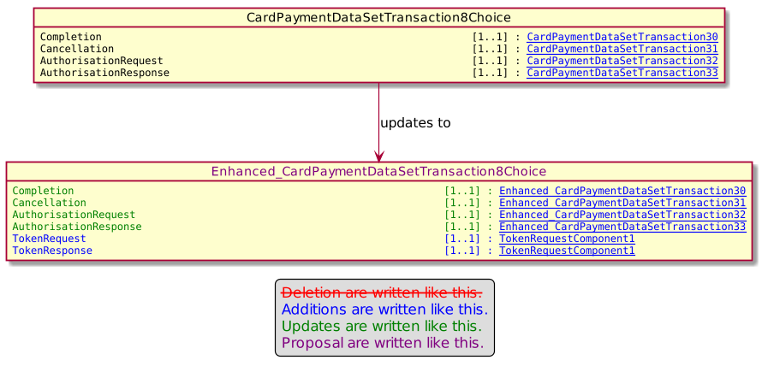

The new message AcceptorTransactionLogReportRequest is created accordingly to the approved Change Request.

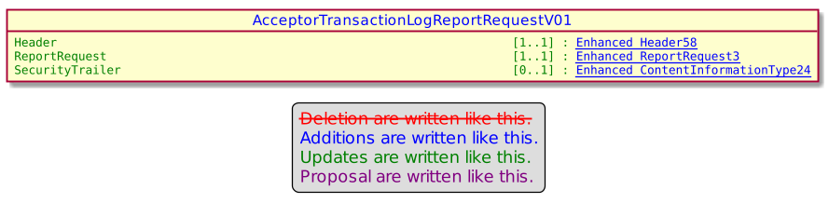

And the same policy is applied to the AcceptorTransactionLogReportResponse.

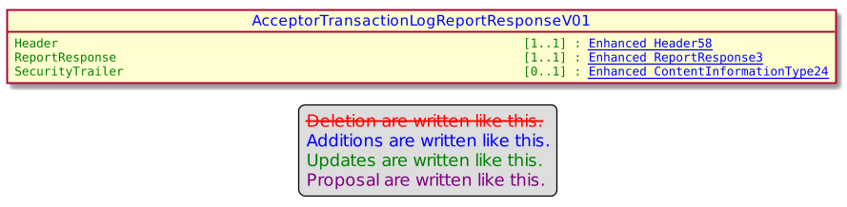

Regarding the message component MessageFunction40Code used in TMS messages to identify MessageToSend we changed a little bit some codeset and values in order to be compliant with previous naming conventions.

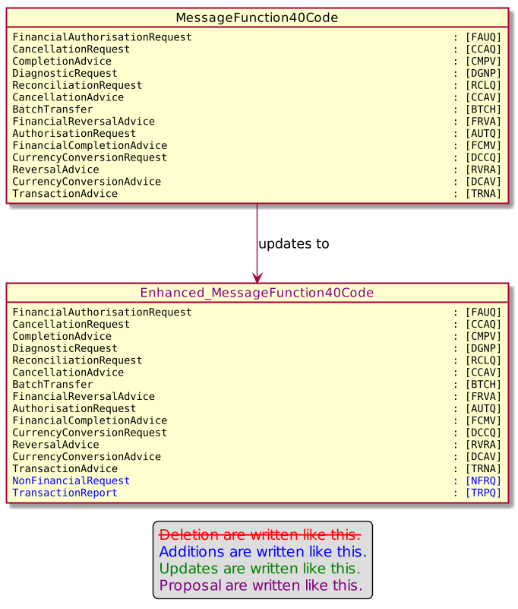

Then the introduction of the ServiceProvider is done with the update of the message component AcceptorConfigurationContent9 and the creation of ServiceProviderParameters.

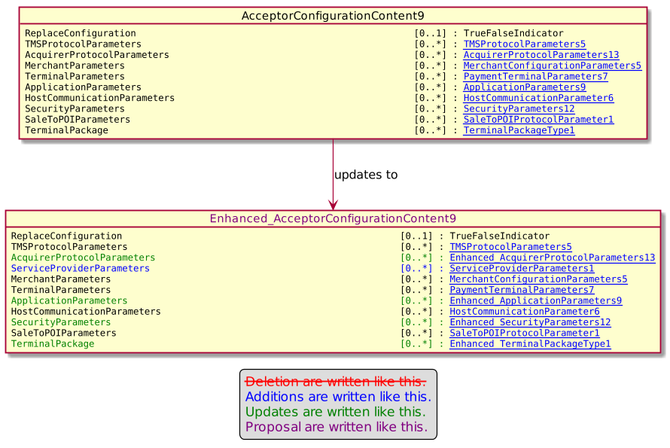

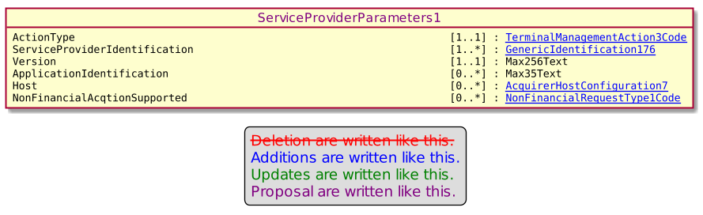

Finally the update of DataSetCategory15Code provides the following component.

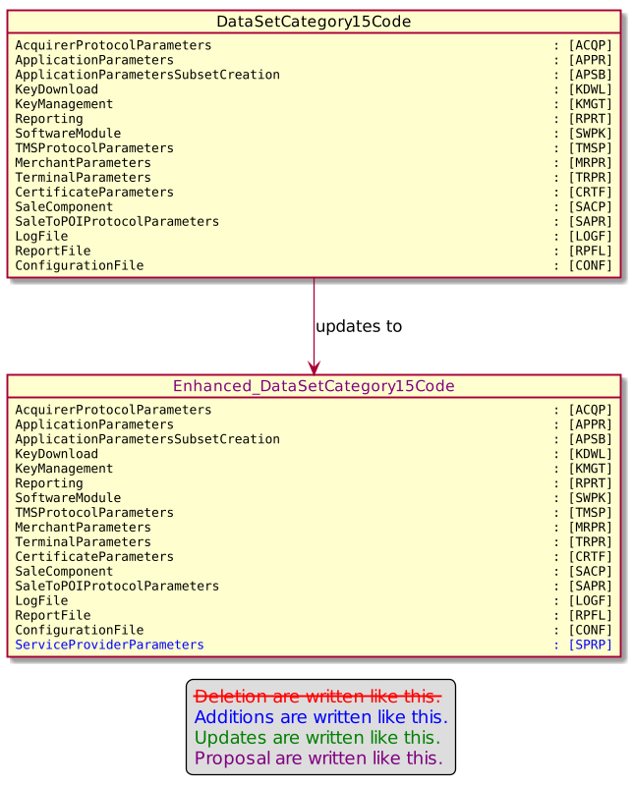

Proposed timing:
The submitting organization confirms that it can implement the requested changes in the requested timing, or, if not, proposes another timing.

Timing | - As requested
 | - Other:

Final decision of the SEG(s):
This section is not to be taken care of by the submitting organization. It will be completed in due time by the SEG(s) in charge of the related ISO 20022 messages.
Approve
Comments:

Reject
Reason for rejection:

Change request number 0873 – Nexo catm POI Group

Copy of the approved change request:

Origin of the request:
A.1 Submitter: nexo A.I.S.B.L.
A.2 Contact person: Philippe CECE (Philippe.cece@ingenico.com) / Pierre MOURA (pierre.moura@frenchsys.com)
A.3 Sponsors: nexo A.I.S.B.L.

Related messages:

- StatusReport V09 catm 001.001.09
- AcceptorConfigurationUpdate V09 catm 003.001.09

Description of the change request:

In some use cases, the MTM may have to dynamically managed POIs. In that case, the POI is dynamically inserted in the MTM realm. This kind of management could be done, if the MTM is able to dynamically associate the POI to at least one group of POI in order to identify the parameters it has to send back.

The aim of this Change Request is to provide such management.

Purpose of the change:

In order to achieve this, we would like to add a message POIGroupIdentification as multiple Max35Text values. These values are optionally sent in a StatusReport and a AcceptorConfigurationUpdate as highlighted by the following diagram.

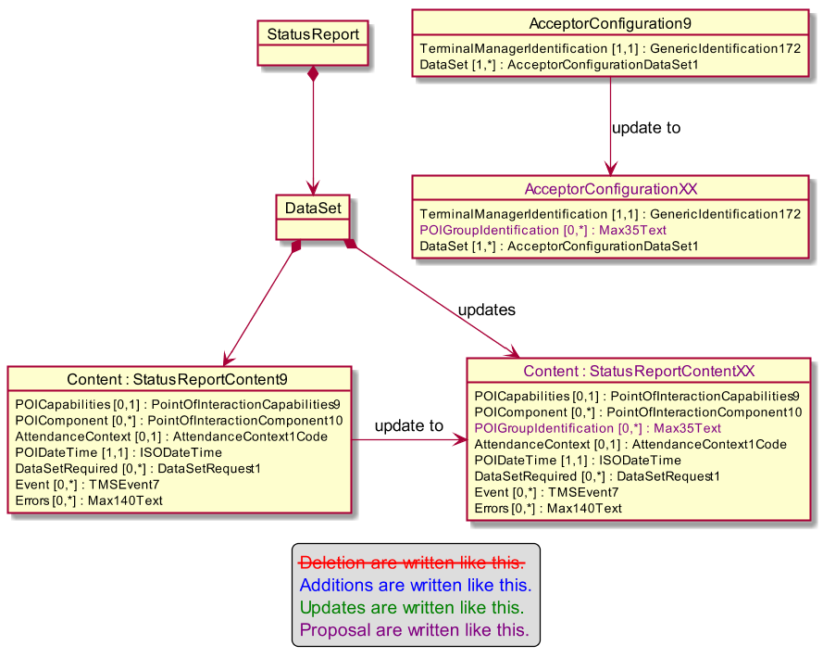

Urgency of the request:

Urgent.

Business examples:
Examples illustrating the change request.

SEG/TSG recommendation:
This section is not to be taken care of by the submitter of the change request. It will be completed in due time by the SEG(s) in charge of the related ISO 20022 messages or the TSG for changes related to the BAH.

Consider |  | X | Timing
 |  |  | - Next yearly cycle: 2020/2021  (the change will be considered for implementation in the yearly maintenance cycle which starts in 2020 and completes with the publication of new message versions in the spring of 2021) |  | X
- At the occasion of the next maintenance of the messages
(the change will be considered for implementation, but does not justify maintenance of the messages in its own right – will be pending until more critical change requests are received for the messages)
- Urgent unscheduled
(the change justifies an urgent implementation outside of the normal yearly cycle)
 |  |  | - Other timing:
Comments:

Reject
Reason for rejection:

Impact analysis and type of impact:

The update will be done according to the approved Change Request.

The analysis of the ripple effects is quite simple since these 2 message components are aimed by previous Change Requests.

StatusReportContent9
- Already changed by previous Change Request.
AcceptorConfiguration9
- Already changed by previous Change Request.

The severity of the impact of the proposed change for the message users should be indicated in the table below (either “no impact”, “conditional’ or “mandatory”).
Type of impact
 | No impact | The change(s) will not impact the schema (the version number will not change) and will not impact the business applications of any users, e.g. the clarification of a definition
X | Conditional | The change(s) will impact the schema (at least the version number) and the business applications of certain users but not all, e.g. the addition of an optional component
 | Mandatory | The change(s) will impact the schema and the business applications of all users, e.g. addition of a mandatory component.

Proposed implementation:

The StatusReportContent will be changed to the following diagram.

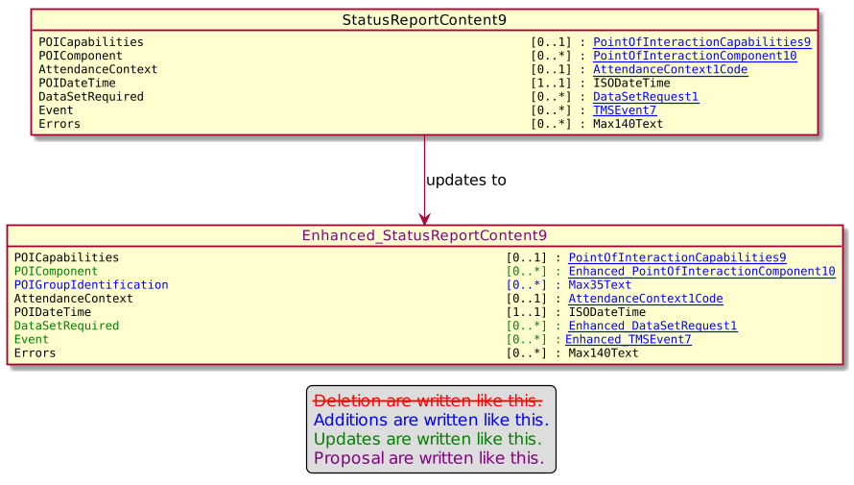

The message component AcceptorConfiguration9 will be changed with the following diagram.

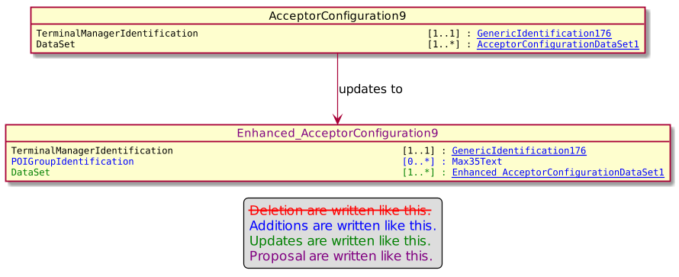

Proposed timing:
The submitting organization confirms that it can implement the requested changes in the requested timing, or, if not, proposes another timing.

Timing | - As requested
 | - Other:

Final decision of the SEG(s):
This section is not to be taken care of by the submitting organization. It will be completed in due time by the SEG(s) in charge of the related ISO 20022 messages.
Approve
Comments:

Reject
Reason for rejection:

Change request number 0874 – Nexo catm Process Timing

Copy of the approved change request:

Origin of the request:
A.1 Submitter: nexo A.I.S.B.L.
A.2 Contact person: Philippe CECE (Philippe.cece@ingenico.com) / Pierre MOURA (pierre.moura@frenchsys.com)
A.3 Sponsors: nexo A.I.S.B.L.

Related messages:

- ManagementPlanReplacement V08 catm 002.001.008
- AcceptorConfigurationUpdate V09 catm 003.001.09
- MaintenanceDelegationRequest V06 catm 005.001.006

Description of the change request:

In the current protocol definition, Minute is the lowest definition of time. But in order to fasten certification steps and tests, we would like to change waiting time and period description to take second into account.

The aim of this Change Request is to provide such management.

Purpose of the change:

First, in order to keep backward compatibility, we would like to add a code set named MinimumUnitOfTime defined as Identification of the smallest unit used in time settings with multiplicity [0,1] and defined as a TimeUnit1Code in ProcessTiming4 and ProcessTiming3.
Secondly, since they only differ by optional elements, we would like to simplify the repository management by simplifying the use of ProcessTiming3 and ProcessTiming4 to a unique message component as highlighted by the following diagram.

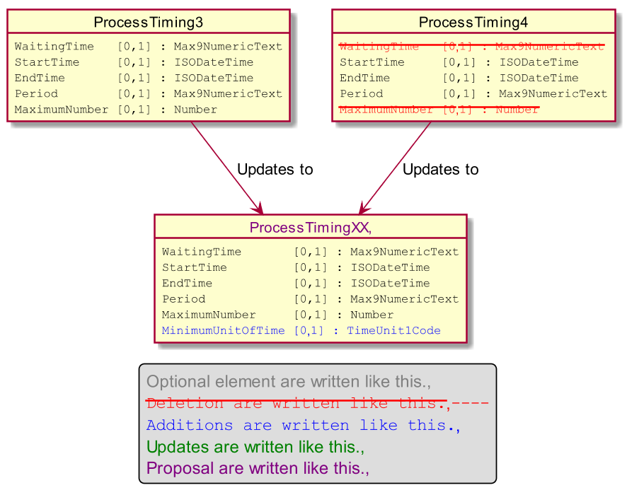
TimeUnit1Code already exists in the repository and provides the necessary information. Irrelevant values will be identified in the MUG.
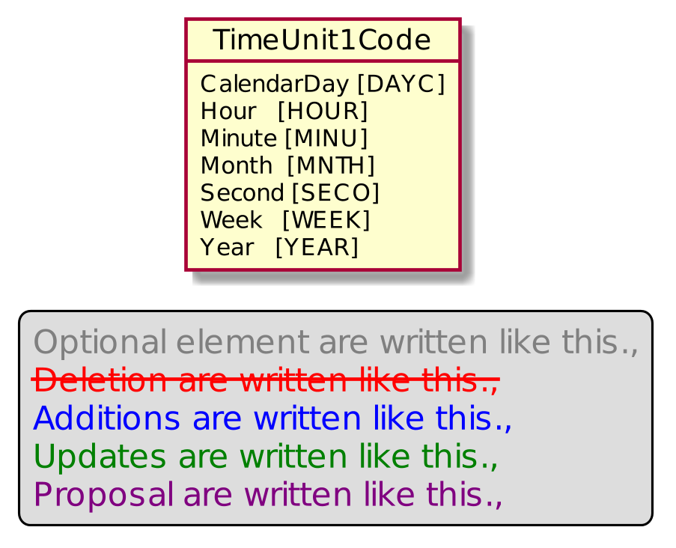

Urgency of the request:

Urgent.

Business examples:
Examples illustrating the change request.

SEG/TSG recommendation:
This section is not to be taken care of by the submitter of the change request. It will be completed in due time by the SEG(s) in charge of the related ISO 20022 messages or the TSG for changes related to the BAH.

Consider |  | X | Timing
 |  |  | - Next yearly cycle: 2020/2021  (the change will be considered for implementation in the yearly maintenance cycle which starts in 2020 and completes with the publication of new message versions in the spring of 2021) |  | X
- At the occasion of the next maintenance of the messages
(the change will be considered for implementation, but does not justify maintenance of the messages in its own right – will be pending until more critical change requests are received for the messages)
- Urgent unscheduled
(the change justifies an urgent implementation outside of the normal yearly cycle)
 |  |  | - Other timing:
Comments:

Reject
Reason for rejection:

Impact analysis and type of impact:

After an additional meeting, it has been decided to name the new message element of ProcessTiming message component, UnitOfTime rather than MinimUnitOfTime.
We decided to keep also an update of ProcessTiming4 and not only manage one message component for this 2 use cases.
Finally, we also realise that we need to update also the message component ProcessRetry2 too.

The ripple effect of changes gives the following list.

ProcessTiming3
- TMSAction8
ProcessTiming4
- ExchangeConfiguration8
  - AcquirerProtocolExchangeBehavior1
    - AcquirerProtocolParameters13
  - AcquirerProtocolParameters13
ProcessRetry2
- ExchangeConfiguration8
- MaintenanceDelegation5
- TMSAction8

The severity of the impact of the proposed change for the message users should be indicated in the table below (either “no impact”, “conditional’ or “mandatory”).
Type of impact
 | No impact | The change(s) will not impact the schema (the version number will not change) and will not impact the business applications of any users, e.g. the clarification of a definition
X | Conditional | The change(s) will impact the schema (at least the version number) and the business applications of certain users but not all, e.g. the addition of an optional component
 | Mandatory | The change(s) will impact the schema and the business applications of all users, e.g. addition of a mandatory component.

Proposed implementation:

The ProcessTiming3 will be updated according to the following diagram.

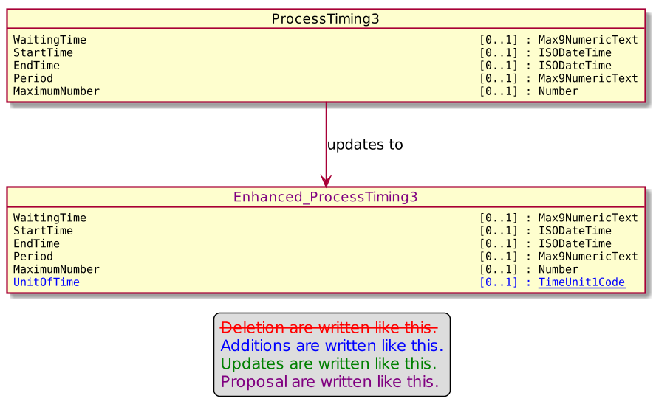

The ProcessTiming4 will be updated according to the following diagram.

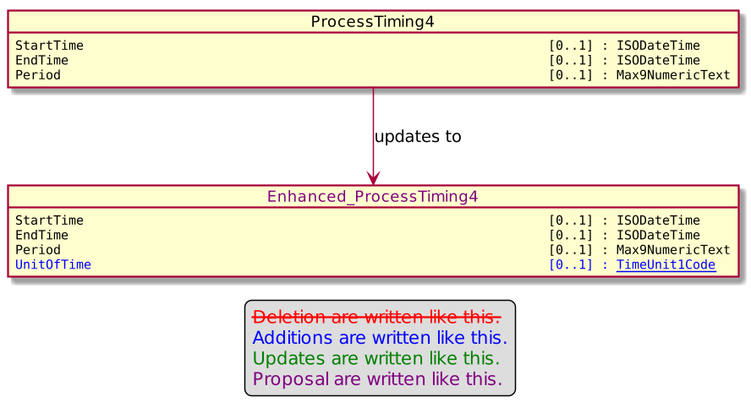

And the ProcessRetry2 will be updated according to this diagram.

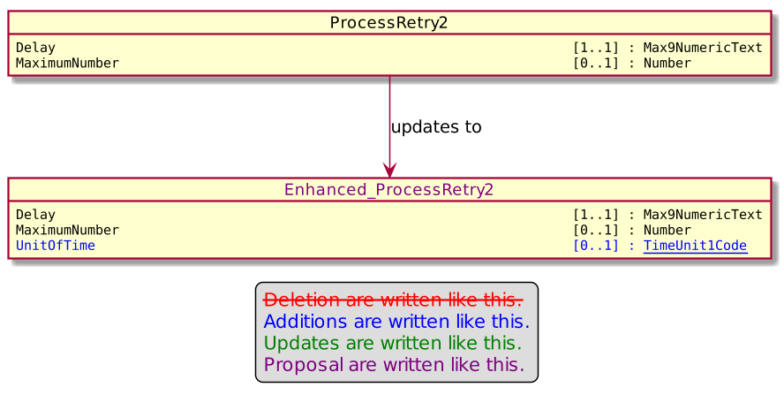

Proposed timing:
The submitting organization confirms that it can implement the requested changes in the requested timing, or, if not, proposes another timing.

Timing | - As requested
 | - Other:

Final decision of the SEG(s):
This section is not to be taken care of by the submitting organization. It will be completed in due time by the SEG(s) in charge of the related ISO 20022 messages.
Approve
Comments:

Reject
Reason for rejection:

Change request number 0875 – Nexo catm Reservation Settings

Copy of the approved change request:

Origin of the request:
A.1 Submitter: nexo A.I.S.B.L.
A.2 Contact person: Philippe CECE (Philippe.cece@ingenico.com) / Pierre MOURA (pierre.moura@frenchsys.com)
A.3 Sponsors: nexo A.I.S.B.L.

Related messages:

- AcceptorConfigurationUpdate V09 catm 003.001.09
- MaintenanceDelegationRequest V06 catm 005.001.06

Description of the change request:

In regards of Reservation, some acquirers may expect to receive a completion advice message after each reservation update, and a maximum amount might be set for reservation update too.

The aim of this Change Request is to back these functions.

Purpose of the change:

In order to achieve this, we would like to update the AcquirerProtocolParameters13 by adding new elements as highlighted by the following diagram.

Urgency of the request:

Urgent.

Business examples:
Examples illustrating the change request.

SEG/TSG recommendation:
This section is not to be taken care of by the submitter of the change request. It will be completed in due time by the SEG(s) in charge of the related ISO 20022 messages or the TSG for changes related to the BAH.

Consider |  | X | Timing
 |  |  | - Next yearly cycle: 2020/2021  (the change will be considered for implementation in the yearly maintenance cycle which starts in 2020 and completes with the publication of new message versions in the spring of 2021) |  | X
- At the occasion of the next maintenance of the messages
(the change will be considered for implementation, but does not justify maintenance of the messages in its own right – will be pending until more critical change requests are received for the messages)
- Urgent unscheduled
(the change justifies an urgent implementation outside of the normal yearly cycle)
 |  |  | - Other timing:
Comments:

Reject
Reason for rejection:

Impact analysis and type of impact:

After an additional meeting, since it is rather linked at the application level rather than the protocol level, we decided to not add the following message elements :
- ReservationCurrency
- MaxReservationAmount
- MaxUpdateReservationAmount
- MaxUpdateReservationPercentage.

The other 2 elements will be managed according to the approved Change Request.

Since the modifications aim AcquirerProtocolParameters13 which is already aimed by previous Change Request, there is no need to check the ripple effect analysis.

The severity of the impact of the proposed change for the message users should be indicated in the table below (either “no impact”, “conditional’ or “mandatory”).
Type of impact
 | No impact | The change(s) will not impact the schema (the version number will not change) and will not impact the business applications of any users, e.g. the clarification of a definition
X | Conditional | The change(s) will impact the schema (at least the version number) and the business applications of certain users but not all, e.g. the addition of an optional component
 | Mandatory | The change(s) will impact the schema and the business applications of all users, e.g. addition of a mandatory component.

Proposed implementation:

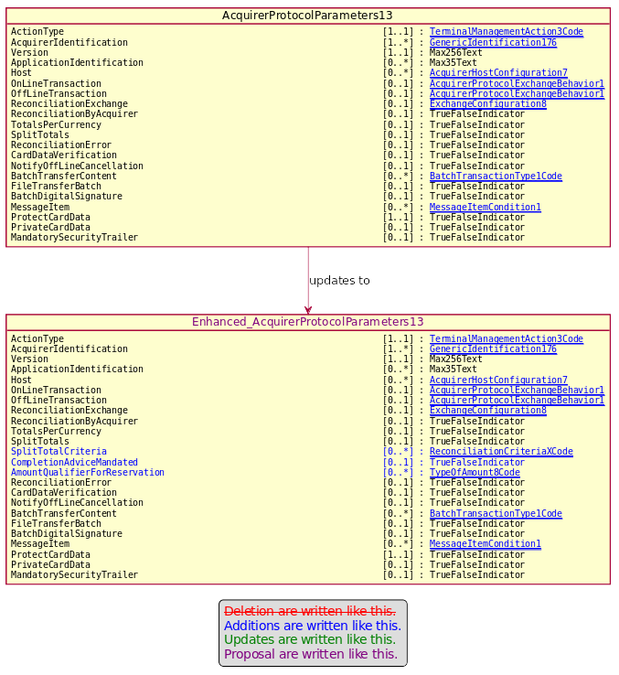

Proposed timing:
The submitting organization confirms that it can implement the requested changes in the requested timing, or, if not, proposes another timing.

Timing | - As requested
 | - Other:

Final decision of the SEG(s):
This section is not to be taken care of by the submitting organization. It will be completed in due time by the SEG(s) in charge of the related ISO 20022 messages.
Approve
Comments:

Reject
Reason for rejection:

Change request number 0876 – Nexo catm Sale To POI Parameters

Copy of the approved change request:

Origin of the request:
A.1 Submitter: nexo A.I.S.B.L.
A.2 Contact person: Philippe CECE (Philippe.cece@ingenico.com) / Pierre MOURA (pierre.moura@frenchsys.com)
A.3 Sponsors: nexo A.I.S.B.L.

Related messages:

- MaintenanceDelegationRequest V06 catm 005.001.06
- MaintenanceDelegationResponse V04 catm 006.001.04

Description of the change request:

We discovered an error in the delegation parameters management. Indeed, if we are able to ask for delegation of some parameters like the SaleToPOIParameters, we are not able to receive the answer.

The aim of this Change Request is to correct this.

Purpose of the change:

In order to achieve this, we would like to correct DelegationResponse to point to the correct DataSetCategory15Code as highlighted by the following diagram.

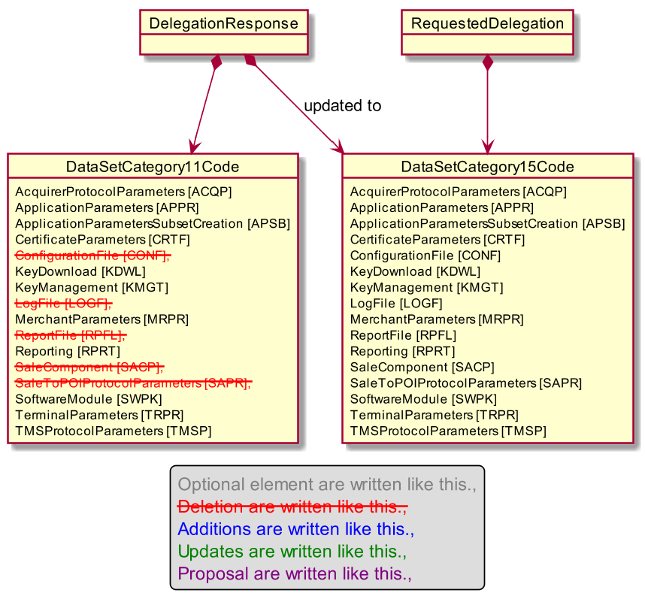

Urgency of the request:

Urgent.

Business examples:
Examples illustrating the change request.

SEG/TSG recommendation:
This section is not to be taken care of by the submitter of the change request. It will be completed in due time by the SEG(s) in charge of the related ISO 20022 messages or the TSG for changes related to the BAH.

Consider |  | X | Timing
 |  |  | - Next yearly cycle: 2020/2021  (the change will be considered for implementation in the yearly maintenance cycle which starts in 2020 and completes with the publication of new message versions in the spring of 2021 |  | X
- At the occasion of the next maintenance of the messages
(the change will be considered for implementation, but does not justify maintenance of the messages in its own right – will be pending until more critical change requests are received for the messages)
- Urgent unscheduled
(the change justifies an urgent implementation outside of the normal yearly cycle)
 |  |  | - Other timing:
Comments:

Reject
Reason for rejection:

Impact analysis and type of impact:

As seen in a previous Change Request, DataSetCategory15Code has been updated too, so we have to use this update in the message component MaintenanceDelegation9.

The analysis of the ripple effect provides a unique message component MainteanceDelegationResponse4 which is already aimed by another Change Request.

The severity of the impact of the proposed change for the message users should be indicated in the table below (either “no impact”, “conditional’ or “mandatory”).
Type of impact
 | No impact | The change(s) will not impact the schema (the version number will not change) and will not impact the business applications of any users, e.g. the clarification of a definition
X | Conditional | The change(s) will impact the schema (at least the version number) and the business applications of certain users but not all, e.g. the addition of an optional component
 | Mandatory | The change(s) will impact the schema and the business applications of all users, e.g. addition of a mandatory component.

Proposed implementation:

The MaintenceDelegation9 will be changed accordingly to the following diagram.

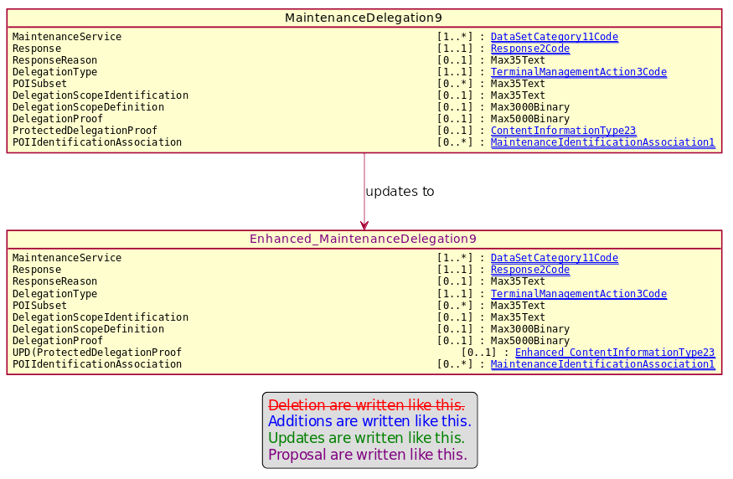

Proposed timing:
The submitting organization confirms that it can implement the requested changes in the requested timing, or, if not, proposes another timing.

Timing | - As requested
 | - Other:

Final decision of the SEG(s):
This section is not to be taken care of by the submitting organization. It will be completed in due time by the SEG(s) in charge of the related ISO 20022 messages.
Approve
Comments:

Reject
Reason for rejection:

Change request number 0877 – Nexo catm Split Message

Copy of the approved change request:

Origin of the request:
A.1 Submitter: nexo A.I.S.B.L.
A.2 Contact person: Philippe CECE (Philippe.cece@ingenico.com) / Pierre MOURA (pierre.moura@frenchsys.com)
A.3 Sponsors: nexo A.I.S.B.L.

Related messages:

- StatusReport V09 catm 001.001.09
- ManagementPlanReplacement V08 catm 002.001.08
- AcceptorConfigurationUpdate V09 catm 003.001.09
- MaintenanceDelegationRequest V06 catm 005.001.06

Description of the change request:

In some architectures it might be interesting to be able to split a message in multiple smaller ones. Though this functionality was currently possible in the messages listed above, we believe that the current solution might be in some circumstances unreliable since we are not able to identify how many messages we will receive or to identify the last one.

Additionnaly we realised that if some containers, that the AcceptorConfigurationUpdate has to vehicle, are too big, then the message might not be sent due to excessive length for the communication media. Then we need to provide a way to split these contianers in smaller chunks.

The aim of this Change Request is to correct these lacks.

Purpose of the change:

In order to identify the lost of the penultimate message, we would like to add just after the SequenceCounter the message element LastSequence defined as Indication of the last sequence in case of split messages, with multiplicity [0,1] and type TrueFalseIndicator. Then the messages will be updated according to the following diagrams.

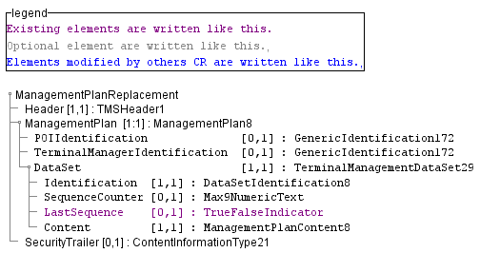

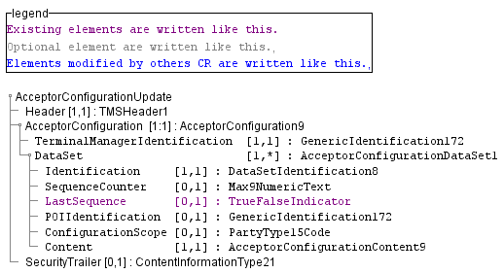

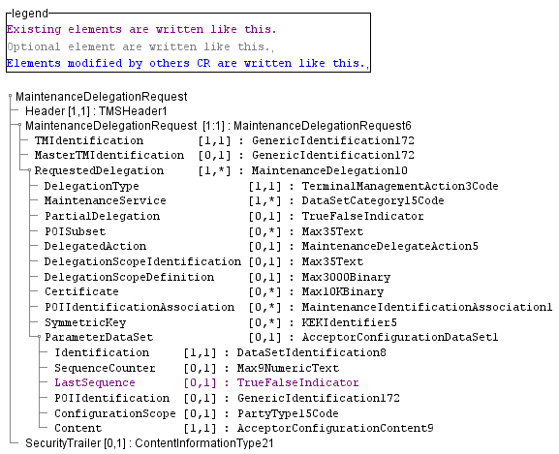

Finally, in order to divide containers in smaller parts, as depicted in the following diagram, we would like to reuse the same model than we used last year with the TerminalPackages by the addition of 3 new message elements, one to identify the full length and OffsetStart, OffsetEnd to identify where this part resides.

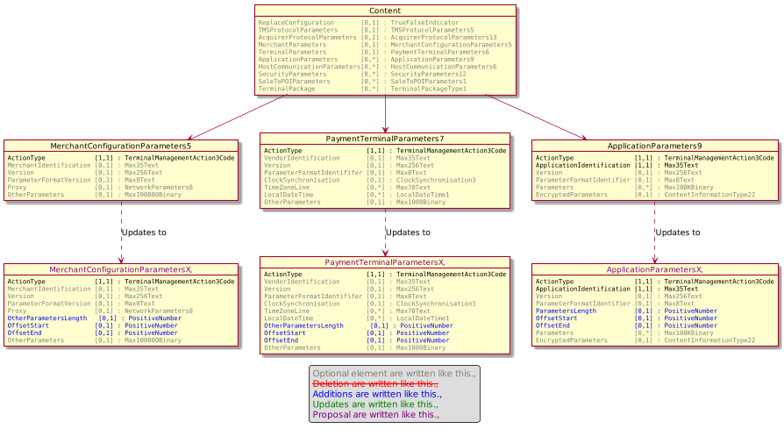

Urgency of the request:

Urgent.

Business examples:
Examples illustrating the change request.

SEG/TSG recommendation:
This section is not to be taken care of by the submitter of the change request. It will be completed in due time by the SEG(s) in charge of the related ISO 20022 messages or the TSG for changes related to the BAH.

Consider |  | X | Timing
 |  |  | - Next yearly cycle: 2020/2021  (the change will be considered for implementation in the yearly maintenance cycle which starts in 2020 and completes with the publication of new message versions in the spring of 2021) |  | X
- At the occasion of the next maintenance of the messages
(the change will be considered for implementation, but does not justify maintenance of the messages in its own right – will be pending until more critical change requests are received for the messages)
- Urgent unscheduled
(the change justifies an urgent implementation outside of the normal yearly cycle)
 |  |  | - Other timing:
Comments:

Reject
Reason for rejection:

Impact analysis and type of impact:

Regarding the addition of a new message element named LastSequence, this change will also apply on StatusReport message.
Otherwise modifications will be done accordingly to the approved Change Request.

The analysis of ripple effect provides the following list.

StatusReportDataSetRequest1
- StatusReport9
TerminalManagementDataSet29
- ManagementPlan8
AcceptorConfigurationDataSet1
- AcceptorConfiguration9
- MaintenanceDelegation10
MerchantConfigurationParameters5
- AcceptorConfigurationContent9
PaymentTerminalParameters7
- AcceptorConfigurationContent9
ApplicationParameters9

The severity of the impact of the proposed change for the message users should be indicated in the table below (either “no impact”, “conditional’ or “mandatory”).
Type of impact
 | No impact | The change(s) will not impact the schema (the version number will not change) and will not impact the business applications of any users, e.g. the clarification of a definition
X | Conditional | The change(s) will impact the schema (at least the version number) and the business applications of certain users but not all, e.g. the addition of an optional component
 | Mandatory | The change(s) will impact the schema and the business applications of all users, e.g. addition of a mandatory component.

Proposed implementation:

After modifications, the StatusReport message will look like the following diagrams.

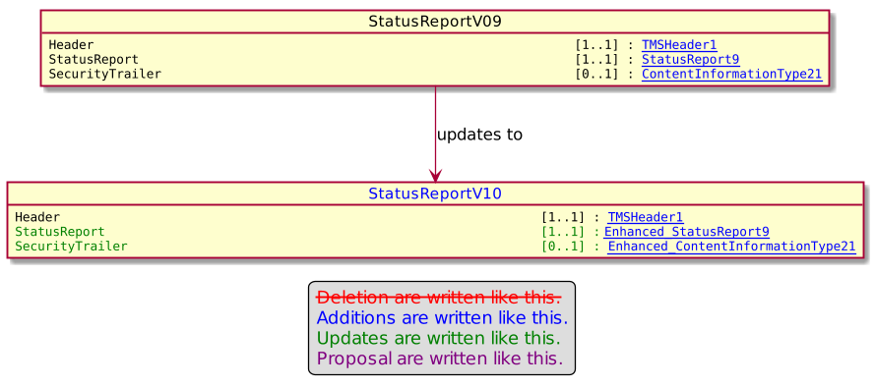
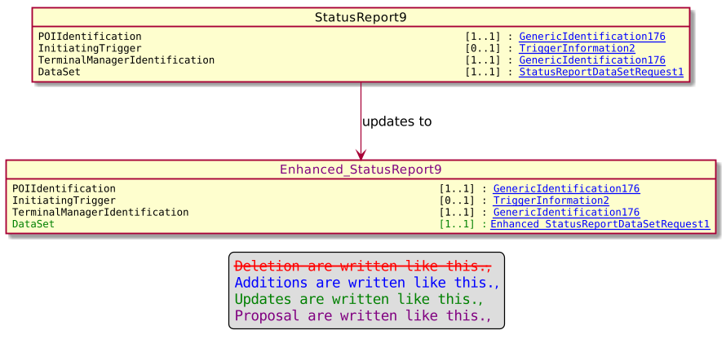

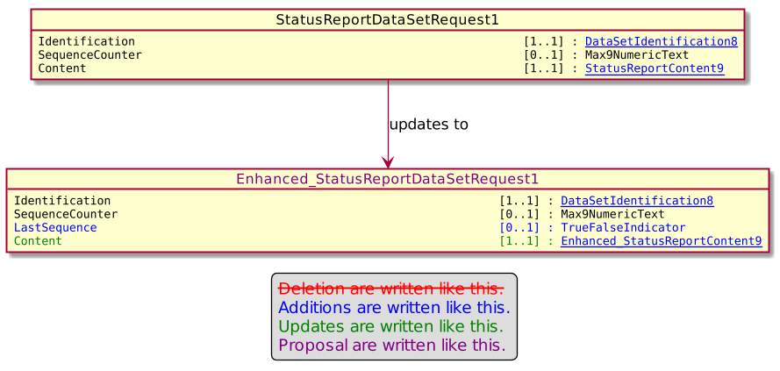

After modifications, the ManagementPlanReplacement message will look like the following diagrams.

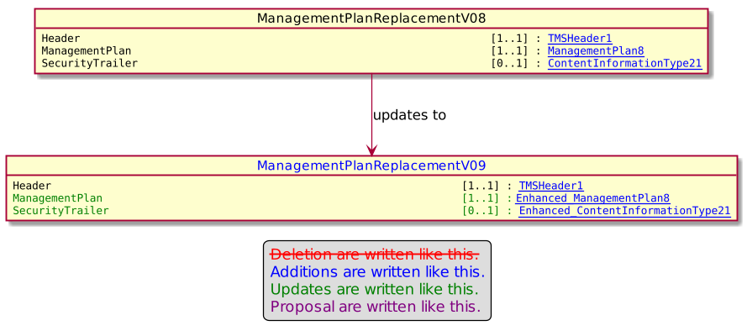

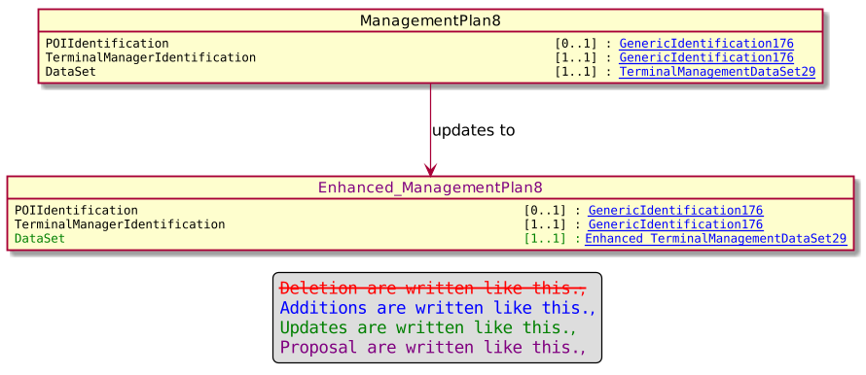

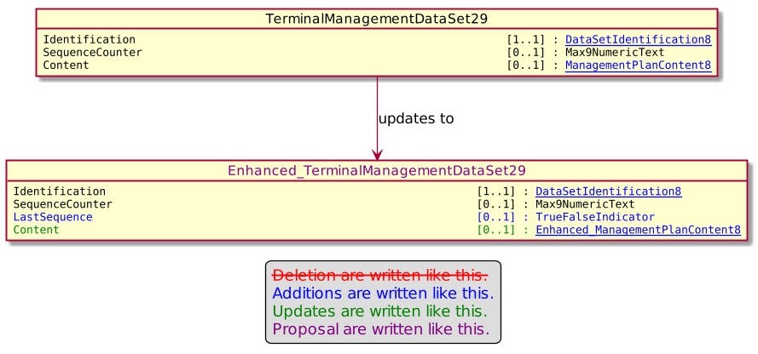

After modifications, the AcceptorConfigurationUpdate message will look like the following diagrams.

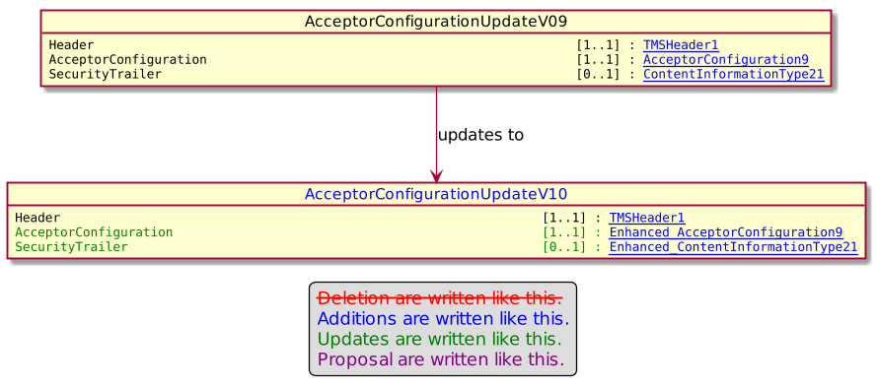

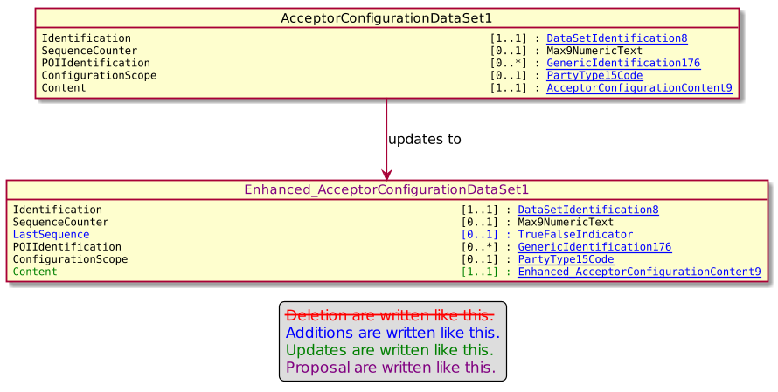

After modifications, the MaintenanceDelegationRequest message will look like the following diagrams.

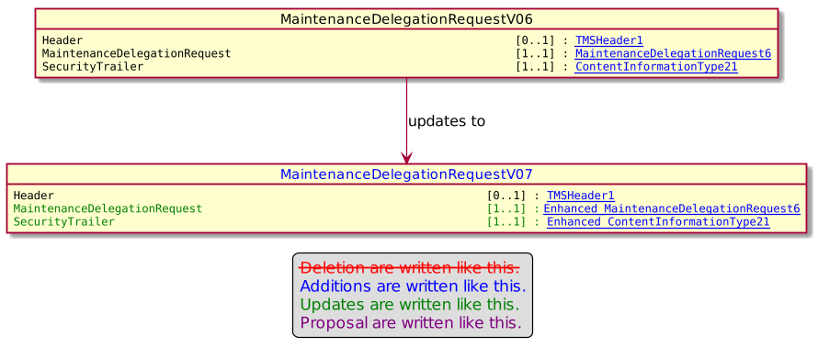

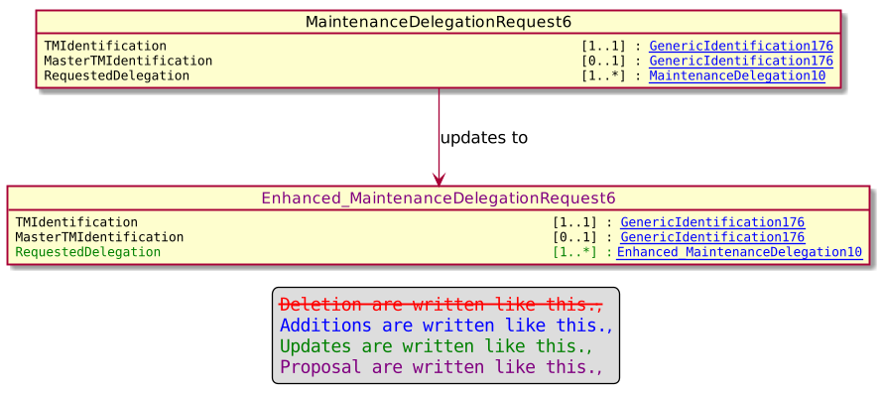

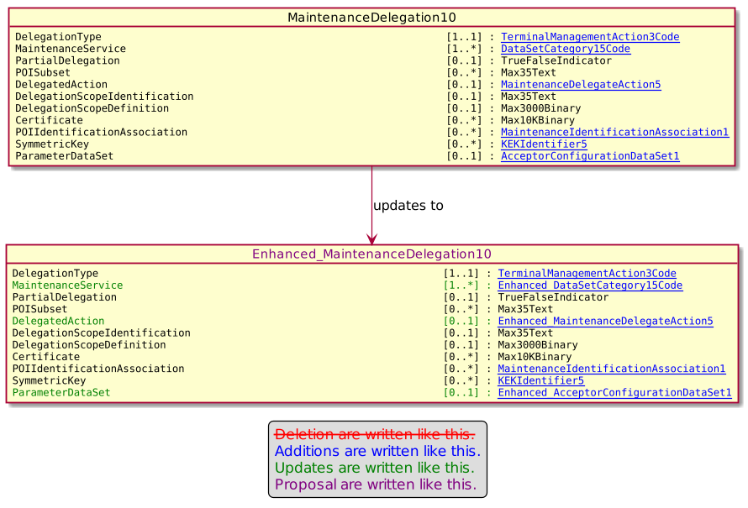

The MerchantConfigurationParameters5 will be updated accroding to the following diagram.

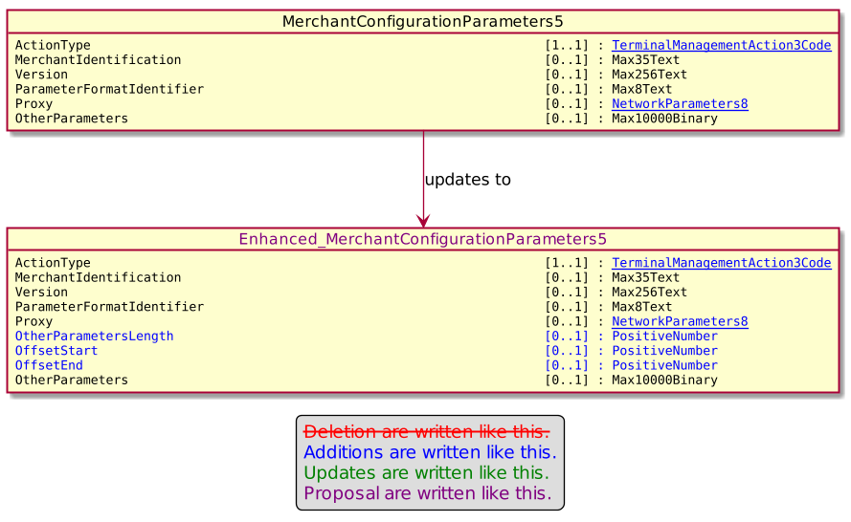

The PaymentTerminalParameters7 will be updated according to the diagram.

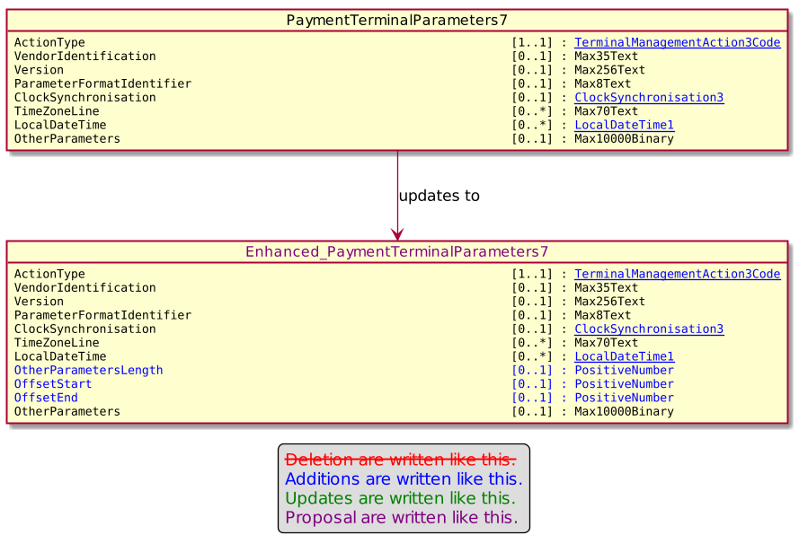

Finally the ApplicationParameters9 will be updated according to the following diagram.

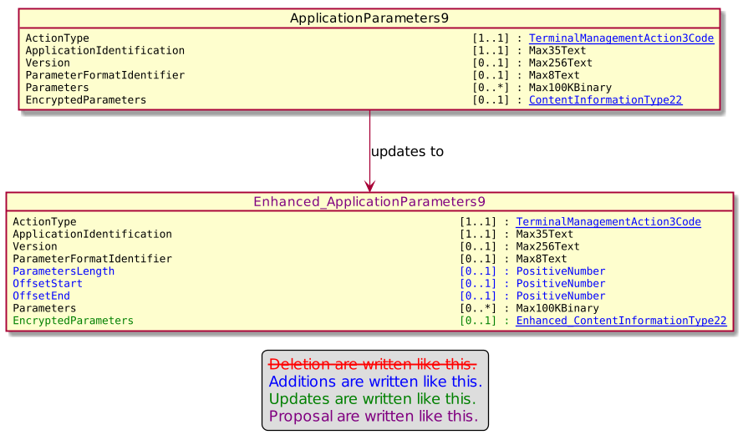

Proposed timing:
The submitting organization confirms that it can implement the requested changes in the requested timing, or, if not, proposes another timing.

Timing | - As requested
 | - Other:

Final decision of the SEG(s):
This section is not to be taken care of by the submitting organization. It will be completed in due time by the SEG(s) in charge of the related ISO 20022 messages.
Approve
Comments:

Reject
Reason for rejection:

Modifications done during repository update.

OutputFormatXCode was not created since OutputFormatCode already exists in the repository. The codeset has been renamed ResourceTypeCode.

For IssuerAndSerialNumber2, the message element SerialNumber has been set to Max500Binary.

CompletionExchange10 was created from CompletionExchange7 in order to correct an unsoillicited modification from last year on AcquirerProtocolExchangeBehavior1. Consequently, the AcquirerProtocolExchangeBehavior2 has been corrected.

MessageFunction40Code reused the codeset value TransactionReportRequest rather than created a new one.

Modifications done during second repository update.

The 2 messages:
- AcceptorTransactionLogReportRequest
- AcceptorTransactionLogReportResponse
Have been created again in order to be part of this maintenance step as identified in the MCR.
They are inserted in the new message set Card Payments Exchanges – AcceptorToAcquirer – DRAFT2 – New version. The previous drafts of messages are also inserted in this new message set.

A new message set is created with the name Card Sale to POI – Merchant to Acceptor – DRAFT 2 – New version.
The message component ReversalResponse4 is updated to a new component ReversalResponse5 in order to correct the size of the message element IssuerReferenceData from Max35Text to Max140Text.
Then the ripple effect management leads to the following changes.

The message component MessageStatusResponseData4 is updated to MessageStatusResponseData5 in order to reuse the new ReversalResponse5. Consequently, the MessageStatusResponse4 is update to MessageStatusReponse5. Finally, the message SaleToPOIMessageStatusResponseV03 is updated to SaleToPOIMessageStatusResponseV03 with prefix set to DRAFT2 to reuse the MessageStatusResponse5.

The message component ServiceResponse4 is updated to ServiceResponse5 in order to reuse the ReversalResponse5. Then the message SaleToPOIServiceResponseV03 is updated to SaleToPOIServiceResponseV03 with prefix ser to DRAFT2 in order to reuse the ServiceResponse5.

Both messages, SaleToPOIMessageStatusResponseV03 and SaleToPOIServiceResponseV03 identified with prefix DRAFT2 are inserted in the new message set Card Sale to POI – Merchant to Acceptor – DRAFT 2 – New version, with unchanged messages from the previous message set.

Important Notice.

The following messages are absent from the repository extract and then couldn’t be inserted in the new draft for caaa or casp business domain.

These 3 messages are important and MUST be present in their respective domain.

- AcceptorRejectionV06 (caaa.015.001.06)
- TerminalManagementRejectionV05 (catm.004.001.05)
- SaleToPOIMessageRejectionV02 (casp.013.001.02)

Messages SaleToPOIServiceResponseV03 and SaleToPOIMessageStatusResponseV03 identified with prefix DRAFT1 couldn’t be changed (lock icon) under LightStandardEditor. Consequently, a Compliancy Check raises 2 warning for message identifiers used multiple times for these 2 messages.

