Standards
Standards MT Release 2021
Discussion paper and Minutes
Settlement and Reconciliation
Distribution: Settlement and Reconciliation Maintenance Working Group
Author: Alexandre Hotat

Date Issued: September 2020
Meeting Date: 26th of August 2020

Table of Contents
1 Introduction 3
2 Overview of ISO15022 User Change requests 4
2.1 CR 001639: New Code Word to field 22F 4
2.2 CR 001640: Add code to indicate that settlement has been internalised, add references and & new Buy-In Transaction Type 9
2.3 CR 001641: Add status reason code to indicate that a buy-in procedure may be about to commence 22
2.4 CR 001642: Remove existing duplication for pending failing reason codes 26
2.5 CR 001643: Add On Hold status reason codes to PACK or PPRC 32
2.6 CR 001655: Add Format Option 98E to the Matched and Acknowledged Timestamps 38
2.7 CR 001656: Modify a single leg of already matched instructions 42
2.8 CR 001658: Negative Deal price - Format option B 45
3 Overview of ISO20022 User Change requests 50
3.1 CR 001666: Add a new SettlementTransactionCondition code. (ISO20022 - CR0902) 50
3.2 CR 001667: Addition of Triparty Collateral Transaction instruction identifications. (ISO20022 - CR0917) 57
3.3 CR 001578: Update the pattern of AnyBICIdentifier, BICIdentifier or BICNonFIIdentifier. (ISO20022 - CR0751) 60
4 Overview of SWIFT Change requests 62

Introduction

Maintenance working group members: |  | Representing: | Present
Hiroaki Okumura - Mitsubishi Bank |  | Japan | X
Annemie Loose - Euroclear |  | ICSD | X
Jason Brasile – Statestreet |  | United States of America | X
Robin Leary – Citibank |  | United Kingdom - IE | X
Denis Andrejew – DB |  | Germany | X
Ton Van Andel – ABN Amro |  | Netherlands | X
Stephan Schuetter – UBS |  | Switzerland | X
Jennifer Chan– HSBC |  | Honk Kong | X
David Wouters – BNYMellon |  | Belgium | X
Axelle Wurmser – BNP Paribas |  | France | X
Arnaud Jochems – Clearstream |  | ICSD / Luxembourg | X

Overview of ISO15022 User Change requests

CR 001639: New Code Word to field 22F
Origin of request
Requesting Group: | ISITC
Sponsors
ISITC
Message type(s) impacted
MT 536, MT 537, MT 540, MT 541, MT 542,MT 543, MT 544, MT 545, MT 546, MT 547, MT 548, MT 575 and sese.038.
Complies with regulation
None
Business impact of this request
MEDIUM - Receivers of messages will need to account for being able to consume and process the new code word as they do now for the FCTA
Commitment to implement the change
US-ISITC in 2021
Business context
Over the last several years, there has been an increase in the issuance of variable and stepped rate CMO and other Bonds. There is a delay between the effective date and actual date of when the new coupon rate is released. Similar to the mortgage factors, settled trades are impacted by the change in such a way a cancel and rebook needs to be done. This code would tell the Custodian Banks that the Investment Managers intent on the cancel and rebook is to adjust the amount of traded interest and to set up a movement of the money difference.
Nature of change
The nature of the change is to add a Code Word, INTA that could be used in field 22F. It would be used to indicate that the traded interest is being changed and that there will be a money difference that needs to be resolved.
Examples
Sample Trade format using INTA in field 22F :16R:GENL
:20C::SEME//12345-C
:23G::CANC
:16R:LINK
:20C::PREV//12345
:16S:LINK
:16S:GENL
:16R:TRADDET
:98A::SETT//20200512
:98C::TRAD//20200508141825
:90A::DEAL//PRCT//85,5
:35B::ISIN//US385210AA74// GAMLT 2017-RPL1 A1 144A
:16R:FIA
:12A::CLAS//ISIT//CMO
:98A::MATU//20640825
:92A::CUFC//0,813936
:92A:: INTR//3,25
:16S:FIA
:16S:TRADDET
:16R:FIAC
:36B::SETT//FAMT//375000
:36B::SETT//AMOR//307987,59
:97A::WXYZ
:16S::FIAC
:16R:SETDET
:22F::SETR/INTA
:16R:SETPRTY
:95P::PSET//DTCYUS33
:16S:SETPRTY
:16R:SETPRTY
:95R::REAG//DTCYID//547
:16S:SETPRTY
:16R:SETPRTY
:95R::BUYR//DTCYID//00547
:16S:SETPRTY
:16R:AMT
:19A::DEAL//USD//263329,39
:16S:AMT
:16R AMT
:19A::SETT//USD//263635,24
:16S:AMT
:16R:AMT
:19A::ACRU//USD//305,85
:16S:AMT
:16R:AMT
:19A::EXEC//USD//0
:16S:AMT
:16S:SETDET
Standards Illustration

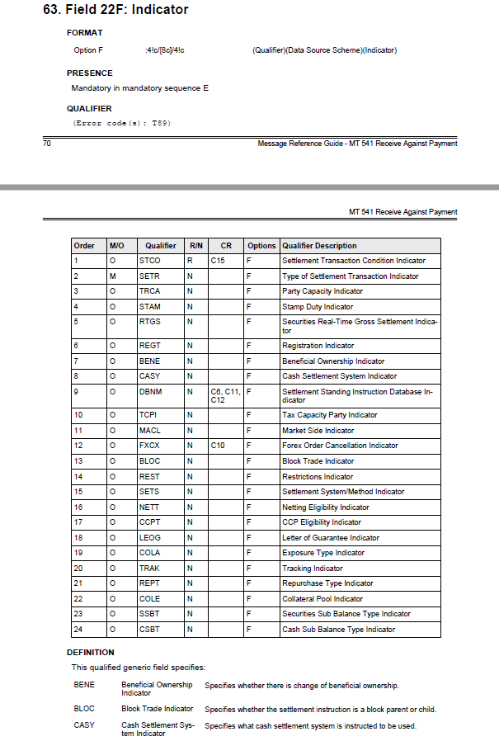
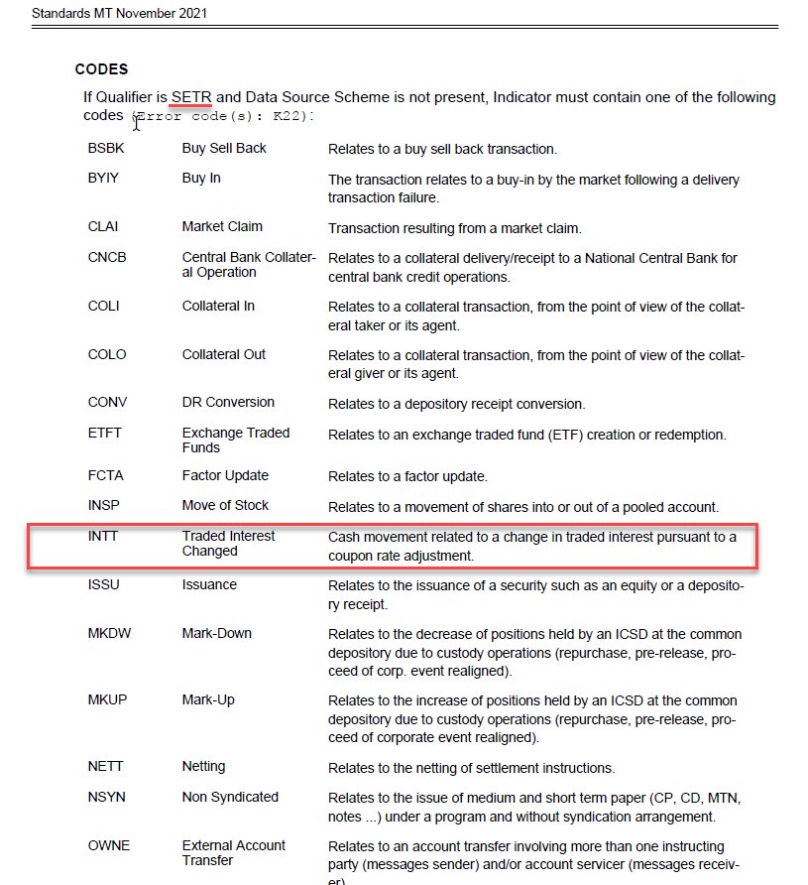
SWIFT Comment

- SWIFT would propose to add the new code under the STCO (Settlement Transaction Condition) instead of SETR (Type of Settlement Transaction).

- As INTA already exist in ISO15022, SWIFT created INTT.

- SWIFT propose to add the new code word under the qualifier in all S&R ISO15022 messages.

- SWIFT proposes to update the equivalent messages in ISO20022 for coexistence reasons.

Working Group Meeting

Discussion
It was questioned why the MT 530 is not used. ISITC explained that they don’t use the MT 530. SWIFT explained that during the reverse engineering this was put into the ISO 20022 modification message sese.038, not the sese.030 (MT 530 equivalent) as the sese.030 is used to modify non-core information, therefore the MT530 cannot be used.
In Europe a settled transaction cannot be updated. In the US this is used between the custodian and the investment manager. The MT 530 must not be updated with this code if the MT 54x is updated.
Currently the factor update (FCTA) is included in the sese.023 securities transaction type. As this code is used post settlement, it is part of the sese.038 and might not be required in the sese.023.
The removal in the sese.023 should be investigated for SR 2022.

In ISO20022, the new code must be added only to the sese.038 as the modification after settlement cannot be done with a sese.023.

It was agreed to add the code to all MTs 54x under the qualifier SETR for consistency.

Nobody opposed to the CR.
Decision
ACCEPTED
Final decision of the Securities SEG regarding ISO 20022 messages:
Approve the MWG decision | approved
Comments:

Reject the MWG decision
Reason for rejection:

CR 001640: Add code to indicate that settlement has been internalised, add cash penalty references and new Buy-In Transaction Type.
Origin of request
Requesting Group: | SMPG
Sponsors
SMPG
Message type(s) impacted
MT 536, MT 537, MT542, MT543, MT 544, MT 545, MT 546, MT 547, MT 548, sese.024, sese.025, semt.017, semt.018, semt.044
Complies with regulation
CSDR
Business impact of this request
LOW
Commitment to implement the change
SMPG in 2021
Business context
There are 5 changes in total in the context of CSDR.

- Internalised Settlement
The change request is for where a market infrastructure / CSD has an omnibus account structure and client and counterparty use the same custodian in the market and share the same account in the market but don’t know that’s the case.
In this scenario, the instructions would be kept internal to sub custodian (direct participant of the CSD) but the client and counterparty aren’t aware of this. These settlements may fail but as we understand it, they would not be subject to penalties (or at least that is TBD) so client / counterparty may be expecting a penalty that doesn’t come and questioning why.

- Cash Penalty Reference and new rules on Party Identifier fields
As the 19A GBNT (Global Net Amount) is in Sequence D1 (PENACUR), if the penalty relates to a cross-border instruction, separate global net amounts would be needed in the MT537 if the client CSD is different to that of the counterparty (due to 95a CASD being in the same sequence)
You could show this in the D1a PENACOUNT sequence instead but the “either / or” means you can’t then show the counterparty ID
From a custodian perspective, they will likely just pay one net amount for all the penalties in one CSD
Therefore, there may be two or more global net amounts in the MT537 but only one payment in the MT9xx cash messages
Added to this, although there are individual penalty references, if there’s one global net amount, one penalty reference to appear on the MT9xx cash message reporting would be needed
There is a potential workaround but it’s not the best solution

- TRTR vs SETR / CAEV Indicator fields
In a MT537 Status Report, the SETR and CAEV qualifiers, are an “either / or” and if you had :22F::TRAN//SETT present, you would then normally include :22F::SETR (and conversely, if :22F::TRAN//CORP was present, you would have :22F:CAEV)
In the MT537 Penalty Report, in Sequence D1a1B1 (Transaction Details), REDE, PAYM and TRAN are again mandatory (however, TRAN only has codes SETT and CORP, which is OK for the purposes of penalties)
However, rather than the optional either / or being between SETR and CORP, it’s between TRTR (Trade Transaction Type). This is also a mandatory either / or.
This leads to a situation whereby if you have :22F::TRAN//SETT, you pick between TRTR and SETR (SETR would be expected but you could get TRTR) but if :22F::TRAN//CAEV is present, you still have to have TRTR or SETR and CAEV is optional. Hence you could have a Corporate Action event related transaction but you don’t have to indicate what the event is but have to specify a code that doesn’t relate to it being a CA event type
TRTR also does not appear in other MT messages with this similar structure
Furthermore, in the semt.044, the elements are an either / or between the settlement transaction type or the CA event type and the trade transaction type does not exist as an element

- Penalty Status and Reason fields
The Penalty Status (25D) and Reason (24B) fields in the Penalty Details Sequence D1a1 (PENADET) seem to have a number of codes that appear to do the same thing but if different fields
For example, :25D::PNST//RLOC and :25D::PNST//ACTV with :24B::ACTV//RALO both indicate reallocated penalties or :25D::PNST//SWIC and :25D::PNST//ACTV with :24B::ACTV//SWIC both represent a switch.
Also, both the Status and Reason fields are optional which, in theory, means you could have a reason without a status. Or, even worse, you can have a Reason Narrative without actually having a status or reason.

- Buy In Settlement Transaction Type
Currently only the MT540 and MT541 contain the :22F::SETR//BYIY settlement transaction type code. We believe buy-in is the reason for the settlement transaction, i.e. similar to SETR//TRAD, OWNE, BSBK, etc. and hence should be available as a SETR code for all settlement instruction messages. Both the delivering and receiving party is settling a buy-in, after all.
RPOR is for reporting indications, but the settlement agents and the CSDs will not perform any reporting due to this. Compare BYIY with the other RPOR codes:
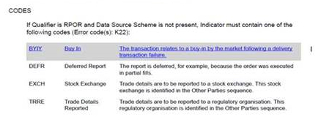

Nature of change
- Internalised Settlement
The initial workaround / market practice will be to use field :22F::STCO/SMPG/INTS (or REGL instead of SMPG as DSS) on MT 548’s and MT 54y confirmations to indicate the settlement was been internalised. This change request will be to make INTS an official SWIFT code so it becomes :22F::STCO//INTS from SR2021.
The change must also be applied to the MT 536 and MT 537 statements and the ISO 20022 equivalent messages for co-existence purposes.
The change will benefit clients and counterparties who currently would not be aware when a settlement has been internalised.
The short name of the new INTS code should be "Internalised Settlement". The long definition needs to be specific as such that it distinguishes the fact the this is a settlement that has been internalised at the sub-custodian / direct participant of the CSD and is the same as the "OWNI" process which clearly identifies this is a separate, own account transfer (or OWNE as an external account transfer). For example,
"The settlement has been internalised at the sub-custodian / direct participant of the CSD (receiving or delivering agent) as the client of the receiving and delivering agents shares uses the same sub-custodian which maintains an omnibus account at the CSD / Market Infrastructure. This differs from a regular "account transfer" settlement instruction which can be identified as an internal settlement through the settlement transaction type code OWNI."
- Cash Penalty Reference and new rules on Party Identifier fields
In order to meet the needs of custodians whilst not impacting any CSD development of the report, the following change requests are proposed

    - Change the 95a REPA and 95a ASDP field logic so that the field is mandatory so that one party at least has to be present but change the logic so it allows both REPA and ASDP to be present

    - Add a new optional 20C Reference field to Sequence D1 PENACUR to represent the reference of the penalty payment as it will pertain to the cash statements / messages

This would then allow one global net amount to be sent to the client from a custodian perspective on both the MT537 and MT9xx, aligning the reporting of payments and referencing of them where penalties for the client on one CSD may relate to transactions where the counterparty is settling through a different CSD
As the reference addition would be optional, it would not need to be used if not required
Making the 95a field mandatory but with a rule that means one qualifier should be present but allows for both allows for both existing developments and new developments to be considered

- TRTR vs SETR / CAEV Indicator fields

    - Remove qualifier TRTR (Trade Transaction Type) from Sequence D1a1B1 (Transaction Details) to align with the semt.044 (and other MT message types)

    - Make the mandatory either / or between SETR and CAEV

- Penalty Status and Reason Fields
Remove the 25D Penalty Status codes where they duplicate another code already available as a status / reason combination. For example,
Delete :25D::PNST//RLOC as same as :25D::PNST//ACTV with :24B::ACTV//RALO
Delete :25D::PNST//SWIC as same as :25D::PNST//ACTV with :24B::ACTV//SWIC
Delete :25D::PNST//OTHR as same as the use of the OTHR in all 24B Reason qualifiers
Delete :25D::PNST//REIC as same as :25D::PNST//ACTV with :24B::ACTV//UPDT (which includes “reincluded” in the definition)
Add a Network Validation Rule that states 24B Reason and 70D REAS* should not be present unless 25D Penalty Status is present first.
*or Add network validation rule that states 70D REAS should not be present unless 24B Reason is present

- Buy In Settlement Transaction Type
  - Add the BYIY (or something similar) settlement transaction type code to the :22F::SETR settlement transaction type indicator field in the MT542 and MT543

  - Remove the BYIY reporting indicator code from the :22F::RPOR field in MT54x.

Workaround
Any current workaround would involve the use of the :70E::SPRO or ADTX narrative
Examples
- Internalised Settlement
Client A and B instruct to their global or direct (sub) custodian with a MT543 and MT541 respectively.
The global custodian's sub-custodian or the direct custodian is the same party, ie the REAG field in the MT 543 and DEAG field in the MT 541 identify the same institution.
Unbeknown to Client A and B, the receiving / delivering agent institution maintains an omnibus account in the CSD. Hence, the settlement can remain internalised at the sub-custodian.
When the sub-custodian provides status updates and settlement confirmations (and associated statements) back to Client A and B, there is no way of indicating that the settlement has been internalised. If there's any issue with settlement, Clients A and B may be expecting penalties but because the settlement has been internalised, there wouldn't be any.
Therefore, to inform Clients A and B that the settlement has been internalised, field :22F::STCO//INTS can (optionally) be included on the MT 548 and MT5 44-7 settlement confirmations back to them (:22F::STCO/SMPG/INTS (or REGL as an alternative DSS) as an interim solution until SR 2021).

- Cash Penalty Reference and new rules on Party Identifier fields

Standards Illustration
ISO15022 ILLUSTRATION
- Internalised Settlement
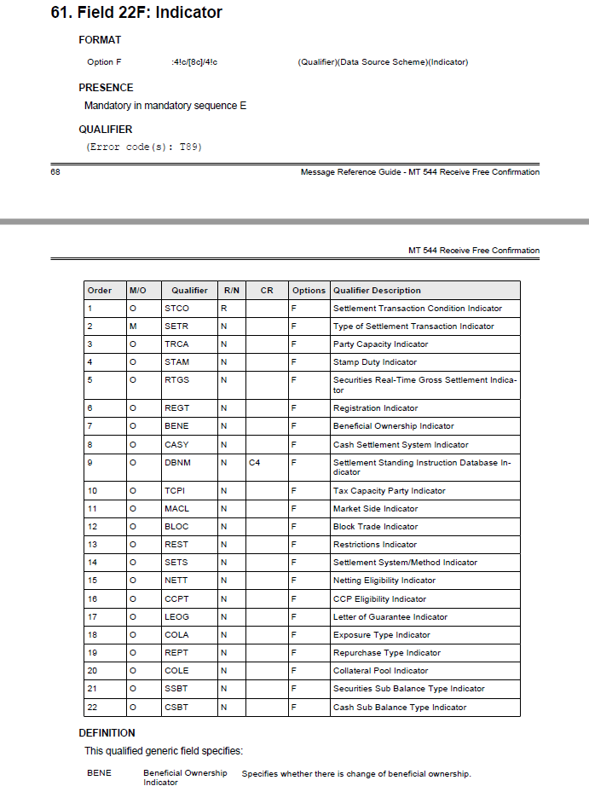
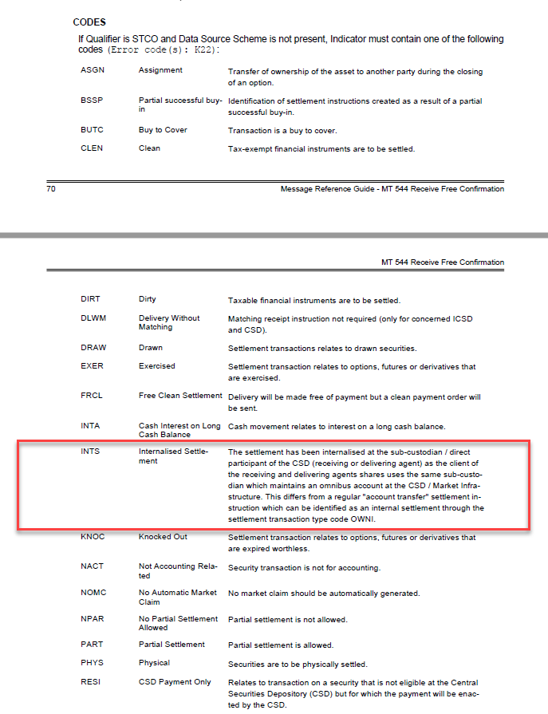
- Cash Penalty Reference and new rules on Party Identifier fields

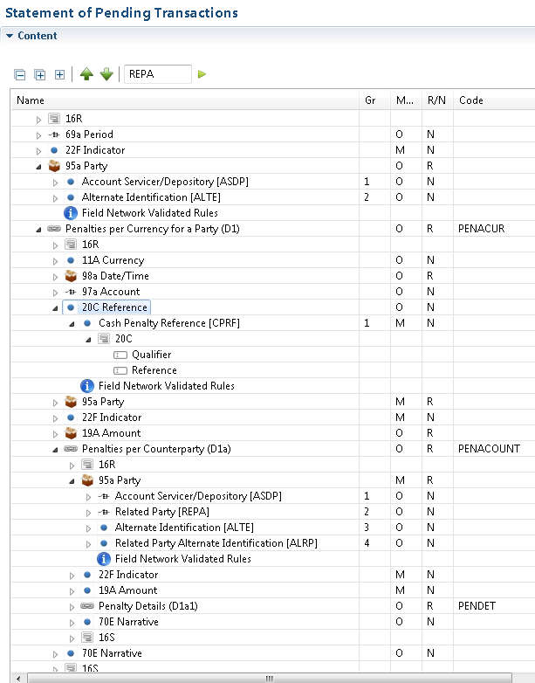

- TRTR vs SETR / CAEV Indicator fields
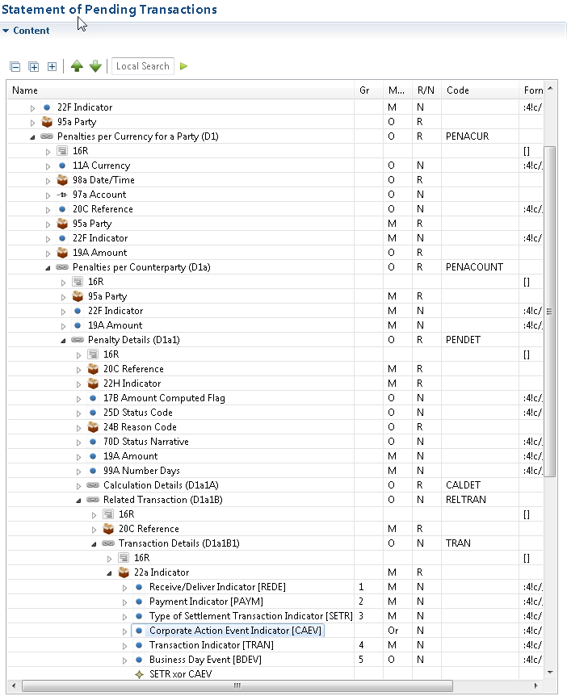
- Penalty Status and Reason Fields

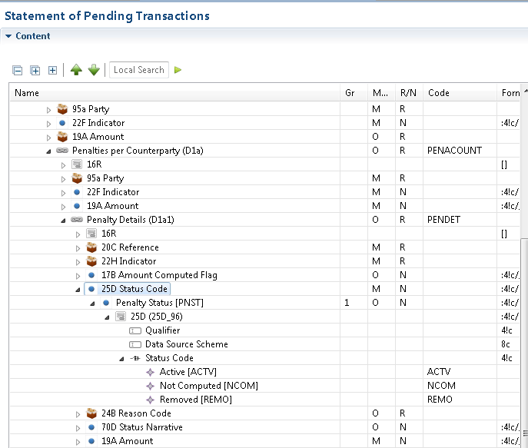

- Buy In Settlement Transaction Type

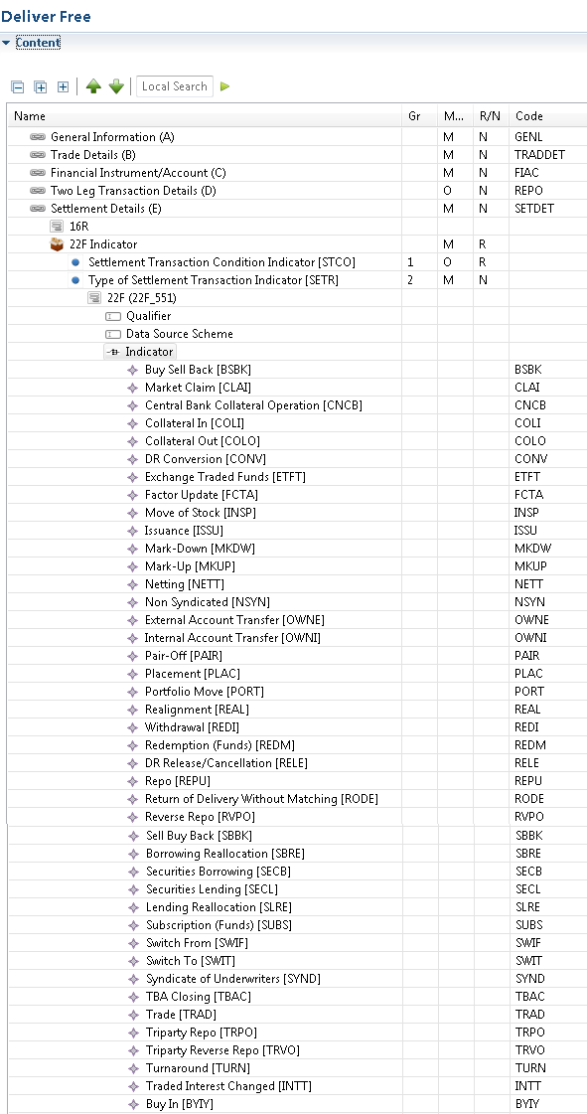

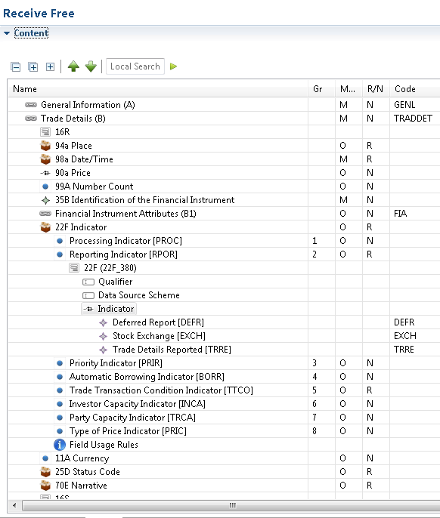

ISO20022 ILLUSTRATION

This ISO20022 will be shown here at a later stage.
SWIFT Comment

- SWIFT agrees that only confirmation/status messages (as requested) must be updated in ISO15022 and ISO20022.

- The semt.044 is not under SWIFT’s responsibility, please take contact with 4CB’s / T2S.

Working Group Meeting

Discussion
- Internalised Settlement

Even if CSDR and the penalties reporting applies to Europe, in cross-border trades this has also an impact on JP, US and CH global players.
The group could not reach a direct consensus.
As long as it is optional and none of the clients request it, Switzerland is in favour of the CR.
JP is against the CR because sub-custodians in JP only copy the content of the STCO, if they have to use the new code they have to change their systems. It was explained that JP does not need to adopt immediately. It is also an optional field.
After some explanations, only japan rejected the Internalised Settlement CR.
From a general point of view of the group, a better definition needs to be drafted and be part of the final minutes.
The cr will be applied to the MT542, MT543, MT 544, MT 545, MT 546, MT 547, MT 548, MT 536, MT 537, sese.024, sese.025, semt.017, semt.018, semt.044 as requested.

- Cash Penalty Reference and new rules on Party Identifier fields
The group reached an agreement directly and did not have any comments.
Impact only the MT 537

- TRTR vs SETR / CAEV Indicator fields
The group reached an agreement directly and did not have any comments.
Impact only the MT 537 and MT 548

- Penalty Status and Reason Fields
The group reached an agreement directly and did not have any comments.
Impact only the MT 537 and MT548

- Buy In Settlement Transaction Type
The group reached an agreement directly.
The group mentioned that the SMPG market practices require updates because it refers to the RPOR qualifier.
Impact only the MT 542 MT 543 MT 546 MT 547

Global Custodian or any institution that will use one single Global Net can do it as long as they will honor the obligation towards the CSD/ICSD. If the CSD put multiple PFODs (see below in the example), the CSD participant cannot delay their payments obligation as their underlying client has not paid the full amount because they have used one single Global Net. Failing to fund their account until the underlying has paid may result in deadlock scenario that will prevent a smooth collection and distribution process.

Decision
The CR was accepted, after a vote, only JP rejected the first part (Internalised Settlement)

ACCEPTED

Final decision of the Securities SEG regarding ISO 20022 messages:
Approve the MWG decision | approved
Comments:

Reject the MWG decision
Reason for rejection:

CR 001641: Add status reason code to indicate that a buy-in procedure may be about to commence
Origin of request
Requesting Group: | SMPG
Sponsors
SMPG
Message type(s) impacted
MT 548, MT 537, MT 549, sese.024, semt.018, sese.022, semt.044
Complies with regulation
CSDR
Business impact of this request
LOW - It is a new code within an existing, optional field
Commitment to implement the change
SMPG in 2021
Business context
Currently there is a Pending Failing Status Reason code BYIY that indicates that a buy-in process HAS started.

BYIY
Buy-in Procedure
A buy-in procedure has started on the market (on your behalf if your instruction is a receipt, by the counterparty if your instruction is a delivery).

However, it is felt that it may be beneficial to be able to advise parties in a settlement that a buy-in procedure is also about to start and not just when it has started. The change would benefit clients of custodians etc as it would provide a specific status / reason to indicate a buy-in procedure is about to start.

Additional Reason Code narrative could optionally be used to indicate when the buy-in procedure is expected to start.
Nature of change
Currently there is a Pending Failing Status Reason code BYIY that indicates that a buy-in process HAS started.

BYIY
Buy-in Procedure
A buy-in procedure has started on the market (on your behalf if your instruction is a receipt, by the counterparty if your instruction is a delivery).

However, it is felt that it may be beneficial to be able to advise parties in a settlement that a buy-in procedure is also about to start and not just when it has started.

The change request is to add a PENF (pending failing) reason code of BYIS to indicate a buy-in procedure is about to start

BYIS
Buy-in Procedure Pending
A buy-in procedure is imminent on the market (on your behalf if your instruction is a receipt, by the counterparty if your instruction is a delivery).
Workaround
Any current work around would involve the use of the PENF/NARR reason update
Examples
Participant A's settlement instruction is failing settlement in the market. As per CSDR guidelines, a buy-in procedure can be invoked if the instruction does not settle.

In order to inform Participant A that the buy-in procedure is about to commence, a PENF reason code with optional narrative would be helpful to identify when this may occur.

For example, on contract settlement date +1, a MT 548 could be sent with

:16R:STAT
:25D::SETT//PENF
:16R:REAS
:24B::PENF//BYIS
:70D::REAS//THE BUY-IN PROCEDURE WILL BE
INITIATED IN 5 DAYS
:16S:REAS
:16S:STAT

On csd +2, the following could be sent

:16R:STAT
:25D::SETT//PENF
:16R:REAS
:24B::PENF//BYIS
:70D::REAS//THE BUY-IN PROCEDURE WILL BE
INITIATED IN 4 DAYS
:16S:REAS
:16S:STAT

Etc.

Standards Illustration
ISO15022 ILLUSTRATION

ISO20022 ILLUSTRATION

SWIFT Comment

- SWIFT would propose to add the new code for all S&R ISO15022 messages under the qualifier PENF (Pending/Failing reason) where only the current BYIY (Buy-in Procedure) is already present.

- SWIFT proposes to update the equivalent messages in ISO20022 for coexistence reasons.

- The semt.044 is not under SWIFT’s responsibility, please take contact with 4CB’s / T2S.

Working Group Meeting

Discussion
The group agreed this CR is related to a service that is not yet offered by everyone, it might be simpler to keep the information in the narrative for now and to rethink when the service will be offered.
Decision
REJECTED
Final decision of the Securities SEG regarding ISO 20022 messages:
Approve the MWG decision
Comments:

Reject the MWG decision | rejected
Reason for rejection:

CR 001642: Remove existing duplication for pending failing reason codes
Origin of request
Requesting Group: | SMPG
Sponsors
SMPG
Message type(s) impacted
MT 549, MT 548, MT 537, sese.024, sese.022, semt.018, semt.044
Complies with regulation
None
Business impact of this request
MEDIUM - Depending on the option selected as part of the MWG (if accepted), this could impact how some institutions report pending / pending failing updates
Commitment to implement the change
SMPG in 2021
Business context
There are currently two pending / pending failing reason codes that effectively describe the same thing.

CYCL
Awaiting Next Settlement Cycle
Instruction is confirmed in the local market or is ready for settlement, awaiting next settlement cycle.

is available with both PEND and PENF

FUTU
Awaiting Settlement Date
Awaiting settlement date. No settlement problems to be reported.

is available with PEND only.

Although it's obvious why FUTU is used only with PEND (it can't be awaiting settlement date if past settlement date, which is when PENF is used), the two updates are similar and could either be merged into one, or CYCL is made available only for PENF updates. This would help harmonise the use of the codes (for example, some may use CYCL with PEND with others may use FUTU).
Nature of change
Three options are proposed for the change:

1. Remove the CYCL code from PEND so that FUTU can only be used in a PEND update and CYCL is then used when PENF becomes the status

2. Delete FUTU as a PEND reason code and redefine CYCL to the following:

CYCL
Awaiting Next Settlement Cycle / Settlement Date
Instruction is confirmed in the local market or is ready for settlement, no settlement problems to be reported. Awaiting settlement date or next settlement cycle.

3. (From Denmark)
CR for new reason code for unmatched pending failing, PEND/PENF:
Since CSDR demands that a settlement status is send in disregard of match status, an indication of unmatched is needed. Therefore we suggest the following reason codes implemented:
PEND//NMAT
PENF//NMAT
Examples
A settlement instruction is awaiting settlement pre contract settlement date. (I)CSD A sends a status update SETT/PEND/PEND/FUTU to the delivering / receiving agent who in turn sends this on to their client.

(I)CSD B has the same scenario but sends SETT/PEND/PEND/CYCL.

It's the same situation but two different status updates can be used.

Standards Illustration
ISO15022 ILLUSTRATION

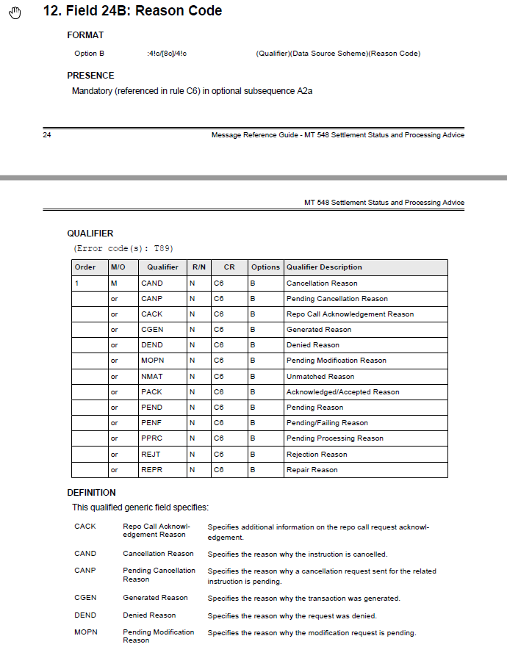
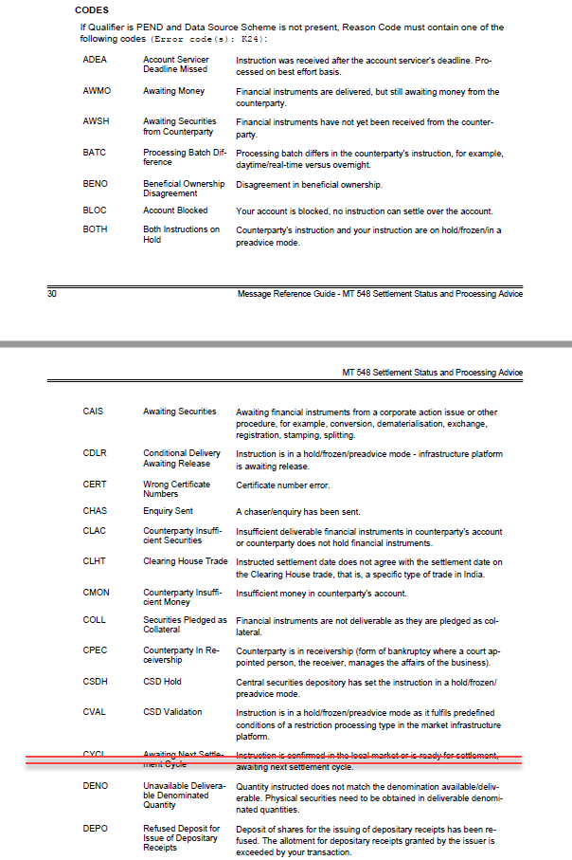
ISO20022 ILLUSTRATION
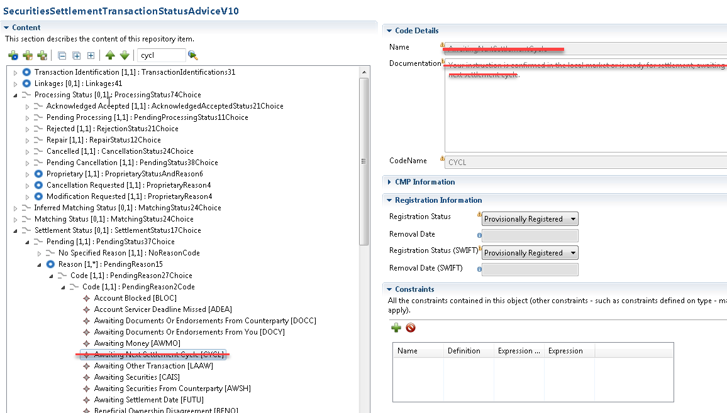

SWIFT Comment

- SWIFT is not in favour to merge the two codes.

- SWIFT proposes to remove CYCL (Awaiting Next Settlement Cycle) from PEND (Pending Reason) only.

- SWIFT proposes to update the equivalent messages in ISO20022 for coexistence reasons.

- The semt.044 is not under SWIFT’s responsibility, please take contact with 4CB’s / T2S.

Working Group Meeting

Discussion
The MWG does not support option 2 proposed.
The MWG does not support option 3 as it would duplicate the match / unmatch statuses, and create more confusion.
The group agreed on the proposed solution from SWIFT and also to update the semt.044.
The CR was rejected by the US, who indicated that this is not an urgent change and that there are other codes clean up to be done. Moreover it will disrupt how people work today with no real added value to the process.

Decision
The CR was accepted, after a vote, only US rejected.
ACCEPTED
Final decision of the Securities SEG regarding ISO 20022 messages:
Approve the MWG decision | approved
Comments:

Reject the MWG decision
Reason for rejection:

CR 001643: Add On Hold status reason codes to PACK or PPRC
Origin of request
Requesting Group: | SMPG
Sponsors
SMPG
Message type(s) impacted
MT 548, MT 549, MT 537, sese.024, sese.022, semt.018, semt.044
Complies with regulation
Although not necessarily directly linked to a regulatory requirement, this CR is being raised following discussions in relation to CSDR.
Business impact of this request
MEDIUM - This could impact how some institutions report unmatched updates that also require a pending settlement update.
Commitment to implement the change
SMPG in 2021
Business context
The SMPG MT548 documentation currently indicates that pending settlement updates should only happen once an instruction has been matched (where there is a matching process in the market). However, it does also state that matching and settlement processes can occur at the same time.

However, most CSD participants (eg custodians) would expect a settlement pending / failing update to come after an instruction has been matched in the market. There are instances, however, where a settlement instruction may be unmatched in the market but the instruction has also been put on hold, for example. It is important to identify that both status updates apply but identifying an instruction has been put on hold can only be done through the PEND or PENF status update, therefore indicating that the instruction is pending or failing settlement but at the same time being unmatched.

The change is needed to allow institutions to continue to be able to report that an instruction is both unmatched and on hold, for example, but to be able to do this in a way that means an instruction isn't both unmatched and pending / failing settlement in the same update. It would also bring some clarity to the SMPG documentation and less ambiguity around the two statements highlighted at the beginning of this rationale. The main reason why an instruction may be impacted by penalties in relation to CSDR, for example, is because it is unmatched, not because it is on hold.
Nature of change
The proposed change is to add the "on hold" reason codes to either the IPRC//PACK (Instruction Acknowledged / Accepted) or IPRC//PPRC (Pending Processing) status updates. These status updates, in line with SMPG guidelines, come prior to the matching process and hence it would make sense to be able to indicate that an instruction is both on hold and unmatched without having to indicate that the instruction is pending / failing settlement.

The PEND / PENF reason updates have the following "on hold" codes.

BOTH
Both Instructions on Hold
Counterparty's instruction and your instruction are on hold/frozen/in a preadvice mode.

CSDH
CSD Hold
Central securities depository has set the instruction in a hold/frozen/preadvice mode.

PRCY
Counterparty Instruction on Hold
Counterparty's instruction is on hold/frozen/in a preadvice mode.

PREA
Your Instruction on Hold
Your instruction is on hold/frozen/in a preadvice mode.

PRSY
On Hold by System
The transaction was put on hold by the system.

These codes should be added to PACK or PPRC to be able to indicate that an instruction is both on hold and unmatched.
Examples
A (I)CSD / Market Infrastructure has received a settlement instruction that is both unmatched but also on hold. The (I)CSD / MI wishes to indicate this through one MT548. They currently send

:16R::STAT
:25D::MTCH//NMAT
:16R:REAS
:24B::NMAT//DSEC
:16S:REAS
:16S:STAT
:16R::STAT
:25D::SETT//PENF
:16R:REAS
:24B::PENF//PREA
:16S:REAS
:16S:STAT

However, this indicates that the instruction is both unmatched yet pending (failing) settlement, which goes against best market practice. Instead, a better update would be, for example, to indicate that the instruction has been accepted but is on hold, and is unmatched, eg
:16R::STAT
:25D::IPRC//PACK
:16R:REAS
:24B::PACK//PREA
:16S:REAS
:16S:STAT
:16R::STAT
:25D::MTCH//NMAT
:16R:REAS
:24B::NMAT//DSEC
:16S:REAS
:16S:STAT

Standards Illustration
ISO15022 ILLUSTRATION

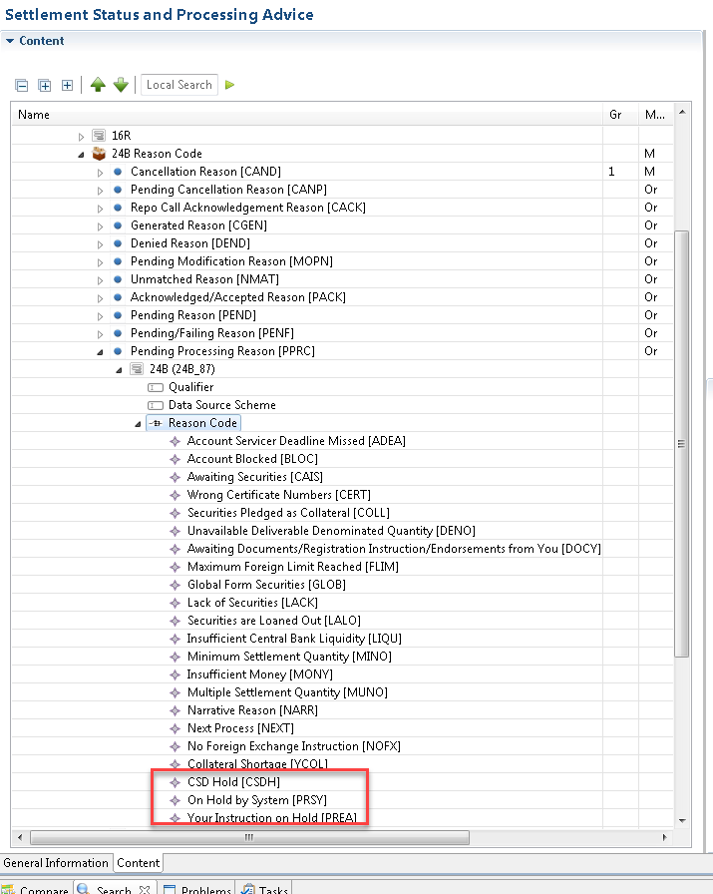

ISO20022 ILLUSTRATION
This ISO20022 will be shown here at a later stage.

SWIFT Comment

- SWIFT would propose to add the new code under the PPRC (Pending Procession Reason) instead of PACK (Acknowledge/Accepted Reason).

- SWIFT propose to add the new code words under the qualifier in all S&R ISO15022 messages.

- SWIFT proposes to update the equivalent messages in ISO20022 for coexistence reasons.

- The semt.044 is not under SWIFT’s responsibility, please take contact with 4CB’s / T2S.

Working Group Meeting

Discussion
The group acknowledged the business case and SWIFT recommendation to add the “on hold” reason codes to IPRC//PPRC (pending processing) and not to IPRC/PACK .
The group agreed to add codes PREA, PRSY and CSDH but not BOTH and PRCY as the matching process has not started yet and therefore the counterparty information is not known.

CSDH - CSD Hold
Central securities depository has set the instruction in a hold/frozen/preadvice mode.

PRSY - On Hold by System
The transaction was put on hold by the system.

PREA - Your Instruction on Hold
Your instruction is on hold/frozen/in a preadvice mode.

The group decided not to update the semt.044.

Decision
ACCEPTED

Final decision of the Securities SEG regarding ISO 20022 messages:
Approve the MWG decision | approved
Comments:

Reject the MWG decision
Reason for rejection:

CR 001655: Add Format Option 98E to the Matched and Acknowledged Timestamps
Origin of request
Requesting Group: | UK&IE NMPG
Sponsors
AFME
Message type(s) impacted
MT 548, MT 537, sese.024, semt.018, semt.044
Complies with regulation
CSDR
Business impact of this request
LOW - The 98C format option will still exist and it will be up to each individual institution as to whether or not 98E will be implemented
Commitment to implement the change
AFME, UK&IE in 2021
Business context
Generally, the date / timestamps in SWIFT messages are reflected in the time zone of the account servicer, ie the entity sending the statement, who services the account referenced in the statement.

Will it be confusing to now have a timestamp that references a time zone that could be different to the account servicer’s time zone (in the case of CSD / Sub-Custodian / Global Custodian / Client that is 4 steps removed).
If they need to, how will the receiver of the statement understand what time zone the CSD operates in, as this is not referenced anywhere.

While the group may not feel that this is relevant, a CR is being submitted just in case.
Nature of change
Addition of format Option 98E to the Matched (MTCH) and Acknowledged Timestamps (ASTS) in the MT548 and MT537.

Format option 98E

:4!c//8!n6!n[,3n][/[N]2!n[2!n]] (Qualifier)(Date)(Time)(Decimals)(UTC Indicator)

The change is required to be able to easily identify the timezone in which the matching and acknowledged timestamps are being applied.
Examples
A settlement is instructed in the German market. The sub-custodian is based in Ireland. However, the Global Custodian is based in New York and the end investor is in the San Francisco.

That's 4 timezones and, in theory, a possible 3 timezones in which the timestamp could apply.

Although generally the matching etc. will be taking place in the CSD (eg. Germany), settlements could be internalised, in which case the timestamp could apply to a different timezone but that may not be known further down the chain.

Standards Illustration
ISO15022 ILLUSTRATION

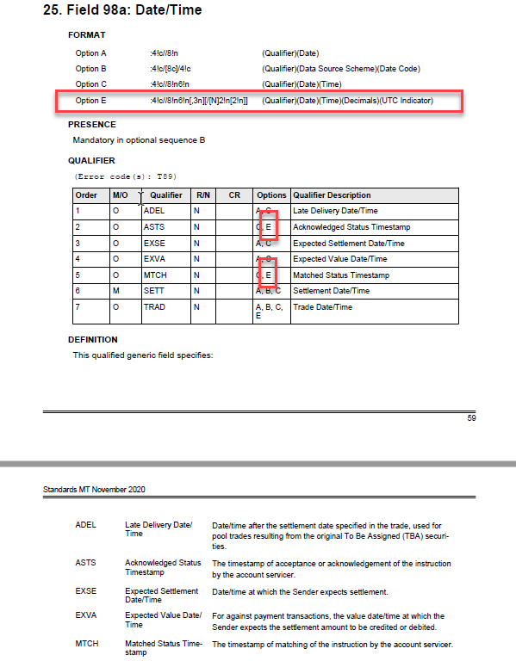
ISO20022 ILLUSTRATION
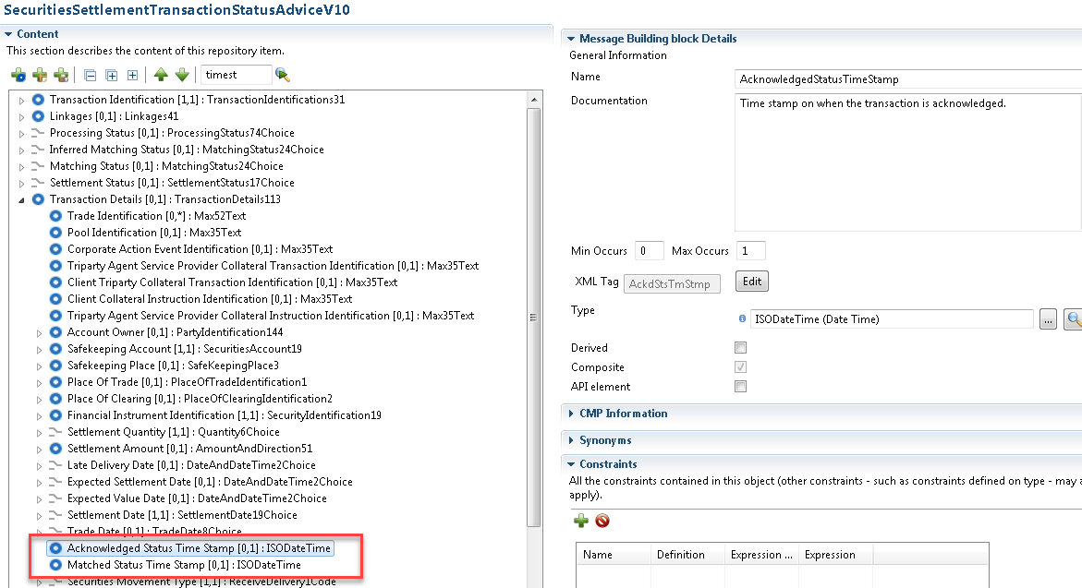

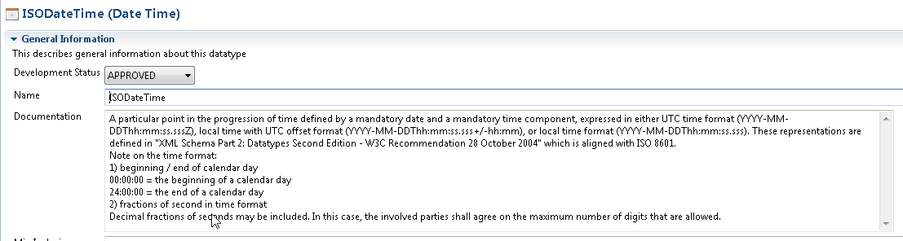

SWIFT Comment

- SWIFT propose to add the format E for those status timestamps in all S&R ISO15022 messages.

- ISO20022 messages that already include this field have the data type “ISODateTime” which already compatible with UTC. Therefore, there is no update required.

Working Group Meeting

Discussion
As no consensus could be reached, the MWG voted: with the result of 9 in favour 3 against (CH, HK, JP)

US mentioned that they also need this functionality, they would even be in favour of removing completely option C for field :98:: as option E allows to include just date and time, however the impact would be huge across all the messages and the business areas.
HK and JP explained that they were not in favour of the change request as even though it is optional, their client could request to receive it as it will be then possible and this would have a huge impact on the back office system.

Decision
The CR was accepted, after a vote, CH, HK, JP rejected.

ACCEPTED
Final decision of the Securities SEG regarding ISO 20022 messages:
Approve the MWG decision | approved
Comments:

Reject the MWG decision
Reason for rejection:

CR 001656: Modify a single leg of already matched instructions
Origin of request
Requesting Country: | LU Luxembourg
Sponsors
Clearstream Group
Message type(s) impacted
MT 530
Complies with regulation
None
Business impact of this request
MEDIUM
Commitment to implement the change
Number of messages sent and received: 100000
Percentage of messages impacted: 30
Commits to implement and when: Clearstream Group in 2021
Business context
Various CSDs in Europe (e.g.T2S CSDs) offer already matched instructions where both legs of the transactions are generated at the same time by the instructing party.

Today, it is not possible in ISO15022 through a MT 530 (except for T2S where the MITI can be used) to change only one leg of the already matched transaction (e.g. to process a linkage or flag the instruction as "on hold). The field 20a in sequence B needs to be populated with the reference of the instruction that needs to be modified. However, the PREV, RELA or COMM do not allow to isolate one single leg and only make reference to both legs

For example, in sequence B of the MT530, the field :22F::SETT/NPRE could be used to put the full transaction on "hold". This could be problematic especially in the context of CSDR cash penalties where if both legs have the "hold" indicator, they will be both charged with cash penalties. This problematic could be avoided if one single leg could be amended via MT530

This change will benefit to all parties using already matched instructions and that cannot today do an update on a single side of the transaction
Already matched instructions typically refer to accounts of two independent clients, and one of the clients might want to apply a modification of one leg, e.g. hold/release or change of partial settlement flag.
Nature of change
Introduce additional optional 22F qualifier in sequence B that determines the type of leg (e.g. qualifier “Movement Type” with values “DELI” and “RECE”)

New qualifier MOTY with the following code "DELI" or "RECE".

If "DELI" is used, the action of the message should be done on the delivery side of the already matched transaction

If "RECI" is used, the action of the message should be done on the receipt side of the already matched transaction
Workaround
Today, the MITI reference in field 20a of sequence B can be used but this solution would be limited to infrastructure using the MITI (not ideal).

In any case, this workaround cannot be applied in all cases even when the MITI reference exist. E.g. clients might want to modify an instructions already BEFORE a MITI is assigned to it. This is the case for some stock exchange trades already intraday, but in the flows from stock exchanges to the CSD and then to T2S, those are collected over the day and only instructed late in the evening of the current BD. But clients start the hold/release processing on their side already intraday, i.e. BEFORE the instructions are even sent to T2S, and thus BEFORE they even have a MITI.
So, in addition to infrastructures using MITI, we have the aspects where a MITI is not yet available but clients want to modify nevertheless.
Examples
1. In a buy-in context, the failing transaction reaches the end of its extension period and needs to be put on hold to avoid settlement while the buy-in is executed. The failing party will be penalized with cash penalties and not the non-failing party. There is a necessity to only flag one leg (the delivery leg)
=> MT 530 example:
:22F::MOTY//DELI,
:22F::SETT//NPRE,
2. Later on, the instruction needs to be released as the buy-in was not possible and that deliverer was able to cover his position
=> MT 530 example:
:22F::MOTY//DELI,
:22F::SETT//YPRE,
3. Only one side of the already matched transaction needs to be linked(the receipt leg)
=> MT 530 example:
:22F::MOTY//RECE,
:22F::LINK//WITH
:20A::RELA//XXXXX

Standards Illustration
ISO15022 ILLUSTRATION

SWIFT Comment

- SWIFT have the feeling this is a business request to support a technical issue.

In the status received by the client from the CSD there is the reference of the CSD in the PREV field, therefore the receipt and delivery legs should have their own identification included in the PREV field.
RELA will be NONREF as the instruction was generated by the CSD.
When the client sends the MT530 he should send the reference of the CSD in RELA.

- to avoid the creation of a new Qualifier SWIFT will use the qualifier RECE already present in ISO15022 messages like the MT548.

Working Group Meeting

Discussion
The group acknowledged the need (more technical than business) for the addition of an indicator.
SWIFT stressed the fact that normally it is against standard to add elements in the message due to technical constraint of the user even if the change is optional and the impact is low.
As no consensus was reached. a vote took place. As per weight of messages, we have 45,4% against the CR and 54.6% voted in favor.
Seeing the reluctances to the CR from SWIFT and other countries (BE, CH, IE, UK, US, Euroclear), LU decided to withdraw the CR after finding an internal workaround.
Decision
WITHDRAWN
Final decision of the Securities SEG regarding ISO 20022 messages:
Approve the MWG decision
Comments:

Reject the MWG decision | withdrawn
Reason for rejection:

CR 001658: Negative Deal price - Format option B
Origin of request
Requesting Group: | ISITC
Sponsors
ISITC
Message type(s) impacted
MT 540, MT 541, MT 542, MT 543, MT 544, MT 545, MT 546, MT 547
sese.020, sese.023, sese.032, sese.033, sese.036, sese.025, sese.026, sese.035
Complies with regulation
None
Business impact of this request
MEDIUM - Receivers of messages will need to account for being able to consume and process the Negative indicator in their systems as is coded today for the format option 90A::
Commitment to implement the change
US - ISITC in 2021
Business context
Due to recent market conditions, oil futures which are priced as actual per contract have gone negative. Currently Inv Mgrs instructing their custodians aren't able to note the deal price as a negative amount on a price per contract 90B::DEAL//ACTU due to SWIFT rule that only the 90A::DEAL//YIEL allow for the negative indicator.
Nature of change
Currently the SWIFT standard only allows a negative indicator on the format option A applicable for 90A::DEAL//YIEL. Due to recent market conditions, oil futures which are priced as actual per contract aren't able to be instructed as a yield.
The expectation is volumes will be significant in near term, and want to avoid reverting to fax due to the SWIFT limitation preventing prices in the format option B of the 90a::DEAL field within seq. B of the MT 54x instruction.
Priority is focused on this 90B::DEAL qualifier within the Seq. B, but alignment likely need across the B1 FIA sequence 90B qualifiers as well. Also alignment across other 5 series messages types noted in the impacted section above beyond the instruction MT 540/541/542/543 as the priority.
Workaround
Proposed workaround from SWIFT standards is to populate the 90B::DEAL//ACTU as a positive amount, then provide the negative amount in the narrative field 70E::SPRO as follows:
70E::SPRO//NEGP//DEAL/ACTU/NUSD1000,

Concern is this field is disregarded if received by custodians across various asset types today unless the additional field 22F::STCO//SPDL field is also populated. By including the 22F::STCO//SPDL and 70E::SPRO content, there is no opportunity for recipients to build automation to address this immediate spike in volumes occurring. Reverting to fax would accomplish the same level of automation of a SPDL codeword usage.
Examples
Sample trade format where the price needs to be negative, but not possible due to the 90B::DEAL//ACTU/ unable to contain an negative indicator:
:16R:GENL
:20C::SEME//123456789
:23G:NEWM
:16S:GENL
:16R:TRADDET
:98A::SETT//20200421
:98A::TRAD//20200420
:35B:/TS/AGDK20
FIN FUT DTD BRT-BRT LIN SWP ICE 05-
//29-20
:16R:FIA
:12A::CLAS/ISIT/FUT
:11A::DENO//USD
:98A::EXPI//20200530
:36B::SIZE//UNIT/1000,
:16S:FIA
:22F::PROC//CLOP
:16S:TRADDET
:16R:FIAC
:36B::SETT//UNIT/6,
:97A::SAFE//ABCD
:16S:FIAC
:16R:SETDET
:22F::SETR//TRAD
:16R:SETPRTY
:95Q::PSET//XX
:16S:SETPRTY
:16R:SETPRTY
:95P::REAG/ABCDUS33XXX
:16S:SETPRTY
:16R:SETPRTY
:95P::BUYR//ABCDUS33XXX
:16S:SETPRTY
:16R:AMT
:19A::DEAL//USD31800,
:16S:AMT
:16R:AMT
:19A::EXEC//USD10,14
:16S:AMT
:16R:AMT
:19A::SETT//USD10,14
:16S:AMT
:16S:SETDET

Workaround agreed by ISITC and SWIFT standards:
:16R:GENL
:20C::SEME//123456789
:23G:NEWM
:16S:GENL
:16R:TRADDET
:98A::SETT//20200421
:98A::TRAD//20200420
:35B:/TS/AGDK20
FIN FUT DTD BRT-BRT LIN SWP ICE 05-
//29-20
:16R:FIA
:12A::CLAS/ISIT/FUT
:11A::DENO//USD
:98A::EXPI//20200530
:36B::SIZE//UNIT/1000,
:16S:FIA
:22F::PROC//CLOP
:70E::SPRO//NEGP//DEAL/ACTU/NUSD5,3
:16S:TRADDET
:16R:FIAC
:36B::SETT//UNIT/6,
:97A::SAFE//ABCD
:16S:FIAC
:16R:SETDET
:22F::SETR//TRAD
:22F::STCO//SPDL

Standards Illustration
ISO15022 ILLUSTRATION
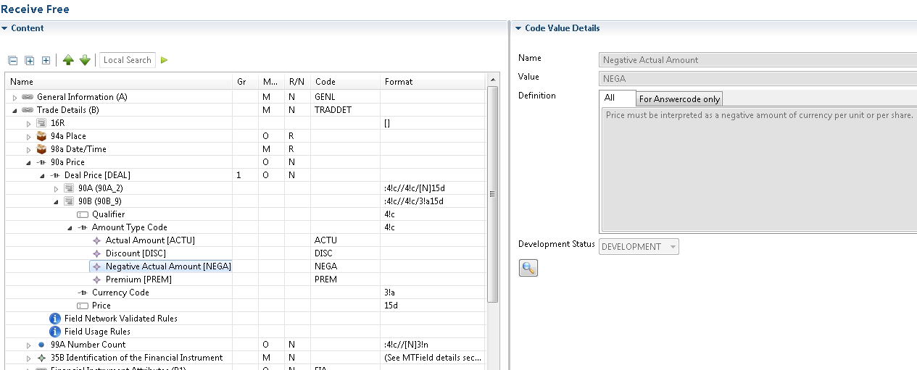

ISO20022 ILLUSTRATION
This ISO20022 will be shown here at a later stage.

SWIFT Comment

- SWIFT do not recommend to update the current format because of the impact in other business area (TIC, CA …).

- SWIFT suggest creating a new format (N) for the field 98 that will be identical to the format B with an optional negative sign.

- Question to the group: As the format N is richer than format B, could the format B be replaced at the CR’s requested location?
The replacement would have some impact for sure.

- SWIFT propose that corresponding messages in ISO20022 be updated for the coexistence.

Working Group Meeting

Discussion
The group rejected the creation of a new format option N, but wanted a change to the format option B. This requires discussion with all impacted MWGs and a new common cat5 CR can be proposed for SR2022.
The group accepts the CR with the proposed workaround solution (addition of the “NEGA” code for the format B) for the limited requested number of MTs.
Given the potential impact on financial institutions, the group agreed to consider the impact of the CR on community of users, and changing an existing format option 90B in ALL category 5 messages would be a huge effort for all financial institutions and vendors. As the back office systems are not prepared to received and deal with negative deal prices.

Decision
ACCEPTED with alternative solution
Final decision of the Securities SEG regarding ISO 20022 messages:
Approve the MWG decision | approved
Comments:

Reject the MWG decision
Reason for rejection:

Overview of ISO20022 User Change requests

CR 001666: Add a new SettlementTransactionCondition code (ISO20022 - CR0902)
Origin of request
Requesting Group: | Deutsche Bundesbank on behalf of the Eurosystem / 4CB
Sponsors
TARGET2-Securities Community
Message type(s) impacted
- Settlement Instruction (sese.023), Settlement Instruction Status Advice (sese.024), Securities Settlement Transaction Confirmation (sese.025), Allegement notification (sese.028), Securities Transaction posting Report (semt.017), Securities Transaction Pending Report (semt.018), Securities Settlement Transaction Query Response (semt.027)
- MT 536 - MT 537 - MT 540 - MT 541 - MT 542 - MT 543 - MT 544 - MT 545 - MT 546 - MT 547 - MT 548 - MT 578
Complies with regulation
None
Business impact of this request
Some exemptions from the application of cash penalties are mandated by the CSDR. In the T2S penalty mechanism, these exemptions from cash penalties are performed in two ways:
- Ex ante [prior to the calculation process] on an automated basis by the system, e.g. for Corporate Actions on stock identified by “CORP” ISO transaction type code as these transactions are deemed out of scope of the T2S penalty mechanism;
- Ex post [after the calculation of cash penalties] based on the removal request of already computed cash penalties sent by CSDs.
In the context of discussions around the buy-in process, CSDR TF members have identified a specific scenario whereby:
- A buy-in procedure is triggered, e.g. to deliver 100 securities. The settlement instructions [original transaction] that led to trigger the buy-in are put on [party] hold;
- The buy-in is initiated by the trading parties but cannot be executed in full, e.g. only 70 securities can successfully be bought in. The resulting instructions for the buy-in for the partial quantity are instructed to T2S. I.e. settlement instructions with ‘BYIY’ code in the ISO transaction type code (sese.023, Settlement Parameters/Securities Transaction Type/Code) and with ISD equal to the business day when they are entered in T2S. Upon successful settlement of the buy-in for the partial quantity, the settlement instructions [original transaction] that led to trigger the buy-in are cancelled;
- New settlement instructions with the same ISO transaction type code as the one of the original transaction must be entered by both parties to settle the remaining quantity, i.e. 30 securities.
As per CSDR requirements, Article 16.3 of Commission Delegated Regulation (EU) 2018/1229, where settlement instructions are entered into a securities settlement system as a result of a partially successful buy-in, cash penalties shall only apply as from the day those instructions are entered into the securities settlement system.
The initial assumption from the CSDR TF was that, similarly to the settlement instructions of the buy-in, also the new settlement instructions resulting from the partially successful buy-in can contain the ISD of the business day they are entered in T2S to avoid undue computation of cash penalties.
However, following further interactions with market participants, CSDR TF members are of the view that the new settlement instructions should be entered with the same ISD as the one of the original transaction, in order to avoid operational complexities for the processing of corporate actions and to facilitate reconciliation.
As a result, after a partially successful buy-in, when the new settlement instructions for the remaining quantity would be entered in T2S with the ISD of the original transaction, an undue Late Matching Fail Penalty (LMFP) would be computed by T2S for the business days between the ISD of the original transaction and the business day the settlement instructions are entered. Upon reporting of such cash penalties, CSD participants should appeal to their CSD and request an ex post removal of the relevant LMFP.
The CSDR TF has identified a solution to automate such exemption. If both settlement instructions of a transaction contain the buy-in code ‘BSSP’ in the Settlement Transaction Condition code, the T2S penalty mechanism shall not compute LMFP for those instructions because T2S identifies they are resulting from a partially successful buy-in.

Commitment to implement the change
Business context
According to CSDR Regulatory Technical Standards (RTS) on Settlement Discipline, in the case where a buy-in is only partially successful (i.e. the full quantity could not be bought-in / settled), “new settlement instructions are entered into the securities settlement system for any non-delivered financial instruments and the CSD receives the information necessary to identify such new settlement instructions accordingly.”
In order to satisfy this requirement, the securities settlement system needs to identify, store,
and report settlement information related to settlement instructions created as a result of partially successful buy-in across its messages. In order to do that a new SettlementTransactionCondition code is required.
The above solution does not impact the ISO transaction type code (which, accordingly, can still inform the same ISO transaction type code as the one of the original transaction).
The settlement instruction messages should contain the ‘BSSP’ settlement transaction condition code allowing to identify that the settlement instruction has been created as a result of a partial successful buy-in.
For further information, please rely on T2S change requests T2S-0717_URD and T2S-0728_SYS.
Nature of change
Add a new SettlementTransactionCondition code:
Code | Code Name | Definition
BSSP | Partial successful buy-in | Identification of settlement instructions created as a result of a partial successful buy-in

Examples

Standards Illustration
ISO15022 ILLUSTRATION

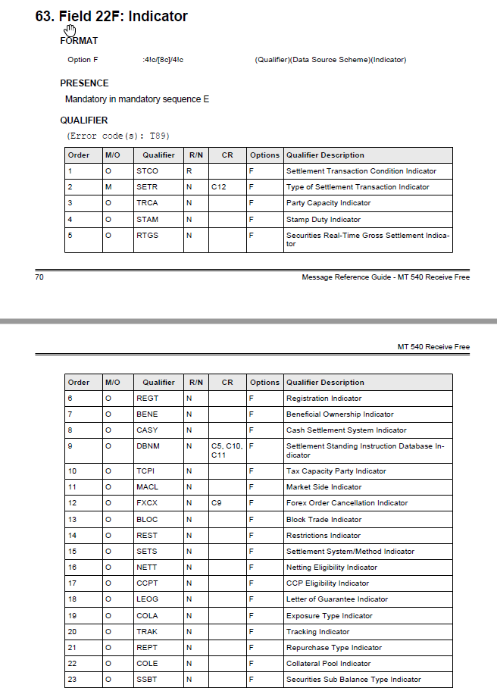
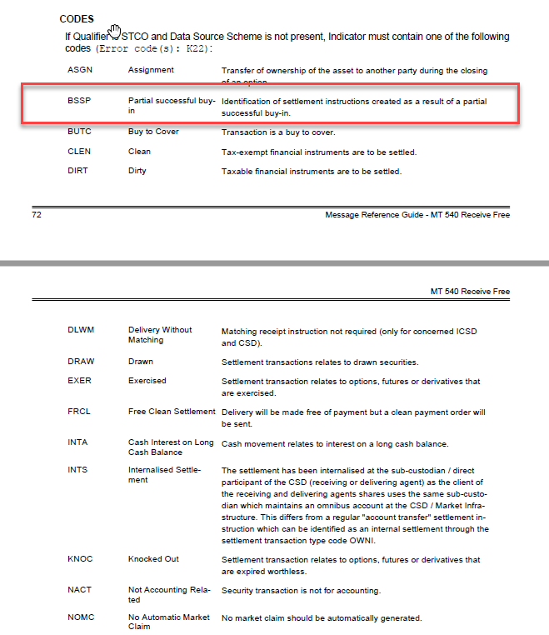
ISO20022 ILLUSTRATION

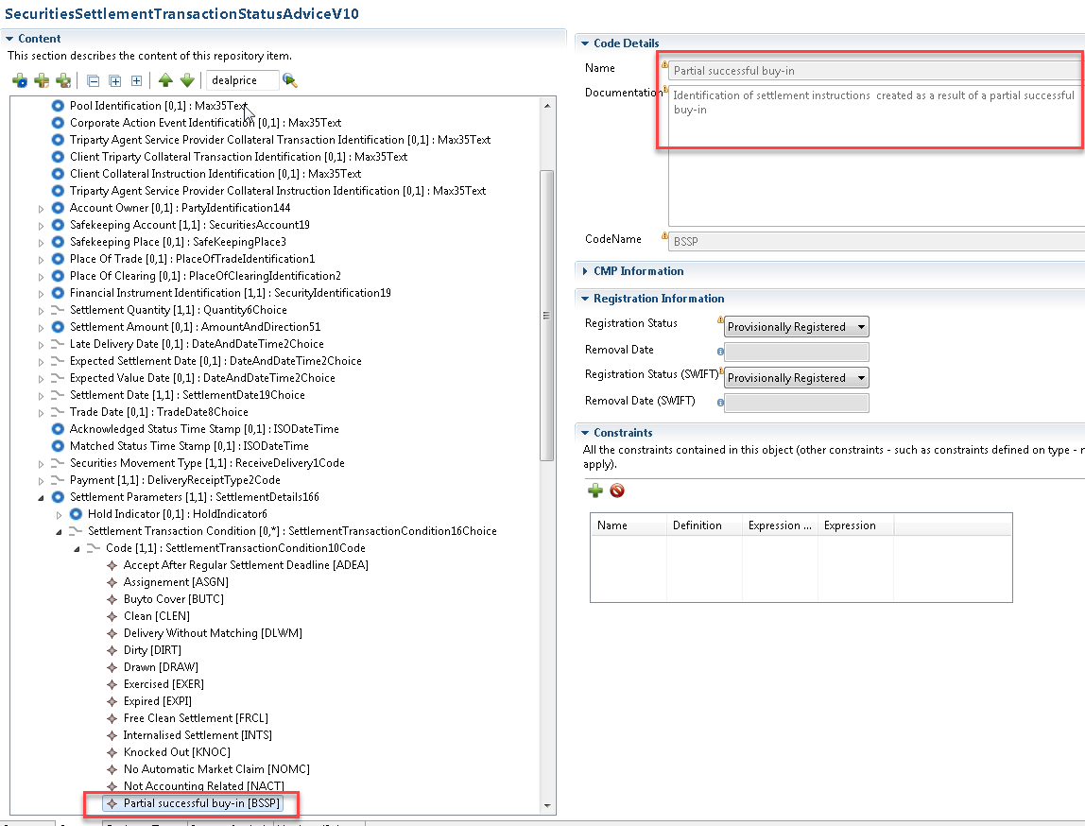

SWIFT Comment

- SWIFT propose to update the equivalent messages in ISO15022 for coexistence reasons.

- The SecuritiesSettlementTransactionQueryResponse (semt.027) is not under SWIFT’s responsibility, please take contact with 4CB’s / T2S.

Working Group Meeting

Discussion
The proposed codes have already been implemented in MT 530 for SR 2020 but is also needed in MT 54x to indicate that the reinstruction of the trade after a buy in is due to partial successful buy. As this is slightly different, ideally another code “BSSP” must be used.
MWG agrees to accept the CR for ISO 20022 and also in ISO 15022 in all MTs 54n, except the confirmations.
Euroclear questioned whether there would not be other scenarios outside Europe that could use it in the confirmation.
Finally it was agreed to add the code to the proposed ISO20022 and to the equivalent messages in ISO15022 for coexistence reasons. The code will be added under the STCO qualifier in all MT54x.

Decision
ACCEPTED
Final decision of the Securities SEG regarding ISO 20022 messages:
Approve the MWG decision | approved
Comments:

Reject the MWG decision
Reason for rejection:

CR 001667: Addition of Triparty Collateral Transaction instruction identifications. (ISO20022 - CR0917)
Origin of request
Requesting Group: | Banco de España on behalf of 4CB for ECMS; SWIFT.
Sponsors
The Eurosystem’s Advisory Group on Market Infrastructures for Securities and Collateral (AMI-SeCo) agreed to introduce a single, harmonised triparty model for Europe that would be based on the global ISO20022 messaging standard.
There is broad endorsement of the Standards by all TPAs, central banks and other market participants.
Message type(s) impacted
semt.020 (Securities Message Cancellation Advice)
Complies with regulation
None
Business impact of this request
Commitment to implement the change
Business context
In the context of the reverse engineering of the ISO 15022 Triparty Collateral Management messages, the MT558 and MT569 cancellation functions will be done through the existing ISO 20022 existing message semt.020. Therefore, the colr.020 Triparty Collateral Transaction Instruction Processing Status Advice, the colr.023 Triparty Collateral Status Advice and the colr.022 Triparty Collateral And Exposure Report will be cancelled with the semt.020. Despite the fact that this message is generic, some changes are required in order to meet the requirements of Triparty Collateral Management business.

- At the Reference level the following identifications must be added:
  - Triparty Collateral Transaction Instruction Processing Status Advice Identification
  - Triparty Collateral Status Advice Identification
  - Triparty Collateral and Exposure Report Identification.

Nature of change
The Eurosystem’s Advisory Group on Market Infrastructures for Securities and Collateral (AMI-SeCo) agreed to introduce a single, harmonised triparty model for Europe that would be based on the global ISO20022 messaging standard. In the light of the harmonisation needs identified by the AMI-SeCo in December 2017, a harmonised triparty model (the Single Triparty Model for Europe) was developed in June 2018 covering all relevant business processes and workflows. Key data elements were then mapped to ISO20022-compliant messages.

The Standards cover the communication of the triparty agents (TPAs) with relevant stakeholders based solely on the latest ISO20022-compliant messaging. The Triparty Collateral Management Standards defined requirements cover all existing triparty business processes and workflows and introduce enhanced features that will facilitate improved reporting capabilities to support the needs of treasurers and to meet regulatory requirements.

The Triparty Collateral Management Standards cover triparty processes offered to commercial and central banks. There is a single set of processes applicable for central banks and commercial banks. A few processes are more relevant in the context of the collateralisation of central bank operations (e.g.unilateral increase), while a number of other processes are more relevant for commercial banks (e.g.future-dated processing or customised baskets).

Implementation of theTriparty Collateral Management Standards will be mandatory for all TPAs (regardless of whether they are regulated as an (international) central securities depository ((I)CSD) or as a bank). (I)CSDs and custodian banks acting as TPAs are key stakeholders and are obliged to comply. It will also be mandatory for Eurosystem central banks and central counterparties (CCPs) as key users to implement the Triparty Collateral Management Standards. For collateral givers and collateral takers (unless they are Eurosystem central banks or CCPs), the use of existing messaging standards other than those based on ISO20022 remains possible.
The Triparty Collateral Management Standards should be implemented by November 2022 by all TPAs, CCPs and Eurosystem central banks (for triparty activities between key stakeholders in AMI-SeCo markets covered by the Standards). Timely implementation of the Triparty Collateral Management Standards by other actors (e.g.custodians not acting as TPAs but as collateral takers/givers) is also greatly encouraged in order to foster broader harmonisation across the industry.
Examples
Not provided.

Standards Illustration

ISO20022 ILLUSTRATION

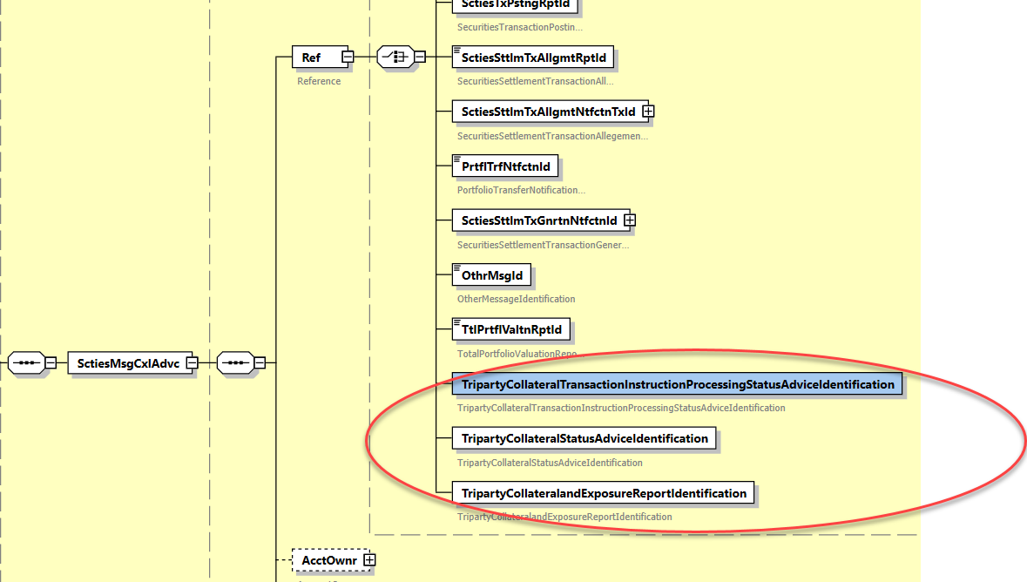

SWIFT Comment

- This should not be harmonised in ISO15022 as we have the concept of PREV and RELA to be able to link to the original instruction to cancel (to cancel a MT548 NEWN, use a MT548 CANC with the PREV is sent).

Working Group Meeting

Discussion
No comments were raised, so accepted.
Decision
ACCEPTED

Final decision of the Securities SEG regarding ISO 20022 messages:
Approve the MWG decision | approved
Comments:

Reject the MWG decision
Reason for rejection:

3.3 CR 001578: Update the pattern of AnyBICIdentifier, BICIdentifier or BICNonFIIdentifier. (ISO20022 - CR0751)
Origin of request
Requesting Group: | ISO 20022 Registration Authority
Sponsors
N/A
Message type(s) impacted
All message definitions that use the AnyBICIdentifier or the BICIdentifier or the BICNonFIIdentifier.
Complies with regulation
None
Business impact of this request
The patterns of the current datatypes AnyBICIdentifier , BICFIIdentifier and BICNonFIIdentifier are not fully aligned with the patterns described in ISO 9362.
Commitment to implement the change
Business context
Nature of change
- Change the pattern of datatype AnyBICIdentifier from:
  - [A-Z]{6,6}[A-Z2-9][A-NP-Z0-9]([A-Z0-9]{3,3}){0,1}
To:
  - [A-Z0-9]{4,4}[A-Z]{2,2}[A-Z0-9]{2,2}([A-Z0-9]{3,3}){0,1}
- Change the pattern of datatype BICFIIdentifier from:
  - [A-Z]{6,6}[A-Z2-9][A-NP-Z0-9]([A-Z0-9]{3,3}){0,1}
To:
  - [A-Z0-9]{4,4}[A-Z]{2,2}[A-Z0-9]{2,2}([A-Z0-9]{3,3}){0,1}
- Change the pattern of datatype BICNonFIIdentifier from:
  - [A-Z]{6,6}[A-Z2-9][A-NP-Z0-9]([A-Z0-9]{3,3}){0,1}
To:
  - [A-Z0-9]{4,4}[A-Z]{2,2}[A-Z0-9]{2,2}([A-Z0-9]{3,3}){0,1}

For this purpose, the RA has created three new datatypes:
- AnyBICDec2014Identifier
- BICFIDec2014Identifier
- BICNonFIDec2014Identifier
And, to avoid further re-use of the current datatypes, the RA has changed the registration status of the current AnyBICIdentifier , BICFIIdentifier and BICNonFIIdentifier to “Obsolete”.
Examples

SWIFT Comment

No comment.

Working Group Meeting

Discussion
NA
Decision
ACCEPTED in SR2019
Final decision of the Securities SEG regarding ISO 20022 messages:
Approve the MWG decision | approved
Comments:

Reject the MWG decision
Reason for rejection:

Overview of SWIFT Change requests
None

Legal Notices
Copyright
SWIFT © 2020. All rights reserved.
Disclaimer
This publication constitutes advance information only and is not to be considered the final and complete standards documentation for the subject matter published herein. The information in this publication may change from time to time. You must always refer to the latest available version.
SWIFT Standards Intellectual Property Rights (IPR) Policy - End-User License Agreement
SWIFT Standards are licensed subject to the terms and conditions of the SWIFT Standards IPR Policy - End-User License Agreement, available at www.swift.com > About Us > Legal > IPR Policies > SWIFT Standards IPR Policy.
Translations
The English version of SWIFT documentation is the only official and binding version.
Trademarks
SWIFT is the trade name of S.W.I.F.T. SC. The following are registered trademarks of SWIFT: 3SKey, Innotribe, MyStandards, Sibos, SWIFT, SWIFTNet, SWIFT Institute, the Standards Forum logo, the SWIFT logo and UETR. Other product, service, or company names in this publication are trade names, trademarks, or registered trademarks of their respective owners.

The cancellation instruction message, sese.020, is populated with the cancellation reason code BYIY that will be added with CR-688

