Standards

Standards MT Release 2021

ISO 20022 maintenance cycle 2020/2021

Maintenance Change Request – Maintenance Working Group FINAL Minutes

Corporate Actions

Distribution: Corporate Actions Maintenance Working Group

Author: Jacques Littré

Date Issued: 7 September 2020

Meeting Date: August 19, 20 and August 25, 2020

Version: FINAL 1.0

**Table of Contents**

1 Introduction 3

ISO 15022 – 20022 Maintenance Process 3

Standards Illustrations in this document 3

SR 2021 change requests 3

CR Title Colour notation (**for minutes only**) 3

Contact persons regarding this document 3

CA MWG Members for SR2021 3

2 Overview of User Change Requests 5

2.1 CR 001657: Move Index Factor to Corporate Action Details Sequence 5

2.2 CR 001633: Add Offer Type Indicator Code for Registered Shared 17

2.3 CR 001634: Add Indicator Type code for Event Processed on Memorized Balance 24

2.4 CR 001635: Add Blocking/Unblocking Indicator of Elected Securities and Removal of Blocking Period 29

2.5 CR 001654: Add Minimum and Maximum Prices to Option Level 43

2.6 CR 001631: Add New Bid Range Type for Bid Tender or Dutch Auctions in US Market 54

2.7 CR 001636: Add Date Time Format Option E for some Qualifiers & Name and Definition Consistency Fixes 59

2.8 CR 001629: Add New CA Option for WTRC Breakdown Request and new OWND Country Code Format Option 68

2.9 CR 001659: Add Offer Eligibility Acknowledgement Indicator 75

2.10 CR 001638: Add Event Type ACCU to Instruction and Status 81

2.11 CR 001630: Add Solicitation Dealer Fee Request Indicator 85

2.12 CR 001649: Add New Sequence in Status for Market Claim Details 94

2.13 CR 001653: Add Pending and Rejected Reason Codes for Voluntary Reorganisations 110

2.14 CR 001660: Fix Incorrect MITI data Type in Base message (ISO20022 – CR 0896) 118

2.15 CR 001661: Add Support for Multi Languages Announcements (ISO20022 – CR 0897) 120

2.16 CR 001662: Amend Narrative Message Scope Description (ISO20022 – CR 0898) 124

# Introduction

ISO 15022 – 20022 Maintenance Process

As from the year 2012, a joint maintenance process has been put in place for ISO 20022 and 15022 and Corporate Action messages with the support of the ISO 20022 RMG and of the SWIFT Board.

This joint maintenance will ensure interoperability between the two standards and a more efficient maintenance process.

Standards Illustrations in this document

Standards illustrations are provided by SWIFT Standards. They are not part of the original request.

Any standard illustrations (rules, codes, qualifiers, wordings) are **only for illustration purposes**. It does not mean SWIFT Standards is in agreement with the maintenance request or that the final standards solutions (for accepted maintenance requests) will be as shown in this document.

The MT Standards Release Guide (+ potential erratum) and the ISO 20022 message definition reports are the ONLY source of reliable information based on which implementation of changes should be made. Any other documentation (including this one) is subject to change.

SR 2021 change requests

This document contains all CA MT/MX CRs for MT category 5 and equivalent MX messages investigated this year for implementation in SR 2021.

The requests originator is indicated as follows:

* + Requesting Country; Country code of requesting NMPG or UG; eg. BE
  + Requesting Group: a SWIFT User Group or a National (Securities) Market Practice Group with the acknowledgement of the UGC or Recognized industry group eg. SMPG (the global Securities Market Practice Group)

CR Title Colour notation (**for minutes[[1]](#footnote-1) only**)

In GREEN are items that are approved or approved with comments or approved with alternative solution.

In RED are items that are rejected, postponed, withdrawn or linked to agreed items

Contact persons regarding this document

Jacques Littré – SWIFT Standards; [jacques.littre@swift.com](mailto:jacques.littre@swift.com)

CA MWG Members for SR2021

The following people are part of the CA MWG for SR2021.

|  |  |
| --- | --- |
| **Maintenance working group members** | **Representing** |
| Narelle Rutter | AU |
| Véronique Peeters | BE |
| Michael Blumer | CH |
| Daniel Schäfer | DE |
| Jean-Pierre Klak | FR |
| James Mullens | HK |
| Catarina Marques | LU |
| Sanjeev Jayram | ZA |
| Mariangela Fumagalli | UK |
| Paul Fullam | US / ISITC |
| Jean-Paul Lambotte | XS |
| Christine Strandberg | ISO 20022 Securities SEG (SE) |
| Steve Sloan | ISO 20022 Securities SEG (US) |
| Jacques Littré | CA MWG Chair |

# Overview of User Change Requests

## CR 001657: Move Index Factor to Corporate Action Details Sequence

|  |  |
| --- | --- |
| **Origin of request** | |
| Requesting Group: | SMPG |
| **Sponsors** | |
| SMPG | |
| **Message type(s) impacted** | |
| MT 564, MT 566, seev.031, seev.035, seev.036 | |
| **Complies with regulation** | |
| None | |
| **Business impact of this request** | |
| LOW | |
| **Commitment to implement the change** | |
| SR2021 | |
| **Business context** | |
| The change is to align the usage of the components used to calculate of INTP and OFFR in E2 according to GMP1 section 3.12.7. Bonds can be linked to index (e.g. inflation index) which is used to adjust the interest and redemption amounts.   * For interest payment, the interest rate for the period (INTP) is calculated by taking the index into account. For instance, INTP = ( INTR \* DAAC \* PRFC \* INDX ) / (nb of days in the year). The interest amount to pay to the account holder is then the eligible position balance \* multiplied by INTP, without additional multiplication by the (inflation) index a second time. * For redemption, the OFFR is also taking into account the index. The redemption amount to pay to the account holder is then the eligible position balance \* multiplied by OFFR, without additional multiplication by the (inflation) index a second time. (The difference compared with an interest payment is that there is no way to show what the OFFR rate was before it was multiplied with the index; only the resulting OFFR can be included in the message.)   For INDX and Index bonds, the INDX qualifier is not available in sequence D as static information, but in sequence E. Moving INDX to sequences from E to D. To align with the other fields INTR,DAAC and PRFC which are included in the OFFR or INTP when calculating payments for bonds. | |
| **Nature of change** | |
| Moving of INDX from sequence E to sequence D for the MT564  Moving of INDX from sequence D to sequence C for the MT566 | |
| **Examples** | |
| :16R:GENL  :20C::SEME//123  :20C::CORP//39038  :23G:NEWM  :22F::CAEV//PCAL  :22F::CAEP//REOR  :22F::CAMV//MAND  :25D::PROC//COMP  :16S:GENL  :16R:USECU  :35B:ISIN NO0009247843  2,50 KUD EN INDEX44  :16R:ACCTINFO  :97A::SAFE//02000123456  :93B::ELIG//FAMT/835002211,63  :16S:ACCTINFO  :16S:USECU  :16R:CADETL  :98A::RDTE//20181231  :16S:CADETL  :16R:CAOPTN  :13A::CAON//001  :22F::CAOP//CASH  :17B::DFLT//Y  **:92A::INDX**//276,249000 <----- INDX  :16R:SECMOVE  :22H::CRDB//DEBT  :35B:ISIN NO0009247843  2,50 KUD EN INDEX44  :36B::ENTL//FAMT/23484796,09  :98A::PAYD//20190102  :16S:SECMOVE  :16R:CASHMOVE  :22H::CRDB//CRED  :19B::GRSS//DKK23484796,09  :19B::ENTL//DKK23484796,09  :98A::PAYD//20190102  :92A::RATE//2,8125429799  :90A::OFFR//PRCT/100,  :16S:CASHMOVE  :16S:CAOPTN  :16R:GENL  :20C::CORP//2100496932001  :20C::SEME//0000000150676441  :23G:NEWM  :22F::CAEV//PCAL  :22F::CAMV//MAND  :22F::CAEP//REOR  :25D::PROC//COMP  :16S:GENL  :16R:USECU  :35B:ISIN DK0009247843  REALKREDIT DANMARK A/S BD FIXED 2.5  :16R:ACCTINFO  :97A::SAFE//AFDE453  :93B::ELIG//FAMT/75108475,97  :93B::SETT//FAMT/75108475,97  :16S:ACCTINFO  :16S:USECU  :16R:CADETL  :98A::RDTE//20200630  :16S:CADETL  :16R:CAOPTN  :13A::CAON//001  :22F::CAOP//CASH  :11A::OPTN//DKK  :17B::DFLT//Y  **:92A::INDX**//280,858  :16R:SECMOVE  :22H::CRDB//DEBT  :35B:ISIN DK0009247843  REALKREDIT DANMARK A/S BD FIXED 2.5  36B::ENTL//FAMT/2290083,57  :98A::PAYD//20200701  :16S:SECMOVE  :16R:CASHMOVE  :22H::CRDB//CRED  :19B::ENTL//DKK6431882,91  :19B::GRSS//DKK6431882,91  :19B::NETT//DKK6431882,91  :98A::PAYD//20200701  :92A::RATE//3,0490347977  :90A::OFFR//PRCT/280,858  :16S:CASHMOVE  :16S:CAOPTN  :16R:GENL  :20C::CORP//0000000627071505  :20C::SEME//3453-DE009  :23G:NEWM  :22F::CAEV//INTR  :16R:LINK  :13A::LINK//564  :20C::PREV//3453-DE008  :16S:LINK  :16S:GENL  :16R:USECU  :97A::SAFE//12345678  :35B:ISIN DK0009294928  1,00 Realkredit  93B::CONB//FAMT/91300000,  :16S:USECU  :16R:CADETL  :98A::RDTE//20200331  :92A::INTR//1,00000  :16S:CADETL  :16R:CACONF  :13A::CAON//001  :22H::CAOP//CASH  :92A::INTP//1,00000  :**92A::INDX**//1,00000  :16R:CASHMOVE  :22H::CRDB//CRED  :97A::CASH//3453937555  :19B::PSTA//DKK913000,  :19B::INTR//DKK913000,  :98A::POST//20200401  :98A::VALU//20200401  :16S:CASHMOVE  :16S:CACONF | |

**SWIFT Comment**

|  |
| --- |
| In the CA MX messages the Index Factor element is included in the Corporate ActionNotification (seev.031), CorporateActionMovementPreliminaryAdvice (seev.035) and CorporateActionMovementConfirmation messages (seev.036) messages; however in the seev.035 and seev.036, the CA details sequence has been reduced to a very limited set of data elements which do not include any rates.  Therefore in these 2 preliminary Advice and confirmation messages, if we follow the same logic, the Index factor should in principle not be moved to the CA details sequence but simply removed from the option sequences.  This is the assumption that has been followed in the illustrated implementation for MX messages here below. If on the other hand, the Index Factor must be present in these 2 messages, then it will need to be added into the CA Details sequence of the seev.035 and seev.036. |

**Standards Illustration**

**1. ISO 15022 Illustration**

1. **In the MT 564 in sequence E and in the MT 566 in sequence D, in field 92A, remove the qualifier INDX and add the same removed INDX qualifier in the field 92a respectively in the MT 564 in sequence D and in the MT 566 in sequence C as illustrated below:**

**MT 564 Field Specifications**

46. Field 92a: Rate

FORMAT

|  |  |  |
| --- | --- | --- |
| Option A | :4!c//[N]15d | (Qualifier)(Sign)(Rate) |
| Option F | :4!c//3!a15d | (Qualifier)(Currency Code)(Amount) |
| Option K | :4!c//4!c | (Qualifier)(Rate Type Code) |
| Option P | :4!c//15d | (Qualifier)(Index Points) |

PRESENCE

Optional in optional sequence D

QUALIFIER

(Error code(s): T89)

| **Order** | **M/O** | **Qualifier** | **R/N** | **CR** | **Options** | **Qualifier Description** |
| --- | --- | --- | --- | --- | --- | --- |
| 1 | O | RDIS | N |  | A or K | Reinvestment Discount Rate to Market |
| 2 | O | INTR | N |  | A, F, or K | Interest Rate |
| 3 | O | BIDI | N |  | A, F, K, or P | Bid Interval Rate |
| 4 | O | NWFC | N |  | A or K | Next Factor |
| 5 | O | PTSC | N |  | A or K | Percentage Sought |
| 6 | O | PRFC | N |  | A or K | Previous Factor |
| 7 | O | RINR | N |  | A or K | Related Index Rate |
| 8 | O | RSPR | N |  | A or K | Spread Rate |
| 9 | O | SHRT | N |  | A or F | Interest Shortfall |
| 10 | O | RLOS | N |  | A or F | Realised Loss |
| 11 | O | DEVI | N | C18 | A or F | Declared Rate |
| **12** | **O** | **INDX** | **N** |  | **A, F, or K** | **Index Factor** |

DEFINITION

This qualified generic field specifies:

|  |  |  |
| --- | --- | --- |
| BIDI | Bid Interval Rate | Acceptable price increment used for submitting a bid. |
| DEVI | Declared Rate | Dividend or interest rate declared by the issuer. |
| **INDX** | **Index Factor** | **Public index rate applied to the amount paid to adjust it to inflation.** |
| INTR | Interest Rate | Annualised interest rate of a financial instrument used to calculate the actual interest rate of the coupon or the accrued interest. |
| NWFC | Next Factor | Factor used to calculate the value of the outstanding principal of the financial instrument (for factored securities) that will be applicable after the redemption (factor) date. |
| PRFC | Previous Factor | Factor used to calculate the value of the outstanding principal of the financial instrument (for factored securities) until the next redemption (factor) date. |
| PTSC | Percentage Sought | Percentage of securities the offeror/issuer will purchase or redeem under the terms of the event. |
| RDIS | Reinvestment Discount Rate to Market | Rate of discount for securities purchased through a reinvestment scheme as compared to the current market price of security. |
| RINR | Related Index Rate | Index rate related to the interest rate of the forthcoming interest payment. |
| RLOS | Realised Loss | For structured security issues where there is a set schedule of principal and interest payments for the life of the issue, this is the difference between the actual rate of the capital or principal repayment and the scheduled capital repayment. |
| RSPR | Spread Rate | Margin allowed over or under a given rate. |
| SHRT | Interest Shortfall | For structured security issues where there is a set schedule of principal and interest payments for the life of the issue, this is the difference between the actual rate of the interest payment and the expected or scheduled rate of the interest payment. |

CODES

In option K, if Qualifier is RDIS or Qualifier is INTR or Qualifier is BIDI or Qualifier is NWFC or Qualifier is PRFC or Qualifier is RINR or Qualifier is RSPR, **or qualifier in INDX**, Rate Type Code must contain the following code (Error code(s): K92):

|  |  |  |
| --- | --- | --- |
| UKWN | Unknown Rate | Rate is unknown by the sender or has not been established. |

**MT 564 Field Specifications**

64. Field 92a: Rate

FORMAT

|  |  |  |
| --- | --- | --- |
| Option A | :4!c//[N]15d | (Qualifier)(Sign)(Rate) |
| Option B | :4!c//3!a/3!a/15d | (Qualifier)(First Currency Code)(Second Currency Code)(Rate) |
| Option F | :4!c//3!a15d | (Qualifier)(Currency Code)(Amount) |
| Option H | :4!c//3!a15d/4!c | (Qualifier)(Currency Code)(Amount)(Rate Status) |
| Option J | :4!c/[8c]/4!c/3!a15d[/4!c] | (Qualifier)(Data Source Scheme)(Rate Type Code)(Currency Code)(Amount)(Rate Status) |
| Option K | :4!c//4!c | (Qualifier)(Rate Type Code) |
| Option R | :4!c/[8c]/4!c/15d | (Qualifier)(Data Source Scheme)(Rate Type Code)(Rate) |

PRESENCE

Optional in optional sequence E

QUALIFIER

(Error code(s): T89)

| **Order** | **M/O** | **Qualifier** | **R/N** | **CR** | **Options** | **Qualifier Description** |
| --- | --- | --- | --- | --- | --- | --- |
| 1 | O | GRSS | R | C7, C8 | F, H, J, or K | Gross Dividend Rate |
| 2 | O | TAXR | R | C7, C8, C19 | A, F, K, or R | Withholding Tax Rate |
| 3 | O | ATAX | N |  | A, F, or K | Additional Tax |
| **~~4~~** | **~~O~~** | **~~INDX~~** | **~~N~~** |  | **~~A, F, or K~~** | **~~Index Factor~~** |
| 5 | O | OVEP | N |  | A or K | Maximum Allowed Oversubscription Rate |
| 6 | O | PROR | N |  | A or K | Pro-Ration Rate |
| 7 | O | INTP | R |  | A, F, J, or K | Interest Rate Used for Payment |
| 8 | O | TDMT | R |  | J | Taxable Income Per Dividend/Share |
| 9 | O | NETT | R | C7, C8 | F, H, J, or K | Net Dividend Rate |
| 10 | O | IDFX | N | C18 | B | Issuer Declared Exchange Rate |
| 11 | O | TXIN | N |  | A, F, or K | Tax on Income |
| 12 | O | WITL | R | C7, C8, C19 | A, F, K, or R | Second Level Tax |

DEFINITION

This qualified generic field specifies:

|  |  |  |
| --- | --- | --- |
| ATAX | Additional Tax | Rate used for additional tax that cannot be categorised. |
| GRSS | Gross Dividend Rate | Cash dividend amount per equity before deductions or allowances have been made. |
| IDFX | Issuer Declared Exchange Rate | Exchange rate (provided by the issuer) between the dividend or interest rate in the paid currency and the declared dividend or interest rate. |
| **~~INDX~~** | **~~Index Factor~~** | **~~Public index rate applied to the amount paid to adjust it to inflation.~~** |
| INTP | Interest Rate Used for Payment | The actual interest rate used for the payment of the interest for the specified interest period. |
| NETT | Net Dividend Rate | Cash dividend amount per equity after deductions or allowances have been made. |
| OVEP | Maximum Allowed Oversubscription Rate | A maximum percentage of shares available through the over subscription privilege, usually a percentage of the basic subscription shares, for example, an account owner subscribing to 100 shares may over subscribe to a maximum of 50 additional shares when the over subscription maximum is 50%. |
| PROR | Pro-Ration Rate | Percentage of securities accepted by the offeror/issuer. |
| TAXR | Withholding Tax Rate | Percentage of a cash distribution that will be withheld by the tax authorities of the jurisdiction of the issuer, for which a relief at source and/or reclaim may be possible. |
| TDMT | Taxable Income Per Dividend/Share | Amount included in the dividend/NAV that is identified as gains directly or indirectly derived from interest payments, for example, in the context of the EU Savings directive. |
| TXIN | Tax on Income | Overall tax withheld at source by fund managers prior to considering the tax obligation of each unit holder. |
| WITL | Second Level Tax | Rate at which the income will be withheld by a jurisdiction other than the jurisdiction of the issuer's country of tax incorporation, for which a relief at source and/or reclaim may be possible. It is levied in complement or offset of the withholding tax rate (TAXR) levied by the jurisdiction of the issuer's tax domicile. |

CODES

In option K, if Qualifier is TAXR or Qualifier is ATAX **~~or Qualifier is INDX~~** or Qualifier is OVEP or Qualifier is PROR or Qualifier is NETT or Qualifier is TXIN or Qualifier is WITL, Rate Type Code must contain the following code (Error code(s): K92):

|  |  |  |
| --- | --- | --- |
| UKWN | Unknown Rate | Rate is unknown by the sender or has not been established. |

**MT 566 Field Specifications**

32. Field 92a: Rate

FORMAT

|  |  |  |
| --- | --- | --- |
| Option A | :4!c//[N]15d | (Qualifier)(Sign)(Rate) |
| Option F | :4!c//3!a15d | (Qualifier)(Currency Code)(Amount) |
| Option K | :4!c//4!c | (Qualifier)(Rate Type Code) |
| Option P | :4!c//15d | (Qualifier)(Index Points) |

PRESENCE

Optional in optional sequence C

QUALIFIER

(Error code(s): T89)

| **Order** | **M/O** | **Qualifier** | **R/N** | **CR** | **Options** | **Qualifier Description** |
| --- | --- | --- | --- | --- | --- | --- |
| 1 | O | RDIS | N |  | A | Reinvestment Discount Rate to Market |
| 2 | O | INTR | N |  | A or F | Interest Rate |
| 3 | O | BIDI | N |  | F or P | Bid Interval Rate |
| 4 | O | NWFC | N |  | A | Next Factor |
| 5 | O | PRFC | N |  | A | Previous Factor |
| 6 | O | PTSC | N |  | A or K | Percentage Sought |
| 7 | O | SHRT | N |  | A or F | Interest Shortfall |
| 8 | O | RLOS | N |  | A or F | Realised Loss |
| **9** | **O** | **INDX** | **N** |  | **A or F** | **Index Factor** |

DEFINITION

This qualified generic field specifies:

|  |  |  |
| --- | --- | --- |
| BIDI | Bid Interval Rate | Acceptable price increment used for submitting a bid. |
| **INDX** | **Index Factor** | **Public index rate applied to the amount paid to adjust it to inflation.** |
| INTR | Interest Rate | Annualised interest rate of a financial instrument used to calculate the actual interest rate of the coupon or the accrued interest. |
| NWFC | Next Factor | Factor used to calculate the value of the outstanding principal of the financial instrument (for factored securities) that will be applicable after the redemption (factor) date. |
| PRFC | Previous Factor | Factor used to calculate the value of the outstanding principal of the financial instrument (for factored securities) until the next redemption (factor) date. |
| PTSC | Percentage Sought | Percentage of securities the offeror/issuer will purchase or redeem under the terms of the event. This can be a number or the term 'any and all'. |
| RDIS | Reinvestment Discount Rate to Market | Rate of discount for securities purchased through a reinvestment scheme as compared to the current market price of security. |
| RLOS | Realised Loss | For structured security issues where there is a set schedule of principal and interest payments for the life of the issue, this is the difference between the actual rate of the capital or principal repayment and the scheduled capital repayment. |
| SHRT | Interest Shortfall | For structured security issues where there is a set schedule of principal and interest payments for the life of the issue, this is the difference between the actual rate of the interest payment and the expected or scheduled rate of the interest payment. |

**MT 566 Field Specifications**

45. Field 92a: Rate

FORMAT

|  |  |  |
| --- | --- | --- |
| Option A | :4!c//[N]15d | (Qualifier)(Sign)(Rate) |
| Option F | :4!c//3!a15d | (Qualifier)(Currency Code)(Amount) |
| Option H | :4!c//3!a15d/4!c | (Qualifier)(Currency Code)(Amount)(Rate Status) |
| Option J | :4!c/[8c]/4!c/3!a15d[/4!c] | (Qualifier)(Data Source Scheme)(Rate Type Code)(Currency Code)(Amount)(Rate Status) |
| Option R | :4!c/[8c]/4!c/15d | (Qualifier)(Data Source Scheme)(Rate Type Code)(Rate) |

PRESENCE

Optional in mandatory sequence D

QUALIFIER

(Error code(s): T89)

| **Order** | **M/O** | **Qualifier** | **R/N** | **CR** | **Options** | **Qualifier Description** |
| --- | --- | --- | --- | --- | --- | --- |
| 1 | O | GRSS | R | C3, C4 | F, H, or J | Gross Dividend Rate |
| 2 | O | TAXR | R | C3, C4, C8 | A, F, or R | Withholding Tax Rate |
| **~~3~~** | **~~O~~** | **~~INDX~~** | **~~N~~** |  | **~~A or F~~** | **~~Index Factor~~** |
| 4 | O | ATAX | N |  | A or F | Additional Tax |
| 5 | O | OVEP | N |  | A | Maximum Allowed Oversubscription Rate |
| 6 | O | PROR | N |  | A | Pro-Ration Rate |
| 7 | O | INTP | R |  | A, F, or J | Interest Rate Used for Payment |
| 8 | O | TDMT | R |  | J | Taxable Income Per Dividend/Share |
| 9 | O | NETT | R | C3, C4 | F, H, or J | Net Dividend Rate |
| 10 | O | WITL | R | C3, C4, C8 | A, F, or R | Second Level Tax |

DEFINITION

This qualified generic field specifies:

|  |  |  |
| --- | --- | --- |
| ATAX | Additional Tax | Rate used for additional tax that cannot be categorised. |
| GRSS | Gross Dividend Rate | Cash dividend amount per equity before deductions or allowances have been made. |
| **~~INDX~~** | **~~Index Factor~~** | **~~Public index rate applied to the amount paid to adjust it to inflation.~~** |
| INTP | Interest Rate Used for Payment | The actual interest rate used for the payment of the interest for the specified interest period. |
| NETT | Net Dividend Rate | Cash dividend amount per equity after deductions or allowances have been made. |
| OVEP | Maximum Allowed Oversubscription Rate | A maximum percentage of shares available through the over subscription privilege, usually a percentage of the basic subscription shares, for example, an account owner subscribing to 100 shares may over subscribe to a maximum of 50 additional shares when the over subscription maximum is 50%. |
| PROR | Pro-Ration Rate | Percentage of securities accepted by the offeror/issuer. |
| TAXR | Withholding Tax Rate | Percentage of a cash distribution that will be withheld by the tax authorities of the jurisdiction of the issuer, for which a relief at source and/or reclaim may be possible. |
| TDMT | Taxable Income Per Dividend/Share | Amount included in the dividend/NAV that is identified as gains directly or indirectly derived from interest payments, for example, in the context of the EU Savings directive. |
| WITL | Second Level Tax | Rate at which the income will be withheld by a jurisdiction other than the jurisdiction of the issuer's country of tax incorporation, for which a relief at source and/or reclaim may be possible. It is levied in complement or offset of the withholding tax rate (TAXR) levied by the jurisdiction of the issuer's tax domicile. |

**2. ISO 20022 Illustration**

**In the seev.031 (CANO – CorporateActionNotification)** message, move the element *IndexFactor* from the sequence *CorporateActionOptionDetails/RateAndAmountDetails* to the sequence *CorporateActionDetails/ RateAndAmountDetails* as illustrated below:

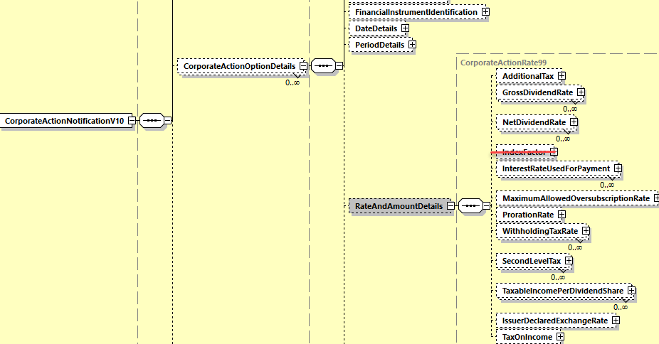

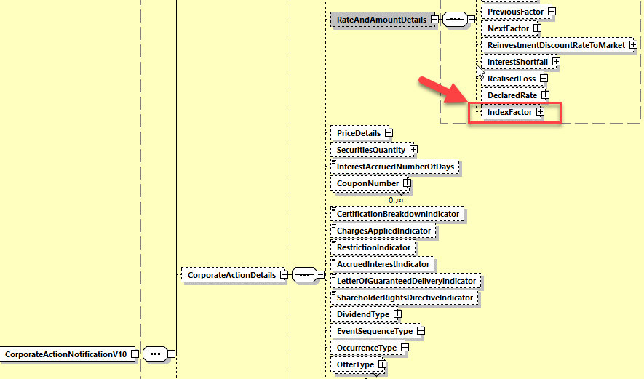

**In the seev.035 (CAPA – CorporateActionMovementPreliminaryAdvice)** message, remove the element *IndexFactor* from the sequence *CorporateActionMovementDetails/RateAndAmountDetails* as illustrated below:

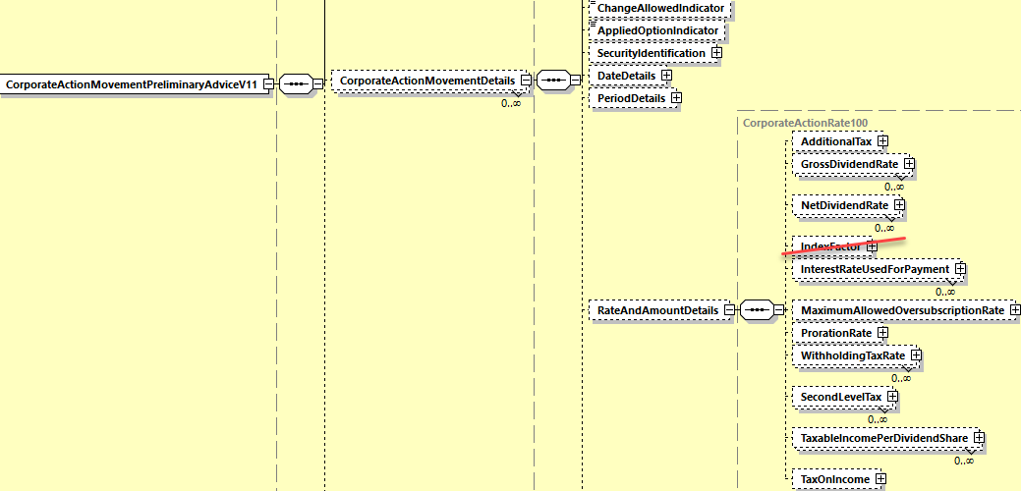

**In the seev.036 (CACO – CorporateActionMovementConfirmation)** message, remove the element *IndexFactor* from the sequence *CorporateActionConfirmationDetails/RateAndAmountDetails* as illustrated below.

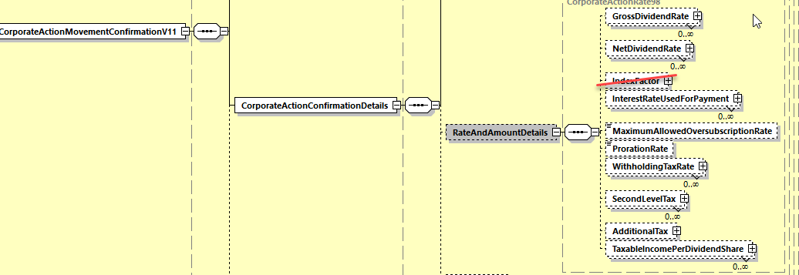

**Working Group Meeting**

|  |
| --- |
| **Discussion** |
| CH is not in favour of the CR as it does not agree with the business case. CH thinks that we might eventually have cases where the INDX factor would be different per option.  The rest of the MWG members rather agree with the business case and with the fact that the index factor can be considered as reference data and would be better placed with the CA Details sequence. Also, we never found business cases so far where the index factor could be different per option. Leaving the index factor in the option sequence can also be misleading as it may look like INTP would still need to be multiplied by INDX to calculate the interest amount whilst the calculation of INTP already includes the index factor.  Based on that later feedback, the CR is approved with the proposed solution. |
| **Decision** |
| **Approved.** |

**Final decision of the Securities SEG regarding ISO 20022 messages:**

|  |  |
| --- | --- |
| Approve the MWG decision | approved |

Comments:

|  |  |
| --- | --- |
| Reject the MWG decision |  |

Reason for rejection:

## CR 001633: Add Offer Type Indicator Code for Registered Shared

|  |  |
| --- | --- |
| **Origin of request** | |
| Requesting Country: | FR France |
| **Sponsors** | |
| FR NMPG including Euroclear France (the French CSD) | |
| **Message type(s) impacted** | |
| MT 564, MT 566, seev.031, seev.035 | |
| **Complies with regulation** | |
| None | |
| **Business impact of this request** | |
| Medium - The Change Request will impact events such as 'Change' events, Cash Dividends, Optional Dividends, Bonus Issues, Rights Issues | |
| **Commitment to implement the change** | |
| Number of messages sent and received: 4800000  Percentage of messages impacted: 30  Commits to implement and when: All ESES client users in 2021 | |
| **Business context** | |
| Some Corporate events may be applied only on the registered form of a security and not on the bearer form. This is the case for example of the different yearly conversions related to loyalty bonus shares such as Air Liquide, L'Oreal, EDF, etc….  A shareholder may decide, at any time, to convert his bearer shares into registered ones. The two forms will be identified at CSD level under an ad hoc accounting method called 'Nature De Compte: NDC' knowing that the ISIN will remain exactly the same whatever the form is.  When the corporate event is due to take place ONLY on registered shares, the CSD can process it correctly in his books based on this NDC (for example, NDC = 001 for registered shares and NDC = 000 for bearer shares).  Unfortunately, for the time being, when announcing the event, the CSD has no possibility in a SWIFT message to inform its participants that the event will take place only on these registered securities and not on the bearer ones of the unique ISIN concerned.  Having a new indicator for that (please see detailed change below) would not only benefit to CSD / CSD participants but also to the complete chain of intermediaries / clients receiving this information (e.g. Global Custodians and more generally all clients holding French securities). | |
| **Nature of change** | |
| Add in sequence D of the MT564 a new code attached to the qualifier OFFE  Two possible options were discussed within the SMPG:  Option 1 : general code meaning 'registered'  For example :22F::OFFE//REGD in order to indicate that the Corporate Actions event only relates to the registered shares of the ISIN.  Option 2 : a more specific code meaning 'loyalty bonus shares'  For example :22F::OFFE//LOYL in order to indicate that the Corporate Actions event only relates to the registered shares of the ISIN in relation to the Loyalty bonus shares program. | |
| **Workaround** | |
| The only workaround potentially identified at this stage is to indicate the information in the narrative part of the MT564 but it will interrupt the STP | |
| **Examples** | |
| Please refer to the different cases indicated in the Euroclear France announcement attached | |

**SWIFT Comment**

|  |
| --- |
| Based on the fact that all Offer Type Indicator (:22F::OFFE) codes present in the MT564 are also currently present in the MT566, I suggest that this change apply also to the OFFE qualifier in the MT 566 in order to keep some consistency with what is present in MT564/566 in terms of CA details.  The Offer Type Indicator :22F::OFFE is also present in the sequence E of the MT 564 with same code values as in the sequence D, therefore the code value REGD should also be added to OFFE in sequence E for consistency.  On the other hand, in ISO 20022, the Offer Type indicator is only present in the seev.031 in both the corporate action details and corporate action option details sequences and in the seev.035 in the corporate action movement details sequence only. |

**Standards Illustration**

**1. ISO 15022 Illustration**

**1. In the MT 564 in sequence D and E as well as in MT 566 sequence C, in field 22F, add the new code value REGD (Registered Form) to the OFFE qualifier as illustrated below:**

**MT 564 Field Specifications**

51. Field 22F: Indicator

FORMAT

|  |  |  |
| --- | --- | --- |
| Option F | :4!c/[8c]/4!c | (Qualifier)(Data Source Scheme)(Indicator) |

PRESENCE

Optional in optional sequence D

QUALIFIER

(Error code(s): T89)

| **Order** | **M/O** | **Qualifier** | **R/N** | **CR** | **Options** | **Qualifier Description** |
| --- | --- | --- | --- | --- | --- | --- |
| 1 | O | DIVI | N |  | F | Dividend Type Indicator |
| 2 | O | CONV | N |  | F | Event Sequence Type Indicator |
| 3 | O | DITY | N |  | F | Occurrence Type Indicator |
| 4 | O | OFFE | R |  | F | Offer Type Indicator |
| 5 | O | SELL | N |  | F | Renounceable Status of Entitlement Indicator |
| ……. |  |  |  |  |  |  |
| 16 | O | INFO | N |  | F | Information Type Indicator |
| 17 | O | TNDP | N |  | F | Tax On Non-Distributed Proceeds Indicator |

DEFINITION

This qualified generic field specifies:

|  |  |  |
| --- | --- | --- |
| ADDB | Additional Business Process Indicator | Specifies the additional business process linked to a corporate action event such as a claim compensation or tax refund. |
| ……. |  |  |
| LOTO | Lottery Type | Specifies the type of lottery announced. |
| OFFE | Offer Type Indicator | Specifies the conditions that apply to the offer. |
| RHDI | Intermediate Securities Distribution Type Indicator | Intermediates securities distribution type. |
| …. |  |  |
| TNDP | Tax On Non-Distributed Proceeds Indicator | Specifies the tax regulation being attributed to the non-distributed proceeds event. |

CODES

If Qualifier is OFFE and Data Source Scheme is not present, Indicator must contain one of the following codes (Error code(s): K22):

|  |  |  |
| --- | --- | --- |
| DISS | Dissenter's Rights | Securities' holder has the right to disagree with a mandatory event. This right is not inherent in all offers and therefore must be noted in announcements only when applicable. |
| ERUN | Restriction Exchange | Exchange of Restricted to Unrestricted (or vice versa). |
| FCFS | First Come First Served | Securities will be accepted in the order they have been submitted until the target number of quantity sought is reached. |
| FINL | Final Offer | Final or last offer to holders subject to offer conditions being reached, for example, 50% accepted on a tender. |
| PART | Partial Offer | Partial offer. |
| **REGD** | **Registered Security** | **Offer applicable to the financial instrument in registered form.** |
| SQUE | Squeeze Out Bid | Offer launched by a company, in possession of a large number of the shares (90% - 95%) of a company (generally as a result of a tender offer), in order to acquire the remaining shares of that company. |

**The Illustration for the MT564 sequence E is similar to the one in sequence D above.**

**MT 566 Field Specifications**

37. Field 22F: Indicator

FORMAT

|  |  |  |
| --- | --- | --- |
| Option F | :4!c/[8c]/4!c | (Qualifier)(Data Source Scheme)(Indicator) |

PRESENCE

Optional in optional sequence C

QUALIFIER

(Error code(s): T89)

| **Order** | **M/O** | **Qualifier** | **R/N** | **CR** | **Options** | **Qualifier Description** |
| --- | --- | --- | --- | --- | --- | --- |
| 1 | O | DIVI | N |  | F | Dividend Type Indicator |
| 2 | O | CONV | N |  | F | Event Sequence Type Indicator |
| 3 | O | DITY | N |  | F | Occurrence Type Indicator |
| 4 | O | OFFE | R |  | F | Offer Type Indicator |
| 5 | O | ADDB | R |  | F | Additional Business Process Indicator |
| … |  |  |  |  |  |  |
| 11 | O | TNDP | N |  | F | Tax On Non-Distributed Proceeds Indicator |

DEFINITION

This qualified generic field specifies:

|  |  |  |
| --- | --- | --- |
| ADDB | Additional Business Process Indicator | Specifies the additional business process linked to a corporate action event such as a claim compensation or tax refund. |
| …. |  |  |
| OFFE | Offer Type Indicator | Specifies the conditions that apply to the offer. |
| …. |  |  |
| TNDP | Tax On Non-Distributed Proceeds Indicator | Specifies the tax regulation being attributed to the non-distributed proceeds event. |

CODES

If Qualifier is OFFE and Data Source Scheme is not present, Indicator must contain one of the following codes (Error code(s): K22):

|  |  |  |
| --- | --- | --- |
| DISS | Dissenter's Rights | Securities' holder has the right to disagree with a mandatory event. This right is not inherent in all offers and therefore must be noted in announcements only when applicable. |
| ERUN | Restriction Exchange | Exchange of Restricted to Unrestricted (or vice versa). |
| FCFS | First Come First Served | Securities will be accepted in the order they have been submitted until the target number of quantity sought is reached. |
| FINL | Final Offer | Final or last offer to holders subject to offer conditions being reached, for example, 50% accepted on a tender. |
| PART | Partial Offer | Partial offer. |
| **REGD** | **Registered Security** | **Offer applicable to the financial instrument in registered form.** |
| SQUE | Squeeze Out Bid | Offer launched by a company, in possession of a large number of the shares (90% - 95%) of a company (generally as a result of a tender offer), in order to acquire the remaining shares of that company. |

**2. ISO 20022 Illustration**

**1. In the seev.031 (CANO – CorporateActionNotification)** message, in the *CorporateActionDetails* and *CorporateActionOptionDetails* sequences, add the new code value REGD (Registered Security) in the data type *OfferType3Code* of the *OfferType/Code* element as defined and illustrated in ISO 15022 above:

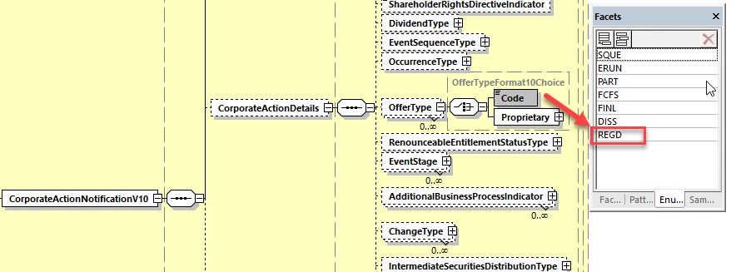

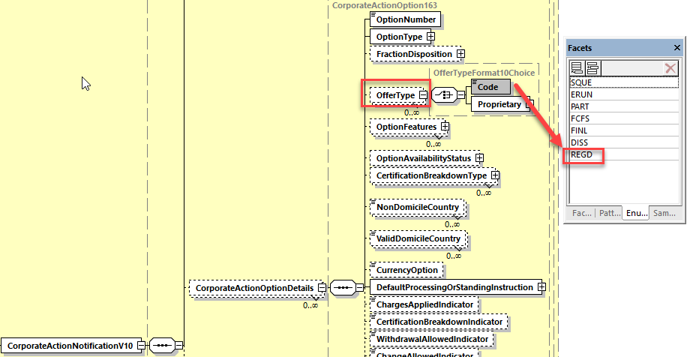

**2. In the seev.035 (CAPA – CorporateActionMovementPreliminaryAdvice)** message, in the *CorporateActionMovementDetails* sequence, add the new code value REGD (Registered Security) in the data type *OfferType3Code* of the *OfferType/Code* element as defined and illustrated in ISO 15022 above:

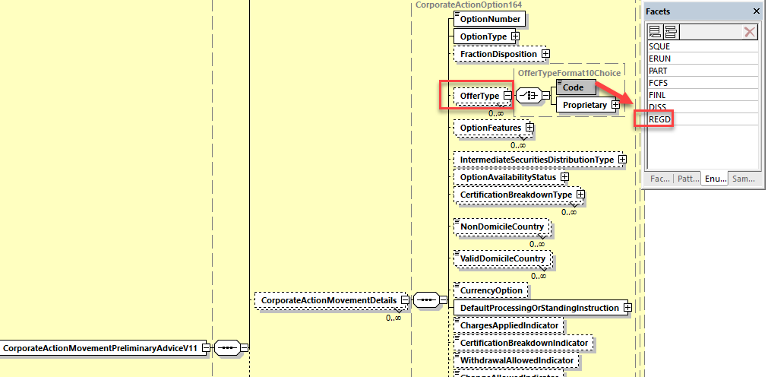

**Working Group Meeting**

|  |
| --- |
| **Discussion** |
| FR explained that this CR relates to registered shares. About 10-12 French institutions have this case of premium bonus shares. As per FR, this could also be used in other markets, eg Spain.  DE does not agree with the business case as it is a very bespoke local process that does not comply with the global standards and DE does not agree that a standard change should be imposed on the global community to support this local specific process.  LU does not agree either with the business case given the low number of cases.  UK also rejects the business case because of the low volume of cases and secondly there is a problem with the principle used in France to work with a “Nature de Compte (NDC)” i.e. use single ISIN for 2 different forms of securities. Using separate ISINs only will solve the issue. All other countries in T2S markets have moved to an interim ISIN as it is the Standard and FR should align with this as part of the European harmonisation effort. FR explained that there are not allowed by law to have separate ISINs.  CH agrees with the business case but would rather propose to use the code that does not refer to the registered shares because it could be misleading. In CH, there is no difference between registered and bearer shares.  US does not agree with the business case and suggests rather that FR uses a data source scheme in OFFE.  In Conclusion, AU, BE, CH, FR, XS: support the CR and DE, HK, LU, UK, US, ZA: reject the CR.  Since there is no majority to support the CR, the CR is rejected and the MWG recommends to use a DSS as a workaround. |
| **Decision** |
| **Rejected** |

**Final decision of the Securities SEG regarding ISO 20022 messages:**

|  |  |
| --- | --- |
| Approve the MWG decision |  |

Comments:

|  |  |
| --- | --- |
| Reject the MWG decision | rejected |

Reason for rejection:

## CR 001634: Add Indicator Type code for Event Processed on Memorized Balance

|  |  |
| --- | --- |
| **Origin of request** | |
| Requesting Country: | FR France |
| **Sponsors** | |
| FR NMPG including Euroclear France (the French CSD) | |
| **Message type(s) impacted** | |
| MT 564, MT566, seev.031, seev.035, seev.036 | |
| **Complies with regulation** | |
| None | |
| **Business impact of this request** | |
| Medium - The Change Request will impact events such as 'Change' events, Cash Dividends, Optional Dividends, Bonus Issues, Rights Issues and also Partial Redemptions With Pool Factor (PRED) | |
| **Commitment to implement the change** | |
| Number of messages sent and received: 4800000  Percentage of messages impacted: 3  Commits to implement and when: All ESES clients users in 2021 | |
| **Business context** | |
| In relation to the loyalty bonus shares programs in France and the registered shares positions linked to that, it appears that some events can't be processed based on the CSD position but on the position provided by the Issuer / the Registrar and so called 'Memorized balance'.  Due to some maximum thresholds applied on some Corporate Actions events, the CSD participant eligible positions (= the custodian positions) may differ from the total of all individual eligible positions calculated by the registrar:  Example: dividend payment on loyalty bonus shares of 1.50 euros with a maximum threshold of 1000 shares  Client A has a position at CSD level of 10000 registered shares.  Eligible position calculated by the CSD = 10000 so Cash related = 15,000.00 EUR  At registrar level:  Client A detail of shareholders:  Client A - shareholder 1: 4000 shares => maximum threshold of 1000 => cash to pay: 1000 \* 1,5 = 1,500.00 EUR  Client A - shareholder 2: 3000 shares => maximum threshold of 1000 => cash to pay: 1000 \* 1,5 = 1,500.00 EUR  Client A - shareholder 3: 2000 shares => maximum threshold of 1000 => cash to pay: 1000 \* 1,5 = 1,500.00 EUR  Client A - shareholder 4: 600 shares => maximum threshold not applicable => cash to pay: 600 \* 1,5 = 900.00 EUR  Client A - shareholder 5: 400 shares => maximum threshold not applicable => cash to pay: 400 \* 1,5 = 600.00 EUR  Consequently, the CSD can't distribute 15000 euros but only 6000 euros as per the registrar records. As a consequence, the positions won't be calculated by the CSD based on Record Date holdings but in relation to an ad hoc file provided by the issuer / the registrar.  The only automated possibility that the French market identified to provide this information of this 'Memorized balance' calculation is to add a code attached to a 22F indicator. Please see below. | |
| **Nature of change** | |
| Add in sequence D of the MT564 a new code attached to a 22F indicator in order to highlight that the event will be processed based on a memorized balance (e.g. MEBA).  It could be either related to an event, for example 22F//DIVI/MEBA in order to indicate that the dividend will be processed on the ‘Memorized balance’ or 22F//RHDI/MEBA for Rights Distribution but also more generally 22F//ADDB/MEBA. | |
| **Workaround** | |
| The only workaround potentially identified at this stage is to indicate the information in the narrative part of the MT564 but it will interrupt the STP. | |
| **Examples** | |
| Please refer to the different cases indicated in the Euroclear France announcement attached | |

**SWIFT Comment**

|  |
| --- |
| It seems more appropriate to add the new proposed code value in the :22F::ADDB indicator since it is more generic than adding it to DIVI or RHDI.  Based on the fact that most of the Additional Business Process Indicator (:22F::ADDB) codes present in the MT564 are also currently present in the MT566, I suggest that this change apply also to the ADDB qualifier in the MT 566 in order to keep some consistency with what is present in MT564/566 in terms of CA details.  If acceptable, I suggest to eventually rename “Memorized balance” which is probably a country specific name to a more generic name as “Alternate Balance” for a balance maintained by a registrar or Issuer. |

**Standards Illustration**

**1. ISO 15022 Illustration**

**1. In the MT 564 in sequence D as well as in MT 566 sequence C, in field 22F, add the new code value ALBA (Alternate Balance) to the Additional Business Process Indicator (ADDB) qualifier as illustrated below:**

**MT 564 Field Specifications**

51. Field 22F: Indicator

FORMAT

|  |  |  |
| --- | --- | --- |
| Option F | :4!c/[8c]/4!c | (Qualifier)(Data Source Scheme)(Indicator) |

PRESENCE

Optional in optional sequence D

QUALIFIER

(Error code(s): T89)

| **Order** | **M/O** | **Qualifier** | **R/N** | **CR** | **Options** | **Qualifier Description** |
| --- | --- | --- | --- | --- | --- | --- |
| 1 | O | DIVI | N |  | F | Dividend Type Indicator |
|  |  |  |  |  |  |  |
| 7 | O | ADDB | R | C14, C15, C17 | F | Additional Business Process Indicator |
| …. |  |  |  |  |  |  |
| 17 | O | TNDP | N |  | F | Tax On Non-Distributed Proceeds Indicator |

DEFINITION

This qualified generic field specifies:

|  |  |  |
| --- | --- | --- |
| ADDB | Additional Business Process Indicator | Specifies the additional business process linked to a corporate action event such as a claim compensation or tax refund. |
| CEFI | Certification Format Indicator | Specifies the certification format required, that is, physical or electronic format. |
| … |  |  |
|  |  |  |
| TNDP | Tax On Non-Distributed Proceeds Indicator | Specifies the tax regulation being attributed to the non-distributed proceeds event. |

CODES

If Qualifier is ADDB and Data Source Scheme is not present, Indicator must contain one of the following codes (Error code(s): K22):

|  |  |  |
| --- | --- | --- |
| ACLA | Automatic Market Claims | Will automatically give rise to market claims by the account servicer (typically, a CSD). |
| ATXF | Subject to Transformation | As a result of the Corporate Action, all transactions in the underlying security will be cancelled by the system and replaced with transactions in the outturn resource(s). |
| CAPA | Preliminary Advice of Payment | The message is a preliminary advice of payment. |
| CLAI | Claim or Compensation | Relates to a claim on the associated corporate action event. |
| CNTR | Cancel Underlying Trades | As a result of the Corporate Action, all transactions in the underlying security will be cancelled by the system. |
| CONS | Consent | Relates to a consent within a corporate action event other than a Consent event (:22F::CAEV//CONS). |
| FPRE | Full Pre-Funding | Full pre-funding of a debt instrument by the issuer prior to original maturity when the issuer deposits assets in trust. Applicable only in the frame of a partial defeasance corporate action event. |
| **ALBA** | **Alternate Balance** | **Proceeds of the event will be calculated based on the registrar’s or issuer’s balance records for the financial instrument.** |
| NAMC | No Automatic Market Claims and Transformations | The event will not automatically give rise to market claims and transformations by the account servicer (typically, a CSD). |
| NPLE | No Split Election | The issuer only allows a single option to be selected per designated holding. |
| PPRE | Partial Pre-Funding | Partial pre-funding of a debt instrument prior to maturity drawn through a lottery process. One new security is issued with an earlier maturity date for the refunded (called portion) and the other new security is issued with the original maturity date for the non refunded (remaining) portion. Applicable only in the frame of a partial defeasance corporate action event . |
| PPUT | Partial Mandatory Put Redemption | Partial mandatory exchange of a portion of bonds where the exchanged securities are usually remarketed. The issuer may offer holders the right to retain instead of exchanging their securities. A lottery will be used to determine eligibility for the event. |
| REAC | Required Action | Proceeds/entitlements of the mandatory event can only be paid if specified action is taken by the account owner. |
| REVR | Reversal | Notification of a reversal. |
| SCHM | Scheme/Plan of Arrangement | Component event of a scheme/plan of arrangement: a reorganisation of a company or a group of companies, and their capital. |
| TAXR | Tax Refund | Relates to a tax refund from the authorities on the associated corporate action event. |

**2. ISO 20022 Illustration**

**In the seev.031 (CANO – CorporateActionNotification)** message, in the sequence *CorporateActionDetails/AdditionalBusinessProcessIndicator*, add a new code value ALBA in the data type *AdditionalBusinessProcess5Code* of the Code element as defined in ISO 15022 above and as illustrated below.

**In the seev.035 (CAPA – CorporateActionMovementPreliminaryAdvice)** message, in the sequence *CorporateActionDetails/AdditionalBusinessProcessIndicator*, add a new code value ALBA in the data type *AdditionalBusinessProcess6Code* of the Code element as defined in ISO 15022 above and as illustrated below.

**In the seev.036 (CACO – CorporateActionMovementConfirmation)** message, in the sequence *CorporateActionDetails/AdditionalBusinessProcessIndicator*, add a new code value ALBA in the data type *AdditionalBusinessProcess7Code* of the Code element as defined in ISO 15022 above and as illustrated below:

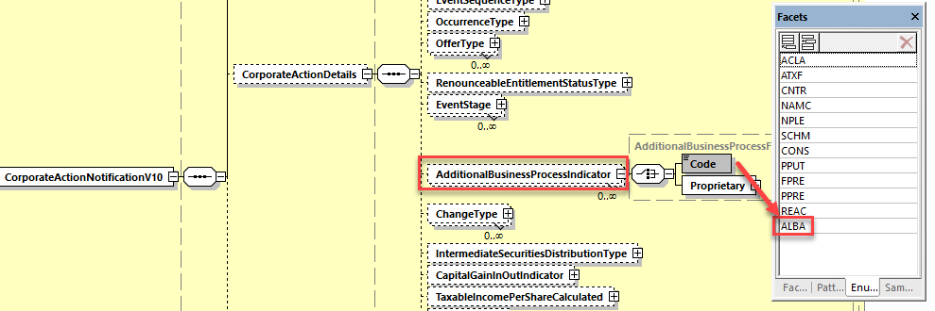

**Working Group Meeting**

|  |
| --- |
| **Discussion** |
| DE does not agree with the business case as this is again a very bespoke local process in FR that does not comply with the global market practices similarly to the CR 001633. If at all, the number of maximum shares that the event will be applicable to, could be communicated by using MIEX.  BE, UK, US, LU, HK, ZA do not agree either with the business case as the process in FR is not in line with standards and the volume of cases is very low.  AU,CH, XS supports the CR.  As there is no majority to support the CR, the CR is rejected.  The MWG recommends to FR to either use MIEX or to use a DSS with ADDB as a workaround. |
| **Decision** |
| **Rejected** |

**Final decision of the Securities SEG regarding ISO 20022 messages:**

|  |  |
| --- | --- |
| Approve the MWG decision |  |

Comments:

|  |  |
| --- | --- |
| Reject the MWG decision | rejected |

Reason for rejection:

## CR 001635: Add Blocking/Unblocking Indicator of Elected Securities and Removal of Blocking Period

|  |  |
| --- | --- |
| **Origin of request** | |
| Requesting Group: | SMPG |
| **Sponsors** | |
| SMPG | |
| **Message type(s) impacted** | |
| MT 564, MT 566, seev.031, | |
| **Complies with regulation** | |
| None | |
| **Business impact of this request** | |
| Medium - The new fields will be optional. | |
| **Commitment to implement the change** | |
| Number of messages sent and received: 10000000  Percentage of messages impacted: 5  Commits to implement and when: MH (Collateral Management Harmonization Group) of the European Central Bank in 2022  Therefore the change should be implemented with SR 2021 for the community to start using the functionality, as it has been requested by a number of participants, but the fixed date by which the implementation is mandatory for the actors in wave 1 of the introductions of the CMH Standards is November 2022 | |
| **Business context** | |
| By introducing a blocking indicator an account servicer will be in a position to inform an account owner that after accepting a specific option, the underlying securities will not be available for settlement for a certain period of time.  This allows account owners to ascertain the impact of accepting an instruction and will also allow them to understand as of when the underlying securities will be available for settlement again. | |
| **Nature of change** | |
| A new indicator should be introduced that will allow an account servicer to inform the account owner that securities will not be available for settlement after instructing a specific option of the corporate action event.  This will be used by the account servicer and not the issuer or the CSD, as the process to block shares (i.e. make a specific number of shares unavailable for settlement) might differ between the process on the level of the CSD and an account servicer.  The indicator is also meant to show, as of when the securities will be available again.  The "Blocking Period" (:69a::BLOK) should be removed, as the new indicators can be used instead to inform about the blocking.  The blocking process itself, where MT 566 or MT 508 messages are being used by market participants to inform about blocking/unblocking taking place will not be changed by the CR.   1. In the MT564 seq. E and MT566 seq. D (to be used on each option except NOAC), add a new securities “End Date of Blocking Period” indicator (22F) with codes representing various key dates (e.g. PAYD, RDTE, MKDT, RDDT, PWAL, MEET, UKWN and NARR). 2. Remove the “Blocking Period” qualifier (:69a::BLOK) in MT 564 seq. D and MT566 seq. C.   MT 564 Sequence E CAOPTN and MT 566 Sequence D CAOPTN:  For Field :22F::// create a new Qualifier  BLOK Blocking of Securities Blocking of securities can occur upon instructing this option  with Indicators  PAYD Blocking until payment date Unblocking will occur on payment date of the option  RDTE Blocking until record date Blocking until and incl. record date of the event  RDDT Blocking until acct. serv. deadline Blocking until and incl. the account servicer deadline of the option  MKDT Blocking until market deadline Blocking until and incl. the market deadline of the option  PWAL Blocking until end of election period Blocking until and incl. end of the election period of the option  MEET Blocking until meeting date Blocking until and incl. the meeting date  NARR unblocking date in narrative Unblocking date is specified in the free text field of the message  UKWN unblocking date unknown Unblocking date not yet known; blocking occurs until further notice  Regarding PAYD: SMPG appreciates that an option might have different payment dates (for example for cash and securities). However, in order to keep the Change Request simple and cover the majority of cases, only one field will be made available with this Change Request. If an account servicer needs to specify, which payment date will be the "unblocking date", then the code NARR should be used. | |
| **Workaround** | |
| Currently, the information is generally provided in the narrative of the message. | |
| **Examples** | |
| :16R:GENL  :20C::CORP//ABC123456789  :20C::SEME//123456789ABC  :23G:REPL  :22F::CAEP//DISN  :22F::CAEV//CONS  :22F::CAMV//VOLU  :98C::PREP//20200514HHMMSS  :25D::PROC//PREC  :16S:GENL  :16R:USECU  :35B:ISIN XS1734077420  //EMPRESA PUBLICA DE 4.62500 06/12  /21 USD  :16R:ACCTINFO  :97A::SAFE//ACCOUNT  :93B::SETT//FAMT/HOLDING  :16S:ACCTINFO  :16S:USECU  :16R:CADETL  :98A::RESU//20200504  :98B::RDTE//UKWN  :69J::BLOK//ONGO <= This field will be removed, the value of the information contained herein is limited.  :17B::CERT//N  :16S:CADETL  :16R:CAOPTN  :13A::CAON//001  :22F::CAOP//CONY  :22F::BLOK//PAYD <= Unblocking will take place on paydate of the option. While the Paydate is yet unknown, this information is valuable to the account owner.  :11A::OPTN//USD  :17B::DFLT//N  :17B::WTHD//N  :98C::EXPI//20200504170000  :98C::MKDT//20200504170000  :98C::RDDT//20200504160000  :69A::PWAL//20200429/20200504  :36B::MIEX//FAMT/200000,  :36B::MILT//FAMT/1,  :16R:CASHMOVE  :22H::CRDB//CRED  :98B::PAYD//UKWN  :98A::VALU//20200504  :92F::SOFE//USD0,000291  :16S:CASHMOVE  :16S:CAOPTN  :16R:CAOPTN  :13A::CAON//002  :22F::CAOP//NOAC  :17B::DFLT//Y  :98A::EXPI//20200504  :98C::RDDT//20200504160000  :69A::PWAL//20200429/20200504  :36B::MIEX//FAMT/200000,  :36B::MILT//FAMT/1,  :16S:CAOPTN  :16R:CAOPTN  :13A::CAON//001  :22F::CAOP//SECU  :22F::BLOK//PWAL <= securities will be blocked until end of PWAL (20181107), if option 001 is instructed  :17B::DFLT//Y  :17B::WTHD//N  :98C::MKDT//20181107160000  :98C::RDDT//20181107150000  :69A::PWAL//20181106/20181107  :36B::MIEX//UNIT/1,  :36B::MILT//UNIT/1,  :16R:SECMOVE  :22H::CRDB//CRED  :35B:ISIN DE000BAY0017  BAYER AG NA O.N.  :94F::SAFE//NCSD/DAKVDEFFXXX  :22F::DISF//RDDN  :92D::NEWO//1,/1,  :98A::PAYD//20181108  :16S:SECMOVE  :16R:SECMOVE  :22H::CRDB//DEBT  :35B:ISIN DE000BASF111  BASF SE NA O.N.  :94F::SAFE//NCSD/DAKVDEFFXXX  :98A::PAYD//20181108  :16S:SECMOVE  :70E::ADTX//.  :16S:CAOPTN  :16R:CAOPTN  :13A::CAON//002  :22F::CAOP//CASH  :22F::BLOK//PAYD <= securities will be unblocked on payment date (20181108) if option 2 is instructed  :17B::DFLT//N  :17B::WTHD//N  :98C::MKDT//20181107160000  :98C::RDDT//20181107150000  :69A::PWAL//20181106/20181107  :36B::MIEX//UNIT/1,  :36B::MILT//UNIT/1,  :16R:SECMOVE  :22H::CRDB//DEBT  :35B:ISIN DE000BASF111  BASF SE NA O.N.  :94F::SAFE//NCSD/DAKVDEFFXXX  :98A::PAYD//20181108  :16S:SECMOVE  :16R:CASHMOVE  :22H::CRDB//CRED  :98A::PAYD//20181108  :90B::OFFR//ACTU/EUR70,  :16S:CASHMOVE  :70E::ADTX//.  :16S:CAOPTN | |

**SWIFT Comment**

|  |
| --- |
| It would be semantically more correct and consistent to create a new Date/Time qualifier with format Option B (code) to define the various date codes to specify the relative date for the “end of blocking period” date than to create the end of blocking period as a 22F indicator.  Both implementation options have been illustrated in the following sections as implementation option A and B. To be discussed at the MWG meeting. |

**Standards Illustration**

**1. ISO 15022 Illustration**

**1. In sequence D of the MT564 and in sequence C of the MT566, in Field :69a: Period, remove the qualifier Blocking Period (BLOK) as illustrated below for the MT564:**

**MT 564 Field Specifications**

44. Field 69a: Period

FORMAT

|  |  |  |
| --- | --- | --- |
| Option A | :4!c//8!n/8!n | (Qualifier)(Date)(Date) |
| Option B | :4!c//8!n6!n/8!n6!n | (Qualifier)(Date)(Time)(Date)(Time) |
| Option C | :4!c//8!n/4!c | (Qualifier)(Date)(Date Code) |
| Option D | :4!c//8!n6!n/4!c | (Qualifier)(Date)(Time)(Date Code) |
| Option E | :4!c//4!c/8!n | (Qualifier)(Date Code)(Date) |
| Option F | :4!c//4!c/8!n6!n | (Qualifier)(Date Code)(Date)(Time) |
| Option J | :4!c//4!c | (Qualifier)(Date Code) |

PRESENCE

Optional in optional sequence D

QUALIFIER

(Error code(s): T89)

| **Order** | **M/O** | **Qualifier** | **R/N** | **CR** | **Options** | **Qualifier Description** |
| --- | --- | --- | --- | --- | --- | --- |
| 1 | O | PRIC | N |  | A, B, C, D, E, F, or J | Price Calculation Period |
| 2 | O | INPE | N |  | A, B, C, D, E, F, or J | Interest Period |
| 3 | O | CSPD | N |  | A, B, C, D, E, F, or J | Compulsory Purchase Period |
| **~~4~~** | **~~O~~** | **~~BLOK~~** | **~~N~~** |  | **~~A, B, C, D, E, F, or J~~** | **~~Blocking Period~~** |
| …. |  |  |  |  |  |  |
| 16 | O | SPLP | N |  | A, B, C, D, E, F, or J | Split Period |

DEFINITION

This qualified generic field specifies:

|  |  |  |
| --- | --- | --- |
| **~~BLOK~~** | **~~Blocking Period~~** | **~~Period during which the security is blocked.~~** |
| BOCL | Book Closure Period | Period defining the last date on which shareholder registration will be accepted by the issuer and the date on which shareholder registration will resume. |
| ….. |  |  |
| SPLP | Split Period | Period during which a physical certificate can be split. |

**MT 566 Field Specifications**

30. Field 69a: Period

FORMAT

|  |  |  |
| --- | --- | --- |
| Option A | :4!c//8!n/8!n | (Qualifier)(Date)(Date) |
| Option B | :4!c//8!n6!n/8!n6!n | (Qualifier)(Date)(Time)(Date)(Time) |
| Option C | :4!c//8!n/4!c | (Qualifier)(Date)(Date Code) |
| Option D | :4!c//8!n6!n/4!c | (Qualifier)(Date)(Time)(Date Code) |
| Option E | :4!c//4!c/8!n | (Qualifier)(Date Code)(Date) |
| Option F | :4!c//4!c/8!n6!n | (Qualifier)(Date Code)(Date)(Time) |

PRESENCE

Optional in optional sequence C

QUALIFIER

(Error code(s): T89)

| **Order** | **M/O** | **Qualifier** | **R/N** | **CR** | **Options** | **Qualifier Description** |
| --- | --- | --- | --- | --- | --- | --- |
| **~~1~~** | **~~O~~** | **~~BLOK~~** | **~~N~~** |  | **~~A, B, C, D, E, or F~~** | **~~Blocking Period~~** |
| 2 | O | PRIC | N |  | A, B, C, D, E, or F | Price Calculation Period |
| 3 | O | INPE | N |  | A, B, C, D, E, or F | Interest Period |
| 4 | O | CSPD | N |  | A, B, C, D, E, or F | Compulsory Purchase Period |
| 5 | O | CLCP | N |  | A, B, C, D, E, or F | Claim Period |
| 6 | O | BOCL | N |  | A, B, C, D, E, or F | Book Closure Period |

DEFINITION

This qualified generic field specifies:

|  |  |  |
| --- | --- | --- |
| **~~BLOK~~** | **~~Blocking Period~~** | **~~Period during which the security is blocked.~~** |
| BOCL | Book Closure Period | Period defining the last date on which shareholder registration will be accepted by the issuer and the date on which shareholder registration will resume. |
| CLCP | Claim Period | Period assigned by the court in a class action. It determines the client's eligible transactions that will be included in the class action and used to determine the resulting entitlement. |
| CSPD | Compulsory Purchase Period | Period during a take-over where any outstanding equity must be purchased by the take-over company. |
| INPE | Interest Period | Period during which the interest rate has been applied. |
| PRIC | Price Calculation Period | Period during which the price of a security is determined. |

1. **Implementation Option A – End of blocking period specified as an 22F Indicator code – OPTION A is rejected. See Option B implementation below.**

**In sequence E of the MT 564 and in sequence D of the MT566, in field 22F, add an optional and non-repeatable Blocking of Securities (BLOK) indicator qualifier with code values PAYD, RDTE, RDDT, MKDT, PWAL, MEET, NARR and UKWN as illustrated below:**

**MT 564 Field Specifications**

57. Field 22F: Indicator

FORMAT

|  |  |  |
| --- | --- | --- |
| Option F | :4!c/[8c]/4!c | (Qualifier)(Data Source Scheme)(Indicator) |

PRESENCE

Mandatory in optional sequence E

QUALIFIER

(Error code(s): T89)

| **Order** | **M/O** | **Qualifier** | **R/N** | **CR** | **Options** | **Qualifier Description** |
| --- | --- | --- | --- | --- | --- | --- |
| 1 | M | CAOP | N | C5 | F | Corporate Action Option Code Indicator |
| 2 | O | DISF | N |  | F | Disposition of Fractions Indicator |
| 3 | O | OFFE | R |  | F | Offer Type Indicator |
| 4 | O | OPTF | R | C20 | F | Option Features Indicator |
| 5 | O | OSTA | N |  | F | Option Status |
| 6 | O | CETI | R |  | F | Certification/Breakdown Type Indicator |
| **7** | **O** | **BLOK** | **N** |  | **F** | **Blocking of Securities Indicator** |

DEFINITION

This qualified generic field specifies:

|  |  |  |
| --- | --- | --- |
| **BLOK** | **Blocking of Securities Indicator** | **Blocking of securities can occur upon instructing this option.** |
| CAOP | Corporate Action Option Code Indicator | Specifies the corporate action options available to the account owner. |
| CETI | Certification/Breakdown Type Indicator | Specifies the type of certification/breakdown. |
| DISF | Disposition of Fractions Indicator | Specifies how fractions resulting from derived securities will be processed or how prorated decisions will be rounding, if provided with a pro ration rate. |
| OFFE | Offer Type Indicator | Specifies the conditions that apply to the offer. |
| OPTF | Option Features Indicator | Specifies the features that may apply to a corporate action option. |
| OSTA | Option Status | Specifies the status of the option. |

**CODES**

**If Qualifier is BLOK and Data Source Scheme is not present, Indicator must contain one of the following codes (Error code(s): K22):**

|  |  |  |
| --- | --- | --- |
| **RDDT** | **Blocking Till Response Deadline** | **Blocking occurs until and inclusive of the account servicer deadline for the option.** |
| **RDTE** | **Blocking Till Record Date** | **Blocking occurs until and inclusive of the record date of the event.** |
| **MEET** | **Blocking Till Meeting Date** | **Blocking occurs until and inclusive of the meeting date.** |
| **MKDT** | **Blocking Till Market Deadline** | **Blocking occurs until and inclusive of the market deadline of the option.** |
| **NARR** | **Narrative unblocking Date** | **See narrative field for the date until when the securities are blocked.** |
| **PAYD** | **Blocking Till Payment Date** | **Unblocking will occur on payment date of the option.** |
| **PWAL** | **Blocking Til End of Election Period** | **Blocking occurs until and inclusive of the end of the election period of the option.** |
| **UKWN** | **Unblocking Date Unknown** | **Unblocking date is unknown. Blocking of securities can occur until further notice.** |

**MT 566 Field Specifications**

41. Field 22a: Indicator

FORMAT

|  |  |  |
| --- | --- | --- |
| Option F | :4!c/[8c]/4!c | (Qualifier)(Data Source Scheme)(Indicator) |
| Option H | :4!c//4!c | (Qualifier)(Indicator) |

PRESENCE

Mandatory in mandatory sequence D

QUALIFIER

(Error code(s): T89)

| **Order** | **M/O** | **Qualifier** | **R/N** | **CR** | **Options** | **Qualifier Description** |
| --- | --- | --- | --- | --- | --- | --- |
| 1 | M | CAOP | N |  | F or H | Corporate Action Option Code Indicator |
| 2 | O | OPTF | R |  | F | Option Features Indicator |
| 3 | O | DISF | N |  | F | Disposition of Fractions Indicator |
| **4** | **O** | **BLOK** | **N** |  | **F** | **Blocking of Securities Indicator** |

DEFINITION

This qualified generic field specifies:

|  |  |  |
| --- | --- | --- |
| **BLOK** | **Blocking of Securities Indicator** | **Blocking of securities can occur upon instructing this option.** |
| CAOP | Corporate Action Option Code Indicator | Specifies the corporate action options available to the account owner. |
| DISF | Disposition of Fractions Indicator | Specifies how fractions resulting from derived securities will be processed or how prorated decisions will be rounding, if provided with a pro ration rate. |
| OPTF | Option Features Indicator | Specifies the features that may apply to a corporate action option. |

**CODES**

**If Qualifier is BLOK and Data Source Scheme is not present, Indicator must contain one of the following codes (Error code(s): K22):**

|  |  |  |
| --- | --- | --- |
| **RDDT** | **Blocking Till Response Deadline** | **Blocking occurs until and inclusive of the account servicer deadline for the option.** |
| **RDTE** | **Blocking Till Record Date** | **Blocking occurs until and inclusive of the record date of the event.** |
| **MEET** | **Blocking Till Meeting Date** | **Blocking occurs until and inclusive of the meeting date.** |
| **MKDT** | **Blocking Till Market Deadline** | **Blocking occurs until and inclusive of the market deadline of the option.** |
| **NARR** | **Narrative Unblocking Date** | **See narrative field for the date until when the securities are blocked.** |
| **PAYD** | **Blocking Till Payment Date** | **Unblocking will occur on payment date of the option.** |
| **PWAL** | **Blocking Til End of Election Period** | **Blocking occurs until and inclusive of the end of the election period of the option.** |
| **UKWN** | **Unblocking Date Unknown** | **Unblocking date is unknown. Blocking of securities can occur until further notice.** |

1. **Implementation Option B - End of blocking period specified as a Date/Time code**

**In sequence E of the MT 564, in field 98a Date/Time, add an optional and non-repeatable new End of Securities Blocking Period (BLOK) qualifier with format options A, B, C and E and with code values PAYD, RDTE, RDDT, MKDT, PWAL, MEET, NARR and UKWN when format option B is used as illustrated below:**

**MT 564 Field Specifications**

62. Field 98a: Date/Time

FORMAT

|  |  |  |
| --- | --- | --- |
| Option A | :4!c//8!n | (Qualifier)(Date) |
| Option B | :4!c/[8c]/4!c | (Qualifier)(Data Source Scheme)(Date Code) |
| Option C | :4!c//8!n6!n | (Qualifier)(Date)(Time) |
| Option E | :4!c//8!n6!n[,3n][/[N]2!n[2!n]] | (Qualifier)(Date)(Time)(Decimals)(UTC Indicator) |
| Option F | :4!c/[8c]/4!c6!n | (Qualifier)(Data Source Scheme)(Date Code)(Time) |
| Option J | :4!c//8!n6!n/4!a2!a2!c[3!c] | (Qualifier)(Date)(Time)(Identifier Code) |
| Option K | :4!c/8c/8!n6!n/34x | (Qualifier)(Data Source Scheme)(Date)(Time)(Proprietary Code) |

PRESENCE

Optional in optional sequence E

QUALIFIER

(Error code(s): T89)

| **Order** | **M/O** | **Qualifier** | **R/N** | **CR** | **Options** | **Qualifier Description** |
| --- | --- | --- | --- | --- | --- | --- |
| 1 | O | DVCP | N |  | A, B, or C | Depository Cover Expiration Date/Time |
| 2 | O | EARD | N |  | A, B, C, or E | Early Response Deadline Date/Time |
| 3 | O | EXPI | N |  | A, B, or C | Expiry Date/Time |
| 4 | O | MKDT | N |  | A, B, C, or E | Market Deadline Date/Time |
| 5 | O | PODT | N |  | A, B, C, or E | Protect Date/Time |
| 6 | O | SUBS | N |  | A, B, or C | Subscription Cost Debit Date/Time |
| 7 | O | RDDT | N |  | A, B, C, E, or F | Response Deadline Date/Time |
| 8 | O | CVPR | N |  | A, B, C, or E | Cover Expiration Date/Time |
| 9 | O | BORD | R | C21, C22 | A, B, C, E, J, or K | Stock Lending Deadline Date/Time |
| **10** | **O** | **BLOK** | **N** |  | **A, B, C or E** | **End of Securities Blocking Period** |

DEFINITION

This qualified generic field specifies:

|  |  |  |
| --- | --- | --- |
| **BLOK** | **End of Securities Blocking Period** | **Date until when the blocking of securities can occur upon instructing this option.** |
| BORD | Stock Lending Deadline Date/Time | Date/time set as the deadline to respond, with instructions, to an outstanding event, for which the underlying security is out on loan. |
| CVPR | Cover Expiration Date/Time | Last day a holder can deliver the securities that it had elected on and/or previously protected. |
| DVCP | Depository Cover Expiration Date/Time | The last day that a participant of the depository can deliver securities that it had elected on and/or previously protected. |
| EARD | Early Response Deadline Date/Time | Date/time that the account servicer has set as the deadline to respond, with instructions, to an outstanding event, giving the holder eligibility to incentives. This time is dependent on the reference time zone of the account servicer as specified in an SLA. |
| EXPI | Expiry Date/Time | Date/time at which an order expires or on which a privilege or offer terminates. |
| MKDT | Market Deadline Date/Time | Issuer or issuer's agent deadline to respond, with an election instruction, to an outstanding offer or privilege. |
| PODT | Protect Date/Time | Last date/time a holder can request to defer delivery of securities pursuant to a notice of guaranteed delivery or other required documentation. |
| RDDT | Response Deadline Date/Time | Date/time at which the account servicer has set as the deadline to respond, with instructions, to an outstanding event. This time is dependent on the reference time zone of the account servicer as specified in an SLA. |
| SUBS | Subscription Cost Debit Date/Time | Date/time by which cash must be in place in order to take part in the event. |

CODES

In option B, **if Qualifier is DVCP or EARD or EXPI or MKDT or PODT or SUBS or RDDT or CVPR or BORD and** if Data Source Scheme is not present, Date Code must contain one of the following codes (Error code(s): K98):

|  |  |  |
| --- | --- | --- |
| ONGO | Ongoing Basis | Date is determined by "on going basis" process, for example "au fil de l'eau". |
| UKWN | Unknown Date | Date is unknown by the sender or has not been established. |

**CODES**

**In option B, if Qualifier is BLOK and Data Source Scheme is not present, Indicator must contain one of the following codes (Error code(s): K22):**

|  |  |  |
| --- | --- | --- |
| **RDDT** | **Blocking Till Response Deadline** | **Blocking occurs until and inclusive of the account servicer deadline for the option.** |
| **RDTE** | **Blocking Till Record Date** | **Blocking occurs until and inclusive of the record date of the event.** |
| **MEET** | **Blocking Till Meeting Date** | **Blocking occurs until and inclusive of the meeting date.** |
| **MKDT** | **Blocking Till Market Deadline** | **Blocking occurs until and inclusive of the market deadline of the option.** |
| **NARR** | **Narrative Unblocking Date** | **See narrative field for the date until when the securities are blocked.** |
| **PAYD** | **Blocking Till Payment Date** | **Unblocking will occur on payment date of the option.** |
| **PWAL** | **Blocking Till End of Election Period** | **Blocking occurs until and inclusive of the end of the election period of the option.** |
| **UKWN** | **Unblocking Date Unknown** | **Unblocking date is unknown. Blocking of securities can occur until further notice.** |

**2. ISO 20022 Illustration**

1. **In the seev.031 (CANO – CorporateActionNotification)** message, in the sequence CorporateActionDetails/PeriodDetails, remove the Blocking Period element as illustrated below:

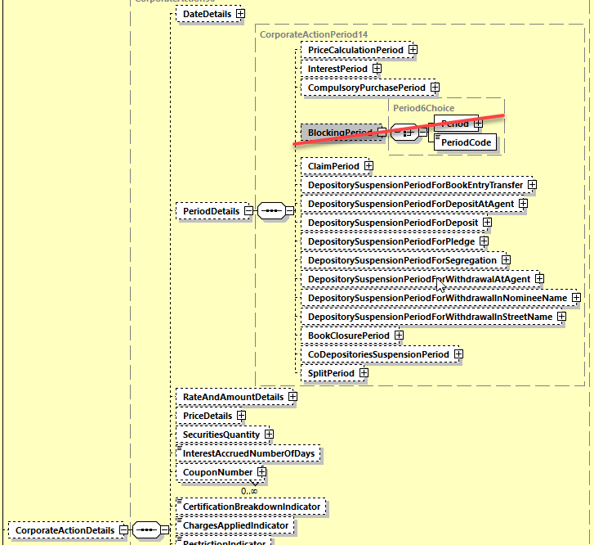

1. **Implementation Option B – End of blocking period specified as an Date Time Code**

**In the seev.031 (CANO – CorporateActionNotification)** message, in the sequence *CorporateActionOptionDetails/DateD*etails, and

add an optional and non-repeatable element ***EndOfSecuritiesBlockingPeriod*** typed by a new data type with a choice of:

* A ***Date*** element typed by DateAndDateTime2Choice data type;
* A ***DateCode*** element typed with a choice of a ***Code*** element typed with a code list ***DateTypeXXCode*** with the following code values defined: **PAYD, RDTE, RDDT, MKDT, PWAL, MEET, NARR and UKWN** or a ***Proprietary*** element;

as defined in ISO 15022 above and as illustrated below:

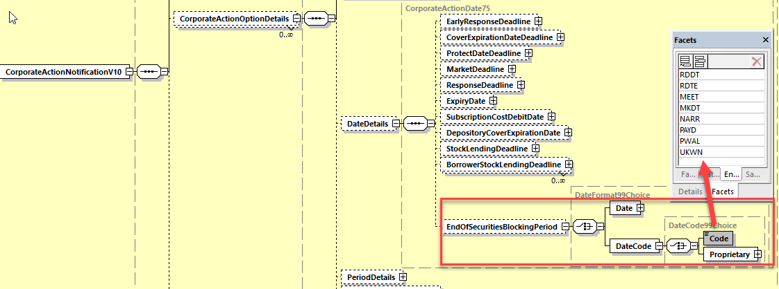

**Working Group Meeting**

|  |
| --- |
| **Discussion** |
| The whole MWG agrees with the business case and with the implementation solution proposed by SWIFT as “Option B” (use of :98a::Date/Time qualifier).  The MWG also agrees with the following amendments to the implementation solution option B:   * Add also format option A, C and E (in addition to B) as proposed by CH; * The implementation of the option B does not apply to the MT566 as proposed by UK (but the current Blocking Period must be removed from both 564 and 566);   The proposal from CH and US to not include the “NARR” code value for BLOK is not supported. NARR code will therefore remain in the solution. |
| **Decision** |
| **Approved with comments on implementation.** |

**Final decision of the Securities SEG regarding ISO 20022 messages:**

|  |  |
| --- | --- |
| Approve the MWG decision | approved |

Comments:

|  |  |
| --- | --- |
| Reject the MWG decision |  |

Reason for rejection:

## CR 001654: Add Minimum and Maximum Prices to Option Level

|  |  |
| --- | --- |
| **Origin of request** | |
| Requesting Group: | ISITC |
| **Sponsors** | |
| DTCC | |
| **Message type(s) impacted** | |
| MT 564,, seev.031, , | |
| **Complies with regulation** | |
| None | |
| **Business impact of this request** | |
| LOW | |
| **Commitment to implement the change** | |
| US in 2021 | |
| **Business context** | |
| Currently today for Dutch Auction and Tender events, the announcement conveys the minimum and maximum price and the bid interval rate at the event level of the announcement. In most cases in the US market there will be two options (besides NOAC). One which the holder instructs a bid within the bid range based on the minimum and maximum price and interval. The other option is typically considered as an non-competitive option which the holder inputs the Offer Price (Generic Cash Price Received Per Product) as Unspecified.  However, a recent event City of Chicago CA ID 119082875 CUSIP 167486HL6 required three options. (i) the Offer Yield Spread option, (ii) the Offer Price option, (iii) the Non-Competitive Offer option, The issue with the standard is that the Maximum Price, Minimum Price and Bid Interval Rate are at the event level. Also there cannot even be a workaround as the fields today allow only one occurrence so you cannot provide both a price format and index points.  Given that the only way to message this event is to use narrative currently, we are asking that these three fields be moved to the Option level from the event level. In most cases, this will be straightforward as the option which includes the specified price will contain the min, max and bid interval. But as in the City of Chicago case, you would then be able to output each option with the applicable range. In the example, Option 1 would have the minimum and maximum price as index points and Option 2 would have the minimum and maximum price in the Amount Price format. Please also note that Bid interval needs to be at the option level as well as both of these options in the example had different intervals (.001 and .01)  As an alternative if the global community wants to maintain the three values at an event level, this could remain so and the three fields could be added (instead of moved) to the option level. | |
| **Nature of change** | |
| 1. Option 1  Move Maximum Price, Minimum Price and Bid Interval (rate) to the Option Level from the Event level  Current Mapping  /Document/CorpActnNtfctn/CorpActnDtls/PricDtls/MaxPric  /Document/CorpActnNtfctn/CorpActnDtls/PricDtls/MinPric  /Document/CorpActnNtfctn/CorpActnDtls/RateAndAmtDtls/BidIntrvl  2. Option 2  Add Maximum Price, Minimum Price and Bid Interval (rate) to the option level and leave Event level mapping in place | |
| **Workaround** | |
| The only workaround would be to announce as two events and link the events however this is not an optimal solution | |
| **Examples** | |
| CA ID 119082875 CUSIP 167486HL6 City of Chicago    Option 1:  max price 9.999  Min Price .001  Bid Interval .001  Option 2  Max Price 2000  Min Price 500  Bid Interval .01  Option 3 - Non-competitive  No Min or Max Price  4. Offer Submission Options.  As described in this Section 4, Bondowners who choose to tender their Bonds will have  the following options for submitting a bid: (i) the Offer Yield Spread option, (ii) the Offer Price  option, (iii) the Non-Competitive Offer option, or (iv) any combination of options (i), (ii) and (iii).  The aggregate par amounts with respect to Bonds for which a Bondowner provides Offer  Yield Spreads, Offer Prices and Non-Competitive Offers cannot exceed the aggregate par  amount of the Bonds owned by that Bondowner and transmitted to the City’s ATOP Account  at DTC in a manner described in this Invitation.  The City’s ATOP Account will accept offers at the Offer Yield Spread in .001  increments, with a possible maximum of 9.999 and a possible minimum offer of 0.001, and the  City’s ATOP Account will accept Offers at Offer Prices in increments of $00.01 with a possible  maximum offer of $2,000.00 and with a possible minimum of $500.00. In order to insure accurate  receipt of each beneficial owner’s intended Offer Yield Spread or Spreads, Offer Price or Prices  or Non-Competitive Offer and any subsequent dissemination of funds, participants in DTC must  submit an individual DTC Voluntary Offering Instruction per each beneficial owner wishing to  participate in this Invitation. Should a beneficial owner offer their Bonds at a variety of Offer  Yield Spreads, Offer Prices or Non-Competitive Offers, a unique DTC Voluntary Offering  Instruction for each Offer Yield Spread, Offer Price or Non-Competitive Offer, must be submitted. | |

**SWIFT Comment**

|  |
| --- |
| If the BIDI rate and MAXP and MINP prices are duplicated in or moved into sequence E of the MT564, then the same changes must also be applied in the MT566 and these qualifiers must be duplicated or moved into sequence D as well for consistency between both messages. |

**Standards Illustration**

**1. ISO 15022 Illustration**

**1. In the MT564 in sequence E in field 92a Rate, add a new optional and non-repeatable Bid Interval Rate (BIDI) rate qualifier same as the BIDI rate defined respectively in the MT564 in sequence D in field 92a;**

**and add also in the MT 564 in sequence E in field 90a Price, the optional and non-repeatable Maximum Price (MAXP) and Minimum Price (MINP) same as the MAXP and MINP defined respectively in the MT 564 sequence D, in field 90a as illustrated below:**

**MT 564 Field Specifications**

64. Field 92a: Rate

FORMAT

|  |  |  |
| --- | --- | --- |
| Option A | :4!c//[N]15d | (Qualifier)(Sign)(Rate) |
| Option B | :4!c//3!a/3!a/15d | (Qualifier)(First Currency Code)(Second Currency Code)(Rate) |
| Option F | :4!c//3!a15d | (Qualifier)(Currency Code)(Amount) |
| Option H | :4!c//3!a15d/4!c | (Qualifier)(Currency Code)(Amount)(Rate Status) |
| Option J | :4!c/[8c]/4!c/3!a15d[/4!c] | (Qualifier)(Data Source Scheme)(Rate Type Code)(Currency Code)(Amount)(Rate Status) |
| Option K | :4!c//4!c | (Qualifier)(Rate Type Code) |
| Option R | :4!c/[8c]/4!c/15d | (Qualifier)(Data Source Scheme)(Rate Type Code)(Rate) |
| **Option P** | **:4!c//15d** | **(Qualifier)(Index Points)** |

PRESENCE

Optional in optional sequence E

QUALIFIER

(Error code(s): T89)

| **Order** | **M/O** | **Qualifier** | **R/N** | **CR** | **Options** | **Qualifier Description** |
| --- | --- | --- | --- | --- | --- | --- |
| 1 | O | GRSS | R | C7, C8 | F, H, J, or K | Gross Dividend Rate |
| 2 | O | TAXR | R | C7, C8, C19 | A, F, K, or R | Withholding Tax Rate |
| 3 | O | ATAX | N |  | A, F, or K | Additional Tax |
| 4 | O | INDX | N |  | A, F, or K | Index Factor |
| 5 | O | OVEP | N |  | A or K | Maximum Allowed Oversubscription Rate |
| 6 | O | PROR | N |  | A or K | Pro-Ration Rate |
| 7 | O | INTP | R |  | A, F, J, or K | Interest Rate Used for Payment |
| 8 | O | TDMT | R |  | J | Taxable Income Per Dividend/Share |
| 9 | O | NETT | R | C7, C8 | F, H, J, or K | Net Dividend Rate |
| 10 | O | IDFX | N | C18 | B | Issuer Declared Exchange Rate |
| 11 | O | TXIN | N |  | A, F, or K | Tax on Income |
| 12 | O | WITL | R | C7, C8, C19 | A, F, K, or R | Second Level Tax |
| **13** | **O** | **BIDI** | **N** |  | **A, F, K, or P** | **Bid Interval Rate** |

DEFINITION

This qualified generic field specifies:

|  |  |  |
| --- | --- | --- |
| ATAX | Additional Tax | Rate used for additional tax that cannot be categorised. |
| **BIDI** | **Bid Interval Rate** | **Acceptable price increment used for submitting a bid.** |
| GRSS | Gross Dividend Rate | Cash dividend amount per equity before deductions or allowances have been made. |
| IDFX | Issuer Declared Exchange Rate | Exchange rate (provided by the issuer) between the dividend or interest rate in the paid currency and the declared dividend or interest rate. |
| …. |  |  |
| WITL | Second Level Tax | Rate at which the income will be withheld by a jurisdiction other than the jurisdiction of the issuer's country of tax incorporation, for which a relief at source and/or reclaim may be possible. It is levied in complement or offset of the withholding tax rate (TAXR) levied by the jurisdiction of the issuer's tax domicile. |

CODES

In option K, if Qualifier is TAXR or Qualifier is ATAX or Qualifier is INDX or Qualifier is OVEP or Qualifier is PROR or Qualifier is NETT or Qualifier is TXIN or Qualifier is WITL **or Qualifier is BIDI**, Rate Type Code must contain the following code (Error code(s): K92):

|  |  |  |
| --- | --- | --- |
| UKWN | Unknown Rate | Rate is unknown by the sender or has not been established. |

**MT 564 Field Specifications**

65. Field 90a: Price

FORMAT

|  |  |  |
| --- | --- | --- |
| Option A | :4!c//4!c/[N]15d | (Qualifier)(Percentage Type Code)(Sign)(Price) |
| Option B | :4!c//4!c/3!a15d | (Qualifier)(Amount Type Code)(Currency Code)(Price) |
| Option E | :4!c//4!c | (Qualifier)(Price Code) |
| **Option L** | **:4!c//[N]15d** | **(Qualifier)(Sign)(Index Points)** |

PRESENCE

Optional in optional sequence E

QUALIFIER

(Error code(s): T89)

| **Order** | **M/O** | **Qualifier** | **R/N** | **CR** | **Options** | **Qualifier Description** |
| --- | --- | --- | --- | --- | --- | --- |
| 1 | O | CINL | N |  | A, B, or E | Cash in Lieu of Shares Price |
| 2 | O | OSUB | N |  | A, B, or E | Over-subscription Deposit Price |
| 3 | O | MACI | N | C20 | B or E | Maximum Cash To Instruct |
| 4 | O | MICI | N | C20 | B or E | Minimum Cash To Instruct |
| 5 | O | MMCI | N | C20 | B or E | Minimum Multiple Cash To Instruct |
| **6** | **O** | **MAXP** | **N** |  | **A, B, E, or L** | **Maximum Price** |
| **7** | **O** | **MINP** | **N** |  | **A, B, E, or L** | **Minimum Price** |

DEFINITION

This qualified generic field specifies:

|  |  |  |
| --- | --- | --- |
| CINL | Cash in Lieu of Shares Price | Cash disbursement in lieu of equities; usually in lieu of fractional quantity. |
| MACI | Maximum Cash To Instruct | Maximum cash amount that may be instructed. |
| MICI | Minimum Cash To Instruct | Minimum cash amount that may be instructed. |
| MMCI | Minimum Multiple Cash To Instruct | Minimum multiple of a cash amount that may be instructed. |
| OSUB | Over-subscription Deposit Price | Amount of money required per over-subscribed equity as defined by the issuer. |
| **MAXP** | **Maximum Price** | **Maximum or cap price at which a holder can bid, for example on a Dutch auction offer.** |
| **MINP** | **Minimum Price** | **Minimum or floor price at which a holder can bid, for example on a Dutch auction offer.** |

CODES

In option B, if Qualifier is CINL or Qualifier is OSUB **or Qualifier is MINP or Qualifier is MAXP**, Amount Type Code must contain one of the following codes (Error code(s): K90):

|  |  |  |
| --- | --- | --- |
| ACTU | Actual Amount | Price expressed as an amount of currency per unit or per share. |
| DISC | Discount | Price expressed as a discount amount. |
| PLOT | Lot | Price expressed as an amount of money per lot. |
| PREM | Premium | Price expressed as a premium. |

**2. ISO 20022 Illustration**

**1. In the seev.031 (CANO – CorporateActionNotification)** message, in the sequence *CorporateActionOptionDetails/RateAndAmountDetails*, and

add the new optional and non-repeatable element *BidIntervalRate* typed by the data type *RateAndAmountFormat38Choice* as defined in the *CorporateActionDetails/RateAndAmountDetails* sequence.

**2. In the seev.031 (CANO – CorporateActionNotification)** message, in the sequence *CorporateActionOptionDetails/PriceDetails*, and

add the new optional and non-repeatable elements *MinimumPrice* and *MaximumPrice* typed by the data type *PriceFormat44Choice* as defined in the *CorporateActionDetails/PriceDetails* sequence

as illustrated below:

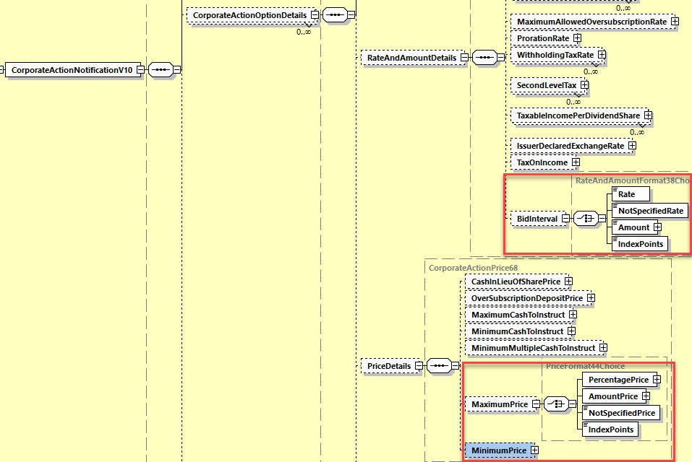

**Working Group Meeting**

|  |
| --- |
| **Discussion** |
| FR and DE do not agree with the business case as this scenario is very rare and do not justify a change.  All other countries agree with the business case and with a majority agreeing to add the MINP and MAXP to the option level (instead of moving them and therefore deleting them in the CA Details sequence D as supported by DE and ZA).  The MWG also agrees that the MINP and MAXP prices do not need to be added in the MT566, seev.035 and seev.036 messages. |
| **Decision** |
| **Approved with implementation comments** |

**Final decision of the Securities SEG regarding ISO 20022 messages:**

|  |  |
| --- | --- |
| Approve the MWG decision | approved |

Comments:

|  |  |
| --- | --- |
| Reject the MWG decision |  |

Reason for rejection:

## CR 001631: Add New Bid Range Type for Bid Tender or Dutch Auctions in US Market

|  |  |
| --- | --- |
| **Origin of request** | |
| Requesting Group: | ISITC |
| **Sponsors** | |
| DTCC | |
| **Message type(s) impacted** | |
| MT 564, seev.031 | |
| **Complies with regulation** | |
| None | |
| **Business impact of this request** | |
| LOW | |
| **Commitment to implement the change** | |
| Commits to implement and when: US in 2021 | |
| **Business context** | |
| In the US market, Dutch Auctions and Bid Tender events involve several criteria that need to be assessed in order to provide Bid Prices that will be acceptable from the terms of the offer. The Minimum Price, Maximum Price and Bid Interval Rate fields in the MT564 / CANO explain the range involved with the event. The sender of the instruction would then input the Price in the MT565 / CAIN in the General Cash Price Received Per Product / OFFR. Normally, the Minimum and Maximum Price are divisible by the Bid Interval (e.g. Min Price 1.0 , Max Price 5.00 Bid Interval .10) However, there are two scenarios which have been observed which do not conform to this practice. A new qualifier Bid Range Type is needed to clarify acceptable Bid values so that narrative would not need to be interpreted. By automating this field, senders of the MT565 / CAIN message should be able to increase their STP rates by avoiding rejected bid prices. Below are the three scenarios that exist with bid range values.  1. Divisible (including endpoints). All values including the min and max price are divisible by the bid interval.  e.g. • Minimum Bid Accepted is $10.30, Maximum Bid Accepted is $11.20 and the Bid Interval 0.10.  ☐ $10.30 ☐ $10.40 ☐ $10.50 ☐ $10.60 ☐ $10.70 ☐ $10.80 ☐ $10.90 ☐ $11.00 ☐ $11.10 ☐ $11.20  2. Multiples. The Minimum or Maximum Price is not divisible by the bid interval. Successive values are in multiples of the bid interval.  e.g Minimum Bid Accepted is $10.32, Maximum Bid Accepted is $10.92 and the Bid Interval $0.10  ☐ $10.32 ☐ $10.40 ☐ $10.50 ☐ $10.60 ☐ $10.70 ☐ $10.80 ☐ $10.90 ☐ $10.92  3. Increments. The bid range values are in increments from the minimum to the maximum price but no values are divisible by the Bid Interval.  Minimum Bid Accepted is $34.15, Maximum Bid Accepted is $35.05 and the Bid Interval = $0.10.  ☐ $34.15 ☐ $34.25 ☐ $34.35 ☐ $34.45 ☐ $34.55 ☐ $34.65 ☐ $34.75 ☐ $34.85 ☐ $34.95 ☐ $35.05  The bid range type would clarify what the first value after the Minimum price should be. In the Increments example, it could be assumed that the next price after the minimum should be $34.20 as it is divisible by the multiple and not $34.25 which is just incremented by $.10 Likewise in scenario 2, it could be confused that the next price after the minimum price of $10.32 is $10.42 instead of $10.40 which is a multiple of the Minimum Price (and is divisible by the bid interval). | |
| **Nature of change** | |
| Add Bid Range Type to Option Level with following Codes:  DIVI - All values (including minimum and maximum price) are divisible by the bid interval.  MULT - The Minimum and Maximum Price are not divisible by the bid interval. All successive values between the minimum and maximum price are in multiples of the bid interval.  INCR - No values within the bid range are divisible by the bid interval including the minimum and maximum price. Each value between the minimum and maximum price is incremented by the bid interval.  /Document/CorpActnNtfctn/CorpActnOptnDtls/BidRangeTp | |
| **Workaround** | |
| Narrative would be the only way possible to convey these differences in the bid range. | |
| **Examples** | |
| 1. For Divisible (DIVI) Gameco CA ID 120106821 CUSIP 361438104 GAMCO INVESTORS INCORPORATED CLASS A < RR Please see CR1631 Attachment for more information  Min Price 15.00 , Max Price 17.00 Bid interval .25  2. MULT - No current example exists can be obtained  3. INCR - Home Capital Group • CA ID 118730505 CUSIP 436913107 HOME CAPITAL GROUP INC COMMON  Minimum Price 34.15 Maximum Price 37.25 Bid Interval .10    *See CR1631\_attachment2.pdf appended to email.* | |

**SWIFT Comment**

|  |
| --- |
| If the decision for the previous CR 1654 was to leave the bid interval rate and the minimum and maximum prices in sequence D and duplicate them in the corporate action option sequence of the MT 564, then this new indicator should perhaps also be duplicated in sequence D and E.  This new indicator does not seem to be necessary in the MT 566 although this could eventually be duplicated in the MT566 (respectively seev.035 & seev.036) for consistency with the MT564.  This option has not been taken into account in the illustrations below. To be discussed at the CA MWG meeting. |

**Standards Illustration**

**1. ISO 15022 Illustration**

**1. In the MT 564 in sequence E in field 22F Indicator, add a new optional and non-repeatable qualifier Bid Range Type Indicator (BIRI) with 3 code values as defined and illustrated here below:**

**MT 564 Field Specifications**

57. Field 22F: Indicator

FORMAT

|  |  |  |
| --- | --- | --- |
| Option F | :4!c/[8c]/4!c | (Qualifier)(Data Source Scheme)(Indicator) |

PRESENCE

Mandatory in optional sequence E

QUALIFIER

(Error code(s): T89)

| **Order** | **M/O** | **Qualifier** | **R/N** | **CR** | **Options** | **Qualifier Description** |
| --- | --- | --- | --- | --- | --- | --- |
| 1 | M | CAOP | N | C5 | F | Corporate Action Option Code Indicator |
| 2 | O | DISF | N |  | F | Disposition of Fractions Indicator |
| 3 | O | OFFE | R |  | F | Offer Type Indicator |
| 4 | O | OPTF | R | C20 | F | Option Features Indicator |
| 5 | O | OSTA | N |  | F | Option Status |
| 6 | O | CETI | R |  | F | Certification/Breakdown Type Indicator |
| **7** | **O** | **BIRI** | **N** |  | **F** | **Bid Range Type Indicator** |

DEFINITION

This qualified generic field specifies:

|  |  |  |
| --- | --- | --- |
| **BIRI** | **Bid Range Type Indicator** | **Specifies the type of acceptable bid range values.** |
| CAOP | Corporate Action Option Code Indicator | Specifies the corporate action options available to the account owner. |
| CETI | Certification/Breakdown Type Indicator | Specifies the type of certification/breakdown. |
| DISF | Disposition of Fractions Indicator | Specifies how fractions resulting from derived securities will be processed or how prorated decisions will be rounding, if provided with a pro ration rate. |
| OFFE | Offer Type Indicator | Specifies the conditions that apply to the offer. |
| OPTF | Option Features Indicator | Specifies the features that may apply to a corporate action option. |
| OSTA | Option Status | Specifies the status of the option. |

**CODES**

**If Qualifier is BIRI and Data Source Scheme is not present, Indicator must contain one of the following codes (Error code(s): K22):**

|  |  |  |
| --- | --- | --- |
| **DIVI** | **Divisible** | **All values (including minimum and maximum prices) are divisible by the bid interval.** |
| **MULT** | **In Multiple** | **The minimum and maximum prices are not divisible by the bid interval. All successive values between the minimum and maximum prices are in multiples of the bid interval.** |
| **INCR** | **Incremental** | **No values within the bid range are divisible by the bid interval including the minimum and maximum prices. Each value between the minimum and maximum prices is incremented by the bid interval.** |

**2. ISO 20022 Illustration**

**In the seev.031 (CANO – CorporateActionNotification) message,** in the sequence *CorporateActionOptionDetails*, add a new optional and non-repeatable element ***BidRangeType*** typed with a new data type *BidRangeType1Code* with 3 new code values DIVI, MULT, INCR as defined in ISO 15022 above and as illustrated below:

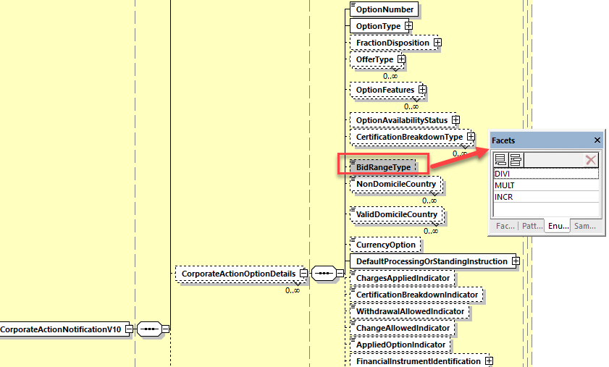

**Working Group Meeting**

|  |
| --- |
| **Discussion** |
| DE, XS, BE and LU do not agree with the business case, it is a rare event and will be too costly to implement.  All other MWG members support the business case and the proposed implementation solution.  The MWG confirms that it is not needed in MT 566, only in MT 564/seev.031. |
| **Decision** |
| Approved as proposed |

**Final decision of the Securities SEG regarding ISO 20022 messages:**

|  |  |
| --- | --- |
| Approve the MWG decision | approved |

Comments:

|  |  |
| --- | --- |
| Reject the MWG decision |  |

Reason for rejection:

## CR 001636: Add Date Time Format Option E for some Qualifiers & Name and Definition Consistency Fixes

|  |  |
| --- | --- |
| **Origin of request** | |
| Requesting Group: | SMPG |
| **Sponsors** | |
| Not provided | |
| **Message type(s) impacted** | |
| MT 564, MT 566, seev.031, seev.035, seev.036 | |
| **Complies with regulation** | |
| None | |
| **Business impact of this request** | |
| Low | |
| **Commitment to implement the change** | |
| Percentage of messages impacted: 5  Commits to implement and when: SMPG in 2021 | |
| **Business context** | |
| During the review of existing messages as part of the SMPG creation of global market practice for messaging related to the European Shareholder Rights Directive II, the SMPG discovered some inconsistencies and need for changes:  SRD II states that issuer/market deadlines are to be provided in UTC format (field 98a, format option E), and this will also impact account servicer/response deadlines. As such, the SMPG believes it needs to be possible to use the UTC format for three additional deadlines that may need to be used for events in scope of SRD II.  In its review of deadlines where UTC format is missing, the SMPG discovered that UTC format is possible for two dates that are not deadlines, and hence UTC is not relevant and should be removed.  The SMPG discovered incorrect wording of two deadlines, currently described as dates, and would like to correct these. The SMPG discovered incorrect text in the definitions of two other deadlines, and would like to correct these. | |
| **Nature of change** | |
| 1. In sequence D of the MT 564, add format option E for ECPD (Election to Counterparty Market Deadline), ECRD (Election to Counterparty Response Deadline) and TAXB (Deadline for Tax Breakdown Instructions) and in sequence C of the MT 566, add format option E for TAXB (Deadline for Tax Breakdown Instructions). 2. In sequence D of the MT 564, remove format option E for MCDT (Market Claim Tracking End Date) and in sequences E1 & E2 of the MT564 and in sequences D1 & D2 of the MT 566, remove format option E for EARL (Earliest Payment Date/Time) as these are not deadline elements and hence UTC is not relevant. 3. In sequence E of the MT 564, change Qualifier Description of PODT from 'Protect Date/Time' to 'Protect Deadline Date/Time'. 4. In sequence E of the MT 564, change Qualifier Description of CVPR from 'Cover Expiration Date/Time' to 'Cover Expiration Deadline Date/Time'. 5. In sequence E of the MT 564, Change Definition of EARD from 'Date/time that the account servicer has set as the deadline to respond, with instructions, to an outstanding event, giving the holder eligibility to incentives. This time is dependent on the reference time zone of the account servicer as specified in an SLA.' to 'Date/time that the account servicer has set as the deadline to respond, with instructions, to an outstanding event, giving the holder eligibility to incentives.' 6. In sequence E of the MT 564 and in sequence D of the MT 566, change Definition of RDDT from 'Date/time at which the account servicer has set as the deadline to respond, with instructions, to an outstanding event. This time is dependent on the reference time zone of the account servicer as specified in an SLA.' to 'Date/time at which the account servicer has set as the deadline to respond, with instructions, to an outstanding event.' | |
| **Examples** | |
| Not provided | |

**SWIFT Comment**

|  |
| --- |
|  |

**Standards Illustration**

**1. ISO 15022 Illustration**

**1. In the MT 564 in sequence D, in field 98a Date Time, add format option E to qualifiers TAXB (Deadline for Tax Breakdown Instructions), ECPD (Election to Counterparty Market Deadline), ECRD (Election to Counterparty Response Deadline) and remove format option E for MCDT (Market Claim Tracking End Date) as illustrated below:**

**MT 564 Field Specifications**

43. Field 98a: Date/Time

FORMAT

|  |  |  |
| --- | --- | --- |
| Option A | :4!c//8!n | (Qualifier)(Date) |
| Option B | :4!c/[8c]/4!c | (Qualifier)(Data Source Scheme)(Date Code) |
| Option C | :4!c//8!n6!n | (Qualifier)(Date)(Time) |
| Option E | :4!c//8!n6!n[,3n][/[N]2!n[2!n]] | (Qualifier)(Date)(Time)(Decimals)(UTC Indicator) |

PRESENCE

Optional in optional sequence D

QUALIFIER

(Error code(s): T89)

| **Order** | **M/O** | **Qualifier** | **R/N** | **CR** | **Options** | **Qualifier Description** |
| --- | --- | --- | --- | --- | --- | --- |
| 1 | O | ANOU | N |  | A, B, or C | Announcement Date/Time |
| …. |  |  |  |  |  |  |
| 11 | O | RDTE | N |  | A, B, or C | Record Date/Time |
| 12 | O | TAXB | N |  | A, B, C **or E** | Deadline for Tax Breakdown Instructions |
| 13 | O | TSDT | N |  | A, B, or C | Trading Suspended Date/Time |
| …. |  |  |  |  |  |  |
| 27 | O | GUPA | N |  | A, B, or C | Guaranteed Participation Date/Time |
| 28 | O | ECPD | N |  | A, B,C **or E** | Election to Counterparty Market Deadline |
| 29 | O | LAPD | N |  | A, B, or C | Lapsed Date/Time |
| 30 | O | MCTD | N |  | A, B, C**~~, or E~~** | Market Claim Tracking End Date |
| …. |  |  |  |  |  |  |
| 36 | O | HEAR | N |  | A or B | Hearing Date |
| 37 | O | ECRD | N |  | A, B,C **or E** | Election to Counterparty Response Deadline |

**2. In the MT564, in sequence E in field 98a, amend the Qualifier PODT description from “Protect Date/Time” to “Protect Deadline Date/Time and qualifier CVPR description from “Cover Expiration Date/Time” to “Cover Expiration Deadline Date/Time” and also amend the definition of the qualifier EARD (Early Response Deadline Date/Time) and amend the definition of the RDDT (Response Deadline Date/Time) as illustrated below** :

**MT 564 Field Specifications**

62. Field 98a: Date/Time

FORMAT

|  |  |  |
| --- | --- | --- |
| Option A | :4!c//8!n | (Qualifier)(Date) |
| Option B | :4!c/[8c]/4!c | (Qualifier)(Data Source Scheme)(Date Code) |
| Option C | :4!c//8!n6!n | (Qualifier)(Date)(Time) |
| Option E | :4!c//8!n6!n[,3n][/[N]2!n[2!n]] | (Qualifier)(Date)(Time)(Decimals)(UTC Indicator) |
| Option F | :4!c/[8c]/4!c6!n | (Qualifier)(Data Source Scheme)(Date Code)(Time) |
| Option J | :4!c//8!n6!n/4!a2!a2!c[3!c] | (Qualifier)(Date)(Time)(Identifier Code) |
| Option K | :4!c/8c/8!n6!n/34x | (Qualifier)(Data Source Scheme)(Date)(Time)(Proprietary Code) |

PRESENCE

Optional in optional sequence E

QUALIFIER

(Error code(s): T89)

| **Order** | **M/O** | **Qualifier** | **R/N** | **CR** | **Options** | **Qualifier Description** |
| --- | --- | --- | --- | --- | --- | --- |
| 1 | O | DVCP | N |  | A, B, or C | Depository Cover Expiration Date/Time |
| 2 | O | EARD | N |  | A, B, C, or E | Early Response Deadline Date/Time |
| 3 | O | EXPI | N |  | A, B, or C | Expiry Date/Time |
| 4 | O | MKDT | N |  | A, B, C, or E | Market Deadline Date/Time |
| 5 | O | PODT | N |  | A, B, C, or E | Protect **Deadline** Date/Time |
| 6 | O | SUBS | N |  | A, B, or C | Subscription Cost Debit Date/Time |
| 7 | O | RDDT | N |  | A, B, C, E, or F | Response Deadline Date/Time |
| 8 | O | CVPR | N |  | A, B, C, or E | Cover Expiration **Deadline** Date/Time |
| 9 | O | BORD | R | C21, C22 | A, B, C, E, J, or K | Stock Lending Deadline Date/Time |

DEFINITION

This qualified generic field specifies:

|  |  |  |
| --- | --- | --- |
| CVPR | Cover Expiration **Deadline** Date/Time | Last day a holder can deliver the securities that it had elected on and/or previously protected. |
| EARD | Early Response Deadline Date/Time | Date/time that the account servicer has set as the deadline to respond, with instructions, to an outstanding event, giving the holder eligibility to incentives. **~~This time is dependent on the reference time zone of the account servicer as specified in an SLA.~~** |
| PODT | Protect **Deadline** Date/Time | Last date/time a holder can request to defer delivery of securities pursuant to a notice of guaranteed delivery or other required documentation. |
| RDDT | Response Deadline Date/Time | Date/time at which the account servicer has set as the deadline to respond, with instructions, to an outstanding event. ~~This time is dependent on the reference time zone of the account servicer as specified in an SLA.~~ |

1. **In the MT564, in sequence E1 and E2, in field 98a, remove format option E of EARL (Earliest Payment Date/Time).**

**MT 564 Field Specifications**

87. Field 98a: Date/Time

FORMAT

|  |  |  |
| --- | --- | --- |
| Option A | :4!c//8!n | (Qualifier)(Date) |
| Option B | :4!c/[8c]/4!c | (Qualifier)(Data Source Scheme)(Date Code) |
| Option C | :4!c//8!n6!n | (Qualifier)(Date)(Time) |
| ~~Option E~~ | ~~:4!c//8!n6!n[,3n][/[N]2!n[2!n]]~~ | ~~(Qualifier)(Date)(Time)(Decimals)(UTC Indicator)~~ |

PRESENCE

Mandatory in optional subsequence E1

QUALIFIER

(Error code(s): T89)

| **Order** | **M/O** | **Qualifier** | **R/N** | **CR** | **Options** | **Qualifier Description** |
| --- | --- | --- | --- | --- | --- | --- |
| 1 | M | PAYD | N |  | A, B, or C | Payment Date/Time |
| 2 | O | AVAL | N |  | A, B, or C | Available Date/Time For Trading |
| 3 | O | DIVR | N |  | A, B, or C | Dividend Ranking Date/Time |
| 4 | O | EARL | N |  | A, B, C, **~~or E~~** | Earliest Payment Date/Time |
| 5 | O | PPDT | N |  | A, B, or C | Pari Passu Date/Time |
| 6 | O | LTRD | N |  | A, B, or C | Last Trading Date/Time |

1. **In the MT 566 sequence C in field 98a Date Time, add format option E to qualifiers TAXB (Deadline for Tax Breakdown Instructions) as illustrated below**:

**MT 566 Field Specifications**

29. Field 98a: Date/Time

FORMAT

|  |  |  |
| --- | --- | --- |
| Option A | :4!c//8!n | (Qualifier)(Date) |
| Option B | :4!c/[8c]/4!c | (Qualifier)(Data Source Scheme)(Date Code) |
| Option C | :4!c//8!n6!n | (Qualifier)(Date)(Time) |
| Option E | :4!c//8!n6!n[,3n][/[N]2!n[2!n]] | (Qualifier)(Date)(Time)(Decimals)(UTC Indicator) |

PRESENCE

Optional in optional sequence C

QUALIFIER

(Error code(s): T89)

| **Order** | **M/O** | **Qualifier** | **R/N** | **CR** | **Options** | **Qualifier Description** |
| --- | --- | --- | --- | --- | --- | --- |
| 1 | O | ANOU | N |  | A, B, or C | Announcement Date/Time |
| …. |  |  |  |  |  |  |
| 10 | O | RDTE | N |  | A, B, or C | Record Date/Time |
| 11 | O | TAXB | N |  | A, B, C **or E** | Deadline for Tax Breakdown Instructions |
| 12 | O | LOTO | N |  | A, B, or C | Lottery Date/Time |
| …. |  |  |  |  |  |  |
| 17 | O | IFIX | N |  | A, B, or C | Fixing Date/Time |

1. **In the MT566 in sequence D in field 98a, amend the Qualifier PODT description from “Protect Date/Time” to “Protect Deadline Date/Time and qualifier CVPR description from “Cover Expiration Date/Time” to “Cover Expiration Deadline Date/Time” and also amend the definition of the RDDT (Response Deadline Date/Time) as illustrated below**:

**MT 566 Field Specifications**

43. Field 98a: Date/Time

FORMAT

|  |  |  |
| --- | --- | --- |
| Option A | :4!c//8!n | (Qualifier)(Date) |
| Option B | :4!c/[8c]/4!c | (Qualifier)(Data Source Scheme)(Date Code) |
| Option C | :4!c//8!n6!n | (Qualifier)(Date)(Time) |
| Option E | :4!c//8!n6!n[,3n][/[N]2!n[2!n]] | (Qualifier)(Date)(Time)(Decimals)(UTC Indicator) |

PRESENCE

Optional in mandatory sequence D

QUALIFIER

(Error code(s): T89)

| **Order** | **M/O** | **Qualifier** | **R/N** | **CR** | **Options** | **Qualifier Description** |
| --- | --- | --- | --- | --- | --- | --- |
| 1 | O | EXPI | N |  | A, B, or C | Expiry Date/Time |
| 2 | O | MKDT | N |  | A, B, C, or E | Market Deadline Date/Time |
| 3 | O | PODT | N |  | A, B, C, or E | Protect **Deadline** Date/Time |
| 4 | O | SUBS | N |  | A, B, or C | Subscription Cost Debit Date/Time |
| 5 | O | RDDT | N |  | A, B, C, or E | Response Deadline Date/Time |
| 6 | O | CVPR | N |  | A, B, C, or E | Cover Expiration **Deadline** Date/Time |
| 7 | O | TRAD | N |  | A, B, C, or E | Trade Date/Time |

DEFINITION

This qualified generic field specifies:

|  |  |  |
| --- | --- | --- |
| CVPR | Cover Expiration **Deadline** Date/Time | Last day a holder can deliver the securities that it had elected on and/or previously protected. |
| EXPI | Expiry Date/Time | Date/time at which an order expires or on which a privilege or offer terminates. |
| MKDT | Market Deadline Date/Time | Issuer or issuer's agent deadline to respond, with an election instruction, to an outstanding offer or privilege. |
| PODT | Protect **Deadline** Date/Time | Last date/time a holder can request to defer delivery of securities pursuant to a notice of guaranteed delivery or other required documentation. |
| RDDT | Response Deadline Date/Time | Date/time at which the account servicer has set as the deadline to respond, with instructions, to an outstanding event. **~~This time is dependent on the reference time zone of the account servicer as specified in an SLA.~~** |
| SUBS | Subscription Cost Debit Date/Time | Date/time by which cash must be in place in order to take part in the event. |
| TRAD | Trade Date/Time | Date/time at which the deal (rights) was agreed. |

1. **In the MT566, in sequence D1 and D2, in field 98a, remove format option E of EARL (Earliest Payment Date/Time).**

**MT 566 Field Specifications**

84. Field 98a: Date/Time

FORMAT

|  |  |  |
| --- | --- | --- |
| Option A | :4!c//8!n | (Qualifier)(Date) |
| Option C | :4!c//8!n6!n | (Qualifier)(Date)(Time) |
| ~~Option E~~ | ~~:4!c//8!n6!n[,3n][/[N]2!n[2!n]]~~ | ~~(Qualifier)(Date)(Time)(Decimals)(UTC Indicator)~~ |

PRESENCE

Mandatory in optional subsequence D2

QUALIFIER

(Error code(s): T89)

| **Order** | **M/O** | **Qualifier** | **R/N** | **CR** | **Options** | **Qualifier Description** |
| --- | --- | --- | --- | --- | --- | --- |
| 1 | M | POST | N |  | A or C | Posting Date/Time |
| 2 | O | VALU | N |  | A or C | Value Date/Time |
| 3 | O | EARL | N |  | A, C, **~~or E~~** | Earliest Payment Date/Time |
| 4 | O | FXDT | N |  | A or C | FX Rate Fixing Date/Time |
| 5 | O | PAYD | N |  | A or C | Payment Date/Time |

**2. ISO 20022 Illustration**

**Note: In ISO 20022 messages, the format option E (UTC offset) for 98a in ISO 15022 is built-in in the ISODateTime data type, therefore removing or adding the UTC offset cannot be applied.**

**In the seev.031 (CANO – CorporateActionNotification) message**, in sequence *CorporateActionOptionDetails/DateDetails*,

**and in the seev.035 (CAPA – CorporateActionMovementPreliminaryAdvice)** message in sequence *CorporateActionMovementDetails/DateDetails*,

**and in the seev.036 (CACO – CorporateActionMovementConfirmation)** message in sequence *CorporateActionConfirmationDetails/DateDetails*,

change the element name “*ProtectDate*” by “*ProtectDeadline*”, “*CoverExpirationDate*” by “*CoverExpirationDeadline*”, and amend the definition of the element “***EarlyResponseDeadline***” and of “***ResponseDeadline***” as in ISO 15022 above and as illustrated below:

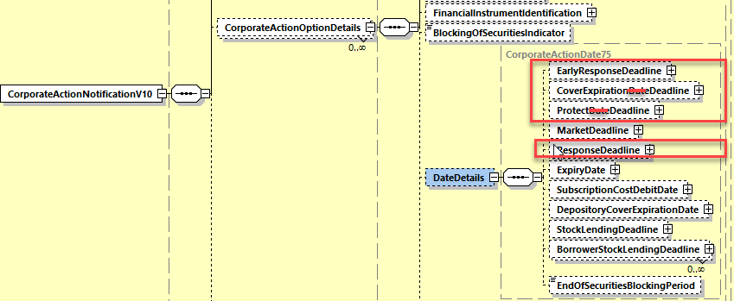

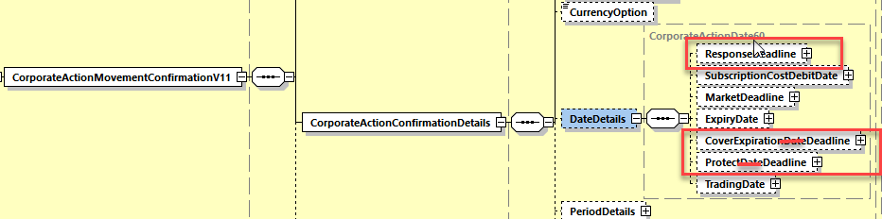

**Working Group Meeting**

|  |
| --- |
| **Discussion** |
| The whole MWG agrees with the business case and proposed solution although CH would prefer that format option E be added systematically to all Date and Time qualifiers so as to enable a general usage of UTC/Zulu time.  The MWG estimates that the CH request is a bit premature for SR2021 but agrees the analysis should be done and therefore recommends to the SMPG to review for a next release all Date and Time qualifiers of CA messages for a possible extension to format option E and see whether option C could be removed. |
| **Decision** |
| **Approved as proposed** |

**Final decision of the Securities SEG regarding ISO 20022 messages:**

|  |  |
| --- | --- |
| Approve the MWG decision | approved |

Comments:

|  |  |
| --- | --- |
| Reject the MWG decision |  |

Reason for rejection:

## CR 001629: Add New CA Option for WTRC Breakdown Request and new OWND Country Code Format Option

|  |  |
| --- | --- |
| **Origin of request** | |
| Requesting Group: | SMPG |
| **Sponsors** | |
| SMPG CA WG members | |
| **Message type(s) impacted** | |
| MT 564, MT 565, MT 567, seev.031, seev.033, seev.034, seev.035, , seev.040, seev.041 | |
| **Complies with regulation** | |
| None | |
| **Business impact of this request** | |
| MEDIUM | |
| **Commitment to implement the change** | |
| Percentage of messages impacted: 15  Commits to implement and when: SMPG in 2021 | |
| **Business context** | |
| When an income payment is due in an omnibus account in countries that require a tax breakdown, it was agreed that a WTRC event should be used to inform account owners with omnibus account that a breakdown should be provided. However, no specific CA option exists to announce the breakdown request.  Moreover, when the breakdown is provided via MT565 for source investment market where a full disclosure of the beneficial owner (e.g. Italy) is required, the beneficial Owner identification information is provided using a unique reference agreed between the account servicer and account owner.  The current :95a::OWND format options do not allow to give this identification appropriately as only BIC, LEI, a DSS reference or a name and address exist. Another format option like S would be more appropriate. | |
| **Nature of change** | |
| Add a new Option code in 22F::CAOP in MT 564, 565, 567 to be used for tax reasons with the WTRC event.  In the MT565, add format option S to the 95a:: OWND qualifier (as it currently exists for 95a:: ALTE). | |
| **Examples** | |
| Not provided | |

**SWIFT Comment**

|  |
| --- |
| Should we have a new NVR in the MT 564, 565, 567 to link the usage of the new option code to the presence of the WTRC CA event in :22F::CAEV? |

**Standards Illustration**

**1. ISO 15022 Illustration**

**1. In the MT564 in sequence E and in the MT565 in sequence D and in MT 567 in sequence B, in field 22a Indicator, add a new code value BOBD (Beneficial Owner Breakdown Request) to the Corporate Action Option code indicator CAOP as defined and illustrated below:**

**MT 564 Field Specifications**

57. Field 22F: Indicator

FORMAT

|  |  |  |
| --- | --- | --- |
| Option F | :4!c/[8c]/4!c | (Qualifier)(Data Source Scheme)(Indicator) |

PRESENCE

Mandatory in optional sequence E

QUALIFIER

(Error code(s): T89)

| **Order** | **M/O** | **Qualifier** | **R/N** | **CR** | **Options** | **Qualifier Description** |
| --- | --- | --- | --- | --- | --- | --- |
| 1 | M | CAOP | N | C5, C23 | F | Corporate Action Option Code Indicator |
| 2 | O | DISF | N |  | F | Disposition of Fractions Indicator |
| 3 | O | OFFE | R |  | F | Offer Type Indicator |
| 4 | O | OPTF | R | C20 | F | Option Features Indicator |
| 5 | O | OSTA | N |  | F | Option Status |
| 6 | O | CETI | R |  | F | Certification/Breakdown Type Indicator |

DEFINITION

This qualified generic field specifies:

|  |  |  |
| --- | --- | --- |
| CAOP | Corporate Action Option Code Indicator | Specifies the corporate action options available to the account owner. |
| CETI | Certification/Breakdown Type Indicator | Specifies the type of certification/breakdown. |
| DISF | Disposition of Fractions Indicator | Specifies how fractions resulting from derived securities will be processed or how prorated decisions will be rounding, if provided with a pro ration rate. |
| OFFE | Offer Type Indicator | Specifies the conditions that apply to the offer. |
| OPTF | Option Features Indicator | Specifies the features that may apply to a corporate action option. |
| OSTA | Option Status | Specifies the status of the option. |

CODES

If Qualifier is CAOP and Data Source Scheme is not present, Indicator must contain one of the following codes (Error code(s): K22):

|  |  |  |
| --- | --- | --- |
| ABST | Abstain | Vote expressed as abstain. In this case, the issuing company will add the number of shares to the quorum of the meeting. If the voting right is not executed, it will not be added to the quorum. In this case, code NOAC should be used. |
| AMGT | Vote Against Management | Vote against management. |
| **BOBD** | **Beneficial Owner Breakdown Request** | **Breakdown of beneficial ownership required for withholding tax reclaim event.** |
| BSPL | Bonus Share Plan | Receive equities from the Share Premium Reserve of the company and considered as a capital distribution rather than a disbursement of income with different tax implications (typically found in Australia). |
| …. |  |  |
| SPLI | Split Instruction | Option to give a split instruction, for example, a split voting instruction on a meeting. |

**2. In the MT 565 in sequence C in field 95a Party, add format option S to the qualifier OWND (beneficial Owner’s Identification) and amend NVR rule C6 as illustrated below:**

**MT 565 Field Specifications**

31. Field 95a: Party

FORMAT

|  |  |  |
| --- | --- | --- |
| Option L | :4!c//18!c2!n | (Qualifier)(Legal Entity Identifier) |
| Option P | :4!c//4!a2!a2!c[3!c] | (Qualifier)(Identifier Code) |
| Option R | :4!c/8c/34x | (Qualifier)(Data Source Scheme)(Proprietary Code) |
| Option S | :4!c/[8c]/4!c/2!a/30x | (Qualifier)(Data Source Scheme)(Type of ID)(Country Code)(Alternate ID) |
| Option V | :4!c//10\*35x | (Qualifier)(Name and Address) |

PRESENCE

Mandatory in optional sequence C

QUALIFIER

(Error code(s): T89)

| **Order** | **M/O** | **Qualifier** | **R/N** | **CR** | **Options** | **Qualifier Description** |
| --- | --- | --- | --- | --- | --- | --- |
| 1 | M | OWND | R | C6 | L, P, R, **S** or V | Beneficial Owner's Identification |
| 2 | O | ALTE | R |  | S | Alternate Identification |

DEFINITION

This qualified generic field specifies:

|  |  |  |
| --- | --- | --- |
| ALTE | Alternate Identification | Alternate identification for a party. |
| OWND | Beneficial Owner's Identification | Party that is the beneficial owner of the specified quantity of securities. |

CODES

In option S, if **~~Qualifier is ALTE and~~** Data Source Scheme is not present, Type of ID must contain one of the following codes (Error code(s): K95):

|  |  |  |
| --- | --- | --- |
| ARNU | Alien Registration Number | Number assigned by a government agency to identify foreign nationals. |
| CCPT | Passport Number | Number assigned by a passport authority. |
| CORP | Corporate Identification | Number assigned to a corporate entity. |
| DRLC | Driver's Licence Number | Number assigned to a driver's licence. |
| FIIN | Foreign Investment Identity Number | Number assigned to a foreign investor (other than the alien number). |
| TXID | Tax Identification Number | Number assigned by a tax authority to an entity. |

**C6**

In each occurrence of sequence C:

* Field :95L::OWND must not be present more than once.
* Field :95P::OWND must not be present more than once.
* Field :95R::OWND must not be present more than once.
* **Field :95S::OWND must not be present more than once.**
* Field :95V::OWND must not be present more than once.

And only one of the following fields :95P::OWND or :95R::OWND **or :95S::OWND** or :95V::OWND must be present.

Field :95L::OWND may be present only if one of the fields :95P::OWND or :95R::OWND or **:95S::OWND or** :95V::OWND is present (Error code(s): E77) .

**3. In the MT 564, MT 565 and MT 567, add a new NVR rule to restrict the usage of the new option code indicator BOBD (Beneficial Owner Breakdown Request) when the corporate action event indicator is WTRC (Withholding Tax Relief Certification) as illustrated below:**

**In MT 564:**

**C23**

In sequence E, if field :22F::CAOP//BOBD is present, then in sequence A field :22F::CAEV//WTRC must be present in the message.(Error code(s): D99).

| **Sequence E, if field :22F::CAOP//BOBD is ...** [**(1)**](file:///C:\No_Backup\DOCUMENTATION\SR2020\us5mc\aldd.htm#foot1036) | **Then in sequence A, field :22F::CAEV//WTRC is ...** |
| --- | --- |
| Present | Mandatory |
| Not present | Not applicable |

*(1)* *if the Data Source Scheme is present in field :22F::CAOP then the conditional rule does not apply.*

**In MT 565:**

C8

In sequence D, if field :22F::CAOP//BOBD is present, then in sequence A field :22F::CAEV//WTRC must be present in the message.(Error code(s): D99).

| Sequence D, if field :22F::CAOP//BOBD is ...   [(1)](file:///C:\No_Backup\DOCUMENTATION\SR2020\us5mc\aldd.htm#foot1036) | Then in sequence A, field :22F::CAEV//WTRC is ... |
| --- | --- |
| Present | Mandatory |
| Not present | Not applicable |

*(1)   if the Data Source Scheme is present in field :22F::CAOP then the conditional rule does not apply.*

**In MT 567:**

**C6**

In sequence B, if field :22F::CAOP//BOBD is present, then in sequence A field :22F::CAEV//WTRC must be present in the message.(Error code(s): D99).

| **Sequence B, if field :22F::CAOP//BOBD is ...** [**(1)**](file:///C:\No_Backup\DOCUMENTATION\SR2020\us5mc\aldd.htm#foot1036) | **Then in sequence A, field :22F::CAEV//WTRC is ...** |
| --- | --- |
| Present | Mandatory |
| Not present | Not applicable |

*(1)   if the Data Source Scheme is present in field :22F::CAOP then the conditional rule does not apply.*

**2. ISO 20022 Illustration**

**In the seev.031 (CANO – CorporateActionNotification) message**, in sequence *CorporateActionOptionDetails/OptionType*,

**In the seev.033 (CAIN – CorporateActionInstruction)** message in sequence *CorporateActionInstruction/OptionType*,

**In the seev.034 (CAIS – CorporateActionInstructionStatusAdvice)** message in sequence *CorporateActionInstruction/OptionType*,

**and in the seev.035 (CAPA – CorporateActionMovementPreliminaryAdvice)** message in sequence *CorporateActionMovementDetails/OptionType*,

**and in the seev.040 (CAIC – CorporateActionInstructionCancellationRequest)** message in sequence *CorporateActionInstruction/OptionType,*

**and in the seev.041 (CACS – CorporateActionInstructionCancellationRequestStatusAdvice)** message in sequence *CorporateActionInstruction/OptionType*,

**Add the new code value BOBD (Beneficial Owner Breakdown Request) to the data type *CorporateActionOptionXXCode* code list of the *Code* element as illustrated below:**

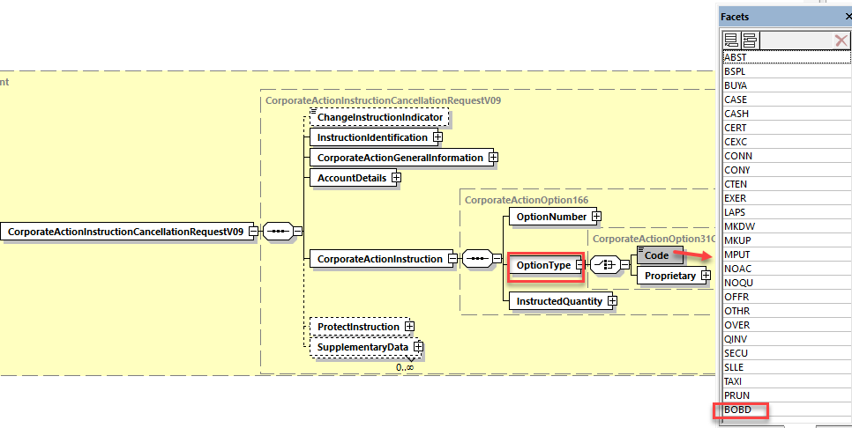

**In all MX messages listed above, add a new complex element rule named BeneficialOwnerBreakdownRequestRule in the root of the messages with the following constraint description( elements paths will need to be adapted for each of the MX messages):**

*“If in at least one occurrence of CorporateActionOptionDetails sequence, OptionType/Code value is BOBD (BeneficialOwnerBreakdownRequest), then CorporateActionGeneralInformation/EventType/Code value must be WTRC (Withholding Tax Relief Certification).”*

**In the seev.033 (CAIN – CorporateActionInstruction)** message in sequence *BeneficialOwnerDetails*, in the Choice data type *PartyIdentification120Choice* of the *OwnerIdentification* element, add a new mandatory element ***IndividualOwnerIdentification*** typed by the data type *AlternatePartyIdentification7* as illustrated below:

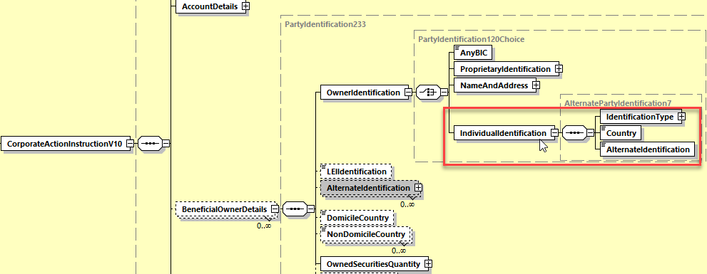

**Working Group Meeting**

|  |
| --- |
| *.***Discussion** |
| The MWG agrees with the business case and with the proposed solution.  The whole MWG with the exception of CH also agrees with the SWIFT proposal to add new NVR rules in all concerned MT messages in order to restrict the usage of the new option code indicator BOBD when the corporate action event is WTRC (Withholding Tax Relief Certification). |
| **Decision** |
| **Approved with comments** |

**Final decision of the Securities SEG regarding ISO 20022 messages:**

|  |  |
| --- | --- |
| Approve the MWG decision | approved |

Comments:

|  |  |
| --- | --- |
| Reject the MWG decision |  |

Reason for rejection:

## CR 001659: Add Offer Eligibility Acknowledgement Indicator

|  |  |
| --- | --- |
| **Origin of request** | |
| Requesting Country: | IN India |
| **Sponsors** | |
| NMPG CA Sub-committee | |
| **Message type(s) impacted** | |
| MT 564, MT 565, seev.031, seev.033, seev.035 | |
| **Complies with regulation** | |
| None | |
| **Business impact of this request** | |
| HIGH - It will simplify the instruction and allow STP by eliminating the need for additional text in field 70E or supporting MT599 | |
| **Commitment to implement the change** | |
| Number of messages sent and received: 1350  Percentage of messages impacted: 100  Commits to implement and when: NMPG CA sub-committee in 2021 | |
| **Business context** | |
| This change will impact investors, global custodians and local custodians.  Various corporate action instructions on the market require free format instructions due to the requirement to fill forms provided in the letter of offer. These forms require the investor (through power of attorney holders like custodians) to acknowledge certain aspects related to the letter of offer such as eligibility to apply. Given the nature of regulations worldwide, custodians require back to back confirmations/ declarations from investors. This results in instructions which contain free format elements in field 70E or additional MT599 and therefore hinders STP processing. Absence of this information constrain the custodians from acting on such instructions as lead managers rely on the forms filled in by custodian to get a confirmation on various conditions including eligibility.  Given the nature of corporate actions, seamless flow of information through STP process can help in reducing errors and delays. | |
| **Nature of change** | |
| We would like to propose an additional tag in MT 565 and a revised process flow as below:  • Custodian announcements contain offer details including link to the offer documents  • Clients will receive corresponding declaration tag in MT 564 hence they are not required to manually insert in MT 565 messages  • Clients will populate the declaration tag in MT 565  • Basis the offer documents supporting the voluntary corporate event, the Y indicator in the tag in MT565 would  substitute the declarations sought to mirror the ask from the Lead Managers as given below:  i. We confirm that we have read and understood the terms and conditions of the offer document  ii. We are eligible to apply for the shares under the offer.  iii. We authorise custodian to execute /provide all required documents contained in the offer document on our behalf | |
| **Workaround** | |
| Issuers require application forms containing specific clauses and conditionalities.  Client declarations sought confirming reading terms and conditions and edibility to subscribe / participate in event via MT565 with field 70E populated or MT599 with event details.  Custodian instruction processing requires manual verification of declaration in the instructions received. Custodian seek back to back confirmation from investors to satisfy themselves of eligibility requirements. | |
| **Examples** | |
| Rights Issues  Bharti Airtel - INE397D01024  5PAISA - INE618L01018  Vodafone - INE669E01016 | |

**SWIFT Comment**

|  |
| --- |
| If this new indicator is included in the MT565, is there a need for a related reason code in the status message in case the eligibility acknowledgement is not provided ?  In that case, could the existing rejection and pending **CERT** reason code be re-used for that ?  If not, a new reason code must be created in the MT567(not assumed and not illustrated in the solution below). |

**Standards Illustration**

**1. ISO 15022 Illustration**

**1. In the MT 564 in sequence E in field 22F Indicator, add the new code value ELIA to the qualifier CETI (Certification/breakdown Type Indicator) as defined and illustrated here below:**

**MT 564 Field Specifications**

57. Field 22F: Indicator

FORMAT

|  |  |  |
| --- | --- | --- |
| Option F | :4!c/[8c]/4!c | (Qualifier)(Data Source Scheme)(Indicator) |

PRESENCE

Mandatory in optional sequence E

QUALIFIER

(Error code(s): T89)

| **Order** | **M/O** | **Qualifier** | **R/N** | **CR** | **Options** | **Qualifier Description** |
| --- | --- | --- | --- | --- | --- | --- |
| 1 | M | CAOP | N | C5 | F | Corporate Action Option Code Indicator |
| 2 | O | DISF | N |  | F | Disposition of Fractions Indicator |
| 3 | O | OFFE | R |  | F | Offer Type Indicator |
| 4 | O | OPTF | R | C20 | F | Option Features Indicator |
| 5 | O | OSTA | N |  | F | Option Status |
| 6 | O | CETI | R |  | F | Certification/Breakdown Type Indicator |

DEFINITION

This qualified generic field specifies:

|  |  |  |
| --- | --- | --- |
| CAOP | Corporate Action Option Code Indicator | Specifies the corporate action options available to the account owner. |
| CETI | Certification/Breakdown Type Indicator | Specifies the type of certification/breakdown. |
| DISF | Disposition of Fractions Indicator | Specifies how fractions resulting from derived securities will be processed or how prorated decisions will be rounding, if provided with a pro ration rate. |
| OFFE | Offer Type Indicator | Specifies the conditions that apply to the offer. |
| OPTF | Option Features Indicator | Specifies the features that may apply to a corporate action option. |
| OSTA | Option Status | Specifies the status of the option. |

CODES

If Qualifier is CETI and Data Source Scheme is not present, Indicator must contain one of the following codes (Error code(s): K22):

|  |  |  |
| --- | --- | --- |
| ACCI | Accredited Investor | The holder of the security has to irrevocably certify that it is an Accredited Investor as defined in US Securities and Exchange Commission Regulation D. |
| DOMI | Country of Domicile | The holder of the security has to certify his domicile. |
| **ELIA** | **Eligibility Acknowledgement** | **The holder of the security has to certify that he has read and understood the terms and conditions of the offer, that he is eligible to apply to the offer and that he has authorised the account servicer to execute / provide all documents required in the offer document on its behalf.** |
| FRAC | Fraction Breakdown | Indicates that the rounding rule in the Fraction Disposition component at the option level can be offered at the beneficial owner level. |
| FULL | Full Beneficial Owner Break Down | The holder of the security has to provide his beneficial owner details for disclosure/instruction purpose. |
| NCOM | Non-Company Related Person | The holder of the security has to certify he is a Non-Company related person. |
| NDOM | Country of Non-Domicile | The holder of the security has to certify, in line with the terms of the corporate action, that it is not domiciled in the country indicated. |
| PABD | (I)CSD participant breakdown | The (I)CSD has to provide its participants' details for disclosure purpose to the issuer/issuer's agent. |
| PAPW | Beneficial Owner's Paperwork | Indicates if the Beneficial Owner is responsible to fill in the paperwork. |
| QIBB | QIB Certification | The holder of the security has to irrevocably certify that it is a Qualified Institutional Buyer as defined in US Securities and Exchange Commission Rule 144A. |
| TRBD | Tax Rate Break Down | The holder of the security has to provide basic details on nominals and associated tax rate to be used by the account servicer. |

**2. In the MT 565 in sequence C in field 22F Indicator, add the new code value ELIA to the qualifier CETI (Certification/breakdown Type Indicator) as defined and illustrated here below:**

**MT 565 Field Specifications**

34. Field 22F: Indicator: Certification Type Indicator

FORMAT

|  |  |  |
| --- | --- | --- |
| Option F | :4!c/[8c]/4!c | (Qualifier)(Data Source Scheme)(Indicator) |

PRESENCE

Optional in optional sequence C

QUALIFIER

(Error code(s): T89)

| **Order** | **M/O** | **Qualifier** | **R/N** | **CR** | **Options** | **Qualifier Description** |
| --- | --- | --- | --- | --- | --- | --- |
| 1 | O | CETI | R |  | F | Certification Type Indicator |

DEFINITION

This qualified generic field specifies:

|  |  |  |
| --- | --- | --- |
| CETI | Certification Type Indicator | Specifies the type of certification. |

CODES

If Data Source Scheme is not present, Indicator must contain one of the following codes (Error code(s): K22):

|  |  |  |
| --- | --- | --- |
| ACCI | Accredited Investor | The holder of the security irrevocably certifies that it is an Accredited Investor as defined in US Securities and Exchange Commission Regulation D. |
| **ELIA** | **Eligibility Acknowledgement** | **The holder of the security irrevocability certifies that he has read and understood the terms and conditions of the offer, that he is eligible to apply to the offer and that he has authorised the account servicer to execute / provide all documents required in the offer document on its behalf.** |
| NCOM | Non-Company Related | The holder of the security is certifying he is a Non-Company related person. |
| QIBB | QIB Certification | The holder of the security irrevocably certifies that it is a Qualified Institutional Buyer as defined in US Securities and Exchange Commission Rule 144A. |

**2. ISO 20022 Illustration**

**1. In the seev.031 (CANO – CorporateActionNotification) message**, in sequence *CorporateActionOptionDetails/CertificationBreakdownType*,

**and in the seev.035 (CAPA – CorporateActionMovementPreliminaryAdvice)** message in *sequence CorporateActionMovementDetails/ CertificationBreakdownType*,

add the new code value **ELIA** (*EligibilityAcknowledgement*) in the data type *BeneficiaryCertificationType4Code* of the Code element as defined in ISO15022 above in the MT 564 and as illustrated below:

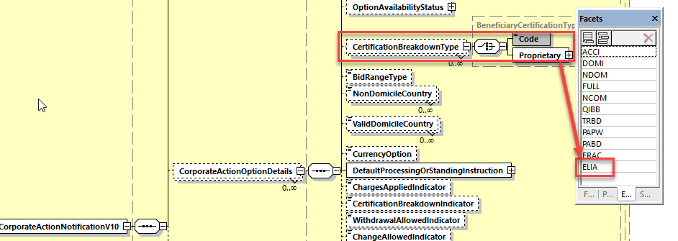

**2. In the seev.033 (CAIN – CorporateActionInstruction)** message in sequence *BeneficialOwnerDetails/CertificationType*, add the new code value **ELIA** (*EligibilityAcknowledgement*) in the data type *BeneficiaryCertificationType5Code* of the *Code* element as defined in ISO15022 above in the MT 565 and as illustrated below:

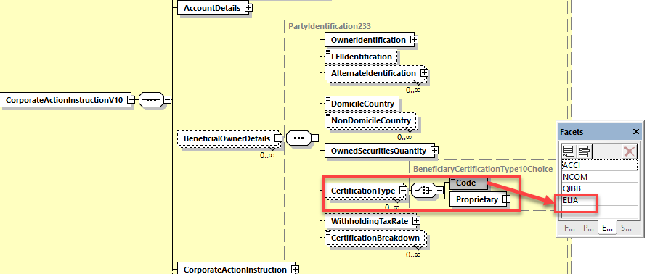

**Working Group Meeting**

|  |
| --- |
| **Discussion** |
| Although a few MWG members recognizes the validity of the business case in India and recognize also that the proposed change request could solve the STP issue of using MT599 traffic in India, the whole MWG unanimously agrees that the legal impacts of this change in all other jurisdictions would be tremendous and could lead to even bigger legal issues.  All MWG members use alternative solution in this case.  The reasons for rejecting the change request are as follows:   * Too low traffic volume for single market; * the new eligibility acknowledgement indicator might quickly become mandatory for every instructions globally whilst all MWG members have alternative working solutions in place; * In many countries, the eligibility acknowledgement by the instructing party is implied; * Using the eligibility acknowledgement indicator in jurisdictions where an alternative solution is used would be very confusing; * If the indicator is not used in an instruction, an instructing party could later take it as an excuse to contest/retract the instruction; * The usage of the indicator could supersede any other pre-existing contractual agreement; * The new indicator will probably lead to additional obligations for custodians.   The MWG proposes the following alternative solutions for India:   * set up a one time SSI (with MT 599) for every event in this scope which means an MT 565 can be used to instruct without including the text every time. * set up a contractual agreement between the account servicers and their clients.   The Indian NMPG representative can also consult with the SMPG CA WG for advice if necessary.  The MWG unanimously rejects the CR. |
| **Decision** |
| **Rejected** |

**Final decision of the Securities SEG regarding ISO 20022 messages:**

|  |  |
| --- | --- |
| Approve the MWG decision |  |

Comments:

|  |  |
| --- | --- |
| Reject the MWG decision | rejected |

Reason for rejection:

## CR 001638: Add Event Type ACCU to Instruction and Status

|  |  |
| --- | --- |
| **Origin of request** | |
| Requesting Country: | CH Switzerland |
| **Sponsors** | |
| Not provided | |
| **Message type(s) impacted** | |
| MT 565, MT 567, seev.032, seev.033, seev.034, seev.040, seev.041, seev.042 | |
| **Complies with regulation** | |
| None | |
| **Business impact of this request** | |
| LOW | |
| **Commitment to implement the change** | |
| Percentage of messages impacted: 25  Commits to implement and when: CH in 2021 | |
| **Business context** | |
| For certain accumulating funds in Switzerland it is possible for financial intermediaries to ask for their non-Swiss resident clients the pay-out of the 35% withholding tax withheld by the fund in regards to the accumulated dividend. For Swiss residents the withholding tax of 35% can only be reclaimed by individually disclosing the accumulated income to the Swiss tax authorities using the tax voucher issued by the clients bank. Although the pay-out of the 35% withholding tax to non-Swiss residents is made via CAEV//WTRC, adding the code ACCU to the corporate action event indicator in the MT565 message makes it easier to instruct the split between resident and non resident holdings on the original accumulating event. If instructing of is made available in MT 565 accepting or rejecting said instructions must be made possible in MT 567. | |
| **Nature of change** | |
| Add code ACCU to qualifier :22F::CAEV corporate action event indicator in MT 565 and MT 567 messages. | |
| **Workaround** | |
| DSS is used, example :22F::CAEV/CAEV/ACCU | |
| **Examples** | |
| Not provided | |

**SWIFT Comment**

|  |
| --- |
|  |

**Standards Illustration**

**1. ISO 15022 Illustration**

**1. In the MT565 and MT567 messages, in sequence A, in field 22F::CAEV, add the code value Accumulation (ACCU) as defined in the other MT 56x messages and as illustrated below:**

**MT 565 Field Specifications**

4. Field 22F: Indicator: Corporate Action Event Indicator

FORMAT

|  |  |  |
| --- | --- | --- |
| Option F | :4!c/[8c]/4!c | (Qualifier)(Data Source Scheme)(Indicator) |

PRESENCE

Mandatory in mandatory sequence A

QUALIFIER

(Error code(s): T89)

| **Order** | **M/O** | **Qualifier** | **R/N** | **CR** | **Options** | **Qualifier Description** |
| --- | --- | --- | --- | --- | --- | --- |
| 1 | M | CAEV | N |  | F | Corporate Action Event Indicator |

DEFINITION

This qualified generic field specifies:

|  |  |  |
| --- | --- | --- |
| CAEV | Corporate Action Event Indicator | Specifies the type of corporate event. |

CODES

If Data Source Scheme is not present, Indicator must contain one of the following codes (Error code(s): K22):

|  |  |  |
| --- | --- | --- |
| **ACCU** | **Accumulation** | **Funds related event in which the income (for example accumulation units) that accrues during an accounting period is retained within the fund instead of being paid away to investors. The retained income is nonetheless deemed to have been distributed to investors for tax purposes.** |
| ACTV | Trading Status: Active | Trading in the security has commenced or security has been re-activated after a suspension in trading. |
| ATTI | Attachment | Combination of different security types to create a unit. Units are usually comprised of warrants and bonds or warrants and equities. Securities may be combined at the request of the security holder or based on market convention. |
| …… |  |  |
| XMET | Extraordinary or Special General Meeting | Extraordinary or special general meeting. |

**MT 567 Field Specifications**

4. Field 22F: Indicator: Corporate Action Event Indicator

FORMAT

|  |  |  |
| --- | --- | --- |
| Option F | :4!c/[8c]/4!c | (Qualifier)(Data Source Scheme)(Indicator) |

PRESENCE

Mandatory in mandatory sequence A

QUALIFIER

(Error code(s): T89)

| **Order** | **M/O** | **Qualifier** | **R/N** | **CR** | **Options** | **Qualifier Description** |
| --- | --- | --- | --- | --- | --- | --- |
| 1 | M | CAEV | N |  | F | Corporate Action Event Indicator |

DEFINITION

This qualified generic field specifies:

|  |  |  |
| --- | --- | --- |
| CAEV | Corporate Action Event Indicator | Specifies the type of corporate event. |

CODES

If Data Source Scheme is not present, Indicator must contain one of the following codes (Error code(s): K22):

|  |  |  |
| --- | --- | --- |
| **ACCU** | **Accumulation** | **Funds related event in which the income (for example accumulation units) that accrues during an accounting period is retained within the fund instead of being paid away to investors. The retained income is nonetheless deemed to have been distributed to investors for tax purposes.** |
| ACTV | Trading Status: Active | Trading in the security has commenced or security has been re-activated after a suspension in trading. |
| ATTI | Attachment | Combination of different security types to create a unit. Units are usually comprised of warrants and bonds or warrants and equities. Securities may be combined at the request of the security holder or based on market convention. |
| …. |  |  |
| XMET | Extraordinary or Special General Meeting | Extraordinary or special general meeting. |

**2. ISO 20022 Illustration**

Create a new version of the *CorporateActionEventType29Code* data type code lists in which the existing **ACCU** code value is added.

This will trigger the change in the following CA messages for the *CorporateActionGeneralInformation/EventType/Code* elements:

**seev.032 (CAPS – CorporateActionEventProcessingStatusAdvice)**

**seev.033 (CAIN – CorporateActionInstruction)**

**seev.034 (CAIS – CorporateActionInstructionStatusAdvice)**

**seev.040 (CAIC – CorporateActionInstructionCancellationRequest)**

**seev.041 (CACS – CorporateActionInstructionCancellationRequestStatusAdvice)**

This will trigger the change in the **seev.042 messages** **(CAST - CorporateActionInstructionStatementReport )** for the element *AccountAndStatementDetails/CorporateActionEventAndBalance/GeneralIndformation/EventType/Code*.

Illustration is provided for the seev.032 (CANO) message here below:

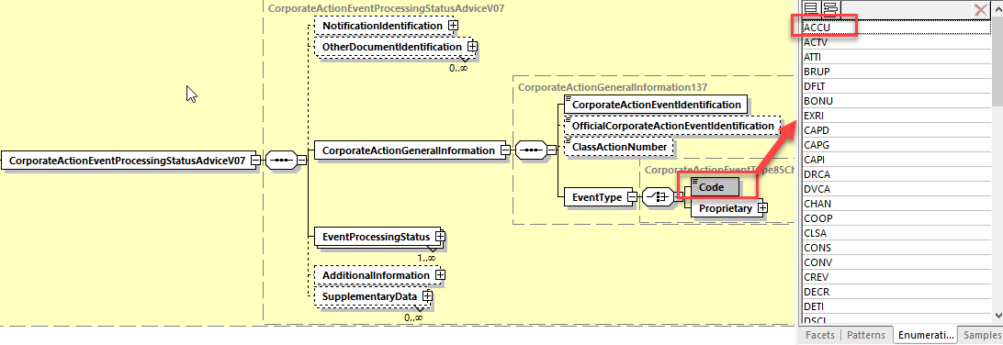

**Working Group Meeting**

|  |
| --- |
| **Discussion** |
| CH has the need to set up options to inform the issuer/paying agent how many securities are held by Swiss clients vs non-Swiss clients. This is not possible as MT 565 and 567 do not allow the ACCU event today. On ACCU no pay-out can be done, it is only a tax voucher.  UK and DE do not agree with the business case as it goes against the new tax MP proposal published by the SMPG. UK clarified that WTRC is an event to collect tax breakdown information on an omnibus account for a particular event. No pay out can be done on WTRC, only an event to collect certification or breakdown.  Despite UK, DE and HK opposition, a majority of the MWG members agree with the business case and with the proposed solution. |
| **Decision** |
| **Approved** |

**Final decision of the Securities SEG regarding ISO 20022 messages:**

|  |  |
| --- | --- |
| Approve the MWG decision | approved |

Comments:

|  |  |
| --- | --- |
| Reject the MWG decision |  |

Reason for rejection:

## CR 001630: Add Solicitation Dealer Fee Request Indicator

|  |  |
| --- | --- |
| **Origin of request** | |
| Requesting Group: | ISITC |
| **Sponsors** | |
| DTCC | |
| **Message type(s) impacted** | |
| MT 565, MT 567, seev.033, seev.034, | |
| **Complies with regulation** | |
| None | |
| **Business impact of this request** | |
| LOW | |
| **Commitment to implement the change** | |
| Commits to implement and when: US in 2021 | |
| **Business context** | |
| DTCC is automating Voluntary Reorganization instruction processing. During this project, it has been determined that for certain Rights, Tender and Exchange events, a solicitation fee could be associated with the particular option. There currently exists a tag within the MT564 / CANO within the Option Rate details INCE / Third Party Incentive Rate.  There is a process whereby the Account Servicer must indicate for US instructions that they wish to receive a solicitation fee for the event. DTCC based upon this indicator, passes this information to the Issuer / Agent. However no tag exists in the MT565 / CAIN message to indicate this request. DTCC has modelled a field within its extension to handle this indicator but is requesting that this is part of the standard.  We are requesting that the tag Solicitation Dealer Fee Indicator be added to the MT565 / CAIN instruction and a CAIS reject code be added ISOL (Invalid Solicitation Dealer Fee Indicator) to handle situations where a client improperly utilizes the indicator on the instruction. | |
| **Nature of change** | |
| 1. . Inclusion of an optional field Solicitation Dealer Fee indicator in the MT565 / CAIN message  /Document/CorpActnInstr/CorpActnInstr/SolicitationDealerFeeIndicator  2. Inclusion of a CAIS Reject Reason Code for Invalid Solicitation Fee Code ISOL  3. Inclusion of an optional field Solicitation Dealer Fee indicator in the MT567 / CAIS message  /Document/CorpActnInstrStsAdvc/CorpActnInstr/SolicitationDealerFeeIndicator | |
| **Workaround** | |
| DTCC utilizes its extension to provide this information and will continue to use the extension unless the standards change is implemented. | |
| **Examples** | |
| 120695402 CUSIP #38173M110    cid:image007.png@01D61CB9.55F5FC00  CANO Announcement Extension  cid:image010.png@01D61CBA.B469B690  Additional info:  As per the Prospectus Supplement dated April 13, 2020: The dealer manager will re-allow to other broker-dealers that have executed and delivered a soliciting dealer agreement and have solicited the exercise of rights, solicitation fees up to 1PCT of the subscription price per share for each share issued pursuant to the exercise of rights as a result of their soliciting efforts, subject to a maximum fee based on the number of shares held by each broker-dealer through the Depository Trust Company on the record date. Participants who wish to indicate a soliciting dealer fee should enter (Y) in the SOLICITATION FEE field and put REQUESTING SOLICITATION FEE in the comments field of the PSOP ticket. Participants are to submit the solicitation fee payment request form directly to the dealer manager. Please refer to LENS Document number: LG20200421-018 for a copy of the Soliciting dealer agreement that needs to be completed. (Updated 04/21/20) | |

**SWIFT Comment**

|  |
| --- |
|  |

**Standards Illustration**

**1. ISO 15022 Illustration**

**1. In the MT565 in sequence D, add a new optional 17B field with a new Solicitation Dealer Fee Indicator (SODF) qualifier as defined and illustrated here below:**

**MT 565 Format Specifications**

| **MT 565 Corporate Action Instruction** | | | | | | |
| --- | --- | --- | --- | --- | --- | --- |
| **Status** | **Tag** | **Qualifier** | **Generic Field Name** | **Detailed Field Name** | **Content/Options** | ***No.*** |

|  |  |  |  |  |  |  |
| --- | --- | --- | --- | --- | --- | --- |
| **Mandatory Sequence D Corporate Action Instruction** | | | | | | |
| M | 16R |  |  | Start of Block | CAINST | *38* |
| M | 13A | CAON | Number Identification | CA Option Number | :4!c//3!c | *39* |
| **----->** | | | | | | |
| M | 22a | 4!c | Indicator | (see qualifier description) | F or H | *40* |
| **-----|** | | | | | | |
| **----->** | | | | | | |
| O | 11A | 4!c | Currency | (see qualifier description) | :4!c//3!a | *41* |
| **-----|** | | | | | | |
| O | 35B |  |  | Identification of the Financial Instrument | [ISIN1!e12!c] [4\*35x] | *42* |
| **----->** | | | | | | |
| O | 36a | 4!c | Quantity of Financial Instrument | (see qualifier description) | B or C | *43* |
| **-----|** | | | | | | |
| O | 19B | QCAS | Amount | Instructed Amount | :4!c//3!a15d | *44* |
| O | 98a | EXRQ | Date/Time | Execution Requested Date/Time | A or C | *45* |
| **----->** | | | | | | |
| O | 92a | 4!c | Rate | (see qualifier description) | A, F, or R | *46* |
| **-----|** | | | | | | |
| **----->** | | | | | | |
| O | 90a | 4!c | Price | (see qualifier description) | A, B, E, F, J, or L | *47* |
| **-----|** | | | | | | |
| O | 20D | SHAR | Reference | Shareholder Number | :4!c//25x | *48* |
| **O** | **17B** | **SODF** | **Flag** | **Solicitation Dealer Fee Indicator** | **:4!c//1a** | **49** |
| **----->** | | | | | | |
| O | 70E | 4!c | Narrative | (see qualifier description) | :4!c//10\*35x | *49* |
| **-----|** | | | | | | |
| M | 16S |  |  | End of Block | CAINST | *50* |
| **End of Sequence D Corporate Action Instruction** | | | | | | |

**MT 565 Field Specifications**

**49. Field 17B: Flag**

**FORMAT**

|  |  |  |
| --- | --- | --- |
| **Option B** | **:4!c//1!a** | **(Qualifier)(Flag)** |

**PRESENCE**

**Optional in mandatory sequence D**

**QUALIFIER**

**(Error code(s): T89)**

| **Order** | **M/O** | **Qualifier** | **R/N** | **CR** | **Options** | **Qualifier Description** |
| --- | --- | --- | --- | --- | --- | --- |
| **1** | **O** | **SODF** | **N** |  | **B** | **Solicitation Dealer Fee Indicator** |

**DEFINITION**

**This qualified generic field specifies:**

|  |  |  |
| --- | --- | --- |
| **SODF** | **Solicitation Dealer Fee Indicator** | **Indicates whether there is a solicitation fee on the event. This fee is paid by the soliciting dealer.** |

**CODES**

**Flag must contain one of the following codes (Error code(s): K17):**

|  |  |  |
| --- | --- | --- |
| **N** | **No** | **No.** |
| **Y** | **Yes** | **Yes.** |

**2. In the MT 567, in subsequence A2a, in field 24B, add a new reason code value “Invalid Solicitation Dealer Fee Use” (ISOL) to the REJT qualifier as defined and illustrated here below:**

**MT 567 Field Specifications**

13. Field 24B: Reason Code

FORMAT

|  |  |  |
| --- | --- | --- |
| Option B | :4!c/[8c]/4!c | (Qualifier)(Data Source Scheme)(Reason Code) |

PRESENCE

Mandatory in optional subsequence A2a

QUALIFIER

(Error code(s): T89)

| **Order** | **M/O** | **Qualifier** | **R/N** | **CR** | **Options** | **Qualifier Description** |
| --- | --- | --- | --- | --- | --- | --- |
| 1 | M | PEND | N | C1 | B | Pending Reason |
|  | or | REJT | N | C1 | B | Rejection Reason |
|  | or | CAND | N | C1 | B | Cancellation Reason |
|  | or | CANP | N | C1 | B | Cancellation Pending Reason |
|  | or | PACK | N | C1 | B | Accepted Reason |

DEFINITION

This qualified generic field specifies:

|  |  |  |
| --- | --- | --- |
| CAND | Cancellation Reason | Specifies the reason why the instruction is cancelled. |
| CANP | Cancellation Pending Reason | Specifies the reason why a cancellation request sent for the related instruction is pending. |
| PACK | Accepted Reason | Specifies additional information about the processed instruction. |
| PEND | Pending Reason | Specifies the reason why the instruction/event has a pending status. |
| REJT | Rejection Reason | Specifies the reason why the instruction/cancellation request has a rejected status. |

CODES

If Qualifier is REJT and Data Source Scheme is not present, Reason Code must contain one of the following codes (Error code(s): K24):

|  |  |  |
| --- | --- | --- |
| ADEA | Account Servicer Deadline Missed | Received after the account servicer's deadline. |
| …. |  |  |
| INVA | Invalid for Tax Authorities | For tax reclaim, the reclaim is invalid for the tax authorities. |
| IRDQ | Invalid Use Round Up Quantity | Instruction is rejected due to invalid use of additional round up quantity (RDUQ). |
| **ISOL** | **Invalid Solicitation Dealer Fee Use** | **Invalid use of solicitation dealer fee indicator.** |
| ITAX | Incorrect Tax Rate | Tax rate provided is incorrect. It falls outside the acceptable values for that investment country. |
| …. |  |  |
| ULNK | Unknown | Linked reference is unknown. |

**3. In the MT 567 in the sequence B Corporate Action Details, add a new optional 17B field with a new Solicitation Dealer Fee Indicator (SODF) qualifier as defined and illustrated here below:**

|  |  |  |  |  |  |  |
| --- | --- | --- | --- | --- | --- | --- |
| **Optional Sequence B Corporate Action Details** | | | | | | |
| M | C:\No_Backup\DOCUMENTATION\SR2020\us5mc\cursor0.gif16R | C:\No_Backup\DOCUMENTATION\SR2020\us5mc\cursor0.gif | C:\No_Backup\DOCUMENTATION\SR2020\us5mc\cursor0.gif | C:\No_Backup\DOCUMENTATION\SR2020\us5mc\cursor0.gifStart of Block | C:\No_Backup\DOCUMENTATION\SR2020\us5mc\cursor0.gifCADETL | [See specification](file:///C:\No_Backup\DOCUMENTATION\SR2020\us5mc\algf018.htm#mt567-18-field-16r)C:\No_Backup\DOCUMENTATION\SR2020\us5mc\cursor0.gif *18* |
| O | C:\No_Backup\DOCUMENTATION\SR2020\us5mc\cursor0.gif13A | C:\No_Backup\DOCUMENTATION\SR2020\us5mc\cursor0.gifCAON | C:\No_Backup\DOCUMENTATION\SR2020\us5mc\cursor0.gifNumber Identification | C:\No_Backup\DOCUMENTATION\SR2020\us5mc\cursor0.gifCA Option Number | C:\No_Backup\DOCUMENTATION\SR2020\us5mc\cursor0.gif:4!c//3!c | [See specification](file:///C:\No_Backup\DOCUMENTATION\SR2020\us5mc\algf019.htm#mt567-19-field-13a)C:\No_Backup\DOCUMENTATION\SR2020\us5mc\cursor0.gif *19* |
| **----->** | | | | | | |
| O | C:\No_Backup\DOCUMENTATION\SR2020\us5mc\cursor0.gif22a | C:\No_Backup\DOCUMENTATION\SR2020\us5mc\cursor0.gif4!c | C:\No_Backup\DOCUMENTATION\SR2020\us5mc\cursor0.gifIndicator | C:\No_Backup\DOCUMENTATION\SR2020\us5mc\cursor0.gif(see qualifier description) | C:\No_Backup\DOCUMENTATION\SR2020\us5mc\cursor0.gifF or H | [See specification](file:///C:\No_Backup\DOCUMENTATION\SR2020\us5mc\algf020.htm#mt567-20-field-22a)C:\No_Backup\DOCUMENTATION\SR2020\us5mc\cursor0.gif *20* |
| **-----|** | | | | | | |
| O | C:\No_Backup\DOCUMENTATION\SR2020\us5mc\cursor0.gif95a | C:\No_Backup\DOCUMENTATION\SR2020\us5mc\cursor0.gifACOW | C:\No_Backup\DOCUMENTATION\SR2020\us5mc\cursor0.gifParty | C:\No_Backup\DOCUMENTATION\SR2020\us5mc\cursor0.gifAccount Owner | C:\No_Backup\DOCUMENTATION\SR2020\us5mc\cursor0.gifP or R | [See specification](file:///C:\No_Backup\DOCUMENTATION\SR2020\us5mc\algf021.htm#mt567-21-field-95a)C:\No_Backup\DOCUMENTATION\SR2020\us5mc\cursor0.gif *21* |
| **----->** | | | | | | |
| O | C:\No_Backup\DOCUMENTATION\SR2020\us5mc\cursor0.gif97a | C:\No_Backup\DOCUMENTATION\SR2020\us5mc\cursor0.gif4!c | C:\No_Backup\DOCUMENTATION\SR2020\us5mc\cursor0.gifAccount | C:\No_Backup\DOCUMENTATION\SR2020\us5mc\cursor0.gif(see qualifier description) | C:\No_Backup\DOCUMENTATION\SR2020\us5mc\cursor0.gifA or E | [See specification](file:///C:\No_Backup\DOCUMENTATION\SR2020\us5mc\algf022.htm#mt567-22-field-97a)C:\No_Backup\DOCUMENTATION\SR2020\us5mc\cursor0.gif *22* |
| **-----|** | | | | | | |
| O | C:\No_Backup\DOCUMENTATION\SR2020\us5mc\cursor0.gif94a | C:\No_Backup\DOCUMENTATION\SR2020\us5mc\cursor0.gifSAFE | C:\No_Backup\DOCUMENTATION\SR2020\us5mc\cursor0.gifPlace | C:\No_Backup\DOCUMENTATION\SR2020\us5mc\cursor0.gifPlace of Safekeeping | C:\No_Backup\DOCUMENTATION\SR2020\us5mc\cursor0.gifB, C, or F | [See specification](file:///C:\No_Backup\DOCUMENTATION\SR2020\us5mc\algf023.htm#mt567-23-field-94a)C:\No_Backup\DOCUMENTATION\SR2020\us5mc\cursor0.gif *23* |
| O | C:\No_Backup\DOCUMENTATION\SR2020\us5mc\cursor0.gif35B | C:\No_Backup\DOCUMENTATION\SR2020\us5mc\cursor0.gif | C:\No_Backup\DOCUMENTATION\SR2020\us5mc\cursor0.gif | C:\No_Backup\DOCUMENTATION\SR2020\us5mc\cursor0.gifIdentification of the Financial Instrument | C:\No_Backup\DOCUMENTATION\SR2020\us5mc\cursor0.gif[ISIN1!e12!c] C:\No_Backup\DOCUMENTATION\SR2020\us5mc\cursor0.gif[4\*35x] | [See specification](file:///C:\No_Backup\DOCUMENTATION\SR2020\us5mc\algf024.htm#mt567-24-field-35b)C:\No_Backup\DOCUMENTATION\SR2020\us5mc\cursor0.gif *24* |
| **----->** | | | | | | |
| O | C:\No_Backup\DOCUMENTATION\SR2020\us5mc\cursor0.gif36B | C:\No_Backup\DOCUMENTATION\SR2020\us5mc\cursor0.gifSTAQ | C:\No_Backup\DOCUMENTATION\SR2020\us5mc\cursor0.gifQuantity of Financial Instrument | C:\No_Backup\DOCUMENTATION\SR2020\us5mc\cursor0.gifStatus Quantity | C:\No_Backup\DOCUMENTATION\SR2020\us5mc\cursor0.gif:4!c//4!c/15d | [See specification](file:///C:\No_Backup\DOCUMENTATION\SR2020\us5mc\algf025.htm#mt567-25-field-36b)C:\No_Backup\DOCUMENTATION\SR2020\us5mc\cursor0.gif *25* |
| **-----|** | | | | | | |
| **----->** | | | | | | |
| O | C:\No_Backup\DOCUMENTATION\SR2020\us5mc\cursor0.gif19B | C:\No_Backup\DOCUMENTATION\SR2020\us5mc\cursor0.gif4!c | C:\No_Backup\DOCUMENTATION\SR2020\us5mc\cursor0.gifAmount | C:\No_Backup\DOCUMENTATION\SR2020\us5mc\cursor0.gif(see qualifier description) | C:\No_Backup\DOCUMENTATION\SR2020\us5mc\cursor0.gif:4!c//3!a15d | [See specification](file:///C:\No_Backup\DOCUMENTATION\SR2020\us5mc\algf026.htm#mt567-26-field-19b)C:\No_Backup\DOCUMENTATION\SR2020\us5mc\cursor0.gif *26* |
| **-----|** | | | | | | |
| **----->** | | | | | | |
| O | C:\No_Backup\DOCUMENTATION\SR2020\us5mc\cursor0.gif93B | C:\No_Backup\DOCUMENTATION\SR2020\us5mc\cursor0.gif4!c | C:\No_Backup\DOCUMENTATION\SR2020\us5mc\cursor0.gifBalance | C:\No_Backup\DOCUMENTATION\SR2020\us5mc\cursor0.gif(see qualifier description) | C:\No_Backup\DOCUMENTATION\SR2020\us5mc\cursor0.gif:4!c/[8c]/4!c/[N]15d | [See specification](file:///C:\No_Backup\DOCUMENTATION\SR2020\us5mc\algf027.htm#mt567-27-field-93b)C:\No_Backup\DOCUMENTATION\SR2020\us5mc\cursor0.gif *27* |
| **-----|** | | | | | | |
| **O** | **17B** | **SODF** | **Flag** | **Solicitation Dealer Fee Indicator** | **:4!c//1a** | **28** |
| M | C:\No_Backup\DOCUMENTATION\SR2020\us5mc\cursor0.gif16S | C:\No_Backup\DOCUMENTATION\SR2020\us5mc\cursor0.gif | C:\No_Backup\DOCUMENTATION\SR2020\us5mc\cursor0.gif | C:\No_Backup\DOCUMENTATION\SR2020\us5mc\cursor0.gifEnd of Block | C:\No_Backup\DOCUMENTATION\SR2020\us5mc\cursor0.gifCADETL | [See specification](file:///C:\No_Backup\DOCUMENTATION\SR2020\us5mc\algf028.htm#mt567-28-field-16s)C:\No_Backup\DOCUMENTATION\SR2020\us5mc\cursor0.gif *28* |

**28. Field 17B: Flag**

**FORMAT**

|  |  |  |
| --- | --- | --- |
| **Option B** | **:4!c//1!a** | **(Qualifier)(Flag)** |

**PRESENCE**

**Optional in mandatory sequence D**

**QUALIFIER**

**(Error code(s): T89)**

| **Order** | **M/O** | **Qualifier** | **R/N** | **CR** | **Options** | **Qualifier Description** |
| --- | --- | --- | --- | --- | --- | --- |
| **1** | **O** | **SODF** | **N** |  | **B** | **Solicitation Dealer Fee Indicator** |

**DEFINITION**

**This qualified generic field specifies:**

|  |  |  |
| --- | --- | --- |
| **SODF** | **Solicitation Dealer Fee Indicator** | **Indicates whether there is a solicitation fee on the event. This fee is paid by the soliciting dealer.** |

**CODES**

**Flag must contain one of the following codes (Error code(s): K17):**

|  |  |  |
| --- | --- | --- |
| **N** | **No** | **No.** |
| **Y** | **Yes** | **Yes.** |

**2. ISO 20022 Illustration**

**1. In the seev.033 (CAIN – CorporateActionInstruction)** in sequence *CorporateActionInstruction*, add a new optional and non-repeatable yes/no Indicator ***SolicitationDealerFeeIndicator*** as defined in ISO15022 above and as illustrated here below:

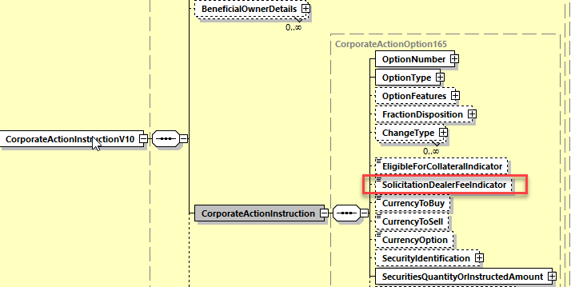

**2. In the seev.034 (CAIS – CorporateActionInstructionStatusAdvice)** in sequence *InstructionProcessingStatus/Rejeted/Reason/ReasonCode*, add a new reason code **ISOL** (***InvalidSolicitationDealerFeeUse***) to the date type *RejectedReason54Code* of the element *Code* as defined in ISO 15022 above and

In sequence *CorporateActionInstruction*, add a new optional and non-repeatable yes/no Indicator ***SolicitationDealerFeeIndicator*** as defined in ISO15022 above and as illustrated below:

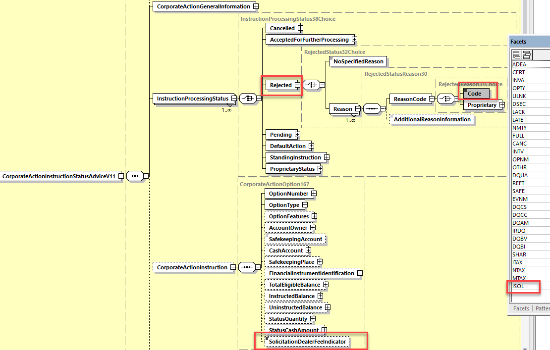

**Working Group Meeting**

|  |
| --- |
| **Discussion** |
| Despite the fact that BE, ZA and LU do not really support the business case, a majority of the MWG members agrees with the business case and proposed solution.  ISITC confirms that the change must NOT be applied on the seev.042 message as proposed in the solution for MX message. Therefore, seev.042 must be removed from the list of impacted messages. |
| **Decision** |
| **Approved with comment** |

**Final decision of the Securities SEG regarding ISO 20022 messages:**

|  |  |
| --- | --- |
| Approve the MWG decision | approved |

Comments:

|  |  |
| --- | --- |
| Reject the MWG decision |  |

Reason for rejection:

## CR 001649: Add New Sequence in Status for Market Claim Details

|  |  |
| --- | --- |
| **Origin of request** | |
| Requesting Group: | SMPG |
| **Sponsors** | |
| SMPG | |
| **Message type(s) impacted** | |
| MT 567 | |
| **Complies with regulation** | |
| None | |
| **Business impact of this request** | |
| MEDIUM | |
| **Commitment to implement the change** | |
| SMPG in 2021 | |
| **Business context** | |
| According to the European standards for transaction management (CAJWG and T2S CASG), CSDs and CCPs are to generate market claims for affected settlement transactions, starting after close of business on record date and continuing for a period of 20 business days.  Market claims are to have an intended settlement date that is equal to the payment date of the CA event or the next business day, if the market claim is generated after payment date.  Market claims are to be created without any link to the underlying settlement transaction; the standards make it clear that a claim may indeed settle before the underlying settlement transaction. However, the CSD members may link a specific market claim to the underlying settlement transaction on a case-by-case basis. Market claims are to be generated with the same status as the underlying settlement instructions, i.e. if the delivery instruction was not released for settlement (likely due to a lack of securities), the market claim instruction will also be created without being released for settlement.  Before T2S, few CSDs supported functionality according to the above. Thus, there has been fairly little need in the industry for reporting of market claims generation and even less for status reporting between generation and settlement.  However, this is no longer the case. Market claims will not settle automatically in many situations and they will be subject to CSDR penalties and buy-ins in case settlement does not take place.  This will generate a series of questions, such as:  a. if a CSD member cannot receive market claim status updates from its CSD, how can the CSD member prioritise the different transactions?  b. if the CSD member cannot do this for its clients, how can the client do it?  c. how can a CSD member, or its client, release a market claim for settlement if they cannot identify it?  There is currently very limited message support for market claims processing. The CA confirmation, MT566/CACO, is used for confirmation of settlement of a market claim and works well for this purpose. For the other processes, there are really no messages available. | |
| **Nature of change** | |
| As the request to create two new ISO 15022 messages was rejected in SR2016, this CR is more limited in scope. Its aim is only to enable intermediaries to report on the creation of a market claim and/or a status change of a market claim, i.e. a market claim advise function. It also proposes to use a similar approach as to penalties reporting, which resulted in a new ISO 20022 message but in ISO 15022 in effect created a new sub-type of the MT 537 and MT 548.  The SMPG CA-WG thus proposes to use the existing MT567 message for this new function. The processes it will be used for are:   1. to report that a market claim has been generated and registered on the account holder's account, including both the market claim transaction details as well as the key CA event details (at least event reference, type, underlying ISIN); and 2. to report a status change of a market claim.   A new sequence should be added to the MT567, Market Claim Details. In order to preserve the usual order of having the Additional Information sequence at the end of the message, the new sequence should be between B/Corporate Action Details and D/Additional Information, and hence named C/Market Claim Details.  The sequence should include the below elements  36B QCLA  19B MKTC  98a TRAD  98a SETT  and include a repetitive sub-sequence, for Counterparty/CTRPRTY, with the below elements  95a DEAG / REAG / SELL / BUYR / PSET  The SMPG CA-WG proposes to use the MT530 to release a market claim for settlement and amend its priority. That should not require any changes to the MT 530. | |
| **Workaround** | |
| Excel spreadsheets sent via email, MT 548 (does not include the corporate action information), MT564 (does not include the settlement instruction details). | |
| **Examples** | |
| Not provided | |

**SWIFT Comment**

|  |
| --- |
|  |

**Standards Illustration**

**1. ISO 15022 Illustration**

**1. In the MT 567, in sequence A, in field 23G, add a new function of the message qualifier code MKTC for Market Claim as defined and illustrated below:**

**MT 567 Field Specifications**

3. Field 23G: Function of the Message

FORMAT

|  |  |  |
| --- | --- | --- |
| Option G | 4!c[/4!c] | (Function)(Subfunction) |

PRESENCE

Mandatory (referenced in rules C2 and C4) in mandatory sequence A

DEFINITION

This field identifies the function of the message.

CODES

Function must contain one of the following codes (Error code(s): T86):

|  |  |  |
| --- | --- | --- |
| CAST | Cancellation Request Status | Message reporting on a cancellation request status. |
| EVST | Event Status | Message reporting on a corporate action event status. |
| INST | Instruction Status | Message reporting on an instruction status. |
| **MKTC** | **Market Claim Status** | **Message reporting on an market claim status.** |

CODES

Subfunction, when present, must contain one of the following codes (Error code(s): T85):

|  |  |  |
| --- | --- | --- |
| CODU | Copy Duplicate | Message is a copy to a party other than the account owner/account servicer, for information purposes and the message is a duplicate of a message previously sent. |
| COPY | Copy | Message is a copy to a party other than the account owner/account servicer, for information purposes. |
| DUPL | Duplicate | Message is for information/confirmation purposes. It is a duplicate of a message previously sent. |

1. **In the MT 567, in subsequence A2, in field 25D, add a new qualifier MPRC qualifier for Market Claim Processing Status with new code values and amend the related C4 NVR as defined and illustrated here below.**

**MT 567 Field Specifications**

11. Field 25D: Status Code

FORMAT

|  |  |  |
| --- | --- | --- |
| Option D | :4!c/[8c]/4!c | (Qualifier)(Data Source Scheme)(Status Code) |

PRESENCE

Mandatory in mandatory subsequence A2

QUALIFIER

(Error code(s): T89)

| **Order** | **M/O** | **Qualifier** | **R/N** | **CR** | **Options** | **Qualifier Description** |
| --- | --- | --- | --- | --- | --- | --- |
| 1 | M | CPRC | N | C4 | D | Cancellation Processing Status |
|  | or | EPRC | N | C4 | D | Corporate Action Event Processing Status |
|  | or | IPRC | N | C4 | D | Instruction Processing Status |
|  | **Or** | **MPRC** | **N** | **C4** | **D** | **Market Claim Processing Status** |

DEFINITION

This qualified generic field specifies:

|  |  |  |
| --- | --- | --- |
| CPRC | Cancellation Processing Status | Provides the status of a cancellation request. |
| EPRC | Corporate Action Event Processing Status | Provides the status of a corporate action or the status of a payment. |
| IPRC | Instruction Processing Status | Provides the status of an instruction. |
| **MPRC** | **Market Claim Processing Status** | **Provides the status of a market claim.** |
|  |  |  |

**CODES**

**If Qualifier is MPRC and Data Source Scheme is not present, Status Code must contain one of the following codes (Error code(s): K25):**

|  |  |  |
| --- | --- | --- |
| **CGEN** | **Generated** | **Market claim instruction was created by the account servicer or a third party. It was not instructed directly by the account owner.** |
| **MACH** | **Matched** | **Market claim instruction has been matched.** |
| **PEND** | **Pending Settlement** | **Market claim instruction is pending. Settlement at the instructed** **settlement date is still possible.** |
| **PENF** | **Pending Failing Settlement** | **Market claim instruction is failing. Settlement at the instructed settlement date is no longer possible.** |
| **CAND** | **Cancelled** | **Market claim has been cancelled** |

**C4**

If the message is a cancellation request status (:23G:CAST), then, in every occurrence of sequence A2 Status, a cancellation processing status must be reported (:25D::CPRC...).

If the message is an instruction status (:23G:INST) then, in every occurrence of sequence A2 Status, an instruction processing status (:25D::IPRC...) must be reported.

If the message is corporate action event processing status (:23G:EVST), then, in every occurrence of sequence A2 Status, an event status (:25D::EPRC...) must be reported.

**If the message is market claim status (:23G:MKTC), then, in every occurrence of sequence A2 Status, a market claim processing status (:25D::MPRC...) must be reported** (Error code(s): C65).

| **In sequence A if field :23G: is ...** | **Then, in every occurrence of sequence A2 Status, field :25D must be...** |
| --- | --- |
| CAST | :25D::CPRC... |
| INST | :25D::IPRC... |
| EVST | :25D::EPRC... |
| **MKTC** | **:25D::MPRC** |

1. **In the MT 567, in subsequence A2a, in field :24B: Reason Code, add the new status qualifier PENF and add the following new reason codes associated to PEND and PENF statuses as defined and illustrated here below and amend the NVR C1 accordingly:**

**MT 567 Field Specifications**

13. Field 24B: Reason Code

FORMAT

|  |  |  |
| --- | --- | --- |
| Option B | :4!c/[8c]/4!c | (Qualifier)(Data Source Scheme)(Reason Code) |

PRESENCE

Mandatory in optional subsequence A2a

QUALIFIER

(Error code(s): T89)

| **Order** | **M/O** | **Qualifier** | **R/N** | **CR** | **Options** | **Qualifier Description** |
| --- | --- | --- | --- | --- | --- | --- |
| 1 | M | PEND | N | C1 | B | Pending Reason |
|  | or | REJT | N | C1 | B | Rejection Reason |
|  | or | CAND | N | C1 | B | Cancellation Reason |
|  | or | CANP | N | C1 | B | Cancellation Pending Reason |
|  | or | PACK | N | C1 | B | Accepted Reason |
|  | **or** | **PENF** | **N** | **C1** | **B** | **Pending Failing Reason** |

DEFINITION

This qualified generic field specifies:

|  |  |  |
| --- | --- | --- |
| CAND | Cancellation Reason | Specifies the reason why the instruction**/market claim** is cancelled. |
| CANP | Cancellation Pending Reason | Specifies the reason why a cancellation request sent for the related instruction is pending. |
| PACK | Accepted Reason | Specifies additional information about the processed instruction. |
| PEND | Pending Reason | Specifies the reason why the instruction/event/**market claim** has a pending status. |
| **PENF** | **Pending Failing Reason** | **Specifies the reason why the market claim has a pending failing status.** |
| REJT | Rejection Reason | Specifies the reason why the instruction/cancellation request has a rejected status. |

CODES

If Qualifier is PEND and Data Source Scheme is not present, Reason Code must contain one of the following codes (Error code(s): K24):

|  |  |  |
| --- | --- | --- |
| ADEA | Account Servicer Deadline Missed | Received after the account servicer's deadline. Processed on best effort basis. |
| AUTH | Sent to Tax Authorities | For tax reclaim, the event is pending because the reclaim is sent to the tax authorities. |
| CERT | Incorrect Certification | The provided certification is incorrect or incomplete. |
| **CLAC** | **Counterparty Insufficient Securities** | **Insufficient deliverable financial instruments in counterparty's account or counterparty does not hold financial instruments.** |
| **CMON** | **Counterparty Insufficient Money** | **Insufficient money in counterparty's account.** |
| DQCS | Disagreement on Cash Amount | Unrecognised or invalid instructed cash amount. |
| DQUA | Disagreement on Quantity | Unrecognised or invalid instructed quantity. |
| FULL | Pending Beneficiary Owner Details | Pending receipt of beneficiary owner details. |
| ITAX | Incorrect Tax Rate | Tax rate provided is incorrect. It falls outside the acceptable values for that investment country. |
| LACK | Lack of Securities | Insufficient financial instruments in your account. |
| LATE | Market Deadline Missed | Instruction was received after market deadline. |
| MCER | Missing or Invalid Certification | Awaiting receipt of adequate certification. |
| MONY | Insufficient Cash | Insufficient cash in your account. |
| MTAX | Missing Tax Rate | Tax rate is missing. |
| NARR | Narrative Reason | See narrative field for reason. |
| NPAY | Payment Not Made | Payment has not been made by issuer. |
| NSEC | Securities Not Delivered | Financial instruments have not been delivered by the issuer. |
| NTAX | Inconsistent Tax Rate | Tax rate is not consistent with the documentation in place. |
| PENR | Pending Receipt | The instruction is pending receipt of securities, for example, from a purchase, loan etc. |
| VLDA | Valid for Tax Authorities | For tax reclaim, the event is pending, the tax reclaim is valid for the tax authorities. |

**CODES**

**If Qualifier is PENF and Data Source Scheme is not present, Reason Code must contain one of the following codes (Error code(s): K24):**

|  |  |  |
| --- | --- | --- |
| **CLAC** | **Counterparty Insufficient Securities** | **Insufficient deliverable financial instruments in counterparty's account or counterparty does not hold financial instruments.** |
| **CMON** | **Counterparty Insufficient Money** | **Insufficient money in counterparty's account.** |
| **LACK** | **Lack of Securities** | **Insufficient financial instruments in your account.** |
| **MONY** | **Insufficient Money** | **Insufficient money in your account and/or credit line is insufficient.** |

**C1**

Within each occurrence of subsequence A2a, the qualifier in field 24B must be the same as the code word (Status Code) used with the appropriate qualifier in field 25D of its surrounding subsequence A2 (Error code(s): E37).

| **In each occurrence of sequence A2 Status** | |
| --- | --- |
| **In each occurrence of subsequence A2a Reason (if present) if field :24B:: is ...** | **Then in sequence A2 Status, field :25D:: must be ...** [**(1)**](file:///C:\No_Backup\DOCUMENTATION\SR2020\us5mc\algd.htm#foot1043) |
| :24B::CAND | :25D::IPRC//CAND or :25D::CPRC//CAND **or**  **:25D::MPRC//CAND** |
| :24B::CANP | :25D::CPRC//CANP |
| :24B::PACK | :25D::IPRC//PACK or :25D::CPRC//PACK |
| :24B::PEND | :25D::IPRC//PEND or :25D::EPRC//PEND **or**  **:25D::MPRC//PEND** |
| :24B::REJT | :25D::IPRC//REJT or :25D::CPRC//REJT |
| **:24B::PENF** | **:25D::MPRC//PENF** |

1. **In the MT 567 add a new Market Claim Details sequence and new NVR Rules as defined and illustrated here below:**

**MT 567 Format Specifications**

| **MT 567 Corporate Action Status and Processing Advice** | | | | | | | | | | | | |
| --- | --- | --- | --- | --- | --- | --- | --- | --- | --- | --- | --- | --- |
| **Status** | | **Tag** | | **Qualifier** | | **Generic Field Name** | **Detailed Field Name** | | **Content/Options** | | ***No.*** | |
|  | | | | | | | | | | | | |
| **Optional Sequence B Corporate Action Details** | | | | | | | | | | | | |
| M | 16R | |  | |  | | | Start of Block | | CADETL | | *18* |
|  |  | |  | | …. | | |  | |  | |  |
| M | 16S | |  | |  | | | End of Block | | CADETL | | *28* |
| **End of Sequence B Corporate Action Details** | | | | | | | | | | | | |
| **Optional Sequence C Market Claim Details** | | | | | | | | | | | | |
| **M** | **16R** | |  | |  | | | **Start of Block** | | **MCLAIM** | | ***29*** |
| **M** | **22H** | | **CRDB** | | **Indicator** | | | **Credit/Debit Indicator** | | **H** | | **30** |
| **O** | **11A** | | **OPTN** | | **Currency** | | | **Currency option** | | **:4!c//3!a** | | **31** |
| **------------>** | | | | | | | | | | | | |
| **O** | **36B** | | **QCLA** | | **Quantity of Financial Instrument** | | | **Quantity Claimed** | | **4!c//4!c/15d** | | **32** |
| **------------]** | | | | | | | | | | | | |
| **------------>** | | | | | | | | | | | | |
| **O** | **19B** | | **4!c** | | **Amount** | | | **(see qualifier description)** | | **:4!c//3!a15d** | | **33** |
| **------------]** | | | | | | | | | | | | |
| **------------>** | | | | | | | | | | | | |
| **M** | **98a** | | **4!c** | | **Date/Time** | | | **(see qualifier description)** | | **A, B, C or E** | | **34** |
| **------------]** | | | | | | | | | | | | |
| **------------>** | | | | | | | | | | | | |
| **M** | **95a** | | **4!c** | | **Party** | | | **(see qualifier description)** | | **C, P, Q, R, or S** | | **35** |
| **------------]** | | | | | | | | | | | | |
| **M** | **16S** | |  | |  | | | **End of Block** | | **MCLAIM** | | ***36*** |
| **End of Sequence C Market Claim Details** | | | | | | | | | | | | |
| **Optional Sequence ~~C~~ D Additional Information** | | | | | | | | | | | | |
| M | 16R | |  | |  | | | Start of Block | | ADDINFO | | *18* |
|  |  | | …. | |  | | |  | |  | |  |
| M | 16S | |  | |  | | | End of Block | | ADDINFO | | *28* |
| **End of Sequence ~~C~~ D Additional Information** | | | | | | | | | | | | |

**MT 567 Field Specifications**

**30. Field 22a: Indicator**

**FORMAT**

|  |  |  |
| --- | --- | --- |
| **Option H** | **:4!c//4!c** | **(Qualifier)(Indicator)** |

**PRESENCE**

**Mandatory in optional sequence C**

**QUALIFIER**

**(Error code(s): T89)**

| **Order** | **M/O** | **Qualifier** | **R/N** | **CR** | **Options** | **Qualifier Description** |
| --- | --- | --- | --- | --- | --- | --- |
| **1** | **M** | **CRDB** | **N** |  | **H** | **Credit/Debit Indicator** |

**DEFINITION**

**This qualified generic field specifies:**

|  |  |  |
| --- | --- | --- |
| **CRDB** | **Credit/Debit Indicator** | **Specifies whether the value is a debit or credit.** |

**CODES**

**In option H, if Qualifier is CRDB, Indicator must contain one of the following codes (Error code(s): K22):**

|  |  |  |
| --- | --- | --- |
| **CRED** | **Credit** | **Value is a credit.** |
| **DEBT** | **Debit** | **Value is a debit.** |

**MT 567 Field Specifications**

**31. Field 11A: Currency: Currency Option**

**FORMAT**

|  |  |  |
| --- | --- | --- |
| **Option A** | **:4!c//3!a** | **(Qualifier)(Currency Code)** |

**PRESENCE**

**Optional in optional subsequence E1**

**QUALIFIER**

**(Error code(s): T89)**

| **Order** | **M/O** | **Qualifier** | **R/N** | **CR** | **Options** | **Qualifier Description** |
| --- | --- | --- | --- | --- | --- | --- |
| **1** | **O** | **OPTN** | **N** |  | **A** | **Currency Option** |

**DEFINITION**

**This qualified generic field specifies:**

|  |  |  |
| --- | --- | --- |
| **OPTN** | **Currency Option** | **Currency in which the cash disbursed from an interest or dividend payment is offered.** |

**NETWORK VALIDATED RULES**

**Currency Code must be a valid ISO 4217 currency code (Error code(s): T52).**

**MT 567 Field Specifications**

**32. Field 36B: Quantity of Financial Instrument: Quantity of Claim**

**FORMAT**

|  |  |  |
| --- | --- | --- |
| **Option B** | **:4!c//4!c/15d** | **(Qualifier)(Quantity Type Code)(Quantity)** |

**PRESENCE**

**Optional in optional sequence C**

**QUALIFIER**

**(Error code(s): T89)**

| **Order** | **M/O** | **Qualifier** | **R/N** | **CR** | **Options** | **Qualifier Description** |
| --- | --- | --- | --- | --- | --- | --- |
| **1** | **M** | **QCLA** | **R** | **C9** | **B** | **Quantity Claimed** |

**DEFINITION**

**This qualified generic field specifies:**

|  |  |  |
| --- | --- | --- |
| **QCLA** | **Quantity of Claim** | **Quantity of securities claimed.** |

**CODES**

**Quantity Type Code must contain one of the following codes (Error code(s): K36):**

|  |  |  |
| --- | --- | --- |
| **AMOR** | **Amortised Value** | **Quantity expressed as an amount representing the current amortised face amount of a bond, for example, a periodic reduction/increase of a bond's principal amount.** |
| **FAMT** | **Face Amount** | **Quantity expressed as an amount representing the face amount, that is, the principal, of a debt instrument.** |
| **UNIT** | **Unit Number** | **Quantity expressed as a number, for example, a number of shares.** |

**NETWORK VALIDATED RULES**

**The integer part of Quantity must contain at least one digit. A decimal comma is mandatory and is included in the maximum length (Error code(s): T40,T43).**

**C5**

**In each occurrence of sequence C, field :36B::QCLA cannot appear more than twice (maximum two occurrences). When repeated, one occurrence must have Quantity Type Code FAMT and the other occurrence must have Quantity Type Code AMOR (Error code(s): C72).**

| **Subsequence D1 if field :36B::QCLA is ...** | **Then one occurrence of :36B::QCLA must be ...** | **And the other occurrence of :36B::QCLA must be ...** |
| --- | --- | --- |
| **Repeated** | **:36B::PSTA//FAMT** | **:36B::PSTA//AMOR** |
| **Not repeated** | **Not applicable** | **Not applicable** |

**MT 567 Field Specifications**

**33. Field 19B: Amount**

**FORMAT**

|  |  |  |
| --- | --- | --- |
| **Option B** | **:4!c//3!a15d** | **(Qualifier)(Currency Code)(Amount)** |

**PRESENCE**

**Optional in optional sequence C**

**QUALIFIER**

**(Error code(s): T89)**

| **Order** | **M/O** | **Qualifier** | **R/N** | **CR** | **Options** | **Qualifier Description** |
| --- | --- | --- | --- | --- | --- | --- |
| **1** | **O** | **MKTC** | **N** |  | **B** | **Market Claim** |
| **2** | **O** | **GRSS** | **N** |  | **B** | **Gross Amount** |
| **3** | **O** | **NETT** | **N** |  | **B** | **Net Cash Amount** |
| **4** | **O** | **TAXR** | **N** |  | **B** | **Withholding Tax Amount** |

**DEFINITION**

**This qualified generic field specifies:**

|  |  |  |
| --- | --- | --- |
| **GRSS** | **Gross Amount** | **Amount of money before any deductions and allowances have been made.** |
| **MKTC** | **Market Claim** | **Amount of money resulting from a market claim.** |
| **NETT** | **Net Cash Amount** | **Amount of money after deductions and allowances have been made, if any, that is, the total amount +/- charges/fees.** |
| **TAXR** | **Withholding Tax Amount** | **Amount of a cash distribution that will be withheld by the tax authorities of the jurisdiction of the issuer, for which a relief at source and/or reclaim may be possible.** |

**NETWORK VALIDATED RULES**

**The integer part of Amount must contain at least one digit. A decimal comma is mandatory and is included in the maximum length. The number of digits following the comma must not exceed the maximum allowed for the specified currency (Error code(s): C03,T40,T43).**

**Currency Code must be a valid ISO 4217 currency code (Error code(s): T52).**

**MT 567 Field Specifications**

**34. Field 98a: Date/Time**

**FORMAT**

|  |  |  |
| --- | --- | --- |
| **Option A** | **:4!c//8!n** | **(Qualifier)(Date)** |
| **Option B** | **:4!c/[8c]/4!c** | **(Qualifier)(Data Source Scheme)(Date Code)** |
| **Option C** | **:4!c//8!n6!n** | **(Qualifier)(Date)(Time)** |
| **Option E** | **:4!c//8!n6!n[,3n][/[N]2!n[2!n]]** | **(Qualifier)(Date)(Time)(Decimals)(UTC Indicator)** |

**PRESENCE**

**Mandatory in optional sequence C**

**QUALIFIER**

**(Error code(s): T89)**

| **Order** | **M/O** | **Qualifier** | **R/N** | **CR** | **Options** | **Qualifier Description** |
| --- | --- | --- | --- | --- | --- | --- |
| **1** | **M** | **SETT** | **N** |  | **A, B or C** | **Settlement Date/Time** |
| **2** | **O** | **TRAD** | **N** |  | **A, B, C, or E** | **Trade Date/Time** |

**DEFINITION**

**This qualified generic field specifies:**

|  |  |  |
| --- | --- | --- |
| **SETT** | **C:\No_Backup\DOCUMENTATION\SR2019\books\us5mc\cursor0.gifSettlement Date/Time** | **C:\No_Backup\DOCUMENTATION\SR2019\books\us5mc\cursor0.gifDate/time at which the financial instruments are to be delivered or received.** |
| **TRAD** | **Trade Date/Time** | **Date/time at which the trade was executed.** |

**CODES**

**In option B, if Qualifier is SETT and Data Source Scheme is not present, Date Code must contain the following code (Error code(s): K98):**

|  |  |  |
| --- | --- | --- |
| **WISS** | **When Issued** | **Settlement is to be done when the security is issued.** |

**CODES**

**In option B, if Qualifier is TRAD and Data Source Scheme is not present, Date Code must contain the following code (Error code(s): K98):**

|  |  |  |
| --- | --- | --- |
| **VARI** | **Various** | **Partial trades have occurred over a period of two or more days.** |

**NETWORK VALIDATED RULES**

**Date must be a valid date expressed as YYYYMMDD (Error code(s): T50).**

**Time must be a valid time expressed as HHMMSS (Error code(s): T38).**

**UTC Indicator must be a valid time expressed as HH[MM] (Error code(s): T39).**

**Sign ([N]) must not be used when UTC Indicator is equal to all zeroes (Error code(s): T14).**

**USAGE RULES**

**Trade Date/Time, when used with format 98C or 98E, must be the local time of the place of trade, for example, of the stock exchange, or of the selling broker for OTC.**

**MT 567 Field Specifications**

**35. Field 95a: Party**

**FORMAT**

|  |  |  |
| --- | --- | --- |
| **Option C** | **:4!c//2!a** | **(Qualifier)(Country Code)** |
| **Option P** | **:4!c//4!a2!a2!c[3!c]** | **(Qualifier)(Identifier Code)** |
| **Option Q** | **:4!c//4\*35x** | **(Qualifier)(Name and Address)** |
| **Option R** | **:4!c/8c/34x** | **(Qualifier)(Data Source Scheme)(Proprietary Code)** |
| **Option S** | **:4!c/[8c]/4!c/2!a/30x** | **(Qualifier)(Data Source Scheme)(Type of ID)(Country Code)(Alternate ID)** |

**PRESENCE**

**Mandatory in optional subsequence D1b**

**QUALIFIER**

**(Error code(s): T89)**

| **Order** | **M/O** | **Qualifier** | **R/N** | **CR** | **Options** | **Qualifier Description** |
| --- | --- | --- | --- | --- | --- | --- |
| **1** | **M** | **BUYR** | **N** |  | **P, Q, or R** | **Buyer** |
|  | **or** | **DEAG** | **N** |  | **P, Q, or R** | **Delivering Agent** |
|  | **or** | **REAG** | **N** |  | **P, Q, or R** | **Receiving Agent** |
|  | **or** | **SELL** | **N** |  | **P, Q, or R** | **Seller** |
|  | **or** | **PSET** | **N** |  | **C, P, or Q** | **Place of Settlement** |
| **2** | **O** | **ALTE** | **R** |  | **S** | **Alternate Identification** |

**DEFINITION**

**This qualified generic field specifies:**

|  |  |  |
| --- | --- | --- |
| **ALTE** | **Alternate Identification** | **Alternate identification for a party.** |
| **BUYR** | **Buyer** | **Party that receives the financial instrument.** |
| **DEAG** | **Delivering Agent** | **Delivering party that interacts with the place of settlement.** |
| **PSET** | **Place of Settlement** | **Place of Settlement.** |
| **REAG** | **Receiving Agent** | **Receiving party that interacts with the place of settlement.** |
| **SELL** | **Seller** | **Party that delivers the financial instrument.** |

**CODES**

**In option S, if Qualifier is ALTE and Data Source Scheme is not present, Type of ID must contain one of the following codes (Error code(s): K95):**

|  |  |  |
| --- | --- | --- |
| **ARNU** | **Alien Registration Number** | **Number assigned by a government agency to identify foreign nationals.** |
| **CCPT** | **Passport Number** | **Number assigned by a passport authority.** |
| **CHTY** | **Tax Exempt Identification Number** | **Number assigned to a tax exempt entity.** |
| **CORP** | **Corporate Identification** | **Number assigned to a corporate entity.** |
| **DRLC** | **Driver's Licence Number** | **Number assigned to a driver's licence.** |
| **FIIN** | **Foreign Investment Identity Number** | **Number assigned to a foreign investor (other than the alien number).** |
| **TXID** | **Tax Identification Number** | **Number assigned by a tax authority to an entity.** |

**NETWORK VALIDATED RULES**

**Country Code must be a valid ISO country code (Error code(s): T73).**

**Identifier Code must be a registered BIC (Error code(s): T27,T28,T29,T45).**

**Proprietary code (Format Option R), Alternate ID (Format Option S) and Name and Address (Format Option Q) must not start or end with a slash '/' and must not contain two consecutive slashes '//'. For field formats with more than 1 line, the rule applies for each line (Error code(s): T26).**

**USAGE RULES**

**In option R, Proprietary Code specifies a local national code or market segment code identifying the party.**

**In option S:**

* **Type of ID specifies the type of alternate identification that can be used to give an alternate identification of the party identified in this sequence.**
* **Country Code specifies the country for which the alternate identification is relevant.**
* **Alternate ID specifies an alternate identification of the party identified in this sequence.**

**C6**

**In each occurrence of sequence C, if field :36B::QCLA is present, then field :19B::MKTC is optional and if field :19B::MKTC is present, then field :36B::QCLA is optional (Error code(s): CXY).**

| **In sequence C if one occurrence of field :36B::QCLA is ...** | **Then field :19B::MKTC is ...** |
| --- | --- |
| **Present** | **Optional** |
| **Not Present** | **Mandatory** |

**2. ISO 20022 Illustration**

N/A for ISO 20022 messages.

**Working Group Meeting**

|  |
| --- |
| **Discussion** |
| The UK representative and ISO representative (Christine Strandberg) explain the rationale for the submission of this CR for the SR2021:  What triggered the creation of this CR is the fact that the market claims will also be subject to CSDR penalties and buy-in principles. A number of change requests for CSDR has been implemented in SR2020 in S&R messages and we need now to adapt the CA Market Claim processing solution to CSDR as well. In this context, the MT564 contains only a subset of what is required as it lacks the settlement information for MC and the MT 548 lacks the CA details. None of them is therefore fit for purpose.  In addition, we need to be able to advice of a market claim, cancel it or instruct hold and release.  Also, the current spreadsheet-based solution used today will not work effectively with CSDR, the ISO 20022 market claim messages that SWIFT and SMPG are developing today will probably not be used extensively for some years and therefore an equivalent function in MT is necessary to cover this interim period. Creating new MT messages was not approved either a couple of years ago, therefore the best compromise is to build the required MC functionalities into the MT 567 before the community fully adopt the ISO 20022 solution.  It is expected that the ISO 20022 solution be used only in the context of CSDR initially and the MT solution will be used by the rest of the community. Having the MC function only in ISO 20022 will not trigger alone the move of the community to ISO 20022 for CA.  **MWG Country Feedback (collected during 2 different calls as the MWG could not come to a conclusion during the first call on the CR):**  **AU**: Has a fully automated MC solution at home in settlement. AU sees valid arguments in both opinions. They do not think that they will be impacted by this CR. AU supports the business case and solution in MT.  **BE** supports the business case and proposed solution as life expectancy of the MT solution is reasonable (at least until 2025 for main players and until MT messages are decommissioned for others).  **CH**: The implementation impact on the MT 567 is huge. CH would prefer to wait to see how the ISO20022/MX solution would look like and then identify if additional changes are necessary in MTs. CH uses the MT548 for the moment and it works well for them. Therefore, for the moment, CH is not in favour of the CR.  **DE**: has a working solution for the DE market for the moment. DE is not convinced that the MT567 message should be used for this purpose and it would add one more way to process MCs. Even if optional, the clients will request it at some point. The change has a huge impact for the community that must be properly planned and thoroughly analysed in advance to be sure the solution fulfils the requirements. No need to rush, the MT solution is a bit premature without knowing what the ISO 20022 solution will be.  **FR**: is currently using the MT 564 for MC but supports the proposed solution in so far as the MT 567 is not intended to replace the current MT 564 solution for MC although FR fears also that they might be at some point forced by clients to adopt both solutions.  **HK**: disagree with the CR changes but does not reject the business case. HK has already a bilateral process in place and it does not want global custodians to enforce it, and HK exchange is implementing ISO 20022.  **LU**: Although LU initially supported the business case, after some additional consultation of the market in between the 2 calls, LU revised its decision and reject the CR. LU thinks that the MT solution is premature as we also need to look at how market claims will need to be handled in the context of ECMS and not only in CSDR context. Once we know more about ECMS, we may need to see if some alignments in MT messages are necessary. LU recommends to request the SMPG to add this topic as an open item to the CA WG calls agenda.  **UK**: Fully supports the business case and proposed solution. The MT548 and MT 564 are not heavily used today for MCs.  **US/ISITC**: Reject the CR as it defeats the purpose of implementing new ISO 20022 flow for Market Claims and coexistence of solutions is not ideal to move to ISO 20022.  **ZA**: acknowledges the business case but main concern is the cost of development and having to implement the solution even if optional, as at some point, it will be requested by the clients. ZA has no issues with market claim at home since it is handled bilaterally. ZA rejects the CR because of high cost of implementation for a solution they do not really need.  **XS**: rejects the CR. XS uses the MT 564 for market claims for now and it works well for them. Having to handle the MT567 for the same purpose is not desirable. XS would like to see first a timeline for the ISO 20022 market claim messages before we eventually see if changes are required in MTs.  **Results of the final vote:**  In favour: AU, BE, FR, UK  Against: CH, DE, HK, LU, US, ZA, XS  The CR is therefore rejected for SR2021.  The CR may be re-submitted again next year after the ISO 20022 solution is finalised.  The MWG recommends to put the topic at the SMPG CA WG agenda. |
| **Decision** |
| **Rejected** |

**Final decision of the Securities SEG regarding ISO 20022 messages:**

|  |  |
| --- | --- |
| Approve the MWG decision |  |

Comments:

|  |  |
| --- | --- |
| Reject the MWG decision | rejected |

Reason for rejection:

## CR 001653: Add Pending and Rejected Reason Codes for Voluntary Reorganisations

|  |  |
| --- | --- |
| **Origin of request** | |
| Requesting Group: | ISITC |
| **Sponsors** | |
| DTCC | |
| **Message type(s) impacted** | |
| MT 567, seev.034, seev.042 | |
| **Complies with regulation** | |
| None | |
| **Business impact of this request** | |
| LOW | |
| **Commitment to implement the change** | |
| US in 2021 | |
| **Business context** | |
| As part of DTCC's Voluntary Reorg Instruction project, we are automating response messages using the CAIS message. We believe that the addition of Pending and Rejected Reason Codes within the Instruction Processing Status Reason codes could be useful to further clarify why instructions are being Pended or Rejected.  Within the Pending status, DTC accepts instructions after business hours as long as it is before the instruction expiration date. However, this will be pended until the processing system is open for the next business day. Having a **NAVL** code relates to the sender that the instruction is being pended for this reason. In most other cases for DTC instructions, we do not hold instructions and Pending is only used as an interim status while the instruction is being processed.  Within the Rejected instruction status, **BSTR** is being requested due to the fact that there is no code for rejection of a message due to an instruction being received before the instruction period begins. DTC does not hold instructions that are submitted before the period begins.  **PROT, PROI , PRON** and **TRTI** are codes we are requesting for rejection based on Cover / Protect functionality which was implemented within the standard in SR2019. We have several scenarios which could utilize a new reason code:  PROT - Cover protect instructions require that Protect Date be input as mandatory criteria within an instruction. Any Cover Protect instruction (an instruction with the Cover Protect / Transaction Type is COVP will require this date.  PROI - Cover protect instructions or Cover on Behalf of Another Participant instructions (Cover Protect / Transaction Type COVR, COVP) require that the Transaction Identification field be included to identify which instruction is being covered.  PRON - Instructions will be rejected if there is no Protect privilege for the event. As part of the Offering documentation, it is stated that the event does not have a protect feature.  CTCT - Contact information is required  ODLY - Odd lot indicator which was added to the CAIN instruction standards must only be used with there is an odd lot feature for that particular option  DUPL - Instruction rejected due to duplicate business message identifier | |
| **Nature of change** | |
| Add Instruction Processing Status / Rejected Reason Codes  Rejected  BSTR - Instruction submitted before instruction start date  PROT - Protect Date required for Cover Protect Instructions  PROI - Protect Identification required for Cover Protect Instructions  PRON - No protect privilege for this event  TRTI - Transaction Type missing or invalid for Protect or Cover Protect Instructions  CTCT- Contact Information Missing  ODLY - Odd lot instruction Invalid  DUPL - Instruction rejected due to duplicate business message identifier  Pending Reason Code  NAVL - System not available instruction sent outside of business hours | |
| **Examples** | |
| Not provided | |

**SWIFT Comment**

|  |
| --- |
| Should these new pending and rejected status codes be also added to the seev.042 message in MX in order to remain consistent with the status codes between the seev.034 and seev.042? |

**Standards Illustration**

**1. ISO 15022 Illustration**

**In the MT567, in sequence A2a, add the following new reason codes for the qualifiers REJT and PEND as defined and illustrated here below:**

**MT 567 Field Specifications**

13. Field 24B: Reason Code

FORMAT

|  |  |  |
| --- | --- | --- |
| Option B | :4!c/[8c]/4!c | (Qualifier)(Data Source Scheme)(Reason Code) |

PRESENCE

Mandatory in optional subsequence A2a

QUALIFIER

(Error code(s): T89)

| **Order** | **M/O** | **Qualifier** | **R/N** | **CR** | **Options** | **Qualifier Description** |
| --- | --- | --- | --- | --- | --- | --- |
| 1 | M | PEND | N | C1 | B | Pending Reason |
|  | or | REJT | N | C1 | B | Rejection Reason |
|  | or | CAND | N | C1 | B | Cancellation Reason |
|  | or | CANP | N | C1 | B | Cancellation Pending Reason |
|  | or | PACK | N | C1 | B | Accepted Reason |

DEFINITION

This qualified generic field specifies:

|  |  |  |
| --- | --- | --- |
| CAND | Cancellation Reason | Specifies the reason why the instruction is cancelled. |
| CANP | Cancellation Pending Reason | Specifies the reason why a cancellation request sent for the related instruction is pending. |
| PACK | Accepted Reason | Specifies additional information about the processed instruction. |
| PEND | Pending Reason | Specifies the reason why the instruction/event has a pending status. |
| REJT | Rejection Reason | Specifies the reason why the instruction/cancellation request has a rejected status. |

CODES

If Qualifier is PEND and Data Source Scheme is not present, Reason Code must contain one of the following codes (Error code(s): K24):

|  |  |  |
| --- | --- | --- |
| ADEA | Account Servicer Deadline Missed | Received after the account servicer's deadline. Processed on best effort basis. |
| AUTH | Sent to Tax Authorities | For tax reclaim, the event is pending because the reclaim is sent to the tax authorities. |
| **BSTR** | **Before Instruction Period** | **Instruction is submitted before instruction start date.** |
| CERT | Incorrect Certification | The provided certification is incorrect or incomplete. |
| DQCS | Disagreement on Cash Amount | Unrecognised or invalid instructed cash amount. |
| DQUA | Disagreement on Quantity | Unrecognised or invalid instructed quantity. |
| FULL | Pending Beneficiary Owner Details | Pending receipt of beneficiary owner details. |
| ITAX | Incorrect Tax Rate | Tax rate provided is incorrect. It falls outside the acceptable values for that investment country. |
| LACK | Lack of Securities | Insufficient financial instruments in your account. |
| LATE | Market Deadline Missed | Instruction was received after market deadline. |
| MCER | Missing or Invalid Certification | Awaiting receipt of adequate certification. |
| MONY | Insufficient Cash | Insufficient cash in your account. |
| MTAX | Missing Tax Rate | Tax rate is missing. |
| NARR | Narrative Reason | See narrative field for reason. |
| **SNAV** | **System Not Available** | **System is not available. Instruction is sent outside of business hours.** |
| NPAY | Payment Not Made | Payment has not been made by issuer. |
| NSEC | Securities Not Delivered | Financial instruments have not been delivered by the issuer. |
| NTAX | Inconsistent Tax Rate | Tax rate is not consistent with the documentation in place. |
| PENR | Pending Receipt | The instruction is pending receipt of securities, for example, from a purchase, loan etc. |
| VLDA | Valid for Tax Authorities | For tax reclaim, the event is pending, the tax reclaim is valid for the tax authorities. |

CODES

If Qualifier is REJT and Data Source Scheme is not present, Reason Code must contain one of the following codes (Error code(s): K24):

|  |  |  |
| --- | --- | --- |
| ADEA | Account Servicer Deadline Missed | Received after the account servicer's deadline. |
| **BSTR** | **Before Instruction Period** | **Instruction is submitted before instruction start date.** |
| CANC | Cancelled | Option is not valid; it has been cancelled by the market or service provider, and cannot be responded to. Any responses already processed against this option are considered void and new responses will be required. |
| CERT | Incorrect Certification | Instruction is rejected since the provided certification is incorrect or incomplete. |
| **CTCT** | **Missing contact** | **Contact information is missing.** |
| DCAN | Rejected Since Already Cancelled | Cancellation request was rejected since the instruction has already been cancelled. |
| DPRG | Rejected Since In Progress | Cancellation request has been rejected because the instruction process is in progress or has been processed. |
| DQAM | Instruction Type Rejection | Invalid use of instructed amount (QCAS) or of instructed quantity (QINS) qualifiers . |
| DQBI | Invalid Bid Increment | Bid price/basis points/percentage increments rejected due to invalid bid increment for the event (generally used in Dutch Auctions or Bid Tenders). |
| DQBV | Invalid Bid Value | Bid price/basis points/percentage falls outside of bid range for the event (generally used in Dutch Auctions or Bid Tenders). |
| DQCC | Currency Rejection | Invalid instructed currency. |
| DQCS | Amount Rejection | Unrecognised or invalid instructed cash amount. |
| DQUA | Quantity Rejection | Unrecognised or invalid instructed quantity. |
| DSEC | Security Rejection | Unrecognised or invalid financial instrument identification. |
| **DUPL** | **Duplicate Instruction** | **Instruction is rejected due to duplicate business message identifier.** |
| EVNM | Unrecognised Corporate Action Event Number Rejection | Unrecognised corporate action event number. |
| FULL | Missing Beneficiary Owner Details | Rejected due to missing beneficiary owner details. |
| INIR | Instruction Irrevocable | The instruction is irrevocable. |
| INTV | Inactive | Option is not active and can no longer be responded to. Any responses already processed against this option will remain valid, for example, expired option. |
| INVA | Invalid for Tax Authorities | For tax reclaim, the reclaim is invalid for the tax authorities. |
| IRDQ | Invalid Use Round Up Quantity | Instruction is rejected due to invalid use of additional round up quantity (RDUQ). |
| ITAX | Incorrect Tax Rate | Tax rate provided is incorrect. It falls outside the acceptable values for that investment country. |
| LACK | Lack of Securities | Instructed position exceeds the eligible balance. |
| LATE | Market Deadline Missed | Received after market deadline. |
| MTAX | Missing Tax Rate | Tax rate is missing. |
| NARR | Narrative Reason | See narrative field for reason. |
| NMTY | Mismatch Option Number and Option Type Rejection | Mismatch between option number and option type. |
| NTAX | Inconsistent Tax Rate | Tax rate is not consistent with the documentation in place. |
|  |  |  |
| OPNM | Option Number Rejection | Unrecognised option number. |
| OPTY | Option Type Rejection | Invalid option type. |
| **PROI** | **Missing Protect Identification** | **Protect Identification is required for cover protect instructions.** |
| **PRON** | **No Protect Privilege** | **No protect privilege for this event.** |
| **PROT** | **Missing Protect Date** | **Protect date is required for cover protect instructions.** |
| REFT | Refused by the Tax Authorities | Reclaim is refused by the tax authorities. |
| SAFE | Safekeeping Account Rejection | Unrecognised or invalid message sender's safekeeping account. |
| SHAR | Shareholder Number Missing | Shareholder number or reference is missing. |
| **TRTI** | **Missing Transaction Type** | **Transaction type is missing or invalid for protect or cover protect instructions.** |
| ULNK | Unknown | Linked reference is unknown. |

**2. ISO 20022 Illustration**

**In the seev.034 (CAIS – CorporateActionInstructionStatusAdvice)** in sequence *InstructionProcessingStatus/Rejected/Reason/ReasonCode, a*dd the following new reason codes to the date type ***RejectedReason54Code*** of the element Code as defined in ISO 15022 above:

BSTR: Before Instruction Period

CTCT: Missing contact

DUPL: Duplicate Instruction

PROI: Missing Protect Identification

PRON: No Protect Privilege

PROT: Missing Protect Date

TRTI: Missing Transaction Type

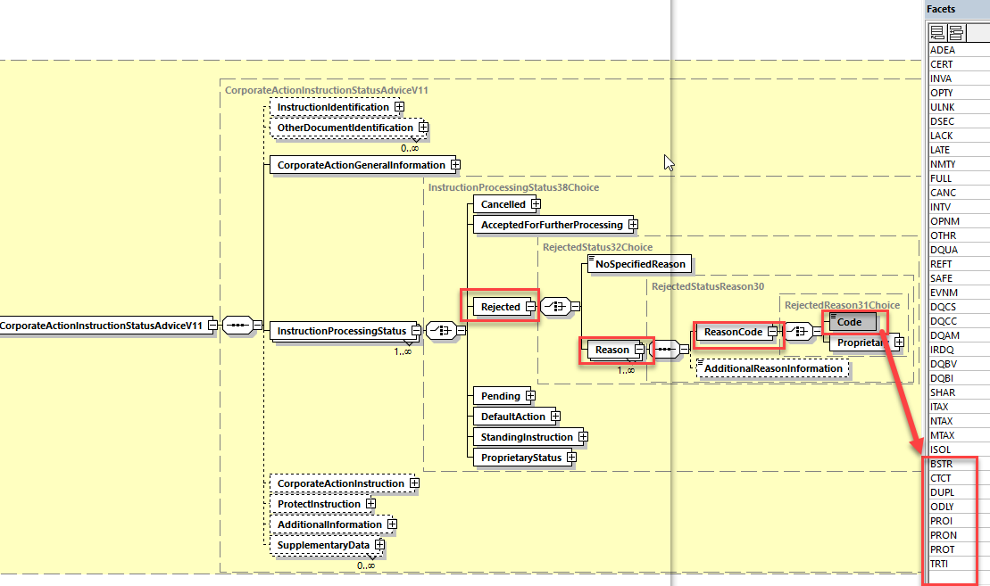

**In the seev.034 (CAIS – CorporateActionInstructionStatusAdvice)** in sequence *InstructionProcessingStatus/Pending/Reason/ReasonCode, a*dd the following new reason code to the date type ***PendingReason18Code*** of the element Code as defined in ISO 15022 above:

SNAV:System Not Available

BSTR: Before Instruction Period

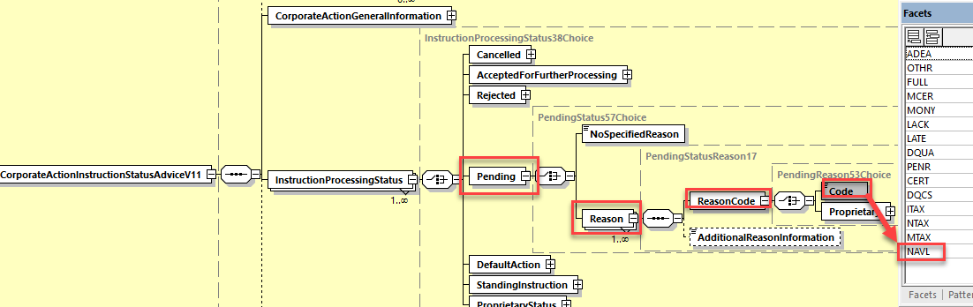

1. In case, the status reason codes must be added to the seev.042, the following **changes are required:**

**In the seev.042 (CAST – CorporateActionInstructionStatementReport)** message, in sequence *AccountAndStatementDetails/CorporateActionEventAndBalance/Balance/TotalInstructedBalanceDetails/OptionDetails/OptionInstructionDetails/InstructionStatus/Rejected/Reason/ReasonCode*, add the following new reason codes to the data type ***RejectedReason49Code*** of the element Code as defined in ISO 15022 above and as illustrated below:

BSTR: Before Instruction Period

CTCT: Missing contact

DUPL: Duplicate Instruction

PROI: Missing Protect Identification

PRON: No Protect Privilege

PROT: Missing Protect Date

TRTI: Missing Transaction Type

**Working Group Meeting**

|  |
| --- |
| **Discussion** |
| Although DE and BE have some comments regarding some of the reason codes with which they do not agree in some specific cases, overall a majority of the MWG agree with the business case.  The MWG agrees with the proposed solution with the following changes:   * Replace NAVL by an alternative 4 letters code to be found as it might be confused with an existing NAVL code already in securities messages and meaning something else. * Do not include ODLY as the existing DQUA reason code can be used instead. * Add the BSTR reason code to the pending status as well.   The MWG recommend that the SMPG works on a market practice for the usage of these new reason codes. |
| **Decision** |
| **Approved with comments** |

**Final decision of the Securities SEG regarding ISO 20022 messages:**

|  |  |
| --- | --- |
| Approve the MWG decision | approved |

Comments:

|  |  |
| --- | --- |
| Reject the MWG decision |  |

Reason for rejection:

## CR 001660: Fix Incorrect MITI data Type in Base message (ISO20022 – CR 0896)

|  |  |
| --- | --- |
| **Origin of request** | |
| Requesting Country: | SWIFT |
| **Sponsors** | |
|  | |
| **Message type(s) impacted** | |
| seev.036, seev.037 | |
| **Complies with regulation** | |
| None | |
| **Business impact of this request** | |
| None | |
| **Commitment to implement the change** | |
| Commits to implement and when: 2021 | |
| **Business context** | |
| The data type “RestrictedFINMax35Text” assigned currently to these elements in the ISO 20022 base messages (variant 001) is the one that must be assigned to the variant “002”. Therefore this is incorrect and the data type should be replaced with simply”Max35Text”. | |
| **Nature of change** | |
| In the CorporateActionMovementConfirmation and in the CorporateActionMovementReversalAdvice messages, replace the data type “RestrictedFINMax35Text” of the element “TransactionIdentification/MarketInfrastructureTransactionIdentification” by “Max35Text”. | |
| **Workaround** | |
| None | |
| **Examples** | |
| NA | |

**SWIFT Comment**

|  |
| --- |
|  |

**Standards Illustration**

**2. ISO 20022 Illustration**

**In the seev.036 (CACO – CorporateActionMovementConfirmation)** message, and

**In the seev.037 (CARA - CorporateActionMovementReversalAdvice)**,

in sequence *TransactionIdentification*, change the data type *RestrictedFINMax35Text* of the element *MarketInfrastructureTransactionIdentification* by the data type *Max35Text* as illustrated below:

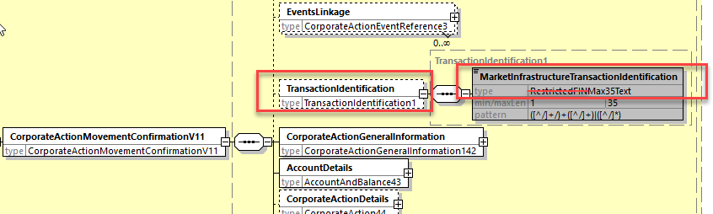

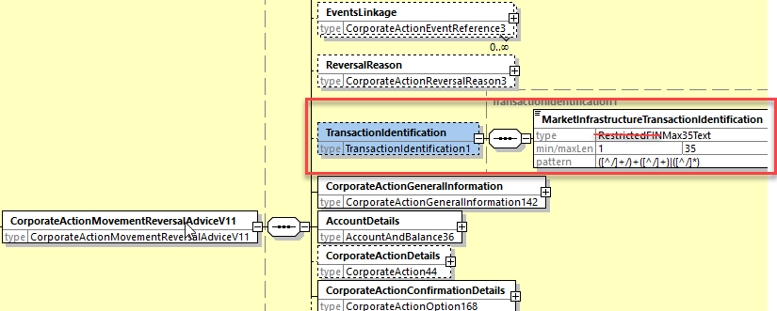

**Working Group Meeting**

|  |
| --- |
| **Discussion** |
| The MWG agrees with the technical change proposed by SWIFT. |
| **Decision** |
| **Approved** |

**Final decision of the Securities SEG regarding ISO 20022 messages:**

|  |  |
| --- | --- |
| Approve the MWG decision | approved |

Comments:

|  |  |
| --- | --- |
| Reject the MWG decision |  |

Reason for rejection:

## CR 001661: Add Support for Multi Languages Announcements (ISO20022 – CR 0897)

|  |  |
| --- | --- |
| **Origin of request** | |
| Requesting Country: | SMPG |
| **Sponsors** | |
| SMPG | |
| **Message type(s) impacted** | |
| seev.031.00x.10 (and seev.001.001.07 – see the GM MCR) | |
| **Complies with regulation** | |
| Shareholders Rights Directive II | |
| **Business impact of this request** | |
| MEDIUM | |
| **Commitment to implement the change** | |
| Commits to implement and when: 2021 | |
| **Business context** | |
| The Shareholder Rights Directive (SRD) Implementation Regulation EU 2018/1212 specifies in article 2 paragraph 2 for corporate action events and general meetings that “The information shall be provided by the issuer in the language in which it publishes its financial information pursuant to Directive 2004/109/EC of the European Parliament and of the Council (1) and, unless not justified taking into account the issuer's shareholder base, also in a language customary in the sphere of international finance.”  This means that the announcement messages for corporate actions and general meetings in the scope of SRDII must be able to accommodate in addition to English the same narrative information in one or more other languages used in the EU/EEA countries and be able identify the language itself.  It should also be possible to provide references to a web site via URL addresses with information in different languages. Therefore it is also necessary to enable the repetition of the URL address element in the announcement and be able to identify the language of the provided information to which the URL is pointing. | |
| **Nature of change** | |
| **In the seev.031 message,**   1. in the sequence *CorporateActionDetails/AdditionalInformation*, make the element *URLAddress* repeatable and change the data type *UpdatedURLInformation2* by adding a mandatory element named *Language* typed with the data type *ISO2ALanguageCode.* 2. In the sequence CorporateActionOptionDetails/AdditionalInformation, make all narrative type elements repetitive and change the data type *UpdatedURLInformation3* by adding a mandatory element named *Language* typed with the data type *ISO2ALanguageCode.* 3. In the sequence AdditionalInformation, make all narrative type elements repetitive and change the data type *UpdatedURLInformation8* by adding a mandatory element named *Language* typed with the data type *ISO2ALanguageCode* and for the URLAddress element, change the data type Max2048 Text by the new data type used to type the URLAddress in the CorporateActionDetails sequence as illustrated below*:* | |
| **Workaround** | |
|  | |
| **Examples** | |
| NA | |

**SWIFT Comment**

|  |
| --- |
|  |

**Standards Illustration**

**2. ISO 20022 Illustration**

**In the seev.031 (CANO – CorporateActionNotification) message,**

1. In the sequence *CorporateActionDetails/AdditionalInformation*, make the element *URLAddress* repeatable and change the data type *UpdatedURLInformation2* by adding a mandatory element named ***Language*** typed with the data type *ISO2ALanguageCode and change the URLAddress element data type Max256Text by Max2048Text as illustrated below:*

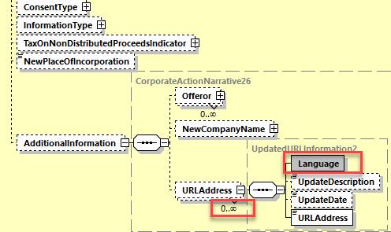

1. In the sequence *CorporateActionOptionDetails/AdditionalInformation*, make all narrative type elements repetitive and change the data type *UpdatedAdditionalInformation3* and UpdatedAdditionalInformation1 by adding a mandatory element named ***Language*** typed with the data type *ISO2ALanguageCode as illustrated below:*

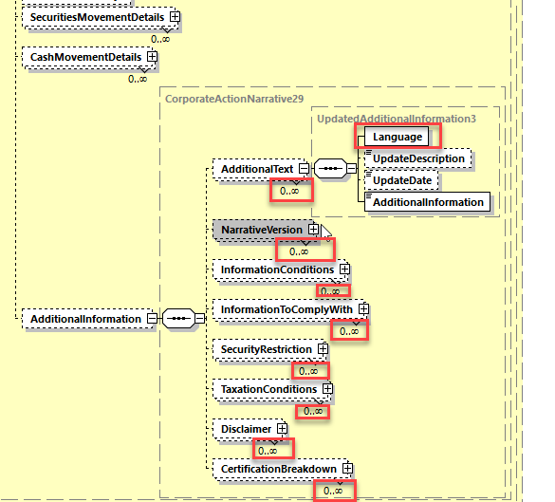

1. In the message building block AdditionalInformation, make all narrative type elements repetitive and change the data type *UpdatedAdditionalInformation8* by adding a mandatory element named ***Language*** typed with the data type *ISO2ALanguageCode* and for the URLAddress element, change the data type Max2048 Text by the new data type used to type the URLAddress in the CorporateActionDetails sequence as illustrated below*:*

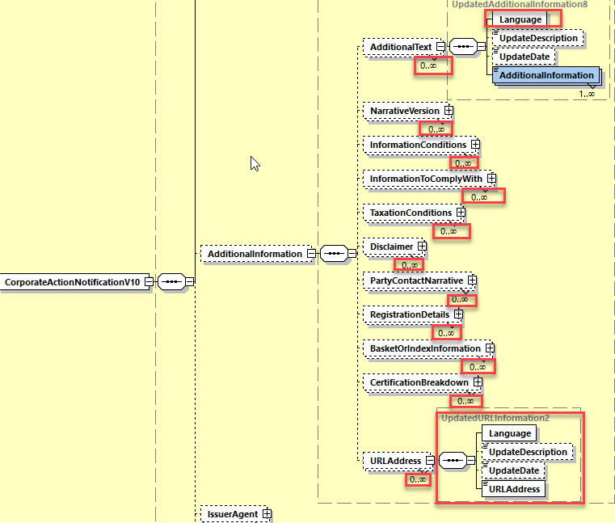

**Working Group Meeting**

|  |
| --- |
| **Discussion** |
| The MWG agrees with the business case and proposed solution.  The MWG agrees with the remark from DE that in a cross-border context, general limitations / agreements / market practices should be put in place so that English should always be used and that local language should only be sent in accordance with the respective SLA.  The MWG recommends to the SMPG to define a related global market practice on this. |
| **Decision** |
| **Approved** |

**Final decision of the Securities SEG regarding ISO 20022 messages:**

|  |  |
| --- | --- |
| Approve the MWG decision | approved |

Comments:

|  |  |
| --- | --- |
| Reject the MWG decision |  |

Reason for rejection:

## CR 001662: Amend Narrative Message Scope Description (ISO20022 – CR 0898)

|  |  |
| --- | --- |
| **Origin of request** | |
| Requesting Country: | SMPG |
| **Sponsors** | |
| SMPG | |
| **Message type(s) impacted** | |
| seev.038 | |
| **Complies with regulation** | |
| None | |
| **Business impact of this request** | |
| None | |
| **Commitment to implement the change** | |
| Commits to implement and when: 2021 | |
| **Business context** | |
| Based on received queries, the SMPG has identified a potential misunderstanding and/or misuse of the CorporateActionNarrative message. Parties more familiar with ISO 15022 corporate action messages may believe that the CorporateActionNarrative message should be used in all scenarios where an MT568 message is used. The revised scope is aimed at preventing such misunderstanding/misuse. | |
| **Nature of change** | |
| **In the seev.038 message,**  Change the scope from  The CorporateActionNarrative message is sent between an account servicer and an account owner or its designated agent to cater for tax reclaims, restrictions, documentation requirements. This message is bi-directional.  To  The CorporateActionNarrative message is sent between an account servicer and an account owner or its designated agent to cater for such processes that cannot be handled using messages such as the CorporateActionNotification. It is not to be used for event narrative as that should be included in the CorporateActionNotification. Examples of when the CorporateActionNarrative message may be used include tax reclaims, restrictions, documentation requirements. This message should only be used when bilaterally agreed. This message is bi-directional. | |
| **Workaround** | |
| None | |
| **Examples** | |
| NA | |

**SWIFT Comment**

|  |
| --- |
|  |

**Standards Illustration**

**2. ISO 20022 Illustration**

**In the seev.038 (CANA – CorporateActionNarrative)** message, amend the “Scope” definition of the message as follows:

*The CorporateActionNarrative message is sent between an account servicer and an account owner or its designated agent to cater for ~~tax reclaims, restrictions, documentation requirements~~* ***such processes that cannot be handled using messages such as the CorporateActionNotification. It is not to be used for event narrative as that should be included in the CorporateActionNotification. Examples of when the CorporateActionNarrative message may be used include tax reclaims, restrictions, documentation requirements. This message should only be used when bilaterally agreed.*** *This message is bi-directional.*

**Working Group Meeting**

|  |
| --- |
| **Discussion** |
| DE requests to rather remove completely the message instead of adapting its definition.  The MWG finds the request from DE a bit premature as the ISO message is known to be used in some countries although not on the SWIFT network although this does not justify the request to remove.  Finally the whole MWG approves the definition change as proposed. |
| **Decision** |
| **Approved** |

**Final decision of the Securities SEG regarding ISO 20022 messages:**

|  |  |
| --- | --- |
| Approve the MWG decision | approved |

Comments:

|  |  |
| --- | --- |
| Reject the MWG decision |  |

Reason for rejection:

**Legal Notices**

Copyright

SWIFT © 2020. All rights reserved.

Disclaimer

This publication constitutes advance information only and is not to be considered the final and complete standards documentation for the subject matter published herein. The information in this publication may change from time to time. You must always refer to the latest available version.

SWIFT Standards Intellectual Property Rights (IPR) Policy - End-User License Agreement

SWIFT Standards are licensed subject to the terms and conditions of the SWIFT Standards IPR Policy - End-User License Agreement, available at www.swift.com > About Us > Legal > IPR Policies > SWIFT Standards IPR Policy.

Translations

The English version of SWIFT documentation is the only official and binding version.

Trademarks

SWIFT is the trade name of S.W.I.F.T. SC. The following are registered trademarks of SWIFT: 3SKey, Innotribe, MyStandards, Sibos, SWIFT, SWIFTNet, SWIFT Institute, the Standards Forum logo, the SWIFT logo and UETR. Other product, service, or company names in this publication are trade names, trademarks, or registered trademarks of their respective owners.

1. MWG maintenance meeting minutes are distributed around first week of September. [↑](#footnote-ref-1)