Change Request
for the update of ISO 20022 financial repository items
Note: the purpose of this document is to give guidelines to parties who want to introduce a request to change an existing ISO 20022 message(s), or update other items of the ISO 20022 financial repository. Such change requests are subject to the approval of the ISO 20022 Standards Evaluation Group(s) in charge of the related message/item or to the approval of the Technical Support Group (TSG), if the requested change relates to the Business Application Header (BAH). Please consult the iso20022.org website for additional details on the maintenance process. All change requests conforming to this template received by June 1st will be considered for development in the following yearly ISO 20022 maintenance cycle which completes with publication of new message versions in April/May of the following year.
Changes requests are to be submitted through the ISO 20022 website through this e-request, in which this template must be attached.
- Origin of the request:
A.1 Submitter: identity of the company, organization, group, initiative or community that submits the change request.

The three Japanese banks are;
- Sumitomo Mitsui Banking Corporation (SMBC)
- MUFG Bank, Ltd. (MUFG)
- Mizuho Bank, Ltd. (Mizuho)

A.2 Contact person: person(s) who can be contacted to get additional information on the request (name, e-mail, telephone)

- SMBC: (Mr.) Toshihiko Aida, Aida_Toshihiko@dn.smbc.co.jp, +81-3-4333-8615
- MUFG: (Mr.) Yousuke Nakamata, yousuke_nakamata@mufg.jp,
- Mizuho: (Mr.) Ryousuke Sakai, ryousuke.sakai@mizuho-bk.co.jp,

A.3 Sponsors: it is highly recommended that a submitter of a Change Request gain the agreement and support from as many additional organisations, groups, initiatives or communities of users as possible, thus demonstrating as wide as possible a consultation of the relevant stakeholders. All organisations, groups, initiatives or communities supporting the change request should be identified as sponsors along with a contact person, if possible. This community involvement is intended to help avoid delays and/or subsequent amendments to the change request.

- CGI MP Working Group 1 (Chairperson Ms. Kerstin)

- Related messages:
The list of ISO 20022 messages which would be impacted by the change, including the Message IDs as shown in the Catalogue of ISO 20022 messages. Only the latest version of a message definition can be maintained.
The submitter is invited to carefully examine whether the change may have an impact on other messages that come into play earlier or later in the transaction chain or on other messages that also use message components that this change request may impact.

The requestors (the Japanese three banks; MUFG, Mizuho, and SMBC) raised the following two use cases to CGI-MP WG1 on 2022/9/14 about the usage suggestion of <SplmtryData> (“Supplementary data”) tag under the pain.001 Version 09 to deal with multiple FX information / debit accounts for single overseas payment with single creditor (not add/amend/delete any existing messages).

CGI-MP WG1 concluded to agree with this request (usage suggestion of <SplmtryData> tag for the described use case in Item C below) on 2022/09/14.

- Description of the change request:
A specific change request form must be completed for each particular change requested (for example, adding, deleting, modifying, renaming, changing the cardinality, moving an element/component, or changing the type of an element, changing a code set).
If the change request consists, for example, of adding new functionality which requires several changes which would not make sense if not performed all together, then all these related changes should be described on the same form.
Change requests may not lead to creation of new messages. In such cases, a 'business justification' for development of new candidate ISO 20022 messages must be introduced by a submitting organization that is ready to develop the new messages.

The requestors don’t request any changes of the existing messages, but just request for approval to the ISO Payments SEG about permission of usage of <SplmtryData> (“Supplementary data”) tag that is incorporated in the pain.001 Version 09.

(Case 1) Usage of multiple different debit currency accounts for single overseas payment with single creditor.

- Debtor banks allow debtors to input multiple different debit currency accounts under <SplmtryData> tag.
- Debtors can input multiple debit accounts under the tag with three mandatory items;
- the amount per deal (Amt tag with InstdAmt)
- the rate type, if applicable, with codeword suggested by the group
(e.g., Spot: “SALE”, forward FX contract “AGRD”)
- the FX contract ID, if applicable
- As for debit accounts under <PmtInf> tag, debtor should input one of the multiple debit accounts. The debit account will be reflected to pacs.008 on behalf of the multiple debit accounts.

(Case 2) Usage of repetition of forward FX contract exchange rate with single debit bank accounts for single overseas payment with single creditor.

- Debtor banks allow debtors to input single debit account with multiple forward FX contract information under <SplmtryData> tag.
- Debtors doesn’t need to input debit account under <SplmtryData> tag again. However, the debtor should input multiple forward FX contract information under the tag with three mandatory items;
- the amount per deal (Amt tag with InstdAmt)
- the rate type (forward FX contract “AGRD”)
- the FX contract ID, if applicable

- Purpose of the change:
Background, business context, community of users interested by the change and expected benefits/savings.
This section must explain why the existing ISO 20022 messages need to be changed. The reason for the update may be a business reason (e.g., evolution of market practice, or creation of new financial instruments), a technical reason (e.g., automation of the business process, or switch from a batch to a real time process), a regulatory reason (introduction, generally mandatory, of new rule/law) or the extension of the user community (newly identified business requirements).

With the current pain.001 Version 09 ISO schema, two types of FX scenario below are not feasible. The use case map span across further APAC countries, or when regulated currencies are used.

(Case 1) Usage of multiple different debit currency accounts for single overseas payment with single creditor.

In a FX scenario, there could be different deals involved under the total amount to be paid to one creditor, e.g., a spot deal with amount x, a deal referring to a particular contract with amount y, and a deal without FX rate agreement with amount z.
All amounts sum up to the total amount xyz transferred as a single overseas payment to the single creditor with the pain.001.

In some cases, these sub-amounts could be agreed to de debited to different debtor accounts.
(e.g., as for trading companies, in case several different business units of HQ order its RHQ to import multiple types of goods, finance dept. of HQ often combines payments to RHQ as a single overseas payment. In order to reduce FX rate change, multiple different debit currency accounts will be used for the single overseas payment with single creditor).

There is a long history in Japan that all Japanese banks has been accepting the “Japan Zengin format” for overseas payment of this use case for more than several decades in Japan. In case the pain.001 Version 09 ISO schema can’t accept this type of overseas payment, there would be huge impacts on huge number of Japanese corporations.

Therefore, the requestors suggest providing the details in a pain.001 Version 09 under <SplmtryData> (“Supplementary data”) tag, and presented how it would like (please refer to the attached two xml files).

In the classic parts of the pain.001, the total Instructed Amount is provided, and one debit account, which is based on bilateral agreement between the debtor and the debtor agent. This is forwarded with the clearing payment message.

Under the <SplmtryData> tag, there can be repetitions of
-the debit accounts with currency, if multiple ones apply (if one debit account, this is provided in the dedicated debtor account tag outside <SplmtryData> tag only)
- the amount per deal (Amt tag with InstdAmt)
- the rate type, if applicable, with codeword suggested by the group
- the FX contract ID, if applicable

The information provided under <SplmtryData> tag will not be forwarded in the clearing payment message, but used between debtor and debtor agent.

(Case 2) Usage of multiple forward FX rates with single debit bank accounts for single overseas payment with single creditor.

In a FX scenario, there could be multiple forward FX contracts deals involved under the total amount to be paid to one creditor, e.g., a deal referring to a contract A with amount x, another deal referring to a contract B with amount y, and another deal referring to a contract C with amount z.
All amounts sum up to the total amount xyz transferred as a single overseas payment to the single creditor with the pain.001.

In some cases, these sub-amounts could be agreed to de debited to single debtor account.
(e.g., in case the number of invoices for single overseas payment are suddenly changed, or changing portion of hedging FX rate fluctuation, etc.)

Currently, many clients use this use case.

Therefore, the requestors suggest providing the details in a pain.001 Version 09 under <SplmtryData> (“Supplementary data”) tag, and presented how it would like (please refer to the attached two xml files).

In the classic parts of the pain.001, the Exchange Rate tag is provided, and single Exchange Rate, which is based on bilateral agreement between the debtor and the debtor agent. These are not forwarded with the clearing payment message.

Under the <SplmtryData> tag, there can be repetitions of
-the debit accounts with currency, if multiple ones apply (if one debit account, this is provided in the dedicated debtor account tag outside <SplmtryData> tag only)
- the amount per deal (Amt tag with InstdAmt)
- the rate type (forward FX contract, “AGRD”)
- the FX contract ID, if applicable

The information provided under <SplmtryData> tag will not be forwarded in the clearing payment message, but used between debtor and debtor agent.

- Urgency of the request:
By default, valid change requests introduced by June 1 and subsequently approved by the SEG/TSG will be included in the following yearly maintenance cycle which completes with the publication of new message versions by April/May of the following year, unless decided otherwise by the SEG/TSG.
If there is a need to have the new version of the related messages published earlier, the reason for the urgency of the maintenance and the expected consequences of a delay should be described here. Acceptance of such an unscheduled maintenance for the BAH is subject to approval by TSG. Acceptance of an unscheduled maintenance for messages other than the BAH is subject to the approval of the SEG and availability of a submitting organization to develop the new version of the messages.
Note: the ISO 20022 maintenance results in the publication of a new version of an ISO 20022 message. The actual implementation of such new version on networks and in user installations is not within the purview of ISO.

The requestors (the three Japanese banks) need to finalize specification of the development to apply for the usage of <SplmtryData> (“Supplementary data”) tag for debtors by the early 2023 at the latest.

This request doesn’t require to add/amend/delete the existing messages, but just require a permission of ISO20022 Registration Authority to use “Supplementary Data” tag to deal with two types of overseas payment transactions. The <SplmtryData> tag is already incorporated in the pain.001 Version 09.

The requestors hope Registration Authority of ISO 20022 permits our request soon.

- Business examples:
Examples illustrating the change request.

(Case 1) Usage of multiple different debit currency accounts for single overseas payment with single creditor.

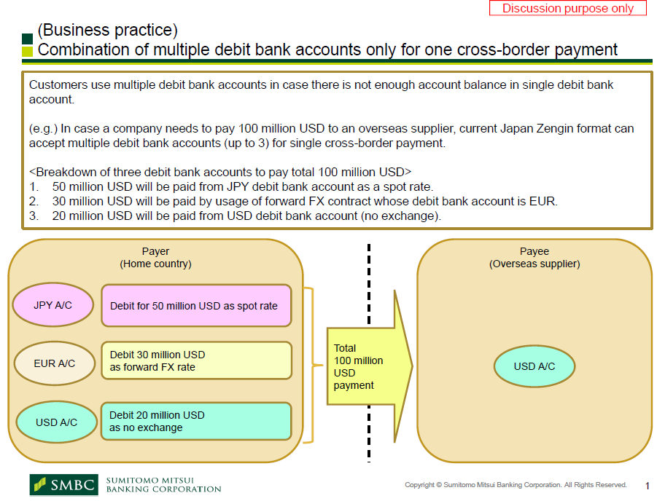

(Case 2) Usage of repetition of forward FX contract exchange rate with single debit bank accounts for single overseas payment with single creditor.

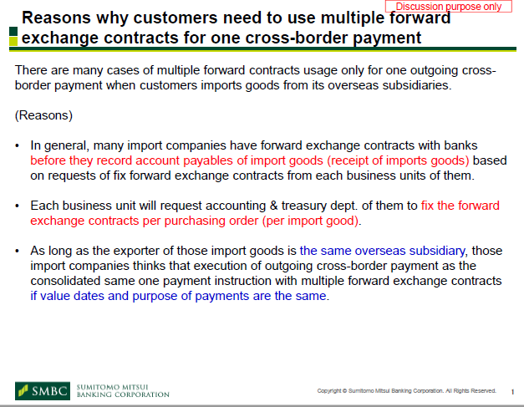

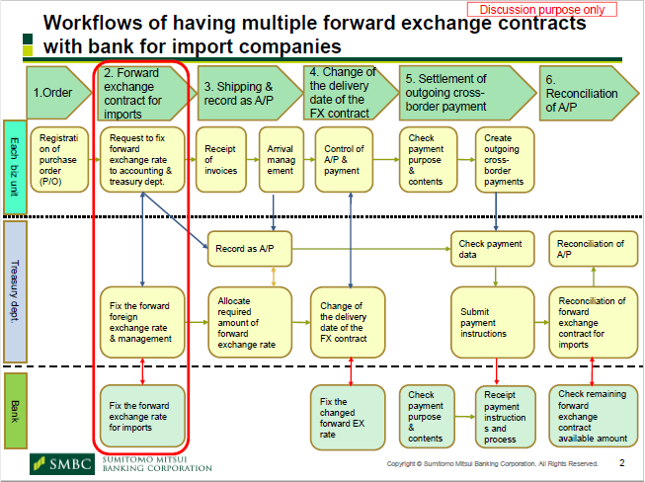
- SEG/TSG recommendation:
This section is not to be taken care of by the submitter of the change request. It will be completed in due time by the SEG(s) in charge of the related ISO 20022 messages or the TSG for changes related to the BAH.

Consider |  |  | Timing
- Next yearly cycle: 2023/2024
(the change will be considered for implementation in the yearly maintenance cycle which starts in 2022 and completes with the publication of new message versions in the spring of 2023)
- At the occasion of the next maintenance of the messages
(the change will be considered for implementation, but does not justify maintenance of the messages in its own right – will be pending until more critical change requests are received for the messages)
- Urgent unscheduled
(the change justifies an urgent implementation outside of the normal yearly cycle)
 |  |  | - Other timing:
Comments:

Reject
Reason for rejection:

