Change Request
for the update of ISO 20022 financial repository items

- Origin of the request:
A.1 Submitter: nexo A.I.S.B.L
A.2 Contact person: Philippe CECE (Philippe.cece@ingenico.com) / Laure BELTRI (laure.beltri@frenchsys.com)
A.3 Sponsors: nexo A.I.S.B.L.

- Related messages:

- ManagementPlanReplacement V10 (catm.002.001.10)
- AcceptorConfigurationUpdate V11 (catm.003.001.11)
- MaintenanceDelegationRequest V08 (catm.005.001.08)

- Description of the change request:

In the current model of the protocols, MessageItem determines the condition of presence for some message elements in messages, and probably its value.
The MessageItem.ItemIdentification identifies the message element concerned by the configuration, and MessageItem.Condition defines the behavior of the configuration on the message element.
The Condition values currently supported are reminded in the following table.

Value | Usage
AllowedValues | Recipient supports only a set of values defined in the value list.
IfAvailable | Message element is sent if the message sender knows it.
Mandatory | Message element must be present in the message.
NotSupported | Message element is not supported by the recipient.
ConfiguredValue | Message element is mandatory and takes the specific value defined in the element Value of MessageItem.

Considering the previous table, we realized that there is no way to express that we expect at least values in a list but others could be also provided. The aim of this Change Request is to create this value.

- Purpose of the change:

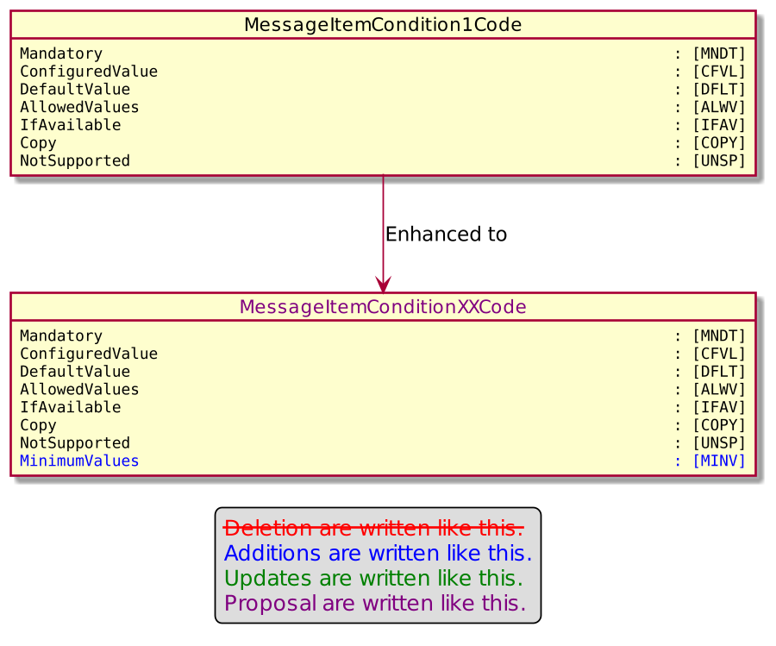

- Urgency of the request:

Urgent

- Business examples:
Examples illustrating the change request.
- SEG/TSG recommendation:
This section is not to be taken care of by the submitter of the change request. It will be completed in due time by the SEG(s) in charge of the related ISO 20022 messages or the TSG for changes related to the BAH.

Consider |  |  | Timing
 |  |  | - Next yearly cycle: 2022/2023  (the change will be considered for implementation in the yearly maintenance cycle which starts in 2022 and completes with the publication of new message versions in the spring of 2023) |  | X
- At the occasion of the next maintenance of the messages
(the change will be considered for implementation, but does not justify maintenance of the messages in its own right – will be pending until more critical change requests are received for the messages)
- Urgent unscheduled
(the change justifies an urgent implementation outside of the normal yearly cycle)
 |  |  | - Other timing:
Comments:

Reject
Reason for rejection:

