Change Request
for the update of ISO 20022 financial repository items
Note: the purpose of this document is to give guidelines to parties who want to introduce a request to change an existing ISO 20022 message(s), or update other items of the ISO 20022 financial repository. Such change requests are subject to the approval of the ISO 20022 Standards Evaluation Group(s) in charge of the related message/item or to the approval of the Technical Support Group (TSG), if the requested change relates to the Business Application Header (BAH). Please consult the iso20022.org website for additional details on the maintenance process. Change requests are to be sent to iso20022ra@iso20022.org. All change requests conforming to this template received by June 1st will be considered for development in the following yearly ISO 20022 maintenance cycle which completes with publication of new message versions in April/May of the following year.
- Origin of the request:
A.1 Submitter: CLS Bank International
A.2 Contact person: Stuart Buckley. sbuckley@cls-services.com
A.3 Sponsors: This change has been socialised with all CLS Member/Participant banks via an official Participant notice. We adopt a policy at CLS of aligning our messages to the latest standards where there is a valid business case to do so. No objections have been received.
The list of ISO 20022 messages which would be impacted by the change, including the Message IDs as shown in the Catalogue of ISO 20022 messages. Only the latest version of a message definition can be maintained.

Message | Message Name
fxtr.014.001.04.xsd | ForeignExchangeTradeInstructionV04
fxtr.015.001.04.xsd | ForeignExchangeTradeInstructionAmendmentV04
fxtr.016.001.04.xsd | ForeignExchangeTradeInstructionCancellationV04
fxtr.017.001.04.xsd | ForeignExchangeTradeStatusAndDetailsNotificationV04

- Description of the change request:

Updating the message schemas listed above from the suite of CLS related FX messages, with Commission and Fee’s fields to align with field 34C and Digital Token Identifier field to align with field 35C in the MT 300 and MT 304.

- Purpose of the change:
CLS also has a policy of aligning messages to the latest versions and standards. Adding the Commission and Fee’s field to align to the MT 300 and MT 304 has been deferred for four years and there are therefore obvious synergies to add the Digital Token Identifier in tandem with these changes. This will meet our Members expectations regarding standards alignment across our message suite.
- Urgency of the request:

Default timeline of June 1st for submission and availability of the new versions in SR2023.
- Business examples:
Examples illustrating the change request.

These are new MX elements required in the fxtr messages to align with the below MT change requests from SR2018 and SR2022 respectively.

Field 34C
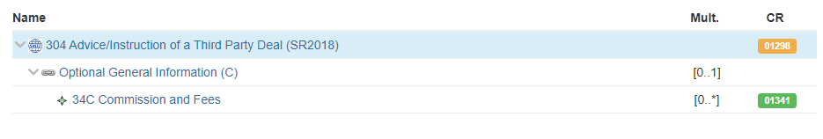

Field 35C
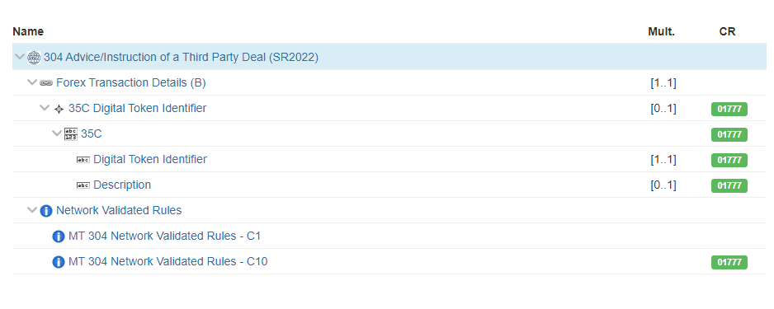

- SEG/TSG recommendation:
This section is not to be taken care of by the submitter of the change request. It will be completed in due time by the SEG(s) in charge of the related ISO 20022 messages or the TSG for changes related to the BAH.

Consider |  |  | Timing
 |  |  | - Next yearly cycle: 2022/2023  (the change will be considered for implementation in the yearly maintenance cycle which starts in 2022 and completes with the publication of new message versions in the spring of 2023) |  | X
- At the occasion of the next maintenance of the messages
(the change will be considered for implementation, but does not justify maintenance of the messages in its own right – will be pending until more critical change requests are received for the messages)
- Urgent unscheduled
(the change justifies an urgent implementation outside of the normal yearly cycle)
 |  |  | - Other timing:
Comments:

Reject
Reason for rejection:

