Change Request
for the update of ISO 20022 financial repository items

- Origin of the request:
A.1 Submitter:
DESSUG CA – PSG (Deutsche SWIFT Securities Market User Group - Corporate Actions - Proxy Subgroup Germany)
This group represents more than 20 different institutions including domestic and global proxy providers and registrars with a key role in the German General Meeting process.

A.2 Contact person:
PSG Chair - Hendrik Melchior (employer change to Clearstream Banking Frankfurt in July)
PSG Deputy Chair - Daniel Schäfer, Daniel.Schaefer@hsbc.de, Phone +49 211 910-2362
Sabine Wolff, Sabine.Wolff@clearstream.com, Phone +352-243-3 66 40
SEG GM-ET Member (Germany) - Sven Gunkel, sven-a.gunkel@db.com, Phone +49 69910-60715
SEG GM-ET Member (Germany) - Rainer Prior, Rainer.Prior@linkmarketservices.de, Phone +49 6196 8870 514

A.3 Sponsors:
German Market - including domestic and global proxy providers with a key role in the German General Meeting process.
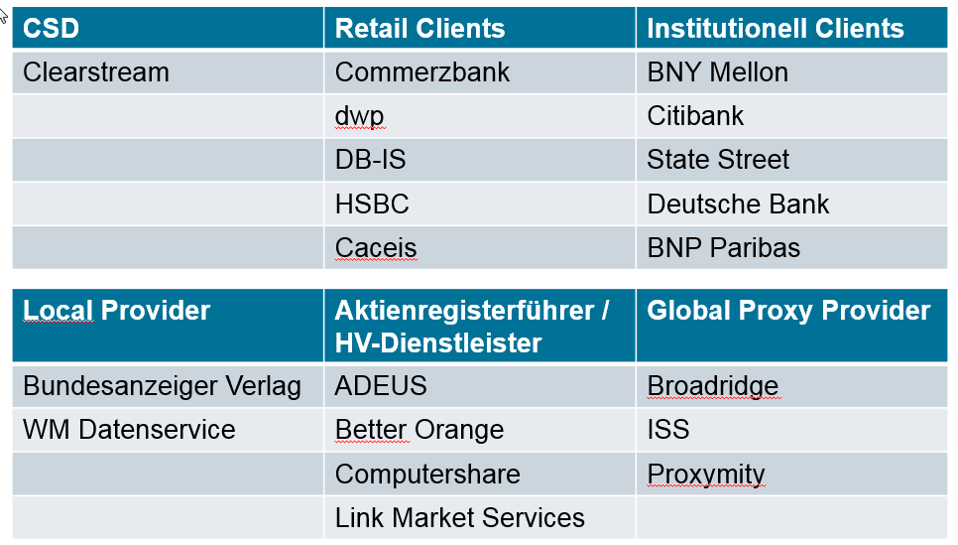

- Related messages:
seev.001.xxx.xxx

- Description of the change request:
Necessity of specific confirmation of holding <NecSpeConfHold>
Multiplicity: optional [0..1]
Value: blank or Yes
Path: /Document/MtgNtfctn/NtfctnGnlInf/NecSpeConfHold
Description: Indicates whether a specific confirmation of holding together with a participation/ vote instruction is required. (e.g. Germany §67c(3))

The German Stock Corporation Act was adopted to include SRD II requirements. This includes the update of paragraph 67c Section3 referring to Confirmation of Holding in line with Article 5 of the Implementation Regulation (EU) 2018/1212.
The Implementing Regulation assumes that a confirmation of entitlement and, where applicable, a notice of participation in the general will enable shareholders to exercise their rights at the general meeting.

The requirement to provide such a confirmation is part of the AoA (Articles of Association) of the company and usually announced in the convocation of the meeting. This confirmation is a prerequisite to participate and vote and needs to be provided to the issuer/agent/registrar together with the participation/vote instruction. In case is not provided, instructions will not be processed.
This is not a general rule to the German market nor limited to SRD II relevant securities and therefore needs to be captured case by case in the meeting notification.

- Purpose of the change:
This is a regulatory requirement for the German market to indicate if the specific confirmation of holding together with a participation/ vote instruction is required.
The field should be populated by the issuer.

- Urgency of the request:
N/A

- Business examples:
…
Notification General Information < NtfctnGnlInf> 1 1
Notification Type < NtfctnTp> 1 1
Notification Status < NtfctnSts> 1 1
Shareholder Rights Directive Indicator <ShrhldrRghtsDrctvInd> 0 1
Necessity of specific confirmation of holding <NecSpeConfHold> 0 1
….

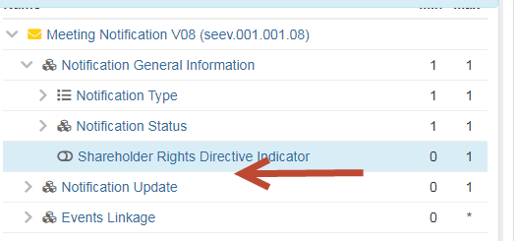

- SEG/TSG recommendation:
This section is not to be taken care of by the submitter of the change request. It will be completed in due time by the SEG(s) in charge of the related ISO 20022 messages or the TSG for changes related to the BAH.

Consider |  |  | Timing
 |  |  | - Next yearly cycle: 2021/2022  (the change will be considered for implementation in the yearly maintenance cycle which starts in 2021 and completes with the publication of new message versions in the spring of 2022) |  | X
- At the occasion of the next maintenance of the messages
(the change will be considered for implementation, but does not justify maintenance of the messages in its own right – will be pending until more critical change requests are received for the messages)
- Urgent unscheduled
(the change justifies an urgent implementation outside of the normal yearly cycle)
 |  |  | - Other timing:
Comments:

Reject
Reason for rejection:

