Standards
Standards MT Release 2023
Discussion paper and Minutes
Settlement and Reconciliation
Distribution: Settlement and Reconciliation Maintenance Working Group
Author: Alexandre Hotat

Date Issued: 30 June 2022
Meeting Date: 25 August 2022

Table of Contents
1 Introduction 3
2 Overview of User Change requests 5
2.1 CR 001887: Addition of a Continuation flag in the PENA sequence of the MT537. 5
2.2 CR 001889: Add a new Network Validation to enforce the presence of the statement period in the monthly penalty report. 10
2.3 CR 001890: Add a new Network Validation to enforce the presence of the payment date in the monthly penalty report. 13
2.4 CR 001891: Update NVR C2 to include the sequence D1a1B1 in the validation. 16
3 Overview of SWIFT Change requests 19

Introduction

ISO 15022 – 20022 Maintenance Process
As from the year 2012, a joint maintenance process has been put in place for ISO 20022 and 15022 and Settlement & Reconciliation messages with the support of the ISO 20022 RMG and of the SWIFT Board.
This joint maintenance will ensure interoperability between the two standards and a more efficient maintenance process.
Standards Illustrations in this document
Standards illustrations are provided by SWIFT Standards. They are not part of the original request.
Any standard illustrations (rules, codes, qualifiers, wordings) are only for illustration purposes. It does not mean SWIFT Standards is in agreement with the maintenance request or that the final standards solutions (for accepted maintenance requests) will be as shown in this document.
The MT Standards Release Guide (+ potential erratum) and the ISO 20022 message definition reports are the ONLY source of reliable information based on which implementation of changes should be made. Any other documentation (including this one) is subject to change.
SR 2023 change requests
This document contains all S&R MT/MX CRs for MT category 5 and equivalent MX messages investigated this year for implementation in SR 2023.
The requests originator is indicated as follows:
  - Requesting Country; Country code of requesting NMPG or UG; eg. BE
  - Requesting Group: a SWIFT User Group or a National (Securities) Market Practice Group with the acknowledgement of the UGC or Recognized industry group eg. SMPG (the global Securities Market Practice Group)
Contact persons regarding this document
Alexandre Hotat – SWIFT Standards, Alexandre.HOTAT@swift.com
CR Title Colour notation (for minutes only)
In GREEN are items that are approved or approved with comments or approved with alternative solution.
In RED are items that are rejected, withdrawn or linked to agreed items
In GREY are items that are postponed for review and implementation at the next release.

S&R MWG Members for SR2023
The following people are part of the S&R MWG for SR2023.

Maintenance working group members: | Representing: | Present
Brendan Laird - ASX | Australia
David Wouters – BNYMellon | Belgium
Xavier Filion Simon - BNC  Daniel Valance - RBC | Canada
Vacant | Denmark
Stephanie Clark Fischer – BNP Paribas  Mihaela Fallourd – BNP Paribas | France
Denis Andrejew – DB | Germany
Jennifer Chan– HSBC | Hong Kong
Jean-François Schleck - Euroclear | ICSD
Robin Leary – Citibank | Ireland
Michela Rabbia - Intesa Sanpaolo – Financial Institution Products  Agostino Guarino - Intesa Sanpaolo – Financial Institution Products | Italy
Takaya Hamamura - Mitsubishi Bank | Japan
Vacant | Republic of Korea
Arnaud Jochems – Clearstream | Luxembourg / ICSD
Ton Van Andel – ABN Amro | The Netherland
Vacant | Singapore
Vacant | South Africa
Cristina del Valle - BNP | Spain
Christine Strandberg - SEB | Sweden
Stephan Schuetter – UBS | Switzerland
Robin Leary – Citibank | United Kingdom
Aundrea Jarvis - BBH | United States of America

Overview of User Change requests

CR 001887: Addition of a Continuation flag in the PENA sequence of the MT537.
Origin of request
Requesting Country:
Requesting Group: | SMPG
Sponsors
SMPG
Message type(s) impacted
MT537, semt.044
Complies with regulation
CSDR
Business impact of this request
MEDIUM
Commitment to implement the change
Number of messages sent and received:
Percentage of messages impacted:
Commits to implement and when: SMPG 2023
Business context
The MT537 PENA (Penalty Report) is structured as such that it contains a great number of subsequences. This structure means that, if a penalty moves across pages, due to the maximum length of the SWIFT message being reached, all previous sequences and subsequences, with at least the mandatory fields at minimum, need to be included again to get to the last point at which the statement was cut on the previous page.

For instance, if there's a late matching penalty that runs over a number of days, each CALDET (calculation detail) subsequence required may not fit into one page of the statement, or it may be the case that a new penalty details were started towards the end of a page and subsequently move to the next page.

Whilst the latter can potentially be addressed with a common market practice guideline, the former is something that could still potentially occur due to the MT537 message length being reached even if it was the first penalty to be reported on that page. For example, this can lead to confusion around duplication of penalties as the PENDET (penalty details) sequence of the message needs to be populated prior to getting back to the CALDET (calculation details) sequence and, within the PENDET sequence, the PCOM (penalty common reference) is mandatory meaning the PCOM is shown on page x and x+1 etc.

The change would allow recipients of the message to help identify where penalties are crossing pages and are not a duplication.
Nature of change
Addition of a new flag or indicator qualifier to the MT537 PENA to indicate that the penalty is a continuation of the one of the page before it. Initial discussions have indicated that the PENDET (Penalty Details) sequence may be the best place to have this, but the Maintenance Working Group discussions should look to answer the following questions (assuming the business case is agreed):

1. Which sequence / subsequence should this go in?
2. Should the field / qualifier be mandatory?

For example, if the logical place of this to be would be in the PENDET sequence. However, that requires a new qualifier in, for example, the existing 17B flag field within the sequence and it would be November 2023 before it could be used.

CONT Continuation Flag
Indicates whether or not the penalty is a continuation of the one on the previous page and all prior information, for example, the penalty common reference, can be ignored

If, however, the MWG decided that the 22F Indicator with a new code (with qualifier CODE) in the PENA sequence would be the best place, a Data Source Scheme could be used in the interim to allow immediate use. The 22F CODE field would be made repetitive to allow the use of CONT as a new code but a Network Validation Rule inserted saying that it can only be repeated if CONT is one of the codes used and not other combination can be used together.
Examples
See accompanying Excel "SR2023 Continuation Flag or Indicator"

Standards Illustration

ISO15022
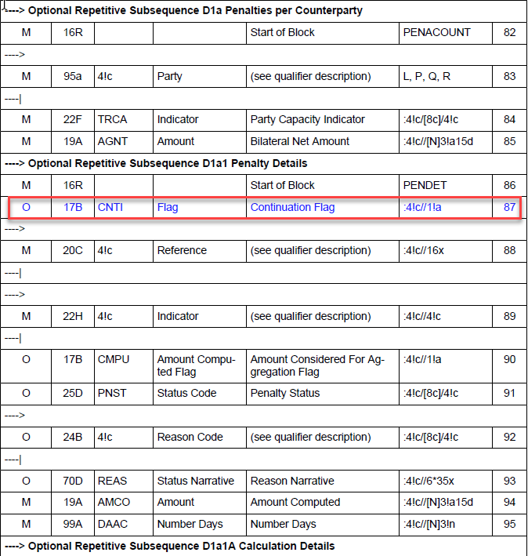

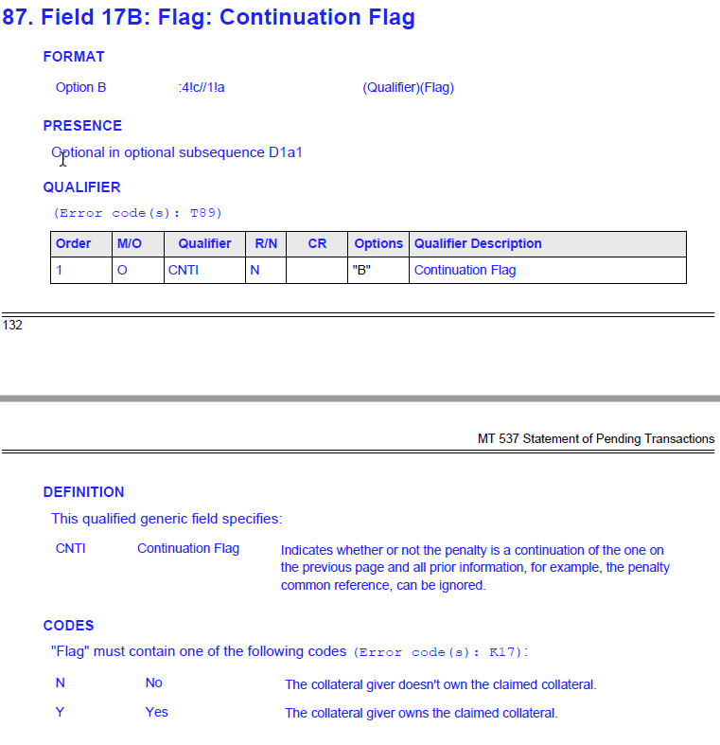

SWIFT Comment

No comment.
The semt.044 is owned by T2S/4CB not by SWIFT, the request has been sent to T2S/4CB.
In ISO20022, the size of the semt.044 should not be an issue as the swift network provides more capacity the’ for MT.

Working Group Meeting

Discussion
Decision

CR 001889: Add a new Network Validation to enforce the presence of the statement period in the monthly penalty report.
Origin of request
Requesting Country:
Requesting Group: | AFME
Sponsors
AFME
Message type(s) impacted
MT537, semt.044
Complies with regulation
CSDR
Business impact of this request
MEDIUM
Commitment to implement the change
Number of messages sent and received:
Percentage of messages impacted:
Commits to implement and when: AFME 2023
Business context
As per Global SMPG guidelines for CSDR Penalty Reporting, field 69a STAT (statement period) is considered mandatory in monthly penalty reports. However, the statement period is often not contained in the monthly report as the field is optional and may not be populated. The non-inclusion of the field makes it difficult to know for which month the statement belongs to.
Nature of change
Add a new Network Validation Rules C16 that states that:

If the statement is a Penalties statement (:23G:PENA), the Statement Frequence is Monthly (:22F::STST//MNTH) and the Activity Flag is Yes (:17B::ACTI//Y), all in sequence A, General Information, then it is mandatory to specify a statement period (field :69A::STAT or :69B::STAT) in sequence D (PENA).

Examples
:16R:GENL
:28E:00001/ONLY
:20C::SEME//0102210432267858
:23G:PENA (If Message Function is PENA)
:98A::STAT//20210314
:98C::PREP//20210201163226
:22F::SFRE//MNTH (and Statement Frequency is MNTH)
:22F::CODE//COMP
:22H::STST//PENA (should we include this field instead of / along with the message function?)
:97A::SAFE//XXXXXXXX
:17B::ACTI//Y
:16S:GENL
:16R:PENA
:22F::CODE//CURR
:95P::ASDP//KELRHUHBXXX
:69A::STAT//20210201/20210228 (then 69a STAT is mandatory)
:16R:PENACUR
:11A::PECU//EUR
:98A::PAYD//20210317
:20C::CPRF//PENREF123456
:95P::REPA//ABCDEFGHXXX
:95P::CASD//KELRHUHBXXX
:22F::TRCA//CSDP
:19A::GBNT//EUR315,00

Standards Illustration

ISO15022
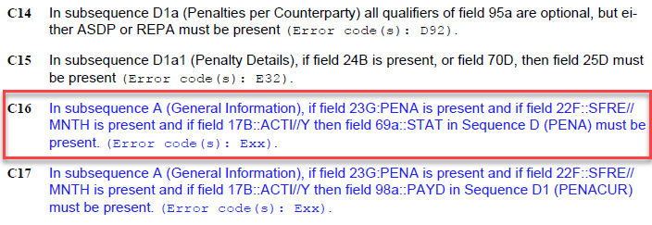

SWIFT Comment

No Comment.
The semt.044 is owned by T2S/4CB not by SWIFT, the request has been sent to T2S/4CB.

Question from the submitter: Should :22H::STST//PENA be included in the NVR or instead of :23G:PENA?

Working Group Meeting

Discussion
Decision

CR 001890: Add a new Network Validation to enforce the presence of the payment date in the monthly penalty report.
Origin of request
Requesting Country:
Requesting Group: | AFME
Sponsors
AFME
Message type(s) impacted
MT537, semt.044
Complies with regulation
CSDR
Business impact of this request
MEDIUM
Commitment to implement the change
Number of messages sent and received:
Percentage of messages impacted:
Commits to implement and when: AFME 2023
Business context
As per Global SMPG guidelines for CSDR Penalty Reporting, field 98a PAYD (pre-advise payment date) is considered mandatory in monthly penalty reports. However, the payment date is often not contained in the monthly report as the field is optional and may not be populated if an institution cannot guarantee that payment will not be made on that date (despite the fact it doesn't mean that payment actually has to happen on that date).
Nature of change
Add a new Network Validation Rules C17 that states that:

If the statement is a Penalties statement (:23G:PENA), the Statement Frequence is Monthly (:22F::STST//MNTH) and the Activity Flag is Yes (:17B::ACTI//Y), all in sequence A, General Information, then it is mandatory to specify a payment date (field :98A::PAYD or :98C::PAYD) in sequence D1 (PENACUR).

Examples
:16R:GENL
:28E:00001/ONLY
:20C::SEME//0102210432267858
:23G:PENA (If Message Function is PENA)
:98A::STAT//20210314
:98C::PREP//20210201163226
:22F::SFRE//MNTH (and Statement Frequency is MNTH)
:22F::CODE//COMP
:22H::STST//PENA (should we include this field instead of / along with the message function?)
:97A::SAFE//XXXXXXXX
:17B::ACTI//Y
:16S:GENL
:16R:PENA
:22F::CODE//CURR
:95P::ASDP//KELRHUHBXXX
:69A::STAT//20210201/20210228
:16R:PENACUR
:11A::PECU//EUR
:98A::PAYD//20210317 (then 98a PAYD is mandatory)
:20C::CPRF//PENREF123456
:95P::REPA//ABCDEFGHXXX
:95P::CASD//KELRHUHBXXX
:22F::TRCA//CSDP
:19A::GBNT//EUR315,00

Standards Illustration

ISO15022

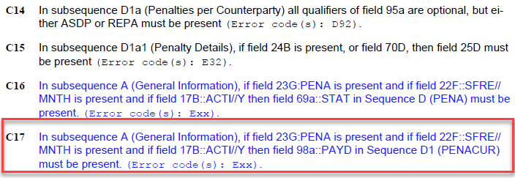

SWIFT Comment

What about the usage of the message as pre-advice of the payment ?

The semt.044 is owned by T2S/4CB not by SWIFT, the request has been sent to T2S/4CB.

Questions from the submitter:
- Should :22H::STST//PENA be included in the NVR or instead of :23G:PENA?

- Should the definition of pay date be updated to advise it's not binding and is on a best-efforts basis (similar to a Corporate Action event where outturns may not actually happen on pay date)? Or is that a market practice update and the definition is OK as is?

Working Group Meeting

Discussion
Decision

CR 001891: Update NVR C2 to include the sequence D1a1B1 in the validation.
Origin of request
Requesting Country:
Requesting Group: | SMPG
Sponsors
SMPG
Message type(s) impacted
MT537, MT548, semt.044
Complies with regulation
CSDR
Business impact of this request
LOW
Commitment to implement the change
Number of messages sent and received:
Percentage of messages impacted:
Commits to implement and when: SMPG 2023
Business context
The MT537 contains a Network Validation Rule C2 that states that, if the transaction type is against payment, then 19A PSTA is mandatory in sequences B2b or C2 (as 19A PSTA is an optional field).

C2 If the instruction is against payment (:22H::PAYM//APMT) then it is mandatory to specify a posting amount (field :19A::PSTA). This rule applies to subsequence B2b and C2 (Error code(s): E83).

However, this rule does not extend to the same fields in the TRAN (Transaction Details) sequence D1a1B1 which means institutions can report against payment transactions subject to penalties but not actually provide the Posting Amount.
Nature of change
Add sequence D1a1B1 to network validation rule C2.

Examples
:19A::PSTA missing after :36B::PSTA even though :22H::PAYM//APMT is present

:16R:RELTRAN
:20C::ACOW//ZIASB222209
:20C::ASRF//I00001SJP9RX00FL
:20C::MITI//2110126210054243
:16R:TRAN
:22H::REDE//DELI
:22H::PAYM//APMT
:22F::SETR//TRAD
:22F::TRAN//SETT
:98A::SETT//20211014
:98A::TRAD//20211012
:98C::ASTS//20211012190800
:98C::MTCH//20211012190728
:36B::PSTA//UNIT/2535,
:16R:STAT
:25D::SETT//PENF
:16R:REAS
:24B::PENF//PREA
:16S:REAS
:16S:STAT
:16S:TRAN
:16S:RELTRAN

Standards Illustration

ISO15022
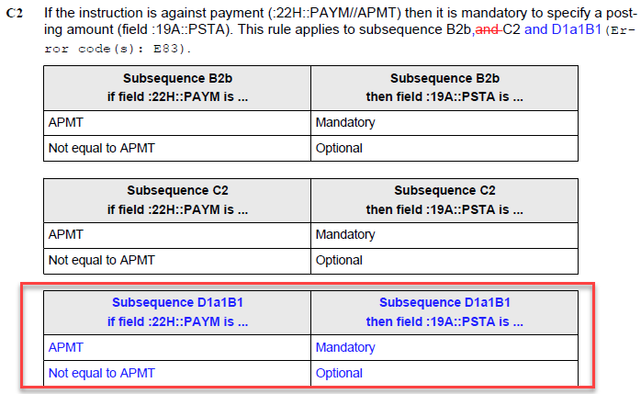
SWIFT Comment

No comment

The semt.044 is owned by T2S/4CB not by SWIFT, the request has been sent to T2S/4CB.

Question from the submitter: Does this also needs to incorporate the fact that either PSTA (Posting Amount) or RSTT (Remaining Settlement Amount) can be used in this sequence?

Working Group Meeting

Discussion
Decision

Overview of SWIFT Change requests
None

End of document

MWG maintenance meeting minutes are distributed around first week of September.

