Standards
Standards MT Release 2023
Discussion paper and Minutes
Common Cat 5
Distribution: Common Cat 5 Maintenance Working Group
Author: Alexandre Hotat

Date Issued: 30 June 2022
Meeting Date: If no conclusion by mail, potentially the 31st of August

Table of Contents
1 Introduction 3
Standards Illustrations in this document 3
SR 2022 change requests 3
Contact persons regarding this document 3
CR Title Colour notation (for minutes only) 3
MWG Members for SR2022 4
2 Overview of User Change requests 6
2.1 CR 001848: Update of Digital Asset usage rule in field 36D. 6
3 Overview of SWIFT Change requests 13

Introduction

Standards Illustrations in this document
Standards illustrations are provided by SWIFT Standards. They are not part of the original request.
Any standard illustrations (rules, codes, qualifiers, wordings) are only for illustration purposes. It does not mean SWIFT Standards is in agreement with the maintenance request or that the final standards solutions (for accepted maintenance requests) will be as shown in this document.
The MT Standards Release Guide (+ potential erratum) and the ISO 20022 message definition reports are the ONLY source of reliable information based on which implementation of changes should be made. Any other documentation (including this one) is subject to change.

SR 2022 change requests
This document contains all Common Cat 5 MT/MX CRs and equivalent MX messages investigated this year for implementation in SR 2022.
The requests originator is indicated as follows:
  - Requesting Country; Country code of requesting NMPG or UG; eg. BE
  - Requesting Group: a SWIFT User Group or a National (Securities) Market Practice Group with the acknowledgement of the UGC or Recognized industry group eg. SMPG (the global Securities Market Practice Group)

Contact persons regarding this document
Karine Taquet - SWIFT Standards, Karine.TAQUET@swift.com
Alexandre Hotat – SWIFT Standards, Alexandre.HOTAT@swift.com
Jacques Littré – SWIFT Standards; jacques.LITTRE@swift.com

CR Title Colour notation (for minutes only)
In GREEN are items that are approved or approved with comments or approved with alternative solution.
In RED are items that are rejected, withdrawn or linked to agreed items
In GREY are items that are postponed for review and implementation at the next release.

MWG Members for SR2022
The following people are part of the Common Cat 5 MWG for SR2022.
 | CA Maintenance working group members |  | Representing
 | Priscilla Ferri de Barros |  | AU
 | Véronique Peeters |  | BE
 | Michael Blumer |  | CH
 | Daniel Schäfer |  | DE
 | Jean-Pierre Klak (Stephanie Clark Fischer / Mihaela Fallourd backup) |  | FR
 | James Mullens |  | HK
 | Yoshihito Suzuki |  | JP
 | Catarina Marques |  | LU
 | Paola De Antoni |  | IT
 | Huseyin Boler |  | NL
 | Jyi-Chen Chueh |  | SG
 | Mariangela Fumagalli |  | UK
 | Paul Fullam |  | US / ISITC
 | Jean-Paul Lambotte |  | XS
CM and TPCM Maintenance working group members | Representing
Australia | Brendan Laird - ASX
Belgium | Faraz Ahmed Khan - Euroclear
France | Mihaela Fallourd - bnpparibas
Luxembourg | Crispin Searle - Clearstream
Switzerland | René Eberhard - SIX-Group
 | Christian Ramseier - SIX-Group
 | Matthias Airault - SIX-Group
United States | Aundrea Jarvis - BBH
 | Roger Cowie - JPM Chase
The Netherlands | Ton Van Andel - ABNAmro
Turkey | Özge Pelin Tekin - Yapı ve Kredi Bankası A.Ş

S&R Maintenance working group members: | Representing:
Brendan Laird - ASX | Australia
David Wouters – BNYMellon | Belgium
Xavier Filion Simon - BNC  Daniel Valance - RBC | Canada
Vacant | Denmark
Stephanie Clark Fischer – BNP Paribas  Mihaela Fallourd – BNP Paribas | France
Denis Andrejew – DB | Germany
Jennifer Chan– HSBC | Hong Kong
Jean-François Schleck - Euroclear | ICSD
Robin Leary – Citibank | Ireland
Michela Rabbia - Intesa Sanpaolo – Financial Institution Products  Agostino Guarino - Intesa Sanpaolo – Financial Institution Products | Italy
Takaya Hamamura - Mitsubishi Bank | Japan
Vacant | Republic of Korea
Arnaud Jochems – Clearstream | Luxembourg / ICSD
Ton Van Andel – ABN Amro | The Netherland
Vacant | Singapore
Vacant | South Africa
Cristina del Valle - BNP | Spain
Christine Strandberg - SEB | Sweden
Stephan Schuetter – UBS | Switzerland
Robin Leary – Citibank | United Kingdom
Aundrea Jarvis - BBH | United States of America

TiC Maintenance working group members | Representing
Mr. Christian Pinetz – OEKB | Austria
Vacant | Australia
Vacant | Belgium
Vacant | Denmark
Vacant | France
Vacant | Germany
Vacant | Ireland
Vacant | Italy
Vacant | Japan
Vacant | Luxembourg
Mr Ton Van Andel, ABN Amro | Netherlands
Vacant | Singapore
Mr. Brett Kotze – A2X | South Africa
Vacant | Spain
Vacant | Sweden
Renato Cricca - SIX Digital Exchange | Switzerland
Vacant | United Kingdom
Vacant | United States of America

Overview of User Change requests

CR 001848: Update of Digital Asset usage rule in field 36D.
Origin of request
Requesting Country:
Requesting Group: | Securities Digital Asset Working Group
Sponsors
BNYM, BNP, HSBC and their counterparties
Message type(s) impacted
MT500, MT501, MT502, MT503, MT504, MT505, MT506, MT508, MT509, MT510, MT513, MT514, MT515, MT518, MT519, MT524, MT527, MT530, MT535, MT536, MT537, MT538, MT540, MT541, MT542, MT543, MT544, MT545, MT546, MT547, MT548, MT558, MT564, MT565, MT566, MT 567, MT568, MT569, MT575, MT576, MT578, MT586 and ISO 20022 equivalents
Complies with regulation
No
Business impact of this request
LOW
Commitment to implement the change
Number of messages sent and received: 1379406324
Percentage of messages impacted: 10
Commits to implement and when: BNYM, BNP, HSBC and their counterparties 2023
Business context
There is growing interest in reusing cat 5 messages (and associated ISO 20022 messages) for the servicing of digital assets, which is a security type of growing importance. This approach requires least adaptation in the back offices. There is interest among most custodians outside the working group as well, and while it is early days for digital assets, the expectation is that it is an instrument type that will grow in importance. This change request avoids the need to implement unstandardised API solutions, rather recommends an efficient re-use of Cat 5 (&equivalent ISO 20022).

This change request is adapting a usage rule that was added in relation to a change request submitted for SR 2022 that required the extension of the number of digits for the quantity field 36a to cater for minimal tradeable units. For example, Wei is a quintillionth of an Ether (18 dp). Combined with the integer part before the decimal separator, this cannot be reflected in unit quantity in ISO 15022 or ISO 20022 as it can exceed15 digits. Therefore, an extra option 36D with 30 digits was created to capture these quantities.

The usage rule introduced in SR 2022 for field 36D “Format option D may only be used when the related account information in sequence C field :97D::BCAW is present.”, is too restrictive.

Some institutions prefer to show balances of digital assets on traditional accounts rather than blockchain addresses. Hence the desired use of high precision numbers in 36D combined with :97a::SAFE.

This is the reason why the change requests to rewrite the usage rule to only pertain to :36D: “Option D should only be used for digital assets”

This usage rule rewrite should have no implementation impact.
Nature of change
Change of usage rule

from:

"Format option D may only be used when the related account information in sequence C field :97D::BCAW is present. When quantity type code is UNIT or DITU, qualifier SETT must not be repeated."

to:

"Format option D may only be used for digital assets. When quantity type code is UNIT or DITU, qualifier SETT must not be repeated."
Examples

Standards Illustration
ISO15022

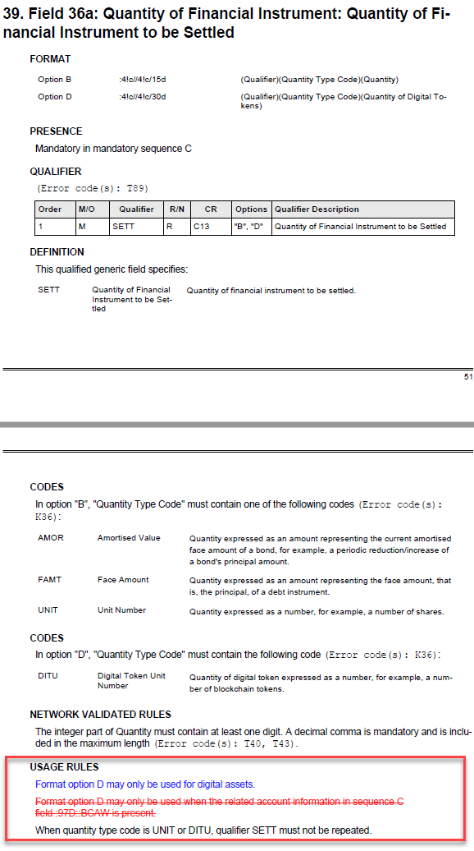

Changes for CA messages to avoid repetition of 36a qualifiers with format option D

Concerns Quantity of FI fields in:
MT564, field item 80, NVR C13
MT565, field item 43, NVR C4
MT566, field item 61, NVR C7
MT567, field item 25, NVR C3

Standards Illustration
ISO15022

In the MT 564, in NVR C13, amend the NVR text as follows:
C13
In each occurrence of subsequence E1, field :36B::ENTL cannot appear more than twice (maximum two occurrences). When repeated, one occurrence must have Quantity Type Code FAMT and the other occurrence must have Quantity Type Code AMOR (Error code(s): C72).
Subsequence E1  if field :36B::ENTL is ... | Then one occurrence of :36B::ENTL must be ... | And the other occurrence of :36B::ENTL must be ...
Repeated | :36B::ENTL//FAMT | :36B::ENTL//AMOR
Not repeated | Not applicable | Not applicable
Note: When used with format option D, field 36a qualifier ENTL cannot be repeated.

In the MT 565, in NVR C4, amend the NVR text as follows:
C4
In sequence D, field :36B::QINS cannot appear more than twice (maximum two occurrences). When repeated, one occurrence must have Quantity Type Code FAMT and the other occurrence must have Quantity Type Code AMOR (Error code(s): C72).
Sequence D  if field :36B::QINS is ... | Then one occurrence of :36B::QINS must be ... | And the other occurrence of :36B::QINS must be ...
Repeated | :36B::QINS//FAMT | :36B::QINS//AMOR
Not repeated | Not applicable | Not applicable
Note: When used with format option C or D, field 36a qualifier QINS cannot be repeated.

In the MT 566, in NVR C7, amend the NVR text as follows:

C7
In each occurrence of subsequence D1, field :36B::PSTA cannot appear more than twice (maximum two occurrences). When repeated, one occurrence must have Quantity Type Code FAMT and the other occurrence must have Quantity Type Code AMOR (Error code(s): C72).
Subsequence D1  if field :36B::PSTA is ... | Then one occurrence of :36B::PSTA must be ... | And the other occurrence of :36B::PSTA must be ...
Repeated | :36B::PSTA//FAMT | :36B::PSTA//AMOR
Not repeated | Not applicable | Not applicable
Note: When used with format option D, field 36a qualifier PSTA cannot be repeated.

In the MT 567, in NVR C3, amend the NVR text as follows:
C3
In sequence B, field :36B::STAQ cannot appear more than twice (maximum two occurrences). When repeated, one occurrence must have Quantity Type Code FAMT and the other occurrence must have Quantity Type Code AMOR (Error code(s): C71).
In sequence B  if field :36B::STAQ is ... | Then one occurrence of :36B::STAQ must be ... | And the other occurrence of :36B::STAQ must be ...
Repeated | :36B::STAQ//FAMT | :36B::STAQ//AMOR
Not repeated | Not applicable | Not applicable
Note: When used with format option D, field 36a qualifier STAQ cannot be repeated.

ISO20022

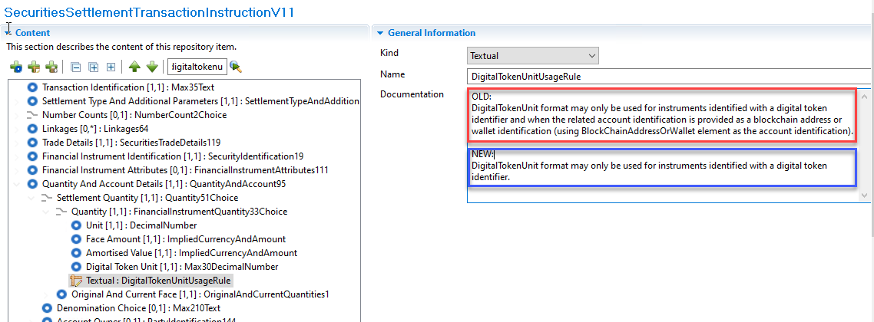

SWIFT Comment

SWIFT requested some workflows to the submitter to have a better view of the business context behind this CR.
SWIFT was involved in the discussion within the digital working group and do not have any comment.

Working Group Meeting

Discussion
Decision

Overview of SWIFT Change requests
None

End of document

MWG maintenance meeting minutes are distributed around first week of September.

