Change Request
for the update of ISO 20022 financial repository items
Note: the purpose of this document is to give guidelines to parties who want to introduce a request to change an existing ISO 20022 message(s), or update other items of the ISO 20022 financial repository. Such change requests are subject to the approval of the ISO 20022 Standards Evaluation Group(s) in charge of the related message/item or to the approval of the Technical Support Group (TSG), if the requested change relates to the Business Application Header (BAH). Please consult the iso20022.org website for additional details on the maintenance process. Change requests are to be sent to iso20022ra@iso20022.org. All change requests conforming to this template received by June 1st will be considered for development in the following yearly ISO 20022 maintenance cycle which completes with publication of new message versions in April/May of the following year.
- Origin of the request:
A.1 Submitter:
SIX Interbank Clearing Ltd.
A.2 Contact person:
Martin Walder
martin.walder@six-group.com
T +41 58 399 53 79
A.3 Sponsors: SIX Interbank Clearing is involved in several committees focused on questions of standardization concerning the national and international payment traffic. In this role SIX Interbank Clearing acts as a representative of the Swiss financial industry.
This change was discussed with the WG responsible for the bank-to-client interfaces.
- Related messages:
camt.053
camt.052
camt.054
There might be other message, for which the change is useful as well.

- Description of the change request:
Add an optional element “Exchange Base” in the Currency Exchange set of elements. 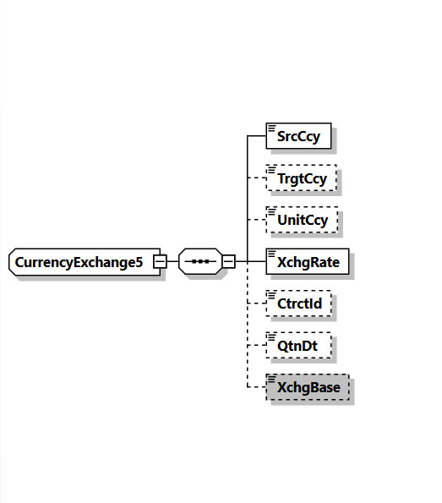
- Purpose of the change:
Although the element ExchangeRate <XchgRate> is defined as factor used to convert an amount from one currency into another, many markets are still using in addition different bases.
For internationally operating corporate clients, it creates problems and can lead to errors if it is not possible to extract from the message whether or not a particular exchange base is being used.
The issues is mostly related to reporting, as the following example of an implementation guideline for camt.053 shows:
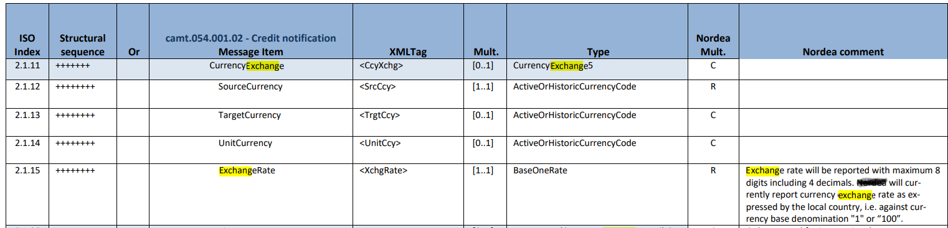
- Urgency of the request:
There is no specific timeline for this change request. I can be assumed, that before 2025 our market is not changing the message version. Nevertheless, it may be helpful for other markets, if this option is available within the next cycle.

Business examples:
Example based on the exchange rate presentation of the Swiss National Bank:
Aktuelle Wechselkurse: Übersicht  Cours de change actuels: aperçu  Current exchange rates: overview  Tassi di cambio attuali: panoramica |  |  |  |  | 30.05.2022
EUR |  | 1 EUR in/en CHF
USD |  | 1 USD in/en CHF
JPY |  | 100 JPY in/en CHF
GBP |  | 1 GBP in/en CHF
 | EUR | USD | JPY | GBP
30.05.2022 | 1.0298 | 0.9569 | 0.7517 | 1.2084
27.05.2022 | 1.0287 | 0.9588 | 0.7547 | 1.2095
25.05.2022 | 1.0275 | 0.9628 | 0.7577 | 1.2058
24.05.2022 | 1.0310 | 0.9631 | 0.7559 | 1.2022
23.05.2022 | 1.0318 | 0.9692 | 0.7598 | 1.2182
20.05.2022 | 1.0290 | 0.9728 | 0.7596 | 1.2147
19.05.2022 | 1.0251 | 0.9764 | 0.7636 | 1.2101
18.05.2022 | 1.0479 | 0.9972 | 0.7717 | 1.2340
Many market practices for client-to-bank interaction are using the same currency exchange methods as their respective regulator, national bank or common usage.
Example:
30’000 JPY (booked)
225.51 CHF (
Exchange rate 0.007517
Unit Currency CHF
Exchange Base 1
225.51/0.007517=30000
30’000 JPY
225.51 CHF
Exchange rate 0.7517
Unit Currency CHF
Exchange Base 100 (1 CHF to 100 JPY)
225.51/0.7517*100=30000
Usage:
Currenttly:
ExchangeRate expresses the ratio between UnitCurrency and QuotedCurrency (ExchangeRate = UnitCurrency/QuotedCurrency).
Added:
ExchangeBase expresses the ratio between the base of the denomination of the UnitCurrency to the base of the denominated of the Quoted Currency.

- SEG/TSG recommendation:
This section is not to be taken care of by the submitter of the change request. It will be completed in due time by the SEG(s) in charge of the related ISO 20022 messages or the TSG for changes related to the BAH.

Consider |  |  | Timing
- Next yearly cycle: 2022/2023
(the change will be considered for implementation in the yearly maintenance cycle which starts in 2022 and completes with the publication of new message versions in the spring of 2023)
- At the occasion of the next maintenance of the messages
(the change will be considered for implementation, but does not justify maintenance of the messages in its own right – will be pending until more critical change requests are received for the messages)
- Urgent unscheduled
(the change justifies an urgent implementation outside of the normal yearly cycle)
 |  |  | - Other timing:
Comments:

Reject
Reason for rejection:

