Change Request
for the update of ISO 20022 financial repository items

- Origin of the request:
A.1 Submitter: nexo A.I.S.B.L
A.2 Contact person: Philippe CECE (Philippe.cece@ingenico.com) / Evelyne de JONGHE (evelyne.de-jonghe@frenchsys.com)
A.3 Sponsors: nexo A.I.S.B.L.

- Related messages:

- AcceptorAuthorisationRequest V11 caaa.001.001.11,
- AcceptorCompletionAdvice V11 caaa.003.001.11,
- AcceptorCancellationRequest V11 caaa.005.001.11,
- AcceptorCancellationAdvice V11 caaa.007.001.11,
- AcceptorBatchTransfer V11 caaa.011.001.11,
- TransactionAdvice V03 caaa.020.001.03,
- AcceptorNonFinancialRequest V02 caaa.022.001.02,
- AcceptorTransactionLogReportRequest V02 caaa.024.001.02,
- AcceptorTransactionLogReportResponse V02 caaa.025.001.02,

- SaleToPOIServiceRequest V04 casp.001.001.04,
- SaleToPOIServiceResponse V04 casp.002.001.04,
- SaleToPOIReconciliationRequest V04 casp.003.001.04,
- SaleToPOIReconciliationResponse V04 casp.004.001.04,
- SaleToPOISessionManagementRequest V04 casp.005.001.04,
- SaleToPOISessionManagementResponse V04 casp.006.001.04,
- SaleToPOIAdministrativeRequest V04 casp.007.001.04,
- SaleToPOIAdministrativeResponse V04 casp.008.001.04,
- SaleToPOIReportRequest V04 casp.009.001.04,
- SaleToPOIReportResponse V04 casp.010.001.04,
- SaleToPOIAbort V04 casp.011.001.04,
- SaleToPOIEventNotification V04 casp.012.001.04,
- SaleToPOIMessageStatusRequest V04 casp.014.001.04,
- SaleToPOIMessageStatusResponse V04 casp.015.001.04,
- SaleToPOIDeviceRequest V04 casp.016.001.04,
- SaleToPOIDeviceResponse V04 casp.017.001.04,

- StatusReport V11 catm.001.001.11,
- AcceptorConfigurationUpdate V10 catm.002.001.10,
- MaintenanceDelegationRequest V08 catm.005.001.08,

- Description of the change request:

In the BusinessArea1Code we are currently using a code value to identify transit open payment solution, but without clearly stating that it is linked to Transport solution. Consequently, we would like to adapt this code value to add the domain information.
Additionally, we would like to add a new code value for Open Solution that could be made on Energy domain, like Electric Vehicle.

- Purpose of the change:

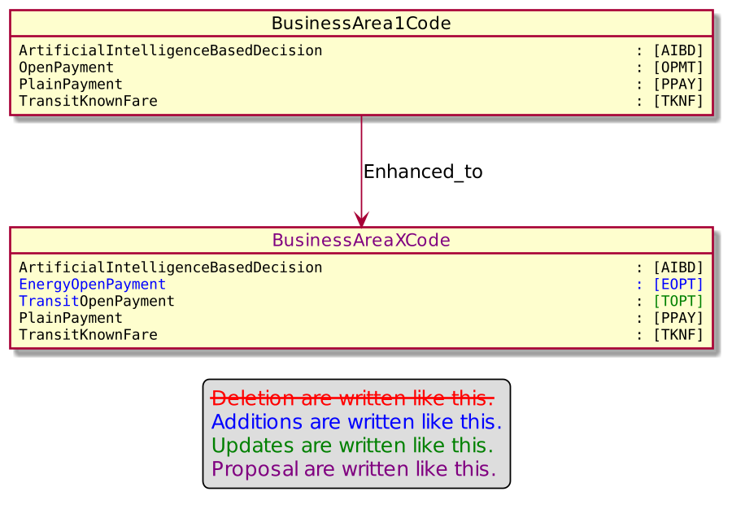
- Urgency of the request:

Urgent

- Business examples:
Examples illustrating the change request.
- SEG/TSG recommendation:
This section is not to be taken care of by the submitter of the change request. It will be completed in due time by the SEG(s) in charge of the related ISO 20022 messages or the TSG for changes related to the BAH.

Consider |  |  | Timing
- Next yearly cycle: 2022/2023
(the change will be considered for implementation in the yearly maintenance cycle which starts in 2022 and completes with the publication of new message versions in the spring of 2023)
- At the occasion of the next maintenance of the messages
(the change will be considered for implementation, but does not justify maintenance of the messages in its own right – will be pending until more critical change requests are received for the messages)
- Urgent unscheduled
(the change justifies an urgent implementation outside of the normal yearly cycle)
 |  |  | - Other timing:
Comments:

Reject
Reason for rejection:

