Change Request
for the update of ISO 20022 financial repository items
Note: the purpose of this document is to give guidelines to parties who want to introduce a request to change an existing ISO 20022 message(s), or update other items of the ISO 20022 financial repository. Such change requests are subject to the approval of the ISO 20022 Standards Evaluation Group(s) in charge of the related message/item or to the approval of the Technical Support Group (TSG), if the requested change relates to the Business Application Header (BAH). Please consult the iso20022.org website for additional details on the maintenance process. Change requests are to be sent to iso20022ra@iso20022.org. All change requests conforming to this template received by June 1st will be considered for development in the following yearly ISO 20022 maintenance cycle which completes with publication of new message versions in April/May of the following year.
- Origin of the request:
A.1 Submitter:
SIX Interbank Clearing Ltd
A.2 Contact person:
Roman Locher
roman.locher@six-group.com
T +41 58 399 4125
A.3 Sponsors:
SIX Interbank Clearing is involved in several committees focused on questions of standardization concerning the national and international payment traffic. In this role SIX Interbank Clearing acts as a representative of the Swiss financial industry. SIX Interbank Clearing also operates the Swiss RTGS systems SIC for Swiss Francs (monitored and steered by the Swiss National Bank) and euroSIC in Euro.
This Change Request is supported by the national committee “Taskforce ISO V2019 Interbank”, representing Swiss National Bank, UBS, Credit Suisse, PostFinance, Raiffeisen, Zürcher Kantonalbank, Entris Banking.
- Related messages:
camt.005 (latest version: camt.005.001.09)

- Description of the change request:
This change request refers to the support of the search criterion UETR within the element "Payment Identification" (<PmtId>, Type PaymentIdentification6Choice) in the block "Payment Search" (<PmtSch>, Type PaymentSearch8) of the message "Get Transaction" (camt.005):
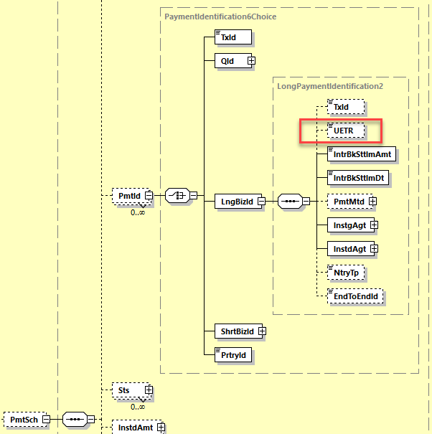
Since Swiss RTGS SIC and euroSIC have fully migrated to ISO 20022 the message camt.005 is well established to query individual transactions. As the use of UETR has been defined mandatory since November 2021 in payment messages of the Swiss Interbank Market Practice, there is also a need for the participants to query corresponding transaction by using the search criterion UETR.

In the current message design camt.005, the search criterion UETR is offered exclusively within the element "Long Business Identification" (<LngBizId>, Type LongPaymentIdentification2). If the search criterion UETR is to be supported, the participant would currently be forced to additionally provide the mandatory elements <IntrbkSttlmAmt>, <IntrbkSttlmDt>, <InstgAgt> and <InstdAgt>. This is in contrast, for example, to the support of <TxId> element, which is provided within the message camt.005 a) also on other messages levels and
b) can also be used as a sole search criterion:
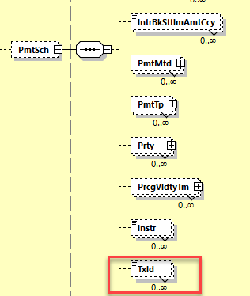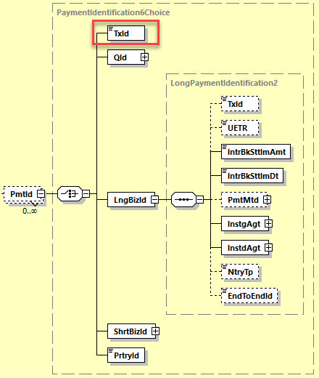
Similar to the <TxId> element, the Swiss community requests that the search criterion UETR is added to the message camt.005 additionally in the following places:
- new sub-element <UETR> under .../SchCrit/PmtSch (optional, unbounded) and
- new sub-element <UETR> under .../SchCrit/PmtSch/PmtId (choice).
- Purpose of the change:
The use of the UETR as a unique identifier has established itself in interbank payment transactions in recent years. Due to the uniqueness of the UETR, it makes sense to support this identifier in query messages as the sole search criterion. However, this is not possible due to the current camt.005 design. According to demands of the Swiss community, more flexibility should be created here in order to use the advantages of this identifier efficiently and to avoid unnecessary additional message content.
- Urgency of the request:
The change should be implemented in the regular yearly maintenance cycle with publication per next ISO 20022 version in spring 2023.
- Business examples:
n/a
- SEG/TSG recommendation:
This section is not to be taken care of by the submitter of the change request. It will be completed in due time by the SEG(s) in charge of the related ISO 20022 messages or the TSG for changes related to the BAH.

Consider |  |  | Timing
- Next yearly cycle: 2022/2023
(the change will be considered for implementation in the yearly maintenance cycle which starts in 2022 and completes with the publication of new message versions in the spring of 2023)
- At the occasion of the next maintenance of the messages
(the change will be considered for implementation, but does not justify maintenance of the messages in its own right – will be pending until more critical change requests are received for the messages)
- Urgent unscheduled
(the change justifies an urgent implementation outside of the normal yearly cycle)
 |  |  | - Other timing:
Comments:

Reject
Reason for rejection:

